 |  | E
TG/GINKG_BIL(proj.2)
ORIGINAL: English
DATE: 2024-03-16

INTERNATIONAL UNION FOR THE PROTECTION OF NEW VARIETIES OF PLANTS
 | Geneva
 | DRAFT
 | GINKGO  UPOV Code(s): GINKG_BIL  Ginkgo biloba L. | *
GUIDELINES
FOR THE CONDUCT OF TESTS
FOR DISTINCTNESS, UNIFORMITY AND STABILITY

prepared by experts from China
to be considered by the
Technical Working Party for Ornamental Plants and Forest Trees

at its fifty-sixth session, to be held virtually
from 2024-04-29 to 2024-05-02

Disclaimer: this document does not represent UPOV policies or guidance
Alternative names:*

Botanical name | English | French | German | Spanish
Ginkgo biloba L. | Ginkgo, Maidenhair | Arbre aux quarante écus, Ginkgo | Ginkgo | Gingco, Ginkgo

The purpose of these guidelines (“Test Guidelines”) is to elaborate the principles contained in the General Introduction (document TG/1/3), and its associated TGP documents, into detailed practical guidance for the harmonized examination of distinctness, uniformity and stability (DUS) and, in particular, to identify appropriate characteristics for the examination of DUS and production of harmonized variety descriptions.
ASSOCIATED DOCUMENTS
These Test Guidelines should be read in conjunction with the General Introduction and its associated TGP documents.

TABLE OF CONTENTS | PAGE
1. | SUBJECT OF THESE TEST GUIDELINES.......................................................................................................... | 3
2. | MATERIAL REQUIRED..................................................................................................................... | 3
3. | METHOD OF EXAMINATION............................................................................................................... | 3
3.1 | Number of Growing Cycles................................................................................................................. | 3
3.2 | Testing Place................................................................................................................... | 3
3.3 | Conditions for Conducting the Examination............................................................................................... | 3
3.4 | Test Design................................................................................................................. | 4
3.5 | Additional Tests................................................................................................................... | 4

4. | ASSESSMENT OF DISTINCTNESS, UNIFORMITY AND STABILITY................................................................. | 4
4.1 | Distinctness.......................................................................................................... | 4
4.2 | Uniformity............................................................................................................ | 5
4.3 | Stability............................................................................................................... | 5

5. | GROUPING OF VARIETIES AND ORGANIZATION OF THE GROWING TRIAL................................................ | 6
6. | INTRODUCTION TO THE TABLE OF CHARACTERISTICS................................................................................ | 6
6.1 | Categories of Characteristics...................................................................................................... | 6
6.2 | States of Expression and Corresponding Notes........................................................................................ | 6
6.3 | Types of Expression............................................................................................................ | 6
6.4 | Example Varieties.............................................................................................................. | 7
6.5 | Legend................................................................................................................. | 8

7. | TABLE OF CHARACTERISTICS/TABLEAU DES CARACTÈRES/MERKMALSTABELLE/TABLA DE CARACTERES.................................................................................................................. | 9
8. | EXPLANATIONS ON THE TABLE OF CHARACTERISTICS............................................................................... | 18
8.1 | Explanations covering several characteristics........................................................................................... | 18
8.2 | Explanations for individual characteristics................................................................................................. | 19

9. | LITERATURE................................................................................................................... | 30
10 | TECHNICAL QUESTIONNAIRE............................................................................................................ | 31

1. | Subject of these Test Guidelines
 | These Test Guidelines apply to all varieties of Ginkgo biloba L.

2. | Material Required
2.1 | The competent authorities decide on the quantity and quality of the plant material required for testing the variety and when and where it is to be delivered. Applicants submitting material from a State other than that in which the testing takes place must ensure that all customs formalities and phytosanitary requirements are complied with.
2.2 | The material is to be supplied in the form of grafted plants.
2.3 | The minimum quantity of plant material, to be supplied by the applicant, should be:
 | 5 plants.
2.4 | The plant material supplied should be visibly healthy, not lacking in vigor, nor affected by any important pest or disease.
2.5 | The plant material should not have undergone any treatment which would affect the expression of the characteristics of the variety, unless the competent authorities allow or request such treatment. If it has been treated, full details of the treatment must be given.

3. | Method of Examination
3.1 | Number of Growing Cycles
3.1.1 | The minimum duration of tests should normally be a single growing cycle.
3.1.2 | The testing of a variety may be concluded when the competent authority can determine with certainty the outcome of the test.
3.2 | Testing Place
 | Tests are normally concluded at one place. In the case of tests conducted at more than one place, guidance is provided in TGP/9 “Examining Distinctness”.
3.3 | Conditions for Conducting the Examination
 | The tests should be carried out under conditions ensuring satisfactory growth for the expression of the relevant characteristics of the variety and for the conduct of the examination.

3.4 | Test Design
3.4.1 | Each test should be designed to result in a total of at least 5 plants.
3.4.2 | The design of the tests should be such that plants or parts of plants may be removed for measurement or counting without prejudice to the observations which must be made up to the end of the growing cycle.
3.5 | Additional Tests
 | Additional tests, for examining relevant characteristics, may be established.

4. | Assessment of Distinctness, Uniformity and Stability
4.1 | Distinctness
4.1.1 | General Recommendations
 | It is of particular importance for users of these Test Guidelines to consult the General Introduction prior to making decisions regarding distinctness. However, the following points are provided for elaboration or emphasis in these Test Guidelines.
4.1.2 | Consistent Differences
 | The differences observed between varieties may be so clear that more than one growing cycle is not necessary. In addition, in some circumstances, the influence of the environment is not such that more than a single growing cycle is required to provide assurance that the differences observed between varieties are sufficiently consistent. One means of ensuring that a difference in a characteristic, observed in a growing trial, is sufficiently consistent is to examine the characteristic in at least two independent growing cycles.
4.1.3 | Clear Differences
 | Determining whether a difference between two varieties is clear depends on many factors, and should consider, in particular, the type of expression of the characteristic being examined, i.e. whether it is expressed in a qualitative, quantitative, or pseudo-qualitative manner. Therefore, it is important that users of these Test Guidelines are familiar with the recommendations contained in the General Introduction prior to making decisions regarding distinctness.
4.1.4 | Number of Plants or Parts of Plants to be Examined
 | Unless otherwise indicated, for the purposes of distinctness, all observations on single plants should be made on 5 plants or parts of plants taken from each of 5 plants and any other observations made on all plants in the test, disregarding any off-type plants.
 | In the case of observations of parts taken from single plants, the number of parts to be taken from each of the plants should be 2.
4.1.5 | Method of Observation
 | The recommended method of observing the characteristic for the purposes of distinctness is indicated by the following key in the Table of Characteristics (see document TGP/9 “Examining Distinctness”, Section 4 “Observation of characteristics”):
MG: single measurement of a group of plants or parts of plants
MS: measurement of a number of individual plants or parts of plants
VG: visual assessment by a single observation of a group of plants or parts of plants
VS: visual assessment by observation of individual plants or parts of plants

 | Type of observation: visual (V) or measurement (M)
 | “Visual” observation (V) is an observation made on the basis of the expert’s judgment. For the purposes of this document, “visual” observation refers to the sensory observations of the experts and, therefore, also includes smell, taste and touch. Visual observation includes observations where the expert uses reference points (e.g. diagrams, example varieties, side-by-side comparison) or non-linear charts (e.g. color charts). Measurement (M) is an objective observation against a calibrated, linear scale e.g. using a ruler, weighing scales, colorimeter, dates, counts, etc.
 | Type of record: for a group of plants (G) or for single, individual plants (S)
 | For the purposes of distinctness, observations may be recorded as a single record for a group of plants or parts of plants (G), or may be recorded as records for a number of single, individual plants or parts of plants (S). In most cases, “G” provides a single record per variety and it is not possible or necessary to apply statistical methods in a plant-by-plant analysis for the assessment of distinctness.
 | In cases where more than one method of observing the characteristic is indicated in the Table of Characteristics (e.g. VG/MG), guidance on selecting an appropriate method is provided in document TGP/9, Section 4.2.
4.2 | Uniformity
4.2.1 | It is of particular importance for users of these Test Guidelines to consult the General Introduction prior to making decisions regarding uniformity. However, the following points are provided for elaboration or emphasis in these Test Guidelines:
4.2.2 | These Test Guidelines have been developed for the examination of vegetatively propagated varieties. For varieties with other types of propagation, the recommendations in the General Introduction and document TGP/13 "Guidance for new types and species" Section 4.5 "Testing Uniformity" should be followed.
4.2.3 | For the assessment of uniformity of vegetatively propagated varieties, a population standard of 1% and an acceptance probability of at least 95% should be applied. In the case of a sample size of 5 plants, no off-types are allowed.
4.3 | Stability
4.3.1 | In practice, it is not usual to perform tests of stability that produce results as certain as those of the testing of distinctness and uniformity. However, experience has demonstrated that, for many types of variety, when a variety has been shown to be uniform, it can also be considered to be stable.
4.3.2 | Where appropriate, or in cases of doubt, stability may be further examined by testing a new plant stock to ensure that it exhibits the same characteristics as those shown by the initial material supplied.

5. | Grouping of Varieties and Organization of the Growing Trial
5.1 | The selection of varieties of common knowledge to be grown in the trial with the candidate varieties and the way in which these varieties are divided into groups to facilitate the assessment of distinctness are aided by the use of grouping characteristics.
5.2 | Grouping characteristics are those in which the documented states of expression, even where produced at different locations, can be used, either individually or in combination with other such characteristics: (a) to select varieties of common knowledge that can be excluded from the growing trial used for examination of distinctness; and (b) to organize the growing trial so that similar varieties are grouped together.
5.3 | The following have been agreed as useful grouping characteristics:
(a) |  | Plant: sex (characteristic 1)
(b) |  | Leaf blade: shape (characteristic 8)
(c) |  | Leaf blade: main color (characteristic 12)
(d) |  | Only varieties with fan-shaped leaves: Leaf blade: shape of leaf base (characteristic 16)
(e) |  | Only varieties with Nut: symmetry: present: Nut: shape in lateral view (characteristic 27)

5.4 | Guidance for the use of grouping characteristics, in the process of examining distinctness, is provided through the General Introduction and document TGP/9 “Examining Distinctness”.

6. | Introduction to the Table of Characteristics
6.1 | Categories of Characteristics
6.1.1 | Standard Test Guidelines Characteristics
 | Standard Test Guidelines characteristics are those which are approved by UPOV for examination of DUS and from which members of the Union can select those suitable for their particular circumstances.
6.1.2 | Asterisked Characteristics
 | Asterisked characteristics (denoted by *) are those included in the Test Guidelines which are important for the international harmonization of variety descriptions and should always be examined for DUS and included in the variety description by all members of the Union, except when the state of expression of a preceding characteristic or regional environmental conditions render this inappropriate.
6.2 | States of Expression and Corresponding Notes
6.2.1 | States of expression are given for each characteristic to define the characteristic and to harmonize descriptions. Each state of expression is allocated a corresponding numerical note for ease of recording of data and for the production and exchange of the description.
6.2.2 | All relevant states of expression are presented in the characteristic.
6.2.3 | Further explanation of the presentation of states of expression and notes is provided in document TGP/7 “Development of Test Guidelines”.
6.3 | Types of Expression
 | An explanation of the types of expression of characteristics (qualitative, quantitative and pseudo-qualitative) is provided in the General Introduction.
6.4 | Example Varieties
 | Where appropriate, example varieties are provided to clarify the states of expression of each characteristic.

6.5 | Legend
 |  | English |  | français |  | deutsch | español | Example Varieties  Exemples  Beispielssorten  Variedades ejemplo | Note/  Nota
1 | 2 | 3 | 4 | 5 | 6 | 7
 |  | Name of characteristics in English |  | Nom du caractère en français |  | Name des Merkmals auf Deutsch | Nombre del carácter en español
 |  | states of expression |  | types d’expression |  | Ausprägungsstufen | tipos de expresión

1 | Characteristic number
2 | (*) | Asterisked characteristic | – see Chapter 6.1.2
3 | Type of expression
 | QL | Qualitative characteristic | – see Chapter 6.3
 | QN | Quantitative characteristic | – see Chapter 6.3
 | PQ | Pseudo-qualitative characteristic | – see Chapter 6.3
4 | Method of observation (and type of plot, if applicable)
 | MG, MS, VG, VS |  | – see Chapter 4.1.5
5 | (+) | See Explanations on the Table of Characteristics in Chapter 8.2
6 | (a)-(c) | See Explanations on the Table of Characteristics in Chapter 8.1
7 | Not applicable

7. | Table of Characteristics/Tableau des caractères/Merkmalstabelle/Tabla de caracteres

 |  | English |  | français |  | deutsch | español | Example Varieties  Exemples  Beispielssorten  Variedades ejemplo | Note/  Nota
1. | (*) | QL | VG |  | (a)
 |  | Plant: sex
 |  | female |  |  |  |  |  | Jia Fo Zhi, Variegata | 1
 |  | male |  |  |  |  |  | Fairmount, Kuiwu | 2
2. |  | QN | MG/VG |  | (a)
 |  | Plant: height
 |  | very short |  |  |  |  |  | Mariken | 1
 |  | very short to short |  |  |  |  |  |  | 2
 |  | short |  |  |  |  |  | Barabits Nana | 3
 |  | short to medium |  |  |  |  |  |  | 4
 |  | medium |  |  |  |  |  | Heksenbezem Leiden | 5
 |  | medium to tall |  |  |  |  |  |  | 6
 |  | tall |  |  |  |  |  | Beijing Gold | 7
 |  | tall to very tall |  |  |  |  |  |  | 8
 |  | very tall |  |  |  |  |  | Menhir | 9
3. |  | PQ | VG | (+) | (a)
 |  | Plant: shape
 |  | conic |  |  |  |  |  | Menhir | 1
 |  | cylindric |  |  |  |  |  | Tian Zhu | 2
 |  | ovoid |  |  |  |  |  |  | 3
 |  | globose |  |  |  |  |  | Globosa | 4
 |  | obloid |  |  |  |  |  |  | 5
 |  | semi-ellipsoid |  |  |  |  |  |  | 6
4. |  | PQ | VG | (+) | (a)
 |  | Plant: growth habit
 |  | fastigiate |  |  |  |  |  |  | 1
 |  | upright |  |  |  |  |  | Tian Zhu | 2
 |  | semi-upright |  |  |  |  |  | Piedmont Pillar | 3
 |  | spreading |  |  |  |  |  | Horizontalis | 4
 |  | drooping |  |  |  |  |  | Mayfield | 5
 |  | weeping |  |  |  |  |  | Pendula | 6
5. |  | QN | MG/VG | (+)
 |  | Branch: length of internode
 |  | short |  |  |  |  |  | Leiden | 1
 |  | short to medium |  |  |  |  |  |  | 2
 |  | medium |  |  |  |  |  |  | 3
 |  | medium to long |  |  |  |  |  |  | 4
 |  | long |  |  |  |  |  | Dong Ting Huang | 5
6. | (*) | PQ | VG | (+)
 |  | Young leaf blade: main color
 |  | light yellow |  |  |  |  |  | Californian Sunset | 1
 |  | medium yellow |  |  |  |  |  | Wan Nian Jin | 2
 |  | yellow green |  |  |  |  |  |  | 3
 |  | green |  |  |  |  |  | Fastigiata | 4
7. | (*) | QL | VG | (+) | (b)
 |  | Leaf: attitude
 |  | upwards |  |  |  |  |  | Fastigiata | 1
 |  | downwards |  |  |  |  |  | Chui Ye, Saratoga | 2
8. | (*) | PQ | VG | (+) | (b)
 |  | Leaf blade: shape
 |  | only fan-shaped |  |  |  |  |  | Fastigiata | 1
 |  | only funnel-shaped |  |  |  |  |  | Tubifolia | 2
 |  | fan-shaped and terete |  |  |  |  |  | Santa Cruz | 3
 |  | fan-shaped and acicular |  |  |  |  |  | Song Zhen | 4
9. |  | QN | MG | (+) | (b)
 |  | Only varieties with fan-shaped leaves: Leaf blade: length
 |  | short |  |  |  |  |  | Zhai Guan | 1
 |  | short to medium |  |  |  |  |  |  | 2
 |  | medium |  |  |  |  |  | Fastigiata | 3
 |  | medium to long |  |  |  |  |  |  | 4
 |  | long |  |  |  |  |  | Heksenbezem Leiden | 5
10 |  | QN | MG | (+) | (b)
 |  | Only varieties with fan-shaped leaves: Leaf blade: width
 |  | narrow |  |  |  |  |  | Saratoga | 1
 |  | narrow to medium |  |  |  |  |  |  | 2
 |  | medium |  |  |  |  |  | Princeton Gold | 3
 |  | medium to broad |  |  |  |  |  |  | 4
 |  | broad |  |  |  |  |  | Princeton Sentry | 5
11 | (*) | QL | VG |  | (b)
 |  | Leaf blade: variegation
 |  | absent |  |  |  |  |  | Blagon | 1
 |  | present |  |  |  |  |  | Santa Cruz | 9
12 | (*) | PQ | VG | (+) | (b)
 |  | Leaf blade: main color
 |  | whitish |  |  |  |  |  |  | 1
 |  | yellow |  |  |  |  |  | Wan Nian Jin | 2
 |  | yellow green |  |  |  |  |  | Saratoga | 3
 |  | medium green |  |  |  |  |  | Fastigiata | 4
 |  | dark green |  |  |  |  |  | Jade Butterflies, Shannong Yin1 | 5
13 |  | PQ | VG | (+) | (b)
 |  | Only varieties with Leaf blade: variegation: present: Leaf blade: secondary color
 |  | white |  |  |  |  |  | Snow Cloud, Vanilla Swirl | 1
 |  | yellow |  |  |  |  |  | Taishan Ban Ye | 2
 |  | yellow green |  |  |  |  |  | Majestic Butterfly | 3
14 |  | PQ | VG
 |  | Only varieties with Leaf blade: variegation: present: Leaf blade: distribution of second color
 |  | irregularly speckled |  |  |  |  |  |  | 1
 |  | marginal |  |  |  |  |  | Snow Cloud | 2
 |  | irregularly striped |  |  |  |  |  | Jade Butterflies | 3
15 |  | QL | VG
 |  | Only varieties with Leaf blade: variegation: present: Leaf blade: tertiary color
 |  | absent |  |  |  |  |  | Ban Ye | 1
 |  | present |  |  |  |  |  | Majestic Butterfly | 9
16 | (*) | PQ | VG | (+) | (b)
 |  | Only varieties with fan-shaped leaves: Leaf blade: shape of leaf base
 |  | cuneate |  |  |  |  |  | Shannong Yin 2 | 1
 |  | truncate |  |  |  |  |  | Piedmont Pillar | 2
 |  | cordate |  |  |  |  |  | Horizontalis | 3
17 | (*) | QN | VG | (+) | (b)
 |  | Only varieties with fan-shaped leaves: Leaf blade: depth of central incision
 |  | very shallow |  |  |  |  |  | Autumn Gold | 1
 |  | shallow |  |  |  |  |  | Princeton Sentry | 2
 |  | medium |  |  |  |  |  | Princeton Gold | 3
 |  | deep |  |  |  |  |  | Fairmount | 4
 |  | very deep |  |  |  |  |  | Wen Bi | 5
18 | (*) | QL | VG | (+) | (b)
 |  | Only varieties with fan-shaped leaves: Leaf blade: number of incisions
 |  | none |  |  |  |  |  |  | 1
 |  | one |  |  |  |  |  | Jade Butterflies | 2
 |  | five |  |  |  |  |  | Wen Bi | 3
19 |  | QN | VG | (+)
 |  | Only varieties with fan-shaped leaves: Leaf blade: size of marginal serrations
 |  | absent |  |  |  |  |  | Da Hai He | 1
 |  | medium |  |  |  |  |  | Zhai Guan | 2
 |  | large |  |  |  |  |  | Saratoga | 3
20 | (*) | QL | VG | (+) | (c)
 |  | Seed: position
 |  | only short branch |  |  |  |  |  | Shan Nong Guo 1 | 1
 |  | short branch and leaf |  |  |  |  |  | Epiphylla | 2
21 | (*) | PQ | VG |  | (c)
 |  | Seed: color of sarcotesta
 |  | yellow |  |  |  |  |  | Tan-107 | 1
 |  | yellow green |  |  |  |  |  | Yu Xiang | 2
 |  | orange |  |  |  |  |  | Qi Xing Guo | 3
 |  | black |  |  |  |  |  | Qi Xing Hai He | 4
22 |  | QN | VG | (+) | (c)
 |  | Seed: bloom on sarcotesta
 |  | weak |  |  |  |  |  | Nan Lin Guo 1 | 1
 |  | medium |  |  |  |  |  | Qi Xing Guo | 2
 |  | strong |  |  |  |  |  | Tan-107 | 3
23 |  | QN | MG/MS | (+) | (c)
 |  | Nut: length
 |  | short |  |  |  |  |  | Shan Nong Guo 1 | 1
 |  | medium |  |  |  |  |  | Shan Nong Guo 5 | 2
 |  | long |  |  |  |  |  | Bian Fo Zhi | 3
24 |  | QN | MG/MS | (+) | (c)
 |  | Nut: width in lateral view
 |  | narrow |  |  |  |  |  | Jia Fo Zhi | 1
 |  | medium |  |  |  |  |  | Ma Ling-5 | 2
 |  | broad |  |  |  |  |  | An Yin-1 | 3
25 |  | QN | MG/MS | (+) | (c)
 |  | Nut: thickness
 |  | thin |  |  |  |  |  | Chang Nuo Bai Guo | 1
 |  | medium |  |  |  |  |  | Shan Nong Guo 5 | 2
 |  | thick |  |  |  |  |  | An Yin-1 | 3
26 |  | QL | VG | (+) | (c)
 |  | Nut: symmetry
 |  | absent |  |  |  |  |  | Xin Yu | 1
 |  | present |  |  |  |  |  | Shan Nong Guo 1 | 9
27 | (*) | PQ | VG | (+) | (c)
 |  | Only varieties with Nut: symmetry: present: Nut: shape in lateral view
 |  | ovate |  |  |  |  |  | Jin Bing Wei | 1
 |  | oblate |  |  |  |  |  |  | 2
 |  | circular |  |  |  |  |  | Shan Nong Guo 1 | 3
 |  | medium elliptic |  |  |  |  |  | Hai Yang Huang | 4
 |  | narrow elliptic |  |  |  |  |  | Jia Fo Zhi | 5
 |  | obovate |  |  |  |  |  | Shannong Guo 2 | 6
28 |  | QL | VG | (+) | (c)
 |  | Nut: pitting on sclerotesta
 |  | absent |  |  |  |  |  | Shan Nong Guo 5 | 1
 |  | present |  |  |  |  |  | Qi Xing Guo | 9
29 |  | PQ | VG | (+) | (c)
 |  | Nut: shape of apex
 |  | obtuse |  |  |  |  |  | Jin Zhui Zi | 1
 |  | rounded |  |  |  |  |  | Hai Yang Huang | 2
 |  | truncate |  |  |  |  |  | Qi Xing Guo | 3
 |  | retuse |  |  |  |  |  | Chang Nuo Bai Guo | 4
30 | (*) | PQ | VG | (+) | (c)
 |  | Nut: shape of base
 |  | cuneate |  |  |  |  |  |  | 1
 |  | convex |  |  |  |  |  |  | 2
 |  | truncate |  |  |  |  |  |  | 3
 |  | concave |  |  |  |  |  |  | 4
31 |  | QL | VG
 |  | Nut: ridge
 |  | absent |  |  |  |  |  |  | 1
 |  | present |  |  |  |  |  |  | 9
32 |  | PQ | VG | (+) | (c)
 |  | Nut: position of ridge
 |  | upper |  |  |  |  |  | Gan Lan Guo | 1
 |  | upper to middle |  |  |  |  |  | Hai Yang Huang | 2
 |  | whole |  |  |  |  |  | Qi Xing Guo | 3
33 |  | QN | VG | (+) | (c)
 |  | Nut: width of ridge
 |  | narrow |  |  |  |  |  |  | 1
 |  | medium |  |  |  |  |  |  | 2
 |  | broad |  |  |  |  |  |  | 3
34 | (*) | PQ | VG | (+) | (c)
 |  | Kernel: color
 |  | yellow white |  |  |  |  |  | Gui-048 | 1
 |  | yellow green |  |  |  |  |  | Shen Nong 1 | 2
 |  | green |  |  |  |  |  |  | 3
35 | (*) | QN | MG/VG | (+)
 |  | Time of beginning of leaf color change
 |  | early |  |  |  |  |  | Xin Yu | 1
 |  | medium |  |  |  |  |  | Shan Nong Guo 1 | 2
 |  | late |  |  |  |  |  | Nan Lin Guo 5 | 3
36 | (*) | QN | MG/VG | (+)
 |  | Time of beginning of seed maturity
 |  | early |  |  |  |  |  | Xin Yu | 1
 |  | medium |  |  |  |  |  | Shan Nong Guo 1 | 2
 |  | late |  |  |  |  |  | Nan Lin Guo 5 | 3

8. | Explanations on the Table of Characteristics
8.1 | Explanations covering several characteristics
 | Characteristics containing the following key in the Table of Characteristics should be examined as indicated below:
(a) | Observations should be made on the whole mature plant in dormant period.
(b) | Observations should be made on the 3rd or 4th fully developed leaf from the base of the current year branches in summer.  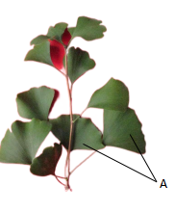  A: 3rd ~ 4th leaves from the base of the current year branches.
(c) | Observations should made on the fully developed seeds in autumn.  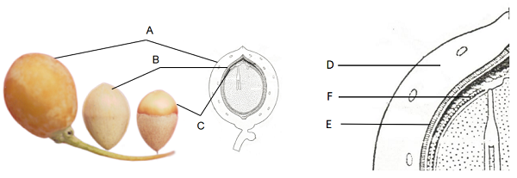  A: Seed  B: Nut  C: Kernel  D: Sarcotesta/ Outer seed coat  E: Sclerotesta/ Stony seed coat  F: Endotesta/ Inner seed coat

8.2 | Explanations for individual characteristics
Ad. 3: Plant: shape

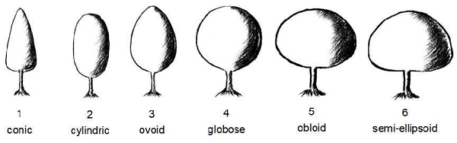

Ad. 4: Plant: growth habit

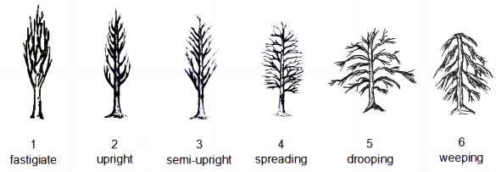

Ad. 5: Branch: length of internode

Observations should be made on the one-year-old long branches when they cease growth in autumn.
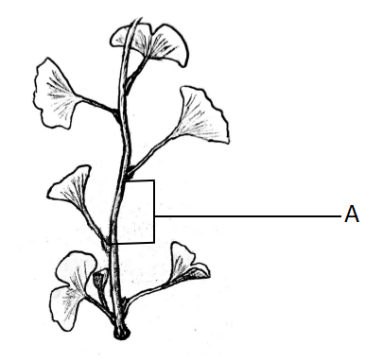
A: Internode

Ad. 6: Young leaf blade: main color

Observations should be made on young leaves in spring on the color with the largest surface area.

Ad. 7: Leaf: attitude

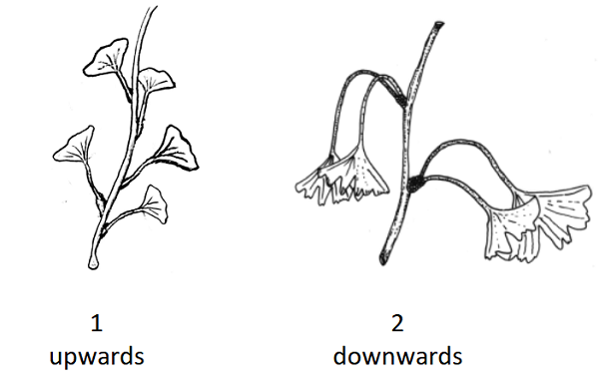

Ad. 8: Leaf blade: shape

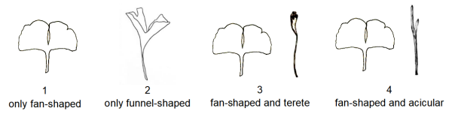

Ad. 9: Only varieties with fan-shaped leaves: Leaf blade: length

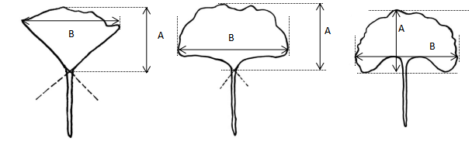
A= Leaf blade: length
B= Leaf blade: width

Ad. 10: Only varieties with fan-shaped leaves: Leaf blade: width

See Ad. 9.

Ad. 12: Leaf blade: main color

The main color is the color with the largest surface area. The secondary color is the color with the second largest surface area. In cases where the areas of the main and secondary color are too similar to reliably decide which color has the largest area, the darker color is considered to be the main color.

Ad. 13: Only varieties with Leaf blade: variegation: present: Leaf blade: secondary color

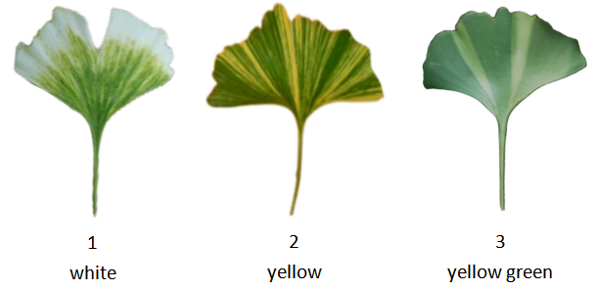

Ad. 16: Only varieties with fan-shaped leaves: Leaf blade: shape of leaf base

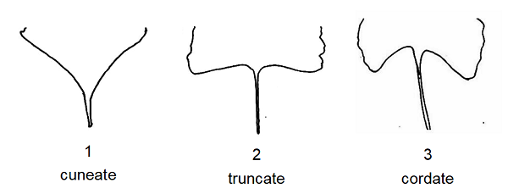

Ad. 17: Only varieties with fan-shaped leaves: Leaf blade: depth of central incision

Observations should be made on the deepest incision.
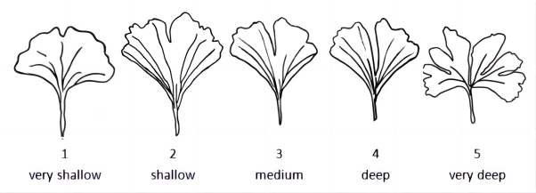

Ad. 18: Only varieties with fan-shaped leaves: Leaf blade: number of incisions

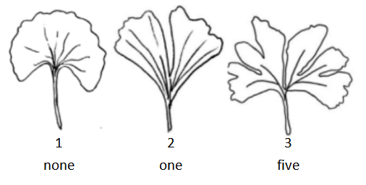

Ad. 19: Only varieties with fan-shaped leaves: Leaf blade: size of marginal serrations

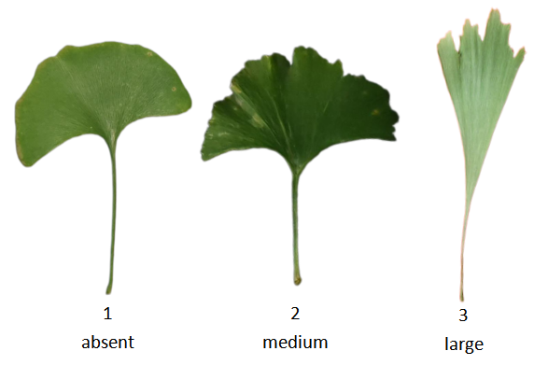

Ad. 20: Seed: position

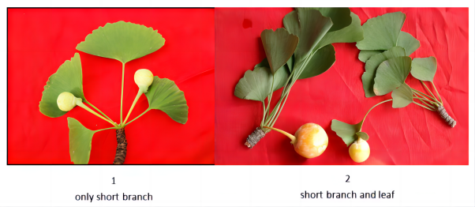

Ad. 22: Seed: bloom on sarcotesta

The bloom is the waxy layer that can be removed by rubbing.

Ad. 23: Nut: length

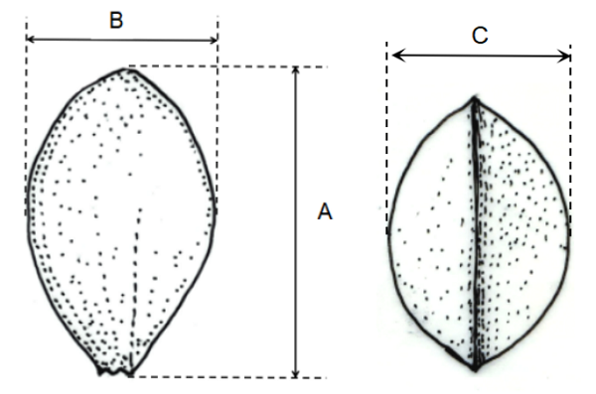
A=Nut: length
B=Nut: width in lateral view
C=Nut: thickness

Ad. 24: Nut: width in lateral view

See Ad. 23.
Observations should be made on the broadest part (including the ridge).

Ad. 25: Nut: thickness

See Ad. 23.

Ad. 26: Nut: symmetry
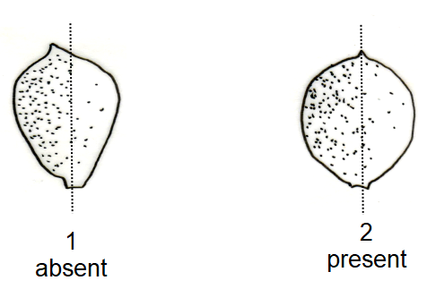

Ad. 27: Only varieties with Nut: symmetry: present: Nut: shape in lateral view

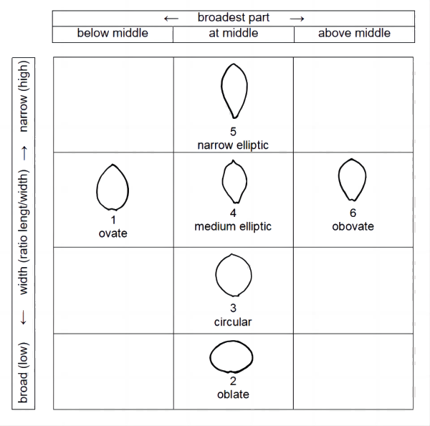

Ad. 28: Nut: pitting on sclerotesta

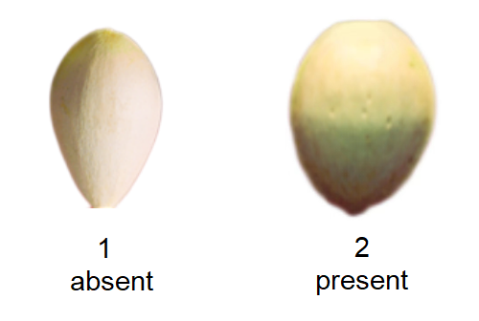

Ad. 29: Nut: shape of apex

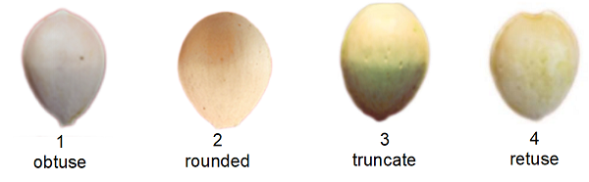

Ad. 30: Nut: shape of base

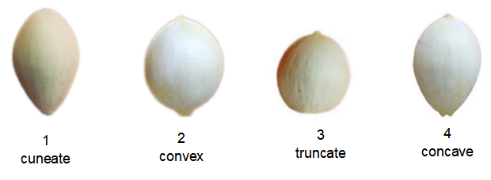

Ad. 32: Nut: position of ridge

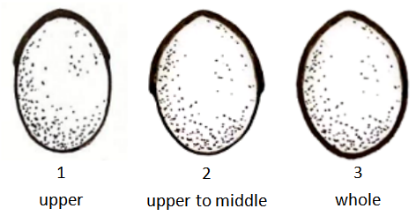

Ad. 33: Nut: width of ridge

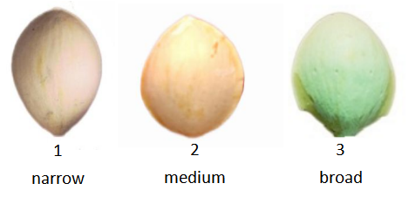

Ad. 34: Kernel: color

Observations should be made on the half-cut kernels.

Ad. 35: Time of beginning of leaf color change

The time of beginning of leaf color change is determined when 30% of leaves have changed color in autumn.

Ad. 36: Time of beginning of seed maturity

The time of beginning of seed mature is determined when 30% of sarcotesta have changed color.

9. | Literature

Guo Shanji. Chinese Fruiter Records[M]. Beijing: China Forestry Publishing House, 1993.
Cao Fuliang. Chinese Ginkgo Records[M]. Beijing: China Forestry Publishing House, 2007.
Xing Shiyan. Evaluation of Ginkgo Germplasm Resources and Selection of Improved Varieties (Volume I)[M]. Beijing: China Environmental Science Press, 2004.
Xing Shiyan. Evaluation of Ginkgo Germplasm Resources and Selection of Improved Varieties (Volume II)[M]. Beijing: China Environmental Science Press, 2004.
Cao Fuliang. An Illustrated Monograph of Ginkgo biloba L.Cultivars in China[M]. Beijing: Science Press, 2010.
Xing Shiyan. Ginkgo Germplasm Resources in China[M]. Beijing: China Forestry Publishing House, 2013.
Xing Shiyan, Jiang Yuezhong, Wu Dejun, et al. Review on Ginkgo Ornanmental Germplasm Resources[J]. Shandong Forestry Science and Technology, 2013, 43(04): 96-100.
Li Shimei, Cui Xifeng, Wang Chengsheng, et al. The Morphological Diversity of Leaf of Ornamental Ginkgo Cultivars[J]. Journal of Forestry Engineering, 2006, 20(2): 33-36.
Xing Shiyan. Descriptors and Date Standards for Germplasm Resources of Ginkgo biloba[M]. Beijing: China Forestry Publishing House, 2016.
LY/T 3000-2018, Guidelines of the Conduct of Tests for Distinctness,uniformity and Stability-Ginkgo (Ginkgo biloba L.)[S].
Wang Ying, Song Chengdong, Guo Shanji, et al. A New Variety of Ginkgo biloba ‘taishanyulian’[J]. Scientia Silvae Sinicae, 2011, 47(11): 208.
Wang Ying, Song Chengdong, Guo Shanji, et al. A New Variety of Ginkgo biloba ‘jindai’[J]. Scientia Silvae Sinicae, 2011, 47(11): 194.
Wang Ying, Song Chengdong, Guo Shanji, et al. A New Variety of Ginkgo biloba ‘jubao’[J]. Scientia Silvae Sinicae, 2011, 47(11): 189.
Wang Ying, Song Chengdong, Guo Shanji, et al..A New Variety of Ginkgo biloba ‘xiajin’[J]. Scientia Silvae Sinicae,2009,45(10):174.
Wang Ying, Song Chengdong, Guo Shanji, et al.A New Variety of Ginkgo biloba ‘songzhen’[J]. Scientia Silvae Sinicae, 2009, 45(09): 174.
Soma, S. A trial to Get the Ginkgo Tree Bearing Leaves with Microsporangia or Ovule on the Leaf[J]. Annual Report of the Faculty of Education Bunkyo University, 2003, 37:11~16.

10. | Technical Questionnaire

TECHNICAL QUESTIONNAIRE | Page {x} of {y} | Reference Number:

Application date:
(not to be filled in by the applicant)
TECHNICAL QUESTIONNAIRE
to be completed in connection with an application for plant breeders' rights

1. | Subject of the Technical Questionnaire
 | 1.1 | Botanical name | Ginkgo biloba L.
 | 1.2 | Common name | Ginkgo, Maidenhair

2. | Applicant
 | Name
 | Address
 | Telephone No.
 | Fax No.
 | E-mail address
 | Breeder (if different from
 | applicant)

3. | Proposed denomination and breeder's reference
 | Proposed denomination
 | (if available)
 | Breeder's reference

TECHNICAL QUESTIONNAIRE |  |  | Page {x} of {y} | Reference Number:
#4. | Information on the breeding scheme and propagation of the variety
 | 4.1 | Breeding scheme
 | Variety resulting from:
4.1.1 | Crossing
(a) | controlled cross | [ ]
(please state parent variety)

(…………………..……………..…) x (……………..…………………..…)

female parent male parent

(b) | partially known cross | [ ]
(please state known parent variety(ies))

(…………………..……………..…) x (……………..…………………..…)

female parent male parent

(c) | unknown cross | [ ]
4.1.2 | Mutation  (please state parent variety) | [ ]
4.1.3 | Discovery and development  (please state where and when discovered and how developed) | [ ]
4.1.4 | Other  (Please provide details) | [ ]

TECHNICAL QUESTIONNAIRE | Page {x} of {y} | Reference Number:

 | 4.2 | Method of propagating the variety
4.2.1 | Vegetative propagation
(a) | Cuttings | [ ]
(b) | Budding or grafting | [ ]
(c) | Division | [ ]
(d) | Other (state method) | [ ]
4.2.2 | Other  (Please provide details) | [ ]

TECHNICAL QUESTIONNAIRE | Page {x} of {y} | Reference Number:

5. | Characteristics of the variety to be indicated (the number in brackets refers to the corresponding characteristic in Test Guidelines; please mark the note which best corresponds).

 | Characteristics | Example Varieties | Note
5.1  (1) | Plant: sex
 | female | Jia Fo Zhi, Variegata | 1 [ ]
 | male | Fairmount, Kuiwu | 2 [ ]
5.2  (6) | Young leaf blade: main color
 | light yellow | Californian Sunset | 1 [ ]
 | medium yellow | Wan Nian Jin | 2 [ ]
 | yellow green |  | 3 [ ]
 | green | Fastigiata | 4 [ ]
5.3  (7) | Leaf: attitude
 | upwards | Fastigiata | 1 [ ]
 | downwards | Chui Ye, Saratoga | 2 [ ]
5.4  (8) | Leaf blade: shape
 | only fan-shaped | Fastigiata | 1 [ ]
 | only funnel-shaped | Tubifolia | 2 [ ]
 | fan-shaped and terete | Santa Cruz | 3 [ ]
 | fan-shaped and acicular | Song Zhen | 4 [ ]
5.5  (11) | Leaf blade: variegation
 | absent | Blagon | 1 [ ]
 | present | Santa Cruz | 9 [ ]
5.6  (12) | Leaf blade: main color
 | whitish |  | 1 [ ]
 | yellow | Wan Nian Jin | 2 [ ]
 | yellow green | Saratoga | 3 [ ]
 | medium green | Fastigiata | 4 [ ]
 | dark green | Jade Butterflies, Shannong Yin1 | 5 [ ]
5.7  (16) | Only varieties with fan-shaped leaves: Leaf blade: shape of leaf base
 | cuneate | Shannong Yin 2 | 1 [ ]
 | truncate | Piedmont Pillar | 2 [ ]
 | cordate | Horizontalis | 3 [ ]
5.8  (17) | Only varieties with fan-shaped leaves: Leaf blade: depth of central incision
 | very shallow | Autumn Gold | 1 [ ]
 | shallow | Princeton Sentry | 2 [ ]
 | medium | Princeton Gold | 3 [ ]
 | deep | Fairmount | 4 [ ]
 | very deep | Wen Bi | 5 [ ]
5.9  (18) | Only varieties with fan-shaped leaves: Leaf blade: number of incisions
 | none |  | 1 [ ]
 | one | Jade Butterflies | 2 [ ]
 | five | Wen Bi | 3 [ ]
5.10  (20) | Seed: position
 | only short branch | Shan Nong Guo 1 | 1 [ ]
 | short branch and leaf | Epiphylla | 2 [ ]
5.11  (21) | Seed: color of sarcotesta
 | yellow | Tan-107 | 1 [ ]
 | yellow green | Yu Xiang | 2 [ ]
 | orange | Qi Xing Guo | 3 [ ]
 | black | Qi Xing Hai He | 4 [ ]
5.12  (27) | Only varieties with Nut: symmetry: present: Nut: shape in lateral view
 | ovate | Jin Bing Wei | 1 [ ]
 | oblate |  | 2 [ ]
 | circular | Shan Nong Guo 1 | 3 [ ]
 | medium elliptic | Hai Yang Huang | 4 [ ]
 | narrow elliptic | Jia Fo Zhi | 5 [ ]
 | obovate | Shannong Guo 2 | 6 [ ]
5.13  (30) | Nut: shape of base
 | cuneate |  | 1 [ ]
 | convex |  | 2 [ ]
 | truncate |  | 3 [ ]
 | concave |  | 4 [ ]
5.14  (34) | Kernel: color
 | yellow white | Gui-048 | 1 [ ]
 | yellow green | Shen Nong 1 | 2 [ ]
 | green |  | 3 [ ]
5.15  (35) | Time of beginning of leaf color change
 | early | Xin Yu | 1 [ ]
 | medium | Shan Nong Guo 1 | 2 [ ]
 | late | Nan Lin Guo 5 | 3 [ ]
5.16  (36) | Time of beginning of seed maturity
 | early | Xin Yu | 1 [ ]
 | medium | Shan Nong Guo 1 | 2 [ ]
 | late | Nan Lin Guo 5 | 3 [ ]

TECHNICAL QUESTIONNAIRE | Page {x} of {y} | Reference Number:

6. | Similar varieties and differences from these varieties
Please use the following table and box for comments to provide information on how your candidate variety differs from the variety (or varieties) which, to the best of your knowledge, is (or are) most similar. This information may help the examination authority to conduct its examination of distinctness in a more efficient way.

Denomination(s) of variety(ies) similar to your candidate variety | Characteristic(s) in which your candidate variety differs from the similar variety(ies) | Describe the expression of the characteristic(s) for the similar variety(ies) | Describe the expression of the characteristic(s) for your candidate variety

Example | Leaf: variegation | absent | present

 | Comments:

TECHNICAL QUESTIONNAIRE | Page {x} of {y} | Reference Number:

#7. | Additional information which may help in the examination of the variety
7.1 | In addition to the information provided in sections 5 and 6, are there any additional characteristics which may help to distinguish the variety?
 | Yes | [ ] | No | [ ]
 | (If yes, please provide details)
7.2 | Are there any special conditions for growing the variety or conducting the examination?
 | Yes | [ ] | No | [ ]
 | (If yes, please provide details)
7.3 | Other information
Is your candidate variety a drawf type? Yes [ ] No [ ]

TECHNICAL QUESTIONNAIRE | Page {x} of {y} | Reference Number:

8. | Authorization for release
 | (a) | Does the variety require prior authorization for release under legislation concerning the protection of the environment, human and animal health?
 |  | Yes | [ ] | No | [ ]
 | (b) | Has such authorization been obtained?
 |  | Yes | [ ] | No | [ ]
 | If the answer to (b) is yes, please attach a copy of the authorization.

9. Information on plant material to be examined or submitted for examination

9.1 The expression of a characteristic or several characteristics of a variety may be affected by factors, such as pests and disease, chemical treatment (e.g. growth retardants or pesticides), effects of tissue culture, different rootstocks, scions taken from different growth phases of a tree, etc.
9.2 The plant material should not have undergone any treatment which would affect the expression of the characteristics of the variety, unless the competent authorities allow or request such treatment. If the plant material has undergone such treatment, full details of the treatment must be given. In this respect, please indicate below, to the best of your knowledge, if the plant material to be examined has been subjected to:

 | (a) | Microorganisms (e.g. virus, bacteria, phytoplasma) | Yes [ ] | No [ ]
 | (b) | Chemical treatment (e.g. growth retardant, pesticide) | Yes [ ] | No [ ]
 | (c) | Tissue culture | Yes [ ] | No [ ]
 | (d) | Other factors | Yes [ ] | No [ ]
 | Please provide details for where you have indicated “yes”.

10. | I hereby declare that, to the best of my knowledge, the information provided in this form is correct:
 | Applicant’s name
 | Signature |  | Date

[End of document]

