E
International Union for the Protection of New Varieties of Plants

Technical Working Party for Vegetables  Fifty-Fifth Session  virtual meeting, June 12 to 16, 2023 | TWO/55/8  Original: English  Date: May 25, 2023
Partial revision of the Test Guidelines for ONCIDIUM
Document prepared by an expert from the Netherlands
Disclaimer: this document does not represent UPOV policies or guidance
The purpose of this document is to present a proposal for a partial revision of the Test Guidelines for Oncidium (document TG/283/1 Rev.).

The Technical Working Party for Ornamentals (TWO), at its fifty-fourth session hosted by Germany and organized by electronic means, from June 13 to 17, 2022, agreed that the Test Guidelines for Oncidium (document TG/283/1 Rev.) should be partially revised (see document TWO/54/6 “Report”, Annex IV).

The following changes are proposed:

- Replace note 2 ‘moderate’ by ‘medium’ for characteristic 30, 50, 70 and 87;
- Relocate the drawings for notes 2, 3 and 5 in Ad. 27;
- Relocate the drawings for note 2 in Ad. 46;
- Relocate the drawings for note 1, 2 and 4 in Ad. 66;
- Adjust spelling of two example varieties throughout whole document TG/238/1 Rev.

The proposed changes are presented below in highlight and underline (insertion) and strikethrough (deletion).

Proposal to replace note 2 ‘moderate’ by ‘medium’ for characteristic 30, 50, 70 and 87

Current wording

 |  | English | français | deutsch | español | Example Varieties  Exemples  Beispielssorten  Variedades ejemplo | Note/  Nota
30.  (+) | VG | Dorsal sepal: undulation of margin | Sépale dorsal : ondulation du bord | Dorsales Kelchblatt: Wellung des Randes | Sépalo dorsal: ondulación del borde
QN | (c) | absent or weak | absente ou faible | fehlend oder gering | ausente o débil | Only You | 1
 |  | moderate | modérée | mittel | moderada | Yellow Days | 2
 |  | strong | forte | stark | fuerte |  | 3
50.  (+)  (*) | VG | Lateral sepal: undulation of margin | Sépale latéral : ondulation du bord | Seitliches Kelchblatt: Wellung des Randes | Sépalo lateral: ondulación del borde
QN | (c) | absent or weak | absente ou faible | fehlend oder gering | ausente o débil | Haruka,  Kaori no Izumi | 1
 |  | moderate | modérée | mittel | moderada | Monshirotyo no Cafe | 2
 |  | strong | forte | stark | fuerte |  | 3
70.  (+) | VG | Petal: undulation of margin | Pétale : ondulation du bord | Blütenblatt: Wellung des Randes | Pétalo: ondulación del borde
QN | (c) | absent or weak | absente ou faible | fehlend oder gering | ausente o débil | Haruka, Sunlight Siesta Ruru | 1
 |  | moderate | modérée | mittel | moderada | Yellow Days | 2
 |  | strong | forte | stark | fuerte |  | 3
87.  (+) | VG | Lip: undulation of margin | Labelle : ondulation du bord | Lippe: Wellung des Randes | Labio: ondulación del borde
QN | (c) | absent or weak | absente ou faible | fehlend oder gering | ausente o débil | Dancing Sunlight Ami | 1
 |  | moderate | modérée | mittel | moderada |  | 2
 |  | strong | forte | stark | fuerte |  | 3

Proposed new wording

 |  | English | français | deutsch | español | Example Varieties  Exemples  Beispielssorten  Variedades ejemplo | Note/  Nota
30.  (+) | VG | Dorsal sepal: undulation of margin | Sépale dorsal : ondulation du bord | Dorsales Kelchblatt: Wellung des Randes | Sépalo dorsal: ondulación del borde
QN | (c) | absent or weak | absente ou faible | fehlend oder gering | ausente o débil | Only You | 1
 |  | moderate medium | modérée moyenne | mittel | moderada media | Yellow Days | 2
 |  | strong | forte | stark | fuerte |  | 3
50.  (+)  (*) | VG | Lateral sepal: undulation of margin | Sépale latéral : ondulation du bord | Seitliches Kelchblatt: Wellung des Randes | Sépalo lateral: ondulación del borde
QN | (c) | absent or weak | absente ou faible | fehlend oder gering | ausente o débil | Haruka,  Kaori no Izumi | 1
 |  | moderate medium | modérée moyenne | mittel | moderada media | Monshirotyo no Cafe | 2
 |  | strong | forte | stark | fuerte |  | 3
70.  (+) | VG | Petal: undulation of margin | Pétale : ondulation du bord | Blütenblatt: Wellung des Randes | Pétalo: ondulación del borde
QN | (c) | absent or weak | absente ou faible | fehlend oder gering | ausente o débil | Haruka, Sunlight Siesta Ruru | 1
 |  | moderate medium | modérée moyenne | mittel | moderada media | Yellow Days | 2
 |  | strong | forte | stark | fuerte |  | 3
87.  (+) | VG | Lip: undulation of margin | Labelle : ondulation du bord | Lippe: Wellung des Randes | Labio: ondulación del borde
QN | (c) | absent or weak | absente ou faible | fehlend oder gering | ausente o débil | Dancing Sunlight Ami | 1
 |  | moderate medium | modérée moyenne | mittel | moderada media |  | 2
 |  | strong | forte | stark | fuerte |  | 3

Proposal to relocate the drawings for notes 2, 3 and 5 in Ad. 27

Current wording

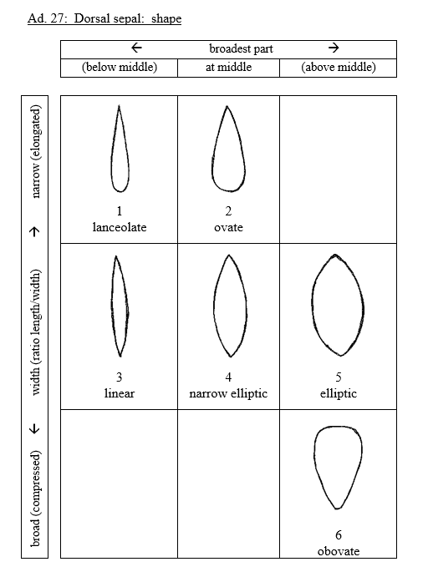

Proposed new wording

 |  | broadest part
 |  | (below middle) | at middle | (above middle)
broad (compressed) width (ratio length/width) narrow (elongated)
 |  | 1 | 3
 |  | lanceolate | linear
 |  | 2 | 4
 |  | ovate | narrow elliptic
 |  |  |  | 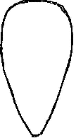
 |  |  | 5 | 6
 |  |  | elliptic | obovate

Proposal to relocate the drawings for note 2 in Ad. 46

Current wording

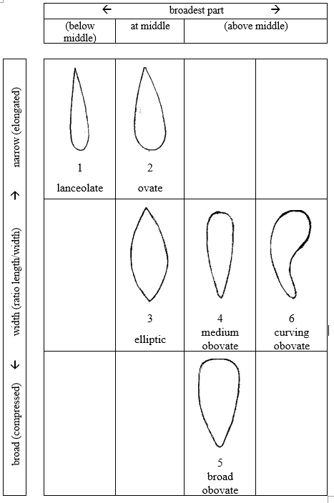

Proposed new wording

 |  | broadest part
 |  | (below middle) | at middle | (above middle)
broad (compressed) width (ratio length/width) narrow (elongated)
 |  | 1
 |  | lanceolate
 |  | 2 | 3 | 4 | 6
 |  | ovate | elliptic | medium  obovate | curving  obovate
 |  |  |  | 5
 |  |  |  | broad obovate

Proposal to relocate the drawings for note 1, 2 and 4 in Ad. 66

Current wording

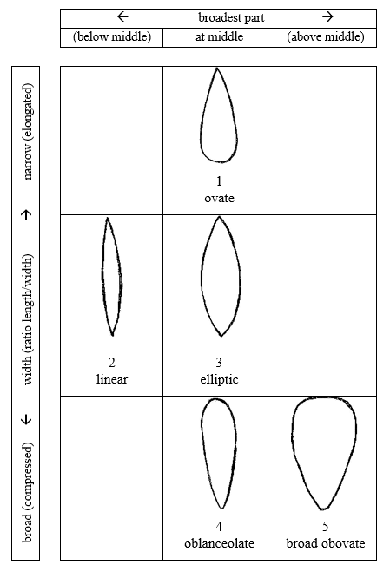

Proposed new wording

 |  | broadest part
 |  | (below middle) | at middle | (above middle)
broad (compressed) width (ratio length/width) narrow (elongated)
 |  |  | 2
 |  |  | linear
 |  | 1 | 3 | 4
 |  | ovate | elliptic | oblanceolate
 |  |  |  | 5
 |  |  |  | broad obovate

Proposal to adjust spelling of two example varieties throughout whole document TG/238/1 Rev.

Current wording

Char. 68, 88, 99: Monshirotyo no Café
Char. 7, 14, 19, 36, 50, 56, 76, 85: Monshirotyo no Cafe

Char: 86, 89, 90: Shimizu Prasol Papurikon
Char. 3, 7, 8, 20, 21, 49, 69, 98: Shimizu Parasol Papurikon

Proposed new wording

Char. 68,88,99: Monshirotyo no Café Monshirochono Cafe
Char. 7,14,19,36,50,56,76,85: Monshirotyo no Cafe Monshirochono Cafe

Char: 86, 89, 90: Shimizu Prasol Papurikon Shimizuparasol Papurikon
Char. 3, 7, 8, 20, 21, 49, 69, 98: Shimizu Parasol Papurikon Shimizuparasol Papurikon

[End of document]

