E
International Union for the Protection of New Varieties of Plants

Technical Working Party for Ornamental Plants and Forest Trees  Fifty-Fifth Session  Virtual meeting, June 12 to 16, 2023 | TWO/55/11  Original: English  Date: June 16, 2023
report
adopted by the Technical Working Party for Ornamental Plants and Forest Trees
Disclaimer: this document does not represent UPOV policies or guidance
Opening of the session

The Technical Working Party for Ornamental Plants and Forest Trees (TWO) held its fifty-fifth session via electronic means, from June 12 to 16, 2023. The list of participants is reproduced in Annex I to this report.

The session was opened by Ms. Ashley Balchin (Canada), Chairperson of the TWO, who welcomed the participants.

Adoption of the agenda

The TWO adopted the agenda as reproduced in document TWO/55/1 Rev.

Increasing participation in the work of the Technical Committee (TC) and restructuring the work of the Technical Working Parties (TWPs)

The TWO considered document TWP/7/1 and noted the proposed draft recommendations under development at the Working Group on DUS support.

The TWO agreed that TWP meetings should allocate more time for discussing DUS procedures and training. The TWO agreed that Test Guidelines discussions was an important means of harmonizing DUS procedures, providing opportunities for interaction between experts and training. The TWO agreed that discussions on Test Guidelines should continue as a central element of TWP meetings, while meetings outside of the TWPs should be used to advance their preparation and to include other crop experts.

The TWO considered the recommendation for the presence of the Office of the Union at in-person meetings and agreed to support the presence of the Office of the Union at TWP meetings preferably on-site, where appropriate.

The TWO agreed with the recommendation to further investigate the development of training on drafting test guidelines. The TWO agreed that the introduction of a tutor or “buddy” system could support new leading experts of UPOV Test Guidelines and the drafting of national test guidelines.

The TWO considered the recommendation that a drafter was selected to lead discussions on particular matters that would require amending or developing guidance in TGP documents. The TWO agreed that the TWPs should be kept informed and have sufficient opportunities to participate in discussions on amending or developing guidance in TGP documents.

Development of guidance and information materials

The TWO considered documents TWP/7/2 and TWO/55/10.

Matters for consideration by the Technical Working Parties

Document TGP/7 “Development of Test Guidelines”

Example varieties for asterisked quantitative characteristics when illustrations are provided

The TWO considered the situations described as the basis to develop guidance on possible exceptions to the requirement to provide example varieties for asterisked quantitative characteristics when illustrations were provided.

The TWO recalled that information on the situations where the approach would be applicable had been provided in document TWP/7/2 and agreed that such an approach would also be applicable for species with few example varieties and where there was difficulty obtaining plant material of such varieties.

The TWO noted that the TWA, at its fifty-second session, had agreed to invite the experts from Germany in collaboration with Canada, Netherlands and United Kingdom to draft a proposal to amend document TGP/7, GN 28 “Example Varieties”, concerning situations where illustrations could replace example varieties and their complementary role to clarify the states of expression of a characteristic.

The TWO agreed to invite the experts from Canada, European Union, France and the United Kingdom to join the TWA experts to draft a proposal to amend document TGP/7, GN 28.

Ornamental varieties of agricultural, fruit or vegetable crops

The TWO received a presentation on “Examinations for ornamental varieties of agricultural, fruit or vegetable crops – a United Kingdom perspective” by an expert from the United Kingdom. A copy of the presentation is provided in document TWO/55/5.

The TWO received a presentation on “Ornamental varieties of agricultural, fruits or vegetable crops” by an expert from France. A copy of the presentation is provided in document TWO/55/5 Add.

The TWO agreed to recommend that drafters of Test Guidelines avoid explicitly excluding ornamental varieties from the coverage of Test Guidelines. The TWO agreed that situations where ornamental varieties of other crop sectors existed should be addressed with the inclusion of the standard wording on “coverage of types of varieties in Test Guidelines” (ASW 0), as follows:

“In the case of ornamental varieties, in particular, it may be necessary to use additional characteristics or additional states of expression to those included in the Table of Characteristics in order to examine Distinctness, Uniformity and Stability.”

The TWO recalled that such wording should not lead to any particular conclusions as to whether other types of varieties should or should not be covered by the development of separate Test Guidelines, since that would need to be considered on a case-by-case basis.

The TWO agreed that Test Guidelines developed for other crop sectors provided a suitable starting point for the testing of ornamental varieties, followed by an assessment on the need for additional characteristics or states of expression.

The TWO considered the example of DUS testing of ornamental Sweet Potato varieties presented in document TWO/55/5. The TWO noted that the root characteristics provided in the Test Guidelines could not be observed due to poor root development of the ornamental varieties examined. The TWO agreed that using Test Guidelines developed for other crop sectors to examine ornamental varieties could lead to similar situations where certain characteristics could not be observed.

The TWO agreed to consider at every session the list of Test Guidelines under development at other TWPs in case of interest for examination of ornamental varieties, and if applicable, provide interested experts.

Information required to enhance the use of existing DUS test reports

The TWO considered document TWO/55/6 presented by an expert from New Zealand.

The TWO considered the proposal presented in document TWO/55/6 to amend document TGP/5, Section 6, Item 17 “Additional information” to include examples of “(a) additional data” that could be provided with variety descriptions. The TWO agreed to propose that the following non-exhaustive list of examples of additional data was considered for inclusion in document TWP/5, Section 6:

“(a) Additional Data (e.g. COYU or COYD results, measured data supporting certain characteristics, scales for measured characters for example varieties)”

The TWO agreed to propose including the following additional element in the list of “Additional Information” under Section 17 of document TGP/5, Section 6:

“(d) Examples varieties used in testing in the growing trial”

The TWO considered document TGP/5, Section 6 “UPOV Report on Technical Examination and UPOV Variety Description” and agreed that missing information in Section 16 “Similar varieties and differences from these varieties” would reduce the usefulness of the DUS test reports for exchange.

The TWO agreed to recommend that authorities providing test reports supply information in Section 16 of the variety description, even to indicate that no similar variety had been identified. The TWO agreed that, in case there was a similar variety (or varieties) they should be mentioned in Section 16 of the test report.

Denomination classes for Allium, Brassica and Prunus

The TWO considered document TWP/7/4.

New variety denomination classes for Allium

The TWO agreed with the TWV, at its fifty-fifth session, to propose the creation of new variety denomination classes within the genus Allium, as set out in document TWP/7/4, paragraph 15.

New variety denomination classes for Prunus

The TWO considered the proposal for creating new variety denomination classes within the genus Prunus. The TWO noted the existence of ornamental varieties of Prunus, including interspecific hybrids, and agreed to propose that the TWF take this information into consideration when discussing the possible creation of new variety denomination classes.

UPOV information databases

(a) Reclassification of species under different genera

The TWO considered document TWP/7/7.

The TWO agreed with the proposals to delete and/or amend UPOV Codes for ornamental species, as set out in document TWP/7/7, paragraphs 14 to 37.

(b) Issues linked to UPOV codes and the update of the botanical nomenclature

The TWO received a presentation on “UPOV Information databases: Issues linked to UPOV codes and the update of the botanical nomenclature” by an expert from the European Union. A copy of the presentation is provided in document TWO/55/9.

The TWO considered the proposal to introduce a system to alert whenever a botanical name used in GENIE was updated in the Germplasm Resources Information Network (GRIN) database, as set out in document TWO/55/9. The TWO agreed to invite the Office of the Union to investigate the resource implications to develop a procedure for updating the principal botanical names of species in the GENIE database following developments in GRIN.

The TWO noted the comment from the Office of the Union that document UPOV/INF/23 “Guide to the UPOV Code System” explained that amendments to UPOV codes would not be made as a result of taxonomic developments unless these would result in a change to the genus classification of a species.

The TWO discussed the example provided in document TWO/55/9 of two UPOV codes for synonym genera in GRIN (STEPH, synonym of NEILL). The TWO agreed to invite the Office of the Union to delete the synonym UPOV code “STEPH” and inform data contributors to the GENIE database accordingly.

The TWO received an oral report from the Office of the Union that 55 genera in GENIE had been identified with redundant UPOV codes as a result of taxonomic changes.

The TWO agreed to invite the Office of the Union to periodically check the GENIE database for the existence of redundant UPOV codes for synonym genera.

(c) Variety description databases

The TWO received a presentation on the “Bigdata Platform for DUS examination” by an expert from China. A copy of the presentation is provided in document TWO/55/7.

Molecular Techniques

The TWO considered document TWP/7/3.

Confidentiality and ownership of molecular information

The TWO noted that experts from members and observers at the TWPs had been invited to report existing policies on confidentiality of molecular information.

The TWO received a presentation on “Confidentiality of Molecular Information” by an expert from CropLife International, on behalf of the African Seed Trade Association (AFSTA), the Asia and Pacific Seed Association (APSA), the International Community of Breeders of Asexually Reproduced Horticultural Plants (CIOPORA), CropLife International, Euroseeds, the International Seed Federation (ISF) and the Seed Association of the Americas (SAA). A copy of the presentation is provided in document TWO/55/4.

The TWO considered the proposed situations when authorization from the breeder would and would not be required in relation to molecular information. The TWO agreed to invite the breeders’ organizations to consider simplifying the proposals and to clarify the situations where it would be harmful to the breeder to disclose molecular information of a protected variety.

Experiences with new types and species

The TWO received a report on Lotus (Nelumbo Adans.) from an expert from China. A copy of the presentation would be provided in document TWO/55/3.

Discussion on draft Test Guidelines

Full draft Test Guidelines

*Amaryllis (Hippeastrum Herb.) (Revision)

The subgroup discussed document TG/181/4(proj.3), presented by Ms. Katie Berbee (Netherlands), and agreed the following:

Cover page | to replace current synonyms with “Moldenkea Traub” (see https://npgsweb.ars-grin.gov/gringlobal/taxon/taxonomygenus?id=5689)
Char. 2 | to read “Leaf: anthocyanin coloration at basal part”
Char. 4 | - to read “Peduncle: thickness”  - to have states from “very thin” to “very thick”
Char. 6 | - Only varieties with Peduncle: anthocyanin coloration: weak to very strong: Peduncle: distribution of anthocyanin coloration  - state 1 to read “basal part”  - state 2 to read “distal part”
Char. 12 | to move “(excluding pedicel)” to Ad. 12 and remove it from characteristic name
Char. 18 | to have the following order of states: (1) broad ovate, (2) medium ovate, (3) narrow ovate, (4) broad elliptic, (5) medium elliptic, (6) narrow elliptic, (7) broad obovate, (8) medium obovate, (9) narrow obovate
Chars. 24, 31 | - state 3 to read “central stripe”  - state 4 to read “narrow marginate”
Char. 28 | to have the following order of states: (1) broad ovate, (2) medium ovate, (3) narrow ovate, (4) broad elliptic, (5) medium elliptic, (6) narrow elliptic, (7) broad obovate, (8) medium obovate, (9) narrow obovate
Char. 34 | to have the following order of states: (1) broad ovate, (2) medium ovate, (3) narrow ovate, (4) broad elliptic, (5) medium elliptic, (6) narrow elliptic, (7) broad obovate, (8) medium obovate, (9) narrow obovate
8.1 (a), (b) | to read “Observations should be made…”
8.1 (c) | to read “Observations should be made when all flowers on then the first peduncle to emerge are open.”
8.1 (d) | to read “Observations should be made when the anthers are open or at an equivalent flower stage for varieties without anthers.”
8.1 (f) | to be deleted
Ad. 2 | to delete sentence
Ad. 4 | - to read “Observations should be made in the middle of the peduncle.  - to replace current illustration with the following one:  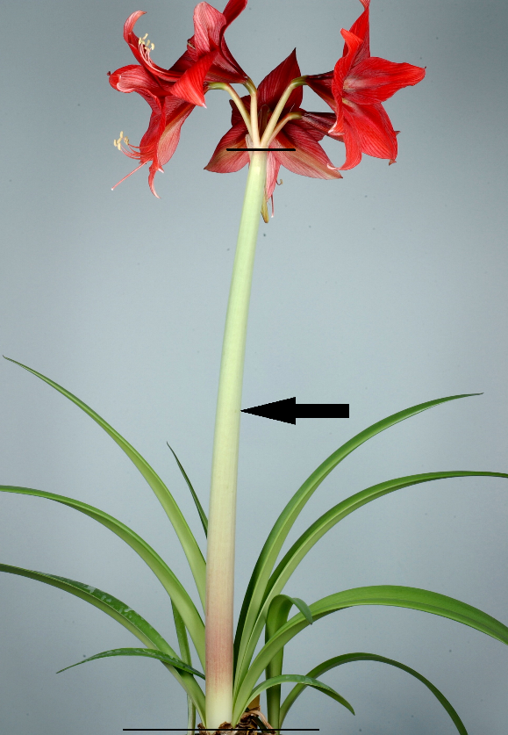
Ad. 8 | to delete illustration
Ad. 12 | to add “Observations should be made excluding the pedicel”
Ad. 17 | to replace current illustration with the following one:  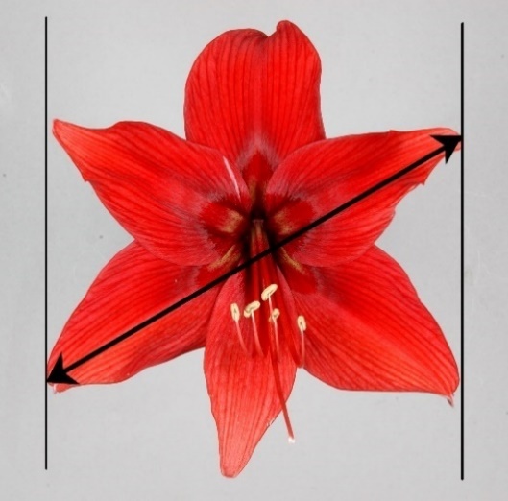
Ads. 24, 31 | to use the following illustrations with increased size and resolution:

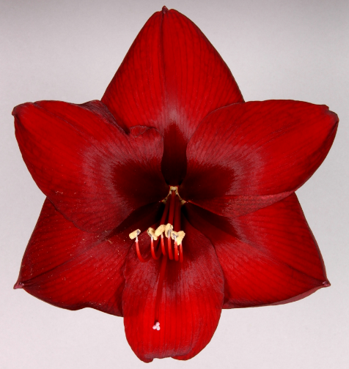 | 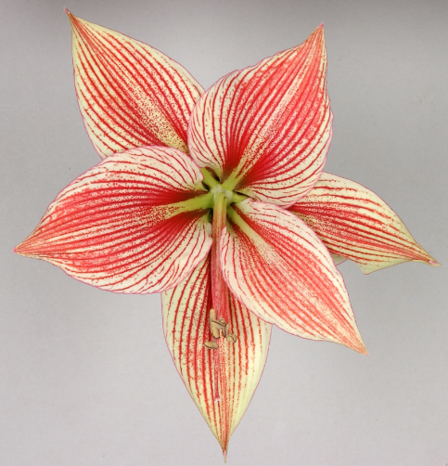 | 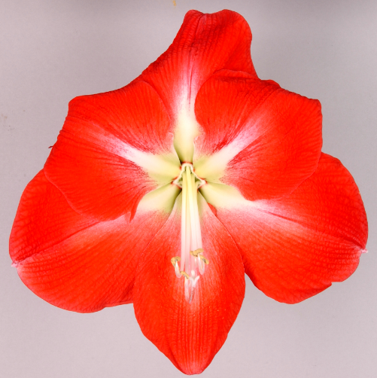
1 | 2 | 3
none | veined | central stripe

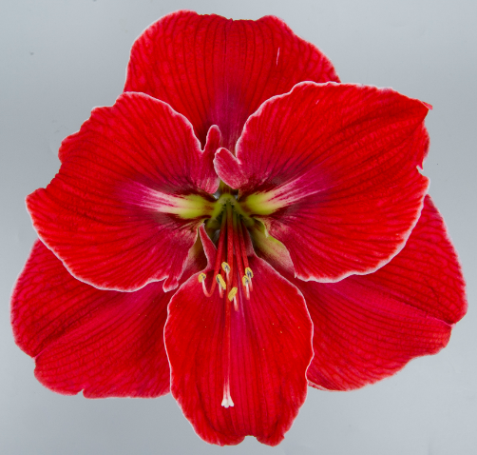 | 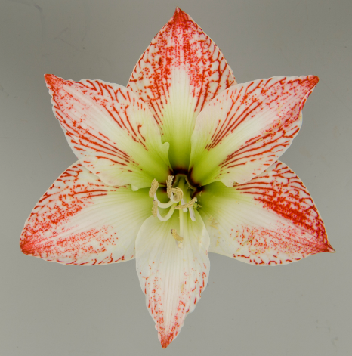
4 | 5
narrow marginate | striped and speckled

Ad. 37 | to read “Observations should be made just before dehiscence.”
Ad. 39 | - to read “Observations should be made on mature flowers.”  - to only have the following illustration  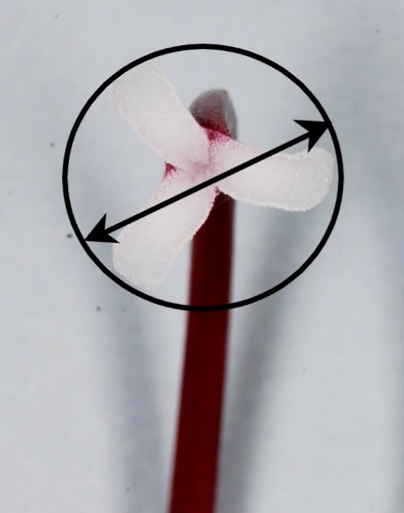
TQ 1. | to add 1.3 for indication of species

Ginkgo (Ginkgo biloba L.)

The subgroup discussed document TG/GINKG_BIL(proj.1), presented by Mr. Yongqi Zheng (China), and agreed the following:

3.1.2 | to be deleted
Char. 1 | to check whether to delete and move request on information on dwarf type in TQ 7.3
Char. 4 | to check whether to add new state 1 “fastigiate” (see name of example variety for state 1)
Char., Ad. 5 | to be deleted
Chars. 6, 9, 10 | to increase number of notes (5 or 9)
Chars. 11, 12 | to invert order (move char. 12 before char. 11)
Char. 13 | - to check whether different intensities are needed (medium and dark green)  - to check whether to add “white” or “whitish”
Char. 14 | to check whether to add “yellow green”
Char. 16 | to add illustrations to show differences between states
Char. 23 | - to read “Nut: width”  - state 1 to read “narrow”  - state 3 to read “broad”
Char. 24 | - to read “Nut: thickness”  - to have states (1) thin, (2) medium, (3) thick
Char. 25 | state “present” to have note 9
Char. 30 | state 3 to read “upper to middle”
Ad. 12 | to read “Observations should be made on young leaves in spring on the color with the largest surface area.”
Ad. 19 | to improve illustration for state 2
Ad. 22 | - B to read “Nut: width”  - C to read “Nut: thickness”
Ad. 23 | - to read “See Ad. 22”  - to add “Observations should be made on the broadest part”
Ad. 24 | to read “See Ad. 22”
TQ 4.2 | to be completed (grafting)
TQ 7.3 | - to check whether to add request on whether the variety is a dwarf variety (see comment on char. 1)  - to add request for plant sex

Leucanthemum Mill.

The subgroup discussed document TG/LEUCA(proj.1), presented by Ms. Hilary Papworth (United Kingdom), and agreed the following:

Cover page | to add “Marguerite” as French alternative name
2.2 | to read “The material is to be supplied in the form of vegetatively propagated young plants.”
Char. 2 | to check whether to read “Plant: floriferousness”
New char after char. 2 | - to read “Stem: pubescence”  - to be indicated as QN and VG  - to have states from (1) absent or very sparse to (5) very dense  - to add illustrations
Chars. 3, 4, 5 | to check whether to reduce scale to 5 notes
Char. 8 | to correct spelling of “indentations”
Char. 9 | to add MS
Char. 18 | to read “Flower head: attitude of ray florets at base”
Char. 19 | - to check whether to add different types of ray floret and/ “Corolla tube: length”  - to check whether toad chars to describe predominant and secondary types of ray florets (see e.g. TG Gerbera)
Char. 25 | - to check whether state 1 to read “incurving” or “incurved”  - to check whether state 3 to read “recurving” or “recurved”
Char. 26 | to check whether some ray floret types should be excluded from the observation
Char. 28 | to check whether the proposed approach also works for divided types of ray florets (to add exclusions from observation?)
Char. 31 | - state 1 to read “absent or few”  - state 3 to read “many”
Ad. 12 | to add explanation on anemone (e.g. petaloid disc florets)
Ad. 26 | to add “Observations should be made on the longitudinal axis of the ray floret.”
TQ 1. | to add 1.3 for indication of species

*Lavender (Lavandula L.) (Revision)

The subgroup discussed document TG/194/2(proj.3), presented by Ms. Laetitia Denecheau (European Union), and agreed the following:

4.1.4 | to delete “self-pollinated” from the second paragraph
5.3 (c) | to be deleted
Char. 3 | - to read “Plant: height” with states from (1) very short to (9) very tall  - to delete (*)
New char. after char. 3 | - to read “Plant: height in relation to width”  - to be indicated as QN and VG  - to add (*) and add to 5.3 as grouping characteristic  - to have the following states and example varieties:  (1) much taller than broad, “LAVVAL (1), 3049EVERG (9)”  (2) slightly taller than broad, “KLELV15115 (9), Ostinato (1)”  (3) as tall as broad, “LAAZ0006 (1), Lavst103 (9)”  (4) slightly broader than tall, “Nana Alba (1), Purpleberry Ruffles (9)”  (5) much broader than tall, “DC000020LS (9), LAAZ0009 (1)”
Char. 16 | to reduce scale to 5 notes by deleting intermediate states
Char. 18 | to reduce scale to 5 notes by deleting intermediate states
Char. 20 | to read “Only varieties with Plant: type: without infertile bracts”
Char. 25 | to add illustrations  1 very low 5 medium 9 very high
Char. 26 | - state 5 “fusiform” to have example variety “TV 38 (9)”  - state 6 to read “narrow rhomboid” and have example variety “Meerlo (1)”
Char. 30 | to correct spelling of example variety “Silver Ghost” in state 1
Ads. 1, 11, 12, 17, 20, 22, 29, 31 | to add “Courtesy of Georita Harriott, Royal Botanic Garden, Kew.”
Ad. 12 | to replace current illustration with the one below:  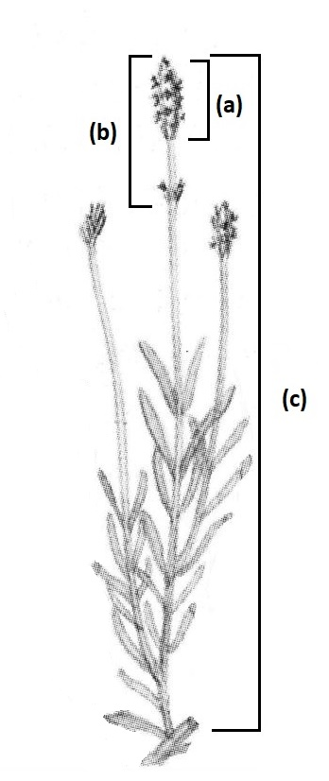
Ad. 19 | to replace current illustration with the following one:  Only varieties with Plant type: without infertile bracts Only varieties with Plant type: with infertile bracts
Ad. 21 | to delete “(b)”
Ad. 22 | to delete “See letter (a).”
Ad. 23 | to delete “(a)”
Ad. 26 | to have the following illustrations:
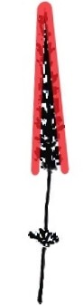 | 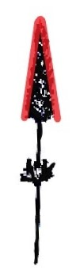 |  |  | 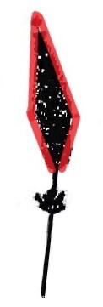 | 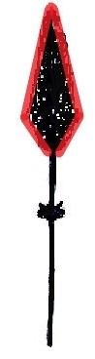
1  narrow conic | 2  medium conic | 3  truncate conic | 4  cylindric | 5  fusiform | 6  narrow rhomboid

Ad. 32 | to replace current illustrations with the following ones:
1  short | 2  medium | 3  long

Ad. 34 | to delete “(b)”
Ad. 35 | to delete “(c)”
TQ 4.2.1 | to read “Seeds” and become 4.2.2
TQ 4.2.2 | to become 4.2.1
TQ 5.3 | to be replaced with new characteristic “Plant: height in relation to width”

Lotus (Nelumbo Adans.)

The subgroup discussed document TG/NELUM(proj.1) Rev., presented Mr. Daike Tian (China), and agreed the following:

Cover page, 1. | - to delete “…including Nelumbo nucifera Gaertn., Nelumbo lutea Willd. and the hybrids of them”  - to check scope of the TG; whole genus or individual species?
2.3 | - the minimum quantity of plant material, to be supplied by the applicant, to read:  “Sufficient rhizome propagules to produce 10 plants or  sufficient seeds to produce 10 plants”  - last paragraph to be deleted
3.1.1 | to check whether to be observed in two growing cycles, depending on the type of propagating material
3.4.4 | to be deleted
4.1.1 | last sentence to be deleted
4.2.2 | to check types of propagation covered in the TG
4.2.5 | to be deleted
4.2.6 | - to check the uniformity levels according to the practice in the leading expert’s condition  - to check whether acceptance probability to be indicates as “at least 95%”
Table of Chars. | - to rename characteristics according to TGP/7, Guidance Note 18 (e.g. “Young root: color”, “Flower bud: shape”, etc.)  - to replace “Nelumbo lutea” with “Yellow Bird”
Char. 2 | - to read “Young floating leaf: color”  - to combine states 3 and 4 to read “green and red”
Char. 3 | - to check whether to read “Plant: foliage height”  - to check whether to use a larger scale of notes (more than 5 notes)
Char. 4 | - to check whether to use scale with more notes  - state “medium” should be in the center of the scale (combine states 1 and 2 to read “absent or very few”?)
Char. 5 | - to read “Excluding varieties with emerging leaves: …”  - to check whether to replace “emerging leaf” with “standing leaf” (throughout the TG)
Char. 7 | to read “Emerging leaf: main color of leaf blade”
Char. 19 | to delete (*)
Char. 21 | to check whether to add “Excluding varieties without flower” to the characteristic name
Char. 23 | to read “Flower: diameter”
Char. 24 | to check whether to clarify characteristic/flower types
Char. 26 | - to read “Flower: main color”  - to check approaches to describing colors (see TGP/14)
Char. 32 | - to read “Tepal: distribution of main color on largest tepal”  - to add explanation on assessment of the characteristic
Ad. 2 | to delete wording
Ad. 3 | to read “To be measured right after flowering peak.”
Ad. 4 | to delete wording
Ad. 22 | to delete last sentence of first paragraph

Magnolia (Magnolia L.)

The subgroup discussed document TG/MAGNO(proj.4), presented by Ms. Yaling Wang (China), and agreed the following:

6.4, Table of Chars. | - to delete example varieties “Kenneth’s Delight”, “Lvyi Zijuan” and “Danyu” from the table in Chapter 6.4 and throughout the Table of characteristics  - to check whether to replace the deleted example varieties with different ones
Table of Chars. | general: to check order of characteristics and follow botanical or chronological order of characteristics (see TGP/7, GN 26)
Char. 6 | - to check whether be moved after characteristic 58  - to check whether to read “Fruit: number of fruits in relation to flowers” or “Plant: number of fruits in relation to flowers”
Char. 10 | - to read “Young leaf blade: anthocyanin coloration of upper side”  - to be indicated as QN, VG and (b)  - to have states (1) absent or very weak, (2) weak, (3) medium, (4) strong, (5) very strong
Char. 23 | to delete (c)
Char. 36 | have states (1) very narrow, (2) narrow, (3) medium, (4) broad, (5) very broad
Char. 41 | - state 8 to read “basal and central”  - state 9 to read “only central”  - state 10 to read “basal transverse”  - to add new state 11 to read “on margin only”  - to add new state 12 to read “throughout”
Char. 42 | - state 3 to read “flush and stripes”  - state 4 to read “stripes only”
Char. 55 | state 2 to read “before and at same time”
8.1 (b) | to read “Observations should be made on new leaves at the end of a shoot in the upper half of the plant.”
8.1 (e) | to read “Sepaloid tepals are the first whorl tepals whose shape or texture are obviously different with those petaloid tepals.  If no sepaloid tepals, first whorl of tepals are the first whorl petaloid tepals.”
Ad. 5 | to add illustrations
Ad. 16 | - to read as follows:  very low: <1.0  low: ≥1.0 to <1.5  medium: ≥ 1.5 to <2.0  high: ≥ 2.0 to <2.5  very high: ≥ 2.5  - to add illustrations (one for high and one for low ratio)
Ad. 23 | to read “Observations should be made shortly before leaf drop.”
Ad. 24 | sentence below illustration to replace with “Observations should be made before the bud has opened.”
Ad. 28 | to replace photos with drawings
Ad. 31 | to read as follows:  very few: up to six 6  few: from 7 to 10  medium: from 11 to 14  many: from 15 to 18  very many: more than 18
Ad. 36 | to read “Observation should be made at the broadest part of the tepal.”
Ad. 41 | to be updated
Ad. 42 | to replace with improved illustrations
Ad. 55 | - to read “The time of young leaves sprouting out can be after, or at the same time, or before the flower buds unfolding.  The time of beginning of flowering is reached when more than 10% flower buds bloom on all plants.  Vegetative growth is reached when…”  - to add that state 2 means flowering begins before vegetative growth and may continue after vegetative growth has begun
TQ 1. | to add 1.3 for indication of species
TQ 4.2.1 (c) | to add “Please specify rootstock:”
TQ 5.9, 5.10 | to add color groups
TQ 5.13 | to add RHS Colour Chart (see TQ 5.9)

*Oxypetalum (Oxypetalum coeruleum (D. Don) Decne.)

The subgroup discussed document TG/OXYPE_CAE(proj.2), presented by Mr. Naoki Eguchi (Japan), and agreed the following:

5.3 | to add char. 28 as grouping characteristic
Char. 7 | to be moved after char. 8
Char. 13 | to be deleted
Char. 22 | to have the following order of states: (1) lanceolate, (2) broad elliptic, (3) medium elliptic, (4) narrow elliptic, (5) spatulate and adjust notes of states in Ad. 22
Char. 28 | to add (*)
Ad. 12 | to replace current explanation with the new one below:  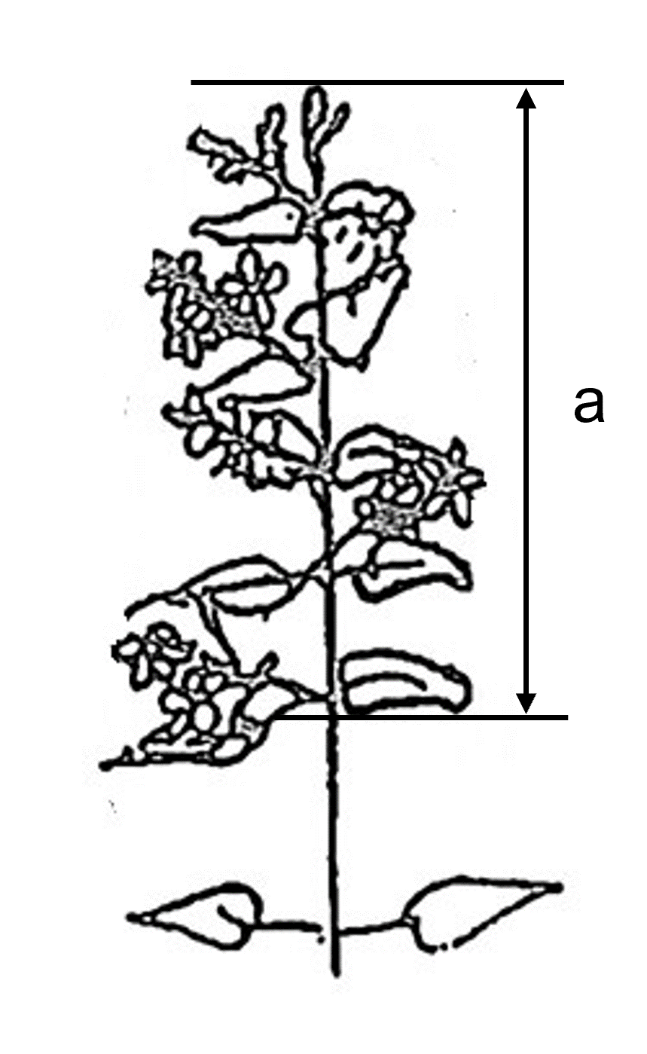
TQ 5. | to add char. 28
TQ 5.10 | to add the same color groups as in TQ 5.9

Poinsettia (Euphorbia pulcherrima Willd. ex Klotzsch) (Revision)

The subgroup discussed document TG/24/7(proj.2), presented by Ms. Laetitia Denecheau (European Union), and agreed the following:

Coverage | to add UPOV code EUPHO_PCO for hybrids with Euphorbia cornastra (Dressler) Radcl.-Sm.
2.3 | minimum quantity of plant material, to be supplied by the applicant, to read “10 rooted cuttings”
General | - to add example varieties  - to add illustrations from current adopted TG, where appropriate
Chars. 5, 6 | to reduce scale to 5 notes
Char. 14 | to check whether “greyish green” is in the correct position (see order of colors in TGP/14) or whether there is a specific reason to have colors in the current order
Char. 20 | to add illustration
Char. 22 | to correct spelling of “dark” in state 4
Char. 27 | - to read “Transitional leaves: number of lobes”  - to have states (1) none or few, (2) medium, (3) many
Char. 30 | to reduce scale to 5 notes
Chars. 33, 34, 38, 41, 42, 45 | to add (b) (color definition)
Char. 35 | - to check whether to move before char. 34 or whether to delete state “none”  - state 2 to read “at center”  - state 3 to read “at veins”  - state 4 to read “at margin”
Char. 36 | to add illustration
Chars. 39, 43 | to have same order and wording of states as in char. 35
Char. 49 | to add illustration
Chars. 50, 51, 52 | to reduce scale to 5 notes
Char. 55 | - to reduce scale to 5 notes  - to check whether it also applies to distribution or extent of red coloration
Char. 56 | to check whether to reduce scale to 5 notes
8.1 | - to add illustration showing all relevant plant parts/organs  - to add new explanation to read “Transitional leaves are leaves with partly bract-colored or fully bract colored leaf blades.”; to become (b) and added to chars. 25 to 27
8.1 (b) | to become (c) and wording to be reviewed
Ad. 31 | to be deleted
Ad. 55 | to delete if only applying to color intensity; to keep if distribution or extent of red coloration is observed
8.3 | to become Ad. 56 and to read “Observations should be made the time of opening of three cyathia on the plants.”
TQ 5.2 (ii), | to remove indication of groups “Gr. …:”
TQ 5.3 (ii) | - to remove indication of groups “Gr. …:”  - to add “none”

*Weigela (Weigela Thunb.) (Revision)

The subgroup discussed document TG/148/3(proj.3), presented by Ms. Stéphanie Christien (France), and agreed the following:

Char. 1 | to replace example variety “Wagneri” with “Gloire des Bosquets”
Char. 2 | to replace example variety “Styriaca” with “Ballet”
Char. 5 | to replace example variety “Candida” with “Descartes”
Char. 6 | to replace example variety “Maximowiczii” with “Eva Rathke, Marjorie”
Char. 7 | to replace example variety “Styriaca” with “Abel Carrière”
Char. 8 | to replace “Wagneri” with “Abel Carrière”
Char. 10 | to replace example variety “Styriaca” with “Abel Carrière, Marjorie”
Char. 11 | to have a capital F for Fire
Char. 15 | to replace example variety “Styriaca” with “Marjorie”
Char. 16 | - to replace example variety “Golden candy” with “Bokrarob”  - to replace example variety “Styriaca” with “Abel Carrière”
Char. 20 | to have the following states of expression: (1) none, (2) white, (3) yellowish white, (4) yellow, (5) light green, (6) medium green, (7) greyish green
Char. 22 | to have the following states and example varieties:  (1) green, “Courtalor”  (2) green and red, “Olympiade”  (3) red, “Bokrasopin, Verweig 4”  (4) purple, “ Alexandra”
Char. 26 | to replace example variety “Candida” with “Victoria”
Char. 28 | to delete "presence of" from the name of the characteristic
Char., Ad. 34 | to be deleted
Char. 41 | example variety “Gloire des bosquets” to have a capital B for “Bosquets”
Char. 43 | to replace example variety “Styriaca” with “Brigela, Rubidor”
8.1 (d) | to read “The main color is the color with the largest surface area. The secondary color is the color with the second largest surface area. In cases where the areas of the main and secondary color are too similar to reliably decide which color has the largest area, the darker color is considered to be the main color. The tertiary color is the color with the third largest surface area. In cases where the areas of the secondary and tertiary color are too similar to reliably decide which color has the second largest area, the darker color is considered to be the secondary color.”
8.1 (f) | to be deleted
8.1 (j) | “… which has the second highest frequency, the flower …”
9. | - second reference: to read to read “Krüssmann”  - to add “Hoffman M., 2007: Weigela. DENDROFLORA, Nr. 44, pp 87 - 127, Boskoop-NL  Available online: https://edepot.wur.nl/148427”
TQ 1. | to add 1.3 for indication of species

Partial revision

Oncidium (Oncidium Sw.; ×Oncidesa Hort.; ×Ionocidium Hort.; ×Zelenkocidium J.M.H.Shaw.)

The subgroup discussed document TWO/55/8, presented by Ms. Katie Berbee (Netherlands), and agreed the following:

Char., Ad. 27 | to have the following order of states: (1) ovate, (2) lanceolate, (3) elliptic, (4) narrow elliptic, (5) linear, (6) obovate
Char., Ad. 46 | to have the following order of states: (1) ovate, (2) lanceolate, (3) elliptic, (4) broad obovate, (5) medium obovate, (6) curving obovate
Char., Ad. 66 | to have the following order of states: (1) ovate, (2) elliptic, (3) linear, (4) broad obovate, (5) oblanceolate

Recommendations on draft Test Guidelines

(a) Test Guidelines to be put forward for adoption by the Technical Committee

The TWO agreed that the following draft Test Guidelines should be submitted to the TC for adoption at its fifty-ninth session, to be held in Geneva on October 23 and 24, 2023, on the basis of the following documents and the comments in this report:

Full draft Test Guidelines

Subject | Basic document(s) (2023)
*Amaryllis (Hippeastrum Herb.) (Revision) | TG/181/4(proj.3)
*Lavender (Lavandula L.) (Revision) | TG/194/2(proj.3)
*Oxypetalum coeruleum (D. Don) Decne. | TG/OXYPE_CAE(proj.2)
*Weigela (Weigela Thunb.) (Revision) | TG/148/3(proj.3)

Partial revision

Subject | Basic document(s) (2023)
Oncidium (Oncidium Sw.; ×Oncidesa Hort.; ×Ionocidium Hort.; ×Zelenkocidium J.M.H.Shaw.)  (example varieties, Chars./Ads. 27, 30, 46, 50, 66, 70, 87) | TG/283/1 Rev., TWO/55/8

(b) Test Guidelines to be discussed at the fifty-sixth session

The TWO agreed to discuss the following draft Test Guidelines at its fifty-sixth session:

Full draft Test Guidelines

Subject | Basic document(s) (2023)
Ginkgo (Ginkgo biloba L.) | TG/GINKG_BIL  (proj.1)
*Leucanthemum Mill. | TG/LEUCA(proj.1)
Lotus (Nelumbo Adans.) | TG/NELUM(proj.1) Rev.
*Magnolia (Magnolia L.) | TG/MAGNO(proj.4)
*Poinsettia (Euphorbia pulcherrima Willd. ex Klotzsch) (Revision) | TG/24/7(proj.2)
Pot Azalea (Rhododendron simsii Planch.) and Rhododendron (Rhododendron L.) (Revision to combine TGs) | TG/42/6 and TG/140/4 Corr.
Zantedeschia | TG/25/9

Partial revision

Subject | Basic document(s) (2023)
Aloe (Aloe L.)  - remove (*) from all flowering characteristics (and possible consequential changes to grouping characteristics and TQ) | TG/310/1
Carnation (Dianthus L.)  - addition of new characteristics for description of Dianthus barbatus types | TG/25/9

The leading experts, interested experts and timetables for the development of the Test Guidelines are set out in Annex II to this report.

(c) Possible Test Guidelines to be discussed in 2025

The TWO agreed that it should consider the development of Test Guidelines for the following at a future session:

Subject | Basic document(s) (2023)
Eucalyptus (Eucalyptus L’Hér.) (Partial revision) | TG/296/1 (QZ)
Helleborus (Helleborus L.) | New (NL)
Tuberous Begonia Hybrids (Begonia ×tuberhybrida Voss) (Revision) | TG/107/3

(d) Participation in discussions of Test Guidelines from other TWPs

The TWO agreed to propose that the following experts be added as interested experts to the following draft Test Guidelines being discussed by the Technical Working Party for Fruit Crops (TWF), subject to the deadlines agreed in document TWF/53/14 “Report”, Annex II:
Subject | Interested experts (countries/organizations)
Hazelnut (Corylus avellana L.; Corylus colurna L.) (Revision) | CA, HU
*Mulberry (Morus L.) | HU

Matters for information

The TWO noted that the following documents contained matters for information only:

- Short reports on developments in plant variety protection
    - Reports from members and observers (document TWO/55/3)
    - Reports on developments within UPOV (document TWO/55/2)
- Development of guidance and information materials: matters for information (document TWP/7/2)
- Cooperation in examination (document TWP/7/1)
- Information and databases
    - UPOV information databases (document TWP/7/7)
    - Variety description databases (document TWP/7/6)
    - Exchange and use of software and equipment (document TWP/7/5)
    - UPOV PRISMA (document TWP/7/1)
- Variety denominations: Matters for information (document TWP/7/8)
- Molecular Techniques: Mattes for information (document TWP/7/3)
- Revision of Test Guidelines (document TWP/7/9)
- Guidance for drafters of Test Guidelines (document TWP/7/1)

Chairperson

The TWO thanked Ms. Ashley Balchin for chairing the TWO and noted that she was awarded a UPOV bronze medal in recognition of chairing the TWO from 2021 to 2023.

Date and place of the next session

The TWO noted that no invitations for the venue of its fifty-sixth session had been received. The TWO noted that a decision on the date and place of its next session would be taken by the Council, at its fifty-seventh session, to be held on October 27, 2023.

The TWO agreed that its fifty-sixth session should be held via electronic means, from April 29 to May 3, 2024, if no alternative offer was received from a member of the Union.

Future program

The TWO agreed that documents would be prepared in case of developments to be reported or presentations from members and observers on agenda items proposed for the session.

The TWO agreed that documents for its fifty-sixth session should be submitted to the Office of the Union by March 18, 2024. The TWO noted that items would be deleted from the agenda if the planned documents have not reached the Office of the Union by the agreed deadline.

The TWO agreed to discuss the following items at its next session:

- Opening of the Session
- Adoption of the agenda
Matters for discussion
- Procedures for DUS examination (presentations invited)
- Variety collections (presentations invited)
- Image analysis and new technologies in DUS examination (presentations invited)
- Molecular techniques in DUS examination (presentations invited)
- Reports on existing policies on confidentiality of molecular information (presentations invited)
- Ornamental varieties of agricultural, fruit or vegetable crops (presentations invited)
- Information required to enhance the use of existing DUS test reports (presentations invited)
- Situations where illustrations could complement or replace example varieties (document to be prepared by Germany in collaboration with Canada, Netherlands and United Kingdom)
- Information databases (presentations invited)
- Experiences with new types and species (oral reports invited)
- Discussion on draft Test Guidelines (Subgroups)
- Recommendations on draft Test Guidelines
- Date and place of the next session
- Future program
- Adoption of the Report on the session (if time permits)
Matters for information
- Reports from members and observers (written reports to be prepared by members and observers)
- Report on developments within UPOV (general developments, including variety denominations, information databases, exchange and use of software and equipment)
- Closing of the session

The TWO adopted this report at the close of its session.

[Annex I follows]

LIST OF PARTICIPANTS
I. mEMBERS
Argentina
María Lilia LOSADA (Sra.), Profesional Técnica, Dirección de Registro de Variedades, Instituto Nacional de Semillas (INASE), Secretaría de Agricultura, Ganadería, Pesca y Alimentación, Buenos Aires
(e-mail: mlosada@inase.gob.ar)
AUSTRALIA
Li WANG (Ms.), PBR Examiner, Plant Breeder's Rights Office, IP Australia, Woden
(e-mail: li.wang@ipaustralia.gov.au)
Brazil
Luiz Claudio AUGUSTO DE OLIVEIRA (Mr.), Federal Agricultural Inspector, Plant Variety Protection Office, National Plant Variety Protection Service (SNPC), Ministry of Agriculture and Livestock, Brasilia D.F.
(e-mail: luiz.oliveira@agro.gov.br)
Bulgaria
Diliyan Rousev DIMITROV (Mr.), Head of Variety Testing Department, Executive Agency for Variety Testing, Field Inspection and Seed Control (IASAS), Sofia
(e-mail: ddimitrov@iasas.government.bg)
CANADA
Ashley BALCHIN (Ms.), Examiner, Plant Breeders' Rights Office, Canadian Food Inspection Agency (CFIA), Ottawa
(e-mail: ashley.balchin@inspection.gc.ca)
Jennifer ROACH (Ms.), Examiner, Plant Breeders' Rights Office, Canadian Food Inspection Agency (CFIA), Ottawa
(e-mail: jennifer.roach@inspection.gc.ca)
Chanel HENRI (Ms.), PBR Junior Assistant, Plant Breeders' Rights Office, Canadian Food Inspection Agency (CFIA), Ottawa
(e-mail: chanel.henri@inspection.gc.ca)
CHINA
Kun YANG (Mr.), Deputy Director, Associate Researcher, Beijing Sub-Center of New Plant Variety Tests, Ministry of Agriculture and Rural Affairs, China, affiliated to Institute of Vegetables and Flowers under Chinese Academy of Agricultural Sciences, Beijing
(e-mail: yangkun@caas.cn)
Yongqi ZHENG (Mr.), Director, Laboratory of Molecular Identification of Plant Varieties, Office of Protection of New Varieties of Plants, National Forestry and Grassland Administration of China (NFGA), Beijing
(e-mail: zyq8565@126.com)
Cuirong ZHAO (Ms.), Director, Xiangyang DUS Test Center, Xiangyang
(e-mail: nkyzhaocr.2007@163.com)
Shenzao FU (Mr.), Leader of DUS Section, Research Assistant, Chinese Academy of Agricultural Sciences, Beijing Sub-Center of New Plant Variety Tests, affiliated to Institute of Vegetables and Flowers under Chinese Academy of Agricultural Sciences, Beijing
(e-mail: fushenzao@caas.cn)
Daike TIAN (Mr.), Professor, International Nelumbo Registrar, Shanghai
(e-mail: dktian@cemps.ac.cn)
Yaling WANG (Ms.), Professor, Xi’an Botanical Garden, Xi’an
(e-mail: wangyl100@aliyun.com)
Shan DENG (Ms.), Agronomist, Shanghai Sub-center for New Plant Variety Tests, Shanghai
(e-mail: dengshan85@163.com)
Yunxia CHU (Ms.), Researcher, Shanghai Sub-center for New Plant Variety Tests, Ministry of Agriculture and Rural Affairs (MARA), Shanghai
(e-mail: chuyx@189.cn)
Chuanhong ZHANG (Ms.), Associate Research Professor, Research Institute of Forestry, Chinese Academy of Forestry, Beijing
(e-mail: zhangch@caf.ac.cn)
Xuedan YU (Ms.), Assistant Researcher, Research Institute of Forestry, Chinese Academy of Forestry Sciences, Beijing
(e-mail: Yuxd@caf.ac.cn)
Hui LI (Ms.), Research assistant, Institute of Botany, Chinese Academy of Sciences, Beijing
(e-mail: lihui@ibcas.ac.cn)
Yang LU (Mr.), Research Assistant, Xiangyang Sub-center for New Plant Variety Tests, Xiangyang
(e-mail: rabbit.5212@163.com)
Chenyu WANG (Ms.), Examiner, Division of DUS Tests, Development Center of Science and Technology (DCST), Ministry of Agriculture and Rural Affairs (MARA), Beijing
(e-mail: 879655472@qq.com)
Qin ZHAO (Ms.), intern-researcher, DUS Test (Kunming) Center for New Varieties of Plants, Kunming
(e-mail: zhaoqin@yaas.org.cn)
Qilong LIU (Mr.), Leader of DUS Section, Yueyang Sub-Center for New Plant Variety Tests, Yueyang
(e-mail: 309364275@qq.com)
Xinhe XIA (Mr.), PhD candidate, Chinese Academy of Forestry, Beijing
(e-mail: xinhex355@163.com)
Shengyuan ZHONG (Mr.), Fuzhou Sub-center for New Plant Variety Tests, Fuzhou
(e-mail: 294034396@qq.com)
Limin SUN (Mr.), Forestry College of Shandong Agricultural University, Tai'an
(e-mail: sunlimin06@163.com)
Xianfeng GUO (Ms.), Forestry College of Shandong Agricultural University, Tai'an
(e-mail: guoxf@sdau.edu.cn)
CZECH REPUBLIC
Jiřina HRABÁLKOVÁ (Ms.), EU Specialist, Variety Denomination Expert, Central Institute for Supervising and Testing in Agriculture (UKZUZ), Brno
(e-mail: jirina.hrabalkova@ukzuz.cz)
Egypt
Shymaa Zoheir ABOSHOSHA (Ms.), Agronomist, Plant Variety Protection Office (PVPO), Central Administration for Seed Testing and Certification (CASC), Giza
(e-mail: sh_z9@hotmail.com)
EUROPEAN UNION
Jean MAISON (Mr.), Deputy Head, Technical Unit, Community Plant Variety Office (CPVO), Angers
(e-mail: maison@cpvo.europa.eu)
Laetitia DENECHEAU (Ms.), Technical Expert for Ornamental Plants, Community Plant Variety Office (CPVO), Angers
(e-mail: denecheau@cpvo.europa.eu)
Jens WEGNER (Mr.), Technical Expert for Ornamental Plants and Fruit Crops, Community Plant Variety Office (CPVO), Angers
(e-mail: wegner@cpvo.europa.eu)
Urszula BRAUN-MLODECKA (Ms.), Technical Expert for Ornamental Plants and Fruit Crops, Community Plant Variety Office (CPVO), Angers
(e-mail: braun@cpvo.europa.eu)
FRANCE
Stéphanie CHRISTIEN (Ms.), Ornamental DUS Manager, Groupe d'étude et de contrôle des variétés et des semences (GEVES), Brion, Les Bois d'Anjou
(e-mail: stephanie.christien@geves.fr)
Florent RENAUD (Mr.), Technicien, SEV Cavaillon, Groupe d'étude et de contrôle des variétés et des semences (GEVES), Le Thor
(e-mail: florent.renaud@geves.fr)
GERMANY
Swenja TAMS (Ms), Head of Section, General affairs of DUS testing, Bundessortenamt, Hanover
(e-mail: Swenja.Tams@bundessortenamt.de)
Daniela CHRIST (Ms.), Head of section, DUS Testing of Woody Ornamentals, Bundessortenamt, Hanover
(e-mail: daniela.christ@bundessortenamt.de)
Renate SOBEK (Ms.), Expert, Section DUS Testing Ornamentals, Bundessortenamt, Hanover
(e-mail: Renate.Sobek@bundessortenamt.de)
HUNGARY
Szilvia MÁRKNÉ DEÁK (Ms.), DUS Expert, Variety Testing Department for Horticultural Crops, Agricultural Genetic Resources Directorate, National Food Chain Safety Office (NÉBIH), Budapest
(e-mail: DeakSz@nebih.gov.hu)
Sarolta CZOTTER (Ms.), Deputy DUS Expert, National Food Chain Safety Office (NÉBIH), Budapest
(e-mail: czotters@nebih.gov.hu)
JAPAN
Ichiro KASAJIMA (Mr.), Senior Investigator, Nishi-Nihon Station, Center for Seeds and Seedlings (NCSS), National Agriculture and Food Research (NARO), Okayama
(e-mail: kasajimai741@affrc.go.jp)
Miwa TAKAHASHI (Ms.), Investigator, Nishi-Nihon Station, Center for Seeds and Seedlings (NCSS), National Agriculture and Food Research (NARO), Okayama
(e-mail: takahashim810@affrc.go.jp)
Naoki EGUCHI (Mr.), Senior investigator, Unzen Station, Center for Seeds and Seedlings (NCSS), National Agriculture and Food Research (NARO), Nagasaki
(e-mail: eguchin150@affrc.go.jp)
Yoshiyuki OHNO (Mr.), Examiner, Plant Variety Protection Office, Intellectual Property Division, Export and International Affairs Bureau, Ministry of Agriculture, Forestry and Fisheries (MAFF), Tokyo
(e-mail: yoshiyuki_ono300@maff.go.jp)
Koji NAKANISHI (Mr.), Assistant Examiner, Plant Variety Protection Office, Intellectual Property Division, Export and International Affairs Bureau, Ministry of Agriculture, Forestry and Fisheries (MAFF), Tokyo
(e-mail: koji_nakanishi200@maff.go.jp)
Mariko ISHINO (Ms.), Assistant Examiner, Plant Variety Protection Office, Intellectual Property Division, Export and International Affairs Bureau, Ministry of Agriculture, Forestry and Fisheries (MAFF), Tokyo
(e-mail: mariko_ishino300@maff.go.jp)
Kenya
Lucas SUVA (Mr.), Principal Plant Examiner, Ministry of Agriculture, Kenya Plant Health Inspectorate Service (KEPHIS), Nairobi
(e-mail: lsuva@kephis.org)
Gentrix Nasimiyu JUMA (Ms.), Principal Plant Examiner, Kenya Plant Health Inspectorate Service (KEPHIS), Nairobi
(e-mail: gjuma@kephis.org)
Mexico
Víctor Manuel VÁSQUEZ NAVARRETE (Sr.), Director de área, Servicio Nacional de Inspección y Certificación de Semillas (SNICS), Secretaria de Agricultura y Desarrollo Rural (Agricultura), Ciudad de México
(e-mail: victor.vasquez@agricultura.gob.mx)
José Merced MEJIA MUÑOZ (Sr.), Director de Planeación Agrícola, Secretaría de Agricultura y Desarrollo Rural, Ciudad de México
(e-mail: jmerced58@hotmail.com)
Heriberto ORTEGA (Sr.), Jefe de departamento, Secretaría de Agricultura y Desarrollo Rural, Ciudad de México
(e-mail: heriberto.ortega@agricultura.gob.mx)
Amando ESPINOSA-FLORES (Sr.), Profesor Investigador, Departamento de Fitotecnia, Universidad Autónoma Chapingo, Chapingo
(e-mail: jmerced58@hotmail.com)
NETHERLANDS
Marco HOFFMAN (Mr.), Senior Policy Maker, Naktuinbouw, Roelofarendsveen
(e-mail: m.hoffman@naktuinbouw.nl)
Katie BERBEE (Ms.), DUS Expert, Naktuinbouw, Roelofarendsveen
(e-mail: k.berbee-pont@naktuinbouw.nl)
Jolanda VAN SCHIE (Ms.), DUS Expert, Naktuinbouw, Roelofarendsveen
(e-mail: j.v.schie@naktuinbouw.nl)
New Zealand
Christopher J. BARNABY (Mr.), PVR Manager / Assistant Commissioner, Plant Variety Rights Office, Intellectual Property Office of New Zealand, Ministry of Business, Innovation and Employment, Christchurch
(e-mail: Chris.Barnaby@pvr.govt.nz)
Cecilia REQUEJO-JACKMAN (Ms.), Senior Plant Variety Rights Examiner, Plant Variety Rights Office, Intellectual Property Office of New Zealand, Ministry of Business, Innovation and Employment, Wellington
(e-mail: Cecilia.R-Jackman@pvr.govt.nz)
POLAND
Marcin KRÓL (Mr.), Head of DUS Testing Department, Research Centre for Cultivar Testing (COBORU), Slupia Wielka
(e-mail: m.Krol@coboru.gov.pl)
Joanna GRUSZCZYŃSKA (Ms.), Head of DUS Testing and Variety Identity Verification Unit, DUS Testing Department, Research Centre for Cultivar Testing (COBORU), Slupia Wielka
(e-mail: j.gruszczynska@coboru.gov.pl)
REPUBLIC OF KOREA
Hyun-Joo SHIN (Ms.), Deputy Director, Dongbu (East) Branch Office, Korea Seed & Variety Service (KSVS), Gangwon-do
(e-mail: shjnew@korea.kr)
Tae Hoon KIM (Mr.), Senior Forest Researcher, Examiner, National Forest Seed Variety Center (NFSV), Chungcheongbuk-do
(e-mail: algae23@korea.kr)
Mu Seok HAN (Mr.), Researcher, National Forest Seed Variety Center (NFSV), Chungcheongbuk-do
(e-mail: mshan99@korea.kr)
Ro-Young LEE (Mr.), Researcher, National Forest Seed Variety Center (NFSV), Chungcheonbuk-do
(e-mail: rubus250@korea.kr)
Won-Bum CHO (Mr.), Forest Researcher, Plant Variety Protection Division, National Forest Seed Variety Center (NFSV), Chungcheongbuk-do
(e-mail: rudis99@korea.kr)
Hwan-Su HWANG (Mr.), Forest Researcher, Plant Variety Protection Division, National Forest Seed Variety Center, Korea Forest Service, Chungcheongbuk-do
(e-mail: hwansu3368@korea.kr)
Yongsu KIM (Mr.), DUS Expert, Korea Seed & Variety Service (KSVS), Gyeongsangnam-do
(e-mail: carota@korea.kr)
Lakjung CHOE (Mr.), DUS Examiner, Jeju Branch Office, Korea Seed & Variety Service (KSVS), Jeju
(e-mail: clj1216@korea.kr)
Eun-Jung HEO (Ms.), DUS Examiner, Seobu Branch, Korea Seed and Variety Service (KSVS), Iksan-Si
(e-mail: heoej@korea.kr)
Yuna AN (Ms.), DUS Examiner, Dongbu (East) Branch Office, Korea Seed & Variety Service (KSVS), Gangwon-do
(e-mail: yunaan@korea.kr)
Hyunwoo OH (Mr.), DUS Examiner, Jeju Branch Office, Korea Seed and Variety Service (KSVS), Gyeongsangnam-do
(e-mail: blackcow@korea.kr)
Romania
Cosmina Luminita STANCIU (Ms.), DUS Examiner for fruit trees, vines and ornamental plants, State Institute for Variety Testing and Registration (ISTIS), Bucarest
(e-mail: cosmina_stanciu@istis.ro)
Russian Federation
Tatiana FEDOSOVA (Ms.), Chief Agronomist, Department of Vegetable, Fruit and Berry Crops and Ornamental Plants, State Commission of the Russian Federation for Selection Achievements Test and Protection, Moscow
(e-mail: plod@gossortrf.ru)
South Africa
Lynette CROUKAMP (Ms.), Examiner, Division of Variety Control, Directorate: Genetic Resources, National Department of Agriculture, Land Reform & Rural Development, Pretoria
(e-mail: Lynettecroukamp@gmail.com)
Adriaan Jakobus DE VILLIERS (Mr.), Examiner, Division of Variety Control, Directorate: Genetic Resources, Department of Agriculture, Land Reform & Rural Development, Pretoria
(e-mail: riaandevill@gmail.com)
Mashudu Thomas MAFENYA (Mr.), DUS Examiner, Directorate: Genetic Resources, Variety Control, Department of Agriculture, Land reform and Rural Development, Gezina
(e-mail: MafenyaM@Dalrrd.gov.za)
United Kingdom
Hilary PAPWORTH (Ms.), Senior Technical Manager, NIAB, Cambridge
(e-mail: hilary.papworth@niab.com)
UNITED STATES OF AMERICA
David CHALKLEY (Mr.), Plant Variety Examiner, Plant Variety Protection Office, Washington D.C.
(e-mail: david.chalkley@usda.gov)
Viet Nam
Thi Thuy Hang TRAN (Ms.), Officer/Examiner, Department of Crop Production (DCP), Plant Variety Protection Office (PVPO), Ministry of Agriculture and Rural Development (MARD)
(e-mail: tranhang.mard.vn@gmail.com)
II. Observers
Guyana
David Bartholomew FREDERICKS (Mr.), Chief Scientist, National Agricultural Research and Extension Institute (NAREI), East Coast Demerara
(e-mail: dfredericsdks@narei.gov.gy)
Analesa SKEETE (Ms.), Research Scientist, National Agricultural Research and Extension Institute (NAREI), East Coast Demerara
(e-mail: analesa_skeete@yahoo.com)
Thailand
Orporn PHUEAKKHLAI (Ms.), Agricultural Research Officer, Practitioner Level, Plant Variety Protection Office, Department of Agriculture (DOA), Ministry of Agriculture and Cooperatives, Bangkok
(e-mail: orpornpvp@gmail.com)
III. ORGANIZATIONS
CROPLIFE INTERNATIONAL
Marcel BRUINS (Mr.), Consultant, CropLife International, Bruxelles, Belgium
(e-mail: marcel@bruinsseedconsultancy.com)
INTERNATIONAL COMMUNITY OF BREEDERS OF ASEXUALLY REPRODUCED ORNAMENTAL AND FRUIT PLANTS (CIOPORA)
Paulo PERALTA (Mr.), Technical Expert, International Community of Breeders of Asexually Reproduced Horticultural Plants (CIOPORA), Hamburg, Germany
(e-mail: paulo.peralta@ciopora.org)
Ingrid SLANGEN (Ms.), Board Member, International Community of Breeders of Asexually Reproduced Horticultural Plants (CIOPORA), Stuttgart, Germany
(e-mail:. i.slangen@selecta-one.com)
AFRICAN SEED TRADE ASSOCIATION
Justin J. RAKOTOARISAONA (Mr.), Secretary General, African Seed Trade Association (AFSTA), Nairobi, Kenya
(e-mail: justin@afsta.org)
IV. Officers
Ashley BALCHIN (Ms.), Examiner, Plant Breeders' Rights Office, Canadian Food Inspection Agency (CFIA), Ottawa
(e-mail: ashley.balchin@inspection.gc.ca)
V. OFFICE OF UPOV
Leontino TAVEIRA (Mr.), Head of Technical Affairs and Regional Development (Latin America, Caribbean)
Manabu SUZUKI (Mr.), Technical/Regional Officer (Asia)
Kees VAN ETTEKOVEN (Mr.), Technical Expert
Romy OERTEL (Ms.), Secretary II
Jessica MAY (Ms.), Secretary I

[Annex II follows]

LIST OF LEADING EXPERTS

DRAFT TEST GUIDELINES TO BE SUBMITTED
TO THE TECHNICAL COMMITTEE IN 2023

All requested information to be submitted to the Office of the Union
by July 28, 2023

Full draft Test Guidelines

Species | Basic Document(s) | Leading expert(s)
*Amaryllis (Hippeastrum Herb.) (Revision) | TG/181/4(proj.3) | Ms. Katie Berbee (NL)
*Lavender (Lavandula L.) (Revision) | TG/194/2(proj.3) | Ms. Laetitia Denecheau (QZ)
*Oxypetalum coeruleum (D. Don) Decne. | TG/OXYPE_CAE  (proj.2) | Mr. Naoki Eguchi (JP)
*Weigela (Weigela Thunb.) (Revision) | TG/148/3(proj.3) | Ms. Stéphanie Christien (FR)

Partial revision

Species | Basic Document(s) | Leading expert(s)
Oncidium (Oncidium Sw.; ×Oncidesa Hort.; ×Ionocidium Hort.; ×Zelenkocidium J.M.H.Shaw.)  (example varieties, Chars./Ads. 27, 30, 46, 50, 66, 70, 87) | TG/283/1 Rev., TWO/55/8 | Mr. Marco Hoffman (NL)

DRAFT TEST GUIDELINES TO BE DISCUSSED AT TWO/56
(* indicates possible final draft Test Guidelines)

(Guideline date for Subgroup draft to be submitted by Leading Expert: January 19, 2024
Guideline date for comments to Leading Expert by Subgroup: February 16, 2024)

New draft to be submitted to the Office of the Union

before March 15, 2024

Full draft Test Guidelines

Species | Basic Document(s) | Leading expert(s) | Interested experts (States/Organizations)
Ginkgo (Ginkgo biloba L.) | TG/GINKG_BIL  (proj.1) | Mr. Yongqi Zheng (CN) | HU, KR, QZ, NZ, CIOPORA, Office
*Leucanthemum Mill. | TG/LEUCA(proj.1) | Ms. Hilary Papworth (GB) | CA, FR, JP, MX, QZ, ZA, CIOPORA, Office
Lotus (Nelumbo Adans.) | TG/NELUM(proj.1) Rev. | Mr. Daike Tian (CN) | TWV, JP, CIOPORA, Office
*Magnolia (Magnolia L.) | TG/MAGNO(proj.4) | Ms. Yaling Wang (CN) | AU, CA, FR, GB, JP, KR, NZ, QZ, CIOPORA, Office
*Poinsettia (Euphorbia pulcherrima Willd. ex Klotzsch) (Revision) | TG/24/7(proj.2) | Ms. Laetitia Denecheau (QZ) | CA, CN, GB, JP, MX, PL, QZ, CIOPORA, Office
Pot Azalea (Rhododendron simsii Planch.) and Rhododendron (Rhododendron L.) (Revision to combine TGs) | TG/42/6 and TG/140/4 Corr. | Ms. Daniela Christ (DE) | CA, CN, GB, JP, QZ, ZA, CIOPORA, Office
Zantedeschia (Zantedeschia Spreng.) (Revision) | TG/25/9 | Ms. Katie Berbee (NL) | CN, JP, MX, QZ, ZA, CIOPORA, Office

Partial revision

Species | Basic Document(s) | Leading expert(s) | Interested experts (States/Organizations) ²
Aloe (Aloe L.)  - remove (*) from all flowering characteristics (and possible consequential changes to grouping characteristics and TQ) | TG/310/1 | Mr. Marco Hoffman (NL) | QZ, ZA, CIOPORA, Office
Carnation (Dianthus L.)  - addition of new characteristics for description of Dianthus barbatus types | TG/25/9 | Ms. Katie Berbee (NL) | CA, GB, JP, KE, MX, QZ, ZA, CIOPORA, Office

Draft Test Guidelines to possibly be discussed in 2025

Species | Basic  Document(s)
Eucalyptus (Eucalyptus L’Hér.) (Partial revision) | TG/296/1 (QZ)
Helleborus (Helleborus L.) | New (NL)
Tuberous Begonia Hybrids (Begonia ×tuberhybrida Voss) (Revision) | TG/107/3

[End of document]

for name of experts, see list of participants
for name of experts, see List of Participants.

