 |  | E
TG/194/2(proj.3)
ORIGINAL: English
DATE: 2023-04-27

INTERNATIONAL UNION FOR THE PROTECTION OF NEW VARIETIES OF PLANTS
 | Geneva
 | DRAFT
 | LAVANDULA/LAVENDER  UPOV Code(s): LAVAN  Lavandula L. | *
GUIDELINES
FOR THE CONDUCT OF TESTS
FOR DISTINCTNESS, UNIFORMITY AND STABILITY

prepared by experts from the European Union
to be considered by the
Technical Working Party for Ornamental Plants and Forest Trees

at its fifty-fifth session, to be held virtually
from 2023-06-12 to 2023-06-16

Disclaimer: this document does not represent UPOV policies or guidance
Alternative names:*

Botanical name | English | French | German | Spanish
Lavandula L. | Lavandula, Lavender | Lavande, Lavandin | Lavendel | Lavanda, Lavándula

The purpose of these guidelines (“Test Guidelines”) is to elaborate the principles contained in the General Introduction (document TG/1/3), and its associated TGP documents, into detailed practical guidance for the harmonized examination of distinctness, uniformity and stability (DUS) and, in particular, to identify appropriate characteristics for the examination of DUS and production of harmonized variety descriptions.
ASSOCIATED DOCUMENTS
These Test Guidelines should be read in conjunction with the General Introduction and its associated TGP documents.

TABLE OF CONTENTS | PAGE
1. | SUBJECT OF THESE TEST GUIDELINES.......................................................................................................... | 3
2. | MATERIAL REQUIRED..................................................................................................................... | 3
3. | METHOD OF EXAMINATION............................................................................................................... | 3
3.1 | Number of Growing Cycles................................................................................................................. | 3
3.2 | Testing Place................................................................................................................... | 3
3.3 | Conditions for Conducting the Examination............................................................................................... | 3
3.4 | Test Design................................................................................................................. | 5
3.5 | Additional Tests................................................................................................................... | 5

4. | ASSESSMENT OF DISTINCTNESS, UNIFORMITY AND STABILITY................................................................. | 5
4.1 | Distinctness.......................................................................................................... | 5
4.2 | Uniformity............................................................................................................ | 6
4.3 | Stability............................................................................................................... | 6

5. | GROUPING OF VARIETIES AND ORGANIZATION OF THE GROWING TRIAL................................................ | 7
6. | INTRODUCTION TO THE TABLE OF CHARACTERISTICS................................................................................ | 7
6.1 | Categories of Characteristics...................................................................................................... | 7
6.2 | States of Expression and Corresponding Notes........................................................................................ | 8
6.3 | Types of Expression............................................................................................................ | 8
6.4 | Example Varieties.............................................................................................................. | 8
6.5 | Legend................................................................................................................. | 9

7. | TABLE OF CHARACTERISTICS/TABLEAU DES CARACTÈRES/MERKMALSTABELLE/TABLA DE CARACTERES.................................................................................................................. | 10
8. | EXPLANATIONS ON THE TABLE OF CHARACTERISTICS............................................................................... | 28
8.1 | Explanations covering several characteristics........................................................................................... | 28
8.2 | Explanations for individual characteristics................................................................................................. | 29

9. | LITERATURE................................................................................................................... | 39
10 | TECHNICAL QUESTIONNAIRE............................................................................................................ | 40

1. | Subject of these Test Guidelines
 | These Test Guidelines apply to all varieties of Lavandula L.

2. | Material Required
2.1 | The competent authorities decide on the quantity and quality of the plant material required for testing the variety and when and where it is to be delivered. Applicants submitting material from a State other than that in which the testing takes place must ensure that all customs formalities and phytosanitary requirements are complied with.
2.2 | The material is to be supplied in the form of young plants or seeds.
2.3 | The minimum quantity of plant material, to be supplied by the applicant, should be:
• | ​for vegetatively propagated varieties: 10 young plants
• | for seed-propagated varieties: sufficient seeds to produce 20 plants

 | In the case of seed, the seed should meet the minimum requirements for germination, species and analytical purity, health and moisture content, specified by the competent authority. In cases where the seed is to be stored, the germination capacity should be as high as possible and should, be stated by the applicant.
2.4 | The plant material supplied should be visibly healthy, not lacking in vigor, nor affected by any important pest or disease.
2.5 | The plant material should not have undergone any treatment which would affect the expression of the characteristics of the variety, unless the competent authorities allow or request such treatment. If it has been treated, full details of the treatment must be given.

3. | Method of Examination
3.1 | Number of Growing Cycles
3.1.1 | The minimum duration of tests should normally be a single growing cycle.
3.1.2 | The testing of a variety may be concluded when the competent authority can determine with certainty the outcome of the test.
3.2 | Testing Place
 | Tests are normally conducted at one place. In the case of tests conducted at more than one place, guidance is provided in TGP/9 “Examining Distinctness”.
3.3 | Conditions for Conducting the Examination
3.3.1 | The tests should be carried out under conditions ensuring satisfactory growth for the expression of the relevant characteristics of the variety and for the conduct of the examination.

3.3.2 | Because daylight varies, color determinations made against a color chart should be made either in a suitable cabinet providing artificial daylight or in the middle of the day in a room without direct sunlight. The spectral distribution of the illuminant for artificial daylight should conform with the CIE Standard of Preferred Daylight D 6500 and should fall within the tolerances set out in the British Standard 950, Part I. These determinations should be made with the plant part placed against a white background. The color chart and version used should be specified in the variety description.

3.4 | Test Design
3.4.1 | In the case of vegetatively propagated varieties, each test should be designed to result in a total of at least 10 plants.
3.4.2 | In the case of seed-propagated varieties, each test should be designed to result in a total of at least 20 plants.

3.5 | Additional Tests
 | Additional tests, for examining relevant characteristics, may be established.

4. | Assessment of Distinctness, Uniformity and Stability
4.1 | Distinctness
4.1.1 | General Recommendations
 | It is of particular importance for users of these Test Guidelines to consult the General Introduction prior to making decisions regarding distinctness. However, the following points are provided for elaboration or emphasis in these Test Guidelines.
4.1.2 | Consistent Differences
 | The differences observed between varieties may be so clear that more than one growing cycle is not necessary. In addition, in some circumstances, the influence of the environment is not such that more than a single growing cycle is required to provide assurance that the differences observed between varieties are sufficiently consistent. One means of ensuring that a difference in a characteristic, observed in a growing trial, is sufficiently consistent is to examine the characteristic in at least two independent growing cycles.
4.1.3 | Clear Differences
 | Determining whether a difference between two varieties is clear depends on many factors, and should consider, in particular, the type of expression of the characteristic being examined, i.e. whether it is expressed in a qualitative, quantitative, or pseudo-qualitative manner. Therefore, it is important that users of these Test Guidelines are familiar with the recommendations contained in the General Introduction prior to making decisions regarding distinctness.
4.1.4 | Number of Plants or Parts of Plants to be Examined
In the case of vegetatively propagated varieties, unless otherwise indicated, for the purposes of distinctness, all observations on single plants should be made on 9 plants or parts taken from each of 9 plants and any other observation made on all plants in the test, disregarding any off-type plants.

In the case of self-pollinated seed-propagated varieties, unless otherwise indicated, for the purposes of distinctness, all observations on single plants should be made on 15 plants or parts taken from each of 15 plants and any other observation made on all plants in the test, disregarding any off-type plants.

4.1.5 | Method of Observation
 | The recommended method of observing the characteristic for the purposes of distinctness is indicated by the following key in the Table of Characteristics (see document TGP/9 “Examining Distinctness”, Section 4 “Observation of characteristics”):

MG: single measurement of a group of plants or parts of plants
MS: measurement of a number of individual plants or parts of plants
VG: visual assessment by a single observation of a group of plants or parts of plants
VS: visual assessment by observation of individual plants or parts of plants

 | Type of observation: visual (V) or measurement (M)
 | “Visual” observation (V) is an observation made on the basis of the expert’s judgment. For the purposes of this document, “visual” observation refers to the sensory observations of the experts and, therefore, also includes smell, taste and touch. Visual observation includes observations where the expert uses reference points (e.g. diagrams, example varieties, side-by-side comparison) or non-linear charts (e.g. color charts). Measurement (M) is an objective observation against a calibrated, linear scale e.g. using a ruler, weighing scales, colorimeter, dates, counts, etc.
 | Type of record: for a group of plants (G) or for single, individual plants (S)
 | For the purposes of distinctness, observations may be recorded as a single record for a group of plants or parts of plants (G), or may be recorded as records for a number of single, individual plants or parts of plants (S). In most cases, “G” provides a single record per variety and it is not possible or necessary to apply statistical methods in a plant-by-plant analysis for the assessment of distinctness.
 | In cases where more than one method of observing the characteristic is indicated in the Table of Characteristics (e.g. VG/MG), guidance on selecting an appropriate method is provided in document TGP/9, Section 4.2.
4.2 | Uniformity
4.2.1 | It is of particular importance for users of these Test Guidelines to consult the General Introduction prior to making decisions regarding uniformity. However, the following points are provided for elaboration or emphasis in these Test Guidelines:
4.2.2 | These Test Guidelines have been developed for the examination of vegetatively propagated varieties and self-pollinated seed propagated varieties. For varieties with other types of propagation, the recommendations in the General Introduction and document TGP/13 "Guidance for new types and species" Section 4.5 "Testing Uniformity" should be followed.
4.2.3 | For the assessment of uniformity of vegetatively propagated varieties, a population standard of 1% and an acceptance probability of at least 95% should be applied. In the case of a sample size of 10 plants, 1 off-type is allowed.
4.2.4 | For the assessment of uniformity of self-pollinated seed propagated varieties, a population standard of 1 % and an acceptance probability of at least 95 % should be applied. In the case of a sample size of 20 plants, 1 off-type is allowed.
4.3 | Stability
4.3.1 | In practice, it is not usual to perform tests of stability that produce results as certain as those of the testing of distinctness and uniformity. However, experience has demonstrated that, for many types of variety, when a variety has been shown to be uniform, it can also be considered to be stable.
4.3.2 | Where appropriate, or in cases of doubt, stability may be further examined by testing a new seed or plant stock to ensure that it exhibits the same characteristics as those shown by the initial material supplied.

5. | Grouping of Varieties and Organization of the Growing Trial
5.1 | The selection of varieties of common knowledge to be grown in the trial with the candidate varieties and the way in which these varieties are divided into groups to facilitate the assessment of distinctness are aided by the use of grouping characteristics.
5.2 | Grouping characteristics are those in which the documented states of expression, even where produced at different locations, can be used, either individually or in combination with other such characteristics: (a) to select varieties of common knowledge that can be excluded from the growing trial used for examination of distinctness; and (b) to organize the growing trial so that similar varieties are grouped together.
5.3 | The following have been agreed as useful grouping characteristics:
(a) |  | Plant: type (characteristic 1)
(b) |  | Plant: growth habit (characteristic 2)
(c) |  | Plant: size (characteristic 3)
(d) |  | Leaf: variegation (characteristic 7)
(e) |  | Leaf: incisions of margin (characteristic 11)
(f) |  | Infertile bracts: main color (characteristic 37) with the following groups:  Gr.1: white  Gr.2: green  Gr.3: pink  Gr.4: light purple  Gr.5: medium purple  Gr.6: dark purple  Gr.7: violet
(g) |  | Corolla: main color (characteristic 42) with the following groups:  Gr.1: white  Gr.2: pink  Gr.3: purple  Gr.4: violet  Gr.5: blue

5.4 | Guidance for the use of grouping characteristics, in the process of examining distinctness, is provided through the General Introduction and document TGP/9 “Examining Distinctness”.

6. | Introduction to the Table of Characteristics
6.1 | Categories of Characteristics
6.1.1 | Standard Test Guidelines Characteristics

 | Standard Test Guidelines characteristics are those which are approved by UPOV for examination of DUS and from which members of the Union can select those suitable for their particular circumstances.
6.1.2 | Asterisked Characteristics
 | Asterisked characteristics (denoted by *) are those included in the Test Guidelines which are important for the international harmonization of variety descriptions and should always be examined for DUS and included in the variety description by all members of the Union, except when the state of expression of a preceding characteristic or regional environmental conditions render this inappropriate.
6.2 | States of Expression and Corresponding Notes
6.2.1 | States of expression are given for each characteristic to define the characteristic and to harmonize descriptions. Each state of expression is allocated a corresponding numerical note for ease of recording of data and for the production and exchange of the description.
6.2.2 | All relevant states of expression are presented in the characteristic.
6.2.3 | Further explanation of the presentation of states of expression and notes is provided in document TGP/7 “Development of Test Guidelines”.
6.3 | Types of Expression
 | An explanation of the types of expression of characteristics (qualitative, quantitative and pseudo-qualitative) is provided in the General Introduction.
6.4 | Example Varieties
 | Where appropriate, example varieties are provided to clarify the states of expression of each characteristic.
For certain characteristics, different example varieties are indicated, depending on the Plant type (characteristic 1).
(1) : example varieties for Plant type: without infertile bracts
(9) : example varieties for Plant type: with infertile bracts

6.5 | Legend
 |  | English |  | français |  | deutsch | español | Example Varieties/  Exemples/  Beispielssorten/  Variedades ejemplo | Note/  Nota
1 | 2 | 3 | 4 | 5 | 6 | 7
 |  | Name of characteristics in English |  | Nom du caractère en français |  | Name des Merkmals auf Deutsch | Nombre del carácter en español
 |  | states of expression |  | types d’expression |  | Ausprägungsstufen | tipos de expresión

1 | Characteristic number
2 | (*) | Asterisked characteristic | – see Chapter 6.1.2
3 | Type of expression
 | QL | Qualitative characteristic | – see Chapter 6.3
 | QN | Quantitative characteristic | – see Chapter 6.3
 | PQ | Pseudo-qualitative characteristic | – see Chapter 6.3
4 | Method of observation (and type of plot, if applicable)
 | MG, MS, VG, VS |  | – see Chapter 4.1.5
5 | (+) | See Explanations on the Table of Characteristics in Chapter 8.2
6 | (a)-(c) | See Explanations on the Table of Characteristics in Chapter 8.1
7 | Not applicable

7. | Table of Characteristics/Tableau des caractères/Merkmalstabelle/Tabla de caracteres

 |  | English |  | français |  | deutsch | español | Example Varieties/  Exemples/  Beispielssorten/  Variedades ejemplo | Note/  Nota
1. | (*) | QL | VG | (+)
 |  | Plant: type
 |  | without infertile bracts |  |  |  |  |  | Twickel Purple (1) | 1
 |  | with infertile bracts |  |  |  |  |  | Marshwood (9) | 9
2. | (*) | QN | VG | (+)
 |  | Plant: growth habit |  | Plante : port |  | Pflanze: Wuchsform | Planta: porte
 |  | upright |  | dressé |  | aufrecht | erecto | 3049EVERG (9),  Meerlo (1) | 1
 |  | semi-upright |  |  |  |  |  | KLELV15115 (9),  Twickel Purple (1) | 2
 |  | semi-upright to spreading |  |  |  |  |  | Munstead (1), TV 38 (9) | 3
 |  | spreading |  | étalé |  | gespreizt | extendido | Lavst103 (9), Pas1213797 (1) | 4
3. | (*) | QN | MG/MS/VG
 |  | Plant: size |  | Plante : taille |  | Pflanze: Größe | Planta: tamaño
 |  | very small |  | très petite |  | sehr klein | muy pequeña | Nana Alba (1) | 1
 |  | very small to small |  |  |  |  |  |  | 2
 |  | small |  | petite |  | klein | pequeña | LAAZ0009 (1), Purpleberry Ruffles (9) | 3
 |  | small to medium |  |  |  |  |  | FORLEV03 (1), KLELV15115 (9) | 4
 |  | medium |  | moyenne |  | mittel | mediana | LAAZ0006 (1), TV 38 (9) | 5
 |  | medium to large |  |  |  |  |  | DC000116LS (9) | 6
 |  | large |  | grande |  | groß | grande | FW Radiance (9), Ostinato (1) | 7
 |  | large to very large |  |  |  |  |  |  | 8
 |  | very large |  | très grande |  | sehr groß | muy grande | Marshwood (9) | 9
4. | (*) | QN | VG | (+)
 |  | Plant: density
 |  | very sparse |  |  |  |  |  |  | 1
 |  | very sparse to sparse |  |  |  |  |  |  | 2
 |  | sparse |  |  |  |  |  | FLORLAVBL1 (1), LABZ0011 (9) | 3
 |  | sparse to medium |  |  |  |  |  | Ostinato (1),  Twickel Purple (1) | 4
 |  | medium |  |  |  |  |  | 3049EVERG (9), LAAZ0008 (1) | 5
 |  | medium to dense |  |  |  |  |  | Abrial (1),  Purpleberry Ruffles (9) | 6
 |  | dense |  |  |  |  |  | LAAZ0009 (1),  Lavsd014 (9) | 7
 |  | dense to very dense |  |  |  |  |  | Dolavimp (9), KLELV16122 (1) | 8
 |  | very dense |  |  |  |  |  | Felice pink (1), KLELV15115 (9) | 9
5. |  | QN | VG |  | (a)
 |  | Leaf: intensity of green color
 |  | very light |  |  |  |  |  | KLELV15115 (9) | 1
 |  | light |  |  |  |  |  | LAAZ0009 (1), Purpleberry Ruffles (9) | 2
 |  | medium |  |  |  |  |  | LAAZ0008 (1),  LABZ0011 (9) | 3
 |  | dark |  |  |  |  |  | BKLVDVABL (1), EVERMLV19 (9) | 4
 |  | very dark |  |  |  |  |  |  | 5
6. |  | QN | VG |  | (a)
 |  | Leaf: intensity of grey tinge
 |  | very weak |  |  |  |  |  | TV 38 (9) | 1
 |  | weak |  |  |  |  |  | EVERMLV19 (9), KLELV16122 (1) | 2
 |  | medium |  |  |  |  |  | LAAZ0009 (1),  LABZ0011 (9) | 3
 |  | strong |  |  |  |  |  | DC000116LS (9), LAAZ0008 (1) | 4
 |  | very strong |  |  |  |  |  |  | 5
7. | (*) | QL | VG |  | (a)
 |  | Leaf: variegation
 |  | absent |  |  |  |  |  | Felice pink (1),  LABZ0011 (9) | 1
 |  | present |  |  |  |  |  | Meerlo (1) | 9
8. | (*) | QN | MG/MS/VG |  | (a)
 |  | Leaf: length
 |  | very short |  |  |  |  |  | Purpleberry Ruffles (9) | 1
 |  | very short to short |  |  |  |  |  | LAAZ0009 (1) | 2
 |  | short |  |  |  |  |  | 3049EVERG (9) | 3
 |  | short to medium |  |  |  |  |  |  | 4
 |  | medium |  |  |  |  |  | LAAZ0008 (1),  Lavsd014 (9) | 5
 |  | medium to long |  |  |  |  |  | RUYLAA1701 (1) | 6
 |  | long |  |  |  |  |  | LABZ0011 (9),  LAVVAL (1) | 7
 |  | long to very long |  |  |  |  |  | KLELV16122 (1) | 8
 |  | very long |  |  |  |  |  |  | 9
9. | (*) | QN | MG/MS/VG |  | (a)
 |  | Leaf: width
 |  | very narrow |  |  |  |  |  | KLELV16122 (1), Purpleberry Ruffles (9) | 1
 |  | very narrow to narrow |  |  |  |  |  | LAVVAL (1) | 2
 |  | narrow |  |  |  |  |  | LAAZ0009 (1),  Royal Purple (9) | 3
 |  | narrow to medium |  |  |  |  |  | Lavsd014 (9), RUYLAA1701 (1) | 4
 |  | medium |  |  |  |  |  | LABZ0011 (9),  Momparler (1) | 5
 |  | medium to broad |  |  |  |  |  | Dolavimp (9), Meerlo (1) | 6
 |  | broad |  |  |  |  |  | LAAZ0008 (1) | 7
 |  | broad to very broad |  |  |  |  |  |  | 8
 |  | very broad |  |  |  |  |  |  | 9
10. |  | QN | MG/MS/VG |  | (a)
 |  | Leaf : length/width ratio
 |  | very low |  |  |  |  |  |  | 1
 |  | low |  |  |  |  |  | 3049EVERG (9), LAAZ0008 (1) | 2
 |  | medium |  |  |  |  |  | Purpleberry Ruffles (9) | 3
 |  | high |  |  |  |  |  | KLELV16122 (1) | 4
 |  | very high |  |  |  |  |  | LAVVAL (1) | 5
11. | (*) | QN | VG | (+) | (a)
 |  | Leaf: incisions of margin
 |  | absent or shallow |  |  |  |  |  | Felice pink (1), Purpleberry Ruffles (9) | 1
 |  | medium |  |  |  |  |  | Meerlo (1),  Pure Harmony (9) | 2
 |  | deep |  |  |  |  |  |  | 3
12. |  | QN | MG/MS/VG | (+) | (b)
 |  | Flowering stem: length
 |  | very short |  |  |  |  |  | Purpleberry Ruffles (9) | 1
 |  | very short to short |  |  |  |  |  | BKLVDVABL (1), KLELV15115 (9) | 2
 |  | short |  |  |  |  |  | LABZ0011 (9),  Munstead (1) | 3
 |  | short to medium |  |  |  |  |  | EVERMLV19 (9) | 4
 |  | medium |  |  |  |  |  | Abrial (1), Dolavimp (9) | 5
 |  | medium to long |  |  |  |  |  | RUYLAA1701 (1) | 6
 |  | long |  |  |  |  |  | Meerlo (1) | 7
 |  | long to very long |  |  |  |  |  | Ostinato (1) | 8
 |  | very long |  |  |  |  |  |  | 9
13. |  | QN | MS/VG | (+) | (b)
 |  | Flowering stem: thickness
 |  | very thin |  |  |  |  |  | Lady (1) | 1
 |  | thin |  |  |  |  |  | Meerlo (1),  Purpleberry Ruffles (9) | 2
 |  | medium |  |  |  |  |  | LAAZ0008 (1), TV 38 (9) | 3
 |  | thick |  |  |  |  |  | DC000116LS (9),  Ferréol (1) | 4
 |  | very thick |  |  |  |  |  | H 1116 (9), Ostinato (1) | 5
14. | (*) | QN | VG |  | (b)
 |  | Flowering stem: intensity of green color
 |  | very light |  |  |  |  |  | Ostinato (1),  Purpleberry Ruffles (9) | 1
 |  | light |  |  |  |  |  | Meerlo (1), TV 38 (9) | 2
 |  | medium |  |  |  |  |  | BKLVDVABL (1), LABZ0011 (9) | 3
 |  | dark |  |  |  |  |  | EVERMLV19 (9), LAAZ0008 (1) | 4
 |  | very dark |  |  |  |  |  |  | 5
15. |  | QN | VG |  | (b)
 |  | Only varieties with Plant type: without infertile bracts: Flowering stem: rigidity of basal part
 |  | very weak |  |  |  |  |  | Ostinato (1) | 1
 |  | weak |  |  |  |  |  | LAAZ0009 (1) | 2
 |  | medium |  |  |  |  |  | Meerlo (1) | 3
 |  | strong |  |  |  |  |  | LAAZ0008 (1) | 4
 |  | very strong |  |  |  |  |  | Ferréol (1) | 5
16. |  | QN | VG |  | (b)
 |  | Only varieties with Plant type: with infertile bracts: Flowering stem: pubescence
 |  | very sparse |  |  |  |  |  |  | 1
 |  | very sparse to sparse |  |  |  |  |  | BKLVSTFRS (9) | 2
 |  | sparse |  |  |  |  |  | TV 38 (9) | 3
 |  | sparse to medium |  |  |  |  |  |  | 4
 |  | medium |  |  |  |  |  | EVERMLV19 (9) | 5
 |  | medium to dense |  |  |  |  |  | LABZ0011 (9) | 6
 |  | dense |  |  |  |  |  | Marshwood (9) | 7
 |  | dense to very dense |  |  |  |  |  |  | 8
 |  | very dense |  |  |  |  |  |  | 9
17. | (*) | QL | VG | (+)
 |  | Flowering stem: lateral branching above foliage
 |  | absent |  |  |  |  |  | Meerlo (1) | 1
 |  | present |  |  |  |  |  | Ostinato (1),  Purpleberry Ruffles (9) | 9
18. |  | QN | MG/MS/VG |  | (b)
 |  | Flowering stem: number of lateral branches above foliage
 |  | very few |  |  |  |  |  | Trio (1) | 1
 |  | very few to few |  |  |  |  |  | LABZ0011 (9) | 2
 |  | few |  |  |  |  |  | Ostinato (1), TV 38 (9) | 3
 |  | few to medium |  |  |  |  |  |  | 4
 |  | medium |  |  |  |  |  | EVERMLV19 (9),  Felice purple (1) | 5
 |  | medium to many |  |  |  |  |  |  | 6
 |  | many |  |  |  |  |  | Niko (1),  Purpleberry Ruffles (9) | 7
 |  | many to very many |  |  |  |  |  |  | 8
 |  | very many |  |  |  |  |  |  | 9
19. | (*) | QN | MG/MS/VG | (+)
 |  | Flowering stem: length of the longest lateral branch above foliage
 |  | very short |  |  |  |  |  | Ferréol (1) | 1
 |  | short |  |  |  |  |  | LABZ0011 (9),  Ostinato (1) | 2
 |  | medium |  |  |  |  |  | Purpleberry Ruffles (9) | 3
 |  | long |  |  |  |  |  | Niko (1), TV 38 (9) | 4
 |  | very long |  |  |  |  |  | DC000020LS (9) | 5
20. |  | QL | VG | (+)
 |  | Spike: arrangement of flowers
 |  | solitary |  |  |  |  |  |  | 1
 |  | clustered |  |  |  |  |  | LAAZ0009 (1) | 2
21. | (*) | QN | MG/MS/VG | (+) | (b)
 |  | Spike: length from first whorl
 |  | very short |  |  |  |  |  |  | 1
 |  | very short to short |  |  |  |  |  | LAAZ0009 (1) | 2
 |  | short |  |  |  |  |  | LAAZ0008 (1), Purpleberry Ruffles (9) | 3
 |  | short to medium |  |  |  |  |  | BKLVDVABL (1),  TV 38 (9) | 4
 |  | medium |  |  |  |  |  | 3049EVERG (9),  Ferréol (1) | 5
 |  | medium to long |  |  |  |  |  | Ostinato (1) | 6
 |  | long |  |  |  |  |  | Meerlo (1) | 7
 |  | long to very long |  |  |  |  |  |  | 8
 |  | very long |  |  |  |  |  | Niko (1) | 9
22. | (*) | QN | MG/MS/VG | (+) | (b)
 |  | Spike: width
 |  | very narrow |  |  |  |  |  | Niko (1) | 1
 |  | very narrow to narrow |  |  |  |  |  | BKLVDVABL (1) | 2
 |  | narrow |  |  |  |  |  | Hidcote Pink (1),  TV 38 (9) | 3
 |  | narrow to medium |  |  |  |  |  | LAAZ0009 (1), Purpleberry Ruffles (9) | 4
 |  | medium |  |  |  |  |  | Marshwood (9),  Meerlo (1) | 5
 |  | medium to broad |  |  |  |  |  | DC000116LS (9), LAAZ0008 (1) | 6
 |  | broad |  |  |  |  |  | Lavst103 (9) | 7
 |  | broad to very broad |  |  |  |  |  | Ostinato (1) | 8
 |  | very broad |  |  |  |  |  | Ferréol (1) | 9
23. | (*) | QN | MG/MS/VG | (+) | (b)
 |  | Only varieties with Plant type: without infertile bracts: Spike: length from second whorl
 |  | very short |  |  |  |  |  | LAAZ0009 (1) | 1
 |  | very short to short |  |  |  |  |  | LAAZ0008 (1) | 2
 |  | short |  |  |  |  |  | BKLVDVABL (1) | 3
 |  | short to medium |  |  |  |  |  | Ferréol (1) | 4
 |  | medium |  |  |  |  |  | RUYLAA1701 (1) | 5
 |  | medium to long |  |  |  |  |  | Ostinato (1) | 6
 |  | long |  |  |  |  |  | Meerlo (1) | 7
 |  | long to very long |  |  |  |  |  |  | 8
 |  | very long |  |  |  |  |  | Niko (1) | 9
24. | (*) | QN | MG/MS/VG | (+) | (b)
 |  | Only varieties with Plant type: without infertile bracts: Spike: number of whorls
 |  | very few |  |  |  |  |  |  | 1
 |  | very few to few |  |  |  |  |  | LAAZ0009 (1) | 2
 |  | few |  |  |  |  |  | LAAZ0008 (1) | 3
 |  | few to medium |  |  |  |  |  |  | 4
 |  | medium |  |  |  |  |  | RUYLAA1701 (1) | 5
 |  | medium to many |  |  |  |  |  |  | 6
 |  | many |  |  |  |  |  |  | 7
 |  | many to very many |  |  |  |  |  |  | 8
 |  | very many |  |  |  |  |  | Niko (1) | 9
25. | (*) | QN | MG/MS |  | (b)
 |  | Only varieties with Plant type:without infertile bracts: Spike: ratio length from second whorl / number of whorls
 |  | very low |  |  |  |  |  | KLELV16122 (1) | 1
 |  | very low to low |  |  |  |  |  |  | 2
 |  | low |  |  |  |  |  | LAAZ0008 (1) | 3
 |  | low to medium |  |  |  |  |  | BKLVDVABL (1) | 4
 |  | medium |  |  |  |  |  | Niko (1) | 5
 |  | medium to high |  |  |  |  |  | Meerlo (1) | 6
 |  | high |  |  |  |  |  | Ostinato (1) | 7
 |  | high to very high |  |  |  |  |  |  | 8
 |  | very high |  |  |  |  |  |  | 9
26. | (*) | PQ | VG | (+) | (b)
 |  | Spike: shape
 |  | narrow conic |  |  |  |  |  | Niko (1) | 1
 |  | medium conic |  |  |  |  |  | Abrial (1), LABZ0011 (9) | 2
 |  | truncate conic |  |  |  |  |  | Ferréol (1) | 3
 |  | cylindric |  |  |  |  |  | LAAZ0009 (1), Purpleberry Ruffles (9) | 4
 |  | fusiform |  |  |  |  |  | Meerlo (1) | 5
 |  | narrow trullate |  |  |  |  |  | TV 38 (9) | 6
 |  | conic and cylindric |  |  |  |  |  | Ostinato (1) | 7
27. |  | QN | MG/VG | (+) | (b)
 |  | Spike: number of flowers
 |  | very few |  |  |  |  |  | LAAZ0009 (1) | 1
 |  | few |  |  |  |  |  | KLELV15115 (9),  Meerlo (1) | 2
 |  | medium |  |  |  |  |  | LAAZ0008 (1), Purpleberry Ruffles (9) | 3
 |  | many |  |  |  |  |  | Ferréol (1), LABZ0011 (9) | 4
 |  | very many |  |  |  |  |  | DC000020LS (9), Niko (1) | 5
28. |  | QN | MG/VG |  | (b)
 |  | Only varieties with Plant type: without infertile bracts: Spike: number of flowers on apical whorl
 |  | very few |  |  |  |  |  | Niko (1) | 1
 |  | few |  |  |  |  |  | LAAZ0009 (1) | 2
 |  | medium |  |  |  |  |  | LAAZ0008 (1) | 3
 |  | many |  |  |  |  |  | Ostinato (1) | 4
 |  | very many |  |  |  |  |  | KLELV16122 (1) | 5
29. |  | QN | MG/MS/VG | (+) | (b)
 |  | Spike: width of fertile bracts
 |  | very narrow |  |  |  |  |  |  | 1
 |  | very narrow to narrow |  |  |  |  |  | LAAZ0008 (1) | 2
 |  | narrow |  |  |  |  |  | LAAZ0009 (1) | 3
 |  | narrow to medium |  |  |  |  |  |  | 4
 |  | medium |  |  |  |  |  | Impress Purple (1), Purpleberry Ruffles (9) | 5
 |  | medium to broad |  |  |  |  |  | KLELV15115 (9) | 6
 |  | broad |  |  |  |  |  | DC000020LS (9) | 7
 |  | broad to very broad |  |  |  |  |  | LABZ0008 (9) | 8
 |  | very broad |  |  |  |  |  |  | 9
30. | (*) | PQ | VG |  | (b)
 |  | Only varieties with Plant type: with infertile bracts: Spike: main color of fertile bracts
 |  | white |  |  |  |  |  | Siver Ghost (9) | 1
 |  | green |  |  |  |  |  | Pippa White (9) | 2
 |  | violet |  |  |  |  |  | KLELV15115 (9) | 3
 |  | red purple |  |  |  |  |  | Purpleberry Ruffles (9) | 4
 |  | brown |  |  |  |  |  | Sidonie (9) | 5
31. |  | QL | VG | (+) | (b)
 |  | Only varieties with Plant type: without infertile bracts: Spike: presence of bracteole
 |  | sometimes present |  |  |  |  |  | Munstead (1) | 1
 |  | always present |  |  |  |  |  | LAAZ0008 (1) | 9
32. |  | QN | VG | (+) | (b)
 |  | Only varieties with Plant type: without infertile bracts: Spike: length of bracteole
 |  | short |  |  |  |  |  | LAAZ0008 (1) | 1
 |  | medium |  |  |  |  |  | LAAZ0009 (1) | 2
 |  | long |  |  |  |  |  |  | 3
33. |  | QN | MG/MS/VG | (+) | (b)
 |  | Infertile bracts: number
 |  | few |  |  |  |  |  |  | 1
 |  | few to medium |  |  |  |  |  | Lavst103 (9) | 2
 |  | medium |  |  |  |  |  | Lavsd014 (9) | 3
 |  | medium to many |  |  |  |  |  | Purpleberry Ruffles (9) | 4
 |  | many |  |  |  |  |  |  | 5
34. | (*) | QN | MG/MS/VG | (+) | (b)
 |  | Infertile bracts: length
 |  | very short |  |  |  |  |  | EVERMLV19 (9) | 1
 |  | short |  |  |  |  |  | H 1116 (9) | 2
 |  | medium |  |  |  |  |  | LABZ0008 (9) | 3
 |  | long |  |  |  |  |  | KLELV15115 (9) | 4
 |  | very long |  |  |  |  |  | 3049EVERG (9) | 5
35. |  | QN | MG/MS/VG | (+) | (b)
 |  | Infertile bracts: width
 |  | very narrow |  |  |  |  |  | H 1116 (9) | 1
 |  | narrow |  |  |  |  |  | EVERMLV19 (9) | 2
 |  | medium |  |  |  |  |  | LABZ0008 (9) | 3
 |  | broad |  |  |  |  |  | Purpleberry Ruffles (9) | 4
 |  | very broad |  |  |  |  |  | 3049EVERG (9) | 5
36. | (*) | PQ | VG | (+) | (b)
 |  | Infertile bracts: shape
 |  | linear |  |  |  |  |  | H 1116 (9) | 1
 |  | elliptic |  |  |  |  |  | Purpleberry Ruffles (9) | 2
 |  | oblong |  |  |  |  |  | Pukehou (9) | 3
 |  | oblanceolate |  |  |  |  |  | TV 38 (9) | 4
 |  | obovate |  |  |  |  |  | KLELV15115 (9) | 5
 |  | spatulate |  |  |  |  |  | Otto Quast (9) | 6
 |  | rhombic |  |  |  |  |  | EVERMLV19 (9) | 7
37. | (*) | PQ | VG |  | (b)
 |  | Infertile bracts: main color
 |  | RHS Colour Chart (indicate reference number)
38. |  | QN | VG | (+) | (b)
 |  | Infertile bracts: undulation of margin
 |  | very weak |  |  |  |  |  |  | 1
 |  | weak |  |  |  |  |  | LABZ0011 (9) | 2
 |  | medium |  |  |  |  |  | Purpleberry Ruffles (9) | 3
 |  | strong |  |  |  |  |  | TV 38 (9) | 4
 |  | very strong |  |  |  |  |  | Lavst103 (9) | 5
39. |  | QN | MG/MS/VG | (+)
 |  | Pedicel: length
 |  | short |  |  |  |  |  | LAAZ0009 (1), Purpleberry Ruffles (9) | 1
 |  | medium |  |  |  |  |  |  | 2
 |  | long |  |  |  |  |  |  | 3
40. | (*) | PQ | VG |  | (b)
 |  | Calyx: color
 |  | greyish |  |  |  |  |  | EVERMLV19 (9) | 1
 |  | greenish |  |  |  |  |  | Azur (1), LABZ0008 (9) | 2
 |  | purplish |  |  |  |  |  | Purpleberry Ruffles (9) | 3
 |  | violet |  |  |  |  |  | LAAZ0008 (1) | 4
41. |  | QN | VG |  | (b)
 |  | Calyx: density of pubescence
 |  | very sparse |  |  |  |  |  |  | 1
 |  | sparse |  |  |  |  |  | IBPRU41016 (9),  Meerlo (1) | 2
 |  | medium |  |  |  |  |  | LAAZ0008 (1),  LABZ0011 (9) | 3
 |  | dense |  |  |  |  |  | KLELV15115 (9), LAAZ0009 (1) | 4
 |  | very dense |  |  |  |  |  | EVERMLV19 (9), Kerbeelight (1) | 5
42. | (*) | PQ | VG |  | (c)
 |  | Corolla: main color
 |  | RHS Colour chart (indicate reference number)
43. |  | PQ | VG |  | (c)
 |  | Corolla: secondary color
 |  | RHS Colour Chart (indicate reference number)
44. |  | QN | MG/VG | (+)
 |  | Time of beginning of flowering
 |  | very early |  |  |  |  |  |  | 1
 |  | very early to early |  |  |  |  |  |  | 2
 |  | early |  |  |  |  |  | Azur (1), LABZ0008 (9) | 3
 |  | early to medium |  |  |  |  |  | Meerlo (1) | 4
 |  | medium |  |  |  |  |  | Ferréol (1),  Purpleberry Ruffles (9) | 5
 |  | medium to late |  |  |  |  |  | LABZ0011 (9), Niko (1) | 6
 |  | late |  |  |  |  |  | Abrial (1),  FW Radiance (9) | 7
 |  | late to very late |  |  |  |  |  |  | 8
 |  | very late |  |  |  |  |  |  | 9

8. | Explanations on the Table of Characteristics
8.1 | Explanations covering several characteristics
 | Unless otherwise indicated all observations should be made when 80% of the spikes are flowering.
 | Characteristics containing the following key in the Table of Characteristics should be examined as indicated below:
(a) | Observations should be made on fully developed leaves from the middle third of the main flowering stem.
(b) | Observations should be made on the main flowering stem.
(c) | The main color is the color with the largest surface area. In cases where the areas of the main and secondary color are too similar to reliably decide which color has the largest area, the darker color is considered to be the main color.

8.2 | Explanations for individual characteristics
Ad. 1: Plant: type

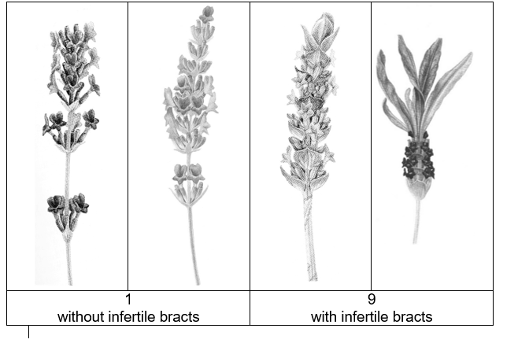

Ad. 2: Plant: growth habit

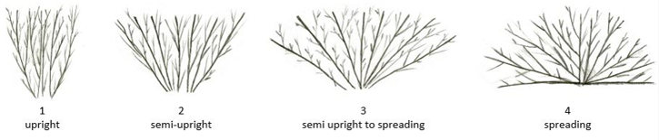

Ad. 4: Plant: density

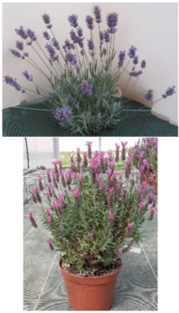 | 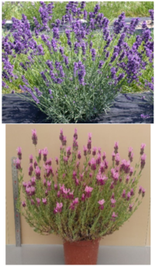 | 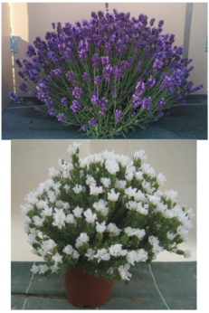
3 | 5 | 7
sparse | medium | dense

Ad. 11: Leaf: incisions of margin

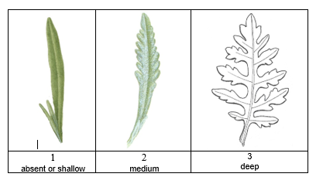

Ad. 12: Flowering stem: length

Ad. 13: Flowering stem: thickness

Observation should be made at middle third of the stem, excluding the spike

Ad. 17: Flowering stem: lateral branching above foliage

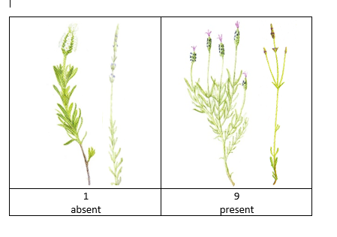

Ad. 19: Flowering stem: length of the longest lateral branch above foliage

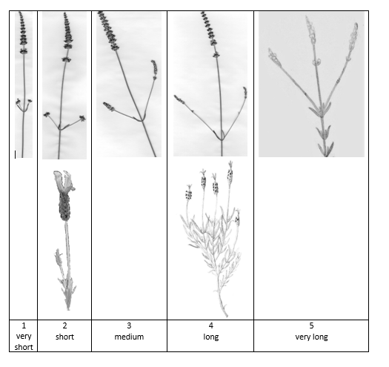
Observation should be made including the spike.

Ad. 20: Spike: arrangement of flowers
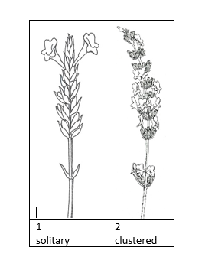

Ad. 21: Spike: length from first whorl

See Ad.12, (b)

Ad. 22: Spike: width

See letter (a).
Observations should be made at full flowering, on the widest point of the spike (including corolla).

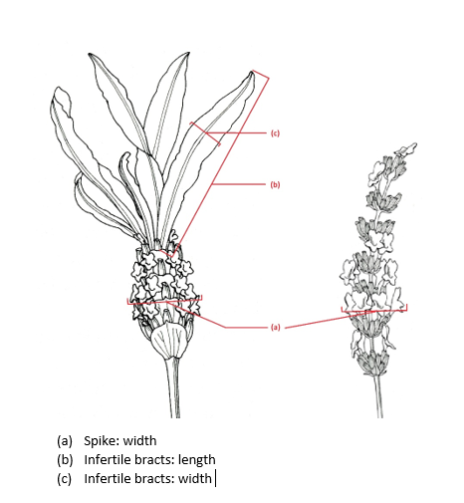

Ad. 23: Only varieties with Plant type: without infertile bracts: Spike: length from second whorl

See Ad 12, (a)

Ad. 24: Only varieties with Plant type: without infertile bracts: Spike: number of whorls

Exclude first whorl.

Ad. 26: Spike: shape

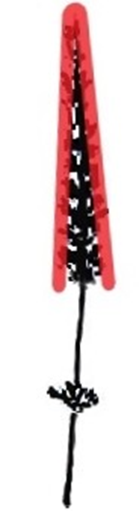 | 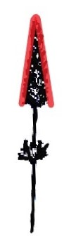 | 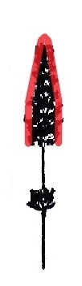 |  | 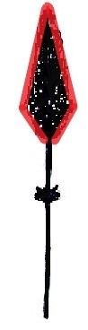 | 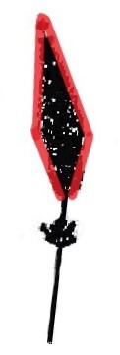
1 | 2 | 3 | 4 | 5 | 6
narrow conic | medium conic | truncate conic | cylindric | fusiform | narrow trullate

State 7: Both conic and cylindric shapes are observed on each plant, in the same proportion.

Ad. 27: Spike: number of flowers
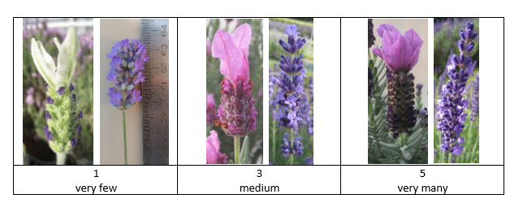

Ad. 29: Spike: width of fertile bracts
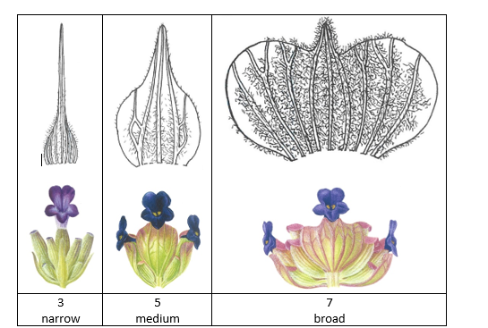

Observations should be made on the broadest part of the bract, before drying out.

Ad. 31: Only varieties with Plant type: without infertile bracts: Spike: presence of bracteole

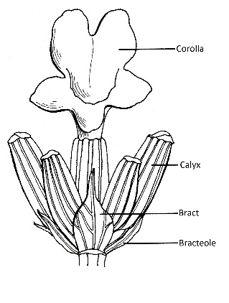

Ad. 32: Only varieties with Plant type: without infertile bracts: Spike: length of bracteole
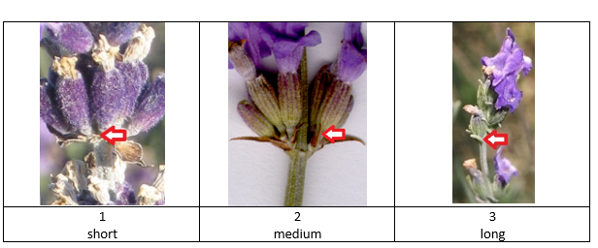WILL BE IMPROVED FOR TWO

Ad. 33: Infertile bracts: number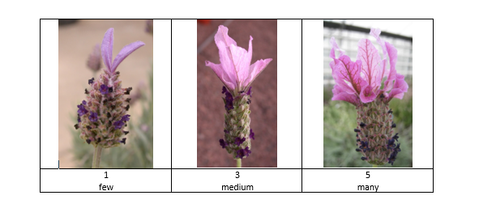

Ad. 34: Infertile bracts: length

See Ad. 22, (b)

Ad. 35: Infertile bracts: width

See Ad. 22, (c)

Ad. 36: Infertile bracts: shape

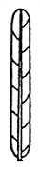 | 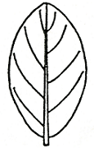 | 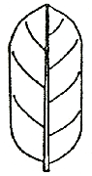 | 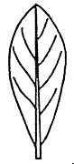
1 | 2 | 3 | 4
linear | elliptic | oblong | oblanceolate

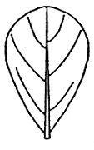 | 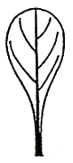 | 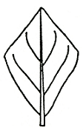
5 | 6 | 7
obovate | spatulate | rhombic

Ad. 38: Infertile bracts: undulation of margin
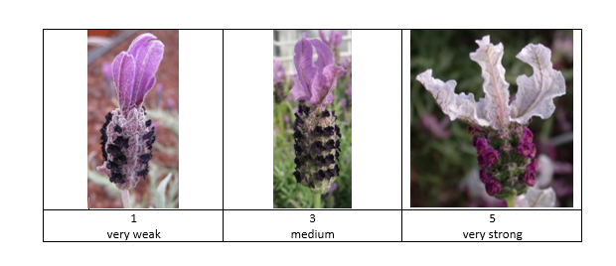

Ad. 39: Pedicel: length
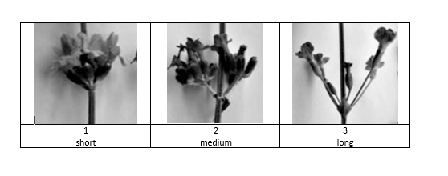

Ad. 44: Time of beginning of flowering

The beginning of flowering is reached when 20% of the plants have open flowers.

9. | Literature

Armitage, A.M., 1989: “Herbaceous Perennial Plants”. Varsity Press, Inc., Athens, Georgia.
De Wolf, Gordon P., 1955: “Notes on Cultivated Labiates”. 5. Lavandula B… 3: 47-57.
McLeod J.A., 1989: “Lavander, Sweet Lavender”. Kangaroo Press, reprinted in 1991.
McNaughton, V.J., 1994: “The Essential Lavender”, Penguin Books.
McNaughton, V. J., 2000: “Lavender: The Grower’s Guide” Bloomings Books, Melbourne.
Tucker, Arthur O., 1981: “The Correct Name of Lavandin and its Cultivars (Labiatae)”, Baileya 21: 131 – 133.
Tucker, Arthur O. and Hensen, Karel, J.W., 1985: “The Cultivars of Lavender and Lavandin (Labiatae)”, Baileya 22: 168 – 177.
Upson, Tim and Andrews, Susyn, 2004, “The Genus Lavandula”, Royal Botanic Garden, Kew.”

10. | Technical Questionnaire

TECHNICAL QUESTIONNAIRE | Page {x} of {y} | Reference Number:

Application date:
(not to be filled in by the applicant)
TECHNICAL QUESTIONNAIRE
to be completed in connection with an application for plant breeders' rights

1. | Subject of the Technical Questionnaire
 | 1.1 | Botanical name | Lavandula L.
 | 1.2 | Common name | Lavandula, Lavender
 | 1.3 | Species : indicate species

2. | Applicant
 | Name
 | Address
 | Telephone No.
 | Fax No.
 | E-mail address
 | Breeder (if different from
 | applicant)

3. | Proposed denomination and breeder's reference
 | Proposed denomination
 | (if available)
 | Breeder's reference

TECHNICAL QUESTIONNAIRE |  |  | Page {x} of {y} | Reference Number:
#4. | Information on the breeding scheme and propagation of the variety
 | 4.1 | Breeding scheme
 | Variety resulting from:
4.1.1 | Crossing
(a) | controlled cross | [ ]
(please state parent variety)

(…………………..……………..…) x (……………..…………………..…)

female parent male parent

(b) | partially known cross | [ ]
(please state known parent variety(ies))

(…………………..……………..…) x (……………..…………………..…)

female parent male parent

(c) | unknown cross | [ ]
4.1.2 | Mutation  (please state parent variety) | [ ]
4.1.3 | Discovery and development  (please state where and when discovered and how developed) | [ ]
4.1.4 | Other  (Please provide details) | [ ]

TECHNICAL QUESTIONNAIRE | Page {x} of {y} | Reference Number:

 | 4.2 | Method of propagating the variety
4.2.1 | Seed-propagated varieties
4.2.2 | Vegetative propagation
(a) | Cuttings | [ ]
(b) | In vitro propagation | [ ]
(c) | Other (state method) | [ ]
4.2.3 | Other  (Please provide details) | [ ]

TECHNICAL QUESTIONNAIRE | Page {x} of {y} | Reference Number:

5. | Characteristics of the variety to be indicated (the number in brackets refers to the corresponding characteristic in Test Guidelines; please mark the note which best corresponds).

 | Characteristics | Example Varieties | Note
5.1  (1) | Plant: type
 | without infertile bracts | Twickel Purple (1) | 1 [ ]
 | with infertile bracts | Marshwood (9) | 9 [ ]
5.2  (2) | Plant: growth habit
 | upright | 3049EVERG (9), Meerlo (1) | 1 [ ]
 | semi-upright | KLELV15115 (9), Twickel Purple (1) | 2 [ ]
 | semi-upright to spreading | Munstead (1), TV 38 (9) | 3 [ ]
 | spreading | Lavst103 (9), Pas1213797 (1) | 4 [ ]
5.3  (3) | Plant: size
 | very small | Nana Alba (1) | 1 [ ]
 | very small to small |  | 2 [ ]
 | small | LAAZ0009 (1), Purpleberry Ruffles (9) | 3 [ ]
 | small to medium | FORLEV03 (1), KLELV15115 (9) | 4 [ ]
 | medium | LAAZ0006 (1), TV 38 (9) | 5 [ ]
 | medium to large | DC000116LS (9) | 6 [ ]
 | large | FW Radiance (9), Ostinato (1) | 7 [ ]
 | large to very large |  | 8 [ ]
 | very large | Marshwood (9) | 9 [ ]
5.4  (7) | Leaf: variegation
 | absent | Felice pink (1), LABZ0011 (9) | 1 [ ]
 | present | Meerlo (1) | 9 [ ]
5.5  (11) | Leaf: incisions of margin
 | absent or shallow | Felice pink (1), Purpleberry Ruffles (9) | 1 [ ]
 | medium | Meerlo (1), Pure Harmony (9) | 2 [ ]
 | deep |  | 3 [ ]

 | Characteristics | Example Varieties | Note
5.6(i)  (37) | Infertile bracts: main color
 | RHS Colour Chart (indicate reference number)
5.6(ii)  (37) | Infertile bracts: main color
 | white |  | 1 [ ]
 | green |  | 2 [ ]
 | pink |  | 3 [ ]
 | light purple |  | 4 [ ]
 | medium purple |  | 5 [ ]
 | dark purple |  | 6 [ ]
 | violet |  | 7 [ ]
 | other (please specify) |  | [ ]
5.7(i)  (42) | Corolla: main color
 | RHS Colour chart (indicate reference number)
5.7(ii)  (42) | Corolla: main color
 | white |  | 1 [ ]
 | pink |  | 2 [ ]
 | purple |  | 3 [ ]
 | violet |  | 4 [ ]
 | blue |  | 5 [ ]
 | other (please specify) |  | [ ]

TECHNICAL QUESTIONNAIRE | Page {x} of {y} | Reference Number:

6. | Similar varieties and differences from these varieties
Please use the following table and box for comments to provide information on how your candidate variety differs from the variety (or varieties) which, to the best of your knowledge, is (or are) most similar. This information may help the examination authority to conduct its examination of distinctness in a more efficient way.

Denomination(s) of variety(ies) similar to your candidate variety | Characteristic(s) in which your candidate variety differs from the similar variety(ies) | Describe the expression of the characteristic(s) for the similar variety(ies) | Describe the expression of the characteristic(s) for your candidate variety

Example | Plant: size | very small | medium

 | Comments:

TECHNICAL QUESTIONNAIRE | Page {x} of {y} | Reference Number:

#7. | Additional information which may help in the examination of the variety
7.1 | In addition to the information provided in sections 5 and 6, are there any additional characteristics which may help to distinguish the variety?
 | Yes | [ ] | No | [ ]
 | (If yes, please provide details)
7.2 | Are there any special conditions for growing the variety or conducting the examination?
 | Yes | [ ] | No | [ ]
 | (If yes, please provide details)
7.3 | Other information
A representative color photograph of the variety displaying its main distinguishing feature(s), should accompany the Technical Questionnaire. The photograph will provide a visual illustration of the candidate variety which supplements the information provided in the Technical Questionnaire.
The key points to consider when taking a photograph of the candidate variety are:
• Indication of the date and geographic location
• Correct labeling (breeder’s reference)
• Good quality printed photograph (minimum 10 cm x 15 cm) and/or sufficient resolution electronic format version (minimum 960 x 1280 pixels)”
Further guidance on providing photographs with the Technical Questionnaire is available in document TGP/7 "Development of Test Guidelines", Guidance Note 35 (http://www.upov.int/tgp/en/).
[The link provided may be deleted by members of the Union when developing authorities’ own test guidelines.]
- Is the variety intended to be grown
- in greenhouse [ ]
- outdoor [ ]

- Main use: (precise)
garden plant [ ]
pot plant [ ]
dried flowers [ ]
essential oil [ ]
others (specify) [ ]
……………………………..……………………………

- Resistance to pests and diseases ……………………………..……………………………

TECHNICAL QUESTIONNAIRE | Page {x} of {y} | Reference Number:

8. | Authorization for release
 | (a) | Does the variety require prior authorization for release under legislation concerning the protection of the environment, human and animal health?
 |  | Yes | [ ] | No | [ ]
 | (b) | Has such authorization been obtained?
 |  | Yes | [ ] | No | [ ]
 | If the answer to (b) is yes, please attach a copy of the authorization.

9. Information on plant material to be examined or submitted for examination

9.1 The expression of a characteristic or several characteristics of a variety may be affected by factors, such as pests and disease, chemical treatment (e.g. growth retardants or pesticides), effects of tissue culture, different rootstocks, scions taken from different growth phases of a tree, etc.
9.2 The plant material should not have undergone any treatment which would affect the expression of the characteristics of the variety, unless the competent authorities allow or request such treatment. If the plant material has undergone such treatment, full details of the treatment must be given. In this respect, please indicate below, to the best of your knowledge, if the plant material to be examined has been subjected to:

 | (a) | Microorganisms (e.g. virus, bacteria, phytoplasma) | Yes [ ] | No [ ]
 | (b) | Chemical treatment (e.g. growth retardant, pesticide) | Yes [ ] | No [ ]
 | (c) | Tissue culture | Yes [ ] | No [ ]
 | (d) | Other factors | Yes [ ] | No [ ]
 | Please provide details for where you have indicated “yes”.

10. | I hereby declare that, to the best of my knowledge, the information provided in this form is correct:
 | Applicant’s name
 | Signature |  | Date

[End of document]

