 |  | E
TG/MAGNO(proj.3)
ORIGINAL: English
DATE: 2022-04-29

INTERNATIONAL UNION FOR THE PROTECTION OF NEW VARIETIES OF PLANTS
 | Geneva
 | DRAFT
 | MAGNOLIA  UPOV Code(s): MAGNO  Magnolia L. | *
GUIDELINES
FOR THE CONDUCT OF TESTS
FOR DISTINCTNESS, UNIFORMITY AND STABILITY

prepared by experts from China
to be considered by the
Technical Working Party for Ornamental Plants and Forest Trees

at its fifty-fourth session, to be held virtually,
from 2022-06-13 to 2022-06-17

Disclaimer: this document does not represent UPOV policies or guidance
Alternative names:*

Botanical name | English | French | German | Spanish
Magnolia L.,  Michelia L. | Magnolia | Magnolia | Magnolie | Magnolia

The purpose of these guidelines (“Test Guidelines”) is to elaborate the principles contained in the General Introduction (document TG/1/3), and its associated TGP documents, into detailed practical guidance for the harmonized examination of distinctness, uniformity and stability (DUS) and, in particular, to identify appropriate characteristics for the examination of DUS and production of harmonized variety descriptions.
ASSOCIATED DOCUMENTS
These Test Guidelines should be read in conjunction with the General Introduction and its associated TGP documents.

TABLE OF CONTENTS | PAGE
1. | SUBJECT OF THESE TEST GUIDELINES.......................................................................................................... | 3
2. | MATERIAL REQUIRED..................................................................................................................... | 3
3. | METHOD OF EXAMINATION............................................................................................................... | 3
3.1 | Number of Growing Cycles................................................................................................................. | 3
3.2 | Testing Place................................................................................................................... | 3
3.3 | Conditions for Conducting the Examination............................................................................................... | 3
3.4 | Test Design................................................................................................................. | 4
3.5 | Additional Tests................................................................................................................... | 4

4. | ASSESSMENT OF DISTINCTNESS, UNIFORMITY AND STABILITY................................................................. | 4
4.1 | Distinctness.......................................................................................................... | 4
4.2 | Uniformity............................................................................................................ | 5
4.3 | Stability............................................................................................................... | 5

5. | GROUPING OF VARIETIES AND ORGANIZATION OF THE GROWING TRIAL................................................ | 6
6. | INTRODUCTION TO THE TABLE OF CHARACTERISTICS................................................................................ | 6
6.1 | Categories of Characteristics...................................................................................................... | 6
6.2 | States of Expression and Corresponding Notes........................................................................................ | 6
6.3 | Types of Expression............................................................................................................ | 7
6.4 | Example Varieties.............................................................................................................. | 7
6.5 | Legend................................................................................................................. | 8

7. | TABLE OF CHARACTERISTICS/TABLEAU DES CARACTÈRES/MERKMALSTABELLE/TABLA DE CARACTERES.................................................................................................................. | 9
8. | EXPLANATIONS ON THE TABLE OF CHARACTERISTICS............................................................................... | 30
8.1 | Explanations covering several characteristics........................................................................................... | 30
8.2 | Explanations for individual characteristics................................................................................................. | 32

9. | LITERATURE................................................................................................................... | 44
10 | TECHNICAL QUESTIONNAIRE............................................................................................................ | 45

1. | Subject of these Test Guidelines
 | These Test Guidelines apply to all varieties of Magnolia L.

2. | Material Required
2.1 | The competent authorities decide on the quantity and quality of the plant material required for testing the variety and when and where it is to be delivered. Applicants submitting material from a State other than that in which the testing takes place must ensure that all customs formalities and phytosanitary requirements are complied with.
2.2 | The material is to be supplied in the form of young plants, grafted or on their own roots.
2.3 | The minimum quantity of plant material, to be supplied by the applicant, should be:
 | 6 plants
2.4 | The plant material supplied should be visibly healthy, not lacking in vigor, nor affected by any important pest or disease.
2.5 | The plant material should not have undergone any treatment which would affect the expression of the characteristics of the variety, unless the competent authorities allow or request such treatment. If it has been treated, full details of the treatment must be given.

3. | Method of Examination
3.1 | Number of Growing Cycles
3.1.1 | The minimum duration of tests should normally be a single growing cycle.
3.1.2 | The testing of a variety may be concluded when the competent authority can determine with certainty the outcome of the test.
3.2 | Testing Place
 | Tests are normally conducted at one place. In the case of tests conducted at more than one place, guidance is provided in TGP/9 “Examining Distinctness”.
3.3 | Conditions for Conducting the Examination
3.3.1 | The tests should be carried out under conditions ensuring satisfactory growth for the expression of the relevant characteristics of the variety and for the conduct of the examination.
3.3.2 | Because daylight varies, color determinations made against a color chart should be made either in a suitable cabinet providing artificial daylight or in the middle of the day in a room without direct sunlight. The spectral distribution of the illuminant for artificial daylight should conform with the CIE Standard of Preferred Daylight D 6500 and should fall within the tolerances set out in the British Standard 950, Part I. These determinations should be made with the plant part placed against a white background. The color chart and version used should be specified in the variety description.

3.4 | Test Design
3.4.1 | In the case of vegetatively propagated varieties, each test should be designed to result in a total of at least 6 plants.

3.4.2 | The design of the tests should be such that plants or parts of plants may be removed for measurement or counting without prejudice to the observations which must be made up to the end of the growing cycle.
3.5 | Additional Tests
 | Additional tests, for examining relevant characteristics, may be established.

4. | Assessment of Distinctness, Uniformity and Stability
4.1 | Distinctness
4.1.1 | General Recommendations
 | It is of particular importance for users of these Test Guidelines to consult the General Introduction prior to making decisions regarding distinctness. However, the following points are provided for elaboration or emphasis in these Test Guidelines.
4.1.2 | Consistent Differences
 | The differences observed between varieties may be so clear that more than one growing cycle is not necessary. In addition, in some circumstances, the influence of the environment is not such that more than a single growing cycle is required to provide assurance that the differences observed between varieties are sufficiently consistent. One means of ensuring that a difference in a characteristic, observed in a growing trial, is sufficiently consistent is to examine the characteristic in at least two independent growing cycles.
4.1.3 | Clear Differences
 | Determining whether a difference between two varieties is clear depends on many factors, and should consider, in particular, the type of expression of the characteristic being examined, i.e. whether it is expressed in a qualitative, quantitative, or pseudo-qualitative manner. Therefore, it is important that users of these Test Guidelines are familiar with the recommendations contained in the General Introduction prior to making decisions regarding distinctness.
4.1.4 | Number of Plants or Parts of Plants to be Examined
 | Unless otherwise indicated, for the purposes of distinctness, all observations on single plants should be made on 5 plants or parts of plants taken from each of 5 plants and any other observations made on all plants in the test, disregarding any off-type plants.
 | In the case of observations of parts taken from single plants, the number of parts to be taken from each of the plants should be 2.
4.1.5 | Method of Observation
 | The recommended method of observing the characteristic for the purposes of distinctness is indicated by the following key in the Table of Characteristics (see document TGP/9 “Examining Distinctness”, Section 4 “Observation of characteristics”):
MG: single measurement of a group of plants or parts of plants
MS: measurement of a number of individual plants or parts of plants
VG: visual assessment by a single observation of a group of plants or parts of plants
VS: visual assessment by observation of individual plants or parts of plants

Type of observation: visual (V) or measurement (M)
“Visual” observation (V) is an observation made on the basis of the expert’s judgment. For the purposes of this document, “visual” observation refers to the sensory observations of the experts and, therefore, also includes smell, taste and touch. Visual observation includes observations where the expert uses reference points (e.g. diagrams, example varieties, side-by-side comparison) or non-linear charts (e.g. color charts). Measurement (M) is an objective observation against a calibrated, linear scale e.g. using a ruler, weighing scales, colorimeter, dates, counts, etc.
Type of record: for a group of plants (G) or for single, individual plants (S)

For the purposes of distinctness, observations may be recorded as a single record for a group of plants or parts of plants (G), or may be recorded as records for a number of single, individual plants or parts of plants (S). In most cases, “G” provides a single record per variety and it is not possible or necessary to apply statistical methods in a plant-by-plant analysis for the assessment of distinctness.

 | In cases where more than one method of observing the characteristic is indicated in the Table of Characteristics (e.g. VG/MG), guidance on selecting an appropriate method is provided in document TGP/9, Section 4.2.
4.2 | Uniformity
4.2.1 | It is of particular importance for users of these Test Guidelines to consult the General Introduction prior to making decisions regarding uniformity. However, the following points are provided for elaboration or emphasis in these Test Guidelines:
4.2.2 | These Test Guidelines have been developed for the examination of vegetatively propagated varieties. For varieties with other types of propagation, the recommendations in the General Introduction and document TGP/13 "Guidance for new types and species" Section 4.5 "Testing Uniformity" should be followed.
4.2.3 | For the assessment of uniformity of vegetatively propagated varieties, a population standard of 1% and an acceptance probability of at least 95% should be applied. In the case of a sample size of 6 plants, 1 off-type is allowed.
4.3 | Stability
4.3.1 | In practice, it is not usual to perform tests of stability that produce results as certain as those of the testing of distinctness and uniformity. However, experience has demonstrated that, for many types of variety, when a variety has been shown to be uniform, it can also be considered to be stable.
4.3.2 | Where appropriate, or in cases of doubt, stability may be further examined by testing a new plant stock to ensure that it exhibits the same characteristics as those shown by the initial material supplied.

5. | Grouping of Varieties and Organization of the Growing Trial
5.1 | The selection of varieties of common knowledge to be grown in the trial with the candidate varieties and the way in which these varieties are divided into groups to facilitate the assessment of distinctness are aided by the use of grouping characteristics.
5.2 | Grouping characteristics are those in which the documented states of expression, even where produced at different locations, can be used, either individually or in combination with other such characteristics: (a) to select varieties of common knowledge that can be excluded from the growing trial used for examination of distinctness; and (b) to organize the growing trial so that similar varieties are grouped together.
5.3 | The following have been agreed as useful grouping characteristics:
(a) |  | Plant: seasonality (characteristic 1)
(b) |  | Plant: position of flower buds on branch (characteristic 5)
(c) |  | Flower: number of tepals (characteristic 31)
(d) |  | First whorl petaloid tepals: main color on outer side (characteristic 39)  Gr. 1: white  Gr. 2: green  Gr. 3: yellow  Gr. 4: red pink  Gr. 5: red  Gr. 6: purple
(e) |  | Time of beginning of vegetative growth in relation to flowering (characteristic 55)
(f) |  | Time of beginning of first flowering (characteristic 56)

5.4 | Guidance for the use of grouping characteristics, in the process of examining distinctness, is provided through the General Introduction and document TGP/9 “Examining Distinctness”.

6. | Introduction to the Table of Characteristics
6.1 | Categories of Characteristics
6.1.1 | Standard Test Guidelines Characteristics
 | Standard Test Guidelines characteristics are those which are approved by UPOV for examination of DUS and from which members of the Union can select those suitable for their particular circumstances.
6.1.2 | Asterisked Characteristics
 | Asterisked characteristics (denoted by *) are those included in the Test Guidelines which are important for the international harmonization of variety descriptions and should always be examined for DUS and included in the variety description by all members of the Union, except when the state of expression of a preceding characteristic or regional environmental conditions render this inappropriate.

6.2 | States of Expression and Corresponding Notes
6.2.1 | States of expression are given for each characteristic to define the characteristic and to harmonize descriptions. Each state of expression is allocated a corresponding numerical note for ease of recording of data and for the production and exchange of the description.
6.2.2 | All relevant states of expression are presented in the characteristic.
6.2.3 | Further explanation of the presentation of states of expression and notes is provided in document TGP/7 “Development of Test Guidelines”.
6.3 | Types of Expression
 | An explanation of the types of expression of characteristics (qualitative, quantitative and pseudo-qualitative) is provided in the General Introduction.
6.4 | Example Varieties
 | Where appropriate, example varieties are provided to clarify the states of expression of each characteristic.
Example variety
Magnolia figo 'Purple Queen'
Magnolia acuminata 'Kenneth's Delight'
Magnolia denudata 'Duoban Baiyulan'
Magnolia 'Hong Jixing'
Magnolia ×loebneri 'Mag's Pirouette'
Magnolia sargentiana 'Mossman 's Giant'
Magnolia sprengerii ' iva'
Magnolia ' Yellow Bird'
Magnolia×soulangiana 'Burgundy'
Magnolia 'Silver Parasol'
Magnolia sieboldii 'Qingxin'
Magnolia grandiflora 'Bracken's Brown Beauty'
Magnolia virginiana 'Tensaw'
Magnolia 'Lvyi Zijuan'

6.5 | Legend
 |  | English |  | français |  | deutsch | español | Example Varieties  Exemples  Beispielssorten  Variedades ejemplo | Note/  Nota
1 | 2 | 3 | 4 | 5 | 6 | 7
 |  | Name of characteristics in English |  | Nom du caractère en français |  | Name des Merkmals auf Deutsch | Nombre del carácter en español
 |  | states of expression |  | types d’expression |  | Ausprägungsstufen | tipos de expresión

1 | Characteristic number
2 | (*) | Asterisked characteristic | – see Chapter 6.1.2
3 | Type of expression
 | QL | Qualitative characteristic | – see Chapter 6.3
 | QN | Quantitative characteristic | – see Chapter 6.3
 | PQ | Pseudo-qualitative characteristic | – see Chapter 6.3
4 | Method of observation (and type of plot, if applicable)
 | MG, MS, VG, VS |  | – see Chapter 4.1.5
5 | (+) | See Explanations on the Table of Characteristics in Chapter 8.2
6 | (a)-(f) | See Explanations on the Table of Characteristics in Chapter 8.1
7 | Not applicable

7. | Table of Characteristics/Tableau des caractères/Merkmalstabelle/Tabla de caracteres

 |  | English |  | français |  | deutsch | español | Example Varieties  Exemples  Beispielssorten  Variedades ejemplo | Note/  Nota
1. | (*) | QL | VG |  | (a)
 |  | Plant: seasonality
 |  | deciduous |  |  |  |  |  |  | 1
 |  | evergreen |  |  |  |  |  |  | 2
2. | (*) | PQ | VG | (+) | (a)
 |  | Plant: growth type
 |  | tree |  |  |  |  |  |  | 1
 |  | shrub |  |  |  |  |  |  | 2
3. | (*) | PQ | VG | (+) | (a)
 |  | Plant: growth habit
 |  | fastigiate |  |  |  |  |  |  | 1
 |  | upright |  |  |  |  |  | Yellow Bird | 2
 |  | upright to spreading |  |  |  |  |  | Burgundy | 3
 |  | spreading |  |  |  |  |  | Duoban Baiyulan | 4
 |  | drooping |  |  |  |  |  |  | 5
4. | (*) | QN | VG |  | (a)
 |  | Plant: density of branches
 |  | sparse |  |  |  |  |  | Kenneth's Delight | 1
 |  | sparse to medium |  |  |  |  |  |  | 2
 |  | medium |  |  |  |  |  | Burgundy | 3
 |  | medium to dense |  |  |  |  |  |  | 4
 |  | dense |  |  |  |  |  | Mag's Pirouette | 5
5. | (*) | PQ | VG | (+)
 |  | Plant: position of flower buds on branch
 |  | terminal only |  |  |  |  |  |  | 1
 |  | terminal and axillary |  |  |  |  |  |  | 2
 |  | axillary only |  |  |  |  |  |  | 3

 |  | English |  | français |  | deutsch | español | Example Varieties  Exemples  Beispielssorten  Variedades ejemplo | Note/  Nota
6. |  | QN | MG | (+)
 |  | Plant: number of terminal or axillary flowers on branch
 |  | only one |  |  |  |  |  |  | 1
 |  | one and two |  |  |  |  |  |  | 2
 |  | more than two |  |  |  |  |  |  | 3
7. |  | QN | MG/MS/VG | (+)
 |  | Plant: number of fruits
 |  | absent or few |  |  |  |  |  | Hong Jixing,  Purple Queen | 1
 |  | medium |  |  |  |  |  | Yellow Bird | 3
 |  | many |  |  |  |  |  | Bracken's Brown Beauty, Duoban Baiyulan | 5
8. | (*) | QN | MG/MS/VG | (+) | (a)
 |  | Flowering shoot: length of internodes
 |  | short |  |  |  |  |  | Tensaw | 1
 |  | medium |  |  |  |  |  | Burgundy | 3
 |  | long |  |  |  |  |  | Kenneth's Delight | 5
9. | (*) | PQ | VG | (+) | (a)
 |  | One-year-old branch: color of shoot
 |  | green |  |  |  |  |  | Lvyi Zijuan | 1
 |  | yellow green |  |  |  |  |  | Diva | 2
 |  | yellow |  |  |  |  |  |  | 3
 |  | brown purple |  |  |  |  |  | Bracken's Brown Beauty | 4
 |  | brown |  |  |  |  |  | Yellow Bird | 5
 |  | yellow brown |  |  |  |  |  | Duoban Baiyulan | 6
10 |  | QN | VG |  | (b)
 |  | Young leaf blade: pubescence on lower side
 |  | absent or very sparse |  |  |  |  |  |  | 1
 |  | sparse |  |  |  |  |  | Diva | 2
 |  | medium |  |  |  |  |  | Burgundy | 3
 |  | dense |  |  |  |  |  |  | 4
 |  | very dense |  |  |  |  |  | Bracken's Brown Beauty | 5

 |  | English |  | français |  | deutsch | español | Example Varieties  Exemples  Beispielssorten  Variedades ejemplo | Note/  Nota
11 |  | PQ | VG |  | (b)
 |  | Young leaf blade: main color of upper side
 |  | green |  |  |  |  |  |  | 1
 |  | yellow green |  |  |  |  |  |  | 2
 |  | yellow |  |  |  |  |  |  | 3
 |  | yellow brown |  |  |  |  |  |  | 4
 |  | red |  |  |  |  |  |  | 5
 |  | red brown |  |  |  |  |  |  | 6
12 |  | PQ | VG |  | (b)
 |  | Young leaf blade: color of lower side
 |  | white |  |  |  |  |  |  | 1
 |  | green |  |  |  |  |  |  | 2
 |  | grey green |  |  |  |  |  |  | 3
 |  | yellow |  |  |  |  |  |  | 4
 |  | brown red |  |  |  |  |  |  | 5
 |  | brown purple |  |  |  |  |  |  | 6
 |  | light brown |  |  |  |  |  |  | 7
 |  | medium brown |  |  |  |  |  |  | 8
 |  | dark brown |  |  |  |  |  |  | 9
 |  | yellow brown |  |  |  |  |  |  | 10
13 | (*) | QL | VG | (+) | (c)
 |  | Leaf: arrangement
 |  | alternate |  |  |  |  |  |  | 1
 |  | clustered |  |  |  |  |  |  | 9
14 | (*) | PQ | VG |  | (c)
 |  | Mature leaf blade: shape
 |  | ovate |  |  |  |  |  |  | 1
 |  | elliptic |  |  |  |  |  |  | 2
 |  | obovate |  |  |  |  |  |  | 3

 |  | English |  | français |  | deutsch | español | Example Varieties  Exemples  Beispielssorten  Variedades ejemplo | Note/  Nota
15 | (*) | QN | MG/MS | (+) | (c)
 |  | Mature leaf blade: length
 |  | very short |  |  |  |  |  | Tensaw | 1
 |  | short |  |  |  |  |  | Mag's Pirouette | 3
 |  | medium |  |  |  |  |  | Burgundy | 5
 |  | long |  |  |  |  |  | Bracken's Brown Beauty | 7
 |  | very long |  |  |  |  |  | Silver Parasol | 9
16 |  | QN | MG/MS | (+) | (c)
 |  | Mature leaf blade: width
 |  | very narrow |  |  |  |  |  | Tensaw | 1
 |  | narrow |  |  |  |  |  | Lvyi Zijuan | 2
 |  | medium |  |  |  |  |  | Burgundy | 3
 |  | broad |  |  |  |  |  | Kenneth's Delight | 4
 |  | very broad |  |  |  |  |  | Silver Parasol | 5
17 |  | QN | MG/MS | (+) | (c)
 |  | Mature leaf blade: ratio length/width
 |  | very small |  |  |  |  |  |  | 1
 |  | small |  |  |  |  |  | Duoban Baiyulan | 2
 |  | medium |  |  |  |  |  | Yellow Bird | 3
 |  | large |  |  |  |  |  | Bracken's Brown Beauty | 4
 |  | very large |  |  |  |  |  | Lvyi Zijuan, Silver Parasol | 5
18 |  | PQ | VG | (+) | (c)
 |  | Mature leaf blade: shape of base
 |  | decurrent |  |  |  |  |  |  | 1
 |  | attenuate |  |  |  |  |  |  | 2
 |  | acute cuneate |  |  |  |  |  |  | 3
 |  | obtuse cuneate |  |  |  |  |  |  | 4
 |  | rounded |  |  |  |  |  |  | 5
 |  | truncate |  |  |  |  |  |  | 6
 |  | cordate |  |  |  |  |  |  | 7
 |  | auriculate |  |  |  |  |  |  | 8

 |  | English |  | français |  | deutsch | español | Example Varieties  Exemples  Beispielssorten  Variedades ejemplo | Note/  Nota
19 | (*) | PQ | VG | (+) | (c)
 |  | Mature leaf blade: shape of tip
 |  | acute |  |  |  |  |  |  | 1
 |  | obtuse |  |  |  |  |  |  | 2
 |  | rounded |  |  |  |  |  |  | 3
 |  | truncate |  |  |  |  |  |  | 4
 |  | apiculate |  |  |  |  |  |  | 5
 |  | acuminate |  |  |  |  |  |  | 6
 |  | caudate |  |  |  |  |  |  | 7
 |  | retuse |  |  |  |  |  |  | 8
 |  | emarginate |  |  |  |  |  |  | 9
20 | (*) | QN | VG | (+) | (c)
 |  | Mature leaf blade: texture
 |  | thin-papery |  |  |  |  |  | Mag's Pirouette | 1
 |  | thick-papery |  |  |  |  |  | Duoban Baiyulan | 2
 |  | thin-leathery |  |  |  |  |  | Purple Queen | 3
 |  | thick-leathery |  |  |  |  |  | Bracken's Brown Beauty | 4
21 |  | QN | VG |  | (c)
 |  | Mature leaf blade: glossiness of upper side
 |  | absent |  |  |  |  |  | Duoban Baiyulan | 1
 |  | weak |  |  |  |  |  | Diva | 2
 |  | medium |  |  |  |  |  | Purple Queen | 3
 |  | strong |  |  |  |  |  | Bracken's Brown Beauty | 4
22 |  | QL | VG
 |  | Mature leaf: variegation
 |  | absent |  |  |  |  |  |  | 1
 |  | present |  |  |  |  |  |  | 9

 |  | English |  | français |  | deutsch | español | Example Varieties  Exemples  Beispielssorten  Variedades ejemplo | Note/  Nota
23 |  | PQ | VG |  | (c)
 |  | Mature leaf blade: main color of upper side
 |  | light green |  |  |  |  |  |  | 1
 |  | medium green |  |  |  |  |  |  | 2
 |  | dark green |  |  |  |  |  |  | 3
 |  | yellow green |  |  |  |  |  |  | 4
 |  | grey green |  |  |  |  |  |  | 5
 |  | blue green |  |  |  |  |  |  | 6
 |  | light yellow |  |  |  |  |  |  | 7
 |  | yellow |  |  |  |  |  |  | 8
24 |  | PQ | VG | (+) | (c)
 |  | Only varieties with Plant: seasonality: deciduous: Leaf blade: color in autumn
 |  | green |  |  |  |  |  |  | 1
 |  | yellow green |  |  |  |  |  |  | 2
 |  | yellow |  |  |  |  |  |  | 3
 |  | brown purple |  |  |  |  |  |  | 4
 |  | brown |  |  |  |  |  |  | 5
 |  | yellow brown |  |  |  |  |  |  | 6
25 |  | PQ | VG | (+)
 |  | Flower bud: colour of spathaceous bract
 |  | green |  |  |  |  |  |  | 1
 |  | grey green |  |  |  |  |  |  | 2
 |  | yellow |  |  |  |  |  |  | 3
 |  | grey yellow |  |  |  |  |  |  | 4
 |  | brown |  |  |  |  |  |  | 5
 |  | brown red |  |  |  |  |  |  | 6
26 | (*) | QN | VG | (+) | (d)
 |  | Flower: attitude
 |  | erect |  |  |  |  |  | Bracken's Brown Beauty | 1
 |  | semi-erect |  |  |  |  |  | Burgundy | 2
 |  | drooping |  |  |  |  |  | Qingxin | 3

 |  | English |  | français |  | deutsch | español | Example Varieties  Exemples  Beispielssorten  Variedades ejemplo | Note/  Nota
27 |  | QN | VG |  | (d)
 |  | Flower: fragrance
 |  | absent or weak |  |  |  |  |  | Lvyi Zijuan | 1
 |  | medium |  |  |  |  |  | Bracken's Brown Beauty | 2
 |  | strong |  |  |  |  |  | Purple Queen | 3
28 | (*) | PQ | VG | (+) | (d)
 |  | Flower: form
 |  | obovoid |  |  |  |  |  |  | 1
 |  | globose |  |  |  |  |  |  | 2
 |  | cup-shaped |  |  |  |  |  |  | 3
 |  | campanulate |  |  |  |  |  |  | 4
 |  | cup-plate-shaped |  |  |  |  |  |  | 5
 |  | bowl-shaped |  |  |  |  |  |  | 6
 |  | saucer-shaped |  |  |  |  |  |  | 7
 |  | stellate |  |  |  |  |  |  | 8
 |  | goldfish-shaped |  |  |  |  |  |  | 9
 |  | irregular |  |  |  |  |  |  | 10
29 | (*) | QN | MG/MS | (+) | (d), (e)
 |  | Flower: diameter
 |  | very small |  |  |  |  |  | Purple Queen | 1
 |  | small |  |  |  |  |  | Lvyi Zijuan | 3
 |  | medium |  |  |  |  |  | Burgundy | 5
 |  | large |  |  |  |  |  | Diva, Duoban Baiyulan | 7
 |  | very large |  |  |  |  |  | Bracken's Brown Beauty, Mossman's Giant | 9
30 |  | QN | MG/MS | (+) | (d), (e)
 |  | Flower: height
 |  | short |  |  |  |  |  | Purple Queen | 1
 |  | medium |  |  |  |  |  | Burgundy,  Kenneth's Delight | 2
 |  | tall |  |  |  |  |  | Silver Parasol | 3

 |  | English |  | français |  | deutsch | español | Example Varieties  Exemples  Beispielssorten  Variedades ejemplo | Note/  Nota
31 | (*) | QN | MG/MS | (+) | (d)
 |  | Flower: number of tepals
 |  | very few |  |  |  |  |  | Purple Queen | 1
 |  | few |  |  |  |  |  | Burgundy | 2
 |  | medium |  |  |  |  |  | Diva | 3
 |  | many |  |  |  |  |  | Duoban Baiyulan | 4
 |  | very many |  |  |  |  |  | Mag's Pirouette | 5
32 | (*) | QL | VG | (+) | (e)
 |  | Flower: presence of sepaloid tepals
 |  | absent |  |  |  |  |  |  | 1
 |  | present |  |  |  |  |  |  | 9
33 | (*) | PQ | VG | (+) | (e)
 |  | First whorl tepals: texture
 |  | membranous |  |  |  |  |  | Mag's Pirouette | 1
 |  | fleshy |  |  |  |  |  | Bracken's Brown Beauty | 2
 |  | leathery |  |  |  |  |  | Lvyi Zijuan | 3
34 | (*) | PQ | VG | (+) | (d), (e)
 |  | First whorl petaloid tepals: shape
 |  | medium ovate |  |  |  |  |  |  | 1
 |  | narrow ovate |  |  |  |  |  |  | 2
 |  | circular |  |  |  |  |  |  | 3
 |  | elliptic |  |  |  |  |  |  | 4
 |  | oblong |  |  |  |  |  |  | 5
 |  | linear |  |  |  |  |  |  | 6
 |  | obovate |  |  |  |  |  |  | 7
 |  | oblanceolate |  |  |  |  |  |  | 8
 |  | spatulate |  |  |  |  |  |  | 9

 |  | English |  | français |  | deutsch | español | Example Varieties  Exemples  Beispielssorten  Variedades ejemplo | Note/  Nota
35 |  | QN | MG/MS |  | (d), (e)
 |  | First whorl petaloid tepals: length
 |  | very short |  |  |  |  |  | Purple Queen | 1
 |  | very short to short |  |  |  |  |  |  | 2
 |  | short |  |  |  |  |  | Lvyi Zijuan | 3
 |  | short to medium |  |  |  |  |  |  | 4
 |  | medium |  |  |  |  |  | Burgundy | 5
 |  | medium to long |  |  |  |  |  |  | 6
 |  | long |  |  |  |  |  | Diva | 7
 |  | long to very long |  |  |  |  |  |  | 8
 |  | very long |  |  |  |  |  | Bracken's Brown Beauty | 9
36 |  | QN | MG/MS | (+) | (d), (e)
 |  | First whorl petaloid tepals: width
 |  | very narrow |  |  |  |  |  | Mag's Pirouette | 1
 |  | very narrow to narrow |  |  |  |  |  |  | 2
 |  | narrow |  |  |  |  |  | Lvyi Zijuan | 3
 |  | narrow to medium |  |  |  |  |  |  | 4
 |  | medium |  |  |  |  |  | Burgundy | 5
 |  | medium to broad |  |  |  |  |  |  | 6
 |  | broad |  |  |  |  |  | Bracken's Brown Beauty | 7
 |  | broad to very broad |  |  |  |  |  |  | 8
 |  | very broad |  |  |  |  |  |  | 9
37 |  | QN | VG | (+) | (d), (e)
 |  | First whorl petaloid tepal: attitude
 |  | inwards |  |  |  |  |  | Kenneth's Delight | 1
 |  | upwards |  |  |  |  |  | Purple Queen | 2
 |  | outwards |  |  |  |  |  | Duoban Baiyulan | 3
 |  | horizontal |  |  |  |  |  | Lvyi Zijuan | 4
 |  | drooping |  |  |  |  |  |  | 5
 |  | weeping |  |  |  |  |  | Silver Parasol | 6

 |  | English |  | français |  | deutsch | español | Example Varieties  Exemples  Beispielssorten  Variedades ejemplo | Note/  Nota
38 |  | QN | VG | (+) | (d), (e)
 |  | First whorl petaloid tepal: shape in cross section view
 |  | concave |  |  |  |  |  |  | 1
 |  | flat |  |  |  |  |  |  | 2
 |  | convex |  |  |  |  |  |  | 3
39 | (*) | PQ | VG |  | (d), (e), (f)
 |  | First whorl petaloid tepals: main color on outer side
 |  | RHS Colour Chart (indicate reference number)
40 | (*) | PQ | VG |  | (d), (e), (f)
 |  | First whorl petaloid tepals: secondary color on outer side
 |  | RHS Colour Chart (indicate reference number)
41 | (*) | PQ | VG | (+) | (d), (e), (f)
 |  | First whorl petaloid tepals: distribution of secondary color on outer side
 |  | absent |  |  |  |  |  |  | 1
 |  | at base only |  |  |  |  |  |  | 2
 |  | basal quarter |  |  |  |  |  |  | 3
 |  | basal half |  |  |  |  |  |  | 4
 |  | at apex only |  |  |  |  |  |  | 5
 |  | distal quarter |  |  |  |  |  |  | 6
 |  | distal half |  |  |  |  |  |  | 7
 |  | central band |  |  |  |  |  |  | 8
 |  | basal transverse |  |  |  |  |  |  | 9
 |  | on margin only |  |  |  |  |  |  | 10

 |  | English |  | français |  | deutsch | español | Example Varieties  Exemples  Beispielssorten  Variedades ejemplo | Note/  Nota
42 | (*) | PQ | VG | (+) | (d), (e), (f)
 |  | First whorl petaloid tepals: pattern of secondary color on outer side
 |  | only flush |  |  |  |  |  |  | 1
 |  | flush and stripe |  |  |  |  |  |  | 2
 |  | only stripes |  |  |  |  |  |  | 3
 |  | aciculate |  |  |  |  |  |  | 4
 |  | speckles |  |  |  |  |  |  | 5
43 |  | PQ | VG |  | (d), (e), (f)
 |  | First whorl petaloid tepals: tertiary color on outer side
 |  | absent |  |  |  |  |  |  | 1
 |  | green |  |  |  |  |  |  | 2
 |  | yellow |  |  |  |  |  |  | 3
 |  | red |  |  |  |  |  |  | 4
 |  | orange |  |  |  |  |  |  | 5
44 | (*) | PQ | VG |  | (d), (e), (f)
 |  | First whorl petaloid tepals: main color on inner side
 |  | RHS Colour Chart (indicate reference number)
45 |  | PQ | VG |  | (d), (e), (f)
 |  | First whorl petaloid tepals: secondary color on inner side
 |  | RHS Colour Chart (indicate reference number)

 |  | English |  | français |  | deutsch | español | Example Varieties  Exemples  Beispielssorten  Variedades ejemplo | Note/  Nota
46 |  | PQ | VG | (+) | (d), (e), (f)
 |  | First whorl petaloid tepals: distribution of secondary color on inner side
 |  | absent |  |  |  |  |  |  | 1
 |  | at base only |  |  |  |  |  |  | 2
 |  | basal quarter |  |  |  |  |  |  | 3
 |  | basal half |  |  |  |  |  |  | 4
 |  | at apex only |  |  |  |  |  |  | 5
 |  | distal quarter |  |  |  |  |  |  | 6
 |  | distal half |  |  |  |  |  |  | 7
 |  | central band |  |  |  |  |  |  | 8
 |  | basal transverse |  |  |  |  |  |  | 9
 |  | on margin only |  |  |  |  |  |  | 10
47 |  | PQ | VG | (+) | (d), (e), (f)
 |  | First whorl petaloid tepals: pattern of secondary color on inner side
 |  | only flush |  |  |  |  |  |  | 1
 |  | flush and stripe |  |  |  |  |  |  | 2
 |  | only stripes |  |  |  |  |  |  | 3
 |  | aciculate |  |  |  |  |  |  | 4
 |  | speckles |  |  |  |  |  |  | 5

 |  | English |  | français |  | deutsch | español | Example Varieties  Exemples  Beispielssorten  Variedades ejemplo | Note/  Nota
48 |  | PQ | VG | (+) | (d), (e)
 |  | Second whorl petaloid tepals: attitude
 |  | inwards |  |  |  |  |  |  | 1
 |  | upwards |  |  |  |  |  |  | 2
 |  | outwards |  |  |  |  |  |  | 3
 |  | horizontal |  |  |  |  |  |  | 4
 |  | drooping |  |  |  |  |  |  | 5
 |  | weeping |  |  |  |  |  |  | 6
49 | (*) | PQ | VG |  | (d), (e), (f)
 |  | Second whorl petaloid tepals: main color on outer side
 |  | RHS Colour Chart (indicate reference number)
50 |  | PQ | VG |  | (d), (e), (f)
 |  | Second whorl petaloid tepals: secondary color on outer side
 |  | RHS Colour Chart (indicate reference number)
51 |  | PQ | VG | (+) | (d), (e), (f)
 |  | Second whorl petaloid tepals: distribution of secondary color on outer side
 |  | absent |  |  |  |  |  |  | 1
 |  | at base only |  |  |  |  |  |  | 2
 |  | basal quarter |  |  |  |  |  |  | 3
 |  | basal half |  |  |  |  |  |  | 4
 |  | at apex only |  |  |  |  |  |  | 5
 |  | distal quarter |  |  |  |  |  |  | 6
 |  | distal half |  |  |  |  |  |  | 7
 |  | central band |  |  |  |  |  |  | 8
 |  | basal transverse |  |  |  |  |  |  | 9
 |  | on margin only |  |  |  |  |  |  | 10

 |  | English |  | français |  | deutsch | español | Example Varieties  Exemples  Beispielssorten  Variedades ejemplo | Note/  Nota
52 |  | PQ | VG | (+) | (d), (e), (f)
 |  | Second whorl petaloid tepals: pattern of secondary color on outer side
 |  | only flush |  |  |  |  |  |  | 1
 |  | flush and stripe |  |  |  |  |  |  | 2
 |  | only stripe |  |  |  |  |  |  | 3
 |  | aciculate |  |  |  |  |  |  | 4
 |  | speckles |  |  |  |  |  |  | 5
53 | (*) | PQ | VG |  | (d), (e)
 |  | Stamens: color
 |  | white |  |  |  |  |  |  | 1
 |  | yellow |  |  |  |  |  |  | 2
 |  | red |  |  |  |  |  |  | 3
 |  | purple red |  |  |  |  |  |  | 4
 |  | purple |  |  |  |  |  |  | 5
54 |  | PQ | VG |  | (d), (e)
 |  | Gynoecium: color
 |  | green |  |  |  |  |  |  | 1
 |  | yellow green |  |  |  |  |  |  | 2
 |  | light yellow |  |  |  |  |  |  | 3
 |  | yellow |  |  |  |  |  |  | 4
 |  | red |  |  |  |  |  |  | 5
 |  | purple red |  |  |  |  |  |  | 6
 |  | purple |  |  |  |  |  |  | 7
55 | (*) | QN | VG
 |  | Time of beginning of vegetative growth in relation to flowering
 |  | before |  |  |  |  |  | Mag's Pirouette | 1
 |  | before and at same time |  |  |  |  |  | Burgundy | 2
 |  | at the same time |  |  |  |  |  | Kenneth's Delight | 3
 |  | after |  |  |  |  |  | Bracken's Brown Beauty, Lvyi Zijuan | 4

 |  | English |  | français |  | deutsch | español | Example Varieties  Exemples  Beispielssorten  Variedades ejemplo | Note/  Nota
56 | (*) | QN | MG | (+)
 |  | Time of beginning of first flowering
 |  | very early |  |  |  |  |  |  | 1
 |  | early |  |  |  |  |  | Mag's Pirouette | 2
 |  | medium |  |  |  |  |  | Burgundy | 3
 |  | late |  |  |  |  |  | Hong Jixing | 4
 |  | very late |  |  |  |  |  | Bracken's Brown Beauty | 5
57 | (*) | QN | MG/MS | (+)
 |  | Length of flowering period
 |  | very short |  |  |  |  |  |  | 1
 |  | short |  |  |  |  |  | Mag's Pirouette | 2
 |  | medium |  |  |  |  |  | Burgundy | 3
 |  | long |  |  |  |  |  | Bracken's Brown Beauty | 4
 |  | very long |  |  |  |  |  | Purple Queen | 5
58 | (*) | QN | VG | (+)
 |  | Flowering: frequency
 |  | once |  |  |  |  |  |  | 1
 |  | twice |  |  |  |  |  |  | 2
 |  | more than twice |  |  |  |  |  |  | 3
59 |  | QN | MG | (+)
 |  | Only varieties with Plant: seasonality: deciduous: Time of leaf fall
 |  | very early |  |  |  |  |  | Kenneth's Delight | 1
 |  | early |  |  |  |  |  |  | 2
 |  | medium |  |  |  |  |  | Burgundy | 3
 |  | late |  |  |  |  |  |  | 4
 |  | very late |  |  |  |  |  | Hong Jixing | 5

8. | Explanations on the Table of Characteristics
8.1 | Explanations covering several characteristics
 | Characteristics containing the following key in the Table of Characteristics should be examined as indicated below:
(a) | Observations should be made during dormancy.
(b) | Observations should be made on fully developed new leaves on the top of the twig of middle upper part of plant.
(c) | Observations should be made on fully developed leaves on the middle third of the current-year shoot located on the middle to upper part of the plant.
(d) | Observations on the flower should be made on fully opened flowers at the beginning of anther dehiscence in the middle upper part of plant.
(e) | Flower structure: 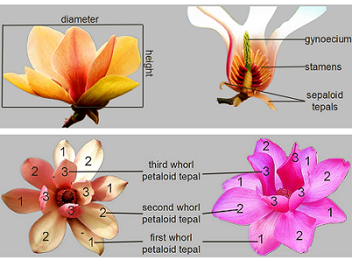  Sepaloid tepals are the first whorl tepals whose shape or texture are obviously different with those inner tepals.  If no sepaloid tepals, first whorl of tepals are the first whorl petaloid tepals. Otherwise, they are second whorl of tepals.
(f) | The main color is the color with the largest surface area, the secondary color is the color with the second largest surface area, and the tertiary color is the color with the third largest surface area. In cases where the area of the main and secondary color are too similar to reliably decide which color has the largest area, the darker color is considered to be the main color. In cases where the area of the secondary and tertiary color are too similar to reliably decide which color has the second largest area, the darker color is considered to be the secondary color.

8.2 | Explanations for individual characteristics
Ad. 2: Plant: growth type

Tree type have one obvious thick trunks.
Shrub type have more than two trunks.

Ad. 3: Plant: growth habit

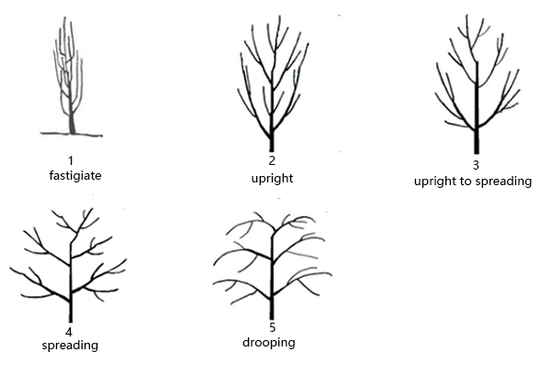

Ad. 5: Plant: position of flower buds on branch

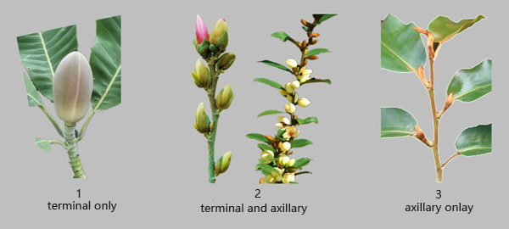

Ad. 6: Plant: number of terminal or axillary flowers on branch

Observations should be made at time of beginning of flowering.

Ad. 7: Plant: number of fruits

Observations should be made two months after flowering.
Number of fruits is relative numbers, being compared to the number of flowers.

Ad. 8: Flowering shoot: length of internodes

Observations should be made on the internodes on middle part of flowering stem.

Ad. 9: One-year-old branch: color of shoot

Observed on sunny side of the one-year-old shoot.

Ad. 13: Leaf: arrangement

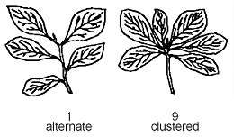

Ad. 15: Mature leaf blade: length

The leaf length is observed excluding the petiole.

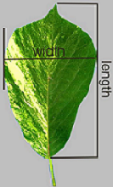

Ad. 16: Mature leaf blade: width

See Ad.15.

Ad. 17: Mature leaf blade: ratio length/width

very small<1.0
small: ≥1.0<1.5
medium: ≥ 1.5<2.0
large: ≥ 2.0<2.5
very large: ≥ 2.5

Ad. 18: Mature leaf blade: shape of base
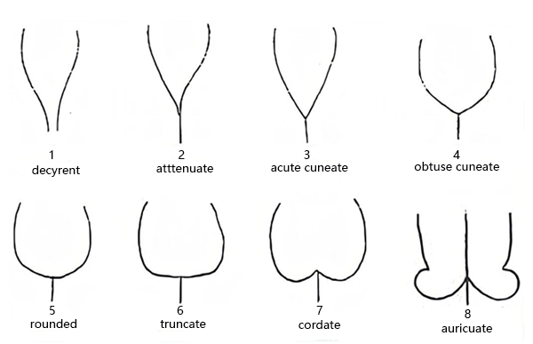

Ad. 19: Mature leaf blade: shape of tip

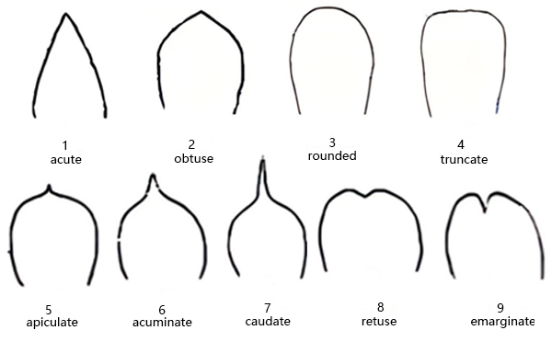

Ad. 20: Mature leaf blade: texture

Texture refers to the tactile sensation of leaf, such as thickness, softness, firmness, smoothness etc.
Leathery leaf: waxiness on surface of leaves, with a firm and thick texture, such as M. grandiflora.
Papery leaf: a pliable and thin texture, such as M. denudata.

Ad. 24: Only varieties with Plant: seasonality: deciduous: Leaf blade: color in autumn

Observations on the time when the temperature is going to drop dramatically in autumn season. This characteristic is probably not applicable to varieties from warmer areas.

Ad. 25: Flower bud: colour of spathaceous bract

Spathaceous bract: flower buds of Magnolias have big and obvious bract with colourful hair or glabrous, membranous or leathery, which resemble a spathe and protect flower buds.
Observed before the bud as opened.

Ad. 26: Flower: attitude

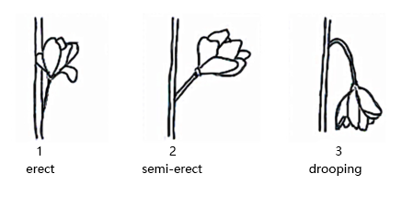

Ad. 28: Flower: form

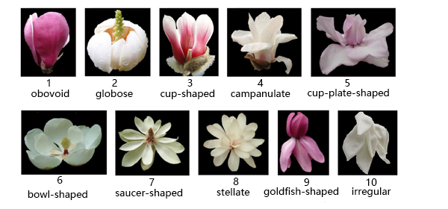

Ad. 29: Flower: diameter

very small ≥3 cm
small 5-6 cm
medium 7-8 cm
large 9-10 cm
very large ≥11 cm

Ad. 30: Flower: height

The height of goldfish shape or irregular flowers are observed from the lower edge of the lower tepals to the upper edge of the upper tepals.

Ad. 31: Flower: number of tepals

very few: number of tepals ≤6
few: number of tepals ≤10
medium: number of tepals ≤14
many: number of tepals ≤18
very many: number of tepals >18

Ad. 32: Flower: presence of sepaloid tepals

Observation made on the first tepal whorl at the beginning of flowering.

Ad. 33: First whorl tepals: texture

Texture refers to the tactile sensation of leaf, such as thickness, softness, firmness, smoothness etc.
Membranous tepals are thin epidermis, without cutin thickening.
Fleshy tepals are soft and thick.
Leathery tepals are waxiness on surface, with a firm and thick texture.

Ad. 34: First whorl petaloid tepals: shape

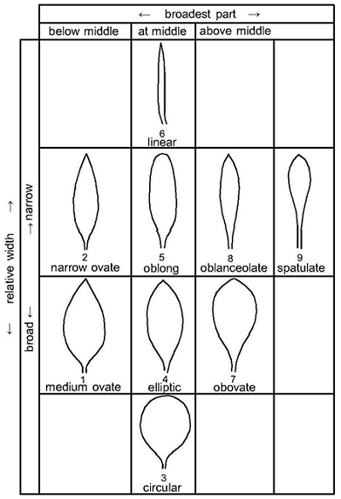

Ad. 36: First whorl petaloid tepals: width

To be observed at the widest part of the tepal.

Ad. 37: First whorl petaloid tepal: attitude
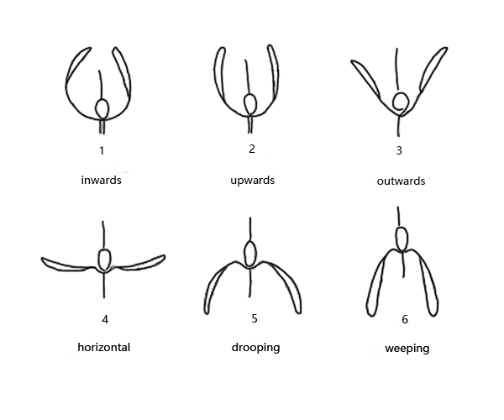

Ad. 38: First whorl petaloid tepal: shape in cross section view
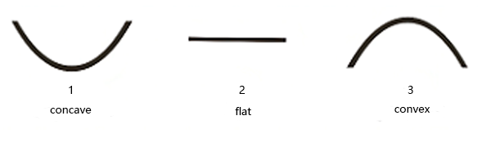

Ad. 41: First whorl petaloid tepals: distribution of secondary color on outer side

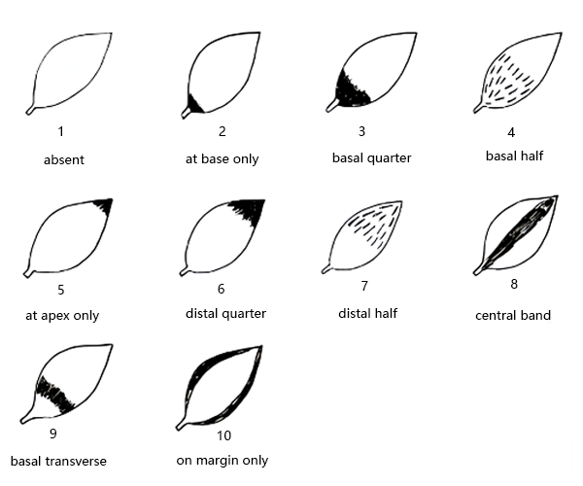

Ad. 42: First whorl petaloid tepals: pattern of secondary color on outer side
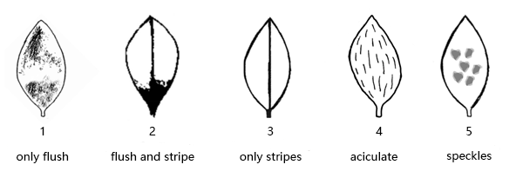

Ad. 46: First whorl petaloid tepals: distribution of secondary color on inner side

See Ad. 41.

Ad. 47: First whorl petaloid tepals: pattern of secondary color on inner side

See Ad. 42.

Ad. 48: Second whorl petaloid tepals: attitude

See Ad. 37.

Ad. 51: Second whorl petaloid tepals: distribution of secondary color on outer side

See Ad. 41.

Ad. 52: Second whorl petaloid tepals: pattern of secondary color on outer side

See Ad. 42.

Ad. 56: Time of beginning of first flowering

The time of beginning of flowering is when more than three flower buds bloom on all plants within five days.
In the case of more than one flowering period, the first flowering period should be observed.

Ad. 57: Length of flowering period

Record the full time of flowering, from beginning to end. The time of beginning of first flowering occurs when more than three flower buds bloom on all plants within five days. The end of flowering occurs when less than three flowers are left in bloom on all plants within five days.
In the case of more than one flowering period, the first flowering period should be observed.

Ad. 58: Flowering: frequency

One flowering period is from the beginning to the end of blooming.
See Ad. 57.

Ad. 59: Only varieties with Plant: seasonality: deciduous: Time of leaf fall

The time of leaf fall is reached when 50% of leaves on all plants have fallen.

9. | Literature

Callaway, D. J., 1994: The World of Magnolias. Timber Press, Oregon.
Figlar, R. B., Nooteboom, H. P., 2004: Notes on Magnoliaceae IV. Blumea 49: 87-100.

Xia N.H., Liu Y.H., Nooteboom H.P., 2008: Magnoliaceae. In: Wu ZY et al, Flora of China Vol.7. Science Press and Missouri Botanical Garden Press, pp. 47-91.

10. | Technical Questionnaire

TECHNICAL QUESTIONNAIRE | Page {x} of {y} | Reference Number:

Application date:
(not to be filled in by the applicant)
TECHNICAL QUESTIONNAIRE
to be completed in connection with an application for plant breeders' rights

1. | Subject of the Technical Questionnaire
 | 1.1 | Botanical name | Magnolia L.
 | 1.2 | Common name | Magnolia

2. | Applicant
 | Name
 | Address
 | Telephone No.
 | Fax No.
 | E-mail address
 | Breeder (if different from
 | applicant)

3. | Proposed denomination and breeder's reference
 | Proposed denomination
 | (if available)
 | Breeder's reference

TECHNICAL QUESTIONNAIRE |  |  | Page {x} of {y} | Reference Number:
#4. | Information on the breeding scheme and propagation of the variety
 | 4.1 | Breeding scheme
 | Variety resulting from:
4.1.1 | Crossing
(a) | controlled cross | [ ]
(please state parent variety)

(…………………..……………..…) x (……………..…………………..…)

female parent male parent

(b) | partially known cross | [ ]
(please state known parent variety(ies))

(…………………..……………..…) x (……………..…………………..…)

female parent male parent

(c) | unknown cross | [ ]
4.1.2 | Mutation  (please state parent variety) | [ ]
4.1.3 | Discovery and development  (please state where and when discovered and how developed) | [ ]
4.1.4 | Other  (Please provide details) | [ ]

TECHNICAL QUESTIONNAIRE | Page {x} of {y} | Reference Number:

 | 4.2 | Method of propagating the variety
4.2.1 | Vegetative propagation
(a) | Cuttings | [ ]
(b) | In vitro propagation | [ ]
(c) | Budding or grafting | [ ]
(d) | Division | [ ]
(e) | Other (state method) | [ ]
4.2.2 | Other  (Please provide details) | [ ]

TECHNICAL QUESTIONNAIRE | Page {x} of {y} | Reference Number:

5. | Characteristics of the variety to be indicated (the number in brackets refers to the corresponding characteristic in Test Guidelines; please mark the note which best corresponds).

 | Characteristics | Example Varieties | Note
5.1  (1) | Plant: seasonality
 | deciduous |  | 1 [ ]
 | evergreen |  | 2 [ ]
5.2  (5) | Plant: position of flower buds on branch
 | terminal only |  | 1 [ ]
 | terminal and axillary |  | 2 [ ]
 | axillary only |  | 3 [ ]
5.3  (20) | Mature leaf blade: texture
 | thin-papery | Mag's Pirouette | 1 [ ]
 | thick-papery | Duoban Baiyulan | 2 [ ]
 | thin-leathery | Purple Queen | 3 [ ]
 | thick-leathery | Bracken's Brown Beauty | 4 [ ]
5.4  (26) | Flower: attitude
 | erect | Bracken's Brown Beauty | 1 [ ]
 | semi-erect | Burgundy | 2 [ ]
 | drooping | Qingxin | 3 [ ]
5.5  (27) | Flower: fragrance
 | absent or weak | Lvyi Zijuan | 1 [ ]
 | medium | Bracken's Brown Beauty | 2 [ ]
 | strong | Purple Queen | 3 [ ]
5.6  (28) | Flower: form
 | obovoid |  | 1 [ ]
 | globose |  | 2 [ ]
 | cup-shaped |  | 3 [ ]
 | campanulate |  | 4 [ ]
 | cup-plate-shaped |  | 5 [ ]
 | bowl-shaped |  | 6 [ ]
 | saucer-shaped |  | 7 [ ]
 | stellate |  | 8 [ ]
 | goldfish-shaped |  | 9 [ ]
 | irregular |  | 10 [ ]

 | Characteristics | Example Varieties | Note
5.7  (29) | Flower: diameter
 | very small | Purple Queen | 1 [ ]
 | very small to small |  | 2 [ ]
 | small | Lvyi Zijuan | 3 [ ]
 | small to medium |  | 4 [ ]
 | medium | Burgundy | 5 [ ]
 | medium to large |  | 6 [ ]
 | large | Diva, Duoban Baiyulan | 7 [ ]
 | large to very large |  | 8 [ ]
 | very large | Bracken's Brown Beauty, Mossman's Giant | 9 [ ]
5.8  (31) | Flower: number of tepals
 | very few | Purple Queen | 1 [ ]
 | few | Burgundy | 2 [ ]
 | medium | Diva | 3 [ ]
 | many | Duoban Baiyulan | 4 [ ]
 | very many | Mag's Pirouette | 5 [ ]
5.9  (39) | First whorl petaloid tepals: main color on outer side
 | white |  | 1 [ ]
 | green |  | 2 [ ]
 | yellow |  | 3 [ ]
 | red pink |  | 4 [ ]
 | red |  | 5 [ ]
 | purple |  | 6 [ ]
5.10  (40) | First whorl petaloid tepals: secondary color on outer side
 | white |  | 1 [ ]
 | green |  | 2 [ ]
 | yellow |  | 3 [ ]
 | red pink |  | 4 [ ]
 | red |  | 5 [ ]
 | purple |  | 6 [ ]

 | Characteristics | Example Varieties | Note
5.11  (41) | First whorl petaloid tepals: distribution of secondary color on outer side
 | absent |  | 1 [ ]
 | at base only |  | 2 [ ]
 | basal quarter |  | 3 [ ]
 | basal half |  | 4 [ ]
 | at apex only |  | 5 [ ]
 | distal quarter |  | 6 [ ]
 | distal half |  | 7 [ ]
 | central band |  | 8 [ ]
 | basal transverse |  | 9 [ ]
 | on margin only |  | 10 [ ]
5.12  (42) | First whorl petaloid tepals: pattern of secondary color on outer side
 | only flush |  | 1 [ ]
 | flush and stripe |  | 2 [ ]
 | only stripes |  | 3 [ ]
 | aciculate |  | 4 [ ]
 | speckles |  | 5 [ ]
5.13  (44) | First whorl petaloid tepals: main color on inner side
 | white |  | 1 [ ]
 | green |  | 2 [ ]
 | yellow |  | 3 [ ]
 | red pink |  | 4 [ ]
 | red |  | 5 [ ]
 | purple |  | 6 [ ]

 | Characteristics | Example Varieties | Note
5.14  (55) | Time of beginning of vegetative growth in relation to flowering
 | before | Mag's Pirouette | 1 [ ]
 | before and at same time | Burgundy | 2 [ ]
 | at the same time | Kenneth's Delight | 3 [ ]
 | after | Bracken's Brown Beauty, Lvyi Zijuan | 4 [ ]
5.15  (56) | Time of beginning of first flowering
 | very early |  | 1 [ ]
 | early | Mag's Pirouette | 2 [ ]
 | medium | Burgundy | 3 [ ]
 | late | Hong Jixing | 4 [ ]
 | very late | Bracken's Brown Beauty | 5 [ ]
5.16  (58) | Flowering: frequency
 | once |  | 1 [ ]
 | twice |  | 2 [ ]
 | more than twice |  | 3 [ ]

TECHNICAL QUESTIONNAIRE | Page {x} of {y} | Reference Number:

6. | Similar varieties and differences from these varieties
Please use the following table and box for comments to provide information on how your candidate variety differs from the variety (or varieties) which, to the best of your knowledge, is (or are) most similar. This information may help the examination authority to conduct its examination of distinctness in a more efficient way.

Denomination(s) of variety(ies) similar to your candidate variety | Characteristic(s) in which your candidate variety differs from the similar variety(ies) | Describe the expression of the characteristic(s) for the similar variety(ies) | Describe the expression of the characteristic(s) for your candidate variety

Example | Flower: number of tepals | medium | few

 | Comments:

TECHNICAL QUESTIONNAIRE | Page {x} of {y} | Reference Number:

#7. | Additional information which may help in the examination of the variety
7.1 | In addition to the information provided in sections 5 and 6, are there any additional characteristics which may help to distinguish the variety?
 | Yes | [ ] | No | [ ]
 | (If yes, please provide details)
7.2 | Are there any special conditions for growing the variety or conducting the examination?
 | Yes | [ ] | No | [ ]
 | (If yes, please provide details)
7.3 | Other information
A representative color photograph of the variety displaying its main distinguishing feature(s), should accompany the Technical Questionnaire. The photograph will provide a visual illustration of the candidate variety which supplements the information provided in the Technical Questionnaire.
The key points to consider when taking a photograph of the candidate variety are:
• Indication of the date and geographic location
• Correct labeling (breeder’s reference)
• Good quality printed photograph (minimum 10 cm x 15 cm) and/or sufficient resolution electronic format version (minimum 960 x 1280 pixels)”
Further guidance on providing photographs with the Technical Questionnaire is available in document TGP/7 "Development of Test Guidelines", Guidance Note 35 (http://www.upov.int/tgp/en/).
[The link provided may be deleted by members of the Union when developing authorities’ own test guidelines.]

TG/MAGNO(proj.3)
Magnolia, 2022-04-29
64

TECHNICAL QUESTIONNAIRE | Page {x} of {y} | Reference Number:

8. | Authorization for release
 | (a) | Does the variety require prior authorization for release under legislation concerning the protection of the environment, human and animal health?
 |  | Yes | [ ] | No | [ ]
 | (b) | Has such authorization been obtained?
 |  | Yes | [ ] | No | [ ]
 | If the answer to (b) is yes, please attach a copy of the authorization.

9. Information on plant material to be examined or submitted for examination

9.1 The expression of a characteristic or several characteristics of a variety may be affected by factors, such as pests and disease, chemical treatment (e.g. growth retardants or pesticides), effects of tissue culture, different rootstocks, scions taken from different growth phases of a tree, etc.
9.2 The plant material should not have undergone any treatment which would affect the expression of the characteristics of the variety, unless the competent authorities allow or request such treatment. If the plant material has undergone such treatment, full details of the treatment must be given. In this respect, please indicate below, to the best of your knowledge, if the plant material to be examined has been subjected to:

 | (a) | Microorganisms (e.g. virus, bacteria, phytoplasma) | Yes [ ] | No [ ]
 | (b) | Chemical treatment (e.g. growth retardant, pesticide) | Yes [ ] | No [ ]
 | (c) | Tissue culture | Yes [ ] | No [ ]
 | (d) | Other factors | Yes [ ] | No [ ]
 | Please provide details for where you have indicated “yes”.

10. | I hereby declare that, to the best of my knowledge, the information provided in this form is correct:
 | Applicant’s name
 | Signature |  | Date

[End of document]
[End of document]

