 |  | E
TG/86/6(proj.3)
ORIGINAL: English
DATE: 2022-04-29

INTERNATIONAL UNION FOR THE PROTECTION OF NEW VARIETIES OF PLANTS
 | Geneva
 | DRAFT
 | ANTHURIUM  UPOV Code(s): ANTHU  Anthurium Schott | *
GUIDELINES
FOR THE CONDUCT OF TESTS
FOR DISTINCTNESS, UNIFORMITY AND STABILITY

prepared by experts from Japan
to be considered by the
Technical Working Party for Ornamental Plants and Forest Trees

at its fifty-fourth session, to be held virtually,
from 2022-06-13 to 2022-06-17

Disclaimer: this document does not represent UPOV policies or guidance
Alternative names:*

Botanical name | English | French | German | Spanish
Anthurium Schott | Anthurium | Anthurium | Flamingoblume | Anthurium

The purpose of these guidelines (“Test Guidelines”) is to elaborate the principles contained in the General Introduction (document TG/1/3), and its associated TGP documents, into detailed practical guidance for the harmonized examination of distinctness, uniformity and stability (DUS) and, in particular, to identify appropriate characteristics for the examination of DUS and production of harmonized variety descriptions.
ASSOCIATED DOCUMENTS
These Test Guidelines should be read in conjunction with the General Introduction and its associated TGP documents.

TABLE OF CONTENTS | PAGE
1. | SUBJECT OF THESE TEST GUIDELINES.......................................................................................................... | 3
2. | MATERIAL REQUIRED..................................................................................................................... | 3
3. | METHOD OF EXAMINATION............................................................................................................... | 3
3.1 | Number of Growing Cycles................................................................................................................. | 3
3.2 | Testing Place................................................................................................................... | 3
3.3 | Conditions for Conducting the Examination............................................................................................... | 3
3.4 | Test Design................................................................................................................. | 4
3.5 | Additional Tests................................................................................................................... | 4

4. | ASSESSMENT OF DISTINCTNESS, UNIFORMITY AND STABILITY................................................................. | 4
4.1 | Distinctness.......................................................................................................... | 4
4.2 | Uniformity............................................................................................................ | 5
4.3 | Stability............................................................................................................... | 5

5. | GROUPING OF VARIETIES AND ORGANIZATION OF THE GROWING TRIAL................................................ | 6
6. | INTRODUCTION TO THE TABLE OF CHARACTERISTICS................................................................................ | 7
6.1 | Categories of Characteristics...................................................................................................... | 7
6.2 | States of Expression and Corresponding Notes........................................................................................ | 7
6.3 | Types of Expression............................................................................................................ | 7
6.4 | Example Varieties.............................................................................................................. | 7
6.5 | Legend................................................................................................................. | 8

7. | TABLE OF CHARACTERISTICS/TABLEAU DES CARACTÈRES/MERKMALSTABELLE/TABLA DE CARACTERES.................................................................................................................. | 9
8. | EXPLANATIONS ON THE TABLE OF CHARACTERISTICS............................................................................... | 27
8.1 | Explanations covering several characteristics........................................................................................... | 27
8.2 | Explanations for individual characteristics................................................................................................. | 28

9. | LITERATURE................................................................................................................... | 39
10 | TECHNICAL QUESTIONNAIRE............................................................................................................ | 40

1. | Subject of these Test Guidelines
 | These Test Guidelines apply to all varieties of Anthurium Schott.

2. | Material Required
2.1 | The competent authorities decide on the quantity and quality of the plant material required for testing the variety and when and where it is to be delivered. Applicants submitting material from a State other than that in which the testing takes place must ensure that all customs formalities and phytosanitary requirements are complied with.
2.2 | The material is to be supplied in the form of young plants.
2.3 | The minimum quantity of plant material, to be supplied by the applicant, should be:
 | 6 plants
2.4 | The plant material supplied should be visibly healthy, not lacking in vigor, nor affected by any important pest or disease.
2.5 | The plant material should not have undergone any treatment which would affect the expression of the characteristics of the variety, unless the competent authorities allow or request such treatment. If it has been treated, full details of the treatment must be given.

3. | Method of Examination
3.1 | Number of Growing Cycles
3.1.1 | The minimum duration of tests should normally be a single growing cycle.
3.1.2 | The testing of a variety may be concluded when the competent authority can determine with certainty the outcome of the test.
3.2 | Testing Place
 | Tests are normally conducted at one place. In the case of tests conducted at more than one place, guidance is provided in TGP/9 “Examining Distinctness”.
3.3 | Conditions for Conducting the Examination
3.3.1 | The tests should be carried out under conditions ensuring satisfactory growth for the expression of the relevant characteristics of the variety and for the conduct of the examination.
3.3.2 | Because daylight varies, color determinations made against a color chart should be made either in a suitable cabinet providing artificial daylight or in the middle of the day in a room without direct sunlight. The spectral distribution of the illuminant for artificial daylight should conform with the CIE Standard of Preferred Daylight D 6500 and should fall within the tolerances set out in the British Standard 950, Part I. These determinations should be made with the plant part placed against a white background. The color chart and version used should be specified in the variety description.

3.4 | Test Design
3.4.1 | Each test should be designed to result in a total of at least 6 plants.
3.4.2 | The design of the tests should be such that plants or parts of plants may be removed for measurement or counting without prejudice to the observations which must be made up to the end of the growing cycle.
3.5 | Additional Tests
 | Additional tests, for examining relevant characteristics, may be established.

4. | Assessment of Distinctness, Uniformity and Stability
4.1 | Distinctness
4.1.1 | General Recommendations
 | It is of particular importance for users of these Test Guidelines to consult the General Introduction prior to making decisions regarding distinctness. However, the following points are provided for elaboration or emphasis in these Test Guidelines.
4.1.2 | Consistent Differences
 | The differences observed between varieties may be so clear that more than one growing cycle is not necessary. In addition, in some circumstances, the influence of the environment is not such that more than a single growing cycle is required to provide assurance that the differences observed between varieties are sufficiently consistent. One means of ensuring that a difference in a characteristic, observed in a growing trial, is sufficiently consistent is to examine the characteristic in at least two independent growing cycles.
4.1.3 | Clear Differences
 | Determining whether a difference between two varieties is clear depends on many factors, and should consider, in particular, the type of expression of the characteristic being examined, i.e. whether it is expressed in a qualitative, quantitative, or pseudo-qualitative manner. Therefore, it is important that users of these Test Guidelines are familiar with the recommendations contained in the General Introduction prior to making decisions regarding distinctness.
4.1.4 | Number of Plants or Parts of Plants to be Examined
 | Unless otherwise indicated, for the purposes of distinctness, all observations on single plants should be made on 5 plants or parts of plants taken from each of 5 plants and any other observations made on all plants in the test, disregarding any off-type plants.
4.1.5 | Method of Observation
 | The recommended method of observing the characteristic for the purposes of distinctness is indicated by the following key in the Table of Characteristics (see document TGP/9 “Examining Distinctness”, Section 4 “Observation of characteristics”):
MG: single measurement of a group of plants or parts of plants
MS: measurement of a number of individual plants or parts of plants
VG: visual assessment by a single observation of a group of plants or parts of plants
VS: visual assessment by observation of individual plants or parts of plants

Type of observation: visual (V) or measurement (M)
“Visual” observation (V) is an observation made on the basis of the expert’s judgment. For the purposes of this document, “visual” observation refers to the sensory observations of the experts and, therefore, also includes smell, taste and touch. Visual observation includes observations where the expert uses reference points (e.g. diagrams, example varieties, side-by-side comparison) or non-linear charts (e.g. color charts). Measurement (M) is an objective observation against a calibrated, linear scale e.g. using a ruler, weighing scales, colorimeter, dates, counts, etc.
Type of record: for a group of plants (G) or for single, individual plants (S)

For the purposes of distinctness, observations may be recorded as a single record for a group of plants or parts of plants (G), or may be recorded as records for a number of single, individual plants or parts of plants (S). In most cases, “G” provides a single record per variety and it is not possible or necessary to apply statistical methods in a plant-by-plant analysis for the assessment of distinctness.

In cases where more than one method of observing the characteristic is indicated in the Table of Characteristics (e.g. VG/MG), guidance on selecting an appropriate method is provided in document TGP/9, Section 4.2.

4.2 | Uniformity
4.2.1 | It is of particular importance for users of these Test Guidelines to consult the General Introduction prior to making decisions regarding uniformity. However, the following points are provided for elaboration or emphasis in these Test Guidelines:
4.2.2 | These Test Guidelines have been developed for the examination of vegetatively propagated varieties. For varieties with other types of propagation, the recommendations in the General Introduction and document TGP/13 "Guidance for new types and species" Section 4.5 "Testing Uniformity" should be followed.
4.2.3 | For the assessment of uniformity of vegetatively propagated varieties, a population standard of 1% and an acceptance probability of at least 95% should be applied. In the case of a sample size of 6 plants, 1 off-type is allowed.
4.3 | Stability
4.3.1 | In practice, it is not usual to perform tests of stability that produce results as certain as those of the testing of distinctness and uniformity. However, experience has demonstrated that, for many types of variety, when a variety has been shown to be uniform, it can also be considered to be stable.
4.3.2 | Where appropriate, or in cases of doubt, stability may be further examined by testing a new plant stock to ensure that it exhibits the same characteristics as those shown by the initial material supplied.

5. | Grouping of Varieties and Organization of the Growing Trial
5.1 | The selection of varieties of common knowledge to be grown in the trial with the candidate varieties and the way in which these varieties are divided into groups to facilitate the assessment of distinctness are aided by the use of grouping characteristics.
5.2 | Grouping characteristics are those in which the documented states of expression, even where produced at different locations, can be used, either individually or in combination with other such characteristics: (a) to select varieties of common knowledge that can be excluded from the growing trial used for examination of distinctness; and (b) to organize the growing trial so that similar varieties are grouped together.
5.3 | The following have been agreed as useful grouping characteristics:
(a) |  | Plant: height (characteristic 1)
(b) |  | Inflorescence: number of spathes (characteristic 16)
(c) |  | Spathe: length (characteristic 17)
(d) |  | Spathe: main color of upper side (characteristic 25)  Gr. 1: white  Gr. 2: green  Gr. 3: yellow  Gr. 4: orange  Gr. 5: pink  Gr. 6: red  Gr. 7: purple  Gr. 8: brown
(e) |  | Spathe: secondary color of upper side (characteristic 26)  Gr. 1: white  Gr. 2: green  Gr. 3: yellow  Gr. 4: orange  Gr. 5: pink  Gr. 6: red  Gr. 7: purple  Gr. 8: brown
(f) |  | Spathe: distribution of secondary color of upper side (characteristic 27)
(g) |  | Spadix: rolling (characteristic 36)
(h) |  | Spadix: main color of basal part (characteristic 39)
(i) |  | Spadix: main color of distal part (characteristic 41)

5.4 | Guidance for the use of grouping characteristics, in the process of examining distinctness, is provided through the General Introduction and document TGP/9 “Examining Distinctness”.

6. | Introduction to the Table of Characteristics
6.1 | Categories of Characteristics
6.1.1 | Standard Test Guidelines Characteristics
 | Standard Test Guidelines characteristics are those which are approved by UPOV for examination of DUS and from which members of the Union can select those suitable for their particular circumstances.
6.1.2 | Asterisked Characteristics
 | Asterisked characteristics (denoted by *) are those included in the Test Guidelines which are important for the international harmonization of variety descriptions and should always be examined for DUS and included in the variety description by all members of the Union, except when the state of expression of a preceding characteristic or regional environmental conditions render this inappropriate.
6.2 | States of Expression and Corresponding Notes
6.2.1 | States of expression are given for each characteristic to define the characteristic and to harmonize descriptions. Each state of expression is allocated a corresponding numerical note for ease of recording of data and for the production and exchange of the description.
6.2.2 | All relevant states of expression are presented in the characteristic.
6.2.3 | Further explanation of the presentation of states of expression and notes is provided in document TGP/7 “Development of Test Guidelines”.
6.3 | Types of Expression
 | An explanation of the types of expression of characteristics (qualitative, quantitative and pseudo-qualitative) is provided in the General Introduction.
6.4 | Example Varieties
 | Where appropriate, example varieties are provided to clarify the states of expression of each characteristic.

6.5 | Legend
 |  | English |  | français |  | deutsch | español | Example Varieties  Exemples  Beispielssorten  Variedades ejemplo | Note/  Nota
1 | 2 | 3 | 4 | 5 | 6 | 7
 |  | Name of characteristics in English |  | Nom du caractère en français |  | Name des Merkmals auf Deutsch | Nombre del carácter en español
 |  | states of expression |  | types d’expression |  | Ausprägungsstufen | tipos de expresión

1 | Characteristic number
2 | (*) | Asterisked characteristic | – see Chapter 6.1.2
3 | Type of expression
 | QL | Qualitative characteristic | – see Chapter 6.3
 | QN | Quantitative characteristic | – see Chapter 6.3
 | PQ | Pseudo-qualitative characteristic | – see Chapter 6.3
4 | Method of observation (and type of plot, if applicable)
 | MG, MS, VG, VS |  | – see Chapter 4.1.5
5 | (+) | See Explanations on the Table of Characteristics in Chapter 8.2
6 | (a)-(c) | See Explanations on the Table of Characteristics in Chapter 8.1
7 | Not applicable

7. | Table of Characteristics/Tableau des caractères/Merkmalstabelle/Tabla de caracteres

 |  | English |  | français |  | deutsch | español | Example Varieties  Exemples  Beispielssorten  Variedades ejemplo | Note/  Nota
1. | (*) | QN | MG/MS/VG | (+)
 |  | Plant: height
 |  | very short |  |  |  |  |  |  | 1
 |  | very short to short |  |  |  |  |  |  | 2
 |  | short |  |  |  |  |  | ANTHDOSDOH | 3
 |  | short to medium |  |  |  |  |  |  | 4
 |  | medium |  |  |  |  |  | ANTHCAPBUK | 5
 |  | medium to tall |  |  |  |  |  |  | 6
 |  | tall |  |  |  |  |  | ANTHARYSIA | 7
 |  | tall to very tall |  |  |  |  |  |  | 8
 |  | very tall |  |  |  |  |  |  | 9
2. | (*) | QN | MG/MS/VG | (+) | (a)
 |  | Leaf blade: length
 |  | very short |  |  |  |  |  |  | 1
 |  | very short to short |  |  |  |  |  |  | 2
 |  | short |  |  |  |  |  | ANTHEPEDI | 3
 |  | short to medium |  |  |  |  |  |  | 4
 |  | medium |  |  |  |  |  | ANTHCAPBUK | 5
 |  | medium to long |  |  |  |  |  |  | 6
 |  | long |  |  |  |  |  | ANTHARYSIA | 7
 |  | long to very long |  |  |  |  |  |  | 8
 |  | very long |  |  |  |  |  |  | 9
3. | (*) | QN | MG/MS/VG | (+) | (a)
 |  | Leaf blade: width
 |  | very narrow |  |  |  |  |  |  | 1
 |  | very narrow to narrow |  |  |  |  |  |  | 2
 |  | narrow |  |  |  |  |  | RYN2009006 | 3
 |  | narrow to medium |  |  |  |  |  |  | 4
 |  | medium |  |  |  |  |  | ANTHCAPBUK | 5
 |  | medium to broad |  |  |  |  |  |  | 6
 |  | broad |  |  |  |  |  | ANTHAQUIRE | 7
 |  | broad to very broad |  |  |  |  |  |  | 8
 |  | very broad |  |  |  |  |  |  | 9

 |  | English |  | français |  | deutsch | español | Example Varieties  Exemples  Beispielssorten  Variedades ejemplo | Note/  Nota
4. | (*) | QN | MG/MS/VG | (+) | (a)
 |  | Leaf blade: ratio length/width
 |  | very low |  |  |  |  |  |  | 1
 |  | very low to low |  |  |  |  |  |  | 2
 |  | low |  |  |  |  |  | RIJN200565 | 3
 |  | low to medium |  |  |  |  |  |  | 4
 |  | medium |  |  |  |  |  | ANTHCAMZIP | 5
 |  | medium to high |  |  |  |  |  |  | 6
 |  | high |  |  |  |  |  | ANTHDUBAQ | 7
 |  | high to very high |  |  |  |  |  |  | 8
 |  | very high |  |  |  |  |  |  | 9
5. | (*) | QN | VG | (+) | (a)
 |  | Leaf blade: size of lobes
 |  | absent or very small |  |  |  |  |  | ANTHDOSDOH | 1
 |  | very small to small |  |  |  |  |  |  | 2
 |  | small |  |  |  |  |  | ANTHZUPAP | 3
 |  | small to medium |  |  |  |  |  |  | 4
 |  | medium |  |  |  |  |  | ANTHCOTBIK | 5
 |  | medium to large |  |  |  |  |  |  | 6
 |  | large |  |  |  |  |  | ANTHAQUIRE | 7
 |  | large to very large |  |  |  |  |  |  | 8
 |  | very large |  |  |  |  |  |  | 9
6. |  | PQ | VG | (+) | (a)
 |  | Leaf blade: relative position of lobes at base
 |  | incurved but not touching |  |  |  |  |  | RIJN200449 | 1
 |  | free |  |  |  |  |  | ANTHEPEDI | 2
 |  | touching |  |  |  |  |  | ANTHQUODO | 3
 |  | overlapping |  |  |  |  |  |  | 4
 |  | adpressed |  |  |  |  |  |  | 5

 |  | English |  | français |  | deutsch | español | Example Varieties  Exemples  Beispielssorten  Variedades ejemplo | Note/  Nota
7. |  | PQ | VG | (+) | (a)
 |  | Leaf blade: angle of apex
 |  | acute |  |  |  |  |  |  | 1
 |  | approximately right angle |  |  |  |  |  |  | 2
 |  | obtuse |  |  |  |  |  |  | 3
8. | (*) | PQ | VG | (+) | (a)
 |  | Leaf blade: differentiated tip
 |  | absent |  |  |  |  |  |  | 1
 |  | narrow acuminate |  |  |  |  |  |  | 2
 |  | medium acuminate |  |  |  |  |  |  | 3
 |  | broad acuminate |  |  |  |  |  |  | 4
9. |  | QN | VG |  | (a)
 |  | Leaf blade: intensity of green color of upper side
 |  | very light |  |  |  |  |  |  | 1
 |  | very light to light |  |  |  |  |  |  | 2
 |  | light |  |  |  |  |  | ANTHDOSDOH | 3
 |  | light to medium |  |  |  |  |  |  | 4
 |  | medium |  |  |  |  |  | ANTHBNZL | 5
 |  | medium to dark |  |  |  |  |  |  | 6
 |  | dark |  |  |  |  |  | ANTHARYSIA | 7
 |  | dark to very dark |  |  |  |  |  |  | 8
 |  | very dark |  |  |  |  |  |  | 9

 |  | English |  | français |  | deutsch | español | Example Varieties  Exemples  Beispielssorten  Variedades ejemplo | Note/  Nota
10 |  | QN | VG |  | (a)
 |  | Leaf blade: blistering of upper side
 |  | absent or very weak |  |  |  |  |  | ANTHDOSDOH | 1
 |  | very weak to weak |  |  |  |  |  |  | 2
 |  | weak |  |  |  |  |  | ANTHCIMWI | 3
 |  | weak to medium |  |  |  |  |  |  | 4
 |  | medium |  |  |  |  |  | ANTHCAPBUK | 5
 |  | medium to strong |  |  |  |  |  |  | 6
 |  | strong |  |  |  |  |  | ANTHAHOTO | 7
 |  | strong to very strong |  |  |  |  |  |  | 8
 |  | very strong |  |  |  |  |  |  | 9
11 |  | QN | MG/MS/VG |  | (a)
 |  | Petiole: length
 |  | very short |  |  |  |  |  |  | 1
 |  | very short to short |  |  |  |  |  |  | 2
 |  | short |  |  |  |  |  | ANTHEBENEX | 3
 |  | short to medium |  |  |  |  |  |  | 4
 |  | medium |  |  |  |  |  | ANTHBNZL | 5
 |  | medium to long |  |  |  |  |  |  | 6
 |  | long |  |  |  |  |  | ANTHAQUIRE | 7
 |  | long to very long |  |  |  |  |  |  | 8
 |  | very long |  |  |  |  |  |  | 9
12 | (*) | QN | MG/MS/VG |  | (b)
 |  | Peduncle: length
 |  | very short |  |  |  |  |  |  | 1
 |  | very short to short |  |  |  |  |  |  | 2
 |  | short |  |  |  |  |  | ANTHEPEDI | 3
 |  | short to medium |  |  |  |  |  |  | 4
 |  | medium |  |  |  |  |  | ANTHCAPBUK | 5
 |  | medium to long |  |  |  |  |  |  | 6
 |  | long |  |  |  |  |  | ANTHAQUIRE | 7
 |  | long to very long |  |  |  |  |  |  | 8
 |  | very long |  |  |  |  |  |  | 9

 |  | English |  | français |  | deutsch | español | Example Varieties  Exemples  Beispielssorten  Variedades ejemplo | Note/  Nota
13 |  | QN | MG/MS/VG | (+) | (b)
 |  | Peduncle: thickness
 |  | very thin |  |  |  |  |  |  | 1
 |  | thin |  |  |  |  |  | ANTHEPEDI | 2
 |  | medium |  |  |  |  |  | ANTHCAPBUK | 3
 |  | thick |  |  |  |  |  | ANTHAQUIRE | 4
 |  | very thick |  |  |  |  |  |  | 5
14 |  | QN | VG |  | (b)
 |  | Peduncle: anthocyanin coloration
 |  | absent or very weak |  |  |  |  |  | ANTHCAPBUK | 1
 |  | very weak to weak |  |  |  |  |  |  | 2
 |  | weak |  |  |  |  |  | ANTHBNZL | 3
 |  | weak to medium |  |  |  |  |  |  | 4
 |  | medium |  |  |  |  |  |  | 5
 |  | medium to strong |  |  |  |  |  |  | 6
 |  | strong |  |  |  |  |  | ANTHEBENEX | 7
 |  | strong to very strong |  |  |  |  |  |  | 8
 |  | very strong |  |  |  |  |  |  | 9
15 | (*) | QN | VG | (+) | (b)
 |  | Inflorescence: position in relation to foliage
 |  | below |  |  |  |  |  |  | 1
 |  | same level |  |  |  |  |  | ANTHBNEK | 2
 |  | slightly above |  |  |  |  |  | ANTHEPEDI | 3
 |  | above |  |  |  |  |  | ANTHEBENEX | 4
16 | (*) | QL | VG | (+) | (b)
 |  | Inflorescence: number of spathes
 |  | one |  |  |  |  |  | ANTHBNZL | 1
 |  | two |  |  |  |  |  | KURIN HEART | 2

 |  | English |  | français |  | deutsch | español | Example Varieties  Exemples  Beispielssorten  Variedades ejemplo | Note/  Nota
17 | (*) | QN | MG/MS/VG | (+) | (b)
 |  | Spathe: length
 |  | very short |  |  |  |  |  |  | 1
 |  | very short to short |  |  |  |  |  |  | 2
 |  | short |  |  |  |  |  | ANTHEBENEX | 3
 |  | short to medium |  |  |  |  |  |  | 4
 |  | medium |  |  |  |  |  | ANTHEPEDI | 5
 |  | medium to long |  |  |  |  |  |  | 6
 |  | long |  |  |  |  |  | ANTHARYSIA | 7
 |  | long to very long |  |  |  |  |  |  | 8
 |  | very long |  |  |  |  |  |  | 9
18 | (*) | QN | MG/MS/VG | (+) | (b)
 |  | Spathe: width
 |  | very narrow |  |  |  |  |  |  | 1
 |  | very narrow to narrow |  |  |  |  |  |  | 2
 |  | narrow |  |  |  |  |  | RIJN200332 | 3
 |  | narrow to medium |  |  |  |  |  |  | 4
 |  | medium |  |  |  |  |  | ANTHEPEDI | 5
 |  | medium to broad |  |  |  |  |  |  | 6
 |  | broad |  |  |  |  |  | ANTHAQUIRE | 7
 |  | broad to very broad |  |  |  |  |  |  | 8
 |  | very broad |  |  |  |  |  |  | 9
19 |  | QN | MS/VG | (+) | (b)
 |  | Spathe: ratio length/width
 |  | very low |  |  |  |  |  |  | 1
 |  | very low to low |  |  |  |  |  |  | 2
 |  | low |  |  |  |  |  | ANTHCAPBUK | 3
 |  | low to medium |  |  |  |  |  |  | 4
 |  | medium |  |  |  |  |  | ANTHAQUIRE | 5
 |  | medium to high |  |  |  |  |  |  | 6
 |  | high |  |  |  |  |  | ANTHEQIWIK | 7
 |  | high to very high |  |  |  |  |  |  | 8
 |  | very high |  |  |  |  |  |  | 9

 |  | English |  | français |  | deutsch | español | Example Varieties  Exemples  Beispielssorten  Variedades ejemplo | Note/  Nota
20 | (*) | QN | VG | (+) | (b)
 |  | Spathe: position of broadest part
 |  | at base |  |  |  |  |  | ANTHBNZL | 1
 |  | between base and middle |  |  |  |  |  | ANTHOLYL | 2
 |  | at middle |  |  |  |  |  | ANTHITOXO | 3
21 | (*) | QN | VG | (+) | (b)
 |  | Spathe: size of lobes
 |  | absent or very small |  |  |  |  |  | ANTHDOSDOH | 1
 |  | very small |  |  |  |  |  |  | 2
 |  | small |  |  |  |  |  | ANTHZUPAP | 3
 |  | small to medium |  |  |  |  |  |  | 4
 |  | medium |  |  |  |  |  | ANTHOLYL | 5
 |  | medium to large |  |  |  |  |  |  | 6
 |  | large |  |  |  |  |  | ANTHAHOTO | 7
 |  | large to very large |  |  |  |  |  |  | 8
 |  | very large |  |  |  |  |  |  | 9
22 |  | PQ | VG | (+) | (b)
 |  | Spathe: relative position of lobes at base
 |  | incurved but not touching |  |  |  |  |  |  | 1
 |  | free |  |  |  |  |  |  | 2
 |  | touching |  |  |  |  |  |  | 3
 |  | overlapping |  |  |  |  |  |  | 4
 |  | adpressed |  |  |  |  |  |  | 5
23 |  | PQ | VG | (+) | (b)
 |  | Spathe: shape of apex
 |  | acute |  |  |  |  |  |  | 1
 |  | obtuse |  |  |  |  |  |  | 2
 |  | rounded |  |  |  |  |  |  | 3

 |  | English |  | français |  | deutsch | español | Example Varieties  Exemples  Beispielssorten  Variedades ejemplo | Note/  Nota
24 | (*) | PQ | VG | (+) | (b)
 |  | Spathe: differentiated tip
 |  | absent |  |  |  |  |  |  | 1
 |  | narrow acuminate |  |  |  |  |  |  | 2
 |  | medium acuminate |  |  |  |  |  |  | 3
 |  | broad acuminate |  |  |  |  |  |  | 4
25 | (*) | PQ | VG |  | (b), (c)
 |  | Spathe: main color of upper side
 |  | RHS Colour Chart (indicate reference number)
26 | (*) | PQ | VG |  | (b), (c)
 |  | Spathe: secondary color of upper side
 |  | RHS Colour Chart (indicate reference number)
27 | (*) | PQ | VG | (+) | (b), (c)
 |  | Spathe: distribution of secondary color of upper side
 |  | none |  |  |  |  |  |  | 1
 |  | at basal zone |  |  |  |  |  |  | 2
 |  | at central zone |  |  |  |  |  |  | 3
 |  | at apex |  |  |  |  |  |  | 4
 |  | at marginal zone |  |  |  |  |  |  | 5
 |  | along veins |  |  |  |  |  |  | 6
 |  | at apex and along veins |  |  |  |  |  |  | 7
 |  | throughout |  |  |  |  |  |  | 8
28 | (*) | PQ | VG | (+)
 |  | Spathe: pattern of secondary color of upper side
 |  | solid |  |  |  |  |  |  | 1
 |  | flushed |  |  |  |  |  |  | 2
 |  | spotted |  |  |  |  |  |  | 3
 |  | irregular |  |  |  |  |  |  | 4

 |  | English |  | français |  | deutsch | español | Example Varieties  Exemples  Beispielssorten  Variedades ejemplo | Note/  Nota
29 |  | PQ | VG |  | (b), (c)
 |  | Spathe: main color of lower side
 |  | RHS Colour Chart (indicate reference number)
30 |  | QN | VG |  | (b)
 |  | Spathe: glossiness on the upper side
 |  | absent or very weak |  |  |  |  |  | ARINOS | 1
 |  | very weak to weak |  |  |  |  |  |  | 2
 |  | weak |  |  |  |  |  | KURIN HEART | 3
 |  | weak to medium |  |  |  |  |  |  | 4
 |  | medium |  |  |  |  |  | ANTHARYSIA | 5
 |  | medium to strong |  |  |  |  |  |  | 6
 |  | strong |  |  |  |  |  | ANTHBNZL | 7
 |  | strong to very strong |  |  |  |  |  |  | 8
 |  | very strong |  |  |  |  |  |  | 9
31 | (*) | QN | VG |  | (b)
 |  | Spathe: blistering
 |  | absent or very weak |  |  |  |  |  | ANTHDOSDOH | 1
 |  | very weak to weak |  |  |  |  |  |  | 2
 |  | weak |  |  |  |  |  | ANTHCAPBUK | 3
 |  | weak to medium |  |  |  |  |  |  | 4
 |  | medium |  |  |  |  |  | ANTHEPEDI | 5
 |  | medium to strong |  |  |  |  |  |  | 6
 |  | strong |  |  |  |  |  | ANTHBNZL | 7
 |  | strong to very strong |  |  |  |  |  |  | 8
 |  | very strong |  |  |  |  |  |  | 9
32 |  | QN | VG | (+) | (b)
 |  | Spathe: shape in cross section of middle zone
 |  | concave |  |  |  |  |  |  | 1
 |  | flat |  |  |  |  |  |  | 2
 |  | convex |  |  |  |  |  |  | 3

 |  | English |  | français |  | deutsch | español | Example Varieties  Exemples  Beispielssorten  Variedades ejemplo | Note/  Nota
33 |  | QN | VG | (+) | (b)
 |  | Spathe: angle of distal part to peduncle
 |  | acute |  |  |  |  |  |  | 1
 |  | right angle |  |  |  |  |  |  | 2
 |  | obtuse |  |  |  |  |  |  | 3
34 | (*) | QN | MG/MS/VG | (+) | (b)
 |  | Spadix: length
 |  | very short |  |  |  |  |  |  | 1
 |  | very short to short |  |  |  |  |  |  | 2
 |  | short |  |  |  |  |  | ANTHEPEDI | 3
 |  | short to medium |  |  |  |  |  |  | 4
 |  | medium |  |  |  |  |  | ANTHBNZL | 5
 |  | medium to long |  |  |  |  |  |  | 6
 |  | long |  |  |  |  |  | ANTHAQUIRE | 7
 |  | long to very long |  |  |  |  |  |  | 8
 |  | very long |  |  |  |  |  |  | 9
35 |  | QN | MG/MS/VG | (+) | (b)
 |  | Spadix: thickness
 |  | very thin |  |  |  |  |  |  | 1
 |  | very thin to thin |  |  |  |  |  |  | 2
 |  | thin |  |  |  |  |  | RYN2009006 | 3
 |  | thin to medium |  |  |  |  |  |  | 4
 |  | medium |  |  |  |  |  | ANTHBNZL | 5
 |  | medium to thick |  |  |  |  |  |  | 6
 |  | thick |  |  |  |  |  |  | 7
 |  | thick to very thick |  |  |  |  |  |  | 8
 |  | very thick |  |  |  |  |  | ANTHBAQEP | 9
36 | (*) | QL | VG | (+) | (b)
 |  | Spadix: rolling
 |  | absent |  |  |  |  |  | ANTHBNZL | 1
 |  | present |  |  |  |  |  | ARINOS | 9

 |  | English |  | français |  | deutsch | español | Example Varieties  Exemples  Beispielssorten  Variedades ejemplo | Note/  Nota
37 | (*) | QN | VG | (+) | (b)
 |  | Excluding varieties with Spadix: rolling: present: Spadix: curvature of longitudinal axis
 |  | strongly incurved |  |  |  |  |  |  | 1
 |  | weakly incurved |  |  |  |  |  |  | 2
 |  | straight |  |  |  |  |  |  | 3
 |  | weakly recurved |  |  |  |  |  |  | 4
 |  | strongly recurved |  |  |  |  |  |  | 5
38 |  | QN | VG | (+) | (b)
 |  | Spadix: tapering towards the tip
 |  | absent or very weak |  |  |  |  |  |  | 1
 |  | very weak to weak |  |  |  |  |  |  | 2
 |  | weak |  |  |  |  |  |  | 3
 |  | weak to medium |  |  |  |  |  |  | 4
 |  | medium |  |  |  |  |  |  | 5
 |  | medium to strong |  |  |  |  |  |  | 6
 |  | strong |  |  |  |  |  |  | 7
 |  | strong to very strong |  |  |  |  |  |  | 8
 |  | very strong |  |  |  |  |  |  | 9
39 | (*) | PQ | VG | (+) | (b), (c)
 |  | Spadix: main color of basal part
 |  | whitish |  |  |  |  |  |  | 1
 |  | green |  |  |  |  |  |  | 2
 |  | yellow |  |  |  |  |  |  | 3
 |  | orange |  |  |  |  |  |  | 4
 |  | pink |  |  |  |  |  |  | 5
 |  | red |  |  |  |  |  |  | 6
 |  | red purple |  |  |  |  |  |  | 7
 |  | purple |  |  |  |  |  |  | 8
 |  | brown |  |  |  |  |  |  | 9

 |  | English |  | français |  | deutsch | español | Example Varieties  Exemples  Beispielssorten  Variedades ejemplo | Note/  Nota
40 |  | PQ | VG | (+) | (b), (c)
 |  | Spadix: main color of middle part (only if different from basal and distal part)
 |  | white |  |  |  |  |  |  | 1
 |  | green |  |  |  |  |  |  | 2
 |  | yellow |  |  |  |  |  |  | 3
 |  | orange |  |  |  |  |  |  | 4
 |  | pink |  |  |  |  |  |  | 5
 |  | red |  |  |  |  |  |  | 6
 |  | red purple |  |  |  |  |  |  | 7
 |  | purple |  |  |  |  |  |  | 8
 |  | brown |  |  |  |  |  |  | 9
41 | (*) | PQ | VG | (+) | (b), (c)
 |  | Spadix: main color of distal part
 |  | white |  |  |  |  |  |  | 1
 |  | green |  |  |  |  |  |  | 2
 |  | yellow |  |  |  |  |  |  | 3
 |  | orange |  |  |  |  |  |  | 4
 |  | pink |  |  |  |  |  |  | 5
 |  | red |  |  |  |  |  |  | 6
 |  | red purple |  |  |  |  |  |  | 7
 |  | purple |  |  |  |  |  |  | 8
 |  | brown |  |  |  |  |  |  | 9
42 |  | PQ | VG | (+) | (c)
 |  | Spadix: main color of basal part after dehiscence of anthers
 |  | whitish |  |  |  |  |  |  | 1
 |  | green |  |  |  |  |  |  | 2
 |  | yellow |  |  |  |  |  |  | 3
 |  | orange |  |  |  |  |  |  | 4
 |  | pink |  |  |  |  |  |  | 5
 |  | red |  |  |  |  |  |  | 6
 |  | red purple |  |  |  |  |  |  | 7
 |  | purple |  |  |  |  |  |  | 8
 |  | brown |  |  |  |  |  |  | 9

 |  | English |  | français |  | deutsch | español | Example Varieties  Exemples  Beispielssorten  Variedades ejemplo | Note/  Nota
43 |  | PQ | VG | (+) | (c)
 |  | Spadix: main color of distal part after dehiscence of anthers
 |  | white |  |  |  |  |  |  | 1
 |  | green |  |  |  |  |  |  | 2
 |  | yellow |  |  |  |  |  |  | 3
 |  | orange |  |  |  |  |  |  | 4
 |  | pink |  |  |  |  |  |  | 5
 |  | red |  |  |  |  |  |  | 6
 |  | red purple |  |  |  |  |  |  | 7
 |  | purple |  |  |  |  |  |  | 8
 |  | brown |  |  |  |  |  |  | 9

8. | Explanations on the Table of Characteristics
8.1 | Explanations covering several characteristics
 | All observations should be made on full grown plants with fully developed flowers.
 | Characteristics containing the following key in the Table of Characteristics should be examined as indicated below:
(a) | Observations should be made on largest fully developed leaf.
(b) | Observations should be made when the basal 1/3 to 2/3 of the flowers spadix are developed and feel rough.  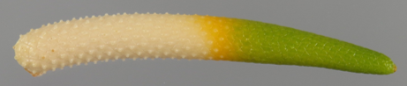
(c) | The main color is the color with the largest surface area, the secondary color is the color with the second largest surface area, and the tertiary color is the color with the third largest surface area. In cases where the area of the main and secondary color are too similar to reliably decide which color has the largest area, the darker color is considered to be the main color. In cases where the area of the secondary and tertiary color are too similar to reliably decide which color has the second largest area, the darker color is considered to be the secondary color.

8.2 | Explanations for individual characteristics
Ad. 1: Plant: height

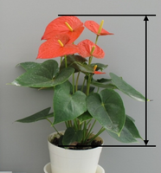

Ad. 2: Leaf blade: length
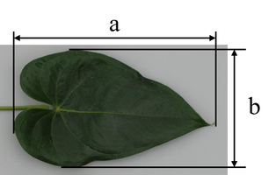

a= Leaf blade: length
b= Leaf blade: width

Ad. 3: Leaf blade: width

See Ad. 2

Ad. 4: Leaf blade: ratio length/width

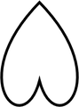
3 | 5 | 7
low | medium | high

Ad. 5: Leaf blade: size of lobes

Observation should be made on size of lobes relative to whole size of leaf blade.

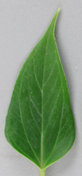 | 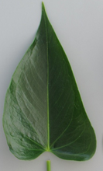 | 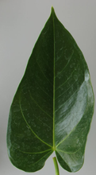 | 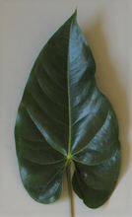
1 | 3 | 5 | 7
absent or very small | small | medium | large

Ad. 6: Leaf blade: relative position of lobes at base

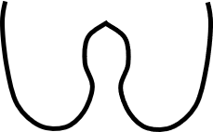 |  | 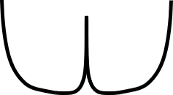 | 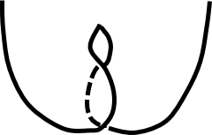 | 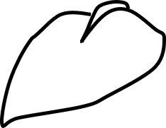
1 | 2 | 3 | 4 | 5
incurved but not touching | free | touching | overlapping | adpressed

Ad. 7: Leaf blade: angle of apex

The general shape of the apex should be observed.
If present, the tip should be excluded from observation.

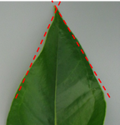 | 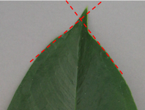 | 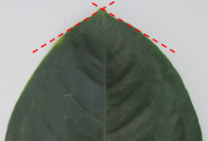
1 | 2 | 3
acute | approximately right angle | obtuse

Ad. 8: Leaf blade: differentiated tip

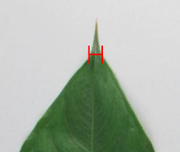 |  | 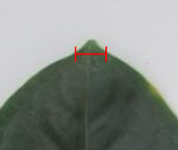
2 | 3 | 4
narrow acuminate | medium acuminate | broad acuminate

Ad. 13: Peduncle: thickness

Observation should be made at the middle of the peduncle.

Ad. 15: Inflorescence: position in relation to foliage

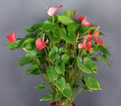 | 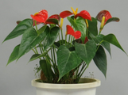 | 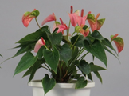 | 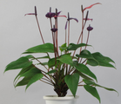
1 | 2 | 3 | 4
below | same level | slightly above | above

Ad. 16: Inflorescence: number of spathes

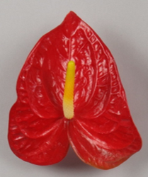 | 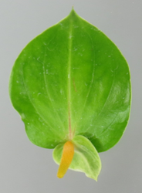
1 | 2
one | two

Ad. 17: Spathe: length

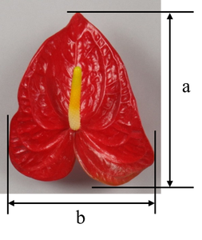
a= Spathe: length
b= Spathe: width

Ad. 18: Spathe: width

See Ad. 17

Ad. 19: Spathe: ratio length/width

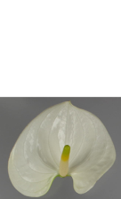 | 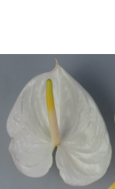 | 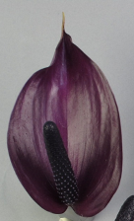
3 | 5 | 7
low | medium | high

Ad. 20: Spathe: position of broadest part

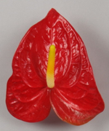 | 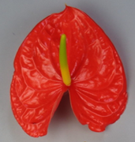 | 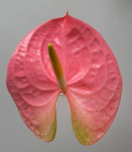
1 | 2 | 3
at base | between base and middle | at middle

Ad. 21: Spathe: size of lobes

Observation should be made on size of lobes relative to whole size of spathe.

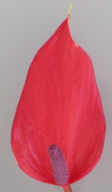 | 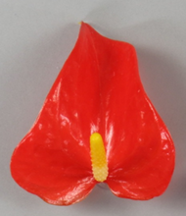 | 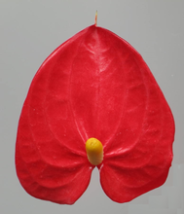 | 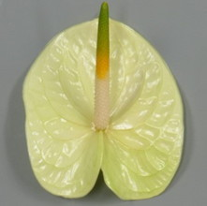
1 | 3 | 5 | 7
absent or very small | small | medium | large

Ad. 22: Spathe: relative position of lobes at base

See Ad. 6

Ad. 23: Spathe: shape of apex

If present, the tip should be excluded from observation.

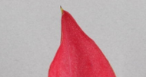 | 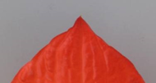 | 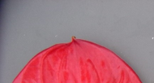
1 | 2 | 3
acute | obtuse | rounded

Ad. 24: Spathe: differentiated tip

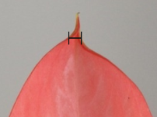 | 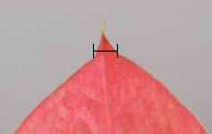 | 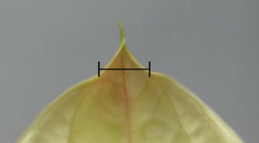
2 | 3 | 4
narrow acuminate | medium acuminate | broad acuminate

Ad. 27: Spathe: distribution of secondary color of upper side

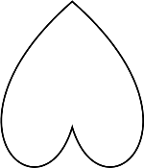 | 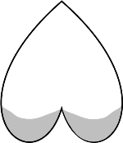 | 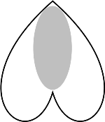 | 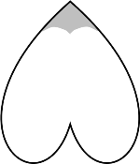
1 | 2 | 3 | 4
none | at basal zone | at central zone | at apex

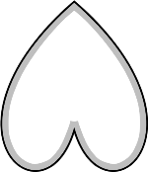 | 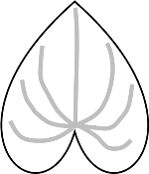 | 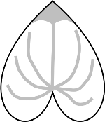 | 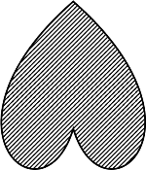
5 | 6 | 7 | 8
at marginal zone | along veins | at apex and along veins | throughout

Ad. 28: Spathe: pattern of secondary color of upper side

1 | 2 | 3 | 4
solid | flushed | spotted | irregular

Ad. 32: Spathe: shape in cross section of middle zone

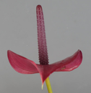 | 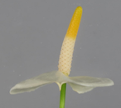 | 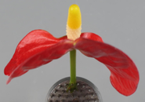
1 | 2 | 3
concave | flat | convex

Ad. 33: Spathe: angle of distal part to peduncle

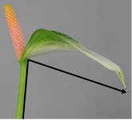 | 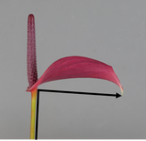 | 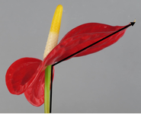
1 | 2 | 3
acute | right angle | obtuse

Ad. 34: Spadix: length

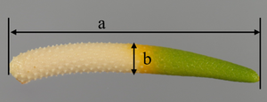
a= length
b= thickness

Ad. 35: Spadix: thickness

See Ad. 34

Observation should be made at the middle of the spadix.

Ad. 36: Spadix: rolling

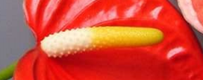 | 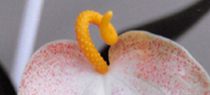
1 | 9
absent | present

Ad. 37: Excluding varieties with Spadix: rolling: present: Spadix: curvature of longitudinal axis

 | 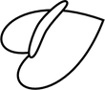 |  | 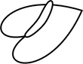 | 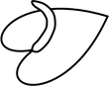
1 | 2 | 3 | 4 | 5
strongly incurved | weakly incurved | straight | weakly recurved | strongly recurved

Ad. 38: Spadix: tapering towards the tip

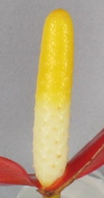 | 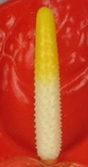 | 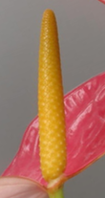 | 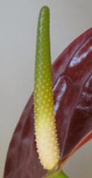 | 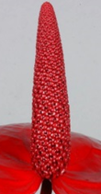
1 | 2 | 3 | 4 | 5
absent or very weak | weak | medium | strong | very strong

Ad. 39: Spadix: main color of basal part

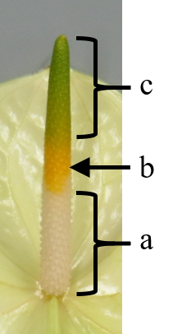 | a= main color of basal part (Char. 39)  b= main color of middle part (only if different from basal part and distal part) (Char. 40)  c= main color of distal part (Char. 41)

Ad. 40: Spadix: main color of middle part (only if different from basal and distal part)

See Ad. 39

Ad. 41: Spadix: main color of distal part

See Ad. 39

Ad. 42: Spadix: main color of basal part after dehiscence of anthers

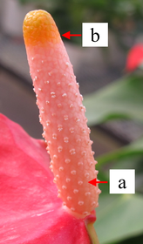 | Observations should be made when basal 1/3 - 2/3 of anthers on spadix are dehisced.  Some modern varieties don't show these signs at all. In those cases, observation should be made when the flowers at the top of spadix are developed and feel rough.  a=Spadix: main color of basal part after dehiscence of anthers (Char. 42)  b=Spadix: main color of distal part after dehiscence of anthers (Char. 43)

Ad. 43: Spadix: main color of distal part after dehiscence of anthers

See Ad. 43

9. | Literature

Tsukamoto, Y., 1994: The Grand Dictionary of Horticulture (Volume 1), Shogakukan Inc., Chiyoda-ku, Tokyo, JP, pp. 187-192

Brickel, C., 2003: A to Z Encyclopedia of Garden Plants, Seibundo Shinkosha Publishing Co. Ltd., Bunkyo-ku, Tokyo, JP, pp. 123, translated by Yokoi M et al.

10. | Technical Questionnaire

TECHNICAL QUESTIONNAIRE | Page {x} of {y} | Reference Number:

Application date:
(not to be filled in by the applicant)
TECHNICAL QUESTIONNAIRE
to be completed in connection with an application for plant breeders' rights

1. | Subject of the Technical Questionnaire
 | 1.1 | Botanical name | Anthurium Schott
 | 1.2 | Common name | Anthurium

2. | Applicant
 | Name
 | Address
 | Telephone No.
 | Fax No.
 | E-mail address
 | Breeder (if different from
 | applicant)

3. | Proposed denomination and breeder's reference
 | Proposed denomination
 | (if available)
 | Breeder's reference

TECHNICAL QUESTIONNAIRE |  |  | Page {x} of {y} | Reference Number:
#4. | Information on the breeding scheme and propagation of the variety
 | 4.1 | Breeding scheme
 | Variety resulting from:
4.1.1 | Crossing
(a) | controlled cross | [ ]
(please state parent variety)

(…………………..……………..…) x (……………..…………………..…)

female parent male parent

(b) | partially known cross | [ ]
(please state known parent variety(ies))

(…………………..……………..…) x (……………..…………………..…)

female parent male parent

(c) | unknown cross | [ ]
4.1.2 | Mutation  (please state parent variety) | [ ]
4.1.3 | Discovery and development  (please state where and when discovered and how developed) | [ ]
4.1.4 | Other  (Please provide details) | [ ]

TECHNICAL QUESTIONNAIRE | Page {x} of {y} | Reference Number:

 | 4.2 | Method of propagating the variety
4.2.1 | Vegetative propagation
(a) | In vitro propagation | [ ]
(b) | Other (state method) | [ ]
4.2.2 | Other  (Please provide details) | [ ]

TECHNICAL QUESTIONNAIRE | Page {x} of {y} | Reference Number:

5. | Characteristics of the variety to be indicated (the number in brackets refers to the corresponding characteristic in Test Guidelines; please mark the note which best corresponds).

 | Characteristics | Example Varieties | Note
5.1  (1) | Plant: height
 | very short |  | 1 [ ]
 | very short to short |  | 2 [ ]
 | short | ANTHDOSDOH | 3 [ ]
 | short to medium |  | 4 [ ]
 | medium | ANTHCAPBUK | 5 [ ]
 | medium to tall |  | 6 [ ]
 | tall | ANTHARYSIA | 7 [ ]
 | tall to very tall |  | 8 [ ]
 | very tall |  | 9 [ ]
5.2  (2) | Leaf blade: length
 | very short |  | 1 [ ]
 | very short to short |  | 2 [ ]
 | short | ANTHEPEDI | 3 [ ]
 | short to medium |  | 4 [ ]
 | medium | ANTHCAPBUK | 5 [ ]
 | medium to long |  | 6 [ ]
 | long | ANTHARYSIA | 7 [ ]
 | long to very long |  | 8 [ ]
 | very long |  | 9 [ ]
5.3  (16) | Inflorescence: number of spathes
 | one | ANTHBNZL | 1 [ ]
 | two | KURIN HEART | 2 [ ]

 | Characteristics | Example Varieties | Note
5.4  (17) | Spathe: length
 | very short |  | 1 [ ]
 | very short to short |  | 2 [ ]
 | short | ANTHEBENEX | 3 [ ]
 | short to medium |  | 4 [ ]
 | medium | ANTHEPEDI | 5 [ ]
 | medium to long |  | 6 [ ]
 | long | ANTHARYSIA | 7 [ ]
 | long to very long |  | 8 [ ]
 | very long |  | 9 [ ]
5.5  (18) | Spathe: width
 | very narrow |  | 1 [ ]
 | very narrow to narrow |  | 2 [ ]
 | narrow | RIJN200332 | 3 [ ]
 | narrow to medium |  | 4 [ ]
 | medium | ANTHEPEDI | 5 [ ]
 | medium to broad |  | 6 [ ]
 | broad | ANTHAQUIRE | 7 [ ]
 | broad to very broad |  | 8 [ ]
 | very broad |  | 9 [ ]
5.6(i)  (25) | Spathe: main color of upper side
 | RHS Colour Chart (indicate reference number)
5.6(ii)  (25) | Spathe: main color of upper side
 | white |  | 1 [ ]
 | green |  | 2 [ ]
 | yellow |  | 3 [ ]
 | orange |  | 4 [ ]
 | pink |  | 5 [ ]
 | red |  | 6 [ ]
 | purple |  | 7 [ ]
 | brown |  | 8 [ ]
 | other (please indicate) |  | [ ]

 | Characteristics | Example Varieties | Note
5.7(i)  (26) | Spathe: secondary color of upper side
 | RHS Colour Chart (indicate reference number)
5.7(ii)  (26) | Spathe: secondary color of upper side
 | white |  | 1 [ ]
 | green |  | 2 [ ]
 | yellow |  | 3 [ ]
 | orange |  | 4 [ ]
 | pink |  | 5 [ ]
 | red |  | 6 [ ]
 | purple |  | 7 [ ]
 | brown |  | 8 [ ]
 | other (please indicate) |  | [ ]
5.8  (27) | Spathe: distribution of secondary color of upper side
 | none |  | 1 [ ]
 | at basal zone |  | 2 [ ]
 | at central zone |  | 3 [ ]
 | at apex |  | 4 [ ]
 | at marginal zone |  | 5 [ ]
 | along veins |  | 6 [ ]
 | at apex and along veins |  | 7 [ ]
 | throughout |  | 8 [ ]
5.9  (36) | Spadix: rolling
 | absent | ANTHBNZL | 1 [ ]
 | present | ARINOS | 9 [ ]
5.10  (39) | Spadix: main color of basal part
 | whitish |  | 1 [ ]
 | green |  | 2 [ ]
 | yellow |  | 3 [ ]
 | orange |  | 4 [ ]
 | pink |  | 5 [ ]
 | red |  | 6 [ ]
 | red purple |  | 7 [ ]
 | purple |  | 8 [ ]
 | brown |  | 9 [ ]

 | Characteristics | Example Varieties | Note
5.11  (41) | Spadix: main color of distal part
 | white |  | 1 [ ]
 | green |  | 2 [ ]
 | yellow |  | 3 [ ]
 | orange |  | 4 [ ]
 | pink |  | 5 [ ]
 | red |  | 6 [ ]
 | red purple |  | 7 [ ]
 | purple |  | 8 [ ]
 | brown |  | 9 [ ]

TECHNICAL QUESTIONNAIRE | Page {x} of {y} | Reference Number:

6. | Similar varieties and differences from these varieties
Please use the following table and box for comments to provide information on how your candidate variety differs from the variety (or varieties) which, to the best of your knowledge, is (or are) most similar. This information may help the examination authority to conduct its examination of distinctness in a more efficient way.

Denomination(s) of variety(ies) similar to your candidate variety | Characteristic(s) in which your candidate variety differs from the similar variety(ies) | Describe the expression of the characteristic(s) for the similar variety(ies) | Describe the expression of the characteristic(s) for your candidate variety

Example | Plant: height | high | medium

 | Comments:

TECHNICAL QUESTIONNAIRE | Page {x} of {y} | Reference Number:

#7. | Additional information which may help in the examination of the variety
7.1 | In addition to the information provided in sections 5 and 6, are there any additional characteristics which may help to distinguish the variety?
 | Yes | [ ] | No | [ ]
 | (If yes, please provide details)
7.2 | Are there any special conditions for growing the variety or conducting the examination?
 | Yes | [ ] | No | [ ]
 | (If yes, please provide details)
7.3 | Other information
A representative color photograph of the variety displaying its main distinguishing feature(s), should accompany the Technical Questionnaire. The photograph will provide a visual illustration of the candidate variety which supplements the information provided in the Technical Questionnaire.
The key points to consider when taking a photograph of the candidate variety are:
• Indication of the date and geographic location
• Correct labeling (breeder’s reference)
• Good quality printed photograph (minimum 10 cm x 15 cm) and/or sufficient resolution electronic format version (minimum 960 x 1280 pixels)”
Further guidance on providing photographs with the Technical Questionnaire is available in document TGP/7 "Development of Test Guidelines", Guidance Note 35 (http://www.upov.int/tgp/en/).
[The link provided may be deleted by members of the Union when developing authorities’ own test guidelines.]
- Resistance to pests and diseases

- (i) Use of variety/utilisation de la variété/Verwendung der Sorte
- cut flower [ ]
- pot plant [ ]

- (ii) Other conditions

TECHNICAL QUESTIONNAIRE | Page {x} of {y} | Reference Number:

8. | Authorization for release
 | (a) | Does the variety require prior authorization for release under legislation concerning the protection of the environment, human and animal health?
 |  | Yes | [ ] | No | [ ]
 | (b) | Has such authorization been obtained?
 |  | Yes | [ ] | No | [ ]
 | If the answer to (b) is yes, please attach a copy of the authorization.

9. Information on plant material to be examined or submitted for examination

9.1 The expression of a characteristic or several characteristics of a variety may be affected by factors, such as pests and disease, chemical treatment (e.g. growth retardants or pesticides), effects of tissue culture, different rootstocks, scions taken from different growth phases of a tree, etc.
9.2 The plant material should not have undergone any treatment which would affect the expression of the characteristics of the variety, unless the competent authorities allow or request such treatment. If the plant material has undergone such treatment, full details of the treatment must be given. In this respect, please indicate below, to the best of your knowledge, if the plant material to be examined has been subjected to:

 | (a) | Microorganisms (e.g. virus, bacteria, phytoplasma) | Yes [ ] | No [ ]
 | (b) | Chemical treatment (e.g. growth retardant, pesticide) | Yes [ ] | No [ ]
 | (c) | Tissue culture | Yes [ ] | No [ ]
 | (d) | Other factors | Yes [ ] | No [ ]
 | Please provide details for where you have indicated “yes”.

10. | I hereby declare that, to the best of my knowledge, the information provided in this form is correct:
 | Applicant’s name
 | Signature |  | Date

[End of document]

