 |  | E
TG/181/4(proj.2)
ORIGINAL: English
DATE: 2022-05-03

INTERNATIONAL UNION FOR THE PROTECTION OF NEW VARIETIES OF PLANTS
 | Geneva
 | DRAFT
 | AMARYLLIS  UPOV Code(s): HIPPE  Hippeastrum Herb. | *
GUIDELINES
FOR THE CONDUCT OF TESTS
FOR DISTINCTNESS, UNIFORMITY AND STABILITY

prepared by experts from the Netherlands
to be considered by the
Technical Working Party for Ornamental Plants and Forest Trees

at its fifty-fourth session, to be held virtually,
from 2022-06-13 to 2022-06-17

Disclaimer: this document does not represent UPOV policies or guidance
Alternative names:*

Botanical name | English | French | German | Spanish
Hippeastrum Herb., Hippeastrum × hybridum hort., Hippeastrum Hybrids, Hippeastrum x hortorum Maatsch, Hippeastrum-Hybridae | Amaryllis | Amaryllis | Amaryllis, Ritterstern | Amarilis

The purpose of these guidelines (“Test Guidelines”) is to elaborate the principles contained in the General Introduction (document TG/1/3), and its associated TGP documents, into detailed practical guidance for the harmonized examination of distinctness, uniformity and stability (DUS) and, in particular, to identify appropriate characteristics for the examination of DUS and production of harmonized variety descriptions.

ASSOCIATED DOCUMENTS
These Test Guidelines should be read in conjunction with the General Introduction and its associated TGP documents.

TABLE OF CONTENTS | PAGE
1. | SUBJECT OF THESE TEST GUIDELINES.......................................................................................................... | 4
2. | MATERIAL REQUIRED..................................................................................................................... | 4
3. | METHOD OF EXAMINATION............................................................................................................... | 4
3.1 | Number of Growing Cycles................................................................................................................. | 4
3.2 | Testing Place................................................................................................................... | 4
3.3 | Conditions for Conducting the Examination............................................................................................... | 4
3.4 | Test Design................................................................................................................. | 5
3.5 | Additional Tests................................................................................................................... | 5

4. | ASSESSMENT OF DISTINCTNESS, UNIFORMITY AND STABILITY................................................................. | 5
4.1 | Distinctness.......................................................................................................... | 5
4.2 | Uniformity............................................................................................................ | 6
4.3 | Stability............................................................................................................... | 6

5. | GROUPING OF VARIETIES AND ORGANIZATION OF THE GROWING TRIAL................................................ | 7
6. | INTRODUCTION TO THE TABLE OF CHARACTERISTICS................................................................................ | 7
6.1 | Categories of Characteristics...................................................................................................... | 7
6.2 | States of Expression and Corresponding Notes........................................................................................ | 7
6.3 | Types of Expression............................................................................................................ | 8
6.4 | Example Varieties.............................................................................................................. | 8
6.5 | Legend................................................................................................................. | 9

7. | TABLE OF CHARACTERISTICS/TABLEAU DES CARACTÈRES/MERKMALSTABELLE/TABLA DE CARACTERES.................................................................................................................. | 10
8. | EXPLANATIONS ON THE TABLE OF CHARACTERISTICS............................................................................... | 23
8.1 | Explanations covering several characteristics........................................................................................... | 23
8.2 | Explanations for individual characteristics................................................................................................. | 25

9. | LITERATURE................................................................................................................... | 33
10 | TECHNICAL QUESTIONNAIRE............................................................................................................ | 34

1. | Subject of these Test Guidelines
 | These Test Guidelines apply to all varieties of Hippeastrum Herb.

2. | Material Required
2.1 | The competent authorities decide on the quantity and quality of the plant material required for testing the variety and when and where it is to be delivered. Applicants submitting material from a State other than that in which the testing takes place must ensure that all customs formalities and phytosanitary requirements are complied with.
2.2 | The material is to be supplied in the form of bulbs.
2.3 | The minimum quantity of plant material, to be supplied by the applicant, should be:
 | 20 bulbs
2.4 | The plant material supplied should be visibly healthy, not lacking in vigor, nor affected by any important pest or disease.
2.5 | The plant material should not have undergone any treatment which would affect the expression of the characteristics of the variety, unless the competent authorities allow or request such treatment. If it has been treated, full details of the treatment must be given.

3. | Method of Examination
3.1 | Number of Growing Cycles
3.1.1 | The minimum duration of tests should normally be a single growing cycle.
3.1.2 | The testing of a variety may be concluded when the competent authority can determine with certainty the outcome of the test.
3.2 | Testing Place
 | Tests are normally conducted at one place. In the case of tests conducted at more than one place, guidance is provided in TGP/9 “Examining Distinctness”.
3.3 | Conditions for Conducting the Examination
3.3.1 | The tests should be carried out under conditions ensuring satisfactory growth for the expression of the relevant characteristics of the variety and for the conduct of the examination.
3.3.2 | Because daylight varies, color determinations made against a color chart should be made either in a suitable cabinet providing artificial daylight or in the middle of the day in a room without direct sunlight. The spectral distribution of the illuminant for artificial daylight should conform with the CIE Standard of Preferred Daylight D 6500 and should fall within the tolerances set out in the British Standard 950, Part I. These determinations should be made with the plant part placed against a white background. The color chart and version used should be specified in the variety description.

3.4 | Test Design
 | Each test should be designed to result in a total of at least 20 plants.
3.5 | Additional Tests
 | Additional tests, for examining relevant characteristics, may be established.

4. | Assessment of Distinctness, Uniformity and Stability
4.1 | Distinctness
4.1.1 | General Recommendations
 | It is of particular importance for users of these Test Guidelines to consult the General Introduction prior to making decisions regarding distinctness. However, the following points are provided for elaboration or emphasis in these Test Guidelines.
4.1.2 | Consistent Differences
 | The differences observed between varieties may be so clear that more than one growing cycle is not necessary. In addition, in some circumstances, the influence of the environment is not such that more than a single growing cycle is required to provide assurance that the differences observed between varieties are sufficiently consistent. One means of ensuring that a difference in a characteristic, observed in a growing trial, is sufficiently consistent is to examine the characteristic in at least two independent growing cycles.
4.1.3 | Clear Differences
 | Determining whether a difference between two varieties is clear depends on many factors, and should consider, in particular, the type of expression of the characteristic being examined, i.e. whether it is expressed in a qualitative, quantitative, or pseudo-qualitative manner. Therefore, it is important that users of these Test Guidelines are familiar with the recommendations contained in the General Introduction prior to making decisions regarding distinctness.
4.1.4 | Number of Plants or Parts of Plants to be Examined
 | Unless otherwise indicated, for the purposes of distinctness, all observations on single plants should be made on 10 plants or parts of plants taken from each of 10 plants and any other observations made on all plants in the test, disregarding any off-type plants.
4.1.5 | Method of Observation
 | The recommended method of observing the characteristic for the purposes of distinctness is indicated by the following key in the Table of Characteristics (see document TGP/9 “Examining Distinctness”, Section 4 “Observation of characteristics”):
MG: single measurement of a group of plants or parts of plants
MS: measurement of a number of individual plants or parts of plants
VG: visual assessment by a single observation of a group of plants or parts of plants
VS: visual assessment by observation of individual plants or parts of plants

 | Type of observation: visual (V) or measurement (M)

“Visual” observation (V) is an observation made on the basis of the expert’s judgment. For the purposes of this document, “visual” observation refers to the sensory observations of the experts and, therefore, also includes smell, taste and touch. Visual observation includes observations where the expert uses reference points (e.g. diagrams, example varieties, side-by-side comparison) or non-linear charts (e.g. color charts). Measurement (M) is an objective observation against a calibrated, linear scale e.g. using a ruler, weighing scales, colorimeter, dates, counts, etc.
Type of record: for a group of plants (G) or for single, individual plants (S)

For the purposes of distinctness, observations may be recorded as a single record for a group of plants or parts of plants (G), or may be recorded as records for a number of single, individual plants or parts of plants (S). In most cases, “G” provides a single record per variety and it is not possible or necessary to apply statistical methods in a plant-by-plant analysis for the assessment of distinctness.

In cases where more than one method of observing the characteristic is indicated in the Table of Characteristics (e.g. VG/MG), guidance on selecting an appropriate method is provided in document TGP/9, Section 4.2.

4.2 | Uniformity
4.2.1 | It is of particular importance for users of these Test Guidelines to consult the General Introduction prior to making decisions regarding uniformity. However, the following points are provided for elaboration or emphasis in these Test Guidelines:
4.2.2 | These Test Guidelines have been developed for the examination of vegetatively propagated varieties. For varieties with other types of propagation, the recommendations in the General Introduction and document TGP/13 "Guidance for new types and species" Section 4.5 "Testing Uniformity" should be followed.
4.2.3 | For the assessment of uniformity of vegetatively propagated varieties, a population standard of 1% and an acceptance probability of at least 95% should be applied. In the case of a sample size of 20 plants, 1 off-type is allowed.
4.3 | Stability
4.3.1 | In practice, it is not usual to perform tests of stability that produce results as certain as those of the testing of distinctness and uniformity. However, experience has demonstrated that, for many types of variety, when a variety has been shown to be uniform, it can also be considered to be stable.
4.3.2 | Where appropriate, or in cases of doubt, stability may be further examined by testing a new plant stock to ensure that it exhibits the same characteristics as those shown by the initial material supplied.

5. | Grouping of Varieties and Organization of the Growing Trial
5.1 | The selection of varieties of common knowledge to be grown in the trial with the candidate varieties and the way in which these varieties are divided into groups to facilitate the assessment of distinctness are aided by the use of grouping characteristics.
5.2 | Grouping characteristics are those in which the documented states of expression, even where produced at different locations, can be used, either individually or in combination with other such characteristics: (a) to select varieties of common knowledge that can be excluded from the growing trial used for examination of distinctness; and (b) to organize the growing trial so that similar varieties are grouped together.
5.3 | The following have been agreed as useful grouping characteristics:
(a) |  | Flower: type (characteristic 10)
(b) |  | Flower: maximum width of perianth (characteristic 17)
(c) |  | Outer median tepal: main color of inner side (characteristic 22) with the following groups  Gr. 1: white  Gr. 2: yellow green  Gr. 3: orange  Gr. 4: light pink  Gr. 5: medium pink  Gr. 6: dark pink  Gr. 7: medium red  Gr: 8: dark red

5.4 | Guidance for the use of grouping characteristics, in the process of examining distinctness, is provided through the General Introduction and document TGP/9 “Examining Distinctness”.

6. | Introduction to the Table of Characteristics
6.1 | Categories of Characteristics
6.1.1 | Standard Test Guidelines Characteristics
 | Standard Test Guidelines characteristics are those which are approved by UPOV for examination of DUS and from which members of the Union can select those suitable for their particular circumstances.
6.1.2 | Asterisked Characteristics
 | Asterisked characteristics (denoted by *) are those included in the Test Guidelines which are important for the international harmonization of variety descriptions and should always be examined for DUS and included in the variety description by all members of the Union, except when the state of expression of a preceding characteristic or regional environmental conditions render this inappropriate.
6.2 | States of Expression and Corresponding Notes
6.2.1 | States of expression are given for each characteristic to define the characteristic and to harmonize descriptions. Each state of expression is allocated a corresponding numerical note for ease of recording of data and for the production and exchange of the description.
6.2.2 | All relevant states of expression are presented in the characteristic.

6.2.3 | Further explanation of the presentation of states of expression and notes is provided in document TGP/7 “Development of Test Guidelines”.
6.3 | Types of Expression
 | An explanation of the types of expression of characteristics (qualitative, quantitative and pseudo-qualitative) is provided in the General Introduction.
6.4 | Example Varieties
 | Where appropriate, example varieties are provided to clarify the states of expression of each characteristic.

6.5 | Legend
 |  | English |  | français |  | deutsch | español | Example Varieties  Exemples  Beispielssorten  Variedades ejemplo | Note/  Nota
1 | 2 | 3 | 4 | 5 | 6 | 7
 |  | Name of characteristics in English |  | Nom du caractère en français |  | Name des Merkmals auf Deutsch | Nombre del carácter en español
 |  | states of expression |  | types d’expression |  | Ausprägungsstufen | tipos de expresión

1 | Characteristic number
2 | (*) | Asterisked characteristic | – see Chapter 6.1.2
3 | Type of expression
 | QL | Qualitative characteristic | – see Chapter 6.3
 | QN | Quantitative characteristic | – see Chapter 6.3
 | PQ | Pseudo-qualitative characteristic | – see Chapter 6.3
4 | Method of observation (and type of plot, if applicable)
 | MG, MS, VG, VS |  | – see Chapter 4.1.5
5 | (+) | See Explanations on the Table of Characteristics in Chapter 8.2
6 | (a)-(f) | See Explanations on the Table of Characteristics in Chapter 8.1
7 | Not applicable

7. | Table of Characteristics/Tableau des caractères/Merkmalstabelle/Tabla de caracteres

 |  | English |  | français |  | deutsch | español | Example Varieties  Exemples  Beispielssorten  Variedades ejemplo | Note/  Nota
1. | (*) | QN | MS/VG | (+) | (b)
 |  | Leaf: width
 |  | very narrow |  |  |  |  |  |  | 1
 |  | very narrow to narrow |  |  |  |  |  |  | 2
 |  | narrow |  |  |  |  |  | Balentino | 3
 |  | narrow to medium |  |  |  |  |  |  | 4
 |  | medium |  |  |  |  |  | Coral Flame | 5
 |  | medium to broad |  |  |  |  |  |  | 6
 |  | broad |  |  |  |  |  | Peach Melba | 7
 |  | broad to very broad |  |  |  |  |  |  | 8
 |  | very broad |  |  |  |  |  |  | 9
2. |  | QN | VG | (+) | (b)
 |  | Leaf: anthocyanin coloration
 |  | absent or very weak |  |  |  |  |  |  | 1
 |  | weak |  |  |  |  |  |  | 2
 |  | medium |  |  |  |  |  |  | 3
 |  | strong |  |  |  |  |  |  | 4
 |  | very strong |  |  |  |  |  |  | 5
3. | (*) | QN | MS/VG | (+) | (c)
 |  | Peduncle: length
 |  | very short |  |  |  |  |  |  | 1
 |  | very short to short |  |  |  |  |  |  | 2
 |  | short |  |  |  |  |  | Double Dragon | 3
 |  | short to medium |  |  |  |  |  |  | 4
 |  | medium |  |  |  |  |  | Red Beauty | 5
 |  | medium to long |  |  |  |  |  |  | 6
 |  | long |  |  |  |  |  | Scarlet Belle | 7
 |  | long to very long |  |  |  |  |  |  | 8
 |  | very long |  |  |  |  |  |  | 9

 |  | English |  | français |  | deutsch | español | Example Varieties  Exemples  Beispielssorten  Variedades ejemplo | Note/  Nota
4. | (*) | QN | MS/VG | (+) | (c)
 |  | Peduncle: width
 |  | very narrow |  |  |  |  |  |  | 1
 |  | very narrow to narrow |  |  |  |  |  |  | 2
 |  | narrow |  |  |  |  |  | Balentino | 3
 |  | narrow to medium |  |  |  |  |  |  | 4
 |  | medium |  |  |  |  |  | Coral Flame | 5
 |  | medium to broad |  |  |  |  |  |  | 6
 |  | broad |  |  |  |  |  | Scarlet Belle | 7
 |  | broad to very broad |  |  |  |  |  |  | 8
 |  | very broad |  |  |  |  |  |  | 9
5. |  | QN | VG | (+) | (c)
 |  | Peduncle: anthocyanin coloration
 |  | absent or very weak |  |  |  |  |  |  | 1
 |  | weak |  |  |  |  |  |  | 2
 |  | medium |  |  |  |  |  |  | 3
 |  | strong |  |  |  |  |  |  | 4
 |  | very strong |  |  |  |  |  |  | 5
6. |  | PQ | VG | (+) | (c)
 |  | Only varieties with anthocyanin coloration: present: Peduncle: distribution of anthocyanin coloration
 |  | basal third |  |  |  |  |  |  | 1
 |  | distal third |  |  |  |  |  |  | 2
 |  | entire |  |  |  |  |  |  | 3
7. |  | QN | VG | (+) | (c)
 |  | Bracts: anthocyanin coloration
 |  | absent or very weak |  |  |  |  |  |  | 1
 |  | weak |  |  |  |  |  |  | 2
 |  | medium |  |  |  |  |  |  | 3
 |  | strong |  |  |  |  |  |  | 4
 |  | very strong |  |  |  |  |  |  | 5

 |  | English |  | français |  | deutsch | español | Example Varieties  Exemples  Beispielssorten  Variedades ejemplo | Note/  Nota
8. |  | QN | VG | (+) | (c)
 |  | Bracts: intensity of green color
 |  | very light |  |  |  |  |  |  | 1
 |  | light |  |  |  |  |  |  | 2
 |  | medium |  |  |  |  |  |  | 3
 |  | dark |  |  |  |  |  |  | 4
 |  | very dark |  |  |  |  |  |  | 5
9. | (*) | QN | MS/VG |  | (a)
 |  | Inflorescence: number of flowers
 |  | very few |  |  |  |  |  |  | 1
 |  | few |  |  |  |  |  | Pretnym | 2
 |  | medium |  |  |  |  |  | Peach Melba | 3
 |  | many |  |  |  |  |  |  | 4
 |  | very many |  |  |  |  |  |  | 5
10 | (*) | QL | VG | (+) | (a), (d)
 |  | Flower: type
 |  | single |  |  |  |  |  | Peach Melba | 1
 |  | double |  |  |  |  |  | Scarlet Belle | 2
11 |  | QL | VG | (+) | (a), (d)
 |  | Only varieties with flower type: double: Flower: shape of petaloid staminodes
 |  | regular |  |  |  |  |  |  | 1
 |  | irregular |  |  |  |  |  |  | 2
12 |  | QN | VG | (+) | (a), (d)
 |  | Flower: attitude of perianth (excluding pedicel)
 |  | erect |  |  |  |  |  |  | 1
 |  | erect to horizontal |  |  |  |  |  |  | 2
 |  | horizontal |  |  |  |  |  |  | 3
 |  | horizontal to drooping |  |  |  |  |  |  | 4
 |  | drooping |  |  |  |  |  |  | 5

 |  | English |  | français |  | deutsch | español | Example Varieties  Exemples  Beispielssorten  Variedades ejemplo | Note/  Nota
13 | (*) | QN | MS/VG | (+) | (a), (d)
 |  | Pedicel: length
 |  | very short |  |  |  |  |  |  | 1
 |  | very short to short |  |  |  |  |  |  | 2
 |  | short |  |  |  |  |  | Peach Melba | 3
 |  | short to medium |  |  |  |  |  |  | 4
 |  | medium |  |  |  |  |  | Balentino | 5
 |  | medium to long |  |  |  |  |  |  | 6
 |  | long |  |  |  |  |  | Scarlet Belle | 7
 |  | long to very long |  |  |  |  |  |  | 8
 |  | very long |  |  |  |  |  |  | 9
14 |  | QN | VG | (+) | (a), (d)
 |  | Pedicel: anthocyanin coloration
 |  | absent or very weak |  |  |  |  |  |  | 1
 |  | weak |  |  |  |  |  |  | 2
 |  | medium |  |  |  |  |  |  | 3
 |  | strong |  |  |  |  |  |  | 4
 |  | very strong |  |  |  |  |  |  | 5
15 | (*) | PQ | VG | (+) | (a), (d)
 |  | Flower: shape in front view
 |  | round |  |  |  |  |  | Scarlet Belle | 1
 |  | triangular |  |  |  |  |  | Peach Melba | 2
 |  | star shaped |  |  |  |  |  | Balentino | 3
16 | (*) | QN | MS/VG | (+) | (a), (d)
 |  | Flower: length of perianth
 |  | very short |  |  |  |  |  |  | 1
 |  | very short to short |  |  |  |  |  |  | 2
 |  | short |  |  |  |  |  | White Garden | 3
 |  | short to medium |  |  |  |  |  |  | 4
 |  | medium |  |  |  |  |  | Peach Melba | 5
 |  | medium to long |  |  |  |  |  |  | 6
 |  | long |  |  |  |  |  | Tosca | 7
 |  | long to very long |  |  |  |  |  |  | 8
 |  | very long |  |  |  |  |  |  | 9

 |  | English |  | français |  | deutsch | español | Example Varieties  Exemples  Beispielssorten  Variedades ejemplo | Note/  Nota
17 | (*) | QN | MS/VG | (+) | (a), (d)
 |  | Flower: maximum width of perianth
 |  | very narrow |  |  |  |  |  |  | 1
 |  | very narrow to narrow |  |  |  |  |  |  | 2
 |  | narrow |  |  |  |  |  | White Garden | 3
 |  | narrow to medium |  |  |  |  |  |  | 4
 |  | medium |  |  |  |  |  | Coral Flame | 5
 |  | medium to broad |  |  |  |  |  |  | 6
 |  | broad |  |  |  |  |  | Tosca | 7
 |  | broad to very broad |  |  |  |  |  |  | 8
 |  | very broad |  |  |  |  |  |  | 9
18 | (*) | PQ | VG |  | (a), (d)
 |  | Outer median tepal: shape
 |  | broad ovate |  |  |  |  |  | Peach Melba | 1
 |  | medium ovate |  |  |  |  |  | Tosca | 2
 |  | narrow ovate |  |  |  |  |  | Red Beauty | 3
 |  | broad elliptic |  |  |  |  |  | Coral Flame | 4
 |  | medium elliptic |  |  |  |  |  | Estella | 5
 |  | narrow elliptic |  |  |  |  |  | Night Star | 6
 |  | broad obovate |  |  |  |  |  | Mama Mia | 7
 |  | medium obovate |  |  |  |  |  | Monaco | 8
 |  | narrow obovate |  |  |  |  |  |  | 9
19 |  | PQ | VG | (+) | (a), (d)
 |  | Outer median tepal: shape of apex
 |  | rounded |  |  |  |  |  |  | 1
 |  | acute |  |  |  |  |  |  | 2
 |  | acuminate |  |  |  |  |  |  | 3
20 |  | QN | VG |  | (a), (d)
 |  | Outer median tepal: undulation of margin
 |  | very weak |  |  |  |  |  |  | 1
 |  | weak |  |  |  |  |  |  | 2
 |  | medium |  |  |  |  |  |  | 3
 |  | strong |  |  |  |  |  |  | 4
 |  | very strong |  |  |  |  |  |  | 5

 |  | English |  | français |  | deutsch | español | Example Varieties  Exemples  Beispielssorten  Variedades ejemplo | Note/  Nota
21 |  | QN | VG |  | (a), (d)
 |  | Outer median tepal: attitude
 |  | horizontal |  |  |  |  |  |  | 1
 |  | slightly reflexed |  |  |  |  |  |  | 2
 |  | moderately reflexed |  |  |  |  |  |  | 3
 |  | strongly reflexed |  |  |  |  |  |  | 4
22 | (*) | PQ | VG |  | (a), (d), (e)
 |  | Outer median tepal: main color of inner side
 |  | RHS Colour Chart (indicate reference number)
23 |  | PQ | VG |  | (a), (d), (e)
 |  | Outer median tepal: secondary color of inner side
 |  | RHS Colour Chart (indicate reference number)
24 | (*) | PQ | VG | (+) | (a), (d)
 |  | Outer median tepal: color pattern
 |  | none |  |  |  |  |  | Peach Melba | 1
 |  | veined |  |  |  |  |  | Estella | 2
 |  | star-shaped |  |  |  |  |  | Balentino | 3
 |  | narrow marginated |  |  |  |  |  | Picotee | 4
 |  | striped-speckled |  |  |  |  |  | Mama Mia | 5
25 |  | QN | VG | (+) | (a), (d)
 |  | Only varieties with outer median tepal: secondary color of inner side: absent: Outer median tepal: conspicuousness of veins
 |  | very weak |  |  |  |  |  |  | 1
 |  | weak |  |  |  |  |  |  | 2
 |  | medium |  |  |  |  |  |  | 3
 |  | strong |  |  |  |  |  |  | 4
 |  | very strong |  |  |  |  |  |  | 5

 |  | English |  | français |  | deutsch | español | Example Varieties  Exemples  Beispielssorten  Variedades ejemplo | Note/  Nota
26 |  | PQ | VG |  | (a), (d), (e), (f)
 |  | Outer median tepal: main color of outer side
 |  | RHS Colour Chart (indicate reference number)
27 |  | PQ | VG |  | (a), (d), (e), (f)
 |  | Outer median tepal: secondary color of outer side
 |  | RHS Colour Chart (indicate reference number)
28 |  | PQ | VG |  | (a), (d)
 |  | Inner median tepal: shape
 |  | broad ovate |  |  |  |  |  |  | 1
 |  | medium ovate |  |  |  |  |  |  | 2
 |  | narrow ovate |  |  |  |  |  |  | 3
 |  | broad elliptic |  |  |  |  |  |  | 4
 |  | medium elliptic |  |  |  |  |  | Estella | 5
 |  | narrow elliptic |  |  |  |  |  | Night Star | 6
 |  | broad obovate |  |  |  |  |  |  | 7
 |  | medium obovate |  |  |  |  |  |  | 8
 |  | narrow obovate |  |  |  |  |  |  | 9
29 |  | PQ | VG |  | (a), (d), (e)
 |  | Inner median tepal: main color of inner side
 |  | RHS Colour Chart (indicate reference number)
30 |  | PQ | VG |  | (a), (d), (e)
 |  | Inner median tepal: secondary color of inner side
 |  | RHS Colour Chart (indicate reference number)

 |  | English |  | français |  | deutsch | español | Example Varieties  Exemples  Beispielssorten  Variedades ejemplo | Note/  Nota
31 |  | PQ | VG |  | (a), (d)
 |  | Inner median tepal: color pattern
 |  | none |  |  |  |  |  | Peach Melba | 1
 |  | veined |  |  |  |  |  | Estella | 2
 |  | star shaped |  |  |  |  |  | Balentino | 3
 |  | narrow marginated |  |  |  |  |  | Picotee | 4
 |  | striped-speckled |  |  |  |  |  | Lieve | 5
32 |  | PQ | VG |  | (a), (d), (e), (f)
 |  | Inner median tepal: main color of outer side
 |  | RHS Colour Chart (indicate reference number)
33 |  | PQ | VG |  | (a), (d), (e), (f)
 |  | Inner median tepal: secondary color of outer side
 |  | RHS Colour Chart (indicate reference number)
34 |  | PQ | VG |  | (a), (d)
 |  | Inner lateral tepal: shape
 |  | broad ovate |  |  |  |  |  | Monaco | 1
 |  | medium ovate |  |  |  |  |  | Red Beauty | 2
 |  | narrow ovate |  |  |  |  |  |  | 3
 |  | broad elliptic |  |  |  |  |  |  | 4
 |  | medium elliptic |  |  |  |  |  | Estella | 5
 |  | narrow elliptic |  |  |  |  |  | Night Star | 6
 |  | broad obovate |  |  |  |  |  |  | 7
 |  | medium obovate |  |  |  |  |  |  | 8
 |  | narrow obovate |  |  |  |  |  |  | 9

 |  | English |  | français |  | deutsch | español | Example Varieties  Exemples  Beispielssorten  Variedades ejemplo | Note/  Nota
35 |  | QN | VG | (+) | (a), (d)
 |  | Inner lateral tepal: depth of incisions
 |  | absent or very shallow |  |  |  |  |  |  | 1
 |  | shallow |  |  |  |  |  |  | 2
 |  | medium |  |  |  |  |  |  | 3
 |  | deep |  |  |  |  |  |  | 4
 |  | very deep |  |  |  |  |  |  | 5
36 |  | PQ | VG |  | (a), (d)
 |  | Filament: color
 |  | RHS Colour Chart (indicate reference number)
37 |  | PQ | VG | (+) | (a)
 |  | Anther: color
 |  | yellowish |  |  |  |  |  |  | 1
 |  | reddish |  |  |  |  |  |  | 2
 |  | pinkish |  |  |  |  |  |  | 3
 |  | purplish |  |  |  |  |  |  | 4
38 |  | PQ | VG |  | (a), (d)
 |  | Style: color
 |  | RHS Colour Chart (indicate reference number)
39 |  | QN | VG | (+) | (a), (d)
 |  | Stigma: size
 |  | very small |  |  |  |  |  |  | 1
 |  | very small to small |  |  |  |  |  |  | 2
 |  | small |  |  |  |  |  | Estella | 3
 |  | small to medium |  |  |  |  |  |  | 4
 |  | medium |  |  |  |  |  | Peach Melba | 5
 |  | medium to large |  |  |  |  |  |  | 6
 |  | large |  |  |  |  |  | Monaco | 7
 |  | large to very large |  |  |  |  |  |  | 8
 |  | very large |  |  |  |  |  |  | 9

8. | Explanations on the Table of Characteristics
8.1 | Explanations covering several characteristics
 | 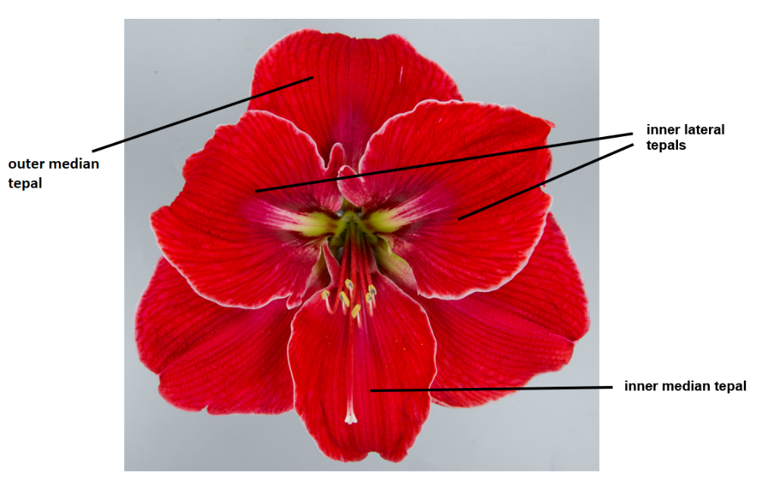
 | Characteristics containing the following key in the Table of Characteristics should be examined as indicated below:
(a) | Observations should be made when all flowers on the first peduncle are open.

(b) | Observations on the leaf should be made on the largest fully expanded leaf. This is in most cases after the flowering period.
(c) | Observations on peduncle and bracts should be made before the flowers open.
(d) | Observations on the flower should be made when the anthers are open.
(e) | The main color is the color with the largest surface area. In cases where the areas of the main and secondary color are too similar to reliably decide which color has the largest area, the darker color is considered to be the main color.
(f) | Observations on the color of outer side should only be made if the color is clearly different from the color of the inner side.

8.2 | Explanations for individual characteristics
Ad. 1: Leaf: width

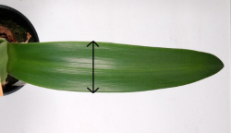

Ad. 2: Leaf: anthocyanin coloration

Anthocyanin coloration of leaf should be observed on the basal part of the leaf.

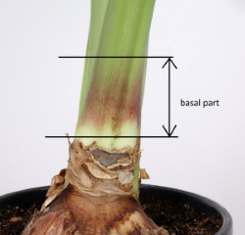

Ad. 3: Peduncle: length

Length of peduncle should be observed from the top of the bulb to the base of the pedicel.

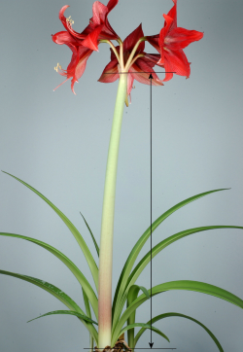

Ad. 4: Peduncle: width

Width of peduncle should be observed on the broadest part at middle third of peduncle.

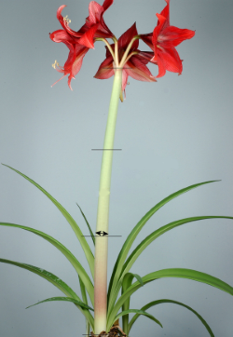

Ad. 5: Peduncle: anthocyanin coloration

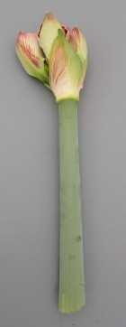 | 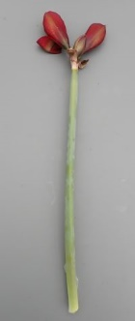 |  | 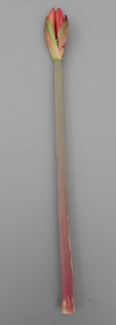 | 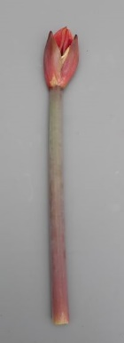
1 | 2 | 3 | 4 | 5
absent or very weak | weak | medium | strong | very strong

Ad. 6: Only varieties with anthocyanin coloration: present: Peduncle: distribution of anthocyanin coloration

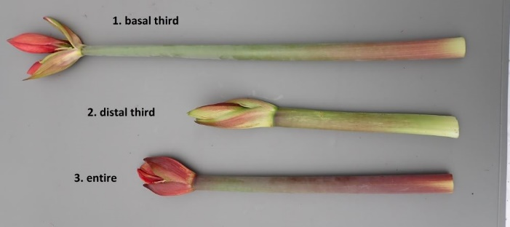

Ad. 7: Bracts: anthocyanin coloration

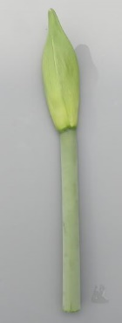 | 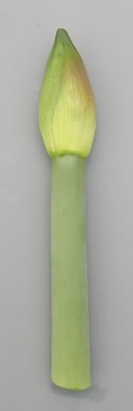 | 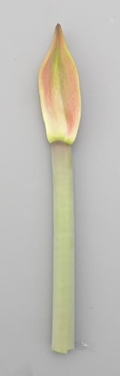 | 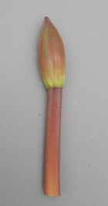 | 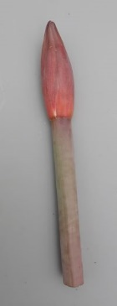
1 | 2 | 3 | 4 | 5
absent or very weak | weak | medium | strong | very strong

Ad. 8: Bracts: intensity of green color

Only to be observed for varieties with 'Bracts: anthocanin coloration' less than strong (less than note 7 to 9).
​
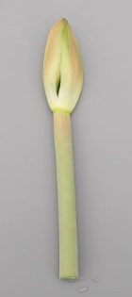 |  | 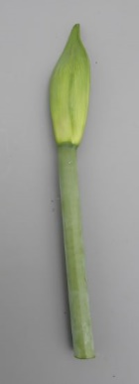
1 | 2 | 3 | 4 | 5
very light | light | medium | dark | very dark

Ad. 10: Flower: type

Double flowers have more than 6 tepals.

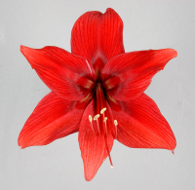 | 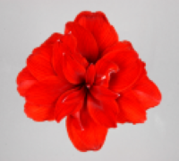
1 | 2
single | double

Ad. 11: Only varieties with flower type: double: Flower: shape of petaloid staminodes

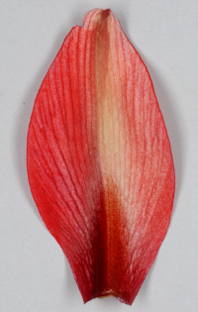 | 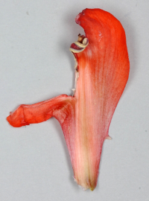
1 | 2
regular | irregular

Ad. 12: Flower: attitude of perianth (excluding pedicel)

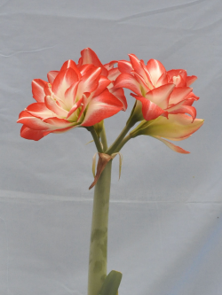 | 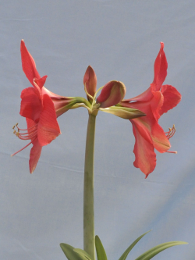 | 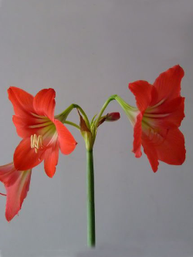
1 | 3 | 5
erect | horizontal | drooping

Ad. 13: Pedicel: length

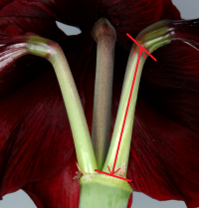

Ad. 14: Pedicel: anthocyanin coloration

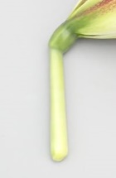 | 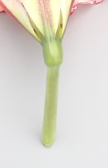 | 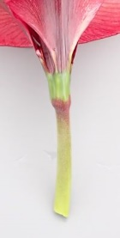 | 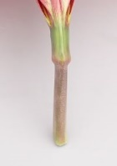
1 | 2 | 3 | 4 | 5
absent or very weak | weak | medium | strong | very strong

Ad. 15: Flower: shape in front view

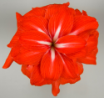 | 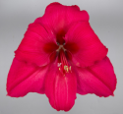 | 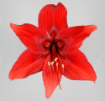
1 | 2 | 3
round | triangular | star shaped

Ad. 16: Flower: length of perianth

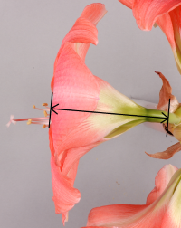

Ad. 17: Flower: maximum width of perianth

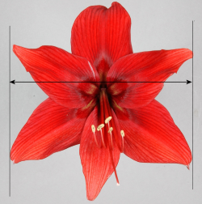

Ad. 19: Outer median tepal: shape of apex

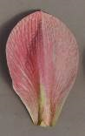 | 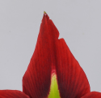 | 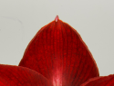
1 | 2 | 3
rounded | acute | acuminate

Ad. 24: Outer median tepal: color pattern

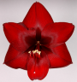 | 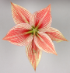 | 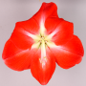 | 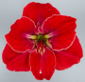 | 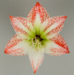
1 | 2 | 3 | 4 | 5
none | veined | star-shaped | narrow marginated | striped-speckled

Ad. 25: Only varieties with outer median tepal: secondary color of inner side: absent: Outer median tepal: conspicuousness of veins

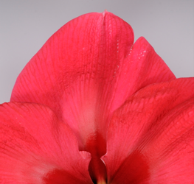 | 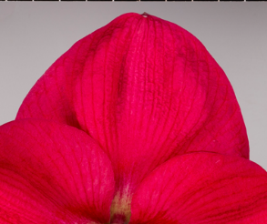 | 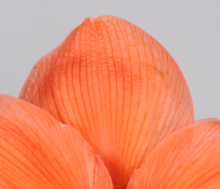 | 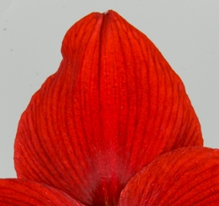 | 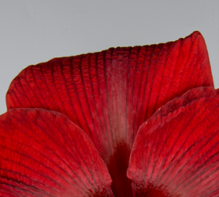
1 | 2 | 3 | 4 | 5
very weak | weak | medium | strong | very strong

Ad. 35: Inner lateral tepal: depth of incisions

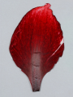 | 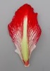 | 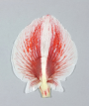 | 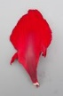
1 | 2 | 3 | 4 | 5
absent or very shallow | shallow | medium | deep | very deep

Ad. 37: Anther: color

Observations on the color of the anther should be made just before dehiscence.

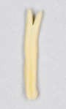 | 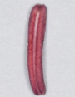 | 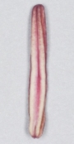 | 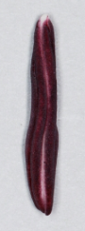
1 | 2 | 3 | 4
yellowish | reddish | pinkish | purplish

Ad. 39: Stigma: size

Observations on the stigma should be made on mature flowers.
​
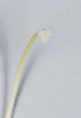 |  | 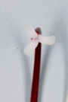
3 | 5 | 7
small | medium | large

9. | Literature

10. | Technical Questionnaire

TECHNICAL QUESTIONNAIRE | Page {x} of {y} | Reference Number:

Application date:
(not to be filled in by the applicant)
TECHNICAL QUESTIONNAIRE
to be completed in connection with an application for plant breeders' rights

1. | Subject of the Technical Questionnaire
 | 1.1 | Botanical name | Hippeastrum Herb.
 | 1.2 | Common name | Amaryllis

2. | Applicant
 | Name
 | Address
 | Telephone No.
 | Fax No.
 | E-mail address
 | Breeder (if different from
 | applicant)

3. | Proposed denomination and breeder's reference
 | Proposed denomination
 | (if available)
 | Breeder's reference

TECHNICAL QUESTIONNAIRE |  |  | Page {x} of {y} | Reference Number:
#4. | Information on the breeding scheme and propagation of the variety
 | 4.1 | Breeding scheme
 | Variety resulting from:
4.1.1 | Crossing
(a) | controlled cross | [ ]
(please state parent variety)

(…………………..……………..…) x (……………..…………………..…)

female parent male parent

(b) | partially known cross | [ ]
(please state known parent variety(ies))

(…………………..……………..…) x (……………..…………………..…)

female parent male parent

(c) | unknown cross | [ ]
4.1.2 | Mutation  (please state parent variety) | [ ]
4.1.3 | Discovery and development  (please state where and when discovered and how developed) | [ ]
4.1.4 | Other  (Please provide details) | [ ]

TECHNICAL QUESTIONNAIRE | Page {x} of {y} | Reference Number:

 | 4.2 | Method of propagating the variety
4.2.1 | Vegetative propagation
(a) | In vitro propagation | [ ]
(b) | Division | [ ]
(c) | Other (state method) | [ ]
4.2.2 | Other  (Please provide details) | [ ]

TECHNICAL QUESTIONNAIRE | Page {x} of {y} | Reference Number:

5. | Characteristics of the variety to be indicated (the number in brackets refers to the corresponding characteristic in Test Guidelines; please mark the note which best corresponds).

 | Characteristics | Example Varieties | Note
5.1  (10) | Flower: type
 | single | Peach Melba | 1 [ ]
 | double | Scarlet Belle | 2 [ ]
5.2  (17) | Flower: maximum width of perianth
 | very narrow |  | 1 [ ]
 | very narrow to narrow |  | 2 [ ]
 | narrow | White Garden | 3 [ ]
 | narrow to medium |  | 4 [ ]
 | medium | Coral Flame | 5 [ ]
 | medium to broad |  | 6 [ ]
 | broad | Tosca | 7 [ ]
 | broad to very broad |  | 8 [ ]
 | very broad |  | 9 [ ]
5.3(i)  (22) | Outer median tepal: main color of inner side
 | RHS Colour Chart (indicate reference number)
5.4(ii)  (22) | Outer lateral tepal: main color of inner side
 | white | White Garden | 1 [ ]
 | yellow green |  | 2 [ ]
 | orange | Peach Melba | 3 [ ]
 | light pink |  | 4 [ ]
 | medium pink | Estella | 5 [ ]
 | dark pink |  | 6 [ ]
 | medium red | Monaco | 7 [ ]
 | dark red |  | 8 [ ]
 | other (please indicate) |  | 9 [ ]

TECHNICAL QUESTIONNAIRE | Page {x} of {y} | Reference Number:

6. | Similar varieties and differences from these varieties
Please use the following table and box for comments to provide information on how your candidate variety differs from the variety (or varieties) which, to the best of your knowledge, is (or are) most similar. This information may help the examination authority to conduct its examination of distinctness in a more efficient way.

Denomination(s) of variety(ies) similar to your candidate variety | Characteristic(s) in which your candidate variety differs from the similar variety(ies) | Describe the expression of the characteristic(s) for the similar variety(ies) | Describe the expression of the characteristic(s) for your candidate variety

Example | Peduncle: length | short | medium

 | Comments:

TECHNICAL QUESTIONNAIRE | Page {x} of {y} | Reference Number:

#7. | Additional information which may help in the examination of the variety
7.1 | In addition to the information provided in sections 5 and 6, are there any additional characteristics which may help to distinguish the variety?
 | Yes | [ ] | No | [ ]
 | (If yes, please provide details)
7.2 | Are there any special conditions for growing the variety or conducting the examination?
 | Yes | [ ] | No | [ ]
 | (If yes, please provide details)
7.3 | Other information
A representative color photograph of the variety displaying its main distinguishing feature(s), should accompany the Technical Questionnaire. The photograph will provide a visual illustration of the candidate variety which supplements the information provided in the Technical Questionnaire.
The key points to consider when taking a photograph of the candidate variety are:
• Indication of the date and geographic location
• Correct labeling (breeder’s reference)
• Good quality printed photograph (minimum 10 cm x 15 cm) and/or sufficient resolution electronic format version (minimum 960 x 1280 pixels)”
Further guidance on providing photographs with the Technical Questionnaire is available in document TGP/7 "Development of Test Guidelines", Guidance Note 35 (http://www.upov.int/tgp/en/).
[The link provided may be deleted by members of the Union when developing authorities’ own test guidelines.]
- Resistance to pests and diseases

TECHNICAL QUESTIONNAIRE | Page {x} of {y} | Reference Number:

8. | Authorization for release
 | (a) | Does the variety require prior authorization for release under legislation concerning the protection of the environment, human and animal health?
 |  | Yes | [ ] | No | [ ]
 | (b) | Has such authorization been obtained?
 |  | Yes | [ ] | No | [ ]
 | If the answer to (b) is yes, please attach a copy of the authorization.

9. Information on plant material to be examined or submitted for examination

9.1 The expression of a characteristic or several characteristics of a variety may be affected by factors, such as pests and disease, chemical treatment (e.g. growth retardants or pesticides), effects of tissue culture, different rootstocks, scions taken from different growth phases of a tree, etc.
9.2 The plant material should not have undergone any treatment which would affect the expression of the characteristics of the variety, unless the competent authorities allow or request such treatment. If the plant material has undergone such treatment, full details of the treatment must be given. In this respect, please indicate below, to the best of your knowledge, if the plant material to be examined has been subjected to:

 | (a) | Microorganisms (e.g. virus, bacteria, phytoplasma) | Yes [ ] | No [ ]
 | (b) | Chemical treatment (e.g. growth retardant, pesticide) | Yes [ ] | No [ ]
 | (c) | Tissue culture | Yes [ ] | No [ ]
 | (d) | Other factors | Yes [ ] | No [ ]
 | Please provide details for where you have indicated “yes”.

10. | I hereby declare that, to the best of my knowledge, the information provided in this form is correct:
 | Applicant’s name
 | Signature |  | Date

[End of document]

