 |  | E
TG/148/3(proj.2)
ORIGINAL: English
DATE: 2022-04-29

INTERNATIONAL UNION FOR THE PROTECTION OF NEW VARIETIES OF PLANTS
 | Geneva
 | DRAFT
 | WEIGELA  UPOV Code(s): WEIGE  Weigela Thunb. | *
GUIDELINES
FOR THE CONDUCT OF TESTS
FOR DISTINCTNESS, UNIFORMITY AND STABILITY

prepared by experts from France
to be considered by the
Technical Working Party for Ornamental Plants and Forest Trees

at its fifty-fourth session, to be held virtually,
from 2022-06-13 to 2022-06-17

Disclaimer: this document does not represent UPOV policies or guidance
Alternative names:*

Botanical name | English | French | German | Spanish
Weigela Thunb. | Weigela | Weigela | Weigela | Weigela

The purpose of these guidelines (“Test Guidelines”) is to elaborate the principles contained in the General Introduction (document TG/1/3), and its associated TGP documents, into detailed practical guidance for the harmonized examination of distinctness, uniformity and stability (DUS) and, in particular, to identify appropriate characteristics for the examination of DUS and production of harmonized variety descriptions.
ASSOCIATED DOCUMENTS
These Test Guidelines should be read in conjunction with the General Introduction and its associated TGP documents.

TABLE OF CONTENTS | PAGE
1. | SUBJECT OF THESE TEST GUIDELINES.......................................................................................................... | 3
2. | MATERIAL REQUIRED..................................................................................................................... | 3
3. | METHOD OF EXAMINATION............................................................................................................... | 3
3.1 | Number of Growing Cycles................................................................................................................. | 3
3.2 | Testing Place................................................................................................................... | 3
3.3 | Conditions for Conducting the Examination............................................................................................... | 3
3.4 | Test Design................................................................................................................. | 5
3.5 | Additional Tests................................................................................................................... | 5

4. | ASSESSMENT OF DISTINCTNESS, UNIFORMITY AND STABILITY................................................................. | 5
4.1 | Distinctness.......................................................................................................... | 5
4.2 | Uniformity............................................................................................................ | 6
4.3 | Stability............................................................................................................... | 6

5. | GROUPING OF VARIETIES AND ORGANIZATION OF THE GROWING TRIAL................................................ | 7
6. | INTRODUCTION TO THE TABLE OF CHARACTERISTICS................................................................................ | 9
6.1 | Categories of Characteristics...................................................................................................... | 9
6.2 | States of Expression and Corresponding Notes........................................................................................ | 9
6.3 | Types of Expression............................................................................................................ | 9
6.4 | Example Varieties.............................................................................................................. | 9
6.5 | Legend................................................................................................................. | 10

7. | TABLE OF CHARACTERISTICS/TABLEAU DES CARACTÈRES/MERKMALSTABELLE/TABLA DE CARACTERES.................................................................................................................. | 11
8. | EXPLANATIONS ON THE TABLE OF CHARACTERISTICS............................................................................... | 24
8.1 | Explanations covering several characteristics........................................................................................... | 24
8.2 | Explanations for individual characteristics................................................................................................. | 26

9. | LITERATURE................................................................................................................... | 34
10 | TECHNICAL QUESTIONNAIRE............................................................................................................ | 35

1. | Subject of these Test Guidelines
 | These Test Guidelines apply to all varieties of Weigela Thunb., but primarily to varieties of hybrids between Weigela coraeensis Thunb., Weigela floribunda (Sieb. et Zucc.) K. Koch, Weigela florida (Bunge) A.DC. and Weigela hortensis (Sieb. et Zucc.) K. Koch.

2. | Material Required
2.1 | The competent authorities decide on the quantity and quality of the plant material required for testing the variety and when and where it is to be delivered. Applicants submitting material from a State other than that in which the testing takes place must ensure that all customs formalities and phytosanitary requirements are complied with.
2.2 | The material is to be supplied in the form of plants (two years old) on their own roots.
2.3 | The minimum quantity of plant material, to be supplied by the applicant, should be:
 | 6 plants
2.4 | The plant material supplied should be visibly healthy, not lacking in vigor, nor affected by any important pest or disease.
2.5 | The plant material should not have undergone any treatment which would affect the expression of the characteristics of the variety, unless the competent authorities allow or request such treatment. If it has been treated, full details of the treatment must be given.

3. | Method of Examination
3.1 | Number of Growing Cycles
3.1.1 | The minimum duration of tests should normally be a single growing cycle.
3.1.2 | The testing of a variety may be concluded when the competent authority can determine with certainty the outcome of the test.
3.2 | Testing Place
 | Tests are normally conducted at one place. In the case of tests conducted at more than one place, guidance is provided in TGP/9 “Examining Distinctness”.
3.3 | Conditions for Conducting the Examination
3.3.1 | The tests should be carried out under conditions ensuring satisfactory growth for the expression of the relevant characteristics of the variety and for the conduct of the examination.

3.3.2 | Because daylight varies, color determinations made against a color chart should be made either in a suitable cabinet providing artificial daylight or in the middle of the day in a room without direct sunlight. The spectral distribution of the illuminant for artificial daylight should conform with the CIE Standard of Preferred Daylight D 6500 and should fall within the tolerances set out in the British Standard 950, Part I. These determinations should be made with the plant part placed against a white background. The color chart and version used should be specified in the variety description.

3.4 | Test Design
3.4.1 | Each test should be designed to result in a total of at least 6 plants.
3.4.2 | The design of the tests should be such that plants or parts of plants may be removed for measurement or counting without prejudice to the observations which must be made up to the end of the growing cycle.
3.5 | Additional Tests
 | Additional tests, for examining relevant characteristics, may be established.

4. | Assessment of Distinctness, Uniformity and Stability
4.1 | Distinctness
4.1.1 | General Recommendations
 | It is of particular importance for users of these Test Guidelines to consult the General Introduction prior to making decisions regarding distinctness. However, the following points are provided for elaboration or emphasis in these Test Guidelines.
4.1.2 | Consistent Differences
 | The differences observed between varieties may be so clear that more than one growing cycle is not necessary. In addition, in some circumstances, the influence of the environment is not such that more than a single growing cycle is required to provide assurance that the differences observed between varieties are sufficiently consistent. One means of ensuring that a difference in a characteristic, observed in a growing trial, is sufficiently consistent is to examine the characteristic in at least two independent growing cycles.
4.1.3 | Clear Differences
 | Determining whether a difference between two varieties is clear depends on many factors, and should consider, in particular, the type of expression of the characteristic being examined, i.e. whether it is expressed in a qualitative, quantitative, or pseudo-qualitative manner. Therefore, it is important that users of these Test Guidelines are familiar with the recommendations contained in the General Introduction prior to making decisions regarding distinctness.
4.1.4 | Number of Plants or Parts of Plants to be Examined
 | Unless otherwise indicated, for the purposes of distinctness, all observations on single plants should be made on 5 plants or parts of plants taken from each of 5 plants and any other observations made on all plants in the test, disregarding any off-type plants.
4.1.5 | Method of Observation
 | The recommended method of observing the characteristic for the purposes of distinctness is indicated by the following key in the Table of Characteristics (see document TGP/9 “Examining Distinctness”, Section 4 “Observation of characteristics”):
MG: single measurement of a group of plants or parts of plants
MS: measurement of a number of individual plants or parts of plants
VG: visual assessment by a single observation of a group of plants or parts of plants
VS: visual assessment by observation of individual plants or parts of plants

Type of observation: visual (V) or measurement (M)
“Visual” observation (V) is an observation made on the basis of the expert’s judgment. For the purposes of this document, “visual” observation refers to the sensory observations of the experts and, therefore, also includes smell, taste and touch. Visual observation includes observations where the expert uses reference points (e.g. diagrams, example varieties, side-by-side comparison) or non-linear charts (e.g. color charts). Measurement (M) is an objective observation against a calibrated, linear scale e.g. using a ruler, weighing scales, colorimeter, dates, counts, etc.
Type of record: for a group of plants (G) or for single, individual plants (S)

For the purposes of distinctness, observations may be recorded as a single record for a group of plants or parts of plants (G), or may be recorded as records for a number of single, individual plants or parts of plants (S). In most cases, “G” provides a single record per variety and it is not possible or necessary to apply statistical methods in a plant-by-plant analysis for the assessment of distinctness.

In cases where more than one method of observing the characteristic is indicated in the Table of Characteristics (e.g. VG/MG), guidance on selecting an appropriate method is provided in document TGP/9, Section 4.2.

4.2 | Uniformity
4.2.1 | It is of particular importance for users of these Test Guidelines to consult the General Introduction prior to making decisions regarding uniformity. However, the following points are provided for elaboration or emphasis in these Test Guidelines:
4.2.2 | These Test Guidelines have been developed for the examination of vegetatively propagated varieties. For varieties with other types of propagation, the recommendations in the General Introduction and document TGP/13 "Guidance for new types and species" Section 4.5 "Testing Uniformity" should be followed.
4.2.3 | For the assessment of uniformity of vegetatively propagated varieties, a population standard of 1% and an acceptance probability of at least 95% should be applied. In the case of a sample size of 6 plants, 1 off-type is allowed.
4.3 | Stability
4.3.1 | In practice, it is not usual to perform tests of stability that produce results as certain as those of the testing of distinctness and uniformity. However, experience has demonstrated that, for many types of variety, when a variety has been shown to be uniform, it can also be considered to be stable.
4.3.2 | Where appropriate, or in cases of doubt, stability may be further examined by testing a new plant stock to ensure that it exhibits the same characteristics as those shown by the initial material supplied.

5. | Grouping of Varieties and Organization of the Growing Trial
5.1 | The selection of varieties of common knowledge to be grown in the trial with the candidate varieties and the way in which these varieties are divided into groups to facilitate the assessment of distinctness are aided by the use of grouping characteristics.
5.2 | Grouping characteristics are those in which the documented states of expression, even where produced at different locations, can be used, either individually or in combination with other such characteristics: (a) to select varieties of common knowledge that can be excluded from the growing trial used for examination of distinctness; and (b) to organize the growing trial so that similar varieties are grouped together.
5.3 | The following have been agreed as useful grouping characteristics:
(a) |  | Plant: growth habit (characteristic 3)
(b) |  | Shoot: color (characteristic 5)
(c) |  | Leaf blade: main color (characteristic 16)
(d) |  | Leaf blade: secondary color (characteristic 17)
(e) |  | Leaf blade: presence of tertiary color (characteristic 19)
(f) |  | Inflorescence: type (characteristic 24)
(g) |  | Flower: presence of different colored flowers on the same plant (characteristic 28)
(h) |  | Only varieties with Flower: presence of different colored flowers on the same plant: absent: Corolla lobe: main color of outer side (characteristic 29) with the following groups:  Gr. 1: white  Gr. 2: yellow  Gr. 3: pink  Gr. 4: red  Gr. 5: purple
(i) |  | Only varieties with Flower: presence of different colored flowers on the same plant: absent: Corolla lobe: main color of inner side (characteristic 32) with the following groups :  Gr. 1: white  Gr. 2: yellow  Gr. 3: pink  Gr. 4: red  Gr. 5: purple

(j) |  | Only varieties with Flower: presence of different colored flowers on the same plant: present: Corolla lobe: main color of outer side of the predominantly present flower (characteristic 35) with the following groups :  Gr. 1: white  Gr. 2: pink  Gr. 3: red  Gr. 4: purple
(k) |  | Only varieties with Flower: presence of different colored flowers on the same plant: present: Corolla lobe: main color of inner side of the predominantly present flower (characteristic 36) with the following groups:  Gr. 1: white  Gr. 2: pink  Gr. 3: red  Gr. 4: purple
(l) |  | Only varieties with Flower: presence of different colored flowers on the same plant: present: Corolla lobe: main color of outer side of the second predominantly present flower (characteristic 37) with the following groups :  Gr. 1: white  Gr. 2: pink  Gr. 3: red  Gr. 4: purple
(m) |  | Only varieties with Flower: presence of different colored flowers on the same plant: present: Corolla lobe: main color of inner side of the second predominantly present flower (characteristic 38) with the following groups :  Gr. 1: white  Gr. 2: pink  Gr. 3: red  Gr. 4: purple
(n) |  | Only varieties with Flower: presence of different colored flowers on the same plant: present: Corolla lobe: main color of outer side of the third predominantly present flower (characteristic 39) with the following groups :  Gr. 1: white  Gr. 2: pink  Gr. 3: red  Gr. 4: purple

(o) |  | Only varieties with Flower: presence of different colored flowers on the same plant: present: Corolla lobe: main color of inner side of the third predominantly present flower (characteristic 40) with the following groups :  Gr. 1: white  Gr. 2: pink  Gr. 3: red  Gr. 4: purple
(p) |  | Corolla throat: color of blotch (characteristic 42)
(q) |  | Time of beginning of flowering (characteristic 44)

5.4 | Guidance for the use of grouping characteristics, in the process of examining distinctness, is provided through the General Introduction and document TGP/9 “Examining Distinctness”.

6. | Introduction to the Table of Characteristics
6.1 | Categories of Characteristics
6.1.1 | Standard Test Guidelines Characteristics
 | Standard Test Guidelines characteristics are those which are approved by UPOV for examination of DUS and from which members of the Union can select those suitable for their particular circumstances.

6.1.2 | Asterisked Characteristics
 | Asterisked characteristics (denoted by *) are those included in the Test Guidelines which are important for the international harmonization of variety descriptions and should always be examined for DUS and included in the variety description by all members of the Union, except when the state of expression of a preceding characteristic or regional environmental conditions render this inappropriate.
6.2 | States of Expression and Corresponding Notes
6.2.1 | States of expression are given for each characteristic to define the characteristic and to harmonize descriptions. Each state of expression is allocated a corresponding numerical note for ease of recording of data and for the production and exchange of the description.
6.2.2 | All relevant states of expression are presented in the characteristic.
6.2.3 | Further explanation of the presentation of states of expression and notes is provided in document TGP/7 “Development of Test Guidelines”.
6.3 | Types of Expression
 | An explanation of the types of expression of characteristics (qualitative, quantitative and pseudo-qualitative) is provided in the General Introduction.
6.4 | Example Varieties
 | Where appropriate, example varieties are provided to clarify the states of expression of each characteristic.

6.5 | Legend
 |  | English |  | français |  | deutsch | español | Example Varieties  Exemples  Be ejemplo | Note
1 | 2 | 3 | 4 | 5 | 6 | 7
 |  | Name of characteristics in English |  | Nom du caractère en français |  | Name des Merkmals auf Deutsch | Nombre del carácter en español
 |  | states of expression |  | types d’expression |  | Ausprägungsstufen | tipos de expresión

1 | Characteristic number
2 | (*) | Asterisked characteristic | – see Chapter 6.1.2
3 | Type of expression
 | QL | Qualitative characteristic | – see Chapter 6.3
 | QN | Quantitative characteristic | – see Chapter 6.3
 | PQ | Pseudo-qualitative characteristic | – see Chapter 6.3
4 | Method of observation (and type of plot, if applicable)
 | MG, MS, VG, VS |  | – see Chapter 4.1.5
5 | (+) | See Explanations on the Table of Characteristics in Chapter 8.2
6 | (a)-(j) | See Explanations on the Table of Characteristics in Chapter 8.1
7 | Not applicable

7. | Table of Characteristics/Tableau des caractères/Merkmalstabelle/Tabla de caracteres

 |  | English |  | français |  | deutsch | español | Example Varieties  Exemples  Beispielssorten  Variedades ejemplo | Note/  Nota
1. |  | QN | MG/VG |  | (a)
 |  | Plant: height
 |  | very short |  |  |  |  |  | Elvera | 1
 |  | very short to short |  |  |  |  |  |  | 2
 |  | short |  |  |  |  |  | Bokraspark | 3
 |  | short to medium |  |  |  |  |  |  | 4
 |  | medium |  |  |  |  |  | Wagneri | 5
 |  | medium to tall |  |  |  |  |  |  | 6
 |  | tall |  |  |  |  |  | Girondin | 7
 |  | tall to very tall |  |  |  |  |  |  | 8
 |  | very tall |  |  |  |  |  | Le Printemps | 9
2. |  | QN | VG |  | (a)
 |  | Plant: height in relation to width
 |  | taller than broad |  |  |  |  |  | Alexandra | 1
 |  | as tall as broad |  |  |  |  |  | Bokraspark | 2
 |  | broader than tall |  |  |  |  |  | Styriaca | 3
3. | (*) | QN | VG |  | (a)
 |  | Plant: growth habit
 |  | erect |  |  |  |  |  | Alexandra | 1
 |  | semi erect |  |  |  |  |  | Bokraspark | 2
 |  | rounded |  |  |  |  |  | Elvera | 3
 |  | spreading |  |  |  |  |  | Styriaca | 4
4. |  | QN | VG |  | (a)
 |  | Plant: density
 |  | sparse |  |  |  |  |  | Fiesta | 1
 |  | sparse to medium |  |  |  |  |  |  | 2
 |  | medium |  |  |  |  |  | Kolsunn | 3
 |  | medium to dense |  |  |  |  |  |  | 4
 |  | dense |  |  |  |  |  | TVP2 | 5

 |  | English |  | français |  | deutsch | español | Example Varieties  Exemples  Beispielssorten  Variedades ejemplo | Note/  Nota
5. | (*) | PQ | VG |  | (b)
 |  | Shoot: color
 |  | green |  |  |  |  |  | Candida | 1
 |  | red |  |  |  |  |  | Courtadur | 2
 |  | brownish purple |  |  |  |  |  | Alexandra | 3
6. |  | QN | VG |  | (b)
 |  | Shoot: shape in cross-section
 |  | rounded |  |  |  |  |  | Maximowiczii | 1
 |  | rounded to slightly angular |  |  |  |  |  | Courtadur | 2
 |  | angular |  |  |  |  |  | Descartes | 3
7. |  | QN | VG | (+) | (b), (c)
 |  | Leaf blade: attitude in relation to the shoot
 |  | upwards |  |  |  |  |  | Kolmagira | 1
 |  | outwards |  |  |  |  |  | Kolsunn | 2
 |  | downwards |  |  |  |  |  | Styriaca | 3
8. |  | QN | MG/MS/VG | (+) | (b), (c)
 |  | Leaf blade: length
 |  | very short |  |  |  |  |  |  | 1
 |  | very short to short |  |  |  |  |  |  | 2
 |  | short |  |  |  |  |  | Bokraspark | 3
 |  | short to medium |  |  |  |  |  |  | 4
 |  | medium |  |  |  |  |  | Wagneri | 5
 |  | medium to long |  |  |  |  |  |  | 6
 |  | long |  |  |  |  |  | Conquête | 7
 |  | long to very long |  |  |  |  |  |  | 8
 |  | very long |  |  |  |  |  |  | 9

 |  | English |  | français |  | deutsch | español | Example Varieties  Exemples  Beispielssorten  Variedades ejemplo | Note/  Nota
9. |  | QN | MG/MS/VG | (+) | (b), (c)
 |  | Leaf blade: width
 |  | very narrow |  |  |  |  |  |  | 1
 |  | very narrow to narrow |  |  |  |  |  |  | 2
 |  | narrow |  |  |  |  |  | Bokraspark | 3
 |  | narrow to medium |  |  |  |  |  |  | 4
 |  | medium |  |  |  |  |  | Wagneri | 5
 |  | medium to broad |  |  |  |  |  |  | 6
 |  | broad |  |  |  |  |  | Conquête | 7
 |  | broad to very broad |  |  |  |  |  |  | 8
 |  | very broad |  |  |  |  |  |  | 9
10 | (*) | PQ | VG |  | (b), (c)
 |  | Leaf blade: shape
 |  | ovate |  |  |  |  |  | Styriaca | 1
 |  | elliptic |  |  |  |  |  | TVP2 | 2
 |  | obovate |  |  |  |  |  | Canary | 3
11 |  | QN | VG | (+) | (b), (c)
 |  | Leaf blade: shape in cross-section
 |  | concave |  |  |  |  |  | Wings of fire | 1
 |  | flat |  |  |  |  |  |  | 2
 |  | convex |  |  |  |  |  | Bokraspark | 3
12 |  | QN | VG | (+) | (b), (c)
 |  | Leaf blade: blistering
 |  | absent or weak |  |  |  |  |  | Alexandra | 1
 |  | weak to medium |  |  |  |  |  | Courtared | 2
 |  | medium |  |  |  |  |  | Féerie | 3
 |  | medium to strong |  |  |  |  |  | Courtatom | 4
 |  | strong |  |  |  |  |  | Caricature | 5
13 | (*) | QN | VG |  | (b), (c)
 |  | Leaf blade: pubescence of lower side
 |  | absent or sparse |  |  |  |  |  | Venusta | 1
 |  | medium |  |  |  |  |  | TVP2 | 2
 |  | dense |  |  |  |  |  | Courtadur | 3

 |  | English |  | français |  | deutsch | español | Example Varieties  Exemples  Beispielssorten  Variedades ejemplo | Note/  Nota
14 |  | QN | VG | (+) | (b), (c)
 |  | Leaf blade: undulation of margin
 |  | absent or weak |  |  |  |  |  | Alexandra | 1
 |  | medium |  |  |  |  |  | Kosteriana Variegata | 2
 |  | strong |  |  |  |  |  | Courtared | 3
15 |  | QN | VG |  | (b), (c)
 |  | Leaf blade: depth of incisions of margin
 |  | absent or shallow |  |  |  |  |  | Caricature | 1
 |  | medium |  |  |  |  |  | Alexandra | 2
 |  | deep |  |  |  |  |  | Styriaca | 3
16 | (*) | PQ | VG |  | (b), (c), (d), (e)
 |  | Leaf blade: main color
 |  | yellow |  |  |  |  |  | Newzako | 1
 |  | light green |  |  |  |  |  | Golden candy | 2
 |  | medium green |  |  |  |  |  | Styriaca | 3
 |  | dark green |  |  |  |  |  | Bristol Ruby | 4
 |  | purple |  |  |  |  |  | Alexandra | 5
17 | (*) | PQ | VG |  | (b), (c), (e), (f)
 |  | Leaf blade: secondary color
 |  | none |  |  |  |  |  | Alexandra | 1
 |  | white |  |  |  |  |  | Kolsunn | 2
 |  | yellowish white |  |  |  |  |  | Verweig | 3
 |  | yellow |  |  |  |  |  | Brigela | 4
 |  | yellow green |  |  |  |  |  | Milk and Honey | 5
 |  | dark green |  |  |  |  |  | Olympiade | 6
18 |  | PQ | VG | (+) | (b), (c), (e), (f)
 |  | Leaf blade: distribution of secondary color
 |  | on margin only |  |  |  |  |  | Marginata Alba | 1
 |  | marginal zone |  |  |  |  |  | Brigela | 2
 |  | central zone |  |  |  |  |  | Olympiade | 3
 |  | irregular |  |  |  |  |  | Milk and Honey | 4

 |  | English |  | français |  | deutsch | español | Example Varieties  Exemples  Beispielssorten  Variedades ejemplo | Note/  Nota
19 | (*) | QL | VG |  | (b), (c), (e), (f)
 |  | Leaf blade: presence of tertiary color
 |  | absent |  |  |  |  |  | Alexandra | 1
 |  | present |  |  |  |  |  | Kolmagira, Verweig | 9
20 |  | PQ | VG |  | (b), (c), (e), (f)
 |  | Only varieties with Leaf blade: tertiary color: present: Leaf blade: tertiary color
 |  | RHS Colour Chart (indicate reference number)
21 |  | PQ | VG | (+)
 |  | Flower bud: color
 |  | RHS Colour Chart (indicate reference number)
22 |  | PQ | VG |  | (g)
 |  | Sepal: color
 |  | green |  |  |  |  |  | Candida | 1
 |  | red |  |  |  |  |  | Verweig 4 | 2
23 |  | QN | VG |  | (g)
 |  | Sepal: pubescence
 |  | absent or sparse |  |  |  |  |  |  | 1
 |  | medium |  |  |  |  |  |  | 2
 |  | dense |  |  |  |  |  |  | 3
24 | (*) | QL | VG
 |  | Inflorescence: type
 |  | solitary flower |  |  |  |  |  | Elvera | 1
 |  | simple panicle |  |  |  |  |  | Verweig 4 | 2
 |  | compound panicle |  |  |  |  |  | Courtadur | 3
25 |  | QN | MG/VG |  | (g), (h)
 |  | Corolla: length
 |  | short |  | court |  | kurz | corto |  | 1
 |  | medium |  | moyen |  | mittel | mediano |  | 2
 |  | long |  | long |  | lang | largo |  | 3

 |  | English |  | français |  | deutsch | español | Example Varieties  Exemples  Beispielssorten  Variedades ejemplo | Note/  Nota
26 |  | QN | MG/VG |  | (g), (h)
 |  | Corolla: diameter
 |  | very small |  |  |  |  |  | Slingpink | 1
 |  | very small to small |  |  |  |  |  |  | 2
 |  | small |  |  |  |  |  | Candida | 3
 |  | smal to medium |  |  |  |  |  |  | 4
 |  | medium |  | moyenne |  | mittel | mediana | Fiesta | 5
 |  | medium to large |  |  |  |  |  |  | 6
 |  | large |  |  |  |  |  | Courtadur | 7
 |  | large to very large |  |  |  |  |  |  | 8
 |  | very large |  |  |  |  |  | Conquête | 9
27 |  | QN | VG |  | (g), (h)
 |  | Corolla: length in relation to diameter
 |  | longer than large |  |  |  |  |  | TVP2 | 1
 |  | as long as large |  |  |  |  |  | Bristol Ruby | 2
 |  | larger than long |  |  |  |  |  | Brigela | 3
28 | (*) | QL | VG
 |  | Flower: presence of different colored flowers on the same plant
 |  | absent |  |  |  |  |  |  | 1
 |  | present |  |  |  |  |  |  | 9
29 | (*) | PQ | VG |  | (d), (g), (h)
 |  | Only varieties with Flower: presence of different colored flowers on the same plant: absent: Corolla lobe: main color of outer side
 |  | RHS Colour Chart (indicate reference number)
30 |  | PQ | VG |  | (f), (g), (h)
 |  | Only varieties with Flower: presence of different colored flowers on the same plant: absent: Corolla lobe: secondary color of outer side
 |  | RHS Colour Chart (indicate reference number)

 |  | English |  | français |  | deutsch | español | Example Varieties  Exemples  Beispielssorten  Variedades ejemplo | Note/  Nota
31 |  | PQ | VG | (+) | (f), (g), (h)
 |  | Only varieties with Flower: presence of different colored flowers on the same plant: absent: Corolla lobe: distribution of secondary color of outer side
 |  | on margin only |  |  |  |  |  |  | 1
 |  | marginal zone |  |  |  |  |  |  | 2
 |  | central zone |  |  |  |  |  |  | 3
32 | (*) | PQ | VG |  | (d), (g), (h)
 |  | Only varieties with Flower: presence of different colored flowers on the same plant: absent: Corolla lobe: main color of inner side
 |  | RHS Colour Chart (indicate reference number)
33 |  | PQ | VG |  | (f), (g), (h)
 |  | Only varieties with Flower: presence of different colored flowers on the same plant: absent: Corolla lobe: secondary color of inner side
 |  | RHS Colour Chart (indicate reference number)
34 |  | QN | VG |  | (f), (g), (h)
 |  | Only varieties with Flower: presence of different colored flowers on the same plant: absent: Corolla lobe: area of secondary color on the margin of inner side
 |  | small |  |  |  |  |  |  | 1
 |  | medium |  |  |  |  |  |  | 2
 |  | large |  |  |  |  |  |  | 3

 |  | English |  | français |  | deutsch | español | Example Varieties  Exemples  Beispielssorten  Variedades ejemplo | Note/  Nota
35 | (*) | PQ | VG |  | (g), (h), (i)
 |  | Only varieties with Flower: presence of different colored flowers on the same plant: present: Corolla lobe: main color of outer side of the predominantly present flower
 |  | RHS Colour Chart (indicate reference number)
36 | (*) | PQ | VG |  | (g), (h), (i)
 |  | Only varieties with Flower: presence of different colored flowers on the same plant: present: Corolla lobe: main color of inner side of the predominantly present flower
 |  | RHS Colour Chart (indicate reference number)
37 | (*) | PQ | VG |  | (g), (h), (j)
 |  | Only varieties with Flower: presence of different colored flowers on the same plant: present: Corolla lobe: main color of outer side of the second predominantly present flower
 |  | RHS Colour Chart (indicate reference number)
38 | (*) | PQ | VG |  | (g), (h), (j)
 |  | Only varieties with Flower: presence of different colored flowers on the same plant: present: Corolla lobe: main color of inner side of the second predominantly present flower
 |  | RHS Colour Chart (indicate reference number)

 |  | English |  | français |  | deutsch | español | Example Varieties  Exemples  Beispielssorten  Variedades ejemplo | Note/  Nota
39 | (*) | PQ | VG |  | (g), (h), (j)
 |  | Only varieties with Flower: presence of different colored flowers on the same plant: present: Corolla lobe: main color of outer side of the third predominantly present flower
 |  | RHS Colour Chart (indicate reference number)
40 | (*) | PQ | VG |  | (g), (h), (j)
 |  | Only varieties with Flower: presence of different colored flowers on the same plant: present: Corolla lobe: main color of inner side of the third predominantly present flower
 |  | RHS Colour Chart (indicate reference number)
41 |  | QN | VG | (+) | (g)
 |  | Corolla lobe: attitude
 |  | erect |  |  |  |  |  | Bokrarob | 1
 |  | semi erect |  |  |  |  |  | Gloire des bosquets | 2
 |  | horizontal |  |  |  |  |  | Olympiade | 3
42 | (*) | PQ | VG | (+) | (g)
 |  | Corolla throat: color of blotch
 |  | none |  |  |  |  |  |  | 1
 |  | yellow |  |  |  |  |  | Courtadur | 2
 |  | orange yellow |  |  |  |  |  | Bokrarob | 3
 |  | yellow or red |  |  |  |  |  | Mango | 4
43 | (*) | QN | VG | (+)
 |  | Stigma: position in relation to anthers
 |  | same level |  |  |  |  |  | Kolmas | 1
 |  | slightly above |  |  |  |  |  | Olympiade | 2
 |  | strongly above |  |  |  |  |  | Styriaca | 3

 |  | English |  | français |  | deutsch | español | Example Varieties  Exemples  Beispielssorten  Variedades ejemplo | Note/  Nota
44 | (*) | QN | MG/VG | (+)
 |  | Time of beginning of flowering
 |  | very early |  |  |  |  |  | Canary | 1
 |  | very early to early |  |  |  |  |  |  | 2
 |  | early |  |  |  |  |  | Bokraspark, Pink Princess | 3
 |  | early to medium |  |  |  |  |  |  | 4
 |  | medium |  |  |  |  |  | Abel Carrière | 5
 |  | medium to late |  |  |  |  |  |  | 6
 |  | late |  |  |  |  |  | Bokrarob | 7
 |  | late to very late |  |  |  |  |  |  | 8
 |  | very late |  |  |  |  |  | Marjorie | 9
45 | (*) | QL | VG
 |  | Second flowering
 |  | absent |  |  |  |  |  | Féerie | 1
 |  | present |  |  |  |  |  | Slingco 4 | 9

8. | Explanations on the Table of Characteristics
8.1 | Explanations covering several characteristics
 | Unless otherwise indicated all observations should be made at the time of full flowering (at least 50% of inflorescence with open flowers)
 | Characteristics containing the following key in the Table of Characteristics should be examined as indicated below:
(a) | Observation should be made just before flowering.
(b) | Observations on shoots and leaves should be made on current year shoots.
(c) | Observations should be made on fully expanded leaves.
(d) | The main color is the color with the largest surface area. In cases where the areas of the main and secondary color are too similar to reliably decide which color has the largest area, the darker color is considered to be the main color.
(e) | Assessment and distribution of colors should be made on upper side of the leaf blade
(f) | The secondary color is the color with the second largest surface area. In cases where the areas of the secondary and tertiary color are too similar to reliably decide which color has the largest area, the darker color is considered to be the secondary color.
(g) | 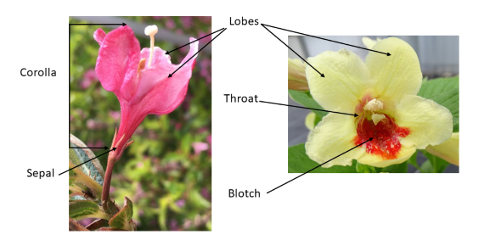

(h) | 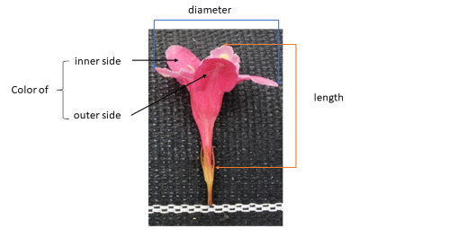

(i) | The predominantly present flower is the flower whose color occurs at the highest frequency on the plant. In cases where the frequency of the predominantly present flower and the second predominantly present flower are too similar to reliably decide which flower has the highest frequency on the plant, the flower with the darker color is considered to be the predominantly present flower.
(j) | The second predominantly present flower is the flower whose color occurs at the second highest frequency on the plant. In cases where the frequency of the second predominantly present flower and the third predominantly present flower are too similar to reliably decide which has the highest frequency, the flower with the darker color is considered to be the second predominantly present flower.

8.2 | Explanations for individual characteristics
Ad. 7: Leaf blade: attitude in relation to the shoot

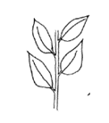 | 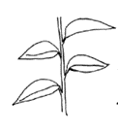 | 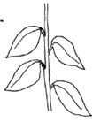
1 | 2 | 3
upwards | outwards | downwards

Ad. 8: Leaf blade: length

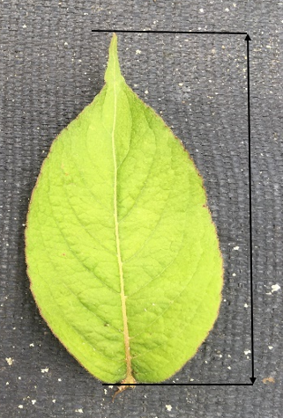

Ad. 9: Leaf blade: width

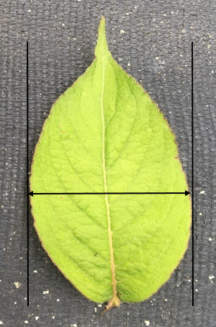

Ad. 11: Leaf blade: shape in cross-section

 |  | 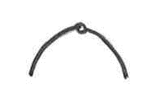
1 | 2 | 3
concave | flat | convexe

Ad. 12: Leaf blade: blistering

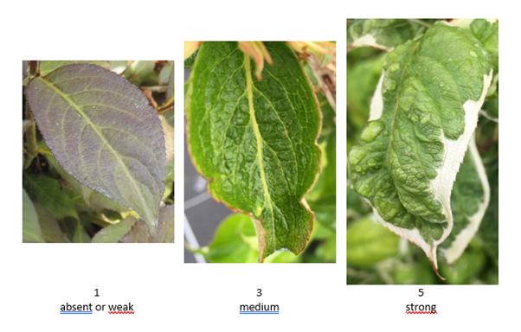

Ad. 14: Leaf blade: undulation of margin
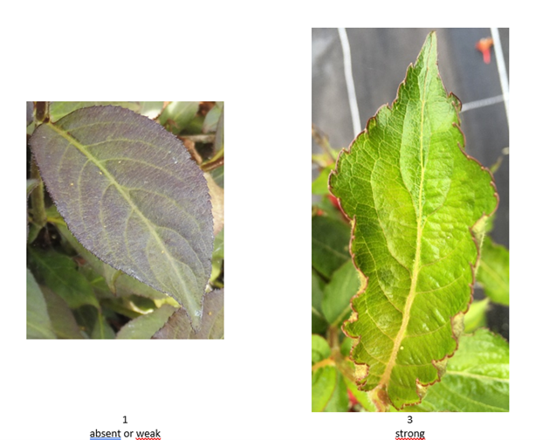

Ad. 18: Leaf blade: distribution of secondary color

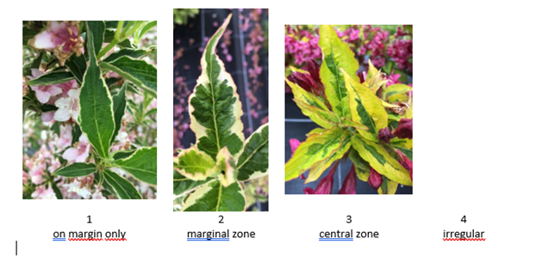

Ad. 21: Flower bud: color

Observation should be made just before opening of the bud.

Ad. 31: Only varieties with Flower: presence of different colored flowers on the same plant: absent: Corolla lobe: distribution of secondary color of outer side

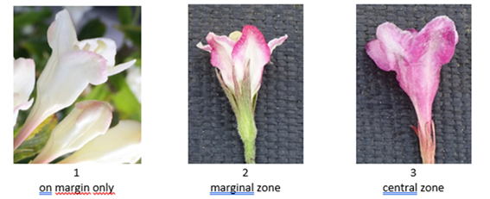

Ad. 41: Corolla lobe: attitude

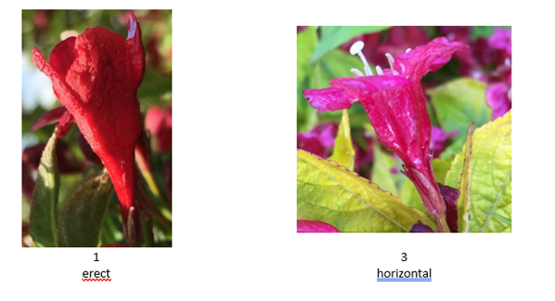

Ad. 42: Corolla throat: color of blotch

State 4 "yellow or red" means that on the same plant there are simultaneously flowers with a yellow blotch in the corolla throat and flowers with a red blotch in the corolla throat.

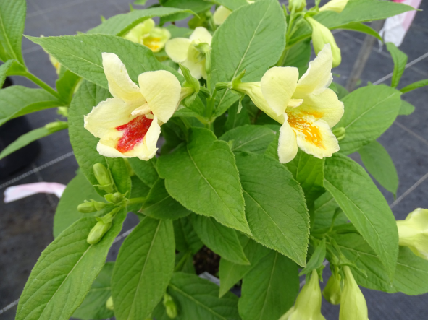

Ad. 43: Stigma: position in relation to anthers

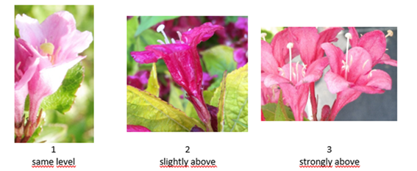

Ad. 44: Time of beginning of flowering

The time of beginning of flowering is reached when all plants have approximately 10% of inflorescences with open flowers.

9. | Literature

Howard, 1965: A check-list of Cultivar names in Weigela. Arnoldia volume 25, 9-11

Kruessman, 1976-77: Handbuch des Laubgehölze. Bd I + II, Paul Parey, Hamburg-DE

Grootendorst, 1968: Weigela. DENDROFLORA, Nr. 5, pp 56-60, Boskoop-NL

De Courtye, 1992: Le Weigela. Chapitre d'ouvrage "Amélioration des espèces végétales cultivées" par A. Gallais et H. Bannerot, Edition INRA, p. 358

10. | Technical Questionnaire

TECHNICAL QUESTIONNAIRE | Page {x} of {y} | Reference Number:

Application date:
(not to be filled in by the applicant)
TECHNICAL QUESTIONNAIRE
to be completed in connection with an application for plant breeders' rights

1. | Subject of the Technical Questionnaire
 | 1.1 | Botanical name | Weigela Thunb.
 | 1.2 | Common name | Weigela
 | 1.3 | Species (please indicate)

2. | Applicant
 | Name
 | Address
 | Telephone No.
 | Fax No.
 | E-mail address
 | Breeder (if different from
 | applicant)

3. | Proposed denomination and breeder's reference
 | Proposed denomination
 | (if available)
 | Breeder's reference

TECHNICAL QUESTIONNAIRE |  |  | Page {x} of {y} | Reference Number:
#4. | Information on the breeding scheme and propagation of the variety
 | 4.1 | Breeding scheme
 | Variety resulting from:
4.1.1 | Crossing
4.1.2 | Mutation  (please state parent variety) | [ ]
4.1.3 | Discovery and development  (please state where and when discovered and how developed) | [ ]
4.1.4 | Other  (Please provide details) | [ ]

TECHNICAL QUESTIONNAIRE | Page {x} of {y} | Reference Number:

 | 4.2 | Method of propagating the variety
4.2.1 | Vegetative propagation
(a) | Cuttings | [ ]
(b) | In vitro propagation | [ ]
(c) | Other (state method) | [ ]
4.2.2 | Other  (Please provide details) | [ ]

TECHNICAL QUESTIONNAIRE | Page {x} of {y} | Reference Number:

5. | Characteristics of the variety to be indicated (the number in brackets refers to the corresponding characteristic in Test Guidelines; please mark the note which best corresponds).

 | Characteristics | Example Varieties | Note
5.1  (3) | Plant: growth habit
 | erect | Alexandra | 1 [ ]
 | semi erect | Bokraspark | 2 [ ]
 | rounded | Elvera | 3 [ ]
 | spreading | Styriaca | 4 [ ]
5.2  (5) | Shoot: color
 | green | Candida | 1 [ ]
 | red | Courtadur | 2 [ ]
 | brownish purple | Alexandra | 3 [ ]
5.3  (16) | Leaf blade: main color
 | yellow | Newzako | 1 [ ]
 | light green | Golden candy | 2 [ ]
 | medium green | Styriaca | 3 [ ]
 | dark green | Bristol Ruby | 4 [ ]
 | purple | Alexandra | 5 [ ]
5.4  (17) | Leaf blade: secondary color
 | none | Alexandra | 1 [ ]
 | white | Kolsunn | 2 [ ]
 | yellowish white | Verweig | 3 [ ]
 | yellow | Brigela | 4 [ ]
 | yellow green | Milk and Honey | 5 [ ]
 | dark green | Olympiade | 6 [ ]
5.5  (19) | Leaf blade: presence of tertiary color
 | absent | Alexandra | 1 [ ]
 | present | Kolmagira, Verweig | 9 [ ]
5.6  (24) | Inflorescence: type
 | solitary flower | Elvera | 1 [ ]
 | simple panicle | Verweig 4 | 2 [ ]
 | compound panicle | Courtadur | 3 [ ]

 | Characteristics | Example Varieties | Note
5.7  (28) | Flower: presence of different colored flowers on the same plant
 | absent |  | 1 [ ]
 | present |  | 9 [ ]
5.8(i)  (29) | Only varieties with Flower: presence of different colored flowers on the same plant: absent: Corolla lobe: main color of outer side
 | RHS Colour Chart (indicate reference number)
5.8(ii)  (29) | Only varieties with Flower: presence of different colored flowers on the same plant: absent: Corolla lobe: main color of outer side
 | white |  | 1 [ ]
 | yellow |  | 2 [ ]
 | pink |  | 3 [ ]
 | red |  | 4 [ ]
 | purple |  | 5 [ ]
 | other (please specify) |  | 6 [ ]
5.9(i)  (32) | Only varieties with Flower: presence of different colored flowers on the same plant: absent: Corolla lobe: main color of inner side
 | RHS Colour Chart (indicate reference number)
5.9(ii)  (32) | Only varieties with Flower: presence of different colored flowers on the same plant: absent: Corolla lobe: main color of inner side
 | white |  | 1 [ ]
 | yellow |  | 2 [ ]
 | pink |  | 3 [ ]
 | red |  | 4 [ ]
 | purple |  | 5 [ ]
 | other (please specify) |  | 6 [ ]
5.10(i)  (35) | Only varieties with Flower: presence of different colored flowers on the same plant: present: Corolla lobe: main color of outer side of the predominantly present flower
 | RHS Colour Chart (indicate reference number)
5.10(ii)  (35) | Only varieties with Flower: presence of different colored flowers on the same plant: present: Corolla lobe: main color of outer side of the predominantly present flower
 | white |  | 1 [ ]
 | pink |  | 2 [ ]
 | red |  | 3 [ ]
 | purple |  | 4 [ ]
 | other (please specify) |  | 5 [ ]

 | Characteristics | Example Varieties | Note
5.11(i)  (36) | Only varieties with Flower: presence of different colored flowers on the same plant: present: Corolla lobe: main color of inner side of the predominantly present flower
 | RHS Colour Chart (indicate reference number)
5.11(ii)  (36) | Only varieties with Flower: presence of different colored flowers on the same plant: present: Corolla lobe: main color of inner side of the predominantly present flower
 | white |  | 1 [ ]
 | pink |  | 2 [ ]
 | red |  | 3 [ ]
 | purple |  | 4 [ ]
 | other (please specify) |  | 5 [ ]
5.12(i)  (37) | Only varieties with Flower: presence of different colored flowers on the same plant: present: Corolla lobe: main color of outer side of the second predominantly present flower
 | RHS Colour Chart (indicate reference number)
5.12(ii)  (37) | Only varieties with Flower: presence of different colored flowers on the same plant: present: Corolla lobe: main color of outer side of the second predominantly present flower
 | white |  | 1 [ ]
 | pink |  | 2 [ ]
 | red |  | 3 [ ]
 | purple |  | 4 [ ]
 | other (please specify) |  | 5 [ ]
5.13(i)  (38) | Only varieties with Flower: presence of different colored flowers on the same plant: present: Corolla lobe: main color of inner side of the second predominantly present flower
 | RHS Colour Chart (indicate reference number)
5.13(ii)  (38) | Only varieties with Flower: presence of different colored flowers on the same plant: present: Corolla lobe: main color of inner side of the second predominantly present flower
 | white |  | 1 [ ]
 | pink |  | 2 [ ]
 | red |  | 3 [ ]
 | purple |  | 4 [ ]
 | other (please specify) |  | 5 [ ]

 | Characteristics | Example Varieties | Note
5.14(i)  (39) | Only varieties with Flower: presence of different colored flowers on the same plant: present: Corolla lobe: main color of outer side of the third predominantly present flower
 | RHS Colour Chart (indicate reference number)
5.14(ii)  (39) | Only varieties with Flower: presence of different colored flowers on the same plant: present: Corolla lobe: main color of outer side of the third predominantly present flower
 | none |  | 1 [ ]
 | white |  | 2 [ ]
 | pink |  | 3 [ ]
 | red |  | 4 [ ]
 | purple |  | 5 [ ]
 | other (please specify) |  | 6 [ ]
5.15(i)  (40) | Only varieties with Flower: presence of different colored flowers on the same plant: present: Corolla lobe: main color of inner side of the third predominantly present flower
 | RHS Colour Chart (indicate reference number)
5.15(ii)  (40) | Only varieties with Flower: presence of different colored flowers on the same plant: present: Corolla lobe: main color of inner side of the third predominantly present flower
 | none |  | 1 [ ]
 | white |  | 2 [ ]
 | pink |  | 3 [ ]
 | red |  | 4 [ ]
 | purple |  | 5 [ ]
 | other (please specify) |  | 6 [ ]
5.16  (42) | Corolla throat: color of blotch
 | none |  | 1 [ ]
 | yellow | Courtadur | 2 [ ]
 | orange yellow | Bokrarob | 3 [ ]
 | yellow or red | Mango | 4 [ ]
 | other (please specify) |  | 5 [ ]
5.17  (44) | Time of beginning of flowering
 | very early | Canary | 1 [ ]
 | very early to early |  | 2 [ ]
 | early | Bokraspark, Pink Princess | 3 [ ]
 | early to medium |  | 4 [ ]
 | medium | Abel Carrière | 5 [ ]
 | medium to late |  | 6 [ ]
 | late | Bokrarob | 7 [ ]
 | late to very late |  | 8 [ ]
 | very late | Marjorie | 9 [ ]

TECHNICAL QUESTIONNAIRE | Page {x} of {y} | Reference Number:

6. | Similar varieties and differences from these varieties
Please use the following table and box for comments to provide information on how your candidate variety differs from the variety (or varieties) which, to the best of your knowledge, is (or are) most similar. This information may help the examination authority to conduct its examination of distinctness in a more efficient way.

Denomination(s) of variety(ies) similar to your candidate variety | Characteristic(s) in which your candidate variety differs from the similar variety(ies) | Describe the expression of the characteristic(s) for the similar variety(ies) | Describe the expression of the characteristic(s) for your candidate variety

Example | Leaf blade: main color | yellow | dark green

 | Comments:

TECHNICAL QUESTIONNAIRE | Page {x} of {y} | Reference Number:

#7. | Additional information which may help in the examination of the variety
7.1 | In addition to the information provided in sections 5 and 6, are there any additional characteristics which may help to distinguish the variety?
 | Yes | [ ] | No | [ ]
 | (If yes, please provide details)
7.2 | Are there any special conditions for growing the variety or conducting the examination?
 | Yes | [ ] | No | [ ]
 | (If yes, please provide details)
7.3 | Other information
A representative color photograph of the variety displaying its main distinguishing feature(s), should accompany the Technical Questionnaire. The photograph will provide a visual illustration of the candidate variety which supplements the information provided in the Technical Questionnaire.
The key points to consider when taking a photograph of the candidate variety are:
• Indication of the date and geographic location
• Correct labeling (breeder’s reference)
• Good quality printed photograph (minimum 10 cm x 15 cm) and/or sufficient resolution electronic format version (minimum 960 x 1280 pixels)”
Further guidance on providing photographs with the Technical Questionnaire is available in document TGP/7 "Development of Test Guidelines", Guidance Note 35 (http://www.upov.int/tgp/en/).
[The link provided may be deleted by members of the Union when developing authorities’ own test guidelines.]

TECHNICAL QUESTIONNAIRE | Page {x} of {y} | Reference Number:

8. | Authorization for release
 | (a) | Does the variety require prior authorization for release under legislation concerning the protection of the environment, human and animal health?
 |  | Yes | [ ] | No | [ ]
 | (b) | Has such authorization been obtained?
 |  | Yes | [ ] | No | [ ]
 | If the answer to (b) is yes, please attach a copy of the authorization.

9. Information on plant material to be examined or submitted for examination

9.1 The expression of a characteristic or several characteristics of a variety may be affected by factors, such as pests and disease, chemical treatment (e.g. growth retardants or pesticides), effects of tissue culture, different rootstocks, scions taken from different growth phases of a tree, etc.
9.2 The plant material should not have undergone any treatment which would affect the expression of the characteristics of the variety, unless the competent authorities allow or request such treatment. If the plant material has undergone such treatment, full details of the treatment must be given. In this respect, please indicate below, to the best of your knowledge, if the plant material to be examined has been subjected to:

 | (a) | Microorganisms (e.g. virus, bacteria, phytoplasma) | Yes [ ] | No [ ]
 | (b) | Chemical treatment (e.g. growth retardant, pesticide) | Yes [ ] | No [ ]
 | (c) | Tissue culture | Yes [ ] | No [ ]
 | (d) | Other factors | Yes [ ] | No [ ]
 | Please provide details for where you have indicated “yes”.

10. | I hereby declare that, to the best of my knowledge, the information provided in this form is correct:
 | Applicant’s name
 | Signature |  | Date

[End of document]

