E
International Union for the Protection of New Varieties of Plants

Technical Working Party for Ornamental Plants and Forest Trees  Fifty-Third Session  Roelofarendsveen, Netherlands, June 7 to 11, 2021 | TWO/53/3  Original: English  Date: February 8, 2022
Reports on Developments in Plant Variety Protection from Members and Observers
Document prepared by the Office of the Union
Disclaimer: this document does not represent UPOV policies or guidance
The Technical Committee (TC), at its forty-seventh session held in Geneva, from April 4 to 6, 2011, agreed to request the Office of the Union to invite experts to submit written reports to the Office of the Union in advance of the Technical Working Party (TWP) sessions in order that a document containing those reports could be prepared by the Office of the Union. The TC noted that TWP experts would be invited to make a brief oral summary of their written report at the session and would also be encouraged to make reports under the agenda item “Experiences with new types and species”, as appropriate. The TC also noted that TWP experts would have an opportunity to raise questions concerning matters of interest (see document TC/47/26 “Report on the Conclusions”, paragraphs 9 and 10).

Written reports were invited by the Office of the Union in Circular E-21/036 of March 16, 2021. The following reports were received (in alphabetical order):

- Members of the Union: Annexes I to VIII: European Union, France, Hungary, Japan, Netherlands, New Zealand, Republic of Korea and the United Kingdom

[Annexes follow]

EUROPEAN UNION

Statistics for 2020

In 2020, the Community Plant Variety Office of the European Union (CPVO) received 3 427 applications for Community plant variety rights (CPVRs). 651 applicants filed applications for CPVRs. In 2020, the distribution between crop sectors was as follows:

- Ornamental, 1459 applications (42.6%); minus 135 applications as compared to 2019
- Agricultural, 978 applications (28.5%)
- Vegetable, 688 applications (20.1%)
- Fruit 302 applications (8.8%).

In 2020, CPVO granted 2978 titles for Community protection; 29 013 titles were in force by the end of the year. National authorities from all over the world regularly base their decisions on applications for CPVRs on technical examinations carried out on behalf of the CPVO (international cooperation, takeover of reports). In 2020 the CPVO provided 7743 technical reports to 60 countries. During 2020, the five countries from which most requests emanated were Kenya, Morocco, Colombia, Brazil and Malaysia.

Administrative Council (AC)

The CPVO is supervised by an Administrative Council (AC) comprising representatives of the EU Member States and the European Commission and their alternates. Breeders organizations attend the meetings as observers. In 2020, the members of the AC took note of the following:

- The European Commission was working on the extension of the duration of protection to 30 years for varieties of asparagus, ornamental bulb species, woody small fruits and woody ornamentals.
- Ongoing development of the EU Plant Variety Portal, unique IT-based contribution system to a database for plant varieties in EU.
- The EUIPO Observatory responded positively to a CPVO request to make a study on the impact of the EU PVR system on the EU economy. The study will be carried out in 2021.

Invite project

The CPVO participates in the ‘Invite’ consortium supported by a grant from the call SFS-29 under the Horizon 2020 program financed by the European Commission. The proposal aims at improving variety testing (both DUS and VCU) in the EU with the help of genotyping, modelling and phenotyping tools. Ten species from the agricultural, vegetable (tomato) and fruit sector are studied in the project; ornamentals are not part of this project. In 2020, an agreement designed by CPVO has been signed by the members of the consortium to define the conditions of access to reference material and raw historical data held by examinations offices. Good progress has been made in all planned tasks despite the lockdown.

International affairs

The CPVO organized a Seminar in Estonia dedicated to Farm-Saved-Seed (FSS) and in particular the functioning of the FSS system in Estonia and the neighboring countries. Such seminar aims to clarify the FSS concept throughout the EU and to encourage cooperation between farmers and breeders on the implementation of the right for information with the view to exercise compliance with the FSS mechanism.

The CPVO participated in several IP Key international outreach activities

- IP Key China: expert training and enforcement seminar
- IP Key LA: On-site events in February; Regional workshop on DUS examination and independence (CoI; QAS)
- IP Key SEA: Awareness seminars for accession to UPOV 91
- CARIPI: revision of PVR legislation in Dominican Republic
- OAPI: on-site event in February

Ornamental sector

Administrative Council decisions on ornamental TPs

In 2020, the following revised technical protocols were prepared for adoption by the AC on 14 April 2021:

- Alstroemeria L. CPVO/TP-029/3
- Phalaenopsis Blume CPVO/TP-213/2-Rev

Statistics

Breeders and producers of ornamentals were hit particularly hard by the outbreak of the Covid-19 pandemic in the beginning of 2020. The CPVO Office responded to this by postponing due dates for payments of all fees until 27 September 2020. Furthermore, the CPVO Office allowed for postponement of the conduct of the technical examination to 2021; however, only a small number of applicants felt the need to make use of such possibility – for 58 ornamental varieties the technical examination was postponed.

With 42.6 % of the applications received in 2020, ornamentals continue to represent the largest group of applications filed for CPVRs, despite the drop of 135 applications compared to the previous year. This drop is within the range of year-to-year variations observed in the past – it is thus not possible to say whether the Covid-19 pandemic had an impact on these figures.

A particularity of ornamentals is the great diversity of species. In all years, there were for many of them a rather low number of applications per species.

The table below shows the 10 most important ornamental crops over the last 5 years (the term ‘importance’ is always used in this text to refer to the number of applications received). Changes in the importance of most of these crops seem to be rather accidental. Roses and chrysanthemums remained by far the most important species in 2020. The application numbers for Phalaenopsis varieties have dropped noticeably.

Species | 2016 | 2017 | 2018 | 2019 | 2020 | Total (1995-2020)
Rosa L. | 185 | 169 | 242 | 175 | 174 | 4802
Chrysanthemum L. | 117 | 148 | 140 | 121 | 78 | 3823
Pelargonium L’Hér. ex Aiton | 43 | 33 | 53 | 56 | 79 | 1758
Calibrachoa Llave & Lex. and Petunia Juss. | 50 | 104 | 78 | 50 | 78 | 1647
Phalaenopsis Blume and x Doritaenopsis hort. | 51 | 134 | 112 | 153 | 108 | 1484
Lilium L. | 50 | 36 | 35 | 21 | 14 | 1335
Gerbera L. | 30 | 30 | 54 | 44 | 18 | 1212
Dianthus L. | 35 | 60 | 35 | 40 | 48 | 1103
Impatiens L. | 10 | 12 | 12 | 16 | 12 | 1006
Anthurium Schott | 30 | 25 | 15 | 30 | 22 | 861
Total | 601 | 751 | 776 | 706 | 631

The ornamental expert meeting

The meeting of ornamental experts was held in form of a video conference in September 2020. The aim of the meeting was to inform examiners of the developments in the work of the CPVO and to discuss items linked to the technical examinations (such as observing in multi-annual tests certain characteristics only once, the adoption and publication of national test protocols by the CPVO, the consideration of disease resistance characteristics in CPVO protocols, obtaining reference varieties for DUS testing, number of plants of reference varieties to be assessed). Some of the discussions held served as preparation for the annual meeting with all the Examination Offices.

For up-to-date information on the CPVO’s activities, please visit the CPVO website, read its newsletter and follow and engage with the CPVO on Twitter: @CPVOTweet

[Annex II follows]

FRANCE

GEVES website can be consulted here www.geves.fr

Description files can be found on the website for the varieties listed on the French catalogue. https://www.geves.fr/catalogue-france/

You can subscribe to our NEWSLETTER available both in French and in English to receive the latest information on GEVES’s expert activities in plants and seeds, at national and international levels. Please subscribe here : https://www.geves.fr/newsletter-en/

The activity in the framework of national listing, PBR, and the activity in the framework of DUS bilateral agreements has slightly increased in 2020.

Main activity remains on agricultural species, but during the last past 3 years, GEVES has significantly developed its activity on ornamental species.

Several ornamental genera have been added into the scope of GEVES : Coreopsis, Salvia, Penstemon, Spiraea, Hibiscus, Leucenthemum, Echinacea, Escallonia, Astrantia, Ipomoea, Iberis, Scabiosa, Chrysanthemum natural season…

In total in 2020, GEVES tested more than 1800 new cultivars for DUS :
- around 1300 new varieties and parental components in the agricultural sector.
Main species tested are maize, wheat, barley, oilseed rape, sunflower, soybean.
- around 250 new candidate varieties in the vegetable sector.
Main species are tomato, melon, lettuce.
- around 200 new candidate varieties in the ornamental sector.
Main species are Hydrangea, Lavandula, Chrysanthemum, Salvia.
- around 70 new candidate varieties in the fruit sector.
Main species tested are apple, pear, peach, cherry, apricot, Japanese plum, vine.

Additional figures can be found on the annual report available on our website.

The International System of Cooperation is active and efficient. For more information, the international cooperation service of GEVES can be contacted here: Camille.zitter@geves.fr

In 2020, the international cooperation service of GEVES received more than 1100 applications, mainly from the European Union but also from all over the world. 70% of the requests are take-over requests and the DUS reports are then sent according to UPOV document TGP/5.

In addition to that, the French National Office for PBR (INOV) has received 89 applications in 2020, out of which 95% were tested for DUS by GEVES.
INOV is involved in UPOV PRISMA for all genera and species.

Regarding the use of molecular markers, GEVES is using in 2020 in routine molecular markers for the management of reference collection according to UPOV guidance, for maize, sorghum, spring barley.
Projects are being currently led on Oilseed rape and Tomato.

For more information on BMT, please contact: GEVES BIOGEVES rene.mathis@geves.fr.

Regarding the use of disease resistance characteristics, GEVES uses in routine genetic disease resistance characteristics, processed in bioassays, for DUS results. It provides also services, facilities, protocols, identified standards and strains for such activities to Examination Offices and seed companies, all over the world. For more information, please contact: GEVES SNES valerie.grimault@geves.fr.

[Annex III follows]

HUNGARY

The National Food Chain Safety Office (NÉBIH) is responsible for national variety registration and preparing the DUS examinations for the National Listing and PBR.

In Hungary there is ornamental plant breeding from some species, such as Doronicum, Pinus, Sorbus, Juniperus, Tilia, Ginkgo, Hedera, Ulmus, Prunus laurocerasus, etc. Most of the Hungarian breeders aim is the European PBR. Some larger nurseries have own breeding activity.

The aim of the breeding is the heat and dry condition tolerance in the case of street trees. The compact growing habit and tolerance of city condition are the other important aims. Additional goals are the spectacular flower form, and long flowering period in case of perennials.

National Listing: The National Food Chain Safety Office (NÉBIH) prepares the National List (NL). The NL is completed each year, following the change of new varieties.

Year by year we take part in the CPVO new species procedure, in connection with we develop national testing guidelines (Cornus, Corylus, etc.) and prepare new national technical protocols (Ulmus, Aesculus, Doronicum, Chaenomeles, etc).

We have more applications from Cercis, Ulmus, Corylus and Rudbeckia regularly for National Listing and PBR.

[Annex IV follows]

JAPAN

1. Number of applications in 2020

Year | Number | (2020/2019) | Ornamental | (2020/2019)
1978 to 2020 | 35147 | - | 28103 | -
2019  2020 | 822  713 | (86.7%) | 649  537 | (82.7%)
Top 5 of application for Ornamentals in 2020
Chrysanthemum 87, Hydrangea 57, Rosa 55, Dianthus 33, Petunia and Calibracoa 31 (14; 17),

2. Number of granted in 2020

Year | Number | (2020/2019) | Ornamental | (2020/2019)
1978 to 2020 | 28235 | - | 22282 | -
2019  2020 | 591  502 | (84.9%) | 491  382 | (77.8%)
Top 5 of granted for Ornamentals in 2020
Chrysanthemum 102 Dianthus 42, Rosa 29, Hydrangea 22, Limonium:19,

3. National test guidelines harmonized with UPOV TGs in 2020

Genera and Species (0)

4. National test guidelines developed for new type of species in 2020

Genera and Species (0)
Website: http://www.hinshu2.maff.go.jp/info/sinsakijun/botanical_taxon_e.html

5. Other

- Japan PVP and Seed Act was amended in December 2020. Main items are the followings;

- In order to protect PBR properly, it was clarified that to export protected propagating materials should be authorized by PBR holders (since April 1, 2021).
- In order to enable PBR holders to exercise their rights properly, optional exception related to the Article 15 (2) of the UPOV91 will not be applied (since April 1, 2022).

- Japan continuously provides other UPOV members with examination reports under the Memorandum of Cooperation (MOC). We have agreed the MOC with 15 members at April 2021.

- Since establishment of the East Asia Plant Variety Protection Forum in 2008, Japan continuously support Forum member’s activities and will enhance support to establish effective PVP system consistent with the UPOV Convention by strengthening national PVP system and by contributing to facilitate harmonization of application and examination procedures and to enhance efficient PVP cooperation under the 10-Year Strategic Plan of the Forum. Especially, Japan, Viet Nam and other partners are working together on the pilot project to develop a single online application Platform “e-PVP Asia” for submitting one application data to multiple PVP Offices. “e- PVP Asia” includes the function to facilitate cooperation in examination among participating countries (UPOV members), that applicant can select country where DUS test would be done, and the report of the DUS test would be transferred to other countries.

- Since 2016, based on the Memorandum of Understanding, Center for Seeds and Seedlings, NARO (NCSS) and Naktuinbouw have established Calibration Manuals for DUS technical harmonization. “Calibration manual for chrysanthemum” was finalized in 2020, and a total of 9 Calibration Manuals are currently available for third country through both of websites.

NCSS and Naktuinbouw agreed to extend the MOU for 3 years, for the purpose of publication and revision of Calibration Manuals, on March 24, 2021.

[Annex V follows]

NETHERLANDS

Naktuinbouw Variety Testing developments

- As from April 2020 the DUS team was enlarged with 1 more DUS colleague. One colleague retired. The team now consists of 39 employees, 2 of them are managers, 5 of them work on disease resistance. The Department of Variety Testing includes also a support team, a trial management team and a project team. In total there are 74 employees.
- The Variety Testing Department yearly offers a number of courses around Plant Breeders’ Rights and/or Listing. Last year all courses have been provided online via Video.
- For these courses we have a new professional system and software tool: Naktuinbouw Academy. This works very well for E-learning and online courses (see also below in DUS projects).
- From October 30, 2020, Marian van Leeuwen is chairperson of the UPOV-TWV.
- In 2020 Henk de Greef finished his task as chairperson of the UPOV-TWO.
- A stricter hygiene protocol for staff and visitors has been applied in the DUS fields and greenhouses. This is to prevent unwanted plant diseases.
- From June 2020 variety descriptions are linked to varieties in the Dutch Variety Register: https://nederlandsrassenregister.nl/.
- We have new laboratory facilities for the preparation of disease resistance tests used in DUS.
- During the COVID-19 crisis, the daily business of the employees of the Variety Testing department is not disturbed. They succeed to do the DUS work at the normal quality level and are also flexible in the contacts with the applicants.
- Applicants more and more use the online systems of UPOV and CPVO for filing their applications for listing and/or plant breeders’ rights. Nowadays it is possible to apply for Plant Breeders’ Rights for all species through UPOV PRISMA as well as for Listing in the Netherlands. Up to now we received a limited number of online applications through UPOV PRISMA. At this moment it is possible to apply for listing/plant breeders’ rights in the Netherlands for 87 species through the CPVO online system. In 2020 we received 719 applications for Listing/Plant Breeders’ Rights in the Netherlands through the CPVO online system.
In 2020 51% of the National applications were filed by electronic means, mainly due to a reduced application fee (in 2019 25%).

Number of applications received

In 2020, 2793 applications were received for testing for the first year for National listing, and for National or European Plant Breeders’ Rights. Applications of the same variety for Listing as well PBR, in vegetables and in agricultural crops are split in this table.

2020 | NL listing | NL PBR | EU PBR | TOTAL
Agriculture | 265 | 94 | 80
Vegetable | 842 | 529 | 131
Ornamental (incl. trees) |  | 214 | 638
TOTAL | 1107 | 837 | 849 | 2793

DUS projects

Below a selection of the DUS projects at Naktuinbouw.

- Digitise
- Naktuinbouw Academy: a digital training platform. Some of the trainings that were organised in traditional physical meetings are organised now in a digital manner. A good example is the Plant Breeders Rights for Food security and Economic Development training course with Wageningen University. But also internal trainings for PVP-officers of Naktuinbouw are organised this way.
- In 2020 a lot of effort was put into the development of general database systems to harmonise data for the purpose of exchange of controlled data between partners.
- With the help of new tools it will be possible to organise visits to the trials at a distance. Naktuinbouw expects to facilitate this possibility in the course of 2021.

- EU cooperation: Database Melon, Harmorescoll and INVITE
- An EU database for melon varieties is developed by cooperation between France, Spain, Portugal, Slovakia and the Netherlands. The development is funded by CPVO. In 2021 the project will be finished and continuation in cooperation is expected.
- Harmorescoll: in this project the reference material for obligatory disease resistance tests will be harmonized.
- The EU project on the improvement on DUS and VCU testing has started. Naktuinbouw is one of the partners in this program.

- International cooperation. Calibration manuals. Naktuinbouw cooperates since 2016 with NCSS Japan on the harmonisation of Dutch Calibration Books and Japanese Testing Manuals in a 5 years working plan. In 2019, Tomato and Gerbera were discussed. Due to COVID the cooperation for tulip in 2020 was postponed. In an online meeting in 2021 tulip was finalized. Continuation of cooperation with Japan is agreed.

- Databases: Naktuinbouw develops SNP-databases in French bean, rose, lettuce, onion, hemp, tomato and perennial ray grass. Some databases are developed nationally, others in international projects. The projects are funded by amongst others the Dutch board for plant varieties and CPVO.

- Other projects: DUS testing of garlic from seeds; development of DNA markers tests for disease resistance in tomato for Passalora fulva (Fulvia fulva), Lettuce (LMV); testing of organic varieties;

International cooperation

- In 2020 only a limited number of PVP projects was carried out.
- In cooperation with CPVO, Naktuinbouw joined the IPKey-project China. Training was organised digitally with direct translation.
- Digital inception mission (14 days) to the Philippines was organised to National Seed Technology Park.
- In April 2021 a 2-year EU twinning project with the Ukraine has started. Latvia is the lead project partner, Poland and the Netherlands (Naktuinbouw) are the junior partners in this project with amongst others a focus on Plant Breeders’ Rights.
- In 2021 a 4-year project is started by the Wageningen university on the Nigerian Seed sector. The Nigerian government and Naktuinbouw are involved on the topics of Plant Breeders rights and variety registration.

PVP Development Program (Toolbox)

- This is a tool to help countries to develop their Plant Breeders’ Rights system. The Dutch Ministry makes funds available for the implementation of this program. For more information about this program of possible cooperation please contact: PVPToolbox@naktuinbouw.nl

Plant Breeders Rights for Food security and Economic Development training course.

- More information https://www.wur.nl/en/show/Plant-Breeders-Rights-for-Food-Security-and-Economic-Development.htm or contact: l.pinan.gonzalez@naktuinbouw.nl

[Annex VI follows]

NEW ZEALAND

Forty two (42) applications for ornamental varieties were accepted in 2020, an increase in comparison with 31 applications accepted in 2019, indicating a positive recovery from the downward trend of recent years. At the end of 2020, there were 85 varieties under examination belonging to 35 genera. The origin of the New Zealand applications is approximately 63% from foreign breeders and 37% from domestic breeding.

The make-up of new ornamental applications is primarily Roses, Magnolia, Lavender, Hydrangeas and Australian and New Zealand native species. Applications for the protection of Tulip varieties continue to represent an important slice of the activity.

The effects of the pandemic and quarantine during 2020, has brought a consumer shift towards varieties for indoor use. After 24 years a second application for Philodendron was received. The first applications for Corydalis, Phlebodium aureum and Peperomia caperata were received. Initial research work has commenced to design the testing methodology and evaluation process, which may include the use of foreign test reports.

No new applications for Zantedeschia spreng have been received since 2014 which has resulted in the cessation of the maintenance activities of the collection kept at the central testing facility. In case of receiving new applications the collection will have to be rebuilt although a number of unprotected varieties are no longer available nationally.

The New Zealand government review of the Plant Variety Rights Act 1987 has continued and has cumulated in the recent introduction of a Bill to Parliament. The new Act is anticipated to be in force at the end of 2021. The new law incorporates all provisions of the 1991 Act of the UPOV Convention and in addition addresses Treaty of Waitangi requirements with respect to New Zealand indigenous plant species.

[Annex VII follows]

REPUBLIC OF KOREA

The NFSV (National Forest Seed Variety Center) was established in 2008. It consists of two departments, the Department of Plant Variety Examination and the Department of Seed & Seeding Management. The former consists of 3 teams responsible for Application Examination, DUS Examination and Variety Protection. The latter consists of 3 teams and 4 branch offices responsible for managing seed orchards and forest plant genetic resources.

In forest sector, total 228 varieties have been granted for PBRs and 515 varieties were applied at the end of 2020. Among the applied varieties, the ornamental is 43% of total, and fruits are 23%, mushrooms are 17%. Major species of applied variety is oak mushrooms, Korean lawn grasses, persimmon and pine tree species. According to the applicant types, most of application were from individual breeders and followed by government, local government and company. The foreign variety from abroad are 6% of total application. The major foreign application were from Japan and the Netherlands. Total 300 national Test Guideline of forest plants were developed until now.

In 2020, some New Variety which was bred using Korean endemic plants were applied. Introduction of new characteristics are expected from these Korean endemic Pusatilla and Hydrangea.

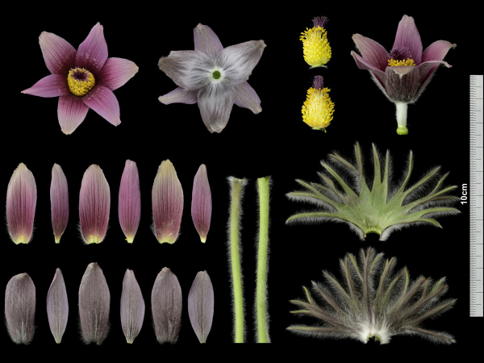 | 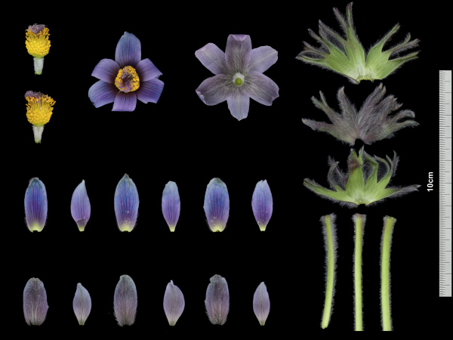
Pulsatilla tongkangensis Y.N.Lee & T.C.Lee : ‘Aura Jahong’, ‘Aura Cheonghong’
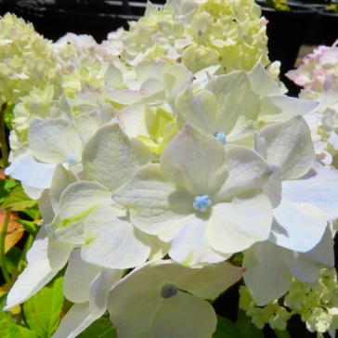 | 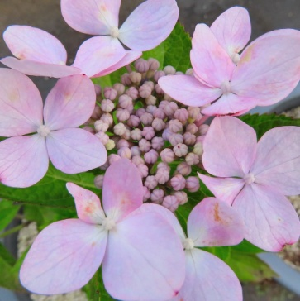 | 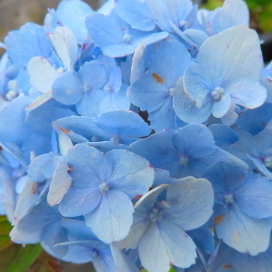 | 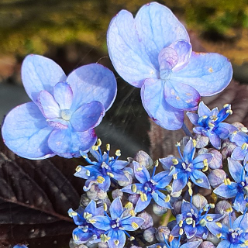
Hydrangea serrata f. fertilis Nakai : ‘Jejuilchul’, Jejuoreum‘’, ‘Jejubada’ , ‘Jejudochaebi’
Fig 1. Photographs of applied varieties bred from Endemic plants in the Republic of Korea (2020)

[Annex VIII follows]

UNITED KINGDOM

Report on the activity of the United Kingdom Plant Varieties and Seeds Office in Cambridge and the examination centres of NIAB, SASA and AFBI. The Plant Varieties and Seeds Office is part of the Service Delivery Directorate of the Animal and Plant Health Agency (APHA), an executive agency of the Department for Environment, Food and Rural Affairs (Defra). Contact details and phone numbers are available on Gov.UK website where all Government departments now have their website details. www.gov.uk

Across all the United Kingdom trial stations, approximately 1500 candidate varieties were under test for Listing and/or PVR in the past year, including 320 winter oilseed rape, 291 cereals and the remainder herbage and fodder, ornamentals, vegetables, field peas, potatoes, field beans, sugar beet and fodder kale. Applications in the agricultural sector for the coming season remain stable.

Ornamental DUS testing in the United Kingdom is conducted at NIAB in Cambridge, with specialisation in Chrysanthemum, Rose and many hardy ornamental species.

During the COVID–19 pandemic, DUS trials are being done under Government health and safety guidance in a step by step approach to ensure the safety and well-being of staff. With suitable adaptation, it has so far been possible to continue almost all trials.

On the international front, Variety Testing staff at the different examination centres continue to be fully committed to working with our colleagues in Europe and within UPOV. We continue to be involved in the CPVO projects for developing a strategy to apply SNP molecular markers in the framework of winter oilseed rape DUS testing, which is now in its second phase and ‘Harmorescoll’ which aims to facilitate access to reference material for performing disease resistance tests within DUS examinations for vegetable crops. There is also involvement in two EU Horizon 2020 funded projects with NIAB, SASA and BioSS contributing to the INVITE project, and APHA and AFBI to INNOVAR.

The United Kingdom continues to support the UPOV online courses by providing tutors and with technical and administrative staff throughout the United Kingdom taking the distance learning opportunities through DL205 and DL305.

[End of Annex VIII and of document]

