 |  | E
 | INCLUDEPICTURE "wordml://75.png" \* MERGEFORMATINET INCLUDEPICTURE "wordml://75.png" \* MERGEFORMATINET INCLUDEPICTURE "wordml://75.png" \* MERGEFORMATINET INCLUDEPICTURE "wordml://75.png" \* MERGEFORMATINET 
  TG/95/4(proj.3)
  ORIGINAL: English
  DATE: 2020-04-24
INTERNATIONAL UNION FOR THE PROTECTION OF NEW VARIETIES OF PLANTS
 | Geneva
  DRAFT
  LAGERSTROEMIA
  UPOV Code(s): LAGER
  Lagerstroemia L.
  *
GUIDELINES
FOR THE CONDUCT OF TESTS
FOR DISTINCTNESS, UNIFORMITY AND STABILITY

prepared by experts from France
to be considered by the
Technical Working Party for Ornamental Plants and Forest Trees

at its fifty-second session, to be held in Roelofarendsveen, Netherlands,
from 2020-06-08 to 2020-06-12

Disclaimer: this document does not represent UPOV policies or guidance
Alternative names:*

Botanical name | English | French | German | Spanish
  Lagerstroemia L.
  Crape Myrtle
  Lagerstrœmia
  Lagerstroemia
  Lagerstroemia, Lagestroemia

The purpose of these guidelines (“Test Guidelines”) is to elaborate the principles contained in the General Introduction (document TG/1/3), and its associated TGP documents, into detailed practical guidance for the harmonized examination of distinctness, uniformity and stability (DUS) and, in particular, to identify appropriate characteristics for the examination of DUS and production of harmonized variety descriptions.
ASSOCIATED DOCUMENTS
These Test Guidelines should be read in conjunction with the General Introduction and its associated TGP documents.

TABLE OF CONTENTS | PAGE
1. | SUBJECT OF THESE TEST GUIDELINES.......................................................................................................... | 3
2. | MATERIAL REQUIRED......................................................................................................................................... | 3
3. | METHOD OF EXAMINATION................................................................................................................................ | 3
3.1 | Number of Growing Cycles........................................................................................................................ | 3
3.2 | Testing Place............................................................................................................................................. | 3
3.3 | Conditions for Conducting the Examination............................................................................................... | 3
3.4 | Test Design................................................................................................................................................ | 4
3.5 | Additional Tests......................................................................................................................................... | 4

4. | ASSESSMENT OF DISTINCTNESS, UNIFORMITY AND STABILITY................................................................. | 4
4.1 | Distinctness............................................................................................................................................... | 4
4.2 | Uniformity.................................................................................................................................................. | 5
4.3 | Stability...................................................................................................................................................... | 5

5. | GROUPING OF VARIETIES AND ORGANIZATION OF THE GROWING TRIAL................................................ | 6
6. | INTRODUCTION TO THE TABLE OF CHARACTERISTICS................................................................................ | 6
6.1 | Categories of Characteristics..................................................................................................................... | 6
6.2 | States of Expression and Corresponding Notes........................................................................................ | 6
6.3 | Types of Expression.................................................................................................................................. | 7
6.4 | Example Varieties...................................................................................................................................... | 7
6.5 | Legend....................................................................................................................................................... | 8

7. | TABLE OF CHARACTERISTICS/TABLEAU DES CARACTÈRES/MERKMALSTABELLE/TABLA DE CARACTERES...................................................................................................................................................... | 9
8. | EXPLANATIONS ON THE TABLE OF CHARACTERISTICS............................................................................... | 19
8.1 | Explanations covering several characteristics........................................................................................... | 19
 | Explanations for individual characteristics................................................................................................. | 20
  8.2

9. | LITERATURE......................................................................................................................................................... | 29
10. | TECHNICAL QUESTIONNAIRE............................................................................................................................ | 30

1. | Subject of these Test Guidelines
  These Test Guidelines apply to all varieties of Lagerstroemia L.

2. | Material Required
2.1
  The competent authorities decide on the quantity and quality of the plant material required for testing the variety and when and where it is to be delivered. Applicants submitting material from a State other than that in which the testing takes place must ensure that all customs formalities and phytosanitary requirements are complied with.
2.2
  The material is to be supplied in the form of plants capable of flowering and expressing all relevant characteristics of the variety during the first growing cycle.
2.3
  The minimum quantity of plant material, to be supplied by the applicant, should be:
  6 plants
2.4
  The plant material supplied should be visibly healthy, not lacking in vigor, nor affected by any important pest or disease.
2.5
  The plant material should not have undergone any treatment which would affect the expression of the characteristics of the variety, unless the competent authorities allow or request such treatment. If it has been treated, full details of the treatment must be given.

3. | Method of Examination
3.1 | Number of Growing Cycles
 | The minimum duration of tests should normally be a single growing cycle.
  3.1.1
 | The testing of a variety may be conducted when the competent authority can determine with certainty the outcome of the test.
  3.1.2
3.2 | Testing Place
 | Tests are normally conducted at one place. In the case of tests conducted at more than one place, guidance is provided in TGP/9 “Examining Distinctness”.
3.3 | Conditions for Conducting the Examination
 | The tests should be carried out under conditions ensuring satisfactory growth for the expression of the relevant characteristics of the variety and for the conduct of the examination.
  3.3.1
 | Because daylight varies, color determinations made against a color chart should be made either in a suitable cabinet providing artificial daylight or in the middle of the day in a room without direct sunlight. The spectral distribution of the illuminant for artificial daylight should conform with the CIE Standard of Preferred Daylight D 6500 and should fall within the tolerances set out in the British Standard 950, Part I. These determinations should be made with the plant part placed against a white background. The color chart and version used should be specified in the variety description.
  3.3.2

3.4 | Test Design
  Each test should be designed to result in a total of at least 6 plants.
3.5 | Additional Tests
 | Additional tests, for examining relevant characteristics, may be established.

4. | Assessment of Distinctness, Uniformity and Stability
4.1 | Distinctness
4.1.1 | General Recommendations
 | It is of particular importance for users of these Test Guidelines to consult the General Introduction prior to making decisions regarding distinctness. However, the following points are provided for elaboration or emphasis in these Test Guidelines.
4.1.2 | Consistent Differences
 | The differences observed between varieties may be so clear that more than one growing cycle is not necessary. In addition, in some circumstances, the influence of the environment is not such that more than a single growing cycle is required to provide assurance that the differences observed between varieties are sufficiently consistent. One means of ensuring that a difference in a characteristic, observed in a growing trial, is sufficiently consistent is to examine the characteristic in at least two independent growing cycles.
4.1.3 | Clear Differences
 | Determining whether a difference between two varieties is clear depends on many factors, and should consider, in particular, the type of expression of the characteristic being examined, i.e. whether it is expressed in a qualitative, quantitative, or pseudo-qualitative manner. Therefore, it is important that users of these Test Guidelines are familiar with the recommendations contained in the General Introduction prior to making decisions regarding distinctness.
4.1.4
  Number of Plants or Parts of Plants to be Examined
  Unless otherwise indicated, for the purposes of distinctness, all observations on single plants should be made on 5 plants or parts of plants taken from each of 5 plants and any other observations made on all plants in the test, disregarding any off-type plants.
  In the case of observations of parts taken from single plants, the number of parts to be taken from each of the plants should be 5.
4.1.5 | Method of Observation
 | The recommended method of observing the characteristic for the purposes of distinctness is indicated by the following key in the Table of Characteristics (see document TGP/9 “Examining Distinctness”, Section 4 “Observation of characteristics”):
MG: single measurement of a group of plants or parts of plants
MS: measurement of a number of individual plants or parts of plants
VG: visual assessment by a single observation of a group of plants or parts of plants
VS: visual assessment by observation of individual plants or parts of plants

 | Type of observation: visual (V) or measurement (M)

“Visual” observation (V) is an observation made on the basis of the expert’s judgment. For the purposes of this document, “visual” observation refers to the sensory observations of the experts and, therefore, also includes smell, taste and touch. Visual observation includes observations where the expert uses reference points (e.g. diagrams, example varieties, side-by-side comparison) or non-linear charts (e.g. color charts). Measurement (M) is an objective observation against a calibrated, linear scale e.g. using a ruler, weighing scales, colorimeter, dates, counts, etc.
Type of record: for a group of plants (G) or for single, individual plants (S)

For the purposes of distinctness, observations may be recorded as a single record for a group of plants or parts of plants (G), or may be recorded as records for a number of single, individual plants or parts of plants (S). In most cases, “G” provides a single record per variety and it is not possible or necessary to apply statistical methods in a plant-by-plant analysis for the assessment of distinctness.

 | In cases where more than one method of observing the characteristic is indicated in the Table of Characteristics (e.g. VG/MG), guidance on selecting an appropriate method is provided in document TGP/9, Section 4.2.
4.2 | Uniformity
4.2.1 | It is of particular importance for users of these Test Guidelines to consult the General Introduction prior to making decisions regarding uniformity. However, the following points are provided for elaboration or emphasis in these Test Guidelines:
  4.2.2
  These Test Guidelines have been developed for the examination of vegetatively propagated varieties. For varieties with other types of propagation, the recommendations in the General Introduction and document TGP/13 "Guidance for new types and species" Section 4.5 "Testing Uniformity" should be followed.
4.2.3
  For the assessment of uniformity of vegetatively propagated varieties, a population standard of 1% and an acceptance probability of at least 95% should be applied. In the case of a sample size of 6 plants, 1 off-type is allowed.
4.3 | Stability
4.3.1 | In practice, it is not usual to perform tests of stability that produce results as certain as those of the testing of distinctness and uniformity. However, experience has demonstrated that, for many types of variety, when a variety has been shown to be uniform, it can also be considered to be stable.
4.3.2 | Where appropriate, or in cases of doubt, stability may be further examined by testing a new plant stock to ensure that it exhibits the same characteristics as those shown by the initial material supplied.

5. | Grouping of Varieties and Organization of the Growing Trial
5.1 | The selection of varieties of common knowledge to be grown in the trial with the candidate varieties and the way in which these varieties are divided into groups to facilitate the assessment of distinctness are aided by the use of grouping characteristics.
5.2 | Grouping characteristics are those in which the documented states of expression, even where produced at different locations, can be used, either individually or in combination with other such characteristics: (a) to select varieties of common knowledge that can be excluded from the growing trial used for examination of distinctness; and (b) to organize the growing trial so that similar varieties are grouped together.
5.3 | The following have been agreed as useful grouping characteristics:
  (a)
  Plant: height (characteristic 1)
  (b)
  Leaf blade: distribution of anthocyanin coloration (characteristic 7)
  (c)
  Leaf blade: intensity of anthocyanin coloration (characteristic 8)
  (d)
  Petal: main color of inner side (characteristic 27) with the followings groups:
  Gr. 1: white
  Gr. 2: light pink
  Gr. 3: dark pink
  Gr. 4: red
  Gr. 5: purple
  (e)
  Time of beginning of flowering (characteristic 38)

5.4 | Guidance for the use of grouping characteristics, in the process of examining distinctness, is provided through the General Introduction and document TGP/9 “Examining Distinctness”.

6. | Introduction to the Table of Characteristics
6.1 | Categories of Characteristics
6.1.1 | Standard Test Guidelines Characteristics
 | Standard Test Guidelines characteristics are those which are approved by UPOV for examination of DUS and from which members of the Union can select those suitable for their particular circumstances.
6.1.2 | Asterisked Characteristics
 | Asterisked characteristics (denoted by *) are those included in the Test Guidelines which are important for the international harmonization of variety descriptions and should always be examined for DUS and included in the variety description by all members of the Union, except when the state of expression of a preceding characteristic or regional environmental conditions render this inappropriate.
6.2 | States of Expression and Corresponding Notes

6.2.1 | States of expression are given for each characteristic to define the characteristic and to harmonize descriptions. Each state of expression is allocated a corresponding numerical note for ease of recording of data and for the production and exchange of the description.
6.2.2 | In the case of qualitative and pseudo-qualitative characteristics (see Chapter 6.3), all relevant states of expression are presented in the characteristic. However, in the case of quantitative characteristics with 5 or more states, an abbreviated scale may be used to minimize the size of the Table of Characteristics. For example, in the case of a quantitative characteristic with 9 states, the presentation of states of expression in the Test Guidelines may be abbreviated as follows:
State | Note
small | 3
medium | 5
large | 7

 | However, it should be noted that all of the following 9 states of expression exist to describe varieties and should be used as appropriate:
State | Note
very small | 1
very small to small | 2
small | 3
small to medium | 4
medium | 5
medium to large | 6
large | 7
large to very large | 8
very large | 9

6.2.3 | Further explanation of the presentation of states of expression and notes is provided in document TGP/7 “Development of Test Guidelines”.
6.3 | Types of Expression
 | An explanation of the types of expression of characteristics (qualitative, quantitative and pseudo-qualitative) is provided in the General Introduction.
6.4 | Example Varieties
 | Where appropriate, example varieties are provided to clarify the states of expression of each characteristic.

6.5 | Legend
 |  | English |  | français |  | deutsch | español | Example Varieties  Exemples  Beispielssorten  Variedades ejemplo | Note/  Nota
  1
  2
  3
  4
  5
  6
  7
  Name of characteristics in English
  Nom du caractère en français
  Name des Merkmals auf Deutsch
  Nombre del carácter en español
  states of expression
  types d’expression
  Ausprägungsstufen
  tipos de expresión

1 | Characteristic number
2 | (*) | Asterisked characteristic | – see Chapter 6.1.2
3 | Type of expression
 | QL | Qualitative characteristic | – see Chapter 6.3
 | QN | Quantitative characteristic | – see Chapter 6.3
 | PQ | Pseudo-qualitative characteristic | – see Chapter 6.3
4 | Method of observation (and type of plot, if applicable)
 | MG, MS, VG, VS |  | – see Chapter 4.1.5
5
  (+)
  See Explanations on the Table of Characteristics in Chapter 8.2
6
  (a)-(h)
  See Explanations on the Table of Characteristics in Chapter 8.1
7
  Not applicable

7. | Table of Characteristics/Tableau des caractères/Merkmalstabelle/Tabla de caracteres

 |  | English |  | français |  | deutsch | español | Example Varieties  Exemples  Beispielssorten  Variedades ejemplo | Note/  Nota
1. | (*) | QN | MS/VG |  | (a)
  Plant: height
 |  | short |  |  |  |  |  | Dablage-01 | 1
 |  | medium |  |  |  |  |  | Desal 173 | 3
 |  | tall |  |  |  |  |  | Water Melon | 5
2. | (*) | PQ | VG | (+) | (a)
  Plant: growth habit
 |  | upright |  |  |  |  |  | Dynamite, Lucas Red | 1
 |  | semi-upright |  |  |  |  |  | Desber 102 | 2
 |  | spreading |  |  |  |  |  | Houston,  Petite Canaille Blanc | 3
3. | (*) | QN | VG |  | (b)
  Stem: anthocyanin coloration
 |  | weak |  |  |  |  |  | Grand Cru, Kimono | 3
 |  | medium |  |  |  |  |  | Coral Filli,  Fushia d'été, Milaperl | 5
 |  | strong |  |  |  |  |  | Lucas Red | 7
4. | (*) | QN | MG/MS/VG |  | (c)
  Leaf blade: length
 |  | short |  |  |  |  |  | Coral Filli | 3
 |  | medium |  |  |  |  |  | Perigord pourpre | 5
 |  | long |  |  |  |  |  | Burgundi Cotton | 7
5. | (*) | QN | MG/MS/VG |  | (c)
  Leaf blade: width
 |  | narrow |  |  |  |  |  | Petite Canaille Blanc | 3
 |  | medium |  |  |  |  |  | Braise d'été | 5
 |  | broad |  |  |  |  |  | Hopi | 7
6. | (*) | PQ | VG |  | (c)
  Leaf blade: shape
 |  | only elliptic |  |  |  |  |  | Red Rocket | 1
 |  | mainly elliptic |  |  |  |  |  | Royal Velvet, Violet Filli | 2
 |  | mainly obovate |  |  |  |  |  | Camaïeu d'été, Red Filli | 3
 |  | only obovate |  |  |  |  |  | Mystic Magenta | 4

 |  | English |  | français |  | deutsch | español | Example Varieties  Exemples  Beispielssorten  Variedades ejemplo | Note/  Nota
7. | (*) | PQ | VG | (+) | (c)
  Leaf blade: distribution of anthocyanin coloration
 |  | absent |  |  |  |  |  | Petite Canaille Blanc | 1
 |  | along margin |  |  |  |  |  | Main Little Chief,  Red Rocket | 2
 |  | irregular |  |  |  |  |  | Burgundi Cotton | 3
 |  | entire |  |  |  |  |  | Lucas Red | 4
8. | (*) | QN | VG |  | (c)
  Leaf blade: intensity of anthocyanin coloration
 |  | light |  |  |  |  |  | Coral Filli | 3
 |  | medium |  |  |  |  |  | Royal Velvet | 5
 |  | dark |  |  |  |  |  | Dynamite | 7
9. | (*) | QN | VG |  | (c)
  Leaf blade: intensity of green color
 |  | very light |  |  |  |  |  | Purely purple | 1
 |  | light |  |  |  |  |  | Nana Lavender,  Yang Tse | 3
 |  | medium |  |  |  |  |  | Tonto | 5
 |  | dark |  |  |  |  |  | Desemi 103 | 7
 |  | very dark |  |  |  |  |  |  | 9
10. | (*) | QN | VG | (+) | (c)
  Leaf blade: undulation of margin
 |  | absent or very weak |  |  |  |  |  | Deschin,  Petite Canaille Blanc | 1
 |  | weak |  |  |  |  |  | Fushia d'été | 3
 |  | medium |  |  |  |  |  | Super Violac | 5
 |  | strong |  |  |  |  |  | Desha | 7
 |  | very strong |  |  |  |  |  |  | 9

 |  | English |  | français |  | deutsch | español | Example Varieties  Exemples  Beispielssorten  Variedades ejemplo | Note/  Nota
11. | (*) | QN | VG |  | (c)
  Leaf blade: glossiness of upper side
 |  | absent or very weak |  |  |  |  |  | Perigord pourpre | 1
 |  | weak |  |  |  |  |  | Petite Canaille Blanc | 2
 |  | medium |  |  |  |  |  | Violet d'été | 3
 |  | strong |  |  |  |  |  | Braise d'été | 4
 |  | very strong |  |  |  |  |  |  | 5
12. |  | QL | VG | (+) | (c)
  Leaf blade: variegation (excluding anthocyanin coloration)
 |  | absent |  |  |  |  |  | Dynamite | 1
 |  | present |  |  |  |  |  | Shirohakekomifu | 9
13. |  | PQ | VG | (+) | (c)
  Leaf blade: hue of variegation
 |  | white |  |  |  |  |  | Shirohakekomifu | 1
 |  | yellow green |  |  |  |  |  | Kibotafu | 2
 |  | grey green |  |  |  |  |  |  | 3
 |  | pinkish |  |  |  |  |  |  | 4
14. |  | QN | MG/VG |  | (d)
  Flower bud: length
 |  | short |  |  |  |  |  | Coral Filli | 3
 |  | medium |  |  |  |  |  | Deschin | 5
 |  | long |  |  |  |  |  | Desmou 083 | 7
15. |  | QN | MG/VG |  | (d)
  Flower bud: width
 |  | narrow |  |  |  |  |  | Petite Red | 3
 |  | medium |  |  |  |  |  | Dessoi 062,  Petite Canaille Rouge | 5
 |  | broad |  |  |  |  |  | Desemi 103, Water Melon | 7

 |  | English |  | français |  | deutsch | español | Example Varieties  Exemples  Beispielssorten  Variedades ejemplo | Note/  Nota
16. | (*) | PQ | VG | (+) | (d)
  Flower bud: shape
 |  | circular |  |  |  |  |  | Desemi 103, Despan 001 | 1
 |  | broad oblong |  |  |  |  |  | Dessoi 062, Petit Orchid | 2
 |  | narrow oblong |  |  |  |  |  | Red Imperator | 3
 |  | narrow obovate |  |  |  |  |  | Desber 102, Seminole | 4
 |  | broad obovate |  |  |  |  |  | Potomac | 5
17. |  | QN | VG | (+) | (d)
  Flower bud: prominence of ridges
 |  | absent or weak |  |  |  |  |  | Kimono | 1
 |  | medium |  |  |  |  |  | Yang Tse | 3
 |  | strong |  |  |  |  |  | Magestic Orchid,  Petite Canaille Blanc | 5
18. | (*) | QN | VG | (+) | (d)
  Flower bud: area with anthocyanin coloration
 |  | null or small |  |  |  |  |  | Near East | 1
 |  | medium |  |  |  |  |  | Violet d'été | 3
 |  | large |  |  |  |  |  | Lucas Red | 5
19. |  | QN | VG |  | (d)
  Flower bud: glossiness
 |  | weak |  |  |  |  |  | La Valette | 1
 |  | medium |  |  |  |  |  | Margaux | 2
 |  | strong |  |  |  |  |  | Braise d'été | 3
20. | (*) | QN | VG |  | (e)
  Thyrse : number
 |  | few |  |  |  |  |  | Lucas Red, Nivea | 3
 |  | medium |  |  |  |  |  | Fushia d'été, Orlando | 5
 |  | many |  |  |  |  |  | Desal 173, Petit Orchid | 7

 |  | English |  | français |  | deutsch | español | Example Varieties  Exemples  Beispielssorten  Variedades ejemplo | Note/  Nota
21. | (*) | PQ | VG | (+) | (e)
  Thyrse: shape
 |  | globular |  |  |  |  |  | Nivea | 1
 |  | conical |  |  |  |  |  | Desmon | 2
 |  | sagittate |  |  |  |  |  | Royal Velvet | 3
 |  | irregular |  |  |  |  |  | Desjac 124 | 4
22. | (*) | QN | VG | (+) | (e)
  Thyrse: length
 |  | short |  |  |  |  |  | Provence, Tonto | 3
 |  | medium |  |  |  |  |  | Desper | 5
 |  | long |  |  |  |  |  | Seminole | 7
23. | (*) | QN | VG |  | (e)
  Thyrse: number of flowers
 |  | few |  |  |  |  |  | Despan 001, Pink Blush | 3
 |  | medium |  |  |  |  |  | Kimono | 5
 |  | many |  |  |  |  |  | Deschin, Desjac 124 | 7
24. | (*) | QN | VG | (+) | (f)
  Flower: diameter
 |  | small |  |  |  |  |  | Petite Canaille,  Super Violac | 3
 |  | medium |  |  |  |  |  | Desal 173, Seminole | 5
 |  | large |  |  |  |  |  | Desmou 083, Kimono | 7
25. |  | QN | VG | (+) | (f)
  Petal claw : length
 |  | short |  |  |  |  |  | Berlingo Menthe | 1
 |  | medium |  |  |  |  |  | Catawba, Desha | 2
 |  | long |  |  |  |  |  | Potomac | 3
26. |  | PQ | VG |  | (f), (h)
  Petal claw : color
 |  | white |  |  |  |  |  | Enduring summer white | 1
 |  | light pink |  |  |  |  |  | Near East | 2
 |  | medium pink |  |  |  |  |  | Catawba, Kimono, Milaperl | 3
 |  | dark pink |  |  |  |  |  | La Valette, Lucas Red | 4
 |  | red |  |  |  |  |  | Water Melon | 5

 |  | English |  | français |  | deutsch | español | Example Varieties  Exemples  Beispielssorten  Variedades ejemplo | Note/  Nota
27. | (*) | PQ | VG |  | (f), (h)
  Petal: main color of inner side
 |  | RHS Colour Chart (indicate reference number)
28. | (*) | PQ | VG |  | (f), (h)
  Petal: secondary color of inner side
 |  | RHS Colour Chart (indicate reference number)
29. | (*) | QN | VG | (+) | (f)
  Petal: undulation
 |  | weak |  |  |  |  |  | Desber 102, Orlando | 1
 |  | medium |  |  |  |  |  | Hopi, Houston | 2
 |  | strong |  |  |  |  |  | Milavio,  Ruffled Red Magic | 3
30. | (*) | QN | VG | (+) | (f)
  Stamen: conspicuousness
 |  | conspicuous |  |  |  |  |  | Desber 102, Grand Cru | 1
 |  | not conspicuous |  |  |  |  |  | Red Imperator, Rocamadour | 2
31. |  | QN | VG |  | (g)
  Fruit : number
 |  | few |  |  |  |  |  | Petite Red, Rocamadour | 3
 |  | medium |  |  |  |  |  | Orlando, Potomac | 5
 |  | many |  |  |  |  |  | Violet Filli | 7
32. | (*) | QL | VG | (+) | (g)
  Fruit: shape
 |  | elliptic |  |  |  |  |  | Perigord pourpre,  Petite Canaille Blanc | 1
 |  | circular |  |  |  |  |  | Burgundi Cotton,  Red Rocket | 2
33. | (*) | QN | VG |  | (g)
  Fruit: length
 |  | short |  |  |  |  |  | Coral Filli | 1
 |  | medium |  |  |  |  |  | Camaïeu d'été | 2
 |  | long |  |  |  |  |  | Milavio | 3

 |  | English |  | français |  | deutsch | español | Example Varieties  Exemples  Beispielssorten  Variedades ejemplo | Note/  Nota
34. | (*) | QN | VG |  | (g)
  Fruit: diameter
 |  | small |  |  |  |  |  | Margaux | 1
 |  | medium |  |  |  |  |  | Royal Velvet | 2
 |  | large |  |  |  |  |  | Fushia d'été | 3
35. | (*) | QN | VG |  | (g)
  Fruit: intensity of green coloration
 |  | absent or very light |  |  |  |  |  | Purely purple | 1
 |  | light |  |  |  |  |  | Catawba, Powhatan | 3
 |  | medium |  |  |  |  |  | Yang Tse | 5
 |  | dark |  |  |  |  |  | Desand 081 | 7
 |  | very dark |  |  |  |  |  |  | 9
36. |  | QN | VG |  | (g)
  Fruit: anthocyanin coloration
 |  | absent or very weak |  |  |  |  |  | Potomac | 1
 |  | weak |  |  |  |  |  | Milarosso | 3
 |  | medium |  |  |  |  |  | Pure white | 5
 |  | strong |  |  |  |  |  | Purely purple | 7
 |  | very strong |  |  |  |  |  | Red Hot | 9
37. | (*) | QN | VG | (+)
  Plant: time of vegetative bud burst
 |  | very early |  |  |  |  |  | Milavio | 1
 |  | early |  |  |  |  |  | Petite Red | 3
 |  | medium |  |  |  |  |  | Despan 001, Dessoi 062 | 5
 |  | late |  |  |  |  |  | Berlingo Menthe,  Pure red | 7
 |  | very late |  |  |  |  |  |  | 9
38. | (*) | QN | MG/VG | (+)
  Time of beginning of flowering
 |  | very early |  |  |  |  |  | Milarosa | 1
 |  | early |  |  |  |  |  | Near East,  Perigord pourpre | 3
 |  | medium |  |  |  |  |  | Tonto | 5
 |  | late |  |  |  |  |  | Red Rocket | 7
 |  | very late |  |  |  |  |  | Crimson red | 9

8. | Explanations on the Table of Characteristics
8.1 | Explanations covering several characteristics
 | Characteristics containing the following key in the Table of Characteristics should be examined as indicated below:
  (a)
  Observations on plant should be made before the flowering period, on fully developed plants
  (b)
  Observations on the stem should be made on the middle third of the stem, just before flowering, on well developed plant
  (c)
  Observations on the leaves should be made on fully expanded leaves, on the middle third of the stem
  (d)
  Observations on the flower bud should be made on the top of the principal thyrse, just before opening, on the broadest flower bud
  (e)
  Observations on thyrse should be made on fully developed thyrse with fully opened flowers
  (f)
  Observations on the flower, petal and stamen should be made on a just fully opened flower
  (g)
  Observations on the fruit should be made on the top of the principal thyrse when fruits are well developed and at maturity
  (h)
  Where more than one color is present the main color is the color with the largest surface area .The color with the second largest area is the secondary color. the color with the third largest area is the tertiary color. In cases where the areas of colors are too similar to reliably decide which color has the largest area, the darkest color is considered to be the main color

 | Explanations for individual characteristics
  8.2
Ad. 2: Plant: growth habit

INCLUDEPICTURE "wordml://76.png" \* MERGEFORMATINET INCLUDEPICTURE "wordml://76.png" \* MERGEFORMATINET INCLUDEPICTURE "wordml://76.png" \* MERGEFORMATINET INCLUDEPICTURE "wordml://76.png" \* MERGEFORMATINET 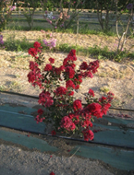 | INCLUDEPICTURE "wordml://77.png" \* MERGEFORMATINET INCLUDEPICTURE "wordml://77.png" \* MERGEFORMATINET INCLUDEPICTURE "wordml://77.png" \* MERGEFORMATINET INCLUDEPICTURE "wordml://77.png" \* MERGEFORMATINET 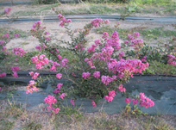 | INCLUDEPICTURE "wordml://78.png" \* MERGEFORMATINET INCLUDEPICTURE "wordml://78.png" \* MERGEFORMATINET INCLUDEPICTURE "wordml://78.png" \* MERGEFORMATINET INCLUDEPICTURE "wordml://78.png" \* MERGEFORMATINET 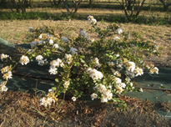
1 | 2 | 3
upright | semi-upright | spreading

Ad. 7: Leaf blade: distribution of anthocyanin coloration

INCLUDEPICTURE "wordml://79.png" \* MERGEFORMATINET INCLUDEPICTURE "wordml://79.png" \* MERGEFORMATINET INCLUDEPICTURE "wordml://79.png" \* MERGEFORMATINET INCLUDEPICTURE "wordml://79.png" \* MERGEFORMATINET 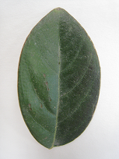 | INCLUDEPICTURE "wordml://80.png" \* MERGEFORMATINET INCLUDEPICTURE "wordml://80.png" \* MERGEFORMATINET INCLUDEPICTURE "wordml://80.png" \* MERGEFORMATINET INCLUDEPICTURE "wordml://80.png" \* MERGEFORMATINET 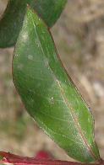 | INCLUDEPICTURE "wordml://81.png" \* MERGEFORMATINET INCLUDEPICTURE "wordml://81.png" \* MERGEFORMATINET INCLUDEPICTURE "wordml://81.png" \* MERGEFORMATINET INCLUDEPICTURE "wordml://81.png" \* MERGEFORMATINET 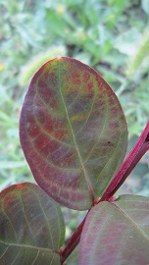 | INCLUDEPICTURE "wordml://82.png" \* MERGEFORMATINET INCLUDEPICTURE "wordml://82.png" \* MERGEFORMATINET INCLUDEPICTURE "wordml://82.png" \* MERGEFORMATINET INCLUDEPICTURE "wordml://82.png" \* MERGEFORMATINET 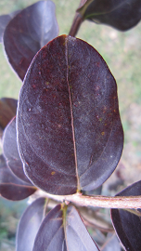
1 | 2 | 3 | 4
absent | along margin | irregular | entire

Ad. 10: Leaf blade: undulation of margin
INCLUDEPICTURE "wordml://83.png" \* MERGEFORMATINET INCLUDEPICTURE "wordml://83.png" \* MERGEFORMATINET INCLUDEPICTURE "wordml://83.png" \* MERGEFORMATINET INCLUDEPICTURE "wordml://83.png" \* MERGEFORMATINET | INCLUDEPICTURE "wordml://84.png" \* MERGEFORMATINET INCLUDEPICTURE "wordml://84.png" \* MERGEFORMATINET INCLUDEPICTURE "wordml://84.png" \* MERGEFORMATINET INCLUDEPICTURE "wordml://84.png" \* MERGEFORMATINET 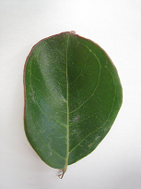 | INCLUDEPICTURE "wordml://85.png" \* MERGEFORMATINET INCLUDEPICTURE "wordml://85.png" \* MERGEFORMATINET INCLUDEPICTURE "wordml://85.png" \* MERGEFORMATINET INCLUDEPICTURE "wordml://85.png" \* MERGEFORMATINET 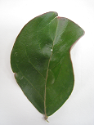 | INCLUDEPICTURE "wordml://86.png" \* MERGEFORMATINET INCLUDEPICTURE "wordml://86.png" \* MERGEFORMATINET INCLUDEPICTURE "wordml://86.png" \* MERGEFORMATINET INCLUDEPICTURE "wordml://86.png" \* MERGEFORMATINET 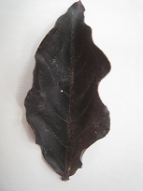
1 | 3 | 5 | 7
absent or very weak | weak | medium | strong

Ad. 12: Leaf blade: variegation (excluding anthocyanin coloration)

Well defined areas of different colors or intensities, with less or no chlorophyll, especially as
very light green, yellow or white longitudinal stripes or irregular shaped areas or marginal zone combined with a green color on leaves. Variegation consists of color, color distribution and pattern. Depending on the species concerned, it may not be necessary for all components to be described.

Ad. 13: Leaf blade: hue of variegation

 | INCLUDEPICTURE "wordml://87.png" \* MERGEFORMATINET INCLUDEPICTURE "wordml://87.png" \* MERGEFORMATINET INCLUDEPICTURE "wordml://87.png" \* MERGEFORMATINET INCLUDEPICTURE "wordml://87.png" \* MERGEFORMATINET 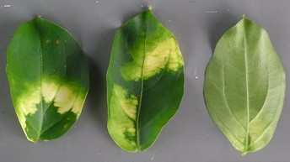
1 | 2
white | yellow green
INCLUDEPICTURE "wordml://88.png" \* MERGEFORMATINET INCLUDEPICTURE "wordml://88.png" \* MERGEFORMATINET INCLUDEPICTURE "wordml://88.png" \* MERGEFORMATINET INCLUDEPICTURE "wordml://88.png" \* MERGEFORMATINET 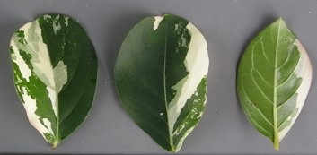 | INCLUDEPICTURE "wordml://89.png" \* MERGEFORMATINET INCLUDEPICTURE "wordml://89.png" \* MERGEFORMATINET INCLUDEPICTURE "wordml://89.png" \* MERGEFORMATINET INCLUDEPICTURE "wordml://89.png" \* MERGEFORMATINET 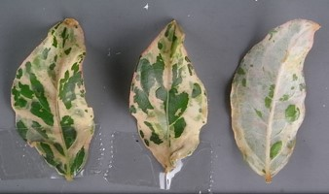
3 | 4
grey green | pinkish

Ad. 16: Flower bud: shape
INCLUDEPICTURE "wordml://90.png" \* MERGEFORMATINET INCLUDEPICTURE "wordml://90.png" \* MERGEFORMATINET INCLUDEPICTURE "wordml://90.png" \* MERGEFORMATINET INCLUDEPICTURE "wordml://90.png" \* MERGEFORMATINET 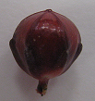 | INCLUDEPICTURE "wordml://91.png" \* MERGEFORMATINET INCLUDEPICTURE "wordml://91.png" \* MERGEFORMATINET INCLUDEPICTURE "wordml://91.png" \* MERGEFORMATINET INCLUDEPICTURE "wordml://91.png" \* MERGEFORMATINET 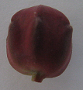 | INCLUDEPICTURE "wordml://92.png" \* MERGEFORMATINET INCLUDEPICTURE "wordml://92.png" \* MERGEFORMATINET INCLUDEPICTURE "wordml://92.png" \* MERGEFORMATINET INCLUDEPICTURE "wordml://92.png" \* MERGEFORMATINET 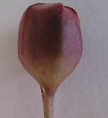 | INCLUDEPICTURE "wordml://93.png" \* MERGEFORMATINET INCLUDEPICTURE "wordml://93.png" \* MERGEFORMATINET INCLUDEPICTURE "wordml://93.png" \* MERGEFORMATINET INCLUDEPICTURE "wordml://93.png" \* MERGEFORMATINET 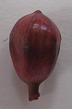 | INCLUDEPICTURE "wordml://94.png" \* MERGEFORMATINET INCLUDEPICTURE "wordml://94.png" \* MERGEFORMATINET INCLUDEPICTURE "wordml://94.png" \* MERGEFORMATINET INCLUDEPICTURE "wordml://94.png" \* MERGEFORMATINET 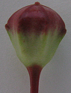
1 | 2 | 3 | 4 | 5
circular | broad oblong | narrow oblong | narrow obovate | broad obovate

Ad. 17: Flower bud: prominence of ridges

INCLUDEPICTURE "wordml://95.png" \* MERGEFORMATINET INCLUDEPICTURE "wordml://95.png" \* MERGEFORMATINET INCLUDEPICTURE "wordml://95.png" \* MERGEFORMATINET INCLUDEPICTURE "wordml://95.png" \* MERGEFORMATINET 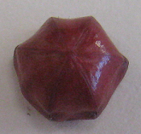 | INCLUDEPICTURE "wordml://96.png" \* MERGEFORMATINET INCLUDEPICTURE "wordml://96.png" \* MERGEFORMATINET INCLUDEPICTURE "wordml://96.png" \* MERGEFORMATINET INCLUDEPICTURE "wordml://96.png" \* MERGEFORMATINET 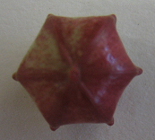 | INCLUDEPICTURE "wordml://97.png" \* MERGEFORMATINET INCLUDEPICTURE "wordml://97.png" \* MERGEFORMATINET INCLUDEPICTURE "wordml://97.png" \* MERGEFORMATINET INCLUDEPICTURE "wordml://97.png" \* MERGEFORMATINET 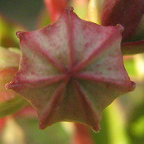
1 | 3 | 5
absent or weak | medium | strong

Ad. 18: Flower bud: area with anthocyanin coloration

INCLUDEPICTURE "wordml://98.png" \* MERGEFORMATINET INCLUDEPICTURE "wordml://98.png" \* MERGEFORMATINET INCLUDEPICTURE "wordml://98.png" \* MERGEFORMATINET INCLUDEPICTURE "wordml://98.png" \* MERGEFORMATINET 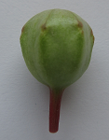 INCLUDEPICTURE "wordml://99.png" \* MERGEFORMATINET INCLUDEPICTURE "wordml://99.png" \* MERGEFORMATINET INCLUDEPICTURE "wordml://99.png" \* MERGEFORMATINET INCLUDEPICTURE "wordml://99.png" \* MERGEFORMATINET 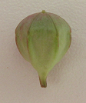 | INCLUDEPICTURE "wordml://100.png" \* MERGEFORMATINET INCLUDEPICTURE "wordml://100.png" \* MERGEFORMATINET INCLUDEPICTURE "wordml://100.png" \* MERGEFORMATINET INCLUDEPICTURE "wordml://100.png" \* MERGEFORMATINET | INCLUDEPICTURE "wordml://101.png" \* MERGEFORMATINET INCLUDEPICTURE "wordml://101.png" \* MERGEFORMATINET INCLUDEPICTURE "wordml://101.png" \* MERGEFORMATINET INCLUDEPICTURE "wordml://101.png" \* MERGEFORMATINET
1 | 3 | 5
null or small | medium | large

Ad. 21: Thyrse: shape
INCLUDEPICTURE "wordml://102.png" \* MERGEFORMATINET INCLUDEPICTURE "wordml://102.png" \* MERGEFORMATINET INCLUDEPICTURE "wordml://102.png" \* MERGEFORMATINET INCLUDEPICTURE "wordml://102.png" \* MERGEFORMATINET 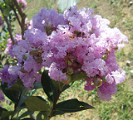 | INCLUDEPICTURE "wordml://103.png" \* MERGEFORMATINET INCLUDEPICTURE "wordml://103.png" \* MERGEFORMATINET INCLUDEPICTURE "wordml://103.png" \* MERGEFORMATINET INCLUDEPICTURE "wordml://103.png" \* MERGEFORMATINET 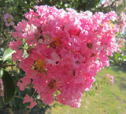
1 | 2
globular | conical

INCLUDEPICTURE "wordml://104.png" \* MERGEFORMATINET INCLUDEPICTURE "wordml://104.png" \* MERGEFORMATINET INCLUDEPICTURE "wordml://104.png" \* MERGEFORMATINET INCLUDEPICTURE "wordml://104.png" \* MERGEFORMATINET 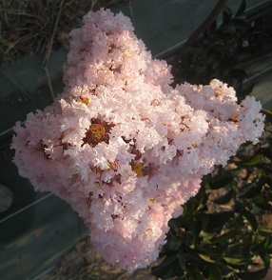 | INCLUDEPICTURE "wordml://105.png" \* MERGEFORMATINET INCLUDEPICTURE "wordml://105.png" \* MERGEFORMATINET INCLUDEPICTURE "wordml://105.png" \* MERGEFORMATINET INCLUDEPICTURE "wordml://105.png" \* MERGEFORMATINET 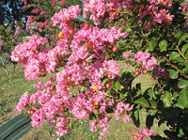
3 | 4
sagittate | irregular

Ad. 22: Thyrse: length

INCLUDEPICTURE "wordml://106.png" \* MERGEFORMATINET INCLUDEPICTURE "wordml://106.png" \* MERGEFORMATINET INCLUDEPICTURE "wordml://106.png" \* MERGEFORMATINET INCLUDEPICTURE "wordml://106.png" \* MERGEFORMATINET 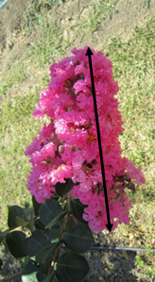

Ad. 24: Flower: diameter
INCLUDEPICTURE "wordml://107.png" \* MERGEFORMATINET INCLUDEPICTURE "wordml://107.png" \* MERGEFORMATINET INCLUDEPICTURE "wordml://107.png" \* MERGEFORMATINET INCLUDEPICTURE "wordml://107.png" \* MERGEFORMATINET 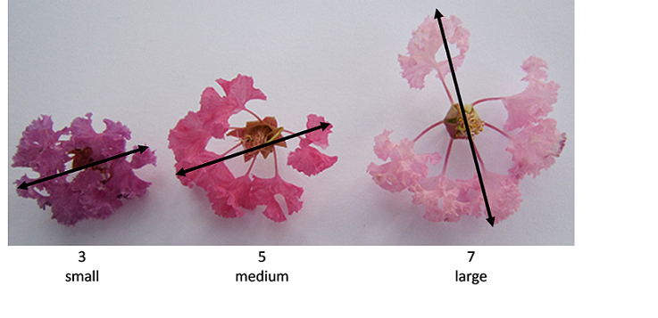

Ad. 25: Petal claw : length

INCLUDEPICTURE "wordml://108.png" \* MERGEFORMATINET INCLUDEPICTURE "wordml://108.png" \* MERGEFORMATINET INCLUDEPICTURE "wordml://108.png" \* MERGEFORMATINET INCLUDEPICTURE "wordml://108.png" \* MERGEFORMATINET 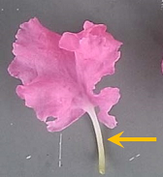

Ad. 29: Petal: undulation

INCLUDEPICTURE "wordml://109.png" \* MERGEFORMATINET INCLUDEPICTURE "wordml://109.png" \* MERGEFORMATINET INCLUDEPICTURE "wordml://109.png" \* MERGEFORMATINET INCLUDEPICTURE "wordml://109.png" \* MERGEFORMATINET 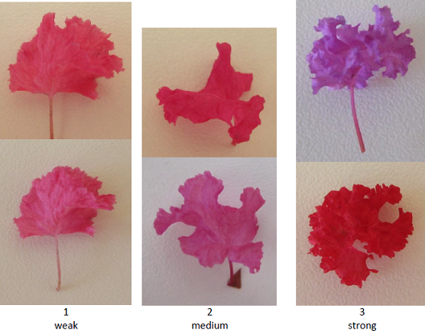

Ad. 30: Stamen: conspicuousness
INCLUDEPICTURE "wordml://110.png" \* MERGEFORMATINET INCLUDEPICTURE "wordml://110.png" \* MERGEFORMATINET INCLUDEPICTURE "wordml://110.png" \* MERGEFORMATINET INCLUDEPICTURE "wordml://110.png" \* MERGEFORMATINET 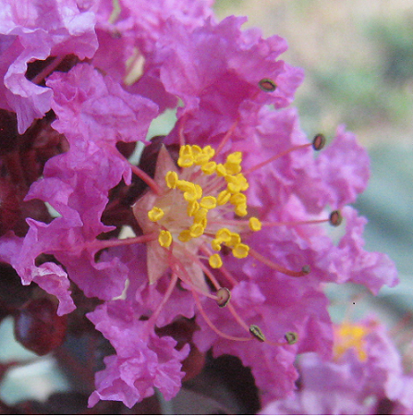 | INCLUDEPICTURE "wordml://111.png" \* MERGEFORMATINET INCLUDEPICTURE "wordml://111.png" \* MERGEFORMATINET INCLUDEPICTURE "wordml://111.png" \* MERGEFORMATINET INCLUDEPICTURE "wordml://111.png" \* MERGEFORMATINET 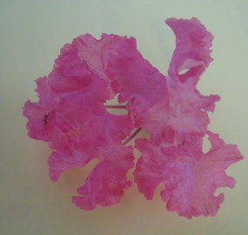
1 | 2
conspicuous | not conspicuous

Ad. 32: Fruit: shape

INCLUDEPICTURE "wordml://112.png" \* MERGEFORMATINET INCLUDEPICTURE "wordml://112.png" \* MERGEFORMATINET INCLUDEPICTURE "wordml://112.png" \* MERGEFORMATINET INCLUDEPICTURE "wordml://112.png" \* MERGEFORMATINET 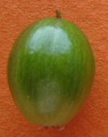 | INCLUDEPICTURE "wordml://113.png" \* MERGEFORMATINET INCLUDEPICTURE "wordml://113.png" \* MERGEFORMATINET INCLUDEPICTURE "wordml://113.png" \* MERGEFORMATINET INCLUDEPICTURE "wordml://113.png" \* MERGEFORMATINET 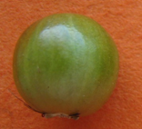
1 | 2
elliptique | circular

Ad. 37: Plant: time of vegetative bud burst

The time of vegetative bud burst should be observed as the appearance of first leaves on all plants.

Ad. 38: Time of beginning of flowering
The time of beginning of flowering is when all plants have approximately 10% of thyrses showing some open flowers.

9.
Literature

Byers, MD. (1997): Crape Myrtle. Owl Bay Pub. Cornell University, Ithaca, New York State 14850, US, 180pp.
Edwards, AD. (1994): Freezing Tolerance of Lagerstroemia Indica X Fauriei Cultivars in USDA Zones 7 and 8.
Mississippi State University. Department of Plant and Soil Sciences. US. 66 pp.

10.
Technical Questionnaire

TECHNICAL QUESTIONNAIRE | Page {x} of {y} | Reference Number:

Application date:
(not to be filled in by the applicant)
TECHNICAL QUESTIONNAIRE
to be completed in connection with an application for plant breeders' rights

1. | Subject of the Technical Questionnaire
 |  | Botanical name
  1.1
  Lagerstroemia L.
 |  | Common name
  1.2
  Crape Myrtle
  1.3
  Species (please specify):

2. | Applicant
 | Name
 | Address
 | Telephone No.
 | Fax No.
 | E-mail address
 | Breeder (if different from
 | applicant)

3. | Proposed denomination and breeder's reference
 | Proposed denomination
 | (if available)
 | Breeder's reference

TECHNICAL QUESTIONNAIRE |  |  | Page {x} of {y} | Reference Number:
 | Information on the breeding scheme and propagation of the variety
  #4.
 | 4.1 | Breeding scheme
 | Variety resulting from:
  4.1.1
  Crossing
 |  | [ ]
  (a)
  controlled cross
(please state parent variety)

(…………………..……………..…) x (……………..…………………..…)

female parent male parent

 |  | [ ]
  (b)
  partially known cross
(please state known parent variety(ies))

(…………………..……………..…) x (……………..…………………..…)

female parent male parent

 |  | [ ]
  (c)
  unknown cross
 |  | [ ]
  4.1.2
  Mutation
  (please state parent variety)
 |  | [ ]
  4.1.3
  Discovery and development
  (please state where and when discovered and how developed)
 | Other  (Please provide details) | [ ]
  4.1.4

TECHNICAL QUESTIONNAIRE  Page {x} of {y} | Reference Number:

 | 4.2 | Method of propagating the variety
  4.2.1
  Vegetative propagation
 |  | [ ]
  (a)
  Cuttings
 |  | [ ]
  (b)
  In vitro propagation
 |  | [ ]
  (c)
  Other (state method)
 | Other  (Please provide details) | [ ]
  4.2.2

TECHNICAL QUESTIONNAIRE | Page {x} of {y} | Reference Number:

5. | Characteristics of the variety to be indicated (the number in brackets refers to the corresponding characteristic in Test Guidelines; please mark the note which best corresponds).

 | Characteristics | Example Varieties | Note
  5.1
  (1)
  Plant: height
  short
  Dablage-01
  1 [ ]
  medium
  Desal 173
  3 [ ]
  tall
  Water Melon
  5 [ ]
  5.2
  (2)
  Plant: growth habit
  upright
  Dynamite, Lucas Red
  1 [ ]
  semi-upright
  Desber 102
  2 [ ]
  spreading
  Houston, Petite Canaille Blanc
  3 [ ]
  5.3
  (3)
  Stem: anthocyanin coloration
  very weak
  1 [ ]
  very weak to weak
  2 [ ]
  weak
  Grand Cru, Kimono
  3 [ ]
  weak to medium
  4 [ ]
  medium
  Coral Filli, Fushia d'été, Milaperl
  5 [ ]
  medium to strong
  6 [ ]
  strong
  Lucas Red
  7 [ ]
  strong to very strong
  8 [ ]
  very strong
  9 [ ]
  5.4
  (7)
  Leaf blade: distribution of anthocyanin coloration
  absent
  Petite Canaille Blanc
  1 [ ]
  along margin
  Main Little Chief, Red Rocket
  2 [ ]
  irregular
  Burgundi Cotton
  3 [ ]
  entire
  Lucas Red
  4 [ ]

 | Characteristics | Example Varieties | Note
  5.5
  (8)
  Leaf blade: intensity of anthocyanin coloration
  very light
  1 [ ]
  very light to light
  2 [ ]
  light
  Coral Filli
  3 [ ]
  light to medium
  4 [ ]
  medium
  Royal Velvet
  5 [ ]
  medium to dark
  6 [ ]
  dark
  Dynamite
  7 [ ]
  dark to very dark
  8 [ ]
  very dark
  9 [ ]
  5.6
  (12)
  Leaf blade: variegation (excluding anthocyanin coloration)
  absent
  Dynamite
  1 [ ]
  present
  Shirohakekomifu
  9 [ ]
  5.7
  (21)
  Thyrse: shape
  globular
  Nivea
  1 [ ]
  conical
  Desmon
  2 [ ]
  sagittate
  Royal Velvet
  3 [ ]
  irregular
  Desjac 124
  4 [ ]
  5.8(i)
  (27)
  Petal: main color of inner side
  RHS Colour Chart (indicate reference number)
  5.8(ii)
  (27)
  Petal: main color of inner side
  white
  1 [ ]
  light pink
  2 [ ]
  dark pink
  3 [ ]
  red
  4 [ ]
  purple
  5 [ ]

 | Characteristics | Example Varieties | Note
  5.9
  (38)
  Time of beginning of flowering
  very early
  Milarosa
  1 [ ]
  very early to early
  2 [ ]
  early
  Near East, Perigord pourpre
  3 [ ]
  early to medium
  4 [ ]
  medium
  Tonto
  5 [ ]
  medium to late
  6 [ ]
  late
  Red Rocket
  7 [ ]
  late to very late
  8 [ ]
  very late
  Crimson red
  9 [ ]

TECHNICAL QUESTIONNAIRE | Page {x} of {y} | Reference Number:

6. | Similar varieties and differences from these varieties
Please use the following table and box for comments to provide information on how your candidate variety differs from the variety (or varieties) which, to the best of your knowledge, is (or are) most similar. This information may help the examination authority to conduct its examination of distinctness in a more efficient way.

  Denomination(s) of variety(ies) similar to your candidate variety
  Characteristic(s) in which your candidate variety differs from the similar variety(ies)
  Describe the expression of the characteristic(s) for the similar variety(ies)
  Describe the expression of the characteristic(s) for your candidate variety

Example
  Flower bud: shape
  circular
  narrow obovate

 | Comments:

TECHNICAL QUESTIONNAIRE
Page {x} of {y}
Reference Number:

#7. | Additional information which may help in the examination of the variety
7.1 | In addition to the information provided in sections 5 and 6, are there any additional characteristics which may help to distinguish the variety?
 | Yes | [ ] | No | [ ]
 | (If yes, please provide details)
7.2 | Are there any special conditions for growing the variety or conducting the examination?
 | Yes | [ ] | No | [ ]
 | (If yes, please provide details)
7.3 | Other information
A representative color photograph of the variety displaying its main distinguishing feature(s), should accompany the Technical Questionnaire. The photograph will provide a visual illustration of the candidate variety which supplements the information provided in the Technical Questionnaire.
The key points to consider when taking a photograph of the candidate variety are:
• Indication of the date and geographic location
• Correct labeling (breeder’s reference)
• Good quality printed photograph (minimum 10 cm x 15 cm) and/or sufficient resolution electronic format version (minimum 960 x 1280 pixels)”
Further guidance on providing photographs with the Technical Questionnaire is available in document TGP/7 "Development of Test Guidelines", Guidance Note 35 (http://www.upov.int/tgp/en/).
[The link provided may be deleted by members of the Union when developing authorities’ own test guidelines.]

TECHNICAL QUESTIONNAIRE
Page {x} of {y} | Reference Number:

8. | Authorization for release
 | (a) | Does the variety require prior authorization for release under legislation concerning the protection of the environment, human and animal health?
 |  | Yes | [ ] | No | [ ]
 | (b) | Has such authorization been obtained?
 |  | Yes | [ ] | No | [ ]
 | If the answer to (b) is yes, please attach a copy of the authorization.

9. Information on plant material to be examined or submitted for examination

9.1 The expression of a characteristic or several characteristics of a variety may be affected by factors, such as pests and disease, chemical treatment (e.g. growth retardants or pesticides), effects of tissue culture, different rootstocks, scions taken from different growth phases of a tree, etc.
9.2 The plant material should not have undergone any treatment which would affect the expression of the characteristics of the variety, unless the competent authorities allow or request such treatment. If the plant material has undergone such treatment, full details of the treatment must be given. In this respect, please indicate below, to the best of your knowledge, if the plant material to be examined has been subjected to:

 | (a) | Microorganisms (e.g. virus, bacteria, phytoplasma) | Yes [ ] | No [ ]
 | (b) | Chemical treatment (e.g. growth retardant, pesticide) | Yes [ ] | No [ ]
 | (c) | Tissue culture | Yes [ ] | No [ ]
 | (d) | Other factors | Yes [ ] | No [ ]
 | Please provide details for where you have indicated “yes”.

10. | I hereby declare that, to the best of my knowledge, the information provided in this form is correct:
 | Applicant’s name
 | Signature |  | Date

[End of document]

