E
International Union for the Protection of New Varieties of Plants

Technical Working Party for Ornamental Plants and Forest Trees  Fifty-First Session  Christchurch, New Zealand, February 18 to 22, 2019 | TWO/51/3  Original: English  Date: March 4, 2019
Reports on Developments in Plant Variety Protection from Members and Observers
Document prepared by the Office of the Union
Disclaimer: this document does not represent UPOV policies or guidance
The Technical Committee (TC), at its forty-seventh session, held in Geneva from April 4 to 6, 2011, agreed to request the Office of the Union to invite experts to submit written reports to the Office of the Union in advance of the Technical Working Party (TWP) sessions in order that a document containing those reports could be prepared by the Office of the Union. The TC noted that TWP experts would be invited to make a brief oral summary of their written report at the session and would also be encouraged to make reports under the agenda item “Experiences with new types and species”, as appropriate. The TC also noted that TWP experts would have an opportunity to raise questions concerning matters of interest (see document TC/47/26 “Report on the Conclusions”, paragraphs 9 and 10).

Written reports were invited by the Office of the Union in Circular E-18/217 of December 13, 2018. The following reports were received (in alphabetical order):

- Members of the Union: Annexes I to VII: China, European Union, Japan, Netherlands, New Zealand, Republic of Korea and the United Kingdom

[Annexes follow]

CHINA

- Revision of the national PVP regulation

The national PVP regulation is under significant revision. Protection of PBR under the revised regulation is expected to be strengthened, closer to the 1991 Act. This indicates a big step towards the 1991 act of UPOV. The revision proposals are now open for public comments.

- Latest statistics for the year of 2018

In 2018, the PVP Office of the SFGA (The State Forestry and Grassland Administration) has granted a total of 405 PBRs, increased by 153% compared to 2017. The Office has received a total of 906 new applications for PBR, increased by 45% compared to 2017.

The details of break down to different crop types are given in table 1 and table 2 below, including statistics of both agriculture and forestry sectors.

Table 1, Statistics of PBR applications and grants in 2018

Number of PBR applications |  |  | Number of PBR grants
Domestic | Foreign | Sum | Sum
5222 | 538 | 5760 | 2395

Table 2, Statistics of PBR grants from in 2018 on different types of plants

 | Field crop | Vegetable | Fruit trees | Ornamentals | Timber trees | Bamboo | Woody vines | Others
Grants | 1676 | 163 | 185 | 293 | 62 | 2 | 3 | 11
Applications | 3539 | 631 | 263 | 339 | NA | NA | NA | 82

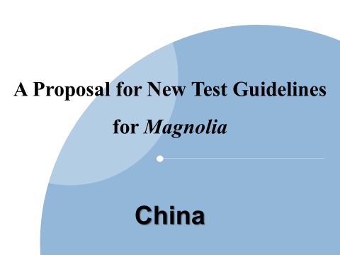 | 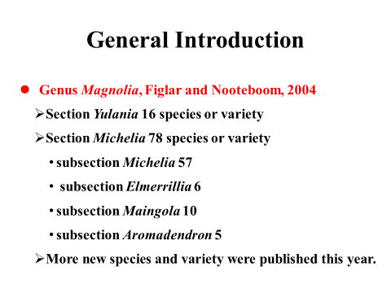
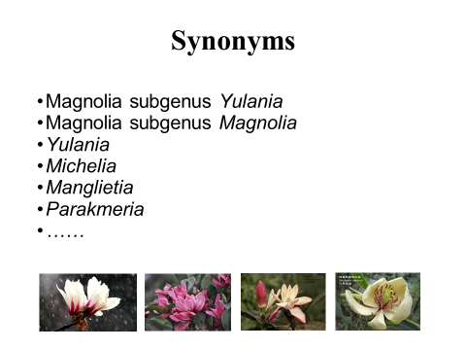 | 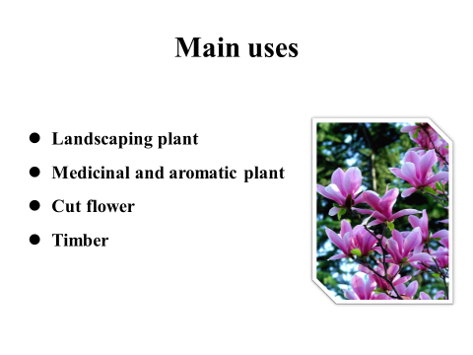
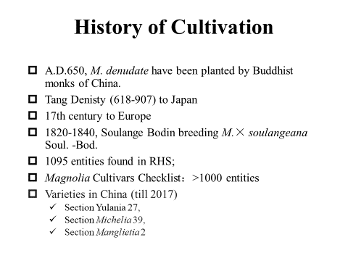 | 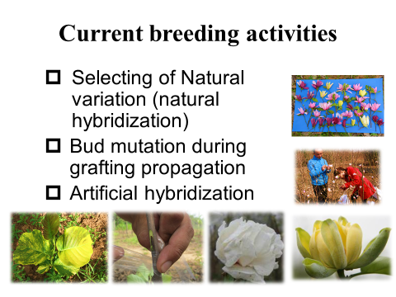

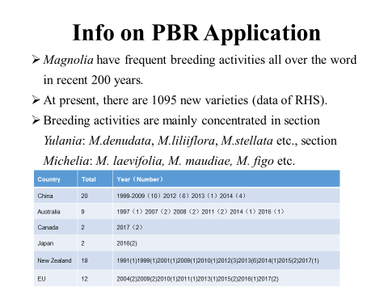 | 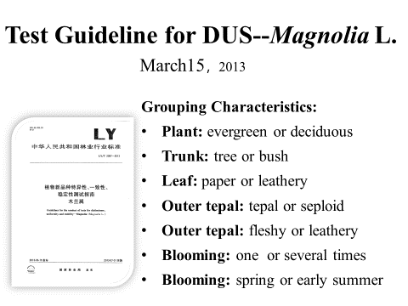
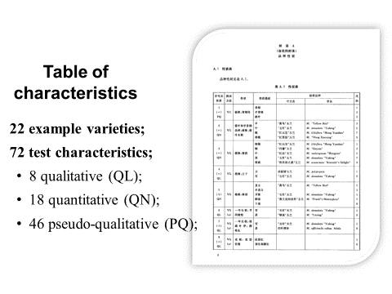 | 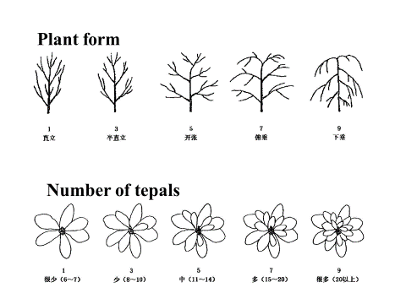
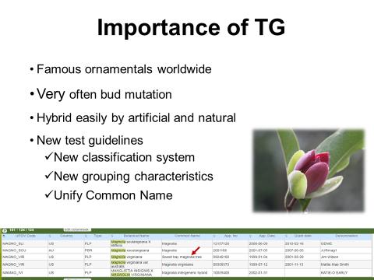 | 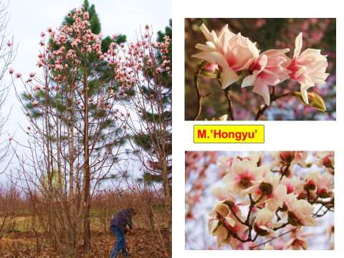

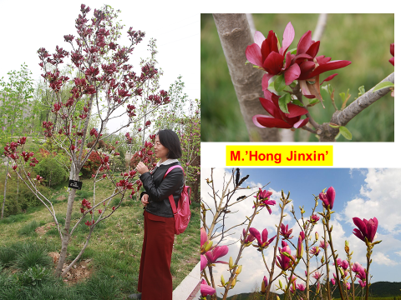 | 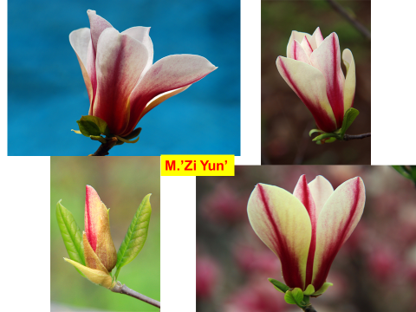
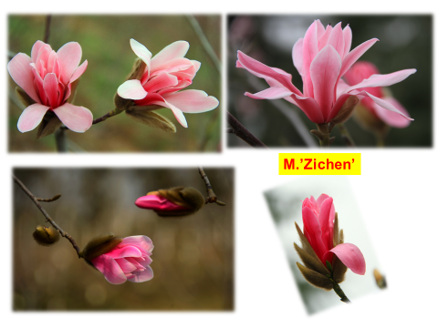 | 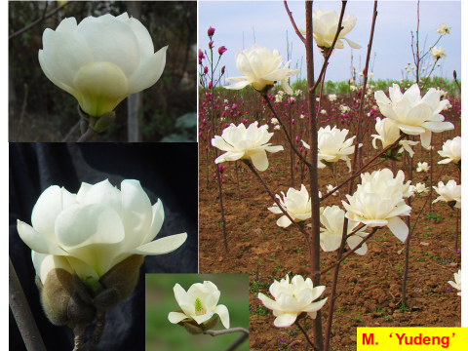
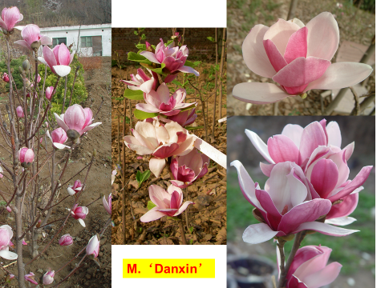 | 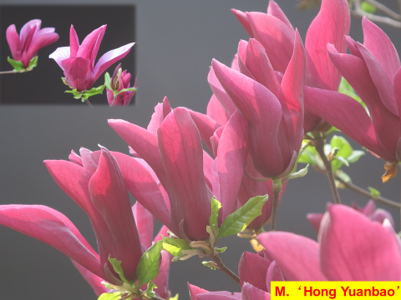

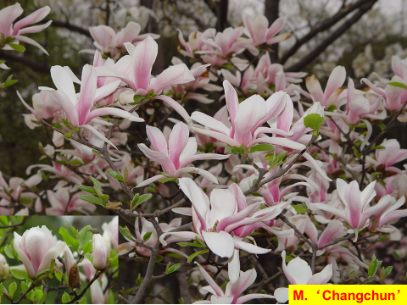 | 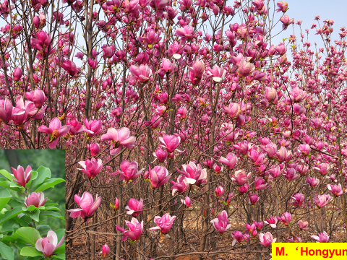
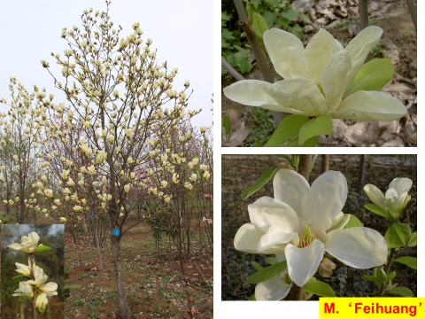 | 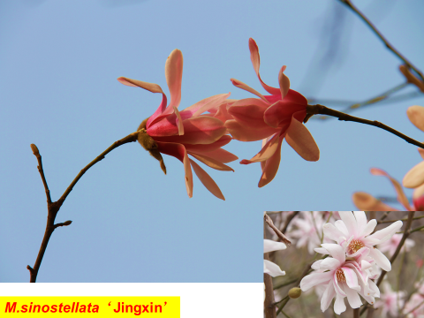
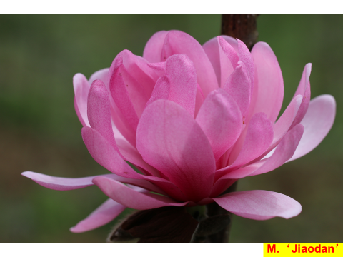 | 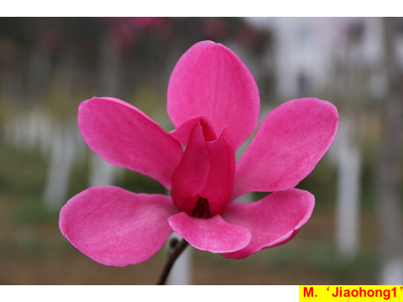

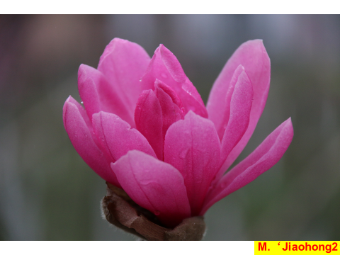 | 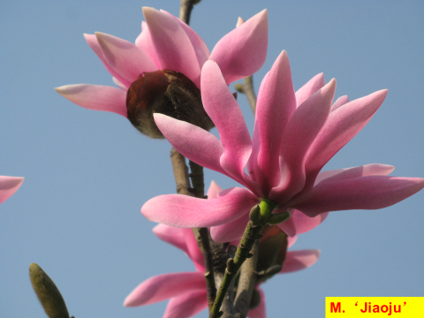
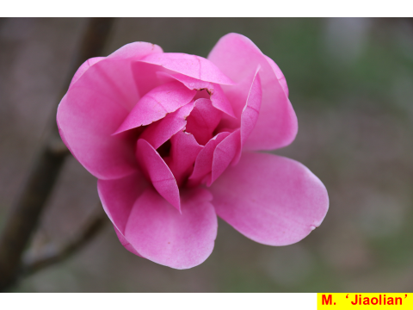 | 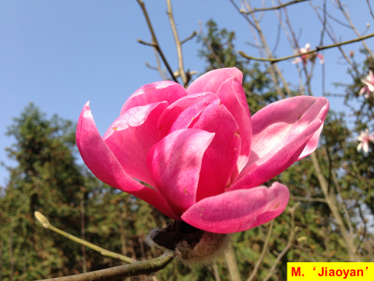
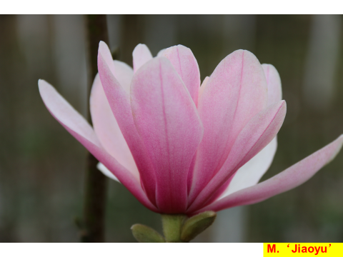 | 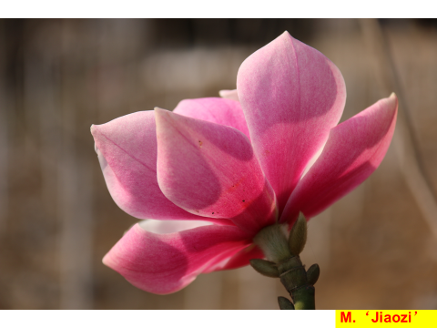

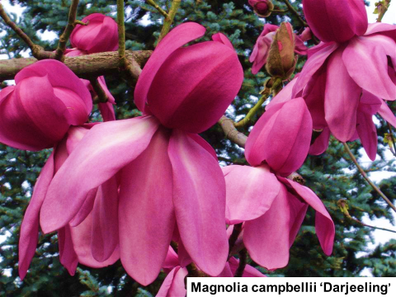 | 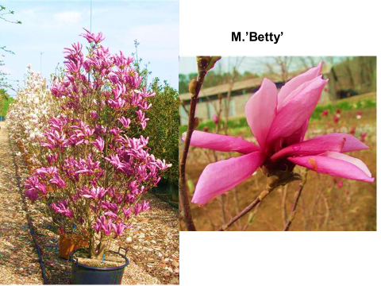
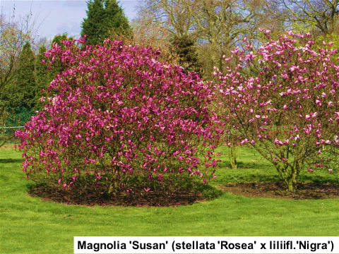 | 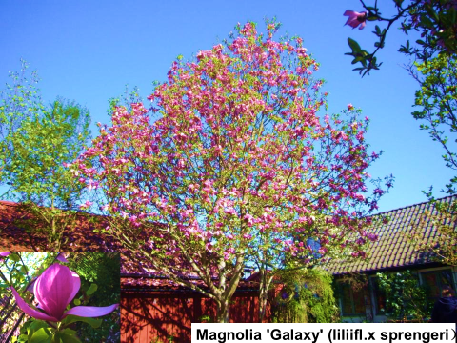
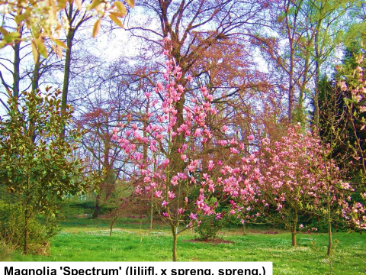 | 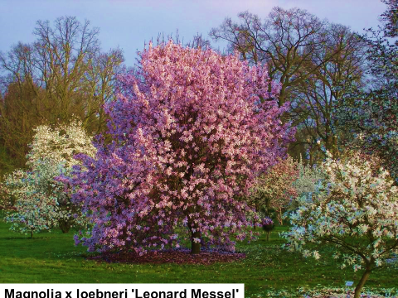

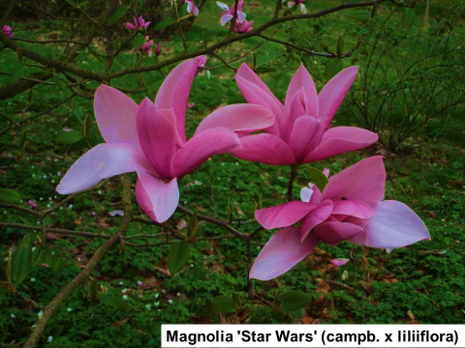 | 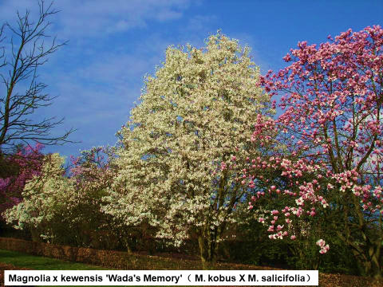
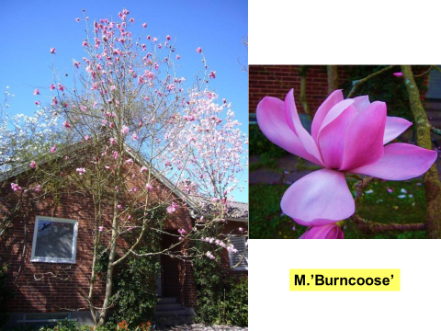 | 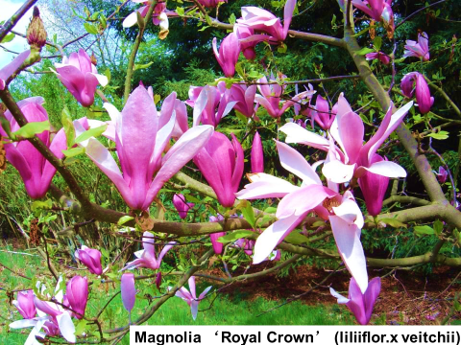
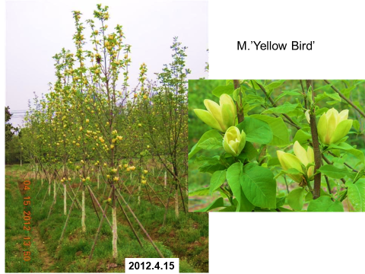 | 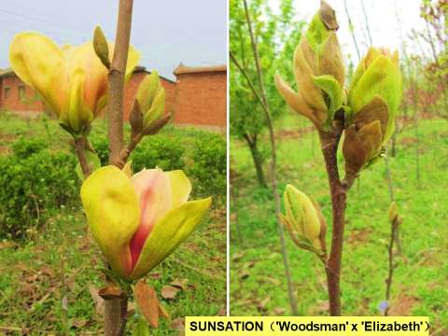

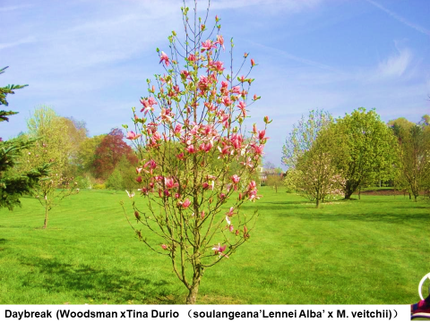 | 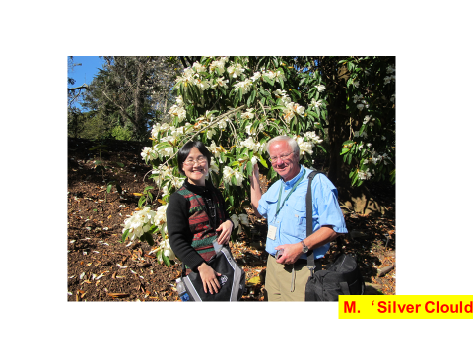
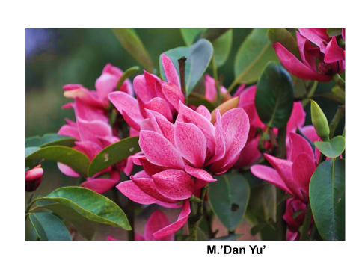 | 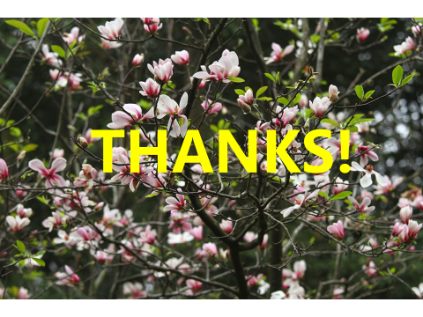

[Annex II follows]

EUROPEAN UNION

Report on activities of the Community Plant Variety Office of the European Union (CPVO)

Statistics for 2018: In 2018, the CPVO received 3 554 applications for Community plant variety rights – the second highest number in the history of the Office – which are 132 more (+3.9 %) than in the previous year.

Despite the higher total number, the number of applications for ornamental crops fell in 2018 to 1561 (-4.2 %). The increase in application numbers was essentially in the agricultural sector. The top two ornamental crops were, as always Roses and Chrysanthemum. These were followed by Phalaenopsis, Calibrachoa and Gerbera which are traditionally amongst the top ten; however, with different ranking.

In 2018, the Office granted 2757 titles for Community protection; 26 859 titles were in force at the end of the year.

Administrative Council (AC): In 2018, the AC continued meeting twice a year discussing and deciding upon strategic matters of the EU plant variety rights system. The AC members showed their appreciation as regards the international strategy and invited the CPVO to maintain the policy of cooperation. In 2018, the AC agreed with the proposal to take over DUS test reports from PVP authorities from outside the European Union where DUS testing facilities do exist in the EU (take-over of Phalaenopsis reports), provided the CPVO quality requirements are met. The Office investigates further possibilities of cooperation with other countries.

Seminar on “The benefits of Plant Variety Protection”: The last AC meeting was followed by the enforcement seminar in Sofia (Bulgaria). The seminar was prepared in collaboration with the Bulgarian Ministry of Agriculture and Foodstuffs and the Bulgarian Executive Agency for Variety Testing, Field Inspection and Seed Control. It aimed at promoting investments in plant breeding and benefits in protecting new plant varieties at national or EU level. More than 130 participants from the private and the public sectors attended the event.

Cooperation with the European Patent Office (EPO): The CPVO reinforced its cooperation with the EPO and made recently available to EPO a range of application documents and variety descriptions for search on routine basis to EPO examiners in order to ensure that plant related patent applications do not overlap with existing Plant breeders’ rights.

Brexit situation: In view of the forthcoming withdrawal of the United Kindom from the EU, the CPVO had to stop organizing new DUS examinations in examination offices in the United Kingdom; all species entrusted to these offices for testing and pending applications had to be re-attributed to other EU-based examination offices.

R&D: The CPVO participates in the ‘Invite’ consortium, which submitted a bid in February 2018 to the call SFS-29 under the Horizon 2020 programme financed by the European Commission. The proposal aims at improving variety testing (both DUS and VCU) in the EU with the help of genotyping, modelling and phenotyping tools. Ten species from the agricultural, vegetable and fruit sector will be studied in the project. The R&D proposal was accepted on December 10, 2018.

In October, the Office approved a practical case study on minimum distances between Pelargonium varieties. The project was proposed by CIOPORA; 7 pairs of protected varieties were selected for a side-by-side comparison at the Bundessortemamt, Germany. A discussion with breeders is scheduled for June/July and the outcome of the study is scheduled for October 2019.

Ornamental experts’ meeting: The annual meeting of 2018 was hosted by our Hungarian examination office NEBIH in May in Budapest and gave the possibility to visit parts of the growing trials conducted at the Vácrátót Botanical Garden. The meetings were attended by representatives of the CPVO’s entrusted examination offices, CIOPORA and Plantum. Experts discussed in particular the assessment of uniformity of variegated varieties, the influence of the environment on the expression of characteristics with its impact on the DUS decision and issues of costs in DUS testing.

For up-to-date information on the CPVO’s activities, please visit the CPVO website, read its newsletter and follow and engage with the CPVO on Twitter: @CPVOTweet

[Annex III follows]

JAPAN

1. Number of applications in 2017
Year | Total | (2017/2016) | Ornamentals | (2017/2016)
1978 to 2017 | 32903 | - | 26072 | -
2016  2017 | 977  1019 | (104%) | 775  819 | (106%)

Top 5 of application for Ornamentals in 2017

Chrysanthemum 176, Rosa 93, Petunia and Calibracoa 39 (30; 9), Dianthus 55, Hydrangea 32

2. Number of titles granted in 2017
Year | Total | (2017/2016) | Ornamentals | (2017/2016)
1978 to 2017 | 26382 | - | 20671 | -
2016  2017 | 942  811 | (86%) | 796  663 | (83%)

Top 5 of granted for Ornamentals in 2017

Rosa 114, Chrysanthemum 113, Dianthus 57, Petunia and Calibracoa 37 (30; 7), Anthurium 25

3. National test guidelines harmonized with UPOV TGs in 2017.
Genera and Species (4)
Pineapple, China Aster, Regal Pelargonium, Salvia

4. National test guidelines developed for new type or species in 2017.
Genera and Species (15)
Alternanthera brasiliana (L.) Kuntze, Antigonon leptopus Hook. & Arn., Arabidopsis halleri (L) O'Kane & Al-Shehbaz subsp.gemmifera (Matsum.) O'Kane & Al-Shehbaz, Avena strigosa Schreb., Dodonaea viscosa (L.) Jacq., Ipomoea carnea Jacq. subsp. fistulosa (Mart. ex Choisy) D. F. Austin, Leucothoe D.Don, Panicum miliaceum L., Physostegia virginiana (L.) Benth., Pilea depressa (Sw.) Blume, Polianthes tuberosa L., Potentilla sundaica (Bl.) O. Kuntze var. robusta (Franch. & Savat.) Kitag., Rhodanthe Lindl., Syringa L., Triticum turgidum L. subsp. durum (Desf.) Husn.
Web-site: http://www.hinshu2.maff.go.jp/info/sinsakijun/botanical_taxon_e.html

5. Other.
✓ Japan continuously offers to other UPOV member examination reports at no charge by the Memorandum of Cooperation (MOC) agreed upon. We have exchanged the MOC documents with 14 members at May 2018.

✓ Japan launched MAFF electronic application system (national electronic application system) on March 26, 2018, to improve convenience for applicants. This system allows users with user ID and password provided by the PVPO to send application form by electric system. Users are requested to send a Request Form by postal mail to PVPO for obtaining user ID and password in advance. The accepting language is Japanese only. Paper application is acceptable also. We started the MAFF electronic application system for improving effective PVP proceedings in Japan.
More information is provided on MAFF’s website,”http://www.hinshu2.maff.go.jp/” (Explanation is available only in Japanese)

✓ For encouraging PBR holder to apply overseas applications for registered varieties in Japan, PVP office is supporting PBR holders including setting up the manual for applying overseas and the consultation desk with some financial support for them.

✓ Since establishment of the East Asia Plant Variety Protection Forum in 2008, Japan continuously support its activities to facilitate the improvement of the implementation and the harmonization of the plant variety protection system based on the UPOV system in the Asian region. On the 11th session of EAPVPF, held on August 1st, 2018, in the Republic of the Philippines “10-year Strategic Plan” was adopted.

✓ Joint activity of Naktuinbouw and NCSS for DUS test based on their Memorandum of Understanding
Naktuinbouw and NCSS have established Calibration Manual for DUS test. Calibration Manuals, which include many photographs explaining how to observe and measure characteristics of varieties will be easy-to-understand reference material for users. This joint activity will result in 11 calibration manuals.
Four manuals for Rose (cut-flower type), Carnation, Lettuce and Watermelon were completed and now available on NCSS website as well as Naktuinbouw website.

[Annex IV follows]

NETHERLANDS

Naktuinbouw Variety Testing Developments

From the beginning of 2017 it has been the intention to integrate the 3 DUS teams Ornamentals, Vegetables and Agricultural crops into one large DUS team. This will enhance cross-over of employees between the different sectors. The new structure came into force at the beginning of 2018. During 2017, the group of employees who are involved in a wide range of resistance tests was enlarged and restructured. Resistance is an increasing discussion topic related to DUS, even in Ornamentals.

Close cooperation with the Naktuinbouw Research and Development team is evolving on the use of DNA techniques in the management of variety collections and in description of characteristics as an alternative for morphological observations. In 2017, Naktuinbouw invested in many activities concerning methodology research, especially in the use of DNA in DUS examination.

Members of the DUS teams were involved in the Training Course DNA Techniques and Variety Identification, which was organized twice in 2017. This Course was developed by the Research and Development team. A wide variety of persons with a background in variety testing (UPOV), certification (OECD) or seed testing (ISTA) participated.

Spring 2017 the first True Potato Seed variety was granted Plant Breeders’ Right in the Netherlands.

For the major crops for listing and/or Plant Breeders’ Rights, Naktuinbouw has developed calibration books. The calibration book serves as a very practical manual that gives an illustrated explanation of each crop characteristic mentioned in these guidelines/protocols. Calibration books are now freely available on the Naktuinbouw website.

Naktuinbouw has been assigned by the CPVO (Community Plant Variety Office) to carry out DUS tests for 130 extra crops for Plant Breeders' Rights applications in the European Union. This is due to the Brexit, as a result of which the CPVO will no longer accept DUS reports from the United Kingdom which are issued after March 29, 2019. The CPVO redistributed the crops that were only tested in the United Kingdom.
The Administrative Council of the CPVO has entrusted Naktuinbouw for the examination of Chrysanthemum.

Number of applications received

In 2017, 1850 applications were received for testing for the first year for National listing, and for National or European Plant Breeders’ Rights (in brackets the difference in numbers with 2016):
Ornamentals 862 (+5)
Agriculture 154 (+18)
Vegetables 834 (+5)
Total 1850 (+28)
A forecast for 2018 is not yet possible, but in the first quarter 505 applications were received, which is 54 more than in the same quarter of 2017.

Activities for UPOV

- In July 2017 Naktuinbouw hosted the UPOV Technical Working Party for Vegetables, in Leiden and Roelofarendsveen.
- In October 2017 Mr. Henk de Greef was appointed as chairperson of the Technical Working Party for Ornamental Plants and Forest Trees.

International cooperation

- Naktuinbouw cooperates since 2016 with NCSS Japan on the harmonisation of Dutch Calibration Books and Japanese Testing Manuals in a 5 years working plan. In 2018 this has resulted in publication of Calibration Manuals for Lettuce, Rose, Carnation and Watermelon on their respective websites. For 2018, Eggplant and Anthurium are scheduled.
- Colleagues from Ghana, United Republic of Tanzania and Argentina did an internship at Naktuinbouw, respectively with focus on administration around PVP, DUS testing of potato and DUS examination vegetables and ornamentals.
- In 2017 several activities where organised by Naktuinbouw Variety Testing Department and the Department of Agricultural Research (DAR) of Myanmar in the framework of a three years project “Strengthening Myanmar Seed Sector”. In 2018 Naktuinbouw received a delegation of Myanmar experts with the aim to let them see how an UPOV 91 PVP system works. There will be close collaboration with other UPOV EA and the United Kingdom examination offices in the training of Myanmar experts.

PVP Development Program

This is a new tool to help countries to develop their Plant Breeders’ Rights system. The Dutch Ministry makes funds available for the implementation of this program. Naktuinbouw is charged to manage the program where they cooperate with the Dutch Agricultural Counsellors and their staff. They can propose projects aimed at the creation or development of a Plant Breeders’ Right system in the territory they work for.

In 2017 many projects were carried out. Some highlights:
- UPOV Seminar United Republic of Tanzania
27 participants attended a 3 days seminar organised to strengthen the effective implementation of the plant variety protection system in the United Republic of Tanzania.
- Sponsoring 5 candidates to the 2017 PVP course
During the 2017 annual international PVP course the participation of 5 candidates was sponsored from the PVP Development budget: one participant from India, two from Cuba, one from Viet Nam and one from Indonesia.
- EAPVP forum activity training watermelon in Viet Nam
From 24 April to 27 April the Quang Ngai (Central Viet Nam) DUS station was visited by a Naktuinbouw expert where a training on DUS test of watermelon was given.
- China request for DUS training
On request of the Chinese DUS authorities, two training session were organised in conjunction with a meeting on the possible benefits of China becoming a UPOV member under the 1991 Convention.
- Mexico; promotion of the 1991 Act of the UPOV Convention
On invitation of the Agri attaché the Mexican authorities were visited by Naktuinbouw. A great interest for membership to the 1991 Act of the UPOV Convention was encountered. A follow-up (extra) activity in the Netherlands was planned. A Mexican delegation visited the Netherlands to study the effects of membership to the 1991 Act of the UPOV Convention in the Netherlands.
- Indonesia Shallots
From 25 September to 29 September two Indonesian government officials visited for 2 weeks Naktuinbouw in the Netherlands. This training focussed on two main subjects: Importance and benefits of being an UPOV member. Furthermore, practical training on true seed shallots and seed potatoes was given, in order to try to speed up the introduction of new varieties and the production of high quality seed/tubers.

[Annex V follows]

NEW ZEALAND

The number of applications for ornamental varieties (27) accepted in 2018 continues to decrease in comparison with 42 applications accepted in 2017. This continues the steady decline in application numbers (79) experienced since 2013. The question that this prompts is when this decline will level off or the reverse? Roses remain the most important genus followed by Lavandula and New Zealand native species. Applications for popular woody garden plants (such as Camellia, Rhododendron, Hydrangea) were formally regular, however now these have decreased and other woody genera (such as Magnolia, Nandina) are more frequent. Low numbers of applications for varieties of herbaceous perennials remain consistent (Petunia, Dianthus).

The first application has been made by a NZ breeder for a variety of Delphinium. Applications for varieties in this genus were previously made only from foreign breeders. The existing test guideline requires revision and testing is expected to begin in the 2019/20 growing season.

The first application for a variety of Zamioculcas zamiifolia has been made by a breeder from the Republic of Korea. The genus is beginning to be used as an indoor plant and is almost unknown nationally. The variety has been tested and granted rights in the Republic of Korea and the Test Report has been taken over from the Korea Seed and Variety Service.

A programme to provide technical guidance documents on the website was started several years ago. Three revised documents and have been updated in the last year.

Use of foreign test reports for DUS testing in New Zealand https://www.iponz.govt.nz/about-ip/pvr/technical-guidance/current/use-of-foreign-test-reports-for-dus-testing-in-new-zealand/

Availability and supply of plant material for PVR purposes https://www.iponz.govt.nz/about-ip/pvr/technical-guidance/current/availability-and-supply-of-plant-material/

In addition, the following new document has been added
Variety testing in New Zealand https://www.iponz.govt.nz/about-ip/pvr/technical-guidance/current/variety-testing-in-new-zealand/

The New Zealand government has commenced a review of the Plant Variety Rights Act 1987. Public consultation has commenced, with the release of an Issues Paper in September 2018. The review will be completed within approximately three years.

[Annex VI follows]

REPUBLIC OF KOREA

- Plant Breeder's Right

The total number of application has reached 10,274 and 7,450 varieties are under the protection as of 31st December, 2018.

Last year we received 713 applications, among them, 348 varieties were ornamental plants such as rose (60), chrysanthemum (39), hydrangea (26), echeveria (22), gerbera (14), anthurium (14) coreopsis (13), lily (11), etc.

- International Cooperation

KSVS (Korea Seed & Variety Service) provided PVP training course for the 13 participants from 6 countries including Ghana, Sudan, Guatemala, Philippines, Peru and Republic of Moldova for 3 weeks from May 13rd to June 2nd in 2018. Since 2007, 161 trainees have participated across 31 countries.

- Establishing International Seed and Life Education Center (ISLEC, tentative)

The Republic of Korea decided to establish international seed and life education center located in Kimcheon-si. This organization would support capacity of human resources and delivering knowledge to the doorsteps of seed industry. ISLEC will start July in 2019. More than 20 customized courses will be open for internal/external/international applicants.

- Hosting 53rd Technical Working party in Vegetables

The 53rd TWV will be hosted by KSVS (Korea Seed and Variety Service) at Hotel President in Seoul from May 19th to 24th in 2019.

- 373 national test guidelines have been published by KSVS

So far, national test guidelines of 373 species have been published by KSVS. Some of these guidelines have not been published in other countries. If needed, please request a copy of our test guidelines. The list of national test guidelines follows.

The list of national test guidelines published by KSVS
No. | Botanical name | Common name in english
1 | Oryza sativa L. | Rice
2 | Hordeum vulgare L. | Barley
3 | Triticum aestivum L. | Wheat
4 | Glycine max (L.) Merrill | Soybean
5 | Zea mays L. | Maize
6 | Solanum tuberosum L. | Potato
7 | Raphanus sativus L. | Radish
8 | Brassica campestris L. spp. pekinensis (Lour.) Rupr. | Chinese cabbage
9 | Brassica oleracea L. var. capitata | Cabbage
10 | Citrullus vulgaris Schrad. | Watermelon
11 | Cucurbita pepo L. | Vegetavle marrow, Squash
12 | Cucumis sativus L. | Cucumber
13 | Cucumis melo L. var. makuwa Makino | Oriental melon
14 | Capsicum annuum L. | Sweet pepper, Hot pepper, Paprika, Chili
15 | Lycopersicum esculentum MilL. | Tomato
16 | Allium fistulosum L. | Welsh Onion
17 | Allium cepa L. var. cepa, Allium cepa L. var. aggregatum | Onion, Shallot
18 | Daucus carota L. | Carrot
19 | Lactuca sativa L. | Lettuce
20 | Spinacia oleracea L. | Spinach
21 | Malus domestica Borkh. | Apple
22 | Pyrus pyrifolia Nakai | Pear
23 | Prunus persica (L.) Batsch. | Peach
24 | Gymnocalycium mihanovichii Br. & R. | Ruby ball, Moon cactus
25 | Lolium spp. | Ryegrass
26 | Festuca elatior var. arundianacea (Schreb.) Wimm. | Tall fescue
27 | Trifolium pratense L. | Red clover
28 | Avena sativa L. | Oats
29 | Ipomoea batatas (L.) Lam. | Sweet Potato
30 | Sesamum indicum L. | Sesame
31 | Perilla frutescens Brit. var. japonica Hara | Perilla
32 | Arachis hypogaea L. | Groundnut(Peanut)
33 | Brassica napus L. | Rape
34 | Angelica gigas Nakai | Korean angelica
35 | Astragalus membranaceus Bunge | -
36 | Panax ginseng C. A. Meyer | Ginseng
37 | Cucumis melo L. var. reticulatus Naud. | Melon
38 | Brassica oleracea L. var. italica Plen. | Broccoli
39 | Brassica oleracea L. var. botrytis (L.) Alef. | Cauliflower
40 | Vitis spp. | Grapevine
41 | Citrus junos Sieb. ex Tanaka | Yuzu
42 | Forsythia spp. | Forsythia
43 | Hibiscus spp. | Rose-of-Sharon
44 | Lycoris spp. | Lycoris
45 | Ajuga multiflora Bunge | Ajuga
46 | Eustoma grandiflorum Shinn | Lisianthus
47 | Petunia hybrida Hort. | Petunia
48 | Godetia grandiflora Lindl. | Godetia
49 | Impatiens spp. | Impatiens
50 | Cyclamen persicum Mill. | Cyclamen
51 | Antirrhinum majus L. | Snapdragon
52 | Viola tricolor L. var. hortensis DC. | Pansy
53 | Bellis perennis L. | Lawndaisy
54 | Alstroemeria spp. | Alstroemeria
55 | Hyacinthus spp. | Hyacinth
56 | Pleurotus spp. | Oyster mushroom
57 | Dactylis glomerata L. | Orchardgrass
58 | Cassia tora L. | Sickle senna
59 | Lycium chinense Mill. | Chinese desert-thorn
60 | Angelica dahurica(Fisch.) Benth. et Hooker f. | Dahurian angelica
61 | Platycodon grandiflorum (Jacq) A. DC | Balloon-flower
62 | Dioscorea batatas Decne | Yam
63 | Liriope platyphylla Wang et Tang | Big blue lilyturf
64 | Bupleurum falcatum L. | -
65 | Peucedanum japonicum Thunb. | -
66 | Rehmannia glutinosa (Gaertner) Liboschitz | Adhesive rehmannia
67 | Ligusticum chuanxiong Hort. | -
68 | Dendranthema spp. | Chrysanthemum
69 | Gladiolus gandavensis Van Houtte | Gladiolus
70 | Calendula officinalis L. | Pot marigold
71 | Dendrobium spp. | Dendrobium
72 | Celosia spp. | Celosia
73 | Zinnia spp. | Zinnia
74 | Lilium spp. | Lily
75 | Matthiola incana R. Br. | Stock
76 | Ageratum houstonianum Mill. | Ageratum
77 | Iris spp. | Iris
78 | Hemerocallis spp. | Day lily
79 | Rosa spp. | Rose
80 | Tulipa gesneriana L. | Tulip
81 | Euphorbia pulcherrima Willd. ex Klot. | Poinsettia
82 | Neofinettia falcata Hu., Aerides japonicum Lindemb. et Reichb. | Sickle neofinetia
83 | Tropaeolum majus L. | Nasturtium
84 | Secale cereale L. | Rye
85 | Vigna angularis (Willd.) Ohwi ＆ Ohashi | Adzuki bean
86 | Vigna radiata (L.) Wilczek | Mungbean
87 | Pisum sativum L. | Pea
88 | Solanum melognena L. | Egg plant
89 | Brassica rapa L. ssp. chinensis Jusl. | Pakchoi
90 | Lagenaria siceraria Standley | Gourd
91 | Kalanchoe spp. | Kalanchoe
92 | Cattleya Lindl. | Cattleya
93 | Oncidium spp. | Oncidium
94 | Hosta spp. | Plantain lily
95 | Paeonia lactiflora | Chinese peony
96 | Chamaecereus silvestrii | Peanut cactus
97 | Campanula spp. | Bellflower
98 | Pelargonium spp. | Geranium
99 | Actinidia spp. | Actinidia
100 | Calanthe spp. | Calanthe
101 | Phaseolus vulgaris L. | French bean
102 | Coix lacryma-jobi L. | Job's-tear
103 | Brassica juncea (L.)Czern. | India mustard
104 | Brassica oleracea L. var. gongylodes L. | Kohlrabi
105 | Brassica rapa L. var. rapa | Turnip
106 | Chrysanthemum coronarium L. | Garland chrysanthemum
107 | Zantedeschia spp. | Calla
108 | Ornithogalum spp. | Chincherinchee
109 | Anthurium spp. | Anthurium
110 | Hippeastrum hybridum Hort. | Amaryllis
111 | Rhododendron spp. | Rhododendron
112 | Hydrangea macrophylla Ser. | Hydrangea
113 | Dianthus spp. | Carnation
114 | Gerbera spp. | Gerbera
115 | Gypsophila spp. | Gypsophila
116 | Limonium spp. | Statice
117 | Phalaenopsis spp. | Phalaenopsis
118 | Gentiana L. | Gentian
119 | Freesia hybrida L.H. Bailey | Freesia
120 | Cymbidium spp. | Cymbidium
121 | Camellia spp. | Camellia
122 | Schizandra chinensis Baillon | Schizandra
123 | Angelica acutiloba Kitagawa | Angelica
124 | Ganoderma spp. | Reishi mushroom
125 | Angelica koreana Max. (Ostericum koreanum Max.) | Osterici koreani
126 | Phellinus spp. | Phellinus heartrot
127 | Fagopyrum spp. | Buckwheat
128 | Codonopsis pilosula (Franch.) Nannf. | Pilosula asiabell/Tangshen
129 | Anemarrhena asphodeloides Bunge | Anemarrhena rhizome
130 | Cliviaminiata Regel. | Kaffir lily
131 | Aquilegia spp. | Columbine
132 | Clematis spp. | Clematis
133 | Cordyceps spp. | Insects-born fungus
134 | x Triticosecale Wittmack | Triticale
135 | Medicago sativa L. | Alfafa, Lucerne
136 | Diospyros kaki L. | Persimmon
137 | Delphinium spp. | Delphinium
138 | Phlox spp. | Phlox
139 | Anemone spp. | Anemone
140 | Ficus elastica Roxb. | Indian rubberplant
141 | Dracaena spp. | Dracaena
142 | Ficus benjamina | Weeping fig
143 | Nicotiana tabacum L. | Tabacco
144 | Allium tuberosum Rottl. ex Spreng. | Chinese chives
145 | Brassica oleracea L. var. acephala (DC.) Alef. | Kale
146 | Cichorium intybus L. | Chicory
147 | Prunus mume Sieb. et Zucc. | Mume, Japanese apricot
148 | Begonia x hiemalis Fotsch | Elatior begonia
149 | Begonia x tuberhybrida Voss | Tuberous begonia
150 | Begonia spp. | Foliage begonia
151 | Cichorium endivia L. | Endive
152 | Saxifraga fortunei | Saxifraga
153 | Beta vulgaris L. var. cicla L.(Ulrich) | Leaf beet, Swiss chard
154 | Apium graveolens L. | Celery
155 | Petroselinum crispum Nym. ex Hill | Parsley
156 | Prunus salicina Lindl. | Japanese plum
157 | Prunus armeniaca L. | Apricot
158 | Flammulina velutipes (Curtis) Singer | Winter mushroom
159 | Gaura spp. | Gaura
160 | Cucurbita moschata Duch. | Butternut
161 | Cucurbita maxima Duch. | Pumpkin
162 | Setaria italica (L.) Beauv. | Foxtail millet
163 | Sorghum bicolor L. | Sorghum
164 | Pentas Benth. | Pentas
165 | Fragaria L. | Strawberry
166 | Argyranthemum frutescens (L.) Sch. Bip. | Marguerite
167 | Brugmansia spp. | Angel's trumpet
168 | Calibrachoa spp. | Calibrachoa
169 | Calluna vulgaris (L.) Hull | Scots heather
170 | Coreopsis spp. | Tickseed
171 | Diascia spp. | Diascia
172 | Hedera spp. | Ivy
173 | Hypericum spp. | St. Johnswort
174 | Lavandula spp. | Lavender
175 | Matricaria recutita | Camomile
176 | Muehlenbeckia spp. | Mattress vine
177 | Nelumbo spp. | Lotus
178 | Nymphaea spp. | Water lily
179 | Ocimum spp. | Basil
180 | Osteospermum spp. | Daisybush
181 | Primula polyantha | Elatior hybrid primroses
182 | Rhododendron simsii Planch. | Pot Azalea
183 | Streptocarpus spp. | Cape primrose
184 | Sutera spp. | Sutera
185 | Tagetes spp. | Marygold
186 | Alocasia spp. | Alocasia
187 | Caladium spp. | Caladium
188 | Calathea spp. | Calathea
189 | Epipremnum spp. | Epipremnum
190 | Euphorbia fulgens | Scarlet-plume
191 | Euphorbia milii | Crown of thorns
192 | Fittonia albivenis | Fittonia
193 | Guzmania spp. | Guzmania
194 | Opuntia spp. | Opuntia
195 | Philodendron spp. | Philodendron
196 | Schlumbergera truncata | Crab cactus
197 | Spathiphyllum spp. | Spathiphyllum
198 | Anigozanthos Labill. | Kangaroo paw
199 | Belamcanda spp. | Leopard lily
200 | Caryopteris spp. | Caryopteris
201 | Catharanthus roseus (L.) G. Don | Madagascar periwinkle
202 | Dahlia spp. | Dahlia
203 | Epidendrum spp. | Star orchid
204 | Iris ensata | Japanese iris
205 | Lobelia spp. | Lobelia
206 | Portulaca oleracea L. | Purslane
207 | Torenia spp. | Torenia
208 | Hypsizigus marmoreus | Beech mushroom
209 | Agrocybe spp. | Agrocybe
210 | Pholiota spp. | Pholiota
211 | Grifola frondosa | Dancing mushroom
212 | Bougainvillea spp. | Bougainvillea
213 | Bouvardia spp. | Bouvardia
214 | Crossandra spp. | Crossandra
215 | Exacum spp. | Exacum
216 | Fuchsia spp. | Fuchsia
217 | Xerochrysum bracteatum | Strawflower
218 | Lantana spp. | Lantana
219 | Miltonia spp. | Miltonia
220 | Odontoglossum spp. | Odontoglossum
221 | Zygopetalum spp. | Zygopetalum
222 | Astilbe spp. | Astilbe
223 | Callistephus chinensis | Chinese Aster
224 | Codiaeum spp. | Croton
225 | Cosmos bipinnatus | Cosmos
226 | Cupressus spp. | Cupressus
227 | Oxalis spp. | Oxalis
228 | Peperomia spp. | Peperomia
229 | Saintpaulia ionantha | African violet
230 | Tillandsia spp. | Tillandsia
231 | Veronica spp. | Veronica
232 | Chlorophytum spp. | Chlorophytum
233 | Nertera granadensis | Bead plant
234 | Cuphea hyssopifolia | Cuphea
235 | Fatsia spp. | Fatsia
236 | Mandevilla spp. | Mandevilla
237 | Nemesia spp. | Nemesia
238 | Neoregelia spp. | Neoregelia
239 | Plectranthus scutellarioides | Coleus
240 | Verbena spp. | Verbena
241 | Yucca elephantipes | Yucca
242 | Agapanthus spp. | Agapanthus
243 | Angelonia spp. | Angelonia
244 | Canna spp. | Canna
245 | Curcuma spp. | Curcuma
246 | Gloriosa spp. | Gloriosa
247 | Gloxinia sylvatica | Bolivian sunset
248 | Helleborus spp. | Helleborus
249 | Lathyrus odoratus | Sweet pea
250 | Ranunculus spp. | Ranunculus
251 | Euphorbia hypericifolia | Chickenweed
252 | Phyla nodiflora | Capeweed
253 | Pulsatilla spp. | Pasque flower
254 | Schefflera elegantissima | false aralia
255 | Allium porrum L. | Leek
256 | Allium sativum L. | Garlic
257 | Angelica keiskei | Angelica, Ashitava
258 | Beta vulgaris L. | Beet root
259 | Zingiber officinale Rosc. | Ginger
260 | Camellia sinensis (L.) O. Kuntze | Tea
261 | Hippophae rhamnoides L. | Common sea buckthorn
262 | Eryngium spp. | Eryngo
263 | Parthenocissus spp. | Parthenocissus
264 | Syngonanthus chrysanthus | Syngonanthus
265 | Panicum miliaceum L. | Common millet
266 | Vigna unguiculata (L.) Walp subsp. sesquipedalis (L.) Verdc. | Asparagus bean
267 | Vicia faba L. | Broad bean
268 | Morus spp. | Mulberry
269 | Linum usitatissimum L. | Flax, Linseed
270 | Asplenium spp. | Asplenium
271 | Euonymus japonicus | Evergreen euonymus
272 | Narcissus spp. | Narcissus
273 | Pyrrosia spp. | Felt fern
274 | Vaccinium corymbosum L., Vaccinium angustifolium Aiton, Vaccinium ashei Reade | Blueberry
275 | Eriobotrya japonica (Thunb.) Lindl. | Loquat
276 | Malpighia Emarginata DC. | Acerola, Babados cherry
277 | Asparagus officinalis L. | Asparagus
278 | Hibiscus rosa-sinensis | Chinese hibiscus
279 | Viburnum tinus | Laurustinus
280 | Hoya carnosa | Waxplant
281 | Malus Mill. | Apple Rootstocks
282 | Citrus L. - Group 1 | Satsuma mandarin
283 | Ficus carica L. | Fig
284 | Agaricus L. | Button mushroom
285 | Vicia villosa Roth. | Vetch(Hairy vetch)
286 | Pyrus communis L. | European pear
287 | Prunus avium L. | Sweet cherry
288 | Brachyscome Cass. | Brachyscome
289 | Chamelaucium Desf. | Waxflower
290 | Passiflora spp. | Passion flower
291 | Pyracantha spp. | Pyracanth
292 | Zamioculcas zamiifolia | ZZ plant
293 | Hibiscus cannabinus | Kenaf
294 | Aralia cordata Thunb. | Araliaceae
295 | Prunus humilis | Chinese dwarf cherry
296 | Phlox paniculata L. | Perennial phlox
297 | Ipomoea nil | Morning glory
298 | Momordica charantia L. | Bitter gourd
299 | Cryptotaenia japonica Hassk | Japanese cryptotaenia
300 | Psidium guajava L. | Guava
301 | Rubus idaeus L. | Raspberry
302 | Pyrus L. | Pear rootstocks
303 | Ribes nigrum L. | Black currant
304 | Punica granatum | Pomegranate
305 | Trifolium repens L. | White clover
306 | Miscanthus spp. | Miscanthus
307 | Breynia disticha | Breynia
308 | Primula malacoides | Fairy primrose
309 | Paphiopedilum | Lady's-slipper
310 | Aglaonema spp. | Chinese evergreen
311 | Echeveria spp. | Echeveria
312 | Lactuca indica L. | Indian lettuce
313 | Stevia rebaudiana | Stevia
314 | Tricholoma giganteum. | Giant mushroom
315 | Boronia spp. | Boronia
316 | Crassula ovata | Jade plant
317 | Hebe spp. | Hebe
318 | Ardisia spp. | Ardisia
319 | Citrus L. - Group 4 | Grapefruit
320 | Citrus L. - Group 3 | Limes
321 | Citrus L. - Group 2 | Sweet orange
322 | Citrus L. - Group 5 | Trifoliate orange
323 | Prunus L. | Prunus rootstocks
324 | Solanum nigrum | Black nightshade
325 | Mangifera indica L. | Mango
326 | Cynara cardumculus L. | Artichoke, Cardoon
327 | Annona cherimola Mill. | Cherimoya
328 | Coffea arabica, C. canephora L., Pierre ex A. Froehner | Coffee
329 | Rebutia spp. | Rebutia
330 | Delosperma N.E.Br. | Delosperma
331 | Lithospermum erythrorhizon Siebold et Zuc. | Redroot gromwell
332 | Echinochloa spp. | Barnyardgrass
333 | Viola spp. | Viola
334 | Scabiosa spp. | Scabiosa
335 | Fortunella Swingle | Kumquat
336 | Musa acuminata Colla; Musa × paradisiaca L. | Banana
337 | Brassica oleracea L. var. gemmifera DC. | Brussels sprouts
338 | Cucurbita maxima Duch. x Cucurbita moschata Duch. | Cucurbita maxima x Cucurbita moschata
339 | Aronia Medik. | Aronia
340 | Rubus subgenus Eubatus sect. Moriferi & Ursini | Blackberry
341 | Salvia miltiorrhiza | Redroot sage
342 | Boehmeria nivea | Chinese silkplant
343 | Camelina sativa | German sesame
344 | Pennisetum spp. | Foxtail fountain grass
345 | Achillea spp. | Yarrow
346 | Aster spp. | Aster
347 | Sarcococca spp. | Sweetbox
348 | Aloe spp. | Aloe
349 | Magnolia spp. | Magnolia
350 | Trachelospermum spp. | Asiatic jasmine
351 | Craspedia spp. | Craspedia
352 | Olea europaea L. | Olive
353 | Litchi chinensis Sonn. | Litchi
354 | Hylocereus undatus (Haw.) Britton & Rose | Dragon Fruit
355 | Persea americana Mill. | Avocado
356 | Ribes uva-crispa L. | Gooseberry
357 | Syzygium samarangense Merr. & L.M.Perry | Java apple
358 | Silene spp. | Silene
359 | Sedum spp. | Stonecrop
360 | Achyranthes spp. | Achyranthes root
361 | Stokesia laevis (Hill) Greene | Stokesia
362 | Ficus natalensis Hochst. subsp. leprieurii C.C.Berg | Natal fig.
363 | Schefflera spp. | Umbrella tree
364 | Dimocarpus longan L., Euphoria longan Lour. | Longan
365 | Lonicera caerulea L. | Blue honeysuckle
366 | Mesembryanthemum crystallinum L. | Crystal iceplant
367 | Ricinus communis L. | Castor bean
368 | Astrophytum spp. | Astrophytum
369 | Carica papaya L. | Papaya
370 | Senna spp. | Senna
371 | Eleusine coracana(L.) Gaertn. | Finger millet
372 | Oxypetalum coeruleum (D. Don) Decne | Oxypetalum
373 | Helenium spp. | Helenium

[Annex VII follows]

UNITED KINGDOM

Report on the activity of the United Kingdom Plant Varieties and Seeds Office in Cambridge and the regional examination centres of NIAB, SASA and AFBI. The Plant Varieties and Seeds Office is part of the Science Directorate of the Animal and Plant Health Agency (APHA), an executive agency of the Department for Environment, Food and Rural Affairs (Defra). Contact details and phone numbers are available on Gov.uk website where all Government departments now have their website details.

Across all the United Kingdom trial stations, nearly 1500 candidate varieties were under test for Listing and/or PVR in the past year, including 302 winter oilseed rape, 297 cereals, 239 herbage and fodder, >350 ornamentals and the remainder potatoes, field beans, sugar beet, vegetables and kale. Applications in the agricultural sector for the coming season remain stable.

The ornamental trials consist of 150 Chrysanthemum varieties and 200 applications in a wide range herbaceous and woody species, with Clematis, Dahlia, Campanula, Hebe and Heuchera in significant numbers.

United Kingdom DUS testing complies with CPVO’s quality requirements with APHA and its TQB’s NIAB, SASA and AFBI achieving Entrustment from CPVO for designated species in October 2016 for the third audit running from 2010.

NIAB is pleased to have partnered with GEVES for the delivery of CPVO/APHA funded project ‘Test of the potential use of SNP markers on Oilseed Rape Varieties’. This was a pilot study with a positive outcome, the final report will be published by the CPVO and will be available on their website in due course.

[End of Annex VII and of document]

