 |  | E
 | 
  TG/SOLEN_SCU(proj.2)
  ORIGINAL: English
  DATE: 2016-05-09
INTERNATIONAL UNION FOR THE PROTECTION OF NEW VARIETIES OF PLANTS
 | Geneva
  DRAFT
  COLEUS
  UPOV Code(s): PLECT_SCU
  Plectranthus scutellarioides (L.) R. Br.
  *
GUIDELINES
FOR THE CONDUCT OF TESTS
FOR DISTINCTNESS, UNIFORMITY AND STABILITY

prepared by experts from Japan
to be considered by the
Technical Working Party for Ornamental Plants and Forest Trees

at its forty-ninth session, to be held in Gimcheon City, Republic of Korea,
from 2016-06-13 to 2016-06-17

Disclaimer: this document does not represent UPOV policies or guidance
Alternative names:*

Botanical name | English | French | German | Spanish
  Plectranthus scutellarioides (L.) R. Br., Coleus blumei Benth., Solenostemon scutellarioides (L.) Codd
  coleus, painted-nettle
  Buntblatt, Buntnessel
  macho, nene

The purpose of these guidelines (“Test Guidelines”) is to elaborate the principles contained in the General Introduction (document TG/1/3), and its associated TGP documents, into detailed practical guidance for the harmonized examination of distinctness, uniformity and stability (DUS) and, in particular, to identify appropriate characteristics for the examination of DUS and production of harmonized variety descriptions.
ASSOCIATED DOCUMENTS
These Test Guidelines should be read in conjunction with the General Introduction and its associated TGP documents.

TABLE OF CONTENTS | PAGE
1. | SUBJECT OF THESE TEST GUIDELINES.......................................................................................................... | 3
2. | MATERIAL REQUIRED......................................................................................................................................... | 3
3. | METHOD OF EXAMINATION................................................................................................................................ | 4
3.1 | Number of Growing Cycles........................................................................................................................ | 4
3.2 | Testing Place............................................................................................................................................. | 4
3.3 | Conditions for Conducting the Examination............................................................................................... | 4
3.4 | Test Design................................................................................................................................................ | 4
3.5 | Additional Tests......................................................................................................................................... | 4

4. | ASSESSMENT OF DISTINCTNESS, UNIFORMITY AND STABILITY................................................................. | 5
4.1 | Distinctness............................................................................................................................................... | 5
4.2 | Uniformity.................................................................................................................................................. | 5
4.3 | Stability...................................................................................................................................................... | 5

5. | GROUPING OF VARIETIES AND ORGANIZATION OF THE GROWING TRIAL................................................ | 6
6. | INTRODUCTION TO THE TABLE OF CHARACTERISTICS................................................................................ | 7
6.1 | Categories of Characteristics..................................................................................................................... | 7
6.2 | States of Expression and Corresponding Notes........................................................................................ | 7
6.3 | Types of Expression.................................................................................................................................. | 7
6.4 | Example Varieties...................................................................................................................................... | 7
6.5 | Legend....................................................................................................................................................... | 7

7. | TABLE OF CHARACTERISTICS/TABLEAU DES CARACTÈRES/MERKMALSTABELLE/TABLA DE CARACTERES...................................................................................................................................................... | 8
8. | EXPLANATIONS ON THE TABLE OF CHARACTERISTICS............................................................................... | 9
8.1 | Explanations covering several characteristics........................................................................................... | 9
 | Explanations for individual characteristics................................................................................................. | 9
  8.2

9. | LITERATURE......................................................................................................................................................... | 9
10. | TECHNICAL QUESTIONNAIRE............................................................................................................................ | 11

1.
Subject of these Test Guidelines
These Test Guidelines apply to all varieties of Plectranthus scutellarioides (L.) R. Br.

2. | Material Required
2.1
  The competent authorities decide on the quantity and quality of the plant material required for testing the variety and when and where it is to be delivered. Applicants submitting material from a State other than that in which the testing takes place must ensure that all customs formalities and phytosanitary requirements are complied with.
2.2
  The material is to be supplied in the form of seeds or rooted cuttings.
2.3
  The minimum quantity of plant material, to be supplied by the applicant, should be:
  seed-propagated varieties: sufficient seeds to produce 30 plants vegetatively propagated varieties: 10 rooted cuttings
2.4
  The plant material supplied should be visibly healthy, not lacking in vigor, nor affected by any important pest or disease.
2.5
  The plant material should not have undergone any treatment which would affect the expression of the characteristics of the variety, unless the competent authorities allow or request such treatment. If it has been treated, full details of the treatment must be given.

3. | Method of Examination
3.1 | Number of Growing Cycles
 | The minimum duration of tests should normally be a single growing cycle.
3.2 | Testing Place
 | Tests are normally conducted at one place. In the case of tests conducted at more than one place, guidance is provided in TGP/9 “Examining Distinctness”.
3.3 | Conditions for Conducting the Examination
 | The tests should be carried out under conditions ensuring satisfactory growth for the expression of the relevant characteristics of the variety and for the conduct of the examination.
  3.3.1
 | Because daylight varies, color determinations made against a color chart should be made either in a suitable cabinet providing artificial daylight or in the middle of the day in a room without direct sunlight. The spectral distribution of the illuminant for artificial daylight should conform with the CIE Standard of Preferred Daylight D 6500 and should fall within the tolerances set out in the British Standard 950, Part I. These determinations should be made with the plant part placed against a white background. The color chart and version used should be specified in the variety description.
  3.3.2
3.4 | Test Design
  3.4.1
  Each test should be designed to result in a total of at least 30 plants for seed-propagated varieties or 10 plants for vegetatively propagated varieties.
3.5 | Additional Tests
 | Additional tests, for examining relevant characteristics, may be established.

4.
Assessment of Distinctness, Uniformity and Stability
4.1 | Distinctness
4.1.1 | General Recommendations
 | It is of particular importance for users of these Test Guidelines to consult the General Introduction prior to making decisions regarding distinctness. However, the following points are provided for elaboration or emphasis in these Test Guidelines.
4.1.2 | Consistent Differences
 | The differences observed between varieties may be so clear that more than one growing cycle is not necessary. In addition, in some circumstances, the influence of the environment is not such that more than a single growing cycle is required to provide assurance that the differences observed between varieties are sufficiently consistent. One means of ensuring that a difference in a characteristic, observed in a growing trial, is sufficiently consistent is to examine the characteristic in at least two independent growing cycles.
4.1.3 | Clear Differences
 | Determining whether a difference between two varieties is clear depends on many factors, and should consider, in particular, the type of expression of the characteristic being examined, i.e. whether it is expressed in a qualitative, quantitative, or pseudo-qualitative manner. Therefore, it is important that users of these Test Guidelines are familiar with the recommendations contained in the General Introduction prior to making decisions regarding distinctness.
4.1.4
  Number of plants or parts of plants to be Examined
In the case of Seed-propagated varieties, unless otherwise indicated, for the purposes of distinctness, all observations on single plants should be made on 20 plants or parts taken from each of 20 plants and any other observation made on all plants in the test, disregarding any off-type plants.

In the case of Vegetatively propagated varieties, unless otherwise indicated, for the purposes of distinctness, all observations on single plants should be made on 9 plants or parts taken from each of 9 plants and any other observation made on all plants in the test, disregarding any off-type plants.

4.1.5 | Method of Observation
 | The recommended method of observing the characteristic for the purposes of distinctness is indicated by the following key in the second column of the Table of Characteristics (see document TGP/9 “Examining Distinctness”, Section 4 “Observation of characteristics”):
MG: single measurement of a group of plants or parts of plants
MS: measurement of a number of individual plants or parts of plants
VG: visual assessment by a single observation of a group of plants or parts of plants
VS: visual assessment by observation of individual plants or parts of plants

 | Type of observation: visual (V) or measurement (M)
 | “Visual” observation (V) is an observation made on the basis of the expert’s judgment. For the purposes of this document, “visual” observation refers to the sensory observations of the experts and, therefore, also includes smell, taste and touch. Visual observation includes observations where the expert uses reference points (e.g. diagrams, example varieties, side-by-side comparison) or non-linear charts (e.g. color charts). Measurement (M) is an objective observation against a calibrated, linear scale e.g. using a ruler, weighing scales, colorimeter, dates, counts, etc.
  Type of record: for a group of plants (G) or for single, individual plants (S)
  For the purposes of distinctness, observations may be recorded as a single record for a group of plants or parts of plants (G), or may be recorded as records for a number of single, individual plants or parts of plants (S). In most cases, “G” provides a single record per variety and it is not possible or necessary to apply statistical methods in a plant-by-plant analysis for the assessment of distinctness.
 | In cases where more than one method of observing the characteristic is indicated in the Table of Characteristics (e.g. VG/MG), guidance on selecting an appropriate method is provided in document TGP/9, Section 4.2.
4.2 | Uniformity
4.2.1 | It is of particular importance for users of these Test Guidelines to consult the General Introduction prior to making decisions regarding uniformity. However, the following points are provided for elaboration or emphasis in these Test Guidelines:
4.2.2 | The assessment of uniformity for seed-propagated varieties should be according to the recommendations for cross-pollinated varieties in the General Introduction.
4.2.3
  For the assessment of uniformity of vegetatively propagated varieties, a population standard of 1% and an acceptance probability of at least 95% should be applied. In the case of a sample size of 10 plants, 1 off-types are allowed.
4.3 | Stability
4.3.1 | In practice, it is not usual to perform tests of stability that produce results as certain as those of the testing of distinctness and uniformity. However, experience has demonstrated that, for many types of variety, when a variety has been shown to be uniform, it can also be considered to be stable.
4.3.2 | Where appropriate, or in cases of doubt, stability may be further examined by testing a new seed or plant stock to ensure that it exhibits the same characteristics as those shown by the initial material supplied.

5.
Grouping of Varieties and Organization of the Growing Trial
5.1 | The selection of varieties of common knowledge to be grown in the trial with the candidate varieties and the way in which these varieties are divided into groups to facilitate the assessment of distinctness are aided by the use of grouping characteristics.
5.2 | Grouping characteristics are those in which the documented states of expression, even where produced at different locations, can be used, either individually or in combination with other such characteristics: (a) to select varieties of common knowledge that can be excluded from the growing trial used for examination of distinctness; and (b) to organize the growing trial so that similar varieties are grouped together.
5.3 | The following have been agreed as useful grouping characteristics:
(a) Leaf blade: color covering the greatest surface area,with the following groups:
Gr. 1: white
Gr. 2: yellow green
Gr. 3: green
Gr. 4: light yellow
Gr. 5: yellow
Gr. 6: orange
Gr. 7: pink
Gr. 8: red
Gr. 9: purple red
Gr. 10: purple
Gr. 11: brown
(b) Leaf blade: color covering the next greatest surface area,with the following groups:
Gr. 1: white
Gr. 2: yellow green
Gr. 3: green
Gr. 4: light yellow
Gr. 5: yellow
Gr. 6: orange
Gr. 7: pink
Gr. 8: red
Gr. 9: purple red
Gr. 10: purple
Gr. 11: brown

5.4 | Guidance for the use of grouping characteristics, in the process of examining distinctness, is provided through the General Introduction and document TGP/9 “Examining Distinctness”.

6. | Introduction to the Table of Characteristics
6.1 | Categories of Characteristics
6.1.1 | Standard Test Guidelines Characteristics
 | Standard Test Guidelines characteristics are those which are approved by UPOV for examination of DUS and from which members of the Union can select those suitable for their particular circumstances.
6.1.2 | Asterisked Characteristics
 | Asterisked characteristics (denoted by *) are those included in the Test Guidelines which are important for the international harmonization of variety descriptions and should always be examined for DUS and included in the variety description by all members of the Union, except when the state of expression of a preceding characteristic or regional environmental conditions render this inappropriate.
6.2 | States of Expression and Corresponding Notes
6.2.1 | States of expression are given for each characteristic to define the characteristic and to harmonize descriptions. Each state of expression is allocated a corresponding numerical note for ease of recording of data and for the production and exchange of the description.
6.2.2 | In the case of qualitative and pseudo-qualitative characteristics (see Chapter 6.3), all relevant states of expression are presented in the characteristic. However, in the case of quantitative characteristics with 5 or more states, an abbreviated scale may be used to minimize the size of the Table of Characteristics. For example, in the case of a quantitative characteristic with 9 states, the presentation of states of expression in the Test Guidelines may be abbreviated as follows:
State | Note
small | 3
medium | 5
large | 7

 | However, it should be noted that all of the following 9 states of expression exist to describe varieties and should be used as appropriate:
State | Note
very small | 1
very small to small | 2
small | 3
small to medium | 4
medium | 5
medium to large | 6
large | 7
large to very large | 8
very large | 9

6.2.3 | Further explanation of the presentation of states of expression and notes is provided in document TGP/7 “Development of Test Guidelines”.
6.3 | Types of Expression
 | An explanation of the types of expression of characteristics (qualitative, quantitative and pseudo-qualitative) is provided in the General Introduction.
6.4 | Example Varieties
 | Where appropriate, example varieties are provided to clarify the states of expression of each characteristic.
6.5 | Legend
 |  | English |  | français |  | deutsch | español | Example Varieties  Exemples  Beispielssorten  Variedades ejemplo | Note/  Nota
  1
  2
  3
  4
  5
  6
  7
  Name of characteristics in English
  Nom du caractère en français
  Name des Merkmals auf Deutsch
  Nombre del carácter en español
  states of expression
  types d’expression
  Ausprägungsstufen
  tipos de expresión

1 | Characteristic number
2 | (*) | Asterisked characteristic | – see Chapter 6.1.2
3 | Type of expression
 | QL | Qualitative characteristic | – see Chapter 6.3
 | QN | Quantitative characteristic | – see Chapter 6.3
 | PQ | Pseudo-qualitative characteristic | – see Chapter 6.3
4 | Method of observation (and type of plot, if applicable)
 | MG, MS, VG, VS |  | – see Chapter 4.1.5
5
  (+)
  See Explanations on the Table of Characteristics in Chapter 8.2
6
  (a)-(g)
  See Explanations on the Table of Characteristics in Chapter 8.1
7
  Not applicable

7. | Table of Characteristics/Tableau des caractères/Merkmalstabelle/Tabla de caracteres

 |  | English |  | français |  | deutsch | español | Example Varieties  Exemples  Beispielssorten  Variedades ejemplo | Note/  Nota
1. |  | PQ | VG | (+)
  Plant: growth habit
 |  | upright |  |  |  |  |  |  | 1
 |  | semi-upright |  |  |  |  |  |  | 2
 |  | spreading |  |  |  |  |  |  | 3
2. | (*) | QN | MG/MS/VG |  | (a)
  Plant: height
  Plante: hauteur
  Pflanze: Höhe
  Planta: altura
 |  | short |  | basse |  | niedrig | baja |  | 3
 |  | medium |  | moyenne |  | mittel | media |  | 5
 |  | tall |  | haute |  | hoch | alta | Grecom Orange Marmalade | 7
3. | (*) | QN | MG/MS/VG |  | (a)
  Plant: width
  Plante : largeur
  Pflanze: Breite
  Planta: anchura
 |  | narrow |  | étroite |  | schmal | estrecha |  | 3
 |  | medium |  | moyenne |  | mittel | media |  | 5
 |  | broad |  | large |  | breit | ancha | Grecom Orange Marmalade | 7
4. |  | PQ | VG | (+)
  Stem: color
 |  | RHS Colour Chart (indicate reference number)
5. | (*) | QN | MG/MS/VG |  | (b), (c)
  Petiole: length
 |  | short |  | court |  | kurz | corta | BALAUBLACH | 3
 |  | medium |  | moyen |  | mittel | media |  | 5
 |  | long |  | long |  | lang | larga |  | 7
6. | (*) | QN | MG/MS/VG |  | (c), (d)
  Leaf blade: length
  Limbe : longueur
  Blattspreite: Länge
  Limbo: longitud
 |  | short |  | court |  | kurz | corto |  | 3
 |  | medium |  | moyen |  | mittel | mediano |  | 5
 |  | long |  | long |  | lang | largo | Grecom Orange Marmalade | 7
7. | (*) | QN | MG/MS/VG |  | (c), (d)
  Leaf blade: width
  Limbe : largeur
  Blattspreite: Breite
  Limbo: anchura
 |  | narrow |  | étroit |  | schmal | estrecho | BALAUBLACH | 3
 |  | medium |  | moyen |  | mittel | mediano |  | 5
 |  | broad |  | large |  | breit | ancho |  | 7
8. |  | QN | MG/MS/VG | (+) | (d)
  Leaf blade: ratio length/width
  Limbe: rapport longueur/largeur
  Blattspreite: Verhältnis Länge/Breite
  Limbo: relación entre la longitud y la anchura
 |  | low |  |  |  |  |  |  | 3
 |  | medium |  | moyen |  | mittel | media |  | 5
 |  | high |  |  |  |  |  |  | 7
9. | (*) | PQ | VG | (+) | (d)
  Leaf blade: shape of apex
 |  | acute |  |  |  |  |  |  | 1
 |  | obtuse |  |  |  |  |  |  | 2
 |  | rounded |  |  |  |  |  |  | 3
10. | (*) | PQ | VG | (+) | (d)
  Leaf blade: shape of base
 |  | acuminate |  |  |  |  |  |  | 1
 |  | obtuse |  |  |  |  |  |  | 2
 |  | truncate |  |  |  |  |  |  | 3
 |  | shallow cordate |  |  |  |  |  |  | 4
 |  | deep cordate |  |  |  |  |  |  | 5
11. | (*) | PQ | VG |  | (b)
  Leaf blade: color one
 |  | RHS Colour Chart (indicate reference number)
12. | (*) | PQ | VG |  | (b), (e)
  Leaf blade: color one: distribution
 |  | along veins |  |  |  |  |  |  | 1
 |  | marginal zone |  |  |  |  |  |  | 2
 |  | central zone |  |  |  |  |  |  | 3
 |  | basal zone |  |  |  |  |  |  | 4
 |  | between midrib and margin |  |  |  |  |  |  | 5
 |  | throughout |  |  |  |  |  |  | 6
13. | (*) | PQ | VG |  | (b), (f)
  Leaf blade: color one: pattern
 |  | flushed |  |  |  |  |  |  | 1
 |  | blotched |  |  |  |  |  |  | 2
 |  | random |  |  |  |  |  |  | 3
 |  | solid or nearly solid |  |  |  |  |  |  | 4
14. | (*) | QN | VG |  | (b)
  Leaf blade: color one: total area
 |  | small |  |  |  |  |  |  | 3
 |  | medium |  |  |  |  |  |  | 5
 |  | large |  |  |  |  |  |  | 7
15. | (*) | PQ | VG |  | (b), (d)
  Leaf blade: color two
 |  | RHS Colour Chart (indicate reference number)
16. | (*) | PQ | VG |  | (b), (g)
  Leaf blade: color two: distribution
 |  | none |  |  |  |  |  |  | 1
 |  | along veins |  |  |  |  |  |  | 2
 |  | marginal zone |  |  |  |  |  |  | 3
 |  | central zone |  |  |  |  |  |  | 4
 |  | basal zone |  |  |  |  |  |  | 5
 |  | between midrib and margin |  |  |  |  |  |  | 6
 |  | throughout |  |  |  |  |  |  | 7
17. | (*) | PQ | VG |  | (b), (f)
  Leaf blade: color two: pattern
 |  | flushed |  |  |  |  |  |  | 1
 |  | blotched |  |  |  |  |  |  | 2
 |  | random |  |  |  |  |  |  | 3
 |  | solid or nearly solid |  |  |  |  |  |  | 4
18. | (*) | QN | VG |  | (b)
  Leaf blade: color two: total area
 |  | small |  |  |  |  |  |  | 3
 |  | medium |  |  |  |  |  |  | 5
 |  | large |  |  |  |  |  |  | 7
19. | (*) | PQ | VG |  | (b), (d)
  Leaf blade: color three
 |  | RHS Colour Chart (indicate reference number)
20. | (*) | PQ | VG |  | (b), (g)
  Leaf blade: color three: distribution
 |  | none |  |  |  |  |  |  | 1
 |  | along veins |  |  |  |  |  |  | 2
 |  | marginal zone |  |  |  |  |  |  | 3
 |  | central zone |  |  |  |  |  |  | 4
 |  | basal zone |  |  |  |  |  |  | 5
 |  | between midrib and margin |  |  |  |  |  |  | 6
 |  | throughout |  |  |  |  |  |  | 7
21. | (*) | PQ | VG |  | (b), (f)
  Leaf blade: color three: pattern
 |  | flushed |  |  |  |  |  |  | 1
 |  | blotched |  |  |  |  |  |  | 2
 |  | random |  |  |  |  |  |  | 3
 |  | solid or nearly solid |  |  |  |  |  |  | 4
22. | (*) | QN | VG |  | (b)
  Leaf blade: color three: total area
 |  | small |  |  |  |  |  |  | 3
 |  | medium |  |  |  |  |  |  | 5
 |  | large |  |  |  |  |  |  | 7
23. | (*) | PQ | VG |  | (b), (d)
  Leaf blade: color four
 |  | RHS Colour Chart (indicate reference number)
24. | (*) | PQ | VG |  | (b), (g)
  Leaf blade: color four: distribution
 |  | none |  |  |  |  |  |  | 1
 |  | along veins |  |  |  |  |  |  | 2
 |  | marginal zone |  |  |  |  |  |  | 3
 |  | central zone |  |  |  |  |  |  | 4
 |  | basal zone |  |  |  |  |  |  | 5
 |  | between midrib and margin |  |  |  |  |  |  | 6
 |  | throughout |  |  |  |  |  |  | 7
25. | (*) | PQ | VG |  | (b), (f)
  Leaf blade: color four: pattern
 |  | flushed |  |  |  |  |  |  | 1
 |  | blotched |  |  |  |  |  |  | 2
 |  | irregular |  |  |  |  |  |  | 3
 |  | random |  |  |  |  |  |  | 4
 |  | solid or nearly solid |  |  |  |  |  |  | 5
26. | (*) | QN | VG |  | (b)
  Leaf blade: color four: total area
 |  | small |  |  |  |  |  |  | 3
 |  | medium |  |  |  |  |  |  | 5
 |  | large |  |  |  |  |  |  | 7
27. |  | PQ | VG |  | (b), (d)
  Leaf blade: color one of lower side
 |  | RHS Colour Chart (indicate reference number)
28. |  | PQ | VG |  | (b), (e)
  Leaf blade: color one: distribution on lower side
 |  | along veins |  |  |  |  |  |  | 1
 |  | marginal zone |  |  |  |  |  |  | 2
 |  | central zone |  |  |  |  |  |  | 3
 |  | basal zone |  |  |  |  |  |  | 4
 |  | between midrib and margin |  |  |  |  |  |  | 5
 |  | throughout |  |  |  |  |  |  | 6
29. |  | PQ | VG |  | (b), (f)
  Leaf blade: color one: pattern of lower side
 |  | flushed |  |  |  |  |  |  | 1
 |  | blotched |  |  |  |  |  |  | 2
 |  | random |  |  |  |  |  |  | 3
 |  | solid or nearly solid |  |  |  |  |  |  | 4
30. |  | QN | VG |  | (b)
  Leaf blade: color one: total area of lower side
 |  | small |  |  |  |  |  |  | 3
 |  | medium |  |  |  |  |  |  | 5
 |  | large |  |  |  |  |  |  | 7
31. |  | PQ | VG |  | (b), (d)
  Leaf blade: color two of lower side
 |  | RHS Colour Chart (indicate reference number)
32. |  | PQ | VG |  | (b), (g)
  Leaf blade: color two: distribution of lower side
 |  | none |  |  |  |  |  |  | 1
 |  | along veins |  |  |  |  |  |  | 2
 |  | marginal zone |  |  |  |  |  |  | 3
 |  | central zone |  |  |  |  |  |  | 4
 |  | basal zone |  |  |  |  |  |  | 5
 |  | between midrib and margin |  |  |  |  |  |  | 6
 |  | throughout |  |  |  |  |  |  | 7
33. |  | PQ | VG |  | (b), (f)
  Leaf blade: color two: pattern of lower side
 |  | flushed |  |  |  |  |  |  | 1
 |  | blotched |  |  |  |  |  |  | 2
 |  | random |  |  |  |  |  |  | 3
 |  | solid or nearly solid |  |  |  |  |  |  | 4
34. |  | QN | VG |  | (b)
  Leaf blade: color two: total area of lower side
 |  | small |  |  |  |  |  |  | 3
 |  | medium |  |  |  |  |  |  | 5
 |  | large |  |  |  |  |  |  | 7
35. | (*) | QN | VG | (+) | (b)
  Leaf blade: depth of incisions of margin
  Limbe : profondeur des découpures du bord
  Blattspreite: Tiefe der Randeinschnitte
  Limbo: profundidad de las incisiones del borde
 |  | shallow |  | peu profondes |  | flach | poco profundas |  | 3
 |  | medium |  | moyennes |  | mittel | medias |  | 5
 |  | deep |  | profondes |  | tief | profundas |  | 7
36. | (*) | QN | VG |  | (b)
  Leaf blade: undulation of margin
 |  | absent or very weak |  | absente ou très faible |  | fehlend oder sehr schwach | ausente o muy débil |  | 1
 |  | weak |  | faible |  | schwach | débil |  | 2
 |  | medium |  | moyenne |  | mittel | media |  | 3
 |  | strong |  | forte |  | stark | fuerte |  | 4

8. | Explanations on the Table of Characteristics
8.1 | Explanations covering several characteristics
 | Characteristics containing the following key in the second column of the Table of Characteristics should be examined as indicated below:
  (a)
  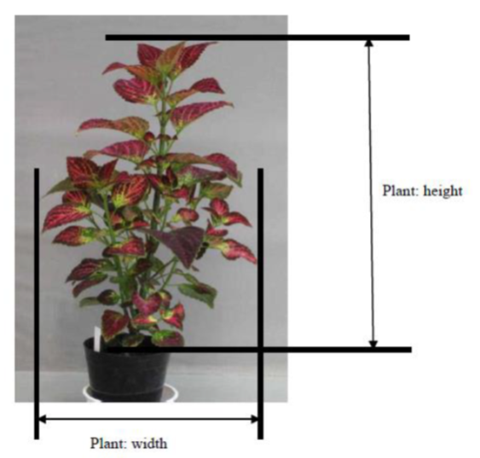
  (b)
  Observations on the leaf should be made on the fully expanded leaves from the middle third of the stem.
  (c)
  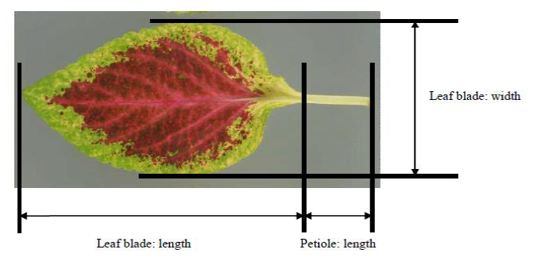
  (d)
  Where the characteristic refers to colors as "one", "two" etc., they are to be recorded in the order that they appear on the RHS chart, i.e. color one is the one with the lowest number, color two with the second lowest and so on. For example, if the leaves are Green 137A dotted with White 155A, Green 137A will be color one and White 155A color two. If two colors are on the same leaf of the chart, for example Green 137A and Green 137D, 137A is regarded as the lower
  numbered color. It should be noted that under this system, ranking is independent of surface area, so the color covering the greatest surface area may
  be classified as color three or four. The Guideline makes provision for four colors; if there are more, the color[s] with the smallest surface area[s] should
  be discounted.
  (e)
  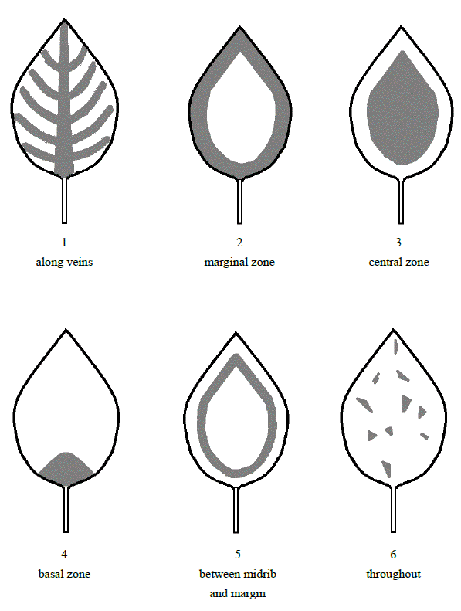
  (f)
  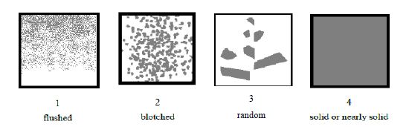
  (g)
  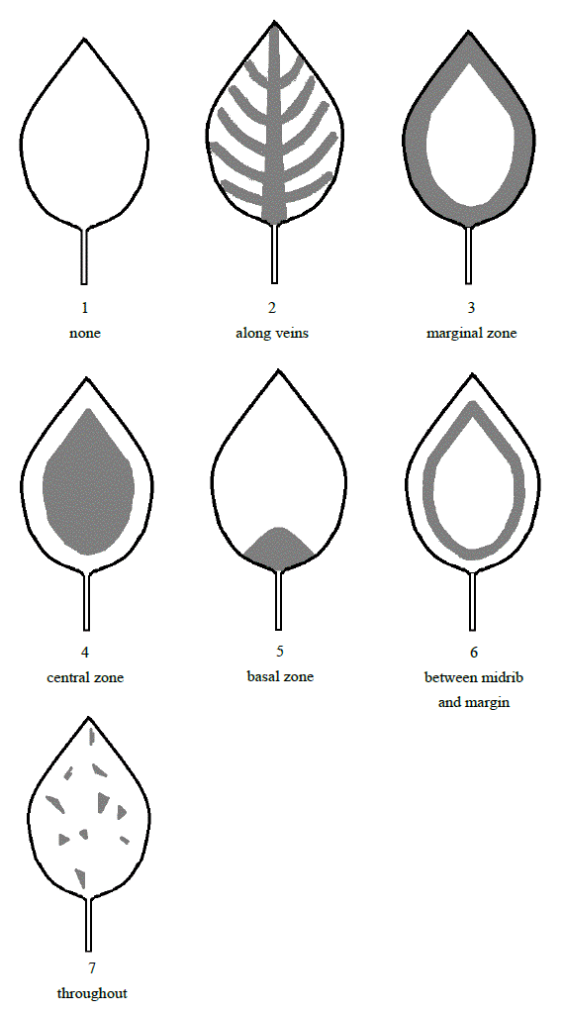

 | Explanations for individual characteristics
  8.2
Ad. 1: Plant: growth habit

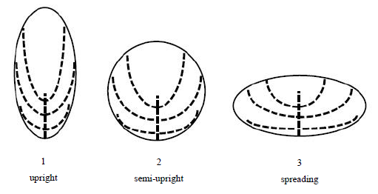

Ad. 4: Stem: color

Observations should be made on the middle third of an actively growing stem.

Ad. 8: Leaf blade: ratio length/width

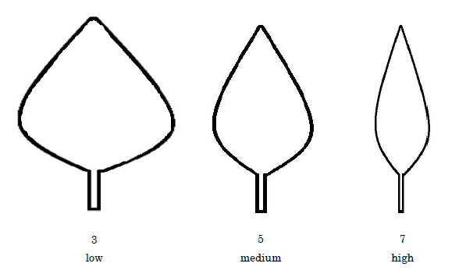

Ad. 9: Leaf blade: shape of apex

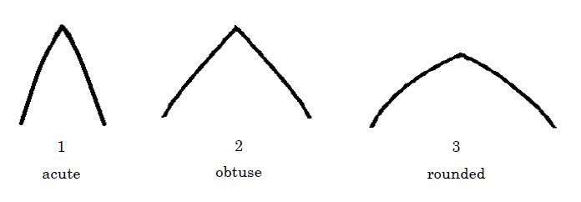

Ad. 10: Leaf blade: shape of base

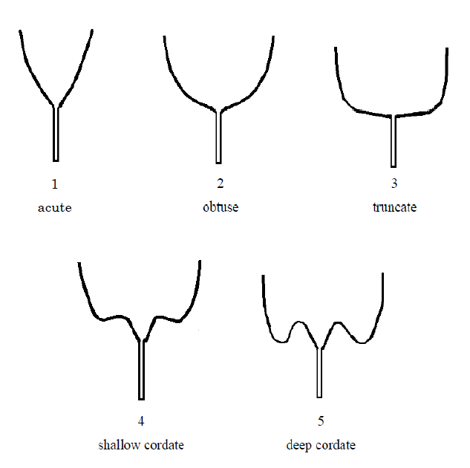

Ad. 35: Leaf blade: depth of incisions of margin

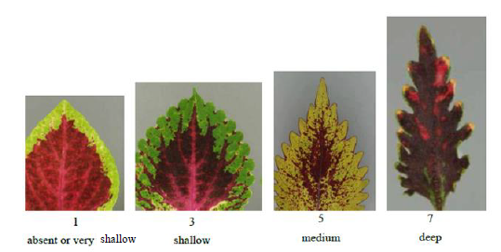

9. | Literature

Tsukamoto, Y., 1994: The Grand Dictionary of Horticulture.Volume 1. The Shogakukan Ltd., Tokyo, JP, pp. 908-910.
Hartlage, R., 2008: Coleus Rainbow Foliage for Containers and Gardens. Timber Press, Portland, Oregon, USA.

10.
Technical Questionnaire

TECHNICAL QUESTIONNAIRE | Page {x} of {y} | Reference Number:

Application date:
(not to be filled in by the applicant)
TECHNICAL QUESTIONNAIRE
to be completed in connection with an application for plant breeders' rights

1. | Subject of the Technical Questionnaire
 |  | Botanical name
  1.1
  Plectranthus scutellarioides (L.) R. Br.
 |  | Common name
  1.2
  coleus, painted-nettle

2. | Applicant
 | Name
 | Address
 | Telephone No.
 | Fax No.
 | E-mail address
 | Breeder (if different from
 | applicant)

3. | Proposed denomination and breeder's reference
 | Proposed denomination
 | (if available)
 | Breeder's reference

TECHNICAL QUESTIONNAIRE |  |  | Page {x} of {y} | Reference Number:
#4. | Information on the breeding scheme and propagation of the variety
 | 4.1 | Breeding scheme
Variety resulting from:
4.1.1 Crossing
(a) controlled cross [ ]
(please state parent varieties)
(…………………..……………..…) x (……………..…………………..…)
female parent male parent

(b) partially known cross [ ]
(please state known parent variety(ies))

(…………………..……………..…) x (……………..…………………..…)

female parent male parent
(c) unknown cross [ ]
4.1.2 Mutation [ ]
(please state parent variety)

4.1.3 Discovery and development [ ]
(please state where and when discovered and how developed)

4.1.4 Other [ ]
(please provide details)

 | 4.2 | Method of propagating the variety
  4.2.1
  Seed-propagated varieties
 |  | [ ]
  (a)
  Self-pollination
 |  | [ ]
  (b)
  Cross-pollination
 |  | [ ]
  (i)
  Synthetic variety
 |  | [ ]
  (ii)
  Population
 |  | [ ]
  (c)
  Hybrid
 |  | [ ]
  (d)
  Other (please provide details)
  4.2.2
  Vegetative propagation
 |  | [ ]
  (a)
  Cuttings
 |  | [ ]
  (b)
  Other (state method)
 | Other  (Please provide details) | [ ]
  4.2.3

TECHNICAL QUESTIONNAIRE
Page {x} of {y} | Reference Number:

5. | Characteristics of the variety to be indicated (the number in brackets refers to the corresponding characteristic in Test Guidelines; please mark the note which best corresponds).

 | Characteristics | Example Varieties | Note
  5.1
  (1)
  Plant: growth habit
  upright
  1 [ ]
  semi-upright
  2 [ ]
  spreading
  3 [ ]
  5.2
  (2)
  Plant: height
  short
  3 [ ]
  medium
  5 [ ]
  tall
  Grecom Orange Marmalade
  7 [ ]
  5.3
  (35)
  Leaf blade: depth of incisions of margin
  shallow
  3 [ ]
  medium
  5 [ ]
  deep
  7 [ ]

TECHNICAL QUESTIONNAIRE | Page {x} of {y} | Reference Number:

6. | Similar varieties and differences from these varieties
Please use the following table and box for comments to provide information on how your candidate variety differs from the variety (or varieties) which, to the best of your knowledge, is (or are) most similar. This information may help the examination authority to conduct its examination of distinctness in a more efficient way.

  Denomination(s) of variety(ies) similar to your candidate variety
  Characteristic(s) in which your candidate variety differs from the similar variety(ies)
  Describe the expression of the characteristic(s) for the similar variety(ies)
  Describe the expression of the characteristic(s) for your candidate variety

Example
  Leaf blade: depth of incisions of margin
  shallow
  deep

 | Comments:

TECHNICAL QUESTIONNAIRE |  |  | Page {x} of {y} | Reference Number:
#7. | Additional information which may help in the examination of the variety
7.1 | In addition to the information provided in sections 5 and 6, are there any additional characteristics which may help to distinguish the variety?
 | Yes | [ ] | No | [ ]
 | (If yes, please provide details)
7.2 | Are there any special conditions for growing the variety or conducting the examination?
 | Yes | [ ] | No | [ ]
 | (If yes, please provide details)
7.3 | Other information
A representative color photograph of the variety displaying its main distinguishing feature(s), should accompany the Technical Questionnaire. The photograph will provide a visual illustration of the candidate variety which supplements the information provided in the Technical Questionnaire.
The key points to consider when taking a photograph of the candidate variety are:
• Indication of the date and geographic location
• Correct labeling (breeder’s reference)
• Good quality printed photograph (minimum 10 cm x 15 cm) and/or sufficient resolution electronic format version (minimum 960 x 1280 pixels)”
Further guidance on providing photographs with the Technical Questionnaire is available in document TGP/7 "Development of Test Guidelines", Guidance Note 35 (http://www.upov.int/tgp/en/).
[The link provided may be deleted by members of the Union when developing authorities’ own test guidelines.]
(a)Leaf blade: color covering the greatest surface area,with the following groups:
Gr. 1: white
Gr. 2: yellow green
Gr. 3: green
Gr. 4: light yellow
Gr. 5: yellow
Gr. 6: orange
Gr. 7: pink
Gr. 8: red
Gr. 9: purple red
Gr. 10: purple
Gr. 11: brown

(b)Leaf blade: color covering the next greatest surface area,with the following groups:
Gr. 1: white
Gr. 2: yellow green
Gr. 3: green
Gr. 4: light yellow
Gr. 5: yellow
Gr. 6: orange
Gr. 7: pink
Gr. 8: red
Gr. 9: purple red
Gr. 10: purple
Gr. 11: brown

8. | Authorization for release
 | (a) | Does the variety require prior authorization for release under legislation concerning the protection of the environment, human and animal health?
 |  | Yes | [ ] | No | [ ]
 | (b) | Has such authorization been obtained?
 |  | Yes | [ ] | No | [ ]
 | If the answer to (b) is yes, please attach a copy of the authorization.

9. Information on plant material to be examined or submitted for examination

9.1 The expression of a characteristic or several characteristics of a variety may be affected by factors, such as pests and disease, chemical treatment (e.g. growth retardants or pesticides), effects of tissue culture, different rootstocks, scions taken from different growth phases of a tree, etc.
9.2 The plant material should not have undergone any treatment which would affect the expression of the characteristics of the variety, unless the competent authorities allow or request such treatment. If the plant material has undergone such treatment, full details of the treatment must be given. In this respect, please indicate below, to the best of your knowledge, if the plant material to be examined has been subjected to:

 | (a) | Microorganisms (e.g. virus, bacteria, phytoplasma) | Yes [ ] | No [ ]
 | (b) | Chemical treatment (e.g. growth retardant, pesticide) | Yes [ ] | No [ ]
 | (c) | Tissue culture | Yes [ ] | No [ ]
 | (d) | Other factors | Yes [ ] | No [ ]
 | Please provide details for where you have indicated “yes”.

10. | I hereby declare that, to the best of my knowledge, the information provided in this form is correct:
 | Applicant’s name
 | Signature |  | Date

[End of document]

