 |  | 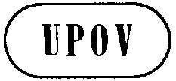 | E  TG/ZINNIA(proj.5)  ORIGINAL: English  DATE: 2015-08-03
INTERNATIONAL UNION FOR THE PROTECTION OF NEW VARIETIES OF PLANTS
Geneva
 | DRAFT

 | Zinnia  UPOV Code: ZINNI  Zinnia L. | *

GUIDELINES
FOR THE CONDUCT OF TESTS
FOR DISTINCTNESS, UNIFORMITY AND STABILITY

prepared by (an) expert(s) from Mexico

to be considered by the
Technical Working Party for Ornamental Plants and Forest Trees
at its forty-eighth session
to be held in Cambridge, United Kingdom,
from 2015-09-14
to 2015-09-18

Alternative Names:*
Botanical name | English | French | German | Spanish
Zinnia L. | Zinnia | Zinnia | Zinnia | Miguelito, Carolina

The purpose of these guidelines (“Test Guidelines”) is to elaborate the principles contained in the General Introduction (document TG/1/3), and its associated TGP documents, into detailed practical guidance for the harmonized examination of distinctness, uniformity and stability (DUS) and, in particular, to identify appropriate characteristics for the examination of DUS and production of harmonized variety descriptions.

ASSOCIATED DOCUMENTS
These Test Guidelines should be read in conjunction with the General Introduction and its associated TGP documents.
TABLE OF CONTENTS PAGE

1. Subject of these Test Guidelines 3
2. Material Required 3
3. Method of Examination 3
3.1 Number of Growing Cycles 3
3.2 Testing Place 3
3.3 Conditions for Conducting the Examination 3
3.4 Test Design 3
3.5 Additional Tests 4
4. Assessment of Distinctness, Uniformity and Stability 4
4.1 Distinctness 4
4.2 Uniformity 5
4.3 Stability 5
5. Grouping of Varieties and Organization of the Growing Trial 5
6. Introduction to the Table of Characteristics 6
6.1 Categories of Characteristics 6
6.2 States of Expression and Corresponding Notes 6
6.3 Types of Expression 7
6.4 Example Varieties 7
6.5 Legend 7
7. Table of Characteristics/Tableau des caractères/Merkmalstabelle/Tabla de caracteres 8
8. Explanations on the Table of Characteristics 16
9. Literature 22
10. Technical Questionnaire 23

Subject of these Test Guidelines

These Test Guidelines apply to all varieties of Zinnia L..

These Test guidelines apply to all varieties of Zinnia L. Zinnia angustifolia, Z. haageana, Z. elegans, Z peruviana, and their hybrids

Material Required

2.1 The competent authorities decide on the quantity and quality of the plant material required for testing the variety and when and where it is to be delivered. Applicants submitting material from a State other than that in which the testing takes place must ensure that all customs formalities and phytosanitary requirements are complied with.

  - The material is to be supplied in the form of seeds.

2.3 The minimum quantity of plant material, to be supplied by the applicant, should be:

a sufficient quantity of seeds to produce 10 plants for F1 hybrids and 40 plants for open pollinated varieties

The seed should meet the minimum requirements for germination, species and analytical purity, health and moisture content, specified by the competent authority. In cases where the seed is to be stored, the germination capacity should be as high as possible and should be stated by the applicant.

2.4 The plant material supplied should be visibly healthy, not lacking in vigor, nor affected by any important pest or disease.

2.5 The plant material should not have undergone any treatment which would affect the expression of the characteristics of the variety, unless the competent authorities allow or request such treatment. If it has been treated, full details of the treatment must be given.

The applicant must indicate if the material comes from F1 hybrids or from open pollinated varieties

Method of Examination

3.1 Number of Growing Cycles

3.1.1 The minimum duration of tests should normally be a single growing cycle.

3.1.2 The minimum duration of tests should normally be a single growing cycle for F1 hybrids, and 2 growing cycles for cross-pollinated varieties.

3.2 Testing Place

Tests are normally conducted at one place. In the case of tests conducted at more than one place, guidance is provided in TGP/9 “Examining Distinctness”.

3.3 Conditions for Conducting the Examination

3.3.1 The tests should be carried out under conditions ensuring satisfactory growth for the expression of the relevant characteristics of the variety and for the conduct of the examination.

3.4 Test Design

3.4.1 Each test should be designed to result in a total of at least 10 plants.

3.4.2 The design of the tests should be such that plants or parts of plants may be removed for measurement or counting without prejudice to the observations which must be made up to the end of the growing cycle.

3.4.3 Each test should be designed to result in a total of at least 10 plants for F1 hybrids and 40 plants for cross-pollinated varieties.

3.5 Additional Tests

Additional tests, for examining relevant characteristics, may be established.

Assessment of Distinctness, Uniformity and Stability

4.1 Distinctness

4.1.1 General Recommendations

It is of particular importance for users of these Test Guidelines to consult the General Introduction prior to making decisions regarding distinctness. However, the following points are provided for elaboration or emphasis in these Test Guidelines.

4.1.2 Consistent Differences

The differences observed between varieties may be so clear that more than one growing cycle is not necessary. In addition, in some circumstances, the influence of the environment is not such that more than a single growing cycle is required to provide assurance that the differences observed between varieties are sufficiently consistent. One means of ensuring that a difference in a characteristic, observed in a growing trial, is sufficiently consistent is to examine the characteristic in at least two independent growing cycles.

4.1.3 Clear Differences

Determining whether a difference between two varieties is clear depends on many factors, and should consider, in particular, the type of expression of the characteristic being examined, i.e. whether it is expressed in a qualitative, quantitative, or pseudo-qualitative manner. Therefore, it is important that users of these Test Guidelines are familiar with the recommendations contained in the General Introduction prior to making decisions regarding distinctness.

4.1.4 Number of Plants / Parts of Plants to be Examined

Unless otherwise indicated, for the purposes of distinctness, all observations on single plants should be made on 10 plants or parts taken from each of 10 plants and any other observations made on all plants in the test, disregarding any off-type plants. In the case of observations of parts taken from single plants, the number of parts to be taken from each of the plants should be 10.

4.1.5 Method of Observation

The recommended method of observing the characteristic for the purposes of distinctness is indicated by the following key in the second column of the Table of Characteristics (see document TGP/9 “Examining Distinctness”, Section 4 “Observation of characteristics”):

MG: single measurement of a group of plants or parts of plants
MS: measurement of a number of individual plants or parts of plants
VG: visual assessment by a single observation of a group of plants or parts of plants
VS: visual assessment by observation of individual plants or parts of plants

Type of observation: visual (V) or measurement (M)

“Visual” observation (V) is an observation made on the basis of the expert’s judgment. For the purposes of this document, “visual” observation refers to the sensory observations of the experts and, therefore, also includes smell, taste and touch. Visual observation includes observations where the expert uses reference points (e.g. diagrams, example varieties, side-by-side comparison) or non-linear charts (e.g. color charts). Measurement (M) is an objective observation against a calibrated, linear scale e.g. using a ruler, weighing scales, colorimeter, dates, counts, etc.

Type of record: for a group of plants (G) or for single, individual plants (S)

For the purposes of distinctness, observations may be recorded as a single record for a group of plants or parts of plants (G), or may be recorded as records for a number of single, individual plants or parts of plants (S). In most cases, “G” provides a single record per variety and it is not possible or necessary to apply statistical methods in a plant-by-plant analysis for the assessment of distinctness.

In cases where more than one method of observing the characteristic is indicated in the Table of Characteristics (e.g. VG/MG), guidance on selecting an appropriate method is provided in document TGP/9, Section 4.2.

Unless otherwise indicated, for the purposes of distinctness all observations on single plants should be made on 9 plants for F1 hybrids and at least 20 for cross-polinated varieties or parts taken from each plant and any other observations made on all plants in the test, disregarding any off-type plants.

4.2 Uniformity

    - It is of particular importance for users of these Test Guidelines to consult the General Introduction prior to making decisions regarding uniformity. However, the following points are provided for elaboration or emphasis in these Test Guidelines:

4.2.2 The assessment of uniformity for -1 varieties should be according to the recommendations for cross-pollinated varieties in the General Introduction.

4.2.3 The assessment of uniformity for hybrid varieties depends on the type of hybrid and should be according to the recommendations for hybrid varieties in the General Introduction.

4.2.4 For the assessment of uniformity, a population standard of 1% and an acceptance probability of at least 95% should be applied. In the case of a sample size of 10 plants, 1 off-type is allowed.

4.2.5 For cross-polinated varieties, the assessement of uniformity should be according to the recommendations for cross-polinated varieties as appropiate, in the General Introduction.

4.3 Stability

4.3.1 In practice, it is not usual to perform tests of stability that produce results as certain as those of the testing of distinctness and uniformity. However, experience has demonstrated that, for many types of variety, when a variety has been shown to be uniform, it can also be considered to be stable.

4.3.2 Where appropriate, or in cases of doubt, stability may be further examined by testing a new seed stock to ensure that it exhibits the same characteristics as those shown by the initial material supplied.

4.3.3 In practice, it is not usual to perform tests of stability that produce results as certain as those of the testing of distinctness and uniformity. However, experience has demonstrated that, for many types of variety, when a variety has been shown to be uniform, it can also be considered to be stable.

Grouping of Varieties and Organization of the Growing Trial

5.1 The selection of varieties of common knowledge to be grown in the trial with the candidate varieties and the way in which these varieties are divided into groups to facilitate the assessment of distinctness are aided by the use of grouping characteristics.

5.2 Grouping characteristics are those in which the documented states of expression, even where produced at different locations, can be used, either individually or in combination with other such characteristics: (a) to select varieties of common knowledge that can be excluded from the growing trial used for examination of distinctness; and (b) to organize the growing trial so that similar varieties are grouped together.

5.3 The following have been agreed as useful grouping characteristics:

(a) Plant: growth habit (characteristic 1)
(b) Plant: branching (characteristic 3)
(c) Stem: density of pubescence (characteristic 5)
(d) Leaf: length/width ratio (characteristic 8)
(e) Leaf: position of broadest part (characteristic 9)
(f) Leaf: profile in cross section (characteristic 10)
(g) Leaf: undulation of margin (characteristic 11)
(h) Leaf: anthocyanin coloration at base (characteristic 13)
(i) Flower head: peduncle length (characteristic 14)
(j) Flower head: type (characteristic 15)
(k) Ray floret: profile in cross section at mid point (characteristic 21)
(l) Ray floret: longitudinal axis (characteristic 22)
(m) Ray floret:strength of curvature (characteristic 24)
(n) Ray floret: shape of apex (characteristic 25)
(o) Ray floret: pattern of secondary color of inner side (characteristic 29)

5.4 Guidance for the use of grouping characteristics, in the process of examining distinctness, is provided through the General Introduction and document TGP/9 “Examining Distinctness”.

Introduction to the Table of Characteristics

6.1 Categories of Characteristics

6.1.1 Standard Test Guidelines Characteristics

Standard Test Guidelines characteristics are those which are approved by UPOV for examination of DUS and from which members of the Union can select those suitable for their particular circumstances.

6.1.2 Asterisked Characteristics

Asterisked characteristics (denoted by *) are those included in the Test Guidelines which are important for the international harmonization of variety descriptions and should always be examined for DUS and included in the variety description by all members of the Union, except when the state of expression of a preceding characteristic or regional environmental conditions render this inappropriate.

6.2 States of Expression and Corresponding Notes

6.2.1 States of expression are given for each characteristic to define the characteristic and to harmonize descriptions. Each state of expression is allocated a corresponding numerical note for ease of recording of data and for the production and exchange of the description.

6.2.2 In the case of qualitative and pseudo-qualitative characteristics (see Chapter 6.3), all relevant states of expression are presented in the characteristic. However, in the case of quantitative characteristics with 5 or more states, an abbreviated scale may be used to minimize the size of the Table of Characteristics. For example, in the case of a quantitative characteristic with 9 states, the presentation of states of expression in the Test Guidelines may be abbreviated as follows:

State | Note
small | 3
medium | 5
large | 7

However, it should be noted that all of the following 9 states of expression exist to describe varieties and should be used as appropriate:

State | Note
very small | 1
very small to small | 2
small | 3
small to medium | 4
medium | 5
medium to large | 6
large | 7
large to very large | 8
very large | 9

6.2.3 Further explanation of the presentation of states of expression and notes is provided in document TGP/7 “Development of Test Guidelines”.

6.3 Types of Expression

An explanation of the types of expression of characteristics (qualitative, quantitative and pseudo-qualitative) is provided in the General Introduction.

6.4 Example Varieties

Where appropriate, example varieties are provided to clarify the states of expression of each characteristic.

6.5 Legend

(*) Asterisked characteristic – see Chapter 6.1.2

QL Qualitative characteristic – see Chapter 6.3
QN Quantitative characteristic – see Chapter 6.3
PQ Pseudo-qualitative characteristic – see Chapter 6.3

MG, MS, VG, VS – see Chapter 4.1.5

(a)-(e) See Explanations on the Table of Characteristics in Chapter 8.

(+) See Explanations on the Table of Characteristics in Chapter 8.

Table of Characteristics/Tableau des caractères/Merkmalstabelle/Tabla de caracteres

English | français | deutsch | español | Example Varieties Exemples Beispielssorten Variedades ejemplo | Note/ Nota
1. (*) PQ VG (+)
Plant: growth habit | Plante: port | Pflanze: Wuchsform | Planta: porte
upright | dressé | aufrecht | erecta | Peppermint | 1
semi-upright | demi-dressé | halbaufrecht | semierecta | Profussion | 2
spreading | étalé | breitwüchsig | extendido | Solecito | 3
2. (*) QN MS VG
Plant: height | Plante: hauteur | Pflanze: Höhe | Planta: altura
short | basse | niedrig | baja | Peppermint | 3
medium | moyenne | mittel | media | Witworna | 5
tall | haute | hoch | alta | Inca | 7
3. (*) QN VG
Plant: branching | Plante : ramification | Pflanze: Verzweigung | Planta: ramificación
absent or very weak |  |  |  | Witworna | 1
weak |  |  |  |  | 2
medium |  |  |  | Peppermint | 3
strong |  |  |  |  | 4
very strong |  |  |  | Profussion | 5
4. (*) QN VG
Stem: anthocyanin coloration on upper third | Tige : pigmentation anthocyanique au tiers supérieur | Stengel: Anthocyanfärbung im oberen Drittel | Tallo: pigmentación antociánica del tercio superior
absent or weak | nulle ou faible | fehlend oder gering | ausente o débil | Dreamland | 1
weak |  |  |  | Lilliput | 2
medium | moyenne | mittel | media | Profussion | 3
strong | forte | stark | fuerte | Arcos | 4

English | français | deutsch | español | Example Varieties Exemples Beispielssorten Variedades ejemplo | Note/ Nota
5. QN VG (+)
Stem: density of pubescence
absent or sparse |  |  |  | Zestr | 1
medium |  |  |  | Uproar | 2
dense |  |  |  | Short stuff | 3
6. (*) QN MS VG (a)
Leaf: length | Feuille : longueur | Blatt: Länge | Hoja: longitud
short |  |  |  |  | 3
medium |  |  |  |  | 5
long |  |  |  |  | 7
7. (*) QN MS VG (a)
Leaf:width
narrow |  |  |  | Starbright | 3
medium |  |  |  | Yellow flame | 5
long |  |  |  | Short stuff | 6
8. (*) QN MS VG (+) (a)
Leaf: length/width ratio
low |  |  |  | Crystal yellow | 3
medium |  |  |  |  | 5
high |  |  |  | Dreamland rose | 7
9. QN VG (a)
Leaf: position of broadest part | Feuille : position de la partie la plus large | Blatt: Position der breitesten Stelle | Hoja: posición de la parte más ancha
towards base |  |  |  | Dreamland rose | 1
towards middle |  |  |  | Cherry ivory, Swizzle | 2
towards apex |  |  |  | Oklahoma | 3

English | français | deutsch | español | Example Varieties Exemples Beispielssorten Variedades ejemplo | Note/ Nota
10. (*) QN VG (a)
Leaf: profile in cross section
flat |  |  |  |  | 1
moderately concave |  |  |  |  | 2
strongly concave |  |  |  |  | 3
11. QN VG (a)
Leaf: undulation of margin | Feuille: ondulation du bord | Blatt: Wellung des Randes | Hoja: ondulación del margen
absent or weak | nulle ou faible | fehlend oder gering | ausente o débil |  | 1
medium | moyenne | mittel | media |  | 2
strong | forte | stark | fuerte |  | 3
12. QN VG (a)
Leaf: intensity of green color
very light |  |  |  |  | 1
light |  |  |  | Oklahoma | 2
medium |  |  |  |  | 3
dark |  |  |  | Starbright | 4
very dark |  |  |  |  | 5
13. (*) QN VG (a)
Leaf: anthocyanin coloration at base
absent or weak |  |  |  | Oklahoma | 1
medium |  |  |  | Uproar rose | 2
strong |  |  |  | state fair | 3

English | français | deutsch | español | Example Varieties Exemples Beispielssorten Variedades ejemplo | Note/ Nota
14. QN MS VG
Flower head: peduncle length
short |  |  |  | Sahara | 3
medium |  |  |  | Witworna | 5
long |  |  |  | Uproar rose | 7
15. (*) PQ VG (e)
Flower head: type
single |  |  |  | Star | 1
semi-double |  |  |  | Yellow flame | 2
double |  |  |  | Lilliput | 3
16. QN VG
Flower head: number of ray florets | Capitule : nombre de fleurs ligulées | Blütenstand: Anzahl der Randblüten | Capítulo: número de flores liguladas
few |  |  |  |  | 3
medium |  |  |  |  | 5
many |  |  |  |  | 7
17. QN MS VG
Flower head: diameter | Capitule : diamètre | Blütenstand: Durchmesser | Capítulo: diámetro
small |  |  |  | Lilliput | 3
medium |  |  |  | Oklahoma | 5
large |  |  |  | Inca | 7
18. (*) QN MS VG (b)
Ray floret: length | Fleur ligulée: longueur | Randblüte: Länge | Flor ligulada: longitud
short | courte | kurz | corta | Lilliput | 3
medium | moyenne | mittel | media | Peppermint stick, Profussion knee | 5
long | longue | lang | larga | Inca | 7

English | français | deutsch | español | Example Varieties Exemples Beispielssorten Variedades ejemplo | Note/ Nota
19. (*) QN MS VG (b)
Ray floret: width | Fleur ligulée: largeur | Zungenblüte: Breite | Flor ligulada: anchura
narrow | étroite | schmal | estrecha |  | 3
medium | moyenne | mittel | media |  | 5
broad | large | breit | ancha |  | 7
20. (*) QN MS VG (b) (c)
Ray floret: length/width ratio | Fleur ligulée : rapport longueur/largeur | Randblüte: Verhältnis Länge/Breite | Flor ligulada: relación entre la longitud y la altura
low | faible | klein | baja |  | 3
medium | moyen | mittel | media |  | 5
high | élevé | groß | elevada |  | 7
21. QN VG (+) (c)
Ray floret: profile in cross section at mid point | Fleuron: profil en section transversale au point médian | Zungenblüte: Profil im Querschnitt am Mittelpunkt | Lígula: perfil en sección transversal en el punto medio
strongly convex with margins touching | fortement convexe à bords tangents | stark konvex mit sich berührenden Rändern | fuertemente convexa con bordes que se tocan
strongly concave with margins overlapping | fortement concave à bords chevauchants | stark konkav mit überlappenden Rändern | fuertemente cóncava con bordes superpuestos |  | 1
strongly concave with margins touching | fortement concave à bords tangents | stark konkav mit sich berührenden Rändern | fuertemente cóncava con bordes que se tocan |  | 2
moderately concave | moyennement concave | mittel konkav | moderadamente cóncava |  | 4
weakly concave | faiblement concave | schwach konkav | débilmente cóncava |  | 5
flat | plat | flach | plana |  | 6
weakly convex | faiblement convexe | schwach konvex | débilmente convexa |  | 7
moderately convex | moyennement convexe | mittel konvex | moderadamente convexa |  | 8
strongly convex | fortement convexe | stark konvex | fuertemente convexa |  | 9

English | français | deutsch | español | Example Varieties Exemples Beispielssorten Variedades ejemplo | Note/ Nota
22. QN VG (+) (c)
Ray floret: longitudinal axis | Fleuron: axe longitudinal | Zungenblüte: Längsachse | Lígula: eje longitudinal
incurving | incurvé | aufgebogen | curvado hacia arriba |  | 1
straight | droit | gerade | recto |  | 2
reflexing | recourbé | zurückgebogen | curvado hacia abajo |  | 3
23. QN VG (c)
Ray floret: part of axis curved | Fleuron: partie de l’axe courbé | Zungenblüte: Teils der gebogenen Achse | Lígula: parte del eje que es curvado
distal quarter | quart distal | distales Viertel | cuarto distal |  | 1
distal half | moitié distale | distale Hälfte | mitad distal |  | 2
distal three quarters | trois quarts distaux | distale drei Viertel | tres cuartos, zona distal |  | 3
24. QN VG (c)
Ray floret:strength of curvature
weak |  |  |  | Uproar rose | 3
medium |  |  |  | Swizzle cherry ivory | 5
strong |  |  |  | Inca | 7
25. (*) PQ VG (+) (c)
Ray floret: shape of apex
mucronate |  |  |  |  | 1
truncate |  |  |  |  | 2
rounded |  |  |  |  | 3
emarginated |  |  |  |  | 4

English | français | deutsch | español | Example Varieties Exemples Beispielssorten Variedades ejemplo | Note/ Nota
26. (*) PQ VG (c) (d)
Ray floret: main color of inner side
RHS Colour Chart
27. PQ VG (+) (d)
Ray floret: distribution of secondary color of inner side
none |  |  |  | Sahara | 1
basal part |  |  |  | Swizzle | 2
distal part |  |  |  |  | 3
along midrib |  |  |  |  | 4
throughout |  |  |  | Peppermint | 5
28. PQ VG (d)
Ray floret: secondary color of inner side (if present)
RHS Colour Chart
29. PQ VG
Ray floret: pattern of secondary color of inner side
solid |  |  |  |  | 1
blotches |  |  |  |  | 2
stripes |  |  |  |  | 3
30. PQ VG (d)
Ray floret: tertiary color of inner side (if present)
RHS colour chart

English | français | deutsch | español | Example Varieties Exemples Beispielssorten Variedades ejemplo | Note/ Nota
31. PQ VG
Ray floret pattern of tertiary color of inner side
solid |  |  |  |  | 1
blotches |  |  |  |  | 2
stripes |  |  |  |  | 3
32. PQ VG (+)
Ray floret: distribution of tertiary color of inner side
basal |  |  |  |  | 1
distal |  |  |  |  | 2
striped |  |  |  |  | 3
blotched |  |  |  | Peppermint | 4
33. PQ VG
Flower head: color of disc (if present)
RHS Colour chart

Explanations on the Table of Characteristics

8.1 Explanations covering several characteristics

Characteristics containing the following key in the second column of the Table of Characteristics should be examined as indicated below:

(a) Leaf characteristics are recorded on typical leaves taken from the middle thirdof the stem, and are recorded on the whole leaf, looking at the upper surface.
(b) The characteristics of ray florets should be observed on the outer most rows of ray florets.
(c)
(d) The main color, is the color with the largest total surface area, the secondary color (if present) is the color with the second largest surface area; the tertiary color (if present) is that with the third largest total surface. In case of when none of the colors is clearly predominant, then the darkest color will be the main color.
(e) Single flower head has only one row of ray florets. Semi-double flower head: has more than one row of ray florets and a visible flower head disc. Double flower head: has no flower head disc, at any state of development.

8.2 Explanations for individual characteristics

Ad. 1: Plant: growth habit

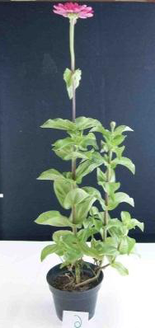
1 - upright
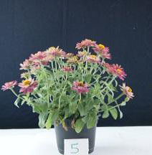
2 - semi-upright
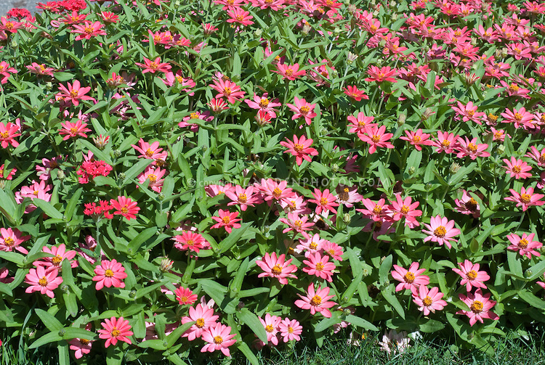
3 - spreading

Ad. 5: Stem: density of pubescence

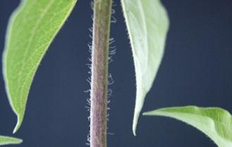
2 - medium
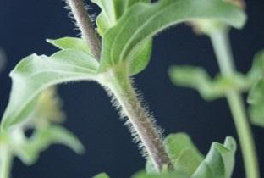
3 - dense

Ad. 8: Leaf: length/width ratio

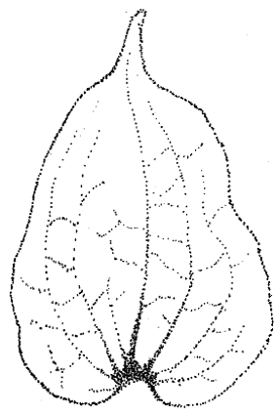
3 - low
5 - medium
7 - high
Ad. 21: Ray floret: profile in cross section at mid point

8 - moderately convex
Ad. 22: Ray floret: longitudinal axis
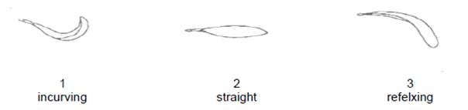
Ad. 25: Ray floret: shape of apex

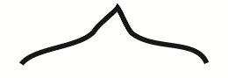
1 - mucronate
2 - truncate
3 - rounded
4 - emarginated

Ad. 27: Ray floret: distribution of secondary color of inner side

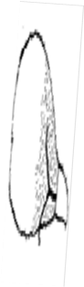
2 - basal part
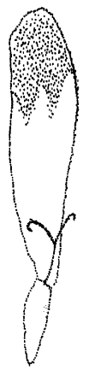
3 - distal part
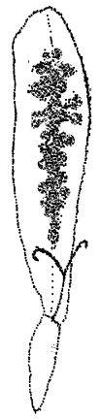
4 - along midrib
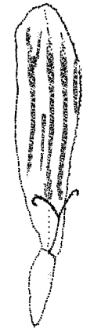
5 - throughout

Ad. 32: Ray floret: distribution of tertiary color of inner side
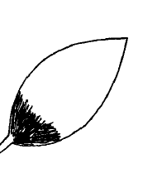
1 - basal
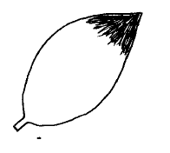
2 - distal
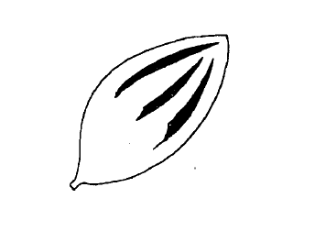
3 - striped
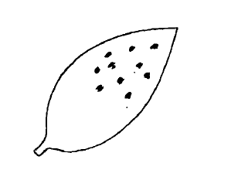
4 - blotched

Literature

Calderón de Rzedowski, G. y J. Rzedowski. 2006. Flora Fanerogámica del Valle de México. Ed. Instituto de Ecología A.C. y Comisión Nacional para el Conocimiento y Uso de la Biodiversidad. México. 983 p.

Flora of North America. 2003. Flora of North America, North of Mexico. Editorial Committee. Vol 25. New York (NY): Oxford University Press.

Smith A. R. 226. Zinnia L. In: Flora of North America Vol.21. Oxford University Press.

Torres A. M. 1963. Taxonomy of Zinnia. Brittonia 15: 1-25.

Technical Questionnaire

TECHNICAL QUESTIONNAIRE |  | Page {x} of {y} | Reference Number:
 |  |  | Application date:
 |  |  | (not to be filled in by the applicant)
TECHNICAL QUESTIONNAIRE
to be completed in connection with an application for plant breeders’ rights

1. Subject of the Technical Questionnaire
1.1.1 | Botanical Name | Zinnia L.
1.1.2 | Common Name | Zinnia

2. Applicant
Name
Address
Telephone No.
Fax No.
E-mail address
Breeder (if different from applicant)
3. Proposed denomination and breeder’s reference
Proposed denomination
(if available)

Breeder’s reference

TECHNICAL QUESTIONNAIRE |  | Page {x} of {y} | Reference Number:
4. Information on the breeding scheme and propagation of the variety

4.1 Breeding scheme

Variety resulting from:

4.1.1 Crossing

(a) controlled cross [ ]
(please state parent varieties)

(…………………..……………..…) x (……………..…………………..…)
female parent male parent

(b) partially known cross [ ]
(please state known parent variety(ies))

(…………………..……………..…) x (……………..…………………..…)
female parent male parent

(c) unknown cross [ ]

4.1.2 Mutation [ ]
(please state parent variety)

4.1.3 Discovery and development [ ]
(please state where and when discovered and how developed)

4.1.4 Other [ ]
(please provide details)

4.2 Method of propagating the variety

4.2.1 Other [ ]

(please provide details)
..................................................................................................................................................
: :
: :
:................................................................................................................................................:

5. Characteristics of the variety to be indicated (the number in brackets refers to the corresponding characteristic in Test Guidelines; please mark the note which best corresponds).

 | Characteristics | Example Varieties | Note
5.1 (1) | Plant: growth habit
 | upright | Peppermint | 1[ ]
 | semi-upright | Profussion | 2[ ]
 | spreading | Solecito | 3[ ]
5.2 (2) | Plant: height
 | short | Peppermint | 3[ ]
 | medium | Witworna | 5[ ]
 | tall | Inca | 7[ ]
5.3 (15) | Flower head: type
 | single | Star | 1[ ]
 | semi-double | Yellow flame | 2[ ]
 | double | Lilliput | 3[ ]
5.4 (24) | Ray floret:strength of curvature
 | weak | Uproar rose | 3[ ]
 | medium | Swizzle cherry ivory | 5[ ]
 | strong | Inca | 7[ ]

6. Similar varieties and differences from these varieties

Please use the following table and box for comments to provide information on how your candidate variety differs from the variety (or varieties) which, to the best of your knowledge, is (or are) most similar. This information may help the examination authority to conduct its examination of distinctness in a more efficient way.

Denomination(s) of variety(ies) similar to your candidate variety | Characteristic(s) in which your candidate variety differs from the similar variety(ies) | Describe the expression of the characteristic(s) for the similar variety(ies) | Describe the expression of the characteristic(s) for your candidate variety
Example
Comments:

7. Additional information which may help in the examination of the variety

7.1 In addition to the information provided in sections 5 and 6, are there any additional characteristics which may help to distinguish the variety?

Yes [ ] No [ ]

(If yes, please provide details)

7.2 Are there any special conditions for growing the variety or conducting the examination?

Yes [ ] No [ ]

(If yes, please provide details)

7.3 Other information

8. Authorization for release

(a) Does the variety require prior authorization for release under legislation concerning the protection of the environment, human and animal health?

Yes [ ] No [ ]

(b) Has such authorization been obtained?

Yes [ ] No [ ]

If the answer to (b) is yes, please attach a copy of the authorization.

TECHNICAL QUESTIONNAIRE | Page {x} of {y} | Reference Number:
9. Information on plant material to be examined or submitted for examination

9.1 The expression of a characteristic or several characteristics of a variety may be affected by factors, such as pests and disease, chemical treatment (e.g. growth retardants or pesticides), effects of tissue culture, different rootstocks, scions taken from different growth phases of a tree, etc.

9.2 The plant material should not have undergone any treatment which would affect the expression of the characteristics of the variety, unless the competent authorities allow or request such treatment. If the plant material has undergone such treatment, full details of the treatment must be given. In this respect, please indicate below, to the best of your knowledge, if the plant material to be examined has been subjected to:

(a) Microorganisms (e.g. virus, bacteria, phytoplasma) Yes [ ] No [ ]

(b) Chemical treatment (e.g. growth retardant, pesticide) Yes [ ] No [ ]

(c) Tissue culture Yes [ ] No [ ]

(d) Other factors Yes [ ] No [ ]

Please provide details for where you have indicated “yes”.

10. I hereby declare that, to the best of my knowledge, the information provided in this form is correct:

Applicant’s name

Signature Date

[End of document]

* These names were correct at the time of the introduction of these Test Guidelines but may be revised or updated. [Readers are advised to consult the UPOV Code, which can be found on the UPOV Website (www.upov.int), for the latest information.]

