E
TG/SALVI(proj.3)
ORIGINAL: English
DATE: 2015-08-03
INTERNATIONAL UNION FOR THE PROTECTION OF NEW VARIETIES OF PLANTS
Geneva
DRAFT

 | Salvia  UPOV Code: SALVI  Salvia L. | *

GUIDELINES
FOR THE CONDUCT OF TESTS
FOR DISTINCTNESS, UNIFORMITY AND STABILITY

prepared by (an) expert(s) from Japan

to be considered by the
Technical Working Party for Ornamental Plants and Forest Trees
at its forty-eighth session
to be held in Cambridge, United Kingdom,
from 2015-09-14
to 2015-09-18

Alternative Names:*
Botanical name | English | French | German | Spanish
Salvia L. | Salvia, Sage | Sauge | Salbei | Salvia

The purpose of these guidelines (“Test Guidelines”) is to elaborate the principles contained in the General Introduction (document TG/1/3), and its associated TGP documents, into detailed practical guidance for the harmonized examination of distinctness, uniformity and stability (DUS) and, in particular, to identify appropriate characteristics for the examination of DUS and production of harmonized variety descriptions.

ASSOCIATED DOCUMENTS
These Test Guidelines should be read in conjunction with the General Introduction and its associated TGP documents.
TABLE OF CONTENTS PAGE

1. Subject of these Test Guidelines 3
2. Material Required 3
3. Method of Examination 3
3.1 Number of Growing Cycles 3
3.2 Testing Place 3
3.3 Conditions for Conducting the Examination 3
3.4 Test Design 3
3.5 Additional Tests 4
4. Assessment of Distinctness, Uniformity and Stability 4
4.1 Distinctness 4
4.2 Uniformity 5
4.3 Stability 5
5. Grouping of Varieties and Organization of the Growing Trial 5
6. Introduction to the Table of Characteristics 6
6.1 Categories of Characteristics 6
6.2 States of Expression and Corresponding Notes 6
6.3 Types of Expression 7
6.4 Example Varieties 7
6.5 Legend 7
7. Table of Characteristics/Tableau des caractères/Merkmalstabelle/Tabla de caracteres 8
8. Explanations on the Table of Characteristics 19
9. Literature 28
10. Technical Questionnaire 29

Subject of these Test Guidelines

These Test Guidelines apply to all varieties of Salvia L..

The characteristics in these Test Guidelines have been developed to distinguish between ornamental varieties and additional characteristics and states of expression may be needed in order to examine herbal varieties.

Material Required

2.1 The competent authorities decide on the quantity and quality of the plant material required for testing the variety and when and where it is to be delivered. Applicants submitting material from a State other than that in which the testing takes place must ensure that all customs formalities and phytosanitary requirements are complied with.

  - The material is to be supplied in the form of plants, or seed.

2.3 The minimum quantity of plant material, to be supplied by the applicant, should be:

vegetatively propagated varieties: 10 plants
seed propagated varieties: a sufficient quantity of seed to produce 40 plants

In the case of seed, the seed should meet the minimum requirements for germination, species and analytical purity, health and moisture content, specified by the competent authority. In cases where the seed is to be stored, the germination capacity should be as high as possible and should, be stated by the applicant.

2.4 The plant material supplied should be visibly healthy, not lacking in vigor, nor affected by any important pest or disease.

2.5 The plant material should not have undergone any treatment which would affect the expression of the characteristics of the variety, unless the competent authorities allow or request such treatment. If it has been treated, full details of the treatment must be given.

Method of Examination

3.1 Number of Growing Cycles

3.1.1 The minimum duration of tests should normally be a single growing cycle.

3.2 Testing Place

Tests are normally conducted at one place. In the case of tests conducted at more than one place, guidance is provided in TGP/9 “Examining Distinctness”.

3.3 Conditions for Conducting the Examination

3.3.1 The tests should be carried out under conditions ensuring satisfactory growth for the expression of the relevant characteristics of the variety and for the conduct of the examination.

3.3.2 Because daylight varies, color determinations made against a color chart should be made either in a suitable cabinet providing artificial daylight or in the middle of the day in a room without direct sunlight. The spectral distribution of the illuminant for artificial daylight should conform with the CIE Standard of Preferred Daylight D 6500 and should fall within the tolerances set out in the British Standard 950, Part I. These determinations should be made with the plant part placed against a white background. The color chart and version used should be specified in the variety description.

3.4 Test Design

3.4.1 Vegetatively propagated varieties: each test should be designed to result in a total of at least 10 plants.

3.4.2 Seed propagated varieties: each test should be designed to result in a total of at least 40 plants.

3.4.3 The design of the tests should be such that plants or parts of plants may be removed for measurement or counting without prejudice to the observations which must be made up to the end of the growing cycle.

3.5 Additional Tests

Additional tests, for examining relevant characteristics, may be established.

Assessment of Distinctness, Uniformity and Stability

4.1 Distinctness

4.1.1 General Recommendations

It is of particular importance for users of these Test Guidelines to consult the General Introduction prior to making decisions regarding distinctness. However, the following points are provided for elaboration or emphasis in these Test Guidelines.

4.1.2 Consistent Differences

The differences observed between varieties may be so clear that more than one growing cycle is not necessary. In addition, in some circumstances, the influence of the environment is not such that more than a single growing cycle is required to provide assurance that the differences observed between varieties are sufficiently consistent. One means of ensuring that a difference in a characteristic, observed in a growing trial, is sufficiently consistent is to examine the characteristic in at least two independent growing cycles.

4.1.3 Clear Differences

Determining whether a difference between two varieties is clear depends on many factors, and should consider, in particular, the type of expression of the characteristic being examined, i.e. whether it is expressed in a qualitative, quantitative, or pseudo-qualitative manner. Therefore, it is important that users of these Test Guidelines are familiar with the recommendations contained in the General Introduction prior to making decisions regarding distinctness.

4.1.4 Number of Plants / Parts of Plants to be Examined

4.1.4.1 In the case of vegetatively propagated varieties, unless otherwise indicated, for the purposes of distinctness, all observations on single plants should be made on 9 plants or parts taken from each of 9 plants and any other observations made on all plants in the test, disregarding any off-type plants.

4.1.4.2 In the case of seed-propagated varieties, unless otherwise indicated, for the purposes of distinctness, all observations on single plants should be made on 20 plants or parts taken from each of 20 plants and any other observations made on all plants in the test, disregarding any off-type plants.

4.1.5 Method of Observation

The recommended method of observing the characteristic for the purposes of distinctness is indicated by the following key in the second column of the Table of Characteristics (see document TGP/9 “Examining Distinctness”, Section 4 “Observation of characteristics”):

MG: single measurement of a group of plants or parts of plants
MS: measurement of a number of individual plants or parts of plants
VG: visual assessment by a single observation of a group of plants or parts of plants
VS: visual assessment by observation of individual plants or parts of plants

Type of observation: visual (V) or measurement (M)

“Visual” observation (V) is an observation made on the basis of the expert’s judgment. For the purposes of this document, “visual” observation refers to the sensory observations of the experts and, therefore, also includes smell, taste and touch. Visual observation includes observations where the expert uses reference points (e.g. diagrams, example varieties, side-by-side comparison) or non-linear charts (e.g. color charts). Measurement (M) is an objective observation against a calibrated, linear scale e.g. using a ruler, weighing scales, colorimeter, dates, counts, etc.

Type of record: for a group of plants (G) or for single, individual plants (S)

For the purposes of distinctness, observations may be recorded as a single record for a group of plants or parts of plants (G), or may be recorded as records for a number of single, individual plants or parts of plants (S). In most cases, “G” provides a single record per variety and it is not possible or necessary to apply statistical methods in a plant-by-plant analysis for the assessment of distinctness.

In cases where more than one method of observing the characteristic is indicated in the Table of Characteristics (e.g. VG/MG), guidance on selecting an appropriate method is provided in document TGP/9, Section 4.2.

4.2 Uniformity

    - It is of particular importance for users of these Test Guidelines to consult the General Introduction prior to making decisions regarding uniformity. However, the following points are provided for elaboration or emphasis in these Test Guidelines:

4.2.2 For the assessment of uniformity of vegetatively propagated varieties, a population standard of 1% and an acceptance probability of at least 95% should be applied. In the case of a sample size of 10 plants, 1 off-type is allowed.

4.2.3 For the assessment of uniformity of self-pollinated seed-propagated varieties, a population standard of 1% and an acceptance probability of at least 95% should be applied. In the case of a sample size of 40 plants, 2 off-types are allowed.

4.2.4 For the assessment of uniformity of cross-pollinated seed-propagated varieties, the recommendations in the General Introduction for cross-pollinated varieties should be followed, as appropriate.

4.3 Stability

4.3.1 In practice, it is not usual to perform tests of stability that produce results as certain as those of the testing of distinctness and uniformity. However, experience has demonstrated that, for many types of variety, when a variety has been shown to be uniform, it can also be considered to be stable.

4.3.2 Where appropriate, or in cases of doubt, stability may be further examined by testing a new seed or plant stock to ensure that it exhibits the same characteristics as those shown by the initial material supplied.

Grouping of Varieties and Organization of the Growing Trial

5.1 The selection of varieties of common knowledge to be grown in the trial with the candidate varieties and the way in which these varieties are divided into groups to facilitate the assessment of distinctness are aided by the use of grouping characteristics.

5.2 Grouping characteristics are those in which the documented states of expression, even where produced at different locations, can be used, either individually or in combination with other such characteristics: (a) to select varieties of common knowledge that can be excluded from the growing trial used for examination of distinctness; and (b) to organize the growing trial so that similar varieties are grouped together.

5.3 The following have been agreed as useful grouping characteristics:

(a) Plant: growth habit (characteristic 1)
(b) Plant: height (characteristic 2)
(c) Leaf blade: variegation (characteristic 15)
(d) Inflorescence: number of florets per node (characteristic 25)
(e) Corolla tube: main color of outer side (characteristic 37)
with the following groups:
Gr.1: white
Gr.2: green
Gr.3: yellow
Gr.4: orange
Gr.5: pink
Gr.6: red
Gr.7: purple
Gr.8: violet
Gr.9: blue
(f) Corolla lower lip: main color of inner side (characteristic 43)
with the following groups:
Gr.1: white
Gr.2: green
Gr.3: yellow
Gr.4: orange
Gr.5: pink
Gr.6: red
Gr.7: purple
Gr.8: violet
Gr.9: blue
(g) Corolla lower lip: secondary color of inner side (characteristic 44)
with the following groups:
Gr.1: white
Gr.2: green
Gr.3: yellow
Gr.4: orange
Gr.5: pink
Gr.6: red
Gr.7: purple
Gr.8: violet
Gr.9: blue

5.4 Guidance for the use of grouping characteristics, in the process of examining distinctness, is provided through the General Introduction and document TGP/9 “Examining Distinctness”.

Introduction to the Table of Characteristics

6.1 Categories of Characteristics

6.1.1 Standard Test Guidelines Characteristics

Standard Test Guidelines characteristics are those which are approved by UPOV for examination of DUS and from which members of the Union can select those suitable for their particular circumstances.

6.1.2 Asterisked Characteristics

Asterisked characteristics (denoted by *) are those included in the Test Guidelines which are important for the international harmonization of variety descriptions and should always be examined for DUS and included in the variety description by all members of the Union, except when the state of expression of a preceding characteristic or regional environmental conditions render this inappropriate.

6.2 States of Expression and Corresponding Notes

6.2.1 States of expression are given for each characteristic to define the characteristic and to harmonize descriptions. Each state of expression is allocated a corresponding numerical note for ease of recording of data and for the production and exchange of the description.

6.2.2 In the case of qualitative and pseudo-qualitative characteristics (see Chapter 6.3), all relevant states of expression are presented in the characteristic. However, in the case of quantitative characteristics with 5 or more states, an abbreviated scale may be used to minimize the size of the Table of Characteristics. For example, in the case of a quantitative characteristic with 9 states, the presentation of states of expression in the Test Guidelines may be abbreviated as follows:

State | Note
small | 3
medium | 5
large | 7

However, it should be noted that all of the following 9 states of expression exist to describe varieties and should be used as appropriate:

State | Note
very small | 1
very small to small | 2
small | 3
small to medium | 4
medium | 5
medium to large | 6
large | 7
large to very large | 8
very large | 9

6.2.3 Further explanation of the presentation of states of expression and notes is provided in document TGP/7 “Development of Test Guidelines”.

6.3 Types of Expression

An explanation of the types of expression of characteristics (qualitative, quantitative and pseudo-qualitative) is provided in the General Introduction.

6.4 Example Varieties

Where appropriate, example varieties are provided to clarify the states of expression of each characteristic.

6.5 Legend

(*) Asterisked characteristic – see Chapter 6.1.2

QL Qualitative characteristic – see Chapter 6.3
QN Quantitative characteristic – see Chapter 6.3
PQ Pseudo-qualitative characteristic – see Chapter 6.3

MG, MS, VG, VS – see Chapter 4.1.5

(a)-(e) See Explanations on the Table of Characteristics in Chapter 8.

(+) See Explanations on the Table of Characteristics in Chapter 8.

Table of Characteristics/Tableau des caractères/Merkmalstabelle/Tabla de caracteres

English | français | deutsch | español | Example Varieties Exemples Beispielssorten Variedades ejemplo | Note/ Nota
1. (*) PQ VG (+) (a)
Plant: growth habit
upright |  |  |  | Yellow Majesty | 1
semi-upright |  |  |  | Sunsaruki | 2
spreading |  |  |  | Santa Barbara | 3
trailing |  |  |  |  | 4
2. (*) QN MG MS VG (+) (a)
Plant: height | Plante : hauteur | Pflanze: Höhe | Planta: altura
very short | très courte | sehr niedrig | muy baja | Haeumanarc | 1
short | courte | niedrig | baja | Hot Jazz | 3
medium | moyenne | mittel | media | Lady in Red | 5
tall | haute | hoch | alta |  | 7
very tall | très haute | sehr hoch | muy alta | Yellow Majesty | 9
3. QN MG MS VG (a)
Plant: width | Plante : largeur | Pflanze: Breite | Planta: anchura
narrow | étroite | schmal | estrecha | Hot Jazz | 3
medium | moyenne | mittel | media | Lady in Red | 5
broad | large | breit | ancha | Santa Barbara | 7
4. QN VG (a)
Plant: density of shoots | Plante : densité des rameaux | Pflanze: Dichte der Triebe | Planta: densidad de las ramas
sparse | faible | locker | laxa |  | 1
medium | moyenne | mittel | media | Lady in Red | 3
dense | élevée | dicht | densa |  | 5

English | français | deutsch | español | Example Varieties Exemples Beispielssorten Variedades ejemplo | Note/ Nota
5. QN VG (a) (b)
Stem: anthocyanin coloration | Tige: pigmentation anthocyanique | Trieb: Anthocyan-färbung | Tallo: pigmentación antociánica
absent or very weak | nulle ou très faible | fehlend oder sehr gering | ausente o muy débil |  | 1
weak | faible | gering | débil |  | 2
medium | moyenne | mittel | media |  | 3
strong | forte | stark | fuerte |  | 4
very strong |  |  |  |  | 5
6. QN VG (a) (b)
Stem: pubescence | Tige : pilosité | Haupttrieb: Behaarung | Tallo: pubescencia
absent or very sparse | absente ou très peu dense | fehlend oder sehr locker | ausente o muy escasa | Hot Jazz | 1
sparse | peu dense | locker | escasa |  | 2
medium | moyenne | mittel | media |  | 3
dense | dense | dicht | densa | Santa Barbara | 4
7. QL VG (+) (a) (b)
Leaf: type | Feuille : type | Blatt: Typ | Hoja: tipo
simple | simple | einfach | simple |  | 1
compound | composée | zusammengesetzt | compuesta |  | 2
8. QN MG MS VG (+) (a) (b)
Petiole: length | Pétiole: longueur | Blattstiel: Länge | Pecíolo: longitud
absent or very short | absent ou très court | fehlend oder sehr kurz | ausente o muy corta |  | 1
short | court | kurz | corta | Sunsaruki | 3
medium | moyen | mittel | media |  | 5
long | long | lang | larga | Yellow Majesty | 7

English | français | deutsch | español | Example Varieties Exemples Beispielssorten Variedades ejemplo | Note/ Nota
9. (*) QN MG MS VG (a) (b)
Leaf blade: length | Limbe: longueur | Blattspreite: Länge | Limbo: longitud
short | court | kurz | corto | Sunsaruki | 3
medium | moyen | mittel | medio | Lady in Red | 5
long | long | lang | largo | Yellow Majesty | 7
10. (*) QN MG MS VG (a) (b)
Leaf blade: width | Limbe: largeur | Blattspreite: Breite | Limbo: anchura
narrow | étroit | schmal | estrecha | Sunsaruki | 3
medium | moyen | mittel | media | Lady in Red | 5
broad | large | breit | ancha | Yellow Majesty | 7
11. (*) QN MG MS VG (+) (a) (b)
Leaf blade: ratio length/width | Limbe: rapport longueur/largeur | Blattspreite: Ver­hältnis Länge/Breite | Limbo: relación longitud/anchura
low |  |  |  |  | 3
medium | moyen | mittel | media |  | 5
high |  |  |  | Santa Barbara | 7
very high |  |  |  | West Texas Form | 9
12. QN VG (+) (a) (b)
Leaf blade: position of broadest part | Limbe : position de la partie la plus large | Blattspreite: Position der breitesten Stelle | Limbo: posición de la parte más ancha
strongly towards base |  |  |  |  | 1
moderately towards base |  |  |  |  | 2
at middle |  |  |  |  | 3
moderately towards apex |  |  |  |  | 4

English | français | deutsch | español | Example Varieties Exemples Beispielssorten Variedades ejemplo | Note/ Nota
13. PQ VG (+) (a) (b)
Leaf blade: shape of base | Limbe : forme de la base | Blattspreite: Form der Basis | Limbo: forma de la base
acute |  |  |  |  | 1
obtuse |  |  |  |  | 2
rounded |  |  |  |  | 3
truncate |  |  |  |  | 4
cordate |  |  |  |  | 5
14. PQ VG (+) (a) (b)
Leaf blade: shape of apex | Limbe : forme du sommet | Blattspreite: Form der Spitze | Limbo: forma del ápice
acuminate | acuminée | zugespitzt | acuminado |  | 1
acute | aigue | spitz | agudo |  | 2
obtuse |  |  |  |  | 3
rounded |  |  |  |  | 4
15. (*) QL VG (a) (b)
Leaf blade: variegation | Limbe : panachure | Blattspreite: Panaschierung | Limbo: variegación
absent | absente | fehlend | ausente | Hot Jazz | 1
present | présente | vorhanden | presente | Dancing Flame | 9
16. PQ VG (a) (b) (c)
Leaf blade: main color of upper side | Limbe: couleur principale de la face supérieure | Blattspreite: Hauptfarbe der Oberseite | Limbo: color principal del haz
white |  |  |  |  | 1
yellowish white |  |  |  |  | 2
yellow |  |  |  | Dancing Flame | 3
yellow green |  |  |  | Golden Delicious | 4
light green |  |  |  |  | 5
medium green |  |  |  | Lady in Red | 6
dark green |  |  |  | Hot Jazz | 7
grey green |  |  |  |  | 8
purplish green |  |  |  |  | 9
purple |  |  |  |  | 10

English | français | deutsch | español | Example Varieties Exemples Beispielssorten Variedades ejemplo | Note/ Nota
17. PQ VG (a) (b) (c)
Leaf blade: secondary color of upper side
white |  |  |  |  | 1
yellowish white |  |  |  |  | 2
yellow |  |  |  |  | 3
yellow green |  |  |  |  | 4
light green |  |  |  |  | 5
medium green |  |  |  |  | 6
dark green |  |  |  |  | 7
grey green |  |  |  |  | 8
purplish green |  |  |  |  | 9
purple |  |  |  |  | 10
18. PQ VG (+) (a) (b)
Leaf blade: distribution of secondary color of upper side
marginal zone |  |  |  | Caramba | 1
central zone |  |  |  |  | 2
throughout |  |  |  | Dancing Flame | 3
19. QN VG (a) (b)
Leaf blade: pubescence on upper side
absent or very sparse |  |  |  | Hot Jazz | 1
sparse |  |  |  |  | 2
medium |  |  |  |  | 3
dense |  |  |  | Artemis | 4

English | français | deutsch | español | Example Varieties Exemples Beispielssorten Variedades ejemplo | Note/ Nota
20. QN VG (+) (a) (b)
Leaf blade: rugosity | Limbe : rugosité | Blattspreite: Blasigkeit | Limbo: rugosidad
absent or very weak |  |  |  |  | 1
weak |  |  |  | Lady in Red | 2
medium |  |  |  |  | 3
strong |  |  |  | Omaha Gold | 4
21. (*) QN VG (+) (a) (b)
Leaf blade: incisions of margin | Limbe: incisions du bord | Blattspreite: Randeinschnitte | Limbo: incisiones del borde
absent or very shallow | absentes ou très faibles | fehlend oder sehr flach | ausente o poco profunda |  | 1
shallow | faibles | flach | poco profunda |  | 2
medium | moyennes | mittel | media | Hot Jazz | 3
deep | fortes | tief | profunda |  | 4
very deep |  |  |  |  | 5
22. QN VG (+) (a) (b)
Leaf blade: undulation of margin | Limbe: ondulation du bord | Blattspreite: Wellung des Randes | Limbo: ondulación del borde
absent or very weak | nulle ou très faible | fehlend oder sehr gering | ausente o muy débil |  | 1
weak | faible | gering | débil |  | 2
medium | moyenne | mittel | media |  | 3
strong | forte | stark | fuerte |  | 4
23. (*) QN MG MS VG (+) (a) (d)
Inflorescence: length | Inflorescence : longueur | Blütenstand: Länge | Inflorescencia: longitud
short | courte | kurz | corta |  | 3
medium | moyenne | mittel | media | Lady in Red | 5
long | longue | lang | larga | Santa Barbara | 7

English | français | deutsch | español | Example Varieties Exemples Beispielssorten Variedades ejemplo | Note/ Nota
24. (*) QN MG MS VG (+) (a) (d)
Inflorescence: length of internode
short |  |  |  | Heatwave Glimmer, Hot Jazz | 3
medium |  |  |  | Insalgosca | 5
long |  |  |  | Wendys Wish | 7
25. (*) QN VG (+) (a) (d)
Inflorescence: number of florets per node
few |  |  |  | Hot Lips | 1
medium |  |  |  |  | 2
many |  |  |  | Yellow Majesty | 3
26. QN VG (a) (d)
Inflorescence: number of lateral branches
absent or very few |  |  |  | Insalgosca | 1
few |  |  |  | Wendys Wish | 2
medium |  |  |  | Haeumanarc | 3
many |  |  |  | Blaukönigin | 4
very many |  |  |  | Schneehügel | 5
27. QN VG (+) (a) (d)
Inflorescence: attitude of tip
upright |  |  |  | Caradonna, Yellow Majesty | 1
semi-upright |  |  |  | Haeumanarc | 2
outwards |  |  |  |  | 3
semi-downwards |  |  |  | Insalgosca | 4
downwards |  |  |  | Wendys Wish | 5

English | français | deutsch | español | Example Varieties Exemples Beispielssorten Variedades ejemplo | Note/ Nota
28. QN VG (a)
Bract: persistence
absent or very weak |  |  |  |  | 1
weak |  |  |  | Insalgosca | 2
medium |  |  |  | Wendys Wish | 3
strong |  |  |  |  | 4
very strong |  |  |  | Haeumanarc | 5
29. QN MG MS VG (+) (a)
Bract: length | Bractée : longueur | Deckblatt: Länge | Bráctea: longitud
very short |  |  |  |  | 1
short |  |  |  | Haeumanarc | 2
medium |  |  |  | Insalgosca | 3
long |  |  |  |  | 4
very long |  |  |  |  | 5
30. (*) PQ VG (+) (a) (c)
Bract: main color of outer side
RHS Colour Chart (indicate reference number)
31. (*) QN MG MS VG (+) (a)
Calyx: length | Calice : longueur | Kelch: Länge | Cáliz: longitud
short |  |  |  |  | 1
medium |  |  |  |  | 3
long |  |  |  |  | 5

English | français | deutsch | español | Example Varieties Exemples Beispielssorten Variedades ejemplo | Note/ Nota
32. (*) PQ VG (a)
Calyx: main color of outer side
RHS Colour Chart (indicate reference number)
33. QN VG (a)
Calyx: pubescence on outer side
absent or very sparse |  |  |  | Lady in Red | 1
sparse |  |  |  |  | 2
medium |  |  |  |  | 3
dense |  |  |  | Santa Barbara | 4
34. (*) QN MG MS VG (a) (e)
Corolla: length | Corolle: longueur | Krone: Länge | Corola: longitud
very short |  |  |  | Haeumanarc | 1
short |  |  |  | Mainacht | 3
medium |  |  |  | Heatwave Glimmer | 5
long |  |  |  | Hot Jazz, Yellow Majesty | 7
very long |  |  |  | Wendys Wish | 9
35. (*) QN MG MS VG (+) (a) (e)
Corolla: height
short |  |  |  | Mainacht | 3
medium |  |  |  | Wendys Wish | 5
tall |  |  |  |  | 7

English | français | deutsch | español | Example Varieties Exemples Beispielssorten Variedades ejemplo | Note/ Nota
36. (*) QN MG MS VG (a) (e)
Corolla tube: length | Tube de la corolle: longueur | Kronenröhre: Länge | Tubo de la corola: longitud
short |  |  |  |  | 1
medium |  |  |  | Lady in Red | 3
long |  |  |  | Hot Jazz | 5
37. (*) PQ VG (a) (c) (e)
Corolla tube: main color of outer side
RHS Colour Chart (indicate reference number)
38. (*) PQ VG (a) (c) (e)
Corolla upper lip: main color of outer side
RHS Colour Chart (indicate reference number)
39. PQ VG (a) (c) (e)
Corolla upper lip: secondary color of outer side
RHS Colour Chart (indicate reference number)
40. QN VG (a) (e)
Corolla upper lip: pubescence on outer side
absent or very sparse |  |  |  |  | 1
sparse |  |  |  | Hot Jazz | 2
medium |  |  |  |  | 3
dense |  |  |  | Santa Barbara | 4
41. (*) QN MG MS VG (a) (e)
Corolla lower lip: width
narrow |  |  |  |  | 1
medium |  |  |  | Lady in Red | 3
broad |  |  |  |  | 5

English | français | deutsch | español | Example Varieties Exemples Beispielssorten Variedades ejemplo | Note/ Nota
42. QN VG (+) (a) (e)
Corolla lower lip: direction (relative to corolla tube)
forward |  |  |  |  | 1
slightly downwards |  |  |  |  | 2
downwards |  |  |  |  | 3
slightly backwards |  |  |  |  | 4
strongly backwards |  |  |  |  | 5
43. (*) PQ VG (a) (c) (e)
Corolla lower lip: main color of inner side
RHS Colour Chart (indicate reference number)
44. (*) PQ VG (a) (c) (e)
Corolla lower lip: secondary color of inner side
RHS Colour Chart (indicate reference number)
45. (*) PQ VG (+) (a) (c) (e)
Corolla lower lip: distribution of secondary color of inner side
at base |  |  |  |  | 1
basal third |  |  |  | Hot Lips | 2
central zone |  |  |  |  | 3
at margin |  |  |  |  | 4
randomly throughout |  |  |  | Pinafore Purplestream | 5
46. QN VG (+) (a) (e)
Corolla lower lip: undulation of margin
absent or very weak |  |  |  |  | 1
weak |  |  |  |  | 2
medium |  |  |  |  | 3
strong |  |  |  |  | 4

Explanations on the Table of Characteristics

8.1 Explanations covering several characteristics

Characteristics containing the following key in the second column of the Table of Characteristics should be examined as indicated below:
(a) Unless otherwise indicated, characteristics should be examined at the time of full flowering.
(b) Observations on the stem and leaf should be made on the middle third of a flowering stem, excluding the inflorescence. Observations of the leaf blade should be made on the upper side.
(c) The main color is the color with the largest surface area. The secondary color is the color with the second largest surface area. In cases where the areas of the main and secondary color are too similar to reliably decide which color has the largest area, the darkest color is considered to be the main color.
(d) Observations on the inflorescence should be made before the lowest flower in the inflorescence fades.
(e) Observations on the corolla should be made on fresh fully open flowers.

8.2 Explanations for individual characteristics

Ad. 1: Plant: growth habit
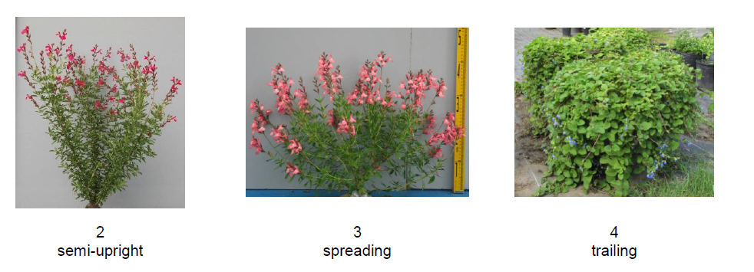

Ad. 2: Plant: height
Plant height should be observed from the surface of the growing medium to the top of the plant, including inflorescence.

Ad. 7: Leaf: type
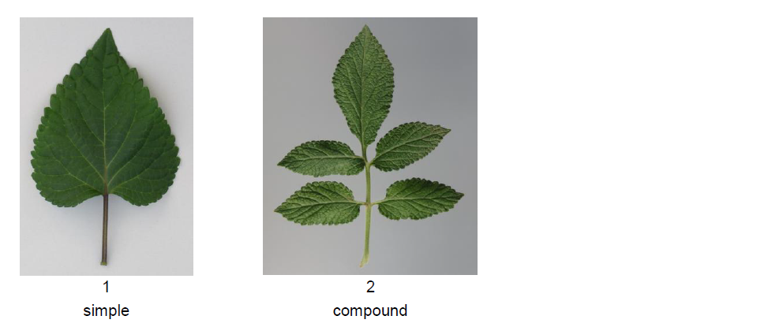

Ad. 8: Petiole: length
Ad. 9: Leaf blade: length
Ad. 10: Leaf blade: width

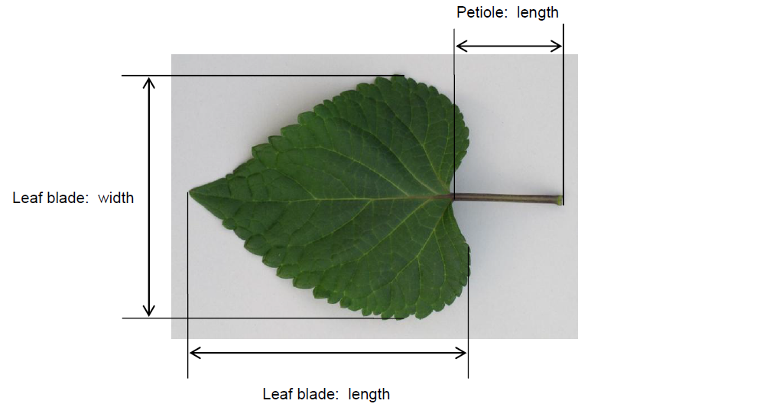

Ad. 11: Leaf blade: ratio length/width
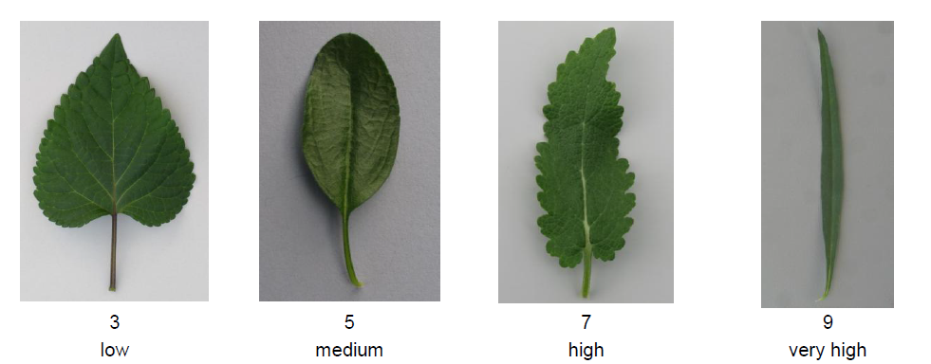

Ad. 12: Leaf blade: position of broadest part
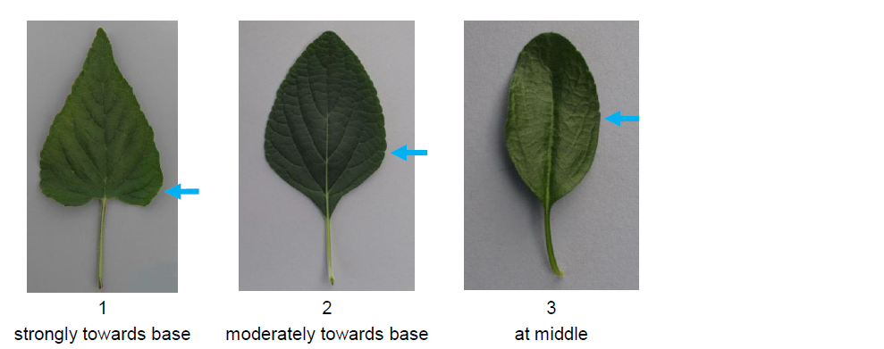

Ad. 13: Leaf blade: shape of base
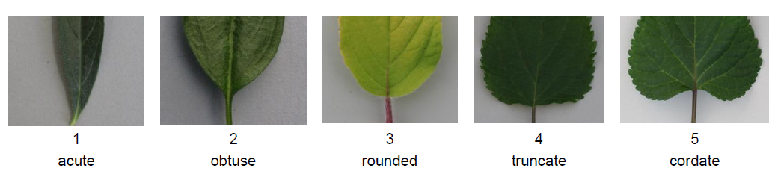

Ad. 14: Leaf blade: shape of apex
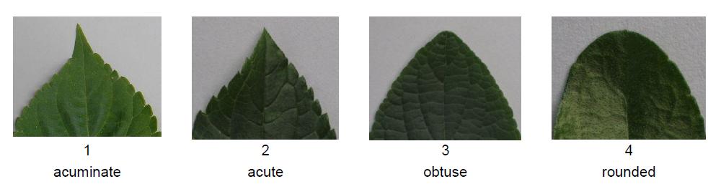

Ad. 18: Leaf blade: distribution of secondary color of upper side
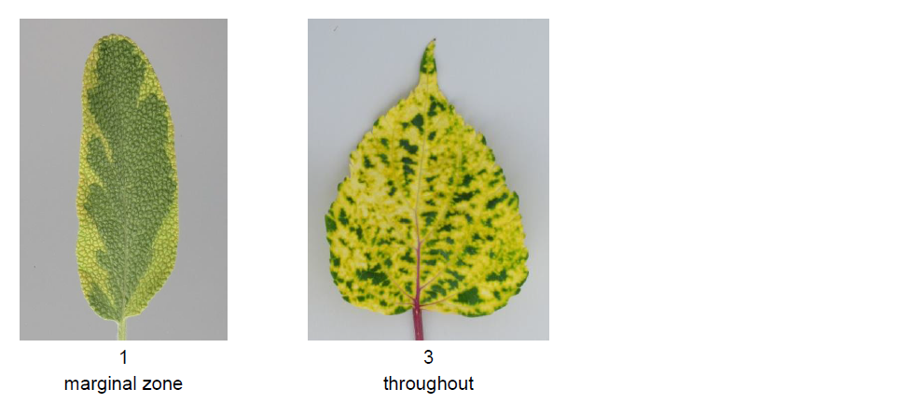

Ad. 20: Leaf blade: rugosity
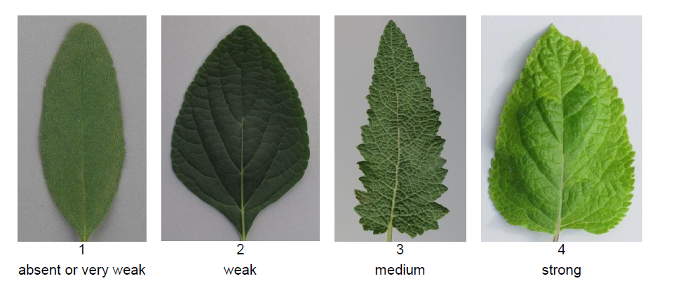

Ad. 21: Leaf blade: incisions of margin
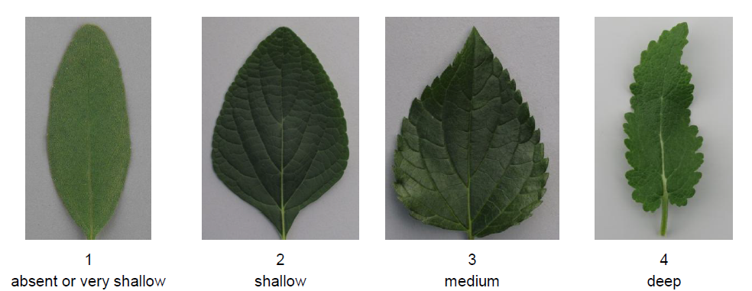

Ad. 22: Leaf blade: undulation of margin
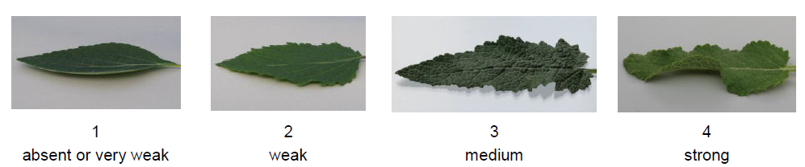

Ad. 23: Inflorescence: length
The length of Inflorescence should be observed at natural length.
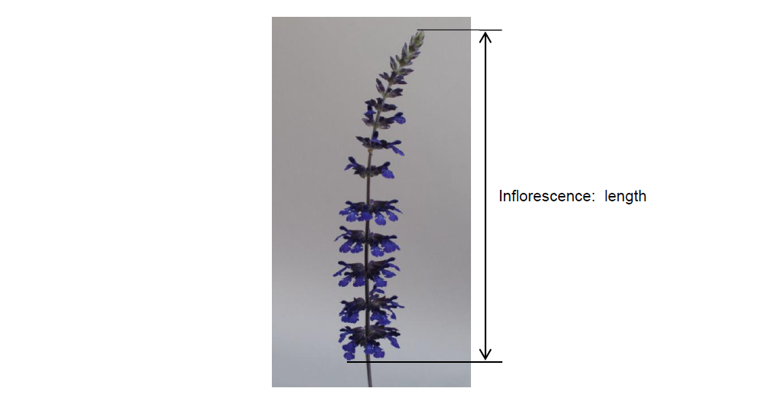

Ad. 24: Inflorescence: length of internode
The internode should be observed on the middle third of an inflorescence.

Ad. 25: Inflorescence: number of florets per node
The number of florets should be observed on a node from the middle third of an inflorescence.
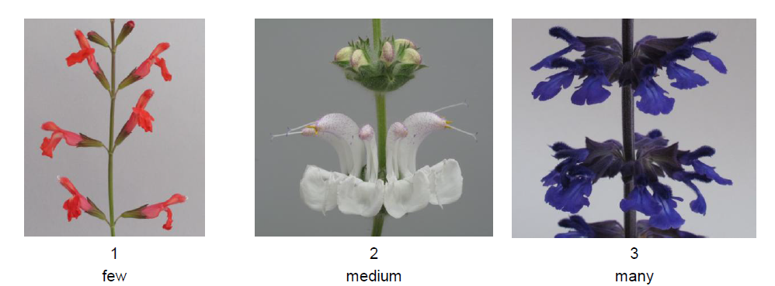

Ad. 27: Inflorescence: attitude of tip
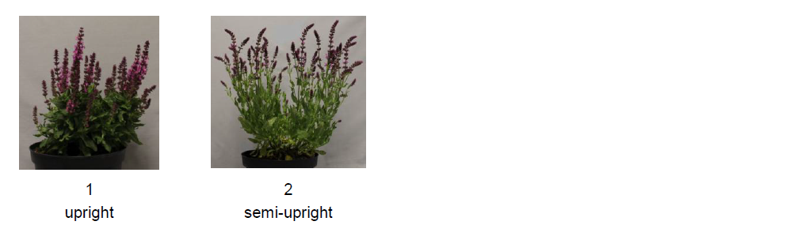

Ad. 29: Bract: length
Bract length should be observed on the lowest bract still remaining in the inflorescence.

Ad. 30: Bract: main color of outer side
Observation should be made on a bract towards the tip of the inflorescence.

Ad. 31: Calyx: length
Ad. 34: Corolla: length
Ad. 36: Corolla tube: length
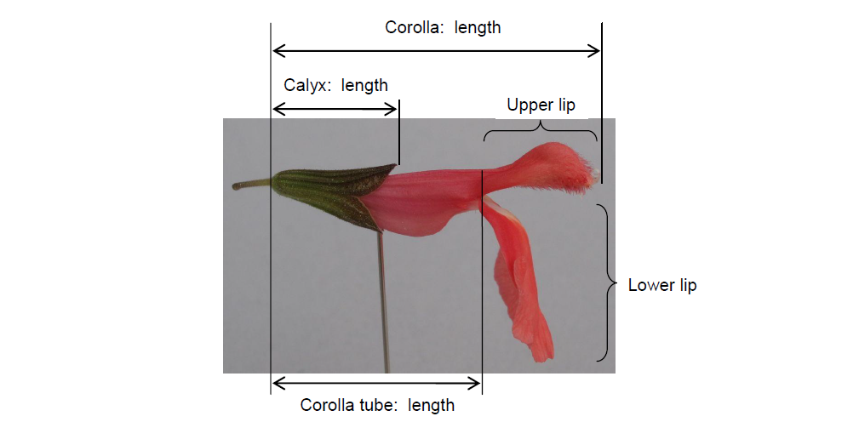

Ad. 35: Corolla: height
Ad. 41: Corolla lower lip: width
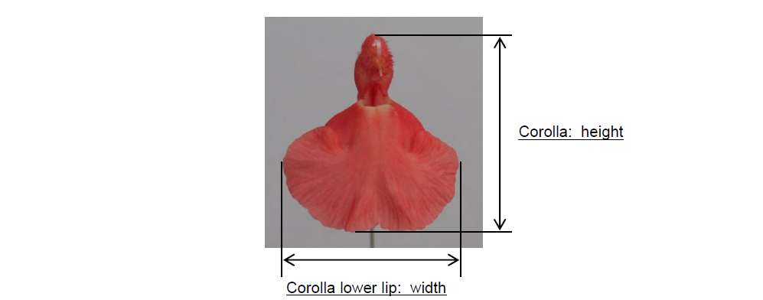

Ad. 42: Corolla lower lip: direction (relative to corolla tube)
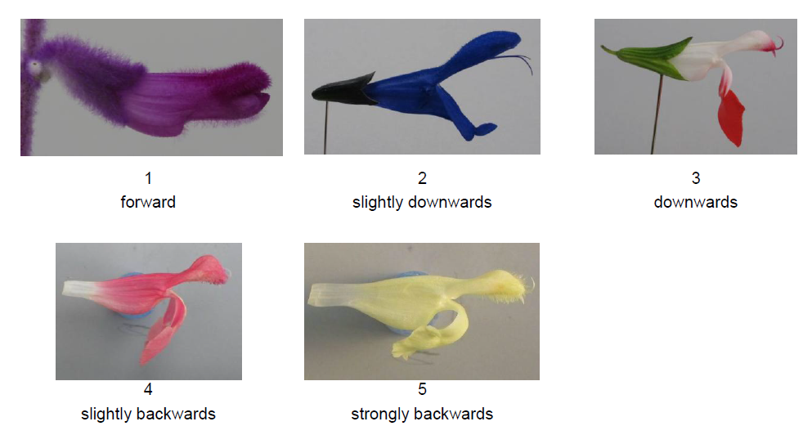

Ad. 45: Corolla lower lip: distribution of secondary color of inner side
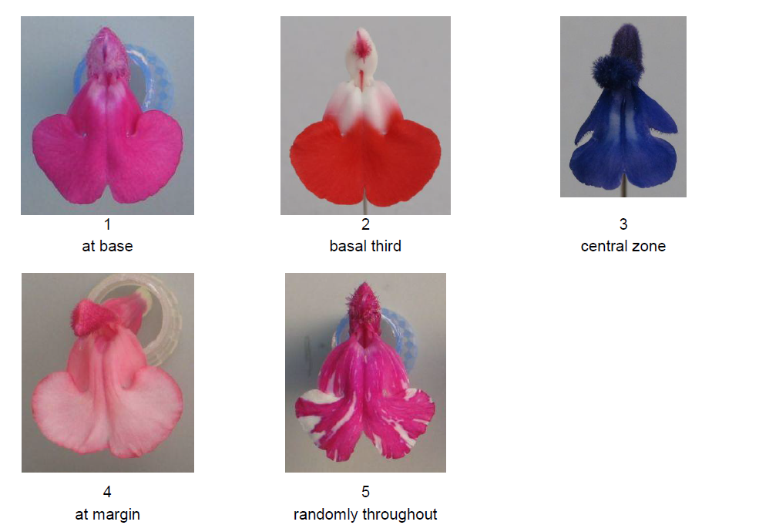

Ad. 46: Corolla lower lip: undulation of margin
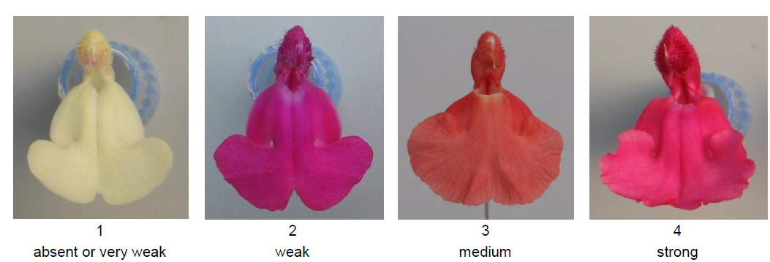

Literature

Tsukamoto, Y., 1994: The Grand Dictionary of Horticulture, Compact version. Shogakukan. Tokyo, JP, pp.1085-1089

Clebsch, B., 2008: The New Book of Salvias: Sages for Every Garden. Timber Press, Inc. Oregon, USA, 344 pp.

Yeo, C., 1995: Salvias. Pleasant View Nursery. Newton Abbot, Devon, GB, 52 pp.

Yeo, C., 1997: Salvias II. Pleasant View Nursery. Newton Abbot, Devon, GB

Froissart, C.,2008: La Connaissance des Sauges. Edisud. Aix-en-Provence, Fr, 320 pp.

Nishikawa, A.,2001: Salvia. NHK Publishing. Tokyo, JP, 127 pp.

Technical Questionnaire

TECHNICAL QUESTIONNAIRE |  | Page {x} of {y} | Reference Number:
 |  |  | Application date:
 |  |  | (not to be filled in by the applicant)
TECHNICAL QUESTIONNAIRE
to be completed in connection with an application for plant breeders’ rights

1. Subject of the Technical Questionnaire
1.1.1 | Botanical Name | Salvia L.
1.1.2 | Common Name | Salvia, Sage
1.1.3 | Species (please complete)

2. Applicant
Name
Address
Telephone No.
Fax No.
E-mail address
Breeder (if different from applicant)
3. Proposed denomination and breeder’s reference
Proposed denomination
(if available)

Breeder’s reference

TECHNICAL QUESTIONNAIRE |  | Page {x} of {y} | Reference Number:
4. Information on the breeding scheme and propagation of the variety

4.1 Breeding scheme

Variety resulting from:

4.1.1 Crossing

(a) controlled cross [ ]
(please state parent varieties)

(…………………..……………..…) x (……………..…………………..…)
female parent male parent

(b) partially known cross [ ]
(please state known parent variety(ies))

(…………………..……………..…) x (……………..…………………..…)
female parent male parent

(c) unknown cross [ ]

4.1.2 Mutation [ ]
(please state parent variety)

4.1.3 Discovery and development [ ]
(please state where and when discovered and how developed)

4.1.4 Other [ ]
(please provide details)

4.2 Method of propagating the variety

4.2.1 Seed-propagated varieties

(a) Self-pollination [ ]
(b) Cross-pollination [ ]
(i) population [ ]
(ii) synthetic variety [ ]
(c) Hybrid [ ]
(d) Other [ ]
(please provide details)
..................................................................................................................................................
: :
: :
:................................................................................................................................................:

4.2.2 Vegetative propagation

(a) cuttings [ ]
(b) in vitro propagation [ ]
(c) Other (state method) [ ]
..................................................................................................................................................
: :
: :
:................................................................................................................................................:

4.2.3 Other [ ]

(please provide details)
..................................................................................................................................................
: :
: :
:................................................................................................................................................:

5. Characteristics of the variety to be indicated (the number in brackets refers to the corresponding characteristic in Test Guidelines; please mark the note which best corresponds).

 | Characteristics | Example Varieties | Note
5.1 (1) | Plant: growth habit
 | upright | Yellow Majesty | 1[ ]
 | semi-upright | Sunsaruki | 2[ ]
 | spreading | Santa Barbara | 3[ ]
 | trailing |  | 4[ ]
5.2 (2) | Plant: height
 | very short | Haeumanarc | 1[ ]
 | short | Hot Jazz | 3[ ]
 | medium | Lady in Red | 5[ ]
 | tall |  | 7[ ]
 | very tall | Yellow Majesty | 9[ ]
5.3 (15) | Leaf blade: variegation
 | absent | Hot Jazz | 1[ ]
 | present | Dancing Flame | 9[ ]
5.4 (25) | Inflorescence: number of florets per node
 | few | Hot Lips | 1[ ]
 | medium |  | 2[ ]
 | many | Yellow Majesty | 3[ ]
5.5 (37) | Corolla tube: main color of outer side
 | RHS Colour Chart (indicate reference number)
 | white |  | 1[ ]
 | green |  | 2[ ]
 | yellow |  | 3[ ]
 | orange |  | 4[ ]
 | pink |  | 5[ ]
 | red |  | 6[ ]
 | purple |  | 7[ ]
 | violet |  | 8[ ]
 | blue |  | 9[ ]
5.6 (43) | Corolla lower lip: main color of inner side
 | RHS Colour Chart (indicate reference number)
 | white |  | 1[ ]
 | green |  | 2[ ]
 | yellow |  | 3[ ]
 | orange |  | 4[ ]
 | pink |  | 5[ ]
 | red |  | 6[ ]
 | purple |  | 7[ ]
 | violet |  | 8[ ]
 | blue |  | 9[ ]
5.7 (44) | Corolla lower lip: secondary color of inner side
 | RHS Colour Chart (indicate reference number)
 | white |  | 1[ ]
 | green |  | 2[ ]
 | yellow |  | 3[ ]
 | orange |  | 4[ ]
 | pink |  | 5[ ]
 | red |  | 6[ ]
 | purple |  | 7[ ]
 | violet |  | 8[ ]
 | blue |  | 9[ ]

6. Similar varieties and differences from these varieties

Please use the following table and box for comments to provide information on how your candidate variety differs from the variety (or varieties) which, to the best of your knowledge, is (or are) most similar. This information may help the examination authority to conduct its examination of distinctness in a more efficient way.

Denomination(s) of variety(ies) similar to your candidate variety | Characteristic(s) in which your candidate variety differs from the similar variety(ies) | Describe the expression of the characteristic(s) for the similar variety(ies) | Describe the expression of the characteristic(s) for your candidate variety
Example | Plant: growth habit | upright | semi-upright
Comments:

7. Additional information which may help in the examination of the variety

7.1 In addition to the information provided in sections 5 and 6, are there any additional characteristics which may help to distinguish the variety?

Yes [ ] No [ ]

(If yes, please provide details)

7.2 Are there any special conditions for growing the variety or conducting the examination?

Yes [ ] No [ ]

(If yes, please provide details)

7.3 Other information

7.4 Main use
(a) garden plant [ ]
(b) pot plant [ ]
(c) culinary [ ]
(d) medical [ ]
(e) other [ ]
(please provide details)

7.5 A representative color photograph of the variety displaying its main distinguishing feature(s), should accompany the Technical Questionnaire. The photograph will provide a visual illustration of the candidate variety which supplements the information provided in the Technical Questionnaire.

The key points to consider when taking a photograph of the candidate variety are:

- Indication of the date and geographic location
- Correct labeling (breeder’s reference)
- Good quality printed photograph (minimum 10 cm x 15 cm) and/or sufficient resolution electronic format version (minimum 960 x 1280 pixels)

Further guidance on providing photographs with the Technical Questionnaire is available in document TGP/7 “Development of Test Guidelines”, Guidance Note 35 (http://www.upov.int/tgp/en/).

[The link provided may be deleted by members of the Union when developing authorities’ own test guidelines.]

8. Authorization for release

(a) Does the variety require prior authorization for release under legislation concerning the protection of the environment, human and animal health?

Yes [ ] No [ ]

(b) Has such authorization been obtained?

Yes [ ] No [ ]

If the answer to (b) is yes, please attach a copy of the authorization.

TECHNICAL QUESTIONNAIRE | Page {x} of {y} | Reference Number:
9. Information on plant material to be examined or submitted for examination

9.1 The expression of a characteristic or several characteristics of a variety may be affected by factors, such as pests and disease, chemical treatment (e.g. growth retardants or pesticides), effects of tissue culture, different rootstocks, scions taken from different growth phases of a tree, etc.

9.2 The plant material should not have undergone any treatment which would affect the expression of the characteristics of the variety, unless the competent authorities allow or request such treatment. If the plant material has undergone such treatment, full details of the treatment must be given. In this respect, please indicate below, to the best of your knowledge, if the plant material to be examined has been subjected to:

(a) Microorganisms (e.g. virus, bacteria, phytoplasma) Yes [ ] No [ ]

(b) Chemical treatment (e.g. growth retardant, pesticide) Yes [ ] No [ ]

(c) Tissue culture Yes [ ] No [ ]

(d) Other factors Yes [ ] No [ ]

Please provide details for where you have indicated “yes”.

10. I hereby declare that, to the best of my knowledge, the information provided in this form is correct:

Applicant’s name

Signature Date

[End of document]

* These names were correct at the time of the introduction of these Test Guidelines but may be revised or updated. [Readers are advised to consult the UPOV Code, which can be found on the UPOV Website (www.upov.int), for the latest information.]

