E
TG/212/2(proj.2)
ORIGINAL: English
DATE: 2015-08-03
INTERNATIONAL UNION FOR THE PROTECTION OF NEW VARIETIES OF PLANTS
Geneva
DRAFT

 | Petunia  UPOV Code: PETCH; PETUN  Petunia Juss.; ×Petchoa J. M. H. Shaw | *

GUIDELINES
FOR THE CONDUCT OF TESTS
FOR DISTINCTNESS, UNIFORMITY AND STABILITY

prepared by (an) expert(s) from Germany

to be considered by the
Technical Working Party for Ornamental Plants and Forest Trees
at its forty-eighth session
to be held in Cambridge, United Kingdom,
from 2015-09-14
to 2015-09-18

Alternative Names:*
Botanical name | English | French | German | Spanish
Petunia Juss., | Petunia | Pétunia | Petunie | Petunia
×Petchoa J. M. H. Shaw, Petunia × Calibrachoa

The purpose of these guidelines (“Test Guidelines”) is to elaborate the principles contained in the General Introduction (document TG/1/3), and its associated TGP documents, into detailed practical guidance for the harmonized examination of distinctness, uniformity and stability (DUS) and, in particular, to identify appropriate characteristics for the examination of DUS and production of harmonized variety descriptions.

ASSOCIATED DOCUMENTS
These Test Guidelines should be read in conjunction with the General Introduction and its associated TGP documents.
TABLE OF CONTENTS PAGE

1. Subject of these Test Guidelines 3
2. Material Required 3
3. Method of Examination 3
3.1 Number of Growing Cycles 3
3.2 Testing Place 3
3.3 Conditions for Conducting the Examination 3
3.4 Test Design 3
3.5 Additional Tests 4
4. Assessment of Distinctness, Uniformity and Stability 4
4.1 Distinctness 4
4.2 Uniformity 5
4.3 Stability 5
5. Grouping of Varieties and Organization of the Growing Trial 5
6. Introduction to the Table of Characteristics 6
6.1 Categories of Characteristics 6
6.2 States of Expression and Corresponding Notes 6
6.3 Types of Expression 7
6.4 Example Varieties 7
6.5 Legend 7
7. Table of Characteristics/Tableau des caractères/Merkmalstabelle/Tabla de caracteres 8
8. Explanations on the Table of Characteristics 16
9. Literature 23
10. Technical Questionnaire 24

Subject of these Test Guidelines

These Test Guidelines apply to all varieties of ×Petchoa J. M. H. Shaw, Petunia Juss..

These Test Guidelines do not apply to varieties of the genus Calibrachoa, which are covered by the Test Guidelines for Calibrachoa (TG/207/2).

Material Required

2.1 The competent authorities decide on the quantity and quality of the plant material required for testing the variety and when and where it is to be delivered. Applicants submitting material from a State other than that in which the testing takes place must ensure that all customs formalities and phytosanitary requirements are complied with.

  - The material is to be supplied in the form of rooted cuttings or seed.

2.3 The minimum quantity of plant material, to be supplied by the applicant, should be:

vegetatively propagated varieties: 15 rooted cuttings
seed propagated varieties: a sufficient quantity of seed to produce 30 plants.

In the case of seed, the seed should meet the minimum requirements for germination, species and analytical purity, health and moisture content, specified by the competent authority.

2.4 The plant material supplied should be visibly healthy, not lacking in vigor, nor affected by any important pest or disease.

2.5 The plant material should not have undergone any treatment which would affect the expression of the characteristics of the variety, unless the competent authorities allow or request such treatment. If it has been treated, full details of the treatment must be given.

Method of Examination

3.1 Number of Growing Cycles

3.1.1 The minimum duration of tests should normally be a single growing cycle.

3.2 Testing Place

Tests are normally conducted at one place. In the case of tests conducted at more than one place, guidance is provided in TGP/9 “Examining Distinctness”.

3.3 Conditions for Conducting the Examination

3.3.1 The tests should be carried out under conditions ensuring satisfactory growth for the expression of the relevant characteristics of the variety and for the conduct of the examination.

3.3.2 Because daylight varies, color determinations made against a color chart should be made either in a suitable cabinet providing artificial daylight or in the middle of the day in a room without direct sunlight. The spectral distribution of the illuminant for artificial daylight should conform with the CIE Standard of Preferred Daylight D 6500 and should fall within the tolerances set out in the British Standard 950, Part I. These determinations should be made with the plant part placed against a white background. The color chart and version used should be specified in the variety description.

3.4 Test Design

3.4.1 Vegetatively propagated varieties: each test should be designed to result in a total of at least 15 plants.

3.4.2 Seed propagated varieties: each test should be designed to result in a total of at least 30 plants.

3.4.3 The design of the tests should be such that plants or parts of plants may be removed for measurement or counting without prejudice to the observations which must be made up to the end of the growing cycle.

3.5 Additional Tests

Additional tests, for examining relevant characteristics, may be established.

Assessment of Distinctness, Uniformity and Stability

4.1 Distinctness

4.1.1 General Recommendations

It is of particular importance for users of these Test Guidelines to consult the General Introduction prior to making decisions regarding distinctness. However, the following points are provided for elaboration or emphasis in these Test Guidelines.

4.1.2 Consistent Differences

The differences observed between varieties may be so clear that more than one growing cycle is not necessary. In addition, in some circumstances, the influence of the environment is not such that more than a single growing cycle is required to provide assurance that the differences observed between varieties are sufficiently consistent. One means of ensuring that a difference in a characteristic, observed in a growing trial, is sufficiently consistent is to examine the characteristic in at least two independent growing cycles.

4.1.3 Clear Differences

Determining whether a difference between two varieties is clear depends on many factors, and should consider, in particular, the type of expression of the characteristic being examined, i.e. whether it is expressed in a qualitative, quantitative, or pseudo-qualitative manner. Therefore, it is important that users of these Test Guidelines are familiar with the recommendations contained in the General Introduction prior to making decisions regarding distinctness.

4.1.4 Number of Plants / Parts of Plants to be Examined

4.1.4.1 In the case of vegetatively propagated varieties, unless otherwise indicated, for the purposes of distinctness, all observations on single plants should be made on 10 plants or parts taken from each of 10 plants and any other observations made on all plants in the test, disregarding any off-type plants.

4.1.4.2 In the case of seed-propagated varieties, unless otherwise indicated, for the purposes of distinctness, all observations on single plants should be made on 20 plants or parts taken from each of 20 plants and any other observations made on all plants in the test, disregarding any off-type plants.

4.1.5 Method of Observation

The recommended method of observing the characteristic for the purposes of distinctness is indicated by the following key in the second column of the Table of Characteristics (see document TGP/9 “Examining Distinctness”, Section 4 “Observation of characteristics”):

MG: single measurement of a group of plants or parts of plants
MS: measurement of a number of individual plants or parts of plants
VG: visual assessment by a single observation of a group of plants or parts of plants
VS: visual assessment by observation of individual plants or parts of plants

Type of observation: visual (V) or measurement (M)

“Visual” observation (V) is an observation made on the basis of the expert’s judgment. For the purposes of this document, “visual” observation refers to the sensory observations of the experts and, therefore, also includes smell, taste and touch. Visual observation includes observations where the expert uses reference points (e.g. diagrams, example varieties, side-by-side comparison) or non-linear charts (e.g. color charts). Measurement (M) is an objective observation against a calibrated, linear scale e.g. using a ruler, weighing scales, colorimeter, dates, counts, etc.

Type of record: for a group of plants (G) or for single, individual plants (S)

For the purposes of distinctness, observations may be recorded as a single record for a group of plants or parts of plants (G), or may be recorded as records for a number of single, individual plants or parts of plants (S). In most cases, “G” provides a single record per variety and it is not possible or necessary to apply statistical methods in a plant-by-plant analysis for the assessment of distinctness.

In cases where more than one method of observing the characteristic is indicated in the Table of Characteristics (e.g. VG/MG), guidance on selecting an appropriate method is provided in document TGP/9, Section 4.2.

4.2 Uniformity

    - It is of particular importance for users of these Test Guidelines to consult the General Introduction prior to making decisions regarding uniformity. However, the following points are provided for elaboration or emphasis in these Test Guidelines:

4.2.2 For the assessment of uniformity of vegetatively propagated varieties, a population standard of 1% and an acceptance probability of at least 95% should be applied. In the case of a sample size of 15 plants, 1 off-type is allowed.

4.2.3 For the assessment of uniformity of self-pollinated seed propagated varieties, a population standard of 2% and an acceptance probability of at least 95% should be applied. In the case of a sample size of 30 plants, 2 off-type are allowed.

4.3 Stability

4.3.1 In practice, it is not usual to perform tests of stability that produce results as certain as those of the testing of distinctness and uniformity. However, experience has demonstrated that, for many types of variety, when a variety has been shown to be uniform, it can also be considered to be stable.

4.3.2 Where appropriate, or in cases of doubt, stability may be further examined by testing a new seed or plant stock to ensure that it exhibits the same characteristics as those shown by the initial material supplied.

Grouping of Varieties and Organization of the Growing Trial

5.1 The selection of varieties of common knowledge to be grown in the trial with the candidate varieties and the way in which these varieties are divided into groups to facilitate the assessment of distinctness are aided by the use of grouping characteristics.

5.2 Grouping characteristics are those in which the documented states of expression, even where produced at different locations, can be used, either individually or in combination with other such characteristics: (a) to select varieties of common knowledge that can be excluded from the growing trial used for examination of distinctness; and (b) to organize the growing trial so that similar varieties are grouped together.

5.3 The following have been agreed as useful grouping characteristics:

(a) Plant: growth habit (characteristic 1)
(b) Leaf: variegation (characteristic 8)
(c) Flower: type (characteristic 15)
(d) Flower: width (characteristic 17)
(e) Flower: conspicuousness of veins (characteristic 20)
(f) Flower: main color (characteristic 22) with the following groups:
Gr. 1: white
Gr. 2: yellow
Gr. 3: orange red
Gr. 4: red
Gr. 5: blue pink
Gr. 6: purple
Gr. 7: violet
Gr. 8: black
(g) Flower: secondary color (characteristic 23) with the following groups:
Gr. 1: white
Gr. 2: green
Gr. 3: yellow
Gr. 4: red
Gr. 5 blue pink
Gr. 6: purple
Gr. 7: violet
Gr. 8: brown
Gr. 9: black

5.4 Guidance for the use of grouping characteristics, in the process of examining distinctness, is provided through the General Introduction and document TGP/9 “Examining Distinctness”.

Introduction to the Table of Characteristics

6.1 Categories of Characteristics

6.1.1 Standard Test Guidelines Characteristics

Standard Test Guidelines characteristics are those which are approved by UPOV for examination of DUS and from which members of the Union can select those suitable for their particular circumstances.

6.1.2 Asterisked Characteristics

Asterisked characteristics (denoted by *) are those included in the Test Guidelines which are important for the international harmonization of variety descriptions and should always be examined for DUS and included in the variety description by all members of the Union, except when the state of expression of a preceding characteristic or regional environmental conditions render this inappropriate.

6.2 States of Expression and Corresponding Notes

6.2.1 States of expression are given for each characteristic to define the characteristic and to harmonize descriptions. Each state of expression is allocated a corresponding numerical note for ease of recording of data and for the production and exchange of the description.

6.2.2 In the case of qualitative and pseudo-qualitative characteristics (see Chapter 6.3), all relevant states of expression are presented in the characteristic. However, in the case of quantitative characteristics with 5 or more states, an abbreviated scale may be used to minimize the size of the Table of Characteristics. For example, in the case of a quantitative characteristic with 9 states, the presentation of states of expression in the Test Guidelines may be abbreviated as follows:

State | Note
small | 3
medium | 5
large | 7

However, it should be noted that all of the following 9 states of expression exist to describe varieties and should be used as appropriate:

State | Note
very small | 1
very small to small | 2
small | 3
small to medium | 4
medium | 5
medium to large | 6
large | 7
large to very large | 8
very large | 9

6.2.3 Further explanation of the presentation of states of expression and notes is provided in document TGP/7 “Development of Test Guidelines”.

6.3 Types of Expression

An explanation of the types of expression of characteristics (qualitative, quantitative and pseudo-qualitative) is provided in the General Introduction.

6.4 Example Varieties

Where appropriate, example varieties are provided to clarify the states of expression of each characteristic.

6.5 Legend

(*) Asterisked characteristic – see Chapter 6.1.2

QL Qualitative characteristic – see Chapter 6.3
QN Quantitative characteristic – see Chapter 6.3
PQ Pseudo-qualitative characteristic – see Chapter 6.3

MG, MS, VG, VS – see Chapter 4.1.5

(a)-(d) See Explanations on the Table of Characteristics in Chapter 8.

(+) See Explanations on the Table of Characteristics in Chapter 8.

Table of Characteristics/Tableau des caractères/Merkmalstabelle/Tabla de caracteres

English | français | deutsch | español | Example Varieties Exemples Beispielssorten Variedades ejemplo | Note/ Nota
1. QN VG (+) (a)
Plant: growth habit | Plante : port | Pflanze: Wuchsform | Planta: hábito de crecimiento
upright | dressé | aufrecht | erguido |  | 1
semi-upright | semi‑dressé | halbaufrecht | semierguido |  | 2
spreading | étalé | breitwüchsig | extendido |  | 3
2. (*) QN MS VG (+) (a)
Plant: height | Plante: hauteur | Pflanze: Höhe | Planta: altura
short | basse | niedrig | baja |  | 3
medium | moyenne | mittel | media |  | 5
tall | haute | hoch | alta |  | 7
3. (*) QN MS VG (+) (a)
Shoot: length | Tige: longueur | Trieb: Länge | Rama: longitud
short | courte | kurz | corta |  | 3
medium | moyenne | mittel | media |  | 5
long | longue | lang | larga |  | 7
4. (*) QN MS VG (+) (a) (b)
Leaf: length | Feuille: longueur | Blatt: Länge | Hoja: longitud
short | courte | kurz | corta |  | 3
medium | moyenne | mittel | media |  | 5
long | longue | lang | larga |  | 7
5. (*) QN MS VG (a) (b)
Leaf: width | Feuille : largeur | Blatt: Breite | Hoja: anchura
narrow | étroite | schmal | estrecha |  | 3
medium | moyenne | mittel | media |  | 5
broad | large | breit | ancha |  | 7

English | français | deutsch | español | Example Varieties Exemples Beispielssorten Variedades ejemplo | Note/ Nota
6. PQ VG (+) (a) (b)
Leaf: shape
ovate |  |  |  |  | 1
elliptic |  |  |  |  | 2
circular |  |  |  |  | 3
obovate |  |  |  |  | 4
rhombic |  |  |  |  | 5
7. PQ VG (+) (a) (b)
Leaf: shape of apex
narrow acute |  |  |  |  | 1
broad acute |  |  |  |  | 2
obtuse |  |  |  |  | 3
8. (*) QL VG (+) (a) (b)
Leaf: variegation | Feuille : panachure | Blatt: Panaschierung | Hoja: variegación
absent |  |  |  |  | 1
present |  |  |  |  | 9
9. PQ VG (a) (b) (c)
Leaf: main color
light yellow |  |  |  |  | 1
light green |  |  |  |  | 2
medium green |  |  |  |  | 3
dark green |  |  |  |  | 4

English | français | deutsch | español | Example Varieties Exemples Beispielssorten Variedades ejemplo | Note/ Nota
10. QN VG (a) (b)
Leaf: blistering | Feuille : clôqure | Blatt: Blasigkeit | Hoja: abullonado
absent or weak |  |  |  |  | 1
medium |  |  |  |  | 2
strong |  |  |  |  | 3
11. QN MS VG (+) (a)
Pedicel: length | Pédicelle: longueur | Blütenstiel: Länge | Pedicelo: longitud
very short |  |  |  |  | 1
short |  |  |  |  | 2
medium |  |  |  |  | 3
long |  |  |  |  | 4
very long |  |  |  |  | 5
12. QN VG (+) (a)
Pedicel: anthocyanin coloration | Pédicelle: pigmentation anthocyanique | Blütenstiel: Anthocyanfärbung | Pedicelo: pigmentación antociánica
absent or very weak |  |  |  |  | 1
weak |  |  |  |  | 2
medium |  |  |  |  | 3
strong |  |  |  |  | 4
13. (*) QN VG (+) (a)
Calyx lobe: length
very short |  |  |  |  | 1
short |  |  |  |  | 2
medium |  |  |  |  | 3
long |  |  |  |  | 4
very long |  |  |  |  | 5

English | français | deutsch | español | Example Varieties Exemples Beispielssorten Variedades ejemplo | Note/ Nota
14. (*) QN VG (a)
Calyx lobe: width
very narrow |  |  |  |  | 1
narrow |  |  |  |  | 2
medium |  |  |  |  | 3
broad |  |  |  |  | 4
very broad |  |  |  |  | 5
15. (*) QL VG (+) (a)
Flower: type | Fleur: type | Blüte: Typ | Flor: tipo
single | simple | einfach | sencilla |  | 1
double | double | gefüllt | doble |  | 2
16. QN VG (+) (a)
Only varieties with Flower: type: double: Flower: density
very sparse |  |  |  |  | 1
sparse |  |  |  |  | 2
medium |  |  |  |  | 3
dense |  |  |  |  | 4
17. (*) QN MS VG (+) (a) (d)
Flower: width | Fleur: largeur | Blüte: Breite | Flor: anchura
narrow |  |  |  |  | 3
medium |  |  |  |  | 5
broad |  |  |  |  | 7

English | français | deutsch | español | Example Varieties Exemples Beispielssorten Variedades ejemplo | Note/ Nota
18. (*) QN VG (+) (a) (d)
Flower: lobing
absent or very weak |  |  |  |  | 1
weak |  |  |  |  | 2
medium |  |  |  |  | 3
strong |  |  |  |  | 4
very strong |  |  |  |  | 5
19. QN VG (+) (a) (d)
Flower: undulation
absent or very weak |  |  |  |  | 1
weak |  |  |  |  | 2
medium |  |  |  |  | 3
strong |  |  |  |  | 4
very strong |  |  |  |  | 5
20. (*) QN VG (+) (a) (d)
Flower: conspicuousness of veins
absent or very weak |  |  |  |  | 1
weak |  |  |  |  | 3
medium |  |  |  |  | 5
strong |  |  |  |  | 7
very strong |  |  |  |  | 9

English | français | deutsch | español | Example Varieties Exemples Beispielssorten Variedades ejemplo | Note/ Nota
21. PQ VG (+) (a) (d)
Flower: color of veins
white |  |  |  |  | 1
greenish |  |  |  |  | 2
yellow |  |  |  |  | 3
pink |  |  |  |  | 4
red |  |  |  |  | 5
purple |  |  |  |  | 6
violet |  |  |  |  | 7
black |  |  |  |  | 8
22. (*) PQ VG (a) (c) (d)
Flower: main color | Fleur: couleur principale | Blüte: Hauptfarbe | Flor: color principal
RHS Colour Chart (indicate reference number)
23. (*) PQ VG (+) (a) (d)
Flower: secondary color
RHS Colour Chart (indicate reference number)
24. (*) PQ VG (+) (a) (d)
Only varieties with Flower: type: single: Flower: distribution of secondary color
at transition to corolla tube |  |  |  |  | 1
along mid-veins of corolla lobes |  |  |  |  | 2
along the fused parts of the corolla lobes |  |  |  |  | 3
at margin of corolla |  |  |  |  | 4
irregular |  |  |  |  | 5

English | français | deutsch | español | Example Varieties Exemples Beispielssorten Variedades ejemplo | Note/ Nota
25. QN VG (+) (a)
Only varieties with Flower: type: single: Flower: area of secondary color
small |  |  |  |  | 1
medium |  |  |  |  | 2
large |  |  |  |  | 3
26. QN VG (+) (a)
Only varieties with Flower: type: single: Plant: number of flowers with different size of area of secondary color
absent or few |  |  |  |  | 1
medium |  |  |  |  | 2
many |  |  |  |  | 3
27. PQ VG (+) (a) (d)
Flower: tertiary color
RHS Color Chart (indicate reference number)
28. (*) PQ VG (+) (a) (c)
Young flower: main color
RHS Color Chart (indicate reference number)
29. PQ VG (+) (a) (c)
Aged flower: main color
RHS Color Chart (indicate reference number)
30. PQ VG (+) (a) (d)
Corolla lobe: shape of apex
acute |  |  |  |  | 1
cuspidate |  |  |  |  | 2
rounded |  |  |  |  | 3
truncate |  |  |  |  | 4
emarginate |  |  |  |  | 5

English | français | deutsch | español | Example Varieties Exemples Beispielssorten Variedades ejemplo | Note/ Nota
31. QN MS VG (+) (a)
Only varieties with Flower: type: single: Corolla tube: width
narrow |  |  |  |  | 1
medium |  |  |  |  | 2
broad |  |  |  |  | 3
32. PQ VG (a) (c)
Only varieties with Flower: type: single: Corolla tube: main color of inner side
RHS Color Chart (indicate reference number)
33. QN VG (+) (a)
Only varieties with Flower: type: single: Corolla tube: conspicuousness of veins on inner side
absent or very weak |  |  |  |  | 1
weak |  |  |  |  | 3
medium |  |  |  |  | 5
strong |  |  |  |  | 7
very strong |  |  |  |  | 9
34. (*) PQ VG c (+) (a)
Corolla tube: main color of outer side
RHS Color Chart (indicate reference number)
35. (*) PQ VG (a)
Only varieties with Flower: type: single: Anther: color before dehiscence
light grey |  |  |  |  | 1
yellowish white |  |  |  |  | 2
yellow |  |  |  |  | 3
light brown |  |  |  |  | 4
light blue |  |  |  |  | 5
medium blue |  |  |  |  | 6
violet |  |  |  |  | 7

Explanations on the Table of Characteristics

8.1 Explanations covering several characteristics

Characteristics containing the following key in the second column of the Table of Characteristics should be examined as indicated below:
(a) Unless otherwise indicated observations should be made at the time of full flowering.
(b) Observations on the leaf should be made on the upper side of fully developed leaves from the middle part of a shoot.
(c) The main color is the color with the largest surface area excluding veins. In cases where the areas of the main and the secondary color are too similar to reliably decide which color has the largest area, the darker color is considered to be the main color.
(d) Observations on the flower should be made on the inner side of the corolla lobes of a middle aged flower. Observations on varieties with double flowers should be made on the outer corolla lobes.

8.2 Explanations for individual characteristics

Ad. 1: Plant: growth habit

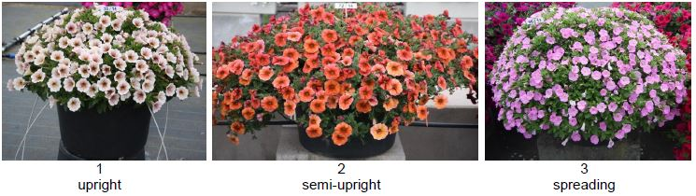

Ad. 2: Plant: height
The plant height should be observed from the soil level to the highest point of the plant. The observation should be done towards the end of the trial.

Ad. 3: Shoot: length
The shoot length should be observed on the longest shoot from the soil level to the end of the shoot. The observation should be done towards the end of the trial.

Ad. 4: Leaf: length
The leaf length is observed including petiole.

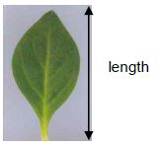
Ad. 6: Leaf: shape

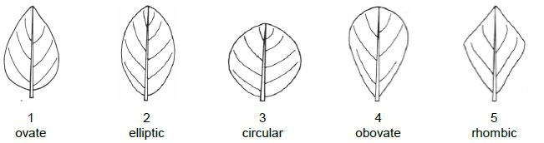

Ad. 7: Leaf: shape of apex

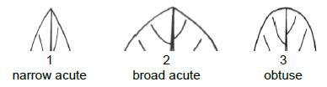

Ad. 8: Leaf: variegation

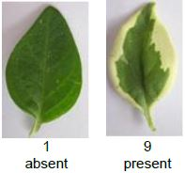

Ad. 11: Pedicel: length

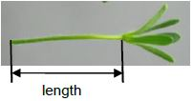

Ad. 12: Pedicel: anthocyanin coloration
The anthocyanin coloration should be observed on the distal third of the pedicel.

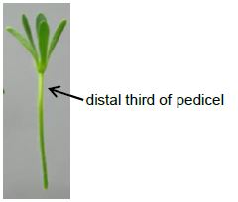

Ad. 13: Calyx lobe: length
Ad. 14: Calyx lobe: width

Observations on the calyx lobe should be made on the broadest calyx lobe.

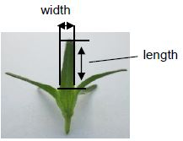

Ad. 15: Flower: type

A double flower has more than 6 corolla lobes.

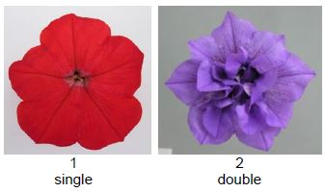

Ad. 16: Only varieties with Flower: type: double: Flower: density

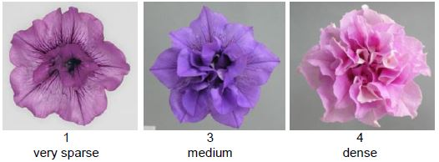

Ad. 17: Flower: width
The width is observed at the broadest part of the flower.

Ad. 18: Flower: lobing

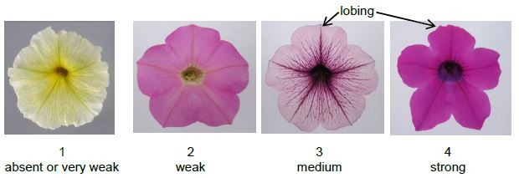

Ad. 19: Flower: undulation

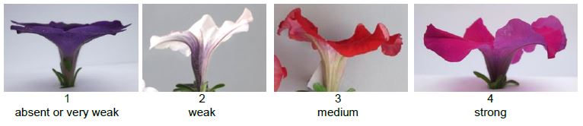

Ad. 20: Flower: conspicuousness of veins

The conspicuousness is determined by the color contrast and the number of contrasting veins.

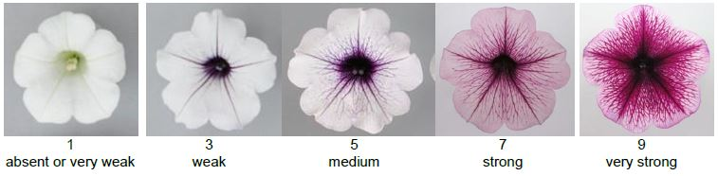

Ad. 21: Flower: color of veins

To be observed only when the conspiciuousness of the veins (char. 20) is at least weak (3).

Ad. 23: Flower: secondary color

The secondary color is the color with the second largest surface area excluding veins. In cases where the areas of the main and the secondary color are too similar to reliably decide which color has the largest area, the lighter color is considered to be the secondary color. In cases where the areas of the secondary and the tertiary color are too similar to reliably decide which color has the largest area, the darker color is considered to be the secondary color.

Ad. 24: Only varieties with Flower: type: single: Flower: distribution of secondary color

Petunia varieties with bi- or multi-colored flowers can have a strong reaction on the environmental conditions. Due the conditions during a specific period of their bud development the area of the secondary color on some flowers can be different from the area on other flowers. Therefore the distribution of the secondary color on those flowers should be observed which have the predominant distribution.

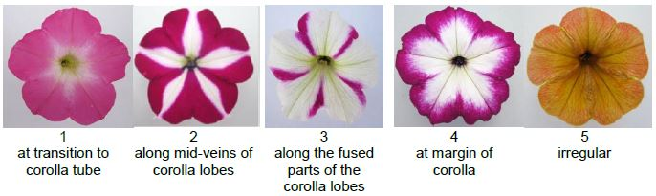

Ad. 25: Only varieties with Flower: type: single: Flower: area of secondary color

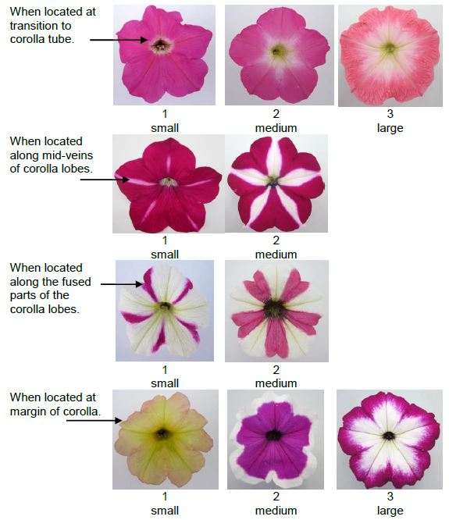

Ad. 26: Only varieties with Flower: type: single: Plant: number of flowers with different size of area of secondary color

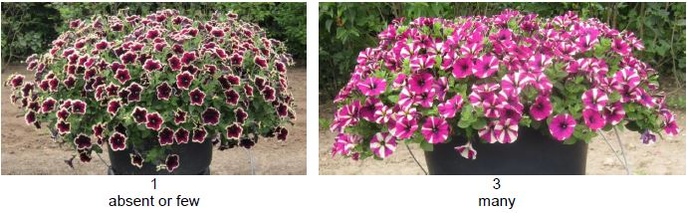

Ad. 27: Flower: tertiary color

The tertiary color is the color with the third largest area excluding veins. In cases where the areas of the secondary and the tertiary color are too similar to reliably decide which color has the largest area, the lighter color is considered to be the tertiary color.

Ad. 28: Young flower: main color

Observations on the young flower should be made on the upper side of corolla lobes of flowers which have just fully opened. Observations on varieties with double flowers should be made on the outer corolla lobes.

Ad. 29: Aged flower: main color
Observations on the aged flower should be made on the upper side of corolla lobes of flowers which have just started to fade. Observations on varieties with double flowers should be made on the outer corolla lobes.

Ad. 30: Corolla lobe: shape of apex
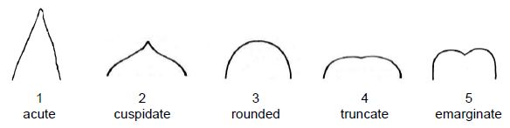

Ad. 31: Only varieties with Flower: type: single: Corolla tube: width

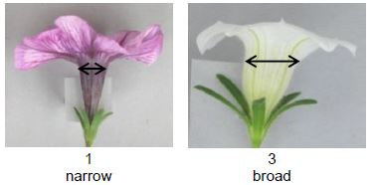

Ad. 33: Only varieties with Flower: type: single: Corolla tube: conspicuousness of veins on inner side
The conspicuousness is determined by the color contrast and the number of contrasting veins.

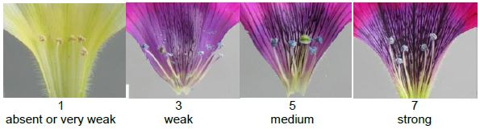

Ad. 34: Corolla tube: main color of outer side

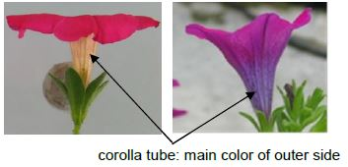

Literature

Rünger, W., 1976: Licht uind Temperatur im Zierpflanzenbau. Verlag Paul Parey, DE, pp.62-64.

Wijsman, H.J.W., 1982: On the Interrelationships of Certain Species of Petunia I. Taxonomic Notes on the Parental Species of Petunia Hybrida. ActaBot. Neerl. 31 (5/6), NL, pp. 477-490.

Wijsman, H.J.W. and de Jong, J.H., 1985: On the Interrelationships of Certain Species of Petunia IV. Hybridization Between P. linearis and P. calycina and Nomenclatorial Consequences in the Petunia Group. Acta Bot. Neerl. 34 (3), NL, pp. 337-349.

Wijsman, H.J.W., 1990: On the Interrelationships of Certain Species of Petunia VI. New Names for the Species of Calibrachoa Formerly Included Into Petunia (Solanaceae). Acta Bot. Neerl. 39 (19), NL, pp. 101 and 102.

Technical Questionnaire

TECHNICAL QUESTIONNAIRE |  | Page {x} of {y} | Reference Number:
 |  |  | Application date:
 |  |  | (not to be filled in by the applicant)
TECHNICAL QUESTIONNAIRE
to be completed in connection with an application for plant breeders’ rights

1. Subject of the Technical Questionnaire
1.1.1 | Botanical Name | ×Petchoa J. M. H. Shaw |  | [ ]
1.1.2 | Common Name | Petunia x Calibrachoa
1.2.1 | Botanical Name | Petunia Juss. |  | [ ]
1.2.2 | Common Name | Petunia

2. Applicant
Name
Address
Telephone No.
Fax No.
E-mail address
Breeder (if different from applicant)
3. Proposed denomination and breeder’s reference
Proposed denomination
(if available)

Breeder’s reference

TECHNICAL QUESTIONNAIRE |  | Page {x} of {y} | Reference Number:
4. Information on the breeding scheme and propagation of the variety

4.1 Breeding scheme

Variety resulting from:

4.1.1 Crossing

(a) controlled cross [ ]
(please state parent varieties)

(…………………..……………..…) x (……………..…………………..…)
female parent male parent

(b) partially known cross [ ]
(please state known parent variety(ies))

(…………………..……………..…) x (……………..…………………..…)
female parent male parent

(c) unknown cross [ ]

4.1.2 Mutation [ ]
(please state parent variety)

4.1.3 Discovery and development [ ]
(please state where and when discovered and how developed)

4.1.4 Other [ ]
(please provide details)

4.2 Method of propagating the variety

4.2.1 Seed-propagated varieties

(a) Self-pollination [ ]
(b) Other [ ]
(please provide details)
..................................................................................................................................................
: :
: :
:................................................................................................................................................:

4.2.2 Vegetative propagation

(a) cuttings [ ]
(b) in vitro propagation [ ]
(c) Other (state method) [ ]
..................................................................................................................................................
: :
: :
:................................................................................................................................................:

4.2.3 Other [ ]

(please provide details)
..................................................................................................................................................
: :
: :
:................................................................................................................................................:

5. Characteristics of the variety to be indicated (the number in brackets refers to the corresponding characteristic in Test Guidelines; please mark the note which best corresponds).

 | Characteristics | Example Varieties | Note
5.1 (1) | Plant: growth habit
 | upright |  | 1[ ]
 | semi-upright |  | 2[ ]
 | spreading |  | 3[ ]
5.2 (8) | Leaf: variegation
 | absent |  | 1[ ]
 | present |  | 9[ ]
5.3 (15) | Flower: type
 | single |  | 1[ ]
 | double |  | 2[ ]
5.4 (17) | Flower: width
 | very narrow |  | 1[ ]
 | very narrow to narrow |  | 2[ ]
 | narrow |  | 3[ ]
 | narrow to medium |  | 4[ ]
 | medium |  | 5[ ]
 | medium to broad |  | 6[ ]
 | broad |  | 7[ ]
 | broad to very broad |  | 8[ ]
 | very broad |  | 9[ ]
5.5 (20) | Flower: conspicuousness of veins
 | absent or very weak |  | 1[ ]
 | very weak to weak |  | 2[ ]
 | weak |  | 3[ ]
 | weak to medium |  | 4[ ]
 | medium |  | 5[ ]
 | medium to strong |  | 6[ ]
 | strong |  | 7[ ]
 | strong to very strong |  | 8[ ]
 | very strong |  | 9[ ]
5.6 (22) | Flower: main color
 | RHS Colour Chart (indicate reference number)
 | white |  | 1[ ]
 | yellow |  | 2[ ]
 | orange red |  | 3[ ]
 | red |  | 4[ ]
 | blue pink |  | 5[ ]
 | purple |  | 6[ ]
 | violet |  | 7[ ]
 | black |  | 8[ ]
 | other color (indicate) |  | 9[ ]
5.7 (23) | Flower: secondary color
 | RHS Colour Chart (indicate reference number)
 | white |  | 1[ ]
 | green |  | 2[ ]
 | yellow |  | 3[ ]
 | red |  | 4[ ]
 | blue pink |  | 5[ ]
 | purple |  | 6[ ]
 | violet |  | 7[ ]
 | brown |  | 8[ ]
 | black |  | 9[ ]
 | other color (indicate) |  | 10[ ]

6. Similar varieties and differences from these varieties

Please use the following table and box for comments to provide information on how your candidate variety differs from the variety (or varieties) which, to the best of your knowledge, is (or are) most similar. This information may help the examination authority to conduct its examination of distinctness in a more efficient way.

Denomination(s) of variety(ies) similar to your candidate variety | Characteristic(s) in which your candidate variety differs from the similar variety(ies) | Describe the expression of the characteristic(s) for the similar variety(ies) | Describe the expression of the characteristic(s) for your candidate variety
Example | Flower: width | narrow | medium
Comments:

7. Additional information which may help in the examination of the variety

7.1 In addition to the information provided in sections 5 and 6, are there any additional characteristics which may help to distinguish the variety?

Yes [ ] No [ ]

(If yes, please provide details)

7.2 Are there any special conditions for growing the variety or conducting the examination?

Yes [ ] No [ ]

(If yes, please provide details)

7.3 Other information

7.4 A representative color photograph of the variety displaying its main distinguishing feature(s), should accompany the Technical Questionnaire. The photograph will provide a visual illustration of the candidate variety which supplements the information provided in the Technical Questionnaire.

The key points to consider when taking a photograph of the candidate variety are:

- Indication of the date and geographic location
- Correct labeling (breeder’s reference)
- Good quality printed photograph (minimum 10 cm x 15 cm) and/or sufficient resolution electronic format version (minimum 960 x 1280 pixels)

Further guidance on providing photographs with the Technical Questionnaire is available in document TGP/7 “Development of Test Guidelines”, Guidance Note 35 (http://www.upov.int/tgp/en/).

[The link provided may be deleted by members of the Union when developing authorities’ own test guidelines.]

8. Authorization for release

(a) Does the variety require prior authorization for release under legislation concerning the protection of the environment, human and animal health?

Yes [ ] No [ ]

(b) Has such authorization been obtained?

Yes [ ] No [ ]

If the answer to (b) is yes, please attach a copy of the authorization.

TECHNICAL QUESTIONNAIRE | Page {x} of {y} | Reference Number:
9. Information on plant material to be examined or submitted for examination

9.1 The expression of a characteristic or several characteristics of a variety may be affected by factors, such as pests and disease, chemical treatment (e.g. growth retardants or pesticides), effects of tissue culture, different rootstocks, scions taken from different growth phases of a tree, etc.

9.2 The plant material should not have undergone any treatment which would affect the expression of the characteristics of the variety, unless the competent authorities allow or request such treatment. If the plant material has undergone such treatment, full details of the treatment must be given. In this respect, please indicate below, to the best of your knowledge, if the plant material to be examined has been subjected to:

(a) Microorganisms (e.g. virus, bacteria, phytoplasma) Yes [ ] No [ ]

(b) Chemical treatment (e.g. growth retardant, pesticide) Yes [ ] No [ ]

(c) Tissue culture Yes [ ] No [ ]

(d) Other factors Yes [ ] No [ ]

Please provide details for where you have indicated “yes”.

10. I hereby declare that, to the best of my knowledge, the information provided in this form is correct:

Applicant’s name

Signature Date

[End of document]

* These names were correct at the time of the introduction of these Test Guidelines but may be revised or updated. [Readers are advised to consult the UPOV Code, which can be found on the UPOV Website (www.upov.int), for the latest information.]

