E
TG/27/7(proj.2)
ORIGINAL: English
DATE: 2015-08-03
INTERNATIONAL UNION FOR THE PROTECTION OF NEW VARIETIES OF PLANTS
Geneva
DRAFT

 | Freesia  UPOV Code: FREES  Freesia Eckl. ex Klatt | *

GUIDELINES
FOR THE CONDUCT OF TESTS
FOR DISTINCTNESS, UNIFORMITY AND STABILITY

prepared by (an) expert(s) from the Netherlands

to be considered by the
Technical Working Party for Ornamental Plants and Forest Trees
at its forty-eighth session
to be held in Cambridge, United Kingdom,
from 2015-09-14
to 2015-09-18

Alternative Names:*
Botanical name | English | French | German | Spanish
Freesia Eckl. ex Klatt | Freesia | Freesia | Freesie | Freesia

The purpose of these guidelines (“Test Guidelines”) is to elaborate the principles contained in the General Introduction (document TG/1/3), and its associated TGP documents, into detailed practical guidance for the harmonized examination of distinctness, uniformity and stability (DUS) and, in particular, to identify appropriate characteristics for the examination of DUS and production of harmonized variety descriptions.

ASSOCIATED DOCUMENTS
These Test Guidelines should be read in conjunction with the General Introduction and its associated TGP documents.
TABLE OF CONTENTS PAGE

1. Subject of these Test Guidelines 3
2. Material Required 3
3. Method of Examination 3
3.1 Number of Growing Cycles 3
3.2 Testing Place 3
3.3 Conditions for Conducting the Examination 3
3.4 Test Design 3
3.5 Additional Tests 3
4. Assessment of Distinctness, Uniformity and Stability 4
4.1 Distinctness 4
4.2 Uniformity 5
4.3 Stability 5
5. Grouping of Varieties and Organization of the Growing Trial 5
6. Introduction to the Table of Characteristics 6
6.1 Categories of Characteristics 6
6.2 States of Expression and Corresponding Notes 6
6.3 Types of Expression 6
6.4 Example Varieties 7
6.5 Legend 7
7. Table of Characteristics/Tableau des caractères/Merkmalstabelle/Tabla de caracteres 8
8. Explanations on the Table of Characteristics 19
9. Literature 30
10. Technical Questionnaire 31

Subject of these Test Guidelines

These Test Guidelines apply to all varieties of Freesia Eckl. ex Klatt.

Material Required

2.1 The competent authorities decide on the quantity and quality of the plant material required for testing the variety and when and where it is to be delivered. Applicants submitting material from a State other than that in which the testing takes place must ensure that all customs formalities and phytosanitary requirements are complied with.

  - The material is to be supplied in the form of corms, able to show all the characteristics in the first year of examination.

2.3 The minimum quantity of plant material, to be supplied by the applicant, should be:

30 corms.

2.4 The plant material supplied should be visibly healthy, not lacking in vigor, nor affected by any important pest or disease.

2.5 The plant material should not have undergone any treatment which would affect the expression of the characteristics of the variety, unless the competent authorities allow or request such treatment. If it has been treated, full details of the treatment must be given.

Method of Examination

3.1 Number of Growing Cycles

3.1.1 The minimum duration of tests should normally be a single growing cycle.

3.2 Testing Place

Tests are normally conducted at one place. In the case of tests conducted at more than one place, guidance is provided in TGP/9 “Examining Distinctness”.

3.3 Conditions for Conducting the Examination

3.3.1 The tests should be carried out under conditions ensuring satisfactory growth for the expression of the relevant characteristics of the variety and for the conduct of the examination.

3.3.2 Because daylight varies, color determinations made against a color chart should be made either in a suitable cabinet providing artificial daylight or in the middle of the day in a room without direct sunlight. The spectral distribution of the illuminant for artificial daylight should conform with the CIE Standard of Preferred Daylight D 6500 and should fall within the tolerances set out in the British Standard 950, Part I. These determinations should be made with the plant part placed against a white background. The color chart and version used should be specified in the variety description.

3.4 Test Design

3.4.1 Each test should be designed to result in a total of at least 20 select.

3.4.2 The design of the tests should be such that plants or parts of plants may be removed for measurement or counting without prejudice to the observations which must be made up to the end of the growing cycle.

3.5 Additional Tests

Additional tests, for examining relevant characteristics, may be established.

Assessment of Distinctness, Uniformity and Stability

4.1 Distinctness

4.1.1 General Recommendations

It is of particular importance for users of these Test Guidelines to consult the General Introduction prior to making decisions regarding distinctness. However, the following points are provided for elaboration or emphasis in these Test Guidelines.

4.1.2 Consistent Differences

The differences observed between varieties may be so clear that more than one growing cycle is not necessary. In addition, in some circumstances, the influence of the environment is not such that more than a single growing cycle is required to provide assurance that the differences observed between varieties are sufficiently consistent. One means of ensuring that a difference in a characteristic, observed in a growing trial, is sufficiently consistent is to examine the characteristic in at least two independent growing cycles.

4.1.3 Clear Differences

Determining whether a difference between two varieties is clear depends on many factors, and should consider, in particular, the type of expression of the characteristic being examined, i.e. whether it is expressed in a qualitative, quantitative, or pseudo-qualitative manner. Therefore, it is important that users of these Test Guidelines are familiar with the recommendations contained in the General Introduction prior to making decisions regarding distinctness.

4.1.4 Number of Plants / Parts of Plants to be Examined

Unless otherwise indicated, for the purposes of distinctness, all observations on single plants should be made on 10 plants or parts taken from each of 10 plants and any other observations made on all plants in the test, disregarding any off-type plants. In the case of observations of parts taken from single plants, the number of parts to be taken from each of the plants should be 1.

4.1.5 Method of Observation

The recommended method of observing the characteristic for the purposes of distinctness is indicated by the following key in the second column of the Table of Characteristics (see document TGP/9 “Examining Distinctness”, Section 4 “Observation of characteristics”):

MG: single measurement of a group of plants or parts of plants
MS: measurement of a number of individual plants or parts of plants
VG: visual assessment by a single observation of a group of plants or parts of plants
VS: visual assessment by observation of individual plants or parts of plants

Type of observation: visual (V) or measurement (M)

“Visual” observation (V) is an observation made on the basis of the expert’s judgment. For the purposes of this document, “visual” observation refers to the sensory observations of the experts and, therefore, also includes smell, taste and touch. Visual observation includes observations where the expert uses reference points (e.g. diagrams, example varieties, side-by-side comparison) or non-linear charts (e.g. color charts). Measurement (M) is an objective observation against a calibrated, linear scale e.g. using a ruler, weighing scales, colorimeter, dates, counts, etc.

Type of record: for a group of plants (G) or for single, individual plants (S)

For the purposes of distinctness, observations may be recorded as a single record for a group of plants or parts of plants (G), or may be recorded as records for a number of single, individual plants or parts of plants (S). In most cases, “G” provides a single record per variety and it is not possible or necessary to apply statistical methods in a plant-by-plant analysis for the assessment of distinctness.
In cases where more than one method of observing the characteristic is indicated in the Table of Characteristics (e.g. VG/MG), guidance on selecting an appropriate method is provided in document TGP/9, Section 4.2.

4.2 Uniformity

    - It is of particular importance for users of these Test Guidelines to consult the General Introduction prior to making decisions regarding uniformity. However, the following points are provided for elaboration or emphasis in these Test Guidelines:

4.2.2 For the assessment of uniformity, a population standard of 1% and an acceptance probability of at least 95% should be applied. In the case of a sample size of 20 plants, 1 off-type is allowed.

4.3 Stability

4.3.1 In practice, it is not usual to perform tests of stability that produce results as certain as those of the testing of distinctness and uniformity. However, experience has demonstrated that, for many types of variety, when a variety has been shown to be uniform, it can also be considered to be stable.

4.3.2 Where appropriate, or in cases of doubt, stability may be further examined by testing a new plant stock to ensure that it exhibits the same characteristics as those shown by the initial material supplied.

Grouping of Varieties and Organization of the Growing Trial

5.1 The selection of varieties of common knowledge to be grown in the trial with the candidate varieties and the way in which these varieties are divided into groups to facilitate the assessment of distinctness are aided by the use of grouping characteristics.

5.2 Grouping characteristics are those in which the documented states of expression, even where produced at different locations, can be used, either individually or in combination with other such characteristics: (a) to select varieties of common knowledge that can be excluded from the growing trial used for examination of distinctness; and (b) to organize the growing trial so that similar varieties are grouped together.

5.3 The following have been agreed as useful grouping characteristics:

(a) Plant: height (characteristic 1)
(b) Spike: length (characteristic 11)
(c) Flower: type (characteristic 19)
(d) Perianth: main color of inner side of outer segments (characteristic 34)
with the following groups
Gr. 1: white
Gr. 2: yellow
Gr. 3: yellow orange
Gr. 4: orange
Gr. 5: pink
Gr. 6: red
Gr. 7: violet
Gr. 8: blue violet
Gr. 9: blue
(e) Perianth: main color of inner side of inner segment (characteristic 42)
with the following groups
Gr. 1: white
Gr. 2: yellow
Gr. 3: yellow orange
Gr. 4: orange
Gr. 5: pink
Gr. 6: red
Gr. 7: violet
Gr. 8: blue violet
Gr. 9: violet

5.4 Guidance for the use of grouping characteristics, in the process of examining distinctness, is provided through the General Introduction and document TGP/9 “Examining Distinctness”.

Introduction to the Table of Characteristics

6.1 Categories of Characteristics

6.1.1 Standard Test Guidelines Characteristics

Standard Test Guidelines characteristics are those which are approved by UPOV for examination of DUS and from which members of the Union can select those suitable for their particular circumstances.

6.1.2 Asterisked Characteristics

Asterisked characteristics (denoted by *) are those included in the Test Guidelines which are important for the international harmonization of variety descriptions and should always be examined for DUS and included in the variety description by all members of the Union, except when the state of expression of a preceding characteristic or regional environmental conditions render this inappropriate.

6.2 States of Expression and Corresponding Notes

6.2.1 States of expression are given for each characteristic to define the characteristic and to harmonize descriptions. Each state of expression is allocated a corresponding numerical note for ease of recording of data and for the production and exchange of the description.

6.2.2 In the case of qualitative and pseudo-qualitative characteristics (see Chapter 6.3), all relevant states of expression are presented in the characteristic. However, in the case of quantitative characteristics with 5 or more states, an abbreviated scale may be used to minimize the size of the Table of Characteristics. For example, in the case of a quantitative characteristic with 9 states, the presentation of states of expression in the Test Guidelines may be abbreviated as follows:

State | Note
small | 3
medium | 5
large | 7

However, it should be noted that all of the following 9 states of expression exist to describe varieties and should be used as appropriate:

State | Note
very small | 1
very small to small | 2
small | 3
small to medium | 4
medium | 5
medium to large | 6
large | 7
large to very large | 8
very large | 9

6.2.3 Further explanation of the presentation of states of expression and notes is provided in document TGP/7 “Development of Test Guidelines”.

6.3 Types of Expression

An explanation of the types of expression of characteristics (qualitative, quantitative and pseudo-qualitative) is provided in the General Introduction.

6.4 Example Varieties

Where appropriate, example varieties are provided to clarify the states of expression of each characteristic.

6.5 Legend

(*) Asterisked characteristic – see Chapter 6.1.2

QL Qualitative characteristic – see Chapter 6.3
QN Quantitative characteristic – see Chapter 6.3
PQ Pseudo-qualitative characteristic – see Chapter 6.3

MG, MS, VG, VS – see Chapter 4.1.5

(a)-(f) See Explanations on the Table of Characteristics in Chapter 8.

(+) See Explanations on the Table of Characteristics in Chapter 8.

Table of Characteristics/Tableau des caractères/Merkmalstabelle/Tabla de caracteres

English | français | deutsch | español | Example Varieties Exemples Beispielssorten Variedades ejemplo | Note/ Nota
1. (*) QN MG MS VG (+) (a) (f)
Plant: height | Plante: hauteur | Pflanze: Höhe | Planta: altura
short | basse | niedrig | baja | Fragrant Sunburst | 3
medium | moyenne | mittel | media | Golden Passion | 5
tall | haute | hoch | alta | Algarve | 7
2. (*) QN MG VG (a) (b)
Leaf blade: length | Limbe: longueur | Blattspreite: Länge | Limbo: longitud
short |  |  |  |  | 3
medium |  |  |  |  | 5
long |  |  |  |  | 7
3. QN MG VG (a) (b)
Leaf blade: width | Limbe: largeur | Blattspreite: Breite | Limbo: anchura
narrow |  |  |  | Lovely Lake | 3
medium |  |  |  | Golden Passion | 5
broad |  |  |  | Clementine | 7
4. QN VG (a) (b)
Leaf blade: intensity of green color | Limbe : intensité de la couleur verte | Blattspreite: Intensität der Grünfärbung | Limbo: intensidad del color verde
light |  |  |  |  | 1
medium |  |  |  |  | 2
dark |  |  |  |  | 3
5. (*) QN VG (a) (b)
Leaf blade: attitude of distal part
erect |  |  |  | Golden Passion | 1
horizontal |  |  |  | Red Passion | 2
drooping |  |  |  | Hofuni | 3

English | français | deutsch | español | Example Varieties Exemples Beispielssorten Variedades ejemplo | Note/ Nota
6. (*) QN MG VG (+) (a)
Peduncle: length
short | courte | kurz | corta | Vapogom | 3
medium | moyenne | mittel | media | Golden Passion | 5
long | longue | lang | larga | Red Mountain | 7
7. QN MG VG (+) (a)
Peduncle: thickness
thin | mince | dünn | fino | Vapogom | 1
medium | moyenne | mittel | medio | Golden Passion | 2
thick | épaisse | dick | grueso | Moon River | 3
8. (*) QN MG VG (+) (a)
Peduncle: number of branches
few |  |  |  |  | 1
medium |  |  |  |  | 2
many |  |  |  |  | 3
9. QN VG (a)
Peduncle: rugosity
absent or weak |  |  |  | Corvette | 1
medium |  |  |  | Zafretweet | 2
strong |  |  |  |  | 3
10. (*) QN VG (a)
Spike: angle with peduncle
small |  |  |  |  | 3
medium |  |  |  | Yellow Passion | 5
large |  |  |  | Corvette | 7

English | français | deutsch | español | Example Varieties Exemples Beispielssorten Variedades ejemplo | Note/ Nota
11. (*) QN MG VG (+) (a)
Spike: length | Épi : longueur | Ähre: Länge | Espiga: longitud
short |  |  |  |  | 3
medium |  |  |  | Yellow Passion | 5
long |  |  |  | Clementine | 7
12. (*) QN MG VG (a)
Spike: number of flowers and buds
few |  |  |  |  | 3
medium |  |  |  | Golden Passion | 5
many |  |  |  |  | 7
13. (*) QN MG VG (+) (a)
Spike: length of rachis between first and second flower
short |  |  |  | Fragrant Sunburst | 1
medium |  |  |  | Golden Passion | 2
long |  |  |  |  | 3
14. QN MG VG (+) (a)
Spike: length of rachis between second and third flower
short |  |  |  | Fragrant Sunburst | 1
medium |  |  |  | Golden Passion | 2
long |  |  |  | Clementine | 3
15. (*) QN VG (+) (a)
Spike: zig-zag
weak |  |  |  | Sunsett River | 1
medium |  |  |  | Clementine | 2
strong |  |  |  | Zafretweet | 3

English | français | deutsch | español | Example Varieties Exemples Beispielssorten Variedades ejemplo | Note/ Nota
16. (*) QN VG (+) (a)
Spike: curvature at distal part
absent or weak |  |  |  | Zafretweet | 1
medium |  |  |  | Lovely River | 2
strong |  |  |  |  | 3
17. QN VG (+) (a)
Spike: angle between the rows of flowers
absent or very small |  |  |  | Clementine | 1
medium |  |  |  | Zafretweet | 2
large |  |  |  | White Floret | 3
18. (*) QN MG VG (+)
Flower bud: ratio length/width
low |  |  |  |  | 1
medium |  |  |  | Lovely River | 2
high |  |  |  | Purple Velvet | 3
19. (*) QN VG (+) (a) (c)
Flower: type | Fleur : type | Blüte: Typ | Flor: tipo
single |  |  |  | Golden Passion | 1
semi double |  |  |  | Clementine | 2
double |  |  |  | Zafrevil | 3
20. QN MG VG (a) (c) (f)
Bract: length | Bractée : longueur | Hochblatt: Länge | Bráctea: longitud
short |  |  |  |  | 1
medium |  |  |  |  | 2
long |  |  |  |  | 3

English | français | deutsch | español | Example Varieties Exemples Beispielssorten Variedades ejemplo | Note/ Nota
21. QN VG (a) (c) (f)
Bract: intensity of green color
light |  |  |  |  | 1
medium |  |  |  |  | 2
dark |  |  |  |  | 3
22. QN VG (a) (c) (f)
Bract: anthocyanin coloration | Bractée: pigmentation anthocyanique | Hochblatt: Anthocyanfärbung | Bráctea: pigmentación antociánica
absent or weak |  |  |  |  | 1
medium |  |  |  |  | 2
strong |  |  |  |  | 3
23. (*) QN MG VG (a) (c) (f)
Perianth tube: length | Tube du périanthe : longueur | Perianthröhre: Länge | Tubo del periantio: longitud
short | court | kurz | corto |  | 1
medium | moyen | mittel | medio | Lovely River | 2
long | long | lang | largo | Golden Passion | 3
24. (*) PQ VG (a) (c) (f)
Perianth tube: main color
RHS Colour Chart (indicate reference number)
25. (*) QN MG VG (a) (c) (f)
Perianth throat: length
short |  |  |  |  | 1
medium |  |  |  |  | 2
long |  |  |  |  | 3

English | français | deutsch | español | Example Varieties Exemples Beispielssorten Variedades ejemplo | Note/ Nota
26. (*) QN MG VG (a) (c) (f)
Perianth throat: width of distal part
narrow |  |  |  | Zafretweet | 1
medium |  |  |  | Corvette | 2
broad |  |  |  | Clementine | 3
27. PQ VG (a) (c) (f)
Perianth throat: main color of outer side
RHS Colour Chart (indicate reference number)
28. (*) PQ VG (a) (c) (f)
Perianth throat: main color of inner side
RHS Colour Chart (indicate reference number)
29. (*) QN VG (a) (c) (f)
Perianth throat: number of stripes on the ventral part of outer side
few |  |  |  | Sunsett River | 3
medium |  |  |  | Red Passion | 5
many |  |  |  | Clementine | 7
30. (*) QN MG VG (a) (c) (d) (f)
Perianth: length of outer segment
short |  |  |  |  | 3
medium |  |  |  |  | 5
long |  |  |  |  | 7

English | français | deutsch | español | Example Varieties Exemples Beispielssorten Variedades ejemplo | Note/ Nota
31. (*) QN MG VG (a) (c) (d) (f)
Perianth: width of outer segment
narrow |  |  |  |  | 3
medium |  |  |  |  | 5
broad |  |  |  |  | 7
32. QN MG VG (a) (c) (d) (f)
Perianth: ratio length/width of outer segments
low |  |  |  |  | 1
medium |  |  |  |  | 2
high |  |  |  |  | 3
33. (*) QN VG (a) (c) (d) (f)
Perianth: position of broadest part of outer segments
towards base |  |  |  |  | 1
at middle |  |  |  | Lovely Lake | 2
towards apex |  |  |  | Boulevard | 3
34. (*) PQ VG (a) (c) (d) (e)
Perianth: main color of inner side of outer segments
RHS colour chart (indicate reference number)
35. (*) PQ VG (a) (c) (d) (e) (f)
Perianth: secondary color of inner side of outer segments (if present)
RHS Colour Chart (indicate reference number)

English | français | deutsch | español | Example Varieties Exemples Beispielssorten Variedades ejemplo | Note/ Nota
36. (*) PQ VG (a) (c) (d) (f)
Perianth: pattern of secondary color of outer segment
as a macule |  |  |  | Lovely Lake | 1
as a flush |  |  |  |  | 2
striped |  |  |  |  | 3
37. (*) QN MG VG (a) (c) (d) (f)
Perianth: length of inner segment
short |  |  |  |  | 3
medium |  |  |  |  | 5
long |  |  |  |  | 7
38. (*) QN MG VG (a) (c) (f)
Perianth: width of inner segment
narrow |  |  |  |  | 3
medium |  |  |  |  | 5
broad |  |  |  |  | 7
39. (*) QN MG VG (a) (c) (f)
Perianth: ratio length/width of inner segment
low |  |  |  |  | 1
medium |  |  |  |  | 2
high |  |  |  |  | 3
40. (*) QN VG (a) (c) (f)
Perianth: position of broadest part of inner segment
towards base |  |  |  | Lovely Lake | 1
at middle |  |  |  | Zafrevil | 2
towards apex |  |  |  |  | 3

English | français | deutsch | español | Example Varieties Exemples Beispielssorten Variedades ejemplo | Note/ Nota
41. (*) QN VG (a) (c) (d) (f)
Perianth: attitude of inner segment
semi-erect |  |  |  | Lovely White | 1
horizontal |  |  |  | Golden Passion | 2
reflexed |  |  |  |  | 3
42. (*) QN VG (a) (c) (d) (e) (f)
Perianth: main color of inner side of inner segment
RHS Colour Chart (indicate reference number)
43. (*) QN VG (a) (c) (d) (e) (f)
Perianth: secondary color of inner side of inner segment
RHS Colour Chart (indicate reference number)
44. (*) PQ VG (a) (c) (d) (f)
Perianth: pattern of secondary color of inner side of inner segment
as a macule |  |  |  | Lovely Lake | 1
as a flush |  |  |  |  | 2
striped |  |  |  |  | 3
45. QN VG (+) (a) (c) (d) (f)
Perianth: size of macule of inner side of inner segment
small |  |  |  |  | 3
medium |  |  |  |  | 5
large |  |  |  |  | 7

English | français | deutsch | español | Example Varieties Exemples Beispielssorten Variedades ejemplo | Note/ Nota
46. (*) PQ VG (a) (c) (f)
Filament: main color
white |  |  |  | Clementine | 1
yellow |  |  |  | Yellow Passion | 2
blue |  |  |  |  | 3
47. (*) QL VG (+) (a) (c) (f)
Anther: main color
white |  |  |  | Golden Passion | 1
violet |  |  |  | Red Passion | 2
48. (*) PQ VG (a) (c) (e) (f)
Style: main color
white |  |  |  | Golden Passion | 1
yellow |  |  |  | Vancouver | 2
blue |  |  |  | Purple Velvet | 3
49. QN VG (+) (a) (c) (f)
Stigma: position in relation to anthers (before dehiscence)
below |  |  |  | Clementine | 1
same level |  |  |  | Golden Passion | 2
above |  |  |  | Red Passion | 3
50. (*) QN MG VG (+) (a) (c) (f)
Stigma: length of lobes
short |  |  |  |  | 1
medium |  |  |  | Vancouver | 2
long |  |  |  | Clementine | 3

English | français | deutsch | español | Example Varieties Exemples Beispielssorten Variedades ejemplo | Note/ Nota
51. QN VG (+) (a) (c) (f)
Stigma: appearance of lobes
fine |  |  |  | Pink Devotion | 1
medium |  |  |  | Clementine | 2
coarse |  |  |  |  | 3
52. QN VG (+) (a) (c) (f)
Stigma: color in relation upper part of style
lighter |  |  |  | Fragrant Sunburst | 1
same |  |  |  | Golden Passion | 2
darker |  |  |  | Red Passion | 3

Explanations on the Table of Characteristics

8.1 Explanations covering several characteristics

Characteristics containing the following key in the second column of the Table of Characteristics should be examined as indicated below:
(a) Observations on plant, peduncle, spike and flower should be made when 50% of the flowers have opened
(b) Observations on leaves should be made on fully expanded leaves
(c) Observations on bracts and flower should be made on fully open flowers of the main spike.
(d) Observations on the inner and outer segments should be made on the largest segment of the flowers of the main spike
(e) The main color is the color with the largest surface area. In cases where the areas of the main and secondary color are too similar to reliable decide which color has the largest area, the darkest color is considered to be the main color. In cases where the areas of the secondary and tertiairy color are approximately the same, the darkest color will be the secondary color.
(f)
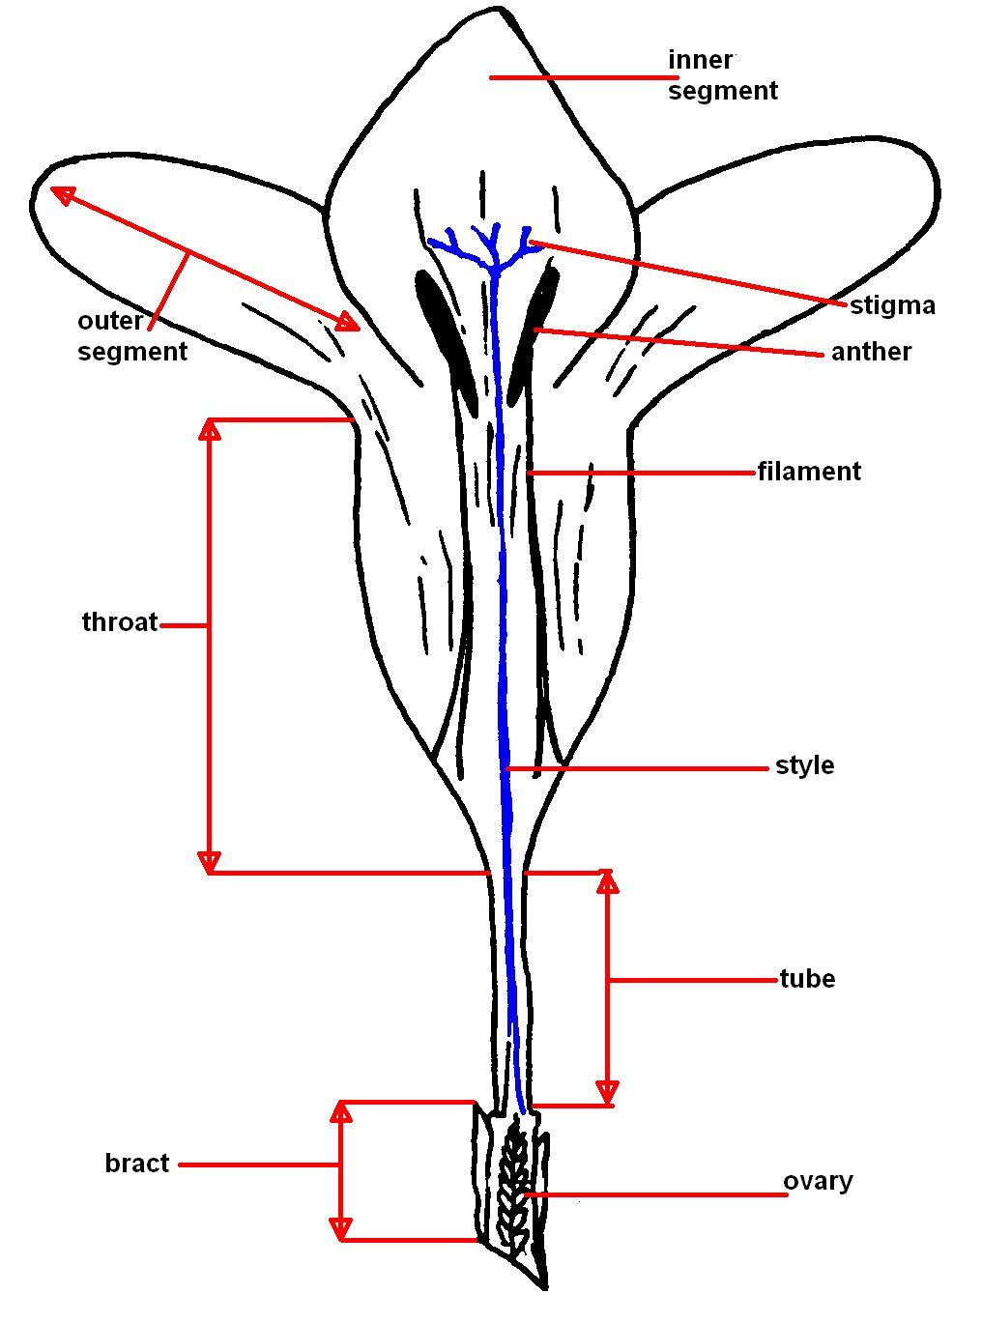

8.2 Explanations for individual characteristics

Ad. 1: Plant: height

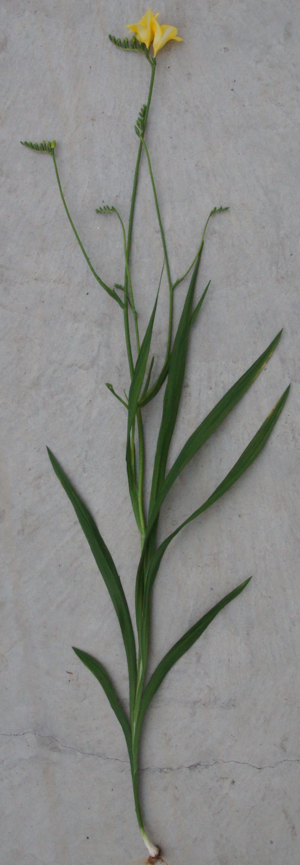
Ad. 6: Peduncle: length
Peduncle length should be observed from the point of attachment of the upper lateral branch to the first flower of the spike

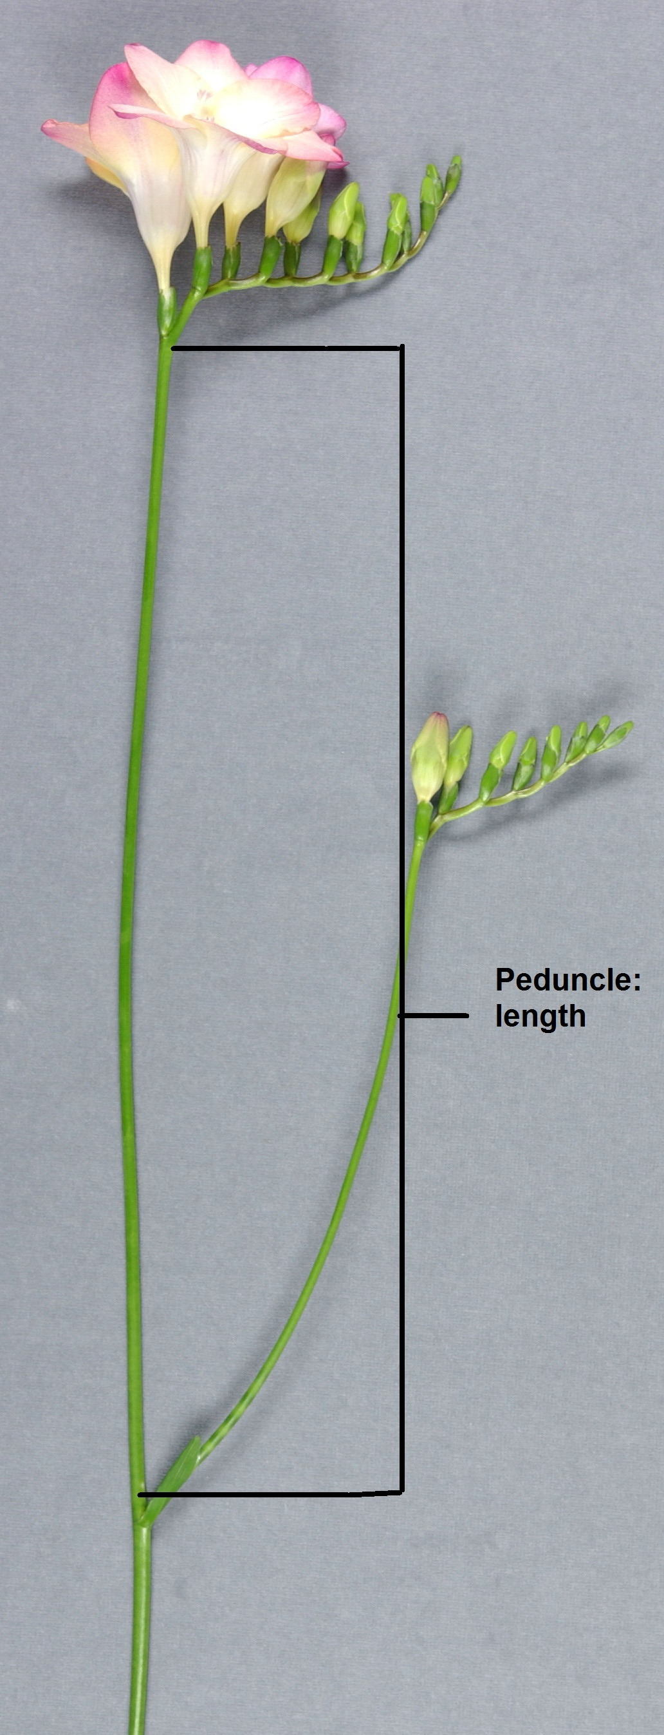

Ad. 7: Peduncle: thickness
Peduncle thickness should be observed at the middle third of the peduncle
Ad. 8: Peduncle: number of branches

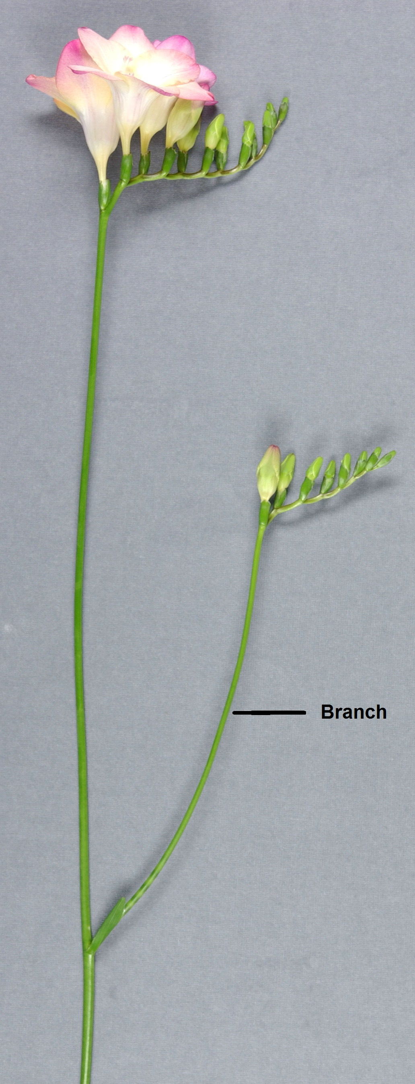

Ad. 10: Spike: angle with peduncle

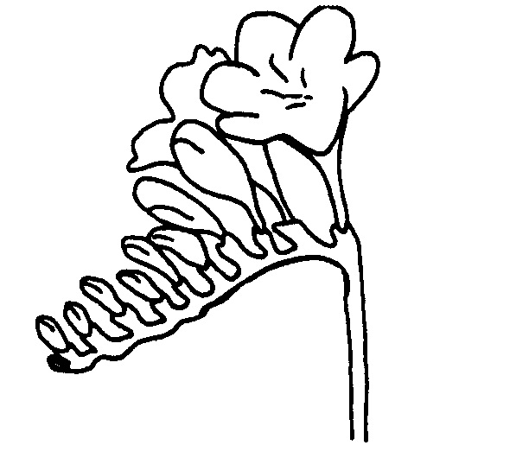
3 - small
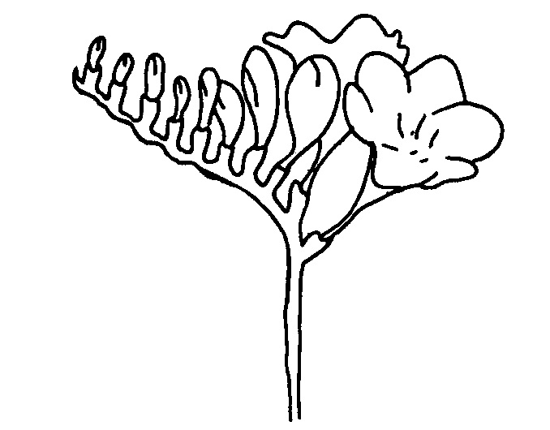
5 - medium
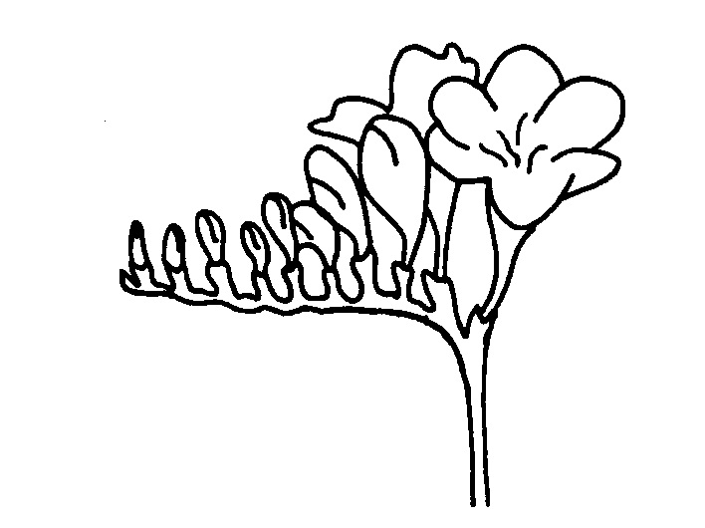
5 - medium

Ad. 11: Spike: length

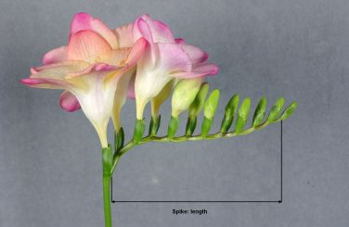

Ad. 13: Spike: length of rachis between first and second flower

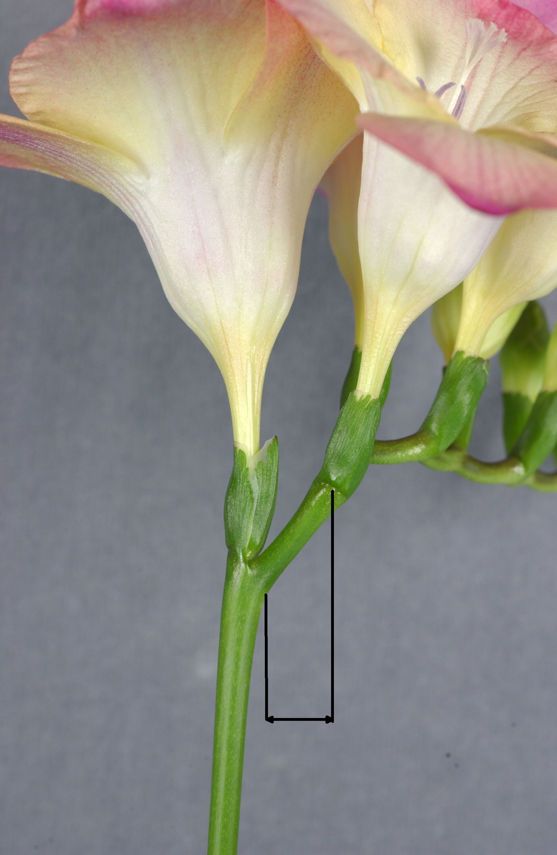

Ad. 14: Spike: length of rachis between second and third flower

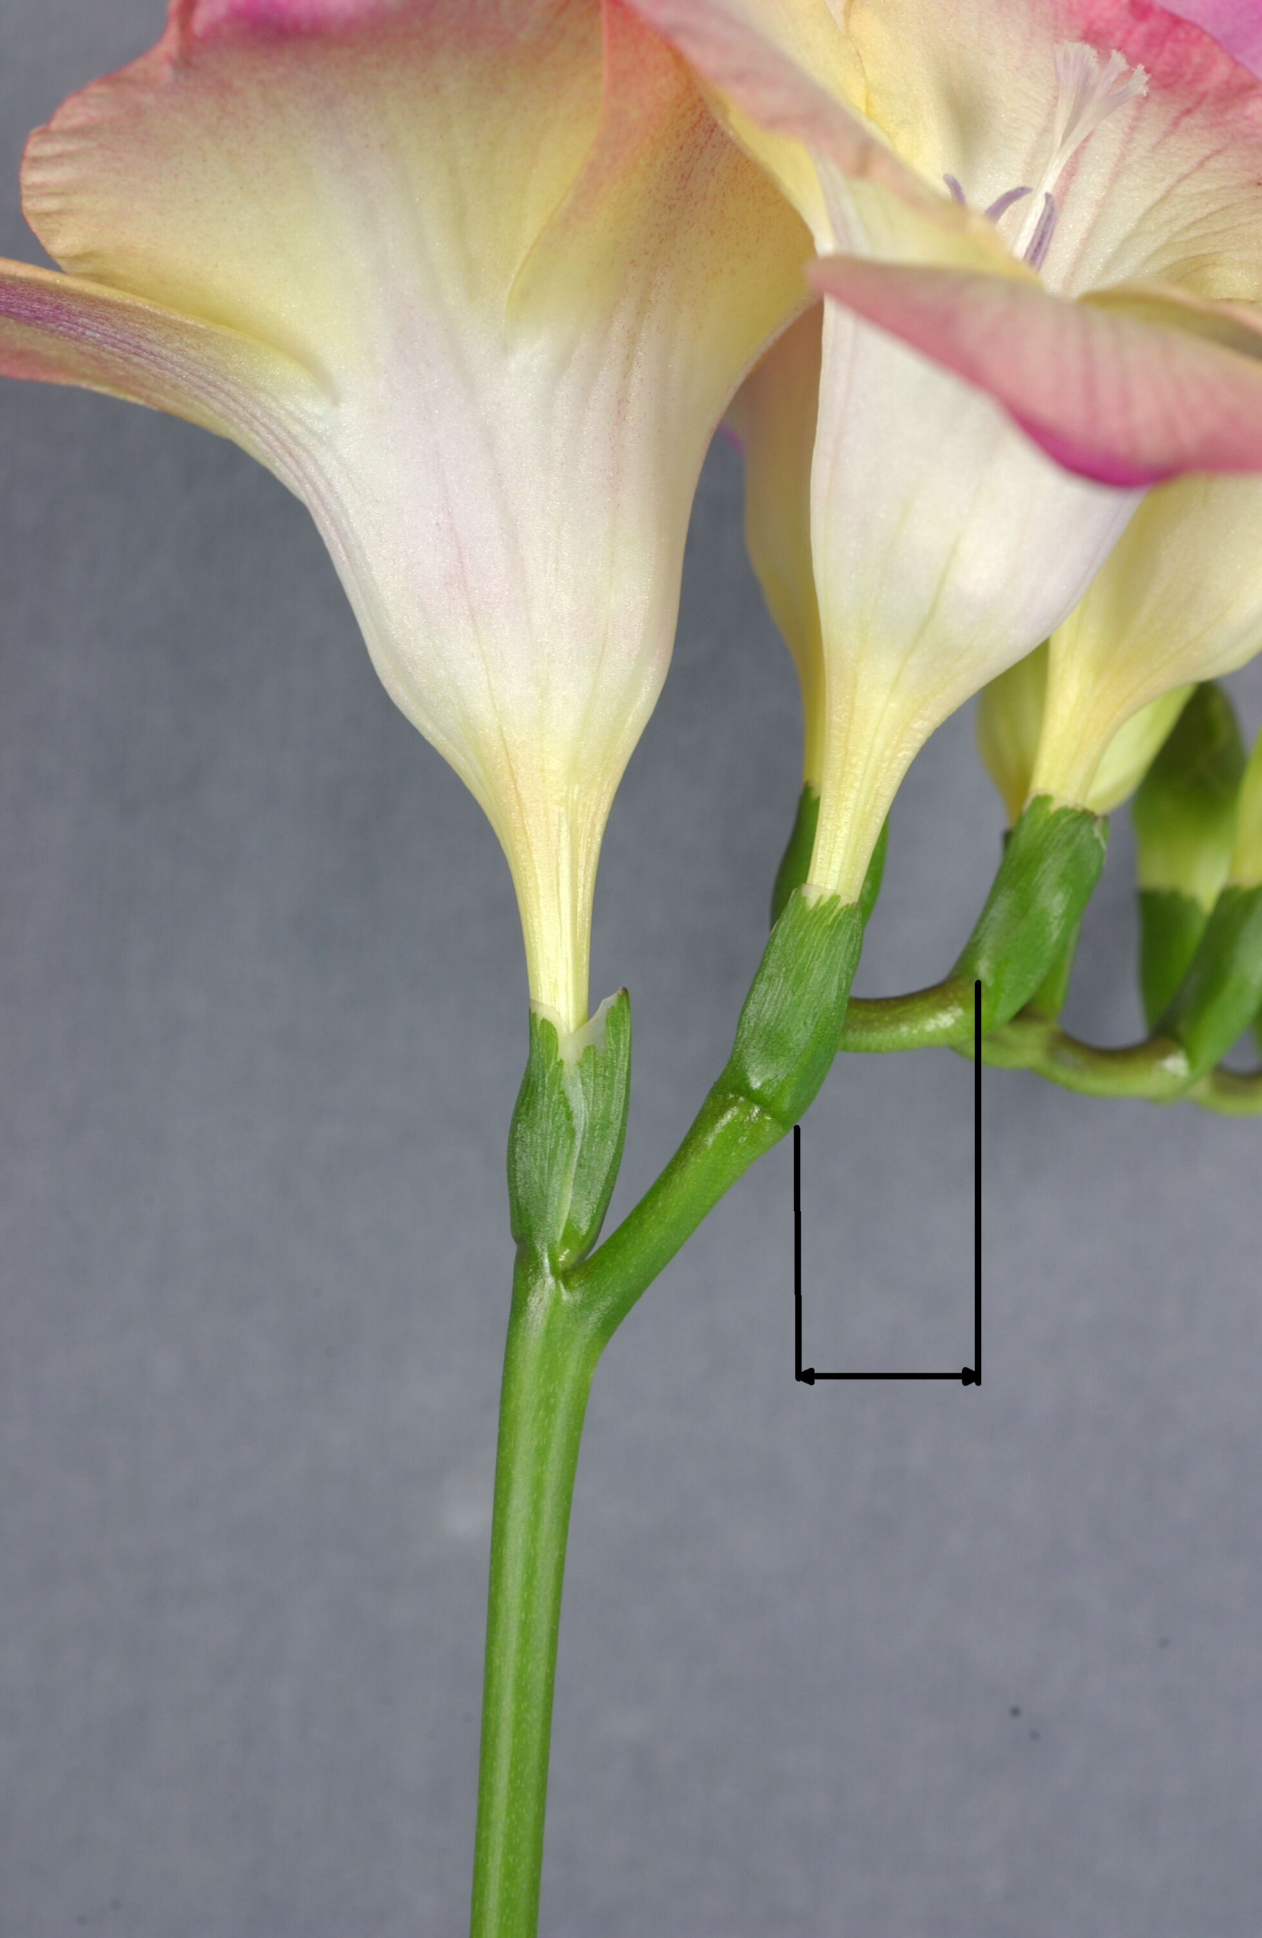

Ad. 15: Spike: zig-zag

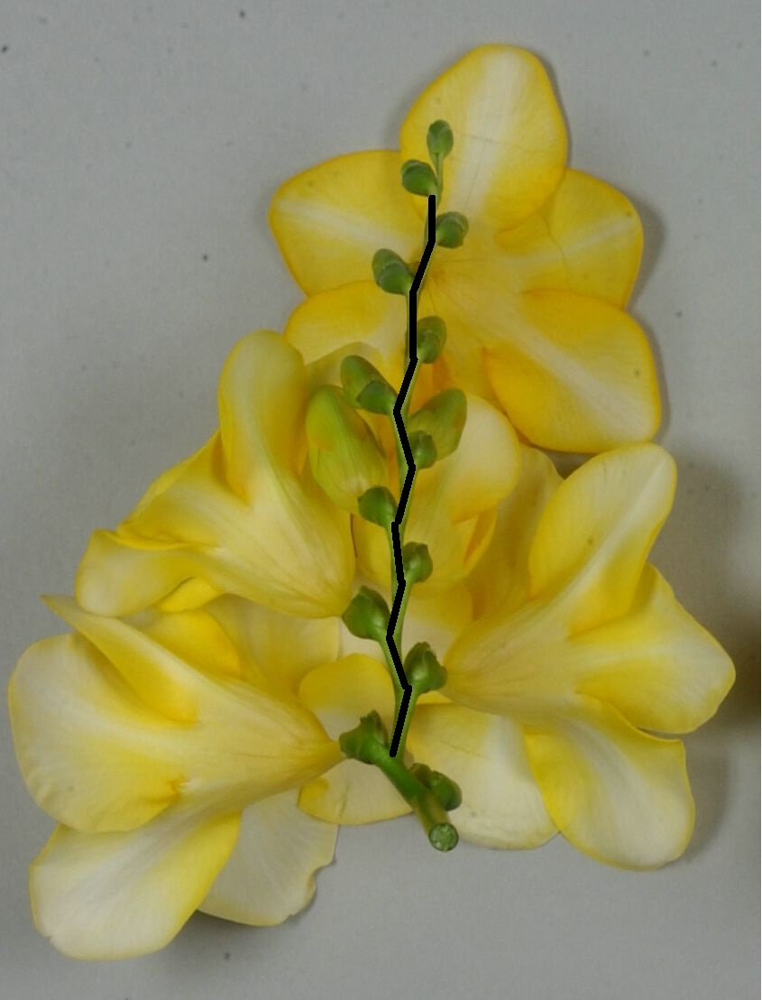
1 - weak
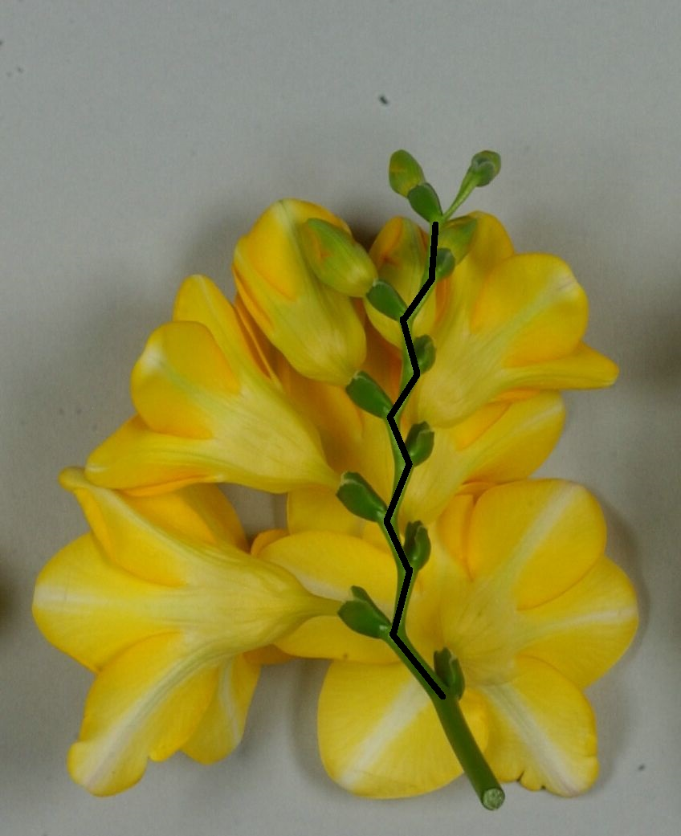
2 - medium
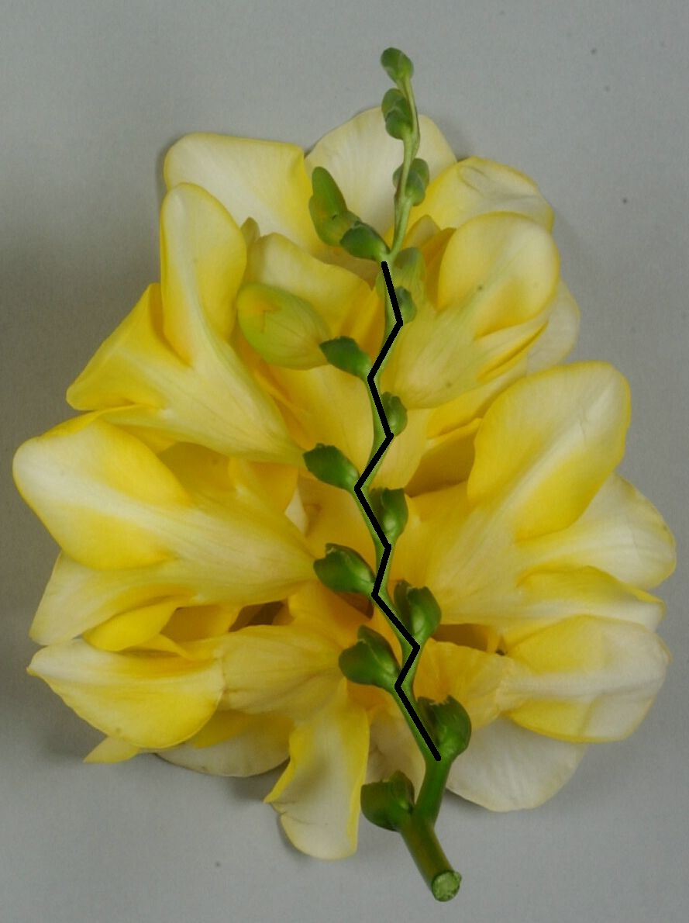
3 - strong

Ad. 16: Spike: curvature at distal part

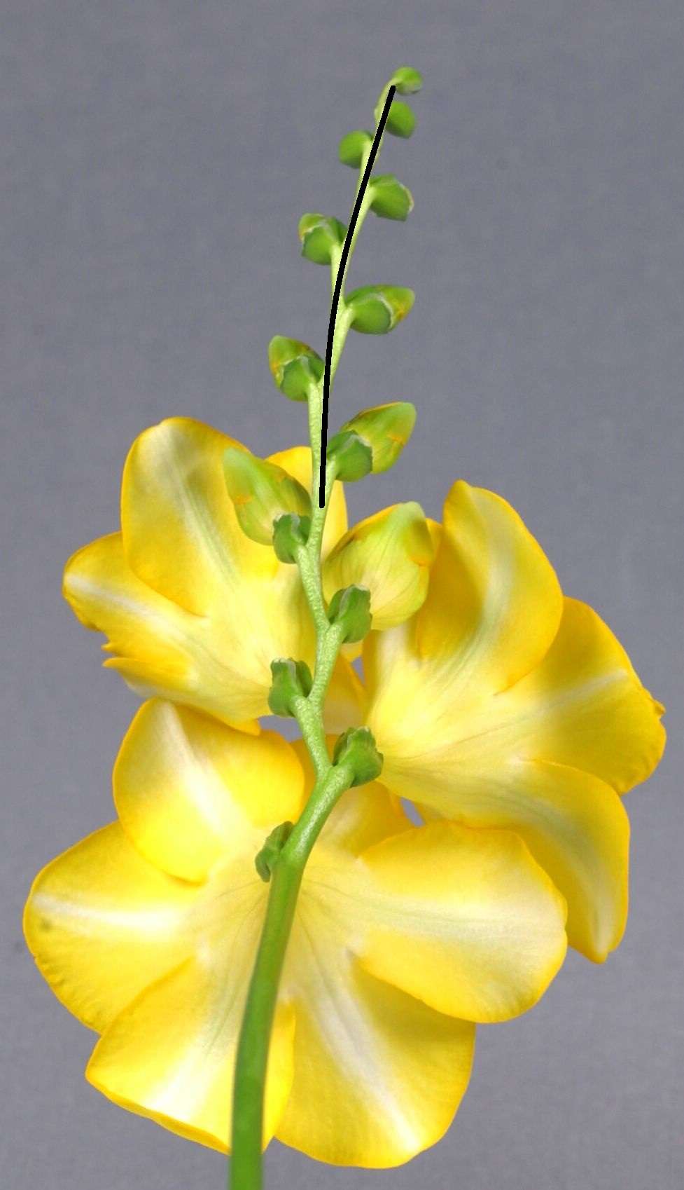
1 - absent or weak
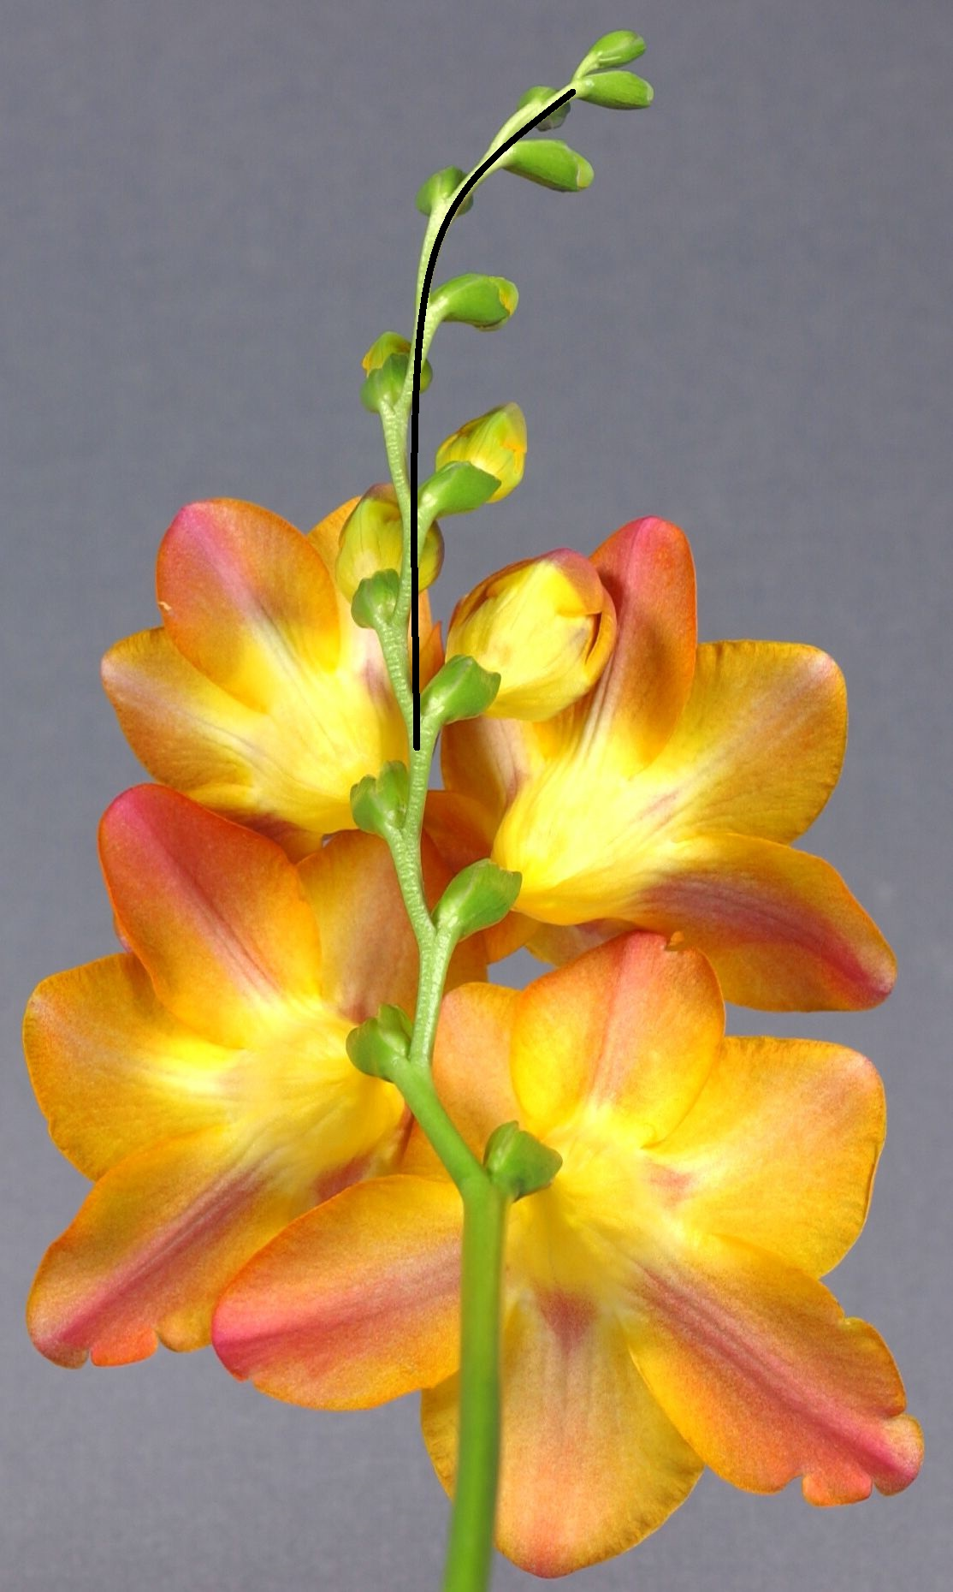
2 - medium
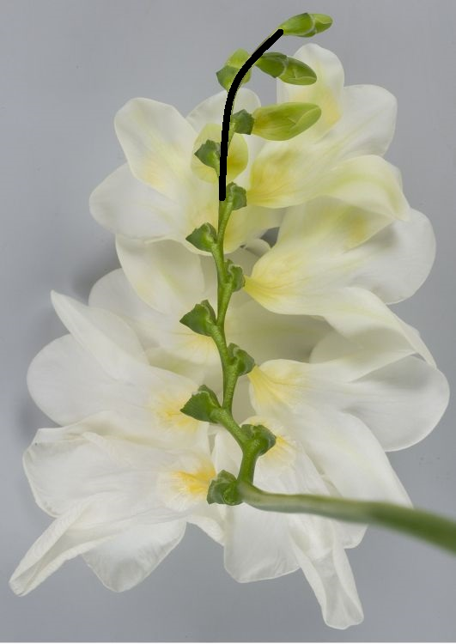
3 - strong

Ad. 17: Spike: angle between the rows of flowers

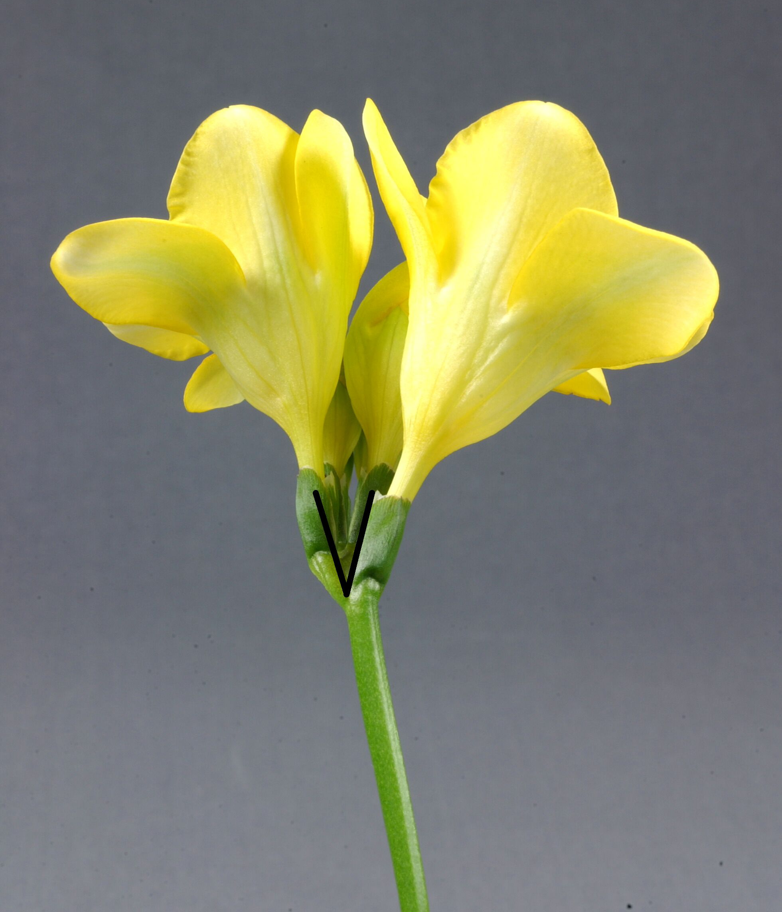
1 - absent or very small
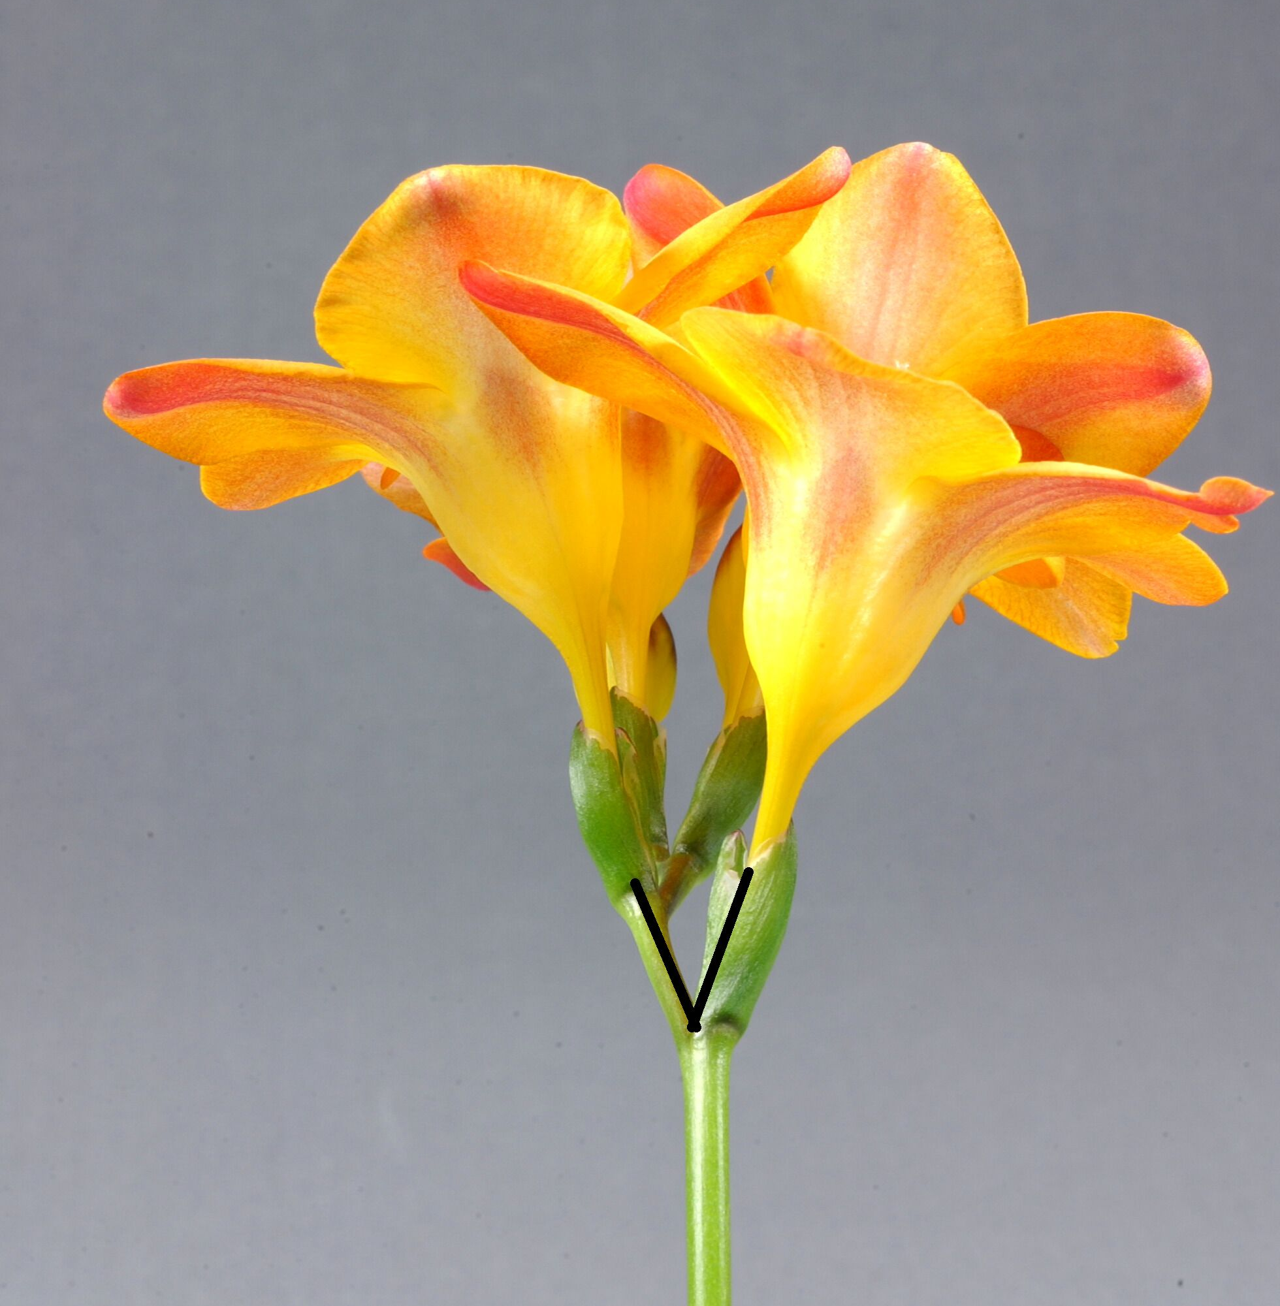
2 - medium
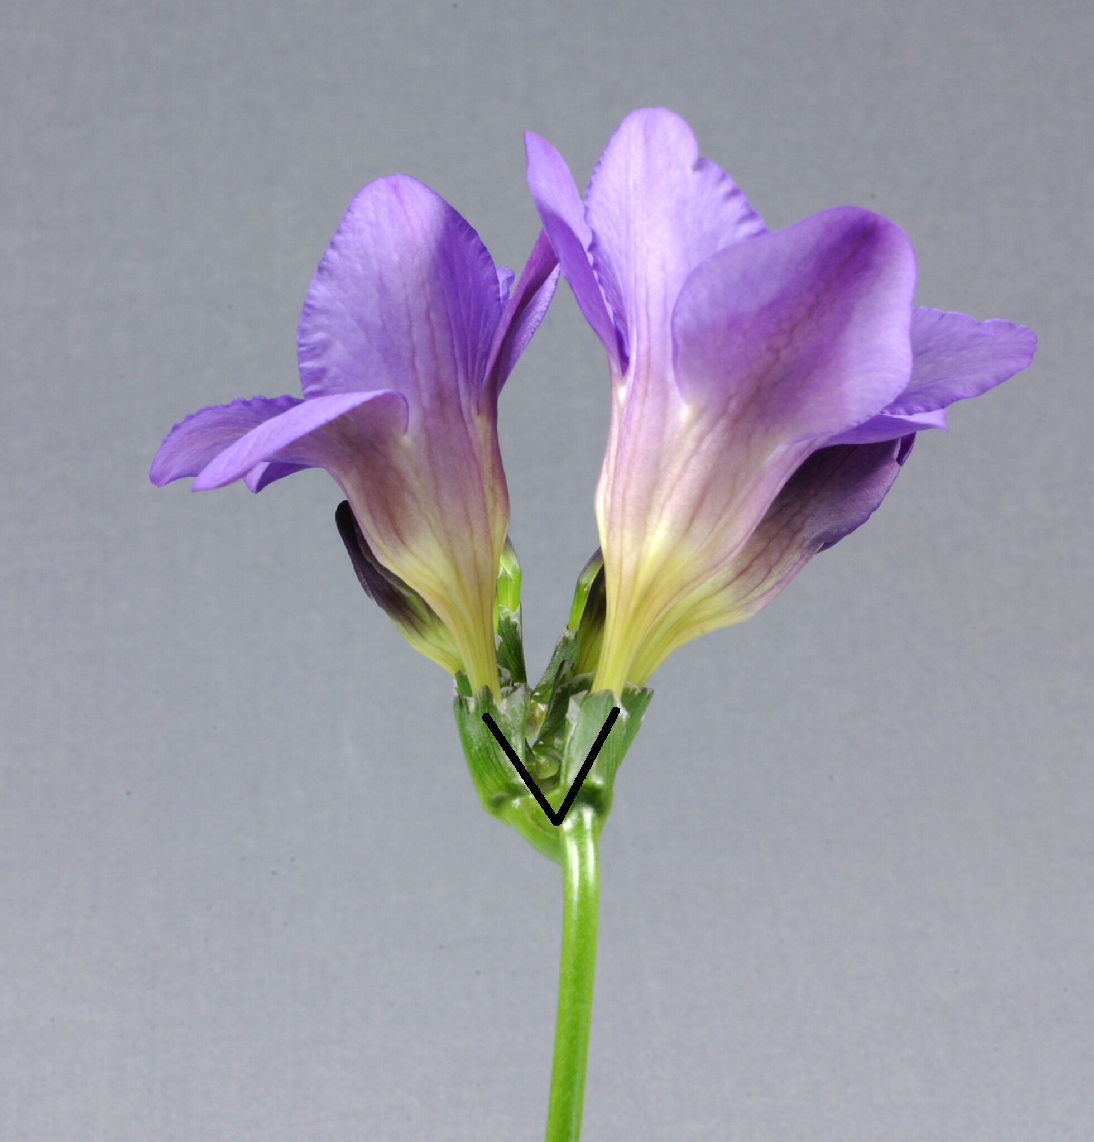
3 - large

Ad. 18: Flower bud: ratio length/width
Observations on bud should be made on the first flower of the main spike just before opening of the bud

Ad. 19: Flower: type
Semi double flowers: flowers where the anthers are transformed into petals and the number of petals is more than 6 but less than 10
Double flowers: flowers where the anthers and spike are transformed into petals and the number of petals is more than 9

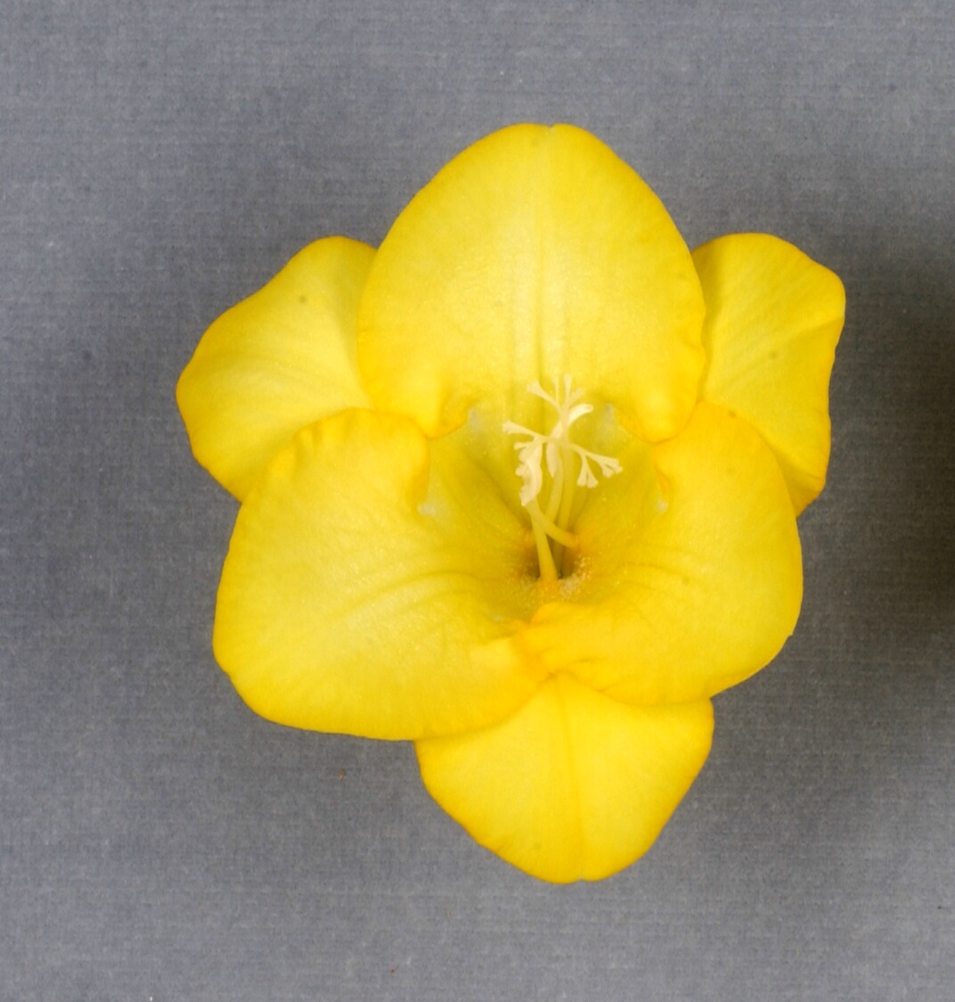
1 - single
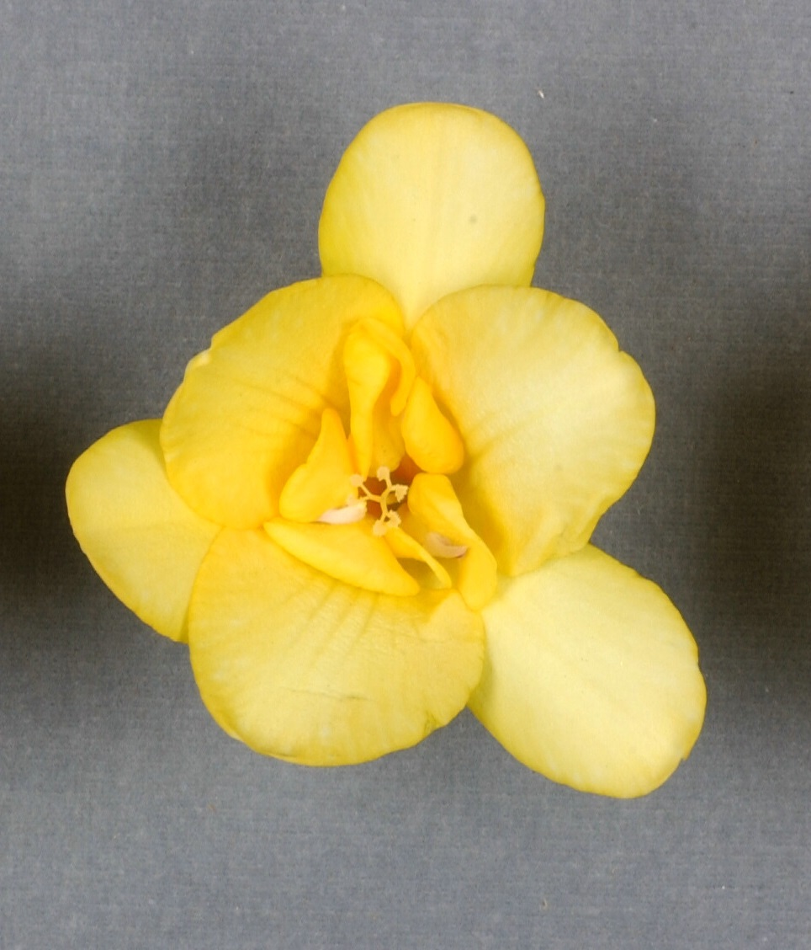
2 - semi double
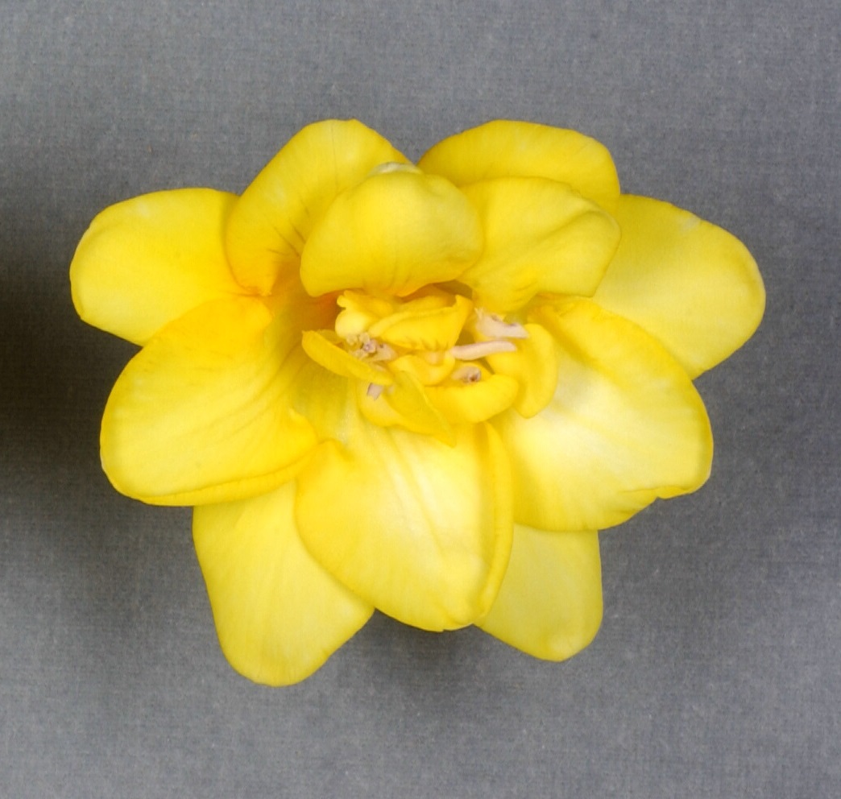
3 - double
Ad. 36: Perianth: pattern of secondary color of outer segment

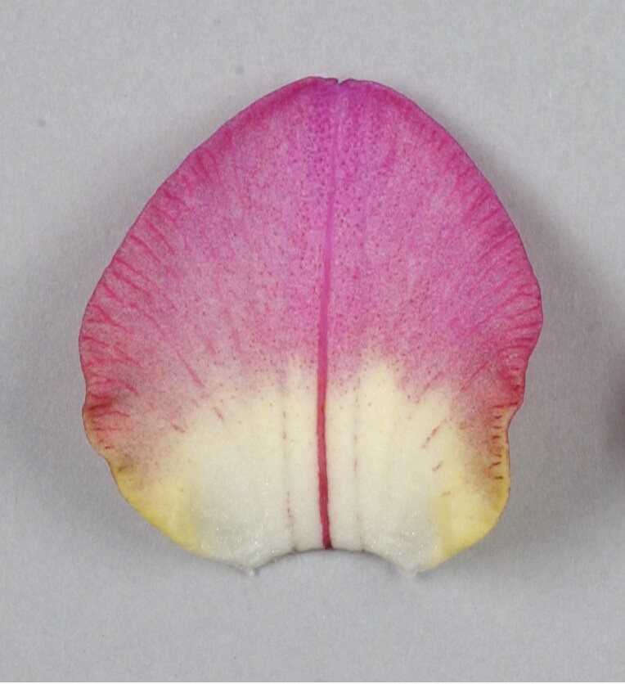
1 - as a macule

Ad. 41: Perianth: attitude of inner segment

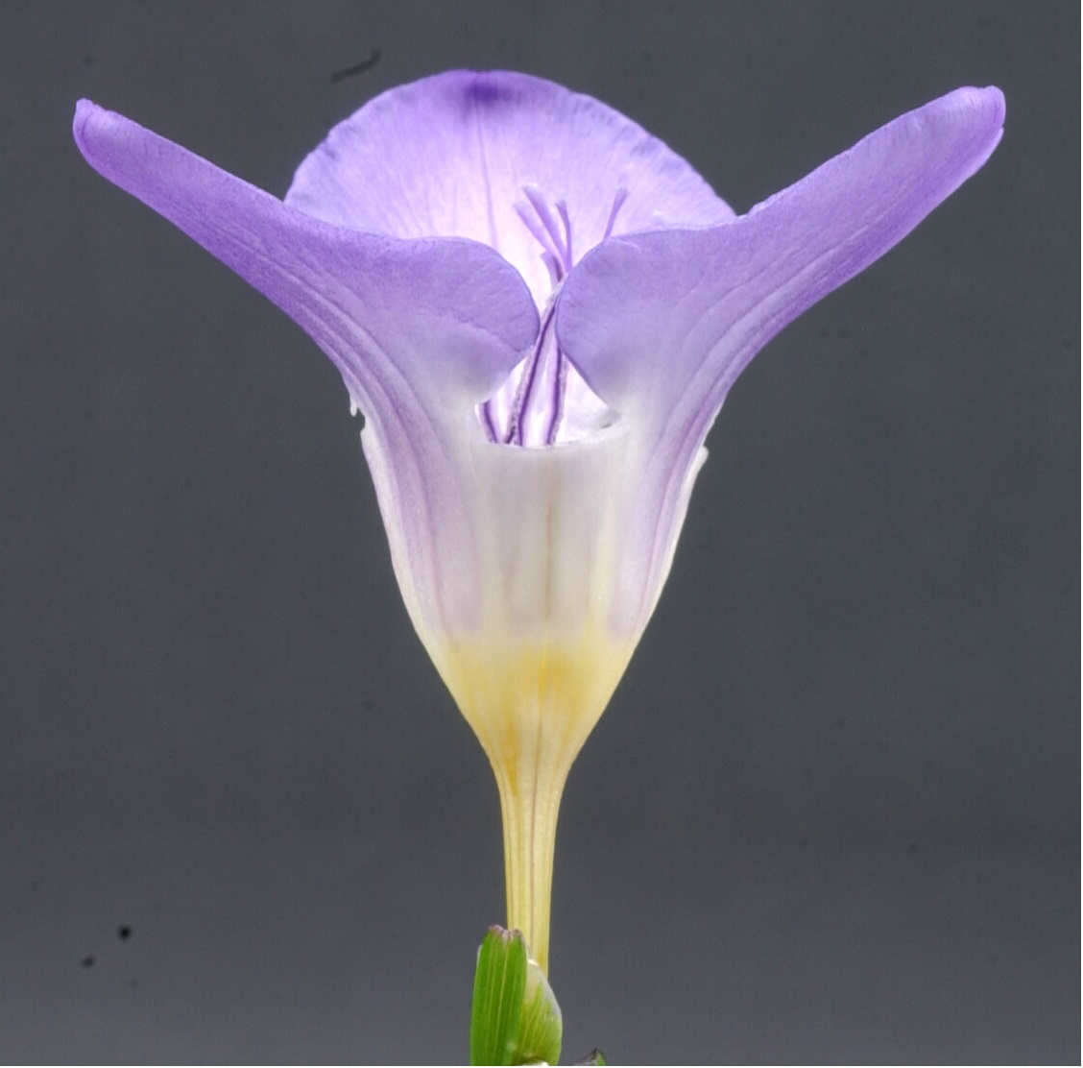
1 - semi-erect
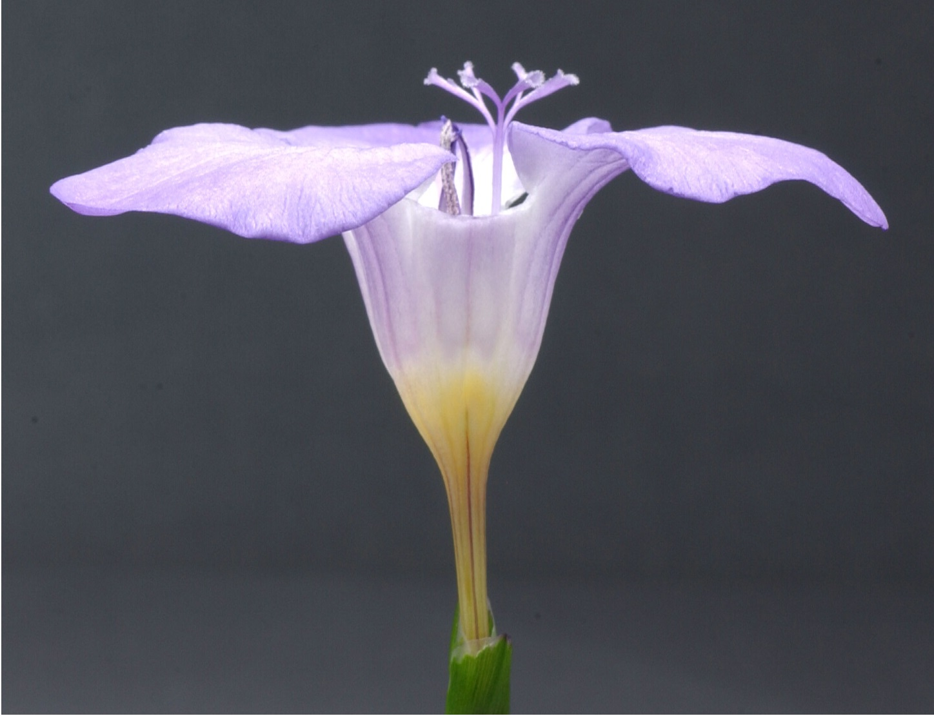
2 - horizontal

Ad. 45: Perianth: size of macule of inner side of inner segment

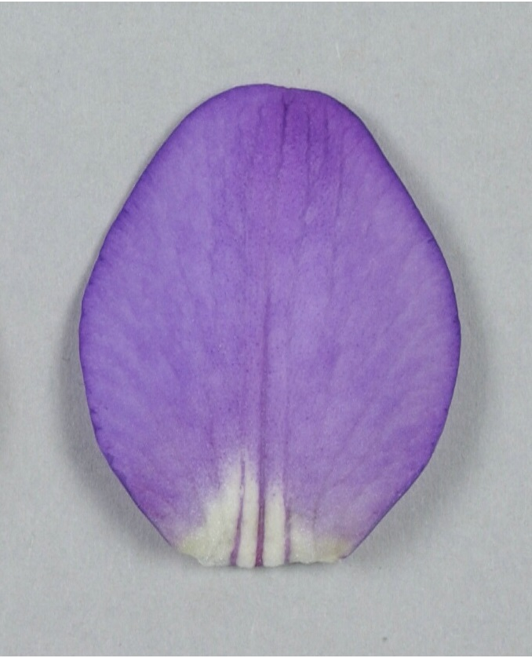
3 - small
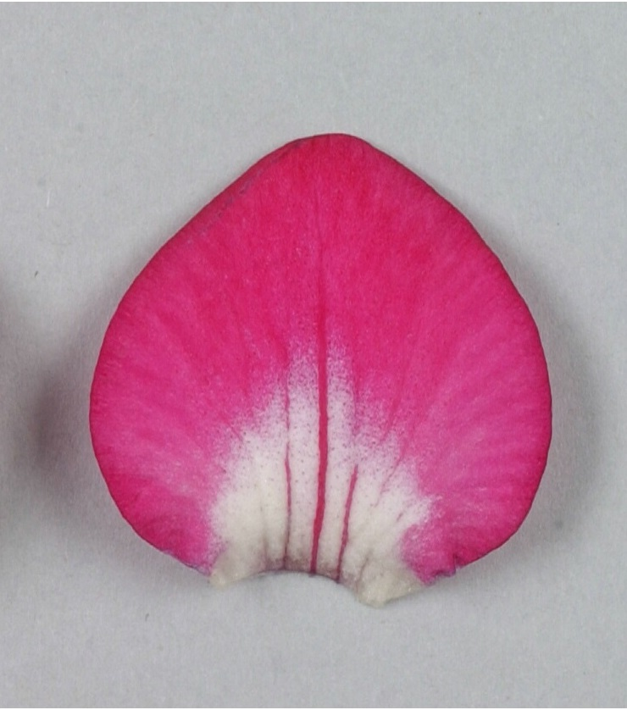
5 - medium
7 - large

Ad. 47: Anther: main color
Observations on the color should be made just before dehiscence of the anther.

Ad. 49: Stigma: position in relation to anthers (before dehiscence)
Observations on the position of the style should be made just before dehiscence of the anthers

Ad. 50: Stigma: length of lobes
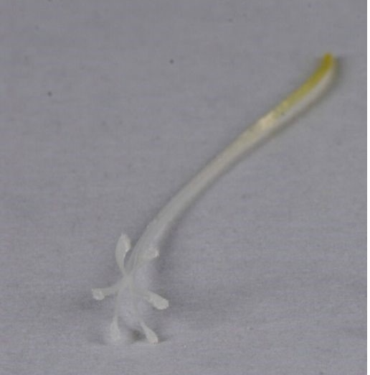
1 - short
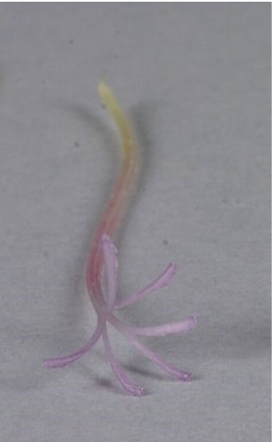
2 - medium
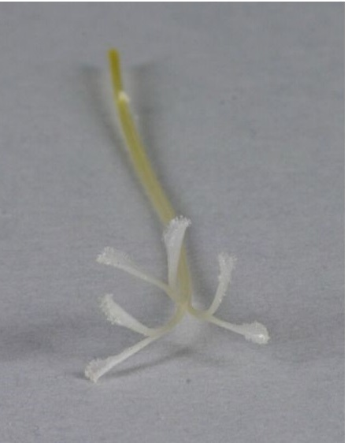
3 - long

Ad. 51: Stigma: appearance of lobes

1 - fine
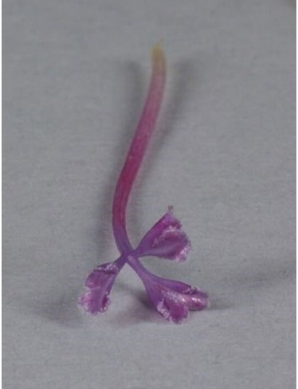
2 - medium
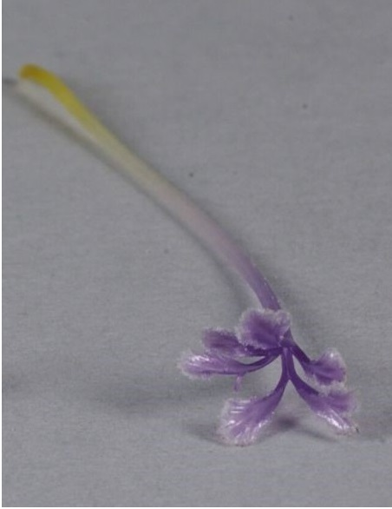
3 - coarse

Ad. 52: Stigma: color in relation upper part of style
observation on color of upper side should be made just before dehiscence of the anthers

Literature

Bryan, John. E., 2002: Bulbs. Timber Press. Portland, Oregon, US, page. 233 to page 235

Synge, Patrick M., 1961: Collins Guide to Bulbs. R & R Clark LTD, Edinburgh, UK, page 126 to page 127

Chittenden, Fred J., 1977: Dictionary of Gardening. Clarendon Press, Oxford, UK, page 836 to page 837

Technical Questionnaire

TECHNICAL QUESTIONNAIRE |  | Page {x} of {y} | Reference Number:
 |  |  | Application date:
 |  |  | (not to be filled in by the applicant)
TECHNICAL QUESTIONNAIRE
to be completed in connection with an application for plant breeders’ rights

1. Subject of the Technical Questionnaire
1.1.1 | Botanical Name | Freesia Eckl. ex Klatt
1.1.2 | Common Name | Freesia

2. Applicant
Name
Address
Telephone No.
Fax No.
E-mail address
Breeder (if different from applicant)
3. Proposed denomination and breeder’s reference
Proposed denomination
(if available)

Breeder’s reference

TECHNICAL QUESTIONNAIRE |  | Page {x} of {y} | Reference Number:
4. Information on the breeding scheme and propagation of the variety

4.1 Breeding scheme

4.2 Method of propagating the variety

4.2.1 Vegetative propagation

(a) tuber [ ]
(b) Other (state method) [ ]
..................................................................................................................................................
: :
: :
:................................................................................................................................................:

4.2.2 Other [ ]

(please provide details)
..................................................................................................................................................
: :
: :
:................................................................................................................................................:

5. Characteristics of the variety to be indicated (the number in brackets refers to the corresponding characteristic in Test Guidelines; please mark the note which best corresponds).

 | Characteristics | Example Varieties | Note
5.1 (1) | Plant: height
 | short | Fragrant Sunburst | 3[ ]
 | medium | Golden Passion | 5[ ]
 | tall | Algarve | 7[ ]
5.2 (11) | Spike: length
 | short |  | 3[ ]
 | medium | Yellow Passion | 5[ ]
 | long | Clementine | 7[ ]
5.3 (19) | Flower: type
 | single | Golden Passion | 1[ ]
 | semi double | Clementine | 2[ ]
 | double | Zafrevil | 3[ ]
5.4 (34) | Perianth: main color of inner side of outer segments
 | RHS colour chart (indicate reference number)
5.5 (42) | Perianth: main color of inner side of inner segment
 | RHS Colour Chart (indicate reference number)
 | white |  | 1[ ]
 | yellow |  | 2[ ]
 | yellow orange |  | 3[ ]
 | orange |  | 4[ ]
 | pink |  | 5[ ]
 | red |  | 6[ ]
 | violet |  | 7[ ]
 | blue violet |  | 8[ ]
 | blue |  | 9[ ]

6. Similar varieties and differences from these varieties

Please use the following table and box for comments to provide information on how your candidate variety differs from the variety (or varieties) which, to the best of your knowledge, is (or are) most similar. This information may help the examination authority to conduct its examination of distinctness in a more efficient way.

Denomination(s) of variety(ies) similar to your candidate variety | Characteristic(s) in which your candidate variety differs from the similar variety(ies) | Describe the expression of the characteristic(s) for the similar variety(ies) | Describe the expression of the characteristic(s) for your candidate variety
Example | Plant: height | short | medium
Comments:

7. Additional information which may help in the examination of the variety

7.1 In addition to the information provided in sections 5 and 6, are there any additional characteristics which may help to distinguish the variety?

Yes [ ] No [ ]

(If yes, please provide details)

7.2 Are there any special conditions for growing the variety or conducting the examination?

Yes [ ] No [ ]

(If yes, please provide details)

7.3 Other information

7.4 A representative color photograph of the variety displaying its main distinguishing feature(s), should accompany the Technical Questionnaire. The photograph will provide a visual illustration of the candidate variety which supplements the information provided in the Technical Questionnaire.

The key points to consider when taking a photograph of the candidate variety are:

- Indication of the date and geographic location
- Correct labeling (breeder’s reference)
- Good quality printed photograph (minimum 10 cm x 15 cm) and/or sufficient resolution electronic format version (minimum 960 x 1280 pixels)

Further guidance on providing photographs with the Technical Questionnaire is available in document TGP/7 “Development of Test Guidelines”, Guidance Note 35 (http://www.upov.int/tgp/en/).

[The link provided may be deleted by members of the Union when developing authorities’ own test guidelines.]

8. Authorization for release

(a) Does the variety require prior authorization for release under legislation concerning the protection of the environment, human and animal health?

Yes [ ] No [ ]

(b) Has such authorization been obtained?

Yes [ ] No [ ]

If the answer to (b) is yes, please attach a copy of the authorization.

TECHNICAL QUESTIONNAIRE | Page {x} of {y} | Reference Number:
9. Information on plant material to be examined or submitted for examination

9.1 The expression of a characteristic or several characteristics of a variety may be affected by factors, such as pests and disease, chemical treatment (e.g. growth retardants or pesticides), effects of tissue culture, different rootstocks, scions taken from different growth phases of a tree, etc.

9.2 The plant material should not have undergone any treatment which would affect the expression of the characteristics of the variety, unless the competent authorities allow or request such treatment. If the plant material has undergone such treatment, full details of the treatment must be given. In this respect, please indicate below, to the best of your knowledge, if the plant material to be examined has been subjected to:

(a) Microorganisms (e.g. virus, bacteria, phytoplasma) Yes [ ] No [ ]

(b) Chemical treatment (e.g. growth retardant, pesticide) Yes [ ] No [ ]

(c) Tissue culture Yes [ ] No [ ]

(d) Other factors Yes [ ] No [ ]

Please provide details for where you have indicated “yes”.

10. I hereby declare that, to the best of my knowledge, the information provided in this form is correct:

Applicant’s name

Signature Date

[End of document]

* These names were correct at the time of the introduction of these Test Guidelines but may be revised or updated. [Readers are advised to consult the UPOV Code, which can be found on the UPOV Website (www.upov.int), for the latest information.]

