E
TWO/47/7
ORIGINAL: English
DATE: May 11, 2014
INTERNATIONAL UNION FOR THE PROTECTION OF NEW VARIETIES OF PLANTS
Geneva
Technical working party for ORNAMENTAL PLANTS AND FOREST TREES
Forty-Seventh Session
Navaisha, Kenya, from May 19 to 23, 2014
Exchangeable software
Document prepared by the Office of the Union
Disclaimer: this document does not represent UPOV policies or guidance
The purpose of this document is to report on developments concerning exchangeable software and a proposal concerning the development of a new information document.

The following abbreviations are used in this document:

CAJ: Administrative and Legal Committee
TC: Technical Committee
TWC: Technical Working Party on Automation and Computer Programs
TWPs: Technical Working Parties

The structure of this document is as follows:

i. new information document 1

II. Review of document UPOV/INF/16 “Exchangeable Software” 3
Software proposed for inclusion in document UPOV/INF/16 “Exchangeable software” 3
SIVAVE software 3
SISNAVA software 3
Information on use by members 3

iII. Translation of SOFTWARE IN document UPOV/INF/16/3 3
AIM software 3
Information System (IS) used for Test and Protection of Plant Varieties in the Russian Federation 3

i. new information document

The CAJ, at its sixty-eighth session, held in Geneva on October 21, 2013, agreed with the conclusions of the TC, at its forty-ninth session, that the title of document UPOV/INF/16 “Exchangeable Software” and the text of Section 1 “Requirements for exchangeable software” should remain unchanged on the basis that the document concerns software that had been developed or customized by a member of the Union for UPOV purposes; and that it would be useful for the TC to seek to develop a separate information document that would allow members of the Union to provide information on the use of non-customized software and equipment (e.g. data loggers) that was used by members of the Union (see document CAJ/68/10 “Report on the Conclusions”, paragraph 30).

The TC at its fiftieth session, held in Geneva, April 7 to 9, 2014, and the CAJ, at its sixty-ninth session, held in Geneva, April 10, 2014, agreed to propose new information document (UPOV/INF/22 “Software and equipment used by members of the Union”) for adoption by the Council at its forty-eighth ordinary session, to be held in Geneva on October 16, 2014, on the following basis (see document TC/50/8, paragraph 6, TC/50/36 “Report on Conclusions”, paragraph 110, and CAJ/69/12 “Report on Conclusions”, paragraph 39).

Title | “Software and equipment used by members of the Union” (document UPOV/INF/22)
1. Requirements | - Members of the Union are invited to provide information on software/equipment for inclusion on the basis that it has been used for the purposes of plant variety protection.  - Information on the following should be provided by any member of the Union proposing software/equipment for inclusion in this document:  Title of software/equipment  Function (brief summary)  Source and contact details  Category(ies) of use (see section 3, below)
2. Procedure for inclusion of software/equipment | 2.1 Software/equipment proposed for inclusion in this document by members of the Union is, in the first instance, presented to the TC.  2.2 The TC will decide whether to:  - propose to include the information in the document;  - request further guidance from other relevant bodies (e.g. CAJ and TWPs); or  - propose not to include the information in the document.  2.3 In the case of a positive recommendation by the TC and, subsequently by the CAJ, the software/equipment will be listed in a draft of the document, to be considered for adoption by the Council.
3. Categories of software/equipment | To assist users, information on software/equipment is provided in the following categories:  Administration of applications  On-line application systems  Variety denomination checking  DUS trial design and data analysis  Data recording and transfer  Image analysis  Biochemical and molecular data
4. Information on use by members of the Union | - A circular is issued to members of the Union on an annual basis, inviting them to provide information on their use of the software/equipment included in this document.  - The information on software/equipment use by members of the Union is indicated in the columns “Member(s) of the Union using the software/equipment” and “Application by user(s)”. With regard to the indication of “Application by user(s)”, members of the Union can indicate, for example, crops or types of crop for which the software/equipment is used.

Subject to adoption of document UPOV/INF/22 by the Council, the Office of the Union will issue a circular to the designated persons of the members of the Union in the TC, inviting them to provide information regarding non-customized software and equipment used by members of the Union for inclusion in the document.

II. Review of document UPOV/INF/16 “Exchangeable Software”

Software proposed for inclusion in document UPOV/INF/16 “Exchangeable software”

SIVAVE software

The TWC, at its thirty-first session, held in Seoul, June 4 to 7, 2013, considered the SIVAVE software proposed by Mexico, which allows for the real-time dissemination of the status of proceedings concerning applications for breeders’ rights. It agreed that the SIVAVE software was suitable for inclusion in document UPOV/INF/16 (see document TWC/31/30, Annex page 7, and TWC/31/32 “Report”, paragraph 72).

The TC, at its fiftieth session, and the CAJ, at its sixty-ninth session, agreed that a draft revision of document UPOV/INF/16/3 concerning the inclusion of the SIVAVE software should be presented for adoption by the Council, at its forty-eighth ordinary session, to be held in Geneva on October 16, 2014 (see document TC/50/36, paragraph 114, and CAJ69/12, paragraph 41 and 42).

SISNAVA software

The TWC, at its thirty-first session, considered the SISNAVA software developed by Mexico, which computes difference in characteristics between varieties. It requested Mexico to provide further information on the SISNAVA software to clarify the method of determination for the crop specific limits of acceptance (sum of differences), including the role of the crop experts in this process, to be presented to the TWC at its thirty-second session (see document TWC/31/30, Annex page 1, and TWC/31/32 “Report”, paragraph 73).

The TC, at its fiftieth session, and the CAJ, at its sixty-ninth session, noted that Mexico had been invited to provide further information on the SISNAVA software at the thirty-second session of the TWC.

Information on use by members

The TC approved the revision of document UPOV/INF/16 concerning the inclusion of information on the use of software by members of the Union to include the information received by the Office of the Union (see document TC/50/36 paragraph 116, and TC/50/8 Annex III).

The CAJ agreed the proposed revision of document UPOV/INF/16 concerning the inclusion of information on the use of software by members of the Union as a basis for its adoption by the Council at its forty-eighth ordinary session, to be held on October 16, 2014 (see document CAJ/69/12 paragraph 44).

iII. Translation of SOFTWARE IN document UPOV/INF/16/3

AIM software

The user interfaces and user manual of the AIM software have been translated into English by the Office of the Union and have been verified by the expert from France. An expert from France will provide a presentation on the AIM software at the thirty-second session of the TWC, to be held in Helsinki, Finland, from June 3 to 6, 2014, based on the screenshots taken from the translated user interfaces and user manual. A complete copy of the user manual is available from the UPOV website at: http://upov.int/meetings/en/details.jsp?meeting_id=31703.

The TC, at its fiftieth session, and the CAJ, at its sixty-ninth session, noted that an expert from France would make a presentation on the AIM software at the thirty-second session of the TWC, based on the English translation of the software requirements (see document TC/50/36 “Report on the Conclusions”, paragraph 118, and CAJ/69/12 “Report on the Conclusions”, paragraph 45)..

Information System (IS) used for Test and Protection of Plant Varieties in the Russian Federation

With regard to the possible translation of the “Information System (IS) used for Test and Protection of Plant Varieties in the Russian Federation”, it was agreed by the CAJ, at its sixty-eighth session, held on October 21, 2013, that the Office of the Union should arrange a telephone meeting in Russian with the IT expert of the Russian Federation in order to clarify translation requirements (see document CAJ/68/10 “Report on the Conclusions”, paragraph 32).

A telephone meeting in Russian with an IT expert of the Russian Federation was organized by the Office of the Union on December 3, 2013, in order to clarify translation requirements for the “Information System (IS) used for Test and Protection of Plant Varieties in the Russian Federation” software. It was concluded from the meeting that the translation of the user interfaces of the software would be technically very difficult as the software is designed only to deal with data written in Russian language and, therefore, it would be necessary to rewrite the entire program of the software in order to create an English version of the user interfaces. It was also reported that a user manual that would be suitable for translation did not exist. However, it was proposed by the IT expert from the Russian Federation that some English screenshots be created for presentation to the TWC, at its thirty-second session, in order to explain how the software works.

The TC, at its fiftieth session, agreed that selected screenshots in English of the software “Information System (IS) used for Test and Protection of Plant Varieties in the Russian Federation” be presented to the TWC at its thirty-second session, in order to explain how the software worked requirements (see document TC/50/36 “Report on the Conclusions”, paragraph 120, and CAJ/69/12 “Report on the Conclusions”, paragraph 46). The selected screenshots in English of the software “Information System (IS) used for Test and Protection of Plant Varieties in the Russian Federation” prepared by an expert from the Russian Federation are attached in the Annex to this document.

The TWO is invited to note that:

(a) document UPOV/INF/22 “Software and equipment used by members of the Union” will be presented for adoption by the Council at its forty-eighth ordinary session, to be held in Geneva on October 16, 2014, as set out in paragraph 5;

(b) subject to adoption of document UPOV/INF/22 by the Council at its forty-eighth ordinary session, a circular will be issued to the designated persons of the members of the Union in the TC, inviting them to provide information regarding non-customized software and equipment used by members of the Union, as appropriate;

(c) a revision of document UPOV/INF/16/3 concerning the inclusion of the SIVAVE software will be presented for adoption by the Council at its forty-eighth ordinary session, to be held on October 16, 2014;

(d) Mexico has been invited to provide further information on the SISNAVA software at the thirty-second session of the TWC;

(e) the TC and CAJ agreed with the proposed revision of document UPOV/INF/16 concerning the inclusion of information on the use of software by members of the Union.

(f) an expert from France will make a presentation on the AIM software at the thirty-second session of the TWC, based on the English translation of the software; and

(g) the explanation of the software “Information System (IS) used for Test and Protection of Plant Varieties in the Russian Federation” is provided in Annex of this document.

[Annex follow]

INFORMATION SYSTEM (IS) USED FOR TEST AND PROTECTION OF SELECTION ACHIEVEMENTS IN THE RUSSIAN FEDERATION
(Information provided by Russian Federation on April 25, 2014)

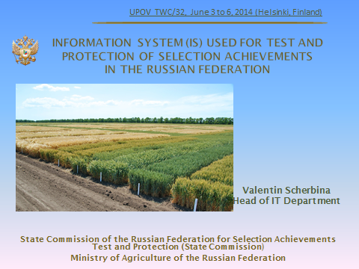

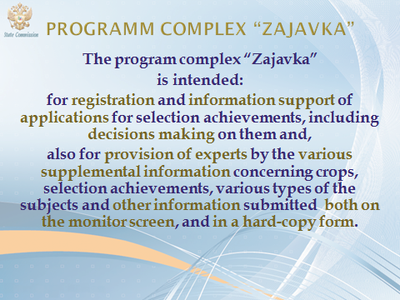

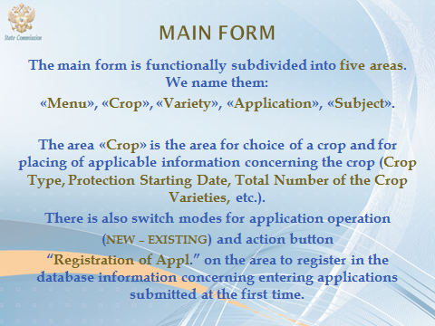

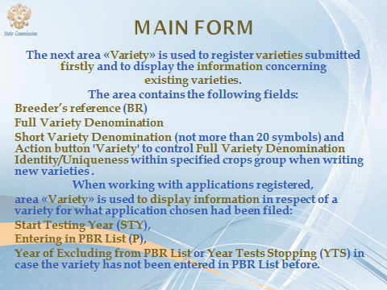

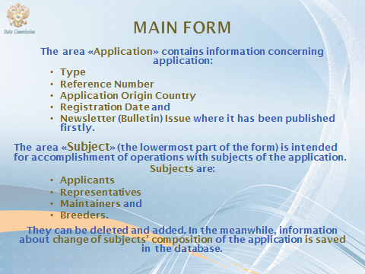

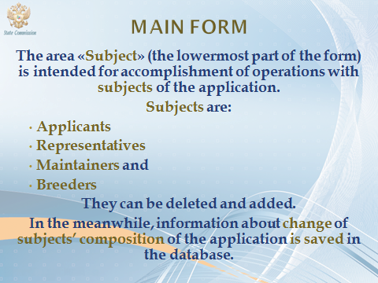

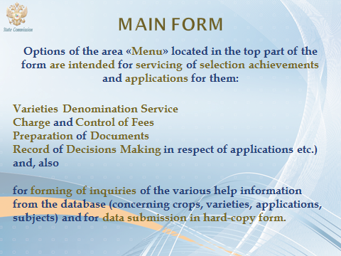

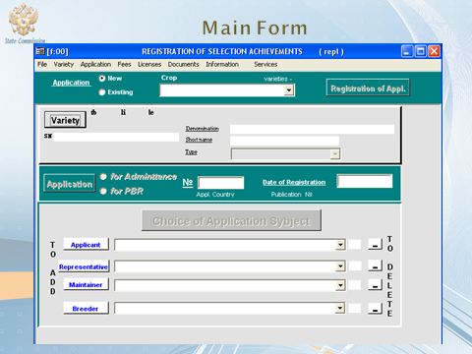

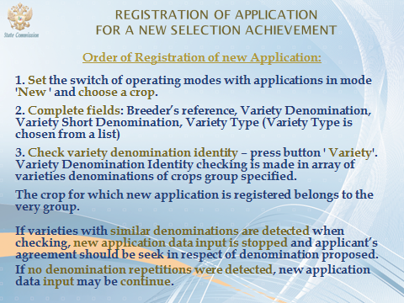

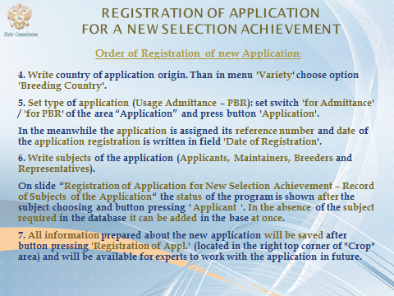

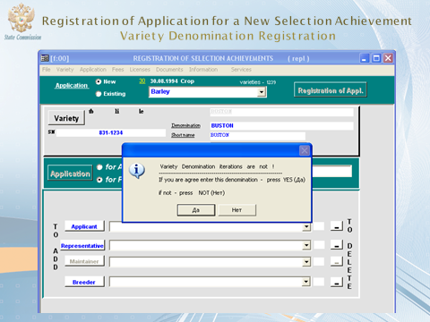

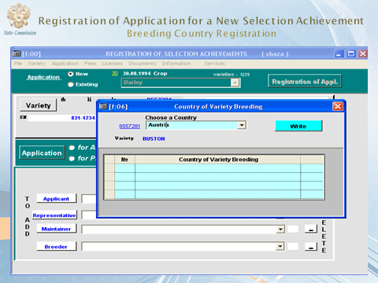

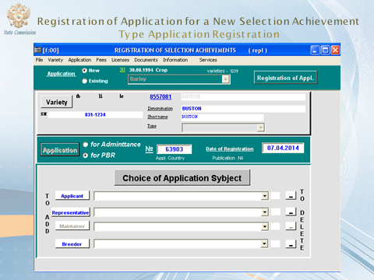

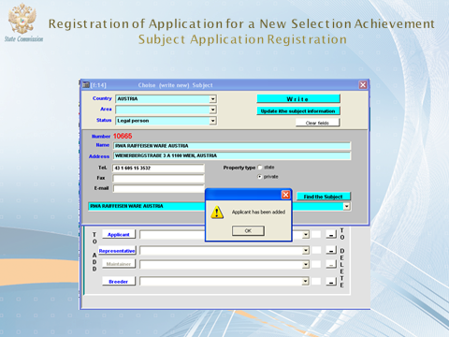

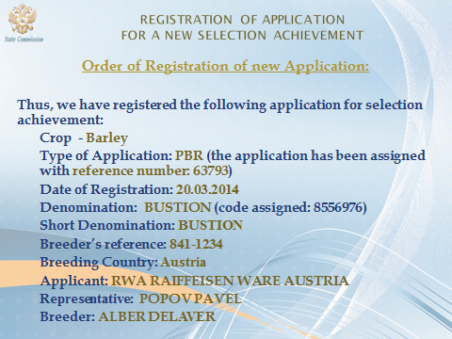

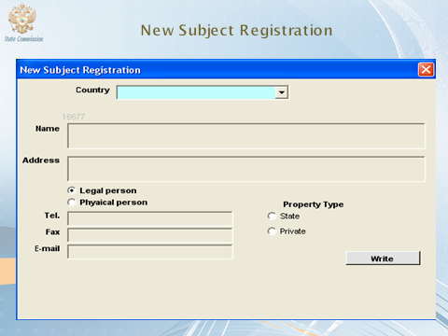

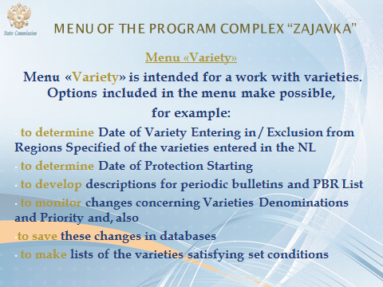

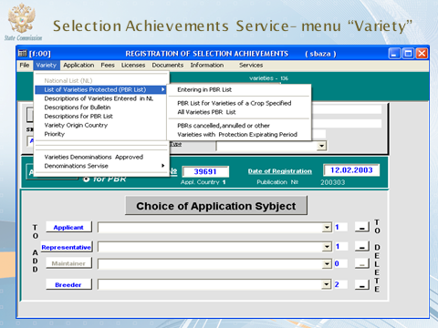

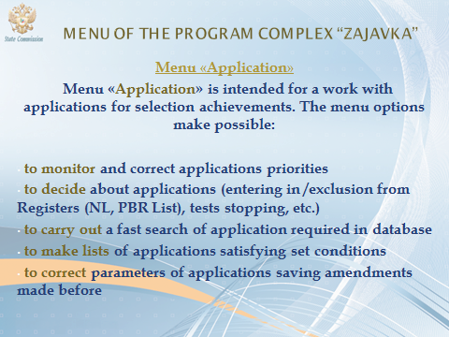

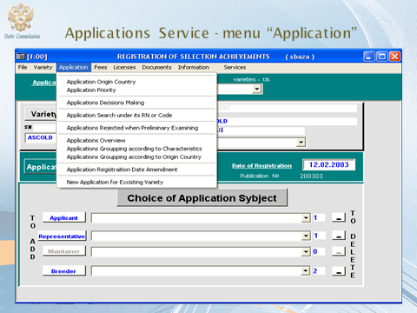

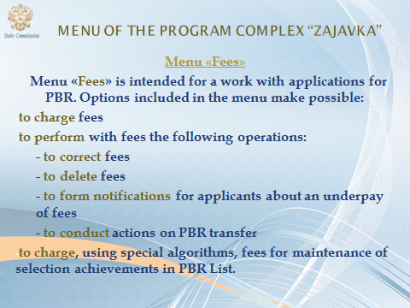

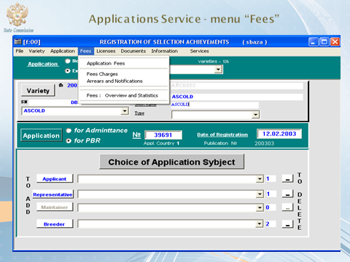

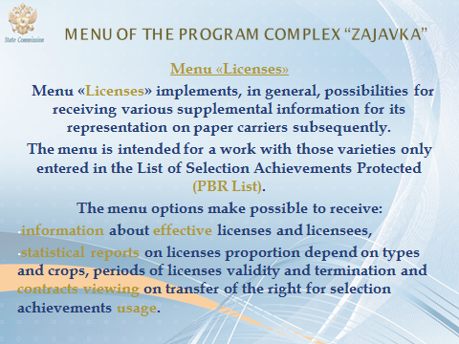

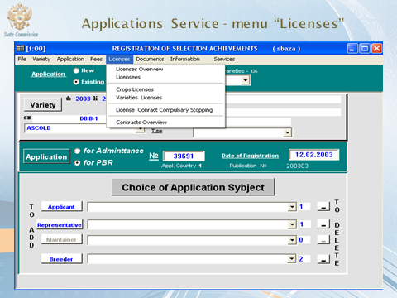

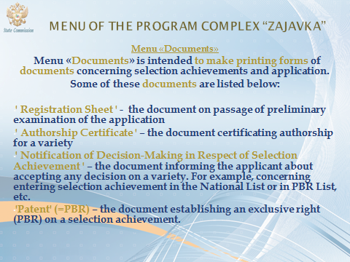

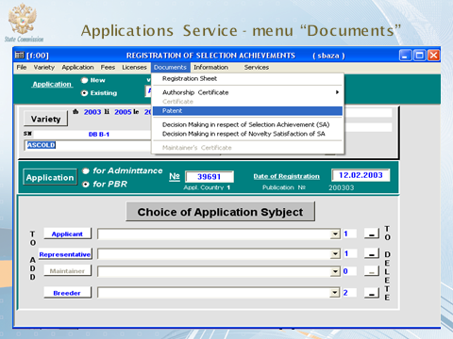

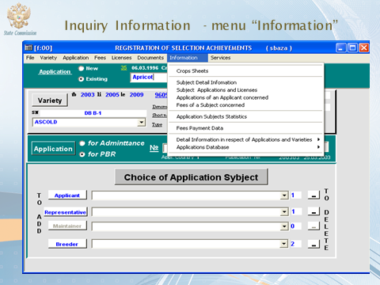

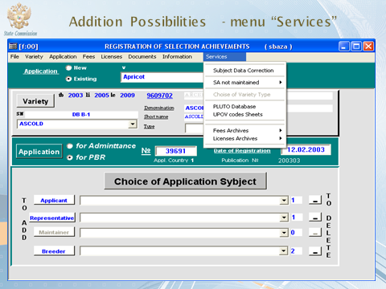

[End of Annex and of document]

