E
TWO/47/25
ORIGINAL: English
DATE: April 23, 2014
INTERNATIONAL UNION FOR THE PROTECTION OF NEW VARIETIES OF PLANTS
Geneva
Technical working party for ORNAMENTAL PLANTS AND FOREST TREES
Forty-Seventh Session
Naivasha, Kenya, May 19 to 23, 2014
partial revision of the test guidelines for buddleja (document tg/263/1)
Document prepared by an expert from France
Disclaimer: this document does not represent UPOV policies or guidance
The purpose of this document is to present the proposals for the partial revision of the Test Guidelines for Buddleja (document TG/263/1).

The following changes are proposed:

- Characteristic 21: “Calyx: length” to be reworded as “Corolla tube: length”;

- To move the reworded Characteristic 21: “Corolla tube: length” after current Characteristic 22: “Calyx: pubescence”;

- To amend Chapter 8.1: “General illustration of flower”.

The proposed revisions are presented in the Annex to this document.

[Annex follows]
Characteristic 21: “Calyx: length”

Current wording:

21. |  | Calyx: length | Calice : longueur | Kelch: Länge | Cáliz: longitud
QN | (c) | short | court | kurz | corta | Huimoon, Morning Mist | 1
 |  | medium | moyen | mittel | media | Masquerade | 2
 |  | long | long | lang | larga | White Ball | 3

Proposed new wording:

21. |  | Corolla tube: length | Tube de la corolle : longueur | Kronröhre: Länge | Tubo de la corolla: longitud
QN | (c) | short | court | kurz | corta | Huimoon, Morning Mist | 1
 |  | medium | moyen | mittel | media | Masquerade | 2
 |  | long | long | lang | larga | White Ball | 3

It is proposed that the amended Characteristic 21 “Corolla tube: length” be placed after the current Characteristic 22: “Calyx: pubescence”.

It is proposed that Chapter 8.1: “General illustration of flower” be amended as follows:

Current illustration:
Corolla lobes
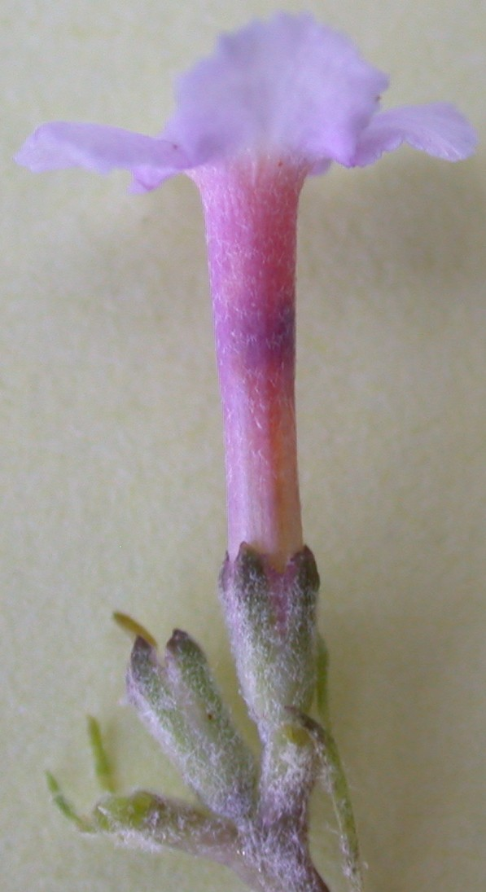

Corolla throat
Calyx

Proposed new illustration:
Corolla lobes
Corolla tube

Calyx
[End of Annex and of document]

