 |  |  | E  TG/ZINNIA(proj.3)  ORIGINAL: English  DATE: 2013-03-13
INTERNATIONAL UNION FOR THE PROTECTION OF NEW VARIETIES OF PLANTS
Geneva
 | DRAFT

 | ZINNIA  UPOV Code: ZINNI  Zinnia L. | *

GUIDELINES
FOR THE CONDUCT OF TESTS
FOR DISTINCTNESS, UNIFORMITY AND STABILITY

prepared by an expert from Mexico

to be considered by the
Technical Working Party for Ornamental Plants and Forest Trees
at its forty-sixth session, to be held in Melbourne, Australia, from April 22 to 26, 2013

Alternative Names:*

Botanical name | English | French | German | Spanish
Zinnia L. | Zinnia | Zinnia | Zinnia | Miguelito, Carolina

The purpose of these guidelines (“Test Guidelines”) is to elaborate the principles contained in the General Introduction (document TG/1/3), and its associated TGP documents, into detailed practical guidance for the harmonized examination of distinctness, uniformity and stability (DUS) and, in particular, to identify appropriate characteristics for the examination of DUS and production of harmonized variety descriptions.

ASSOCIATED DOCUMENTS
These Test Guidelines should be read in conjunction with the General Introduction and its associated TGP documents.
TABLE OF CONTENTS PAGE

1. Subject of these Test Guidelines 3
2. Material Required 3
3. Method of Examination 3
3.1 Number of Growing Cycles 3
3.2 Testing Place 3
3.3 Conditions for Conducting the Examination 3
3.4 Test Design 3
3.5 Additional Tests 4
4. Assessment of Distinctness, Uniformity and Stability 4
4.1 Distinctness 4
4.2 Uniformity 5
4.3 Stability 5
5. Grouping of Varieties and Organization of the Growing Trial 5
6. Introduction to the Table of Characteristics 6
6.1 Categories of Characteristics 6
6.2 States of Expression and Corresponding Notes 6
6.3 Types of Expression 6
6.4 Example Varieties 6
6.5 Legend 7
7. Table of Characteristics/Tableau des caractères/Merkmalstabelle/Tabla de caracteres 8
8. Explanations on the Table of Characteristics 14
8.1 Explanations covering several characteristics 14
8.2 Explanations for individual characteristics 14
9. Literature 18
10. Technical Questionnaire 19

Subject of these Test Guidelines

These Test Guidelines apply to all varieties of Zinnia L.; Zinnia angustifolia Z. haageana, Z. elegans, Z. peruviana and their hybrids.

Material Required

2.1 The competent authorities decide on the quantity and quality of the plant material required for testing the variety and when and where it is to be delivered. Applicants submitting material from a State other than that in which the testing takes place must ensure that all customs formalities and phytosanitary requirements are complied with.

2.2 The material is to be supplied in the form of seeds

2.3 The minimum quantity of plant material, to be supplied by the applicant, should be a sufficient quantity of seeds to produce 10 plants for F1 hybrids and 40 plants for open pollinated varieties.

The seed should meet the minimum requirements for germination, species and analytical purity, health and moisture content, specified by the competent authority. In cases where the seed is to be stored, the germination capacity should be as high as possible and should, be stated by the applicant.

2.4 The plant material supplied should be visibly healthy, not lacking in vigor, nor affected by any important pest or disease.

2.5 The plant material should not have undergone any treatment which would affect the expression of the characteristics of the variety, unless the competent authorities allow or request such treatment. If it has been treated, full details of the treatment must be given.

Method of Examination

3.1 Number of Growing Cycles

The minimum duration of tests should normally be a single growing cycle.

3.2 Testing Place

Tests are normally conducted at one place. In the case of tests conducted at more than one place, guidance is provided in TGP/9 “Examining Distinctness”.

3.3 Conditions for Conducting the Examination

3.3.1 The tests should be carried out under conditions ensuring satisfactory growth for the expression of the relevant characteristics of the variety and for the conduct of the examination.

3.3.2 Because daylight varies, color determinations made against a color chart should be made either in a suitable cabinet providing artificial daylight or in the middle of the day in a room without direct sunlight. The spectral distribution of the illuminant for artificial daylight should conform with the CIE Standard of Preferred Daylight D 6500 and should fall within the tolerances set out in the British Standard 950, Part I. These determinations should be made with the plant part placed against a white background. The color chart and version used should be specified in the variety description.

3.4 Test Design

3.4.1 Each test should be designed to result in a total of at least 10 plants for F1 hybrids and 40 plants for open pollinated varieties

3.4.2 The design of the tests should be such that plants or parts of plants may be removed for measurement or counting without prejudice to the observations which must be made up to the end of the growing cycle.

3.5 Additional Tests

Additional tests, for examining relevant characteristics, may be established.

Assessment of Distinctness, Uniformity and Stability

4.1 Distinctness

4.1.1 General Recommendations

It is of particular importance for users of these Test Guidelines to consult the General Introduction prior to making decisions regarding distinctness. However, the following points are provided for elaboration or emphasis in these Test Guidelines.

4.1.2 Consistent Differences

The differences observed between varieties may be so clear that more than one growing cycle is not necessary. In addition, in some circumstances, the influence of the environment is not such that more than a single growing cycle is required to provide assurance that the differences observed between varieties are sufficiently consistent. One means of ensuring that a difference in a characteristic, observed in a growing trial, is sufficiently consistent is to examine the characteristic in at least two independent growing cycles.

4.1.3 Clear Differences

Determining whether a difference between two varieties is clear depends on many factors, and should consider, in particular, the type of expression of the characteristic being examined, i.e. whether it is expressed in a qualitative, quantitative, or pseudo-qualitative manner. Therefore, it is important that users of these Test Guidelines are familiar with the recommendations contained in the General Introduction prior to making decisions regarding distinctness.

4.1.4 Number of Plants / Parts of Plants to be Examined

Unless otherwise indicated, for the purposes of distinctness, all observations on single plants should be made on 10 plants for F1 hybrids and 40 for open pollinated varieties or parts taken from each of { x } plants and any other observations made on all plants in the test, disregarding any off-type plants.

4.1.5 Method of Observation

The recommended method of observing the characteristic for the purposes of distinctness is indicated by the following key in the second column of the Table of Characteristics (see document TGP/9 “Examining Distinctness”, Section 4 “Observation of characteristics”):

MG: single measurement of a group of plants or parts of plants
MS: measurement of a number of individual plants or parts of plants
VG: visual assessment by a single observation of a group of plants or parts of plants
VS: visual assessment by observation of individual plants or parts of plants

Type of observation: visual (V) or measurement (M)

“Visual” observation (V) is an observation made on the basis of the expert’s judgment. For the purposes of this document, “visual” observation refers to the sensory observations of the experts and, therefore, also includes smell, taste and touch. Visual observation includes observations where the expert uses reference points (e.g. diagrams, example varieties, side-by-side comparison) or non-linear charts (e.g. color charts). Measurement (M) is an objective observation against a calibrated, linear scale e.g. using a ruler, weighing scales, colorimeter, dates, counts, etc.

Type of record: for a group of plants (G) or for single, individual plants (S)

For the purposes of distinctness, observations may be recorded as a single record for a group of plants or parts of plants (G), or may be recorded as records for a number of single, individual plants or parts of plants (S). In most cases, “G” provides a single record per variety and it is not possible or necessary to apply statistical methods in a plant-by-plant analysis for the assessment of distinctness.

In cases where more than one method of observing the characteristic is indicated in the Table of Characteristics (e.g. VG/MG), guidance on selecting an appropriate method is provided in document TGP/9, Section 4.2.

4.2 Uniformity

4.2.1 It is of particular importance for users of these Test Guidelines to consult the General Introduction prior to making decisions regarding uniformity. However, the following points are provided for elaboration or emphasis in these Test Guidelines:

4.2.2 The assessment of uniformity for seed-propagated varieties should be according to the recommendations for cross-pollinated and hybrid varieties as appropriate, in the General Introduction.

4.2.3 For the assessment of uniformity, a population standard of 1% and an acceptance probability of at least 95% should be applied. In the case of a sample size of 10 plants, 1 off-type is allowed; for open pollinated varieties in a sample size of 40 plants, 2 off-types are allowed.

4.3 Stability

4.3.1 In practice, it is not usual to perform tests of stability that produce results as certain as those of the testing of distinctness and uniformity. However, experience has demonstrated that, for many types of variety, when a variety has been shown to be uniform, it can also be considered to be stable.

4.3.2 Where appropriate, or in cases of doubt, stability may be further examined by testing a new seed stock to ensure that it exhibits the same characteristics as those shown by the initial material supplied.

Grouping of Varieties and Organization of the Growing Trial

5.1 The selection of varieties of common knowledge to be grown in the trial with the candidate varieties and the way in which these varieties are divided into groups to facilitate the assessment of distinctness are aided by the use of grouping characteristics.

5.2 Grouping characteristics are those in which the documented states of expression, even where produced at different locations, can be used, either individually or in combination with other such characteristics: (a) to select varieties of common knowledge that can be excluded from the growing trial used for examination of distinctness; and (b) to organize the growing trial so that similar varieties are grouped together.

5.3 The following have been agreed as useful grouping characteristics:

(a) Plant: growth habit (characteristic 1)
(b) Plant: height (characteristic 2)
(c) Flower head: type (characteristic 15)
(d) Ray floret: main color of inner side (characteristic 24) with the following groups:
Gr. 1: white
Gr. 2: green
Gr. 3: yellow
Gr. 4: orange
Gr. 5: pink
Gr. 6: red

5.4 Guidance for the use of grouping characteristics, in the process of examining distinctness, is provided through the General Introduction and document TGP/9 “Examining Distinctness”.

Introduction to the Table of Characteristics

6.1 Categories of Characteristics

6.1.1 Standard Test Guidelines Characteristics

Standard Test Guidelines characteristics are those which are approved by UPOV for examination of DUS and from which members of the Union can select those suitable for their particular circumstances.

6.1.2 Asterisked Characteristics

Asterisked characteristics (denoted by *) are those included in the Test Guidelines which are important for the international harmonization of variety descriptions and should always be examined for DUS and included in the variety description by all members of the Union, except when the state of expression of a preceding characteristic or regional environmental conditions render this inappropriate.

6.2 States of Expression and Corresponding Notes

6.2.1 States of expression are given for each characteristic to define the characteristic and to harmonize descriptions. Each state of expression is allocated a corresponding numerical note for ease of recording of data and for the production and exchange of the description.

6.2.2 In the case of qualitative and pseudo-qualitative characteristics (see Chapter 6.3), all relevant states of expression are presented in the characteristic. However, in the case of quantitative characteristics with 5 or more states, an abbreviated scale may be used to minimize the size of the Table of Characteristics. For example, in the case of a quantitative characteristic with 9 states, the presentation of states of expression in the Test Guidelines may be abbreviated as follows:

State | Note
small | 3
medium | 5
large | 7

However, it should be noted that all of the following 9 states of expression exist to describe varieties and should be used as appropriate:

State | Note
very small | 1
very small to small | 2
small | 3
small to medium | 4
medium | 5
medium to large | 6
large | 7
large to very large | 8
very large | 9

6.2.3 Further explanation of the presentation of states of expression and notes is provided in document TGP/7 “Development of Test Guidelines”.

6.3 Types of Expression

An explanation of the types of expression of characteristics (qualitative, quantitative and pseudo-qualitative) is provided in the General Introduction.

6.4 Example Varieties

Where appropriate, example varieties are provided to clarify the states of expression of each characteristic.

6.5 Legend

(*) Asterisked characteristic – see Chapter 6.1.2

QL Qualitative characteristic – see Chapter 6.3
QN Quantitative characteristic – see Chapter 6.3
PQ Pseudo-qualitative characteristic – see Chapter 6.3

MG, MS, VG, VS – see Chapter 4.1.5

(a)-(e) See Explanations on the Table of Characteristics in Chapter 8.1

(+) See Explanations on the Table of Characteristics in Chapter 8.2.

Table of Characteristics/Tableau des caractères/Merkmalstabelle/Tabla de caracteres

 |  | English | français | deutsch | español | Example Varieties  Exemples  Beispielssorten  Variedades ejemplo | Note/  Nota
1.  (*)  (+) | VG | Plant: growth habit | Plante : port | Pflanze: Wuchsform | Planta: porte
PQ |  | upright | dressé | aufrecht | erecto | Peppermint | 1
 |  | semi-upright | demi –dressé | halbaufrecht | semierecto | Profusion | 2
 |  | spreading | étalé | breitwüchsig | abierto | Solecito | 3
2.  (*) | VG/  MS/  MG | Plant: height | Plante : hauteur | Pflanze: Höhe | Planta: altura
QN |  | short | basse | niedrig | pequeña | Peppermint | 3
 |  | medium | moyenne | mittel | media | Witworna | 5
 |  | tall | haute | hoch | grande | Inca | 7
3.  (*)  (+) | VG | Plant: branching | Plante : ramification | Pflanze: Verzweigung | Planta: ramificación
QN |  | absent or weak | absente ou faible | fehlend oder gering | ausente o débil | Witworna | 1
 |  | medium | moyenne | mittel | media | Peppermint | 2
 |  | strong | forte | stark | fuerte | Profusion | 3
4.  (*) | VG | Stem: anthocyanin coloration | Tige : pigmentation anthocyanique | Stiel: Anthocyanfärbung fehlendvorhanden | Tallo: pigmentación antociánica
QN |  | absent or very weak |  |  | ausente o muy débil | Dreamland | 1
 |  | weak |  |  | débil | Lilliput | 3
 |  | medium |  |  | medio | Profusion | 5
 |  | strong |  |  | fuerte | Arcos | 7
5.  (*)  (+) | VG | Stem: density of pubescence |  |  | Tallo: densidad de pubescencia
QN |  | sparse |  |  | escaza | Zestr | 3
 |  | medium |  |  | media | Uproar | 5
 |  | dense |  |  | densa | Short Stuff | 7
6. | VG | Leaf: position of broadest part |  |  | Hoja: posición de la parte mas ancha
PQ |  | basal |  |  | basal |  | 3
 |  | middle |  |  | media |  | 5
 |  | distal |  |  | distal |  | 7
7.  (*) | VG/ MS | Leaf: length | Feuille : longueur | Blatt: Länge | Hoja: longitud
QN |  | short | courte | kurz | corta |  | 3
 |  | medium | moyenne | mittel | media |  | 5
 |  | long | longue | lang | larga |  | 7
8.  (*) | VG/ MS | Leaf: width | Feuille : larger | Blatt: Breite | Hoja: anchura
QN |  | narrow | étroite | schmal | estrecha |  | 3
 |  | medium | moyenne | mittel | media |  | 5
 |  | broad | large | breit | ancha |  | 7
9.  (*)  (+) | VG | Leaf: length/width ratio |  |  | Hoja: relación longitud/anchura
QN |  | low |  |  | baja |  | 3
 |  | medium |  |  | media |  | 5
 |  | high |  |  | alta |  | 7
10.  (*)  (+) | VG | Leaf: profile in cross section |  |  | Hoja: perfil en sección transversal
QN |  | flat |  |  | plano |  | 1
 |  | moderately concave |  |  | moderadamente cóncavo |  | 2
 |  | strongly concave |  |  | fuertemente cóncavo |  | 3
11.  (+) | VG | Leaf: undulation |  |  | Hoja: ondulación
QN |  | absent or weak |  |  | ausente o débil |  | 1
 |  | medium |  |  | medio |  | 2
 |  | strong |  |  | fuerte |  | 3
12. | VG | Leaf: intensity ofgreen color | Feuille: intensité de la couleur | Blatt: Intensität der Grünfärbung | Hoja: intensidad del color verde
QN |  | light | verte |  | claro |  | 3
 |  | medium | verte claire | hell | medio |  | 5
 |  | dark | moyenne | mittel | oscuro |  | 7
13.  (*)  (+) | VG | Leaf: anthocyanin coloration at base |  |  | Hoja: coloración antociánica en la base
QN |  | absent or weak |  |  | ausente o débil |  | 1
 |  | medium |  |  | medio |  | 2
 |  | strong |  |  | fuerte |  | 3
14.  (+) | VG/ MS | Flower head: peduncle length |  |  | Capítulo: longitud del pedúnculo
QN |  | short |  |  | corto | Zahara | 3
 |  | medium |  |  | medio | Wytworna | 5
 |  | long |  |  | largo | Uproar | 7
15.  (*)  (+) | VG | Flower head: type |  |  | Capítulo: tipo
PQ |  | single |  |  | sencillo | Star | 1
 |  | semi double |  |  | semi doble | Zowie | 2
 |  | double |  |  | doble | Lilliput | 3
16. | VG | Only varieties with double flower head type: density of ray florets |  |  | Únicamente variedades con capítulo doble: densidad de las lígulas
QN |  | sparse |  |  | baja | Thumbelina | 3
 |  | medium |  |  | media | Short Stuff | 5
 |  | dense |  |  | alta | Uproar | 7
17. | VG/ MS | Flower head: diameter | Capitule: diamètre | Blütenstand: Durchmesser | Capítulo: diámetro
QN |  | small | petit | klein | pequeño | Lilliput | 3
 |  | medium | moyen | mittel | medio | Oklahoma | 5
 |  | large | grand | groß | grande | Inca | 7
18. | VG | Flower head: height |  |  | Capítulo: altura
QN |  | short |  |  | corto |  | 3
 |  | medium |  |  | medio |  | 5
 |  | tall |  |  | alto |  | 7
19.  (*) | VG | Ray floret: length |  |  | Flor ligulada: longitud
QN |  | short |  |  | corta |  | 3
 |  | medium |  |  | media |  | 5
 |  | long |  |  | larga |  | 7
20.  (*) | VG | Ray floret: width |  |  | Flor ligulada: amplitud
QN |  | narrow |  |  | estrecha |  | 3
 |  | medium |  |  | media |  | 5
 |  | broad |  |  | ancha |  | 7
21.  (*) | VG | Ray floret: length/width ratio |  |  | Flor ligulada: relación largo/ancho
QN |  | low |  |  | baja |  | 3
 |  | medium |  |  | media |  | 5
 |  | high |  |  | alta |  | 7
22.  (+) | VG | Ray floret: profile in cross section |  |  | Flor ligulada: perfil en sección transversal
QN |  | convex |  |  | convexo |  | 3
 |  | flat |  |  | plano |  | 5
 |  | concave |  |  | cóncavo |  | 7
23.  (*)  (+) | VG | Ray floret: shape of apex |  |  | Flor ligulada: forma del ápice
PQ |  | truncate |  |  | truncado |  | 1
 |  | rounded |  |  | redondo |  | 2
 |  | mucronate |  |  | mucronado |  | 3
 |  | emarginated |  |  | emarginado |  | 4
24.  (*) | VG | Ray floret: main color of inner side |  |  | Flor ligulada: color principal del lado interno
PQ |  | RHS Colour Chart (indicate reference number) | Code RHS des couleurs (indiquer le numéro de référence) | RHS-Farbkarte (Nummer angeben) | Code RHS des couleurs (indiquer le numéro de référence)
25.  (*) | VG | Ray floret: only varieties with two colors: secondary color of inner side |  |  | Flor ligulada: únicamente variedades con dos colores: color secundario del lado interno
PQ |  | RHS Colour Chart (indicate reference number) | Code RHS des couleurs (indiquer le numéro de référence) | RHS-Farbkarte (Nummer angeben) | Code RHS des couleurs (indiquer le numéro de référence)
26.  (*)  (+) | VG | Ray floret: Only varieties with two colors: distribution of secondary color of inner side |  |  | Flor ligulada: únicamente variedades con dos colores: distribución del color secundario del lado interno
PQ |  | lower side |  |  | parte basal | Zahara | 1
 |  | upper side |  |  | parte superior | Zwizzle | 2
 |  | blotched |  |  | manchado |  | 3
 |  | striped |  |  | rayado | Peppermint | 4
27.  (*) | VG | Ray floret: only varieties with more than two colors: tertiary color of inner side |  |  | Flor ligulada: únicamente variedades con más de dos colores: color terciario del lado interno
PQ |  | RHS Colour Chart (indicate reference number) | Code RHS des couleurs (indiquer le numéro de référence) | RHS-Farbkarte (Nummer angeben) | Code RHS des couleurs (indiquer le numéro de référence)
28.  (*) | VG | Ray floret: only varieties with more than two colors: distribution of tertiary color of inner side |  |  | Flor ligulada: solo variedades con más de dos colores: distribución del color terciario del lado interno
PQ |  | lower side |  |  | parte basal
 |  | upper side |  |  | parte superior
 |  | blotched |  |  | manchado
 |  | striped |  |  | rayado | Zowie
29. | VG | Flower head: color of disc |  |  | Capítulo: color del disco
PQ |  | RHS Colour Chart (indicate reference number) | Code RHS des couleurs (indiquer le numéro de référence) | RHS-Farbkarte (Nummer angeben) | Code RHS des couleurs (indiquer le numéro de référence)

Explanations on the Table of Characteristics

  - Explanations covering several characteristics

Unless otherwise indicated, all characteristics should be examined at the time of full flowering.

Characteristics containing the following key in the second column of the Table of Characteristics should be examined as indicated below:

- Leaf characteristics are recorded on typical leaves taken from the middle third of the stem, and are recorded on the whole leaf, looking at the upper surface.

- Single flower head: has only one row of ray florets. Semi double flower head: has more than one rows of ray florets and a visible flower head disc. Double flower head: has no flower head disc.

- Ray floret length and width characteristics should be observed on the outermost row of ray florets.

- In all but single flowered varieties, all ray floret characteristics, other than length and width characteristics (see note (b)), should be observed on the most typical florets, excluding the innermost and outermost rows, unless otherwise stated.

- The main color is the color with the largest total surface area; the secondary color (if present) is the color with the second largest total surface area; the tertiary color (if present) is that with the third largest total surface. In the case that none of the colors is clearly predominant then the darkest color will be the main color.

  - Explanations for individual characteristics

Ad. 1: Plant: growth habit

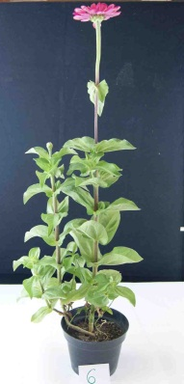 | 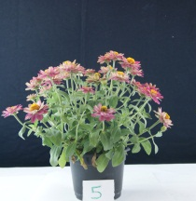 | 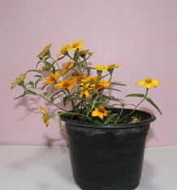
1 | 2 | 3
upright | semi-upright | spreading

Ad. 3: Plant: branching

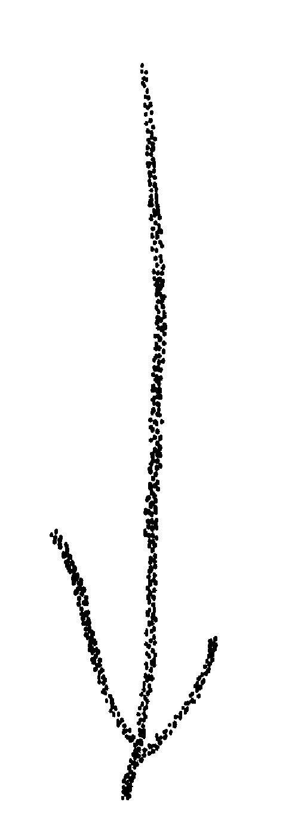 | 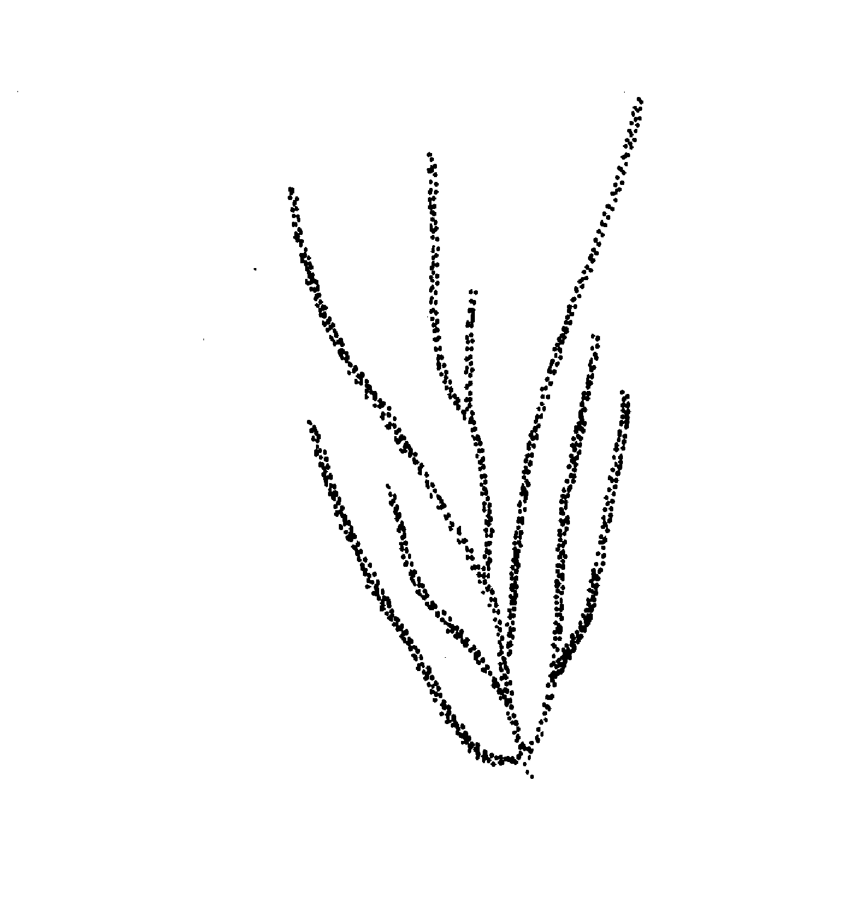 | 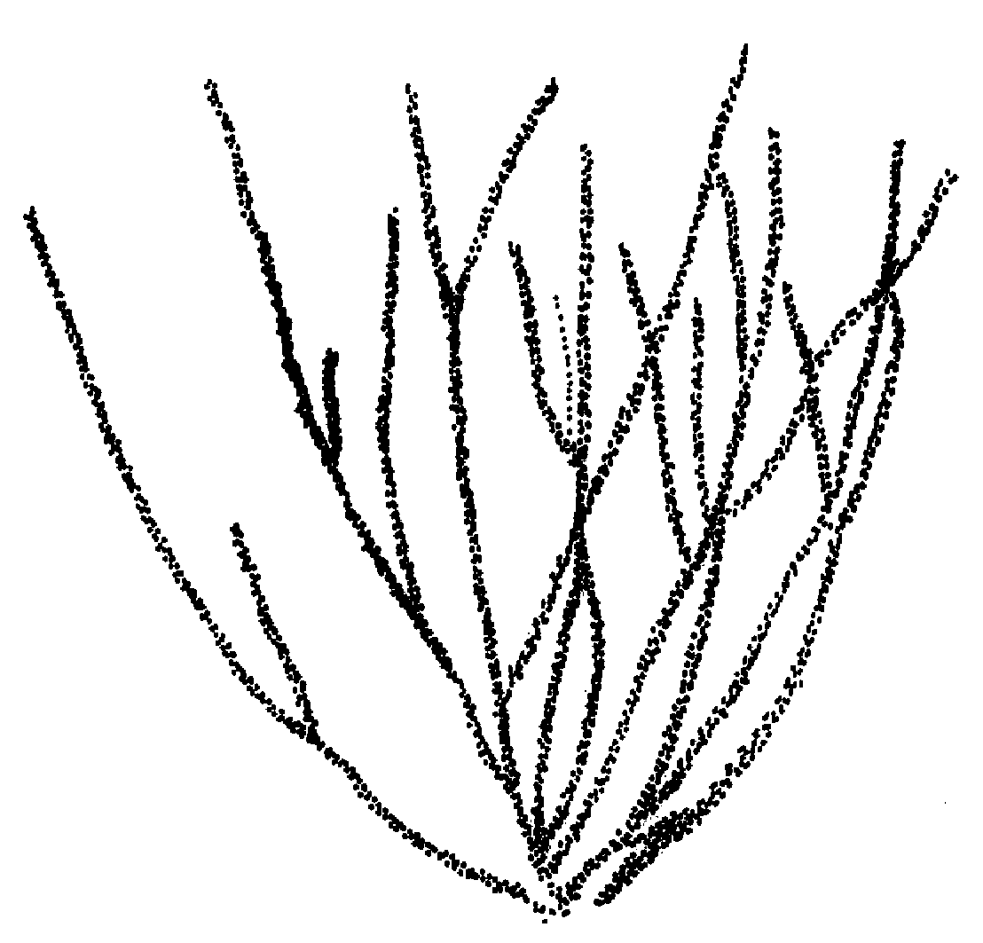
1 | 2 | 3
absent or weak | medium | strong

Ad. 5: Stem: density of pubescence

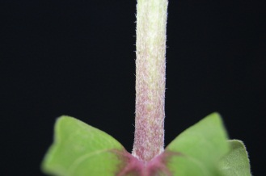 | 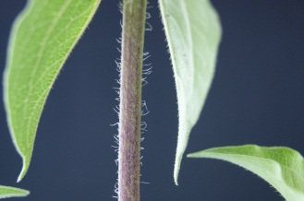 | 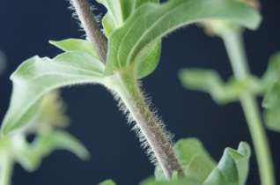
3 | 5 | 7
sparse | medium | dense

Ad. 9: Leaf: length/width ratio

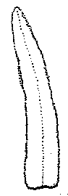 | 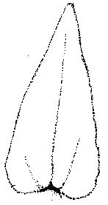 | 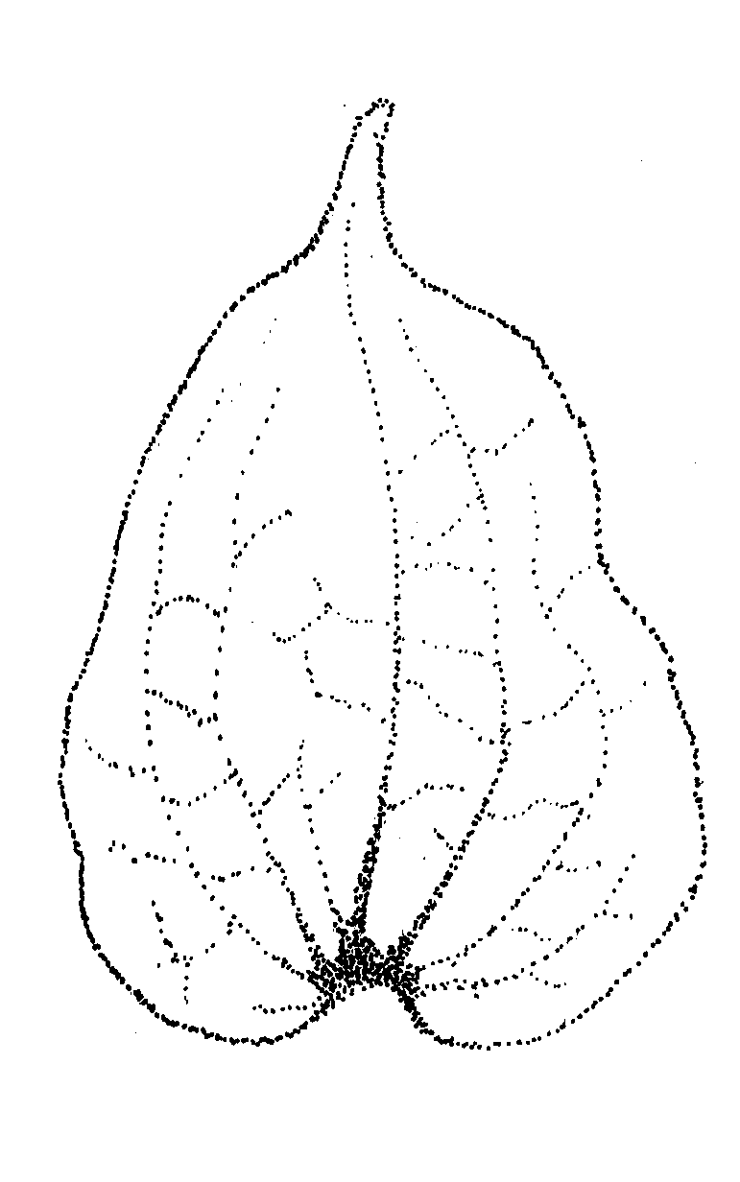
3 | 5 | 7
low | medium | high

Ad. 10: Leaf: profile in cross section

 |  | 
1 | 2 | 3
flat | moderately concave | strongly concave

Ad. 11: Leaf: undulation

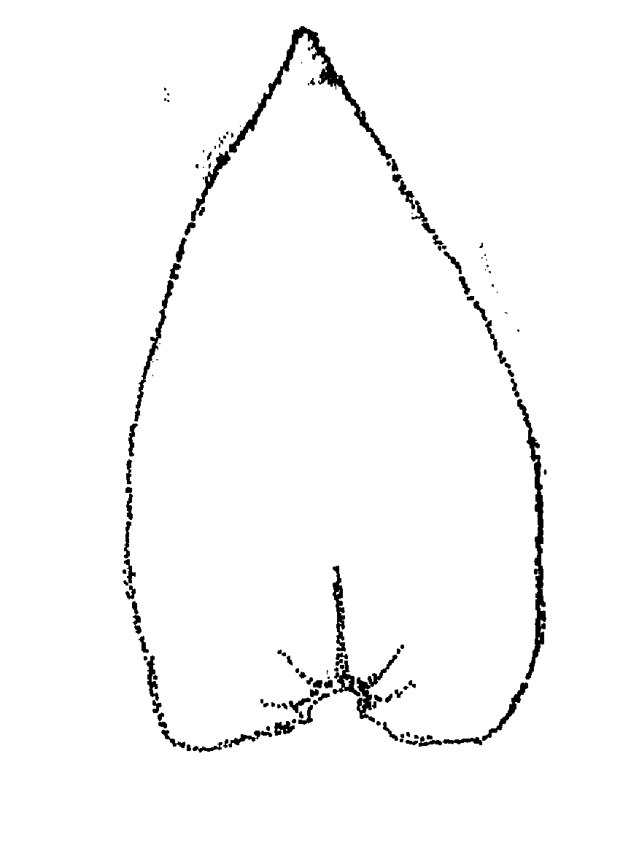 |  | 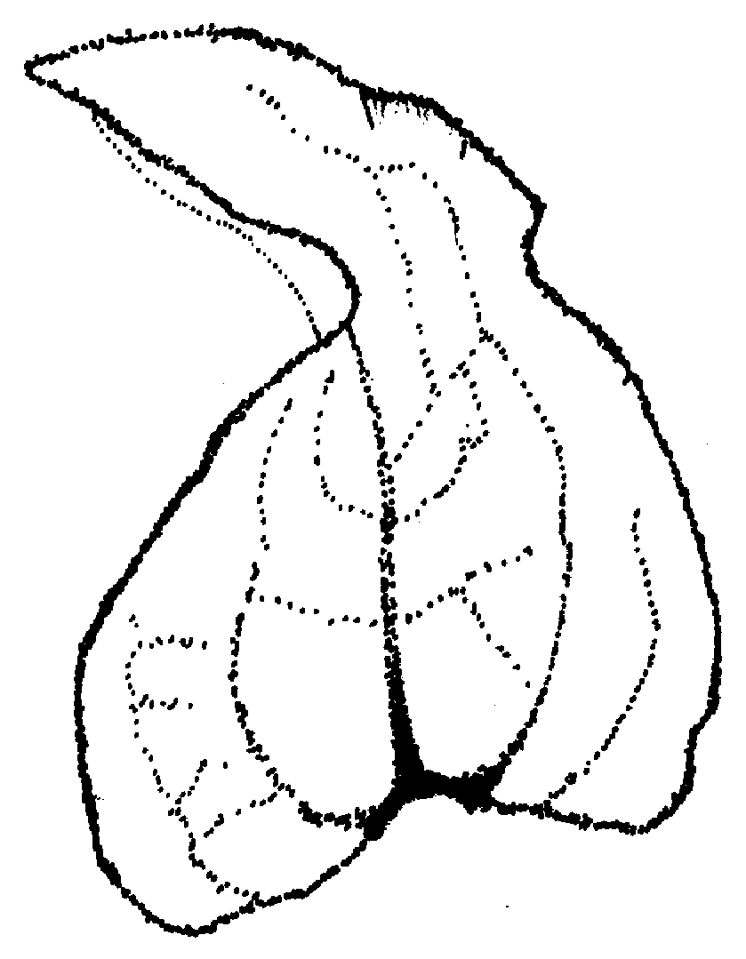
1 | 2 | 3
absent or weak | medium | strong

Ad. 13: Leaf: anthocyanin coloration at base

 | 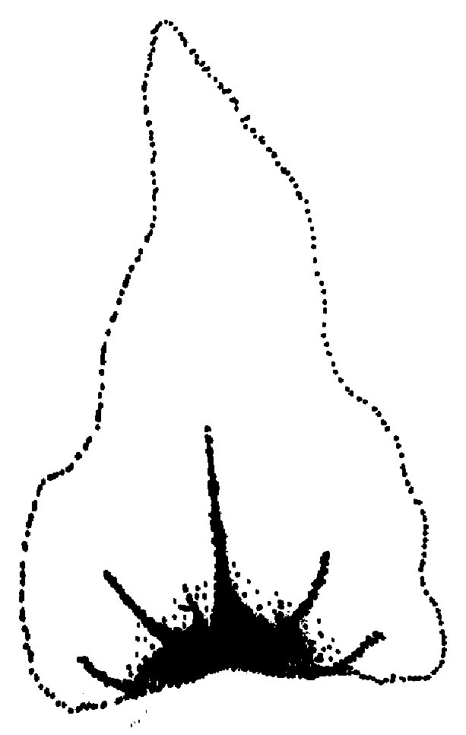 | 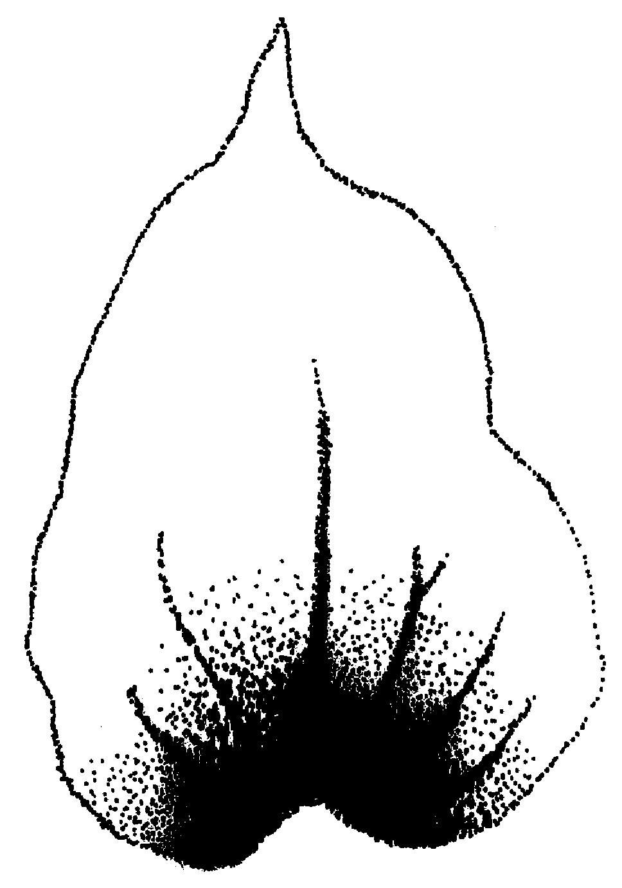
1 | 2 | 3
absent or weak | medium | strong

Ad. 14: Flower head: length of peduncle

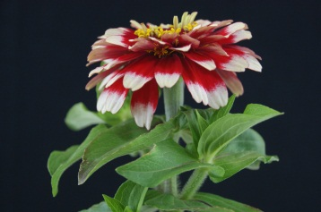 | 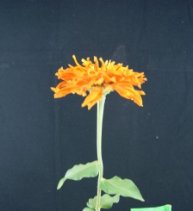 | 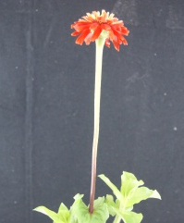
3 | 5 | 7
short | medium | long

Ad. 15: Flower head: type

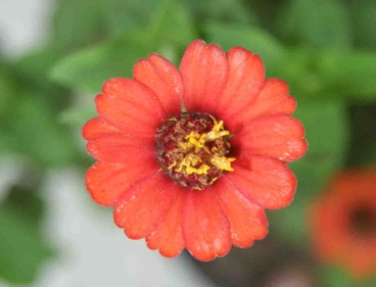 | 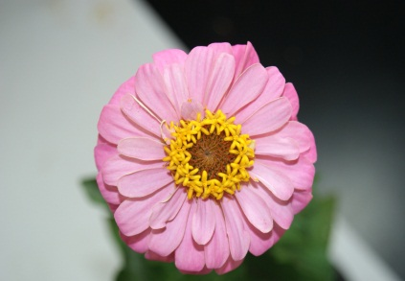 | 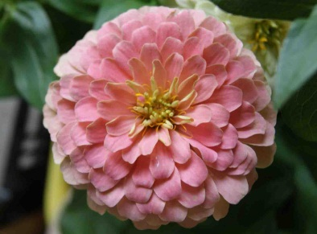
1 | 2 | 3
single | semi double | double

Ad. 22: Ray floret: profile in cross section

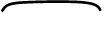
3 | 5 | 7
convex | flat | concave

Ad. 23: Ray floret: shape of the apex

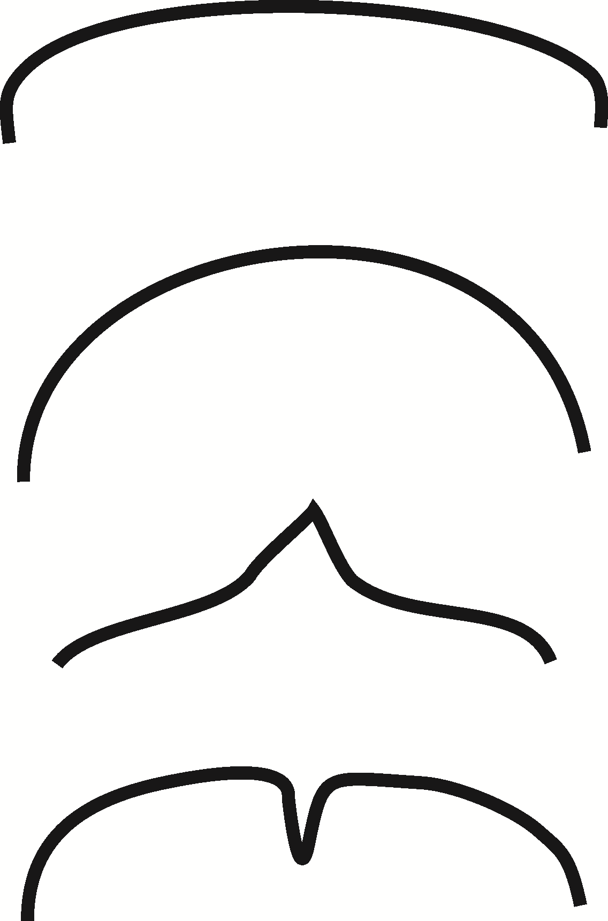
1 | 2 | 3 | 4
truncate | rounded | mucronate | emarginate

Ad. 26: Ray floret: only varieties with two colors: distribution of secondary color of inner side

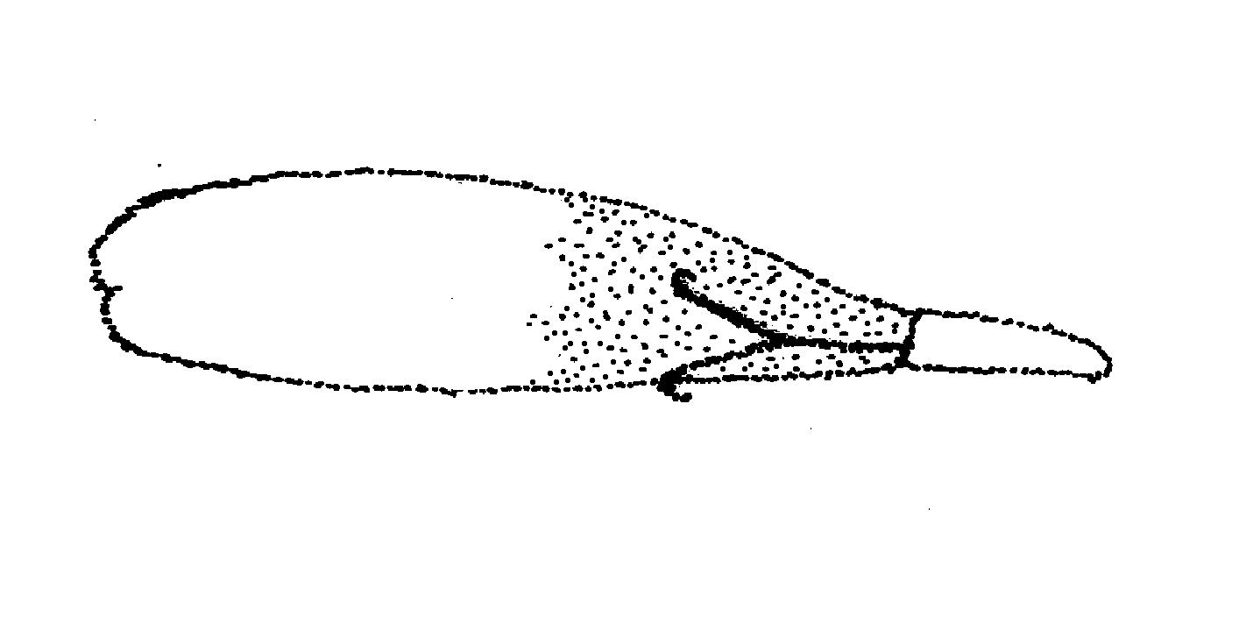 | 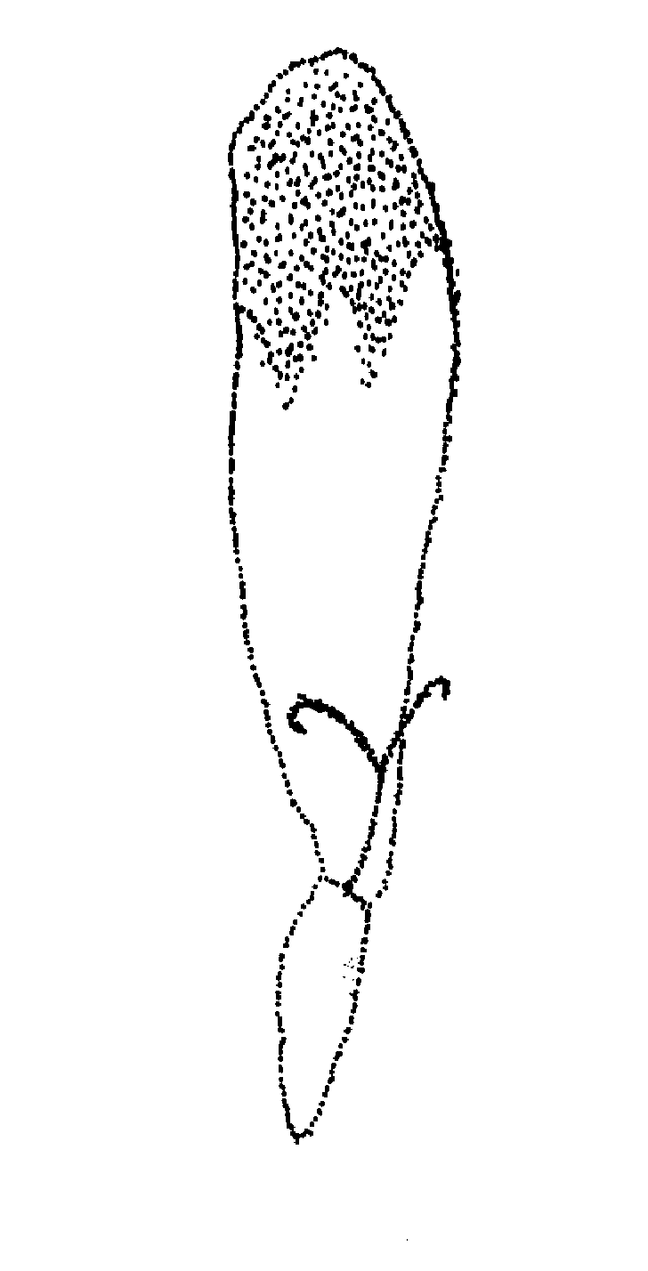 | 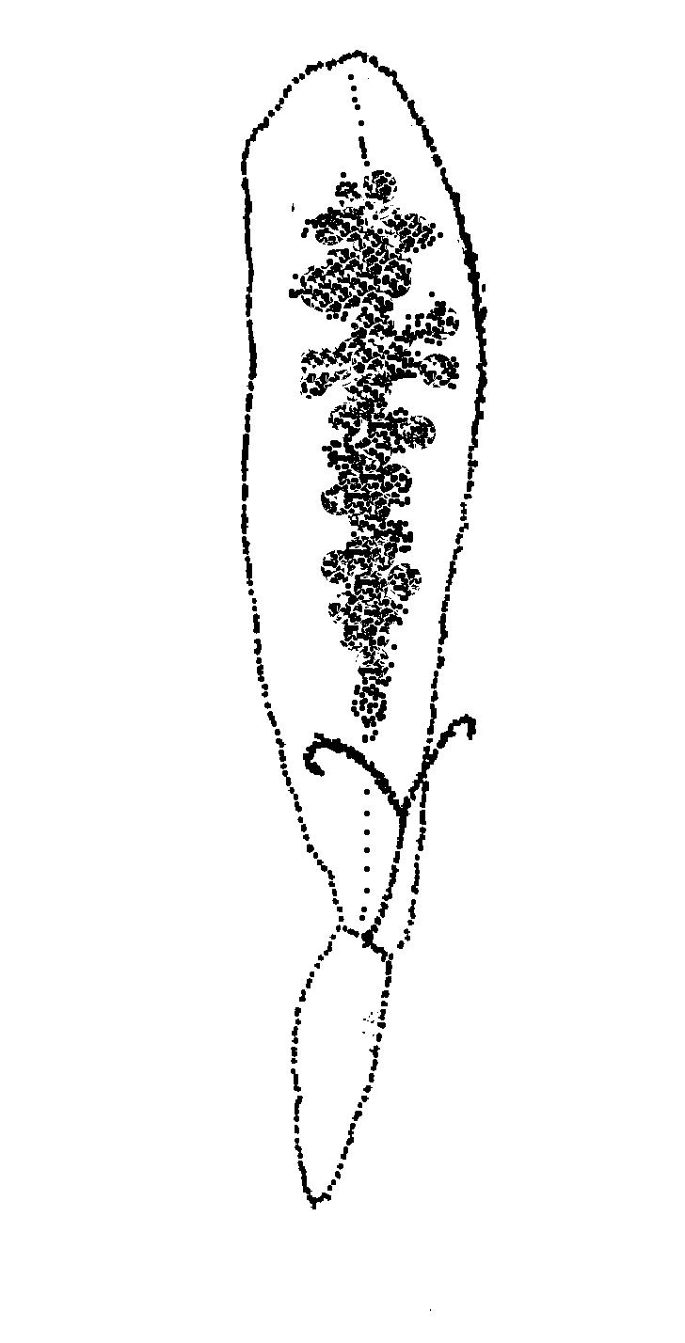 | 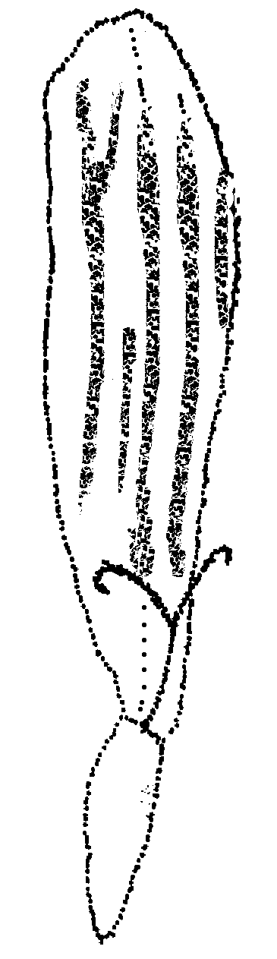
1 | 2 | 3 | 4
lower side | upper side | blotched | striped

Literature

Calderon de Rzedowski, G., Rzedowski J., 2006: Flora Fanerogámica del Valle de México. Ed. Instituto de Ecologia A.C. y Comisión Nacional para el Conocimiento y Uso de la Biodiversidad. México. 983 p.

Smith A.R., 226. Zinnia L. In: Flora of North America Vol.21. Oxford University Press

Torres, A.M., 1963: Taxonomy of Zinnia. Brittonia 15: 1-25

Technical Questionnaire

TECHNICAL QUESTIONNAIRE |  |  |  | Page {x} of {y} |  | Reference Number:
 |  |  |  |  |  | Application date:
 |  |  |  |  |  | (not to be filled in by the applicant)
TECHNICAL QUESTIONNAIRE
to be completed in connection with an application for plant breeders’ rights

In the case of hybrid varieties which are the subject of an application for plant breeders’ rights, and where the parent lines are to be submitted as a part of the examination of the hybrid variety, this Technical Questionnaire should be completed for each of the parent lines, in addition to being completed for the hybrid variety.
1. Subject of the Technical Questionnaire
1.1 Botanical name |  |  | Zinnia L., Zinnia elegans Jacq, Zinnia angustifolia Kunth, Zinnia haageana Regel, Zinnia peruviana L.
1.2 Common name |  |  | Carolina, Miguelito
2. Applicant
Name
Address
Telephone No.
Fax No.
E-mail address
Breeder (if different from
applicant)
3. Proposed denomination and breeder’s reference
Proposed denomination
(if available)
Breeder’s reference
#4. Information on the breeding scheme and propagation of the variety

4.1 Breeding scheme

Variety resulting from:

4.1.1 Crossing

(a) controlled cross [ ]
(please state parent varieties)

(…………………..…………………………) x (……………..…………..………………..…)
female parent male parent

(b) partially known cross [ ]
(please state known parent variety(ies))

(…………………..……………………....…) x (……………..………………..…………..…)
female parent male parent

(c) unknown cross [ ]
4.1.2 Mutation [ ]
(please state parent variety)

4.1.3 Discovery and development [ ]
(please state where and when discovered and how developed)

4.1.4 Other [ ]
(please provide details)”

4.2 Method of propagating the variety

4.2.1 Seed-propagated varieties

(a) Self-pollination [ ]
(b) Cross-pollination
(i) population [ ]
(ii) synthetic variety [ ]
(c) Hybrid [ ]
(d) Other [ ]
(please provide details)

4.2.2 Vegetatively propagated varieties [ ]

4.2.3 Other [ ]
(please provide details)”

4.2.1 Vegetative propagation

(a) cuttings [ ]

(b) in vitro propagation [ ]

(c) other (state method) [ ]

4.2.2 Seed [ ]

4.2.3 Other [ ]
(please provide details)

In the case of hybrid varieties the production scheme for the hybrid should be provided on a separate sheet. This should provide details of all the parent lines required for propagating the hybrid e.g.

Single Hybrid

(…………………..…………………………) x (……………..…………..………………..…)
female parent male parent

Three-Way Hybrid

(…………………..…………………………) x (……………..…………..………………..…)
female line male line

(…………………..…………………………) x (……………..…………..………………..…)
single hybrid used as female parent male parent

and should identify in particular:

(a) any male sterile lines
(b) maintenance system of male sterile lines.

5. Characteristics of the variety to be indicated (the number in brackets refers to the corresponding characteristic in Test Guidelines; please mark the note which best corresponds).

 | Characteristics |  |  |  |  |  | Example Varieties |  |  |  | Note
5.1  (1) | Plant: growth habit
 | upright |  |  |  |  |  | Peppermint |  |  |  | 1
 | semi-upright |  |  |  |  |  | Profusion |  |  |  | 2
 | spreading |  |  |  |  |  | Solecito |  |  |  | 3
5.2  (2) | Plant: height
 | short |  |  |  |  |  | Peppermint |  |  |  | 3
 | medium |  |  |  |  |  | Witworna |  |  |  | 5
 | tall |  |  |  |  |  | Inca |  |  |  | 7
5.3  (15) | Flower head: type
 | single |  |  |  |  |  | Star |  |  |  | 1
 | semi-double |  |  |  |  |  | Zowie |  |  |  | 2
 | double |  |  |  |  |  | Lilliput |  |  |  | 3
5.4  (24) | Ray floret: main color of inner side
 | white |  |  |  |  |  |  |  |  |  | 1
 | green |  |  |  |  |  |  |  |  |  | 2
 | yellow |  |  |  |  |  |  |  |  |  | 3
 | orange |  |  |  |  |  |  |  |  |  | 4
 | pink |  |  |  |  |  |  |  |  |  | 5
 | red |  |  |  |  |  |  |  |  |  | 6
6. Similar varieties and differences from these varieties

Please use the following table and box for comments to provide information on how your candidate variety differs from the variety (or varieties) which, to the best of your knowledge, is (or are) most similar. This information may help the examination authority to conduct its examination of distinctness in a more efficient way.

Denomination(s) of variety(ies) similar to your candidate variety |  | Characteristic(s) in which your candidate variety differs from the similar variety(ies) |  |  | Describe the expression of the characteristic(s) for the similar variety(ies) |  |  | Describe the expression of the characteristic(s) for your candidate variety
Example
Comments:

#7. Additional information which may help in the examination of the variety

7.1 In addition to the information provided in sections 5 and 6, are there any additional characteristics which may help to distinguish the variety?

Yes [ ] No [ ]

(If yes, please provide details)

7.2 Are there any special conditions for growing the variety or conducting the examination?

Yes [ ] No [ ]

(If yes, please provide details)

7.3 Other information

A representative color image of the variety should accompany the Technical Questionnaire.

8. Authorization for release

(a) Does the variety require prior authorization for release under legislation concerning the protection of the environment, human and animal health?

Yes [ ] No [ ]

(b) Has such authorization been obtained?

Yes [ ] No [ ]

If the answer to (b) is yes, please attach a copy of the authorization.

9. Information on plant material to be examined or submitted for examination

9.1 The expression of a characteristic or several characteristics of a variety may be affected by factors, such as pests and disease, chemical treatment (e.g. growth retardants or pesticides), effects of tissue culture, different rootstocks, scions taken from different growth phases of a tree, etc.

9.2 The plant material should not have undergone any treatment which would affect the expression of the characteristics of the variety, unless the competent authorities allow or request such treatment. If the plant material has undergone such treatment, full details of the treatment must be given. In this respect, please indicate below, to the best of your knowledge, if the plant material to be examined has been subjected to:

(a) Microorganisms (e.g. virus, bacteria, phytoplasma) Yes [ ] No [ ]

(b) Chemical treatment (e.g. growth retardant, pesticide) Yes [ ] No [ ]

(c) Tissue culture Yes [ ] No [ ]

(d) Other factors Yes [ ] No [ ]

Please provide details for where you have indicated “yes”.

9.3 Has the plant material to be examined been tested for the presence of virus or other pathogens?

Yes [ ]

(please provide details as specified by the Authority)

No [ ]

10. I hereby declare that, to the best of my knowledge, the information provided in this form is correct:

Applicant’s name

Signature Date

[End of document]

* These names were correct at the time of the introduction of these Test Guidelines but may be revised or updated. [Readers are advised to consult the UPOV Code, which can be found on the UPOV Website (www.upov.int), for the latest information.]
# Authorities may allow certain of this information to be provided in a confidential section of the Technical Questionnaire.
# Authorities may allow certain of this information to be provided in a confidential section of the Technical Questionnaire.

