 |  |  |  |  |  |  | E  TG/GREVI(proj.1)  ORIGINAL: English  DATE: 2013-03-07
INTERNATIONAL UNION FOR THE PROTECTION OF NEW VARIETIES OF PLANTS
Geneva
 |  |  | DRAFT
 |  | GREVILLEA  UPOV Code: GREVI  Grevillea R. Br. corr. R. Br. |  |  | *

GUIDELINES

FOR THE CONDUCT OF TESTS

FOR DISTINCTNESS, UNIFORMITY AND STABILITY

prepared by experts from Australia

to be considered by the
Technical Working Party for Ornamental Plants and Forest Trees
at its forty-sixth session, to be held in Melbourne, Australia, from April 22 to 26, 2013

Alternative Names:*

Botanical name | English | French | German | Spanish
Grevillea R. Br. corr. R. Br. | Grevillea

The purpose of these guidelines (“Test Guidelines”) is to elaborate the principles contained in the General Introduction (document TG/1/3), and its associated TGP documents, into detailed practical guidance for the harmonized examination of distinctness, uniformity and stability (DUS) and, in particular, to identify appropriate characteristics for the examination of DUS and production of harmonized variety descriptions.

ASSOCIATED DOCUMENTS
These Test Guidelines should be read in conjunction with the General Introduction and its associated TGP documents.
TABLE OF CONTENTS PAGE

1. Subject of these Test Guidelines 3
2. Material Required 3
3. Method of Examination 3
3.1 Number of Growing Cycles 3
3.2 Testing Place 3
3.3 Conditions for Conducting the Examination 3
3.4 Test Design 3
3.5 Additional Tests 3
4. Assessment of Distinctness, Uniformity and Stability 4
4.1 Distinctness 4
4.2 Uniformity 5
4.3 Stability 5
5. Grouping of Varieties and Organization of the Growing Trial 5
6. Introduction to the Table of Characteristics 5
6.1 Categories of Characteristics 5
6.2 States of Expression and Corresponding Notes 6
6.3 Types of Expression 6
6.4 Example Varieties 6
6.5 Legend 6
7. Table of Characteristics/Tableau des caractères/Merkmalstabelle/Tabla de caracteres 7
8. Explanations on the Table of Characteristics 22
8.1 Explanations covering several characteristics 22
8.2 Explanations for individual characteristics 22
9. Literature 27
10. Technical Questionnaire 28

Subject of these Test Guidelines

These Test Guidelines apply to all varieties of Grevillea R. Br. corr. R. Br..

Material Required

2.1 The competent authorities decide on the quantity and quality of the plant material required for testing the variety and when and where it is to be delivered. Applicants submitting material from a State other than that in which the testing takes place must ensure that all customs formalities and phytosanitary requirements are complied with.

2.2 The material is to be supplied in the form of plants expressing relevant characteristics of the variety in the first growing cycle.

2.3 The minimum quantity of plant material, to be supplied by the applicant, should be:

10 plants.

2.4 The plant material supplied should be visibly healthy, not lacking in vigor, nor affected by any important pest or disease.

2.5 The plant material should not have undergone any treatment which would affect the expression of the characteristics of the variety, unless the competent authorities allow or request such treatment. If it has been treated, full details of the treatment must be given.

Method of Examination

3.1 Number of Growing Cycles

The minimum duration of tests should normally be a single growing cycle.

3.2 Testing Place

Tests are normally conducted at one place. In the case of tests conducted at more than one place, guidance is provided in TGP/9 “Examining Distinctness”.

3.3 Conditions for Conducting the Examination

3.3.1 The tests should be carried out under conditions ensuring satisfactory growth for the expression of the relevant characteristics of the variety and for the conduct of the examination.

3.3.2 Because daylight varies, color determinations made against a color chart should be made either in a suitable cabinet providing artificial daylight or in the middle of the day in a room without direct sunlight. The spectral distribution of the illuminant for artificial daylight should conform with the CIE Standard of Preferred Daylight D 6500 and should fall within the tolerances set out in the British Standard 950, Part I. These determinations should be made with the plant part placed against a white background. The color chart and version used should be specified in the variety description.

3.4 Test Design

3.4.1 Each test should be designed to result in a total of at least 10 plants

3.4.2 The design of the tests should be such that plants or parts of plants may be removed for measurement or counting without prejudice to the observations which must be made up to the end of the growing cycle.

3.5 Additional Tests

Additional tests, for examining relevant characteristics, may be established.

Assessment of Distinctness, Uniformity and Stability

4.1 Distinctness

4.1.1 General Recommendations

It is of particular importance for users of these Test Guidelines to consult the General Introduction prior to making decisions regarding distinctness. However, the following points are provided for elaboration or emphasis in these Test Guidelines.

4.1.2 Consistent Differences

The differences observed between varieties may be so clear that more than one growing cycle is not necessary. In addition, in some circumstances, the influence of the environment is not such that more than a single growing cycle is required to provide assurance that the differences observed between varieties are sufficiently consistent. One means of ensuring that a difference in a characteristic, observed in a growing trial, is sufficiently consistent is to examine the characteristic in at least two independent growing cycles.

4.1.3 Clear Differences

Determining whether a difference between two varieties is clear depends on many factors, and should consider, in particular, the type of expression of the characteristic being examined, i.e. whether it is expressed in a qualitative, quantitative, or pseudo-qualitative manner. Therefore, it is important that users of these Test Guidelines are familiar with the recommendations contained in the General Introduction prior to making decisions regarding distinctness.

4.1.4 Number of Plants / Parts of Plants to be Examined

Unless otherwise indicated, for the purposes of distinctness, all observations on single plants should be made on 9 plants or parts taken from each of 9 plants and any other observations made on all plants in the test, disregarding any off-type plants.

4.1.5 Method of Observation

The recommended method of observing the characteristic for the purposes of distinctness is indicated by the following key in the second column of the Table of Characteristics (see document TGP/9 “Examining Distinctness”, Section 4 “Observation of characteristics”):

MG: single measurement of a group of plants or parts of plants
MS: measurement of a number of individual plants or parts of plants
VG: visual assessment by a single observation of a group of plants or parts of plants
VS: visual assessment by observation of individual plants or parts of plants

Type of observation: visual (V) or measurement (M)

“Visual” observation (V) is an observation made on the basis of the expert’s judgment. For the purposes of this document, “visual” observation refers to the sensory observations of the experts and, therefore, also includes smell, taste and touch. Visual observation includes observations where the expert uses reference points (e.g. diagrams, example varieties, side-by-side comparison) or non-linear charts (e.g. color charts). Measurement (M) is an objective observation against a calibrated, linear scale e.g. using a ruler, weighing scales, colorimeter, dates, counts, etc.

Type of record: for a group of plants (G) or for single, individual plants (S)

For the purposes of distinctness, observations may be recorded as a single record for a group of plants or parts of plants (G), or may be recorded as records for a number of single, individual plants or parts of plants (S). In most cases, “G” provides a single record per variety and it is not possible or necessary to apply statistical methods in a plant-by-plant analysis for the assessment of distinctness.

In cases where more than one method of observing the characteristic is indicated in the Table of Characteristics (e.g. VG/MG), guidance on selecting an appropriate method is provided in document TGP/9, Section 4.2.

4.2 Uniformity

4.2.1 It is of particular importance for users of these Test Guidelines to consult the General Introduction prior to making decisions regarding uniformity. However, the following points are provided for elaboration or emphasis in these Test Guidelines:

4.2.2 For the assessment of uniformity of vegetatively propagated varieties, a population standard of 1% and an acceptance probability of at least 95 % should be applied. In the case of a sample size of 10 plants, 1 off-type is allowed.

4.3 Stability

4.3.1 In practice, it is not usual to perform tests of stability that produce results as certain as those of the testing of distinctness and uniformity. However, experience has demonstrated that, for many types of variety, when a variety has been shown to be uniform, it can also be considered to be stable.

4.3.2 Where appropriate, or in cases of doubt, stability may be further examined by testing a new plant stock to ensure that it exhibits the same characteristics as those shown by the initial material supplied.

Grouping of Varieties and Organization of the Growing Trial

5.1 The selection of varieties of common knowledge to be grown in the trial with the candidate varieties and the way in which these varieties are divided into groups to facilitate the assessment of distinctness are aided by the use of grouping characteristics.

5.2 Grouping characteristics are those in which the documented states of expression, even where produced at different locations, can be used, either individually or in combination with other such characteristics: (a) to select varieties of common knowledge that can be excluded from the growing trial used for examination of distinctness; and (b) to organize the growing trial so that similar varieties are grouped together.

5.3 The following have been agreed as useful grouping characteristics:

- Plant: habit (characteristic 1)
- Leaf: division of blade (characteristic 19)
- Inflorescence: form (characteristic 37)
- Inflorescence: sequence of flower opening (characteristic 38)
- Inflorescence: predominant color (characteristic 39)
- Perianth: color (characteristic 54)

5.4 Guidance for the use of grouping characteristics, in the process of examining distinctness, is provided through the General Introduction and document TGP/9 “Examining Distinctness”.

Introduction to the Table of Characteristics

6.1 Categories of Characteristics

6.1.1 Standard Test Guidelines Characteristics

Standard Test Guidelines characteristics are those which are approved by UPOV for examination of DUS and from which members of the Union can select those suitable for their particular circumstances.

6.1.2 Asterisked Characteristics

Asterisked characteristics (denoted by *) are those included in the Test Guidelines which are important for the international harmonization of variety descriptions and should always be examined for DUS and included in the variety description by all members of the Union, except when the state of expression of a preceding characteristic or regional environmental conditions render this inappropriate.

6.2 States of Expression and Corresponding Notes

6.2.1 States of expression are given for each characteristic to define the characteristic and to harmonize descriptions. Each state of expression is allocated a corresponding numerical note for ease of recording of data and for the production and exchange of the description.

6.2.2 In the case of qualitative and pseudo-qualitative characteristics (see Chapter 6.3), all relevant states of expression are presented in the characteristic. However, in the case of quantitative characteristics with 5 or more states, an abbreviated scale may be used to minimize the size of the Table of Characteristics. For example, in the case of a quantitative characteristic with 9 states, the presentation of states of expression in the Test Guidelines may be abbreviated as follows:

State | Note
small | 3
medium | 5
large | 7

However, it should be noted that all of the following 9 states of expression exist to describe varieties and should be used as appropriate:

State | Note
very small | 1
very small to small | 2
small | 3
small to medium | 4
medium | 5
medium to large | 6
large | 7
large to very large | 8
very large | 9

6.2.3 Further explanation of the presentation of states of expression and notes is provided in document TGP/7 “Development of Test Guidelines”.

6.3 Types of Expression

An explanation of the types of expression of characteristics (qualitative, quantitative and pseudo-qualitative) is provided in the General Introduction.

6.4 Example Varieties

Where appropriate, example varieties are provided to clarify the states of expression of each characteristic.

6.5 Legend

(*) Asterisked characteristic – see Chapter 6.1.2

QL Qualitative characteristic – see Chapter 6.3
QN Quantitative characteristic – see Chapter 6.3
PQ Pseudo-qualitative characteristic – see Chapter 6.3

MG, MS, VG, VS – see Chapter 4.1.5

(a) See Explanations on the Table of Characteristics in Chapter 8.1

(+) See Explanations on the Table of Characteristics in Chapter 8.2.

Table of Characteristics/Tableau des caractères/Merkmalstabelle/Tabla de caracteres

 |  | English | français | deutsch | español | Example Varieties  Exemples  Beispielssorten  Variedades ejemplo | Note/  Nota
1  (*)  (+) | VG | Plant: habit
PQ | (a) | upright |  |  |  | Callums Gold | 1
 |  | bushy |  |  |  | Honey Gem | 2
 |  | spreading |  |  |  | Ninderry-Sunrise | 3
 |  | prostrate |  |  |  | Raptor | 4
2  (*)  (+) | VG | Plant: attitude of branches
PQ | (a) | erect |  |  |  | Callums Gold | 1
 |  | erect to semi-erect |  |  |  | Blood Orange | 2
 |  | semi-erect |  |  |  | Honey Gem | 3
 |  | semi-erect to horizontal |  |  |  | Ninderry-Sunrise | 4
 |  | horizontal |  |  |  | Raptor | 5
3 | VG/MS | Plant: height of foliage
QN | (a) | short |  |  |  |  | 3
 |  | medium |  |  |  |  | 5
 |  | tall |  |  |  |  | 7
4 | VG | Plant: density of foliage
PQ | (a) | sparse |  |  |  | Raptor | 1
 |  | medium |  |  |  | Callums Gold | 2
 |  | dense |  |  |  | Billy Bonkers | 3
5  (+) | VG | Young stem: color
PQ |  | yellow green |  |  |  | Honey Gem | 1
 |  | green |  |  |  | Fireworks, Coastal Prestige | 2
 |  | purple |  |  |  | Raptor | 3
 |  | orange |  |  |  | Callums Gold | 4
 |  | brown |  |  |  | Autumn Waterfall | 5
6  (*)  (+) | VG | Stem: color
PQ |  | yellow green |  |  |  | New Blood | 1
 |  | green |  |  |  | Burke 3 | 2
 |  | orange |  |  |  | Ninderry-Sunrise | 3
 |  | purple |  |  |  | Callums Gold | 4
 |  | brown |  |  |  | Honey Gem | 5
7 | VG | Young stem: hairiness
QL |  | absent |  |  |  |  | 1
 |  | present |  |  |  | Knockout | 9
8 | VG/MS | Petiole: length
QN |  | short |  |  |  | Raptor | 3
 |  | medium |  |  |  | Callums Gold | 5
 |  | long |  |  |  | Red Rover | 7
9  (+) | VG/MS | Leaf: length
QN |  | short |  |  |  | [Example] | 3
 |  | medium |  |  |  | [Example] | 5
 |  | long |  |  |  | [Example] | 7
10  (+) | VG/MS | Leaf: width
QN |  | narrow |  |  |  | [Example] | 3
 |  | medium |  |  |  | [Example] | 5
 |  | broad |  |  |  | [Example] | 7
11 | VG | Leaf: attitude relative to stem
QN |  | erect |  |  |  | Raptor | 1
 |  | erect to semi-erect |  |  |  | Honey Gem | 2
 |  | semi-erect |  |  |  | Callums Gold | 3
 |  | semi-erect to horizontal |  |  |  | Billy Bonkers | 4
 |  | horizontal |  |  |  | Prostrate Yellow | 5
12  (*)  (+) | VG | Leaf: margin in cross section
PQ |  | flat or slightly recurved |  |  |  | Raptor | 1
 |  | strongly recurved |  |  |  | Callums Gold | 2
 |  | angularly revolute to the mid vein |  |  |  |  | 3
 |  | smoothly revolute to the mid vein |  |  |  | Little Honey | 4
13  (*) | VG | Leaf: intensity of green color of upper side
QN |  | light |  |  |  | Autumn Waterfall | 1
 |  | medium |  |  |  | Raptor | 2
 |  | dark |  |  |  | Callums Gold | 3
14  (*)  (+) | VG | Leaf: color of lower side
PQ |  | white |  |  |  | Callums Gold | 1
 |  | light green |  |  |  | Raptor | 2
 |  | medium green |  |  |  | Ninderry-Sunrise | 3
 |  | dark green |  |  |  |  | 4
 |  | red green |  |  |  |  | 5
15 | VG | Leaf: degree of hairiness on upper side
QN |  | weak |  |  |  | Ninderry-Sunrise | 3
 |  | medium |  |  |  | Callums Gold | 5
 |  | strong |  |  |  |  | 7
16 | VG | Leaf: degree of hairiness on lower side
QN |  | weak |  |  |  | Little Honey | 3
 |  | medium |  |  |  | Blood Orange | 5
 |  | strong |  |  |  | Ninderry-Sunrise | 7
17 | VG | Leaf: color of hairs on lower side
QL |  | white |  |  |  | Callums Gold | 1
 |  | red brown |  |  |  | Honey Gem | 2
18 | VG | Leaf: undulation of margin
QN |  | weak |  |  |  | Callums Gold | 3
 |  | medium |  |  |  | Raptor | 5
 |  | strong |  |  |  | Entrée | 7
19  (*) | VG | Leaf: division of blade
QL |  | absent |  |  |  | Fire Cracker | 1
 |  | present |  |  |  | Callums Gold | 9
20  (*)  (+) | VG | Leaf: blade shape
PQ |  | lanceolate |  |  |  | H22 | 1
 |  | ovate |  |  |  | Burke 3 | 2
 |  | linear |  |  |  | Fire Cracker | 3
 |  | oblong |  |  |  |  | 4
 |  | elliptic |  |  |  | TWD01 | 5
 |  | rhombic |  |  |  | Molly | 6
 |  | circular |  |  |  |  | 7
 |  | obovate |  |  |  |  | 8
21 | VG | Leaf: degree of division of blade
QL |  | primary |  |  |  | Raptor | 1
 |  | secondary |  |  |  | Autumn Waterfall | 2
 |  | tertiary |  |  |  | Callums Gold | 3
22 | VG | Leaf: depth of division of blade
QN |  | sinus less than one third of way to midrib |  |  |  |  | 1
 |  | sinus one third to two thirds of way to midrib |  |  |  | Bedspread | 2
 |  | sinus greater than two thirds of way to midrib |  |  |  | Callums Gold | 3
23 | VG | Leaf: number of lobes
QN |  | few |  |  |  | Parakeet Pink | 3
 |  | medium |  |  |  | Callums Gold | 5
 |  | many |  |  |  | Honey Gem | 7
24 | VG | Leaf: regularity of lobing
QL |  | regular |  |  |  | Callums Gold | 1
 |  | irregular |  |  |  | Raptor | 2
25 | VG | Leaf: attitude of longitudinal axis of lobes to longitudinal axis of midrib
QN |  | erect |  |  |  |  | 1
 |  | erect to semi-erect |  |  |  | Honey Gem | 2
 |  | semi-erect |  |  |  | Callums Gold | 3
 |  | semi-erect to horizontal |  |  |  |  | 4
 |  | horizontal |  |  |  |  | 5
26.  (+) | VG | Leaf: shape of apex of sinus
PQ |  | pointed |  |  |  | Ninderry-Sunrise | 1
 |  | rounded |  |  |  |  | 2
 |  | flattened |  |  |  | Callums Gold | 3
27. | VG/MS | Leaf: width of sinus
QN |  | very narrow |  |  |  |  | 1
 |  | very narrow to narrow |  |  |  | Honey Gem | 2
 |  | narrow |  |  |  |  | 3
 |  | narrow to medium |  |  |  | Ninderry-Sunrise | 4
 |  | medium |  |  |  | Billy Bonkers | 5
 |  | medium to broad |  |  |  | Ivory Whip | 6
 |  | broad |  |  |  | Callums Gold | 7
 |  | broad to very broad |  |  |  |  | 8
 |  | very broad |  |  |  |  | 9
28. | VG/MS | Lobe: length
QN |  | short |  |  |  | Autumn Waterfall | 3
 |  | medium |  |  |  | Billy Bonkers | 5
 |  | long |  |  |  | Callums Gold | 7
29. | VG/MS | Lobe: width
QN |  | narrow |  |  |  | Callums Gold | 3
 |  | medium |  |  |  | Ivory Whip? | 5
 |  | broad |  |  |  |  | 7
30.  (+) |  | Leaf: shape of apex
PQ |  | acute |  |  |  | Little Honey | 1
 |  | obtuse |  |  |  |  | 2
 |  | truncate |  |  |  |  | 3
31. | VG | Leaf: differentiated tip
QL |  | mucronate |  |  |  | H22 | 1
 |  | apiculate |  |  |  | New Blood | 2
32. | VG | Flowering branch: position of inflorescence
QL |  | terminal only |  |  |  | Ninderry-Sunrise | 1
 |  | axillary only |  |  |  |  | 2
 |  | both terminal and axillary |  |  |  | Callums Gold | 3
33. | VG | Inflorescence: attitude
PQ |  | erect |  |  |  | Red Rover | 1
 |  | erect to semi-erect |  |  |  | Little Honey | 2
 |  | semi-erect |  |  |  | Honey Gem | 3
 |  | semi-erect to horizontal |  |  |  | Blood Orange | 4
 |  | horizontal |  |  |  | Callums Gold | 5
 |  | horizontal to semi-drooping |  |  |  | Ninderry-Sunrise | 6
 |  | semi-drooping |  |  |  |  | 7
 |  | semi-drooping to drooping |  |  |  |  | 8
 |  | drooping |  |  |  | Entrée | 9
34. | VG | Inflorescence: branching
QN |  | absent or very weak |  |  |  | Ninderry-Sunrise | 3
 |  | weak |  |  |  | Red Rover | 5
 |  | medium |  |  |  | Callums Gold | 7
35. | VG/MS | Inflorescence: length
QN |  | short |  |  |  | Raptor | 3
 |  | medium |  |  |  | Callums Gold | 5
 |  | long |  |  |  | Autumn Waterfall | 7
36. | VG/MS | Inflorescence: width
QN |  | narrow |  |  |  | Raptor | 3
 |  | medium |  |  |  | Callums Gold | 5
 |  | broad |  |  |  | Red Rover | 7
37.  (*)  (+) | VG | Inflorescence: form
PQ |  | secund |  |  |  | Ninderry-Sunrise | 1
 |  | irregular |  |  |  | LadyO | 2
 |  | cylindrical |  |  |  | Callums Gold | 3
 |  | triangular |  |  |  | Fireworks | 4
 |  | dome |  |  |  |  | 5
 |  | ovoid |  |  |  |  | 6
 |  | globose |  |  |  |  | 7
 |  | umbellate |  |  |  | H22 | 8
38.  (*)  (+) | VG | Inflorescence: sequence of flower opening
QL |  | centripetal |  |  |  | Callums Gold | 1
 |  | centrifugal |  |  |  | Knockout | 2
 |  | synchronous |  |  |  | Coastal Prestige | 3
39  (*) | VG | Inflorescence: predominant color
PQ |  | red |  |  |  | Raptor | 1
 |  | pink |  |  |  | Blood Orange | 2
 |  | orange |  |  |  | Ninderry-Sunrise | 3
 |  | white |  |  |  | Ivory Whip | 4
 |  | yellow |  |  |  | Callums Gold | 5
 |  | green |  |  |  |  | 6
 |  | black |  |  |  |  | 7
40. | VG | Inflorescence: density of florets
QN |  | sparse |  |  |  | Coastal Dawn | 3
 |  | medium |  |  |  | Honey Gem | 5
 |  | dense |  |  |  | Callums Gold | 7
41. | VG/MS | Inflorescence: number of flowers
QN |  | few |  |  |  | Fire Cracker? | 3
 |  | medium |  |  |  | Raptor | 5
 |  | many |  |  |  | Red Rover | 7
42. | VG/MS | Rachis: length
QN |  | short |  |  |  | Raptor | 3
 |  | medium |  |  |  | Callums Gold | 5
 |  | long |  |  |  | Honey Gem | 7
43. | VG | Flower: attitude of pedicel in relation to rachis
QN |  | leaning away from inflorescence peduncle |  |  |  | Callums Gold | 1
 |  | perpendicular |  |  |  | Ninderry-Sunrise | 2
 |  | leaning towards inflorescence peduncle |  |  |  | Autumn Waterfall | 3
44. | VG/MS | Flower: pedicel length
QN |  | short |  |  |  | Callums Gold | 3
 |  | medium |  |  |  | Billy Bonkers | 5
 |  | long |  |  |  | Autumn Waterfall | 7
45.  (+) | VG | Bud: attitude of limb in relation to longitudinal axis of bud
PQ |  | upright |  |  |  | Ninderry-Sunrise | 1
 |  | horizontal |  |  |  | New Blood | 2
 |  | drooping |  |  |  | Callums Gold | 3
46. | VG | Bud: color of limb
PQ |  | yellow |  |  |  | Honey Gem | 1
 |  | green |  |  |  | Callums Gold | 2
 |  | orange |  |  |  | Sylvia | 3
 |  | pink |  |  |  |  | 4
 |  | red |  |  |  | Raptor | 5
 |  | reddish brown |  |  |  |  | 6
 |  | brown |  |  |  | New Blood | 7
 |  | black |  |  |  |  | 8
47.  (*) | VG | Bud: perianth color
PQ |  | white |  |  |  | 'Ivory Whip' | 1
 |  | yellow |  |  |  | Callums Gold | 2
 |  | green |  |  |  | Ninderry-Sunrise | 3
 |  | orange |  |  |  | Entrée | 4
 |  | pink |  |  |  | Molly | 5
 |  | red |  |  |  | Raptor | 6
 |  | black |  |  |  |  | 7
48. | VG/MS | Perianth: length
QN |  | short |  |  |  | Raptor | 3
 |  | medium |  |  |  | Callums Gold | 5
 |  | long |  |  |  | Red Rover | 7
49. | VG/MS | Perianth: width
QN |  | narrow |  |  |  | Callums Gold | 3
 |  | medium |  |  |  | Ninderry-Sunrise | 5
 |  | broad |  |  |  | Entrée | 7
50. | VG | Perianth: degree of hairiness (outside of perianth including limb)
QN |  | absent or very weak |  |  |  | Ninderry-Sunrise | 1
 |  | weak |  |  |  | Honey Gem | 2
 |  | medium |  |  |  | Raptor | 3
 |  | strong |  |  |  | Callums Gold | 4
51. | VG | Perianth: hair color
QL |  | white |  |  |  | Raptor | 1
 |  | red brown |  |  |  | Callums Gold | 2
52. | VG | Perianth: coherence of tepals on dorsal side
QN |  | less than one third |  |  |  | Callums Gold | 1
 |  | one third to two thirds |  |  |  | Molly | 2
 |  | greater than two thirds |  |  |  | Ninderry-Sunrise | 3
53. | VG | Perianth: coherence of tepals on ventral side
QN |  | less than one third |  |  |  | Ninderry-Sunrise | 1
 |  | one third to two thirds |  |  |  | Molly | 2
 |  | greater than two thirds |  |  |  | Callums Gold | 3
54.  (*) | VG | Perianth: color
PQ |  | white |  |  |  | 'Ivory Whip' | 1
 |  | yellow |  |  |  | Callums Gold | 2
 |  | green |  |  |  | Sandra Gordon | 3
 |  | orange |  |  |  | Ninderry-Sunrise | 4
 |  | pink |  |  |  | Blood Orange | 5
 |  | red |  |  |  | Raptor | 6
 |  | black |  |  |  |  | 7
55. | VG | Tepal: flanging at margin
QN |  | absent or very weak |  |  |  | Callums Gold | 1
 |  | weak |  |  |  | Blood Orange | 2
 |  | medium |  |  |  | Red Rover | 3
 |  | strong |  |  |  | Coastal Glimpse | 4
56. | VG | Nectary: color
PQ |  | white |  |  |  | Ivory Whip | 1
 |  | yellow |  |  |  | Honey Gem | 2
 |  | green |  |  |  | Billy Bonkers | 3
 |  | orange |  |  |  | Callums Gold | 4
 |  | pink |  |  |  |  | 5
 |  | red |  |  |  | Coastal Prestige | 6
 |  | black |  |  |  |  | 7
57. | VG | Ovary: hairiness
QN |  | absent or very weak |  |  |  | Knockout | 1
 |  | weak |  |  |  | Jubilee | 2
 |  | medium |  |  |  | Raptor | 3
 |  | strong |  |  |  | Callums Gold | 4
58. | VG | Ovary: color
PQ |  | white |  |  |  | Raptor
 |  | yellow |  |  |  | Honey Gem
 |  | green |  |  |  | Callums Gold
 |  | orange
 |  | pink
 |  | red
 |  | black
59.  (+) | VG | Style: curvature
QN |  | straight |  |  |  | Callums Gold | 1
 |  | gently curved |  |  |  | Ninderry-Sunrise | 2
 |  | sharply curved |  |  |  | Pink Surprise | 3
60. | VG | Style: position of curve
QL |  | continuous along length |  |  |  | Ninderry-Sunrise | 1
 |  | top half |  |  |  | Raptor | 2
61. | VG | Style: hairiness
QN |  | absent or very weak |  |  |  | Callums Gold | 1
 |  | weak |  |  |  | Ivory Whip | 2
 |  | medium |  |  |  | Entrée | 3
 |  | strong |  |  |  |  | 4
62. | VG | Style: position of hairs
QN |  | evenly distributed along length |  |  |  | Entrée | 1
 |  | concentrated towards style end |  |  |  |  | 2
 |  | concentrated towards ovary end |  |  |  | Ninderry-Sunrise | 3
63. | VG | Style: color
PQ |  | white |  |  |  | Ivory Whip | 1
 |  | yellow |  |  |  | Golden Yul-lo | 2
 |  | green |  |  |  | Misty Pink | 3
 |  | orange |  |  |  | Callums Gold | 4
 |  | pink |  |  |  | Knockout | 5
 |  | red |  |  |  | Raptor | 6
 |  | black |  |  |  |  | 7
64. | VG/MS | Pistil: length
QN |  | short |  |  |  | Knockout | 3
 |  | medium |  |  |  | Ninderry-Sunrise | 5
 |  | long |  |  |  | Callums Gold | 7
65. | VG | Pistil: length in relation to length of perianth
QN |  | much longer |  |  |  | Callums Gold | 1
 |  | moderately longer |  |  |  | Ivory Whip | 2
 |  | same length |  |  |  |  | 3
66. | VG | Stigma: color
PQ |  | white |  |  |  | Knockout | 1
 |  | yellow |  |  |  | Callums Gold | 2
 |  | green |  |  |  | Raptor | 3
 |  | orange |  |  |  | Jubilee | 4
 |  | pink |  |  |  | Billy Bonkers | 5
 |  | red |  |  |  | Red Rover | 6
 |  | black |  |  |  |  | 7
67. | VG | Pollen presenter : attitude to style
PQ |  | lateral |  |  |  | Honey Gem | 1
 |  | oblique |  |  |  | Callums Gold | 2
 |  | transverse |  |  |  |  | 3
68. | VG | Pollen presenter : concurrence with style
QL |  | absent |  |  |  | Callums Gold | 1
 |  | present |  |  |  | Raptor | 9
69. | VG | Pollen presenter: shape
PQ |  | cone |  |  |  | Raptor | 1
 |  | cylinder |  |  |  | Honey Gem | 2
 |  | dome |  |  |  | Callums Gold | 3
 |  | flat |  |  |  | LadyO | 4
 |  | convex |  |  |  | Autumn Waterfall | 5
70. | VG | Pollen presenter: color
PQ |  | white |  |  |  | Billy Bonkers | 1
 |  | yellow |  |  |  | Callums Gold | 2
 |  | green |  |  |  | Raptor | 3
 |  | orange |  |  |  | Autumn Waterfall | 4
 |  | pink |  |  |  | Fireworks | 5
 |  | red |  |  |  | LadyO | 6
 |  | black |  |  |  |  | 7
71. | VG | Pollen: color
PQ |  | white |  |  |  | Little Honey | 1
 |  | yellow |  |  |  | Callums Gold | 2
 |  | purple |  |  |  | Raptor | 3

Explanations on the Table of Characteristics

8.1 Explanations covering several characteristics

“Characteristics containing the following key in the second column of the Table of Characteristics should be examined as indicated below:

(a) The assessment of plant characteristics should be carried out at time of flowering.

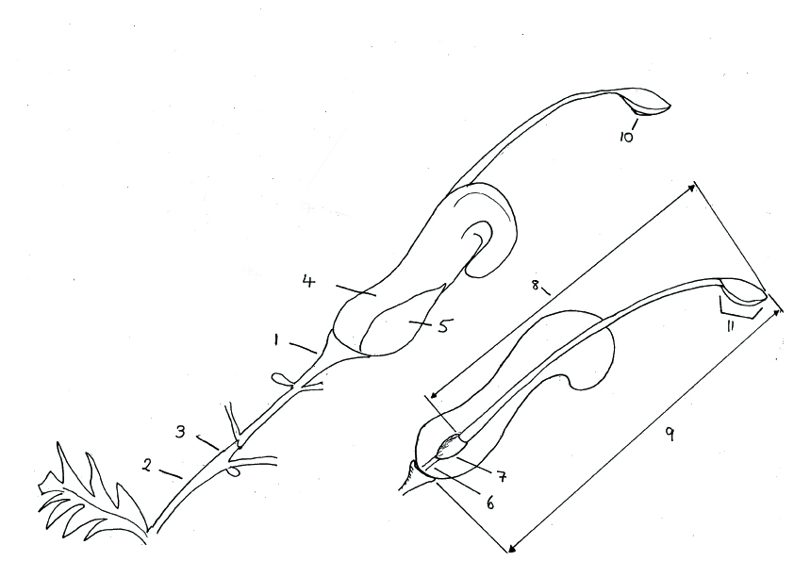 | 1 pedicel  2 peduncle  3 rachis  4 perianth  5 tepals  6 nectary  7 ovary  8 style  9 pistil  10 stigma  11 pollen presenter

8.2 Explanations for individual characteristics

Ad. 1: Plant habit

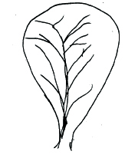 | 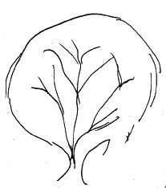 | 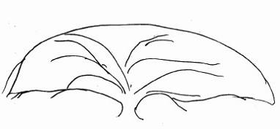 | 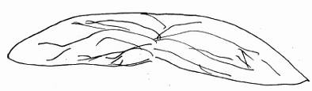
1 | 2 | 3 | 4
upright | bushy | spreading | prostrate

Ad. 5: Young stem color

Sometimes there is a waxy layer covering the stem surface which gives a bluish or whitish appearance. The layer should be removed by rubbing before observing stem color.

Ad. 6: Stem: color

Assessed on side least exposed to sun. Sometimes there is a waxy layer covering the stem surface which gives a bluish or whitish appearance. The layer should be removed by rubbing before observing stem color.

Ad. 9: Leaf: length
Ad. 10: Leaf: width

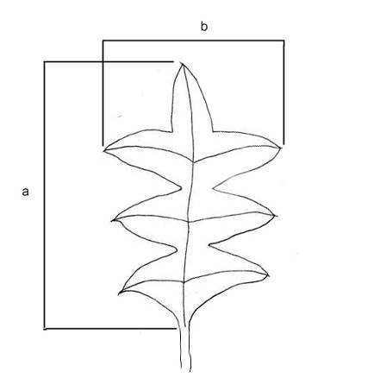 | a – leaf length, observed excluding petiole  b – leaf width, observed at widest point

Ad. 12: Leaf: margin in cross section

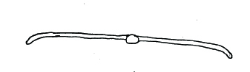 | 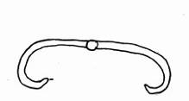 | 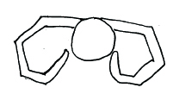 | 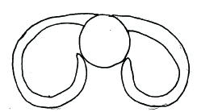
1 | 2 | 3 | 4
flat or slightly recurved | strongly recurved | angularly revolute to the mid vein | smoothly revolute to the mid vein

Ad. 13: Leaf: intensity of green color of upper side
Ad. 14: Leaf: color of lower side

Overall appearance of color with hairs present

Ad. 20: Leaf: blade shape

Varieties with division of blade absent only.
← broadest part →
below middle | at middle | above middle

broad (compressed) ← width (ratio length/width) → narrow (elongated) |  |  | 3  linear
 |  | 1  lanceolate | 4  oblong
 |  |  | 5  elliptic | 8  obovate
6
rhombic
7
circular

Ad. 21: Leaf: degree of division of blade
Ad. 22: Leaf: depth of division of blade
Ad. 23: Leaf: number of lobes
Ad. 24: Leaf: regularity of lobing
Ad. 25: Leaf: attitude of longitudinal axis of lobes to longitudinal axis of midrib
Ad. 28: Lobe: length
Ad. 29: Lobe: width

Varieties with division of blade present only.

Ad. 26: Leaf: shape of apex of sinus
Varieties with division of blade present only.

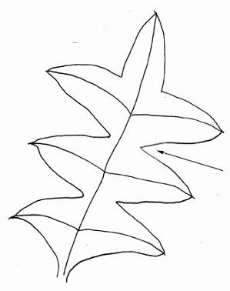 | 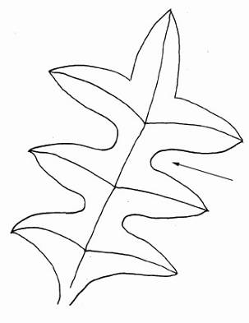 | 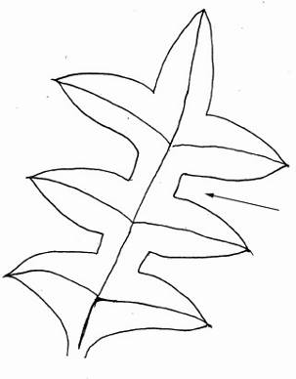
1 | 2 | 3
pointed | rounded | flattened

Ad. 27: Leaf: width of sinus

Observed on varieties with division of blade present and with rounded or flattened sinus.

Ad. 30: Leaf: shape of apex
Ad. 31: Leaf: differentiated tip

Observed on varieties with division of blade absent.

Ad. 37: Inflorescence: form

[Illustrations to be added]

Ad.38: Inflorescence: sequence of flower opening

[Illustrations to be added]

Ad. 45: Bud: attitude of limb in relation to longitudinal axis of bud

Observed during late bud prior to anthesis.

Ad. 59: Style: curvature

Observed after anthesis before dehiscence of perianth.

Literature

No literature.

Technical Questionnaire

TECHNICAL QUESTIONNAIRE |  |  |  | Page {x} of {y} |  | Reference Number:
 |  |  |  |  |  | Application date:
 |  |  |  |  |  | (not to be filled in by the applicant)
TECHNICAL QUESTIONNAIRE
to be completed in connection with an application for plant breeders’ rights

1. Subject of the Technical Questionnaire
1.1 Botanical name |  |  | Grevillea R. Br. corr. R. Br.
1.2 Common name |  |  | Grevillea
2. Applicant
Name
Address
Telephone No.
Fax No.
E-mail address
Breeder (if different from applicant)
3. Proposed denomination and breeder’s reference
Proposed denomination
(if available)

Breeder’s reference
#4. Information on the breeding scheme and propagation of the variety

  - Breeding scheme

Variety resulting from:

4.1.1 Crossing

(a) controlled cross [ ]
(please state parent varieties)

(…………………..……………..…) x (……………..…………………..…)
female parent male parent

(b) partially known cross [ ]
(please state known parent variety(ies))

(…………………..……………..…) x (……………..…………………..…)
female parent male parent

(c) unknown cross [ ]

4.1.2 Mutation [ ]
(please state parent variety)

4.1.3 Discovery and development [ ]
(please state where and when discovered and how developed)

4.1.4 Other [ ]”
(please provide details)”

4.2 Method of propagating the variety

{ GN 31 (Chapter 10: TQ 4.2) – information on method of propagating the variety }

Example 1

“4.2.1 Seed-propagated varieties

“(a) Self-pollination [ ]
“(b) Cross-pollination
(i) population [ ]
(ii) synthetic variety [ ]
“(c) Hybrid [ ]
{…see GN 32 for example...}
“(d) Other [ ]
(please provide details)”

“4.2.2 Vegetatively propagated varieties

{...see Example 2...} [... ... ...]

“4.2.3 Other [ ]”
(please provide details)”

Example 2

“4.2.1 Vegetative propagation

“(a) cuttings [ ]

“(b) in vitro propagation [ ]

“(c) other (state method) [ ]

“4.2.2 Seed [ ]

“4.2.3 Other [ ]”
(please provide details)”

{ GN 32 (Chapter 10: TQ 4.2) – information on method of propagation of hybrid varieties }

“In the case of hybrid varieties the production scheme for the hybrid should be provided on a separate sheet. This should provide details of all the parent lines required for propagating the hybrid e.g.

“Single Hybrid

(…………………..……………..) x (……………..…………………..)
female parent male parent

“Three-Way Hybrid

(…………………..……………..) x (……………..…………………..)
female line male line

(……………..…………………..) x (……………..…………………..)
single hybrid used as female parent male parent

“and should identify in particular:

“(a) any male sterile lines
“(b) maintenance system of male sterile lines.”
5. Characteristics of the variety to be indicated (the number in brackets refers to the corresponding characteristic in Test Guidelines; please mark the note which best corresponds).

 | Characteristics |  |  |  |  |  | Example Varieties |  |  | Note
6. Similar varieties and differences from these varieties

Please use the following table and box for comments to provide information on how your candidate variety differs from the variety (or varieties) which, to the best of your knowledge, is (or are) most similar. This information may help the examination authority to conduct its examination of distinctness in a more efficient way.

Denomination(s) of variety(ies) similar to your candidate variety |  | Characteristic(s) in which your candidate variety differs from the similar variety(ies) |  |  | Describe the expression of the characteristic(s) for the similar variety(ies) |  |  | Describe the expression of the characteristic(s) for your candidate variety
Example
Comments:

#7. Additional information which may help in the examination of the variety

7.1 In addition to the information provided in sections 5 and 6, are there any additional characteristics which may help to distinguish the variety?

Yes [ ] No [ ]

(If yes, please provide details)

7.2 Are there any special conditions for growing the variety or conducting the examination?

Yes [ ] No [ ]

(If yes, please provide details)

7.3 Other information

A representative color image of the variety should accompany the Technical Questionnaire.

8. Authorization for release

(a) Does the variety require prior authorization for release under legislation concerning the protection of the environment, human and animal health?

Yes [ ] No [ ]

(b) Has such authorization been obtained?

Yes [ ] No [ ]

If the answer to (b) is yes, please attach a copy of the authorization.

9. Information on plant material to be examined or submitted for examination.

9.1 The expression of a characteristic or several characteristics of a variety may be affected by factors, such as pests and disease, chemical treatment (e.g. growth retardants or pesticides), effects of tissue culture, different rootstocks, scions taken from different growth phases of a tree, etc.

9.2 The plant material should not have undergone any treatment which would affect the expression of the characteristics of the variety, unless the competent authorities allow or request such treatment. If the plant material has undergone such treatment, full details of the treatment must be given. In this respect, please indicate below, to the best of your knowledge, if the plant material to be examined has been subjected to:

(a) Microorganisms (e.g. virus, bacteria, phytoplasma) Yes [ ] No [ ]

(b) Chemical treatment (e.g. growth retardant, pesticide) Yes [ ] No [ ]

(c) Tissue culture Yes [ ] No [ ]

(d) Other factors Yes [ ] No [ ]

Please provide details for where you have indicated “yes”.

……………………………………………………………

{ ASW 17 (Chapter 10: TQ 9.3) – tests for the presence of virus or other pathogens }

“9.3 Has the plant material to be examined been tested for the presence of virus or other pathogens?

Yes [ ]
(please provide details as specified by the Authority)

No [ ]”

10. I hereby declare that, to the best of my knowledge, the information provided in this form is correct:

Applicant’s name

Signature Date

[End of document]

* These names were correct at the time of the introduction of these Test Guidelines but may be revised or updated. [Readers are advised to consult the UPOV Code, which can be found on the UPOV Website (www.upov.int), for the latest information.]
# Authorities may allow certain of this information to be provided in a confidential section of the Technical Questionnaire.
# Authorities may allow certain of this information to be provided in a confidential section of the Technical Questionnaire.

