 |  |  |  |  |  |  | E  TG/COSMO(proj.5)  ORIGINAL: English  DATE: 2013-03-08
INTERNATIONAL UNION FOR THE PROTECTION OF NEW VARIETIES OF PLANTS
Geneva
 |  |  | DRAFT
 |  | COSMOS  UPOV Code: COSMO  Cosmos Cav. |  |  | *

GUIDELINES

FOR THE CONDUCT OF TESTS

FOR DISTINCTNESS, UNIFORMITY AND STABILITY

prepared by experts from Japan

to be considered by the
Technical Working Party for Ornamental Plants and Forest Trees
at its forty-sixth session, to be held in Melbourne, Australia, from April 22 to 26, 2013

Alternative Names:*

Botanical name | English | French | German | Spanish
Cosmos Cav. | Cosmos | Cosmos | Kosmee,Schmuckkörbchen | Cosmos

The purpose of these guidelines (“Test Guidelines”) is to elaborate the principles contained in the General Introduction (document TG/1/3), and its associated TGP documents, into detailed practical guidance for the harmonized examination of distinctness, uniformity and stability (DUS) and, in particular, to identify appropriate characteristics for the examination of DUS and production of harmonized variety descriptions.

ASSOCIATED DOCUMENTS
These Test Guidelines should be read in conjunction with the General Introduction and its associated TGP documents.
TABLE OF CONTENTS PAGE

1. Subject of these Test Guidelines 3
2. Material Required 3
3. Method of Examination 3
3.1 Number of Growing Cycles 3
3.2 Testing Place 3
3.3 Conditions for Conducting the Examination 3
3.4 Test Design 3
3.5 Additional Tests 4
4. Assessment of Distinctness, Uniformity and Stability 4
4.1 Distinctness 4
4.2 Uniformity 5
4.3 Stability 5
5. Grouping of Varieties and Organization of the Growing Trial 5
6. Introduction to the Table of Characteristics 6
6.1 Categories of Characteristics 6
6.2 States of Expression and Corresponding Notes 6
6.3 Types of Expression 7
6.4 Example Varieties 7
6.5 Legend 7
7. Table of Characteristics/Tableau des caractères/Merkmalstabelle/Tabla de caracteres 8
8. Explanations on the Table of Characteristics 14
8.1 Explanations covering several characteristics 14
8.2 Explanations for individual characteristics 14
9. Literature 23
10. Technical Questionnaire 24

ANNEX ANSWER TO COMMENTS FROM SUBGROUP FOR TG/COSMO(PROJ.5)

Subject of these Test Guidelines

These Test Guidelines apply to all varieties of Cosmos Cav..

Material Required

2.1 The competent authorities decide on the quantity and quality of the plant material required for testing the variety and when and where it is to be delivered. Applicants submitting material from a State other than that in which the testing takes place must ensure that all customs formalities and phytosanitary requirements are complied with.

2.2 The material is to be supplied in the form of seeds or young plants.

2.3 The minimum quantity of plant material, to be supplied by the applicant, should be:

seed propagagted varieties: sufficient seeds to produce 50 plants;
vegetatively propagated varieties: 10 young plants

In the case of seed, the seed should meet the minimum requirements for germination, species and analytical purity, health and moisture content, specified by the competent authority.

2.4 The plant material supplied should be visibly healthy, not lacking in vigor, nor affected by any important pest or disease.

2.5 The plant material should not have undergone any treatment which would affect the expression of the characteristics of the variety, unless the competent authorities allow or request such treatment. If it has been treated, full details of the treatment must be given.

Method of Examination

3.1 Number of Growing Cycles

The minimum duration of tests should normally be a single growing cycle.

3.2 Testing Place

Tests are normally conducted at one place. In the case of tests conducted at more than one place, guidance is provided in TGP/9 “Examining Distinctness”.

3.3 Conditions for Conducting the Examination

3.3.1 The tests should be carried out under conditions ensuring satisfactory growth for the expression of the relevant characteristics of the variety and for the conduct of the examination.

3.3.2 Because daylight varies, color determinations made against a color chart should be made either in a suitable cabinet providing artificial daylight or in the middle of the day in a room without direct sunlight. The spectral distribution of the illuminant for artificial daylight should conform with the CIE Standard of Preferred Daylight D 6500 and should fall within the tolerances set out in the British Standard 950, Part I. These determinations should be made with the plant part placed against a white background. The color chart and version used should be specified in the variety description.

3.4 Test Design

3.4.1 Each test should be designed to result in a total of at least 50 plants for seed propagated varieties or 10 plants for vegetatively propagated varieties.

3.4.2 The design of the tests should be such that plants or parts of plants may be removed for measurement or counting without prejudice to the observations which must be made up to the end of the growing cycle.”

3.5 Additional Tests

Additional tests, for examining relevant characteristics, may be established.

Assessment of Distinctness, Uniformity and Stability

4.1 Distinctness

4.1.1 General Recommendations

It is of particular importance for users of these Test Guidelines to consult the General Introduction prior to making decisions regarding distinctness. However, the following points are provided for elaboration or emphasis in these Test Guidelines.

4.1.2 Consistent Differences

The differences observed between varieties may be so clear that more than one growing cycle is not necessary. In addition, in some circumstances, the influence of the environment is not such that more than a single growing cycle is required to provide assurance that the differences observed between varieties are sufficiently consistent. One means of ensuring that a difference in a characteristic, observed in a growing trial, is sufficiently consistent is to examine the characteristic in at least two independent growing cycles.

4.1.3 Clear Differences

Determining whether a difference between two varieties is clear depends on many factors, and should consider, in particular, the type of expression of the characteristic being examined, i.e. whether it is expressed in a qualitative, quantitative, or pseudo-qualitative manner. Therefore, it is important that users of these Test Guidelines are familiar with the recommendations contained in the General Introduction prior to making decisions regarding distinctness.

4.1.4 Number of Plants / Parts of Plants to be Examined

Unless otherwise indicated, for the purposes of distinctness, all observations on single plants should be made on 20 plants or parts taken from each of 20 plants for seed propagated varieties or 9 plants or parts taken from each of 9 plants for vegetatively propagated varieties and any other observations made on all plants in the test, disregarding any off-type plants.

4.1.5 Method of Observation

The recommended method of observing the characteristic for the purposes of distinctness is indicated by the following key in the second column of the Table of Characteristics (see document TGP/9 “Examining Distinctness”, Section 4 “Observation of characteristics”):

MG: single measurement of a group of plants or parts of plants
MS: measurement of a number of individual plants or parts of plants
VG: visual assessment by a single observation of a group of plants or parts of plants
VS: visual assessment by observation of individual plants or parts of plants

Type of observation: visual (V) or measurement (M)

“Visual” observation (V) is an observation made on the basis of the expert’s judgment. For the purposes of this document, “visual” observation refers to the sensory observations of the experts and, therefore, also includes smell, taste and touch. Visual observation includes observations where the expert uses reference points (e.g. diagrams, example varieties, side-by-side comparison) or non-linear charts (e.g. color charts). Measurement (M) is an objective observation against a calibrated, linear scale e.g. using a ruler, weighing scales, colorimeter, dates, counts, etc.

Type of record: for a group of plants (G) or for single, individual plants (S)

For the purposes of distinctness, observations may be recorded as a single record for a group of plants or parts of plants (G), or may be recorded as records for a number of single, individual plants or parts of plants (S). In most cases, “G” provides a single record per variety and it is not possible or necessary to apply statistical methods in a plant-by-plant analysis for the assessment of distinctness.

In cases where more than one method of observing the characteristic is indicated in the Table of Characteristics (e.g. VG/MG), guidance on selecting an appropriate method is provided in document TGP/9, Section 4.2.

4.2 Uniformity

4.2.1 It is of particular importance for users of these Test Guidelines to consult the General Introduction prior to making decisions regarding uniformity. However, the following points are provided for elaboration or emphasis in these Test Guidelines:

(a) seed-propagated varieties

4.2.2 The assessment of uniformity should be according to the recommendations for seed-propagated varieties in the General Introduction.

(b) vegetatively propagated varieties

4.2.3 For the assessment of uniformity, a population standard of 1 % and an acceptance probability of at least 95 % should be applied. In the case of a sample size of 10 plants, 1 off-type is allowed.

4.3 Stability

4.3.1 In practice, it is not usual to perform tests of stability that produce results as certain as those of the testing of distinctness and uniformity. However, experience has demonstrated that, for many types of variety, when a variety has been shown to be uniform, it can also be considered to be stable.

4.3.2 Where appropriate, or in cases of doubt, stability may be further examined by testing a new seed or plant stock to ensure that it exhibits the same characteristics as those shown by the initial material supplied.

Grouping of Varieties and Organization of the Growing Trial

5.1 The selection of varieties of common knowledge to be grown in the trial with the candidate varieties and the way in which these varieties are divided into groups to facilitate the assessment of distinctness are aided by the use of grouping characteristics.

5.2 Grouping characteristics are those in which the documented states of expression, even where produced at different locations, can be used, either individually or in combination with other such characteristics: (a) to select varieties of common knowledge that can be excluded from the growing trial used for examination of distinctness; and (b) to organize the growing trial so that similar varieties are grouped together.

5.3 The following have been agreed as useful grouping characteristics:

(a) Flower head: disc type (characteristic 13)
(b) Flower head: collar segments (characteristic 14)
(c) Ray floret: type (characteristic 19)
(d) Ray floret: main color of inner side (characteristic 26) with the following color groups :
Gr. 1: white
Gr. 2: yellow
Gr. 3: orange
Gr. 4: pink
Gr. 5: red
Gr. 6: purple red
Gr. 7: brown red

(e) Ray floret: secondary color of inner side (characteristic 27) with the following color groups :
Gr. 1: white
Gr. 2: yellow
Gr. 3: orange
Gr. 4: pink
Gr. 5: red
Gr. 6: purple red
Gr. 7: brown red

(f) Ray floret: distribution of secondary color of inner side (characteristic 28)

5.4 Guidance for the use of grouping characteristics, in the process of examining distinctness, is provided through the General Introduction and document TGP/9 “Examining Distinctness”.

Introduction to the Table of Characteristics

6.1 Categories of Characteristics

6.1.1 Standard Test Guidelines Characteristics

Standard Test Guidelines characteristics are those which are approved by UPOV for examination of DUS and from which members of the Union can select those suitable for their particular circumstances.

6.1.2 Asterisked Characteristics

Asterisked characteristics (denoted by *) are those included in the Test Guidelines which are important for the international harmonization of variety descriptions and should always be examined for DUS and included in the variety description by all members of the Union, except when the state of expression of a preceding characteristic or regional environmental conditions render this inappropriate.

6.2 States of Expression and Corresponding Notes

6.2.1 States of expression are given for each characteristic to define the characteristic and to harmonize descriptions. Each state of expression is allocated a corresponding numerical note for ease of recording of data and for the production and exchange of the description.

6.2.2 In the case of qualitative and pseudo-qualitative characteristics (see Chapter 6.3), all relevant states of expression are presented in the characteristic. However, in the case of quantitative characteristics with 5 or more states, an abbreviated scale may be used to minimize the size of the Table of Characteristics. For example, in the case of a quantitative characteristic with 9 states, the presentation of states of expression in the Test Guidelines may be abbreviated as follows:

State | Note
small | 3
medium | 5
large | 7

However, it should be noted that all of the following 9 states of expression exist to describe varieties and should be used as appropriate:

State | Note
very small | 1
very small to small | 2
small | 3
small to medium | 4
medium | 5
medium to large | 6
large | 7
large to very large | 8
very large | 9

6.2.3 Further explanation of the presentation of states of expression and notes is provided in document TGP/7 “Development of Test Guidelines”.

6.3 Types of Expression

An explanation of the types of expression of characteristics (qualitative, quantitative and pseudo-qualitative) is provided in the General Introduction.

6.4 Example Varieties

Where appropriate, example varieties are provided to clarify the states of expression of each characteristic.

6.5 Legend

(*) Asterisked characteristic – see Chapter 6.1.2

QL Qualitative characteristic – see Chapter 6.3
QN Quantitative characteristic – see Chapter 6.3
PQ Pseudo-qualitative characteristic – see Chapter 6.3

MG, MS, VG, VS – see Chapter 4.1.5

(a)-(c) See Explanations on the Table of Characteristics in Chapter 8.1

(+) See Explanations on the Table of Characteristics in Chapter 8.2.

Table of Characteristics/Tableau des caractères/Merkmalstabelle/Tabla de caracteres

 |  | English | français | deutsch | español | Example Varieties  Exemples  Beispielssorten  Variedades ejemplo | Note/  Nota
1  (+) | VG | Plant: growth habit
PQ |  | erect |  |  |  |  | 1
 |  | semi-erect |  |  |  |  | 2
 |  | spreading |  |  |  |  | 3
2  (*) | VG/MS | Plant: height
QN |  | short |  |  |  | Sunny Yellow | 3
 |  | medium |  |  |  | Sunset | 5
 |  | tall |  |  |  | Sensation Radiance | 7
3  (+) | VG/MS | Stem: number of primary branches
QN |  | few |  |  |  | Sunset | 3
 |  | medium |  |  |  |  | 5
 |  | many |  |  |  | Sensation Radiance | 7
4  (*) | VG | Stem: anthocyanin coloration
QN |  | absent or very weak |  |  |  | Sunny Yellow | 1
 |  | weak |  |  |  |  | 2
 |  | medium |  |  |  | Sunset | 3
 |  | strong |  |  |  |  | 4
5. | VG | Stem: pubescence
QN |  | absent or sparse |  |  |  | Sunrise | 1
 |  | medium |  |  |  | Orange Flare | 2
 |  | dense |  |  |  |  | 3
6.  (*)  (+) | VG/MS | Leaf: length
QN | (a) | short |  |  |  | Sunrise | 3
 |  | medium |  |  |  | Sensation Radiance | 5
 |  | long |  |  |  |  | 7
7.  (*)  (+) | VG/MS | Leaf: width
QN | (a) | narrow |  |  |  | Sunrise | 3
 |  | medium |  |  |  |  | 5
 |  | broad |  |  |  | Sensation Radiance | 7
8. | VG | Leaf: intensity of green color
QN | (a) | light |  |  |  |  | 1
 |  | medium |  |  |  | Sunset | 2
 |  | dark |  |  |  |  | 3
9.  (+) | VG | Leaf: number of lobes
QN | (a) | absent or very few |  |  |  |  | 1
 |  | few |  |  |  |  | 2
 |  | medium |  |  |  |  | 3
 |  | many |  |  |  |  | 4
 |  | very many |  |  |  |  | 5
10.  (+) | VG/MS | Only for divided leaves: Leaf: width of terminal lobe
QN | (a) | narrow |  |  |  |  | 3
 |  | medium |  |  |  | Sunrise | 5
 |  | broad |  |  |  |  | 7
11.  (+) | VG | Flower head: attitude
QN |  | upward |  |  |  |  | 1
 |  | outward |  |  |  |  | 2
 |  | downward |  |  |  |  | 3
12.  (*)  (+) | VG/MS | Flower head: number of ray florets
QN |  | very few |  |  |  |  | 1
 |  | few |  |  |  | Sunset | 2
 |  | medium |  |  |  |  | 3
 |  | many |  |  |  | Double Click | 4
 |  | very many |  |  |  |  | 5
13.  (*)  (+) | VG | Flower head: disc type
QL |  | daisy |  |  |  |  | 1
 |  | anemone |  |  |  | Bridal Bouquet COS | 2
14.  (*)  (+) | VG | Flower head: collar segments
QL |  | absent |  |  |  |  | 1
 |  | present |  |  |  | Red Illusion | 9
15.  (*)  (+) | VG/MS | Flower head: diameter
QN |  | small |  |  |  | Sunrise | 3
 |  | medium |  |  |  |  | 5
 |  | large |  |  |  | Sensation Radiance | 7
16.  (+) | VG/ MS | Flower head: disc diameter
QN |  | very small |  |  |  |  | 1
 |  | small |  |  |  | Sensation Radiance | 2
 |  | medium |  |  |  |  | 3
 |  | large |  |  |  | Bridal Bouquet COS | 4
 |  | very large |  |  |  |  | 5
17.  (*)  (+) | VG/MS | Flower head: disc diameter relative to flower head diameter
QN |  | very small |  |  |  |  | 1
 |  | small |  |  |  | Sensation Radiance | 2
 |  | medium |  |  |  |  | 3
 |  | large |  |  |  | Bridal Bouquet COS | 4
 |  | very large |  |  |  |  | 5
18. | VG/MS | Flower head: length of peduncle
QN |  | short |  |  |  |  | 3
 |  | medium |  |  |  |  | 5
 |  | long |  |  |  |  | 7
19.  (*)  (+) | VG | Ray floret: type
PQ |  | ligulate |  |  |  |  | 1
 |  | ligulate and tubular |  |  |  |  | 2
 |  | tubular |  |  |  |  | 3
20.  (+) | VG | Ray floret: longitudinal axis
QN | (b) | incurved |  |  |  |  | 1
 |  | straight |  |  |  |  | 2
 |  | reflex |  |  |  |  | 3
21.  (+) | VG | Ray floret: degree of curvature (straight florets excluded)
QN | (b) | weak |  |  |  |  | 1
 |  | medium |  |  |  |  | 2
 |  | strong |  |  |  |  | 3
22.  (+) | VG | Ray floret: curved part of axis (straight florets excluded)
PQ | (b) | tip |  |  |  |  | 1
 |  | distal quarter |  |  |  |  | 2
 |  | distal half |  |  |  |  | 3
 |  | distal three quarter |  |  |  |  | 4
 |  | at base only |  |  |  |  | 5
 |  | entire length |  |  |  |  | 6
23.  (*)  (+) | VG/ MS | Ray floret: length
QN | (b) | short |  |  |  | Sunset | 3
 |  | medium |  |  |  |  | 5
 |  | long |  |  |  | Sensation Radiance | 7
24.  (*)  (+) | VG/ MS | Ray floret: width
QN | (b) | narrow |  |  |  | Sunset | 3
 |  | medium |  |  |  | Sensation Radiance | 5
 |  | broad |  |  |  |  | 7
25.  (*)  (+) | VG/ MS | Ray floret: ratio length/ width
QN | (b) | low |  |  |  |  | 3
 |  | medium |  |  |  | Sensation Radiance | 5
 |  | high |  |  |  | Happy Ring | 7
26.  (*)  (+) | VG | Ray floret: main color of inner side
PQ | (b)  (c) | RHS Colour Chart (indicate reference number)
27.  (*)  (+) | VG | Ray floret: secondary color of inner side
PQ | (b) (c) | RHS Colour Chart (indicate reference number)
28.  (*)  (+) | VG | Ray floret: distribution of secondary color of inner side
PQ | (b) | basal zone |  |  |  |  | 1
 | (c) | basal quarter |  |  |  |  | 2
 |  | basal half |  |  |  |  | 3
 |  | distal half |  |  |  |  | 4
 |  | distal quarter |  |  |  |  | 5
 |  | tip |  |  |  |  | 6
 |  | band |  |  |  |  | 7
 |  | marginal zone |  |  |  |  | 8
 |  | central zone |  |  |  |  | 9
 |  | throughout |  |  |  |  | 10
29.  (+) | VG | Ray floret: pattern of secondary color of inner side
PQ | (b) | solid or nearly solid |  |  |  |  | 1
 | (c) | flushed |  |  |  |  | 2
 |  | striped |  |  |  |  | 3
30.  (+) | VG | Ray floret: tertiary color of inner side
PQ | (b) (c) | RHS Colour Chart (indicate reference number)
31.  (+) | VG | Ray floret: distribution of tertiary color of inner side
PQ | (b) | basal zone |  |  |  |  | 1
 | (c) | basal quarter |  |  |  |  | 2
 |  | basal half |  |  |  |  | 3
 |  | distal half |  |  |  |  | 4
 |  | distal quarter |  |  |  |  | 5
 |  | tip |  |  |  |  | 6
 |  | band |  |  |  |  | 7
 |  | marginal zone |  |  |  |  | 8
 |  | central zone |  |  |  |  | 9
 |  | throughout |  |  |  |  | 10
32.  (+) | VG | Ray floret: pattern of tertiary color of inner side
PQ | (b) | solid or nearly solid |  |  |  |  | 1
 | (c) | flushed |  |  |  |  | 2
 |  | striped |  |  |  |  | 3
33.  (*)  (+) | VG | Ray floret: main color of outer side
PQ | (b) (c) | RHS Colour Chart (indicate reference number)
34.  (*)  (+) | VG | Ray floret: incisions of apex
QN | (b) | absent or very shallow |  |  |  |  | 1
 |  | shallow |  |  |  |  | 3
 |  | medium |  |  |  | Sensation Radiance, Sunset | 5
 |  | deep |  |  |  |  | 7
35.  (*)  (+) | VG | Disc: main color
PQ |  | RHS Colour Chart (indicate reference number)

Explanations on the Table of Characteristics

8.1 Explanations covering several characteristics

Characteristics containing the following key in the second column of the Table of Characteristics should be examined as indicated below:

Observations should be made at the time of full flowering.

(a) Leaf characteristics should be observed on the leaves from the middle third of the stem.
(b) Ray floret should be observed on the outermost row of ray florets.
(c) The main color is the color with the largest surface area. In cases where the areas of the main and secondary color are too similar to reliably decide which color has the largest area, the darkest color is considered to be the main color.

8.2 Explanations for individual characteristics

Ad. 1: Plant: growth habit

1 | 2 | 3
erect | semi-erect | spreading

Ad. 3: Stem: number of primary branches

Primary branches should be observed on the branches indicated by arrow of following diagram.

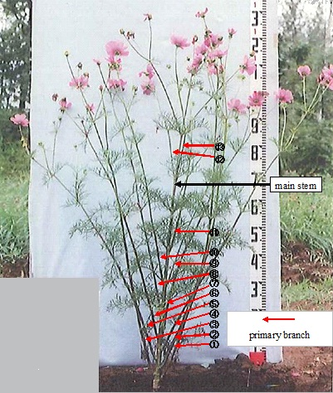

Ad. 6: Leaf: length
Ad. 7: Leaf: width

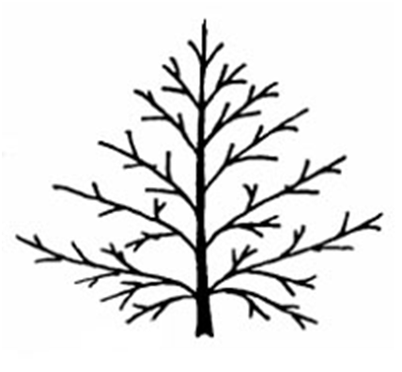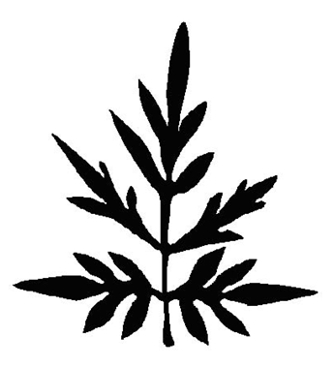
Leaf: width
Leaf: length
Leaf: width
Leaf: length
Ad. 9: Leaf: number of lobes

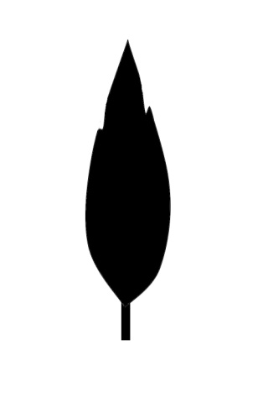
1
absent or very few
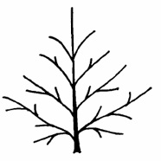
2
few
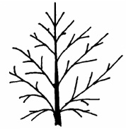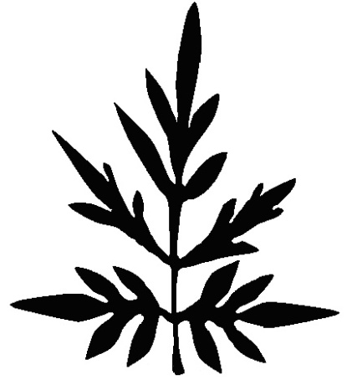
3
medium
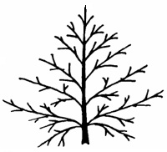
4
many
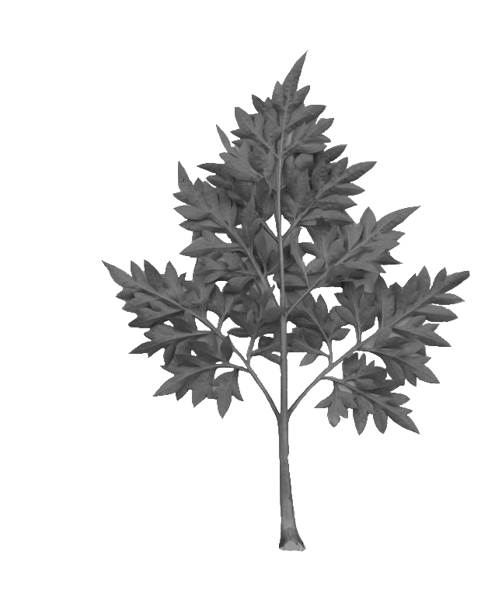
5
very many
Ad. 10: Only for divided leaves: Leaf: width of terminal lobe

Ad. 11: Flower head: attitude

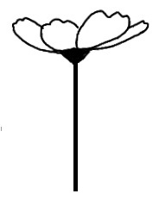 | 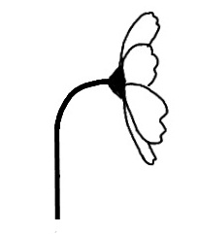 | 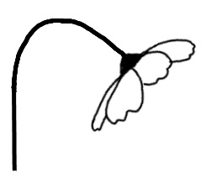
1 | 2 | 3
upward | outward | downward

Ad. 12: Flower head: number of ray florets

In varieties with collar segments the number of ray florets should be observed excluding the collar segments.

Ad. 13: Flower head: disc type

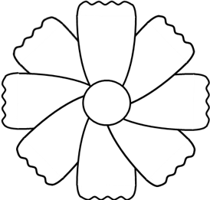 | 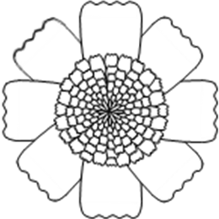
1 | 2
daisy | anemone
Ad. 14: Flower head: collar segments

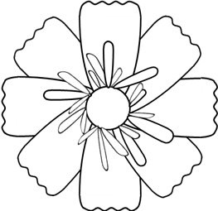
collar segments

Ad. 15: Flower head: diameter
Ad. 16: Flower head: disc diameter
Ad. 17: Flower head: disc diameter relative to flower head diameter

a: flower head diameter
b: disc diameter
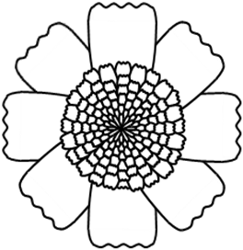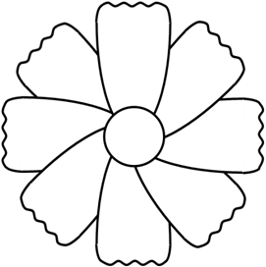
b
a
b
a

Ad. 16: Flower head: disc diameter

In varieties with collar segments the disc diameter should be observed excluding the collar segments.

Ad. 19: Ray floret: type

 | 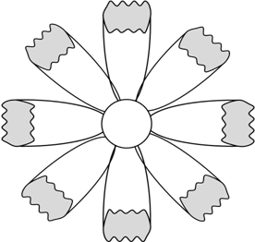
1 | 3
ligulate | tubular

Ad. 20: Ray floret: longitudinal axis
1
ligulate

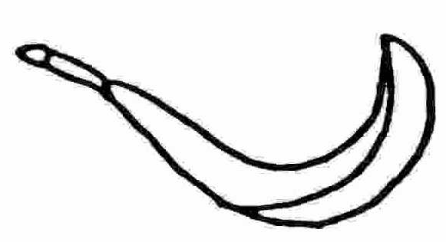 | 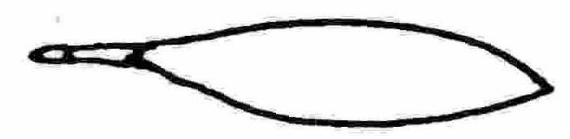 | 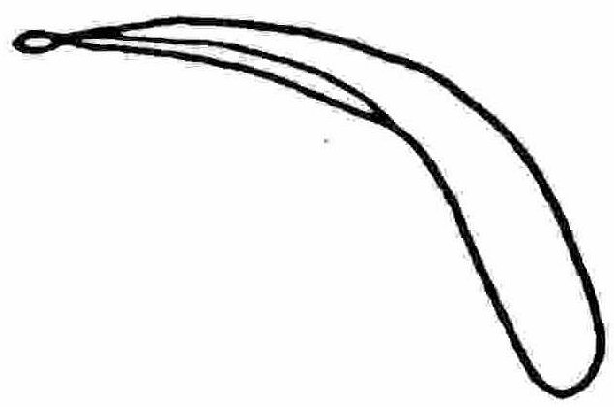
1 | 2 | 3
incurved | straight | reflex

Ad. 21: Ray floret: degree of curvature (straight florets excluded)

1 | 2 | 3
weak | medium | strong

Ad. 22: Ray floret: curved part of axis (straight florets excluded)

1
tip
2
distal quarter
3
distal half
4
distal three quarter
5
at base only
6
entire length
Ad. 23: Ray floret: length
Ad. 24: Ray floret: width
Ray floret: length
Ray floret:
width
Ray floret: length
Ray floret:
width
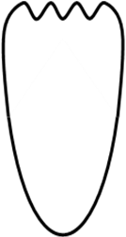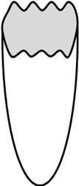

Ad. 25: Ray floret: ratio length/width

Ray floret:
length
3
low
5
medium
7
high
Ray floret: width
Ray floret: width
Ray floret: width
Ray floret:
length
Ray floret:
length

Ad. 28: Ray floret: distribution of secondary color of inner side
Ad. 31: Ray floret: distribution of tertiary color of inner side

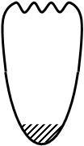 | 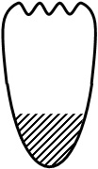 | 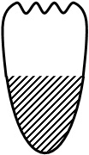 | 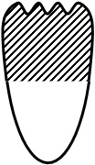 | 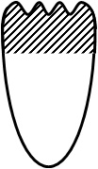
1 | 2 | 3 | 4 | 5
basal zone | basal quarter | basal half | distal half | distal quarter

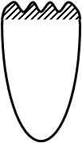 | 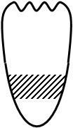 | 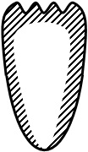 | 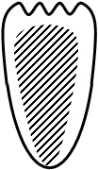 | 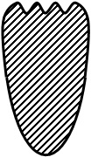
6 | 7 | 8 | 9 | 10
tip | band | marginal zone | central zone | throughout

Ad. 29: Ray floret: pattern of second color of inner side
Ad. 32: Ray floret: pattern of tertiary color of inner side

 |  | 
1 | 2 | 3
solid or nearly solid | flushed | striped

Ad. 34: Ray floret:incisions of apex

3 | 5 | 7
shallow | medium | deep
Ad. 35: Disc: main color

The color of disc should be observed at just before anther dehiscence in daisy type,at full flower in anemone type.

Literature
L. H. Bailey Hortorium, Cornell University,1976: Hortus Third,A Concise Dictionary of Plants Cultivated in the U.S. and Canada the staff of the L. H. Bailey Hortorium, Cormell University.Macmillan Publishing Co.,NewYork,P321.

The Royal Horticultural Society,1999: Dictionary of Gardening

Thomas H. Everett,1980: New York Botanical Garden Illustrated Encyclopedia of Horticulture

Tsukamoto, Y., 1994: The Grand Dictionary of Horticulture Volume 1. The Shogakukan Ltd., Tokyo, JP, pp. 860 to 862.

Technical Questionnaire

TECHNICAL QUESTIONNAIRE |  |  |  | Page {x} of {y} |  | Reference Number:
 |  |  |  |  |  | Application date:
 |  |  |  |  |  | (not to be filled in by the applicant)
TECHNICAL QUESTIONNAIRE
to be completed in connection with an application for plant breeders’ rights

1. Subject of the Technical Questionnaire
1.1 Genus |  |  | Cosmos Cav.
1.2 Species
(please complete)
1.2.1 Botanical name
1.2.2 Common name
2. Applicant
Name
Address
Telephone No.
Fax No.
E-mail address
Breeder
(if different from applicant)
3. Proposed denomination and breeder’s reference
Proposed denomination
(if available)

Breeder’s reference
#4. Information on the breeding scheme and propagation of the variety

4.1 Breeding scheme

Variety resulting from

4.1.1 Crossing

(a) controlled cross [ ]
(please state parent varieties)

(…………………..……………..…) x (……………..…………………..…)
female parent male parent

(b) partially known cross [ ]
(please state known parent variety(ies))

(…………………..……………..…) x (……………..…………………..…)
female parent male parent

(c) unknown cross [ ]

4.1.2 Mutation [ ]
(please state parent variety)

4.1.3 Discovery and development [ ]
(please state where and when discovered and how developed)

4.1.4 Other [ ]
(please provide details)

4.2 Method of propagating the variety

4.2.1 Seed-propagated varieties

(a) Self-pollination [ ]
(b) Cross-pollination
(i) population [ ]
(ii) synthetic variety [ ]
(c) Hybrid [ ]
(d) Other [ ]
(please provide details)”

4.2.2 Vegetatively propagated varieties

(a) cuttings [ ]

(b) in vitro propagation [ ]

(c) other (state method) [ ]

4.2.3 Other [ ]”
(please provide details)

5. Characteristics of the variety to be indicated (the number in brackets refers to the corresponding characteristic in Test Guidelines; please mark the note which best corresponds).

 | Characteristics |  |  |  |  |  | Example Varieties |  |  | Note
5.1  (13) | Flower head: disc type
 | daisy |  |  |  |  |  |  |  |  | 1[ ]
 | anemone |  |  |  |  |  | Bridal Bouquet COS |  |  | 2[ ]
5.2  (14) | Flower head: collar segments
 | absent |  |  |  |  |  |  |  |  | 1[ ]
 | present |  |  |  |  |  | Red Illusion |  |  | 9[ ]
5.3  (19) | Ray floret:type
 | ligulate |  |  |  |  |  |  |  |  | 1[ ]
 | ligulate and tublar |  |  |  |  |  |  |  |  | 2[ ]
 | tubular |  |  |  |  |  |  |  |  | 3[ ]
5.4(i)  (26) | Ray floret: main color of inner side
 | RHS Colour Chart (indicate reference number)
5.4(ii)  (26) | Ray floret: main color of inner side
 | white |  |  |  |  |  |  |  |  | 1[ ]
 | yellow |  |  |  |  |  |  |  |  | 2[ ]
 | orange |  |  |  |  |  |  |  |  | 3[ ]
 | pink |  |  |  |  |  |  |  |  | 4[ ]
 | red |  |  |  |  |  |  |  |  | 5[ ]
 | red purple |  |  |  |  |  |  |  |  | 6[ ]
 | brown red |  |  |  |  |  |  |  |  | 7[ ]
 | other color(indicate) |  |  |  |  |  |  |  |  | 8[ ]
 | Characteristics |  |  |  |  |  | Example Varieties |  |  | Note
5.5(i)  (27) | Ray floret: secondary color of inner side
 | RHS Colour Chart (indicate reference number)
5.5(ii)  (27) | Ray floret: secondary color of inner side
 | white |  |  |  |  |  |  |  |  | 1[ ]
 | yellow |  |  |  |  |  |  |  |  | 2[ ]
 | orange |  |  |  |  |  |  |  |  | 3[ ]
 | pink |  |  |  |  |  |  |  |  | 4[ ]
 | red |  |  |  |  |  |  |  |  | 5[ ]
 | red purple |  |  |  |  |  |  |  |  | 6[ ]
 | brown red |  |  |  |  |  |  |  |  | 7[ ]
 | other color(indicate) |  |  |  |  |  |  |  |  | 8[ ]
5.6  (28) | Ray floret: distribution of secondary color of inner side
 | basal zone |  |  |  |  |  |  |  |  | 1[ ]
 | basal quarter |  |  |  |  |  |  |  |  | 2[ ]
 | basal half |  |  |  |  |  |  |  |  | 3[ ]
 | distal half |  |  |  |  |  |  |  |  | 4[ ]
 | distal quarter |  |  |  |  |  |  |  |  | 5[ ]
 | tip |  |  |  |  |  |  |  |  | 6[ ]
 | band |  |  |  |  |  |  |  |  | 7[ ]
 | marginal zone |  |  |  |  |  |  |  |  | 8[ ]
 | central zone |  |  |  |  |  |  |  |  | 9[ ]
 | throughout |  |  |  |  |  |  |  |  | 10[ ]
6. Similar varieties and differences from these varieties

Please use the following table and box for comments to provide information on how your candidate variety differs from the variety (or varieties) which, to the best of your knowledge, is (or are) most similar. This information may help the examination authority to conduct its examination of distinctness in a more efficient way.

Denomination(s) of variety(ies) similar to your candidate variety |  | Characteristic(s) in which your candidate variety differs from the similar variety(ies) |  |  | Describe the expression of the characteristic(s) for the similar variety(ies) |  |  | Describe the expression of the characteristic(s) for your candidate variety
Example |  | Plant: growth habit |  |  | erect |  |  | semi-erect
Comments:

#7. Additional information which may help in the examination of the variety

7.1 In addition to the information provided in sections 5 and 6, are there any additional characteristics which may help to distinguish the variety?

Yes [ ] No [ ]

(If yes, please provide details)

7.2 Are there any special conditions for growing the variety or conducting the examination?

Yes [ ] No [ ]

(If yes, please provide details)

7.3 Other information

A representative color image of the variety should accompany the Technical Questionnaire.

8. Authorization for release

(a) Does the variety require prior authorization for release under legislation concerning the protection of the environment, human and animal health?

Yes [ ] No [ ]

(b) Has such authorization been obtained?

Yes [ ] No [ ]

If the answer to (b) is yes, please attach a copy of the authorization.

9. Information on plant material to be examined or submitted for examination.

9.1 The expression of a characteristic or several characteristics of a variety may be affected by factors, such as pests and disease, chemical treatment (e.g. growth retardants or pesticides), effects of tissue culture, different rootstocks, scions taken from different growth phases of a tree, etc.

9.2 The plant material should not have undergone any treatment which would affect the expression of the characteristics of the variety, unless the competent authorities allow or request such treatment. If the plant material has undergone such treatment, full details of the treatment must be given. In this respect, please indicate below, to the best of your knowledge, if the plant material to be examined has been subjected to:

(a) Microorganisms (e.g. virus, bacteria, phytoplasma) Yes [ ] No [ ]

(b) Chemical treatment (e.g. growth retardant, pesticide) Yes [ ] No [ ]

(c) Tissue culture Yes [ ] No [ ]

(d) Other factors Yes [ ] No [ ]

Please provide details for where you have indicated “yes”.

……………………………………………………………

10. I hereby declare that, to the best of my knowledge, the information provided in this form is correct:

Applicant’s name

Signature Date

[Annex follows]
Answer to comments from subgroup for TG/COSMO(proj.5) |  |  |  |  | 2013.3.8
Section | Char. no | Char. name | country | comments from Interested Experts | Answer to comments
7 | Char. 10 | Only varieties for divided leaves: Leaf: width of terminal lobe | UK | We think the word ‘varieties’ needs deleting from the characteristic name and then underline the following ‘Only for divided leaves’ as agreed at the TWO in 2012. | Corrected as it is pointed out.
8 | Ad. 10 |  | UK | We think the name of character needs updating as suggested above. | Corrected as it is pointed out.
7 | Char. 12 | Flower head: number of ray florets | UK | The example for state 2 on the 2012 TWO report is ‘Sunrise’, but is ‘Sunset’ on the new document. Please check which is correct. | Although both Sunset and Sunrise were same state,it selected more appropriate Sunset from the number of ray florets.
7 | Char. 19 | Ray floret: angle of longitudinal axis | UK | The new wording does not combine what used to be Char 21 and 22. We would prefer to leave as it was in proj 4 as two characters. If however the group as a whole still wishes to merge the two characters, then we suggest the following presentation:  Ray floret: longitudinal axis  1 – strongly incurving  2 – moderately incurving  3 – weakly incurving  4 – straight  5 – weakly reflexing  6 – moderately reflexing  7 – strongly reflexing  We have attached a rough illustration of what the diagram for this character would be like.  This character is not intended to be about the angle the florets emerge from the disc. If this is required another character should be added to say: ‘Flower head: attitude of florets at origin’ (an example of this is in the Echinacea guideline) | Firstly ,three related characteristics,[Ray floret: longitudinal axis],[Ray floret: degree of curvature],[Ray floret: curved part of axis] was suggested from UK in discussion of proj.2 at 43th TWO.  Therefore,according to proposal of UK,remained two characteristics,[Ray floret: longitudinal axis],[Ray floret: degree of curvature]of proj.4.  And then added (straight florets excluded) for [Ray floret: degree of curvature],[Ray floret: curved part of axis] , as it was discussed in proj.4 at 45th TWO
8 | Ad. 19 |  | UK | This diagram illustrates the angle of florets at the base and if required could be another character. However it does not show what we need about the longitudinal axis – see above comments.
7 | Char. 19 | Ray floret: angle of longitudinal axis | NZ | The characteristic is not clear. Consider Ray floret: attitude at origin horizontal or weakly upright, moderately upright, strongly upright. I recall this is a merged character from two earlier proposed characters. Another option could be Flower head: cross section flat, moderately concave, strongly concave We have not seen enough photos to check fully.
7 | Char. 20 | Ray floret: curved part of axis | UK | We suggest deleting state 5 ‘base’. State 6 ‘almost entire axis’ is the replacement for this state. | Since there is variety of state 5,corrected word which state 5 replace with at base only,state 6 replace with entire length,as it commet from NZ.
8 | Ad.20 |  | UK | In line with our comments above we think state 5 should be removed. We feel the diagram needs improving to match the states.
7 | Char. 20 | Ray floret: curved part of axis | NZ | state 5 replace with at base only  state 6 replace with entire length
7 | Char. 24 | Ray floret: incisions of apex | UK | We suggest leaving in state 1 – ‘absent or very shallow’ as in proj 4, as sometimes there could be no incisions.  We also think that this character would be better placed if it was moved to after char 35. | As it is pointed out,added state1 'absent or very shallow',and also moved to after [Ray floret: main color of outer side].
7 | NEW | Peduncle: length | UK | We think this character should be re-inserted in preparation for the information that should come from Mexico. Has the information regarding example varieties been requested? | Since there was opinion to support strongly for this characteristic,re-inserted.
 |  | Peduncle: length | NZ | Peduncle length This character should be considered again as it is useful, despite the lack of data from the group
8 | Ad. 25 –Ad. 33 |  | UK | Changing this comment from section 8.1 to 8.2 was agreed at the TWO in 2012, but it seems unclear why this non-standard presentation was suggested. | Since this arrangement is not appropriate as compared with other TGs , it returned to arrangement of proj.4.
10 | Point 5.6 |  | UK | We think that state 10 should read ‘throughout’ and not ‘throught’ | Corrected as it is pointed out.

[End of document]

* These names were correct at the time of the introduction of these Test Guidelines but may be revised or updated. [Readers are advised to consult the UPOV Code, which can be found on the UPOV Website (www.upov.int), for the latest information.]
# Authorities may allow certain of this information to be provided in a confidential section of the Technical Questionnaire.
# Authorities may allow certain of this information to be provided in a confidential section of the Technical Questionnaire.

