 |  |  | E  TG/CORDY(proj.1)  ORIGINAL: English  DATE: 2013-04-03
INTERNATIONAL UNION FOR THE PROTECTION OF NEW VARIETIES OF PLANTS
Geneva
 | DRAFT

 | CORDYLINE  UPOV Code: CORDY  Cordyline Comm. Ex Juss. | *

GUIDELINES
FOR THE CONDUCT OF TESTS
FOR DISTINCTNESS, UNIFORMITY AND STABILITY

prepared by experts from New Zealand

to be considered by the
Technical Working Party for Ornamental Plants and Forest Trees
at its forty-sixth session, to be held in Melbourne, Australia, from April 22 to 26, 2013

Alternative Names:*

Botanical name | English | French | German | Spanish
Cordyline Comm Ex. Juss. | Cabbage Tree, Torquay Palm | Abelia | Abelia | Abelia

The purpose of these guidelines (“Test Guidelines”) is to elaborate the principles contained in the General Introduction (document TG/1/3), and its associated TGP documents, into detailed practical guidance for the harmonized examination of distinctness, uniformity and stability (DUS) and, in particular, to identify appropriate characteristics for the examination of DUS and production of harmonized variety descriptions.

ASSOCIATED DOCUMENTS
These Test Guidelines should be read in conjunction with the General Introduction and its associated TGP documents.
TABLE OF CONTENTS PAGE

1. Subject of these Test Guidelines 3
2. Material Required 3
3. Method of Examination 3
3.1 Number of Growing Cycles 3
3.2 Testing Place 3
3.3 Conditions for Conducting the Examination 3
3.4 Test Design 3
3.5 Additional Tests 3
4. Assessment of Distinctness, Uniformity and Stability 4
4.1 Distinctness 4
4.2 Uniformity 5
4.3 Stability 5
5. Grouping of Varieties and Organization of the Growing Trial 5
6. Introduction to the Table of Characteristics 6
6.1 Categories of Characteristics 6
6.2 States of Expression and Corresponding Notes 6
6.3 Types of Expression 6
6.4 Example Varieties 7
6.5 Legend 7
7. Table of Characteristics/Tableau des caractères/Merkmalstabelle/Tabla de caracteres 8
8. Explanations on the Table of Characteristics 13
8.1 Explanations covering several characteristics 13
8.2 Explanations for individual characteristics 13
9. Literature 20
10. Technical Questionnaire 21

ANNEX COMMENTS ON TG/CORDY(PROJ.1)

Subject of these Test Guidelines

These Test Guidelines apply to all varieties of Cordyline Comm. ex Juss..

Material Required

2.1 The competent authorities decide on the quantity and quality of the plant material required for testing the variety and when and where it is to be delivered. Applicants submitting material from a State other than that in which the testing takes place must ensure that all customs formalities and phytosanitary requirements are complied with.

2.2 The material is to be supplied in the form of young plants which express the relevant characteristics of the variety in the first growing cycle.

2.3 The minimum quantity of plant material, to be supplied by the applicant, should be:

7 plants.

2.4 The plant material supplied should be visibly healthy, not lacking in vigor, nor affected by any important pest or disease.

2.5 The plant material should not have undergone any treatment which would affect the expression of the characteristics of the variety, unless the competent authorities allow or request such treatment. If it has been treated, full details of the treatment must be given.

Method of Examination

3.1 Number of Growing Cycles

The minimum duration of tests should normally be a single growing cycle.

3.2 Testing Place

Tests are normally conducted at one place. In the case of tests conducted at more than one place, guidance is provided in TGP/9 “Examining Distinctness”.

3.3 Conditions for Conducting the Examination

3.3.1 The tests should be carried out under conditions ensuring satisfactory growth for the expression of the relevant characteristics of the variety and for the conduct of the examination.

3.3.2 Because daylight varies, color determinations made against a color chart should be made either in a suitable cabinet providing artificial daylight or in the middle of the day in a room without direct sunlight. The spectral distribution of the illuminant for artificial daylight should conform with the CIE Standard of Preferred Daylight D 6500 and should fall within the tolerances set out in the British Standard 950, Part I. These determinations should be made with the plant part placed against a white background. The color chart and version used should be specified in the variety description.

3.4 Test Design

3.4.1 Each test should be designed to result in a total of at least 7 plants.

3.4.2 The design of the tests should be such that plants or parts of plants may be removed for measurement or counting without prejudice to the observations which must be made up to the end of the growing cycle.

3.5 Additional Tests

Additional tests, for examining relevant characteristics, may be established.

Assessment of Distinctness, Uniformity and Stability

4.1 Distinctness

4.1.1 General Recommendations

It is of particular importance for users of these Test Guidelines to consult the General Introduction prior to making decisions regarding distinctness. However, the following points are provided for elaboration or emphasis in these Test Guidelines.

4.1.2 Consistent Differences

The differences observed between varieties may be so clear that more than one growing cycle is not necessary. In addition, in some circumstances, the influence of the environment is not such that more than a single growing cycle is required to provide assurance that the differences observed between varieties are sufficiently consistent. One means of ensuring that a difference in a characteristic, observed in a growing trial, is sufficiently consistent is to examine the characteristic in at least two independent growing cycles.

4.1.3 Clear Differences

Determining whether a difference between two varieties is clear depends on many factors, and should consider, in particular, the type of expression of the characteristic being examined, i.e. whether it is expressed in a qualitative, quantitative, or pseudo-qualitative manner. Therefore, it is important that users of these Test Guidelines are familiar with the recommendations contained in the General Introduction prior to making decisions regarding distinctness.

4.1.4 Number of Plants / Parts of Plants to be Examined

Unless otherwise indicated, for the purposes of distinctness, all observations on single plants should be made on 6 plants or parts taken from each of 6 plants and any other observations made on all plants in the test, disregarding any off-type plants. In the case of observations of parts taken from single plants, the number of parts to be taken from each of the plants should be 2.

4.1.5 Method of Observation

The recommended method of observing the characteristic for the purposes of distinctness is indicated by the following key in the second column of the Table of Characteristics (see document TGP/9 “Examining Distinctness”, Section 4 “Observation of characteristics”):

MG: single measurement of a group of plants or parts of plants
MS: measurement of a number of individual plants or parts of plants
VG: visual assessment by a single observation of a group of plants or parts of plants
VS: visual assessment by observation of individual plants or parts of plants

Type of observation: visual (V) or measurement (M)

“Visual” observation (V) is an observation made on the basis of the expert’s judgment. For the purposes of this document, “visual” observation refers to the sensory observations of the experts and, therefore, also includes smell, taste and touch. Visual observation includes observations where the expert uses reference points (e.g. diagrams, example varieties, side-by-side comparison) or non-linear charts (e.g. color charts). Measurement (M) is an objective observation against a calibrated, linear scale e.g. using a ruler, weighing scales, colorimeter, dates, counts, etc.

Type of record: for a group of plants (G) or for single, individual plants (S)

For the purposes of distinctness, observations may be recorded as a single record for a group of plants or parts of plants (G), or may be recorded as records for a number of single, individual plants or parts of plants (S). In most cases, “G” provides a single record per variety and it is not possible or necessary to apply statistical methods in a plant-by-plant analysis for the assessment of distinctness.

In cases where more than one method of observing the characteristic is indicated in the Table of Characteristics (e.g. VG/MG), guidance on selecting an appropriate method is provided in document TGP/9, Section 4.2.

4.2 Uniformity

4.2.1 It is of particular importance for users of these Test Guidelines to consult the General Introduction prior to making decisions regarding uniformity. However, the following points are provided for elaboration or emphasis in these Test Guidelines:

4.2.2 For the assessment of uniformity of vegetatively propagated varieties, a population standard of 1% and an acceptance probability of at least 95% should be applied. In the case of a sample size of 8 plants, 1 off-type is allowed.

4.3 Stability

4.3.1 In practice, it is not usual to perform tests of stability that produce results as certain as those of the testing of distinctness and uniformity. However, experience has demonstrated that, for many types of variety, when a variety has been shown to be uniform, it can also be considered to be stable.

4.3.2 Where appropriate, or in cases of doubt, stability may be further examined by testing a new plant stock to ensure that it exhibits the same characteristics as those shown by the initial material supplied.

Grouping of Varieties and Organization of the Growing Trial

5.1 The selection of varieties of common knowledge to be grown in the trial with the candidate varieties and the way in which these varieties are divided into groups to facilitate the assessment of distinctness are aided by the use of grouping characteristics.

5.2 Grouping characteristics are those in which the documented states of expression, even where produced at different locations, can be used, either individually or in combination with other such characteristics: (a) to select varieties of common knowledge that can be excluded from the growing trial used for examination of distinctness; and (b) to organize the growing trial so that similar varieties are grouped together.

5.3 The following have been agreed as useful grouping characteristics:

(a) Plant: height (non flowering) (characteristic 2)
(b) Plant: number of basal shoots (characteristic 4)
(c) Mature leaf: width of blade (characteristic11)
(d) Mature leaf: main color (characteristic 19) with the following groups:
white
yellow
green
red
purple
brown
blackish

(e) Mature leaf: second color (characteristic 20) with the following groups:
white
yellow
green
red
purple
brown
blackish

(f) Petiole: length (characteristic 24)

5.4 Guidance for the use of grouping characteristics, in the process of examining distinctness, is provided through the General Introduction and document TGP/9 “Examining Distinctness”.

Introduction to the Table of Characteristics

6.1 Categories of Characteristics

6.1.1 Standard Test Guidelines Characteristics

Standard Test Guidelines characteristics are those which are approved by UPOV for examination of DUS and from which members of the Union can select those suitable for their particular circumstances.

6.1.2 Asterisked Characteristics

Asterisked characteristics (denoted by *) are those included in the Test Guidelines which are important for the international harmonization of variety descriptions and should always be examined for DUS and included in the variety description by all members of the Union, except when the state of expression of a preceding characteristic or regional environmental conditions render this inappropriate.

6.2 States of Expression and Corresponding Notes

6.2.1 States of expression are given for each characteristic to define the characteristic and to harmonize descriptions. Each state of expression is allocated a corresponding numerical note for ease of recording of data and for the production and exchange of the description.

6.2.2 In the case of qualitative and pseudo-qualitative characteristics (see Chapter 6.3), all relevant states of expression are presented in the characteristic. However, in the case of quantitative characteristics with 5 or more states, an abbreviated scale may be used to minimize the size of the Table of Characteristics. For example, in the case of a quantitative characteristic with 9 states, the presentation of states of expression in the Test Guidelines may be abbreviated as follows:

State | Note
small | 3
medium | 5
large | 7

However, it should be noted that all of the following 9 states of expression exist to describe varieties and should be used as appropriate:

State | Note
very small | 1
very small to small | 2
small | 3
small to medium | 4
medium | 5
medium to large | 6
large | 7
large to very large | 8
very large | 9

6.2.3 Further explanation of the presentation of states of expression and notes is provided in document TGP/7 “Development of Test Guidelines”.

6.3 Types of Expression

An explanation of the types of expression of characteristics (qualitative, quantitative and pseudo-qualitative) is provided in the General Introduction.

6.4 Example Varieties

Where appropriate, example varieties are provided to clarify the states of expression of each characteristic.

6.5 Legend

(*) Asterisked characteristic – see Chapter 6.1.2

QL Qualitative characteristic – see Chapter 6.3
QN Quantitative characteristic – see Chapter 6.3
PQ Pseudo-qualitative characteristic – see Chapter 6.3

MG, MS, VG, VS – see Chapter 4.1.5

(a)-(x) See Explanations on the Table of Characteristics in Chapter 8.1

(+) See Explanations on the Table of Characteristics in Chapter 8.2.

Table of Characteristics/Tableau des caractères/Merkmalstabelle/Tabla de caracteres

 |  | English | français | deutsch | español | Example Varieties  Exemples  Beispielssorten  Variedades ejemplo | Note/  Nota
1 | VG | Plant: growth habit
PQ |  | upright |  |  |  |  | 1
 |  | semi upright |  |  |  |  | 2
 |  | spreading |  |  |  |  | 3
2 | VG/MG | Plant: height (non flowering)
QN |  | very short |  |  |  |  | 1
 |  | short |  |  |  | Falcon | 3
 |  | medium |  |  |  | Red Fountain | 5
 |  | tall |  |  |  | Purple Sensation | 7
 |  | very tall |  |  |  |  | 9
3  (+) | VG/MG | Plant: width
QN |  | narrow |  |  |  |  | 3
 |  | medium |  |  |  |  | 5
 |  | broad |  |  |  |  | 7
4  (*)  (+) | VG/MG | Plant: number of basal shoots
QL |  | one |  |  |  |  | 1
 |  | more than one |  |  |  |  | 2
5  (+) | VG | Plant: density of foliage
QN |  | sparse |  |  |  |  | 3
 |  | medium |  |  |  |  | 5
 |  | dense |  |  |  |  | 7
6  (+) | VG | Stem: branching
QL |  | absent |  |  |  | Red Fountain | 1
 |  | present |  |  |  | Purple Sensation | 2
7  (*)  (+) | VG | Mature leaf: attitude (upper third)
QN |  | erect |  |  |  |  | 1
 |  | semi erect |  |  |  | Purple Sensation | 2
 |  | horizontal |  |  |  | Falcon | 3
 |  | downwards |  |  |  |  | 4
8  (+) | VG | Mature leaf: attitude (lower third)
QN |  | erect |  |  |  |  | 1
 |  | semi erect |  |  |  |  | 2
 |  | horizontal |  |  |  |  | 3
 |  | downwards |  |  |  |  | 4
9  (*)  (+) | VG | Mature leaf: apex in relation to point of attachment
QN |  | far above |  |  |  |  | 1
 |  | slightly above |  |  |  |  | 3
 |  | level |  |  |  |  | 5
 |  | slightly below |  |  |  |  | 7
 |  | far below |  |  |  |  | 9
10 | VG/MS | Mature leaf: length of blade
 |  | very short |  |  |  | Karo Kiri | 1
QN |  | short |  |  |  | Pink Champagne | 3
 |  | medium |  |  |  | Tana | 5
 |  | long |  |  |  | Purple Sensation | 7
 |  | very long |  |  |  | Red Fountain | 9
11  (*) | VG/MS | Mature leaf: width of blade
QN |  | very narrow |  |  |  | Pink Champagne | 1
 |  | narrow |  |  |  | Red Fountain | 3
 |  | medium |  |  |  | Purple Sensation | 5
 |  | broad |  |  |  | Green Goddess | 7
12  (*)  (+) | VG | Mature leaf: longitudinal curvature (upper third)
QN |  | straight |  |  |  |  | 1
 |  | slightly curved |  |  |  |  | 2
 |  | strongly curved |  |  |  |  | 3
13  (*)  (+) | VG | Mature leaf: prominence of midrib (upper side)
QN |  | absent or very weak |  |  |  |  | 1
 |  | weak |  |  |  |  | 3
 |  | medium |  |  |  |  | 5
 |  | strong |  |  |  |  | 7
 |  | Very strong |  |  |  |  | 9
14  (+) | VG | Leaf blade: venation (upper side)
QL |  | parallel |  |  |  |  | 1
 |  | angled |  |  |  |  | 2
15  (+) | VG | Young leaf: main color (upper side)
PQ |  | RHS Colour Chart (indicate reference number)
16  (+) | VG | Young leaf: second color (upper side)
PQ |  | RHS Colour Chart (indicate reference number)
17  (+) | VG | Young leaf: distribution of second color (upper side)
PQ |  | entire |  |  |  |  | 1
 |  | marginal only |  |  |  |  | 2
 |  | midrib only |  |  |  |  | 3
 |  | marginal and midrib |  |  |  |  | 4
 |  | between margin and midrib |  |  |  |  | 5
 |  | basal zone |  |  |  |  | 6
 |  | apical zone |  |  |  |  | 7
18 | VG | Young leaf: tertiary color (upper side)
PQ |  | RHS Colour Chart (indicate reference number)
19  (*)  (+) | VG | Mature leaf: main color (upper side)
PQ |  | RHS Colour Chart (indicate reference number)
20  (*)  (+) | VG | Mature leaf: second color (upper side)
PQ |  | RHS Colour Chart (indicate reference number)
21  (+) | VG | Mature leaf: distribution of second color (upper side)
PQ |  | entire |  |  |  |  | 1
 |  | marginal only |  |  |  |  | 2
 |  | midrib only |  |  |  |  | 3
 |  | marginal and midrib |  |  |  |  | 4
 |  | between margin and midrib |  |  |  |  | 5
 |  | distal part only |  |  |  |  | 6
 |  | basal part only |  |  |  |  | 7
22 | VG | Mature leaf: main color (lower side)
PQ |  | RHS Colour Chart (indicate reference number)
23 | VG | Leaf: glossiness
QN |  | absent or very weak |  |  |  |  | 1
 |  | weak |  |  |  |  | 2
 |  | medium |  |  |  |  | 3
 |  | strong |  |  |  |  | 4
24 | VG/MS | Petiole: length
QN |  | very short |  |  |  | Albertii | 1
 |  | short |  |  |  | Green Goddess | 3
 |  | medium |  |  |  | Tana | 5
 |  | long |  |  |  | Cardinal | 7
 |  | very long |  |  |  | Red Fountain | 9
25  (+) | VG/MS | Petiole: width at narrowest point
QN |  | narrow |  |  |  | Red Fountain | 1
 |  | medium |  |  |  | Cardinal | 2
 |  | broad |  |  |  | Green Goddess | 3
26  (+) | VG | Petiole: profile in cross section
QN |  | flat or slightly concave |  |  |  |  | 1
 |  | moderately concave |  |  |  |  | 2
 |  | strongly concave |  |  |  |  | 3
27  (+) | VG | Inflorescence: position in relation to foliage
QN |  | below |  |  |  |  | 1
 |  | level |  |  |  |  | 2
 |  | above |  |  |  |  | 3
28 | VG | Inflorescence: attitude
QN |  | erect |  |  |  |  | 1
 |  | semi erect |  |  |  |  | 2
 |  | horizontal |  |  |  |  | 3
 |  | drooping |  |  |  |  | 4
29 | VG | Inflorescence: density of flowering part
QN |  | sparse |  |  |  |  | 3
 |  | medium |  |  |  |  | 5
 |  | dense |  |  |  |  | 7
30  (+) | MS | Inflorescence: length
QN |  | short |  |  |  |  | 3
 |  | medium |  |  |  |  | 5
 |  | long |  |  |  |  | 7
31 | VG | Flower: color
PQ |  | white |  |  |  |  | 1
 |  | yellow |  |  |  |  | 2
 |  | blue |  |  |  |  | 3
32 | VG | Fruit: color
PQ |  | white |  |  |  |  | 1
 |  | red |  |  |  |  | 2
 |  | blue |  |  |  |  | 3
 |  | purple |  |  |  |  | 4
 |  | blackish purple |  |  |  |  | 5

Explanations on the Table of Characteristics

8.1 Explanations covering several characteristics

Unless otherwise indicated, all characteristics should be examined at the time of full flowering.

Characteristics containing the following key in the second column of the Table of Characteristics should be examined as indicated below:

(a)
(b) etc. to be added

8.2 Explanations for individual characteristics

The following varieties have been used in the photos- `Pink Champagne’, ‘Tana’, `Red Fountain’, ‘Green Goddess’, ‘Can Can’, ‘Cha Cha’, ‘Albertii’, ‘Purple Sensation’, ‘Cardinal’, ‘Wals Goldfinger’, ‘Wals Candystripe’, ‘Kiwi Dazzler’

Ad. 1: Plant: growth habit

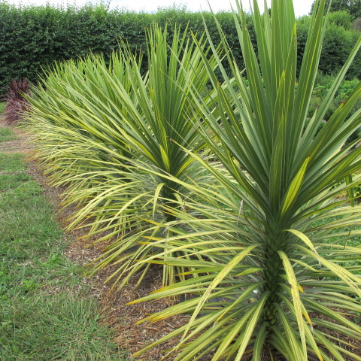 | 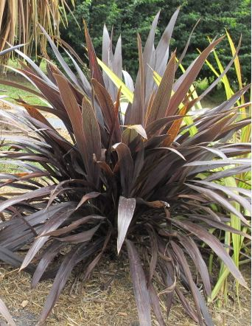 | 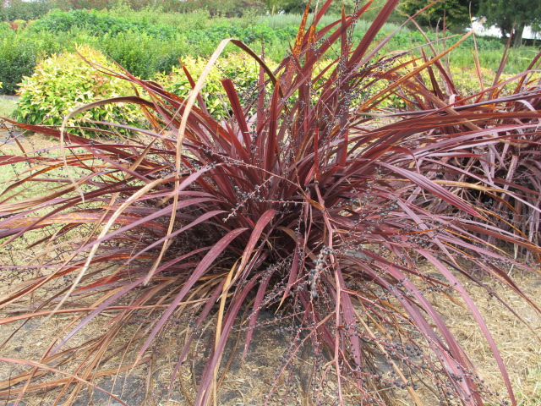
1 | 2 | 3
upright (Wals Goldfinger) | semi upright (Tana) | spreading (Red Fountain)

Ad 3: Plant: width

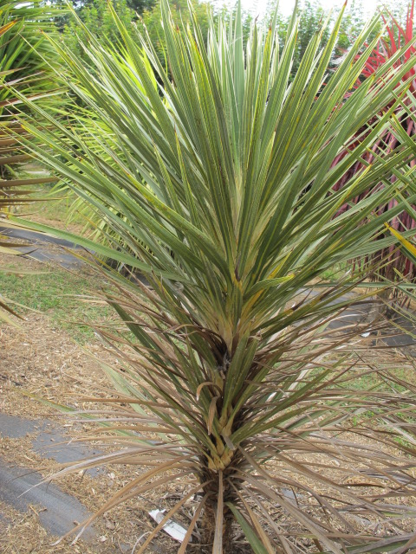 | 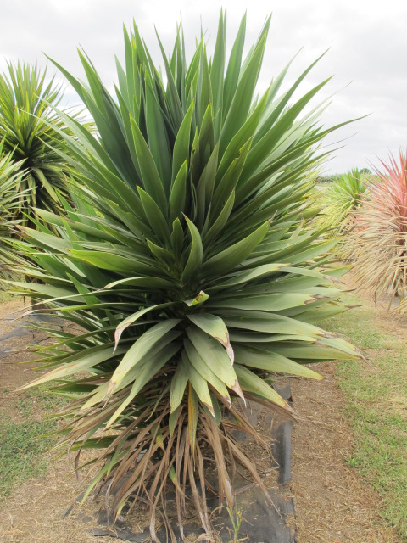
3 | 5 | 7
narrow (Pink Champagne) | medium (Green Goddess) | broad (Red Fountain)

Ad 4: Plant: number of basal shoots

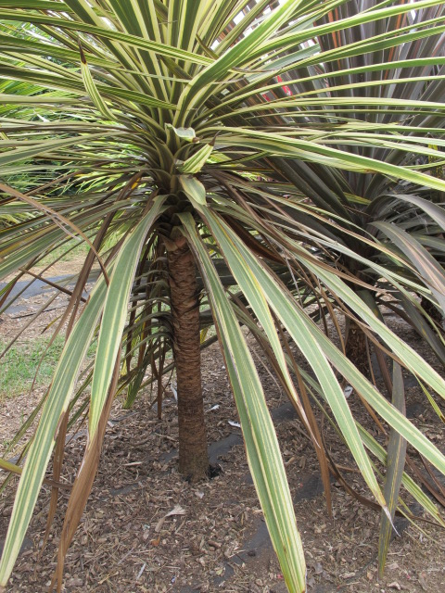 | 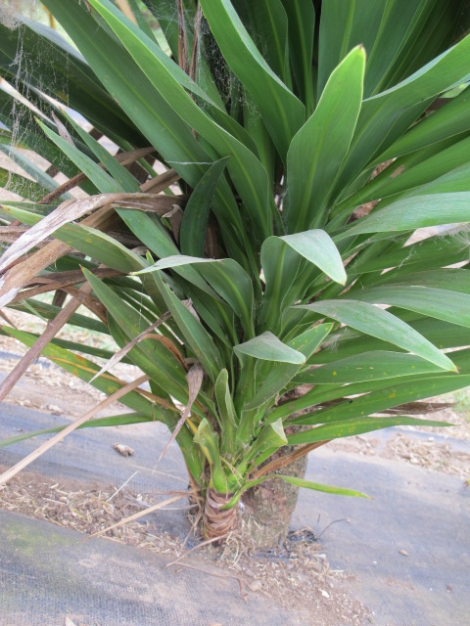
1 | 2
one (Albertii) | more than one (Green Goddess)

Ad. 5: Plant: density of foliage

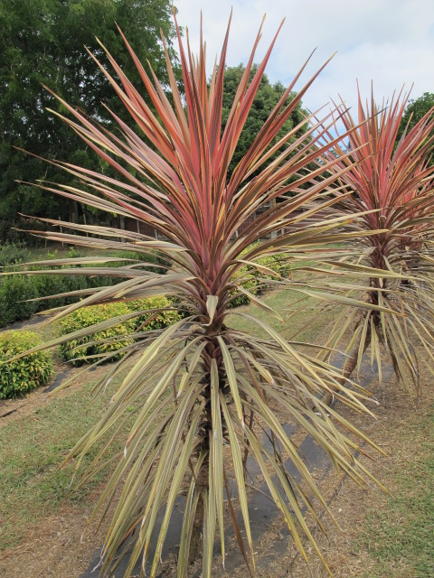 | 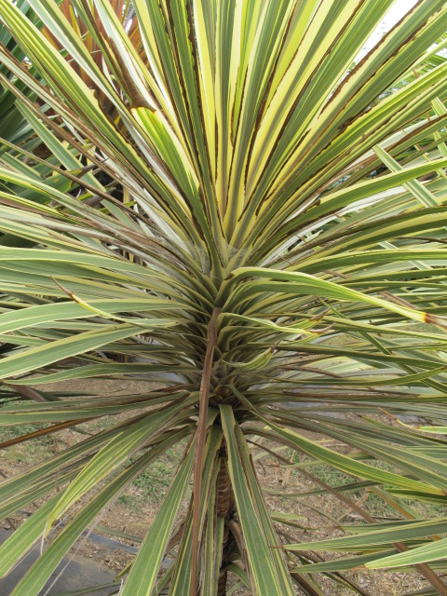
3 | 5 | 7
sparse (Wals Candystripe) | medium (Albertii) | dense (Red Fountain)
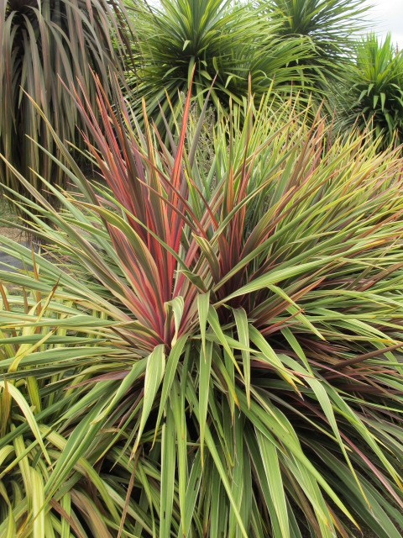
9
very dense (Can Can)

Ad. 6: Stem: branching

1 | 2
absent (Albertii) | present (Green Goddess)
Ad. 7: Mature leaf: attitude (upper third)

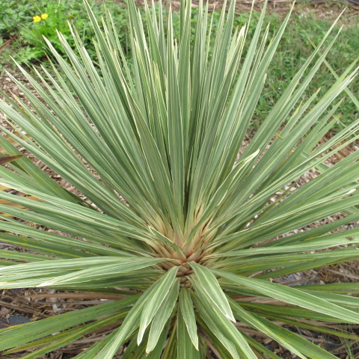 | 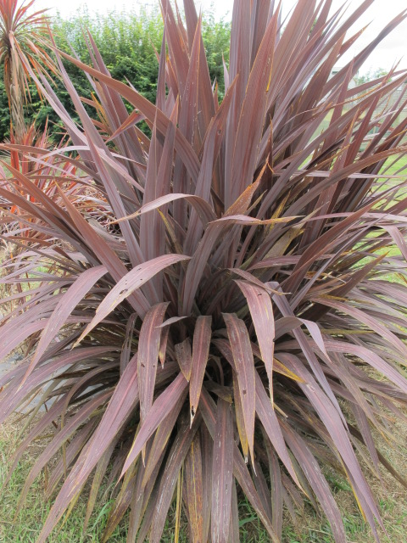
1 | 2
erect (Pink Champagne) | semi erect (Purple Sensation)

 | 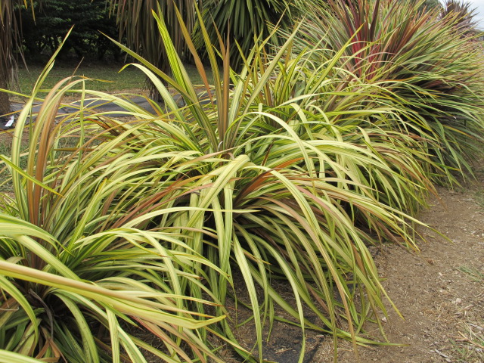
3 | 4
horizontal (Red Fountain) | downwards (Cha Cha)

Ad. 8: Mature leaf: attitude (lower third)

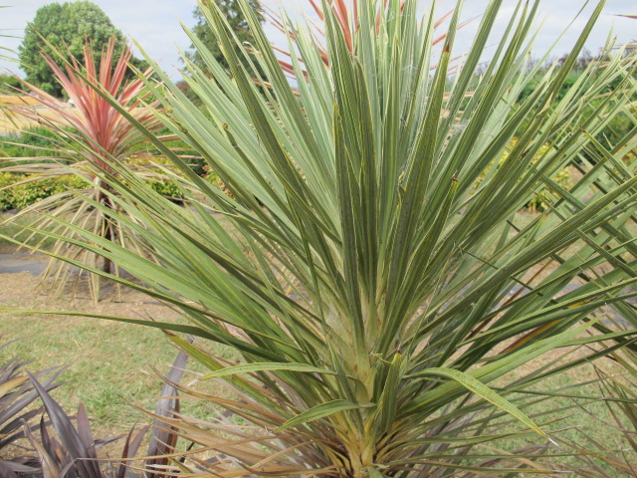 | 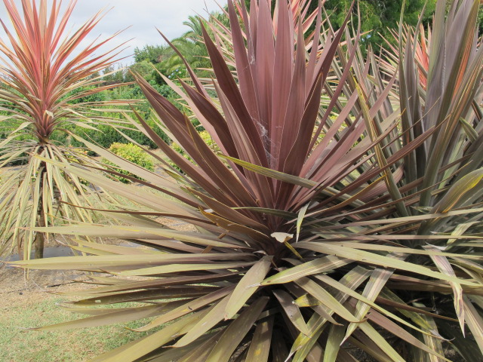 | 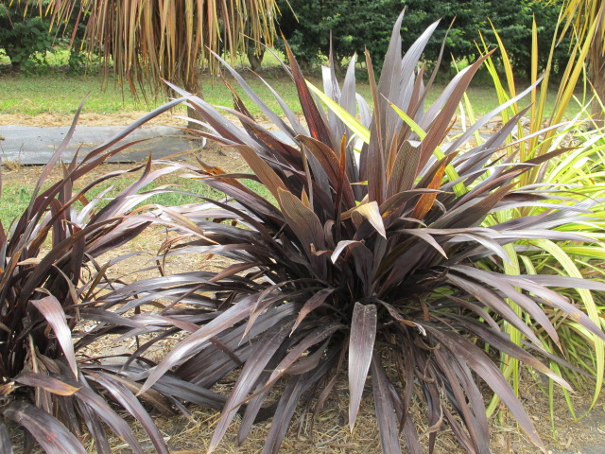
1 | 2 | 3
erect (Pink Champagne) | semi erect (Red Star) | horizontal (Tana)

4
downwards (Cha Cha)

Ad. 9: Mature leaf: apex in relation to point of attachment

To add 1 and 7

 | 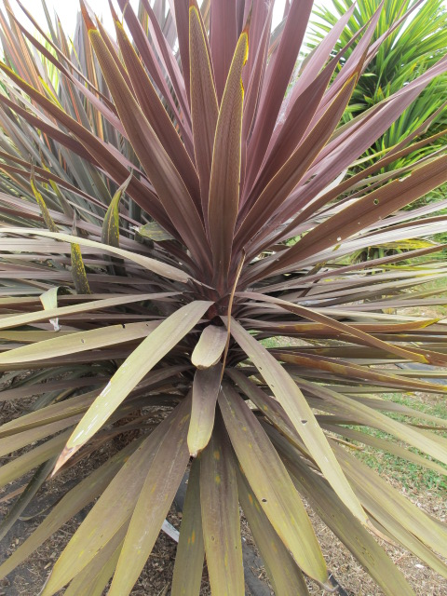
3 | 5 | 9
slightly Below (Cha Cha) | level (Red Star) | far above (Pink Champagne)

Ad. 13: Mature leaf: longitudinal curvature (upper third)

1 | 2 | 3
straight (Pink Champagne) | slightly curved (Red Star) | strongly curved (Green Goddess)

Ad. 14: Mature leaf: prominence of midrib (upper side)

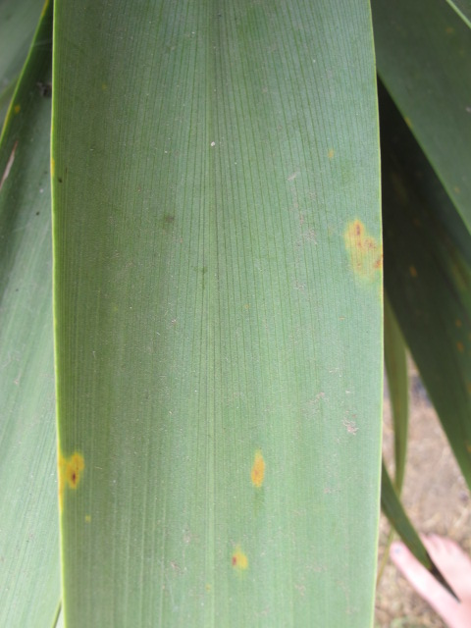 | 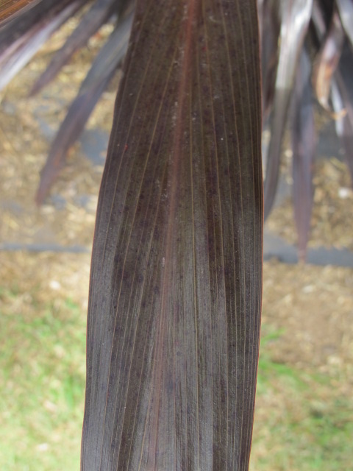 | 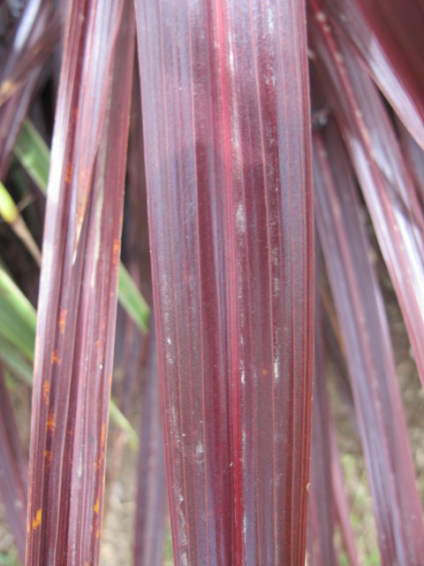
3 | 5 | 7
weak (Green goddess) | medium (Tana) | strong (Red Fountain)

Ad. 15: Leaf blade: venation

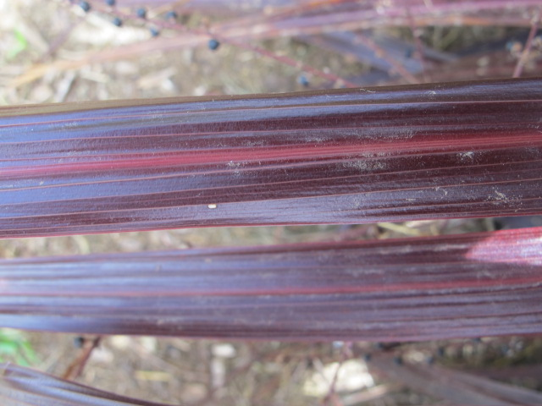
1 | 2
parallel () | angled ()

Ad. 16: Young leaf: main color
Ad. 20: Mature leaf: main color (upper side)

The main color is determined as the color with the largest surface area present on the inner side of a leaf. If two colors are of similar surface area, the color occurring first on the RHS colour chart should be taken as the Primary color, ie: Yellow will come before Purple.

Ad. 17: Young leaf: second color
Ad. 21: Mature leaf: second color

The secondary color is determined as the color with the second largest surface area, usually observed as a defined pattern on the inner side of a leaf.

Ad. 18: Young leaf: distribution of second color
Ad. 22: Mature leaf: distribution of secondary color

1 | 3 | 4
entire | marginal only | midrib only
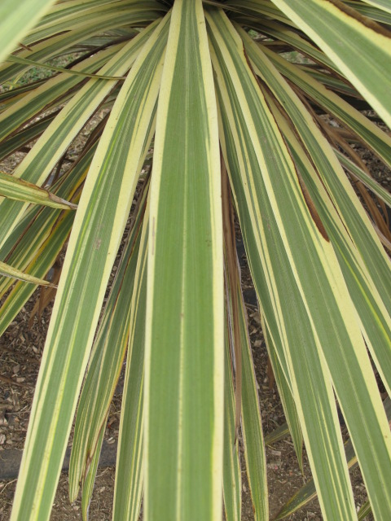
4 | 5 | 6
marginal and midrib (Albertii) | between margin and midrib | basal zone

Ad. 27: Petiole: profile in cross section

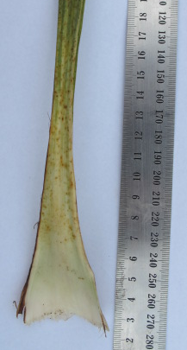 | 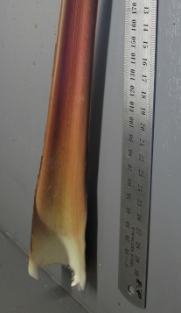 | 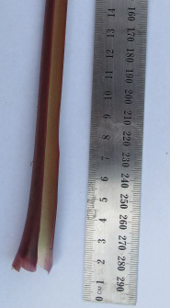
1 | 2 | 3
flat or slightly concave  (Pink Champagne) | moderately concave  (Purple Sensation) | strongly concave  (Red Fountain)

Literature

To be added

Poole A.L. and Adams N.M. 1986. Trees and Shrubs of New Zealand; Government Printing Office Publishing, Wellington, New Zealand, [pp 38 to 42].

Harris W 2001. Horticultural and conservation significance of the genetic variation of cabbage trees (Cordyline spp.). In: Oates MR ed. New Zealand plants and their story : proceedings of a conference held in Wellington 1-3 October 1999. Lincoln, Royal New Zealand Institute of Horticulture. Pp. 87-91.

Technical Questionnaire

TECHNICAL QUESTIONNAIRE |  |  |  | Page {x} of {y} |  | Reference Number:
 |  |  |  |  |  | Application date:
 |  |  |  |  |  | (not to be filled in by the applicant)
TECHNICAL QUESTIONNAIRE
to be completed in connection with an application for plant breeders’ rights

1. Subject of the Technical Questionnaire
1.1 Botanical name |  |  | Cordyline
1.2 Common name |  |  | Cordyline
1.3 Species
2. Applicant
Name
Address
Telephone No.
Fax No.
E-mail address
Breeder (if different from
applicant)
3. Proposed denomination and breeder’s reference
Proposed denomination
(if available)
Breeder’s reference
#4. Information on the breeding scheme and propagation of the variety

4.1 Breeding scheme

Variety resulting from:

4.1.1 Crossing

(a) controlled cross [ ]
(please state parent varieties)

(…………………..…………………………) x (……………..…………..………………..…)
female parent male parent

(b) partially known cross [ ]
(please state known parent variety(ies))

(…………………..……………………....…) x (……………..………………..…………..…)
female parent male parent

(c) unknown cross [ ]

4.1.2 Mutation [ ]
(please state parent variety)

4.1.3 Discovery and development [ ]
(please state where and when discovered and how developed)

4.1.4 Other [ ]
(please provide details)

4.2 Method of propagating the variety

4.2.1 Vegetative propagation

(a) cuttings [ ]

(b) in vitro propagation [ ]

(c) other (state method) [ ]

4.2.2 Other [ ]
(please provide details)

5. Characteristics of the variety to be indicated (the number in brackets refers to the corresponding characteristic in Test Guidelines; please mark the note which best corresponds).

 | Characteristics |  |  |  |  |  | Example Varieties |  |  |  | Note
5.1  (2) | Plant: height (non flowering)
 | very short |  |  |  |  |  |  |  |  |  | 1 [ ]
 | very short to short |  |  |  |  |  |  |  |  |  | 2 [ ]
 | short |  |  |  |  |  | Falcon |  |  |  | 3 [ ]
 | short to medium |  |  |  |  |  |  |  |  |  | 4 [ ]
 | medium |  |  |  |  |  | Red Fountain |  |  |  | 5 [ ]
 | medium to tall |  |  |  |  |  |  |  |  |  | 6 [ ]
 | tall |  |  |  |  |  | Purple Sensation |  |  |  | 7 [ ]
 | tall to very tall |  |  |  |  |  |  |  |  |  | 8 [ ]
 | very tall |  |  |  |  |  |  |  |  |  | 9 [ ]
5.2  (4) | Plant: number of basal shoots
 | one |  |  |  |  |  |  |  |  |  | 1 [ ]
 | two or more |  |  |  |  |  |  |  |  |  | 2 [ ]
5.3  (11) | Mature leaf: width of blade
 | very narrow |  |  |  |  |  | Pink Champagne |  |  |  | 1 [ ]
 | very narrow to narrow |  |  |  |  |  |  |  |  |  | 2 [ ]
 | narrow |  |  |  |  |  | Red Fountain |  |  |  | 3 [ ]
 | narrow to medium |  |  |  |  |  |  |  |  |  | 4 [ ]
 | medium |  |  |  |  |  | Purple Sensation |  |  |  | 5 [ ]
 | medium to broad |  |  |  |  |  |  |  |  |  | 6 [ ]
 | broad |  |  |  |  |  | Green Goddess |  |  |  | 7 [ ]
 | broad to very broad |  |  |  |  |  |  |  |  |  | 8 [ ]
 | very broad |  |  |  |  |  |  |  |  |  | 9 [ ]
5.4 (i)  (19) | Mature leaf: main color (upper side)
 | RHS Colour Chart (indicate reference number)
 | Characteristics |  |  |  |  |  | Example Varieties |  |  |  | Note
5.4 (ii)  (19) | Mature leaf: main color (upper side)
 | white |  |  |  |  |  |  |  |  |  | 1 [ ]
 | yellow |  |  |  |  |  |  |  |  |  | 2 [ ]
 | green |  |  |  |  |  |  |  |  |  | 3 [ ]
 | red |  |  |  |  |  |  |  |  |  | 4 [ ]
 | purple |  |  |  |  |  |  |  |  |  | 5 [ ]
 | brown |  |  |  |  |  |  |  |  |  | 6 [ ]
 | blackish |  |  |  |  |  |  |  |  |  | 7 [ ]
5.5 (i)  (20) | Mature leaf: second color (upper side)
 | RHS Colour Chart (indicate reference number)
5.5 (ii)  (20) | Mature leaf: second color (upper side)
 | white |  |  |  |  |  |  |  |  |  | 1 [ ]
 | yellow |  |  |  |  |  |  |  |  |  | 2 [ ]
 | green |  |  |  |  |  |  |  |  |  | 3 [ ]
 | red |  |  |  |  |  |  |  |  |  | 4 [ ]
 | purple |  |  |  |  |  |  |  |  |  | 5 [ ]
 | brown |  |  |  |  |  |  |  |  |  | 6 [ ]
 | blackish |  |  |  |  |  |  |  |  |  | 7 [ ]
5.6  (24) | Petiole: length
 | very short |  |  |  |  |  | Albertii |  |  |  | 1 [ ]
 | very short to short |  |  |  |  |  |  |  |  |  | 2 [ ]
 | short |  |  |  |  |  | Green Goddess |  |  |  | 3 [ ]
 | short to medium |  |  |  |  |  |  |  |  |  | 4 [ ]
 | medium |  |  |  |  |  | Tana |  |  |  | 5 [ ]
 | medium to long |  |  |  |  |  |  |  |  |  | 6 [ ]
 | long |  |  |  |  |  | Cardinal |  |  |  | 7 [ ]
 | long to very long |  |  |  |  |  |  |  |  |  | 8 [ ]
 | very long |  |  |  |  |  | Red Fountain |  |  |  | 9 [ ]
6. Similar varieties and differences from these varieties

Please use the following table and box for comments to provide information on how your candidate variety differs from the variety (or varieties) which, to the best of your knowledge, is (or are) most similar. This information may help the examination authority to conduct its examination of distinctness in a more efficient way.

Denomination(s) of variety(ies) similar to your candidate variety |  | Characteristic(s) in which your candidate variety differs from the similar variety(ies) |  |  | Describe the expression of the characteristic(s) for the similar variety(ies) |  |  | Describe the expression of the characteristic(s) for your candidate variety
Example |  | Plant: growth habit |  |  | semi upright |  |  | spreading
Comments:

#7. Additional information which may help in the examination of the variety

7.1 In addition to the information provided in sections 5 and 6, are there any additional characteristics which may help to distinguish the variety?

Yes [ ] No [ ]

(If yes, please provide details)

7.2 Are there any special conditions for growing the variety or conducting the examination?

Yes [ ] No [ ]

(If yes, please provide details)

7.3 Main use of the variety

(a) pot plant [ ]
(b) garden plant [ ]
(c) other [ ]
(please provide details)

A representative color image of the variety should accompany the Technical Questionnaire.

8. Authorization for release

(a) Does the variety require prior authorization for release under legislation concerning the protection of the environment, human and animal health?

Yes [ ] No [ ]

(b) Has such authorization been obtained?

Yes [ ] No [ ]

If the answer to (b) is yes, please attach a copy of the authorization.

9. Information on plant material to be examined or submitted for examination

9.1 The expression of a characteristic or several characteristics of a variety may be affected by factors, such as pests and disease, chemical treatment (e.g. growth retardants or pesticides), effects of tissue culture, different rootstocks, scions taken from different growth phases of a tree, etc.

9.2 The plant material should not have undergone any treatment which would affect the expression of the characteristics of the variety, unless the competent authorities allow or request such treatment. If the plant material has undergone such treatment, full details of the treatment must be given. In this respect, please indicate below, to the best of your knowledge, if the plant material to be examined has been subjected to:

(a) Microorganisms (e.g. virus, bacteria, phytoplasma) Yes [ ] No [ ]

(b) Chemical treatment (e.g. growth retardant, pesticide) Yes [ ] No [ ]

(c) Tissue culture Yes [ ] No [ ]

(d) Other factors Yes [ ] No [ ]

Please provide details for where you have indicated “yes”.

10. I hereby declare that, to the best of my knowledge, the information provided in this form is correct:

Applicant’s name

Signature Date

[Annex follows]
Comments on TG/CORDY(proj.1)

The Netherlands:

Character 8 and 13: I do not see the difference between these two characteristics?

Character 10, please explanation?

Character 8 to15 and 20 to 23 mature leaf/leaf: leaf: suggestion to observe all characteristics on mature leafs?

Character 16 to 19 young leaf: these characteristics we only observe on a mature leaf. Problem is how ‘old or young’ is a young leaf, which leaf to chose?

Character 16 to 23 suggestion (as we did in the Hosta guideline):
1: Leaf blade: main colour upper side
2. Leaf blade: area of main colour as a proportion of the total leaf area upper side
3. Leaf blade: main colour distribution upper side
4. Leaf blade: second colour upper side (if present)
5 etc.

Character 24 to 27 to put before the leaf characteristics (to start from 8).

Character petiole: in NL we also describe the colour, suggestion:
1: Petiole: main colour upper side
2. Petiole: area of main colour as a proportion of the total leaf area
3. Petiole: main colour distribution upper side
4. Petiole: second colour upper side (if present)
5. etc.

Character 24 and 25: a short petiole (25) has an weak prominence (24)?

(Character 28 to 34 Inflorescence: within 33 applications in NL, only one flowered during the examination period!)

Comments From the Republic of Korea
- Char. 2, 3 MG to be changed to VG/MS
- Char. 13, 14, 16~23, 27 MS to be changed to VG
- Char. 6. QN to be changed to QL
- Char. 23. main color to be changed to third color
- Char. 27. please consider which term is more suitable - shape in cross section or profile in cross section
- Please consider the additional characteristics
mature leaf : length/width ratio
leaf : variegation or pattern ? absent or present
leaf : shape - linear, oblong, elliptic etc
mature and young leaf glossiness on upper surface
Leaf blade: undulation of margin
Comments from Australia

Propose the minimum quantity of plant material be 10 plants

Suggestion of example varieties made

Suggestion of Plant Suckering instead of Basal Shoots

Opinion Stem: Leaf coverage is not useful

Query as to relationship of Leaf: Apex in relation to point of attachment to Mature Leaf attitude

Query as to leaf curvature- longitudinal?

Query- Prominance of midrib to be looked at on mature leaf?

Suggestion to add character Young and Mature Leaf: Number of Colours of Upper Side.

Opinion: Leaf colour: lower and upper parts do not fit well. (changed to basal zone and apical zone.

Query as to definition of Prominence of Petiole. (Have removed this characteristic)

Opinion: Petiole Characters Length, Width and Cross section not necessary (Disagree)

Comment re: Inflorescence characters. (Not sure they are useful)

[End of document]

* These names were correct at the time of the introduction of these Test Guidelines but may be revised or updated. [Readers are advised to consult the UPOV Code, which can be found on the UPOV Website (www.upov.int), for the latest information.]
# Authorities may allow certain of this information to be provided in a confidential section of the Technical Questionnaire.
# Authorities may allow certain of this information to be provided in a confidential section of the Technical Questionnaire.

