 |  |  |  |  |  |  | E  TG/AGLAO(proj.3)  ORIGINAL: English  DATE: 2013-03-08
INTERNATIONAL UNION FOR THE PROTECTION OF NEW VARIETIES OF PLANTS
Geneva
 |  |  | DRAFT
 |  | AGLAONEMA  UPOV Code: AGLAO  Aglaonema Schott |  |  | *

GUIDELINES

FOR THE CONDUCT OF TESTS

FOR DISTINCTNESS, UNIFORMITY AND STABILITY

prepared by experts from Japan

to be considered by the
Technical Working Party for Ornamental Plants and Forest Trees
at its forty-sixth session, to be held in Melbourne, Australia, from April 22 to 26, 2013

Alternative Names:*

Botanical name | English | French | German | Spanish
Aglaonema Schott | Chinese Evergreen

The purpose of these guidelines (“Test Guidelines”) is to elaborate the principles contained in the General Introduction (document TG/1/3), and its associated TGP documents, into detailed practical guidance for the harmonized examination of distinctness, uniformity and stability (DUS) and, in particular, to identify appropriate characteristics for the examination of DUS and production of harmonized variety descriptions.

ASSOCIATED DOCUMENTS
These Test Guidelines should be read in conjunction with the General Introduction and its associated TGP documents.
TABLE OF CONTENTS PAGE

1. Subject of these Test Guidelines 3
2. Material Required 3
3. Method of Examination 3
3.1 Number of Growing Cycles 3
3.2 Testing Place 3
3.3 Conditions for Conducting the Examination 3
3.4 Test Design 3
3.5 Additional Tests 3
4. Assessment of Distinctness, Uniformity and Stability 4
4.1 Distinctness 4
4.2 Uniformity 5
4.3 Stability 5
5. Grouping of Varieties and Organization of the Growing Trial 5
6. Introduction to the Table of Characteristics 5
6.1 Categories of Characteristics 5
6.2 States of Expression and Corresponding Notes 6
6.3 Types of Expression 6
6.4 Example Varieties 6
7. Table of Characteristics/Tableau des caractères/Merkmalstabelle/Tabla de caracteres 8
8. Explanations on the Table of Characteristics 19
8.1 Explanations covering several characteristics 19
8.2 Explanations for individual characteristics 19
9. Literature 28
10. Technical Questionnaire 29

Subject of these Test Guidelines

These Test Guidelines apply to all varieties of Aglaonema Schott.

Material Required

2.1 The competent authorities decide on the quantity and quality of the plant material required for testing the variety and when and where it is to be delivered. Applicants submitting material from a State other than that in which the testing takes place must ensure that all customs formalities and phytosanitary requirements are complied with.

2.2 The material is to be supplied in the form of plants capable of producing the required number of leaves over the growing period.

2.3 The minimum quantity of plant material, to be supplied by the applicant, should be:

10 plants.

2.4 The plant material supplied should be visibly healthy, not lacking in vigor, nor affected by any important pest or disease.

2.5 The plant material should not have undergone any treatment which would affect the expression of the characteristics of the variety, unless the competent authorities allow or request such treatment. If it has been treated, full details of the treatment must be given.

Method of Examination

3.1 Number of Growing Cycles

The minimum duration of tests should normally be a single growing cycle.

3.2 Testing Place

Tests are normally conducted at one place. In the case of tests conducted at more than one place, guidance is provided in TGP/9 “Examining Distinctness”.

3.3 Conditions for Conducting the Examination

3.3.1 The tests should be carried out under conditions ensuring satisfactory growth for the expression of the relevant characteristics of the variety and for the conduct of the examination.

3.3.2 Because daylight varies, color determinations made against a color chart should be made either in a suitable cabinet providing artificial daylight or in the middle of the day in a room without direct sunlight. The spectral distribution of the illuminant for artificial daylight should conform with the CIE Standard of Preferred Daylight D 6500 and should fall within the tolerances set out in the British Standard 950, Part I. These determinations should be made with the plant part placed against a white background. The color chart and version used should be specified in the variety description.

3.4 Test Design

3.4.1 Each test should be designed to result in a total of at least 10 plants.

3.4.2 The design of the tests should be such that plants or parts of plants may be removed for measurement or counting without prejudice to the observations which must be made up to the end of the growing cycle.

3.5 Additional Tests

Additional tests, for examining relevant characteristics, may be established.

Assessment of Distinctness, Uniformity and Stability

4.1 Distinctness

4.1.1 General Recommendations

It is of particular importance for users of these Test Guidelines to consult the General Introduction prior to making decisions regarding distinctness. However, the following points are provided for elaboration or emphasis in these Test Guidelines.

4.1.2 Consistent Differences

The differences observed between varieties may be so clear that more than one growing cycle is not necessary. In addition, in some circumstances, the influence of the environment is not such that more than a single growing cycle is required to provide assurance that the differences observed between varieties are sufficiently consistent. One means of ensuring that a difference in a characteristic, observed in a growing trial, is sufficiently consistent is to examine the characteristic in at least two independent growing cycles.

4.1.3 Clear Differences

Determining whether a difference between two varieties is clear depends on many factors, and should consider, in particular, the type of expression of the characteristic being examined, i.e. whether it is expressed in a qualitative, quantitative, or pseudo-qualitative manner. Therefore, it is important that users of these Test Guidelines are familiar with the recommendations contained in the General Introduction prior to making decisions regarding distinctness.

4.1.4 Number of Plants / Parts of Plants to be Examined

Unless otherwise indicated, for the purposes of distinctness, all observations on single plants should be made on 9 plants or parts taken from each of 9 plants and any other observations made on all plants in the test, disregarding any off-type plants.

4.1.5 Method of Observation

The recommended method of observing the characteristic for the purposes of distinctness is indicated by the following key in the second column of the Table of Characteristics (see document TGP/9 “Examining Distinctness”, Section 4 “Observation of characteristics”):

MG: single measurement of a group of plants or parts of plants
MS: measurement of a number of individual plants or parts of plants
VG: visual assessment by a single observation of a group of plants or parts of plants
VS: visual assessment by observation of individual plants or parts of plants

Type of observation: visual (V) or measurement (M)

“Visual” observation (V) is an observation made on the basis of the expert’s judgment. For the purposes of this document, “visual” observation refers to the sensory observations of the experts and, therefore, also includes smell, taste and touch. Visual observation includes observations where the expert uses reference points (e.g. diagrams, example varieties, side-by-side comparison) or non-linear charts (e.g. color charts). Measurement (M) is an objective observation against a calibrated, linear scale e.g. using a ruler, weighing scales, colorimeter, dates, counts, etc.

Type of record: for a group of plants (G) or for single, individual plants (S)

For the purposes of distinctness, observations may be recorded as a single record for a group of plants or parts of plants (G), or may be recorded as records for a number of single, individual plants or parts of plants (S). In most cases, “G” provides a single record per variety and it is not possible or necessary to apply statistical methods in a plant-by-plant analysis for the assessment of distinctness.

In cases where more than one method of observing the characteristic is indicated in the Table of Characteristics (e.g. VG/MG), guidance on selecting an appropriate method is provided in document TGP/9, Section 4.2.

4.2 Uniformity

4.2.1 It is of particular importance for users of these Test Guidelines to consult the General Introduction prior to making decisions regarding uniformity. However, the following points are provided for elaboration or emphasis in these Test Guidelines:

4.2.2 For the assessment of uniformity of vegetatively propagated varieties, a population standard of 1% and an acceptance probability of at least 95% should be applied. In the case of a sample size of 10 plants, 1 off-type is allowed.

4.3 Stability

4.3.1 In practice, it is not usual to perform tests of stability that produce results as certain as those of the testing of distinctness and uniformity. However, experience has demonstrated that, for many types of variety, when a variety has been shown to be uniform, it can also be considered to be stable.

4.3.2 Where appropriate, or in cases of doubt, stability may be further examined by testing a new plant stock to ensure that it exhibits the same characteristics as those shown by the initial material supplied.

Grouping of Varieties and Organization of the Growing Trial

5.1 The selection of varieties of common knowledge to be grown in the trial with the candidate varieties and the way in which these varieties are divided into groups to facilitate the assessment of distinctness are aided by the use of grouping characteristics.

5.2 Grouping characteristics are those in which the documented states of expression, even where produced at different locations, can be used, either individually or in combination with other such characteristics: (a) to select varieties of common knowledge that can be excluded from the growing trial used for examination of distinctness; and (b) to organize the growing trial so that similar varieties are grouped together.

5.3 The following have been agreed as useful grouping characteristics:

- Leaf blade: length (characteristic 10)
- Leaf blade: width (characteristic 11)
(c) Leaf blade: color 1 (characteristic 17)
(d) Leaf blade: distribution of color 1 (characteristic 18)
(e) Leaf blade: total area of color 1 (characteristic 20)
(f) Leaf blade: color 2 (characteristic 21)
(g) Leaf blade: distribution of color 2 (characteristic 22)
(h) Leaf blade: total area of color 2 (characteristic 24)
(i) Leaf blade: color 3 (characteristic 25)
(j) Leaf blade: distribution of color 3 (characteristic 26)
(k) Leaf blade: total area of color 3 (characteristic 28)

5.4 Guidance for the use of grouping characteristics, in the process of examining distinctness, is provided through the General Introduction and document TGP/9 “Examining Distinctness”.

Introduction to the Table of Characteristics

6.1 Categories of Characteristics

6.1.1 Standard Test Guidelines Characteristics

Standard Test Guidelines characteristics are those which are approved by UPOV for examination of DUS and from which members of the Union can select those suitable for their particular circumstances.

6.1.2 Asterisked Characteristics

Asterisked characteristics (denoted by *) are those included in the Test Guidelines which are important for the international harmonization of variety descriptions and should always be examined for DUS and included in the variety description by all members of the Union, except when the state of expression of a preceding characteristic or regional environmental conditions render this inappropriate.

6.2 States of Expression and Corresponding Notes

6.2.1 States of expression are given for each characteristic to define the characteristic and to harmonize descriptions. Each state of expression is allocated a corresponding numerical note for ease of recording of data and for the production and exchange of the description.

6.2.2 In the case of qualitative and pseudo-qualitative characteristics (see Chapter 6.3), all relevant states of expression are presented in the characteristic. However, in the case of quantitative characteristics with 5 or more states, an abbreviated scale may be used to minimize the size of the Table of Characteristics. For example, in the case of a quantitative characteristic with 9 states, the presentation of states of expression in the Test Guidelines may be abbreviated as follows:

State | Note
small | 3
medium | 5
large | 7

However, it should be noted that all of the following 9 states of expression exist to describe varieties and should be used as appropriate:

State | Note
very small | 1
very small to small | 2
small | 3
small to medium | 4
medium | 5
medium to large | 6
large | 7
large to very large | 8
very large | 9

6.2.3 Further explanation of the presentation of states of expression and notes is provided in document TGP/7 “Development of Test Guidelines”.

6.3 Types of Expression

An explanation of the types of expression of characteristics (qualitative, quantitative and pseudo-qualitative) is provided in the General Introduction.

6.4 Example Varieties

Where appropriate, example varieties are provided to clarify the states of expression of each characteristic.
6.5 Legend

(*) Asterisked characteristic – see Chapter 6.1.2

QL Qualitative characteristic – see Chapter 6.3
QN Quantitative characteristic – see Chapter 6.3
PQ Pseudo-qualitative characteristic – see Chapter 6.3

MG, MS, VG, VS – see Chapter 4.1.5

(a)-(d) See Explanations on the Table of Characteristics in Chapter 8.1

(+) See Explanations on the Table of Characteristics in Chapter 8.2.

Table of Characteristics/Tableau des caractères/Merkmalstabelle/Tabla de caracteres

 |  | English | français | deutsch | español | Example Varieties  Exemples  Beispielssorten  Variedades ejemplo | Note/  Nota
1. | VG/MG | Plant: height
QN | (a) | short |  |  |  | Subrungrueng | 3
 |  | medium |  |  |  | Chalit’s Pride | 5
 |  | tall |  |  |  | Thep Ranjuan | 7
2.  (+) | VG/MS | Plant: number of basal shoots
QN | (a) | absent or very few |  |  |  | Cassic | 1
 |  | few |  |  |  |  | 2
 |  | medium |  |  |  | Katharngen | 3
 |  | many |  |  |  | Chaowang | 4
3.  (+) | VG/MS | Petiole: length
QN | (b) | short |  |  |  |  | 3
 |  | medium |  |  |  | Chalit’ s Pride | 5
 |  | long |  |  |  | Katharngen | 7
4.  (*) | VG | Petiole: main color
PQ | (b) | RHS Colour Chart (indicate reference number)
5.  (*) | VG | Petiole: secondary color (if present)
PQ | (b) | RHS Colour Chart (indicate reference number)
6.  (*)  (+) | VG/MS | Leaf sheath: length
QN | (b) | absent or very short |  |  |  | World Heritage | 1
 | (b) | short |  |  |  | Bebadary | 3
 |  | medium |  |  |  | Pritty | 5
 |  | long |  |  |  | Katharngen | 7
7.  (+) | VG | Leaf sheath: angle of apical part
QN | (b) | strongly acute |  |  |  | Saisamorn | 1
 |  | moderately acute |  |  |  |  | 2
 |  | rectangular |  |  |  | Supmongkon | 3
 |  | moderately obtuse |  |  |  |  | 4
 |  | strongly obtuse |  |  |  | Katharngen | 5
8.  (*) | VG | Leaf sheath: main color of outer side
PQ | (b) | RHS Colour Chart (indicate reference number)
9.  (*) | VG | Leaf sheath: secondary color of outer side
PQ | (b) | white |  |  |  |  | 1
 |  | yellow |  |  |  |  | 2
 |  | green |  |  |  |  | 3
 |  | pink |  |  |  |  | 4
 |  | red |  |  |  |  | 5
10.  (*)  (+) | VG/MS | Leaf blade: length
QN | (b) | short |  |  |  | Black Beauty | 3
 |  | medium |  |  |  | Tiara | 5
 |  | long |  |  |  | Thep Ranjuan | 7
11.  (*)  (+) | VG/MS | Leaf blade: width
QN | (b) | narrow |  |  |  | Thep Ranjuan | 3
 |  | medium |  |  |  | Katharngen | 5
 |  | broad |  |  |  | World Heritage | 7
12.  (+) | VG/MS | Leaf blade: ratio length/width
QN | (b) | low |  |  |  |  | 3
 |  | medium |  |  |  |  | 5
 |  | high |  |  |  |  | 7
13.  (*)  (+) | VG | Leaf blade: position of broadest part
PQ | (b) | toward base |  |  |  | Ribbon Evergreen | 1
 |  | at middle |  |  |  | Pride of Sumatra | 2
 |  | toward apex |  |  |  | Ik Q san | 3
14. | VG | Leaf blade: symmetry
QN | (b) | symmetric or slightly asymmetric |  |  |  | Katharngen | 1
 |  | moderately asymmetric |  |  |  |  | 2
 |  | strongly asymmetric |  |  |  | Russamithong | ３
15.  (*)  (+) | VG | Leaf blade: shape of apex
PQ | (b) | strongly acute |  |  |  |  | 1
 |  | moderately acute |  |  |  | Chalit’s Pride | 2
 |  | obtuse |  |  |  | D Colour | 3
16.  (*)  (+) | VG | Leaf blade: shape of base
PQ | (b) | attenuate |  |  |  |  | 1
 |  | acute |  |  |  |  | 2
 |  | obtuse |  |  |  | Chalit’ s Pride | 3
 |  | truncate |  |  |  |  | 4
 |  | cordate |  |  |  | World Heritage | 5
17.  (*)  (+) | VG | Leaf blade: color 1
PQ | (b) (c) | RHS Colour Chart (indicate reference number)
18.  (*)  (+) | VG | Leaf blade: distribution of color 1
PQ | (b) | along midrib |  |  |  |  | 1
 | (c) | marginal zone |  |  |  |  | 2
 |  | between midrib and margin |  |  |  |  | 3
 |  | along veins |  |  |  |  | 4
 |  | between veins |  |  |  |  | 5
 |  | throughout |  |  |  |  | 6
 |  | along midrib and marginal zone |  |  |  |  | 7
 |  | along midrib and along veins |  |  |  |  | 8
 |  | along midrib and throughout |  |  |  |  | 9
 |  | along veins and between veins |  |  |  |  | 10
 |  | marginal zone and throughout |  |  |  |  | 11
 |  | along midrib and along veins and throughout |  |  |  |  | 12
 |  | along midrib, along veins and between veins |  |  |  |  | 13
 |  | along midrib, marginal zone and along veins |  |  |  |  | 14
19.  (*)  (+) | VG | Leaf blade: pattern of color 1
PQ | (b) | small blotched |  |  |  |  | 1
 | (c) | small to medium blotched |  |  |  |  | ２
 |  | medium blotched |  |  |  |  | ３
 |  | medium to large blotched |  |  |  |  | ４
 |  | large blotched |  |  |  |  | ５
 |  | solid or nearly solid |  |  |  |  | 6
20.  (*)  (+) | VG | Leaf blade: total area of color 1
QN | (b) | small |  |  |  |  | 3
 | (c) | medium |  |  |  |  | 5
 |  | large |  |  |  |  | 7
21.  (*)  (+) | VG | Leaf blade: color 2
PQ | (b) (c) | RHS Colour Chart (indicate reference number)
22.  (*)  (+) | VG | Leaf blade: distribution of color 2
PQ | (b) | along midrib |  |  |  |  | 1
 | (c) | marginal zone |  |  |  |  | 2
 |  | between midrib and margin |  |  |  |  | 3
 |  | along veins |  |  |  |  | 4
 |  | between veins |  |  |  |  | 5
 |  | throughout |  |  |  |  | 6
 |  | along midrib and marginal zone |  |  |  |  | 7
 |  | along midrib and along veins |  |  |  |  | 8
 |  | along midrib and throughout |  |  |  |  | 9
 |  | along veins and between veins |  |  |  |  | 10
 |  | marginal zone and throughout |  |  |  |  | 11
 |  | along midrib and along veins and throughout |  |  |  |  | 12
 |  | along midrib, along veins and between veins |  |  |  |  | 13
 |  | along midrib, marginal zone and along veins |  |  |  |  | 14
23.  (*)  (+) | VG | Leaf blade: pattern of color 2
PQ | (b) | small blotched |  |  |  |  | 1
 | (c) | medium blotched |  |  |  |  | 2
 |  | large blotched |  |  |  |  | 3
 |  | small to medium blotched |  |  |  |  | 4
 |  | medium to large blotched |  |  |  |  | 5
 |  | solid or nearly solid |  |  |  |  | 6
24.  (*)  (+) | VG | Leaf blade: total area of color 2
QN | (b) | small |  |  |  |  | 3
 | (c) | medium |  |  |  |  | 5
 |  | large |  |  |  |  | 7
25.  (*)  (+) | VG | Leaf blade: color 3
PQ | (b) (c) | RHS Colour Chart (indicate reference number)
26.  (*)  (+) | VG | Leaf blade: distribution of color 3
PQ | (b) | along midrib |  |  |  |  | 1
 | (c) | marginal zone |  |  |  |  | 2
 |  | between midrib and margin |  |  |  |  | 3
 |  | along veins |  |  |  |  | 4
 |  | between veins |  |  |  |  | 5
 |  | throughout |  |  |  |  | 6
 |  | along midrib and marginal zone |  |  |  |  | 7
 |  | along midrib and along veins |  |  |  |  | 8
 |  | along midrib and throughout |  |  |  |  | 9
 |  | along veins and between veins |  |  |  |  | 10
 |  | marginal zone and throughout |  |  |  |  | 11
 |  | along midrib and along veins and throughout |  |  |  |  | 12
 |  | along midrib, along veins and between veins |  |  |  |  | 13
 |  | along midrib, marginal zone and along veins |  |  |  |  | 14
27.  (*)  (+) | VG | Leaf blade: pattern of color 3
PQ | (b) | small blotched |  |  |  |  | 1
 | (c) | medium blotched |  |  |  |  | 2
 |  | large blotched |  |  |  |  | 3
 |  | small to medium blotched |  |  |  |  | 4
 |  | medium to large blotched |  |  |  |  | 5
 |  | solid or nearly solid |  |  |  |  | 6
28.  (*)  (+) | VG | Leaf blade: total area of color 3
QN | (b) | small |  |  |  |  | 3
 | (c) | medium |  |  |  |  | 5
 |  | large |  |  |  |  | 7
29.  (*)  (+) | VG | Leaf blade: color 4
PQ | (b) (c) | RHS Colour Chart (indicate reference number)
30.  (*)  (+) | VG | Leaf blade: distribution of color 4
PQ | (b) | along midrib |  |  |  |  | 1
 | (c) | marginal zone |  |  |  |  | 2
 |  | between midrib and margin |  |  |  |  | 3
 |  | along veins |  |  |  |  | 4
 |  | between veins |  |  |  |  | 5
 |  | throughout |  |  |  |  | 6
 |  | along midrib and marginal zone |  |  |  |  | 7
 |  | along midrib and along veins |  |  |  |  | 8
 |  | along midrib and throughout |  |  |  |  | 9
 |  | along veins and between veins |  |  |  |  | 10
 |  | marginal zone and throughout |  |  |  |  | 11
 |  | along midrib and along veins and throughout |  |  |  |  | 12
 |  | along midrib, along veins and between veins |  |  |  |  | 13
 |  | along midrib, marginal zone and along veins |  |  |  |  | 14
31.  (*)  (+) | VG | Leaf blade: pattern of color 4
PQ | (b) | small blotched |  |  |  |  | 1
 | (c) | medium blotched |  |  |  |  | 2
 |  | large blotched |  |  |  |  | 3
 |  | small to medium blotched |  |  |  |  | 4
 |  | medium to large blotched |  |  |  |  | 5
 |  | solid or nearly solid |  |  |  |  | 6
32.  (*)  (+) | VG | Leaf blade: total area of color 4
QN | (b) | small |  |  |  |  | 3
 | (c) | medium |  |  |  |  | 5
 |  | large |  |  |  |  | 7
33.  (*) | VG | Leaf blade: color 1 of lower side
PQ | (b) | RHS Colour Chart (indicate reference number)
34.  (*)  (+) | VG | Leaf blade: distribution of color 1 of lower side
PQ | (b) | along midrib |  |  |  |  | 1
 | (c) | marginal zone |  |  |  |  | 2
 |  | between midrib and margin |  |  |  |  | 3
 |  | along veins |  |  |  |  | 4
 |  | between veins |  |  |  |  | 5
 |  | throughout |  |  |  |  | 6
 |  | along midrib and marginal zone |  |  |  |  | 7
 |  | along midrib and along veins |  |  |  |  | 8
 |  | along midrib and throughout |  |  |  |  | 9
 |  | along veins and between veins |  |  |  |  | 10
 |  | marginal zone and throughout |  |  |  |  | 11
 |  | along midrib and along veins and throughout |  |  |  |  | 12
 |  | along midrib, along veins and between veins |  |  |  |  | 13
 |  | along midrib, marginal zone and along veins |  |  |  |  | 14
35.  (*)  (+) | VG | Leaf blade: pattern of color 1 of lower side
PQ | (b) | small blotched |  |  |  |  | 1
 | (c) | small to medium blotched |  |  |  |  | ２
 |  | medium blotched |  |  |  |  | ３
 |  | medium to large blotched |  |  |  |  | ４
 |  | large blotched |  |  |  |  | ５
 |  | solid or nearly solid |  |  |  |  | 6
36.  (*)  (+) | VG | Leaf blade: total area of color 1 of lower side
QN | (b) | small |  |  |  |  | 3
 | (c) | medium |  |  |  |  | 5
 |  | large |  |  |  |  | 7
37.  (*)  (+) | VG | Leaf blade: color 2 of lower side
PQ | (b) (c) | RHS Colour Chart (indicate reference number)
38.  (*)  (+) | VG | Leaf blade: distribution of color 2 of lower side
PQ | (b) | along midrib |  |  |  |  | 1
 | (c) | marginal zone |  |  |  |  | 2
 |  | between midrib and margin |  |  |  |  | 3
 |  | along veins |  |  |  |  | 4
 |  | between veins |  |  |  |  | 5
 |  | throughout |  |  |  |  | 6
 |  | along midrib and marginal zone |  |  |  |  | 7
 |  | along midrib and along veins |  |  |  |  | 8
 |  | along midrib and throughout |  |  |  |  | 9
 |  | along veins and between veins |  |  |  |  | 10
 |  | marginal zone and throughout |  |  |  |  | 11
 |  | along midrib and along veins and throughout |  |  |  |  | 12
 |  | along midrib, along veins and between veins |  |  |  |  | 13
 |  | along midrib, marginal zone and along veins |  |  |  |  | 14
39.  (*)  (+) | VG | Leaf blade: pattern of color 2 of lower side
PQ | (b) | small blotched |  |  |  |  | 1
 | (c) | medium blotched |  |  |  |  | 2
 |  | large blotched |  |  |  |  | 3
 |  | small to medium blotched |  |  |  |  | 4
 |  | medium to large blotched |  |  |  |  | 5
 |  | solid or nearly solid |  |  |  |  | 6
40.  (*)  (+) | VG | Leaf blade: total area of color 2 of lower side
QN | (b) | small |  |  |  |  | 3
 | (c) | medium |  |  |  |  | 5
 |  | large |  |  |  |  | 7
41.  (*)  (+) | VG | Leaf blade: color 3 of lower side
PQ | (b) (c) | RHS Colour Chart (indicate reference number)
42.  (*)  (+) | VG | Leaf blade: distribution of color 3 of lower side
PQ | (b) | along midrib |  |  |  |  | 1
 | (c) | marginal zone |  |  |  |  | 2
 |  | between midrib and margin |  |  |  |  | 3
 |  | along veins |  |  |  |  | 4
 |  | between veins |  |  |  |  | 5
 |  | throughout |  |  |  |  | 6
 |  | along midrib and marginal zone |  |  |  |  | 7
 |  | along midrib and along veins |  |  |  |  | 8
 |  | along midrib and throughout |  |  |  |  | 9
 |  | along veins and between veins |  |  |  |  | 10
 |  | marginal zone and throughout |  |  |  |  | 11
 |  | along midrib and along veins and throughout |  |  |  |  | 12
 |  | along midrib, along veins and between veins |  |  |  |  | 13
 |  | along midrib, marginal zone and along veins |  |  |  |  | 14
43.  (*)  (+) | VG | Leaf blade: pattern of color 3 of lower side
PQ | (b) | small blotched |  |  |  |  | 1
 | (c) | medium blotched |  |  |  |  | 2
 |  | large blotched |  |  |  |  | 3
 |  | small to medium blotched |  |  |  |  | 4
 |  | medium to large blotched |  |  |  |  | 5
 |  | solid or nearly solid |  |  |  |  | 6
44.  (*)  (+) | VG | Leaf blade: total area of color 3 of lower side
QN | (b) | small |  |  |  |  | 3
 | (c) | medium |  |  |  |  | 5
 |  | large |  |  |  |  | 7
45.  (*) | VG | Leaf blade: glossiness of upper side
QN | (b) | absent or very weak |  |  |  | Katharngen | 1
 | (c) | weak |  |  |  |  | 2
 |  | medium |  |  |  |  | 3
 |  | strong |  |  |  | Black Beauty | 4
46.  (*)  (+) | VG | Leaf blade: blistering
QN | (b) | absent or very weak |  |  |  | Katharngen | 1
 | (c) | weak |  |  |  | World Heritage | 2
 |  | medium |  |  |  | Tiara | 3
 |  | strong |  |  |  |  | 4
47  (*) | VG | Leaf blade: undulation of margin
QN | (b) | absent or very weak |  |  |  | Chalit’ s Pride | 1
 |  | weak |  |  |  | Katharngen | 2
 |  | medium |  |  |  | Saisamorn | 3
 |  | strong |  |  |  | Black Beauty | 4
48.  (*)  (+) | VG | Leaf blade: profile in cross section
QN | (b) | flat |  |  |  | Katharngen | 1
 |  | slightly concave |  |  |  |  | 2
 |  | moderately concave |  |  |  | Tiara | 3
49.  (*)  (+) | VG | Leaf blade midrib: profile
QN | (b) | raised |  |  |  | Lagazy | 1
 | (c) | flat |  |  |  | Katharngen | 2
 |  | sunken |  |  |  | Russamithong | 3
50.  (*)  (+) | VG/MS | Leaf blade: number of vein pairs
QN | (b) | few |  |  |  | Black Beauty | 3
 |  | medium |  |  |  |  | 5
 |  | many |  |  |  | Kwakngen | 7

Explanations on the Table of Characteristics

8.1 Explanations covering several characteristics

8.1.1 Characteristics containing the following key in the second column of the Table of Characteristics should be examined as indicated below:

- Plant should be observed at the stage of expanding when the stem has 8 to 10 fully grown leaves.
(b) Leaf should be observed on the fourth to sixth fully grown leaves from the top of plant.
(c) Unless otherwise indicated, to be observed on the upper side of leaves.
(d) Where the characteristic refers to colors as "color 1", "color 2" etc., they are to be recorded in the order that they appear on the RHS chart, i.e. color 1 is the one with the lowest number, color 2 with the second lowest and so on. For example, if the leaves are Green 137A patched with White 155A, Green 137A will be color 1 and White 155A color 2. If two colors are on the same leaf of the chart, for example Green 137A and Green 137D, 137A is regarded as the lower numbered color. It should be noted that under this system, ranking is independent of surface area, so the color covering the greatest surface area may be classified as color 3 or 4. The Guideline makes provision for four colors; if there are more, the color[s] with the smallest surface area[s] should be discounted.

8.1.2 Definitions of main color, secondary color

The main color is the color with the largest surface area. In cases where the areas of the main and secondary color are too similar to reliably decide which color has the largest area, the darkest color is considered to be the main color.

8.2 Explanations for individual characteristics

Ad. ２: Plant: number of basal shoots

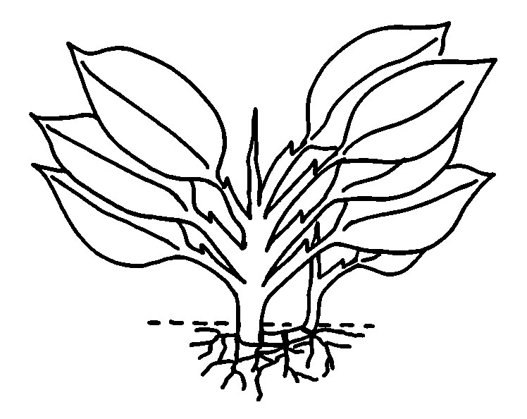 | 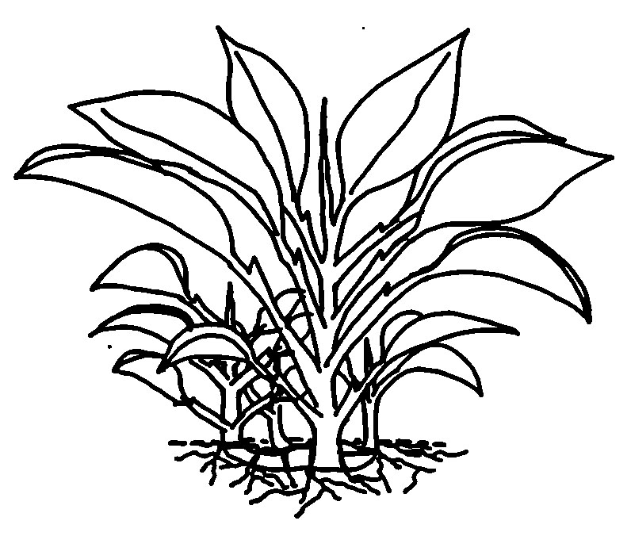 | 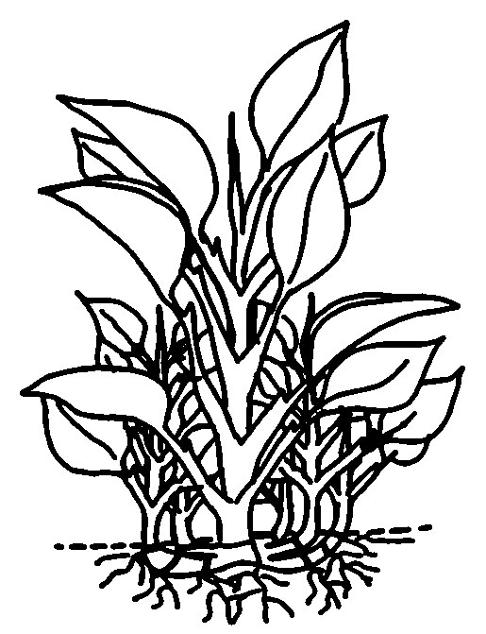
１ | 3 | 4
absent or very few | medium | many

Ad. 3: Petiole: length

Ad. 6: Leaf sheath: length

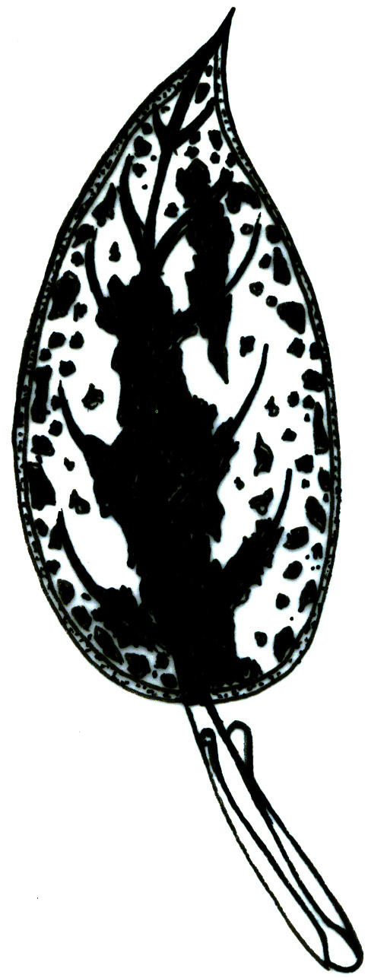
Length of leaf sheath
Length
of
petiole

Ad. 7: Leaf sheath: angle of apical part

1 | 2 | ３ | ４ | ５
strongly acute | moderately acute | rectangular | moderately obtuse | strongly obtuse

Ad. 10: Leaf blade: length

Ad. 11: Leaf blade: width
width
width

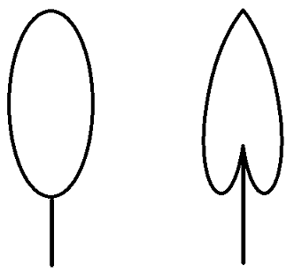
length
length

Ad.12: Leaf blade: ratio length/width

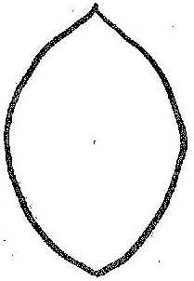 | 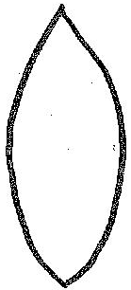 | 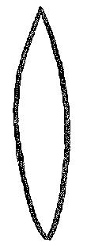
3 | 5 | 7
low | medium | high

Ad. 13: Leaf blade: position of broadest part

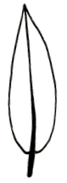 | 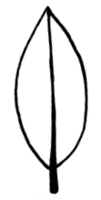 | 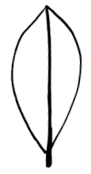
1 | 2 | 3
toward base | at middle | toward apex

Ad. 15: Leaf blade: shape of apex

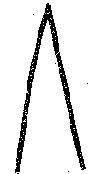 | 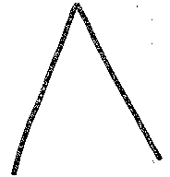 | 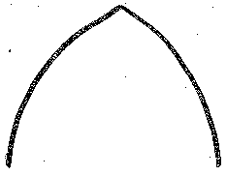
1 | 2 | 3
strongly acute | moderately acute | obtuse

Ad. 16: Leaf blade: shape of base

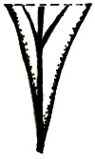 | 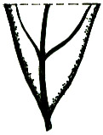 | 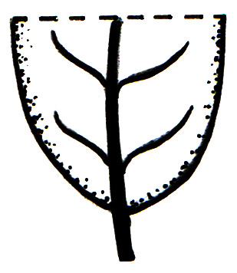 | 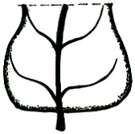 | 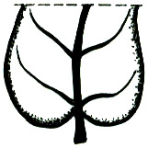
1 | 2 | 3 | 4 | 5
attenuate | acute | obtuse | truncate | cordate

Ad. 17 to 44: Leaf blade: color characteristics

In Aglaonema, leaf color is very significant to the overall appearance of the variety. Leaves often have several colors in different patterns.

These Test Guidelines allow the description of up to four colors using the RHS Colour Charts as well as the distributions, the patterns formed and the areas covered.

Although the colors are referred to as "color 1", "color 2", "color 3" and "color 4" in the headings, this does not indicate a ranking according to prominence or area covered. The order in which the colors should be observed is dictated by the order the colors as they appear in the RHS Colour Chart, as described in section 8.1.1(d).

Example varieties have not been provided for the leaf color characteristics. This is because the number of combinations of observations that these Test Guidelines allow for is larger than the number of combinations seen. Providing example varieties for all states of expression in this case would be misleading.

In order to provide an illustration of the recording method, three worked examples are provided below:

Example One – Pride of Sumatra (variety with two leaf colors)

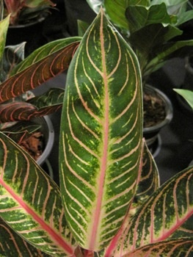
Ad. 17: Leaf blade: color 1 | Red Purple 64B
Ad. 18: Leaf blade: distribution of color 1 | 8 along midrib and along veins veins
Ad. 19: Leaf blade: pattern of color 1 | 6 solid or nearly solid
Ad. 20: Leaf blade: total area of color 1 | 2 very small to small
Ad. 21: Leaf blade: color 2 | Green N137A
Ad. 22: Leaf blade: distribution of color 2 | 6 throughout
Ad. 23: Leaf blade: pattern of color 2 | 4 solid or nearly solid
Ad. 24: Leaf blade: total area of color 2 | 7 large
Ad. 25: Leaf blade: color 3 | not applicable
Ad. 26: Leaf blade: distribution of color 3 | not applicable
Ad. 27: Leaf blade: pattern of color 3 | not applicable
Ad. 28: Leaf blade: total area of color 3 | not applicable
Ad. 29: Leaf blade: color 4 | not applicable
Ad. 30: Leaf blade: distribution of color 4 | not applicable
Ad. 31: Leaf blade: pattern of color 4 | not applicable
Ad. 32: Leaf blade: total area of color 4 | not applicable

Example Two – Spotted Evergreen (variety with three leaf colors)
Ad. 17: Leaf blade: color 1 | Green N137A
Ad. 18: Leaf blade: distribution of color 1 | 6 throughout
Ad. 19: Leaf blade: pattern of color 1 | 4 solid or nearly solid
Ad. 20: Leaf blade: total area of color 1 | 7 large
Ad. 21: Leaf blade: color 2 | Yellow Green 151B
Ad. 22: Leaf blade: distribution of color 2 | 6 throughout
Ad. 23: Leaf blade: pattern of color 2 | 1 small blotched
Ad. 24: Leaf blade: total area of color 2 | 1 very small
Ad. 25: Leaf blade: color 3 | White NN155B
Ad. 26: Leaf blade: distribution of color 3 | 1 along midrib
Ad. 27: Leaf blade: pattern of color 3 | 4 solid or nearly solid
Ad. 28: Leaf blade: total area of color 3 | 1 very small
Ad. 29: Leaf blade: color 4 | not applicable
Ad. 30: Leaf blade: distribution of color 4 | not applicable
Ad. 31: Leaf blade: pattern of color 4 | not applicable
Ad. 32: Leaf blade: total area of color 4 | not applicable

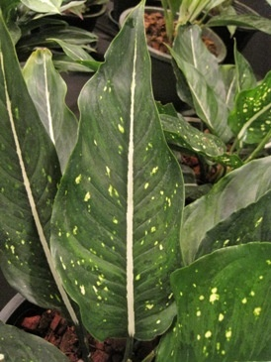

Example Three – Valentine (variety with two leaf colors)

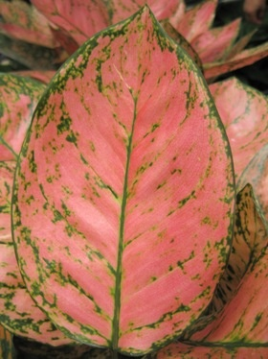
Ad. 17: Leaf blade: color 1 | Red Purple 67C
Ad. 18: Leaf blade: distribution of color 1 | 6 throughout
Ad. 19: Leaf blade: pattern of color 1 | 4 solid or nearly solid
Ad. 20: Leaf blade: total area of color 1 | 7 large
Ad. 21: Leaf blade: color 2 | Green 146A
Ad. 22: Leaf blade: distribution of color 2 | 14 along midrib, marginal zone and along veins
Ad. 23: Leaf blade: pattern of color 2 | 4 solid or nearly solid
Ad. 24: Leaf blade: total area of color 2 | 2 small to very small
Ad. 25: Leaf blade: color 3 | not applicable
Ad. 26: Leaf blade: distribution of color 3 | not applicable
Ad. 27: Leaf blade: pattern of color 3 | not applicable
Ad. 28: Leaf blade: total area of color 3 | not applicable
Ad. 29: Leaf blade: color 4 | not applicable
Ad. 30: Leaf blade: distribution of color 4 | not applicable
Ad. 31: Leaf blade: pattern of color 4 | not applicable
Ad. 32: Leaf blade: total area of color 4 | not applicable

Example Four – Pride of Sumatra (variety with two leaf colors on lower side)

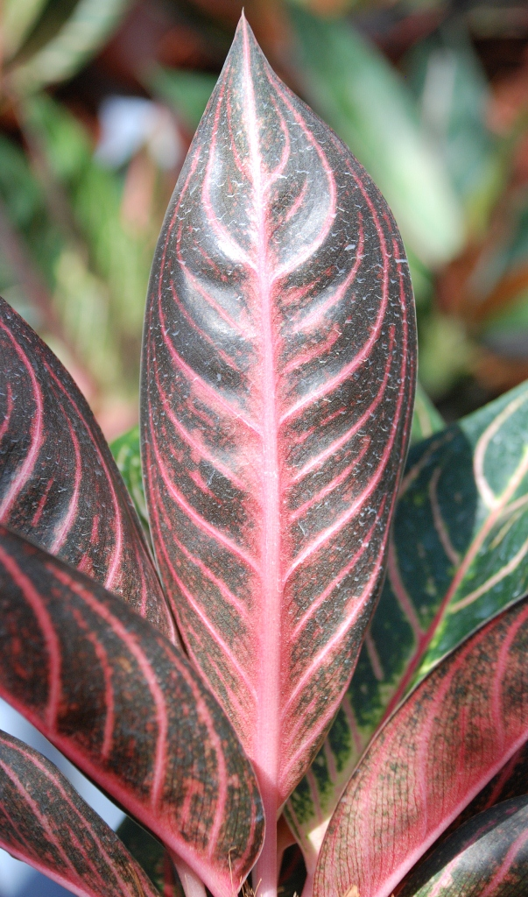
Ad. 33: Leaf blade: color 1 of lower side | Red Purple 64C
Ad. 34: Leaf blade: distribution of color 1 of lower side | 13 along midrib, along veins and between veins
Ad. 35: Leaf blade: pattern of color 1 of lower side | 4 solid or nearly solid
Ad. 36: Leaf blade: total area of color 1 of lower side | 4 small to medium
Ad. 37: Leaf blade: color 2 of lower side | Greyed Purple N186B
Ad. 38: Leaf blade: distribution of color 2 of lower side | 6 throughout
Ad. 39: Leaf blade: pattern of color 2 of lower side | 4 solid or nearly solid
Ad. 40: Leaf blade: total area of color 2 of lower side | 5 medium
Ad. 41: Leaf blade: color 3 of lower side | not applicable
Ad. 42: Leaf blade: distribution of color 3 of lower side | not applicable
Ad. 43: Leaf blade: pattern of color 3 of lower side | not applicable
Ad. 44: Leaf blade: total area of color 3 of lower side | not applicable

Ad. 18: Leaf blade: distribution of color 1

Ad. 22: Leaf blade: distribution of color 2

Ad. 26: Leaf blade: distribution of color 3

Ad. 30: Leaf blade: distribution of color 4

Ad. 34: Leaf blade: distribution of color 1 of lower side

Ad. 38: Leaf blade: distribution of color 2 of lower side

Ad. 42: Leaf blade: distribution of color 3 of lower side

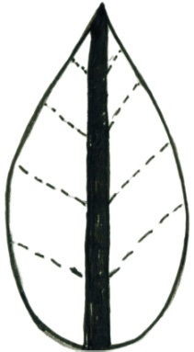 | 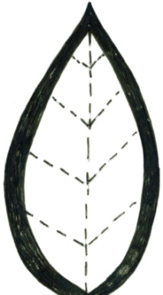 | 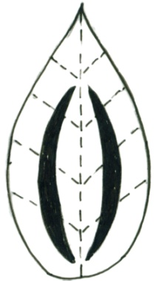 | 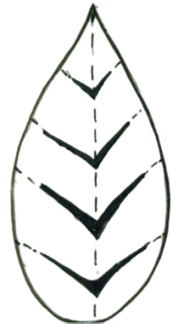 | 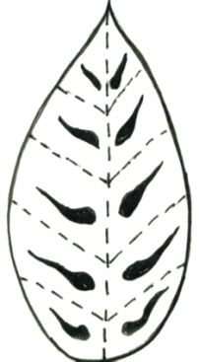 | 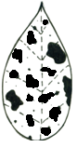 | 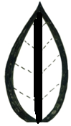
1 | 2 | 3 | 4 | 5 | 6 | 7
along midrib | marginal zone | between midrib and margin | along veins | between veins | throughout | along midrib and marginal zone
 |  |  |  |  | 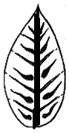 | 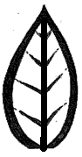
8 | 9 | 10 | 11 | 12 | 13 | 14
along midrib and along veins | along midrib and throughout | along veins and between veins | marginal zone and throughout | along midrib and along veins and throughout | along midrib, along veins and between veins | along midrib, marginal zone and along veins
Ad. 19: Leaf blade: pattern of color 1
Ad. 23: Leaf blade: pattern of color 2
Ad. 27: Leaf blade: pattern of color 3
Ad. 31: Leaf blade: pattern of color 4
Ad. 35: Leaf blade: pattern of color 1 of lower side
Ad. 39: Leaf blade: pattern of color 2 of lower side
Ad. 43: Leaf blade: pattern of color 3 of lower side

 |  |  |  |  | 
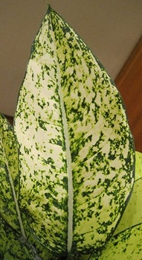 | 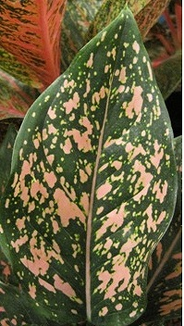 |  |  | 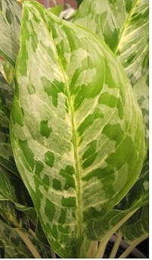 | 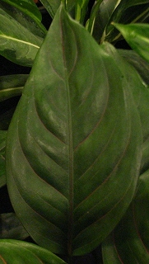
green color | pink color |  |  | green color | green color
1 | 2 | 3 | 4 | 5 | 6
small blotched | small to medium blotched | medium blotched | medium to large blotched | large blotched | solid or nearly solid

Ad. 46: Leaf blade: blistering

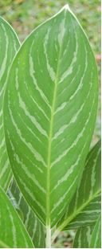 | 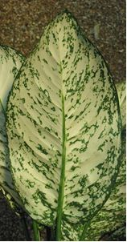 | 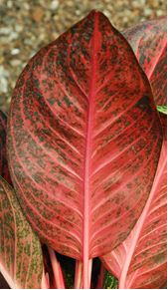
1 | 2 | 3 | 4
absent or very weak | weak | medium | strong
Ad. 48: Leaf blade: profile in cross section

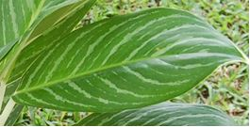 | 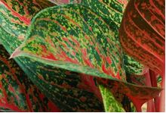
1 | 3
flat | moderately concave

Ad. 49: Leaf blade midrib: profile

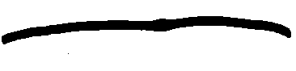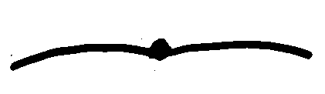
↓upperside
1 | 2 | 3
raised | flat | sunken

Ad. 50: Leaf blade: number of vein pairs

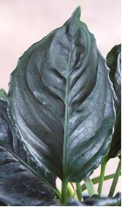 | 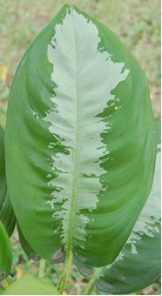
3 | 7
few | many

Literature

Nicolson, D.H., 1969: A revision of Genus Aglaonema (Araceae). Smithsonian Institution Press. Washington, USA

Sinchaisri, N., et al., 2006: Catalog of Aglaonema in Thailand. TH

Technical Questionnaire

TECHNICAL QUESTIONNAIRE |  |  |  | Page {x} of {y} |  | Reference Number:
 |  |  |  |  |  | Application date:
 |  |  |  |  |  | (not to be filled in by the applicant)
TECHNICAL QUESTIONNAIRE
to be completed in connection with an application for plant breeders’ rights

1. Subject of the Technical Questionnaire
1.1 Genus |  |  | Aglaonema Schott.
1.2 Botanical name
1.2.1 Common name |  |  | Aglaonema, Chinese Evergreen
2. Applicant
Name
Address
Telephone No.
Fax No.
E-mail address
Breeder (if different from applicant)
3. Proposed denomination and breeder’s reference
Proposed denomination
(if available)

Breeder’s reference
#4. Information on the breeding scheme and propagation of the variety

4.1 Breeding scheme

Variety resulting from:

4.1.1 Crossing

(a) controlled cross [ ]
(please state parent varieties)

(…………………..……………..…) x (……………..…………………..…)
female parent male parent

(b) partially known cross [ ]
(please state known parent variety(ies))

(…………………..……………..…) x (……………..…………………..…)
female parent male parent

(c) unknown cross [ ]

4.1.2 Mutation [ ]
(please state parent variety)

4.1.3 Discovery and development [ ]
(please state where and when discovered and how developed)

4.1.4 Other [ ]
(please provide details)

4.2 Method of propagating the variety

4.2.1 Vegetative propagation

(a) cuttings [ ]

(b) in vitro propagation [ ]

(c) other (state method) [ ]

5. Characteristics of the variety to be indicated (the number in brackets refers to the corresponding characteristic in Test Guidelines; please mark the note which best corresponds).

 | Characteristics |  |  |  |  |  | Example Varieties |  |  | Note
5.1  (10) | Leaf blade: length
 | very short |  |  |  |  |  |  |  |  | 1[ ]
 | very short to short |  |  |  |  |  |  |  |  | 2[ ]
 | short |  |  |  |  |  | Black Beauty |  |  | 3[ ]
 | short to medium |  |  |  |  |  |  |  |  | 4[ ]
 | medium |  |  |  |  |  | Tiara |  |  | 5[ ]
 | medium to long |  |  |  |  |  |  |  |  | 6[ ]
 | long |  |  |  |  |  | Thep Ranjuan |  |  | 7[ ]
 | long to very long |  |  |  |  |  |  |  |  | 8[ ]
 | very long |  |  |  |  |  |  |  |  | 9[ ]
5.2  (11) | Leaf blade: width
 | very narrow |  |  |  |  |  |  |  |  | 1[ ]
 | very narrow to narrow |  |  |  |  |  |  |  |  | 2[ ]
 | narrow |  |  |  |  |  | Thep Ranjuan |  |  | 3[ ]
 | narrow to medium |  |  |  |  |  |  |  |  | 4[ ]
 | medium |  |  |  |  |  | Katharngen |  |  | 5[ ]
 | medium to broad |  |  |  |  |  |  |  |  | 6[ ]
 | broad |  |  |  |  |  | World Heritage |  |  | 7[ ]
 | broad to very broad |  |  |  |  |  |  |  |  | 8[ ]
 | very broad |  |  |  |  |  |  |  |  | 9[ ]
5.3(i)  (17) | Leaf blade: color 1
 | RHS Colour Chart (indicate reference number)
5.3(ii)  (17) | Leaf blade: color 1
 | white |  |  |  |  |  |  |  |  | 1[ ]
 | yellow |  |  |  |  |  |  |  |  | 2[ ]
 | greyed-green |  |  |  |  |  |  |  |  | 3[ ]
 | green |  |  |  |  |  |  |  |  | 4[ ]
 | red |  |  |  |  |  |  |  |  | 5[ ]
 | Characteristics |  |  |  |  |  | Example Varieties |  |  | Note
5.4  (18) | Leaf blade: distribution of color 1
 | along midrib |  |  |  |  |  |  |  |  | 1[ ]
 | marginal zone |  |  |  |  |  |  |  |  | 2[ ]
 | between midrib and margin |  |  |  |  |  |  |  |  | 3[ ]
 | along veins |  |  |  |  |  |  |  |  | 4[ ]
 | between veins |  |  |  |  |  |  |  |  | 5[ ]
 | throughout |  |  |  |  |  |  |  |  | 6[ ]
 | along midrib and marginal zone |  |  |  |  |  |  |  |  | 7[ ]
 | along midrib and along veins |  |  |  |  |  |  |  |  | 8[ ]
 | along midrib and throughout |  |  |  |  |  |  |  |  | 9[ ]
 | along veins and between veins |  |  |  |  |  |  |  |  | 10[ ]
 | marginal zone and throughout |  |  |  |  |  |  |  |  | 11[ ]
 | along midrib and along veins and throughout |  |  |  |  |  |  |  |  | 12[ ]
 | along midrib, along veins and between veins |  |  |  |  |  |  |  |  | 13[ ]
 | along midrib, marginal zone and along veins |  |  |  |  |  |  |  |  | 14[ ]
5.5  (20) | Leaf blade: total area of color 1
 | very small |  |  |  |  |  |  |  |  | 1[ ]
 | very small to small |  |  |  |  |  |  |  |  | 2[ ]
 | small |  |  |  |  |  |  |  |  | 3[ ]
 | small to medium |  |  |  |  |  |  |  |  | 4[ ]
 | medium |  |  |  |  |  |  |  |  | 5[ ]
 | medium to large |  |  |  |  |  |  |  |  | 6[ ]
 | large |  |  |  |  |  |  |  |  | 7[ ]
 | large to very large |  |  |  |  |  |  |  |  | 8[ ]
 | very large |  |  |  |  |  |  |  |  | 9[ ]
 | Characteristics |  |  |  |  |  | Example Varieties |  |  | Note
5.6(i)  (21) | Leaf blade: color 2
 | RHS Colour Chart (indicate reference number)
5.6(ii)  (21) | Leaf blade: color 2
 | white |  |  |  |  |  |  |  |  | 1[ ]
 | yellow |  |  |  |  |  |  |  |  | 2[ ]
 | greyed-green |  |  |  |  |  |  |  |  | 3[ ]
 | green |  |  |  |  |  |  |  |  | 4[ ]
 | red |  |  |  |  |  |  |  |  | 5[ ]
5.7  (22) | Leaf blade: distribution of color 2
 | along midrib |  |  |  |  |  |  |  |  | 1[ ]
 | marginal zone |  |  |  |  |  |  |  |  | 2[ ]
 | between midrib and margin |  |  |  |  |  |  |  |  | 3[ ]
 | along veins |  |  |  |  |  |  |  |  | 4[ ]
 | between veins |  |  |  |  |  |  |  |  | 5[ ]
 | throughout |  |  |  |  |  |  |  |  | 6[ ]
 | along midrib and marginal zone |  |  |  |  |  |  |  |  | 7[ ]
 | along midrib and along veins |  |  |  |  |  |  |  |  | 8[ ]
 | along midrib and throughout |  |  |  |  |  |  |  |  | 9[ ]
 | along veins and between veins |  |  |  |  |  |  |  |  | 10[ ]
 | marginal zone and throughout |  |  |  |  |  |  |  |  | 11[ ]
 | along midrib and along veins and throughout |  |  |  |  |  |  |  |  | 12[ ]
 | along midrib, along veins and between veins |  |  |  |  |  |  |  |  | 13[ ]
 | along midrib, marginal zone and along veins |  |  |  |  |  |  |  |  | 14[ ]
 | Characteristics |  |  |  |  |  | Example Varieties |  |  | Note
5.8  (24) | Leaf blade: total area of color 2
 | very small |  |  |  |  |  |  |  |  | 1[ ]
 | very small to small |  |  |  |  |  |  |  |  | 2[ ]
 | small |  |  |  |  |  |  |  |  | 3[ ]
 | small to medium |  |  |  |  |  |  |  |  | 4[ ]
 | medium |  |  |  |  |  |  |  |  | 5[ ]
 | medium to large |  |  |  |  |  |  |  |  | 6[ ]
 | large |  |  |  |  |  |  |  |  | 7[ ]
 | large to very large |  |  |  |  |  |  |  |  | 8[ ]
 | very large |  |  |  |  |  |  |  |  | 9[ ]
5.9(i)  (25) | Leaf blade: color 3
 | RHS Colour Chart (indicate reference number)
5.9(ii)  (25) | Leaf blade: color 3
 | white |  |  |  |  |  |  |  |  | 1[ ]
 | yellow |  |  |  |  |  |  |  |  | 2[ ]
 | greyed-green |  |  |  |  |  |  |  |  | 3[ ]
 | green |  |  |  |  |  |  |  |  | 4[ ]
 | red |  |  |  |  |  |  |  |  | 5[ ]
 | Characteristics |  |  |  |  |  | Example Varieties |  |  | Note
5.10  (26) | Leaf blade: distribution of color 3
 | along midrib |  |  |  |  |  |  |  |  | 1[ ]
 | marginal zone |  |  |  |  |  |  |  |  | 2[ ]
 | between midrib and margin |  |  |  |  |  |  |  |  | 3[ ]
 | along veins |  |  |  |  |  |  |  |  | 4[ ]
 | between veins |  |  |  |  |  |  |  |  | 5[ ]
 | throughout |  |  |  |  |  |  |  |  | 6[ ]
 | along midrib and marginal zone |  |  |  |  |  |  |  |  | 7[ ]
 | along midrib and along veins |  |  |  |  |  |  |  |  | 8[ ]
 | along midrib and throughout |  |  |  |  |  |  |  |  | 9[ ]
 | along veins and between veins |  |  |  |  |  |  |  |  | 10[ ]
 | marginal zone and throughout |  |  |  |  |  |  |  |  | 11[ ]
 | along midrib and along veins and throughout |  |  |  |  |  |  |  |  | 12[ ]
 | along midrib, along veins and between veins |  |  |  |  |  |  |  |  | 13[ ]
 | along midrib, marginal zone and along veins |  |  |  |  |  |  |  |  | 14[ ]
5.11  (28) | Leaf blade: total area of color 3
 | very small |  |  |  |  |  |  |  |  | 1[ ]
 | very small to small |  |  |  |  |  |  |  |  | 2[ ]
 | small |  |  |  |  |  |  |  |  | 3[ ]
 | small to medium |  |  |  |  |  |  |  |  | 4[ ]
 | medium |  |  |  |  |  |  |  |  | 5[ ]
 | medium to large |  |  |  |  |  |  |  |  | 6[ ]
 | large |  |  |  |  |  |  |  |  | 7[ ]
 | large to very large |  |  |  |  |  |  |  |  | 8[ ]
 | very large |  |  |  |  |  |  |  |  | 9[ ]
6. Similar varieties and differences from these varieties

Please use the following table and box for comments to provide information on how your candidate variety differs from the variety (or varieties) which, to the best of your knowledge, is (or are) most similar. This information may help the examination authority to conduct its examination of distinctness in a more efficient way.

Denomination(s) of variety(ies) similar to your candidate variety |  | Characteristic(s) in which your candidate variety differs from the similar variety(ies) |  |  | Describe the expression of the characteristic(s) for the similar variety(ies) |  |  | Describe the expression of the characteristic(s) for your candidate variety
Example |  | Leaf blade: length |  |  | medium |  |  | short
Comments:

#7. Additional information which may help in the examination of the variety

7.1 In addition to the information provided in sections 5 and 6, are there any additional characteristics which may help to distinguish the variety?

Yes [ ] No [ ]

(If yes, please provide details)

7.2 Are there any special conditions for growing the variety or conducting the examination?

Yes [ ] No [ ]

(If yes, please provide details)

7.3 Other information

A representative color image of the variety should accompany the Technical Questionnaire.

8. Authorization for release

(a) Does the variety require prior authorization for release under legislation concerning the protection of the environment, human and animal health?

Yes [ ] No [ ]

(b) Has such authorization been obtained?

Yes [ ] No [ ]

If the answer to (b) is yes, please attach a copy of the authorization.

9. Information on plant material to be examined or submitted for examination.

9.1 The expression of a characteristic or several characteristics of a variety may be affected by factors, such as pests and disease, chemical treatment (e.g. growth retardants or pesticides), effects of tissue culture, different rootstocks, scions taken from different growth phases of a tree, etc.

9.2 The plant material should not have undergone any treatment which would affect the expression of the characteristics of the variety, unless the competent authorities allow or request such treatment. If the plant material has undergone such treatment, full details of the treatment must be given. In this respect, please indicate below, to the best of your knowledge, if the plant material to be examined has been subjected to:

(a) Microorganisms (e.g. virus, bacteria, phytoplasma) Yes [ ] No [ ]

(b) Chemical treatment (e.g. growth retardant, pesticide) Yes [ ] No [ ]

(c) Tissue culture Yes [ ] No [ ]

(d) Other factors Yes [ ] No [ ]

Please provide details for where you have indicated “yes”.

……………………………………………………………

10. I hereby declare that, to the best of my knowledge, the information provided in this form is correct:

Applicant’s name

Signature Date

[End of document]

* These names were correct at the time of the introduction of these Test Guidelines but may be revised or updated. [Readers are advised to consult the UPOV Code, which can be found on the UPOV Website (www.upov.int), for the latest information.]
# Authorities may allow certain of this information to be provided in a confidential section of the Technical Questionnaire.
# Authorities may allow certain of this information to be provided in a confidential section of the Technical Questionnaire.

