 |  | E  TWO/45/35  ORIGINAL: English  DATE: July 27, 2012
INTERNATIONAL UNION FOR THE PROTECTION OF NEW VARIETIES OF PLANTS
Geneva
Technical working party for ORNAMENTAL PLANTS AND FOREST TREES
Forty-Fifth Session
Jeju, Republic of Korea, August 6 to 10, 2012
matters to be resolved concerning test guidelines considered by the technical committee: Test GUidelines for Camellia
Document prepared by the Office of the Union
1 The Technical Working Party for Ornamental Plants and Forest Trees (TWO), at its forty-third session, held in Cuernavaca, Morelos State, Mexico, from September 20 to 24, 2010, agreed to submit the draft Test Guidelines for Camellia (document TG/CAMEL(proj.3)) to the Technical Committee (TC) for adoption (see document TWO/44/25 “Report” paragraph 9).

2 The TC at its forty-seventh session, held in Geneva from April 4 to 6, 2011, adopted the draft Test Guidelines for Camellia on the basis of document TG/CAMEL(proj.4) subject to the amendments requested in Annex IV to the Report and the linguistic changes suggested by the Enlarged Editorial Committee (TC-EDC) (see document TC/47/27, “Report”, paragraph 205). Annex I to this document contains the reply from the Leading Expert, Mr. Jiyuan Li, China, to the requests by the.

3 In addition to the amendments proposed in response to the request of the TC, the Leading Expert proposed further changes to be incorporated into the Test Guidelines, which are presented in the Annex II to this document.

4 A copy of document TG/CAMEL(proj.4) is provided on the TWO/43 page of the UPOV website for information.

[Annexes follows]

Changes Requested by the Technical Committee to document tg/Camel (proj.4)

Char. 8 | to read “(1) distichous, (2) four-row dispersed, (3) dispersed” | Leading Expert agrees
Char. 9 | to delete states 1 and 9 | Leading Expert agrees
Chars. 9 and 10 | to read VG/MS | Leading Expert agrees
Char. 11 | to read “(1) below middle third, (2) in middle third, (3) above middle third” | Leading Expert agrees
Char 11 and 25 | to have same wording | Leading Expert agrees
Char. 20 | to add example varieties or to delete (*) | Leading Expert provided example varieties
Char. 30 to 33 | to add (e) | Leading Expert agrees
Char. 32 | to add example varieties | Leading Expert agrees
Char. 33 | to read: “Flower: petaloid organs:” with state (3) “all stamens and pistil petaloid” | Leading Expert agrees
Char. 36 | to add explanation or example varieties | Leading Expert provided example varieties
Char. 40 | to ask leading expert whether this characteristic refers to conspicuousness of veins, number of veins or both and to provide a better explanation and example varieties | Leading Expert proposes:
  Petal: conspicuousness of veins
  weak | Bai Bao Ta | 1
  medium | Chun Jiang Zhi Xia | 2
  strong | Hong Shi Ba Xue Shi | 3
Char. 41 | to add (+) | Leading Expert agrees
Char. 42 | to read “Petal: distribution of shading of main color (excluding variegation)” | Leading Expert agrees
Char. 43 | to add (+) | Leading Expert agrees
Char. 44 | to read “Petal: distribution of secondary color” | Leading Expert agrees
Char. 45 to 49 | to add (g) | Leading Expert agrees
8.1 | (e) to delete “regular” and “5”  (f) to delete “regular” and “in blossoming season”  (g) to provide the diagram | Leading expert agrees and proposes:  - Observations should be made on fully open flowers.  - Observations should be made on petals in first outer row.  - Flower: diagram.  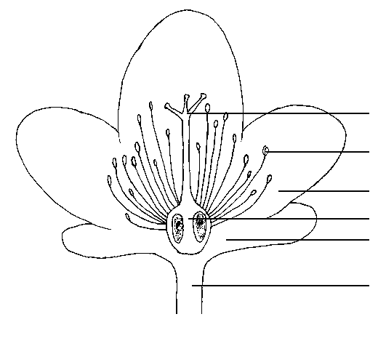  style splitting  stamen  petal  ovary  calyx  pedicel
Ad. 8 | to explain that (2) has a divergence of 90⁰ and (3) has a divergence of >90⁰ | Ad. 8: Leaf: arrangement  Four-row dispersed arrangement means leaves positioned at 90º on stem and dispersed arrangement means leaves positioned at less than 90º on stem.
  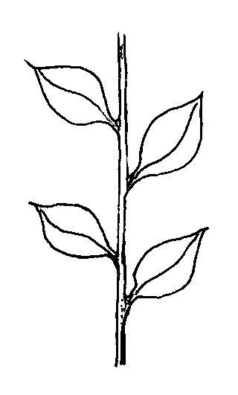 | 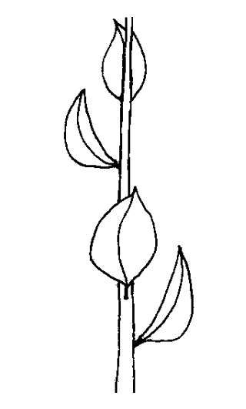 | 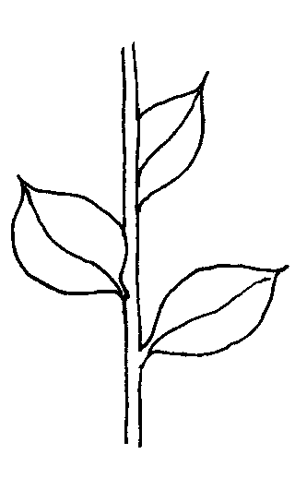
  1 | 2 | 3
  distichous | four-row dispersed | dispersed
Ad 22 | to provide drawings that show leaf cross section for states (2) and (3) | Ad. 22: Leaf blade: shape in cross section
  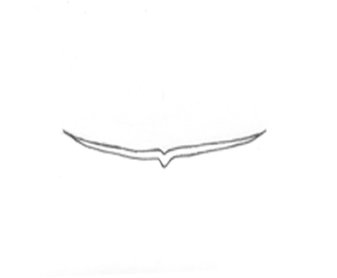 | 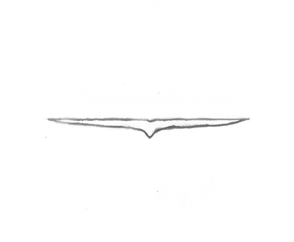 | 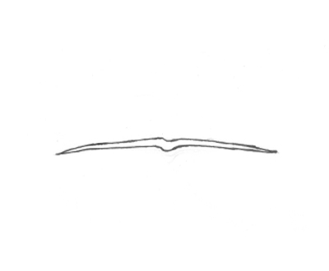
  1 | 2 | 3
  concave | flat | convex
Ad 40 | to provide better drawings | Ad. 40: Petal: conspicuousness of veins
  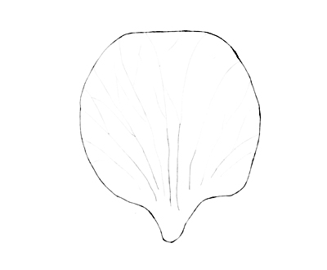 | 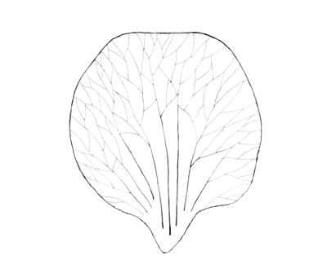 | 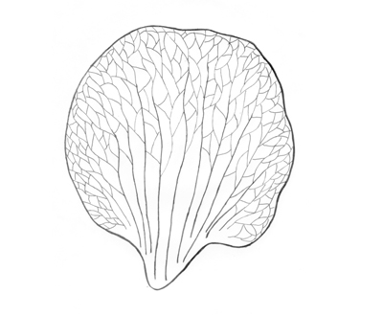
  1 | 2 | 3
  weak | medium | strong
Ad. 41 | to read “The main color is determined as the color with the largest surface area present on the upper side of a petal.” | Leading Expert agrees
Ad. 43 | to read “The secondary color is determined as the color with the second largest surface area, usually observed as a defined pattern on the upper side of a petal.” | Leading Expert agrees
Ad. 41, 42, 43, 44 | to add standard definition concerning main color, secondary color, etc.  “The main color is the color with the largest area and the secondary color is the color with the second largest area on the upper part of the petal.  To ask the leading expert whether it would be useful to include the following sentence in the explanation: “In cases where the area of the main and secondary colors are nearly equal, the darker color should be considered to be the main color.” | Ad 41 and 43: see above.  Ad 42: Leading Expert disagrees.  Ad. 44: Petal: distribution of secondary color  The main color is determined as the color with the largest surface area present on the upper side of a petal.  The secondary color is determined as the color with the second largest surface area, usually observed as a defined pattern on the upper side of a petal.
Ad. 48 | to provide a new drawing for state (3) “Same level” | 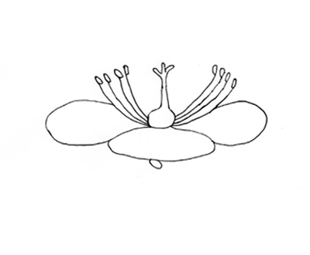
  2
  same level

[Annex II follows]

CHANGES TO DOCUMENT TG/CAMEL(PROJ.4) PROPOSED BY THE LEADING EXPERT

Chapter 6.4.2

Current wording:

“6.4.2 Example varieties contained in the Table of Characteristics originally belong to following parent species:

Camellia changii (Camellia azalea): Chun Jiang Zhi Xia

Camellia japonica: Anticipation, Betty Foy Sanders, Camilla Hebert, Chang E Cai, Colettii, Da Hong Jin Xin, Da Hong Mu Dan, Da Zhu Sha, Elegans Champagne, Fen Fu Rong, Fen Xia, Grape Soda, Hakuhan Kujaku, Helen Bower, Holly Bright, Hong Lu Zhen, Hua Bao Zhu, Hua Mu Dan, Jin Jiang Mu Dan, Jin Pan Li Zhi, Kingyo-tsubaki, Lipstick, L.T. Dees, Margaret Davis, Mary Agnes Patin, Masterpiece, Night Rider, Nokogiriba, Nuccio’s # 4310, Nuccio’s Bella Rossa, Nuccio’s Cameo, Pen Sha, Pu Tao Hong, Raspberry Ice, Ren Mian Tao Hua, Royal Velvet, Sai Luo Yang, Shi Ba Xue Shi, Shi Zi Xiao, Swan Lake, Unryu-tsubaki, Wen Ban Fei Ye Cha, Xiao Tao Hong, Xue Ta, Zao Chun Da Hong Qiu, Zhuang Yuan Hong

Camellia reticulata: Bill Goertz, Da Li Cha, Da Tao Hong, Hou Ye De Chi, Massee Lane, Pink Dalhlia, Tong Zi Mian, Zhu Sha Zi Pao

Camellia sasanqua: First Cover, Xia Mei Gui”

Proposed wording:

Camellia amplexicaulis: Fen Bao Jing Cha

Camellia changii (Camellia azalea): Chun Jiang Zhi Xia

Camellia japonica: Anticipation, Bai Bao Ta, Bai Mu Dan, Betty Foy Sanders, Bian Ye Kuan Cai Dai, Cai Fu Rong, Cai Ye Hong Lv Zhen, Camilla Hebert, Chang E Cai, Chong Qing Hong, Colettii, Da Hong Jin Xin, Da Hong Mu Dan, Da Zhu Sha, Elegans Champagne, Fei Bie Cha, Fen Fu Rong, Fen Xia, Grape Soda, Hakuhan Kujaku Kujaku-tsubaki, Helen Bower, Holly Bright, Hong Lu Zhen, Hong Shi Ba Xue Shi, Hua Bao Zhu, Hua Mu Dan, Jin Jiang Mu Dan, Jin Pan Li Zhi, Kingyo-tsubaki, Lipstick, L.T. Dees, Margaret Davis, Mary Agnes Patin, Masterpiece, Night Rider, Nokogiriba, Nuccio’s # 4310, Nuccio’s Bella Rossa, Nuccio’s Cameo, Pen Sha, Pu Tao Hong, Raspberry Ice, Ren Mian Tao Hua, Royal Velvet, Sai Luo Yang, Shi Ba Xue Shi, Shi Zi Xiao, Swan Lake, Unryu-tsubaki, Wen Ban Fei Ye Cha, Xiao Tao Hong, Xu Bian, Xue Ta, Yi Lan Jiao, Zao Chun Da Hong Qiu, Zhuang Yuan Hong

Camellia minutiflora: We Hua Lian Rui Cha

Camellia reticulata: Bill Goertz, Da Li Cha, Da Tao Hong, Hou Ye De Chi, Massee Lane, Pink Dalhlia, Tong Zi Mian, Zhu Sha Zi Pao

Camellia sasanqua: First Cover, Xia Mei Gui

Hybrids: Dong Hai Guang Yao
Characteristic 1 “Plant: growth habit”

Current wording:

1.  (*)  (+) | VG | Plant: growth habit | Plante : port | Pflanze: Wuchsform | Planta: porte
PQ |  | upright | dressé | aufrecht | erecto | Anticipation | 1
 |  | semi-upright | demi-dressé | halbaufrecht | semierecto | Mary Agnes Patin | 2
 |  | spreading | étalé | breitwüchsig | extendido | Masterpiece | 3
 |  | drooping | retombant | überhängend | colgante | Hakuhan Kujaku | 4
 |  | horizontal | horizontal | waagerecht | horizontal | First Cover | 5

Proposed wording:

1.  (*)  (+) | VG | Plant: growth habit | Plante : port | Pflanze: Wuchsform | Planta: porte
PQ |  | upright | dressé | aufrecht | erecto | Anticipation | 1
 |  | semi-upright | demi-dressé | halbaufrecht | semierecto | Mary Agnes Patin | 2
 |  | spreading | étalé | breitwüchsig | extendido | Masterpiece | 3
 |  | drooping | retombant | überhängend | colgante | Hakuhan Kujaku  Kujaku-tsubaki | 4
 |  | horizontal | horizontal | waagerecht | horizontal | First Cover | 5

Characteristic 13 “Leaf blade: shape of apex”

Current wording:

13.  (*)  (+) | VG | Leaf blade: shape of apex | Limbe : forme du sommet | Blattspreite: Form der Spitze | Limbo: forma del ápice
PQ | (c) | retuse | échancrée | eingedrückt | retuso | Chun Jiang Zhi Xia | 1
 |  | rounded | ronde | abgerundet | redondeado | Hen Tiao Gao | 2
 |  | short acuminate | à pointe courte | kurz zugespitzt | acuminado corto y ancho | Hong Lu Zhen | 3
 |  | medium acuminate | à pointe moyenne | mäßig zugespitzt | acuminado medio |  | 4
 |  | long acuminate | à pointe longue | lang zugespitzt | acuminado largo | Kujaku-tsubaki | 5
 |  | divided | divisée | eingeschnitten | dividido | Kingyo-tsubaki | 6

Proposed wording:

13.  (*)  (+) | VG | Leaf blade: shape of apex | Limbe : forme du sommet | Blattspreite: Form der Spitze | Limbo: forma del ápice
PQ | (c) | retuse | échancrée | eingedrückt | retuso | Chun Jiang Zhi Xia | 1
 |  | rounded | ronde | abgerundet | redondeado | Hen Tiao Gao  Hen Tiaon Gao | 2
 |  | short acuminate | à pointe courte | kurz zugespitzt | acuminado corto y ancho | Hong Lu Zhen | 3
 |  | medium acuminate | à pointe moyenne | mäßig zugespitzt | acuminado medio |  | 4
 |  | long acuminate | à pointe longue | lang zugespitzt | acuminado largo | Kujaku-tsubaki | 5
 |  | divided | divisée | eingeschnitten | dividido | Kingyo-tsubaki | 6

Characteristic 20 “Leaf blade: color of variegation”

Current wording:

20.  (*) | VG | Leaf blade: color of variegation | Limbe : couleur de la panachure | Blattspreite: Farbe der Panaschierung | Limbo: color de la variegación
PQ | (c) | white | blanche | weiß | blanco | Dong Hai Guang Yao | 1
 |  | light yellow | jaune clair | hellgelb | amarillo claro | Bian Ye Kuan Cai Dai | 2
 |  | medium yellow | jaune moyen | mittelgelb | amarillo medio | Cai Ye Hong Lv Zhen | 3

Proposed wording:

20.  (*) | VG | Leaf blade: color of variegation | Limbe : couleur de la panachure | Blattspreite: Farbe der Panaschierung | Limbo: color de la variegación
PQ | (c) | white | blanche | weiß | blanco | Dong Hai Guang Yao | 1
 |  | light yellow | jaune clair | hellgelb | amarillo claro | Bian Ye Kuan Cai Dai | 2
 |  | medium yellow | jaune moyen | mittelgelb | amarillo medio | Cai Ye Hong Lv Zhen  Cai Ye Hong Lu Zhen | 3

Characteristic 24 “Petiole: length”

Current wording:

24. | VG/MS | Petiole: length | Pétiole : longueur | Blattstiel: Länge | Peciolo: longitud
QN | (c) | very short | très courte | sehr kurz | muy corto | Fen Bao Jing | 1
 |  | short | courte | kurz | corto | Hong Lu Zhen | 3
 |  | medium | moyenne | mittel | medio |  | 5
 |  | long | longue | lang | largo |  | 7

Proposed wording:

24. | VG/  MS | Petiole: length | Pétiole : longueur | Blattstiel: Länge | Peciolo: longitud
QN | (c) | very short | très courte | sehr kurz | muy corto | Fen Bao Jing  Fen Bao Jing Cha | 1
 |  | short | courte | kurz | corto | Hong Lu Zhen | 3
 |  | medium | moyenne | mittel | medio |  | 5
 |  | long | longue | lang | largo |  | 7

Characteristic 29 “Flower: diameter”

Current wording:

29.  (*) | MG/VG | Flower: diameter | Fleur : diamètre | Blüte: Durchmesser | Flor: diámetro
QN | (e) | very small | très petit | sehr klein | muy pequeño | Wei Hua Lian Rui Cha | 1
 |  | small | petit | klein | pequeño | Xiao Mei Gui | 3
 |  | medium | moyen | mittel | medio | Hong Lu Zhen | 5
 |  | large | grand | groß | grande | Da Li Cha | 7
 |  | very large | très grand | sehr groß | muy grande | Feng Bao Jing Cha | 9

Proposed wording:

29.  (*) | MG/VG | Flower: diameter | Fleur : diamètre | Blüte: Durchmesser | Flor: diámetro
QN | (e) | very small | très petit | sehr klein | muy pequeño | Wei Hua Lian Rui Cha | 1
 |  | small | petit | klein | pequeño | Xiao Mei Gui | 3
 |  | medium | moyen | mittel | medio | Hong Lu Zhen | 5
 |  | large | grand | groß | grande | Da Li Cha | 7
 |  | very large | très grand | sehr groß | muy grande | Feng Bao Jing Cha  Fen Bao Jing Cha | 9

Characteristic 45 “Stamens: arrangement”

Current wording:

45.  (*)  (+) | VG | Stamens: arrangement | Étamines : disposition | Staubgefäße: Anordnung | Estambres: disposición
PQ | (g) | sasanqua | sasanqua | sasanquaförmig | sasanqua | Xia Mei Gui | 1
 |  | circular | circulaire | kreisförmig | circular | Sai Luo Yang | 2
 |  | apricot | abricot | aprikosenförmig | albaricoque |  | 3
 |  | tea whisk | fouet à thé | teebesenförmig | batidor de bambú | Da Hong Jin Xin | 4
 |  | pinched | pincée | gestutzt | pinzada |  | 5
 |  | tubular | tubuleuse | röhrenförmig | tubular |  | 6
 |  | split | divisée | gespalten | separada | Jin Jiang Mu Dan | 7
 |  | dispersed | dispersée | verstreut | dispersa | Da Hong Mu Dan | 8

Proposed wording:
45.  (*)  (+) | VG | Stamens: arrangement | Étamines : disposition | Staubgefäße: Anordnung | Estambres: disposición
PQ | (g) | sasanqua | sasanqua | sasanquaförmig | sasanqua | Xia Mei Gui  Xiao Mei Gui | 1
 |  | circular | circulaire | kreisförmig | circular | Sai Luo Yang | 2
 |  | apricot | abricot | aprikosenförmig | albaricoque |  | 3
 |  | tea whisk | fouet à thé | teebesenförmig | batidor de bambú | Da Hong Jin Xin | 4
 |  | pinched | pincée | gestutzt | pinzada |  | 5
 |  | tubular | tubuleuse | röhrenförmig | tubular |  | 6
 |  | split | divisée | gespalten | separada | Jin Jiang Mu Dan | 7
 |  | dispersed | dispersée | verstreut | dispersa | Da Hong Mu Dan | 8

[End of Annex II and of document]

Corrected from document TC/47/26 “Report on the Conclusions”

