 |  |  |  |  |  |  | E  TG/LOBEL(proj.2)  ORIGINAL: English  DATE: 2012-06-26
INTERNATIONAL UNION FOR THE PROTECTION OF NEW VARIETIES OF PLANTS
Geneva
 |  |  | DRAFT
 |  | LOBELIA  UPOV Code: LOBEL_ERI,  LOBEL_VAL, LOBEL_EVA  Lobelia erinus L., Lobelia valida L. Bolus, Lobelia erinus x valida |  |  | *

GUIDELINES

FOR THE CONDUCT OF TESTS

FOR DISTINCTNESS, UNIFORMITY AND STABILITY

prepared by an expert from Canada

to be considered by the
Technical Working Party for Ornamental Plants and Forest Trees
at its forty-fifth session, to be held in Jeju, Republic of Korea from August 6 to 10, 2012

Alternative Names:*

Botanical name | English | French | German | Spanish
Lobelia erinus L., Lobelia valida L. Bolus, Lobelia erinus x valida | Lobelia, True Lobelia of Gardens | Lobélie, Lobélie des jardins | Lobelie, Männertreu | Lobelia

The purpose of these guidelines (“Test Guidelines”) is to elaborate the principles contained in the General Introduction (document TG/1/3), and its associated TGP documents, into detailed practical guidance for the harmonized examination of distinctness, uniformity and stability (DUS) and, in particular, to identify appropriate characteristics for the examination of DUS and production of harmonized variety descriptions.

ASSOCIATED DOCUMENTS
These Test Guidelines should be read in conjunction with the General Introduction and its associated TGP documents.
TABLE OF CONTENTS PAGE

1. Subject of these Test Guidelines 3
2. Material Required 3
3. Method of Examination 3
3.1 Number of Growing Cycles 3
3.2 Testing Place 3
3.3 Conditions for Conducting the Examination 3
3.4 Test Design 3
3.5 Additional Tests 4
4. Assessment of Distinctness, Uniformity and Stability 4
4.1 Distinctness 4
4.2 Uniformity 5
4.3 Stability 5
5. Grouping of Varieties and Organization of the Growing Trial 5
6. Introduction to the Table of Characteristics 6
6.1 Categories of Characteristics 6
6.2 States of Expression and Corresponding Notes 6
6.3 Types of Expression 7
6.4 Example Varieties 7
6.5 Legend 7
7. Table of Characteristics/Tableau des caractères/Merkmalstabelle/Tabla de caracteres 8
8. Explanations on the Table of Characteristics 15
8.1 Explanations covering several characteristics 15
8.2 Explanations for individual characteristics 15
9. Literature 21
10. Technical Questionnaire 22

Subject of these Test Guidelines

These Test Guidelines apply to all varieties of Lobelia erinus L., Lobelia valida L. Bolus and hybrids between these species and other Lobelia species.

Material Required

2.1 The competent authorities decide on the quantity and quality of the plant material required for testing the variety and when and where it is to be delivered. Applicants submitting material from a State other than that in which the testing takes place must ensure that all customs formalities and phytosanitary requirements are complied with.

2.2 The material is to be supplied in the form of young plants, or seed.

2.3 The minimum quantity of plant material, to be supplied by the applicant, should be:

vegetatively propagated varieties: 15 rooted cuttings
seed propagated varieties: a sufficient quantity of seed to produce 30 plants

In the case of seed, the seed should meet the minimum requirements for germination, species and analytical purity, health and moisture content, specified by the competent authority.

2.4 The plant material supplied should be visibly healthy, not lacking in vigor, nor affected by any important pest or disease.

2.5 The plant material should not have undergone any treatment which would affect the expression of the characteristics of the variety, unless the competent authorities allow or request such treatment. If it has been treated, full details of the treatment must be given.

Method of Examination

3.1 Number of Growing Cycles

The minimum duration of tests should normally be a single growing cycle.

3.2 Testing Place

Tests are normally conducted at one place. In the case of tests conducted at more than one place, guidance is provided in TGP/9 “Examining Distinctness”.

3.3 Conditions for Conducting the Examination

3.3.1 The tests should be carried out under conditions ensuring satisfactory growth for the expression of the relevant characteristics of the variety and for the conduct of the examination.

3.3.2 Because daylight varies, color determinations made against a color chart should be made either in a suitable cabinet providing artificial daylight or in the middle of the day in a room without direct sunlight. The spectral distribution of the illuminant for artificial daylight should conform with the CIE Standard of Preferred Daylight D 6500 and should fall within the tolerances set out in the British Standard 950, Part I. These determinations should be made with the plant part placed against a white background. The color chart and version used should be specified in the variety description.

3.4 Test Design

3.4.1 Vegetatively propagated varieties: each test should be designed to result in a total of at least 15 plants.

3.4.2 Seed propagated varieties: each test should be designed to result in a total of at least 30 plants.

3.4.3 The design of the tests should be such that plants or parts of plants may be removed for measurement or counting without prejudice to the observations which must be made up to the end of the growing cycle.”

3.5 Additional Tests

Additional tests, for examining relevant characteristics, may be established.

Assessment of Distinctness, Uniformity and Stability

4.1 Distinctness

4.1.1 General Recommendations

It is of particular importance for users of these Test Guidelines to consult the General Introduction prior to making decisions regarding distinctness. However, the following points are provided for elaboration or emphasis in these Test Guidelines.

4.1.2 Consistent Differences

The differences observed between varieties may be so clear that more than one growing cycle is not necessary. In addition, in some circumstances, the influence of the environment is not such that more than a single growing cycle is required to provide assurance that the differences observed between varieties are sufficiently consistent. One means of ensuring that a difference in a characteristic, observed in a growing trial, is sufficiently consistent is to examine the characteristic in at least two independent growing cycles.

4.1.3 Clear Differences

Determining whether a difference between two varieties is clear depends on many factors, and should consider, in particular, the type of expression of the characteristic being examined, i.e. whether it is expressed in a qualitative, quantitative, or pseudo-qualitative manner. Therefore, it is important that users of these Test Guidelines are familiar with the recommendations contained in the General Introduction prior to making decisions regarding distinctness.

4.1.4 Number of Plants / Parts of Plants to be Examined

4.1.4.1 Unless otherwise indicated, for vegetatively propagated varieties, for the purposes of distinctness, all observations on single plants should be made on 10 plants or parts taken from each of 10 plants and any other observations made on all plants in the test, disregarding any off-type plants.

4.1.4.2 Unless otherwise indicated, for seed-propagated varieties, for the purposes of distinctness, all observations on single plants should be made on 20 plants or parts taken from each of 20 plants and any other observations made on all plants in the test, disregarding any off-type plants.

4.1.5 Method of Observation

The recommended method of observing the characteristic for the purposes of distinctness is indicated by the following key in the second column of the Table of Characteristics (see document TGP/9 “Examining Distinctness”, Section 4 “Observation of characteristics”):

MG: single measurement of a group of plants or parts of plants
MS: measurement of a number of individual plants or parts of plants
VG: visual assessment by a single observation of a group of plants or parts of plants
VS: visual assessment by observation of individual plants or parts of plants

Type of observation: visual (V) or measurement (M)

“Visual” observation (V) is an observation made on the basis of the expert’s judgment. For the purposes of this document, “visual” observation refers to the sensory observations of the experts and, therefore, also includes smell, taste and touch. Visual observation includes observations where the expert uses reference points (e.g. diagrams, example varieties, side-by-side comparison) or non-linear charts (e.g. color charts). Measurement (M) is an objective observation against a calibrated, linear scale e.g. using a ruler, weighing scales, colorimeter, dates, counts, etc.

Type of record: for a group of plants (G) or for single, individual plants (S)

For the purposes of distinctness, observations may be recorded as a single record for a group of plants or parts of plants (G), or may be recorded as records for a number of single, individual plants or parts of plants (S). In most cases, “G” provides a single record per variety and it is not possible or necessary to apply statistical methods in a plant-by-plant analysis for the assessment of distinctness.”

In cases where more than one method of observing the characteristic is indicated in the Table of Characteristics (e.g. VG/MG), guidance on selecting an appropriate method is provided in document TGP/9, Section 4.2.

4.2 Uniformity

4.2.1 It is of particular importance for users of these Test Guidelines to consult the General Introduction prior to making decisions regarding uniformity. However, the following points are provided for elaboration or emphasis in these Test Guidelines:

4.2.2 For the assessment of uniformity of vegetatively propagated varieties, a population standard of 1% and an acceptance probability of at least 95% should be applied. In the case of a sample size of 15 plants, 1 off-type is allowed.

4.2.3 For the assessment of uniformity of seed-propagated varieties, a population standard of 1% and an acceptance probability of at least 95% should be applied. In the case of a sample size of 30 plants, 1 off-type is allowed.

4.3 Stability

4.3.1 In practice, it is not usual to perform tests of stability that produce results as certain as those of the testing of distinctness and uniformity. However, experience has demonstrated that, for many types of variety, when a variety has been shown to be uniform, it can also be considered to be stable.

4.3.2 Where appropriate, or in cases of doubt, stability may be further examined by testing a new seed or plant stock to ensure that it exhibits the same characteristics as those shown by the initial material supplied.

4.3.3 Where appropriate, or in cases of doubt, the stability of a hybrid variety may, in addition to an examination of the hybrid variety itself, also be assessed by examination of the uniformity and stability of its parent lines.

Grouping of Varieties and Organization of the Growing Trial

5.1 The selection of varieties of common knowledge to be grown in the trial with the candidate varieties and the way in which these varieties are divided into groups to facilitate the assessment of distinctness are aided by the use of grouping characteristics.

5.2 Grouping characteristics are those in which the documented states of expression, even where produced at different locations, can be used, either individually or in combination with other such characteristics: (a) to select varieties of common knowledge that can be excluded from the growing trial used for examination of distinctness; and (b) to organize the growing trial so that similar varieties are grouped together.

5.3 The following have been agreed as useful grouping characteristics:

(a) Plant: attitude of shoots (characteristic 1)
(b) Flower: type (characteristic 16)
(c) Lower lip: main color of upper side (excluding white zone) (characteristic 25) with the following groups:
Gr. 1: white
Gr. 2: light blue
Gr. 3: blue/violet
Gr. 4: red/purple
(d) Lower lip: white zone on upper side (characteristic 26)
(e) Lower lip: markings (characteristic 28)

5.4 Guidance for the use of grouping characteristics, in the process of examining distinctness, is provided through the General Introduction and document TGP/9 “Examining Distinctness”.

Introduction to the Table of Characteristics

6.1 Categories of Characteristics

6.1.1 Standard Test Guidelines Characteristics

Standard Test Guidelines characteristics are those which are approved by UPOV for examination of DUS and from which members of the Union can select those suitable for their particular circumstances.

6.1.2 Asterisked Characteristics

Asterisked characteristics (denoted by *) are those included in the Test Guidelines which are important for the international harmonization of variety descriptions and should always be examined for DUS and included in the variety description by all members of the Union, except when the state of expression of a preceding characteristic or regional environmental conditions render this inappropriate.

6.2 States of Expression and Corresponding Notes

6.2.1 States of expression are given for each characteristic to define the characteristic and to harmonize descriptions. Each state of expression is allocated a corresponding numerical note for ease of recording of data and for the production and exchange of the description.

6.2.2 In the case of qualitative and pseudo-qualitative characteristics (see Chapter 6.3), all relevant states of expression are presented in the characteristic. However, in the case of quantitative characteristics with 5 or more states, an abbreviated scale may be used to minimize the size of the Table of Characteristics. For example, in the case of a quantitative characteristic with 9 states, the presentation of states of expression in the Test Guidelines may be abbreviated as follows:

State | Note
small | 3
medium | 5
large | 7

However, it should be noted that all of the following 9 states of expression exist to describe varieties and should be used as appropriate:

State | Note
very small | 1
very small to small | 2
small | 3
small to medium | 4
medium | 5
medium to large | 6
large | 7
large to very large | 8
very large | 9

6.2.3 Further explanation of the presentation of states of expression and notes is provided in document TGP/7 “Development of Test Guidelines”.

6.3 Types of Expression

An explanation of the types of expression of characteristics (qualitative, quantitative and pseudo-qualitative) is provided in the General Introduction.

6.4 Example Varieties

Where appropriate, example varieties are provided to clarify the states of expression of each characteristic.

6.5 Legend

(*) Asterisked characteristic – see Chapter 6.1.2

QL Qualitative characteristic – see Chapter 6.3
QN Quantitative characteristic – see Chapter 6.3
PQ Pseudo-qualitative characteristic – see Chapter 6.3

MG, MS, VG, VS – see Chapter 4.1.5

(a)-(e) See Explanations on the Table of Characteristics in Chapter 8.1

(+) See Explanations on the Table of Characteristics in Chapter 8.2

Table of Characteristics/Tableau des caractères/Merkmalstabelle/Tabla de caracteres

 |  | English | français | deutsch | español | Example Varieties  Exemples  Beispielssorten  Variedades ejemplo | Note/  Nota
1  (*)  (+) | VG | Plant: attitude of shoots
QN |  | upright |  |  |  | Lobetis | 1
 |  | semi-upright |  |  |  | USLOB13, Tech Hevio | 3
 |  | horizontal |  |  |  | Tec Hewhitt, Wesloti | 5
 |  | semi drooping |  |  |  | Wespinstar | 7
 |  | drooping |  |  |  |  | 9
2  (+) | VG/MS | Plant: height
QN |  | short |  |  |  | GRÜLO 01 | 3
 |  | medium |  |  |  | Lobmounwi | 5
 |  | tall |  |  |  | Tec Travio | 7
3 | VG/MS | Shoot: length
QN |  | short |  |  |  | Lobmounwi | 3
 |  | medium |  |  |  | Wesstar | 5
 |  | long |  |  |  | Lobmounlila | 7
4 | VG/MS | Shoot: length of internodes
QN | (a) | short |  |  |  | Weslosu | 3
 |  | medium |  |  |  | Tech Elebule | 5
 |  | long |  |  |  |  | 7
5  (*) | VG | Shoot: thickness
QN | (a) | very thin |  |  |  | Loboudtis | 1
 |  | thin |  |  |  | Lobmounwi | 2
 |  | medium |  |  |  | Weslosu | 3
 |  | thick |  |  |  | DANANAB 8 | 4
 |  | very thick |  |  |  | Hot Arctic White | 5
6 | VG | Shoot: intensity of green color
QN | (a) | light |  |  |  | Wesloti | 1
 |  | medium |  |  |  | Tec Travio | 3
 |  | dark |  |  |  | Loboudtis | 5
7 | VG | Shoot: anthocyanin coloration
QN | (b) | absent or very weak |  |  |  | Weslosu | 1
 |  | weak |  |  |  | Tech Elebule | 3
 |  | medium |  |  |  | Wespinstar | 5
 |  | strong |  |  |  | Wespurstar | 7
8 | VG | Shoot: pubescence
QN | (a) | absent or very sparse |  |  |  |  | 1
 |  | sparse |  |  |  |  | 2
 |  | medium |  |  |  |  | 3
 |  | dense |  |  |  |  | 4
 |  | very dense |  |  |  |  | 5
9  (*) | VG/MS | Leaf: length
QN | (c) | short |  |  |  |  | 3
 |  | medium |  |  |  | Lobtrawi | 5
 |  | long |  |  |  | Tech Heplib | 7
10  (*) | VG/MS | Leaf: width
QN | (c) | narrow |  |  |  |  | 3
 |  | medium |  |  |  | Tech Elebule | 5
 |  | broad |  |  |  | Weslowei | 7
11  (*) | VG | Leaf: incisions of margin
QN | (c) | absent or very shallow |  |  |  |  | 1
 |  | shallow |  |  |  | Wespinstar | 3
 |  | medium |  |  |  | Tech Hevio | 5
 |  | deep |  |  |  | Lobstrahob | 7
 |  | very deep |  |  |  |  | 9
12  (+) | VG | Leaf: shape
PQ | (c) | broad ovate |  |  |  |  | 1
 |  | elliptic |  |  |  |  | 2
 |  | circular |  |  |  |  | 3
 |  | oblanceolate |  |  |  |  | 4
 |  | obovate |  |  |  |  | 5
 |  | spatulate |  |  |  |  | 6
13 | VG | Leaf: intensity of green color on upper side
QN | (c) | light |  |  |  | Lobmounlila | 1
 |  | medium |  |  |  | Tech Travio | 2
 |  | dark |  |  |  | Weslowei | 3
14  (+) | VG | Leaf: anthocyanin coloration on lower side
QN | (c) | absent or very weak |  |  |  | Kirilo-LV63 | 1
 |  | weak |  |  |  | Lobtramidblu | 2
 |  | medium |  |  |  | Tech Heplib | 3
 |  | strong |  |  |  | Regatta Midnight Blue | 4
15 | VG | Leaf: pubescence on upper side
QN | (c) | absent or very sparse |  |  |  | Riviera Lilac | 1
 |  | sparse |  |  |  | Lobmounlila | 2
 |  | medium |  |  |  |  | 3
 |  | dense |  |  |  | USLOB13 | 4
 |  | very dense |  |  |  |  | 5
16  (*)  (+) | VG | Flower: type
QL |  | single |  |  |  | KLELE08621 | 1
 |  | double |  |  |  | Kathleen Mallard | 2
17 | VG/MS | Only for varieties with flower type: double: Flower: diameter
QN |  | small |  |  |  |  | 3
 |  | medium |  |  |  |  | 5
 |  | large |  |  |  |  | 7
18 | VG | Only for varieties with flower type: double: Flower: main color
PQ |  | RHS Color Chart  (indicate reference number)
19  (*)  (+) | VG/MS | Corolla: length
QN | (d) | short |  |  |  | Lobmounwi | 3
 |  | medium |  |  |  | Tech Elebule | 5
 |  | long |  |  |  |  | 7
20  (+) | VG | Upper lip: shape of lobes
PQ | (d) | elliptic |  |  |  | Lobantis | 1
 |  | oblanceolate |  |  |  | Lobmounwi | 2
 |  | obovate |  |  |  | Balwalila | 3
 |  | obtriangular |  |  |  | Regatta Sapphire | 4
21 | VG | Upper lip: main color of inner side
PQ | (d) | RHS Color Chart (indicate reference number)
22  (*)  (+) | VG/ MS | Lower lip: length
QN | (d) | very short |  |  |  | Loboudtis | 1
 |  | short |  |  |  | Lobtrawi | 2
 |  | medium |  |  |  |  | 3
 |  | long |  |  |  | Wespurstar | 4
 |  | very long |  |  |  | Tech Hewhitt | 5
23  (*)  (+) | VG/ MS | Lower lip: width
QN | (d) | narrow |  |  |  | Lobmounwi | 3
 |  | medium |  |  |  | Tech Elebule | 5
 |  | broad |  |  |  | Weslosu | 7
24  (*)  (+) | VG/ MS | Lower lip: width of middle lobe
QN | (d) | narrow |  |  |  | Loboudtis | 1
 |  | medium |  |  |  | Tech Elebule | 2
 |  | broad |  |  |  | Tec Hewhitt | 3
25  (*) | VG | Lower lip: main color of upper side (excluding white zone)
PQ | (d) | RHS Color Chart (indicate reference number)
26  (*)  (+) | VG | Lower lip: white zone on upper side
QN | (d) | absent or very small |  |  |  | Riviera Lilac | 1
 |  | small |  |  |  |  | 2
 |  | medium |  |  |  |  | 3
 |  | large |  |  |  |  | 4
 |  | very large |  |  |  |  | 5
27  (+) | VG | Lower lip: shape of white zone on upper side
PQ | (d) | elongated only |  |  |  |  | 1
 |  | elongated and rounded |  |  |  |  | 2
 |  | rounded only |  |  |  |  | 3
 |  | irregular |  |  |  |  | 4
28  (*)  (+) | VG | Lower lip: markings
QL | (d)  (e) | absent |  |  |  | Tech Hepdab | 1
 |  | present |  |  |  | Balwalila | 9
29 | VG | Lower lip: size of markings
QN | (d)  (e) | small |  |  |  |  | 1
 |  | medium |  |  |  |  | 2
 |  | large |  |  |  |  | 3
30 | VG | Lower lip: main color of lower side
PQ | (d) | RHS Color Chart (indicate reference number)
31  (+) | VG | Lower lip: arrangement of lobes
QN | (d) | free |  |  |  | KLELE08621 | 1
 |  | touching |  |  |  | Regatta Sapphire | 2
 |  | overlapping |  |  |  | Lobtrawi | 3
32 | VG | Corolla tube: color of outer side
PQ | (d) | (indicate RHS reference number)

Explanations on the Table of Characteristics

8.1 Explanations covering several characteristics

Unless otherwise indicated, all characteristics should be examined at the time of full flowering.

Characteristics containing the following key in the second column of the Table of Characteristics should be examined as indicated below:

- Unless otherwise indicated, all shoot characteristics should be observed on the middle third of the shoot.
- Anthocyanin colouration on the shoot should be observed on the upper third.
- All leaf characteristics should be observed on the lower third of the shoot just before flowering.
- Observe for single varieties only.
- Markings on the lower lip do not include the white zone or any yellow markings extending from the throat.

8.2 Explanations for individual characteristics

Ad. 1: Plant: attitude of shoots

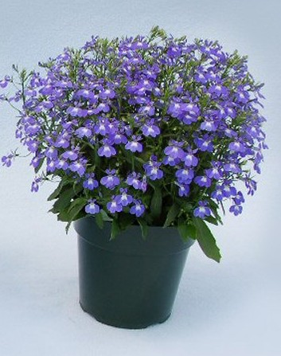 | 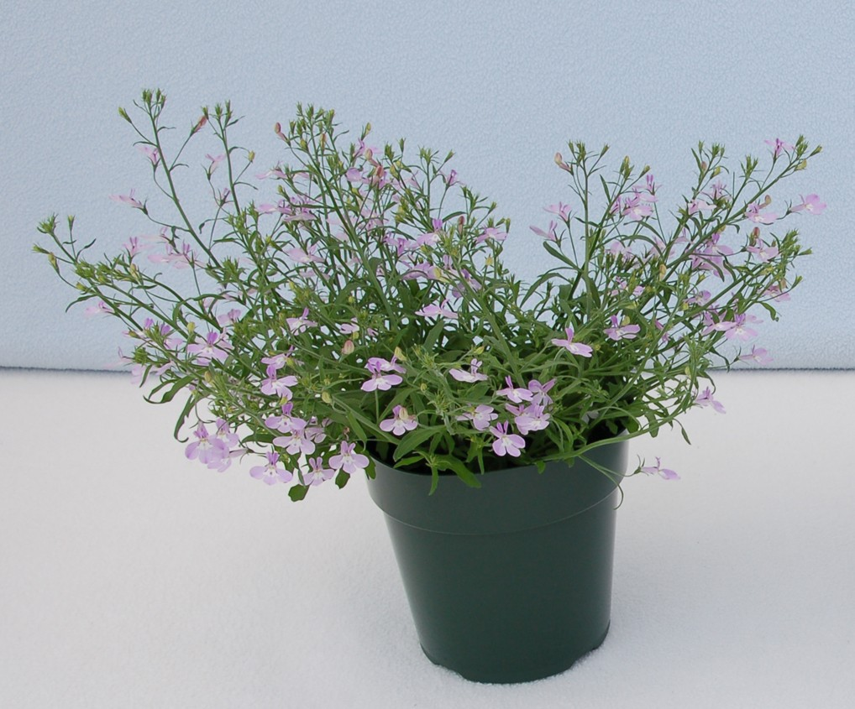 | 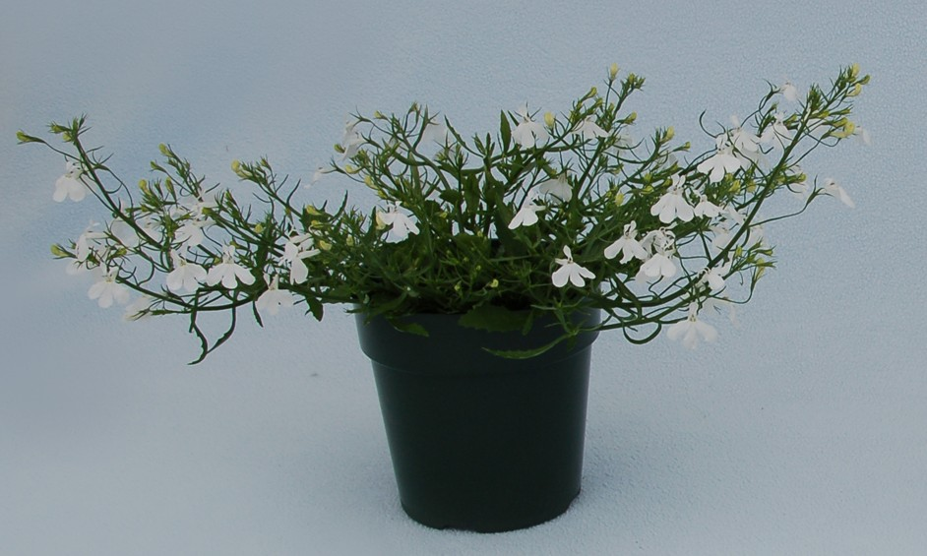
1 | 3 | 5
upright | semi-upright | horizontal
 | 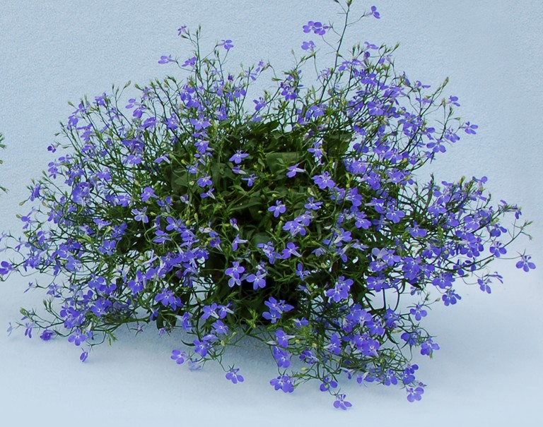
7 | 9
semi drooping | drooping

Ad. 2: Plant: height

Plant height should be assessed from the surface of the growing medium.

Ad. 12: Leaf: shape

 | ← broadest part →
 | (below middle) | at middle | (above middle)

broad (compressed) ← width (ratio length/width) → narrow (elongated) |  |  |  | 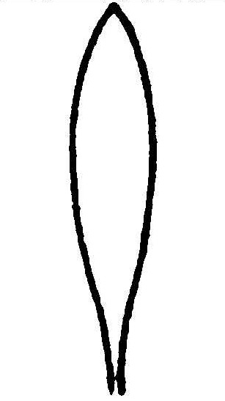 | 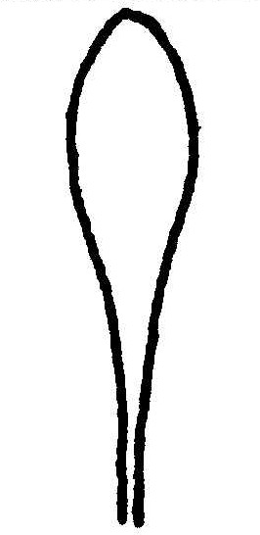
 |  |  |  | 4 | 6
 |  |  |  | oblanceolate | spatulate
 |  |  | 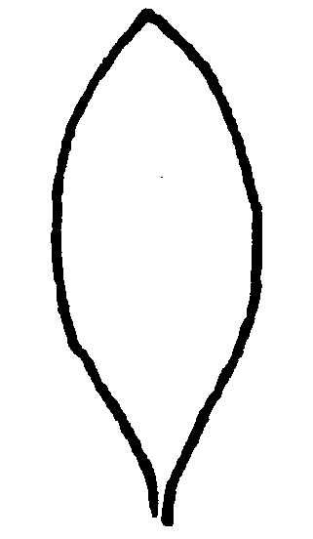 | 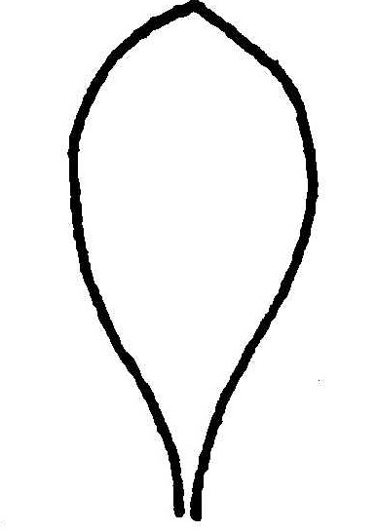
 |  |  | 2 | 5
 |  |  | elliptic | obovate
 |  |  | 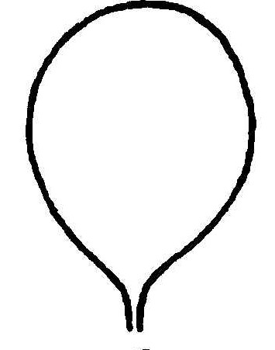
 |  | 1 | 3
 |  | broad ovate | circular

Ad. 14: Leaf: anthocyanin coloration on lower side

1 | 2 | 3 | 4
absent or very weak | weak | medium | strong

Ad. 16: Flower: type

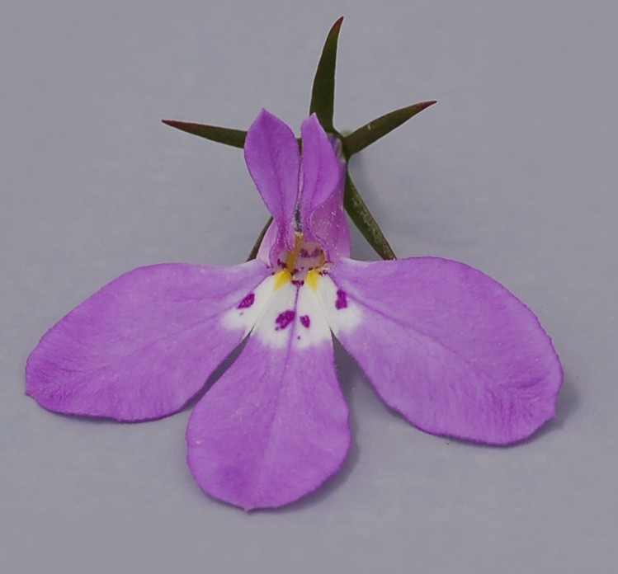 | 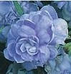
1 | 2
single | double

Ad. 19: Corolla: length

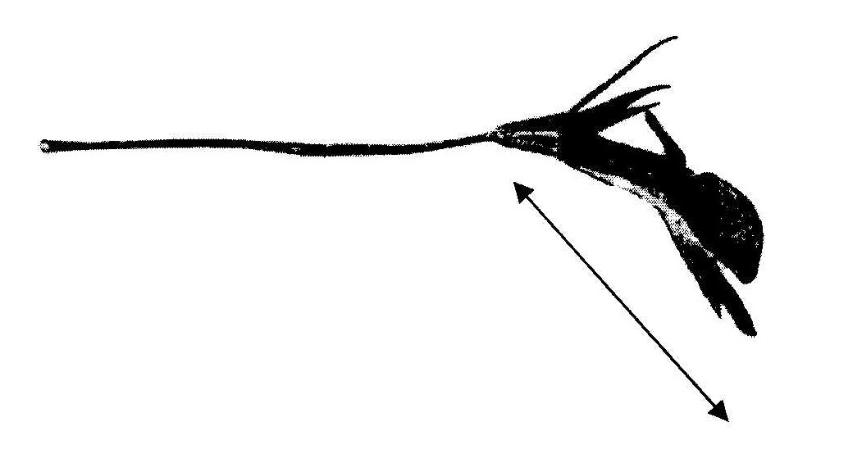 | The length to assess is the real length and not the natural length. Flowers with strong recurvature should be flattened.

Ad. 22: Lower lip: length
Ad. 23: Lower lip: width
Ad. 24: Lower lip: width of middle lobe

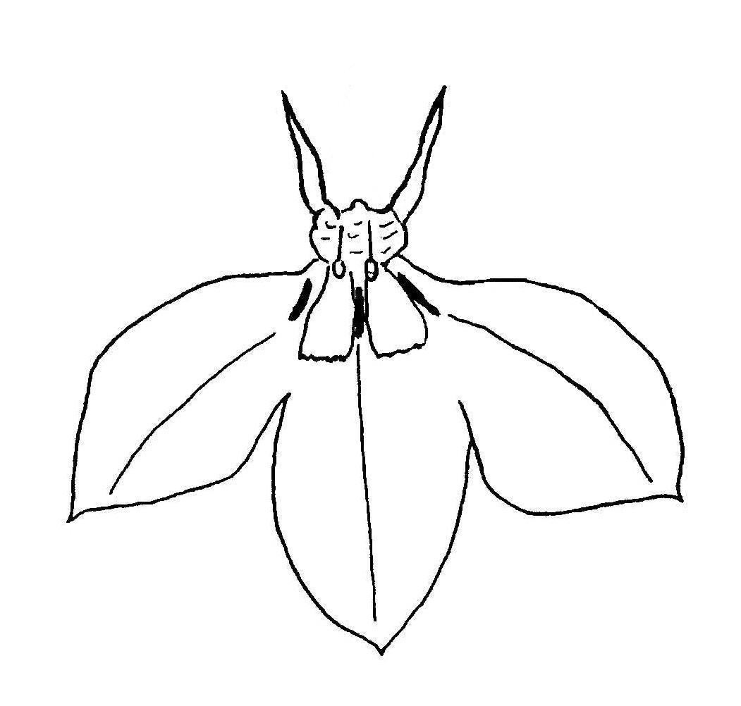
upper lip
lower lip
lower lip length
middle lobe width
lower lip width

Ad. 20: Upper lip: shape of lobes

 |  | ← broadest part →
 | at middle |  | (above middle)

broad (compressed) ← width (ratio length/width) → narrow (elongated) |  |  | 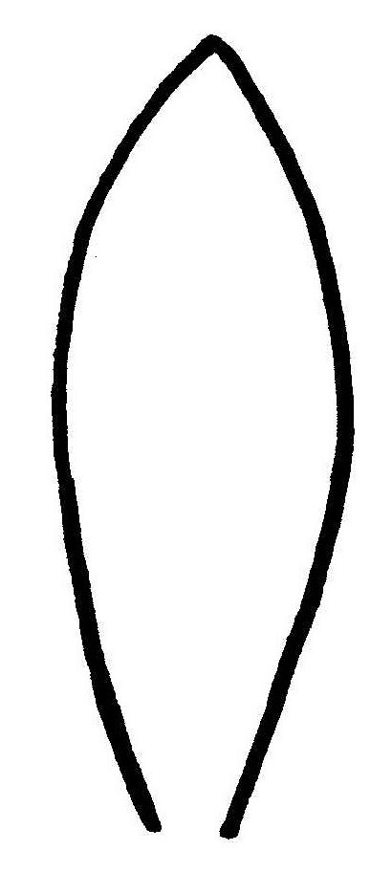
 |  |  | 2
 |  |  | oblanceolate
 |  | 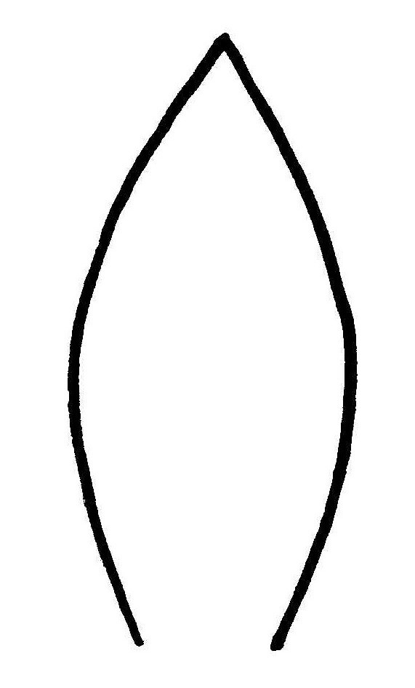 | 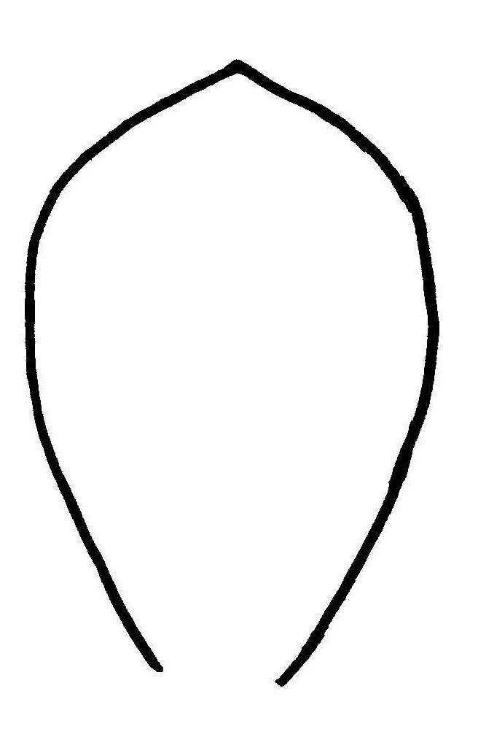 |  | 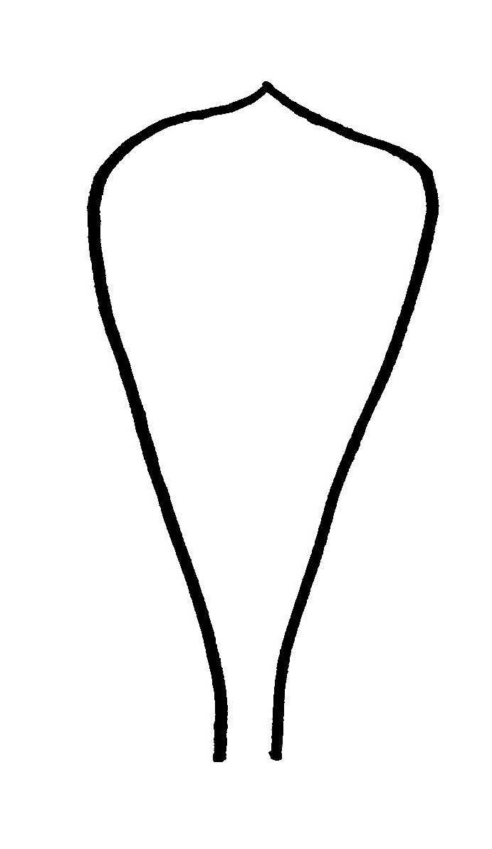
 |  | 1 | 3 |  | 4
 |  | elliptic | obovate |  | obtriangular

Ad. 26: Lower lip: white zone on upper side

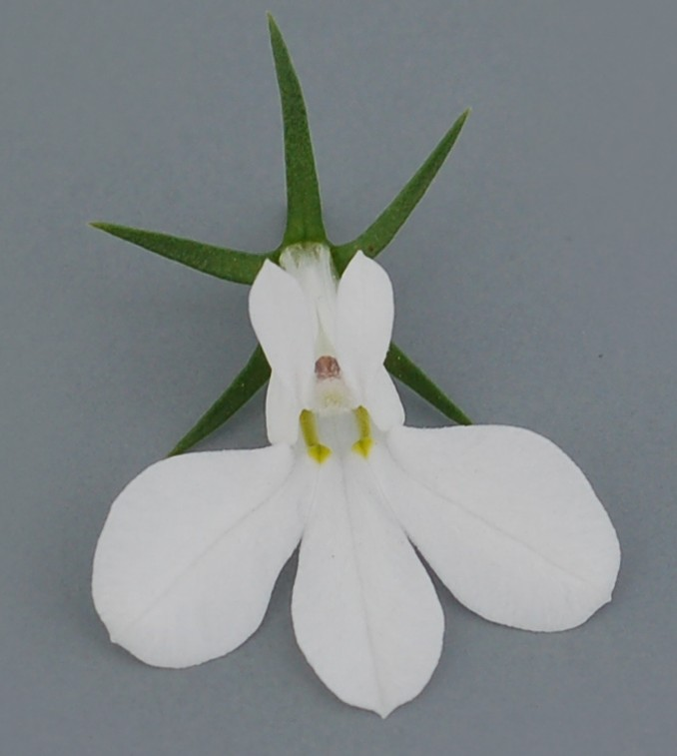 | 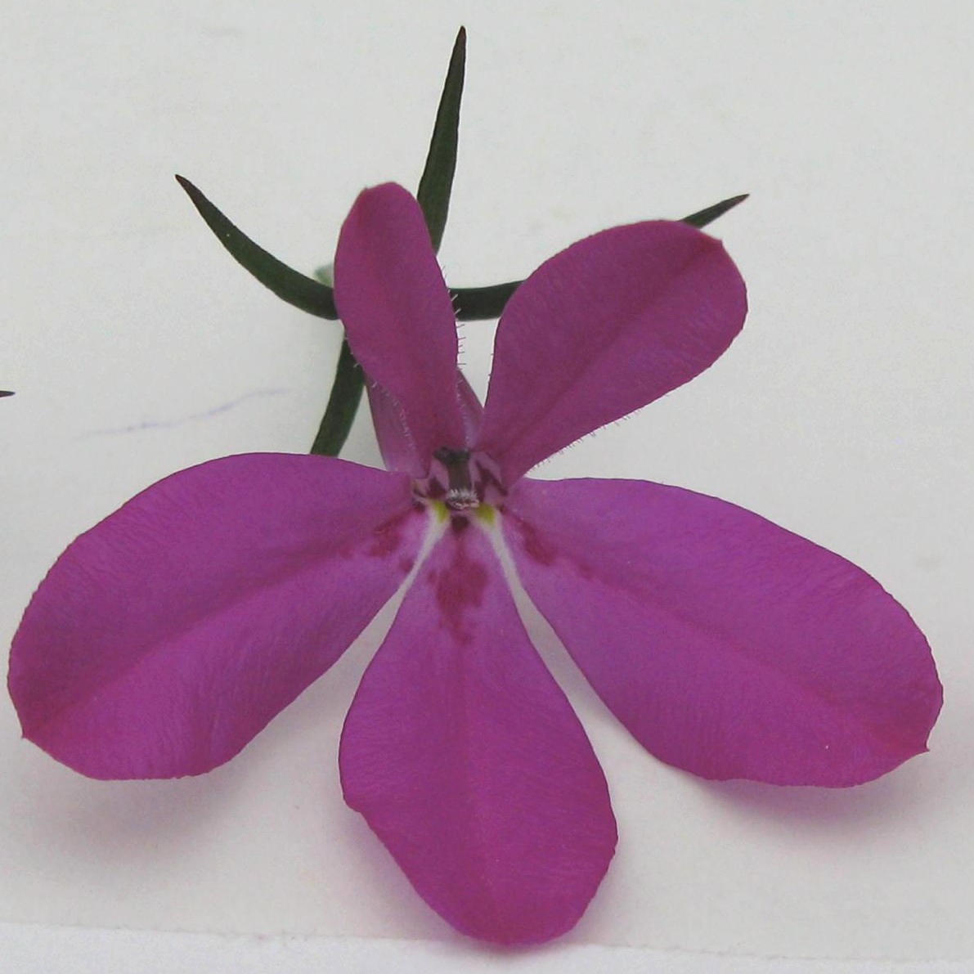 | 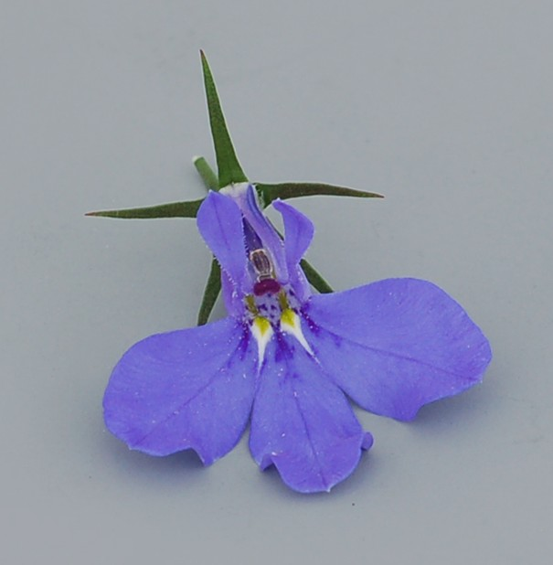
absent |  | present
For white varieties, the white zone is recorded as absent.

Ad. 27: Lower lip: shape of white zone on upper side

 | 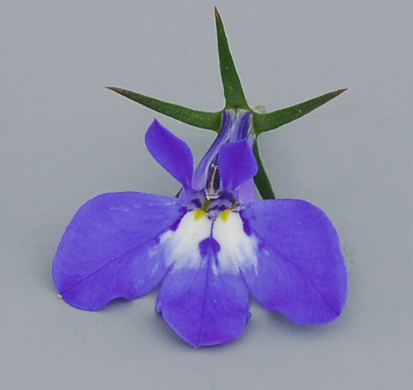 | 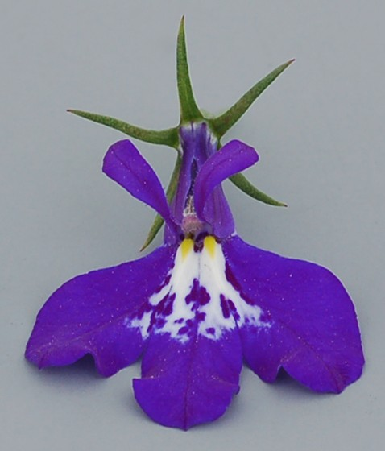
1 | 3 | 4
elongated only | rounded only | irregular
State 2 (elongated and rounded) means that elongated and rounded are both present on the same plant.

Ad. 28: Lower lip: markings

 | 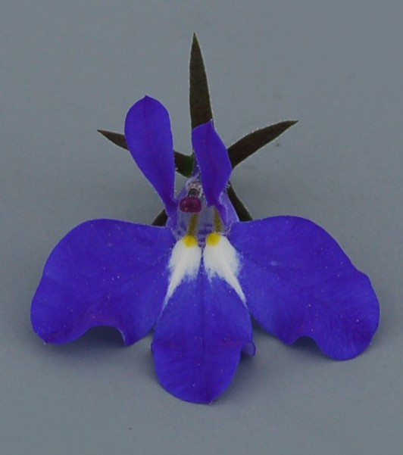
absent |  | present

Ad. 31: Lower lip: arrangement of lobes

 | 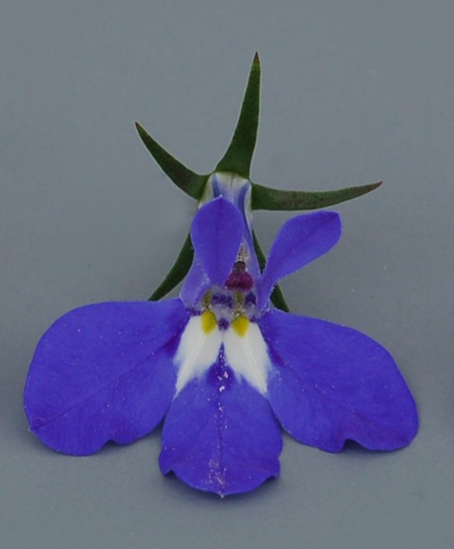 | 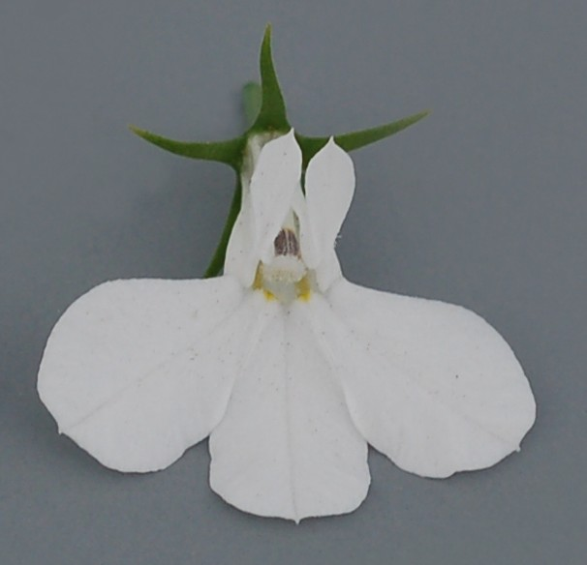
1 | 2 | 3
free | touching | overlapping

Literature

Huxley, A. (ed.), Griffiths, M. (ed.), Levy, M. (ed.), 1999: The Royal Horticultural Society Dictionary of Gardening. Grove’s Dictionaries Inc. New York, New York, US.

Technical Questionnaire

TECHNICAL QUESTIONNAIRE |  |  |  | Page {x} of {y} |  | Reference Number:
 |  |  |  |  |  | Application date:
 |  |  |  |  |  | (not to be filled in by the applicant)
TECHNICAL QUESTIONNAIRE
to be completed in connection with an application for plant breeders’ rights

1. Subject of the Technical Questionnaire
1.1 Botanical name |  |  | Lobelia erinus L., Lobelia valida L. Bolus, Lobelia erinus x valida
1.2 Common name |  |  | Lobelia, True Lobelia of Gardens
2. Applicant
Name
Address
Telephone No.
Fax No.
E-mail address
Breeder (if different from applicant)
3. Proposed denomination and breeder’s reference
Proposed denomination
(if available)

Breeder’s reference
#4. Information on the breeding scheme and propagation of the variety

4.1 Breeding scheme

Variety resulting from:

4.1.1 Crossing

(a) controlled cross [ ]
(please state parent varieties)

(…………………..……………..…) x (……………..…………………..…)
female parent male parent

(b) partially known cross [ ]
(please state known parent variety(ies))

(…………………..……………..…) x (……………..…………………..…)
female parent male parent

(c) unknown cross [ ]

4.1.2 Mutation [ ]
(please state parent variety)

4.1.3 Discovery and development [ ]
(please state where and when discovered and how developed)

4.1.4 Other [ ]”
(please provide details)”

4.2 Method of propagating the variety

4.2.1 Seed-propagated varieties

(a) Self-pollination [ ]
(b) Cross-pollination
(i) population [ ]
(ii) synthetic variety [ ]
(c) Hybrid [ ]
(please provide details)”

(d) Other [ ]
(please provide details)”

4.2.2 Vegetatively propagated varieties

(a) cuttings [ ]

(b) in vitro propagation [ ]

(c) other (state method) [ ]

5. Characteristics of the variety to be indicated (the number in brackets refers to the corresponding characteristic in Test Guidelines; please mark the note which best corresponds).

 | Characteristics |  |  |  |  |  | Example Varieties |  |  | Note
5.1  (1) | Plant: attitude of shoots
 | upright |  |  |  |  |  | Lobetis |  |  | 1[ ]
 | upright to semi-upright |  |  |  |  |  |  |  |  | 2[ ]
 | semi-upright |  |  |  |  |  | USLOB13, Tech Hevio |  |  | 3[ ]
 | semi-upright to horizontal |  |  |  |  |  |  |  |  | 4[ ]
 | horizontal |  |  |  |  |  | Tec Hewhitt, Weslotti |  |  | 5[ ]
 | horizontal to semi-drooping |  |  |  |  |  |  |  |  | 6[ ]
 | semi-drooping |  |  |  |  |  | Wespinstar |  |  | 7[ ]
 | semi-drooping to drooping |  |  |  |  |  | Lobmounlila |  |  | 8[ ]
 | drooping |  |  |  |  |  |  |  |  | 9[ ]
5.2  (16) | Flower: type
 | single |  |  |  |  |  | KLELE08621 |  |  | 1[ ]
 | double |  |  |  |  |  | Kathleen Mallard |  |  | 2[ ]
5.3  (25) | Lower lip: main color of upper side (excluding white zone)
 | white |  |  |  |  |  |  |  |  | 1[ ]
 | light blue |  |  |  |  |  |  |  |  | 2[ ]
 | blue/violet |  |  |  |  |  |  |  |  | 3[ ]
 | red/purple |  |  |  |  |  |  |  |  | 4[ ]
 | Characteristics |  |  |  |  |  | Example Varieties |  |  | Note
5.4  (26) | Lower lip: white zone on upper side
 | absent or very small |  |  |  |  |  | Riviera Lilac |  |  | 1[ ]
 | small |  |  |  |  |  | Loboudtis |  |  | 2[ ]
 | medium |  |  |  |  |  | Tech Hevio |  |  | 3[ ]
 | large |  |  |  |  |  | Tec Heplib |  |  | 4[ ]
 | very large |  |  |  |  |  | Weslosu |  |  | 5[ ]
5.5  (28) | Lower lip: markings
 | absent |  |  |  |  |  | Tec Hepdab |  |  | 1[ ]
 | present |  |  |  |  |  | Balwalila |  |  | 9[ ]
6. Similar varieties and differences from these varieties

Please use the following table and box for comments to provide information on how your candidate variety differs from the variety (or varieties) which, to the best of your knowledge, is (or are) most similar. This information may help the examination authority to conduct its examination of distinctness in a more efficient way.

Denomination(s) of variety(ies) similar to your candidate variety |  | Characteristic(s) in which your candidate variety differs from the similar variety(ies) |  |  | Describe the expression of the characteristic(s) for the similar variety(ies) |  |  | Describe the expression of the characteristic(s) for your candidate variety
Example |  | color of upper side of lower lip |  |  | light blue |  |  | white
Comments:

#7. Additional information which may help in the examination of the variety

7.1 In addition to the information provided in sections 5 and 6, are there any additional characteristics which may help to distinguish the variety?

Yes [ ] No [ ]

(If yes, please provide details)

7.2 Are there any special conditions for growing the variety or conducting the examination?

Yes [ ] No [ ]

(If yes, please provide details)

7.3 Other information

A representative color image of the variety should accompany the Technical Questionnaire.

8. Authorization for release

(a) Does the variety require prior authorization for release under legislation concerning the protection of the environment, human and animal health?

Yes [ ] No [ ]

(b) Has such authorization been obtained?

Yes [ ] No [ ]

If the answer to (b) is yes, please attach a copy of the authorization.

9. Information on plant material to be examined or submitted for examination.

9.1 The expression of a characteristic or several characteristics of a variety may be affected by factors, such as pests and disease, chemical treatment (e.g. growth retardants or pesticides), effects of tissue culture, different rootstocks, scions taken from different growth phases of a tree, etc.

9.2 The plant material should not have undergone any treatment which would affect the expression of the characteristics of the variety, unless the competent authorities allow or request such treatment. If the plant material has undergone such treatment, full details of the treatment must be given. In this respect, please indicate below, to the best of your knowledge, if the plant material to be examined has been subjected to:

(a) Microorganisms (e.g. virus, bacteria, phytoplasma) Yes [ ] No [ ]

(b) Chemical treatment (e.g. growth retardant, pesticide) Yes [ ] No [ ]

(c) Tissue culture Yes [ ] No [ ]

(d) Other factors Yes [ ] No [ ]

Please provide details for where you have indicated “yes”.

……………………………………………………………

10. I hereby declare that, to the best of my knowledge, the information provided in this form is correct:

Applicant’s name

Signature Date

[End of document]

* These names were correct at the time of the introduction of these Test Guidelines but may be revised or updated. [Readers are advised to consult the UPOV Code, which can be found on the UPOV Website (www.upov.int), for the latest information.]
# Authorities may allow certain of this information to be provided in a confidential section of the Technical Questionnaire.
# Authorities may allow certain of this information to be provided in a confidential section of the Technical Questionnaire.

