 |  |  |  |  |  |  | E  TG/LOMAN(proj.3)  ORIGINAL: English  DATE: 2012-06-27
INTERNATIONAL UNION FOR THE PROTECTION OF NEW VARIETIES OF PLANTS
Geneva
 |  |  | DRAFT
 |  | LOMANDRA  UPOV Code: LOMAN  Lomandra Labill. |  |  | *

GUIDELINES

FOR THE CONDUCT OF TESTS

FOR DISTINCTNESS, UNIFORMITY AND STABILITY

prepared by an expert from Australia

to be considered by the
Technical Working Party for Ornamental Plants and Forest Trees
at its forty-fifth session, to be held in Jeju, Republic of Korea, from August 6 to 10, 2012

Alternative Names:*

Botanical name | English | French | German | Spanish
Lomandra Labill. | Lomandra, Mat Rush

The purpose of these guidelines (“Test Guidelines”) is to elaborate the principles contained in the General Introduction (document TG/1/3), and its associated TGP documents, into detailed practical guidance for the harmonized examination of distinctness, uniformity and stability (DUS) and, in particular, to identify appropriate characteristics for the examination of DUS and production of harmonized variety descriptions.

ASSOCIATED DOCUMENTS
These Test Guidelines should be read in conjunction with the General Introduction and its associated TGP documents.
TABLE OF CONTENTS PAGE

1. Subject of these Test Guidelines 3
2. Material Required 3
3. Method of Examination 3
3.2 Testing Place 3
3.3 Conditions for Conducting the Examination 3
3.4 Test Design 3
3.5 Additional Tests 3
4. Assessment of Distinctness, Uniformity and Stability 4
4.1 Distinctness 4
4.2 Uniformity 5
4.3 Stability 5
5. Grouping of Varieties and Organization of the Growing Trial 5
6. Introduction to the Table of Characteristics 5
6.1 Categories of Characteristics 5
6.2 States of Expression and Corresponding Notes 6
6.3 Types of Expression 6
6.4 Example Varieties 6
6.5 Legend 6
7. Table of Characteristics/Tableau des caractères/Merkmalstabelle/Tabla de caracteres 7
8. Explanations on the Table of Characteristics 12
8.1 Explanations covering several characteristics 12
8.2 Explanations for individual characteristics 12
9. Literature 17
10. Technical Questionnaire 18
annex COMMENTS TO DOCUMENT TG/LOMAN(PROJ.3)

1. Subject of these Test Guidelines
These Test Guidelines apply to all varieties of Lomandra Labill..

2. Material Required
2.1 The competent authorities decide on the quantity and quality of the plant material required for testing the variety and when and where it is to be delivered. Applicants submitting material from a State other than that in which the testing takes place must ensure that all customs formalities and phytosanitary requirements are complied with.

2.2 The material is to be supplied in the form of plants expressing relevant characteristics of the variety in the first growing cycle.

2.3 The minimum quantity of plant material, to be supplied by the applicant, should be:

10 plants.

2.4 The plant material supplied should be visibly healthy, not lacking in vigor, nor affected by any important pest or disease.

2.5 The plant material should not have undergone any treatment which would affect the expression of the characteristics of the variety, unless the competent authorities allow or request such treatment. If it has been treated, full details of the treatment must be given.

3. Method of Examination
3.1 Number of Growing Cycles

The minimum duration of tests should normally be a single growing cycle.

3.2 Testing Place

Tests are normally conducted at one place. In the case of tests conducted at more than one place, guidance is provided in TGP/9 “Examining Distinctness”.

3.3 Conditions for Conducting the Examination

3.3.1 The tests should be carried out under conditions ensuring satisfactory growth for the expression of the relevant characteristics of the variety and for the conduct of the examination.

3.3.2 Because daylight varies, color determinations made against a color chart should be made either in a suitable cabinet providing artificial daylight or in the middle of the day in a room without direct sunlight. The spectral distribution of the illuminant for artificial daylight should conform with the CIE Standard of Preferred Daylight D 6500 and should fall within the tolerances set out in the British Standard 950, Part I. These determinations should be made with the plant part placed against a white background. The color chart and version used should be specified in the variety description.

3.4 Test Design

3.4.1 Each test should be designed to result in a total of at least 10 plants

3.4.2 The design of the tests should be such that plants or parts of plants may be removed for measurement or counting without prejudice to the observations which must be made up to the end of the growing cycle.

3.5 Additional Tests

Additional tests, for examining relevant characteristics, may be established.

4. Assessment of Distinctness, Uniformity and Stability

4.1 Distinctness

4.1.1 General Recommendations

It is of particular importance for users of these Test Guidelines to consult the General Introduction prior to making decisions regarding distinctness. However, the following points are provided for elaboration or emphasis in these Test Guidelines.

4.1.2 Consistent Differences

The differences observed between varieties may be so clear that more than one growing cycle is not necessary. In addition, in some circumstances, the influence of the environment is not such that more than a single growing cycle is required to provide assurance that the differences observed between varieties are sufficiently consistent. One means of ensuring that a difference in a characteristic, observed in a growing trial, is sufficiently consistent is to examine the characteristic in at least two independent growing cycles.

4.1.3 Clear Differences

Determining whether a difference between two varieties is clear depends on many factors, and should consider, in particular, the type of expression of the characteristic being examined, i.e. whether it is expressed in a qualitative, quantitative, or pseudo-qualitative manner. Therefore, it is important that users of these Test Guidelines are familiar with the recommendations contained in the General Introduction prior to making decisions regarding distinctness.

4.1.4 Number of Plants / Parts of Plants to be Examined

Unless otherwise indicated, for the purposes of distinctness , all observations on single plants should be made on 9 plants or parts taken from each of 9 plants and any other observations made on all plants in the test, disregarding any off-type plants.

4.1.5 Method of Observation

The recommended method of observing the characteristic for the purposes of distinctness is indicated by the following key in the second column of the Table of Characteristics (see document TGP/9 “Examining Distinctness”, Section 4 “Observation of characteristics”):

MG: single measurement of a group of plants or parts of plants
MS: measurement of a number of individual plants or parts of plants
VG: visual assessment by a single observation of a group of plants or parts of plants
VS: visual assessment by observation of individual plants or parts of plants

Type of observation: visual (V) or measurement (M)

“Visual” observation (V) is an observation made on the basis of the expert’s judgment. For the purposes of this document, “visual” observation refers to the sensory observations of the experts and, therefore, also includes smell, taste and touch. Visual observation includes observations where the expert uses reference points (e.g. diagrams, example varieties, side-by-side comparison) or non-linear charts (e.g. color charts). Measurement (M) is an objective observation against a calibrated, linear scale e.g. using a ruler, weighing scales, colorimeter, dates, counts, etc.

Type of record: for a group of plants (G) or for single, individual plants (S)

For the purposes of distinctness, observations may be recorded as a single record for a group of plants or parts of plants (G), or may be recorded as records for a number of single, individual plants or parts of plants (S). In most cases, “G” provides a single record per variety and it is not possible or necessary to apply statistical methods in a plant-by-plant analysis for the assessment of distinctness.

In cases where more than one method of observing the characteristic is indicated in the Table of Characteristics (e.g. VG/MG), guidance on selecting an appropriate method is provided in document TGP/9, Section 4.2.

4.2 Uniformity

4.2.1 It is of particular importance for users of these Test Guidelines to consult the General Introduction prior to making decisions regarding uniformity. However, the following points are provided for elaboration or emphasis in these Test Guidelines:

4.2.2 For the assessment of uniformity of vegetatively propagated varieties, a population standard of 1% and an acceptance probability of at least 95 % should be applied. In the case of a sample size of 10 plants, 1 off-type is allowed.

4.3 Stability

4.3.1 In practice, it is not usual to perform tests of stability that produce results as certain as those of the testing of distinctness and uniformity. However, experience has demonstrated that, for many types of variety, when a variety has been shown to be uniform, it can also be considered to be stable.

4.3.2 Where appropriate, or in cases of doubt, stability may be further examined by testing a new plant stock to ensure that it exhibits the same characteristics as those shown by the initial material supplied.

5. Grouping of Varieties and Organization of the Growing Trial
5.1 The selection of varieties of common knowledge to be grown in the trial with the candidate varieties and the way in which these varieties are divided into groups to facilitate the assessment of distinctness are aided by the use of grouping characteristics.

5.2 Grouping characteristics are those in which the documented states of expression, even where produced at different locations, can be used, either individually or in combination with other such characteristics: (a) to select varieties of common knowledge that can be excluded from the growing trial used for examination of distinctness; and (b) to organize the growing trial so that similar varieties are grouped together.

5.3 The following have been agreed as useful grouping characteristics:

- Plant: habit (characteristic 1)
- Leaf blade: width (characteristic 6)
- Leaf: glaucosity of adaxial surface (characteristic 11)
- Leaf: variegation (characteristic 12)

5.4 Guidance for the use of grouping characteristics, in the process of examining distinctness, is provided through the General Introduction and document TGP/9 “Examining Distinctness”.

6. Introduction to the Table of Characteristics

6.1 Categories of Characteristics

6.1.1 Standard Test Guidelines Characteristics

Standard Test Guidelines characteristics are those which are approved by UPOV for examination of DUS and from which members of the Union can select those suitable for their particular circumstances.

6.1.2 Asterisked Characteristics

Asterisked characteristics (denoted by *) are those included in the Test Guidelines which are important for the international harmonization of variety descriptions and should always be examined for DUS and included in the variety description by all members of the Union, except when the state of expression of a preceding characteristic or regional environmental conditions render this inappropriate.

6.2 States of Expression and Corresponding Notes

6.2.1 States of expression are given for each characteristic to define the characteristic and to harmonize descriptions. Each state of expression is allocated a corresponding numerical note for ease of recording of data and for the production and exchange of the description.

6.2.2 In the case of qualitative and pseudo-qualitative characteristics (see Chapter 6.3), all relevant states of expression are presented in the characteristic. However, in the case of quantitative characteristics with 5 or more states, an abbreviated scale may be used to minimize the size of the Table of Characteristics. For example, in the case of a quantitative characteristic with 9 states, the presentation of states of expression in the Test Guidelines may be abbreviated as follows:

State | Note
small | 3
medium | 5
large | 7

However, it should be noted that all of the following 9 states of expression exist to describe varieties and should be used as appropriate:

State | Note
very small | 1
very small to small | 2
small | 3
small to medium | 4
medium | 5
medium to large | 6
large | 7
large to very large | 8
very large | 9

6.2.3 Further explanation of the presentation of states of expression and notes is provided in document TGP/7 “Development of Test Guidelines”.

6.3 Types of Expression

An explanation of the types of expression of characteristics (qualitative, quantitative and pseudo-qualitative) is provided in the General Introduction.

6.4 Example Varieties

Where appropriate, example varieties are provided to clarify the states of expression of each characteristic.

6.5 Legend

(*) Asterisked characteristic – see Chapter 6.1.2

QL Qualitative characteristic – see Chapter 6.3
QN Quantitative characteristic – see Chapter 6.3
PQ Pseudo-qualitative characteristic – see Chapter 6.3

MG, MS, VG, VS – see Chapter 4.1.5

(a)-(d) See Explanations on the Table of Characteristics in Chapter 8.1

(+) See Explanations on the Table of Characteristics in Chapter 8.2

7. Table of Characteristics/Tableau des caractères/Merkmalstabelle/Tabla de caracteres

 |  | English | français | deutsch | español | Example Varieties  Exemples  Beispielssorten  Variedades ejemplo | Note/  Nota
1  (*)  (+) | VG | Plant: habit
PQ | (a) | upright |  |  |  | Merlom Ruby | 1
 |  | semi upright |  |  |  | Katrinus Deluxe | 2
 |  | spreading |  |  |  | Stormy Seas | 3
2  (*) | VG/MG | Plant: height of foliage
QN | (a) | short |  |  |  | Merlom Ruby | 3
 |  | medium |  |  |  | Stormy Seas | 5
 |  | tall |  |  |  | Katrinus Deluxe | 7
3  (*) | VG | Plant: density of foliage
QN | (a) | very sparse |  |  |  |  | 1
 |  | sparse |  |  |  | SIR5 | 3
 |  | medium |  |  |  | Stormy Seas | 5
 |  | dense |  |  |  | Katrinus | 7
 |  | very dense |  |  |  | LM400 | 9
4  (*)  (+) | VG | Leaf: attitude of upper third
PQ | (b) | erect |  |  |  |  | 1
 |  | semi-erect |  |  |  |  | 2
 |  | drooping |  |  |  |  | 3
5  (*) | VG/MG | Leaf blade: length
QN | (b) | very short |  |  |  | Joey | 1
 |  | short |  |  |  | LMF500 | 3
 |  | medium |  |  |  | Katrinus Deluxe  Merlom Ruby | 5
 |  | long |  |  |  | Katrinus | 7
 |  | very long |  |  |  |  | 9
6  (*) | VG/MG | Leaf blade: width
QN | (b) | very narrow |  |  |  | LM300 | 1
 |  | narrow |  |  |  | Merlom Ruby | 3
 |  | medium |  |  |  | Stormy Seas | 5
 |  | broad |  |  |  | Cassica | 7
 |  | very broad |  |  |  |  | 9
7  (*)  (+) | VG | Leaf: cross section
QN | (b) | flat |  |  |  | Katrinus | 1
 | (c) | slightly concave |  |  |  | Merlom Ruby | 2
 |  | strongly concave |  |  |  |  | 3
 |  | inrolled |  |  |  |  | 4
8  (*)  (+) | VG | Leaf: type of apex
QL | (b) | entire |  |  |  | Silver Falls | 1
 |  | toothed |  |  |  |  | 2
9  (*)  (+) | VG | Leaf: length of middle tooth (toothed varieties only)
QN | (b) | very short |  |  |  | LM300 | 1
 |  | short |  |  |  | Merlom Ruby | 3
 |  | medium |  |  |  | Katrinus | 5
 |  | long |  |  |  | LM400 | 7
 |  | very long |  |  |  |  | 9
10  (*) | VG | Leaf: texture
QN | (b) | smooth |  |  |  | Stormy Seas | 1
 | (c) | medium |  |  |  | Merlom Ruby | 2
 |  | rough |  |  |  |  | 3
11  (*) | VG | Leaf: glaucosity of adaxial surface
QN | (b) | very weak |  |  |  | Lime Tuff | 1
 | (c) | weak |  |  |  | Katrinus | 3
 |  | medium |  |  |  | Merlom Ruby | 5
 |  | strong |  |  |  | SIR5 | 7
 |  | very strong |  |  |  | Stormy Seas | 9
12  (*) | VG | Leaf: variegation
QL | (b) | absent |  |  |  |  | 1
 | (c) | present |  |  |  | LMV100  WN002 | 9
13  (*)  (+) | VG | Leaf: green color of adaxial side  (excluding variegation)
QN | (b) | light |  |  |  | Little Pal | 1
 | (c) | medium |  |  |  | LM400 | 2
 |  | dark |  |  |  | Stormy Seas | 3
14  (+) | VG | Leaf: color of variegation
PQ | (b) (c) | RHS Colour Chart  (indicate reference number)
15 | VG | Leaf: glossiness of adaxial surface
QN | (b) | absent or weak |  |  |  |  | 1
 | (c) | medium |  |  |  | Katrinus Deluxe | 2
 |  | strong |  |  |  |  | 3
16  (*)  (+) | VG | Leaf: pliability
QN | (b) | weak |  |  |  | SIR5 | 3
 | (c) | medium |  |  |  | Merlom Ruby | 5
 |  | strong |  |  |  | Katrinus | 7
17  (*)  (+) | VG | Basal sheath: shredding of margin
QN |  | absent or very weak |  |  |  | Lime Tuff | 1
 |  | weak |  |  |  | Ll164 | 3
 |  | medium |  |  |  | Ll264 | 5
 |  | strong |  |  |  | LMF500 | 7
 |  | very strong |  |  |  |  | 9
18  (*)  (+) | VG | Basal sheath: intensity of brown color
QN |  | light |  |  |  | Lime Tuff | 1
 |  | medium |  |  |  | Katrinus | 2
 |  | dark |  |  |  | Stormy Seas | 3
19 | VG | Inflorescence: position in relation to foliage
QN | (d) | below |  |  |  | Merlom Ruby | 1
 |  | level |  |  |  | Lime Tuff | 2
 |  | above |  |  |  | LHBYF | 3
20  (+) | VG | Inflorescence: number of branches
QN | (d) | absent or very few |  |  |  | Merlom Ruby | 1
 |  | few |  |  |  | LM300 | 3
 |  | medium |  |  |  | Lime Tuff | 5
 |  | many |  |  |  | LHCOM | 7
21  (+) | VG/MG | Inflorescence: length of flowering part
QN | (d) | very short |  |  |  | LM300 | 1
 |  | short |  |  |  | LHCOM | 3
 |  | medium |  |  |  | Lime Tuff | 5
 |  | long |  |  |  | LHBYF | 7
 |  | very long |  |  |  |  | 9
22  (+) | VG/MG | Peduncle: length
QN | (d) | very short |  |  |  | Merlom Ruby | 1
 |  | short |  |  |  | Seascape | 3
 |  | medium |  |  |  | LHCOM | 5
 |  | long |  |  |  | LM300  Lime Tuff | 7
 |  | very long |  |  |  |  | 9
23 | VG | Peduncle: color
PQ | (d) | yellow green |  |  |  | Little Pal | 1
 |  | green |  |  |  |  | 2
 |  | greyed orange |  |  |  | LM300 | 3
 |  | red brown |  |  |  |  | 4
 |  | brown |  |  |  | Seascape | 5
24  (+) | VG/MS | Bract: length
QN | (d) | very short |  |  |  | Seascape | 1
 |  | short |  |  |  | Silver Grace | 3
 |  | medium |  |  |  | Merlom Ruby | 5
 |  | long |  |  |  | Stormy Seas | 7
 |  | very long |  |  |  | Katrinus Deluxe | 9
25  (+) | VG | Calyx: color
PQ | (d) | white |  |  |  | Bunyip | 1
 |  | yellow |  |  |  | LM300 | 2
 |  | yellow green |  |  |  | LHCOM | 3
 |  | greyed orange |  |  |  | Lime Tuff | 4
 |  | grey purple |  |  |  | Stormy Seas | 5

8. Explanations on the Table of Characteristics

8.1 Explanations covering several characteristics

Characteristics containing the following key in the second column of the Table of Characteristics should be examined as indicated below:

(a) The assessment of plant characteristics should be carried out later in the growing season, towards the end of active vegetative growth.
(b) All observations on the leaf should be made on a fully expanded leaf
(c) Observations should be made on the middle third of the leaf
(d) All observations on the inflorescence and flower should be made on the main flower spike

8.2 Explanations for individual characteristics

Ad. 1: Plant: habit

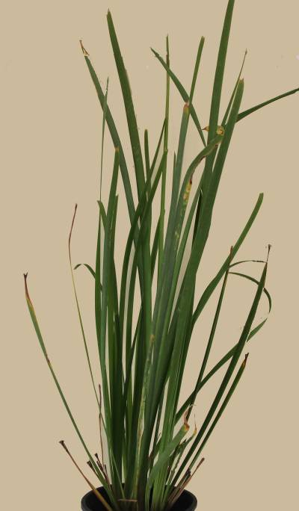 | 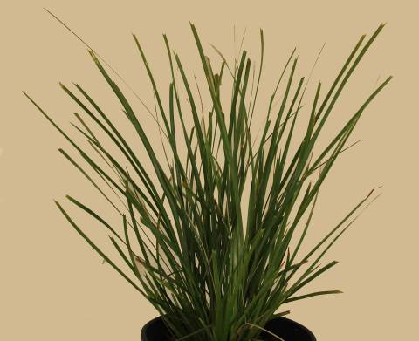 | 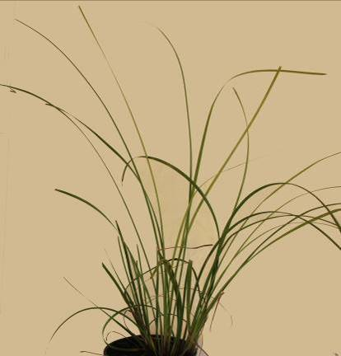
1 | 2 | 3
upright | semi upright | spreading

Ad. 4: Leaf: attitude of upper third

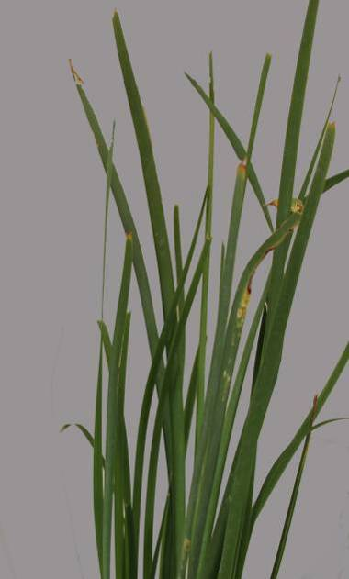 | 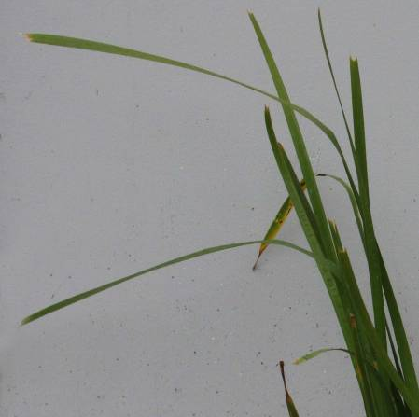 | 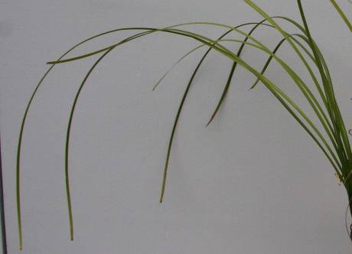
1 | 2 | 3
erect | semi-erect | drooping

Ad. 7: Leaf: cross section

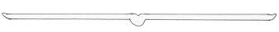 | 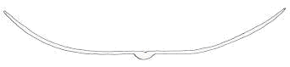 | 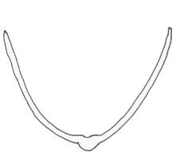 | 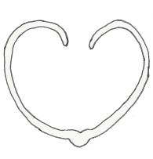
1 | 2 | 3 | 4
flat | slightly concave | strongly concave | inrolled

Ad. 8: Leaf: type of apex

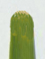 | 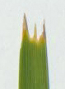
1 | 2
entire | toothed

Ad. 9: Leaf: length of middle tooth (toothed varieties only)

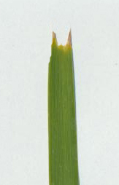 | 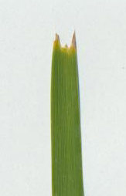 | 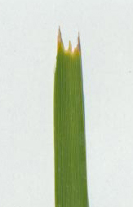 | 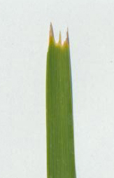
1 | 3 | 5 | 7
very short | short | medium | long

Ad. 13: Leaf: green color of adaxial side (excluding variegation)
Ad. 14: Leaf: color of variegation

Sometimes there is a waxy layer covering the leaf surface which gives a bluish or whitish appearance. The layer should be removed by rubbing before observing leaf color.

Ad. 16: Leaf: pliability

Assessed by folding middle third of leaf over index finger and observing the extent of splitting. Strong pliability is indicated by little or no splitting.

Ad. 17: Basal sheath: shredding of margin

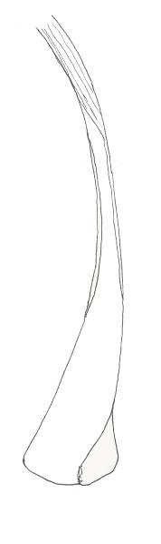 | 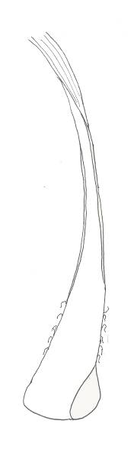 | 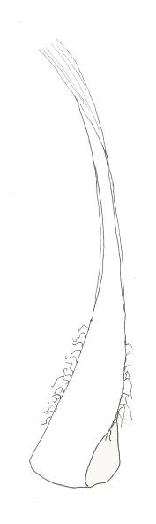 | 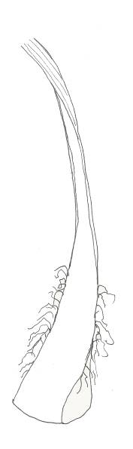
1 | 3 | 5 | 7
absent or very weak | weak | medium | strong

Ad. 18: Basal sheath: intensity of brown color

If present, the shredded margin of the basal leaf sheath should be excluded from the observation.

Ad. 20: Inflorescence: number of branches

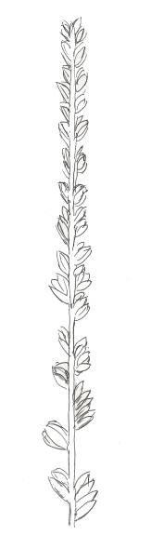 | 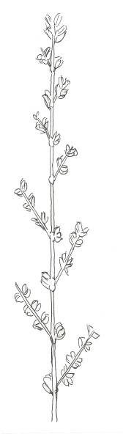 | 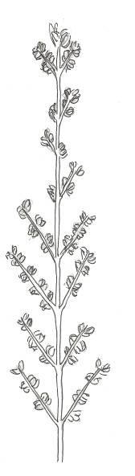 | 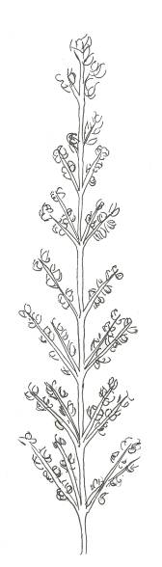
1 | 3 | 5 | 7
absent or very few | few | medium | many

Ad. 21: Inflorescence: length of flowering part
Ad. 22: Peduncle: length
Ad. 24: Bract: length

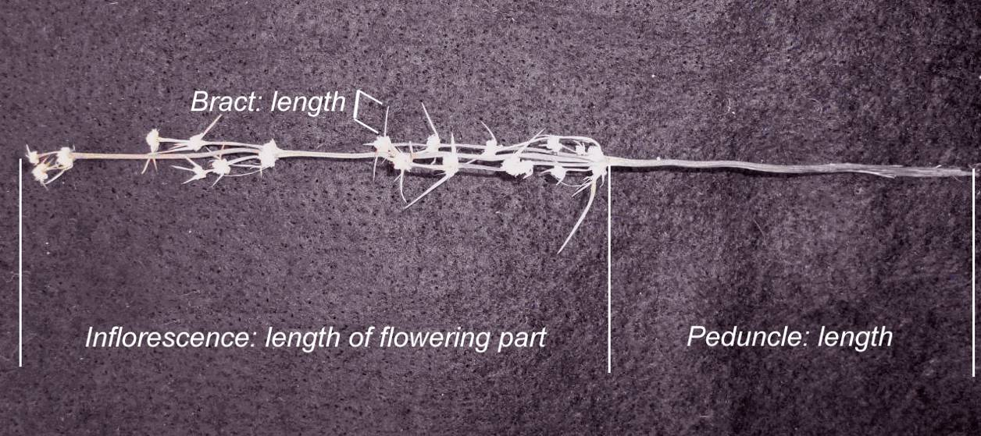

Ad. 25: Calyx: color

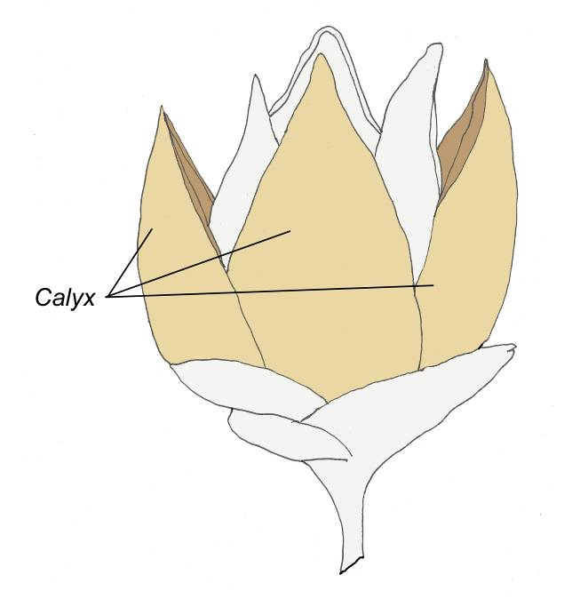

9. Literature

Lee, A.T., Macfarlane, T.D., 1986: Flora of Australia vol 46. Australian Government Publishing Service. Canberra, Australian Capital Territory, AU, pp. 100 to 141.

10. Technical Questionnaire

TECHNICAL QUESTIONNAIRE |  |  |  | Page {x} of {y} |  | Reference Number:
 |  |  |  |  |  | Application date:
 |  |  |  |  |  | (not to be filled in by the applicant)
TECHNICAL QUESTIONNAIRE
to be completed in connection with an application for plant breeders’ rights

1. Subject of the Technical Questionnaire
1.1.1 Botanical name |  |  | Lomandra Labill.
1.1.2 Common name |  |  | Lomandra, Mat Rush
1.2 Species
(please complete)
2. Applicant
Name
Address
Telephone No.
Fax No.
E-mail address
Breeder (if different from applicant)
3. Proposed denomination and breeder’s reference
Proposed denomination
(if available)

Breeder’s reference
#4. Information on the breeding scheme and propagation of the variety

4.1 Breeding scheme

Variety resulting from:

4.1.1 Crossing

(a) controlled cross [ ]
(please state parent varieties)

(…………………..……………..…) x (……………..…………………..…)
female parent male parent

(b) partially known cross [ ]
(please state known parent variety(ies))

(…………………..……………..…) x (……………..…………………..…)
female parent male parent

(c) unknown cross [ ]

4.1.2 Mutation [ ]
(please state parent variety)

4.1.3 Discovery and development [ ]
(please state where and when discovered and how developed)

4.1.4 Other [ ]
(please provide details)

4.2 Method of propagating the variety

4.2.1 Vegetative propagation

(a) cuttings [ ]

(b) in vitro propagation [ ]

(c) other (state method) [ ]

5. Characteristics of the variety to be indicated (the number in brackets refers to the corresponding characteristic in Test Guidelines; please mark the note which best corresponds).

 | Characteristics |  |  |  |  |  | Example Varieties |  |  | Note
5.1  (1) | Plant: habit
 | upright |  |  |  |  |  | Merlom Ruby |  |  | 1 [ ]
 | semi upright |  |  |  |  |  | Katrinus Deluxe |  |  | 2 [ ]
 | spreading |  |  |  |  |  | Stormy Seas |  |  | 3 [ ]
5.2  (6) | Leaf blade: width
 | very narrow |  |  |  |  |  | LM300 |  |  | 1 [ ]
 | very narrow to narrow |  |  |  |  |  |  |  |  | 2 [ ]
 | narrow |  |  |  |  |  | Merlom Ruby |  |  | 3 [ ]
 | narrow to medium |  |  |  |  |  |  |  |  | 4 [ ]
 | medium |  |  |  |  |  | Stormy Seas |  |  | 5 [ ]
 | medium to broad |  |  |  |  |  |  |  |  | 6 [ ]
 | broad |  |  |  |  |  | Cassica |  |  | 7 [ ]
 | broad to very broad |  |  |  |  |  |  |  |  | 8 [ ]
 | very broad |  |  |  |  |  |  |  |  | 9 [ ]
5.3  (11) | Leaf: glaucosity of adaxial surface
 | very weak |  |  |  |  |  | Lime Tuff |  |  | 1 [ ]
 | very weak to weak |  |  |  |  |  |  |  |  | 2 [ ]
 | weak |  |  |  |  |  | Katrinus |  |  | 3 [ ]
 | weak to medium |  |  |  |  |  |  |  |  | 4 [ ]
 | medium |  |  |  |  |  | Merlom Ruby |  |  | 5 [ ]
 | medium to strong |  |  |  |  |  |  |  |  | 6 [ ]
 | strong |  |  |  |  |  | SIR5 |  |  | 7 [ ]
 | strong to very strong |  |  |  |  |  |  |  |  | 8 [ ]
 | very strong |  |  |  |  |  | Stormy Seas |  |  | 9 [ ]
 | Characteristics |  |  |  |  |  | Example Varieties |  |  | Note
5.4  (12) | Leaf: variegation
 | absent |  |  |  |  |  |  |  |  | 1 [ ]
 | present |  |  |  |  |  | LMV100  WN002 |  |  | 9 [ ]
6. Similar varieties and differences from these varieties

Please use the following table and box for comments to provide information on how your candidate variety differs from the variety (or varieties) which, to the best of your knowledge, is (or are) most similar. This information may help the examination authority to conduct its examination of distinctness in a more efficient way.

Denomination(s) of variety(ies) similar to your candidate variety |  | Characteristic(s) in which your candidate variety differs from the similar variety(ies) |  |  | Describe the expression of the characteristic(s) for the similar variety(ies) |  |  | Describe the expression of the characteristic(s) for your candidate variety
Example |  | Plant: habit |  |  | semi upright |  |  | spreading
Comments:

#7. Additional information which may help in the examination of the variety

7.1 In addition to the information provided in sections 5 and 6, are there any additional characteristics which may help to distinguish the variety?

Yes [ ] No [ ]

(If yes, please provide details)

7.2 Are there any special conditions for growing the variety or conducting the examination?

Yes [ ] No [ ]

(If yes, please provide details)

7.3 Other information

7.3.1 Indicate the Plant: sex expression (if known).
Male [ ] Female […]

A representative color image of the variety should accompany the Technical Questionnaire.

8. Authorization for release

(a) Does the variety require prior authorization for release under legislation concerning the protection of the environment, human and animal health?

Yes [ ] No [ ]

(b) Has such authorization been obtained?

Yes [ ] No [ ]

If the answer to (b) is yes, please attach a copy of the authorization.

9. Information on plant material to be examined or submitted for examination.

9.1 The expression of a characteristic or several characteristics of a variety may be affected by factors, such as pests and disease, chemical treatment (e.g. growth retardants or pesticides), effects of tissue culture, different rootstocks, scions taken from different growth phases of a tree, etc.

9.2 The plant material should not have undergone any treatment which would affect the expression of the characteristics of the variety, unless the competent authorities allow or request such treatment. If the plant material has undergone such treatment, full details of the treatment must be given. In this respect, please indicate below, to the best of your knowledge, if the plant material to be examined has been subjected to:

(a) Microorganisms (e.g. virus, bacteria, phytoplasma) Yes [ ] No [ ]

(b) Chemical treatment (e.g. growth retardant, pesticide) Yes [ ] No [ ]

(c) Tissue culture Yes [ ] No [ ]

(d) Other factors Yes [ ] No [ ]

Please provide details for where you have indicated “yes”.

……………………………………………………………

10. I hereby declare that, to the best of my knowledge, the information provided in this form is correct:

Applicant’s name

Signature Date

[Annex follows]

COMMENTS TO DOCUMENT TG/LOMAN(PROJ.3)

Ref. in Proj 2 | TWO/44 comments | Comments on changes in Proj 3 | Comments received from subgroup by 1 June2012 | Subsequent changes and final submission to UPOV for meeting | Ref. in Proj 3
Cover page | to add English common names “Lomandra, Mat rush” | done | NZ: 1 is missing? Or renumbering needed | renumbered
5.3 | to amend in accordance with the Table of Chars. and to delete Char. 1 | done
6.5 | to read “(a)-(d)” | done
Char. 1 | to be deleted | done
Char. 5 | to add (*) | done |  |  | Char 4
Char. 8 | to be indicated as VG and to add state 4 “completely rolled” | done | NZ: 8. Where on the leaf to look? Add (c)? | Added (c) | Char 7
Char. 9 | to be deleted | done
Char. 10 | to check whether QL and, if not, to combine with Char. 11 | Keep QL. Used to separate species |  |  | Char 8
Char. 11 | to read “Leaf: length of middle tooth”, with the states: very short (1); short (3); medium (5); long (6); very long (7) and to be indicated as VG. | done | CPVO: Toothed varieties only : leaf : length of middle tooth. | Not changed: proposed formulation is not used in any other adopted TG’s | Char 9
Char. 12 | to be indicated as VG | done |  |  | Char 10
Char. 15 | to be indicated as QN, to delete “?” after example varieties and to add (+) with explanation to observe the characteristic after removing the waxy layer. | done |  |  | Char 13
Char. 16 | to be indicated as VG and to add (+) with explanation to observe the characteristic after removing the waxy layer. | done |  |  | Char 14
Char. 17 | to delete “very” in state 1 and to be indicated as QN | done |  |  | Char 15
Char. 18 | to read “Leaf: pliability” and to reverse example varieties for states 3 and 7 | Changed “rigidity” to “pliability” and reversed example varieties | CPVO: Is the scale from 1 to 9 worthwhile ? this char seems not so easy to assess and not so precise | Discuss usefulness of this char at TWO? Either amend scale or delete | Char 16
Char. 20 | to add (+) with explanation that the shredded margin should not be observed. | done |  |  | Char 18
Char. 21 | to read “Inflorescence: height position in relation to foliage” and to have the states: below (1); level (2); above (3). | Changed to “Inflorescence: position in relation to foliage” |  |  | Char 19
Char. 22 | to check whether the characteristic concerns the number of branches, angle or length and to review the illustration. To add (+). | Does not relate to the angle or length. It is the number of branches. Characteristic reworded and Ad. changed. |  | Deleted state 9 | Char 20
Chars. 23, 24 | to add (+) | done | CPVO: VG/MG? | Added MG | Char 21,22
Char. 25 | to check whether to have the states: yellow green (1); green (2); greyed orange (3); red brown (4); brown (5) | done |  |  | Char 23
Char. 26 | to add (+) | done | CPVO: Scale from 1 to 9 realistic with VG/MG ? | Changed to VG/MS | Char 24
Char. 27 | to add (+) and provide illustration | done |  |  | Char 25
Char. 28 | to be deleted | Deleted “Perianth: color of inner side”
Ad. 6 | to be amended to Ad. 18 and to read “Assessed by folding middle third of leaf over index finger and observing the extent of splitting. Strong pliability is indicated by little or no splitting.” | done |  |  | Ad 16
Ad. 8 | to provide illustration | done |  |  | Ad 7
Ad 11 |  |  | CPVO: Toothed varieties only : leaf : length of middle tooth | See comment for Ch 11 : Not changed: proposed formulation is not used in any other adopted TG’s | Ad 9
Ad. 19 | to be improved | replaced with illustrations |  |  | Ad 17
Ad. 22 | to be reviewed | replaced with illustrations | CPVO: Why no illustration of the state 9 | Deleted state 9 from char 22 | Ad 20
Ad 23,24 |  |  | CPVO: As are placed the arrows, I would precise the legend on the picture with ‘peduncle : length’, ‘inflorescence : length of flowering part’  NZ: Ad 23 Suggest that the photo labelling matches “length of flowering part” | Amended Ad | Ad 21,22
TQ 1 | Common name to read “Lomandra, Mat Rush” | done
TQ 6 | to amend “drooping” to “spreading” | done
TQ 7 | to add a request for information on sex expression of the variety | Done at 7.3.1 in TQ. Also deleted 5.1 in TQ

[End of Annex and of document]

* These names were correct at the time of the introduction of these Test Guidelines but may be revised or updated. [Readers are advised to consult the UPOV Code, which can be found on the UPOV Website (www.upov.int), for the latest information.]
# Authorities may allow certain of this information to be provided in a confidential section of the Technical Questionnaire.
# Authorities may allow certain of this information to be provided in a confidential section of the Technical Questionnaire.

