 |  | E  TG/266/1  ORIGINAL: English  DATE: 2011-10-20
INTERNATIONAL UNION FOR THE PROTECTION OF NEW VARIETIES OF PLANTS
GENEVA

 | AFRICAN LILY  UPOV Code: AGAPA  Agapanthus L’Hér. | *

GUIDELINES

FOR THE CONDUCT OF TESTS

FOR DISTINCTNESS, UNIFORMITY AND STABILITY

Alternative Names:*

Botanical name | English | French | German | Spanish
Agapanthus L’Hér. | African lily, Agapanthus, Blue lily, Lily of the Nile | Agapanthe,  Fleur d’amour | Agapanthus, Schmucklilie | Agapando, Agapanto,  Estrella de mar

The purpose of these guidelines (“Test Guidelines”) is to elaborate the principles contained in the General Introduction (document TG/1/3), and its associated TGP documents, into detailed practical guidance for the harmonized examination of distinctness, uniformity and stability (DUS) and, in particular, to identify appropriate characteristics for the examination of DUS and production of harmonized variety descriptions.

ASSOCIATED DOCUMENTS

These Test Guidelines should be read in conjunction with the General Introduction and its associated TGP documents.

TABLE OF CONTENTS PAGE

1. Subject of these Test Guidelines 3
2. Material Required 3
3. Method of Examination 3
3.1 Number of Growing Cycles 3
3.2 Testing Place 3
3.3 Conditions for Conducting the Examination 3
3.4 Test Design 4
3.5 Additional Tests 4
4. Assessment of Distinctness, Uniformity and Stability 4
4.1 Distinctness 4
4.2 Uniformity 5
4.3 Stability 5
5. Grouping of Varieties and Organization of the Growing Trial 6
6. Introduction to the Table of Characteristics 6
6.1 Categories of Characteristics 6
6.2 States of Expression and Corresponding Notes 7
6.3 Types of Expression 7
6.4 Example Varieties 8
6.5 Legend 8
7. Table of Characteristics/Tableau des caractères/Merkmalstabelle/Tabla de caracteres 9
8. Explanations on the Table of Characteristics 19
8.1 Explanations covering several characteristics 19
8.2 Explanations for individual characteristics 20
9. Literature 26
10. Technical Questionnaire 27

Subject of these Test Guidelines
These Test Guidelines apply to all varieties of Agapanthus L’Héritier.

Material Required
2.1 The competent authorities decide on the quantity and quality of the plant material required for testing the variety and when and where it is to be delivered. Applicants submitting material from a State other than that in which the testing takes place must ensure that all customs formalities and phytosanitary requirements are complied with.

2.2 The material is to be supplied in the form of plants capable of expressing all relevant characteristics of the variety during the first growing cycle.

2.3 The minimum quantity of plant material, to be supplied by the applicant, should be:

10 plants

2.4 The plant material supplied should be visibly healthy, not lacking in vigor, nor affected by any important pest or disease.

2.5 The plant material should not have undergone any treatment which would affect the expression of the characteristics of the variety, unless the competent authorities allow or request such treatment. If it has been treated, full details of the treatment must be given.

Method of Examination

3.1 Number of Growing Cycles
The minimum duration of tests should normally be a single growing cycle.

3.2 Testing Place
Tests are normally conducted at one place. In the case of tests conducted at more than one place, guidance is provided in TGP/9 “Examining Distinctness”.

3.3 Conditions for Conducting the Examination
3.3.1 The tests should be carried out under conditions ensuring satisfactory growth for the expression of the relevant characteristics of the variety and for the conduct of the examination.

    - Observation of color by eye

Because daylight varies, color determinations made against a color chart should be made either in a suitable cabinet providing artificial daylight or in the middle of the day in a room without direct sunlight. The spectral distribution of the illuminant for artificial daylight should conform with the CIE Standard of Preferred Daylight D 6500 and should fall within the tolerances set out in the British Standard 950, Part I. These determinations should be made with the plant part placed against a white background. The color chart and version used should be specified in the variety description.

3.4 Test Design
3.4.1 Each test should be designed to result in a total of at least 10 plants.

3.4.2 The design of the tests should be such that plants or parts of plants may be removed for measurement or counting without prejudice to the observations which must be made up to the end of the growing cycle.

3.5 Additional Tests
Additional tests, for examining relevant characteristics, may be established.

Assessment of Distinctness, Uniformity and Stability

4.1 Distinctness

4.1.1 General Recommendations

It is of particular importance for users of these Test Guidelines to consult the General Introduction prior to making decisions regarding distinctness. However, the following points are provided for elaboration or emphasis in these Test Guidelines.

4.1.2 Consistent Differences

The differences observed between varieties may be so clear that more than one growing cycle is not necessary. In addition, in some circumstances, the influence of the environment is not such that more than a single growing cycle is required to provide assurance that the differences observed between varieties are sufficiently consistent. One means of ensuring that a difference in a characteristic, observed in a growing trial, is sufficiently consistent is to examine the characteristic in at least two independent growing cycles.

4.1.3 Clear Differences

Determining whether a difference between two varieties is clear depends on many factors, and should consider, in particular, the type of expression of the characteristic being examined, i.e. whether it is expressed in a qualitative, quantitative, or pseudo-qualitative manner. Therefore, it is important that users of these Test Guidelines are familiar with the recommendations contained in the General Introduction prior to making decisions regarding distinctness.

4.1.4 Number of Plants / Parts of Plants to be Examined
Unless otherwise indicated, for the purposes of distinctness, all observations on single plants should be made on 5 plants or parts taken from each of 5 plants and any other observations made on all plants in the test, disregarding any off-type plants.

4.1.5 Method of Observation
The recommended method of observing the characteristic for the purposes of distinctness is indicated by the following key in the second column of the Table of Characteristics (see document TGP/9 “Examining Distinctness”, Section 4 “Observation of characteristics”):

MG: single measurement of a group of plants or parts of plants
MS: measurement of a number of individual plants or parts of plants
VG: visual assessment by a single observation of a group of plants or parts of plants
VS: visual assessment by observation of individual plants or parts of plants

Type of observation: visual (V) or measurement (M)

“Visual” observation (V) is an observation made on the basis of the expert’s judgment. For the purposes of this document, “visual” observation refers to the sensory observations of the experts and, therefore, also includes smell, taste and touch. Visual observation includes observations where the expert uses reference points (e.g. diagrams, example varieties, side-by-side comparison) or non-linear charts (e.g. color charts). Measurement (M) is an objective observation against a calibrated, linear scale e.g. using a ruler, weighing scales, colorimeter, dates, counts, etc.

Type of record: for a group of plants (G) or for single, individual plants (S)

For the purposes of distinctness, observations may be recorded as a single record for a group of plants or parts of plants (G), or may be recorded as records for a number of single, individual plants or parts of plants (S). In most cases, “G” provides a single record per variety and it is not possible or necessary to apply statistical methods in a plant-by-plant analysis for the assessment of distinctness.

In cases where more than one method of observing the characteristic is indicated in the Table of Characteristics (e.g. VG/MG), guidance on selecting an appropriate method is provided in document TGP/9, Section 4.2.

4.2 Uniformity

4.2.1 It is of particular importance for users of these Test Guidelines to consult the General Introduction prior to making decisions regarding uniformity. However, the following points are provided for elaboration or emphasis in these Test Guidelines:

4.2.2 For the assessment of uniformity, a population standard of 1% and an acceptance probability of at least 95% should be applied. In the case of a sample size of 10 plants, 1 off-type is allowed.

4.3 Stability
4.3.1 In practice, it is not usual to perform tests of stability that produce results as certain as those of the testing of distinctness and uniformity. However, experience has demonstrated that, for many types of variety, when a variety has been shown to be uniform, it can also be considered to be stable.

4.3.2 Where appropriate, or in cases of doubt, stability may be further examined by testing a new plant stock to ensure that it exhibits the same characteristics as those shown by the initial material supplied.

Grouping of Varieties and Organization of the Growing Trial
5.1 The selection of varieties of common knowledge to be grown in the trial with the candidate varieties and the way in which these varieties are divided into groups to facilitate the assessment of distinctness are aided by the use of grouping characteristics.

5.2 Grouping characteristics are those in which the documented states of expression, even where produced at different locations, can be used, either individually or in combination with other such characteristics: (a) to select varieties of common knowledge that can be excluded from the growing trial used for examination of distinctness; and (b) to organize the growing trial so that similar varieties are grouped together.

5.3 The following have been agreed as useful grouping characteristics:

(a) Plant: type (characteristic 1)
(b) Leaf: variegation (characteristic 7)
(c) Inflorescence bract: opening (characteristic 14)
(d) Inflorescence: number of flowers (characteristic 19)
(e) Flower bud: main color (characteristic 22) with the following groups:
Gr. 1: white
Gr. 2: yellow green
Gr. 3: violet
Gr. 4: violet blue
Gr. 5: blue
(f) Flower: type (characteristic 29)
(g) Anther: color (characteristic 43)

5.4 Guidance for the use of grouping characteristics, in the process of examining distinctness, is provided through the General Introduction and document TGP/9 “Examining Distinctness”.

Introduction to the Table of Characteristics

6.1 Categories of Characteristics
6.1.1 Standard Test Guidelines Characteristics

Standard Test Guidelines characteristics are those which are approved by UPOV for examination of DUS and from which members of the Union can select those suitable for their particular circumstances.

6.1.2 Asterisked Characteristics

Asterisked characteristics (denoted by *) are those included in the Test Guidelines which are important for the international harmonization of variety descriptions and should always be examined for DUS and included in the variety description by all members of the Union, except when the state of expression of a preceding characteristic or regional environmental conditions render this inappropriate.

6.2 States of Expression and Corresponding Notes
6.2.1 States of expression are given for each characteristic to define the characteristic and to harmonize descriptions. Each state of expression is allocated a corresponding numerical note for ease of recording of data and for the production and exchange of the description.

6.2.2 In the case of qualitative and pseudo-qualitative characteristics (see Chapter 6.3), all relevant states of expression are presented in the characteristic. However, in the case of quantitative characteristics with 5 or more states, an abbreviated scale may be used to minimize the size of the Table of Characteristics. For example, in the case of a quantitative characteristic with 9 states, the presentation of states of expression in the Test Guidelines may be abbreviated as follows:

State | Note
small | 3
medium | 5
large | 7

However, it should be noted that all of the following 9 states of expression exist to describe varieties and should be used as appropriate:

State | Note
very small | 1
very small to small | 2
small | 3
small to medium | 4
medium | 5
medium to large | 6
large | 7
large to very large | 8
very large | 9

6.2.3 Further explanation of the presentation of states of expression and notes is provided in document TGP/7 “Development of Test Guidelines”.

6.3 Types of Expression

An explanation of the types of expression of characteristics (qualitative, quantitative and pseudo-qualitative) is provided in the General Introduction.

6.4 Example Varieties
Where appropriate, example varieties are provided to clarify the states of expression of each characteristic.

6.5 Legend
(*) Asterisked characteristic – see Chapter 6.1.2

QL: Qualitative characteristic – see Chapter 6.3
QN: Quantitative characteristic – see Chapter 6.3
PQ: Pseudo-qualitative characteristic – see Chapter 6.3

MG, MS, VG, VS – see Chapter 4.1.5

(a)-(g) See Explanations on the Table of Characteristics in Chapter 8.1

(+) See Explanations on the Table of Characteristics in Chapter 8.2

Table of Characteristics/Tableau des caractères/Merkmalstabelle/Tabla de caracteres
 |  | English | français | deutsch | español | Example Varieties/  Exemples/  Beispielssorten/  Variedades ejemplo | Note/  Nota
1  (*)  (+) | VG | Plant: type | Plante : type | Pflanze: Typ | Planta: tipo
QL |  | deciduous | caduc | laubabwerfend | caduca | Deep Blue | 1
 |  | evergreen | persistant | immergrün | perenne | Cloudy Skies | 2
2  (*) | VG | Plant: density of foliage | Plante : densité du feuillage | Pflanze: Dichte des Laubes | Planta: densidad del follaje
QN | (a) | sparse | faible | locker | escasa | Baby Pete | 3
 |  | medium | moyenne | mittel | media | Snow Cloud | 5
 |  | dense | elevée | dicht | densa | Snowstorm | 7
3  (+) | MG | Plant: number of leaves per shoot | Plante : nombre de feuilles par pousse | Pflanze: Anzahl Blätter pro Trieb | Planta: número de hojas por rama
QN | (a) | few | faible | gering | bajo | Lapis | 1
 |  | medium | moyen | mittel | medio | Regal Beauty | 2
 |  | many | élevé | hoch | alto | Snow Cloud | 3
4 | VG/MS | Leaf: length | Feuille : longueur | Blatt: Länge | Hoja: longitud
QN | (a) | short | courte | kurz | corta | Tinkerbell | 3
 | (b) | medium | moyenne | mittel | media | Everblue | 5
 |  | long | longue | lang | larga | Deep Blue | 7
5  (*) | VG/MS | Leaf: width | Feuille : largeur | Blatt: Breite | Hoja: anchura
QN | (a) | narrow | étroite | schmal | estrecha | Deep Blue | 3
 | (b) | medium | moyenne | mittel | media | Buddy Blue | 5
 |  | broad | large | breit | ancha | Glen Avon | 7
6 | VG | Leaf: curvature | Feuille : courbure | Blatt: Biegung | Hoja: curvatura
QN | (a) | absent or slightly recurved | absente ou légèrement incurvée | fehlend oder leicht gebogen | ausente o débilmente curvada | Tinkerbell | 1
 | (b) | moderately recurved | modérément incurvée | mäßig gebogen | moderadamente curvada | Aureovittatus | 2
 |  | strongly recurved | fortement incurvée | stark gebogen | muy curvada | Summer Gold | 3
7  (*) | VG | Leaf: variegation | Feuille : panachure | Blatt: Panaschierung | Hoja: variegación
QL | (a) | absent | absente | fehlend | ausente | Blue Velvet | 1
 | (c) | present | présente | vorhanden | presente | Tinkerbell | 9
8  (+) | VG | Leaf: disappearance of variegation with development | Feuille : disparition de la panachure avec le développement | Blatt: Verschwinden der Panaschierung mit dem Wachstum | Hoja: desaparición de la variegación con el desarrollo
QN |  | absent or weak | absente ou faible | fehlend oder gering | ausente o débil | Tinkerbell | 1
 |  | medium | moyenne | mittel | media |  | 2
 |  | strong | marquée | stark | fuerte | Lemon & Lime | 3
9  (*) | VG | Leaf: green color of upper side (excluding variegation) | Feuille : couleur verte de la face supérieure (à l’exclusion de la panachure) | Blatt: Grünfärbung der Oberseite (ohne Panaschierung) | Hoja: color verde del haz (excluida la variegación)
PQ | (a) | yellow green | vert-jaune | gelbgrün | verde amarillento |  | 1
 | (b) | light green | vert clair | hellgrün | verde claro | Sybil Martin | 2
 | (d) | medium green | vert moyen | mittelgrün | verde medio | Snowstorm | 3
 |  | dark green | vert foncé | dunkelgrün | verde oscuro | Blue Horizons | 4
 |  | grey green | vert-gris | graugrün | verde grisáceo | Goldstrike | 5
10  (*) | VG | Leaf: color of variegation of upper side | Feuille : couleur de la panachure de la face supérieure | Blatt: Farbe der Panaschierung der Oberseite | Hoja: color de la variegación del haz
PQ | (a) | white | blanche | weiß | blanco | Tinkerbell | 1
 | (c) | yellow white | blanc-jaune | gelbweiß | blanco amarillento | Silver Star | 2
 | (d) | yellow | jaune | gelb | amarillo | Goldstrike,  Summer Gold | 3
 |  | yellow green | vert-jaune | gelbgrün | verde amarillento | Sybil Martin | 4
11  (*)  (+) | VG | Leaf: anthocyanin coloration at base | Feuille : pigmentation anthocyanique à la base | Blatt: Anthocyanfärbung an der Basis | Hoja: pigmentación antociánica en la base
QL | (a) | absent | absente | fehlend | ausente | Blue Velvet | 1
 |  | present | présente | vorhanden | presente | Wiley J | 9
12  (+) | VG | Inflorescence bract: length of tip relative to total length of bract | Bractée de l’inflorescence : longueur de l’extrémité par rapport à la longueur totale de la bractée | Deckblatt des Blütenstands: Länge der Spitze im Verhältnis zur Gesamtlänge des Deckblatts | Bráctea de la inflorescencia: longitud del extremo en comparación con la longitud total de la bráctea
QN | (a) | very short | très courte | sehr kurz | muy corta | Wiley J | 1
 |  | short | courte | kurz | corta | Lilac Beauty | 3
 |  | medium | moyenne | mittel | media | Nana Blue | 5
 |  | long | longue | lang | larga | Smurfy Blue | 7
 |  | very long | très longue | sehr lang | muy larga | Hartenbos White | 9
13  (*) | VG | Inflorescence bract: anthocyanin coloration | Bractée de l’inflorescence : pigmentation anthocyanique | Deckblatt des Blütenstands: Anthocyanfärbung | Bráctea de la inflorescencia: pigmentación antociánica
QN | (a) | absent or weak | absente ou faible | fehlend oder gering | ausente o débil | ATlblu | 1
 |  | medium | moyenne | mittel | media | Peter Pan | 2
 |  | strong | forte | stark | fuerte | Victoria Bay | 3
14  (*)  (+) | VG | Inflorescence bract: opening | Bractée de l’inflorescence : ouverture | Deckblatt des Blütenstands: Öffnung | Bráctea de la inflorescencia: en apertura
QL |  | one side | un bord | einseitig | un lado | Wiley J | 1
 |  | both sides | les deux bords | beidseitig | ambos lados | Double Diamond | 2
15  (*) | VG/MS | Peduncle: length | Pédoncule : longueur | Blütenstandstiel: Länge | Pedúnculo: longitud
QN |  | very short | très court | sehr kurz | muy corto | Double Diamond | 1
 |  | short | court | kurz | corto | Princess Margaret | 3
 |  | medium | moyen | mittel | medio | Shinkai | 5
 |  | long | long | lang | largo | Ivory Bells | 7
 |  | very long | très long | sehr lang | muy largo | Purple Cloud | 9
16(*) | VG | Peduncle: thickness | Pédoncule : épaisseur | Blütenstandstiel: Dicke | Pedúnculo: grosor
QN | (e) | thin | fin | dünn | delgado | Everblue | 3
 |  | medium | moyen | mittel | medio | Buddy Blue | 5
 |  | thick | épais | dick | grueso | Cloudy Skies | 7
17  (*)  (+) | VG | Peduncle: shape in cross section | Pédoncule : forme en section transversale | Blütenstandstiel: Form im Querschnitt | Pedúnculo: forma en sección transversal
PQ | (e) | circular | circulaire | kreisförmig | circular | Peter Pan | 1
 |  | elliptic | ellipitique | elliptisch | elíptica | Wiley J | 2
 |  | oblong | oblongue | rechteckig | oblonga | Blue Velvet | 3
18  (*) | VG | Peduncle: anthocyanin coloration | Pédoncule : pigmentation anthocyanique | Blütenstandstiel: Anthocyanfärbung | Pedúnculo: pigmentación antociánica
QN | (e) | absent or weak | absente ou faible | fehlend oder gering | ausente o débil | Peter Pan | 1
 |  | medium | moyenne | mittel | media | Midnight Blue | 2
 |  | strong | forte | stark | fuerte | Black Beauty | 3
19  (*)  (+) | VG/MS | Inflorescence: number of flowers | Inflorescence : nombre de fleurs | Blütenstand: Anzahl Blüten | Inflorescencia: número de flores
QN |  | very few | très petit | sehr gering | muy bajo | Peter Pan | 1
 |  | few | petit | gering | bajo | Bright Eyes | 3
 |  | medium | moyen | mittel | medio | Blue Velvet | 5
 |  | many | élevé | groß | alto | Magnifico | 7
 |  | very many | très élevé | sehr groß | muy alto | Maximus | 9
20  (*)  (+) | VG/MS | Inflorescence: diameter | Inflorescence : diamètre | Blütenstand: Durchmesser | Inflorescencia: diámetro
QN |  | very small | très petit | sehr klein | muy pequeño | Franni | 1
 |  | small | petit | klein | pequeño | Adonis | 3
 |  | medium | moyen | mittel | mediano | Atlas | 5
 |  | large | grand | groß | grande | Colossus | 7
 |  | very large | très grand | sehr groß | muy grande | Trudy | 9
21  (*)  (+) | VG | Inflorescence: shape in lateral view | Inflorescence : forme en vue latérale | Blütenstand: Form in Seitenansicht | Inflorescencia: forma en perspectiva lateral
PQ |  | elliptic | elliptique | elliptisch | elíptica | Tall Boy | 1
 |  | circular | circulaire | kreisförmig | circular | Pinchbeck | 2
 |  | narrow oblate | aplatie étroite | schmal breitrund | achatada estrecha | Deep Blue | 3
 |  | broad oblate | aplatie large | breit breitrund | achatada ancha | Loch Hope | 4
22  (*) | VG | Flower bud: main color | Bouton : couleur principale | Blütenknospe: Hauptfarbe | Botón floral: color principal
PQ | (d)  (f) | RHS Colour Chart (indicate reference number) | Code RHS des couleurs (indiquer le numéro de référence) | RHS-Farbkarte (Nummer angeben) | Carta de colores RHS (indíquese el número de referencia)
23 | VG | Flower bud: secondary color | Bouton : couleur secondaire | Blütenknospe: Sekundärfarbe | Yema floral: color secundario
PQ | (d)  (f) | RHS Colour Chart (indicate reference number) | Code RHS des couleurs (indiquer le numéro de référence) | RHS-Farbkarte (Nummer angeben) | Carta de colores RHS (indíquese el número de referencia)
24  (*) | VG | Flower bud: distribution of secondary color | Bouton : répartition de la couleur secondaire | Blütenknospe: Verteilung der Sekundärfarbe | Yema floral: distribución del color secundario
PQ | (d) | none | aucune | keine | ninguna | Double Diamond | 1
 | (f) | towards base | vers la base | zur Basis hin | hacia la base | Cloudy Skies | 2
 |  | towards apex | vers le sommet | zur Spitze hin | hacia el ápice | White Beauty | 3
25 | VG/MS | Pedicel: length | Pédicelle : longueur | Blütenstiel: Länge | Pedicelo: longitud
QN | (f) | short | court | kurz | corto | Deep Blue | 3
 |  | medium | moyen | mittel | medio | Blue Velvet | 5
 |  | long | long | lang | largo | Cloudy Skies | 7
26 | VG | Pedicel: anthocyanin coloration | Pédicelle : pigmentation anthocyanique | Blütenstiel: Anthocyanfärbung | Pedicelo: pigmentación antociánica
QN | (f) | absent or weak | absente ou faible | fehlend oder gering | ausente o débil | Stéphanie Charm | 1
 |  | medium | moyenne | mittel | media | Silver Jubilee | 2
 |  | strong | forte | stark | fuerte | Black Beauty | 3
27  (+) | VG | Pedicel: distribution of anthocyanin coloration | Pédicelle : répartition de la pigmentation anthocyanique | Blütenstiel: Verteilung der Anthocyanfärbung | Pedicelo: distribución de la pigmentación antociánica
PQ | (f) | only on middle third | uniquement sur le tiers médian | nur am mittleren Drittel | únicamente en el tercio medio | Everblue | 1
 |  | entire | entière | überall | en todo el pedicelo | Black Beauty | 2
 |  | only on upper and lower third | uniquement sur le tiers supérieur et le tiers inférieur | nur am oberen und unteren Drittel | únicamente en el tercio superior e inferior | Victoria Bay | 3
28  (*)  (+) | VG | Flower: shape | Fleur : forme | Blüte: Form | Flor: forma
PQ | (g) | globose | globuleuse | kugelförmig | globosa | Buddy Blue | 1
 |  | tubular | tubuleuse | röhrenförmig | tubular | Graskop | 2
 |  | funnel | en entonnoir | trichterförmig | de embudo | Amethyst | 3
 |  | campanulate | campanulée | glockenförmig | acampanada | Blue Stars | 4
29  (*)  (+) | VG | Flower: type | Fleur : type | Blüte: Typ | Flor: tipo
QL | (g) | single | simple | einfach | individual | Blue Velvet | 1
 |  | semi-double | demi-double | halbgefüllt | semidoble | Double Diamond | 2
30  (*)  (+) | VG/MS | Perianth: length | Périanthe : longueur | Blütenhülle: Länge | Periantio: longitud
QN | (g) | short | court | kurz | corto | Lilliput | 3
 |  | medium | moyen | mittel | medio | Blue Velvet | 5
 |  | long | long | lang | largo | Graskop | 7
31  (*)  (+) | VG/MS | Perianth: diameter | Périanthe : diamètre | Blütenhülle: Durchmesser | Periantio: diámetro
QN | (g) | small | petit | klein | pequeño | Graskop | 3
 |  | medium | moyen | mittel | medio | Amethyst | 5
 |  | large | grand | groß | grande | Atlantic Ocean | 7
32  (+) | VG | Perianth: overlapping of tepal lobes | Périanthe : chevauchement des lobes des tépales | Blütenhülle: Überlappen der Perigonlappen | Periantio: superposición de los lóbulos de los tépalos
QN | (g) | absent | absent | fehlend | ausente | Goliath | 1
 |  | incomplete | incomplet | unvollständig | incompleta | Amethyst | 2
 |  | complete | complet | vollständig | completa | Graskop | 3
33  (*)  (+) | VG/MS | Perianth tube: length | Tube du périanthe : longueur | Perianthröhre: Länge | Tubo del periantio: longitud
QN | (g) | short | court | kurz | corto | Peter Pan | 3
 |  | medium | moyen | mittel | medio | Goliath | 5
 |  | long | long | lang | largo | Graskop | 7
34  (*) | VG | Perianth tube: main color of outer side | Tube du périanthe : couleur principale de la face externe | Perianthröhre: Hauptfarbe der Außenseite | Tubo del periantio: color principal de la cara externa
PQ | (d)  (g) | RHS Colour Chart (indicate reference number) | Code RHS des couleurs (indiquer le numéro de référence) | RHS-Farbkarte (Nummer angeben) | Carta de colores RHS (indíquese el número de referencia)
35  (+) | VG | Tepal lobe: ratio length/width | Lobe des tépales : rapport longueur/  largeur | Perigonlappen: Verhältnis Länge/Breite | Lóbulo de los tépalos: relación longitud/anchura
QN | (g) | slightly elongated | légèrement allongé | leicht langgezogen | ligeramente elongado | Blue Globe | 1
 |  | moderately elongated | modérément allongé | mäßig langgezogen | moderadamente elongado | Elisabeth | 2
 |  | strongly elongated | fortement allongé | stark langgezogen | muy elongado | Atlantic Ocean | 3
36  (*) | VG | Tepal lobe: color of marginal zone of inner side | Lobe des tépales : couleur de la zone marginale de la face interne | Perigonlappen: Farbe der Randzone der Innenseite | Lóbulo de los tépalos: color del borde de la cara interna
PQ | (g) | RHS Colour Chart (indicate reference number) | Code RHS des couleurs (indiquer le numéro de référence) | RHS-Farbkarte (Nummer angeben) | Carta de colores RHS (indíquese el número de referencia)
37  (*) | VG | Tepal lobe: color of midrib zone of inner side | Lobe des tépales : couleur de la zone autour de la nervure centrale de la face interne | Perigonlappen: Farbe der Mittelrippenzone der Innenseite | Lóbulo de los tépalos: color del nervio central de la cara interna
PQ | (g) | RHS Colour Chart (indicate reference number) | Code RHS des couleurs (indiquer le numéro de référence) | RHS-Farbkarte (Nummer angeben) | Carta de colores RHS (indíquese el número de referencia)
38 | VG | Tepal lobe: transparency of midrib zone of inner side | Lobe des tépales : transparence de la zone autour de la nervure centrale sur la face interne | Perigonlappen: Transparenz der Mittelrippenzone der Innenseite | Lóbulo de los tépalos: transparencia del nervio central de la cara interna
QN | (g) | absent or weak | absente ou faible | fehlend oder gering | ausente o débil | Amethyst | 1
 |  | medium | moyenne | mittel | media | Cloudy Skies | 2
 |  | strong | forte | stark | fuerte | Windsor Grey | 3
39 | VG | Tepal lobe: undulation of margin | Lobe des tépales : ondulation du bord | Perigonlappen: Randwellung | Lóbulo de los tépalos: ondulación del borde
QN | (g) | weak | légère | gering | débil | Amethyst | 1
 |  | medium | moyenne | mittel | media | Blue Heaven | 2
 |  | strong | forte | stark | fuerte | Blue Stars | 3
40  (*)  (+) | VG | Flower: tepal-like staminodes and pistillodes | Fleur : staminodes et pistillodes en forme de tépale | Blüte: Perigonblattartige Staminodien und Pistillodien | Flor: pistilodios y estaminoides en forma de tépalos
QL | (g) | absent | absents | fehlend | ausente | Blue Velvet | 1
 |  | present | présents | vorhanden | presente | Flore Pleno | 9
41  (*)  (+) | VG | Flower: extrusion of stamens | Fleur : extrusion des étamines | Blüte: Hervortreten der Staubgefäße | Flor: extrusión de los estambres
QN | (g) | absent or weak | absente ou faible | fehlend oder gering | ausente o débil | Kama | 1
 |  | medium | moyenne | mittel | media | Blue Velvet | 2
 |  | strong | forte | stark | fuerte | Blue Stars | 3
42  (*) | VG | Filament: color | Filament : couleur | Staubfaden: Farbe | Filamento: color
PQ | (g) | white | blanc | weiß | blanco | Blue Moon | 1
 |  | violet | violet | violett | violeta | Wiley J | 2
 |  | violet blue | bleu violacé | violettblau | azul violeta | Black Pantha | 3
43  (*)  (+) | VG | Anther: color | Anthère : couleur | Anthere: Farbe | Antera: color
PQ |  | white | blanche | weiß | blanco | Lavender Haze | 1
 |  | green | verte | grün | verde | Blue Brush | 2
 |  | blue green | vert-bleu | blaugrün | verde azulado | Glen Avon | 3
 |  | light yellow | jaune clair | hellgelb | amarillo claro | Ossato Snow | 4
 |  | medium yellow | jaune moyen | mittelgelb | amarillo medio | Polar Ice | 5
 |  | purple | pourpre | purpurn | púrpura | Corinne | 6
 |  | brown | brune | braun | marrón | Umbellatus Albus | 7
 |  | blue grey | gris-bleu | blaugrau | gris azulado | Sarah | 8
 |  | black | noire | schwarz | negro | Aberdeen | 9
44  (*) | VG | Style: color | Style : couleur | Griffel: Farbe | Estilo: color
PQ | (g) | white | blanc | weiß | blanco | Blue Moon | 1
 |  | violet | violet | violett | violeta | Wiley J | 2
 |  | violet blue | bleu violacé | violettblau | azul violeta | Glen Avon | 3
45  (*)  (+) | MG/VG | Time of beginning of flowering | Époque de début de floraison | Zeitpunkt des Blühbeginns | Época del comienzo de la floración
QN |  | early | précoce | früh | temprana | ATlblu | 3
 |  | medium | moyenne | mittel | intermedia | Blue Velvet | 5
 |  | late | tardive | spät | tardía | New Blue | 7

Explanations on the Table of Characteristics

8.1 Explanations covering several characteristics
Unless otherwise indicated, all characteristics should be observed at the time when at least 50% of all flowers have opened.

Characteristics containing the following key in the second column of the Table of Characteristics should be examined as indicated below:

(a) To be observed when the first flower bud starts to protrude from the inflorescence bract.
(b) Observations should be made on fully developed leaves.
(c) Observations on leaf variegation should be made on young leaves.
(d) The main color is the color of the largest surface area. In cases where it is difficult to determine the largest surface area, the darkest color is considered to be the main color. The secondary color is the color of the second largest surface area.
(e) To be observed in the middle third of the peduncle.
(f) Observations should be made when the flower bud is fully expanded, just prior to reflexing of the tepals.
(g) Observations should be made on fresh fully open flowers.
Diagram of flower parts:

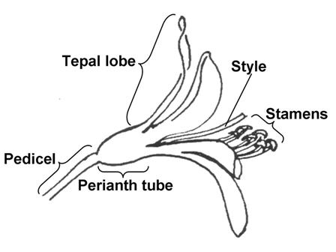

8.2 Explanations for individual characteristics
Ad. 1: Plant: type

Observations should be made during winter and spring.

Ad. 3: Plant: number of leaves per shoot

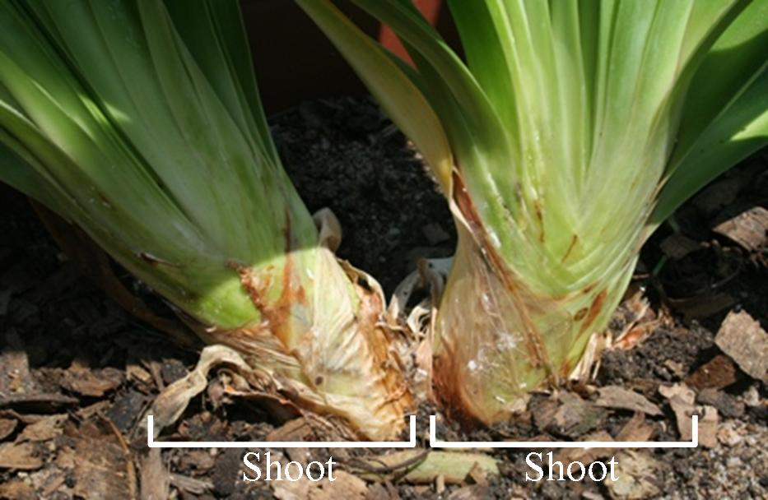

Ad. 8: Leaf: disappearance of variegation with development

Observations should be made by comparing variegation of young leaves with variegation of mature leaves. Disappearance of variegation is present when mature leaves have less variegation than young leaves.

Ad. 11: Leaf: anthocyanin coloration at base

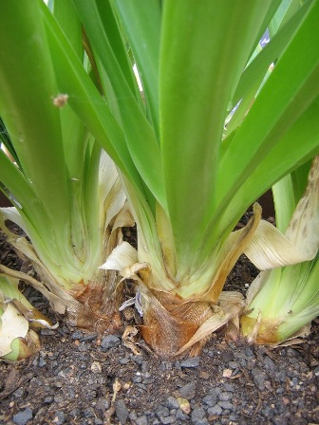 | 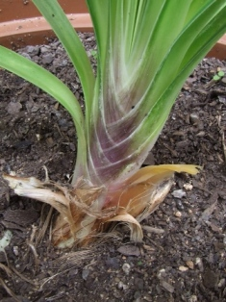
1 | 9
absent | present

Ad. 12: Inflorescence bract: length of tip relative to total length of bract

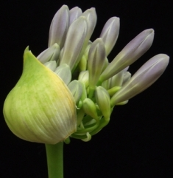 | 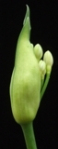 | 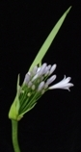 | 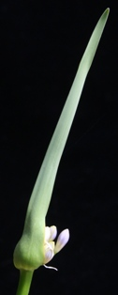 | 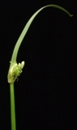
1 | 3 | 5 | 7 | 9
very short | short | medium | long | very long

Ad. 14: Inflorescence bract: opening

To be observed when most of the flower buds have protruded.

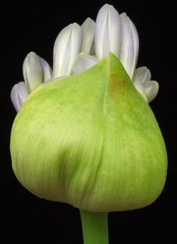 | 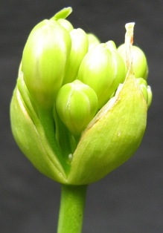
1 | 2
one side | both sides

Ad. 17: Peduncle: shape in cross section

 | 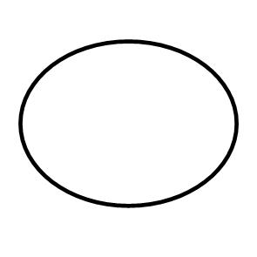 | 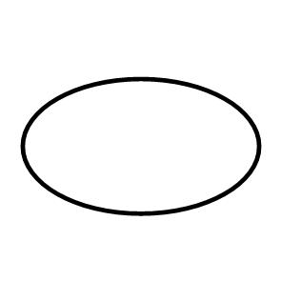
1 | 2 | 3
circular | elliptic | oblong

Ad. 19: Inflorescence: number of flowers

The total number of flowers should be assessed, including flower buds, open flowers, and faded flowers.

Ad. 20: Inflorescence: diameter
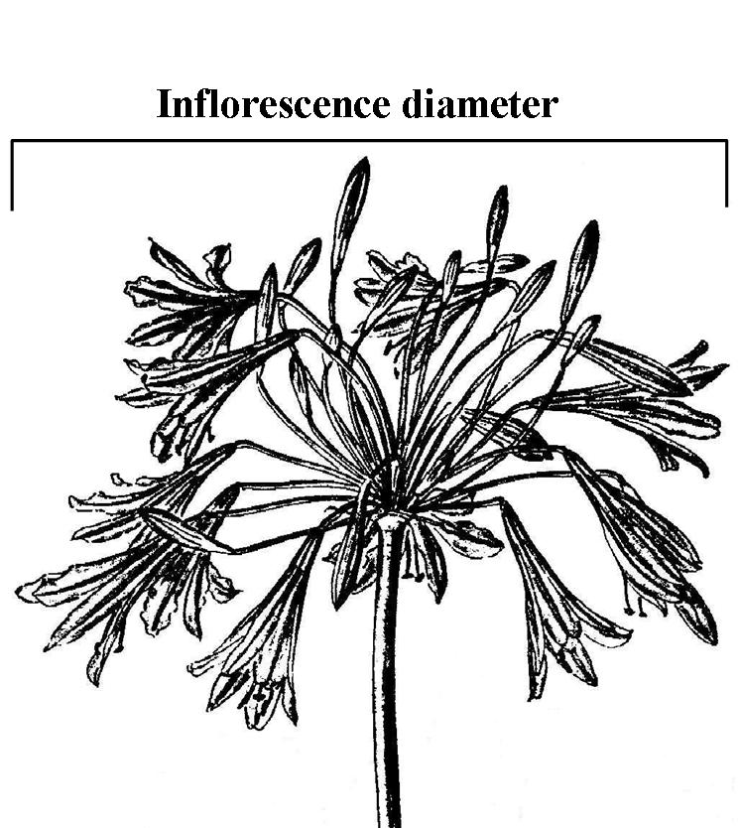

Ad. 21: Inflorescence: shape in lateral view

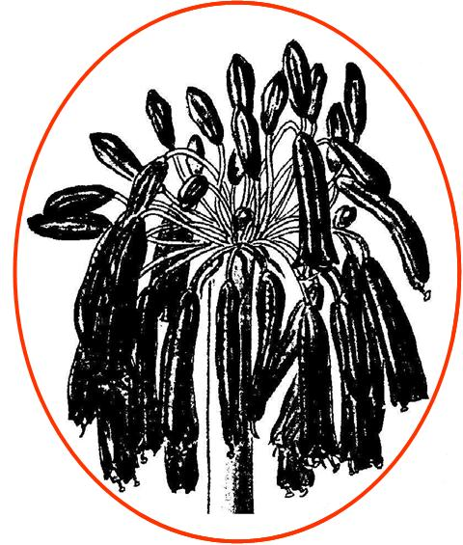 | 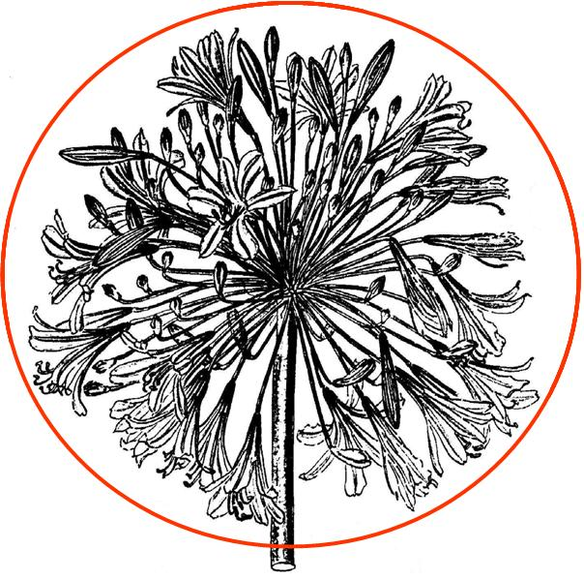 | 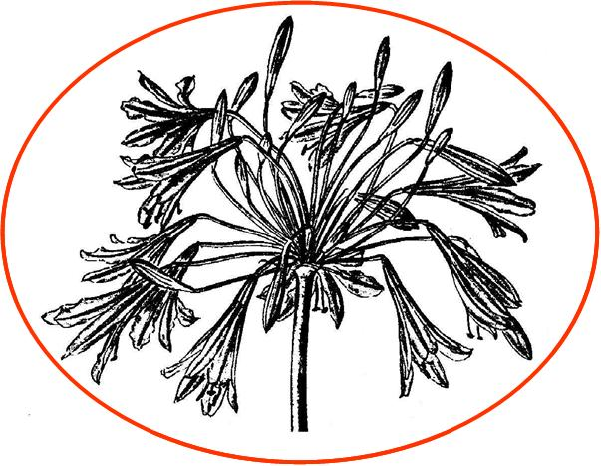 | 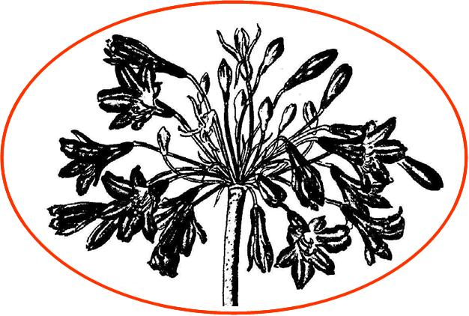
1 | 2 | 3 | 4
elliptic | circular | narrow oblate | broad oblate

Ad. 27: Pedicel: distribution of anthocyanin coloration

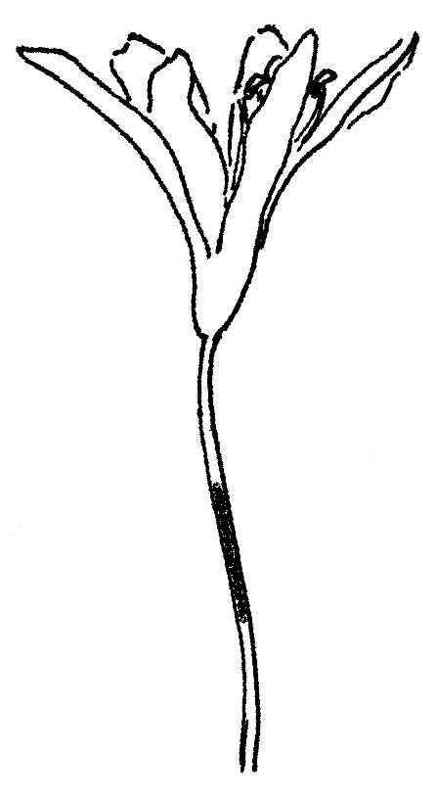 | 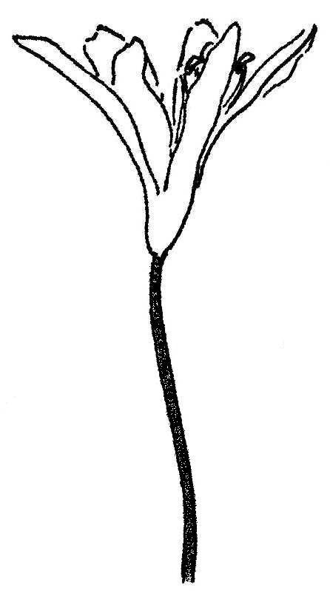 | 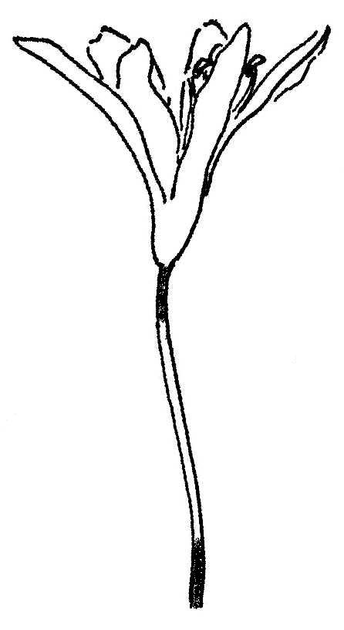
1 | 2 | 3
only on middle third | entire | only on upper and lower third

Ad. 28: Flower: shape

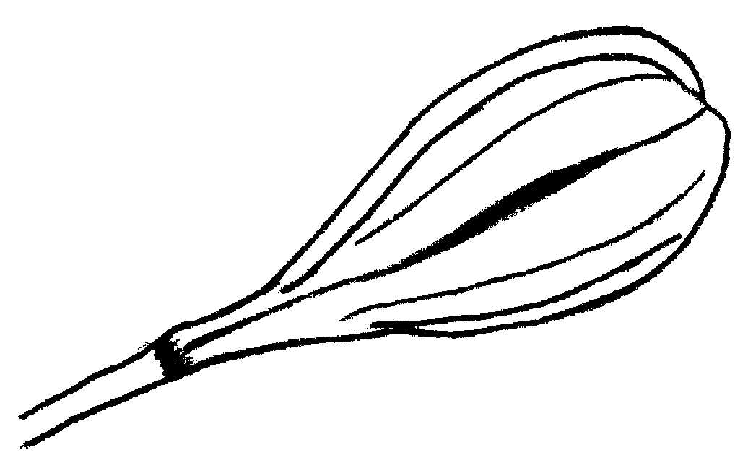 | 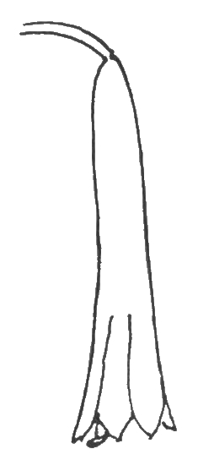 | 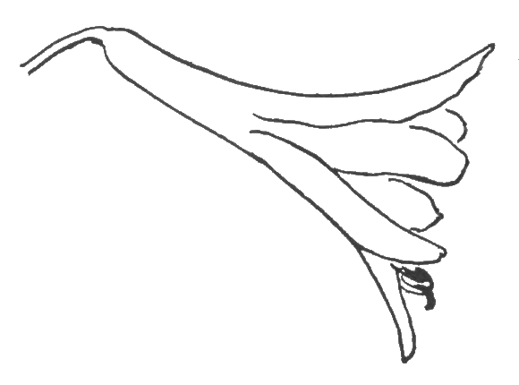 | 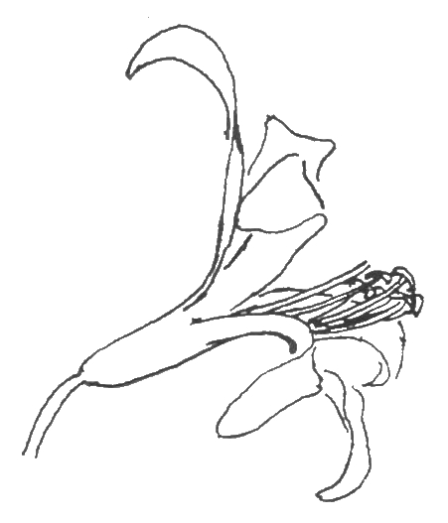
1 | 2 | 3 | 4
globose | tubular | funnel | campanulate

Ad. 29: Flower: type

Single type flowers have six tepals.
Semi-double type flowers have more than six tepals.

Ad. 30: Perianth: length

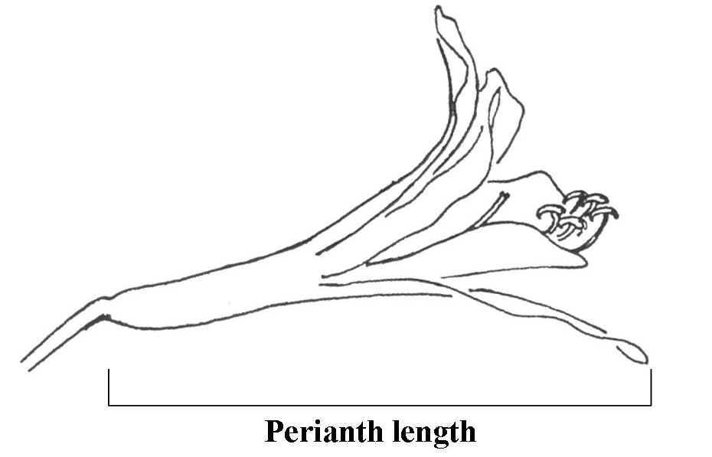

Ad. 31: Perianth: diameter

The maximum natural diameter should be assessed.

Ad. 32: Perianth: overlapping of tepal lobes

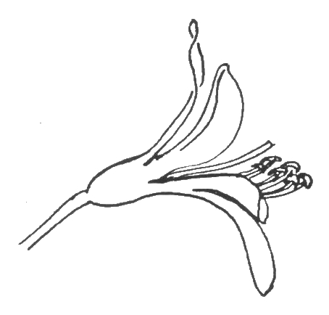 | 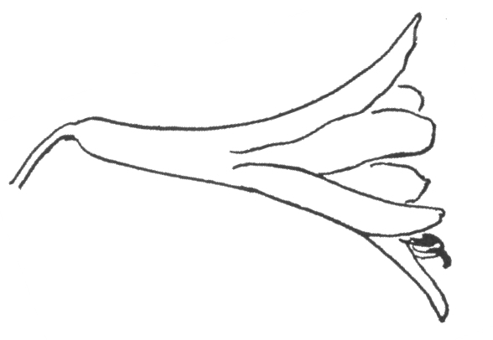
1 | 2 | 3
absent | incomplete | complete

Ad. 32: Perianth: overlapping of tepal lobes
Ad. 33: Perianth tube: length

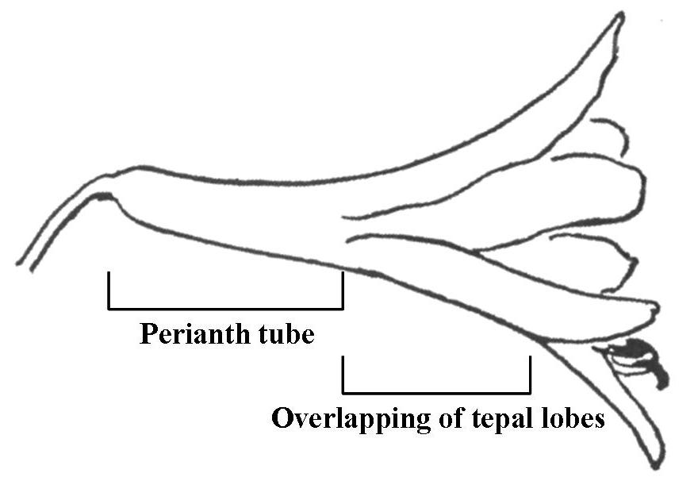

Ad. 35: Tepal lobe: ratio length/width

The tepal lobe is the part of the tepal that does not form part of the perianth tube.

Ad. 40: Flower: tepal-like staminodes and pistillodes

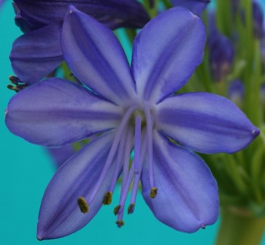 | 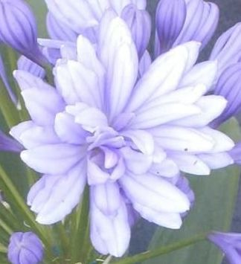
1 | 9
absent | present

Ad. 41: Flower: extrusion of stamens

The extrusion of stamens is observed as the protrusion of the stamens in relation to the apex of the tepal lobes.

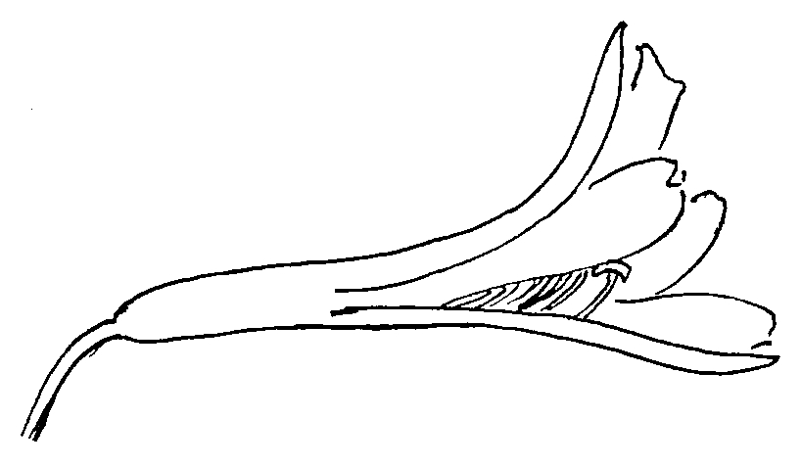 | 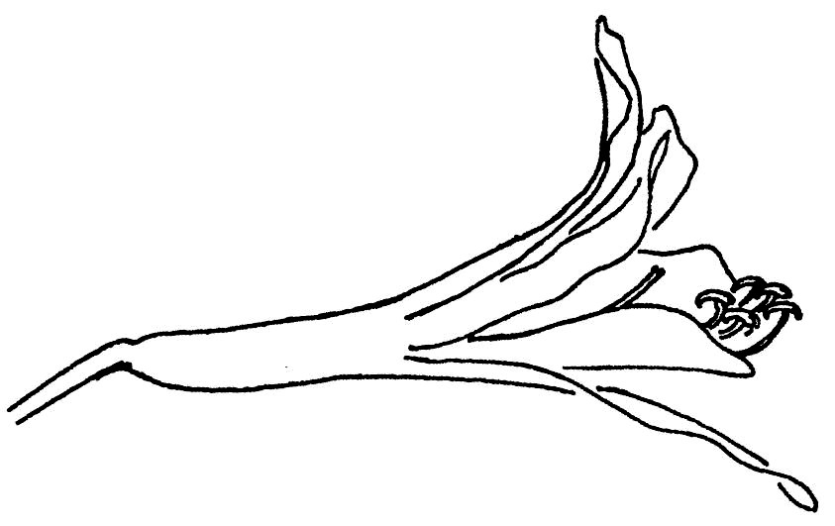 | 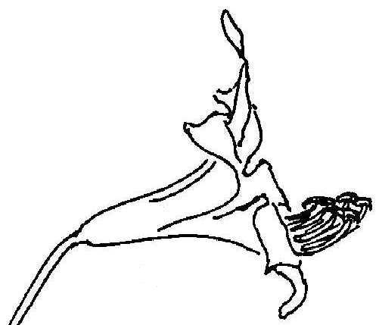
1 | 2 | 3
absent or weak | medium | strong

Ad. 43: Anther: color

The color of the anthers should be observed just before dehiscence.

Ad. 45: Time of beginning of flowering

Time of beginning of flowering is when 50% of plants have at least one flower fully open.

Literature
Duncan, G.D., 1998: Kirstenbosch Gardening Series: Grow Agapanthus: a guide to the species, cultivation and propagation of the genus Agapanthus. National Botanical Institute, Kirstenbosch, Cape Town, ZA, 32 pp.

Germishuizen, G., Meyer, N.L., Steenkamp, Y., Keith, M., 2006: A checklist of South African plants. Southern African Botanical Diversity Network Report No. 41, SABONET, Pretoria, ZA

Hattatt, L., 2001: Encyclopedia of garden plants and flowers. Parragon, Bath, UK, 256 pp.

Leighton, F.M., 1965: The genus Agapanthus L’Heritier. Journal of South African Botany, Supplementary Volume No. IV, ZA, 50 pp.

Perry, F. (ed.), 1980: The Macdonald encyclopedia of plants & flowers. Macdonald General Books, London, UK

Snoeijer, W., 2004: Agapanthus: a revision of the genus. Timber Press, Inc., Portland, Oregon, US, 320 pp.

Zonneveld, B.J.M., Duncan, G.D., 2003: Taxonomic implications of genome size and pollen colour and vitality for species of Agapanthus L’Heritier (Agapanthaceae). Plant Syst. Evol. 241: 115-123

Technical Questionnaire
TECHNICAL QUESTIONNAIRE |  |  |  | Page {x} of {y} |  | Reference Number:
 |  |  |  |  |  | Application date:
 |  |  |  |  |  | (not to be filled in by the applicant)
TECHNICAL QUESTIONNAIRE
to be completed in connection with an application for plant breeders’ rights

1. Subject of the Technical Questionnaire
1.1 Genus
1.1.1 Botanical name |  |  | Agapanthus L’Hér.
1.1.2 Common name |  |  | African lily; Agapanthus
  - Species / Group
(please complete)
2. Applicant
Name
Address
Telephone No.
Fax No.
E-mail address
Breeder (if different from applicant)
3. Proposed denomination and breeder’s reference
Proposed denomination
(if available)

Breeder’s reference
#4. Information on the breeding scheme and propagation of the variety

4.1 Breeding scheme

Variety resulting from:

4.1.1 Crossing

(a) controlled cross [ ]
(please state parent varieties)

(…………………..……………..…) x (……………..…………………..…)
female parent male parent

(b) partially known cross [ ]
(please state known parent variety(ies))

(…………………..……………..…) x (……………..…………………..…)
female parent male parent

(c) unknown cross [ ]

4.1.2 Mutation [ ]
(please state parent variety)

4.1.3 Discovery and development [ ]
(please state where and when discovered and how developed)

4.1.4 Other [ ]
(please provide details)

4.2 Method of propagating the variety

4.2.1 Vegetative propagation

(a) cuttings [ ]

(b) in vitro propagation [ ]

(c) other (state method) [ ]

4.2.2 Other [ ]
(please provide details)

5. Characteristics of the variety to be indicated (the number in brackets refers to the corresponding characteristic in Test Guidelines; please mark the note which best corresponds).

 | Characteristics |  |  |  |  |  | Example Varieties |  |  | Note
5.1  (1) | Plant: type
 | deciduous |  |  |  |  |  | Deep Blue |  |  | 1[ ]
 | evergreen |  |  |  |  |  | Cloudy Skies |  |  | 2[ ]
5.2  (7) | Leaf: variegation
 | absent |  |  |  |  |  | Blue Velvet |  |  | 1[ ]
 | present |  |  |  |  |  | Tinkerbell |  |  | 9[ ]
5.4  (14) | Inflorescence bract: opening
 | one side |  |  |  |  |  | Wiley J |  |  | 1[ ]
 | both sides |  |  |  |  |  | Double Diamond |  |  | 2[ ]
5.5  (19) | Inflorescence: number of flowers
 | very few |  |  |  |  |  | Peter Pan |  |  | 1[ ]
 | very few to few |  |  |  |  |  |  |  |  | 2[ ]
 | few |  |  |  |  |  | Bright Eyes |  |  | 3[ ]
 | few to medium |  |  |  |  |  |  |  |  | 4[ ]
 | medium |  |  |  |  |  | Blue Velvet |  |  | 5[ ]
 | medium to many |  |  |  |  |  |  |  |  | 6[ ]
 | many |  |  |  |  |  | Magnifico |  |  | 7[ ]
 | many to very many |  |  |  |  |  |  |  |  | 8[ ]
 | very many |  |  |  |  |  | Maximus |  |  | 9[ ]
 | Characteristics |  |  |  |  |  | Example Varieties |  |  | Note
5.6(i)  (22) | Flower bud: main color
 | RHS Colour Chart
 | (indicate reference number)
5.6(ii)  (22) | Flower bud: main color
 | white |  |  |  |  |  | Double Diamond |  |  | 1[ ]
 | yellow green |  |  |  |  |  |  |  |  | 2[ ]
 | violet |  |  |  |  |  | Amethyst |  |  | 3[ ]
 | violet blue |  |  |  |  |  | Blue Velvet |  |  | 4[ ]
 | blue |  |  |  |  |  |  |  |  | 5[ ]
5.7  (29) | Flower: type
 | single |  |  |  |  |  | Blue Velvet |  |  | 1[ ]
 | semi-double |  |  |  |  |  | Double Diamond |  |  | 2[ ]
5.8  (43) | Anther: color
 | white |  |  |  |  |  | Lavender Haze |  |  | 1[ ]
 | green |  |  |  |  |  | Blue Brush |  |  | 2[ ]
 | blue green |  |  |  |  |  | Glen Avon |  |  | 3[ ]
 | light yellow |  |  |  |  |  | Ossato Snow |  |  | 4[ ]
 | medium yellow |  |  |  |  |  | Polar Ice |  |  | 5[ ]
 | purple |  |  |  |  |  | Corinne |  |  | 6[ ]
 | brown |  |  |  |  |  | Umbellatus Albus |  |  | 7[ ]
 | blue grey |  |  |  |  |  | Sarah |  |  | 8[ ]
 | black |  |  |  |  |  | Aberdeen |  |  | 9[ ]
6. Similar varieties and differences from these varieties

Please use the following table and box for comments to provide information on how your candidate variety differs from the variety (or varieties) which, to the best of your knowledge, is (or are) most similar. This information may help the examination authority to conduct its examination of distinctness in a more efficient way.

Denomination(s) of variety(ies) similar to your candidate variety |  | Characteristic(s) in which your candidate variety differs from the similar variety(ies) |  |  | Describe the expression of the characteristic(s) for the similar variety(ies) |  |  | Describe the expression of the characteristic(s) for your candidate variety
Example |  | Plant: type |  |  | deciduous |  |  | evergreen
Comments:

#7. Additional information which may help in the examination of the variety

7.1 In addition to the information provided in sections 5 and 6, are there any additional characteristics which may help to distinguish the variety?

Yes [ ] No [ ]

(If yes, please provide details)

7.2 Are there any special conditions for growing the variety or conducting the examination?

Yes [ ] No [ ]

(If yes, please provide details)

7.3 Other information

A representative color image of the variety should accompany the
Technical Questionnaire.

8. Authorization for release

(a) Does the variety require prior authorization for release under legislation concerning the protection of the environment, human and animal health?

Yes [ ] No [ ]

(b) Has such authorization been obtained?

Yes [ ] No [ ]

If the answer to (b) is yes, please attach a copy of the authorization.

9. Information on plant material to be examined or submitted for examination.

9.1 The expression of a characteristic or several characteristics of a variety may be affected by factors, such as pests and disease, chemical treatment (e.g. growth retardants or pesticides), effects of tissue culture, different rootstocks, scions taken from different growth phases of a tree, etc.

9.2 The plant material should not have undergone any treatment which would affect the expression of the characteristics of the variety, unless the competent authorities allow or request such treatment. If the plant material has undergone such treatment, full details of the treatment must be given. In this respect, please indicate below, to the best of your knowledge, if the plant material to be examined has been subjected to:

(a) Microorganisms (e.g. virus, bacteria, phytoplasma) Yes [ ] No [ ]

(b) Chemical treatment (e.g. growth retardant, pesticide) Yes [ ] No [ ]

(c) Tissue culture Yes [ ] No [ ]

(d) Other factors Yes [ ] No [ ]

Please provide details for where you have indicated “yes”.

……………………………………………………………

10. I hereby declare that, to the best of my knowledge, the information provided in this form is correct:

Applicant’s name

Signature Date

[End of document]

* These names were correct at the time of the introduction of these Test Guidelines but may be revised or updated. [Readers are advised to consult the UPOV Code, which can be found on the UPOV Website (www.upov.int), for the latest information.]
# Authorities may allow certain of this information to be provided in a confidential section of the Technical Questionnaire.
# Authorities may allow certain of this information to be provided in a confidential section of the Technical Questionnaire.

