d |  |  |  | E  TG/ARGAN(proj.8) with TWF comments  ORIGINAL: English  DATE: 2026-07-24
INTERNATIONAL UNION FOR THE PROTECTION OF NEW VARIETIES OF PLANTS
Geneva
 |  | DRAFT

 | ARGAN  UPOV Code(s): ARGAN_SPI  Argania spinosa (L.) Skeels | *

GUIDELINES
FOR THE CONDUCT OF TESTS
FOR DISTINCTNESS, UNIFORMITY AND STABILITY

prepared by an expert from Morocco

considered by the

Technical Working Party for Fruit Crops at its fifty-seventh session,
to be held in Leipzig, Germany, from 2026-09-07 to 2026-09-10

Disclaimer: this document does not represent UPOV policies or guidance

Alternative Names:*

Botanical name | English | French | German | Spanish
Argania spinosa (L.) Skeels | Argan, Argantree | Arganier | Arganbaum | Argán

The purpose of these guidelines (“Test Guidelines”) is to elaborate the principles contained in the General Introduction (document TG/1/3), and its associated TGP documents, into detailed practical guidance for the harmonized examination of distinctness, uniformity and stability (DUS) and, in particular, to identify appropriate characteristics for the examination of DUS and production of harmonized variety descriptions.

ASSOCIATED DOCUMENTS

These Test Guidelines should be read in conjunction with the General Introduction and its associated
TGP documents.
English common name to read Argan Tree

TABLE OF CONTENTS PAGE
1. Subject of these Test Guidelines 4
2. Material Required 4
3. Method of Examination 4
3.1 Number of Growing Cycles 4
3.2 Testing Place 4
3.3 Conditions for Conducting the Examination 4
3.4 Test Design 4
3.5 Additional Tests 5
4. Assessment of Distinctness, Uniformity and Stability 5
4.1 Distinctness 5
4.2 Uniformity 6
4.3 Stability 6
5. Grouping of Varieties and Organization of the Growing Trial 6
6. Introduction to the Table of Characteristics 6
6.1 Categories of Characteristics 6
6.2 States of Expression and Corresponding Notes 7
6.3 Types of Expression 7
6.4 Example Varieties 7
6.5 Legend 8
7. Table of Characteristics/Tableau des caracteres/Merkmalstabelle/Tabla de caracteres 9
8. Explanations on the Table of Characteristics 17
8.1 Explanations covering several characteristics 17
8.2 Explanations for individual characteristics 17
9. Literature 22
10. Technical Questionnaire 23

Subject of these Test Guidelines

These Test Guidelines apply to all varieties of Argania spinosa (L.) Skeels.

Material Required

2.1 The competent authorities decide on the quantity and quality of the plant material required for testing the variety and when and where it is to be delivered. Applicants submitting material from a State other than that in which the testing takes place must ensure that all customs formalities and phytosanitary requirements are complied with.

2.2 The material is to be supplied in the form of budwood or grafted trees.

2.3 The minimum quantity of plant material, to be supplied by the applicant, should be:

5 one-year-old grafted trees or 10 budwood. The rootstock to be used should be specified by the competent authority.

2.4 The plant material supplied should be visibly healthy, not lacking in vigor, nor affected by any important pest or disease.

2.5 The plant material should not have undergone any treatment which would affect the expression of the characteristics of the variety, unless the competent authorities allow or request such treatment. If it has been treated, full details of the treatment must be given.

Method of Examination

Number of Growing Cycles

3.1.1 The minimum duration of tests should normally be two independent growing cycles.

3.1.2 The two independent growing cycles may be observed from a single planting, examined in two separate growing cycles.
3.1.3 A growing cycle is generally defined as the period between two successive resumptions of vegetative growth, encompassing all developmental stages, including vegetative growth, flowering, fruit development, and relative dormancy.
3.1.4 In particular, it is essential that the trees produce a satisfactory crop of fruit in each of the two growing cycles.

3.1.5 The testing of a variety may be concluded when the competent authority can determine with certainty the outcome of the test.

Testing Place

Tests are normally conducted at one place. In the case of tests conducted at more than one place, guidance is provided in TGP/9 "Examining Distinctness".

Conditions for Conducting the Examination

The tests should be carried out under conditions ensuring satisfactory growth for the expression of the relevant characteristics of the variety and for the conduct of the examination.

Test Design

3.4.1 Each test should be designed to result in a total of at least 5 trees.

3.4.2 The design of the tests should be such that plants or parts of plants may be removed for measurement or counting without prejudice to the observations which must be made up to the end of the growing cycle.

Additional Tests

Additional tests, for examining relevant characteristics, may be established.

Assessment of Distinctness, Uniformity and Stability

Distinctness

4.1.1 General Recommendations

It is of particular importance for users of these Test Guidelines to consult the General Introduction prior to making decisions regarding distinctness. However, the following points are provided for elaboration or emphasis in these Test Guidelines.

4.1.2 Consistent Differences

The differences observed between varieties may be so clear that more than one growing cycle is not necessary. In addition, in some circumstances, the influence of the environment is not such that more than a single growing cycle is required to provide assurance that the differences observed between varieties are sufficiently consistent. One means of ensuring that a difference in a characteristic, observed in a growing trial, is sufficiently consistent is to examine the characteristic in at least two independent growing cycles.

4.1.3 Clear Differences

Determining whether a difference between two varieties is clear depends on many factors, and should consider, in particular, the type of expression of the characteristic being examined, i.e. whether it is expressed in a qualitative, quantitative, or pseudo-qualitative manner. Therefore, it is important that users of these Test Guidelines are familiar with the recommendations contained in the General Introduction prior to making decisions regarding distinctness.

4.1.4 Number of Plants or Parts of Plants to be Examined

Unless otherwise indicated, for the purposes of distinctness, all observations on single plants should be made on 5 plants or parts taken from each of 5 plants and any other observations made on all plants in the test, disregarding any off-type plants.

4.1.5 Method of Observation

The recommended method of observing the characteristic for the purposes of distinctness is indicated by the following key in the Table of Characteristics (see document TGP/9 "Examining Distinctness", Section 4 "Observation of characteristics"):

MG: single measurement of a group of plants or parts of plants
MS: measurement of a number of individual plants or parts of plants
VG: visual assessment by a single observation of a group of plants or parts of plants
VS: visual assessment by observation of individual plants or parts of plants

Type of observation: visual (V) or measurement (M)

"Visual" observation (V) is an observation made on the basis of the expert's judgment. For the purposes of this document, "visual" observation refers to the sensory observations of the experts and, therefore, also includes smell, taste and touch. Visual observation includes observations where the expert uses reference points (e.g. diagrams, example varieties, side-by-side comparison) or non-linear charts (e.g. color charts). Measurement (M) is an objective observation against a calibrated, linear scale e.g. using a ruler, weighing scales, colorimeter, dates, counts, etc.

Type of record: for a group of plants (G) or for single, individual plants (S)

For the purposes of distinctness, observations may be recorded as a single record for a group of plants or parts of plants (G), or may be recorded as records for a number of single, individual plants or parts of plants (S). In most cases, "G" provides a single record per variety and it is not possible or necessary to apply statistical methods in a plant-by-plant analysis for the assessment of distinctness.

In cases where more than one method of observing the characteristic is indicated in the Table of Characteristics (e.g. VG/MG), guidance on selecting an appropriate method is provided in document TGP/9, Section 4.2.

Uniformity

4.2.1 It is of particular importance for users of these Test Guidelines to consult the General Introduction prior to making decisions regarding uniformity. However, the following points are provided for elaboration or emphasis in these Test Guidelines:

4.2.2 These Test Guidelines have been developed for the examination of vegetatively propagated varieties. For varieties with other types of propagation, the recommendations in the General Introduction and document TGP/13 "Guidance for new types and species" Section 4.5 "Testing Uniformity" should be followed.
4.2.3 For the assessment of uniformity of vegetatively propagated varieties, a population standard of 1% and an acceptance probability of at least 95% should be applied. In the case of a sample size of 5 plants, no off-types are allowed.

Stability

4.3.1 In practice, it is not usual to perform tests of stability that produce results as certain as those of the testing of distinctness and uniformity. However, experience has demonstrated that, for many types of variety, when a variety has been shown to be uniform, it can also be considered to be stable.

4.3.2 Where appropriate, or in cases of doubt, stability may be further examined by testing a new seed or plant stock to ensure that it exhibits the same characteristics as those shown by the initial material supplied.

Grouping of Varieties and Organization of the Growing Trial

5.1 The selection of varieties of common knowledge to be grown in the trial with the candidate varieties and the way in which these varieties are divided into groups to facilitate the assessment of distinctness are aided by the use of grouping characteristics.

5.2 Grouping characteristics are those in which the documented states of expression, even where produced at different locations, can be used, either individually or in combination with other such characteristics: (a) to select varieties of common knowledge that can be excluded from the growing trial used for examination of distinctness; and (b) to organize the growing trial so that similar varieties are grouped together.

5.3 The following have been agreed as useful grouping characteristics:

(a) Tree: growth habit (characteristic 2)
(b) Branch: attitude in relation to stem (characteristic 7)
(c) Leaf: shape (characteristic 8)
(d) Fruiting branch: position of inflorescences (characteristic 16)
(e) Fruit: shape (characteristic 19)
(f) Stone: weight (characteristic 23)
(g) Stone: shape (characteristic 24)
(h) Plant: self-incompatibility (characteristic 41)

5.4 Guidance for the use of grouping characteristics, in the process of examining distinctness, is provided through the General Introduction and document TGP/9 "Examining Distinctness".

Introduction to the Table of Characteristics

Categories of Characteristics

6.1.1 Standard Test Guidelines Characteristics

Standard Test Guidelines characteristics are those which are approved by UPOV for examination of DUS and from which members of the Union can select those suitable for their particular circumstances.

6.1.2 Asterisked Characteristics

Asterisked characteristics (denoted by *) are those included in the Test Guidelines which are important for the international harmonization of variety descriptions and should always be examined for DUS and included in the variety description by all members of the Union, except when the state of expression of a preceding characteristic or regional environmental conditions render this inappropriate.

States of Expression and Corresponding Notes

6.2.1 States of expression are given for each characteristic to define the characteristic and to harmonize descriptions. Each state of expression is allocated a corresponding numerical note for ease of recording of data and for the production and exchange of the description.

6.2.2 All relevant states of expression are presented in the characteristic.

6.2.3 Further explanation of the presentation of states of expression and notes is provided in document TGP/7 "Development of Test Guidelines".

Types of Expression

An explanation of the types of expression of characteristics (qualitative, quantitative and pseudo-qualitative) is provided in the General Introduction.

Example Varieties

Where appropriate, example varieties are provided to clarify the states of expression of each characteristic.

Legend

 |  | English |  | français |  | deutsch | español | Example Varieties  Exemples  Beispielssorten  Variedades ejemplo | Note/  Nota
1 | 2 | 3 | 4 | 5 | 6 | 7
 |  | Name of characteristics in English |  | Nom du caractère en français |  | Name des Merkmals auf Deutsch | Nombre del carácter en español
 |  | states of expression |  | types d’expression |  | Ausprägungsstufen | tipos de expresión

1 Characteristic number

2 (*) Asterisked characteristic – see Chapter 6.1.2

3 Type of expression
QL Qualitative characteristic – see Chapter 6.3
QN Quantitative characteristic – see Chapter 6.3
PQ Pseudo-qualitative characteristic – see Chapter 6.3

4 Method of observation (and type of plot, if applicable)
MG, MS, VG, VS – see Chapter 4.1.5

5 (+) See Explanations on the Table of Characteristics in Chapter 8.2

6 (a)-(e) See Explanations on the Table of Characteristics in Chapter 8.1

7 Not applicable

to add all notes for QN characteristics

Table of Characteristics/Tableau des caracteres/Merkmalstabelle/Tabla de caracteres

 |  | English |  | français |  | deutsch | español | Example Varieties  Exemples  Beispielssorten  Variedades ejemplo | Note/  Nota
1. | (*) | QN | VG | (+)
 |  | Tree: vigor
 |  | weak |  |  |  |  |  | Timllilte | 3
 |  | medium |  |  |  |  |  | Badr | 5
 |  | strong |  |  |  |  |  | Inargane | 7
2. | (*) | PQ | VG | (+)
 |  | Tree: growth habit
 |  | upright |  |  |  |  |  | Inargane, Tidli | 1
 |  | spreading |  |  |  |  |  | Yargana | 2
 |  | drooping |  |  |  |  |  | Ighalen, Timllilte | 3
3. |  | QN | VG | (+)
 |  | Tree: density of foliage
 |  | sparse |  |  |  |  |  | Ighalen | 1
 |  | medium |  |  |  |  |  | Badr | 2
 |  | dense |  |  |  |  |  | Inargane, Yargana | 3
4. |  | QL | VG
 |  | Shoot: apical dominance
 |  | absent |  |  |  |  |  | Badr | 1
 |  | present |  |  |  |  |  | Inargane | 9
5. |  | QN | VG
 |  | Shoot: density of spines
 |  | sparse |  |  |  |  |  |  | 1
 |  | medium |  |  |  |  |  | Badr, Yargana | 2
 |  | dense |  |  |  |  |  | Inargane | 3
6. | (*) | QN | MG/VG
 |  | Shoot: length of internode
 |  | very short |  |  |  |  |  |  | 1
 |  | short |  |  |  |  |  | Badr, Inargane | 2
 |  | medium |  |  |  |  |  | Yargana | 3
 |  | long |  |  |  |  |  |  | 4
 |  | very long |  |  |  |  |  |  | 5
7. | (*) | QN | MG/VG | (+)
 |  | Branch: attitude in relation to stem
 |  | erect |  |  |  |  |  | Badr, Yargana | 1
 |  | semi-erect |  |  |  |  |  | Inargane | 2
 |  | horizontal |  |  |  |  |  | Assole | 3
8. | (*) | PQ | VG | (+) | (a)
 |  | Leaf: shape
 |  | narrow elliptic |  |  |  |  |  | Badr, Inargane | 1
 |  | broad elliptic |  |  |  |  |  | Souhayl | 2
 |  | narrow obovate |  |  |  |  |  | Chouihiya | 3
 |  | broad obovate |  |  |  |  |  |  | 4
9. | (*) | PQ | VG |  | (a)
 |  | Leaf blade: shape of apex
 |  | acute |  |  |  |  |  | Inargane, Yargana | 1
 |  | obtuse |  |  |  |  |  | Badr | 2
 |  | rounded |  |  |  |  |  | Tinirit | 3
10. | (*) | PQ | VG | (+) | (a)
 |  | Leaf blade: shape of base
 |  | attenuate |  |  |  |  |  |  | 1
 |  | acute |  |  |  |  |  | Tinirit | 2
 |  | obtuse |  |  |  |  |  | Badr, Inargane, Yargana | 3
11. | (*) | QN | MG/VG |  | (a)
 |  | Leaf blade: length
 |  | short |  |  |  |  |  |  | 1
 |  | medium |  |  |  |  |  | Badr, Inargane, Yargana | 2
 |  | long |  |  |  |  |  | Timllilte | 3
12. | (*) | QN | MG/VG |  | (a)
 |  | Leaf blade: width
 |  | narrow |  |  |  |  |  | Inargane | 1
 |  | medium |  |  |  |  |  | Badr, Yargana | 2
 |  | broad |  |  |  |  |  |  | 3
13. | (*) | QN | MG/VG |  | (a)
 |  | Leaf blade: ratio length/width
 |  | low |  |  |  |  |  |  | 1
 |  | medium |  |  |  |  |  | Badr, Yargana | 3
 |  | high |  |  |  |  |  | Inargane | 5
14. |  | QN | VG |  | (a)
 |  | Leaf blade: intensity of green color of upper side
 |  | light |  |  |  |  |  | Badr | 1
 |  | medium |  |  |  |  |  | Inargane, Yargana | 2
 |  | dark |  |  |  |  |  |  | 3
15. |  | QN | MG/VG |  | (a)
 |  | Petiole: length
 |  | short |  |  |  |  |  | Awthem | 1
 |  | medium |  |  |  |  |  | Badr, Inargane, Yargana | 2
 |  | long |  |  |  |  |  |  | 3
16. | (*) | QN | VG | (+) | (b)
 |  | Fruiting branch: position of inflorescences
 |  | mainly on leaf axils |  |  |  |  |  | Awthem | 1
 |  | mostly on both leaf axils and on branches |  |  |  |  |  | Badr, Inargane, Yargana | 2
 |  | mainly on branches |  |  |  |  |  |  | 3
17. |  | PQ | VG |  | (b)
 |  | Petal: color
 |  | white |  |  |  |  |  | Tangza | 1
 |  | light yellow |  |  |  |  |  | Badr, Inargane, Yargana | 2
 |  | dark yellow |  |  |  |  |  | Assole | 3
18. |  | PQ | VG |  | (d)
 |  | Stone: color TO BE MOVED BEFORE CHAR. 28
 |  | light brown |  |  |  |  |  |  | 1
 |  | medium brown |  |  |  |  |  | Badr | 2
 |  | dark brown |  |  |  |  |  | Inargane, Yargana | 3
 |  | black |  |  |  |  |  |  | 4
19. | (*) | PQ | VG | (+) | (c)
 |  | Fruit: shape
 |  | circular |  |  |  |  |  | Hamouch | 1
 |  | narrow elliptic |  |  |  |  |  | Mazhar | 2
 |  | broad elliptic |  |  |  |  |  | Khayr | 3
 |  | obovate |  |  |  |  |  | Inargane, Yargana | 4
20. |  | QN | MG/VG |  | (c)
 |  | Fruit: length
 |  | very short |  |  |  |  |  | Awthem | 1
 |  | short |  |  |  |  |  | Zakia | 2
 |  | medium |  |  |  |  |  | Yargana | 3
 |  | long |  |  |  |  |  | Badr, Inargane | 4
 |  | very long |  |  |  |  |  | Mazhar | 5
21. |  | QN | MG/VG |  | (c)
 |  | Fruit: width
 |  | very narrow |  |  |  |  |  | Mazhar | 1
 |  | narrow |  |  |  |  |  |  | 2
 |  | medium |  |  |  |  |  | Badr, Yargana | 3
 |  | broad |  |  |  |  |  | Inargane | 4
 |  | very broad |  |  |  |  |  |  | 5
22. |  | QN | MG/VG |  | (c)
 |  | Fruit: ratio length/width
 |  | low |  |  |  |  |  |  | 1
 |  | medium |  |  |  |  |  | Yargana | 3
 |  | high |  |  |  |  |  | Badr, Inargane | 5
23. | (*) | QN | MG |  | (d)
 |  | Stone: weight
 |  | very low |  |  |  |  |  | Tidli | 1
 |  | low |  |  |  |  |  | Timllilte | 2
 |  | medium |  |  |  |  |  | Assole | 3
 |  | high |  |  |  |  |  | Badr, Inargane, Yargana | 4
 |  | very high |  |  |  |  |  | Tangza | 5
24. | (*) | PQ | VG |  | (d)
 |  | Stone: shape
 |  | circular |  |  |  |  |  | Hamouch | 1
 |  | broad elliptic |  |  |  |  |  | Zakia | 2
 |  | narrow elliptic |  |  |  |  |  | Mazhar | 3
25. |  | QN | MG/VG |  | (d)
 |  | Stone: length
 |  | short |  |  |  |  |  | Zakia | 1
 |  | medium |  |  |  |  |  | Inargane | 3
 |  | long |  |  |  |  |  | Yargana | 5
26. |  | QN | MG/VG |  | (d)
 |  | Stone: width
 |  | narrow |  |  |  |  |  | Mazhar | 1
 |  | medium |  |  |  |  |  | Inargane | 3
 |  | broad |  |  |  |  |  |  | 5
27. |  | QN | MG/VG |  | (d)
 |  | Stone: ratio length/width
 |  | low |  |  |  |  |  | Awthem | 1
 |  | medium |  |  |  |  |  | Inargane | 3
 |  | high |  |  |  |  |  | Badr | 5
28. |  | QN | VG |  | (d)
 |  | Stone: thickness of shell
 |  | thin |  |  |  |  |  | Naama | 1
 |  | medium |  |  |  |  |  | Zakia | 2
 |  | thick |  |  |  |  |  | Yargana | 3
29. |  | QN | MG |  | (d)
 |  | Stone: number of almond lodges
 |  | mainly one |  |  |  |  |  | Yargana | 1
 |  | mainly two |  |  |  |  |  | Badr, Ghallate | 2
 |  | mainly three or more |  |  |  |  |  | Inargane | 3
30. |  | QN | VG |  | (d)
 |  | Stone: resistance to cracking
 |  | weak |  |  |  |  |  | Mazhar | 1
 |  | medium |  |  |  |  |  | Yargana | 2
 |  | strong |  |  |  |  |  | Inargane | 3
31. |  | QN | MG |  | (e)
 |  | Kernel: weight
 |  | low |  |  |  |  |  |  | 1
 |  | medium |  |  |  |  |  | Badr, Inargane | 3
 |  | high |  |  |  |  |  | Yargana | 5
32. |  | QN | MG/VG |  | (e)
 |  | Kernel: length TO BE DELETED
 |  | short |  |  |  |  |  |  | 1
 |  | medium |  |  |  |  |  | Inargane | 3
 |  | long |  |  |  |  |  | Yargana | 5
33. |  | QN | MG/VG |  | (e)
 |  | Kernel: width TO BE DELETED
 |  | narrow |  |  |  |  |  |  | 1
 |  | medium |  |  |  |  |  | Badr | 3
 |  | broad |  |  |  |  |  |  | 5
34. |  | QN | MG/VG |  | (e)
 |  | Kernel: ratio length/width TO BE DELETED
 |  | low |  |  |  |  |  |  | 1
 |  | medium |  |  |  |  |  | Inargane | 3
 |  | high |  |  |  |  |  | Yargana | 5
35. |  | PQ | VG |  | (e)
 |  | Kernel: shape TO BE DELETED
 |  | oblong |  |  |  |  |  |  | 1
 |  | ovoid |  |  |  |  |  |  | 2
 |  | ellipsoid |  |  |  |  |  | Badr | 3
36. |  | QN | MG/VG |  | (e)
 |  | Kernel: number
 |  | one |  |  |  |  |  | Yargana | 1
 |  | two |  |  |  |  |  | Badr | 2
 |  | three |  |  |  |  |  | Inargane | 3
 |  | more than three |  |  |  |  |  |  | 4
37. |  | PQ | VG |  | (e)
 |  | Kernel: color
 |  | white |  |  |  |  |  | Tangza | 1
 |  | light yellow |  |  |  |  |  | Inargane | 2
 |  | dark yellow |  |  |  |  |  | Ighalen | 3
38. |  | QN | MG | (+) | (e)
 |  | Kernel: oil content
 |  | low |  |  |  |  |  | Yargana | 1
 |  | medium |  |  |  |  |  | Badr | 2
 |  | high |  |  |  |  |  | Chouihiya | 3
39. |  | QN | MG |  | (e)
 |  | Kernel: ratio kernel weight / stone weight
 |  | low |  |  |  |  |  | Yargana | 3
 |  | medium |  |  |  |  |  | Tinirit | 5
 |  | high |  |  |  |  |  | Chouihiya | 7
40. |  | QN | MS/VG | (+)
 |  | Time of beginning of flowering
 |  | early |  |  |  |  |  | Badr | 3
 |  | medium |  |  |  |  |  | Yargana | 5
 |  | late |  |  |  |  |  | Mazhar | 7
41. | (*) | QL | VG | (+)
 |  | Plant: self-incompatibility
 |  | absent |  |  |  |  |  |  | 1
 |  | present |  |  |  |  |  |  | 9

Explanations on the Table of Characteristics

Explanations covering several characteristics

Characteristics containing the following key in the Table of Characteristics should be examined as indicated below:

(a) Observations should be made on fully developed leaves from the central part of one-year-old shoots in full growth.

(b) Observations should be made on inflorescences from the central part of fruiting branches.

(c) Observations should be made when 80% of the fruit on the tree has reached their full coloration.

(d) Observations should be made on dry well-cleaned stones of the same sample used for the observations on the fruit.

(e) Observation on kernel should be made after crushing nuts.

Explanations for individual characteristics

Ad. 1: Tree: vigor

Observations should be made on the capacity for vegetative growth, development of branches and woody tissue.

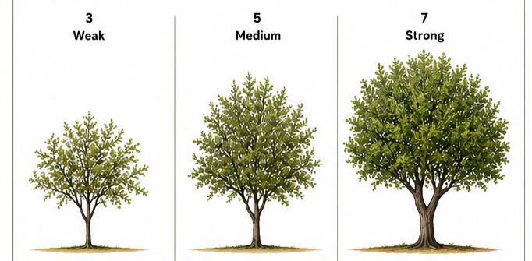

Ad. 2: Tree: growth habit

The tree growth habit states the natural attitude of the branches and shoots.

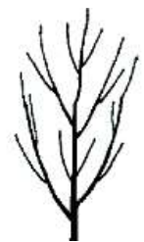 | 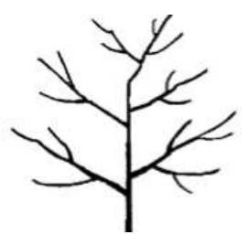 | 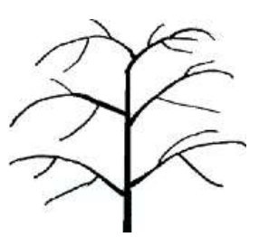
1 | 2 | 3
upright | spreading | drooping

Ad. 3: Tree: density of foliage

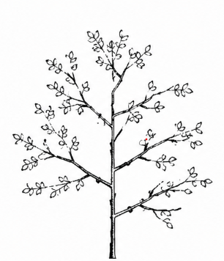 | 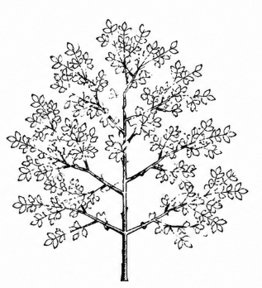 | 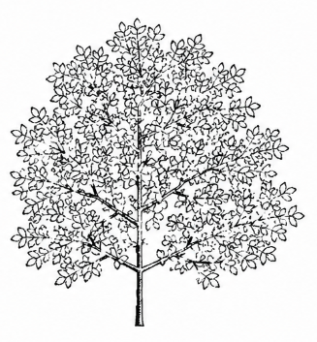
1 | 2 | 3
sparse | medium | dense

Ad. 7: Branch: attitude in relation to stem

Observations should be made on 5 fruiting branches of each tree.

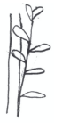 | 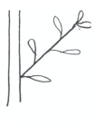 | 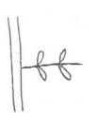
1 | 2 | 3
erect | semi-erect | horizontal

Ad. 8: Leaf: shape

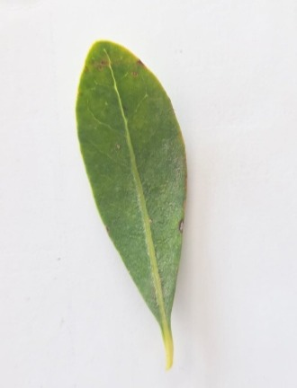 | 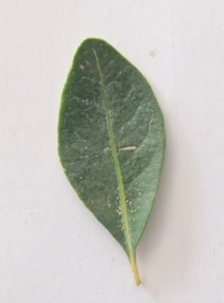 | 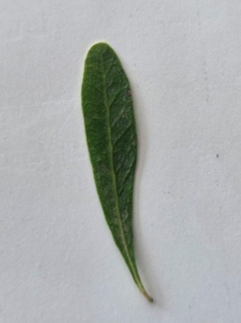 | 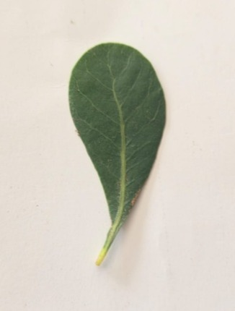
1 | 2 | 3 | 4
narrow elliptic | broad elliptic | narrow obovate | broad obovate

Ad. 10: Leaf blade: shape of base

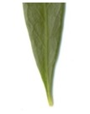 | 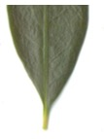 | 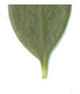
1 | 2 | 3
attenuate | acute | obtuse

Ad. 16: Fruiting branch: position of inflorescences

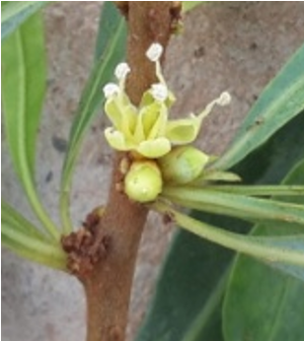 | 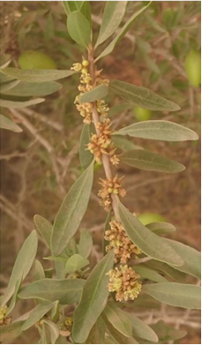 | 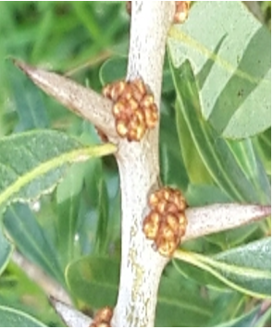
1 | 2 | 3
mainly on leaf axils | mostly on both leaf axils and on branches | mainly on branches

Ad. 19: Fruit: shape

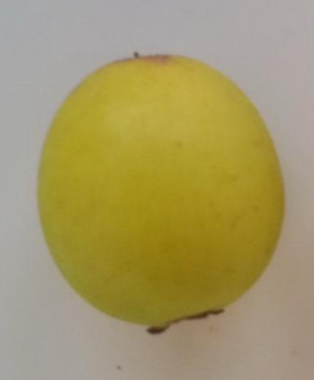 | 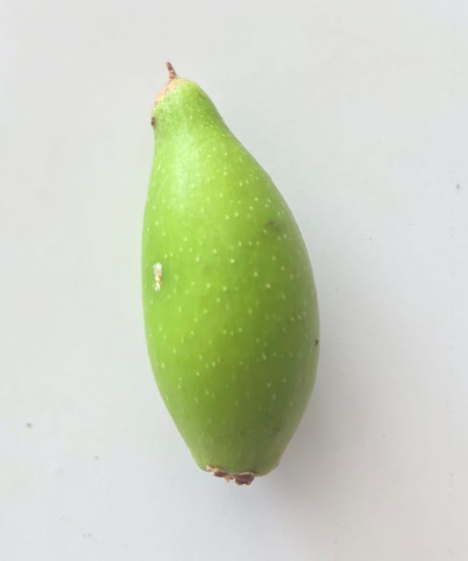 |  | 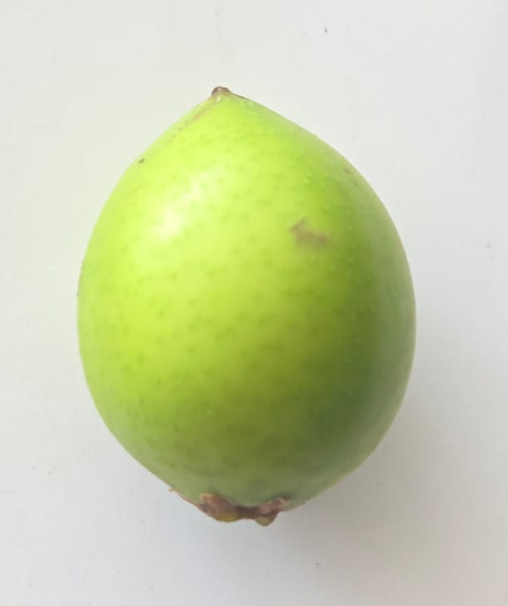 | 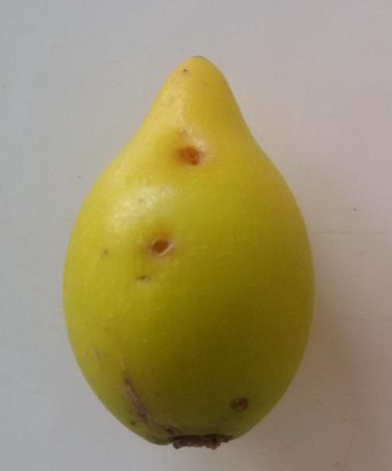
1 | 2 |  | 3 | 3
circular | narrow elliptic |  | broad elliptic | ovate
to rotate illustrations by 180 degrees to have the base at the bottom

Ad. 38: Kernel: oil content
Observations should be made on the amount of oil in relation to kernel weight.

Ad. 40: Time of beginning of flowering

The beginning of flowering is reached when 10% of flowers have fully opened.

Ad. 41: Plant: self-incompatibility

A variety is self-incompatible when the fertile pollen of its own flower or of other flowers of the same variety is not able to fertilize the ovary.
Observations should be made on 5 un-opened flowers which have been emasculated and bagged. On opening the flowers should be hand pollinated using fresh pollen from flowers of the same variety and re-bagged. Selfincompatibility is absent if the ovary of the pollinated flower is swollen and still attached to the plant one week after pollination.

Literature

to be provided

Technical Questionnaire

TECHNICAL QUESTIONNAIRE | Page {x} of {y} | Reference Number:

Application date:
(not to be filled in by the applicant)
TECHNICAL QUESTIONNAIRE
to be completed in connection with an application for plant breeders' rights
1. Subject of the Technical Questionnaire

1.1 |  |  | Botanical name |  | Argania spinosa (L.) Skeels
1.2 |  |  | Common name |  | Argan, Argantree
2. Applicant

 |  | Name
 |  | Address
 |  | Telephone No.
 |  | Fax No.
 |  | E-mail address
 |  | Breeder (if different from applicant)
3. Proposed denomination and breeder's reference

 | Proposed denomination (if available)
 | Breeder's reference

TECHNICAL QUESTIONNAIRE | Page {x} of {y} | Reference Number:

#4. Information on the breeding scheme and propagation of the variety

4.1 Breeding scheme

Variety resulting from:

4.1.1 Crossing

(a) controlled cross [ ]

(please state parent varieties)

(…………………..……………..…) x (……………..…………………..…)

female parent male parent

(b) partially known cross [ ]

(please state known parent variety(ies))

(…………………..……………..…) x (……………..…………………..…)

female parent male parent

(c) unknown cross [ ]

4.1.2 Mutation
(please state parent varieties)

4.1.3 Discovery and development
(please state where and when discovered and how developed)

4.1.4 Other
(Please provide details)

TECHNICAL QUESTIONNAIRE | Page {x} of {y} | Reference Number:

4.2 Method of propagating the variety

4.2.1 Vegetative propagation

(a) Cuttings [ ]
(b) In vitro propagation [ ]
(c) Budding or grafting
(please indicate rootstock): ............................................................................ [ ]
(d) Other (state method) [ ]

4.2.2 Other
(Please provide details) [ ]

TECHNICAL QUESTIONNAIRE |  | Page {x} of {y} |  | Reference Number:
5. Characteristics of the variety to be indicated (the number in brackets refers to the corresponding characteristic in Test Guidelines; please mark the note which best corresponds).

 | Characteristics |  | Example Varieties |  | Note
5.1  (1) | Tree: vigor
 | weak |  | Timllilte |  | 3 [ ]
 | medium |  | Badr |  | 5 [ ]
 | strong |  | Inargane |  | 7 [ ]
5.2  (2) | Tree: growth habit
 | upright |  | Inargane, Tidli |  | 1 [ ]
 | spreading |  | Yargana |  | 2 [ ]
 | drooping |  | Ighalen, Timllilte |  | 3 [ ]
5.3  (7) | Branch: attitude in relation to stem
 | erect |  | Badr, Yargana |  | 1 [ ]
 | semi-erect |  | Inargane |  | 2 [ ]
 | horizontal |  | Assole |  | 3 [ ]
5.4  (8) | Leaf: shape
 | narrow elliptic |  | Badr, Inargane |  | 1 [ ]
 | broad elliptic |  | Souhayl |  | 2 [ ]
 | narrow obovate |  | Chouihiya |  | 3 [ ]
 | broad obovate |  |  |  | 4 [ ]
5.5  (9) | Leaf blade: shape of apex
 | acute |  | Inargane, Yargana |  | 1 [ ]
 | obtuse |  | Badr |  | 2 [ ]
 | rounded |  | Tinirit |  | 3 [ ]
5.6  (16) | Fruiting branch: position of inflorescences
 | mainly on leaf axils |  | Awthem |  | 1 [ ]
 | mostly on both leaf axils and on branches |  | Badr, Inargane, Yargana |  | 2 [ ]
 | mainly on branches |  |  |  | 3 [ ]
5.7  (19) | Fruit: shape
 | circular |  | Hamouch |  | 1 [ ]
 | narrow elliptic |  | Mazhar |  | 2 [ ]
 | broad elliptic |  | Khayr |  | 3 [ ]
 | obovate |  | Inargane, Yargana |  | 4 [ ]

TECHNICAL QUESTIONNAIRE |  | Page {x} of {y} |  | Reference Number:
 | Characteristics |  | Example Varieties |  | Note
5.8  (23) | Stone: weight
 | very low |  | Tidli |  | 1 [ ]
 | low |  | Timllilte |  | 2 [ ]
 | medium |  | Assole |  | 3 [ ]
 | high |  | Badr, Inargane, Yargana |  | 4 [ ]
 | very high |  | Tangza |  | 5 [ ]
5.9  (24) | Stone: shape
 | circular |  | Hamouch |  | 1 [ ]
 | broad elliptic |  | Zakia |  | 2 [ ]
 | narrow elliptic |  | Mazhar |  | 3 [ ]
5.10  (41) | Plant: self-incompatibility
 | absent |  |  |  | 1 [ ]
 | present |  |  |  | 9 [ ]

TECHNICAL QUESTIONNAIRE |  | Page {x} of {y} |  | Reference Number:
6. Similar varieties and differences from these varieties

Please use the following table and box for comments to provide information on how your candidate variety differs from the variety (or varieties) which, to the best of your knowledge, is (or are) most similar. This information may help the examination authority to conduct its examination of distinctness in a more efficient way

Denomination(s) of variety(ies) similar to your candidate variety | Characteristic(s) in which your candidate variety differs from the similar variety(ies) |  | Describe the expression of the characteristic(s) for the similar variety(ies) |  | Describe the expression of the characteristic(s) for your candidate variety
Example | Leaf: shape |  | narrow elliptic |  | broad elliptic
Comments

TECHNICAL QUESTIONNAIRE | Page {x} of {y} | Reference Number:
#7. Additional information which may help in the examination of the variety

7.1 In addition to the information provided in sections 5 and 6, are there any additional characteristics which may help to distinguish the variety?

Yes [ ] No [ ]

(If yes, please provide details)

7.2 Are there any special conditions for growing the variety or conducting the examination?

Yes [ ] No [ ]

(If yes, please provide details)

7.3 Other information

A representative color photograph of the variety displaying its main distinguishing feature(s), should accompany the Technical Questionnaire. The photograph will provide a visual illustration of the candidate variety which supplements the information provided in the Technical Questionnaire.

The key points to consider when taking a photograph of the candidate variety are:

• Indication of the date and geographic location
• Correct labeling (breeder's reference)
• Good quality printed photograph (minimum 10 cm x 15 cm) and/or sufficient resolution electronic format version (minimum 960 x 1280 pixels)

Further guidance on providing photographs with the Technical Questionnaire is available in document TGP/7 "Development of Test Guidelines", Guidance Note 35 (http://www.upov.int/tgp/en/).

The link provided may be deleted by members of the Union when developing authorities' own test guidelines.

In the case of a self-incompatible variety, please indicate pollinizer:
...............................................................................................

TECHNICAL QUESTIONNAIRE | Page {x} of {y} | Reference Number:
8. Authorization for release

(a) Does the variety require prior authorization for release under legislation concerning the protection of the environment, human and animal health?

Yes [ ] No [ ]

(b)Has such authorization been obtained?

Yes [ ] No [ ]

If the answer to (b) is yes, please attach a copy of the authorization.
9. Information on plant material to be examined or submitted for examination

9.1 The expression of a characteristic or several characteristics of a variety may be affected by factors, such as pests and disease, chemical treatment (e.g. growth retardants or pesticides), effects of tissue culture, different rootstocks, scions taken from different growth phases of a tree, etc.

9.2 The plant material should not have undergone any treatment which would affect the expression of the characteristics of the variety, unless the competent authorities allow or request such treatment. If the plant material has undergone such treatment, full details of the treatment must be given. In this respect, please indicate below, to the best of your knowledge, if the plant material to be examined has been subjected to:

(a) Microorganisms (e.g. virus, bacteria, phytoplasma) Yes [ ] No [ ]

(b) Chemical treatment (e.g. growth retardant, pesticide) Yes [ ] No [ ]

(c) Tissue culture Yes [ ] No [ ]

(d) Other factors Yes [ ] No [ ]

Please provide details for where you have indicated "yes".

____________________________________________________________

10. I hereby declare that, to the best of my knowledge, the information provided in this form is correct:

Applicant's name
Signature |  | Date
 | [End of document]

