 |  |  | E
TG/110/4(proj.3)
ORIGINAL: English
DATE: 2024-04-20

INTERNATIONAL UNION FOR THE PROTECTION OF NEW VARIETIES OF PLANTS
 |  | Geneva
 |  | DRAFT
 |  | GUAVA  UPOV Code(s): PSIDI_GUA; PSIDI_CAT_CAT  Psidium guajava L.;  Psidium cattleyanum Sabine var. littorale (Raddi) Fosberg | *
GUIDELINES
FOR THE CONDUCT OF TESTS
FOR DISTINCTNESS, UNIFORMITY AND STABILITY

prepared by experts from China
to be considered by the
Technical Working Party for Fruit Crops

at its fifty-fifth session, to be held virtually
from 2024-06-03 to 2024-06-06

Disclaimer: this document does not represent UPOV policies or guidance
Alternative names:*

Botanical name | English | French | German | Spanish
Psidium guajava L. | Guava | Goyavier | Guave
Psidium cattleyanum Sabine var. littorale (Raddi) Fosberg, Psidium littorale Raddi, Psidium littorale var. littorale Raddi | Chinese strawberry guava, Strawberry guava, Yellow Cattley guava, Yellow strawberry guava

 | The purpose of these guidelines (“Test Guidelines”) is to elaborate the principles contained in the General Introduction (document TG/1/3), and its associated TGP documents, into detailed practical guidance for the harmonized examination of distinctness, uniformity and stability (DUS) and, in particular, to identify appropriate characteristics for the examination of DUS and production of harmonized variety descriptions.

ASSOCIATED DOCUMENTS
These Test Guidelines should be read in conjunction with the General Introduction and its associated TGP documents.
Other associated UPOV documents: | TG/110/3  Date/Datum: 1987-10-07

TABLE OF CONTENTS | PAGE
1. | SUBJECT OF THESE TEST GUIDELINES.......................................................................................................... | 4
2. | MATERIAL REQUIRED..................................................................................................................... | 4
3. | METHOD OF EXAMINATION............................................................................................................... | 4
3.1 | Number of Growing Cycles................................................................................................................. | 4
3.2 | Testing Place................................................................................................................... | 4
3.3 | Conditions for Conducting the Examination............................................................................................... | 5
3.4 | Test Design................................................................................................................. | 6
3.5 | Additional Tests................................................................................................................... | 6

4. | ASSESSMENT OF DISTINCTNESS, UNIFORMITY AND STABILITY................................................................. | 6
4.1 | Distinctness.......................................................................................................... | 6
4.2 | Uniformity............................................................................................................ | 7
4.3 | Stability............................................................................................................... | 7

5. | GROUPING OF VARIETIES AND ORGANIZATION OF THE GROWING TRIAL................................................ | 8
6. | INTRODUCTION TO THE TABLE OF CHARACTERISTICS................................................................................ | 8
6.1 | Categories of Characteristics...................................................................................................... | 8
6.2 | States of Expression and Corresponding Notes........................................................................................ | 8
6.3 | Types of Expression............................................................................................................ | 8
6.4 | Example Varieties.............................................................................................................. | 8
6.5 | Legend................................................................................................................. | 9

7. | TABLE OF CHARACTERISTICS/TABLEAU DES CARACTÈRES/MERKMALSTABELLE/TABLA DE CARACTERES.................................................................................................................. | 10
8. | EXPLANATIONS ON THE TABLE OF CHARACTERISTICS............................................................................... | 23
8.1 | Explanations covering several characteristics........................................................................................... | 23
8.2 | Explanations for individual characteristics................................................................................................. | 24

9. | LITERATURE................................................................................................................... | 33
10 | TECHNICAL QUESTIONNAIRE............................................................................................................ | 34

1. | Subject of these Test Guidelines
1.1 | These Test Guidelines apply to all varieties of Psidium guajava L. and Psidium cattleyanum Sabine var. littorale (Raddi) Fosberg and the hybrid varieties (Psidium guajava L. × Psidium littorale Raddi).
1.2 | In the case of industrial varieties, in particular, it may be necessary to use additional characteristics or additional states of expression to those included in the Table of Characteristics in order to examine Distinctness, Uniformity and Stability.

2. | Material Required
2.1 | The competent authorities decide on the quantity and quality of the plant material required for testing the variety and when and where it is to be delivered. Applicants submitting material from a State other than that in which the testing takes place must ensure that all customs formalities and phytosanitary requirements are complied with.
2.2 | The material is to be supplied in the form of cutting seedlings, air-layering trees or grafted trees.
2.3 | The minimum quantity of plant material, to be supplied by the applicant, should be:
 | 8 plants.
2.4 | The plant material supplied should be visibly healthy, not lacking in vigor, nor affected by any important pest or disease.
2.5 | The plant material should not have undergone any treatment which would affect the expression of the characteristics of the variety, unless the competent authorities allow or request such treatment. If it has been treated, full details of the treatment must be given.

3. | Method of Examination
3.1 | Number of Growing Cycles
3.1.1 | The minimum duration of tests should normally be two independent growing cycles.
3.1.2 | The two independent growing cycles may be observed from a single planting, examined in two separate growing cycles.
3.1.3 | In particular, it is essential that the plants produce a satisfactory crop of fruit in each of the two growing cycles.
3.1.4 | The growing cycle is considered to be the duration of a single growing season, beginning with bud burst (flowering and/or vegetative), flowering and fruit harvest and concluding when the following dormant period ends with the swelling of new season buds.
3.1.5 | The testing of a variety may be concluded when the competent authority can determine with certainty the outcome of the test.
3.2 | Testing Place
 | Tests are normally conducted at one place. In the case of tests conducted at more than one place, guidance is provided in TGP/9 “Examining Distinctness”.
3.3 | Conditions for Conducting the Examination
3.3.1 | The tests should be carried out under conditions ensuring satisfactory growth for the expression of the relevant characteristics of the variety and for the conduct of the examination.
3.3.2 | The optimum stage of development for the assessment of each characteristic is indicated by a number in the Table of Characteristics. The stages of development denoted by each number are described in Chapter 8.
3.4 | Test Design
 | Each test should be designed to result in a total of at least 5 plants.
3.5 | Additional Tests
 | Additional tests, for examining relevant characteristics, may be established.
4. | Assessment of Distinctness, Uniformity and Stability
4.1 | Distinctness
4.1.1 | General Recommendations
 | It is of particular importance for users of these Test Guidelines to consult the General Introduction prior to making decisions regarding distinctness. However, the following points are provided for elaboration or emphasis in these Test Guidelines.
4.1.2 | Consistent Differences
 | The differences observed between varieties may be so clear that more than one growing cycle is not necessary. In addition, in some circumstances, the influence of the environment is not such that more than a single growing cycle is required to provide assurance that the differences observed between varieties are sufficiently consistent. One means of ensuring that a difference in a characteristic, observed in a growing trial, is sufficiently consistent is to examine the characteristic in at least two independent growing cycles.
4.1.3 | Clear Differences
 | Determining whether a difference between two varieties is clear depends on many factors, and should consider, in particular, the type of expression of the characteristic being examined, i.e. whether it is expressed in a qualitative, quantitative, or pseudo-qualitative manner. Therefore, it is important that users of these Test Guidelines are familiar with the recommendations contained in the General Introduction prior to making decisions regarding distinctness.
4.1.4 | Number of Plants or Parts of Plants to be Examined
 | Unless otherwise indicated, for the purposes of distinctness, all observations on single plants should be made on 5 plants or parts of plants taken from each of 5 plants and any other observations made on all plants in the test, disregarding any off-type plants.
 | In the case of observations of parts taken from single plants, the number of parts to be taken from each of the plants should be 2.
4.1.5 | Method of Observation
 | The recommended method of observing the characteristic for the purposes of distinctness is indicated by the following key in the Table of Characteristics (see document TGP/9 “Examining Distinctness”, Section 4 “Observation of characteristics”):
MG: single measurement of a group of plants or parts of plants
MS: measurement of a number of individual plants or parts of plants
VG: visual assessment by a single observation of a group of plants or parts of plants
VS: visual assessment by observation of individual plants or parts of plants

 | Type of observation: visual (V) or measurement (M)

 | “Visual” observation (V) is an observation made on the basis of the expert’s judgment. For the purposes of this document, “visual” observation refers to the sensory observations of the experts and, therefore, also includes smell, taste and touch. Visual observation includes observations where the expert uses reference points (e.g. diagrams, example varieties, side-by-side comparison) or non-linear charts (e.g. color charts). Measurement (M) is an objective observation against a calibrated, linear scale e.g. using a ruler, weighing scales, colorimeter, dates, counts, etc.
 | Type of record: for a group of plants (G) or for single, individual plants (S)
 | For the purposes of distinctness, observations may be recorded as a single record for a group of plants or parts of plants (G), or may be recorded as records for a number of single, individual plants or parts of plants (S). In most cases, “G” provides a single record per variety and it is not possible or necessary to apply statistical methods in a plant-by-plant analysis for the assessment of distinctness.
 | In cases where more than one method of observing the characteristic is indicated in the Table of Characteristics (e.g. VG/MG), guidance on selecting an appropriate method is provided in document TGP/9, Section 4.2.
4.2 | Uniformity
4.2.1 | It is of particular importance for users of these Test Guidelines to consult the General Introduction prior to making decisions regarding uniformity. However, the following points are provided for elaboration or emphasis in these Test Guidelines:
4.2.2 | These Test Guidelines have been developed for the examination of vegetatively propagated varieties. For varieties with other types of propagation, the recommendations in the General Introduction and document TGP/13 "Guidance for new types and species" Section 4.5 "Testing Uniformity" should be followed.
4.2.3 | For the assessment of uniformity of vegetatively propagated, a population standard of 1% and an acceptance probability of at least 95% should be applied. In the case of a sample size of 5 plants, no off-types are allowed.
4.3 | Stability
4.3.1 | In practice, it is not usual to perform tests of stability that produce results as certain as those of the testing of distinctness and uniformity. However, experience has demonstrated that, for many types of variety, when a variety has been shown to be uniform, it can also be considered to be stable.
4.3.2 | Where appropriate, or in cases of doubt, stability may be further examined by testing a new plant stock to ensure that it exhibits the same characteristics as those shown by the initial material supplied.
4.3.3 | Where appropriate, or in cases of doubt, the stability of a hybrid variety may, in addition to an examination of the hybrid variety itself, also be assessed by examination of the uniformity and stability of its parent lines.

5. | Grouping of Varieties and Organization of the Growing Trial
5.1 | The selection of varieties of common knowledge to be grown in the trial with the candidate varieties and the way in which these varieties are divided into groups to facilitate the assessment of distinctness are aided by the use of grouping characteristics.
5.2 | Grouping characteristics are those in which the documented states of expression, even where produced at different locations, can be used, either individually or in combination with other such characteristics: (a) to select varieties of common knowledge that can be excluded from the growing trial used for examination of distinctness; and (b) to organize the growing trial so that similar varieties are grouped together.
5.3 | The following have been agreed as useful grouping characteristics:
5.4 | Guidance for the use of grouping characteristics, in the process of examining distinctness, is provided through the General Introduction and document TGP/9 “Examining Distinctness”.

6. | Introduction to the Table of Characteristics
6.1 | Categories of Characteristics
6.1.1 | Standard Test Guidelines Characteristics
 | Standard Test Guidelines characteristics are those which are approved by UPOV for examination of DUS and from which members of the Union can select those suitable for their particular circumstances.
6.1.2 | Asterisked Characteristics
 | Asterisked characteristics (denoted by *) are those included in the Test Guidelines which are important for the international harmonization of variety descriptions and should always be examined for DUS and included in the variety description by all members of the Union, except when the state of expression of a preceding characteristic or regional environmental conditions render this inappropriate.
6.2 | States of Expression and Corresponding Notes
6.2.1 | States of expression are given for each characteristic to define the characteristic and to harmonize descriptions. Each state of expression is allocated a corresponding numerical note for ease of recording of data and for the production and exchange of the description.
6.2.2 | All relevant states of expression are presented in the characteristic.
6.2.3 | Further explanation of the presentation of states of expression and notes is provided in document TGP/7 “Development of Test Guidelines”.
6.3 | Types of Expression
 | An explanation of the types of expression of characteristics (qualitative, quantitative and pseudo-qualitative) is provided in the General Introduction.
6.4 | Example Varieties
 | Where appropriate, example varieties are provided to clarify the states of expression of each characteristic.

6.5 | Legend
 |  | English |  | français |  | deutsch | español | Example Varieties  Exemples  Beispielssorten  Variedades ejemplo | Note/Nota
1 | 2 | 3 | 4 | 5 | 6 | 7
 |  | Name of characteristics in English |  | Nom du caractère en français |  | Name des Merkmals auf Deutsch | Nombre del carácter en español
 |  | states of expression |  | types d’expression |  | Ausprägungsstufen | tipos de expresión

1 | Characteristic number
2 | (*) | Asterisked characteristic | – see Chapter 6.1.2
3 | Type of expression
 | QL | Qualitative characteristic | – see Chapter 6.3
 | QN | Quantitative characteristic | – see Chapter 6.3
 | PQ | Pseudo-qualitative characteristic | – see Chapter 6.3
4 | Method of observation (and type of plot, if applicable)
 | MG, MS, VG, VS |  | – see Chapter 4.1.5
5 | (+) | See Explanations on the Table of Characteristics in Chapter 8.2
6 | (a)-(e) | See Explanations on the Table of Characteristics in Chapter 8.1
7 | Not applicable

7. | Table of Characteristics/Tableau des caractères/Merkmalstabelle/Tabla de caracteres

 |  | English |  | français |  | deutsch | español | Example Varieties  Exemples  Beispielssorten  Variedades ejemplo | Note/Nota
1. |  | QN | VG |  | (a)
 |  | Tree: growth habit
 |  | upright |  |  |  |  |  |  | 1
 |  | spreading |  |  |  |  |  |  | 2
 |  | drooping |  |  |  |  |  |  | 3
 |  | weeping |  |  |  |  |  |  | 4
2. | (*) | PQ | VG | (+) | (b)
 |  | Young shoot: color
 |  | yellow green |  |  |  |  |  |  | 1
 |  | green |  |  |  |  |  | Oakford, Puerto Rico | 2
 |  | reddish green |  |  |  |  |  | Pink Indian | 3
 |  | red |  |  |  |  |  |  | 4
 |  | dark red |  |  |  |  |  |  | 5
3. |  | QN | VG | (+) | (b)
 |  | Young leaf: anthocyanin coloration
 |  | absent or very weak |  |  |  |  |  | Oakford, Puerto Rico | 1
 |  | weak |  |  |  |  |  | WK 11-26 | 3
 |  | medium |  |  |  |  |  |  | 5
 |  | strong |  |  |  |  |  | Pink Indian | 7
4. |  | QN | VG | (+) | (b)
 |  | Young leaf: pubescence on lower side
 |  | absent or very sparse |  |  |  |  |  |  | 1
 |  | sparse |  |  |  |  |  | Beaumont | 3
 |  | medium |  |  |  |  |  | Puerto Rico | 5
 |  | dense |  |  |  |  |  |  | 7
 |  | very dense |  |  |  |  |  |  | 9
5. |  | QN | MS/VG |  | (c)
 |  | Shoot: thickness
 |  | thin |  |  |  |  |  |  | 3
 |  | medium |  |  |  |  |  |  | 5
 |  | thick |  |  |  |  |  |  | 7
6. |  | QN | MS/VG | (+) | (c)
 |  | Leaf blade: length
 |  | short |  |  |  |  |  | Puerto Rico | 3
 |  | medium |  |  |  |  |  |  | 5
 |  | long |  |  |  |  |  | DA 6, Dert | 7
7. |  | QN | MS/VG |  | (c)
 |  | Leaf blade: width
 |  | narrow |  |  |  |  |  | Buys | 3
 |  | medium |  |  |  |  |  |  | 5
 |  | broad |  |  |  |  |  | Dert | 7
8. | (*) | QN | MS/VG |  | (c)
 |  | Leaf blade: ratio length/width
 |  | low |  |  |  |  |  | Curflau | 3
 |  | medium |  |  |  |  |  |  | 5
 |  | high |  |  |  |  |  | Buys | 7
9. | (*) | PQ | VG | (+) | (c)
 |  | Leaf blade: shape
 |  | ovate |  |  |  |  |  |  | 1
 |  | trullate |  |  |  |  |  |  | 2
 |  | rounded |  |  |  |  |  |  | 3
 |  | oblong |  |  |  |  |  | Buys, Welken | 4
 |  | obovate |  |  |  |  |  |  | 5
 |  | obtrullate |  |  |  |  |  |  | 6
10 |  | QN | VG | (+) | (c)
 |  | Leaf blade: curvature in cross section
 |  | weak |  |  |  |  |  |  | 3
 |  | medium |  |  |  |  |  |  | 5
 |  | strong |  |  |  |  |  | Oakford I | 7
11 |  | QL | VG | (+) | (c)
 |  | Leaf blade: twisting
 |  | absent |  |  |  |  |  | Beaumont | 1
 |  | present |  |  |  |  |  | Oakford I | 9
12 |  | QL | VG | (+) | (c)
 |  | Leaf blade: curvature of midrib
 |  | absent |  |  |  |  |  | Curflau | 1
 |  | present |  |  |  |  |  | Welken | 9
13 |  | QN | VG |  | (c)
 |  | Leaf blade: degree of curvature of midrib
 |  | weak |  |  |  |  |  | Welken | 3
 |  | medium |  |  |  |  |  |  | 5
 |  | strong |  |  |  |  |  |  | 7
14 |  | QL | VG |  | (c)
 |  | Leaf blade: variegation
 |  | absent |  |  |  |  |  | Beaumont, Puerto Rico | 1
 |  | present |  |  |  |  |  |  | 9
15 |  | PQ | VG | (+) | (c)
 |  | Leaf blade: color
 |  | light green |  |  |  |  |  | Puerto Rico | 1
 |  | medium green |  |  |  |  |  | Oakford I | 2
 |  | dark green |  |  |  |  |  |  | 3
 |  | reddish green |  |  |  |  |  |  | 4
 |  | red |  |  |  |  |  |  | 5
16 |  | PQ | VG | (+) | (c)
 |  | Leaf blade: color of midrib on lower side
 |  | white |  |  |  |  |  |  | 1
 |  | yellow |  |  |  |  |  |  | 2
 |  | green |  |  |  |  |  |  | 3
 |  | red |  |  |  |  |  |  | 4
17 |  | QN | MS/VG |  | (c)
 |  | Leaf blade: spacing of secondary veins
 |  | close |  |  |  |  |  | DA 6 | 3
 |  | medium |  |  |  |  |  |  | 5
 |  | wide |  |  |  |  |  | Oakford I | 7
18 |  | PQ | VG |  | (c)
 |  | Leaf blade: texture of upper side
 |  | smooth |  |  |  |  |  | WK 11-26 | 1
 |  | slightly wrinkled |  |  |  |  |  |  | 3
 |  | wrinkled |  |  |  |  |  | Welken | 5
19 |  | QN | VG | (+) | (c)
 |  | Leaf blade: undulation of margin
 |  | absent or very weak |  |  |  |  |  |  | 1
 |  | weak |  |  |  |  |  | Buys | 3
 |  | medium |  |  |  |  |  | Oakford II | 5
 |  | strong |  |  |  |  |  |  | 7
20 |  | PQ | VG | (+) | (c)
 |  | Leaf blade: shape of base
 |  | obtuse |  |  |  |  |  |  | 1
 |  | rounded |  |  |  |  |  | Pink Indian | 2
 |  | cordate |  |  |  |  |  |  | 3
 |  | asymmetric |  |  |  |  |  |  | 4
21 |  | PQ | VG | (+) | (c)
 |  | Leaf blade: shape of apex
 |  | attenuate |  |  |  |  |  |  | 1
 |  | apiculate |  |  |  |  |  | Pink Indian, Puerto Rico | 2
 |  | acute |  |  |  |  |  |  | 3
 |  | obtuse |  |  |  |  |  |  | 4
 |  | rounded |  |  |  |  |  | Dert | 5
 |  | cordate |  |  |  |  |  |  | 6
22 |  | QN | MS |  | (d)
 |  | Inflorescence: predominant number of flowers
 |  | one |  |  |  |  |  |  | 1
 |  | one to three |  |  |  |  |  |  | 2
 |  | three |  |  |  |  |  |  | 3
23 |  | QN | MS/VG |  | (d)
 |  | Flower: size
 |  | small |  |  |  |  |  |  | 3
 |  | medium |  |  |  |  |  |  | 5
 |  | large |  |  |  |  |  |  | 7
24 |  | QN | MS/VG |  | (d)
 |  | Flower: number of fully developed petals
 |  | few |  |  |  |  |  |  | 1
 |  | medium |  |  |  |  |  |  | 2
 |  | many |  |  |  |  |  |  | 3
25 |  | QL | VG |  | (d)
 |  | Flower: staminoid petals
 |  | absent |  |  |  |  |  |  | 1
 |  | present |  |  |  |  |  |  | 9
26 |  | QN | MS/VG |  | (d)
 |  | Flower: number of staminoid petals
 |  | few |  |  |  |  |  |  | 1
 |  | medium |  |  |  |  |  |  | 2
 |  | many |  |  |  |  |  |  | 3
27 | (*) | QN | MS/VG |  | (e)
 |  | Fruit: length
 |  | short |  |  |  |  |  |  | 3
 |  | medium |  |  |  |  |  |  | 5
 |  | long |  |  |  |  |  |  | 7
28 | (*) | QN | MS/VG |  | (e)
 |  | Fruit: width
 |  | narrow |  |  |  |  |  |  | 3
 |  | medium |  |  |  |  |  |  | 5
 |  | broad |  |  |  |  |  |  | 7
29 | (*) | QN | MS/VG |  | (e)
 |  | Fruit: ratio length/width
 |  | small |  |  |  |  |  | Dert | 3
 |  | medium |  |  |  |  |  | Fan Retief | 5
 |  | long |  |  |  |  |  | Beaumont | 7
30 | (*) | PQ | VG | (+) | (e)
 |  | Fruit: shape at stalk end
 |  | broadly rounded |  |  |  |  |  |  | 1
 |  | rounded |  |  |  |  |  |  | 2
 |  | truncate |  |  |  |  |  |  | 3
 |  | pointed |  |  |  |  |  |  | 4
 |  | necked |  |  |  |  |  |  | 5
31 | (*) | PQ | VG |  | (e)
 |  | Fruit: color of skin
 |  | white green |  |  |  |  |  |  | 1
 |  | light yellow |  |  |  |  |  | Beaumont | 2
 |  | dark yellow |  |  |  |  |  |  | 3
 |  | orange |  |  |  |  |  |  | 4
 |  | orange green |  |  |  |  |  |  | 5
 |  | medium green |  |  |  |  |  |  | 6
 |  | dark green |  |  |  |  |  |  | 7
 |  | pink red |  |  |  |  |  |  | 8
 |  | dark red |  |  |  |  |  |  | 9
32 | (*) | PQ | VG |  | (e)
 |  | Fruit: texture of surface
 |  | smooth |  |  |  |  |  | Fan Retief | 1
 |  | rough |  |  |  |  |  |  | 2
 |  | bumpy |  |  |  |  |  |  | 3
33 |  | QL | VG
 |  | Fruit: color of outer flesh in relation to inner flesh
 |  | same color |  |  |  |  |  |  | 1
 |  | other color |  |  |  |  |  |  | 2
34 |  | QL | VG |  | (e)
 |  | Fruit: longitudinal ridges
 |  | absent |  |  |  |  |  |  | 1
 |  | present |  |  |  |  |  |  | 9
35 |  | QN | VG |  | (e)
 |  | Fruit: prominence of longitudinal ridges
 |  | weak |  |  |  |  |  |  | 3
 |  | medium |  |  |  |  |  |  | 5
 |  | strong |  |  |  |  |  |  | 7
36 |  | QL | VG |  | (e)
 |  | Fruit: longitudinal grooves
 |  | absent |  |  |  |  |  |  | 1
 |  | present |  |  |  |  |  |  | 9
37 |  | QN | MS/VG |  | (e)
 |  | Fruit: size of sepal
 |  | small |  |  |  |  |  |  | 3
 |  | medium |  |  |  |  |  |  | 5
 |  | large |  |  |  |  |  |  | 7
38 | (*) | QN | MS/VG | (+) | (e)
 |  | Fruit: diameter of calyx cavity in relation to that of fruit
 |  | small |  |  |  |  |  |  | 3
 |  | medium |  |  |  |  |  |  | 5
 |  | large |  |  |  |  |  |  | 7
39 |  | QL | VG | (+) | (e)
 |  | Fruit: ridged collar around calyx cavity
 |  | inconspicuous |  |  |  |  |  |  | 1
 |  | conspicuous |  |  |  |  |  |  | 2
40 |  | QN | MS/VG |  | (e)
 |  | Fruit: length of stalk
 |  | short |  |  |  |  |  |  | 3
 |  | medium |  |  |  |  |  |  | 5
 |  | long |  |  |  |  |  |  | 7
41 | (*) | PQ | VG |  | (e)
 |  | Fruit: color of flesh
 |  | white |  |  |  |  |  |  | 1
 |  | light yellow |  |  |  |  |  |  | 2
 |  | light pink |  |  |  |  |  |  | 3
 |  | medium pink |  |  |  |  |  | Beaumont, Ka Hua Kula | 4
 |  | dark pink |  |  |  |  |  | DA 6 | 5
 |  | orange pink |  |  |  |  |  | Fan Retief | 6
 |  | orange |  |  |  |  |  | Puerto Rico | 7
 |  | dark red |  |  |  |  |  |  | 8
42 | (*) | QL | VG | (+) | (e)
 |  | Fruit: evenness of color of flesh
 |  | even |  |  |  |  |  |  | 1
 |  | mottled |  |  |  |  |  |  | 2
43 | (*) | QL | VG |  | (e)
 |  | Fruit: grittiness of outer flesh
 |  | absent |  |  |  |  |  | Malherbe | 1
 |  | present |  |  |  |  |  |  | 9
44 | (*) | QL | VG | (+) | (e)
 |  | Fruit: discoloration of flesh after cutting
 |  | absent |  |  |  |  |  |  | 1
 |  | present |  |  |  |  |  |  | 9
45 | (*) | QN | MS/VG | (+) | (e)
 |  | Fruit: thickness of outer flesh in relation to core diameter
 |  | very thin |  |  |  |  |  | Madeira | 1
 |  | thin |  |  |  |  |  |  | 3
 |  | medium |  |  |  |  |  |  | 5
 |  | thick |  |  |  |  |  |  | 7
 |  | very thick |  |  |  |  |  | Hong Kong Pink | 9
46 | (*) | QL | VG |  | (e)
 |  | Fruit: puffiness
 |  | absent |  |  |  |  |  |  | 1
 |  | present |  |  |  |  |  | Beaumont | 9
47 | (*) | QN | VG |  | (e)
 |  | Fruit: degree of puffiness
 |  | weak |  |  |  |  |  |  | 3
 |  | medium |  |  |  |  |  |  | 5
 |  | strong |  |  |  |  |  |  | 7
48 | (*) | QN | MG |  | (e)
 |  | Fruit: juiciness
 |  | low |  |  |  |  |  | Madeira | 1
 |  | medium |  |  |  |  |  | Fan Retief | 2
 |  | high |  |  |  |  |  | Oakford | 3
49 | (*) | QN | MG | (+) | (e)
 |  | Fruit: sweetness
 |  | low |  |  |  |  |  |  | 3
 |  | medium |  |  |  |  |  |  | 5
 |  | high |  |  |  |  |  |  | 7
50 |  | QL | VG |  | (e)
 |  | Fruit: muskiness
 |  | absent |  |  |  |  |  | Fan Retief | 1
 |  | present |  |  |  |  |  |  | 9
51 | (*) | QN | MS/VG |  | (e)
 |  | Fruit: number of seeds
 |  | very few |  |  |  |  |  | Indonesian Seedless | 1
 |  | few |  |  |  |  |  |  | 3
 |  | medium |  |  |  |  |  |  | 5
 |  | many |  |  |  |  |  |  | 7
 |  | very many |  |  |  |  |  | Madeira | 9
52 |  | QN | VG |  | (e)
 |  | Seed: size
 |  | small |  |  |  |  |  |  | 1
 |  | medium |  |  |  |  |  |  | 2
 |  | large |  |  |  |  |  |  | 3
53 |  | QN | MG
 |  | Time of harvest maturity
 |  | early |  |  |  |  |  |  | 3
 |  | medium |  |  |  |  |  | Beaumont, Ka Hua Kula | 5
 |  | late |  |  |  |  |  |  | 7

8. | Explanations on the Table of Characteristics
8.1 | Explanations covering several characteristics
 | Characteristics containing the following key in the Table of Characteristics should be examined as indicated below:
(a) | Observations on the whole plant should be made during the dormant season before pruning.
(b) | Observations on the young leaf and young shoot should be made during a period of active growth (flush), on leaves at the outside of the upper canopy completely exposed to sunlight.
(c) | Observations on shoot and leaf should be made in the middle third of the current season's shoot, after the period of active growth at the outside of the upper canopy completely exposed to sunlight.
(d) | Observations on the inflorescence and flower should be made on fully developed flowers at the outside of the upper canopy.
(e) | Observations on the fruit should be made on fruits from the outside of upper canopy at the time of maturity for consumption.

8.2 | Explanations for individual characteristics
Ad. 2: Young shoot: color

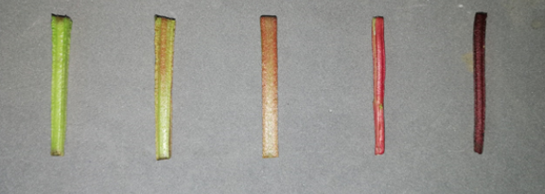
1 2 3 4 5
green reddish green light red medium red dark red

Ad. 3: Young leaf: anthocyanin coloration

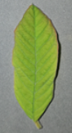 | 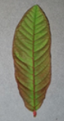 | 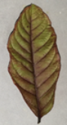 | 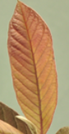
1 | 3 | 5 | 7
absent or very weak | weak | medium | strong

Ad. 4: Young leaf: pubescence on lower side

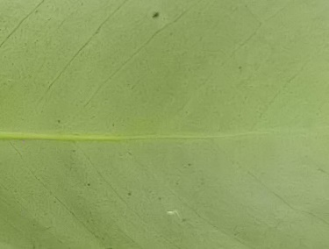 | 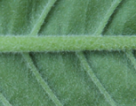 | 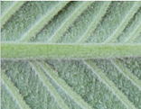
3 | 5 | 9
sparse | medium | very dense

Ad. 6: Leaf blade: length

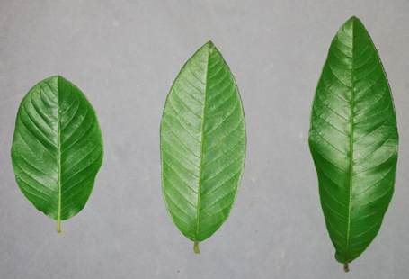
3 5 7
short medium long

Ad. 9: Leaf blade: shape

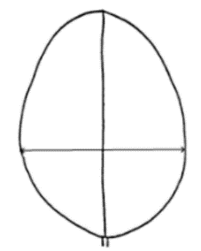 | 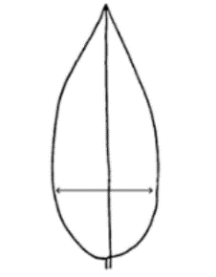 | 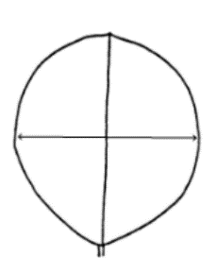 | 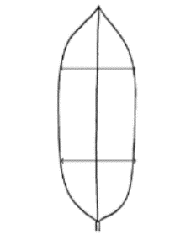 | 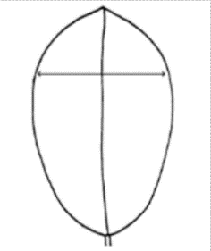 | 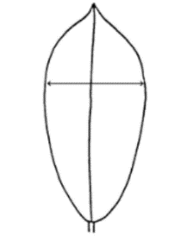
1 | 2 | 3 | 4 | 5 | 6
ovate | trullate | rounded | oblong | obovate | obtrullate

Ad. 10: Leaf blade: curvature in cross section

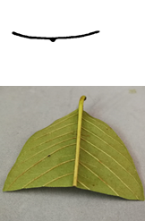 | 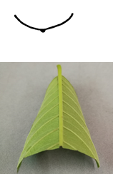 | 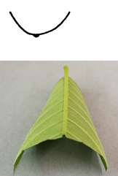
3 | 5 | 7
weak | medium | strong

Ad. 11: Leaf blade: twisting

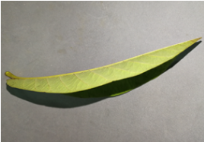 | 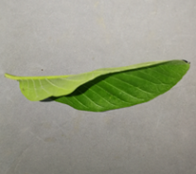
1 | 9
absent | present

Ad. 12: Leaf blade: curvature of midrib

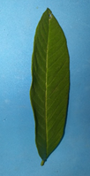 | 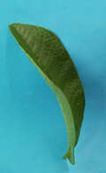
1 | 9
absent | present

Ad. 15: Leaf blade: color

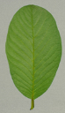 | 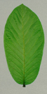 | 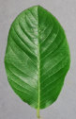 | 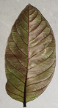 | 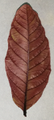
1 | 2 | 3 | 4 | 5
light green | medium green | dark green | reddish green | red

Ad. 16: Leaf blade: color of midrib on lower side

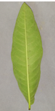 | 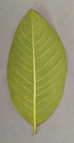 | 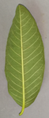 | 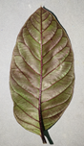
1 | 2 | 3 | 4
white | yellow | green | red

Ad. 19: Leaf blade: undulation of margin

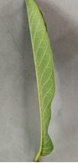 | 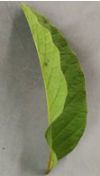
3 | 5
weak | medium

Ad. 20: Leaf blade: shape of base

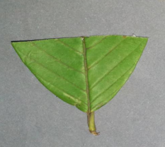 | 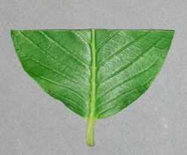
1 | 2
obtuse | rounded
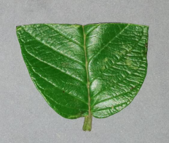 | 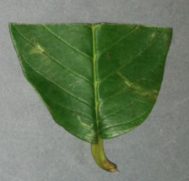
3 | 4
cordate | asymmetric

Ad. 21: Leaf blade: shape of apex

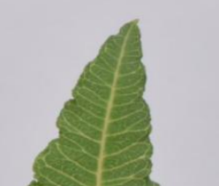 | 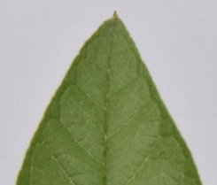 | 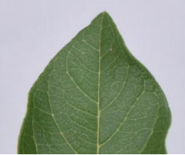
1 | 2 | 3
attenuate | apiculate | acute
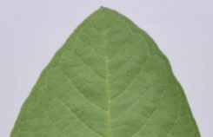 | 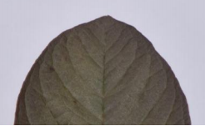 | 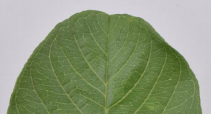
4 | 5 | 6
obtuse | rounded | cordate

Ad. 30: Fruit: shape at stalk end

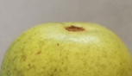 | 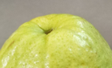 | 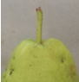 | 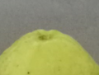
1 | 2 | 3 | 4
broadly rounded | rounded | truncate | pointed

Ad. 38: Fruit: diameter of calyx cavity in relation to that of fruit

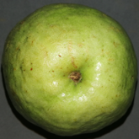 | 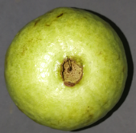 | 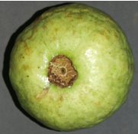
3 | 5 | 7
small | medium | large

Ad. 39: Fruit: ridged collar around calyx cavity

 | 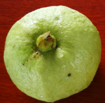
1 | 2
inconspicuous | conspicuous

Ad. 42: Fruit: evenness of color of flesh

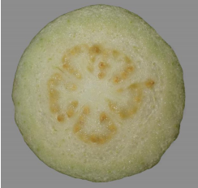 | 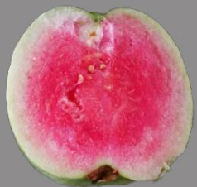
1 | 2
even | mottled

Ad. 44: Fruit: discoloration of flesh after cutting

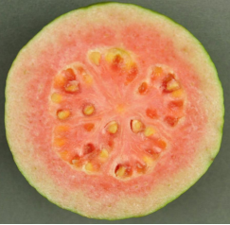 | 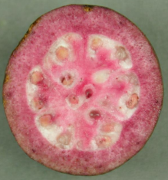
1 | 9
absent | present

Ad. 45: Fruit: thickness of outer flesh in relation to core diameter

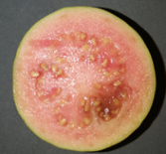 | 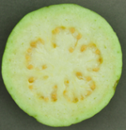 | 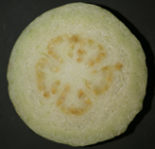
3 | 5 | 7
thin | medium | thick

Ad. 49: Fruit: sweetness

Sweetness of fruit should be expressed as the amount of the total sugar.
The total sugar should be expressed as the amount of the total soluble solids (TSS) deducting the total titratable acids (TTA).
The TSS should be measured by means of a hand refractometer and expressed in Brixo.

9. | Literature

Wu, J.X., Wang, J.B., Zhang,X.C., etc., 2009: Genetic Relationship of Some Guava (Psidium guajava L.) Germplasm by ISSR Markers. Chinese Journal of Tropical Crops.Hainan, CN, 961-964 pp.

10. | Technical Questionnaire

TECHNICAL QUESTIONNAIRE | Page {x} of {y} | Reference Number:

Application date:
(not to be filled in by the applicant)
TECHNICAL QUESTIONNAIRE
to be completed in connection with an application for plant breeders' rights
In the case of hybrid varieties which are the subject of an application for plant breeders' rights, and where the parent lines are to be submitted as a part of the examination of the hybrid variety, this Technical Questionnaire should be completed for each of the parent lines, in addition to being completed for the hybrid variety.

1. | Subject of the Technical Questionnaire
 | 1.1.1 | Botanical name | Psidium guajava L. | [ ]
 | 1.1.2 | Common name | Guava
 | 1.2.1 | Botanical name | Psidium cattleyanum Sabine var. littorale (Raddi) Fosberg | [ ]
 | 1.2.2 | Common name | Chinese strawberry guava, Strawberry guava, Yellow Cattley guava, Yellow strawberry guava

2. | Applicant
 | Name
 | Address
 | Telephone No.
 | Fax No.
 | E-mail address
 | Breeder (if different from
 | applicant)

3. | Proposed denomination and breeder's reference
 | Proposed denomination
 | (if available)
 | Breeder's reference

TECHNICAL QUESTIONNAIRE |  |  | Page {x} of {y} | Reference Number:
#4. | Information on the breeding scheme and propagation of the variety
 | 4.1 | Breeding scheme
 | Variety resulting from:
4.1.1 | Crossing
(a) | controlled cross | [ ]
(b) | partially known cross | [ ]
(c) | unknown cross | [ ]
4.1.2 | Mutation  (please state parent variety) | [ ]
4.1.3 | Discovery and development  (please state where and when discovered and how developed) | [ ]
4.1.4 | Other  (Please provide details) | [ ]

TECHNICAL QUESTIONNAIRE | Page {x} of {y} | Reference Number:

 | 4.2 | Method of propagating the variety
4.2.1 | Vegetative propagation
(a) | Tuber | [ ]
(b) | Cuttings | [ ]
(c) | In vitro propagation | [ ]
(d) | Other (state method) | [ ]
4.2.2 | Other  (Please provide details) | [ ]

TECHNICAL QUESTIONNAIRE | Page {x} of {y} | Reference Number:

5. | Characteristics of the variety to be indicated (the number in brackets refers to the corresponding characteristic in Test Guidelines; please mark the note which best corresponds).

 | Characteristics | Example Varieties | Note
5.1  (30) | Fruit: shape at stalk end
 | broadly rounded |  | 1 [ ]
 | rounded |  | 2 [ ]
 | truncate |  | 3 [ ]
 | pointed |  | 4 [ ]
 | necked |  | 5 [ ]
5.2  (31) | Fruit: color of skin
 | white green |  | 1 [ ]
 | light yellow | Beaumont | 2 [ ]
 | dark yellow |  | 3 [ ]
 | orange |  | 4 [ ]
 | orange green |  | 5 [ ]
 | medium green |  | 6 [ ]
 | dark green |  | 7 [ ]
 | pink red |  | 8 [ ]
 | dark red |  | 9 [ ]
5.3  (32) | Fruit: texture of surface
 | smooth | Fan Retief | 1 [ ]
 | rough |  | 2 [ ]
 | bumpy |  | 3 [ ]
5.4  (41) | Fruit: color of flesh
 | white |  | 1 [ ]
 | light yellow |  | 2 [ ]
 | light pink |  | 3 [ ]
 | medium pink | Beaumont, Ka Hua Kula | 4 [ ]
 | dark pink | DA 6 | 5 [ ]
 | orange pink | Fan Retief | 6 [ ]
 | orange | Puerto Rico | 7 [ ]
 | dark red |  | 8 [ ]

TECHNICAL QUESTIONNAIRE | Page {x} of {y} | Reference Number:

6. | Similar varieties and differences from these varieties
Please use the following table and box for comments to provide information on how your candidate variety differs from the variety (or varieties) which, to the best of your knowledge, is (or are) most similar. This information may help the examination authority to conduct its examination of distinctness in a more efficient way.

Denomination(s) of variety(ies) similar to your candidate variety | Characteristic(s) in which your candidate variety differs from the similar variety(ies) | Describe the expression of the characteristic(s) for the similar variety(ies) | Describe the expression of the characteristic(s) for your candidate variety

Example

 | Comments:

TECHNICAL QUESTIONNAIRE | Page {x} of {y} | Reference Number:

#7. | Additional information which may help in the examination of the variety
7.1 | In addition to the information provided in sections 5 and 6, are there any additional characteristics which may help to distinguish the variety?
 | Yes | [ ] | No | [ ]
 | (If yes, please provide details)
7.2 | Are there any special conditions for growing the variety or conducting the examination?
 | Yes | [ ] | No | [ ]
 | (If yes, please provide details)
7.3 | Other information
A representative color photograph of the variety displaying its main distinguishing feature(s), should accompany the Technical Questionnaire. The photograph will provide a visual illustration of the candidate variety which supplements the information provided in the Technical Questionnaire.
The key points to consider when taking a photograph of the candidate variety are:
• Indication of the date and geographic location
• Correct labeling (breeder’s reference)
• Good quality printed photograph (minimum 10 cm x 15 cm) and/or sufficient resolution electronic format version (minimum 960 x 1280 pixels)”
Further guidance on providing photographs with the Technical Questionnaire is available in document TGP/7 "Development of Test Guidelines", Guidance Note 35 (http://www.upov.int/tgp/en/).
[The link provided may be deleted by members of the Union when developing authorities’ own test guidelines.]

TECHNICAL QUESTIONNAIRE | Page {x} of {y} | Reference Number:

8. | Authorization for release
 | (a) | Does the variety require prior authorization for release under legislation concerning the protection of the environment, human and animal health?
 |  | Yes | [ ] | No | [ ]
 | (b) | Has such authorization been obtained?
 |  | Yes | [ ] | No | [ ]
 | If the answer to (b) is yes, please attach a copy of the authorization.

9. Information on plant material to be examined or submitted for examination

9.1 The expression of a characteristic or several characteristics of a variety may be affected by factors, such as pests and disease, chemical treatment (e.g. growth retardants or pesticides), effects of tissue culture, different rootstocks, scions taken from different growth phases of a tree, etc.
9.2 The plant material should not have undergone any treatment which would affect the expression of the characteristics of the variety, unless the competent authorities allow or request such treatment. If the plant material has undergone such treatment, full details of the treatment must be given. In this respect, please indicate below, to the best of your knowledge, if the plant material to be examined has been subjected to:

 | (a) | Microorganisms (e.g. virus, bacteria, phytoplasma) | Yes [ ] | No [ ]
 | (b) | Chemical treatment (e.g. growth retardant, pesticide) | Yes [ ] | No [ ]
 | (c) | Tissue culture | Yes [ ] | No [ ]
 | (d) | Other factors | Yes [ ] | No [ ]
 | Please provide details for where you have indicated “yes”.

9.3 Has the plant material to be examined been tested for the presence of virus or other pathogens?

 | Yes | [ ]
 | (please provide details as specified by the Authority)
 | No | [ ]

10. | I hereby declare that, to the best of my knowledge, the information provided in this form is correct:
 | Applicant’s name
 | Signature |  | Date

[End of document]

