E
International Union for the Protection of New Varieties of Plants

Technical Working Party for Fruit Crops  Fifty-Third Session  Virtual meeting, July 11 to 15, 2022 | TWF/53/14  Original: English  Date: July 15, 2022
report
adopted by the Technical Working Party for Fruit Crops
Disclaimer: this document does not represent UPOV policies or guidance
The Technical Working Party for Fruit Crops (TWF) held its fifty-third session, organized by electronic means, from July 11 to 15, 2022. The list of participants is reproduced in Annex I to this report.

The session was opened by Mr. Chris Barnaby (New Zealand), chair of the TWF, who welcomed the participants.

Adoption of the agenda

The TWF adopted the agenda as reproduced in document TWF/53/1 Rev..

Short reports on developments in plant variety protection

(a) Reports on developments in plant variety protection from members and observers

The TWF noted the information on developments in plant variety protection from members and observers provided in document TWF/53/3 Prov. The TWF noted that reports submitted to the Office of the Union after July 1, 2022, and until July 15, 2022, would be included in the final version of document TWF/53/3.

(b) Reports on developments within UPOV

The TWF received a presentation from the Office of the Union on developments within UPOV, a copy of which is provided in document TWF/53/2.

Development of guidance and information materials

The TWF considered documents TWP/6/1 and TWF/53/13.

Matters for consideration by the Technical Working Parties

Document UPOV/INF/23 “UPOV Code System”

The TWF agreed to revise document UPOV/INF/23 “Guide to the UPOV Code System” as set out in document TWP/6/1, paragraph 13.

The TWF noted that proposals to append information to UPOV codes for fruit crops should be agreed by the TWF, including the information to be appended. The TWF noted that to date no proposals have been put forward.

Document TGP/7 “Development of Test Guidelines”

Example varieties for asterisked quantitative characteristics when illustrations are provided

The TWF considered the proposal to amend document TGP/7 to remove the requirement to provide example varieties for asterisked quantitative characteristics if illustrations are provided, as set out in document TWP/6/1, paragraphs 18 and 19.

The TWF agreed with the examples provided by the TWO where illustrations would be suitable to replace example varieties for quantitative and pseudo-qualitative floral characteristics which were not measured and only visually observed (VG). Nonetheless, the TWF agreed that example varieties were important for international harmonization of variety descriptions, explaining the expression of characteristics and guiding the constitution or maintenance of variety collections.

Indication of grouping characteristics in UPOV Test Guidelines (Table of characteristics and TQ 5)

The TWF considered the proposal to revise document TGP/7 “Development of Test Guidelines” to indicate characteristics in the table of characteristics and technical questionnaire used as grouping characteristics, as set out in document TWP/6/1, paragraph 22.

The TWF noted that there were different views on the proposal and it was not possible to come to an agreed conclusion at this stage.

Converting standard wording in Test Guidelines into optional wording

The TWF agreed to amend document TGP/7 “Development of Test Guidelines” to convert the standard wording in the Test Guidelines template, paragraph 4.2.2, into additional standard wording (optional), as set out in document TWP/6/1, paragraph 25.

Document TGP/8 ‘Trial Design and Techniques Used in the Examination of Distinctness, Uniformity and Stability

The Combined-Over-Years Uniformity Criterion (COYU)

The TWF considered document TWP/6/11.

The TWF noted that software for COYU Splines would be under evaluation and planned to be implemented in the United Kingdom from 2022.

The TWF noted that evaluation versions of software for COYU Splines had been made available in August 2021.

The TWF noted the invitation for members of the Union to participate in the test campaign of the COYU Splines software and report outcomes to the expert from the United Kingdom.

The TWF noted the request for the TWM to prepare a report of the results of the test campaign of the software for COYU Splines for consideration by the TC, at its fifty-eighth session, in conjunction with the revision of document TGP/8.

Document TGP/12 ‘Guidance on certain physiological characteristics’

Word “highly” in only one state of expression

The TWF noted the invitation for the TWV to revise the states of expression in the example characteristic in document TGP/12/2, Section 2.3.2, to address the use of the word “highly” in only one state of expression.

Matters for information

The TWF noted that matters for information concerning a proposal to revise document TGP/5, Section 6 “UPOV Report on Technical Examination and UPOV Variety Description” to include additional information in DUS test reports and alternative approaches to enhance the use of existing DUS test reports were presented in document TWP/6/1, Annex VI.

The TWF noted that matters for information concerning the addition of state of expression and placement of non-asterisked disease resistance characteristics in the Technical Questionnaire were presented in document TWP/6/1, Annex VII.

The TWF noted that matters for adoption by the Council in 2022 were presented in document TWP/6/1, Annex VIII.

The TWF noted the program for the development of relevant guidance and information materials presented in document TWP/6/1, Annexes IX and X.

Matters relevant in DUS examination for the fruit sector

The TWF considered document TWF/53/7 and a proposal prepared by experts from Brazil and the European Union to amend guidance in document TGP/9 “Examining Distinctness” to clarify the possibility to include in trials a lower number of plants for varieties of common knowledge under certain circumstances.

The TWF agreed there were practical difficulties in implementing DUS trials of fruit crops with the same number of plants indicated in the Test Guidelines for both the candidate variety and a very similar variety of common knowledge. The TWF agreed that it should be possible to use a lower number of plants of the similar variety of common knowledge if uniformity does not need to be assessed.

The TWF agreed to propose amending document TGP/9 to read as follows:

“5.5.5 The required precision of records depends on the size of the difference between the candidate variety and the varieties of common knowledge. If two varieties are very similar it is important to ensure the same precision of the records for both varieties. The number of plants indicated in the Test Guidelines generally applies to both the candidate variety and the similar variety of common knowledge. In other cases, However, it may be possible to include in the trial a lower number of plants for the variety of common knowledge, provided that uniformity does not need to be assessed for that variety, i.e. varieties in the variety collection.”

Variety denominations

The TWF noted developments reported in document TWP/6/6 concerning the “Explanatory Notes on Variety Denominations under the UPOV Convention” (document UPOV/EXN/DEN/1), the possible development of a UPOV similarity search tool for variety denomination and the expansion of the content of the PLUTO database.

The TWF considered document TWF/53/4 and a proposal to create denomination classes within the genus Prunus, as presented by the experts from the Czech Republic.

The TWF considered how to address the interspecific hybrids of Prunus from species in different proposed denomination classes and agreed that further discussion would be required, including the participation of denomination experts. The TWF noted that hybrid varieties from Prunus species in different denomination classes could lead to different approaches in assigning the denomination class.

The TWF agreed to invite the expert from the Czech Republic to further develop the proposal in collaboration with the European Union, France, Germany, Japan and New Zealand and to report developments at the Fifty-Fourth session of the TWF.

Information and databases

(a) UPOV information databases

The TWF considered document TWP/6/4.

GENIE database

The TWF noted that 131 new UPOV codes were created in 2021 and a total of 9,342 UPOV codes are included in the GENIE database.

Proposals for amending UPOV codes

The TWF noted the amendments agreed by the TC, at its fifty-seventh session, to the UPOV codes for Beta vulgaris, Brassica oleracea, Citrus, Zea mays, Aloe aristata and Dicentra spectabilis as set out in paragraphs 15 to 26 of document TWP/6/4.

The TWF noted that members of the Union and contributors of data to the PLUTO database would be informed of the changes to UPOV codes and the date of the changes by means of a circular in advance.

Proposed amendments for consideration by the TWF and TWO in 2022

The TWF agreed with the TWO to delete the UPOV Codes HYLOC, HYLOC_COS, HYLOC_GUA, HYLOC_GUN, HYLOC_POL and HYLOC_UND, as set out in document TWP/6/4, paragraph 34.

TWP checking

The TWF noted the invitation to check the amendments, new UPOV codes or information, and UPOV codes used in the PLUTO database for the first time, as reproduced in document TWP/6/4, Annex IV, and submit comments to the Office of the Union by December 31, 2022.

PLUTO database

The TWF noted the summary of data contributions from members of the Union to the PLUTO database from 2017 to 2021, as presented in document TWP/6/4, the Annex V.

(b) Variety description databases

The TWF considered document TWP/6/2.

The TWF noted the reports made at the TWPs in 2021 on databases containing morphological and/or molecular data.

The TWF noted that members of the Union would be invited to report to the TWPs on work concerning the development of databases containing morphological and/or molecular data.

The TWF noted that Spain could provide variety descriptions upon request from members.

(c) Exchange and use of software and equipment

The TWF considered document TWP/6/5.

Document UPOV/INF/16 “Exchangeable Software”

The TWF noted that the Council had adopted by correspondence, on September 21, 2021, document UPOV/INF/16/10 “Exchangeable Software”.

The TWF noted that the Office of the Union had issued on January 18, 2022, Circular E-22/002 inviting the designated persons of the members of the Union in the TC to provide or update information regarding the use of the software included in document UPOV/INF/16/11 Draft 1 “Exchangeable Software” to the Office of the Union by February 28, 2022.

The TWF noted that information from China, the Czech Republic, France, Poland and Uzbekistan had been received to update document UPOV/INF/16.

The TWF noted that the TWM, at its first session, would be invited to review the software proposed by China, Czech Republic, France, Poland and Uzbekistan and make a recommendation to the TC, at its fifty-eighth session, on whether to include the proposed software in document UPOV/INF/16.

Document UPOV/INF/22 “Software and Equipment Used by Members of the Union”

The TWF noted that the Council had adopted by correspondence, on September 21, 2021, document UPOV/INF/22/8 “Software and Equipment Used by Members of the Union”.

The TWF noted that the Office of the Union had issued on January 18, 2022, Circular E-22/002 inviting the designated persons of the members of the Union in the TC to provide or update information regarding the use of the software included in document UPOV/INF/22/9 Draft 1 “Use of software and equipment” to the Office of the Union by February 28, 2022.

The TWF noted that information from the Czech Republic, the Netherlands, Poland and Uzbekistan had been received to update document UPOV/INF/22.

The TWF noted that the TC, at its fifty-eighth session, would be invited to consider whether to include the proposed software or equipment in document UPOV/INF/22/9 Draft 1, or whether to request further guidance from other relevant bodies.

Availability of documents UPOV/INF/16 “Exchangeable Software” and UPOV/INF/22 “Software and Equipment Used by Members of the Union” in a searchable form

The TWF noted that the information in documents UPOV/INF/16 and UPOV/INF/22 was available in a searchable format on the UPOV website

(d) UPOV PRISMA

The TWF considered document TWP/6/3 and noted the developments concerning UPOV PRISMA.

DUS examination of mutant varieties of apple

The TWF received a presentation on “Apple mutants and disclosure of Parentage” from an expert from Canada. A copy of the presentation is provided in document TWF/53/10.

The TWF considered whether to create a common database for mutant varieties of apple to be made available on the UPOV website. The TWF noted the reports from Australia, Brazil and Canada that there could be limitations to disclosing the parentage of candidate varieties in their countries. The TWF agreed that variety information would have value for DUS examination in case the parentage was also provided.

The TWF agreed to invite the European Union to review the previous practice of collecting information on applications filed for the protection of mutant varieties of apple and report the outcome at the next session. The TWF agreed that the information collected should only be shared among authorities and not to be made publicly available.

Access to plant material for the purpose of management of variety collections and DUS examination

The TWF received a presentation on “Access to plant material for the purpose of management of variety collections and DUS examination” by an expert from the European Union. A copy of the presentation and a model letter for requesting plant material are provided in document TWF/53/11.

The TWF agreed to invite the European Union with the support of Canada, France, Germany, Italy and New Zealand to draft a list of elements to be included in requests for submission of plant material of the candidate variety and for varieties of common knowledge for DUS examination. The TWF agreed that the draft elements may be developed for a future Technical Guidance document. The TWF agreed to invite the European Union to report developments at its fifty-fourth session.

The assessment of color in fruit crops

The TWF received a presentation on “The Assessment of Color in Fruit Crops: A Different Approach?” from an expert from New Zealand. A copy of the presentation is provided in document TWF/53/5.

The TWF noted that RHS Colour Charts were being considered in New Zealand for the assessment of color in fruit crops. The TWF noted a range of challenges to assessing color in fruit crops and agreed that the use of color charts could be considered for variety descriptions and in support of observations.

The TWF agreed to include an agenda item and invite presentations on alternative methods for the assessment of color in fruit crops at its Fifty-Fourth session.

Information required to enhance the use of existing DUS test reports

The TWF considered document TWF/53/6 presented by an expert from New Zealand.

The TWF considered the information to be provided in a UPOV variety description to further promote the exchange and takeover of DUS test reports. The TWF agreed that information should always be provided in Section 16 “Similar Varieties and Differences from These Varieties” to clarify the existence or not of similar varieties.

The TWF noted the different possibilities to provide information in Section 16, including to list one or several varieties considered as most similar; and listing only one or multiple characteristics per variety providing distinctness. The TWF agreed that it should always be indicated when no similar varieties had been identified.

The TWF agreed that discussions should be continued and invited the expert from New Zealand with support of the experts from Australia, Canada, European Union, France, Germany and Italy to develop a proposal for guidance on how to complete Section 16 of the UPOV variety description.

Cooperation in examination

The TWF considered document TWP/6/9.

The TWF noted that members of the Union had the possibility to update information on a person(s) to be contacted for matters concerning international cooperation in DUS examination by:

(i) updating information when invited to provide information for document TC/[xx]/4 “List of genera and species for which authorities have practical experience in the examination of distinctness, uniformity and stability”; and/or

(ii) notifying the Office of the Union by sending an e-mail to upov.mail@upov.int.

The TWF noted the development of a package of compatible IT tools to address the technical and related administrative concerns that prevent cooperation in DUS examination, as reported in document TWP/6/9, paragraphs 9 to 14.

The TWF noted that a presentation on e-PVP Asia would be made to all TWPs, at their sessions in 2022.

The TWF noted that the development of a platform for UPOV member databases containing variety description information would depend on UPOV members indicating which databases they would wish to share.

The TWF noted that the use of machine translation technology would be considered within a review of UPOV’s policy on translation.

The TWF noted that the CAJ, at its seventy-eighth session:

(i) had agreed to include possible “guidance to encourage members of the Union, on a voluntary basis, to take over DUS test reports when the applicants could not submit plant material due to phytosanitary or other related issues where acceptable to the members of the Union concerned” as part of the work to be agreed by the CAJ; and

(ii) agreed measures to address policy or legal barriers that the TC had identified as preventing international cooperation in DUS examination, as set out in document TWP/6/9, paragraph 34.

The TWF noted that the impact of the proposed measures would be assessed on the basis of the number of cooperation agreements reported by members of the Union, as presented in document C/[xx]/INF/5 “Cooperation in examination”.

Increasing participation in the work of the Technical Working Parties and the Technical Committee

The TWF considered document TWP/6/12.

Participation at TWP meetings by electronic means

The TWF noted the participation at the TWP sessions in 2021, as presented in document TWP/6/12, Annex I.

Measures for physical and virtual participation at TWP meetings

The TWF noted the measures agreed by the TC for physical and virtual participation at TWP meetings, as set out in document TWP/6/12, paragraphs 9 to 12.

The TWF noted that the Office of the Union would interview members and observers and report outcomes to the TC, at its fifty-eighth session, along with options for improving the support provided by UPOV for DUS examination.

The TWF noted the increased number of participants in online meetings and agreed that further measures should be considered to increase the number of participants taking the floor during discussions. The TWF agreed that online meetings benefited discussions on Test Guidelines through enabling the participation of additional crop experts.

The TWF noted that measures for physical and virtual participation at meetings were subject to revision at the Technical Committee and would continue to be discussed as further experience was generated.

Molecular techniques

Developments in UPOV

The TWF considered document TWP/6/7.

Cooperation between international organizations

The TWF noted that the results of the survey on the use of molecular marker techniques had been made available on the webpage of the fifty-seventh session of the Technical Committee, as set out in document TWP/6/7, paragraph 28.

The TWF noted that on February 1, 2022, the Office of the Union had issued Circular E-2/009 inviting members to continue the survey on the use of molecular marker techniques.

The TWF noted the draft joint document explaining the principal features of the systems of OECD, UPOV and ISTA, as set out in the Annex to document TWP/6/7.

The TWF noted the topics proposed by the TC for a future joint UPOV/OECD/ISTA workshop, as set out in document TWP/6/7, paragraph 35.

The TWF noted that on December 13, 2021, the Office of the Union had informed OECD and ISTA of the result of the survey, draft joint document and proposed topics for a future joint UPOV/OECD/ISTA workshop. Responses from OECD and ISTA, when available, would be reported to the Technical Working Parties and the Technical Committee.

Developments at the twentieth session of the Working Group on Biochemical and Molecular Techniques, and DNA-Profiling in Particular

The TWF noted the papers presented at the twentieth session of the BMT and the program of work for the first session of the TWM.

Confidentiality & ownership of molecular information

The TWF noted discussions held at the TWPs and the BMT, at their sessions in 2021, on “Confidentiality & Ownership of Molecular Information”

Review of document UPOV/INF/17 “Guidelines for DNA-Profiling: Molecular Marker Selection and Database Construction (‘BMT Guidelines’)”

The TWF noted that a revision of document UPOV/INF/17 “Guidelines for DNA-Profiling: Molecular Marker Selection and Database Construction (“BMT Guidelines”) had been adopted by the Council, in 2021.

Presentation on the use of molecular techniques in DUS examination

The TWF received a presentation on “Application of molecular techniques in DUS testing and PBR enforcement of fruit sector in China” by an expert from China. A copy of the presentation is provided in document TWF/53/12.

The TWF noted that molecular markers could be used in China as first instance evidence for enforcement of breeders’ rights, followed by a growing trial in case required.

Following the presentation from China, the TWF had an open discussion about the use of molecular markers in DUS examination and variety identification. The following aspects were mentioned by participants:

- Possibilities for cooperation on the constitution of common databases, including for authorities receiving relatively few applications for particular crops
- Origin of plant material for DNA extraction (e.g. material provided for DUS testing)
- Selection of markers for each crop, according to intended use (e.g. for PBR and/or variety identification).
- Selecting one or more laboratories capable of providing high-quality molecular profiles (e.g. security back-up);
- High cost for harmonizing methodologies for DNA profiling among different laboratories;
- Difficulties to obtain the same results even for laboratories using harmonized methodologies.

Experiences with new types and species

The TWF noted the report from Spain on the first applications filed in the country for plant variety protection of new varieties of dragon fruit (Hylocereus) and passion fruit (Passiflora). The TWF noted the report on increasing plant breeding activity in Spain for developing new varieties of tropical fruits such as avocado, mango, passion fruit and dragon fruit, which were currently being cultivated in the southern part of the country.

Discussion on draft Test Guidelines

Full draft Test Guidelines

*Apple (fruit varieties) (Revision) (Malus domestica Borkh.)

The subgroup discussed document TG/14/10(proj.5), presented by Mr. Erik Schulte (Germany), and agreed the following:

Cover page, 1., TQ 1. | to update main botanical name and synonyms
1. | reference to ornamental and rootstock varieties to read TG/163 and TG/192
5.3 | to delete characteristic 49 from grouping characteristics
Table of Chars. | to correct spelling of example varieties throughout draft:  - ‘Prem A 153‘ should read ‘PREMA153‘;  - ‘B 8 A 3-323’ should read ’CIV 323’ (with space);  - ‘CIVG 198‘ should read ‘CIVG198‘;  - ‘LB 4852‘ should read ‘LB4852’;  - ‘R 201‘ should read ‘R201‘;  - ‘Y 101‘ should read ‘Y101‘; and  - ‘Y 102‘ should read ‘Y102‘.
Char. 3 | - to add (*) (grouping char.)  - to extend underline until after “ramified”
Char. 10 | to add example variety “R201” to state 8
Char. 16 | to replace “extension” with “extent”
Chars. 21, 30, 31, 32, 33 | to add explanation “The over color is considered a second color such as a flush which develops over time, covering the ground color of the fruit.”
Char. 26 | to have the following order of states: (1) flat globose conical, (2) oblate, (3) circular, (4) elliptic, (5) square, (6) oblong, (7) ovate, (8) conical, (9) conical waisted, (10) obconical
Char. 29 | to add explanation “The ground color is the first color to appear chronologically during the development of the fruit”.
Char. 33 | to delete “(no flush)”
Char. 45 | - to read “Fruit: main color of flesh”  - to have the following states and example varieties:  - white (1): Akane, Minnewashta, Pia, Spartan  - greenish (2): Angold, Gloster, Granny Smith, Northpole, Telamon  - yellowish white (3): Elstar, Jonagold, Pinova, Rafzubin  - yellowish (4): Coxcolumnar, Pisaxa, Topaz, Zari  - orangish (5): Ladina, Transcendent Crab  - pinkish (6): Pomfit  - reddish (7): Bay 3484, Lureprec
New Char. after 45 | - to read “Fruit: secondary color of flesh”  - to have the following states and example varieties:  - none (1): Gloster, Pinova, Zari  - white (2): Luresweet, Pomfital 1  - greenish (3)  - yellowish white (4): Bay 4584, Lureprec, Weirouge  - yellowish (5): Y 101  - orangish (6)  - pinkish (7): Tiara, Y 102  - reddish (8)  - to have the following indications: PQ, VG, (f), 89, (*)
Char. 46 | - to read “Only varieties with secondary color present: Fruit: extent of secondary color”  - to add example variety “Y 101” to state 3
Char. 47 | - to read “Flesh color: distribution of pinkish or reddish coloration”  - to have the following states and example varieties:  - none (1): Gloster, Pinova, Zari  - under skin only (2): Pomfit, Y 102  - around core only (3): R 201  - under skin and around core (4): Lureprec  - throughout (5): Y 101
Char. 49 | to delete (*)
8.1 (b), (f) | to read “Observations should be made…”
Ad. 17 | to read “Observations should be made with petals pressed into horizontal position.”
Ad. 19 | to read “Observations should be made just after petal drop.”
Ad. 26 | to replace current grid with the following one:

 |  |  | ratio height / diameter
 |  |  | low | medium | high
broadest part | above middle |  |  | 10  obconical
 | at middle |  | 2  oblate | 3  circular | 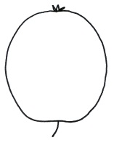  4  elliptic | 6  oblong
5
square
 | below middle |  | 1  flat globose conical | 9  conical waisted | 8  conical | 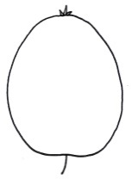  7  ovate

Ad. 30 | to read “Observations should be made after removing bloom.”
Ad. 31 | to delete “(to be updated)”
Ad. 38 | to read “Observations should be made in the central part of the fruit, by counting (in a defined area [e.g. a window of 1 cm²]) …”
Ad. 44 | to read “Observations should be made at time of ripeness for eating. …”
Ad. 47 | to have the following illustrations

 |  | 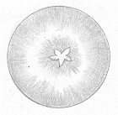
2 | 3 | 4
under skin only | around core only | under skin and around core
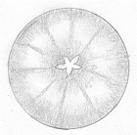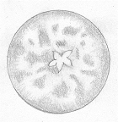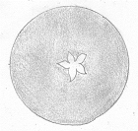
5
throughout

Ad. 48 | to read “The time of beginning of flowering is reached when …”
Ad. 49 | to read “… the time for harvest can also be determined by assessing the starch content.”
Ad. 50 | to read “… the time of eating maturity can also be determined by assessing the starch content.”
9. | to review literature reference

Goji (Lycium barbarum L., L. chinense Mill., L. cylindricum Kuang & A. M. Lu, L. dasystemum Pojark., L. ruthenicum Murray, L. truncatum Y. C. Wang, L. yunnanense Kuang & A. M. Lu)

The subgroup discussed document TG/LYCIUM_BAR(proj.2), presented by Ms. Chuanhong Zhang (China), and agreed the following:

4.1.4 | to reduce number of plants or parts of plants to be observed for distinctness to 3
Char. 1 | to add new state 4 “drooping”
Char. 2 | to display all 5 states of expression (“very few, few, medium, many, very many”)
Char. 3 | - to read “Current year's shoot: length”  - to have 9 state (“very short, very short to short, short, short to medium, medium, medium to long, long, long to very long, very long
Char. 4 | to check which scale of notes to be used (e.g. 3, 5 or 9 notes)
Char. 5 | to check which scale of notes to be used (e.g. 3, 5 or 9 notes)
Char. 8 | - to have the following order of states: (1) yellow brown, (2) medium brown, (3) dark brown, (4) grey brown  - to check whether state “medium brown” to read “light brown”
Char. 10 | to read “Leaf: length”
Char. 11 | to add states (8) broad very broad, (9)very broad
Char. 13 | - to add states (8) high to very high, (9)very high  - to check whether to remove restriction and allow observation of all types of leaves
Char. 16 | to check whether to reduce the scale to 5 notes
Char. 18 | to check whether to use a scale of 5 notes
Char. 19 | - to be indicated as QN  - to have states (1) mostly erect, (2) equally erect and semi-erect, (3) mostly semi-erect
Char. 22 | - to check whether displaying fruits with proximal end at bottom (throughout the document, including Ad. 23)  - to check whether to rename state of expression “obovate” “ovate” (consequential change)  - to check whether to add new states of expression “narrow ovate” and “broad ovate” to replace “ovate”  - to check whether to add new state “obovate” (broadest part at distal end)
Char. 24 | to check whether to use scale of 5 notes
Ad. 1 | - to amend drawing for state 3, currently it shows both spreading an drooping plant habit at the same time  - to add illustration for new state “drooping”.
Ad. 2 | to add drawings for states 2 and 4
Ad. 5 | to add photographs for the states 1, 2, 4, and 6
Ad. 8 | to read “Observations should be made at the middle third of three-year-old shoot in the dormant period.”
Ad. 9 | to read “Observations should be made at the middle third of a one-year-old shoot in the dormant period.”
Ad. 10 | - wording below the drawing: to replace “plant” by “leaf”  - to check whether to indicate that the assessment of Leaf includes the petiole.
Ad. 11 | read “See Ad. 10.”
Ad. 19 | to be improved
Ad. 21 | to read “See Ad. 20”
Ad. 22 | - to be improved  - to correct spelling of “obovate”
Ad. 24 | to check whether to move dotted line to lowest (or upper) part of calix
TQ 6. | the example to start in capital letters

Grapevine (Vitis L.) (Revision)

The subgroup discussed document TG/50/10(proj.5), presented by Mr. Roberto Carraro (Italy), and agreed the following:

Char. 5 | to delete example variety Kyoho from state 3
Char. 7 | to delete example variety Kyoho from state 5
Char. 15 | to have 9 notes
Char. 26 | to delete example variety Kyoho from state 2
Char. 37 | to delete example variety Kyoho from state 8
Char. 40 | to check whether to add new char. “Berry: coloration of flesh” with states “whitish”, “greenish”, “yellowish”, etc.
Char. 42 | - to read “other than muscat, foxy, herbaceous or caramel”  - to add explanation that there are differences in varieties recorded as note 6, but differences are not sufficiently defined to create separate states
8.1 (c) | to be deleted
Ad. 33 | to read  1 = many berries do not touch each other, most pedicels visible.  2 = berries in some grouped formation, many pedicels visible.  3 = berries in many grouped formation, some pedicels visible.  4 = most berries touching each other, very few pedicels visible.  5 = densely distributed berries, pedicels not visible, berries movable.  6 = densely distributed berries, pedicels not visible, some berries movable.  7 = berries not readily movable.  8 = many berries pressed out of shape.  9 = berries pressed out of shape.
Ad. 36 | to read “Observations should be made on berries taken from different bunches of each plant.”
Ad. 37 | - to check whether to improve presentation (see TGP/14, e.g. page 25)  - all states to be either two- or three-dimensional (if three-dimensional to use illustrations showing berries three-dimensional)
8.4 | to add varieties “Tempranillo” and “Gamay de Chaudenay”

Guava (Psidium guajava L.; Psidium cattleyanum Sabine var. littorale (Raddi) Fosberg) (Revision)

The subgroup discussed document TG/110/4(proj.2), presented by Ms. Ling Gao (China), and agreed the following:

Cover page | to add hybrid
5.3 | to check whether to add “Growth habit”, “Fruit: color”, “Fruit: diameter”, “Time of harvest maturity” as grouping characteristics
Char. 1 | - to be indicated as PQ  - to add illustrations:  1 2 3 4  upright spreading drooping weeping
Char. 2 | to delete existing varieties and check whether to add different/more example varieties
Chars. 3-8, 10, 13, 17-19, 23, 27-29, 35, 37-38, 40, 45, 47, 49, 51, 53 | to display all existing states of expression for QN characteristics (all notes from 1 to 9 or 1 to 5)
Chars. 1, 5, 9, 10, 13, 16, 17, 22-28, 30-40, 42, 44, 47, 49, 52-53 | to provide example varieties
Chars. 5, 6-8, 17, 22- 24, 26-29, 37-38, 40, 45, 51 | to replace MS by MG
Char. 1 | to check whether intermediate states are observed and to be indicated as QN
Char. 3 | to delete existing example varieties
Char. 11 | to check whether intermediate states are observed and to be indicated as QN
Char. 12 | to be deleted
Char. 13 | - state 1 to read “weak”  - to add illustrations
Char. 17 | to reduce the scale to three notes
Char. 18 | - to reduce the scale to three notes  - state 2 to read “smooth to wrinkled”
Char. 19 | to have states (1) absent or weak”, (2) medium, (3) strong
Char. 22 | state 2 to read "two to three"
Char. 25 | to add explanation
Char. 26 | to add explanation
Char. 30 | to check naming of states according to nomenclature in document TGP/14
Char. 33 | - to be moved along with other color of flesh characteristics  - state 2 to read “different color”
Char. 34 | to check whether to be deleted
Char. 35 | - to check whether state one to read “absent or weak”  - to check whether to reduce the scale of notes (e.g. 3 notes)
Char. 39 | - to be indicated as QN  - revise states to read (1) inconspicuous, (2) moderately conspicuous, (3) strongly conspicuous
Ad. 9 | to be presented in a grid (see TGP/14)
Ad. 11 | to check whether to improve illustration as per the current adopted version of the TG
Ad. 19 | to improve illustrations

Hazelnut (Corylus avellana L.; Corylus colurna L.) (Revision)

The subgroup discussed document TG/71/4(proj.3), presented by Mr. Flavio Roberto de Salvador (Italy), and agreed the following:

1. | first sentence to read “These Test Guidelines apply to all varieties of Corylus avellana L. and Corylus colurna L. excluding ornamental varieties.” and to delete second sentence
4.1.4 | to reduce number of plants or parts of plants to be observed for distinctness to 3
4.2.3 | to use the agreed standard wording
Table of Chars. | general comment: to check (*)
Chars. 1-5, 9, 13, 15, 16, 18-21, 23, 26, 32-35, 37, 43, 45, 46, 49 | to check whether to add more example varieties
Char. 1 | to reduce scale to 5 notes and have states “weak, weak to medium, medium, medium to strong, strong”
Char. 2 | - to reduce scale to 5 notes and have states “upright, upright to spreading, medium, spreading to drooping, drooping”  - to add illustrations from TGP/14
Char. 3 | to delete “absent or” from state 1
Char. 4 | to reduce scale to 5 notes and have states “very few, few, medium, many, very many”
Char. 5 | - One year old shoot: density of hairs  - to reduce scale to 5 notes and have states “very sparse, sparse, medium, dense, very dense”
Char. 9 | to reduce scale to 5 notes
Char. 11 | “pale yellow” to read “light yellow” and to become state 1
Char. 13 | to reduce scale to 5 notes
Char. 14 | to be deleted
Char. 15 | to reduce scale to 5 notes
Char. 16 | - to read “Petiole: density of hairs”  to have states (1) sparse, (2) medium, (3) dense
Char. 18 | - to read “Involucre: length in relation to length of nut”  - to reduce scale to 5 notes
Chars. 19, 20 | to clarify what is observed/ difference between chars. 19 and 20
Char. 19 | to check whether to read “Involucre: depth of indentation” and notes with states from “shallow” to “medium”
Char. 20 | - state 4 to read “strong”  - state 5 to read “very strong”
Char. 21 | to reduce scale to 3 notes
Char. 22 | to start with a capital letter
Char. 23 | to read “Involucre: density of hairs” and reduce scale to 5 notes
Char. 25 | to have states (1) only one, (2), one or two, (3) two or three, (4) three or four, (5) more than four
Char. 26 | - to reduce scale to 5 notes  - to move example variety “Morell” to state 3 and to add new example variety to state 1
Char. 27 | - state 5 to read “short sub-cylindrical”  - to delete space in state 6  - to move example variety “Cosford” to state 6 and add “Butler” to state 5
Char. 29 | to be indicated as PQ
Char. 30 | - to read “Nut: presence of stripes on shell”  - to have states (1) weak, (2) medium, (3) strong
Char. 31 | to move example variety “Negret” to state 2
Char. 32 | - to reduce scale to 3 notes (“weak, medium, strong”)  - to read “Nut: prominence of mucron”
Char. 33 | to reduce scale to 3 notes
Char. 34 | to reduce scale to 3 notes
Char. 35 | - to read “Nut: relation of basal scar size to nut size”  - to reduce scale to 3 notes
Char. 36 | - to be indicated as QN  - state 2 to read “flat”
Char. 37 | to reduce scale to 5 notes
Char. 43 | - to add a colon after “Kernel”  - to reduce scale to 5 notes
Char. 44 | to delete extra space after “inner”
Char. 45 | - to delete the wording in brackets and to provide an explanation  - to reduce scale to 5 notes
Char. 46 | to reduce scale to 5 notes
Char. 47 | to check whether to reduce scale to 5 notes
Char. 49 | to reduce scale to 5 notes
Char. 50 | to reduce scale to 5 notes
Ads. 19, 20 | to add drawings (from current adopted version?)

Lemon (Lemons and Limes (Citrus L. - Group 3)) (Revision)

The subgroup discussed document TG/203/2(proj.1), presented by Mr. Francisco Fabado Guillem (Spain), and agreed the following:

Table of Chars. | - general remarks:  - QL characteristics: to check whether they are true qualitative characteristics and whether they should be used for grouping  - to check methods of observation  - to display full scale for QN characteristics (all notes from 1 to 9 or 1 to 5)
Char. 2 | - state 1 to read “absent or very sparse”  - to add state 5 “very dense”  - to add explanation that suckers should not be evaluated  - to check whether to be used as grouping characteristic
Char. 24 | add example variety “Laphitou” to state 9
Char. 51 | to read “Fruit: color of flesh”
Ad. 62 | to delete reference to Ad. 74

Mandarin (Citrus L. – Group 1) (Revision)

The subgroup discussed document TG/201/2(proj.1), presented by Mr. Francisco Fabado Guillem (Spain), and agreed the following:

Cover page, 1. | to check whether to include Citrus sphaerocarpa Hort. ex Tanaka Citrus sudachi Hort. ex Shirai
Table of Chars. | - general remarks:  - QL characteristics: to check whether they are true qualitative characteristics and whether they should be used for grouping  - to check methods of observation  - to display full scale for QN characteristics (all notes from 1 to 9 or 1 to 5)
Char. 3 | - state 1 to read “absent or very sparse”  - to add state 5 “very dense”  - to add explanation that suckers should not be evaluated  - to check whether to be used as grouping characteristic  - to add example variety “Gold Nugget (HMA)” to state 4
Char. 7 | to replace current example variety for state 7 with “Caffin (CLE)”
Char. 8 | state 1 to read “none”
Char. 28 | to move example variety “Pixie (HMA)” from state 3 to state 2
Char. 54 | to add example variety “Nova (HMA)” to state 7
Char. 69 | to be deleted
Char. 70 | to read “Time of maturity for consumption”
Ad. 62 | to delete reference to Ad. 67

*Mulberry (Morus L.)

The subgroup discussed document TG/MORUS(proj.4), presented by Mr. Yosuke Abe (Japan), and agreed the following:

4.2.3 | to be deleted and add the following two paragraphs:  “For the assessment of uniformity of varieties resulting from crossing, a population standard of 1% and an acceptance probability of at least 95% should be applied. In the case of a sample size of 5 plants, no off-types are allowed.  “For the assessment of uniformity of varieties resulting from mutation, a population standard of 1% and an acceptance probability of at least 95% should be applied. In the case of a sample size of 10 plants, 1 off-type is allowed.”
Char. 6 | - to read “Current year' shoot: zig-zag”  - to add illustration  - to add (*)  - to add example variety “Yue Shen Da 10” to state 1  - to add example variety “He Ye Bai” to state 2  - to add example variety “Hu Bei Wan Tiao” to state 3
New Char. after Char. 6 | to read “Current year' shoot: twisting” after 6  - to have the following indications : QL, VG, (a)  to have states (1) absent and (9) present with example variety “Sinuense”  - to add illustrations
Chars. 9 to 11 | to read “Leaf bud: …”
Char. 11 | to have the following order of states: (1) medium brown, (2) dark brown, (3) yellowish brown, (4) reddish brown, (5) greyish brown, (6) light grey
Char. 14 | to add example variety “Cattaneo fem.” to state 8
Char. 15 | to add example variety “Cattaneo fem.” to state 8
Char. 18 | - to add (*) (TQ 5 char)  - state 1 to read "none"
Char. 20 | - to add example varieties “Arancina, Ascolana” to state 2  - to add example varieties “Illinois Everbearing, Nervosa, Planifolia” to state 3  - to add example variety “Kokka” to state 4  - to add example variety “Ichinose” to state 5
New Char. before Char. 22 | - to read “Leaf blade: presence of lobes”  - to have the following indications: QL, VG, (*), (b)  - to have states (1) absent with example variety “Arancina, Florio” and (9) present  - to add as grouping char. and TQ 5
Char. 22 | - to read “Only varieties with lobes present: Leaf blade: depth of sinus”  - to correct spelling of state 2 (no capitals)  - state 1 to read “very shallow” and have example varieties “Arancina, Limoncina”
Char. 26 | to delete state 1 “yellow”  - to move state “yellowish green” after state “dark green”
Char. 28 | - to add example varieties  - to delete "the"  - to add illustration  - to add the following example varieties:  - concave (1): Lun Jian 109  - flat (2): Yue Shen Da 10  - concave (3): Wan Nian Sang
New Char. after Char. 28 | - to check whether to add “Leaf blade: twisting” with the following indications: QL, VG, (b), explanation and states (1) absent and (9) present with example variety “Tong Xiang Qing”
Char. 32 | to read “Excluding staminate varieties: Inflorescence: number of pistillate clusters”
Char. 37 | to add example variety “Piramidale” for state 1
Char. 40 | to read “Time of leaf bud burst”
8.1 (a) to (d) | to read “Observations should be made…” (delete mention of plant parts)
Ad. 12 | to have the following illustration:

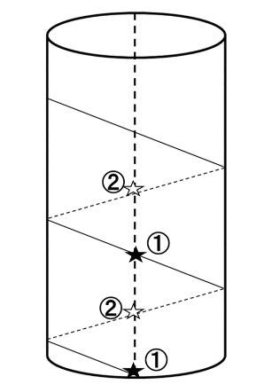 | 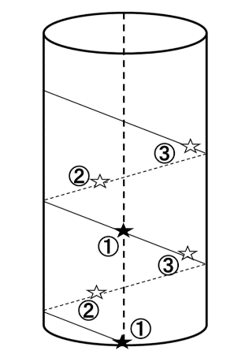 | 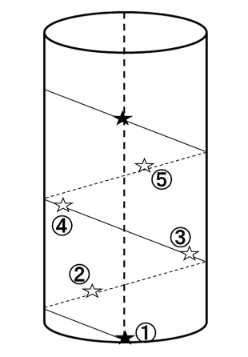 | 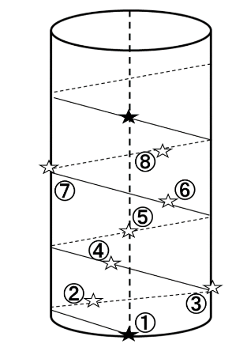 | 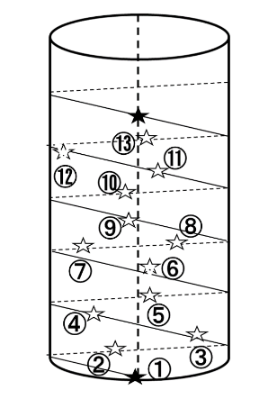
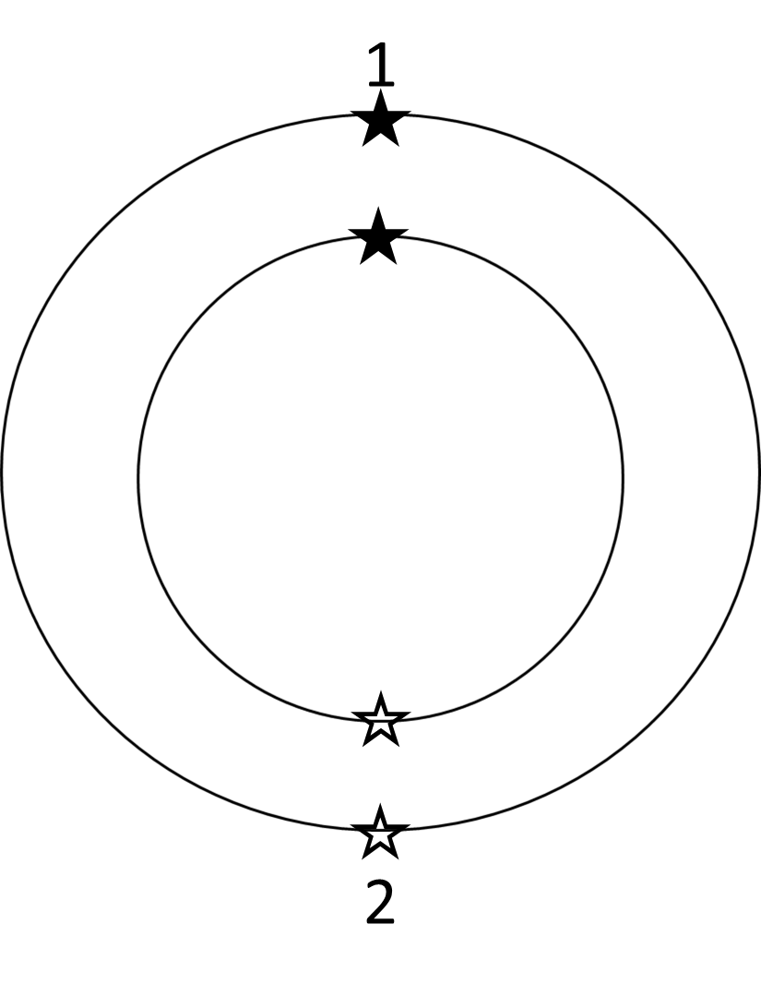  1 | 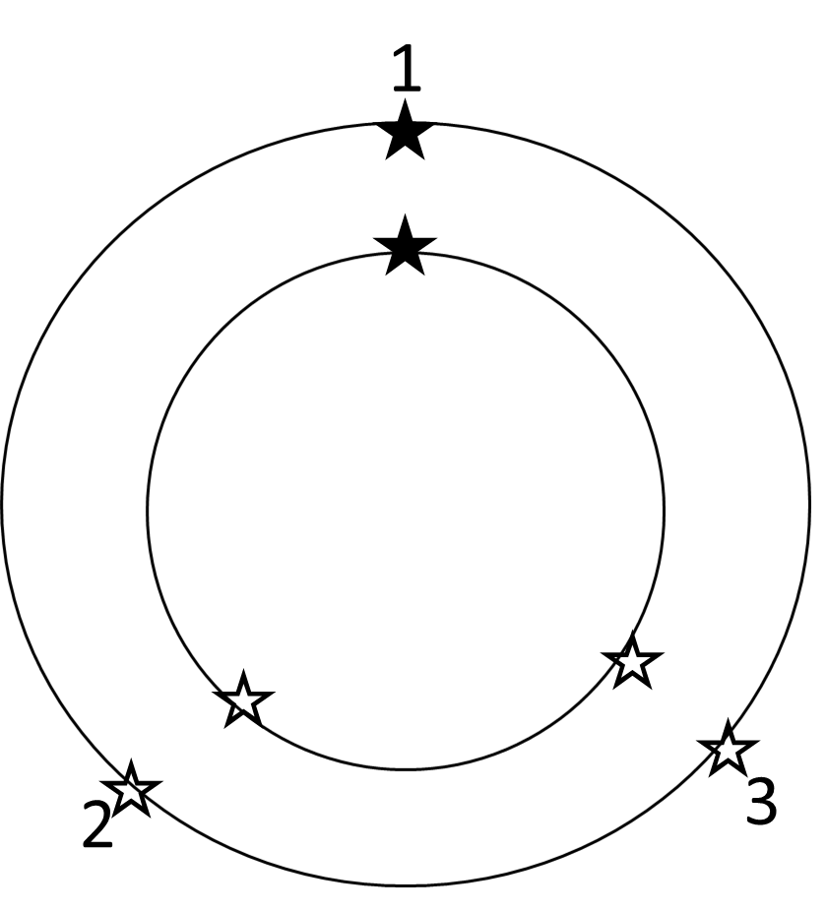  2 | 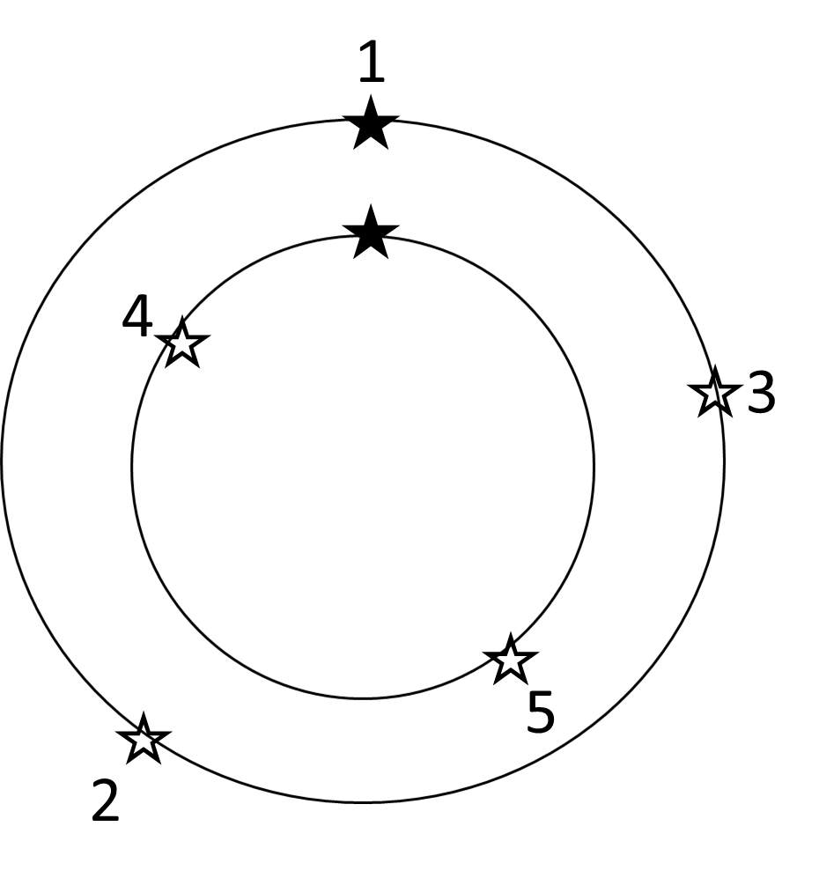  3 | 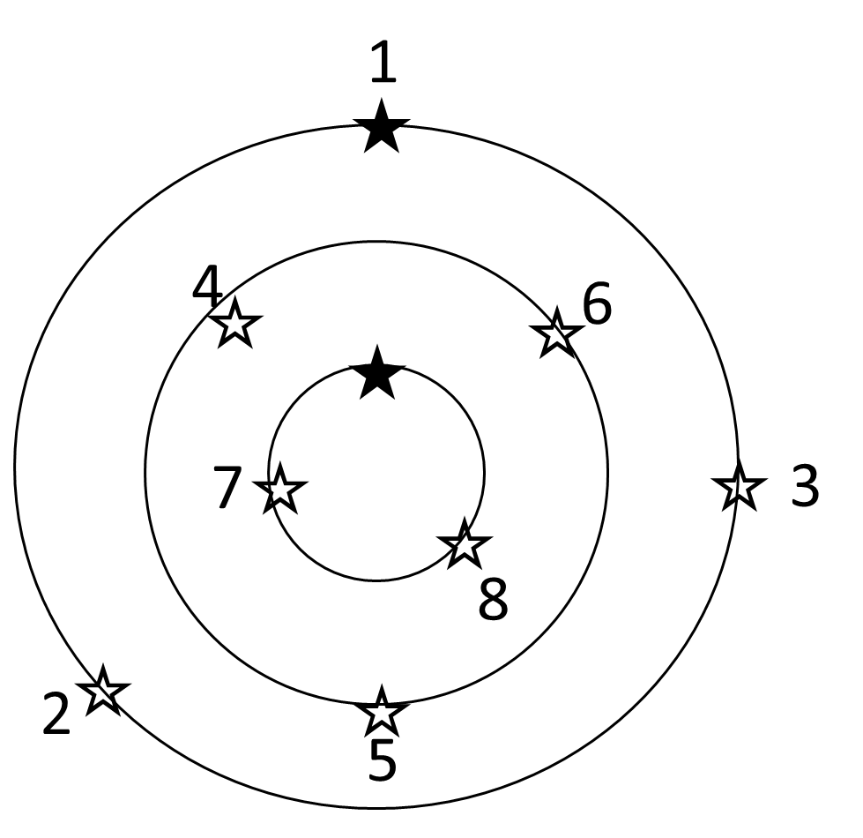  4 | 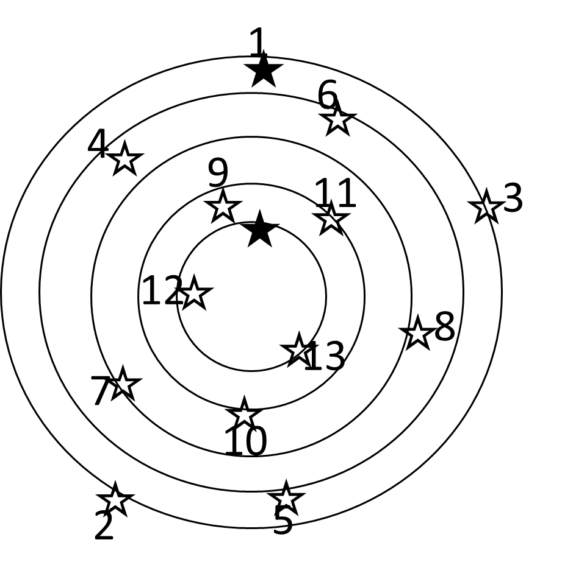  5
one half | one third | two fifth | three eighth | five thirteenth

TQ 1. | to add 1.3 for indication of species

Raspberry (Rubus idaeus L.) (Revision)

The subgroup discussed document TG/43/8(proj.2), presented by Mr. Erik Schulte (Germany), and agreed the following:

1. | - to check whether to read “These Test Guidelines apply to all varieties of Rubus idaeus L., Rubus occidentalis L. and hybrids of them.”  - to check whether there are hybrids with Rubus occidentalis L.  - to check whether to include Rubus parvifolius L.
Char. 8 | to read “Current season’s cane: length”
Char. 24 | to read “Peduncle: intensity of anthocyanin coloration”
Char. 33 | state 7 to read “blackish”
Char. 42 | to delete (*)
8.1 (a) | to read “Observations should be made when the shoots are about 15 cm long.”
8.1 (b) | to read “Observations should be made at harvest time when the cane is fully developed.”
8.1 (c) | to read “Observations should be made in the middle third of the current season’s cane, when the cane is fully developed.”
8.1 (d) | to read “Observations should be made on fully developed leaves from the middle third of the cane.”
8.1 (e) | to read “Observations should be made from canes with flowers and fruits appearing first in the vegetation period (either on previous year's canes in summer or on current year’s canes in autumn). When flowers or fruits have been observed on the current year's cane, they will not be observed on the same canes in the following year. In the absence of previous year's canes observations should be carried out on current year's canes only.”
8.1 (f) | to read “Observations should be made on fruit picked during the second and third harvest.”
Ad. 39 | to read “The time of beginning of flowering is reached when ….”
Ad. 41 | to read “The time of beginning of fruit ripening is reached when the fruit is most easily removed from the torus.”
TQ 1. | - to be updated according to changes to Chapter 1  - to add option to indicate hybrids

Sour Cherry (Prunus cerasus L.); Duke Cherry (Prunus ×gondouinii (Poit. & Turpin) Rehder) (Revision)

The subgroup discussed document TG/230/2(proj.2), presented by Ms. Szilvia Márkné Deák (Hungary), and agreed the following:

4.1.4 | to reduce number of plants or parts of plants to be observed for distinctness to 3
Chars. 1, 5-6, 9-11, 13, 14, 15,-16, 23, 39-41, 43 | to check whether to provide example varieties also for the states of expression with even notes
Chars. 8, 12, 30, 31, 34, 42, 45 | to provide example varieties
Char. 5 | to read “Young shoot: intensity of anthocyanin coloration of apex”
Chars. 5, 6 | to delete “(during rapid growth)” and add explanation to Chapter 8.1 to read “Observations should be made during rapid growth.”
Char. 15 | - to reduce scale to 5 notes and add all notes from 1 to 5  - to delete “(upper side)” from title and move to explanation in Chapter 8.2 to read “Observations should be made on the upper side.”
Char. 18 | state 1 to read “at base of leaf blade only”
Char. 20 | state 1 to read “leaning from shoot”
8.1 | to add new explanation for Chars. 5 and 6 to read “Observations should be made during rapid growth.”
8.1 (a) | to read “Observations should be made during winter, on trees that have fruited at least once.”
8.1 (b) | to read “Observations should be made on fully developed leaves from the middle third of a well-developed current season’s shoot in summer.”
8.1 (c) | to read “Observations should be made in early summer on fully developed leaves from the middle third of a well-developed current season’s shoot.”
8.1 (d) | to read “Observations should be made on fully developed leaves in the middle third of a long shoot, after the rapid growth.”
8.1 (e) | to read “Observations should be made on fully developed flowers at the beginning of anther dehiscence.”
8.1 (f) | to read “Observations should be made at full maturity.”
Ad. 46 | to read “The beginning of flowering is reached when 10% of the flowers are open.”
Ad. 47 | to read “The beginning of fruit ripening is reached when 10% of the fruits are ripe.”
TQ 4.1.1 (a) | to add request for indication of parent varieties (as in (b))
TQ 6. | to provide an example

*Strawberry (Fragaria L.) (Revision)

The subgroup discussed document TG/22/11(proj.4), presented by Mr. Erik Schulte (Germany), and agreed the following:

Char. 3 | to delete example variety “Yael” from state 2
Char. 4 | states 1 and 2 to read “strongly below” and “slightly below”
Char. 5 | state 1: to delete example varieties “Durban, Leo Alba” and add “Alexandria”
Char. 6 | to replace example variety “Leo Alba” by “Weitgasserii I Nivalis” in state 1
Char. 12 | to replace example variety “Aramella” by “Gariguette” in state 1
Char. 13 | to be indicated as QN
Char. 16 | to replace example variety “Rosa Perle” by “Frel”
Char. 17 | to add “Cirano” as example variety to state 4
Char. 24 | to delete the wording in brackets.
Char. 27 | to replace example variety “abz v 32” by “Summer Breeze Snow” in state 3
Char. 29 | to delete “the” from states 1 and 2
Char. 30 | state 2 to read “notched”
Char. 39 | - to replace example variety “ct/bb xov170002” by “Momoirohoppe 8 Go” in state 1  - to replace example variety “FF 1604” by “FD 1604” in state 5
Char. 43 | - to replace example variety “VF 4402” by “CIR 104” in state 3  - to replace example variety “CF 6821” by “Janiss” in state 5
8.1 (a) to (d) | to read “Observations should be made…”
8.1 (c) | to read “…,at the end of bearing of the non-remontant varieties.”
8.1 (d) | “Observations should be made on one-year-old plants when picking ripe, excluding the terminal fruits of the infructescences.”
Ad. 6 | to read “Observations should be made on the middle third of the stolon.”
Ad. 7 | to read “Observations should be made excluding the petiole and stipules.”
Ad. 27 | to read “Observations should be made visually, or by assessing the fruit weight.”
Ad. 32 | to read “Observations should be made on the side of the fruit which is exposed to the sun.”
Ad. 34 | to read “Observations should be made on the central part of fruit surface.”
Ad. 35 | to read “Observations should be made...”
Ad. 36 | to read “Observations should be made on the central part of the fruit by counting in a defined area [e.g. a window of 1 cm²] or by visual assessment of the density of achenes on the skin.”
Ad. 39 | to read “Observations should be made with the sepals held flat.”
Ad. 42 | to read “The time of beginning of flowering is reached when 50% of plants show at least 1 open flower.”
Ad. 43 | to read “The time of beginning of fruit ripening is reached when 50 % of plants provide of at least one fully colored fruit.”
9. | last three references to read as follows:  Groupe d'Étude de contrôle des variétés et des Semences (GEVES), 2003: Les Variétés de Fraisier - anciennes, actuelles, nouvelles (CD-ROM). La Miniére, FR  Istituto Sperimentale per la Frutticoltura, 2002: Monografia di cultivar di fragola. Roma, 291 pp.  Japan Seed Trade Association, 1978: The report on the characterization and classification of strawberry varieties. Japan Seed Trade Association, Tokyo (by consignment of the MAFF), JP, 20 pp.
TQ 1.3 | to add 1.3 for indication of species
TQ 4.2 | to add 4.2.2 for seed-propagated varieties
TQ 7.3 | to read as follows:  7.3.1 Additional information on the bearing type.  The variety is  not remontant [ ]  partially remontant [ ]  fully remontant [ ]  day neutral [ ]  under the following growing conditions:  - temperature ______ °C  - day length ______ h  7.3.2 Additional information on chilling requirements  - Indicate the minimum number of chilling hours:  _______________ hours  7.3.4 Resistance to pests and diseases yes […] no […]  7.3.5 ASW 16 “Where an image of the variety is to be provided”

Sweet Cherry (Prunus avium (L.) L.) (Revision)

The subgroup discussed document TG/35/8(proj.3), presented by Ms. Carole Dirwimmer (France), and agreed the following:

Cover page | - reference to Prunus Rootstocks to read “TG/187” (delete version)  - to check whether to add reference to Sour Cherry; Duke Cherry to other associated documents
2.3 | to check whether to reduce from 5 to 3 trees/budsticks/dormant shoots
4.1.4 | to reduce number of plants or parts of plants to be observed for distinctness to 3
4.3.2 | to read “Where appropriate, or in cases of doubt, stability may be further examined by testing a new seed stock to ensure that it exhibits the same characteristics as those shown by the initial material supplied.” (ASW 9 (b))
Char. 1 | to be deleted
Char. 2 | - state 1 to read “very weak”  - to check example varieties
Char. 4 | - to read “Tree: density of branching”  - to have states from “very sparse” to “very dense”
Char. 7 | - to check whether amount, extent or intensity of anthocyanin coloration is observed  - to add explanation
Char. 8 | to check whether to add example variety “Korvik” for state 1
Char. 9 | to read “Flower bud: shape of apex”
Char. 11 | to check whether to add example variety “Aida” for state 9
Char. 12 | to check whether to reduce scale
Char. 14 | to check whether to add the following example varieties:  - very short to short (2): Tamara  - short to medium (4): Summit  - medium to long (6): Carmen
Char. 16 | to be deleted
Char. 18 | - to be moved before characteristic 17  - to check whether to add example varieties “Namosa, Sylvia” to state 1
Char. 19 | to read “Anthers: position in relation to the top of petals”
Char. 21 | to check whether example variety “Anita” to read “Annus” (throughout document)
Char. 24 | to have states from “very small” to “very large”
Char. 25 | to have states from “very short” to “very tall”
Char. 26 | to have states from “very narrow” to “very broad”
Char. 27 | to have states from “very low” to “very high”
Char. 28 | to check order of states (see Ad. 28; changes to grid)
Char. 29 | - to read “Fruit: shape at stalk end”  - to check whether state 3 to read “angular”  - to move “(from above)” to Ad. 29 (“Observations should be made from above.”)
Char. 31 | state 1 to read “obtuse”
Char. 35 | to check whether to extend scale (5 notes?)
Char. 41 | to check whether to add a char. to distinguish between one colored or bicolored characteristics or include how to observe bicolored varieties
Char. 43 | - to check whether to have the following example varieties:  - very soft (1): Early Rivers  - soft (2): Burlat, Narana, Sunburst  - medium (3): Bellise, Benton, Carmen, Ferrovia, Germersdorfer, Reverchon, Schneider’s late cartilage  - firm (4): Final 12.1, Kavics, Sumtare  - very firm (5): Folfer, Kordia, Regina, Satin  - - to check whether to extend scale to 9 notes
Char. 44 | to check whether to be deleted
Char. 45 | to check whether to be deleted
Char. 49 | to check whether to have 9 notes and the following example varieties:  - very early (1): Christiana, Frühernte, Samba, Souvenir des Charmes  - early (3): Bellise, Lapins , Sumtare  - early to medium (4): Burlat  - medium (5): Kordia, Sumele  - medium to late (6): Carmen, Sylvia  - late (7): Germersdorfi 45  - late to very late (8): Regina
Ad. 4 | - to provide photographs of all of the 5 states  - to be improved (Observations should be carried out in the winter, using the number of lateral branches to indicate density of branches.)
Ad. 6 | to check whether to improve illustration for state 1 or check wording of states
Ad. 9 | to add “Observations should be made on fruiting spurs.”
Ad. 21 | to read “…on fully opened flowers …”
Ad. 24 | to read “Should be assessed by weighing the fruit or measuring the fruit caliber.”
Ad. 28 | - to rotate all illustrations by 180°  - to move illustrations from column “above middle” to “below middle” and delete column “above middle”
Ad. 31 | to check whether replace photos with drawings
Ad. 46 | - to clarify what stone size refers to  - to check whether to read “Can be observed by weighting or measuring the size of the stone.”
Ad. 49 | to read “The time of beginning of flowering is reached when 10% of the flowers are open.”
Ad. 50 | to read “The time of beginning of fruit ripening is reached 10% of the fruits are picking ripe. Fruit ripening should be considered as the time of eating ripeness, when the fruit can most easily be removed from the stalk.”
9. | to add (as reference for the BBCH scale used in the Guidelines):  Meier, U., 1997: "Growth stages of mono- and dicotyledonous plants." Blackwell, Berlin, Vienna.
TQ 6. | to provide an example

Trifoliate Orange ((Poncirus) (Citrus L. - Group 5)) (Revision)

The subgroup discussed document TG/83/5(proj.1), presented by Mr. Francisco Fabado Guillem (Spain), and agreed the following:

Table of Chars. | - general remarks:  - QL characteristics: to check whether they are true qualitative characteristics and whether they should be used for grouping  - to check methods of observation  - to display full scale for QN characteristics (all notes from 1 to 9 or 1 to 5)  - to check whether to reinstate characteristics from current adopted version of the TG:  - Ploidy: level  - Seed: surface  - Leaf blade: blistering
Char. 2 | - state 1 to read “absent or very sparse”  - to add state 5 “very dense”  - to add explanation that suckers should not be evaluated  - to check whether to be used as grouping characteristic
Char. 4 | to be deleted
Char. 5 | to have states of expression “absent or very weak” (note 1) to “very strong” (note 9)
Char. 7 | - state 1 to read “mostly entire leaves”  - state 2 to read “one and three”
Char. 8 | to add explanation that for varieties with “one and three” number of leaflets, the length of the most common type of leaf should be assessed
Char. 35 | to be indicated as QN
Ad. 80 | to read “Open pollination means natural pollination between trees of any variety.” and delete reference to Ad. 101

Partial revisions

Blueberry (Partial revision)

The subgroup discussed documents TG/137/5 and TWF/53/8, presented by Ms. Nahida Bhuiyan (Australia), and agreed the following:

- Expand the scope to include Vaccinium darrowii Camp, Vaccinium uliginosum L. and the interspecific hybrids between V. darrowii and V. corymbosum (UPOV code VACCI_CDA):
  - In the box on the cover page
  - In the table indicating alternative names
  - In Chapter 1 “Subject of these Test Guidelines”
  - In Chapter 10 “Technical Questionnaire”, Section 1 “Subject of the Technical Questionnaire”;
- Char. 14 “Flower: shape of corolla”: to delete example variety ‘Ridley’ from note 2 and replace it with “DrisBlueSeven”;
- Ad. 8: to replace the illustration for the state of expression “lanceolate”

Walnut (Juglans regia L.) (Partial revision)

The subgroup discussed documents TG/125/7 and TWF/53/9, presented by Ms. Andrea Povolná (Czech Republic), and agreed the following:

New Char. after Char. 2 | - to be indicated as PQ  - state 1 to read “at apex of one year old shoot”  - state 2 to read “in clusters at apical part of two years or older branches”  - state 3 to read “on lateral brindilles along the entire one year old shoot”
New Char. after Char. 27 | - to be indicated as MG/VG  - to delete (+)  - to read “Time of vegetative bud burst”

Recommendations on draft Test Guidelines

(a) Test Guidelines to be put forward for adoption by the Technical Committee

The TWF agreed that the following draft Test Guidelines should be submitted to the TC for adoption at its fifty-eighth session, to be held in Geneva on October 24 and 25, 2022, on the basis of the following documents and the comments in this report:

Full draft Test Guidelines

Subject | Basic Document(s) (2022)
*Apple (fruit varieties) (Revision) (Malus domestica Borkh.) | TG/14/10(proj.5)
*Strawberry (Fragaria L.) (Revision) | TG/22/11(proj.4)

Partial revisions

Subject | Basic Document(s) (2022)
Blueberry (Partial revision: expansion of scope; Char. 14, Ad. 8) | TG/137/5, TWF/53/8
Walnut (Juglans regia L.) (Partial revision: Characteristics 10, 11, 13, 14 and 18; to add new chars. “Time of vegetative bud burst”, “Predominant location of fruit buds”) | TG/125/7, TWF/53/9

(b) Test Guidelines to be discussed at the fifty-fourth session

The TWF agreed to discuss the following draft Test Guidelines at its fifty-fourth session:

Full draft Test Guidelines

Subject | Basic Document(s) (2022)
*Goji (Lycium barbarum L., L. chinense Mill., L. cylindricum Kuang & A. M. Lu, L. dasystemum Pojark., L. ruthenicum Murray, L. truncatum Y. C. Wang, L. yunnanense Kuang & A. M. Lu) | TG/LYCIUM_BAR  (proj.2)
*Grapevine (Vitis L.) (Revision) | TG/50/10(proj.5)
Guava (Psidium guajava L.; Psidium cattleyanum Sabine var. littorale (Raddi) Fosberg) (Revision) | TG/110/4(proj.2)
Hazelnut (Corylus avellana L.; Corylus colurna L.) (Revision) | TG/71/4(proj.3)
Lemon (Lemons and Limes (Citrus L. - Group 3)) (Revision) | TG/203/2(proj.1)
Mandarin (Citrus L. – Group 1) (Revision) | TG/201/2(proj.1)
*Mulberry (Morus L.) | TG/MORUS(proj.4)
Granadilla, Passion fruit (Passiflora edulis Sims) (Revision) | TG/256/1
*Raspberry (Rubus idaeus L.) (Revision) | TG/43/8(proj.2)
*Sour Cherry (Prunus cerasus L.); Duke Cherry (Prunus ×gondouinii (Poit. & Turpin) Rehder) (Revision) | TG/230/2(proj.2)
*Sweet Cherry (Prunus avium (L.) L.) (Revision) | TG/35/8(proj.3)
Trifoliate Orange ((Poncirus) (Citrus L. - Group 5)) (Revision) | TG/83/5(proj.1)

Partial revisions

Subject | Basic Document(s) (2022)
Blueberry (Partial revision: Char. 24; addition of three new char.) | TG/137/5
Oranges (Citrus L. - Group 2) (Partial revision: move relevant botanical names from the “principle botanical names” box to the “alternative botanical names” box) | TG/202/1 Rev. 2,  TC/57/11, Annex III
Pummelo (Grapefruit and) (Citrus L. - Group 4) (Partial revision: move relevant botanical names from the “principle botanical names” box to the “alternative botanical names” box) | TG/204/1 Rev. 2,  TC/57/11, Annex III

The leading experts, interested experts and timetables for the development of the Test Guidelines are set out in Annex II to this report.

(c) Possible Test Guidelines to be discussed in the future

The TWF agreed that it should consider the development of Test Guidelines for the following at a future session:

Subject | Basic Document(s)
Argania (Argania spinosa (L.) Skeels) | TG/ARGAN(proj.5) (MO)
Carambola (Averrhoa carambola L.) | NEW
Cape Gooseberry (Physalis peruviana L.) | NEW
Date Palm (Phoenix dactylifera) | TG/PHOEN_DAC(proj.1) (IL)
Japanese Plum (Prunus salicina Lindl.) (Revision including consideration of hybrids) | TG/84/4 Corr. 2 Rev. (FR)
Soursop (Annona muricata L.) | NEW

Revision of Test Guidelines

The TWF considered document TWP/6/10.

Relationship between Asterisked, Grouping and TQ characteristics

The TWF noted that no proposals had been received to revise document TGP/7 “Development of Test Guidelines” to clarify the relationship between asterisks in the Test Guidelines and characteristics in the technical questionnaires.

Guidance for drafters of Test Guidelines

The TWF considered document TWP/6/8.

The TWF noted that the web-based TG template and database of approved characteristics was currently being migrated to cloud servers, including an upgrade to new technologies in infrastructure and program to address issues reported by users and enabling use for drafting individual authorities’ test guidelines.

The TWF noted that interviews would be conducted in 2022 to collect requirements for the development of individual authorities’ test guidelines using the web-based TG template.

The TWF noted that training on the web-based TG template could be organized upon request.

Chairperson

The TWF agreed to propose to the TC that it recommend to the Council to elect Ms. Carole Dirwimmer (France) as the next chairperson of the TWF.

Date and place of the next session

At the invitation of France, the TWF agreed to hold its fifty-fourth session in Nîmes, France, from July 3 to 7, 2023.

Future program

The TWF considered the proposal from Canada to discuss the wording on duration of tests (number of growing cycles) and concluding examination when the authority can determine the outcome of the test, as provided in paragraphs 3.1.1 and 3.1.5 of the Test Guidelines. The TWF agreed to include an agenda item for its fifty-fourth session inviting Canada and other members to make presentations on the subject.

The TWF agreed that documents for its fifty-fourth session should be submitted to the Office of the Union by May 19, 2023. The TWF noted that items would be deleted from the agenda if the planned documents did not reach the Office of the Union by the agreed deadline.

The TWF proposed to discuss the following items at its fifty-third session:

- Opening of the Session
- Adoption of the agenda
- Short reports on developments in plant variety protection
(a) Reports from members and observers (written reports to be prepared by members and observers)
(b) Reports on developments within UPOV (oral report by the Office of the Union)
- Molecular Techniques (document to be prepared by the Office of the Union)
- Developments in UPOV (document to be prepared by the Office of the Union)
- Presentation on the use of molecular techniques in DUS examination (presentations from the European Union and France and presentations invited from members of the Union)
- Development of guidance and information materials (documents to be prepared by the Office of the Union)
- Variety denominations (documents to be prepared by the Office of the Union and the Czech Republic)
- Information and databases
(a) UPOV information databases (documents to be prepared by the Office of the Union)
(b) Variety description databases (documents to be prepared by the Office of the Union and documents invited)
(c) Exchange and use of software and equipment (document to be prepared by the Office of the Union and documents invited)
(d) UPOV PRISMA (document to be prepared by the Office of the Union)
- Experiences with new types and species (oral reports invited)
- Cooperation in examination (document to be prepared by the Office of the Union and documents invited)
- Access to plant material for the purpose of management of variety collections and DUS examination (document to be prepared by the European Union)
- Information on mutant varieties of apple useful for DUS examination (document to be prepared by European Union)
- Matters relevant in DUS examination for the fruit sector (documents invited)
- Number of plants of similar varieties of common knowledge (document to be prepared by Brazil and the European Union)
- Number of growing cycles and concluding examination of fruit crops (document to be prepared by Canada and documents invited)
- Harmonization of content in Technical Questionnaires, Section 7 (document to be prepared by (document to be prepared by the European Union)
- The assessment of color in fruit crops (presentations invited)
- Guidance for drafters of Test Guidelines (document to be prepared by the Office of the Union)
- Matters to be resolved concerning Test Guidelines put forward for adoption by the Technical Committee (if appropriate)
- Discussion on draft Test Guidelines (Subgroups)
- Recommendations on draft Test Guidelines
- Date and place of the next session
- Future program
- Adoption of the Report of the session (if time permits)

The TWF adopted this report at the end of the session.

[Annex I follows]

LIST OF PARTICIPANTS
I. mEMBERS
Argentina
María Lilia LOSADA (Sra.), Profesional Técnica, Dirección de Registro de Variedades, Instituto Nacional de Semillas (INASE), Secretaría de Agricultura, Ganadería, Pesca y Alimentación, Buenos Aires
(e-mail: mlosada@inase.gob.ar)
AUSTRALIA
Nik HULSE (Mr.), Director, Policy and International Affairs, Policy and Stakeholders Group, IP Australia, Woden
(e-mail: nik.hulse@ipaustralia.gov.au)
Nahida BHUIYAN (Ms.), Examiner, Plant Breeder's Rights Office, IP Australia, Woden
(e-mail: nahida.bhuiyan@ipaustralia.gov.au)
Barkat MUSTAFA (Mr.), PBR Examiner, Plant Breeder's Rights Office, IP Australia, Woden
(e-mail: Barkat.Mustafa@ipaustralia.gov.au)
Brazil
Stefania PALMA ARAUJO (Ms.), Federal Agricultural Inspector, Plant Variety Protection Office, National Plant Variety Protection Service, Serviço Nacional de Proteção de Cultivares (SNPC), Brasilia
(e-mail: stefania.araujo@agro.gov.br)
Luiz Cláudio AUGUSTO DE OLIVEIRA (Mr.), Federal Agricultural Inspector, Plant Variety Protection Office, National Plant Variety Protection Service, Serviço Nacional de Proteção de Cultivares (SNPC), Brasilia
(e-mail: luiz.oliveira@agro.gov.br)
CANADA
Marc DE WIT (Mr.), Examiner, Plant Breeders' Rights Office, Canadian Food Inspection Agency (CFIA), Ottawa
(e-mail: Marc.deWit@Inspection.gc.ca)
CHINA
Chao DENG (Mr.), Deputy Director, Division of DUS Tests, Development Center of Science and Technology (DCST), Ministry of Agriculture and Rural Affairs (MARA), Beijing
(e-mail: dengchaowin@sina.com)
Shiping ZHU (Ms.), Associate Professor, Citrus Research Institute, Chongqing
(e-mail: zhushiping@cric.cn)
Chuanhong ZHANG (Ms.), Associate Research Professor, Research Institute of Forestry, Chinese Academy of Forestry, Beijing
(e-mail: zhangch@caf.ac.cn)
Fei WANG (Mr.), Associate Senior Researcher, Institute of Pomology, Chinese Academy of Agricultural Sciences, Xingcheng
(e-mail: wangfei@caas.cn)
Ling GAO (Ms.), Associate Researcher, Danzhou Sub-center for DUS Tests of New Varieties of Plants, Ministry of Agriculture and Rural Affairs (MARA), Danzhou
(e-mail: gaoling_0898@163.com)
Li REN (Ms.), Associate Researcher, Shanghai Academy of Agricultural Sciences, Shanghai Sub-center for New Plant Variety Tests, Shanghai
(e-mail: renliaqx@163.com)
Jianfu JIANG (Mr.), Associate Researcher, Zhengzhou Fruits Station for DUS Tests of New Varieties of Plants, Ministry of Agriculture and Rural Affairs (MARA), Zhengzhou City, Henan Province
(e-mail: jiangjianfu@caas.cn)
Wanxia SHEN (Ms.), Doctor, Citrus Research Institute, Chinese Academy of Agricultural Sciences, Chongqing
(e-mail: shenwanxia@cric.cn)
Junyu WANG (Mr.), Research Assistant, Tea Research Institute, Chinese Academy of Agricultural Sciences
(e-mail: 786290026@qq.com)
Xuedan YU (Ms.), Assistant Researcher, Research Institute of Forestry, Chinese Academy of Forestry Sciences, Beijing
(e-mail: Yuxd@caf.ac.cn)
Xiaofeng LIU (Mr.), Assistant Researcher, Xingcheng
(e-mail: liuxiaofeng01@caas.cn)
Lingling WANG (Ms.), Research Assistant, Zhengzhou fruit research institute of CAAS, Zhengzhou City, Henan Province
(e-mail: 13693572303@163.com)
Duan LINYUAN (Mr.), Goji breeding, Ningxia Academy of agriculture and Forestry Sciences, Yinchuan City
(e-mail: dly698013@163.com)
Qiong ZHANG (Ms.), Wuhan Botanical Garden, Wuhan
(e-mail: qiongzhang@wbgcas.cn)
Wantong ZHAO (Ms.), Tester, Citrus Research Institute, Southwest University, Chongqing, Chonping
(e-mail: zhaowantong@cric.cn)
Czech Republic
Andrea POVOLNÁ (Ms.), Head of DUS Department, National Plant Variety Office, Central Institute for Supervising and Testing in Agriculture (UKZUZ), Brno
(e-mail: andrea.povolna@ukzuz.cz)
Jiřina HRABÁLKOVÁ (Ms.), Variety Denomination Expert, Central Institute for Supervising and Testing in Agriculture (ÚKZÚZ), Brno
(e-mail: jirina.hrabalkova@ukzuz.cz)
Pavla BÍMOVÁ (Ms.), General affairs of DUS testing, National Plant Variety Office, Central Institute for Supervising and Testing in Agriculture (ÚKZÚZ), Brno
(e-mail: pavla.bimova@ukzuz.cz)
Tomás JAN (Mr.), DUS Expert for fruit, Central Institute for Supervising and Testing in Agriculture (ÚKZÚZ), Brno
(e-mail: tomas.jan@ukzuz.cz)
Dusan NESRSTA (Mr.), DUS Expert for fruit, Central Institute for Supervising and Testing in Agriculture (ÚKZÚZ), Brno
(e-mail: dusan.nesrsta@ukzuz.cz)
Klára KOPEČNÁ (Ms.), DUS expert, Central Institute for Supervising and Testing in Agriculture (ÚKZÚZ), Brno
(e-mail: Klara.Kopecna@ukzuz.cz)
EUROPEAN UNION
Jean MAISON (Mr.), Deputy Head, Technical Unit, Community Plant Variety Office (CPVO), Angers
(e-mail: maison@cpvo.europa.eu)
Jens WEGNER (Mr.), Technical Expert for Ornamental Plants and Fruit Crops, Community Plant Variety Office (CPVO), Angers
(e-mail: wegner@cpvo.europa.eu)
Urszula BRAUN-MLODECKA (Ms.), Technical Expert on Ornamental Plants/Fruit Crops, Community Plant Variety Office (CPVO), Angers
(e-mail: braun@cpvo.europa.eu)
FRANCE
Carole DIRWIMMER (Ms.), Head of the Fruit DUS sector, Groupe d'étude et de contrôle des variétés et des semences (GEVES), Beaucouzé
(e-mail: carole.dirwimmer@geves.fr)
Baptiste LEDERER (Mr.), Fruit Species DUS Manager, Groupe d'étude et de contrôle des variétés et des semences (GEVES), Le Thor
(e-mail: baptiste.lederer@geves.fr)
GERMANY
Swenja TAMS (Ms.), Head of Section, Federal Plant Variety Office, Bundessortenamt, Hanover
(e-mail: Swenja.Tams@bundessortenamt.de)
Erik SCHULTE (Mr.), Head of Section 215 (Fruit, Gene banks), Testing Station Wurzen, Bundessortenamt, Wurzen
(e-mail: erik.schulte@bundessortenamt.de)
Benedikt PAEßENS (Mr.), Head of section 219, Head of testing station Haßloch, Bundessortenamt, Haßloch/Pfalz
(e-mail: benedikt.paessens@bundessortenamt.de)
HUNGARY
György PERNESZ (Mr.), Head, Variety Testing Department for Horticultural Crops, National Food Chain Safety Office (NÉBIH), Budapest
(e-mail: perneszgy@nebih.gov.hu)
Sarolta CZOTTER (Ms.), Deputy DUS expert, National Food Chain Safety Office (NÉBIH), Budapest
(e-mail: czotters@nebih.gov.hu)
Zsolt SZANI (Mr.), DUS Expert, Variety Testing Dept. for Horticultural Crops, National Food Chain Safety Office (NÉBIH), Budapest
(e-mail: szanizs@nebih.gov.hu)
Szilvia MÁRKNÉ DEÁK (Ms.), DUS Expert, Agricultural Genetic Resources Directorate, National Food Chain Safety Office (NÉBIH), Budapest
(e-mail: DeakSz@nebih.gov.hu)
ITALY
Luca AGGIO (Mr.), TLO, Research Centre for Viticulture and Enology, Council of Agricultural Research and Economics (CREA) - CPVO Examination Office Grapevine, Conegliano
(e-mail: luca.aggio@crea.gov.it)
Fabio GERVASI (Mr.), TLO and Head of the Examination Office for european PVR, Council for Agricultural Research and Economics (CREA), Roma
(e-mail: fabio.gervasi@crea.gov.it)
Massimo GARDIMAN (Mr.), Senior Researcher, Research Centre for Viticulture and Enology, Council of Agricultural Research and Economics (CREA), Conegliano
(e-mail: massimo.gardiman@crea.gov.it)
Roberto CARRARO (Mr.), Researcher, Research Centre for Viticulture and Enology, Council for Research in Agriculture and Economics (CREA), Conegliano
(e-mail: roberto.carraro@crea.gov.it)
Silvia CAPPELLOZZA (Ms.), Researcher, laboratory of sericulture, Research Centre of Agriculture and Environment (CREA), Padova
(e-mail: silvia.cappellozza@crea.gov.it)
Petra ENGEL (Ms.), DUS expert, Office for International Cooperation, CREA-Council for Research in Agriculture and Economics (CREA), Roma
(e-mail: petra.engel@crea.gov.it)
Flavio Roberto DE SALVADOR (Mr.), Agronomist, Marino
(e-mail: fr.desalvador@gmail.com)
JAPAN
Moyuri KINEBUCHI (Ms.), Senior DUS Examiner, Center for Seeds and Seedlings, National Agriculture and Food Research Organization (NARO), Tsukuba-shi
(e-mail: kinebuchim230@affrc.go.jp)
Yoshiaki TAKAMATSU (Mr.), Senior Staff, Center for Seeds ans Seedlings, National Center for Seeds and Seedlings (NCSS), Tsukuba
(e-mail: yoshia.tak@affrc.go.jp)
Yoshihiro YAMANAKA (Mr.), Senior Examiner, Intellectual Property Division, Food Industry Affairs Bureau, Ministry of Agriculture, Forestry and Fisheries (MAFF), Tokyo
(e-mail: yoshihiro_yamanak860@maff.go.jp)
Yoshiyuki OHNO (Mr.), Examiner, Intellectual Property Division , Food Industry Affairs Bureau, Ministry of Agriculture, Forestry and Fisheries (MAFF), Ibaraki-Ken
(e-mail: yoshiyuki_ono300@maff.go.jp)
Yosuke ABE (Mr.), Assistant Examiner, Plant Variety Protection Office, Intellectual Property Division, Food Industry Affairs Bureau, Ministry of Agriculture, Forestry and Fisheries (MAFF), Tokyo
(e-mail: yosuke_abe880@maff.go.jp)
Hana MAKINO (Ms.), DUS Tester, National Center for Seeds and Seedlings (NCSS), Nagasaki
(e-mail: hmakino@affrc.go.jp)
Tomoaki KANESHIRO (Mr.), DUS tester, National Center for Seeds and Seedlings (NCSS), Hiroshima
(e-mail: kaneshirot680@affrc.go.jp)
Yoshihito YABUCHI, DUS Tester, Center for Seeds and Seedlings, National Agriculture and Food Research Organization (NARO), Nagasaki
(e-mail: yabuchiy847@naro.affrc.go.jp)
KENYA
Gentrix Nasimiyu JUMA (Ms.), Chief Plant Examiner, Kenya Plant Health Inspectorate Service (KEPHIS), Nairobi
(e-mail: gjuma@kephis.org)
Mexico
Miguel Angel PACHECO AGUILAR (Sr.), Examinador varietal, Servicio Nacional de Inspección y Certificacíon de Semillas (SNICS), Ciudad de México
(e-mail: miguel.pacheco@snics.gob.mx)
NETHERLANDS
Marco HOFFMAN (Mr.), Taxonomist / DUS Ornamental & Fruit Crops Specialist, Naktuinbouw DUS Ornamentals & Fruit, Roelofarendsveen
(e-mail: m.hoffman@naktuinbouw.nl)
New Zealand
Christopher J. BARNABY (Mr.), PVR Manager / Assistant Commissioner, Plant Variety Rights Office, Intellectual Property Office of New Zealand, Ministry of Business, Innovation and Employment, Christchurch
(e-mail: Chris.Barnaby@pvr.govt.nz)
Kylie MILLER (Ms.), Senior Plant Variety Rights Examiner, Plant Variety Rights Office, Intellectual Property Office of New Zealand, Ministry of Business, Innovation and Employment, Hawkes Bay
(e-mail: Kylie.Miller@pvr.govt.nz)
Cecilia REQUEJO-JACKMAN (Ms.), Senior Plant Variety Rights Examiner, Plant Variety Rights Office, Intellectual Property Office of New Zealand, Ministry of Business, Innovation and Employment, Christchurch
(e-mail: Cecilia.R-Jackman@pvr.govt.nz)
Scott GREGAN (Mr.), PVR Examiner, Plant Variety Rights Office, Intellectual Property Office of New Zealand, Ministry of Business, Innovation and Employment, Christchurch
(e-mail: scott.gregan@pvr.govt.nz)
POLAND
Marcin KRÓL (Mr.), Head of DUS Testing Department, Research Centre for Cultivar Testing (COBORU), Slupia Wielka
(e-mail: m.Krol@coboru.gov.pl)
Joanna GRUSZCZYŃSKA (Ms.), Head of DUS Testing and Variety Identity Verification Unit, DUS Testing Department, Research Centre for Cultivar Testing (COBORU), Slupia Wielka
(e-mail: j.gruszczynska@coboru.gov.pl)
Anna TARANCZEWSKA (Ms.), DUS Expert, Research Centre for Cultivar Testing (COBORU), Slupia Wielka
(e-mail: a.taranczewska@coboru.gov.pl)
Tomasz PIOTROWSKI (Mr.), DUS Expert, Research Centre for Cultivar Testing (COBORU), Slupia Wielka
(e-mail: T.Piotrowski@coboru.gov.pl)
Portugal
Anabela ROCHA (Ms.), Senior Expert, Plant Breeder Rights Office and National List, Divisãode variedades e Sementes (DVS), Direção-Geral de Alimentação e Veterinária (DGAV), Lisboa
(e-mail: anabelarocha@dgav.pt)
Republic of korea
Mu Seok HAN (Mr.), Senior Researcher, National Forest Seed Variety Center, Chungcheongbuk-do
(e-mail: Mushan@korea.kr)
Dongmin KIM (Mr.), Researcher, Korea Seed and Variety Service (KSVS), Hyeongsangnam-do
(e-mail: acekdm@korea.kr)
Chi Won CHAE (Mr.), Researcher, Korea Seed and Variety Service (KSVS), Jeju-do
(e-mail: chaewho@korea.kr)
Ro-Young LEE (Mr.), Researcher, National Forest Seed Variety Center (NFSV), Chungcheonbuk-do
(e-mail: rubus250@korea.kr)
Hyeojeong LEE (Ms.), Examiner, Korea Seed & Variety Service (KSVS), Jeollabukdo
(e-mail: lhjid@korea.kr)
Lakjung CHOE (Mr.), DUS Examiner, Jeju Branch Office, Korea Seed & Variety Service (KSVS), Jeju-do
(e-mail: clj1216@korea.kr)
Yong-Hyun CHO (Mr.), DUS Examiner, Plant Vareity Protection Division, Korean Seed and Variety Service (KSVS), Gyeonggi-do
(e-mail: flammulina@korea.kr)
Romania
Cosmina Luminita STANCIU (Ms.), Counselor, State Institute for Variety Testing and Registration (ISTIS), Bucarest
(e-mail: cosminadiaconu@yahoo.com)
Russian federation
Anna CHUGUNOVA (Ms.), State Commission of the Russian Federation for Selection Achievements Test and Protection, Moscow
(e-mail: chugunva_ann@mail.ru)
Slovakia
Ľubomir BASTA (Mr.), Head of DUS testing, Department of Variety Testing, Central Control and Testing Institute in Agriculture (ÚKSÚP), Spisské Vlachy
(e-mail: lubomir.basta@uksup.sk)
Marianna JAKUBOVA (Ms.), DUS and International Cooperation, Central Control and Testing Institute in Agriculture (ÚKSÚP), Nitra
(e-mail: marianna.jakubova@uksup.sk)
South Africa
Hendrik VENTER (Mr.), Scientist, Directorate Genetic Resources, Department of Agriculture, Land Reform and Rural Development (DALRRD), Stellenbosch
(e-mail: HennieV@dalrrd.gov.za)
Luvuyo Michael KHOZA (Mr.), Scientist Production Grade C, Department of Agriculture, Land Reform and Rural Development, Stellenbosch
(e-mail: LuvuyoK@dalrrd.gov.za)
Mark SCHAFFNER (Mr.), Scientist, Department of Agriculture, Land Reform and Rural Development, Stellenbosch
(e-mail: MarkSH@Dalrrd.gov.za)
Spain
Nuria URQUÍA FERNÁNDEZ (Sra.), Jefe de Área de Registro de Variedades, Oficina Española de Variedades Vegetales (MPA y OEVV), Ministerio de Agricultura, Pesca y Alimentación (MAPA), Madrid
(e-mail: nurquia@mapa.es)
José Federico SÁNCHEZ SEVILLA (Mr.), Responsible for the Spanish Strawberry Examination Center, Centro IFAPA Málaga (Churriana), Málaga
(e-mail: josef.sanchez@juntadeandalucia.es)
Francisco José FABADO GUILLEM (Mr.), DUS Manager, Citrus and other species DUS Testing Unit (UETIV), Instituto Valenciano de Investigaciones Agrarias (IVIA), Moncada
(e-mail: fabado_fra@gva.es)
Mercè ROVIRA (Ms.), Researcher., Spanish Plant Variety Office, Constanti
(e-mail: merce.rovira@irta.cat)
Ramón MARTÍNEZ GARCÍA (Mr.), DUS Technical Examiner, Spanish Plant Variety Office, La Alberca
(e-mail: ramon.martinez8@carm.es)
José Daniel CASTILLERO GRACIA, Technical Assistant, Albolote
(e-mail: at_sgmpaoevv11@mapa.es)
Ukraine
Nataliia HOLICHENKO (Ms.), Head, Department of International Cooperation and Support of the UPOV Council Representative, Ukrainian Institute for Plant Variety Examination, Kyiv
(e-mail: nataliia.holichenko@gmail.com)
Valentyna MATUS (Ms.), Head of sector, Ukrainian Institute for Plant Variety Examination, Kyiv
(e-mail: matysv@ukr.net)
Nataliya KOSTENKO (Ms.), Head, TG Development Section, DUS-test department, Ukrainian Institute for plant variety examination (UIPVE), Kyiv
(e-mail: kostenko_np@ukr.net)
United Kingdom
Sigurd RAMANS-HARBOROUGH, Manager of UK Variety Listing and PBR, Plant Varieties and Seeds, Animal and Plant Health Agency (APHA), Department for Environment, Food and Rural Affairs (DEFRA), Cambridge
(e-mail: Sigurd.Ramans-Harborough@defra.gov.uk)
UNITED STATES OF AMERICA
Mara SANDERS (Ms.), Plant Variety Examiner, Plant Variety Protection Office, United States Department of Agriculture (USDA), Washington D.C.
(e-mail: mara.sanders@usda.gov)
II. Observers
Thailand
Waraporn THONGPAN (Ms.), Agricultural Research Officer, Plant Varieties Protection Division, Ministry of Agriculture and Cooperatives, Bangkok
(e-mail: waraporn.pvp@gmail.com)
Natthaporn SIANG-ON (Ms.), Agricultural Research Officer, Plant Variety Protection Research Group, Department of Agriculture, Ministry of Agriculture and Cooperatives, Bangkok
(e-mail: puynatt@gmail.com)
Chalisa CHAENGSAKUL (Ms.), Agricultural research officer, Plant Varieties Protection Office, Ministry of Agriculture and Cooperatives, Bangkok
(e-mail: cjangsakul@gmail.com)
III. ORGANIZATIONS
INTERNATIONAL COMMUNITY OF BREEDERS OF ASEXUALLY REPRODUCED Horticultural PLANTS (CIOPORA)
Paulo PERALTA (Mr.), Technical Expert, International Community of Breeders of Asexually Reproduced Horticultural Plants (CIOPORA), Hamburg, Germany
(e-mail: paulo.peralta@ciopora.org)
IV. Officers
Christopher J. BARNABY (Mr.), PVR Manager / Assistant Commissioner, Plant Variety Rights Office, Intellectual Property Office of New Zealand, Ministry of Business, Innovation and Employment, Christchurch
(e-mail: Chris.Barnaby@pvr.govt.nz)
V. OFFICE OF UPOV
Leontino TAVEIRA (Mr.), Head of Technical Affairs and Regional Development (Latin America, Caribbean)
Manabu SUZUKI (Mr.), Technical/Regional Officer (Asia)
Hend MADHOUR (Ms.), IT Officer
Romy OERTEL (Ms.), Secretary II
Jessica MAY (Ms.), Secretary I
Kasumi FALQUET (Ms.), Administrative support

[Annex II follows]

LIST OF LEADING EXPERTS

DRAFT TEST GUIDELINES TO BE SUBMITTED
TO THE TECHNICAL COMMITTEE IN 2022

All requested information to be submitted to the Office of the Union
by August 26, 2022

Full draft Test Guidelines

Species | Basic Document(s) | Leading expert(s)
*Apple (fruit varieties) (Revision) (Malus domestica Borkh.) | TG/14/10(proj.5) | Mr. Erik Schulte (DE)
*Strawberry (Fragaria L.) (Revision) | TG/22/11(proj.4) | Mr. Erik Schulte (DE)

Partial revisions

Species | Basic Document(s) | Leading expert(s)
Blueberry (Partial revision: expansion of scope; Char. 14, Ad. 8) | TG/137/5, TWF/53/8 | Ms. Nahida Bhuiyan (AU)
Walnut (Juglans regia L.) (Partial revision: Characteristics 10, 11, 13, 14 and 18; to add new chars. “Time of vegetative bud burst”, “Predominant location of fruit buds”) | TG/125/7, TWF/53/9 | Ms. Andrea Povolná (CZ)

DRAFT TEST GUIDELINES TO BE DISCUSSED AT TWF/54
(* indicates possible final draft Test Guidelines)

(Guideline date for Subgroup draft to be circulated by Leading Expert: March 24, 2023
Guideline date for comments to Leading Expert by Subgroup: April 21, 2023)

New draft to be submitted to the Office of the Union
May 20, 2023

Full draft Test Guidelines

Species | Basic Document(s) | Leading expert(s) | Interested experts (States/Organizations)
*Goji (Lycium barbarum L., L. chinense Mill., L. cylindricum Kuang & A. M. Lu, L. dasystemum Pojark., L. ruthenicum Murray, L. truncatum Y. C. Wang, L. yunnanense Kuang & A. M. Lu) | TG/LYCIUM_BAR  (proj.2) | Ms. Chuanhong Zhang (CN) | AU, DE, KR, QZ, Office
*Grapevine (Vitis L.) (Revision) | TG/50/10(proj.5) | Mr. Luca Aggio (IT) | AU, BR, CA, CL, CN, CZ, DE, ES, FR, HU, JP, KR, MX, NZ, QZ, RU, SK, ZA, CIOPORA, Office
Guava (Psidium guajava L.; Psidium cattleyanum Sabine var. littorale (Raddi) Fosberg) (Revision) | TG/110/4(proj.2) | Ms. Ling Gao (CN) | BR, KE, KR, MX, MY, QZ, Office
Hazelnut (Corylus avellana L.; Corylus colurna L.) (Revision) | TG/71/4(proj.3) | Mr. Flavio Roberto de Salvador (IT) | TWO, CN, CZ, DE, ES, HU, QZ, Office
Lemon (Lemons and Limes (Citrus L. - Group 3)) (Revision) | TG/203/2(proj.1) | Ms. Nuria Urquía Fernández (ES) | BR, CN, FR, IL, JP, MA, MX, QZ, CIOPORA, Office
Mandarin (Citrus L. – Group 1) (Revision) | TG/201/2(proj.1) | Ms. Nuria Urquía Fernández (ES) | BR, CN, FR, IL, JP, KR, MA, MX, NZ, QZ, CIOPORA, Office
*Mulberry (Morus L.) | TG/MORUS(proj.4) | Mr. Yosuke Abe (JP) | TWO, BR, CN, HU, IT, KR, QZ, Office
Granadilla, Passion fruit (Passiflora edulis Sims) (Revision) | TG/256/1 | Mr. Barkat Mustafa (AU) | CN, ES, JP, QZ, ZA, CIOPORA, Office
*Raspberry (Rubus idaeus L.) (Revision) | TG/43/8(proj.2) | Mr. Erik Schulte (DE) | AU, CA, CN, CZ, HU, IT, JP, KE, KR, MX, NZ, PL, QZ, CIOPORA, Office
*Sour Cherry (Prunus cerasus L.); Duke Cherry (Prunus ×gondouinii (Poit. & Turpin) Rehder) (Revision) | TG/230/2(proj.2) | Ms. Márkné Deák Szilvia (HU) | CA, CN, CZ, DE, QZ, Office
*Sweet Cherry (Prunus avium (L.) L.) (Revision) | TG/35/8(proj.3) | Ms. Carole Dirwimmer (FR) | AU, BG, CA, CZ, DE, ES, HU, IT, JP, KR, NZ, PL, QZ, RO, SK, ZA, CIOPORA, Office
Trifoliate Orange ((Poncirus) (Citrus L. - Group 5)) (Revision) | TG/83/5(proj.1) | Ms. Nuria Urquía Fernández (ES) | CN, FR, JP, MA, NZ, QZ, CIOPORA, Office

Partial revisions

Species | Basic Document(s) | Leading expert(s) | Interested experts (States/Organizations)
Blueberry (Partial revision: Char. 24; addition of three new char.) | TG/137/5 | Ms. Nahida Bhuiyan (AU),  Mr. Chris Barnaby (NZ) | AU, CA, CN, CZ, HU, IT, JP, KE, KR, MX, NZ, PL, PT, QZ, CIOPORA, Office
Oranges (Citrus L. - Group 2) (Partial revision: move relevant botanical names from the “principle botanical names” box to the “alternative botanical names” box) | TG/202/1 Rev. 2,  TC/57/11, Annex III | Ms. Nuria Urquía Fernández (ES) | BR, CN, FR, IL, JP, KR, MA, MX, NZ, QZ, CIOPORA, Office
Pummelo (Grapefruit and) (Citrus L. - Group 4) (Partial revision: move relevant botanical names from the “principle botanical names” box to the “alternative botanical names” box) | TG/204/1 Rev. 2,  TC/57/11, Annex III | Ms. Nuria Urquía Fernández (ES) | BR, CN, FR, IL, JP, KR, MA, MX, NZ, QZ, CIOPORA, Office

Possible Test Guidelines to be discussed in the future

Species | Basic Document(s)
Argania (Argania spinosa (L.) Skeels) | TG/ARGAN(proj.5) (MO)
Carambola (Averrhoa carambola L.) | NEW
Cape Gooseberry (Physalis peruviana L.) | NEW
Date Palm (Phoenix dactylifera) | TG/PHOEN_DAC(proj.1) (IL)
Japanese Plum (Prunus salicina Lindl.) (Revision including consideration of hybrids) | TG/84/4 Corr. 2 Rev. (FR)
Soursop (Annona muricata L.) | NEW

[End of Annex II and of document]

for name of experts, see List of Participants
for name of experts, see List of Participants

