|  |  |
| --- | --- |
|  | E |
| International Union for the Protection of New Varieties of Plants |  |

|  |  |
| --- | --- |
| Technical Working Party for Fruit Crops  Fifty-Third Session Virtual meeting, July 11 to 15, 2022 | TWF/53/13  Original: English  Date: July 1, 2022 |

comments on guidance and information materials

Document prepared by the Office of the Union

Disclaimer: this document does not represent UPOV policies or guidance

The purpose of this document is to report the comments on guidance and information materials made by the Technical Working Party for Vegetables (TWV)[1], Technical Working Party for Agricultural Crops (TWA)[2] and Technical Working Party for Ornamental Plants and Forest Trees (TWO)[3] at their sessions in 2022.

The structure of this document is as follows:

Development of guidance and information materials 2

Document UPOV/INF/23 “UPOV Code System” 2

Document TGP/7 “Development of Test Guidelines” 2

Example varieties for asterisked quantitative characteristics when illustrations are provided 2

Indication of grouping characteristics in UPOV Test Guidelines (Table of characteristics and TQ 5) 4

Converting standard wording in Test Guidelines into optional wording 4

Document TGP/8 ‘Trial Design and Techniques Used in the Examination of Distinctness, Uniformity and Stability’ 4

The Combined Over Years Uniformity Criterion (COYU) 4

Document TGP/12 ‘Guidance on certain physiological characteristics’ 5

Word “highly” in only one state of expression 5

Information and databases 6

(c) Exchange and use of software and equipment 6

Document UPOV/INF/16 “Exchangeable Software” 6

Document UPOV/INF/22 “Software and Equipment Used by Members of the Union” 6

Variety denominations 6

The following abbreviations are used in this document:

TC: Technical Committee

TC-EDC: Enlarged Editorial Committee

TWA: Technical Working Party for Agricultural Crops

TWC: Technical Working Party on Automation and Computer Programs

TWF: Technical Working Party for Fruit Crops

TWM: Technical Working Party on Testing Methods and Techniques

TWO: Technical Working Party for Ornamental Plants and Forest Trees

TWV: Technical Working Party for Vegetables

TWPs: Technical Working Parties

# Development of guidance and information materials

The TWV, TWA and TWO considered document TWP/6/1.

## Document UPOV/INF/23 “UPOV Code System”

The TWV, TWA and TWO agreed to revise document UPOV/INF/23 “Guide to the UPOV Code System” to clarify the maximum number of characters to be used in the appended element to UPOV codes, as set out in document TWP/6/1, paragraph 13 (see documents TWV/56/22 “Report”, paragraph 7, TWA/51/11 “Report”, paragraph 23, and TWO/54/6 “Report”, paragraph 22).

## Document TGP/7 “Development of Test Guidelines”

### Example varieties for asterisked quantitative characteristics when illustrations are provided

The TWV and TWA considered the proposal to amend document TGP/7 to remove the requirement to provide example varieties for asterisked quantitative characteristics if illustrations are provided, as set out in document TWP/6/1, paragraphs 18 and 19 (see documents TWV/56/22 “Report”, paragraph 8 and TWA/51/11 “Report”, paragraph 24).

The TWV agreed that example varieties should continue to be provided for asterisked quantitative characteristics for vegetable crops. The TWV agreed that example varieties could be easily provided for vegetable crops and were useful for harmonizing DUS examination and producing variety descriptions. The TWV recalled that guidance in document TGP/7 required example varieties for three or two states of expression, according to the scale of notes used (see document TWV/56/22 “Report”, paragraph 9).

The TWA agreed example varieties should continue to be required for asterisked quantitative characteristics. The TWA agreed that illustrations were useful and that characteristics should be illustrated as much as possible, in addition to having example varieties. The TWA agreed that example varieties for asterisked quantitative characteristics could be replaced by illustrations under exceptional circumstances when it was not possible to provide example varieties (see document TWA/51/11 “Report”, paragraphs 25 and 26).

The TWA considered the Flow Diagram 2 “*Deciding if example varieties are needed: Regional sets of example varieties*”, provided in document TGP/7, GN 28. The TWA agreed that the procedure to decide whether example varieties were needed for regional sets of example varieties was the same as for the Test Guidelines. The TWA agreed to propose deleting the “Flow Diagram 2” and amending Flow Diagram 1 to remove the mention to regional sets of example varieties.

23. The TWO agreed to propose amending document TGP/7 to remove the requirement to provide example varieties for asterisked quantitative and pseudo‑qualitative characteristics if illustrations are provided, to read as follows (see document TWO/54/6 “Report”, paragraphs 23 to 25):

“(iii) If a characteristic is important for the international harmonization of variety descriptions (asterisked characteristics) ~~and~~ , is influenced by the environment and cannot be illustrated by photographs or drawings in a meaningful way ~~(most quantitative and pseudo-qualitative characteristics)~~ ~~or example varieties are necessary for illustration of the characteristic (see Section 3.1)~~ it is necessary to provide example varieties.

“In species where the range of expression is high at the variety level for a quantitative characteristic (which cannot be measured), it would not be appropriate to illustrate the states of expression exclusively with a drawing or photograph. In these cases, example varieties would be required.”

24. The TWO noted that Test Guidelines for ornamental plants included many quantitative and pseudo‑qualitative floral characteristics, which were not measured and only visually observed (VG). The TWO agreed that the use of illustrations would be suitable to replace example varieties for such characteristics and further facilitate international harmonization. The TWO agreed that the following characteristics could be used as examples of the approach to replace example varieties when illustrations were provided:

* Document TG/336/1 “Coreopsis”:

|  |  |  |  |  |  |  |  |  |  |  |  |  |  |  |  |  |  |  |  |  |  |  |
| --- | --- | --- | --- | --- | --- | --- | --- | --- | --- | --- | --- | --- | --- | --- | --- | --- | --- | --- | --- | --- | --- | --- |
| |  |  |  |  |  |  |  |  |  |  |  |  |  |  |  |  |  |  |  |  |  |  | | --- | --- | --- | --- | --- | --- | --- | --- | --- | --- | --- | --- | --- | --- | --- | --- | --- | --- | --- | --- | --- | --- | | Ad. 24: Ray floret: attitude of basal part (QN)     |  |  |  |  | | --- | --- | --- | --- | | 106 | 107 | 108 | 109 | | 1 | 2 | 3 | 4 | | strongly  ascending | moderately ascending | weakly  ascending | horizontal |  |  |  |  | | --- | --- | --- | | 110 | 111 | 112 | | 5 | 6 | 7 | | weakly  descending | moderately descending | strongly descending | | |

Ad. 29: Ray floret: distribution of main color (PQ)

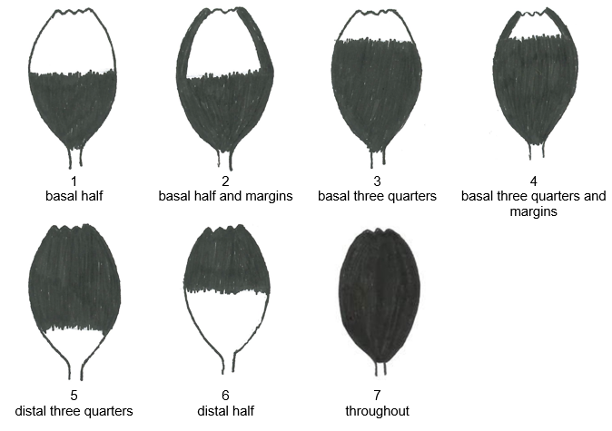

* Document TG/168/3 “Statice”: Ad. 24: Inflorescence: type (PQ)

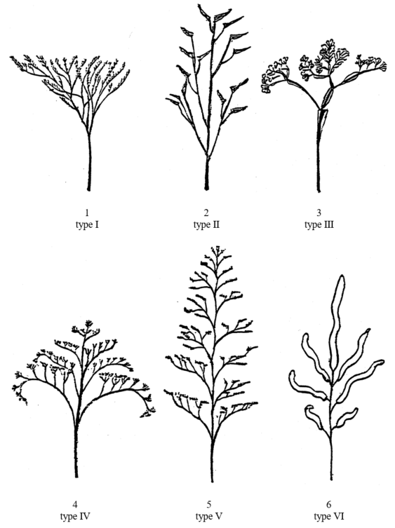

25. The TWO noted that the term “controlled environment” in Flow Diagram 1 of document TGP/7, GN 28, was not explained in the text of GN 28. The TWO agreed that the environment could not be fully controlled even under greenhouse conditions. The TWO agreed to propose that Flow Diagram 1 be amended to replace the question “is the environment controlled” by “is the characteristic observed visually only?”, as follows:

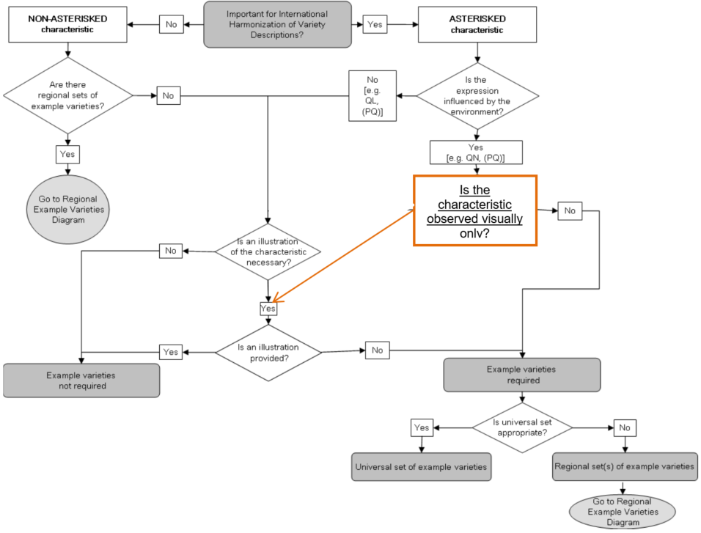

### Indication of grouping characteristics in UPOV Test Guidelines (Table of characteristics and TQ 5)

The TWV agreed to revise document TGP/7 “Development of Test Guidelines” to indicate characteristics in the table of characteristics and technical questionnaire used as grouping characteristics, as set out in document TWP/6/1, paragraph 22 (see document TWV/56/22 “Report”, paragraph 10).

The TWO, at its fifty-fourth session, agreed with the TWA, at its fifty-first session, that no revision of document TGP/7 would be required as information on grouping characteristics was not relevant in the technical questionnaire and it would not be necessary to repeat information from Section 5 in the table of characteristics (see documents TWA/51/11 “Report”, paragraph 28, and TWO/54/6 “Report”, paragraph 27).

##### 

### Converting standard wording in Test Guidelines into optional wording

The TWV, TWA and TWO agreed to amend document TGP/7 “Development of Test Guidelines” to convert the standard wording in the Test Guidelines template, paragraph 4.2.2, into additional standard wording (optional), as set out in document TWP/6/1, paragraph 25 (see documents TWV/56/22 “Report”, paragraph 11, TWA/51/11 “Report”, paragraph 29, and TWO/54/6 “Report”, paragraph 28).

## Document TGP/8 ‘Trial Design and Techniques Used in the Examination of Distinctness, Uniformity and Stability’

### The Combined Over Years Uniformity Criterion (COYU)

The TWV, TWA and TWO considered document TWP/6/11 (see documents TWV/56/22 “Report”, paragraphs 12 to 15, TWA/51/11 “Report”, paragraphs 30 to 34, and TWO/54/6 “Report”, paragraphs 29 to 33).

The TWV, TWA and TWO noted that software for COYU Splines would be under evaluation and planned to be implemented in the United Kingdom from 2022.

The TWV, TWA and TWO noted that evaluation versions of software for COYU Splines had been made available in August 2021. The TWV noted the invitation for members of the Union to participate in the test campaign of the COYU Splines software and report outcomes to the expert from the United Kingdom.

The TWV, TWA and TWO noted the request for the TWM to prepare a report of the results of the test campaign of the software for COYU Splines for consideration by the TC, at its fifty-eight session, in conjunction with the revision of document TGP/8.

#### Using the COYU-Splines method in DUS examination

The TWA received a presentation on “COYU Splines: Path to implementation in the United Kingdom” by an expert from the United Kingdom. A copy of the presentation is provided in document TWA/51/8. The TWA noted the work reported and agreed to invite the expert from the United Kingdom to report developments at its fifty‑second session (see document TWA/51/11 “Report”, paragraph 35).

## Document TGP/12 ‘Guidance on certain physiological characteristics’

### Word “highly” in only one state of expression

The TWV considered whether to revise the states of expression in the example characteristic in document TGP/12/2, Section 2.3.2, to address the use of the word “highly” in only one state of expression (see document TWV/56/22 “Report”, paragraphs 16 to 20).

The TWV noted that the scale “susceptible; intermediately resistant; and highly resistant” had been previously used in the Test Guidelines for Cucumber, Lettuce and Melon and was commonly used in the vegetable sector.

The TWV noted the explanation from France that state of expression “susceptible” covered a range of expressions, including “highly susceptible”. The TWV discussed how to apply general UPOV guidance for drafting disease resistance characteristics and agreed there was no consensus to amend guidance in document TGP/12 to delete the word “highly” from state of expression “highly resistant”.

The TWV agreed to invite the experts from France and the Netherlands to propose draft guidance explaining the particular features of disease resistance characteristics that require special treatment in relation to general UPOV guidance, to be presented to the TWV, at its fifty‑seventh session. The draft guidance should address matters such as establishing clear distinctness for quantitative disease resistance characteristics on the basis of a difference of one note between varieties; and explore possibilities for correlating the scales of UPOV characteristics with those used by phytopathologists for variety descriptions (e.g.: UPOV “Resistant” = phytopathology “Highly Resistant”).

The TWV agreed that state “intermediate” in the example provided in document TWP/6/1, paragraph 28, should read “intermediate resistant”.

The TWA noted discussions on whether to revise the states of expression in the example characteristic in document TGP/12/2, Section 2.3.2, to address the use of the word “highly” in only one state of expression (see document TWA/51/11 “Report”, paragraph 35).

The TWO noted the proposal to revise the states of expression in the example characteristic in document TGP/12/2, Section 2.3.2, to address the use of the word “highly” in only one state of expression (see document TWO/54/6 “Report”, paragraphs 34 and 35).

The TWO noted that the proposal was restricted to the TWV and agreed to propose including all TWPs in discussions.

# Information and databases

## (c) Exchange and use of software and equipment

The TWV, TWA and TWO considered document TWP/6/5.

### Document UPOV/INF/16 “Exchangeable Software”

The TWV, TWA and TWO noted that the Council had adopted by correspondence, on September 21, 2021, document UPOV/INF/16/10 “Exchangeable Software” (see documents TWV/56/22 “Report”, paragraphs 40 to 44, TWA/51/11 “Report”, paragraphs 52 to 55, and TWO/54/6 “Report”, paragraphs 53 to 56).

The TWV, TWA and TWO noted that the Office of the Union had issued on January 18, 2022, Circular E‑22/002 inviting the designated persons of the members of the Union in the TC to provide or update information regarding the use of the software included in document UPOV/INF/16.

The TWV, TWA and TWO noted that information from China, Czech Republic, France, Poland and Uzbekistan had been received to update document UPOV/INF/16.

The TWV, TWA and TWO noted that the TWM, at its first session, would be invited to review the software proposed by China, Czech Republic, France, Poland and Uzbekistan and make a recommendation to the TC, at its fifty‑eighth session, on whether to include the proposed software in document UPOV/INF/16.

The TWV received a presentation on “A Statistical Analysis Software: DUSCEL3.5” from an expert from China. A copy of the presentation is provided in document TWV/56/12 (see document TWV/56/22 “Report”, paragraph 43).

### Document UPOV/INF/22 “Software and Equipment Used by Members of the Union”

The TWV, TWA and TWO noted that the Council had adopted by correspondence, on September 21, 2021, document UPOV/INF/22/8 “Software and Equipment Used by Members of the Union” expression (see documents TWV/56/22 “Report”, paragraphs 45 to 48, TWA/51/11 “Report”, paragraphs 56 to 59, and TWO/54/6 “Report”, paragraphs 57 to 60).

The TWV, TWA and TWO noted that the Office of the Union had issued on January 18, 2022, Circular E‑22/002 inviting the designated persons of the members of the Union in the TC to provide or update information regarding the use of the software included in document UPOV/INF/22.

The TWV, TWA and TWO noted that information from the Czech Republic, Netherlands, Poland and Uzbekistan had been received to update document UPOV/INF/22.

The TWV, TWA and TWO noted that the TC, at its fifty-eighth session, would be invited to consider whether to include the proposed software or equipment in document UPOV/INF/22, or whether to request further guidance from other relevant bodies.

# Variety denominations

The TWV, TWA and TWO considered document TWP/6/6 and noted developments concerning the “Explanatory Notes on Variety Denominations under the UPOV Convention” (document UPOV/EXN/DEN/1), the possible development of a UPOV similarity search tool for variety denomination and the expansion of the content of the PLUTO database (see documents TWV/56/22 “Report”, paragraph 51, TWA/51/11 “Report”, paragraph 62, and TWO/54/6 “Report”, paragraph 40).

The TWV considered document TWV/56/4 and the changes proposed to variety denomination classes for *Brassica* and creation of new classes within *Allium* and *Prunus*, as presented by an expert from the Czech Republic (see document TWV/56/22 “Report”, paragraphs 52 to 54).

The TWV considered the different species within the proposed classes for *Allium* and *Brassica* and agreed that further discussion was required. The TWV agreed that *Allium* species used as vegetable crops should be individually listed to create a separate denomination class from other species used as ornamental plants.

The TWV agreed to invite the experts from the Czech Republic and the Netherlands to develop a new proposal to amend the denomination classes for *Allium* and *Brassica*, to be presented to the TWV at its fifty‑seventh session.

[End of document]

1. At its fifty-sixth session, organized by electronic means, from April 18 to 22, 2022
2. At its fifty-first session, held in Cambridge, United Kingdom, from May 23 to 27, 2022
3. At fifty-fourth session, hosted by Germany and organized by electronic means, from June 13 to 17, 2022