 |  | E
TG/71/4(proj.3)
ORIGINAL: English
DATE: 2022-05-29

INTERNATIONAL UNION FOR THE PROTECTION OF NEW VARIETIES OF PLANTS
 | Geneva
 | DRAFT
 | HAZELNUT  UPOV Code(s): CRYLS_AVE; CRYLS_COL  Corylus avellana L.;  Corylus colurna L. | *
GUIDELINES
FOR THE CONDUCT OF TESTS
FOR DISTINCTNESS, UNIFORMITY AND STABILITY

prepared by experts from Italy
to be considered by the
Technical Working Party for Fruit Crops

at its fifty-third session
from 2022-07-11 to 2022-07-15

Disclaimer: this document does not represent UPOV policies or guidance
Alternative names:*

Botanical name | English | French | German | Spanish
Corylus avellana L., Corylus maxima Mill., Corylus pontica K. Koch | Hazelnut | Noisetier | Haselnuss | Avellano
Corylus colurna L., Corylus iberica Wittm. ex Bobrov | Turkish Hazel | Noisetier de Byzance,  Noisetier de Turquie | Baumhasel, Türkische Baumhasel | Avellano de Turquía

The purpose of these guidelines (“Test Guidelines”) is to elaborate the principles contained in the General Introduction (document TG/1/3), and its associated TGP documents, into detailed practical guidance for the harmonized examination of distinctness, uniformity and stability (DUS) and, in particular, to identify appropriate characteristics for the examination of DUS and production of harmonized variety descriptions.

ASSOCIATED DOCUMENTS
These Test Guidelines should be read in conjunction with the General Introduction and its associated TGP documents.

TABLE OF CONTENTS | PAGE
1. | SUBJECT OF THESE TEST GUIDELINES.......................................................................................................... | 4
2. | MATERIAL REQUIRED..................................................................................................................... | 4
3. | METHOD OF EXAMINATION............................................................................................................... | 5
3.1 | Number of Growing Cycles................................................................................................................. | 5
3.2 | Testing Place................................................................................................................... | 5
3.3 | Conditions for Conducting the Examination............................................................................................... | 5
3.4 | Test Design................................................................................................................. | 6
3.5 | Additional Tests................................................................................................................... | 6

4. | ASSESSMENT OF DISTINCTNESS, UNIFORMITY AND STABILITY................................................................. | 6
4.1 | Distinctness.......................................................................................................... | 6
4.2 | Uniformity............................................................................................................ | 7
4.3 | Stability............................................................................................................... | 7

5. | GROUPING OF VARIETIES AND ORGANIZATION OF THE GROWING TRIAL................................................ | 8
6. | INTRODUCTION TO THE TABLE OF CHARACTERISTICS................................................................................ | 9
6.1 | Categories of Characteristics...................................................................................................... | 9
6.2 | States of Expression and Corresponding Notes........................................................................................ | 9
6.3 | Types of Expression............................................................................................................ | 9
6.4 | Example Varieties.............................................................................................................. | 9
6.5 | Legend................................................................................................................. | 10

7. | TABLE OF CHARACTERISTICS/TABLEAU DES CARACTÈRES/MERKMALSTABELLE/TABLA DE CARACTERES.................................................................................................................. | 11
8. | EXPLANATIONS ON THE TABLE OF CHARACTERISTICS............................................................................... | 32
8.1 | Explanations covering several characteristics........................................................................................... | 32
8.2 | Explanations for individual characteristics................................................................................................. | 33

9. | LITERATURE................................................................................................................... | 46
10 | TECHNICAL QUESTIONNAIRE............................................................................................................ | 47

1. | Subject of these Test Guidelines
 | These Test Guidelines apply to all varieties of Corylus avellana L. and Corylus colurna L. These Test Guidelines only apply to varieties intended for fruit production, not for ornamental ones.

2. | Material Required
2.1 | The competent authorities decide on the quantity and quality of the plant material required for testing the variety and when and where it is to be delivered. Applicants submitting material from a State other than that in which the testing takes place must ensure that all customs formalities and phytosanitary requirements are complied with.
2.2 | The material is to be supplied in the form of one or two year old own rooted plants.  The tests should be carried under conditions ensuring normal growth and should normally be conducted at one place.  If certain important characteristics of the variety cannot be seen at that place, the variety may be tested at an additional place.
2.3 | The minimum quantity of plant material, to be supplied by the applicant, should be:
 | The minimum quantity of plant material to be supplied by the applicant is 5 plants.
2.4 | The plant material supplied should be visibly healthy, not lacking in vigor, nor affected by any important pest or disease.
2.5 | The plant material should not have undergone any treatment which would affect the expression of the characteristics of the variety, unless the competent authorities allow or request such treatment. If it has been treated, full details of the treatment must be given.

3. | Method of Examination
3.1 | Number of Growing Cycles
3.1.1 | The minimum duration of tests should normally be two independent growing cycles.
3.1.2 | The two independent growing cycles may be observed from a single planting, examined in two separate growing cycles.
3.1.3 | In particular, it is essential that the plants produce a satisfactory crop of fruit in each of the two growing cycles.
3.1.4 | The growing cycle is considered to be the duration of a single growing season, beginning with bud burst (flowering and/or vegetative), flowering and fruit harvest and concluding when the following dormant period ends with the swelling of new season buds.
3.1.5 | The testing of a variety may be concluded when the competent authority can determine with certainty the outcome of the test.
3.2 | Testing Place
 | Tests are normally conducted at one place. In the case of tests conducted at more than one place, guidance is provided in TGP/9 “Examining Distinctness”.
3.3 | Conditions for Conducting the Examination
3.3.1 | The tests should be carried out under conditions ensuring satisfactory growth for the expression of the relevant characteristics of the variety and for the conduct of the examination.
3.3.2 | The optimum stage of development for the assessment of each characteristic is indicated by a number in the Table of Characteristics. The stages of development denoted by each number are described in Chapter 8.

3.4 | Test Design
 | Each test should be designed to result in a total of at least 5 plants.
3.5 | Additional Tests
 | Additional tests, for examining relevant characteristics, may be established.

4. | Assessment of Distinctness, Uniformity and Stability
4.1 | Distinctness
4.1.1 | General Recommendations
 | It is of particular importance for users of these Test Guidelines to consult the General Introduction prior to making decisions regarding distinctness. However, the following points are provided for elaboration or emphasis in these Test Guidelines.
4.1.2 | Consistent Differences
 | The differences observed between varieties may be so clear that more than one growing cycle is not necessary. In addition, in some circumstances, the influence of the environment is not such that more than a single growing cycle is required to provide assurance that the differences observed between varieties are sufficiently consistent. One means of ensuring that a difference in a characteristic, observed in a growing trial, is sufficiently consistent is to examine the characteristic in at least two independent growing cycles.
4.1.3 | Clear Differences
 | Determining whether a difference between two varieties is clear depends on many factors, and should consider, in particular, the type of expression of the characteristic being examined, i.e. whether it is expressed in a qualitative, quantitative, or pseudo-qualitative manner. Therefore, it is important that users of these Test Guidelines are familiar with the recommendations contained in the General Introduction prior to making decisions regarding distinctness.
4.1.4 | Number of Plants or Parts of Plants to be Examined
 | Unless otherwise indicated, for the purposes of distinctness, all observations on single plants should be made on 5 plants or parts of plants taken from each of 5 plants and any other observations made on all plants in the test, disregarding any off-type plants.
 | In the case of observations of parts taken from single plants, the number of parts to be taken from each of the plants should be 2.
4.1.5 | Method of Observation
 | The recommended method of observing the characteristic for the purposes of distinctness is indicated by the following key in the Table of Characteristics (see document TGP/9 “Examining Distinctness”, Section 4 “Observation of characteristics”):
MG: single measurement of a group of plants or parts of plants
MS: measurement of a number of individual plants or parts of plants
VG: visual assessment by a single observation of a group of plants or parts of plants
VS: visual assessment by observation of individual plants or parts of plants

 | Type of observation: visual (V) or measurement (M)

“Visual” observation (V) is an observation made on the basis of the expert’s judgment. For the purposes of this document, “visual” observation refers to the sensory observations of the experts and, therefore, also includes smell, taste and touch. Visual observation includes observations where the expert uses reference points (e.g. diagrams, example varieties, side-by-side comparison) or non-linear charts (e.g. color charts). Measurement (M) is an objective observation against a calibrated, linear scale e.g. using a ruler, weighing scales, colorimeter, dates, counts, etc.

 | Type of record: for a group of plants (G) or for single, individual plants (S)
 | For the purposes of distinctness, observations may be recorded as a single record for a group of plants or parts of plants (G), or may be recorded as records for a number of single, individual plants or parts of plants (S). In most cases, “G” provides a single record per variety and it is not possible or necessary to apply statistical methods in a plant-by-plant analysis for the assessment of distinctness.
 | In cases where more than one method of observing the characteristic is indicated in the Table of Characteristics (e.g. VG/MG), guidance on selecting an appropriate method is provided in document TGP/9, Section 4.2.
4.2 | Uniformity
4.2.1 | It is of particular importance for users of these Test Guidelines to consult the General Introduction prior to making decisions regarding uniformity. However, the following points are provided for elaboration or emphasis in these Test Guidelines:
4.2.2 | These Test Guidelines have been developed for the examination of vegetatively propagated varieties. For varieties with other types of propagation, the recommendations in the General Introduction and document TGP/13 "Guidance for new types and species" Section 4.5 "Testing Uniformity" should be followed.
4.2.3 | The off-types are observed visually and considering 5 plants no off-type are admitted.
4.3 | Stability
4.3.1 | In practice, it is not usual to perform tests of stability that produce results as certain as those of the testing of distinctness and uniformity. However, experience has demonstrated that, for many types of variety, when a variety has been shown to be uniform, it can also be considered to be stable.
4.3.2 | Where appropriate, or in cases of doubt, stability may be further examined by testing a new plant stock to ensure that it exhibits the same characteristics as those shown by the initial material supplied.

5. | Grouping of Varieties and Organization of the Growing Trial
5.1 | The selection of varieties of common knowledge to be grown in the trial with the candidate varieties and the way in which these varieties are divided into groups to facilitate the assessment of distinctness are aided by the use of grouping characteristics.
5.2 | Grouping characteristics are those in which the documented states of expression, even where produced at different locations, can be used, either individually or in combination with other such characteristics: (a) to select varieties of common knowledge that can be excluded from the growing trial used for examination of distinctness; and (b) to organize the growing trial so that similar varieties are grouped together.
5.3 | The following have been agreed as useful grouping characteristics:
(a) |  | Leaf blade: shape (characteristic 12)
(b) |  | Involucre: ratio length to length of nut (characteristic 18)
(c) |  | Involucre: indentation (characteristic 19)
(d) |  | Involucre: size of basal support (characteristic 21)
(e) |  | Nut: size (characteristic 26)
(f) |  | Nut: shape in lateral view (characteristic 27)
(g) |  | Nut: shape in cross section (characteristic 28)
(h) |  | Nut: percentage of kernel (/by weight) (characteristic 45)
(i) |  | Time of male flowering (characteristic 46)
(j) |  | Time of female flowering (characteristic 47)

 | (k) Time of harvest maturity (characteristic 50)
5.4 | Guidance for the use of grouping characteristics, in the process of examining distinctness, is provided through the General Introduction and document TGP/9 “Examining Distinctness”.

6. | Introduction to the Table of Characteristics
6.1 | Categories of Characteristics
6.1.1 | Standard Test Guidelines Characteristics
 | Standard Test Guidelines characteristics are those which are approved by UPOV for examination of DUS and from which members of the Union can select those suitable for their particular circumstances.
6.1.2 | Asterisked Characteristics
 | Asterisked characteristics (denoted by *) are those included in the Test Guidelines which are important for the international harmonization of variety descriptions and should always be examined for DUS and included in the variety description by all members of the Union, except when the state of expression of a preceding characteristic or regional environmental conditions render this inappropriate.
6.2 | States of Expression and Corresponding Notes
6.2.1 | States of expression are given for each characteristic to define the characteristic and to harmonize descriptions. Each state of expression is allocated a corresponding numerical note for ease of recording of data and for the production and exchange of the description.
6.2.2 | All relevant states of expression are presented in the characteristic.
6.2.3 | Further explanation of the presentation of states of expression and notes is provided in document TGP/7 “Development of Test Guidelines”.
6.3 | Types of Expression
 | An explanation of the types of expression of characteristics (qualitative, quantitative and pseudo-qualitative) is provided in the General Introduction.
6.4 | Example Varieties
 | Where appropriate, example varieties are provided to clarify the states of expression of each characteristic.

6.5 | Legend
 |  | English |  | français |  | deutsch | español | Example Varieties  Exemples  Beispielssorten  Variedades ejemplo | Note/  Nota
1 | 2 | 3 | 4 | 5 | 6 | 7
 |  | Name of characteristics in English |  | Nom du caractère en français |  | Name des Merkmals auf Deutsch | Nombre del carácter en español
 |  | states of expression |  | types d’expression |  | Ausprägungsstufen | tipos de expresión

1 | Characteristic number
2 | (*) | Asterisked characteristic | – see Chapter 6.1.2
3 | Type of expression
 | QL | Qualitative characteristic | – see Chapter 6.3
 | QN | Quantitative characteristic | – see Chapter 6.3
 | PQ | Pseudo-qualitative characteristic | – see Chapter 6.3
4 | Method of observation (and type of plot, if applicable)
 | MG, MS, VG, VS |  | – see Chapter 4.1.5
5 | (+) | See Explanations on the Table of Characteristics in Chapter 8.2
6 | (a)-(h) | See Explanations on the Table of Characteristics in Chapter 8.1
7 | Growth stage key See Explanations on the Table of Characteristics in Chapter 8.3

7. | Table of Characteristics/Tableau des caractères/Merkmalstabelle/Tabla de caracteres

 |  | English |  | français |  | deutsch | español | Example Varieties  Exemples  Beispielssorten  Variedades ejemplo | Note/  Nota
1. |  | QN | VG |  | (a) | a
 |  | Plant: vigor
 |  | absent or very weak |  |  |  |  |  |  | 1
 |  | very weak to weak |  |  |  |  |  |  | 2
 |  | weak |  |  |  |  |  | Negret, Tonda Romana | 3
 |  | weak to medium |  |  |  |  |  |  | 4
 |  | medium |  |  |  |  |  | Tonda Gentile delle Langhe | 5
 |  | medium to strong |  |  |  |  |  |  | 6
 |  | strong |  |  |  |  |  | Fertile de Coutard | 7
 |  | strong to very strong |  |  |  |  |  |  | 8
 |  | very strong |  |  |  |  |  |  | 9
2. | (*) | QN | VG |  | (a) | a
 |  | Plant: growth habit
 |  | very erect |  |  |  |  |  | Daviana | 1
 |  | very erect to erect |  |  |  |  |  |  | 2
 |  | erect |  |  |  |  |  | San Giovanni, Segorbe | 3
 |  | erect to semi erect |  |  |  |  |  |  | 4
 |  | semi erect |  |  |  |  |  | Fertile de Coutard, Negret, Tonda Gentile delle Langhe | 5
 |  | semi erect to spreading |  |  |  |  |  |  | 6
 |  | spreading |  |  |  |  |  | Morell, Tombul | 7
 |  | spreading to drooping |  |  |  |  |  |  | 8
 |  | drooping |  |  |  |  |  | Imperiale de Trebizonde | 9

 |  | English |  | français |  | deutsch | español | Example Varieties  Exemples  Beispielssorten  Variedades ejemplo | Note/  Nota
3. |  | QN | VG |  | (a), (b) | a
 |  | Plant: density of shoots
 |  | absent or very sparse |  |  |  |  |  |  | 1
 |  | very sparse to sparse |  |  |  |  |  |  | 2
 |  | sparse |  |  |  |  |  |  | 3
 |  | sparse to medium |  |  |  |  |  |  | 4
 |  | medium |  |  |  |  |  | Fertile de Coutard, Negret, Tonda Gentile delle Langhe | 5
 |  | medium to dense |  |  |  |  |  |  | 6
 |  | dense |  |  |  |  |  |  | 7
 |  | dense to very dense |  |  |  |  |  |  | 8
 |  | very dense |  |  |  |  |  |  | 9
4. |  | QN | VG | (+) |  | c
 |  | Plant: tendency to produce suckers
 |  | absent or very weak |  |  |  |  |  | Tonda Bianca | 1
 |  | very weak to weak |  |  |  |  |  |  | 2
 |  | weak |  |  |  |  |  | Cosford, Daviana | 3
 |  | weak to medium |  |  |  |  |  |  | 4
 |  | medium |  |  |  |  |  | Segorbe | 5
 |  | medium to strong |  |  |  |  |  |  | 6
 |  | strong |  |  |  |  |  | Fertile de Coutard | 7
 |  | strong to very strong |  |  |  |  |  |  | 8
 |  | very strong |  |  |  |  |  | Imperiale de Trebizonde | 9

 |  | English |  | français |  | deutsch | español | Example Varieties  Exemples  Beispielssorten  Variedades ejemplo | Note/  Nota
5. |  | QN | VG | (+) | (a), (b), (c) | a
 |  | One year old shoot hairiness
 |  | very weak |  |  |  |  |  |  | 1
 |  | very weak to weak |  |  |  |  |  |  | 2
 |  | weak |  |  |  |  |  | Mortarella, Segorbe | 3
 |  | weak to medium |  |  |  |  |  |  | 4
 |  | medium |  |  |  |  |  | Fertile de Coutard, Tonda Gentile delle Langhe | 5
 |  | medium to strong |  |  |  |  |  |  | 6
 |  | strong |  |  |  |  |  | Imperiale de Trebizonde, Tonda di Giffoni | 7
 |  | strong to very strong |  |  |  |  |  |  | 8
 |  | very strong |  |  |  |  |  |  | 9
6. |  | QN | VG | (+) | (a), (b), (c) | a
 |  | One-year-old shoot: density of lenticels
 |  | sparse |  |  |  |  |  | Negret, Segorbe | 1
 |  | medium |  |  |  |  |  | Mortarella | 2
 |  | dense |  |  |  |  |  | San Giovanni, Tonda Gentile delle Langhe | 3
7. |  | PQ | VG | (+) | (a), (b), (c) | a
 |  | Bud: shape
 |  | conical |  |  |  |  |  | Cosford, Merveille de Bollwiller | 1
 |  | ovoid |  |  |  |  |  | Fertile de Coutard, Negret | 2
 |  | globular |  |  |  |  |  | Du Chilly | 3
8. | (*) | PQ | VG | (+) | (b) | a
 |  | Bud: color
 |  | green |  |  |  |  |  | Du Chilly, Segorbe | 1
 |  | reddish green |  |  |  |  |  | Bergeri, Gunslebert, Negret | 2
 |  | red |  |  |  |  |  | Merveille de Bollwiller | 3

 |  | English |  | français |  | deutsch | español | Example Varieties  Exemples  Beispielssorten  Variedades ejemplo | Note/  Nota
9. |  | QN | VG |  | (b), (c), (e) | b
 |  | Male inflorescence: length
 |  | very short |  |  |  |  |  |  | 1
 |  | very short to short |  |  |  |  |  |  | 2
 |  | short |  |  |  |  |  | Negret | 3
 |  | short to medium |  |  |  |  |  |  | 4
 |  | medium |  |  |  |  |  | Fertile de Coutard, Tonda Gentile delle Langhe | 5
 |  | medium to long |  |  |  |  |  |  | 6
 |  | long |  |  |  |  |  | Segorbe | 7
 |  | long to very long |  |  |  |  |  |  | 8
 |  | very long |  |  |  |  |  |  | 9
10 | (*) | PQ | VG |  |  | b
 |  | Male inflorescence: color
 |  | green |  |  |  |  |  | Fertile de Coutard, Segorbe, Tonda Gentile delle Langhe | 1
 |  | pink brown |  |  |  |  |  | Bergeri, Cosford, Merveille de Bollwiller | 2
 |  | red |  |  |  |  |  | Comun | 3
11 | (*) | PQ | VG |  |  | b
 |  | Stigma: color
 |  | pink |  |  |  |  |  | San Giovanni | 1
 |  | red |  |  |  |  |  | Fertile de Coutard | 2
 |  | purple red |  |  |  |  |  | Merveille de Bollwiller | 3
 |  | pale yellow |  |  |  |  |  | OSU 899.010 Oregon selection | 4
12 | (*) | PQ | VG | (+) | (b), (c), (d) | c
 |  | Leaf blade: shape
 |  | elliptic |  |  |  |  |  | Merveille de Bollwiller | 1
 |  | ovate |  |  |  |  |  | Du Chilly | 2
 |  | obovate |  |  |  |  |  | Tonda di Giffoni | 3
 |  | circular |  |  |  |  |  | Segorbe | 4

 |  | English |  | français |  | deutsch | español | Example Varieties  Exemples  Beispielssorten  Variedades ejemplo | Note/  Nota
13 | (*) | QN | MG/VG |  | (b), (c), (d) | c
 |  | Leaf blade: size
 |  | very small |  |  |  |  |  |  | 1
 |  | very small to small |  |  |  |  |  |  | 2
 |  | small |  |  |  |  |  | Cosford,  Imperatrice Eugenie, Merveille de Bollwiller | 3
 |  | small to medium |  |  |  |  |  |  | 4
 |  | medium |  |  |  |  |  | Fertile de Coutard | 5
 |  | medium to large |  |  |  |  |  |  | 6
 |  | large |  |  |  |  |  | Segorbe, Tonda di Giffoni | 7
 |  | large to very large |  |  |  |  |  |  | 8
 |  | very large |  |  |  |  |  |  | 9
14 |  | QN | VG |  | (b), (c), (d) | c
 |  | Leaf: hairiness of lower side
 |  | weak |  |  |  |  |  | Fertile de Coutard, Merveille de Bollwiller, Negret, Tonda Gentile delle Langhe | 1
 |  | medium |  |  |  |  |  | Imperatrice Eugenie | 2
 |  | strong |  |  |  |  |  | Segorbe, Tonda di Giffoni | 3
15 |  | QN | MG/VG |  | (b), (c), (d) | c
 |  | Petiole: length
 |  | very short |  |  |  |  |  |  | 1
 |  | very short to short |  |  |  |  |  |  | 2
 |  | short |  |  |  |  |  | Fertile de Coutard,  Tonda di Giffoni | 3
 |  | short to medium |  |  |  |  |  |  | 4
 |  | medium |  |  |  |  |  | Segorbe | 5
 |  | medium to long |  |  |  |  |  |  | 6
 |  | long |  |  |  |  |  | Cosford, Tonda Gentile delle Langhe | 7
 |  | long to very long |  |  |  |  |  |  | 8
 |  | very long |  |  |  |  |  |  | 9

 |  | English |  | français |  | deutsch | español | Example Varieties  Exemples  Beispielssorten  Variedades ejemplo | Note/  Nota
16 | (*) | QN | VG |  | (b), (c), (d) | c
 |  | Petiole: hairiness
 |  | absent or very weak |  |  |  |  |  |  | 1
 |  | very weak to weak |  |  |  |  |  |  | 2
 |  | weak |  |  |  |  |  | Segorbe | 3
 |  | weak to medium |  |  |  |  |  |  | 4
 |  | medium |  |  |  |  |  | Merveille de Bollwiller | 5
 |  | medium to strong |  |  |  |  |  |  | 6
 |  | strong |  |  |  |  |  | Fertile de Coutard,  Tonda di Giffoni | 7
 |  | strong to very strong |  |  |  |  |  |  | 8
 |  | very strong |  |  |  |  |  |  | 9
17 | (*) | QL | VG | (+) |  | d
 |  | Involucre: constriction
 |  | absent |  |  |  |  |  | Fertile de Coutard, Tonda Gentile delle Langhe | 1
 |  | present |  |  |  |  |  | Imperiale de Trebizonde | 9
18 | (*) | QN | MG/VG | (+) | (c), (f) | d
 |  | Involucre: ratio length to length of nut
 |  | much shorter |  |  |  |  |  |  | 1
 |  | much shorter to shorter |  |  |  |  |  |  | 2
 |  | shorter |  |  |  |  |  | Tonda Bianca | 3
 |  | shorter to equal |  |  |  |  |  |  | 4
 |  | equal |  |  |  |  |  | Cosford,  Fertile de Coutard, Merveille de Bollwiller | 5
 |  | equal to longer |  |  |  |  |  |  | 6
 |  | longer |  |  |  |  |  | Du Chilly,  Imperiale de Trebizonde, Segorbe, Tombul, Tonda Gentile delle Langhe | 7
 |  | longer to much longer |  |  |  |  |  |  | 8
 |  | much longer |  |  |  |  |  |  | 9

 |  | English |  | français |  | deutsch | español | Example Varieties  Exemples  Beispielssorten  Variedades ejemplo | Note/  Nota
19 | (*) | QN | VG | (+) | (f) | d
 |  | Involucre: indentation
 |  | weak |  |  |  |  |  | Du Chilly, Tombul | 1
 |  | weak to medium |  |  |  |  |  |  | 2
 |  | medium |  |  |  |  |  | Fertile de Coutard, Tonda Gentile delle Langhe | 3
 |  | medium to strong |  |  |  |  |  |  | 4
 |  | strong |  |  |  |  |  | Gunslebert, Negret | 5
20 | (*) | QN | VG | (+) | (f) | d
 |  | Involucre: serration of indentation
 |  | very weak |  |  |  |  |  | Du Chilly, Segorbe, Tombul, Tonda Bianca | 1
 |  | weak |  |  |  |  |  |  | 2
 |  | medium |  |  |  |  |  | Fertile de Coutard, Tonda Gentile delle Langhe | 3
 |  | medium to strong |  |  |  |  |  |  | 4
 |  | strong |  |  |  |  |  | Gunslebert, Morell, Negret | 5
21 | (*) | QN | VG | (+) | (f) | d
 |  | Involucre: size of basal support
 |  | thin |  |  |  |  |  | Cosford | 1
 |  | thin to medium |  |  |  |  |  |  | 2
 |  | medium |  |  |  |  |  | Merveille de Bollwiller, Segorbe | 3
 |  | medium to thick |  |  |  |  |  |  | 4
 |  | thick |  |  |  |  |  | Fertile de Coutard,  Tonda di Giffoni | 5
22 | (*) | QL | VG |  | (f) | d
 |  | involucre: hairiness
 |  | absent |  |  |  |  |  | Morell, Tonda Bianca | 1
 |  | present |  |  |  |  |  | Tonda di Giffoni | 9

 |  | English |  | français |  | deutsch | español | Example Varieties  Exemples  Beispielssorten  Variedades ejemplo | Note/  Nota
23 |  | QN | VG | (+) | (f) | d
 |  | Involucre: density of hairiness
 |  | absent or very sparse |  |  |  |  |  | Morell, Tonda Bianca | 1
 |  | very sparse to sparse |  |  |  |  |  |  | 2
 |  | sparse |  |  |  |  |  | Cosford, Du Chilly, Imperatrice Eugenie, Segorbe | 3
 |  | sparse to medium |  |  |  |  |  |  | 4
 |  | medium |  |  |  |  |  | Fertile de Coutard, Tonda Gentile delle Langhe | 5
 |  | medium to dense |  |  |  |  |  |  | 6
 |  | dense |  |  |  |  |  | Tonda di Giffoni | 7
 |  | dense to very dense |  |  |  |  |  |  | 8
 |  | very dense |  |  |  |  |  |  | 9
24 |  | QN | VG | (+) | (f) | d
 |  | Involucre: jointing of bracts
 |  | not present |  |  |  |  |  | Gunslebert | 1
 |  | on one side only |  |  |  |  |  | Fertile de Coutard, Negret, Tonda di Giffoni, Tonda Gentile delle Langhe | 2
 |  | on both sides |  |  |  |  |  | Imperiale de Trebizonde, Tombul | 3
25 |  | QN | VG |  | (c), (f) | d
 |  | Infructescence: number of nuts per cluster
 |  | one |  |  |  |  |  | Daviana, Tonda Bianca | 1
 |  | one to two |  |  |  |  |  | Cosford,  Merveille de Bollwiller | 2
 |  | two to three |  |  |  |  |  | Fertile de Coutard,  Tonda di Giffoni | 3
 |  | three to four |  |  |  |  |  | Negret, Segorbe | 4
 |  | more than four |  |  |  |  |  | Tombul | 5

 |  | English |  | français |  | deutsch | español | Example Varieties  Exemples  Beispielssorten  Variedades ejemplo | Note/  Nota
26 | (*) | QN | MS/VG |  | (g), (h) | d
 |  | Nut: size
 |  | very small |  |  |  |  |  | Morell | 1
 |  | very small to small |  |  |  |  |  |  | 2
 |  | small |  |  |  |  |  | Negret, Tombul, Tonda Gentile delle Langhe | 3
 |  | small to medium |  |  |  |  |  |  | 4
 |  | medium |  |  |  |  |  | Segorbe, Tonda di Giffoni | 5
 |  | medium to large |  |  |  |  |  |  | 6
 |  | large |  |  |  |  |  | Fertile de Coutard, Merveille de Bollwiller | 7
 |  | large to very large |  |  |  |  |  |  | 8
 |  | very large |  |  |  |  |  | Apoldaer Zellernuss, Bergeri, Ennis | 9
27 | (*) | PQ | VG | (+) | (h) | d
 |  | Nut: shape in lateral view
 |  | globose |  |  |  |  |  | Clark, Fertile de Coutard, Tonda Gentile delle Langhe | 1
 |  | conical |  |  |  |  |  | Ennis, Jean's,  Merveille de Bollwiller | 2
 |  | ovoid |  |  |  |  |  | Imperatrice Eugenie, Negret | 3
 |  | obloid |  |  |  |  |  | Imperiale de Trebizonde | 4
 |  | short sub-cylindical |  |  |  |  |  | Cosford | 5
 |  | long sub-cylindrical |  |  |  |  |  | Du Chilly | 6
28 | (*) | PQ | VG | (+) | (g), (h) | d
 |  | Nut: shape in cross section
 |  | elliptic |  |  |  |  |  | Du Chilly, Negret | 1
 |  | circular |  |  |  |  |  | Merveille de Bollwiller, Tonda Romana | 2
 |  | triangular |  |  |  |  |  | Tonda Gentile delle Langhe | 3
 |  | rectangular |  |  |  |  |  | Gunslebert | 4

 |  | English |  | français |  | deutsch | español | Example Varieties  Exemples  Beispielssorten  Variedades ejemplo | Note/  Nota
29 |  | QL | VG | (+) |  | d
 |  | Nut: color
 |  | greenish yellow |  |  |  |  |  | Tonda Bianca | 1
 |  | light brown |  |  |  |  |  | Cosford, Daviana, Imperiale de Trebizonde, Morell, Tonda Gentile delle Langhe | 2
 |  | brown |  |  |  |  |  | Ennis, Fertile de Coutard, Negret, Tonda Romana | 3
30 |  | QN | VG | (+) |  | d
 |  | Nut: conspicuousness of stripes on shell
 |  | few |  |  |  |  |  | Imperiale de Trebizonde, Segorbe | 1
 |  | medium |  |  |  |  |  | Cosford, Daviana | 2
 |  | many |  |  |  |  |  | Campanica | 3
31 | (*) | PQ | VG | (+) |  | d
 |  | Nut: shape of apex
 |  | narrow acute |  |  |  |  |  | Imperatrice Eugenie, Jean's, Negret | 1
 |  | broad acute |  |  |  |  |  | Merveille de Bollwiller | 2
 |  | obtuse |  |  |  |  |  | Fertile de Coutard, Tonda Gentile delle Langhe | 3
 |  | truncate |  |  |  |  |  | Imperiale de Trebizonde | 4
32 | (*) | QN | VG | (+) |  | d
 |  | Nut: mucron aspect
 |  | flat or very slightly prominent |  |  |  |  |  |  | 1
 |  | very slightly prominent to slightly prominent |  |  |  |  |  |  | 2
 |  | slightly prominent |  |  |  |  |  | Cosford,  Fertile de Coutard,  Tonda di Giffoni | 3
 |  | slightly prominent to medium prominent |  |  |  |  |  |  | 4
 |  | medium prominent |  |  |  |  |  | Du Chilly | 5
 |  | medium prominent to strongly prominent |  |  |  |  |  |  | 6
 |  | strongly prominent |  |  |  |  |  | Tonda Romana | 7
 |  | strongly prominent to very strongly prominent |  |  |  |  |  |  | 8
 |  | very strongly prominent |  |  |  |  |  |  | 9

 |  | English |  | français |  | deutsch | español | Example Varieties  Exemples  Beispielssorten  Variedades ejemplo | Note/  Nota
33 | (*) | QN | VG | (+) |  | d
 |  | Nut: size of pistil scar
 |  | very small |  |  |  |  |  |  | 1
 |  | very small to small |  |  |  |  |  |  | 2
 |  | small |  |  |  |  |  | Negret, Tonda Gentile delle Langhe | 3
 |  | small to medium |  |  |  |  |  |  | 4
 |  | medium |  |  |  |  |  | Fertile de Coutard,  Tonda di Giffoni | 5
 |  | medium to large |  |  |  |  |  |  | 6
 |  | large |  |  |  |  |  | Cosford,  Imperiale de Trebizonde, San Giovanni | 7
 |  | large to very large |  |  |  |  |  |  | 8
 |  | very large |  |  |  |  |  |  | 9
34 | (*) | QN | VG | (+) |  | d
 |  | Nut: hairiness at apex
 |  | absent or very weak |  |  |  |  |  |  | 1
 |  | very weak to weak |  |  |  |  |  |  | 2
 |  | weak |  |  |  |  |  | Cosford,  Imperiale de Trebizonde | 3
 |  | weak to medium |  |  |  |  |  |  | 4
 |  | medium |  |  |  |  |  | Fertile de Coutard | 5
 |  | medium to strong |  |  |  |  |  |  | 6
 |  | strong |  |  |  |  |  | Apoldaer Zellernuss,  Du Chilly | 7
 |  | strong to very strong |  |  |  |  |  |  | 8
 |  | very strong |  |  |  |  |  |  | 9

 |  | English |  | français |  | deutsch | español | Example Varieties  Exemples  Beispielssorten  Variedades ejemplo | Note/  Nota
35 | (*) | QN | VG | (+) |  | d
 |  | Nut: size of basal scar related to nut size
 |  | very small |  |  |  |  |  |  | 1
 |  | very small to small |  |  |  |  |  |  | 2
 |  | small |  |  |  |  |  | Segorbe, Tonda Gentile delle Langhe | 3
 |  | small to medium |  |  |  |  |  |  | 4
 |  | medium |  |  |  |  |  | Fertile de Coutard | 5
 |  | medium to large |  |  |  |  |  |  | 6
 |  | large |  |  |  |  |  | Cosford,  Imperiale de Trebizonde, Merveille de Bollwiller | 7
 |  | large to very large |  |  |  |  |  |  | 8
 |  | very large |  |  |  |  |  |  | 9
36 | (*) | PQ | VG | (+) |  | d
 |  | Nut: curvature of basal scar
 |  | concave |  |  |  |  |  | Tonda Rossa | 1
 |  | even |  |  |  |  |  | Imperiale de Trebizonde, Merveille de Bollwiller | 2
 |  | convex |  |  |  |  |  | Cosford, Du Chilly, Negret | 3
37 | (*) | QN | MG/VG |  | (h) | d
 |  | Kernel: size
 |  | very small |  |  |  |  |  | Sivri, Tombul | 1
 |  | very small to small |  |  |  |  |  |  | 2
 |  | small |  |  |  |  |  | Negret, Tonda Gentile delle Langhe | 3
 |  | small to medium |  |  |  |  |  |  | 4
 |  | medium |  |  |  |  |  | Segorbe,  Tonda di Giffoni,  Tonda Romana | 5
 |  | medium to large |  |  |  |  |  |  | 6
 |  | large |  |  |  |  |  | Daviana,  Fertile de Coutard, Merveille de Bollwiller | 7
 |  | large to very large |  |  |  |  |  |  | 8
 |  | very large |  |  |  |  |  | Pallagrossa | 9

 |  | English |  | français |  | deutsch | español | Example Varieties  Exemples  Beispielssorten  Variedades ejemplo | Note/  Nota
38 | (*) | PQ | VG | (+) |  | d
 |  | Kernel: shape in lateral view
 |  | globose |  |  |  |  |  | Segorbe,  Tonda di Giffoni,  Tonda Gentile delle Langhe, Tonda Romana | 1
 |  | obloid |  |  |  |  |  | Imperiale de Trebizonde | 2
 |  | ovoid |  |  |  |  |  | Imperatrice Eugenie, Merveille de Bollwiller | 3
 |  | short sub-cylindrical |  |  |  |  |  | Daviana, San Giovanni | 4
 |  | long sub-cylindrical |  |  |  |  |  | Cosford, Gunslebert | 5
39 |  | PQ | VG | (+) |  | d
 |  | Kernel: shape of apex
 |  | pointed |  |  |  |  |  | Du Chilly,  Fertile de Coutard, Negret | 1
 |  | obtuse |  |  |  |  |  | Gunslebert,  San Giovanni,  Tonda Romana | 2
 |  | truncate |  |  |  |  |  | Imperiale de Trebizonde | 3
40 |  | PQ | VG | (+) |  | 4
 |  | Kernel: shape in cross section
 |  | elliptic |  |  |  |  |  | Du Chilly | 1
 |  | circular |  |  |  |  |  | Imperiale de Trebizonde, Tonda Romana | 2
 |  | triangular |  |  |  |  |  | Tonda Gentile delle Langhe | 3
41 |  | PQ | VG | (+) |  | d
 |  | Kernel: shape of base
 |  | pointed |  |  |  |  |  | Tombul | 1
 |  | rounded |  |  |  |  |  | Fertile de Coutard, Merveille de Bollwiller, Negret | 2
 |  | truncate |  |  |  |  |  | Imperiale de Trebizonde, Tonda Gentile delle Langhe, Tonda Romana | 3
42 | (*) | QL | VG | (+) |  | d
 |  | Kernel: lateral groove
 |  | absent |  |  |  |  |  | Fertile de Coutard, Merveille de Bollwiller | 1
 |  | present |  |  |  |  |  | Du Chilly, Imperatrice Eugenie, Tonda di Giffoni | 9

 |  | English |  | français |  | deutsch | español | Example Varieties  Exemples  Beispielssorten  Variedades ejemplo | Note/  Nota
43 | (*) | PQ | VG | (+) |  | d
 |  | Kernel presence of fiber
 |  | absent or very weak |  |  |  |  |  | Daviana, Du Chilly, Imperiale de Trebizonde | 1
 |  | very weak to weak |  |  |  |  |  |  | 2
 |  | weak |  |  |  |  |  |  | 3
 |  | weak to medium |  |  |  |  |  |  | 4
 |  | medium |  |  |  |  |  | Cosford,  Fertile de Coutard, Negret, Segorbe | 5
 |  | medium to strong |  |  |  |  |  |  | 6
 |  | strong |  |  |  |  |  |  | 7
 |  | strong to very strong |  |  |  |  |  |  | 8
 |  | very strong |  |  |  |  |  | Campanica, Ennis | 9
44 |  | QN | VG |  |  | d
 |  | Kernel: inner cavity
 |  | absent or very small |  |  |  |  |  | Imperiale de Trebizonde | 1
 |  | medium |  |  |  |  |  | Cosford, Negret,  Tonda Gentile delle Langhe, Tonda Romana | 2
 |  | large |  |  |  |  |  | Fertile de Coutard, Segorbe, Tonda di Giffoni | 3
45 | (*) | QN | MG/VG |  | (h) | d
 |  | Nut: percentage of kernel (/by weight)
 |  | very low |  |  |  |  |  | Merveille de Bollwiller | 1
 |  | very low to low |  |  |  |  |  |  | 2
 |  | low |  |  |  |  |  | Fertile de Coutard, Segorbe | 3
 |  | low to medium |  |  |  |  |  |  | 4
 |  | medium |  |  |  |  |  | Negret, Tonda Gentile delle Langhe | 5
 |  | medium to high |  |  |  |  |  |  | 6
 |  | high |  |  |  |  |  | Daviana,  Imperatrice Eugenie | 7
 |  | high to very high |  |  |  |  |  |  | 8
 |  | very high |  |  |  |  |  | Cosford, Tombul | 9

 |  | English |  | français |  | deutsch | español | Example Varieties  Exemples  Beispielssorten  Variedades ejemplo | Note/  Nota
46 | (*) | QN | MG |  | (e) | b
 |  | Time of male flowering
 |  | very early |  |  |  |  |  |  | 1
 |  | very early to early |  |  |  |  |  | Tonda Gentile delle Langhe | 2
 |  | early |  |  |  |  |  |  | 3
 |  | early to medium |  |  |  |  |  | Fertile de Coutard,  San Giovanni, Segorbe | 4
 |  | medium |  |  |  |  |  | Negret | 5
 |  | medium to late |  |  |  |  |  | Cosford, Daviana,  Tonda Romana | 6
 |  | late |  |  |  |  |  | Du Chilly,  Merveille de Bollwiller | 7
 |  | late to very late |  |  |  |  |  |  | 8
 |  | very late |  |  |  |  |  |  | 9
47 | (*) | QN | MG |  | (e) | b
 |  | Time of female flowering
 |  | very early |  |  |  |  |  |  | 1
 |  | very early to early |  |  |  |  |  | Negret, San Giovanni | 2
 |  | early |  |  |  |  |  | Tonda di Giffoni | 3
 |  | early to medium |  |  |  |  |  |  | 4
 |  | medium |  |  |  |  |  | Fertile de Coutard, Tonda Gentile delle Langhe | 5
 |  | medium to late |  |  |  |  |  | Morell, Segorbe | 6
 |  | late |  |  |  |  |  | Daviana, Du Chilly, Merveille de Bollwiller | 7
 |  | late to very late |  |  |  |  |  | Bergeri | 8
 |  | very late |  |  |  |  |  |  | 9
48 | (*) | QN | MG |  |  | b
 |  | Time of female flowering compared to time of male flowering
 |  | earlier |  |  |  |  |  | Negret, San Giovanni, Tonda Romana | 1
 |  | same time |  |  |  |  |  | Merveille de Bollwiller, Morell | 2
 |  | later |  |  |  |  |  | Bergeri, Cosford, Tonda Gentile delle Langhe | 3

 |  | English |  | français |  | deutsch | español | Example Varieties  Exemples  Beispielssorten  Variedades ejemplo | Note/  Nota
49 | (*) | QN | MG |  |  | a
 |  | Time of beginning of leaf budburst
 |  | very early |  |  |  |  |  | San Giovanni | 1
 |  | very early to early |  |  |  |  |  |  | 2
 |  | early |  |  |  |  |  | Tonda di Giffoni, Tonda Gentile delle Langhe | 3
 |  | early to medium |  |  |  |  |  |  | 4
 |  | medium |  |  |  |  |  | Negret, Tonda Romana | 5
 |  | medium to late |  |  |  |  |  | Daviana, Gunslebert, Segorbe | 6
 |  | late |  |  |  |  |  | Bergeri, Cosford,  Du Chilly,  Merveille de Bollwiller | 7
 |  | late to very late |  |  |  |  |  |  | 8
 |  | very late |  |  |  |  |  |  | 9
50 | (*) | QN | MG |  | (g) | d
 |  | Time of harvest maturity
 |  | very early |  |  |  |  |  | San Pere | 1
 |  | very early to early |  |  |  |  |  |  | 2
 |  | early |  |  |  |  |  | Tonda Gentile delle Langhe | 3
 |  | early to medium |  |  |  |  |  | Grossal, San Giovanni | 4
 |  | medium |  |  |  |  |  | Daviana, Morell,  Tonda Romana | 5
 |  | medium to late |  |  |  |  |  | Fertile de Coutard | 6
 |  | late |  |  |  |  |  | Merveille de Bollwiller, Negret | 7
 |  | late to very late |  |  |  |  |  |  | 8
 |  | very late |  |  |  |  |  |  | 9

8. | Explanations on the Table of Characteristics
8.1 | Explanations covering several characteristics
 | Characteristics containing the following key in the Table of Characteristics should be examined as indicated below:
(a) | All observation on the plants as well has those on the shoots, leaf, buds, should be recorded in dormant period (winter).
(b) | The observation on the shoots and leaf buds should be recorded in the central third of the branches.
(c) | All observation determined by measurements, weighing or counting (the true quantitative characteristics) should be made from a minimum sample of 15 typical organs or plant parts.
(d) | All observations on the leaves should be recorded on fully developed leaves.
(e) | All observation on the inflorescence and the stigmas as well as those on the time of flowering of the male or female flowers should be recorded when 50% of the respective inflorescences are in full flowering (pollen dehiscence or fully developed stigmas).
(f) | All the observation on the involucre, with the exception of its adherence on the fruit, should be made before drying off, on normal developed fruits.
(g) | The time of ripening is reached when 50 to 70% of the fruits have fallen off.
(h) | All observation on the fruit and kernel should be made on at least 25 fruits with a humidity content of less than 8% (about one month after harvesting).

8.2 | Explanations for individual characteristics
Ad. 4: Plant: tendency to produce suckers

The observation on the emission of suckering should be made in June

Ad. 5: One year old shoot hairiness

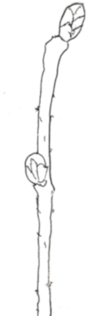 | 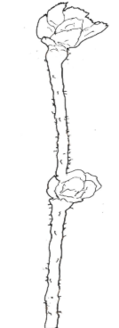 | 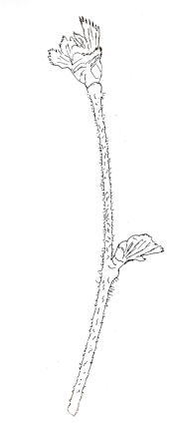
3 | 5 | 7
weak | medium | strong

Ad. 6: One-year-old shoot: density of lenticels

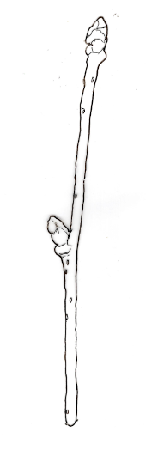 | 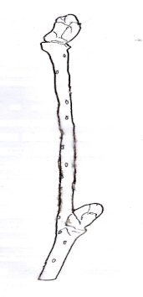 | 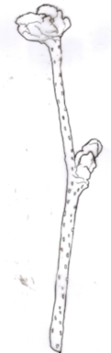
1 | 2 | 3
weak | medium | strong

Ad. 7: Bud: shape

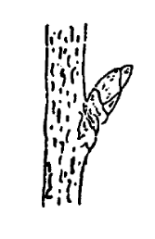 | 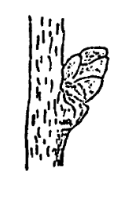 | 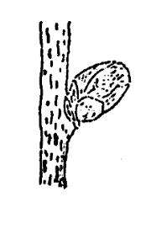
1 | 2 | 3
conical | ovoid | globular

Ad. 8: Bud: color

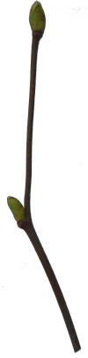 | 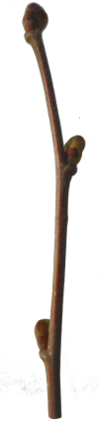 | 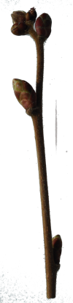
1 | 2 | 3
green | reddish green | red

Ad. 12: Leaf blade: shape

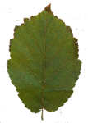 | 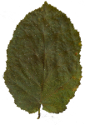 | 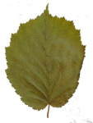 | 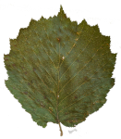
1 | 2 | 3 | 4
elliptic | ovate | obovate | circular

Ad. 17: Involucre: constriction

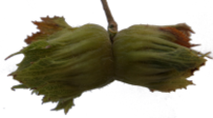 | 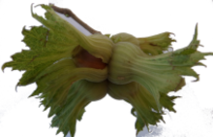
1 | 9
absent | present

Ad. 18: Involucre: ratio length to length of nut

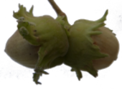 | 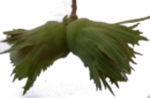 | 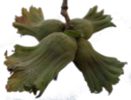
3 | 5 | 7
shorter | equal | longer

Ad. 19: Involucre: indentation

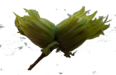 | 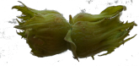 | 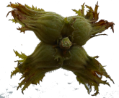
1 | 3 | 5
weak | medium | strong

Ad. 20: Involucre: serration of indentation

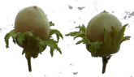 | 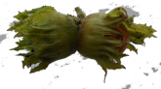 | 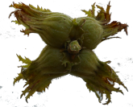
1 | 3 | 5
very weak | medium | strong

Ad. 21: Involucre: size of basal support

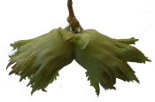 | 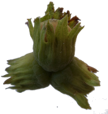 | 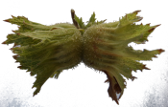
1 | 3 | 5
thin | medium | thick

Ad. 23: Involucre: density of hairiness

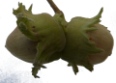 | 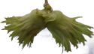 | 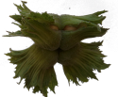 | 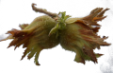
1 | 3 | 5 | 7
absent or very sparse | sparse | medium | dense

Ad. 24: Involucre: jointing of bracts

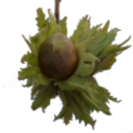 | 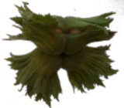 | 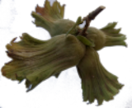
1 | 2 | 3
not present | on one side | on both sides

Ad. 27: Nut: shape in lateral view
​
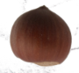 | 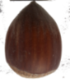 | 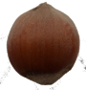 | 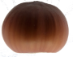 | 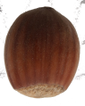 | 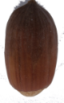
1 | 2 | 3 | 4 | 5 | 6
globose | conical | ovoid | obloid | short sub-cylindical | long sub-cylindrical

Ad. 28: Nut: shape in cross section

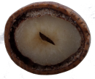 | 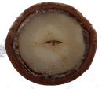 | 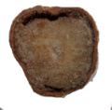 | 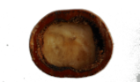
1 | 2 | 3 | 4
elliptical | circular | triangular | rectangular

Ad. 29: Nut: color

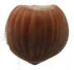 | 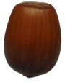 | 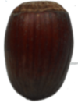
1 | 2 | 3
greenish yellow | light brown | brown

Ad. 30: Nut: conspicuousness of stripes on shell

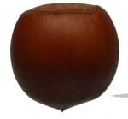 | 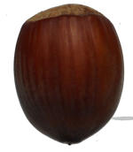 | 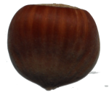
1 | 2 | 3
few | medium | many

Ad. 31: Nut: shape of apex

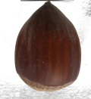 | 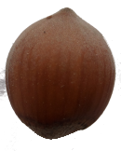 | 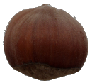 | 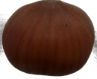
1 | 2 | 3 | 4
narrow acute | broad acute | obtuse | truncate

Ad. 32: Nut: mucron aspect

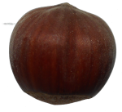 | 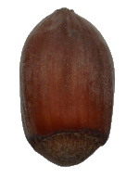 | 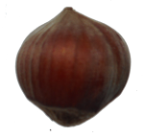
3 | 5 | 7
slightly prominent | medium prominent | strongly prominent

Ad. 33: Nut: size of pistil scar

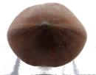 | 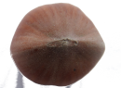 | 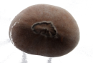
3 | 5 | 7
small | medium | large

Ad. 34: Nut: hairiness at apex

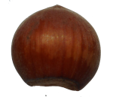 | 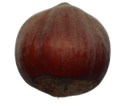 | 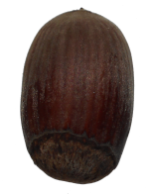
3 | 5 | 7
weak | medium | strong

Ad. 35: Nut: size of basal scar related to nut size

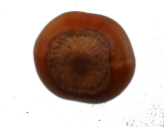 | 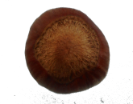 | 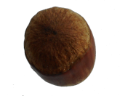
3 | 5 | 7
small | medium | large

Ad. 36: Nut: curvature of basal scar

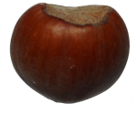 | 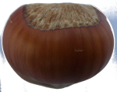 | 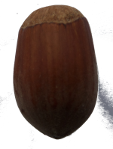
1 | 2 | 3
concave | even | convex

Ad. 38: Kernel: shape in lateral view

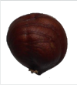 | 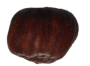 | 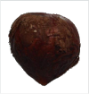 | 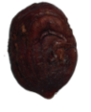 | 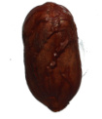
1 | 2 | 3 | 4 | 5
globose | obloid | ovoid | short sub-cylindrical | long sub-cylindrical

Ad. 39: Kernel: shape of apex

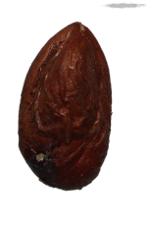 | 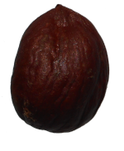 | 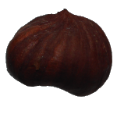
1 | 2 | 3
pointed | obtuse | truncate

Ad. 40: Kernel: shape in cross section

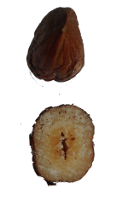 | 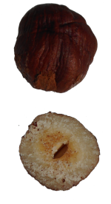 | 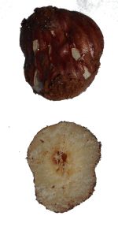
1 | 2 | 3
elliptic | circular | triangular

Ad. 41: Kernel: shape of base

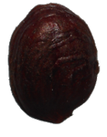 | 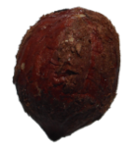 | 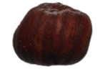
1 | 2 | 3
pointed | rounded | truncate

Ad. 42: Kernel: lateral groove

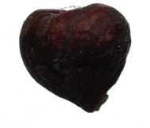 | 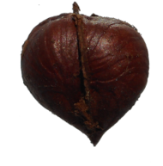
1 | 9
absent | present

Ad. 43: Kernel presence of fiber

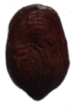 | 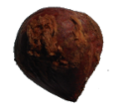 | 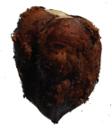
1 | 5 | 9
absent or very weak | medium | strong

8.3 | Growth stages  Phenological phases are indicated as follows:  a Observation should be made in the dormant season  b Observation should be made during flowering  c Observation should be made on fully developed leaves  d Observation should be made at the time of harvest maturity

9. | Literature

Bignami C., De Salvador R.F., Strabbioli G., 1999. Aspetti agronomici e prospettive di valorizzazione della corilicoltura nel Lazio. Frutticoltura, n.11. 16-27.

Botta R., Akkak A., Boccacci P., 2005. DNA-typing of hazelnut: a universal methodology for describing cultivars and evaluating genetic relatedness. Acta Horticulturae 686:117-124.

Cristoferi V., A.L.Pica, Silestri C., Bizzarri S. 2018. Phenology and yield evaluatation of hazelnut cultivars ib Latium region
Acta Hortic. 1226 pp 20-130.

De Salvador, F.R., Giorgioni M., Massari D., Bizzarri S., Onorati P., Kaswalder F., 2002. La collezione di Vico Matrino (VT) per il rinnovo varietale ed il miglioramento qualitativo del nocciolo. 2° Convegno Nazionale sul nocciolo, Giffoni V.P., 171-177.

De Salvador, F.R., Bignami, C., Bizzarri, S., Cristoferi, V., 2005. Monografia di cultivar di nocciolo. Regione Lazio - Area D20 Servizi di sviluppo Agricolo e Informazione Socio-economica. Stampato da Tipolitografia C.S.R. - Centro Stampa e Riproduzione-Roma - IT

P. Manzo, G. Tamponi, Monografia di cultivar di nocciuolo, 1982. Istituto Sperimentale per la Frutticoltura – Roma - IT

Mehlenbacher S.A., 1994. Genetic improvement of the hazelnut. Acta Horticulturae 351, 23-38.
Rovira M., 1997. Genetic variability among hazelnut (Corylus avellana L.) cultivars. Acta Horticulturae. 445: 45-50.

Tombesi A., Limongelli F., 2002. Varietà e miglioramento genetico del nocciolo. 2° Convegno Nazionale sul nocciolo, Giffoni V.P., ottobre 2002, 11:27.

10. | Technical Questionnaire

TECHNICAL QUESTIONNAIRE | Page {x} of {y} | Reference Number:

Application date:
(not to be filled in by the applicant)
TECHNICAL QUESTIONNAIRE
to be completed in connection with an application for plant breeders' rights

1. | Subject of the Technical Questionnaire
 | 1.1.1 | Botanical name | Corylus avellana L. | [ ]
 | 1.1.2 | Common name | Hazelnut
 | 1.2.1 | Botanical name | Corylus colurna L. | [ ]
 | 1.2.2 | Common name | Turkish Hazel

2. | Applicant
 | Name
 | Address
 | Telephone No.
 | Fax No.
 | E-mail address
 | Breeder (if different from
 | applicant)

3. | Proposed denomination and breeder's reference
 | Proposed denomination
 | (if available)
 | Breeder's reference

TECHNICAL QUESTIONNAIRE |  |  | Page {x} of {y} | Reference Number:
#4. | Information on the breeding scheme and propagation of the variety
 | 4.1 | Breeding scheme
 | Variety resulting from:
4.1.1 | Crossing
(a) | controlled cross | [ ]
(please state parent variety)

(…………………..……………..…) x (……………..…………………..…)

female parent male parent

(b) | partially known cross | [ ]
(please state known parent variety(ies))

(…………………..……………..…) x (……………..…………………..…)

female parent male parent

(c) | unknown cross | [ ]
4.1.2 | Mutation  (please state parent variety) | [ ]
4.1.3 | Discovery and development  (please state where and when discovered and how developed) | [ ]
4.1.4 | Other  (Please provide details) | [ ]

TECHNICAL QUESTIONNAIRE | Page {x} of {y} | Reference Number:

 | 4.2 | Method of propagating the variety
 | 4.2.1 Other (Please provide details) [ ]

TECHNICAL QUESTIONNAIRE | Page {x} of {y} | Reference Number:

5. | Characteristics of the variety to be indicated (the number in brackets refers to the corresponding characteristic in Test Guidelines; please mark the note which best corresponds).

 | Characteristics | Example Varieties | Note
5.1  (12) | Leaf blade: shape
 | elliptic | Merveille de Bollwiller | 1 [ ]
 | ovate | Du Chilly | 2 [ ]
 | obovate | Tonda di Giffoni | 3 [ ]
 | circular | Segorbe | 4 [ ]
5.2  (18) | Involucre: ratio length to length of nut
 | much shorter |  | 1 [ ]
 | much shorter to shorter |  | 2 [ ]
 | shorter | Tonda Bianca | 3 [ ]
 | shorter to equal |  | 4 [ ]
 | equal | Cosford, Fertile de Coutard, Merveille de Bollwiller | 5 [ ]
 | equal to longer |  | 6 [ ]
 | longer | Du Chilly, Imperiale de Trebizonde, Segorbe, Tombul, Tonda Gentile delle Langhe | 7 [ ]
 | longer to much longer |  | 8 [ ]
 | much longer |  | 9 [ ]
5.3  (19) | Involucre: indentation
 | weak | Du Chilly, Tombul | 1 [ ]
 | weak to medium |  | 2 [ ]
 | medium | Fertile de Coutard, Tonda Gentile delle Langhe | 3 [ ]
 | medium to strong |  | 4 [ ]
 | strong | Gunslebert, Negret | 5 [ ]
5.4  (21) | Involucre: size of basal support
 | thin | Cosford | 1 [ ]
 | thin to medium |  | 2 [ ]
 | medium | Merveille de Bollwiller, Segorbe | 3 [ ]
 | medium to thick |  | 4 [ ]
 | thick | Fertile de Coutard, Tonda di Giffoni | 5 [ ]

 | Characteristics | Example Varieties | Note
5.5  (26) | Nut: size
 | very small | Morell | 1 [ ]
 | very small to small |  | 2 [ ]
 | small | Negret, Tombul, Tonda Gentile delle Langhe | 3 [ ]
 | small to medium |  | 4 [ ]
 | medium | Segorbe, Tonda di Giffoni | 5 [ ]
 | medium to large |  | 6 [ ]
 | large | Fertile de Coutard, Merveille de Bollwiller | 7 [ ]
 | large to very large |  | 8 [ ]
 | very large | Apoldaer Zellernuss, Bergeri, Ennis | 9 [ ]
5.6  (27) | Nut: shape in lateral view
 | globose | Clark, Fertile de Coutard, Tonda Gentile delle Langhe | 1 [ ]
 | conical | Ennis , Jean's, Merveille de Bollwiller | 2 [ ]
 | ovoid | Imperatrice Eugenie, Negret | 3 [ ]
 | obloid | Imperiale de Trebizonde | 4 [ ]
 | short sub-cylindical | Cosford | 5 [ ]
 | long sub-cylindrical | Du Chilly | 6 [ ]

TECHNICAL QUESTIONNAIRE | Page {x} of {y} | Reference Number:

6. | Similar varieties and differences from these varieties
Please use the following table and box for comments to provide information on how your candidate variety differs from the variety (or varieties) which, to the best of your knowledge, is (or are) most similar. This information may help the examination authority to conduct its examination of distinctness in a more efficient way.

Denomination(s) of variety(ies) similar to your candidate variety | Characteristic(s) in which your candidate variety differs from the similar variety(ies) | Describe the expression of the characteristic(s) for the similar variety(ies) | Describe the expression of the characteristic(s) for your candidate variety

Example

 | Comments:

TECHNICAL QUESTIONNAIRE | Page {x} of {y} | Reference Number:

#7. | Additional information which may help in the examination of the variety
7.1 | In addition to the information provided in sections 5 and 6, are there any additional characteristics which may help to distinguish the variety?
 | Yes | [ ] | No | [ ]
 | (If yes, please provide details)
7.2 | Are there any special conditions for growing the variety or conducting the examination?
 | Yes | [ ] | No | [ ]
 | (If yes, please provide details)
7.3 | Other information
A representative color photograph of the variety displaying its main distinguishing feature(s), should accompany the Technical Questionnaire. The photograph will provide a visual illustration of the candidate variety which supplements the information provided in the Technical Questionnaire.
The key points to consider when taking a photograph of the candidate variety are:
• Indication of the date and geographic location
• Correct labeling (breeder’s reference)
• Good quality printed photograph (minimum 10 cm x 15 cm) and/or sufficient resolution electronic format version (minimum 960 x 1280 pixels)”
Further guidance on providing photographs with the Technical Questionnaire is available in document TGP/7 "Development of Test Guidelines", Guidance Note 35 (http://www.upov.int/tgp/en/).
[The link provided may be deleted by members of the Union when developing authorities’ own test guidelines.]

TG/71/4(proj.3)
Hazelnut, 2022-05-29
42

TECHNICAL QUESTIONNAIRE | Page {x} of {y} | Reference Number:

8. | Authorization for release
 | (a) | Does the variety require prior authorization for release under legislation concerning the protection of the environment, human and animal health?
 |  | Yes | [ ] | No | [ ]
 | (b) | Has such authorization been obtained?
 |  | Yes | [ ] | No | [ ]
 | If the answer to (b) is yes, please attach a copy of the authorization.

9. Information on plant material to be examined or submitted for examination

9.1 The expression of a characteristic or several characteristics of a variety may be affected by factors, such as pests and disease, chemical treatment (e.g. growth retardants or pesticides), effects of tissue culture, different rootstocks, scions taken from different growth phases of a tree, etc.
9.2 The plant material should not have undergone any treatment which would affect the expression of the characteristics of the variety, unless the competent authorities allow or request such treatment. If the plant material has undergone such treatment, full details of the treatment must be given. In this respect, please indicate below, to the best of your knowledge, if the plant material to be examined has been subjected to:

 | (a) | Microorganisms (e.g. virus, bacteria, phytoplasma) | Yes [ ] | No [ ]
 | (b) | Chemical treatment (e.g. growth retardant, pesticide) | Yes [ ] | No [ ]
 | (c) | Tissue culture | Yes [ ] | No [ ]
 | (d) | Other factors | Yes [ ] | No [ ]
 | Please provide details for where you have indicated “yes”.

10. | I hereby declare that, to the best of my knowledge, the information provided in this form is correct:
 | Applicant’s name
 | Signature |  | Date

[End of document]

