 |  | E
TG/14/10(proj.5)
ORIGINAL: English
DATE: 2022-05-24

INTERNATIONAL UNION FOR THE PROTECTION OF NEW VARIETIES OF PLANTS
 | Geneva
 | DRAFT
 | APPLE  UPOV Code(s): MALUS_DOM  Malus domestica Borkh. | *
GUIDELINES
FOR THE CONDUCT OF TESTS
FOR DISTINCTNESS, UNIFORMITY AND STABILITY

prepared by experts from Germany
to be considered by the
Technical Working Party for Fruit Crops

at its fifty-third session, to be held virtually,
from 2022-07-11 to 2022-07-15

Disclaimer: this document does not represent UPOV policies or guidance
Alternative names:*

Botanical name | English | French | German | Spanish
Malus domestica Borkh., Malus pumila Mill var. domestica, Pyrus malus L. | Apple | Pommier,  Pommier commun | Apfel, Kultur-Apfel | Manzano

The purpose of these guidelines (“Test Guidelines”) is to elaborate the principles contained in the General Introduction (document TG/1/3), and its associated TGP documents, into detailed practical guidance for the harmonized examination of distinctness, uniformity and stability (DUS) and, in particular, to identify appropriate characteristics for the examination of DUS and production of harmonized variety descriptions.

ASSOCIATED DOCUMENTS
These Test Guidelines should be read in conjunction with the General Introduction and its associated TGP documents.
Other associated UPOV documents: | TG/163 Apple Rootstocks  TG/192 Ornamental Apple

TABLE OF CONTENTS | PAGE
1. | SUBJECT OF THESE TEST GUIDELINES.......................................................................................................... | 4
2. | MATERIAL REQUIRED..................................................................................................................... | 4
3. | METHOD OF EXAMINATION............................................................................................................... | 4
3.1 | Number of Growing Cycles................................................................................................................. | 4
3.2 | Testing Place................................................................................................................... | 4
3.3 | Conditions for Conducting the Examination............................................................................................... | 5
3.4 | Test Design................................................................................................................. | 6
3.5 | Additional Tests................................................................................................................... | 6

4. | ASSESSMENT OF DISTINCTNESS, UNIFORMITY AND STABILITY................................................................. | 6
4.1 | Distinctness.......................................................................................................... | 6
4.2 | Uniformity............................................................................................................ | 7
4.3 | Stability............................................................................................................... | 7

5. | GROUPING OF VARIETIES AND ORGANIZATION OF THE GROWING TRIAL................................................ | 8
6. | INTRODUCTION TO THE TABLE OF CHARACTERISTICS................................................................................ | 8
6.1 | Categories of Characteristics...................................................................................................... | 8
6.2 | States of Expression and Corresponding Notes........................................................................................ | 9
6.3 | Types of Expression............................................................................................................ | 9
6.4 | Example Varieties.............................................................................................................. | 9
6.5 | Legend................................................................................................................. | 10

7. | TABLE OF CHARACTERISTICS/TABLEAU DES CARACTÈRES/MERKMALSTABELLE/TABLA DE CARACTERES.................................................................................................................. | 11
8. | EXPLANATIONS ON THE TABLE OF CHARACTERISTICS............................................................................... | 32
8.1 | Explanations covering several characteristics........................................................................................... | 32
8.2 | Explanations for individual characteristics................................................................................................. | 33

9. | LITERATURE................................................................................................................... | 45
10 | TECHNICAL QUESTIONNAIRE............................................................................................................ | 46

1. | Subject of these Test Guidelines
 | These Test Guidelines apply to all varieties of Malus domestica Borkh. except for varieties used only as rootstock varieties (see TG/163/3) or only as ornamental varieties (see TG/192/1).

2. | Material Required
2.1 | The competent authorities decide on the quantity and quality of the plant material required for testing the variety and when and where it is to be delivered. Applicants submitting material from a State other than that in which the testing takes place must ensure that all customs formalities and phytosanitary requirements are complied with.
2.2 | The material is to be supplied in the form of trees, on a rootstock specified by the competent authority, or in the form of budsticks or graftwood.
2.3 | The minimum quantity of plant material, to be supplied by the applicant, should be:
(a) varieties resulting from crossing:
5 trees; 5 budsticks; or 5 dormant shoots for grafting;
(b) varieties resulting from mutation:
10 trees; 10 budsticks; or 10 dormant shoots for grafting.

2.4 | The plant material supplied should be visibly healthy, not lacking in vigor, nor affected by any important pest or disease.
2.5 | The plant material should not have undergone any treatment which would affect the expression of the characteristics of the variety, unless the competent authorities allow or request such treatment. If it has been treated, full details of the treatment must be given.

3. | Method of Examination
3.1 | Number of Growing Cycles
3.1.1 | The minimum duration of tests should normally be two independent growing cycles.
3.1.2 | The two independent growing cycles may be observed from a single planting, examined in two separate growing cycles.
3.1.3 | In particular, it is essential that the trees produce a satisfactory crop of fruit in each of the two growing cycles.
3.1.4 | The growing cycle is considered to be the duration of a single growing season, beginning with bud burst (flowering and/or vegetative), flowering and fruit harvest and concluding when the following dormant period ends with the swelling of new season buds.
3.1.5 | The testing of a variety may be concluded when the competent authority can determine with certainty the outcome of the test.

3.2 | Testing Place
 | Tests are normally conducted at one place. In the case of tests conducted at more than one place, guidance is provided in TGP/9 “Examining Distinctness”.
3.3 | Conditions for Conducting the Examination
3.3.1 | The tests should be carried out under conditions ensuring satisfactory growth for the expression of the relevant characteristics of the variety and for the conduct of the examination.
3.3.2 | The optimum stage of development for the assessment of each characteristic is indicated by a number in the Table of Characteristics. The stages of development denoted by each number are described in Chapter 8.

3.4 | Test Design
3.4.1 | In the case of varieties resulting from crossing, each test should be designed to result in a total of at least 5 trees.
3.4.2 | In the case of varieties resulting from mutation, each test should be designed to result in a total of at least 10 trees.

3.4.3 | The design of the tests should be such that plants or parts of plants may be removed for measurement or counting without prejudice to the observations which must be made up to the end of the growing cycle.
3.5 | Additional Tests
 | Additional tests, for examining relevant characteristics, may be established.

4. | Assessment of Distinctness, Uniformity and Stability
4.1 | Distinctness
4.1.1 | General Recommendations
 | It is of particular importance for users of these Test Guidelines to consult the General Introduction prior to making decisions regarding distinctness. However, the following points are provided for elaboration or emphasis in these Test Guidelines.
4.1.2 | Consistent Differences
 | The differences observed between varieties may be so clear that more than one growing cycle is not necessary. In addition, in some circumstances, the influence of the environment is not such that more than a single growing cycle is required to provide assurance that the differences observed between varieties are sufficiently consistent. One means of ensuring that a difference in a characteristic, observed in a growing trial, is sufficiently consistent is to examine the characteristic in at least two independent growing cycles.
4.1.3 | Clear Differences
 | Determining whether a difference between two varieties is clear depends on many factors, and should consider, in particular, the type of expression of the characteristic being examined, i.e. whether it is expressed in a qualitative, quantitative, or pseudo-qualitative manner. Therefore, it is important that users of these Test Guidelines are familiar with the recommendations contained in the General Introduction prior to making decisions regarding distinctness.
4.1.4 | Number of Plants or Parts of Plants to be Examined
 | Unless otherwise indicated, for the purposes of distinctness, all observations on single plants should be made on 3 plants or parts of plants taken from each of 3 plants and any other observations made on all plants in the test, disregarding any off-type plants.
4.1.5 | Method of Observation
 | The recommended method of observing the characteristic for the purposes of distinctness is indicated by the following key in the Table of Characteristics (see document TGP/9 “Examining Distinctness”, Section 4 “Observation of characteristics”):

MG: single measurement of a group of plants or parts of plants
MS: measurement of a number of individual plants or parts of plants
VG: visual assessment by a single observation of a group of plants or parts of plants
VS: visual assessment by observation of individual plants or parts of plants

 | Type of observation: visual (V) or measurement (M)
 | “Visual” observation (V) is an observation made on the basis of the expert’s judgment. For the purposes of this document, “visual” observation refers to the sensory observations of the experts and, therefore, also includes smell, taste and touch. Visual observation includes observations where the expert uses reference points (e.g. diagrams, example varieties, side-by-side comparison) or non-linear charts (e.g. color charts). Measurement (M) is an objective observation against a calibrated, linear scale e.g. using a ruler, weighing scales, colorimeter, dates, counts, etc.
 | Type of record: for a group of plants (G) or for single, individual plants (S)
 | For the purposes of distinctness, observations may be recorded as a single record for a group of plants or parts of plants (G), or may be recorded as records for a number of single, individual plants or parts of plants (S). In most cases, “G” provides a single record per variety and it is not possible or necessary to apply statistical methods in a plant-by-plant analysis for the assessment of distinctness.
 | In cases where more than one method of observing the characteristic is indicated in the Table of Characteristics (e.g. VG/MG), guidance on selecting an appropriate method is provided in document TGP/9, Section 4.2.
4.2 | Uniformity
4.2.1 | It is of particular importance for users of these Test Guidelines to consult the General Introduction prior to making decisions regarding uniformity. However, the following points are provided for elaboration or emphasis in these Test Guidelines:
4.2.2 | These Test Guidelines have been developed for the examination of vegetatively propagated varieties. For varieties with other types of propagation, the recommendations in the General Introduction and document TGP/13 "Guidance for new types and species" Section 4.5 "Testing Uniformity" should be followed.
4.2.3 | For the assessment of uniformity of varieties resulting from crossing, a population standard of 1% and an acceptance probability of at least 95% should be applied. In the case of a sample size of 5 plants, no off-types are allowed.
4.2.4 | For the assessment of uniformity of varieties resulting from mutation, a population standard of 1% and an acceptance probability of at least 95% should be applied. In the case of a sample size of 10 plants, 1 off-type is allowed.
4.3 | Stability
4.3.1 | In practice, it is not usual to perform tests of stability that produce results as certain as those of the testing of distinctness and uniformity. However, experience has demonstrated that, for many types of variety, when a variety has been shown to be uniform, it can also be considered to be stable.
4.3.2 | Where appropriate, or in cases of doubt, stability may be further examined by testing a new plant stock to ensure that it exhibits the same characteristics as those shown by the initial material supplied.

5. | Grouping of Varieties and Organization of the Growing Trial
5.1 | The selection of varieties of common knowledge to be grown in the trial with the candidate varieties and the way in which these varieties are divided into groups to facilitate the assessment of distinctness are aided by the use of grouping characteristics.
5.2 | Grouping characteristics are those in which the documented states of expression, even where produced at different locations, can be used, either individually or in combination with other such characteristics: (a) to select varieties of common knowledge that can be excluded from the growing trial used for examination of distinctness; and (b) to organize the growing trial so that similar varieties are grouped together.

5.3 | The following have been agreed as useful grouping characteristics:
(a) |  | Tree: type (characteristic 2)
(b) |  | Only varieties with Tree type: ramified: Tree: habit (characteristic 3)
(c) |  | Fruit: shape (characteristic 26)
(d) |  | Fruit: hue of over color (characteristic 30)
(e) |  | Fruit: relative area of over color (characteristic 32)
(f) |  | Fruit: pattern of over color (characteristic 33)
(g) |  | Fruit: color of flesh (characteristic 45)
(h) |  | Time of beginning of flowering (characteristic 48)
(i) |  | Time for harvest (characteristic 49)
(j) |  | Time of eating maturity (characteristic 50)

5.4 | Guidance for the use of grouping characteristics, in the process of examining distinctness, is provided through the General Introduction and document TGP/9 “Examining Distinctness”.

6. | Introduction to the Table of Characteristics
6.1 | Categories of Characteristics
6.1.1 | Standard Test Guidelines Characteristics
 | Standard Test Guidelines characteristics are those which are approved by UPOV for examination of DUS and from which members of the Union can select those suitable for their particular circumstances.

6.1.2 | Asterisked Characteristics
 | Asterisked characteristics (denoted by *) are those included in the Test Guidelines which are important for the international harmonization of variety descriptions and should always be examined for DUS and included in the variety description by all members of the Union, except when the state of expression of a preceding characteristic or regional environmental conditions render this inappropriate.
6.2 | States of Expression and Corresponding Notes
6.2.1 | States of expression are given for each characteristic to define the characteristic and to harmonize descriptions. Each state of expression is allocated a corresponding numerical note for ease of recording of data and for the production and exchange of the description.
6.2.2 | All relevant states of expression are presented in the characteristic.
6.2.3 | Further explanation of the presentation of states of expression and notes is provided in document TGP/7 “Development of Test Guidelines”.
6.3 | Types of Expression
 | An explanation of the types of expression of characteristics (qualitative, quantitative and pseudo-qualitative) is provided in the General Introduction.
6.4 | Example Varieties
 | Where appropriate, example varieties are provided to clarify the states of expression of each characteristic.

6.5 | Legend
 |  | English |  | français |  | deutsch | español | Example Varieties  Exemples  Beispielssorten  Variedades ejemplo | Note/  Nota
1 | 2 | 3 | 4 | 5 | 6 | 7
 |  | Name of characteristics in English |  | Nom du caractère en français |  | Name des Merkmals auf Deutsch | Nombre del carácter en español
 |  | states of expression |  | types d’expression |  | Ausprägungsstufen | tipos de expresión

1 | Characteristic number
2 | (*) | Asterisked characteristic | – see Chapter 6.1.2
3 | Type of expression
 | QL | Qualitative characteristic | – see Chapter 6.3
 | QN | Quantitative characteristic | – see Chapter 6.3
 | PQ | Pseudo-qualitative characteristic | – see Chapter 6.3
4 | Method of observation (and type of plot, if applicable)
 | MG, MS, VG, VS |  | – see Chapter 4.1.5
5 | (+) | See Explanations on the Table of Characteristics in Chapter 8.2
6 | (a)-(f) | See Explanations on the Table of Characteristics in Chapter 8.1
7 | Growth stage key See Explanations on the Table of Characteristics in Chapter 8.3

7. | Table of Characteristics/Tableau des caractères/Merkmalstabelle/Tabla de caracteres

 |  | English |  | français |  | deutsch | español | Example Varieties  Exemples  Beispielssorten  Variedades ejemplo | Note/  Nota
1. |  | QN | MG/VG | (+) | (a) | 00
 |  | Tree: vigor
 |  | very weak |  |  |  |  |  | Grenadier, Nield’s Drooper | 1
 |  | very weak to weak |  |  |  |  |  | James Grieve, Redkan | 2
 |  | weak |  |  |  |  |  | Alkmene, Regine | 3
 |  | weak to medium |  |  |  |  |  | Piros, Pomforyou, Renora | 4
 |  | medium |  |  |  |  |  | Gala, Pinova, Trajan | 5
 |  | medium to strong |  |  |  |  |  | Dalili, Pia, Pivita | 6
 |  | strong |  |  |  |  |  | Elstar, Rafzubin, Santana | 7
 |  | strong to very strong |  |  |  |  |  | Bay 3484, Collina,  Cripps Pink | 8
 |  | very strong |  |  |  |  |  | Gloster, Ingrid Marie | 9
2. | (*) | QL | VG |  | (a) | 00
 |  | Tree: type
 |  | columnar |  |  |  |  |  | MacExcel, Wijcik | 1
 |  | ramified |  |  |  |  |  | Elstar, Golden Delicious | 2
3. |  | PQ | VG | (+) | (a) | 00
 |  | Only varieties with Tree type: ramified: Tree: habit
 |  | upright |  |  |  |  |  | Alkmene, Fresco, Solaris | 1
 |  | upright to spreading |  |  |  |  |  | Akane, Arkcharm, Harmensz, Katrina, Reka | 2
 |  | spreading |  |  |  |  |  | Pinova, Redkan, Topaz | 3
 |  | drooping |  |  |  |  |  | Idared, James Grieve, Pivita | 4
 |  | weeping |  |  |  |  |  | Gerlinde, Nield’s Drooper | 5

 |  | English |  | français |  | deutsch | español | Example Varieties  Exemples  Beispielssorten  Variedades ejemplo | Note/  Nota
4. | (*) | QN | MG/VG | (+) | (b) | 00
 |  | One-year-old shoot: length of internode
 |  | very short |  |  |  |  |  | MacExcel, Wijcik | 1
 |  | very short to short |  |  |  |  |  | Alkmene, Coxcolumnar, Tuscan | 2
 |  | short |  |  |  |  |  | Florina | 3
 |  | short to medium |  |  |  |  |  | Ahrista, Margol | 4
 |  | medium |  |  |  |  |  | Jonagold, Redaphough | 5
 |  | medium to long |  |  |  |  |  | Constance, Crowngold, Nicoter, Stela | 6
 |  | long |  |  |  |  |  | Auralia | 7
 |  | long to very long |  |  |  |  |  | Angold | 8
 |  | very long |  |  |  |  |  | Teser | 9
5. | (*) | QN | MG/VG | (+) | (b) | 00
 |  | One-year-old shoot: number of lenticels
 |  | few |  |  |  |  |  | Alkmene, Bramley’s Seedling | 1
 |  | medium |  |  |  |  |  | Cox’s Orange Pippin | 2
 |  | many |  |  |  |  |  | Mutsu, SQ 159 | 3
6. | (*) | QN | VG | (+) | (c) | 75/77
 |  | Leaf blade: attitude in relation to shoot
 |  | upwards |  |  |  |  |  | Delblush, Elstar, Fresco, Redkan, Santana | 1
 |  | upwards to outwards |  |  |  |  |  | Jugala, Prem A 153, Resista, Sweet Lady | 2
 |  | outwards |  |  |  |  |  | Cripps Pink, Jonagold, Pinova, Pomforyou, Schone van Boskoop | 3
 |  | downwards |  |  |  |  |  | Fuji BC, Himekami, Rewena | 4

 |  | English |  | français |  | deutsch | español | Example Varieties  Exemples  Beispielssorten  Variedades ejemplo | Note/  Nota
7. | (*) | QN | MG/VG | (+) | (c) | 75/77
 |  | Leaf blade: length
 |  | very short |  |  |  |  |  | Mars, Reanda | 1
 |  | very short to short |  |  |  |  |  | Coxcolumnar, Goldstar | 2
 |  | short |  |  |  |  |  | Ariwa, Gusto | 3
 |  | short to medium |  |  |  |  |  | Braeburn, Fuji BC, Topaz | 4
 |  | medium |  |  |  |  |  | Cripps Red, Dalili, Elstar | 5
 |  | medium to long |  |  |  |  |  | Jonagold, Pinova, Santana | 6
 |  | long |  |  |  |  |  | Fresco, Minnewashta, Monidel | 7
 |  | long to very long |  |  |  |  |  | Pomforyou, Pompink | 8
 |  | very long |  |  |  |  |  | Northpole, Telamon | 9
8. | (*) | QN | MG/VG | (+) | (c) | 75/77
 |  | Leaf blade: width
 |  | very narrow |  |  |  |  |  | Coxdwarf | 1
 |  | very narrow to narrow |  |  |  |  |  | Cox La Vera, Dalinco | 2
 |  | narrow |  |  |  |  |  | Braeburn,  La Flamboyante | 3
 |  | narrow to medium |  |  |  |  |  | Dalili, Dalinbel, Elstar, Topaz | 4
 |  | medium |  |  |  |  |  | Cripps Red, Nicoter, Pinova, Santana | 5
 |  | medium to broad |  |  |  |  |  | Cripps Pink, Jonagold, Rubinola, Zari | 6
 |  | broad |  |  |  |  |  | Jonagored, Rubinstep | 7
 |  | broad to very broad |  |  |  |  |  | Pomforyou | 8
 |  | very broad |  |  |  |  |  | Charlotte, Northpole | 9

 |  | English |  | français |  | deutsch | español | Example Varieties  Exemples  Beispielssorten  Variedades ejemplo | Note/  Nota
9. | (*) | QN | MG/VG | (+) | (c) | 75/77
 |  | Leaf blade: ratio length/width
 |  | very low |  |  |  |  |  |  | 1
 |  | very low to low |  |  |  |  |  | Reanda | 2
 |  | low |  |  |  |  |  | Goldstar | 3
 |  | low to medium |  |  |  |  |  | Bay 3484, Rubinola | 4
 |  | medium |  |  |  |  |  | Cripps Pink, Rafzubin, Santana | 5
 |  | medium to high |  |  |  |  |  | Braeburn, Cripps Red, Elstar, Pinova | 6
 |  | high |  |  |  |  |  | Fiesta, Minnewashta | 7
 |  | high to very high |  |  |  |  |  | Civni, Monidel | 8
 |  | very high |  |  |  |  |  | Dalinco, Telamon | 9
10 |  | PQ | VG |  | (c) | 75/77
 |  | Leaf blade: color
 |  | light green |  |  |  |  |  |  | 1
 |  | light to medium green |  |  |  |  |  | Maribelle | 2
 |  | medium green |  |  |  |  |  | Civni, Cripps Pink, Ecolette | 3
 |  | medium to dark green |  |  |  |  |  | Braeburn,  Karmijn de Sonnaville,  La Flamboyante, Pomforyou | 4
 |  | dark green |  |  |  |  |  |  | 5
 |  | light purple red |  |  |  |  |  |  | 6
 |  | medium purple red |  |  |  |  |  |  | 7
 |  | dark purple red |  |  |  |  |  | Luresweet | 8
11 |  | QN | VG |  | (c) | 75/77
 |  | Leaf blade: glossiness
 |  | absent or weak |  |  |  |  |  | Blahova Libovice, Solaris | 1
 |  | medium |  |  |  |  |  | Elstar, Falstaff | 2
 |  | strong |  |  |  |  |  | Elise, Fresco, Idared | 3
12 | (*) | QN | VG | (+) | (c) | 75/77
 |  | Leaf blade: incisions of margin
 |  | crenate |  |  |  |  |  | Braeburn, Pinova, Santana | 1
 |  | crenate to serrate |  |  |  |  |  | Ecolette, Elstar, Tenroy | 2
 |  | serrate |  |  |  |  |  | Fuji, Jonagold, Mutsu | 3

 |  | English |  | français |  | deutsch | español | Example Varieties  Exemples  Beispielssorten  Variedades ejemplo | Note/  Nota
13 |  | PQ | VG | (+) | (c) | 75/77
 |  | Leaf blade: shape in cross section
 |  | v-shaped |  |  |  |  |  | Frureru | 1
 |  | concave |  |  |  |  |  | Alkmene, Clivia, Gloster, Piros | 2
 |  | flat with reflexed margins |  |  |  |  |  | Rambour d’Hiver | 3
 |  | flat |  |  |  |  |  | Bittenfelder Sämling, Minnewashta | 4
 |  | convex |  |  |  |  |  | Collina, Vicking | 5
14 | (*) | QN | MG/VG | (+) | (c) | 75/77
 |  | Petiole: length
 |  | very short |  |  |  |  |  |  | 1
 |  | very short to short |  |  |  |  |  | Jonagold | 2
 |  | short |  |  |  |  |  | Delgollune, Jonagored | 3
 |  | short to medium |  |  |  |  |  | Bay 3484, Dalinbel | 4
 |  | medium |  |  |  |  |  | Cripps Pink, Ecolette, Nicoter, Pinova, Topaz | 5
 |  | medium to long |  |  |  |  |  | Civni, Cripps Red, Elstar | 6
 |  | long |  |  |  |  |  | Resista | 7
 |  | long to very long |  |  |  |  |  | Pomforyou, Trajan | 8
 |  | very long |  |  |  |  |  | Northpole, Pompink | 9
15 |  | QN | MG/VG | (+) | (c) | 75/77
 |  | Leaf: ratio length of leaf blade / length of petiole
 |  | very low |  |  |  |  |  |  | 1
 |  | low |  |  |  |  |  |  | 2
 |  | medium |  |  |  |  |  |  | 3
 |  | high |  |  |  |  |  |  | 4
 |  | very high |  |  |  |  |  |  | 5

 |  | English |  | français |  | deutsch | español | Example Varieties  Exemples  Beispielssorten  Variedades ejemplo | Note/  Nota
16 |  | QN | VG |  | (c) | 75/77
 |  | Petiole: extension of anthocyanin coloration from base
 |  | absent or very small |  |  |  |  |  | Befresh | 1
 |  | small |  |  |  |  |  | Civni, Cripps Red, Jonagold | 2
 |  | medium |  |  |  |  |  | Braeburn, Dalinbel, Pilot | 3
 |  | large |  |  |  |  |  | Pomforyou, Scired | 4
 |  | very large |  |  |  |  |  | Bay 3484 | 5
17 | (*) | QN | MG/VG | (+) | (d) | 60/65
 |  | Flower: diameter
 |  | very small |  |  |  |  |  | Spätblühender Taffetapfel | 1
 |  | small |  |  |  |  |  | Pia, Pingo | 2
 |  | medium |  |  |  |  |  | Civni, Elstar, Pinova | 3
 |  | large |  |  |  |  |  | Delcorf, Rafzubin, Zari | 4
 |  | very large |  |  |  |  |  | Astramel | 5
18 |  | QN | VG | (+) | (d) | 60/65
 |  | Flower: position of stigmas relative to anthers
 |  | below |  |  |  |  |  | Bay 3484, Braeburn, Pomforyou, Topaz | 1
 |  | same level |  |  |  |  |  | Cripps Pink, Ecolette, Pinova, Santana | 2
 |  | above |  |  |  |  |  | Civni, Elstar, Nicoter, Rafzubin | 3
19 |  | QN | VG | (+) | (d) | 67/69
 |  | Flower: intensity of anthocyanin coloration at base of filament
 |  | absent or very weak |  |  |  |  |  | Braeburn, Cripps Pink, Karneval, Minnewashta | 1
 |  | weak |  |  |  |  |  | Bruggers Festivale, Dalinbel, Red Jonaprince | 2
 |  | medium |  |  |  |  |  | Elstar | 3
 |  | strong |  |  |  |  |  | Weirouge | 4
 |  | very strong |  |  |  |  |  | Luregust | 5

 |  | English |  | français |  | deutsch | español | Example Varieties  Exemples  Beispielssorten  Variedades ejemplo | Note/  Nota
20 | (*) | QN | VG | (+) | (d) | 60/65
 |  | Flower: arrangement of petals
 |  | free |  |  |  |  |  | Braeburn, Nicoter, Scifresh | 1
 |  | intermediate |  |  |  |  |  | Civni, Elstar, Pinova, Topaz | 2
 |  | overlapping |  |  |  |  |  | Cripps Red, Pomforyou, Šampion | 3
21 |  | QN | VG |  | (e) | 73/74
 |  | Young fruit: relative area of over color
 |  | absent or very small |  |  |  |  |  | Norhey | 1
 |  | very small to small |  |  |  |  |  | Nicogreen | 2
 |  | small |  |  |  |  |  | Cripps Pink, Delcorf, Nicoter | 3
 |  | small to medium |  |  |  |  |  | Braeburn, Tenroy, Topaz | 4
 |  | medium |  |  |  |  |  | Elstar, Golden Delicious | 5
 |  | medium to large |  |  |  |  |  | Pinova, Solaris | 6
 |  | large |  |  |  |  |  | Delblush, Rafzubin | 7
 |  | large to very large |  |  |  |  |  | Jolana | 8
 |  | very large |  |  |  |  |  | Bay 3484, Luregust | 9
22 | (*) | QN | MG |  | (f) | 89
 |  | Fruit: weight
 |  | very low |  |  |  |  |  | Api Noir | 1
 |  | very low to low |  |  |  |  |  | Norhey | 2
 |  | low |  |  |  |  |  | Heco, Trajan | 3
 |  | low to medium |  |  |  |  |  | Bay 3484, Pomforyou | 4
 |  | medium |  |  |  |  |  | Cripps Pink, Elstar, Pinova, Topaz | 5
 |  | high |  |  |  |  |  | Golden Delicious, Santana | 6
 |  | medium to high |  |  |  |  |  | Jonagold, Nicoter | 7
 |  | high to very high |  |  |  |  |  | Nicogreen | 8
 |  | very high |  |  |  |  |  | Howgate Wonder, Pisaxa | 9

 |  | English |  | français |  | deutsch | español | Example Varieties  Exemples  Beispielssorten  Variedades ejemplo | Note/  Nota
23 | (*) | QN | MG/VG | (+) | (f) | 89
 |  | Fruit: height
 |  | very short |  |  |  |  |  | Norhey | 1
 |  | very short to short |  |  |  |  |  | Heco | 2
 |  | short |  |  |  |  |  | Trajan | 3
 |  | short to medium |  |  |  |  |  | Elstar, Pomforyou, Topaz | 4
 |  | medium |  |  |  |  |  | Bay 3484,  La Flamboyante, Santana | 5
 |  | medium to tall |  |  |  |  |  | Cripps Pink, Pinova, Šampion | 6
 |  | tall |  |  |  |  |  | Golden Delicious, Jonagold | 7
 |  | tall to very tall |  |  |  |  |  | Pisaxa | 8
 |  | very tall |  |  |  |  |  | Befresh | 9
24 | (*) | QN | MG/VG | (+) | (f) | 89
 |  | Fruit: diameter
 |  | very small |  |  |  |  |  | Nela, Scarlet Surprise, Summerred | 1
 |  | very small to small |  |  |  |  |  | Heco | 2
 |  | small |  |  |  |  |  |  | 3
 |  | small to medium |  |  |  |  |  | Cox’s Orange Pippin, Cripps Pink, Dalili, Pomforyou | 4
 |  | medium |  |  |  |  |  | Elstar, Pinova, Topaz | 5
 |  | medium to large |  |  |  |  |  | Braeburn, Nicoter | 6
 |  | large |  |  |  |  |  | Dalinbel, Jonagold | 7
 |  | large to very large |  |  |  |  |  | Befresh, Ontario | 8
 |  | very large |  |  |  |  |  | Bramley’s Seedling | 9

 |  | English |  | français |  | deutsch | español | Example Varieties  Exemples  Beispielssorten  Variedades ejemplo | Note/  Nota
25 | (*) | QN | MG/VG | (+) | (f) | 89
 |  | Fruit: ratio height/diameter
 |  | very low |  |  |  |  |  |  | 1
 |  | very low to low |  |  |  |  |  | Brettacher, Ingol | 2
 |  | low |  |  |  |  |  | Auralia, Harmensz | 3
 |  | low to medium |  |  |  |  |  | Dalinbel, Elstar,  Karmijn de Sonnaville | 4
 |  | medium |  |  |  |  |  | Ecolette, Fuji BC, Pomforyou, Santana | 5
 |  | medium to high |  |  |  |  |  | Civni, Jonagold, Rafzubin | 6
 |  | high |  |  |  |  |  | Braeburn,  Golden Delicious, Pinova | 7
 |  | high to very high |  |  |  |  |  | Cripps Pink, Dalili | 8
 |  | very high |  |  |  |  |  | Rewena, Saturn | 9
26 | (*) | PQ | VG | (+) | (f) | 89
 |  | Fruit: shape
 |  | conical waisted |  |  |  |  |  | Gloster, Redkan | 1
 |  | conical |  |  |  |  |  | Civni, Elstar, Nicoter, Pinova, Rafzubin | 2
 |  | flat globose conical |  |  |  |  |  | Melrose | 3
 |  | ovate |  |  |  |  |  | Cripps Pink, Delcorf | 4
 |  | square |  |  |  |  |  | Bonita | 5
 |  | oblong |  |  |  |  |  | Čadel , Renora | 6
 |  | elliptic |  |  |  |  |  | Fuji BC, Minnewashta | 7
 |  | circular |  |  |  |  |  | Dalinbel, Rubinola, Topaz | 8
 |  | oblate |  |  |  |  |  | Bramley’s Seedling, Lipno | 9
 |  | obconical |  |  |  |  |  | Empire | 10
27 |  | QN | VG |  | (f) | 89
 |  | Fruit: ribbing
 |  | absent or weak |  |  |  |  |  | Elstar, Harmensz, Pinova, Scifresh, SQ 159 | 1
 |  | medium |  |  |  |  |  | Cripps Pink, Dalili, Pilot, Santana | 2
 |  | strong |  |  |  |  |  | Redkan | 3

 |  | English |  | français |  | deutsch | español | Example Varieties  Exemples  Beispielssorten  Variedades ejemplo | Note/  Nota
28 |  | QN | VG |  | (f) | 89
 |  | Fruit: crowning at calyx end
 |  | absent or weak |  |  |  |  |  | Elstar, Fresco, Heco, Schone van Boskoop | 1
 |  | medium |  |  |  |  |  | Luregust, Pinova, Santana, Scifresh, Topaz | 2
 |  | strong |  |  |  |  |  | Redkan | 3
29 | (*) | PQ | VG |  | (f) | 89
 |  | Fruit: ground color
 |  | not visible |  |  |  |  |  | Bay 3484, Lurefresh, Luregust, Red Jonaprince | 1
 |  | whitish yellow |  |  |  |  |  | Heco | 2
 |  | yellow |  |  |  |  |  | Rea Gold, Scifresh, Solaris | 3
 |  | whitish green |  |  |  |  |  | Fuji BC, MC 38, Pomforyou, Pompink | 4
 |  | yellow green |  |  |  |  |  | Jonagold, Pia, Suntan | 5
 |  | green |  |  |  |  |  | Canada gris,  Granny Smith, Ontario, Tuscan | 6
30 | (*) | PQ | VG | (+) | (f) | 89
 |  | Fruit: hue of over color
 |  | orange red |  |  |  |  |  | Goldstar, Rea Gold, Solaris | 1
 |  | pink red |  |  |  |  |  | Cripps Pink, Delorgue | 2
 |  | red |  |  |  |  |  | Pinova, Prima,  Red Elstar, Tenroy | 3
 |  | purple red |  |  |  |  |  | Bay 3484, Luresweet,  MC 38, Spartan | 4
 |  | brown red |  |  |  |  |  | Braeburn, Fiesta, Fresco, Fuji BC, Suntan | 5

 |  | English |  | français |  | deutsch | español | Example Varieties  Exemples  Beispielssorten  Variedades ejemplo | Note/  Nota
31 | (*) | QN | VG | (+) | (f) | 89
 |  | Fruit: intensity of over color
 |  | very light |  |  |  |  |  | Alexis | 1
 |  | very light to light |  |  |  |  |  | Golden Delicious, Solaris | 2
 |  | light |  |  |  |  |  | Tenroy, Tuscan | 3
 |  | light to medium |  |  |  |  |  | Elstar, Monidel, Rafzubin | 4
 |  | medium |  |  |  |  |  | Cripps Pink, Pia, Pilot, Remo | 5
 |  | medium to dark |  |  |  |  |  | Fiesta, James Grieve, Jonagold, Suntan | 6
 |  | dark |  |  |  |  |  | Elise, Jonagored, Lurefresh, Scired | 7
 |  | dark to very dark |  |  |  |  |  | Bay 3484, Obelisk,  Red Jonaprince, Redkan | 8
 |  | very dark |  |  |  |  |  | B 8 A 3-323, CIVG 198 | 9
32 | (*) | QN | VG |  | (f) | 89
 |  | Fruit: relative area of over color
 |  | absent or very small |  |  |  |  |  | Granny Smith, Tuscan | 1
 |  | very small to small |  |  |  |  |  | Golden Delicious | 2
 |  | small |  |  |  |  |  | Auralia,  Cox’s Orange Pippin, Goldstar, Solaris | 3
 |  | small to medium |  |  |  |  |  | Charlotte,  Schone van Boskoop | 4
 |  | medium |  |  |  |  |  | Dalili, Elstar, Minnewashta, Rea Gold | 5
 |  | medium to large |  |  |  |  |  | Heco, Pia, Rafzubin | 6
 |  | large |  |  |  |  |  | Fiesta, Santana, Suntan, Tenroy | 7
 |  | large to very large |  |  |  |  |  | Mars, Rosy Glow, SQ 159 | 8
 |  | very large |  |  |  |  |  | Bay 3484, MC 38,  Red Jonaprince, Redkan | 9

 |  | English |  | français |  | deutsch | español | Example Varieties  Exemples  Beispielssorten  Variedades ejemplo | Note/  Nota
33 | (*) | PQ | VG | (+) | (f) | 89
 |  | Fruit: pattern of over color
 |  | only solid flush |  |  |  |  |  | Bay 3484,  Red Jonaprince, Telamon | 1
 |  | solid flush with stripes |  |  |  |  |  | Bruggers Festivale, Charlotte, Cripps Pink, Dalili,  James Grieve Esselborn, Pingo | 2
 |  | only stripes (no flush) |  |  |  |  |  | Dülmener Rosenapfel | 3
 |  | flushed and mottled |  |  |  |  |  | Dalinbel, Scifresh | 4
 |  | flushed, striped and mottled |  |  |  |  |  | Elstar, Pinova, Rafzubin, Topaz | 5
 |  | marbled |  |  |  |  |  | Karneval | 6
34 |  | QN | VG |  | (f) | 89
 |  | Fruit: conspicuousness of stripes
 |  | absent or weak |  |  |  |  |  | Eden | 1
 |  | medium |  |  |  |  |  | Tenroy | 2
 |  | strong |  |  |  |  |  | Caudle | 3
35 | (*) | QN | VG |  | (f) | 89
 |  | Fruit: area of russet around stalk attachment
 |  | absent or small |  |  |  |  |  | Dalili, Jonagold, Pinova, Tuscan | 1
 |  | medium |  |  |  |  |  | Charlotte, Nela, Pilot, Prima | 2
 |  | large |  |  |  |  |  | Elstar, Holsteiner Cox, Schone van Boskoop, Suntan | 3
36 |  | QN | VG |  | (f) | 89
 |  | Fruit: area of russet on cheeks
 |  | absent or small |  |  |  |  |  | Gala, Jonagold, Monidel, Obelisk, Pia, Pilot | 1
 |  | medium |  |  |  |  |  | Lurefresh,  Schone van Boskoop, Suntan | 2
 |  | large |  |  |  |  |  | Canada gris,  Egremont Russet, Zabergäurenette | 3

 |  | English |  | français |  | deutsch | español | Example Varieties  Exemples  Beispielssorten  Variedades ejemplo | Note/  Nota
37 | (*) | QN | VG |  | (f) | 89
 |  | Fruit: area of russet around eye basin
 |  | absent or small |  |  |  |  |  | Gala, Jonagold, Pinova, Prima | 1
 |  | medium |  |  |  |  |  | Elstar, Holsteiner Cox | 2
 |  | large |  |  |  |  |  | Egremont Russet, Fresco, Schone van Boskoop, Suntan | 3
38 |  | QN | MG/VG | (+) | (f) | 89
 |  | Fruit: number of lenticels
 |  | very few |  |  |  |  |  |  | 1
 |  | few |  |  |  |  |  | Coxcolumnar, Rewena | 2
 |  | medium |  |  |  |  |  | Elstar, Pia, Pinova, Redkan, Tenroy | 3
 |  | many |  |  |  |  |  | Dalili, Honeycrisp, Jonagored, Scifresh | 4
 |  | very many |  |  |  |  |  | Hidden Rose | 5
39 | (*) | QN | MG/VG | (+) | (f) | 89
 |  | Fruit: length of stalk
 |  | very short |  |  |  |  |  |  | 1
 |  | short |  |  |  |  |  | Holsteiner Cox, Minnewashta, Telamon, Trajan, Tuscan | 2
 |  | medium |  |  |  |  |  | Bay 3484, Lurefresh, Nicoter | 3
 |  | long |  |  |  |  |  | Elise, Pinova, Rafzubin, Tenroy | 4
 |  | very long |  |  |  |  |  | Rewena | 5
40 | (*) | QN | MG/VG | (+) | (f) | 89
 |  | Fruit: depth of stalk cavity
 |  | very shallow |  |  |  |  |  |  | 1
 |  | shallow |  |  |  |  |  | Pomfit, Pompink, Rafzubin, Suntan, Trajan | 2
 |  | medium |  |  |  |  |  | Dalili, Elstar, Fiesta, Topaz | 3
 |  | deep |  |  |  |  |  | Jonagold, MC 38,  Rosy Glow | 4
 |  | very deep |  |  |  |  |  |  | 5

 |  | English |  | français |  | deutsch | español | Example Varieties  Exemples  Beispielssorten  Variedades ejemplo | Note/  Nota
41 |  | QN | VG |  | (f) | 89
 |  | Fruit: calyx eye
 |  | closed |  |  |  |  |  |  | 1
 |  | partially open |  |  |  |  |  |  | 2
 |  | fully open |  |  |  |  |  |  | 3
42 | (*) | QN | MG/VG | (+) | (f) | 89
 |  | Fruit: depth of eye basin
 |  | very shallow |  |  |  |  |  |  | 1
 |  | shallow |  |  |  |  |  | Braeburn, Lurefresh | 2
 |  | medium |  |  |  |  |  | Obelisk, Pinova, Scifresh, Topaz | 3
 |  | deep |  |  |  |  |  | Dalili, Elstar, Jonagold | 4
 |  | very deep |  |  |  |  |  | MC 38 | 5
43 | (*) | QN | MG/VG | (+) | (f) | 89
 |  | Fruit: width of eye basin
 |  | very narrow |  |  |  |  |  |  | 1
 |  | narrow |  |  |  |  |  | SQ 159 | 2
 |  | medium |  |  |  |  |  | Braeburn, Elstar, Minnewashta, Pia, Tenroy | 3
 |  | broad |  |  |  |  |  | Bruggers Festivale, Dalili, Dalinbel, Obelisk | 4
 |  | very broad |  |  |  |  |  | Solaris | 5
44 | (*) | QN | MG/VG | (+) | (f) | 89
 |  | Fruit: firmness of flesh
 |  | very soft |  |  |  |  |  | Transparent de Croncels | 1
 |  | soft |  |  |  |  |  | Bay 3484, Pia, Pingo, Piros, Tuscan | 2
 |  | medium |  |  |  |  |  | Obelisk, Red Fuji, Santana,  Schone van Boskoop, Topaz | 3
 |  | firm |  |  |  |  |  | Braeburn, Pilot | 4
 |  | very firm |  |  |  |  |  | LB 4852 | 5

 |  | English |  | français |  | deutsch | español | Example Varieties  Exemples  Beispielssorten  Variedades ejemplo | Note/  Nota
45 | (*) | PQ | VG |  | (f) | 89
 |  | Fruit: color of flesh
 |  | white |  |  |  |  |  | Akane, Minnewashta, Pia, Spartan | 1
 |  | yellowish white |  |  |  |  |  | Elstar, Jonagold, Pinova, Rafzubin | 2
 |  | yellowish |  |  |  |  |  | Coxcolumnar, Pisaxa, Topaz, Zari | 3
 |  | orange |  |  |  |  |  | Transcendent Crab | 4
 |  | greenish |  |  |  |  |  | Angold, Gloster,  Granny Smith, Northpole, Telamon | 5
 |  | pinkish |  |  |  |  |  | Pomfit | 6
 |  | reddish |  |  |  |  |  | Bay 3484, Lureprec | 7
 |  | whitish, yellowish or greenish with pinkish or reddish patterns |  |  |  |  |  | R 201 | 8
46 |  | QN | VG |  |  | 89
 |  | Only varieties with Fruit color of flesh other than whitish, yellowish or greenish only: Flesh color: extent
 |  | very small |  |  |  |  |  |  | 1
 |  | small |  |  |  |  |  |  | 2
 |  | medium |  |  |  |  |  | Bay 3484 | 3
 |  | large |  |  |  |  |  |  | 4
 |  | very large |  |  |  |  |  | Luregust | 5
47 | (*) | PQ | VG | (+) |  | 89
 |  | Only varieties with Fruit color of flesh other than whitish, yellowish or greenish only: Flesh color: distribution
 |  | predominantly around skin |  |  |  |  |  |  | 1
 |  | predominantly around core |  |  |  |  |  |  | 2
 |  | other |  |  |  |  |  |  | 3

 |  | English |  | français |  | deutsch | español | Example Varieties  Exemples  Beispielssorten  Variedades ejemplo | Note/  Nota
48 | (*) | QN | MG/VG | (+) |  | 61
 |  | Time of beginning of flowering
 |  | very early |  |  |  |  |  | Anna, Ein-Shemer | 1
 |  | very early to early |  |  |  |  |  | Collina, Delblush, Pompink | 2
 |  | early |  |  |  |  |  | Astramel, Civni, Idared, Topaz | 3
 |  | early to medium |  |  |  |  |  | Cripps Red, Dalili,  James Grieve, Jonagored | 4
 |  | medium |  |  |  |  |  | Braeburn, Rafzubin, Tenroy,  White Transparent, Zari | 5
 |  | medium to late |  |  |  |  |  | Elise, Gala,  Granny Smith, Sansa | 6
 |  | late |  |  |  |  |  | Golden Delicious,  Karmijn de Sonnaville, Reine de Reinettes, Sirprize | 7
 |  | late to very late |  |  |  |  |  | Delorina, Suntan | 8
 |  | very late |  |  |  |  |  | Spätblühender Taffetapfel | 9

 |  | English |  | français |  | deutsch | español | Example Varieties  Exemples  Beispielssorten  Variedades ejemplo | Note/  Nota
49 | (*) | QN | MG/VG | (+) |  | 87
 |  | Time for harvest
 |  | extremely early |  |  |  |  |  | Astramel, Collina,  White Transparent | 1
 |  | extremely early to very early |  |  |  |  |  | Piros | 2
 |  | very early |  |  |  |  |  | Arkcharm, Lena, Minnewashta, Nela | 3
 |  | very early to early |  |  |  |  |  | Bruggers Festivale, Coxcolumnar, Dalili | 4
 |  | early |  |  |  |  |  | Akane, Delorgue,  James Grieve, Monidel, Sansa | 5
 |  | early to medium |  |  |  |  |  | Gerlinde, Prima, Santana, Zari | 6
 |  | medium |  |  |  |  |  | Bay 3484, Fiesta, Rubinola | 7
 |  | medium to late |  |  |  |  |  | Civni, Elstar,  Karmijn de Sonnaville, Saturn, Suntan, Tenroy | 8
 |  | late |  |  |  |  |  | Jonagold, Pomforyou, Redkan, Sirprize, Telamon | 9
 |  | late to very late |  |  |  |  |  | Florina, Golden Delicious, La Flamboyante, Pinova, Pompink, Topaz | 10
 |  | very late |  |  |  |  |  | Delblush, Delgollune,  Fuji BC, Mutsu, Nicoter | 11
 |  | very late to extremely late |  |  |  |  |  | Braeburn, Fuji | 12
 |  | extremely late |  |  |  |  |  | Cripps Pink, Cripps Red, Granny Smith, Iduna | 13

 |  | English |  | français |  | deutsch | español | Example Varieties  Exemples  Beispielssorten  Variedades ejemplo | Note/  Nota
50 | (*) | QN | MG/VG | (+) |  | 89
 |  | Time of eating maturity
 |  | extremely early |  |  |  |  |  | Samo | 1
 |  | extremely early to very early |  |  |  |  |  | Astramel, Julia | 2
 |  | very early |  |  |  |  |  | Discovery, Helios, Nela | 3
 |  | very early to early |  |  |  |  |  | Bruggers Festivale, Minnewashta | 4
 |  | early |  |  |  |  |  | Alkmene, Gravensteiner, James Grieve, Transparent de Croncels | 5
 |  | early to medium |  |  |  |  |  | Santana | 6
 |  | medium |  |  |  |  |  | Elstar, Gala,  Holsteiner Cox,  Reine de Reinettes | 7
 |  | medium to late |  |  |  |  |  | Honeycrisp, Karneval, Rubinstep | 8
 |  | late |  |  |  |  |  | Golden Delicious, Jonagold, Pinova, Topaz | 9
 |  | late to very late |  |  |  |  |  | Nicoter, Pilot, Scifresh, Solaris | 10
 |  | very late |  |  |  |  |  | Braeburn, Florina | 11
 |  | very late to extremely late |  |  |  |  |  | Elise | 12
 |  | extremely late |  |  |  |  |  | Cripps Pink,  Granny Smith | 13

8. | Explanations on the Table of Characteristics
8.1 | Explanations covering several characteristics
 | Characteristics containing the following key in the Table of Characteristics should be examined as indicated below:
(a) | Observations should be made on bare trees in winter, after at least one significant production of fruit.
(b) | Observations on one-year-old shoots should be made on lateral dormant shoots in winter, on trees that have completed at least one growing season.
(c) | Observations should be made on fully developed leaves from the middle third of vigorous vegetative current season shoot
(d) | Observations should be made on second or subsequent flowers, at the start of anther dehiscence.
(e) | Observations should be made around 40 days after flowering (stage 65), when the fruit reaches stages 73-74.
(f) | Observations on the fruit should be made on fruits when they are eating ripe.

8.2 | Explanations for individual characteristics
Ad. 1: Tree: vigor

The vigor of the tree should be considered as the overall abundance of vegetative growth, after at least 1 significant production of fruit. It can either be assessed at the peak of vegetative growth in summer, or during the dormant season before pruning, with reference to shoot length and thickness, and to trunk diameter.

Ad. 3: Only varieties with Tree type: ramified: Tree: habit

The habit of the tree should be assessed in dormant period, after at least one sufficient fruit production.

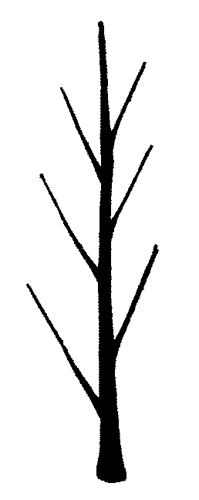 | 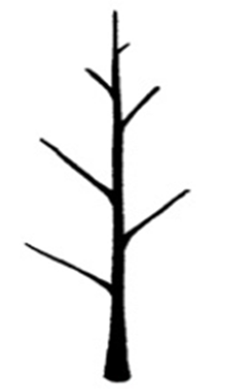 | 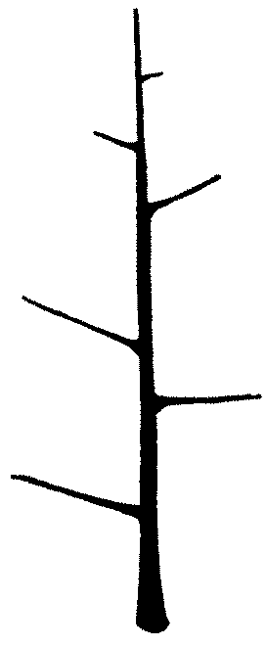 | 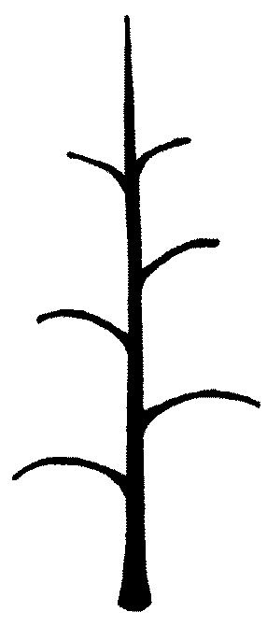 | 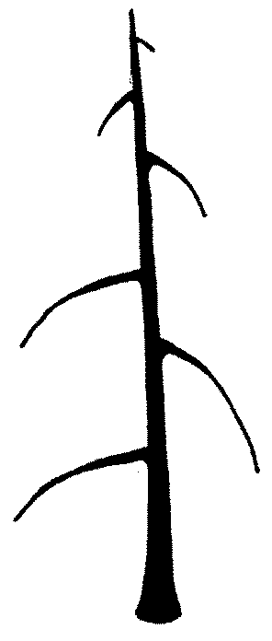
1 | 2 | 3 | 4 | 5
upright | upright to spreading | spreading | drooping | weeping

Ad. 4: One-year-old shoot: length of internode

The length of the internode should be observed in the middle third of the shoot. Measurements can be made using a vernier caliper gauge.

Ad. 5: One-year-old shoot: number of lenticels

The number of lenticels should be assessed at midlength of the shoot, by counting (in a defined area [e.g. a shoot length of 1 cm]) or by visual assessment of the density of lenticels on the bark.

Ad. 6: Leaf blade: attitude in relation to shoot

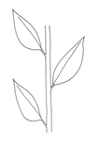 | 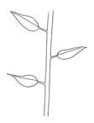 | 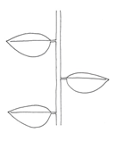 | 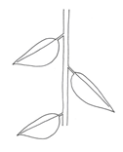
1 | 2 | 3 | 4
upwards | upwards to outwards | outwards | downwards

Ad. 7: Leaf blade: length
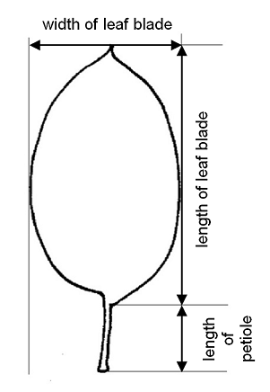

Ad. 8: Leaf blade: width

See Ad. 7

Ad. 9: Leaf blade: ratio length/width

See Ad. 7

Ad. 12: Leaf blade: incisions of margin

The predominant type of incision at distal half should be observed.

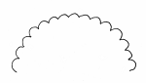 | 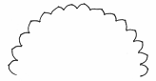 | 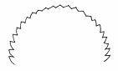
1 | 2 | 3
crenate | crenate to serrate | serrate

Ad. 13: Leaf blade: shape in cross section

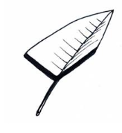 | 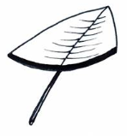 | 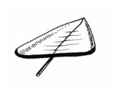
1 | 2 | 3
v-shaped | concave | flat with raised margins

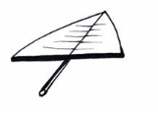
4 | 5
flat | convex

Ad. 14: Petiole: length

See Ad. 7

Ad. 15: Leaf: ratio length of leaf blade / length of petiole

See Ad. 7

Ad. 17: Flower: diameter

The diameter of the flower should be assessed with petals pressed into horizontal position.

Ad. 18: Flower: position of stigmas relative to anthers

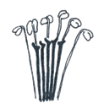 | 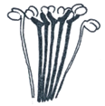 | 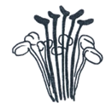
1 | 2 | 3
below | same level | above

Ad. 19: Flower: intensity of anthocyanin coloration at base of filament

The anthocyanin coloration at the base of filament should be observed just after petal drop.

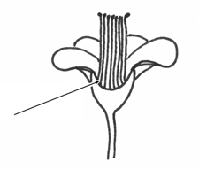

Ad. 20: Flower: arrangement of petals

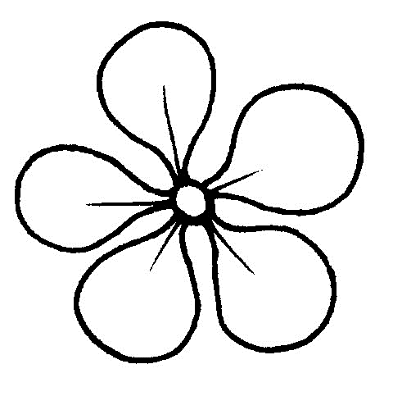 | 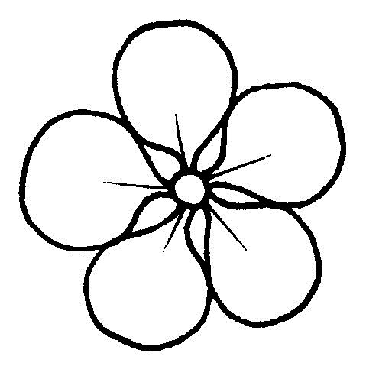 | 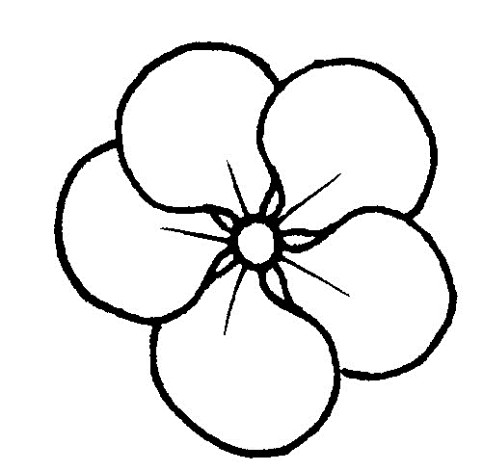
1 | 2 | 3
free | intermediate | overlapping

Ad. 23: Fruit: height

The maximum height should be observed.
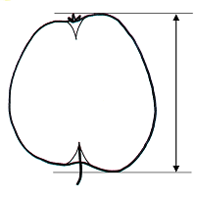

Ad. 24: Fruit: diameter

The maximum diameter should be observed.

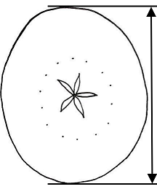

Ad. 25: Fruit: ratio height/diameter

A ratio in the middle of the possible range represents states 1, 5, 8, or 10 of char. 26; values smaller than the middle would result in notes 3 or 9 of char. 26; values larger than the middle would be notes 2, 4, 6 or 7 of char. 26.

Ad. 26: Fruit: shape

See Ad. 25
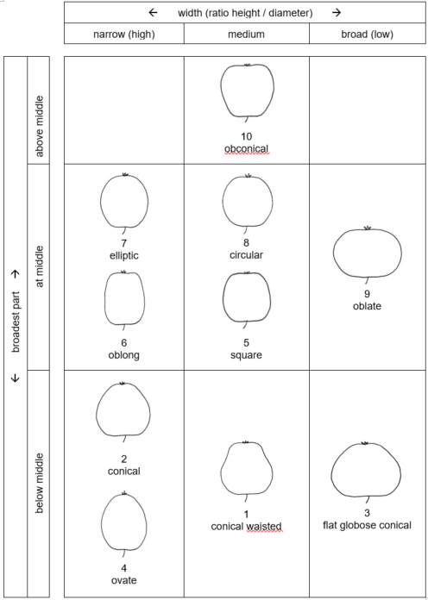

Ad. 30: Fruit: hue of over color

The over color should be observed after removing bloom.

Ad. 31: Fruit: intensity of over color

(to be updated)

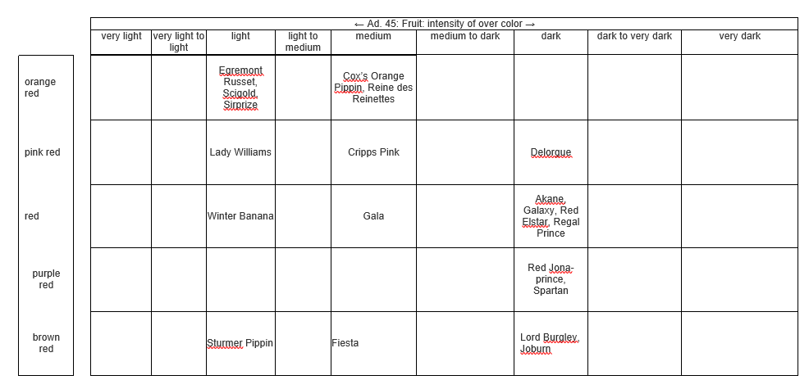

Ad. 33: Fruit: pattern of over color

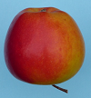 | 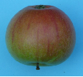 | 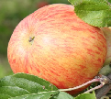
1 | 2 | 3
only solid flush | solid flush with stripes | only stripes (no flush)
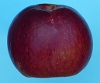 | 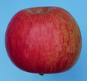 | 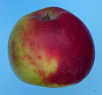
4 | 5 | 6
flushed and mottled | flushed, striped and mottled | marbled

Ad. 38: Fruit: number of lenticels

The number of lenticels should be assessed at midlength of the fruit, by counting (in a defined area [e.g. a window of 1 cm²] or by visual assessment of the density of lenticels on the skin.

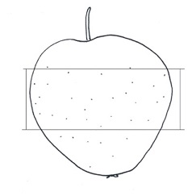

Ad. 39: Fruit: length of stalk

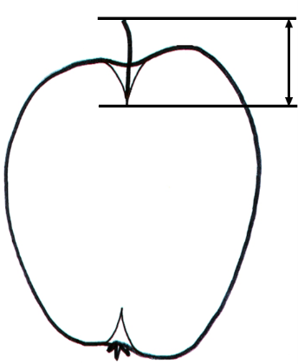

Ad. 40: Fruit: depth of stalk cavity

Fruits should be cut through the central axis as accurately as possible. Stalk cavity and eye basin depth and width should be measured from the sectioned fruits. The following diagram indicates the position of lines scored, using a knife or scalpel, on the fruit prior to measuring these characteristics.

• The lines a-b and e-f must be at right angles to the axis of the fruit. (A plastic protractor can be used to ensure accuracy.)
• The line a-b is marked at the base of the sepals.
• The line e-f is marked at the insertion of the stalk.
• The lines a-c and b-d indicate the eye basin depth. They are drawn at right angles to the line a-b to the point where the basin curve levels out.
• The lines e-g and f-h indicate the stalk cavity depth. They are drawn at right angles to the line e-f to the point where the stalk cavity curve levels out.
• In the case of asymmetric or irregular sections, the larger side should be considered (i.e. in case of depths of stalk cavity: e-g instead of f-h; in case of depth of eye basin: b-d instead of a-c).

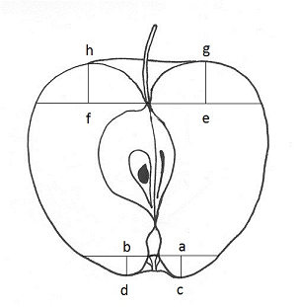 | f-h = depth of stalk cavity (characteristic 40)  a-c = depth of eye basin (characteristic 42)  a-b = width of eye basin (characteristic 43)

Ad. 42: Fruit: depth of eye basin

See Ad. 40.

Ad. 43: Fruit: width of eye basin

See Ad. 40.

Ad. 44: Fruit: firmness of flesh

Firmness of flesh should be assessed at time of ripeness for eating. It can be measured using a penetrometer.

Ad. 47: Only varieties with Fruit color of flesh other than whitish, yellowish or greenish only: Flesh color: distribution

To be observed in cross section.

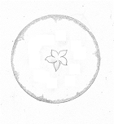 | 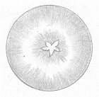
1 | 2
predominantly around skin | predominantly around core

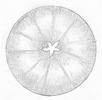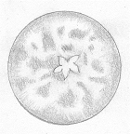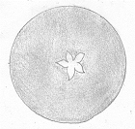
3
other

Ad. 48: Time of beginning of flowering

The time of beginning of flowering is when 10% of the flowers are fully open.

Ad. 49: Time for harvest

The time for harvest should be assessed as time when fruits are picking ripe and can most easily be picked from the trees. As this physiological stage of the fruit is characterized by a degression of starch content in the flesh, the time for harvest can also be assessed by measuring the starch content.

Ad. 50: Time of eating maturity

The time of eating maturity is when the fruit is eating ripe and has reached its optimum of flavor and aroma. Eating maturity can be reached on trees or in cold chambers. As this physiological stage of the fruit is characterized by a degression of starch content in the flesh, the time of eating maturity can also be assessed by measuring the starch content.

8.3 | 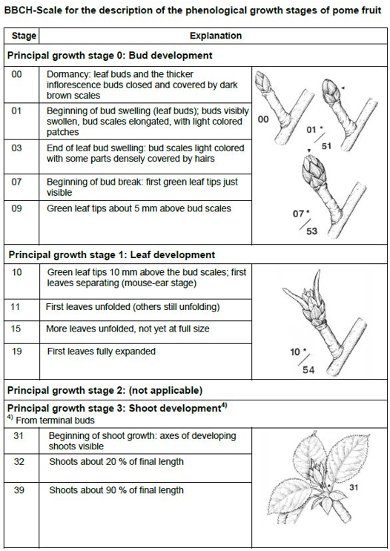  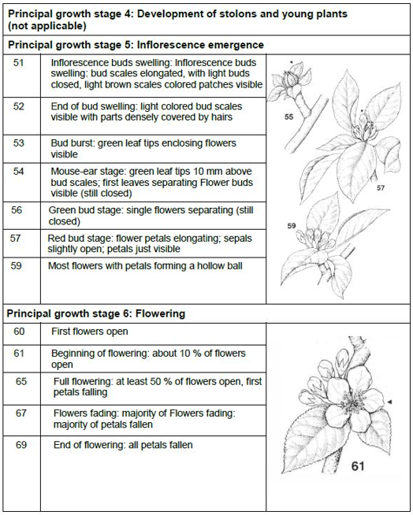  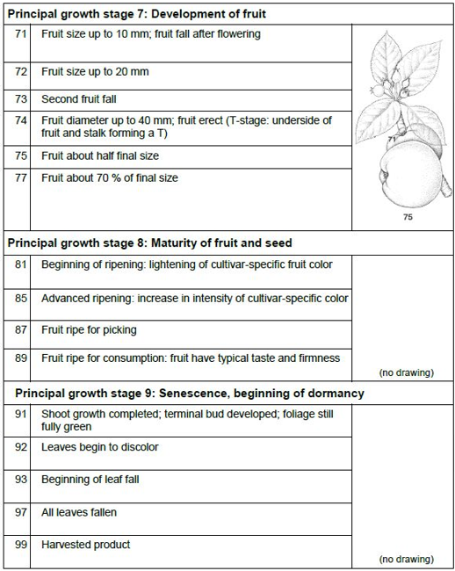  Example varieties Synonyms  Api Noir Schwarzer Noir  Auralia Tumanga  Canada gris Kanadarenette; Reinette de Caen  Cox's Orange Pippin Cox Orangenrenette  Gloster Gloster 69  Golden Delicious Gelber Köstlicher  Golden Noble Gelber Edelapfel  Ingrid Marie Hoed Orange  Rambour d'Hiver Tenroy Rheinischer Winterrambur Royal Gala  Teser TSR 29  Transparente de Croncels Yellow Transparent  Šampion Shampion  Schone van Boskoop Belle de Boskoop; Schöner aus Boskoop  White Transparent Papirovka, Transparente Jaune, Weißer Klarapfel

9. | Literature

Aeppli, A., Gremminger, U., Rapillard, Ch., Röthlisberger, K., 1983: “100 Obstsorten”, Verlag Landwirtschaftliche Lehrmittelzentrale Zollikofen, CH
Aomori-ken, 1977: “The report on the characterization and classification of apple varieties,” Aomori-ken, JP
Baldini, E., Sansavini, S., 1967: “Monografia delle principale cultivar di melo,” Istituto di coltivazioni arboree dell’Università di Bologna, IT
Bergamini, A., Faedi, W. 1983 and 1985: “Monografia di cultivar di melo”, Volumes I + II, Ministero Agricoltura e Foreste, Roma, IT
Brozik, S., Regius J., 1957: “Termeszett gyumolcsfajtaink Almastermesuek. Alma Fruit varieties Apple,” Mezogazdasagi Kiado, Budapest, HU
Bultitude, J., 1983: “A Guide to the Identification of International Varieties,” Macmillan Reference Books, Macmillan Press, London, GB
Dvorak, A., et al., 1956: “Jablka (Apple),” Academia Praha, CZ
Fischer, M., 1995: “Farbatlas Obstsorten,” Eugen Ulmer Verlag, Stuttgart, DE
Fleckinger, J., 1948: "Les stades végétatives des arbres frutiers, en rapport avec les traitements." Pomology Français 1948, supplements 81-93, FR
Khanizadeh, S. and Cousineau, J., 1998: “Our Apples – Les Pommiers de chez nous”, Agriculture and Agri-Food Canada, St.-Jean-sur Richelieu, Quebec, CA
Kessler, H., 1948: “Apfelsorten der Schweiz”, Verlag Verbandsdruckerei AG Bern, CH
Krümmel, H., Groh W., Friedrich, G., 1956: “Deutsche Obstsorten”, Deutscher Bauernverlag, Berlin, DE

Meier, U., 1997: "Growth stages of mono- and dicotyledonous plants." Blackwell, Berlin, Vienna.
Morgan, J., Richards, A., 2002: “The Book of Apples,” Ebury Press, London, GB
Nilsson, Anton, 1987: “Vara applesorter” Allmanna Forlaget AB, Stockholm SE
Petzold, H., 1990: “Apfelsorten”, Verlag Neumann, Leipzig, Radebeul, DE
Silbereisen, R., 1980: “Apfelsorten” 2nd. ed., Verlag Eugen Ulmer, Stuttgart, DE
Smith, M.W.G., 1971: “National Apple Register of the United Kingdom,” Ministry of Agriculture, Fisheries & Food, London, GB
Toth, G. M., 2001: “Gyumolcseszet” Primom, Nyiregyhaza, HU

10. | Technical Questionnaire

TECHNICAL QUESTIONNAIRE | Page {x} of {y} | Reference Number:

Application date:
(not to be filled in by the applicant)
TECHNICAL QUESTIONNAIRE
to be completed in connection with an application for plant breeders' rights

1. | Subject of the Technical Questionnaire
 | 1.1 | Botanical name | Malus domestica Borkh.
 | 1.2 | Common name | Apple

2. | Applicant
 | Name
 | Address
 | Telephone No.
 | Fax No.
 | E-mail address
 | Breeder (if different from
 | applicant)

3. | Proposed denomination and breeder's reference
 | Proposed denomination
 | (if available)
 | Breeder's reference

TECHNICAL QUESTIONNAIRE |  |  | Page {x} of {y} | Reference Number:
#4. | Information on the breeding scheme and propagation of the variety
 | 4.1 | Breeding scheme
 | Variety resulting from:
4.1.1 | Crossing
(a) | controlled cross | [ ]
(please state parent variety)

(…………………..……………..…) x (……………..…………………..…)

female parent male parent

(b) | partially known cross | [ ]
(please state known parent variety(ies))

(…………………..……………..…) x (……………..…………………..…)

female parent male parent

(c) | unknown cross | [ ]
4.1.2 | Mutation  (please state parent variety) | [ ]
4.1.3 | Discovery and development  (please state where and when discovered and how developed) | [ ]
4.1.4 | Other  (Please provide details) | [ ]

TECHNICAL QUESTIONNAIRE | Page {x} of {y} | Reference Number:

 | 4.2 | Method of propagating the variety
4.2.1 | Vegetative propagation
(a) | Budding or grafting | [ ]
(b) | Other (state method) | [ ]
4.2.2 | Other  (Please provide details) | [ ]

TECHNICAL QUESTIONNAIRE | Page {x} of {y} | Reference Number:

5. | Characteristics of the variety to be indicated (the number in brackets refers to the corresponding characteristic in Test Guidelines; please mark the note which best corresponds).

 | Characteristics | Example Varieties | Note
5.1  (2) | Tree: type
 | columnar | MacExcel, Wijcik | 1 [ ]
 | ramified | Elstar, Golden Delicious | 2 [ ]
5.2  (3) | Only varieties with Tree type: ramified: Tree: habit
 | upright | Alkmene, Fresco, Solaris | 1 [ ]
 | upright to spreading | Akane, Arkcharm, Harmensz, Katrina, Reka | 2 [ ]
 | spreading | Pinova, Redkan, Topaz | 3 [ ]
 | drooping | Idared, James Grieve, Pivita | 4 [ ]
 | weeping | Gerlinde, Nield’s Drooper | 5 [ ]
5.3  (26) | Fruit: shape
 | conical waisted | Gloster, Redkan | 1 [ ]
 | conical | Civni, Elstar, Nicoter, Pinova, Rafzubin | 2 [ ]
 | flat globose conical | Melrose | 3 [ ]
 | ovate | Cripps Pink, Delcorf | 4 [ ]
 | square | Bonita | 5 [ ]
 | oblong | Renora, Čadel | 6 [ ]
 | elliptic | Fuji BC, Minnewashta | 7 [ ]
 | circular | Dalinbel, Rubinola, Topaz | 8 [ ]
 | oblate | Bramley’s Seedling, Lipno | 9 [ ]
 | obconical | Empire | 10 [ ]
5.4  (30) | Fruit: hue of over color
 | orange red | Goldstar, Rea Gold, Solaris | 1 [ ]
 | pink red | Cripps Pink, Delorgue | 2 [ ]
 | red | Pinova, Prima, Red Elstar, Tenroy | 3 [ ]
 | purple red | Bay 3484, Luresweet, MC 38, Spartan | 4 [ ]
 | brown red | Braeburn, Fiesta, Fresco, Fuji BC, Suntan | 5 [ ]

 | Characteristics | Example Varieties | Note
5.5  (32) | Fruit: relative area of over color
 | absent or very small | Granny Smith, Tuscan | 1 [ ]
 | very small to small | Golden Delicious | 2 [ ]
 | small | Auralia, Cox’s Orange Pippin, Goldstar, Solaris | 3 [ ]
 | small to medium | Charlotte, Schone van Boskoop | 4 [ ]
 | medium | Dalili, Elstar, Minnewashta, Rea Gold | 5 [ ]
 | medium to large | Heco, Pia, Rafzubin | 6 [ ]
 | large | Fiesta, Santana, Suntan, Tenroy | 7 [ ]
 | large to very large | Mars, Rosy Glow, SQ 159 | 8 [ ]
 | very large | Bay 3484, MC 38, Red Jonaprince, Redkan | 9 [ ]
5.6  (33) | Fruit: pattern of over color
 | only solid flush | Bay 3484, Red Jonaprince, Telamon | 1 [ ]
 | solid flush with stripes | Bruggers Festivale, Charlotte, Cripps Pink, Dalili, James Grieve Esselborn, Pingo | 2 [ ]
 | only stripes (no flush) | Dülmener Rosenapfel | 3 [ ]
 | flushed and mottled | Dalinbel, Scifresh | 4 [ ]
 | flushed, striped and mottled | Elstar, Pinova, Rafzubin, Topaz | 5 [ ]
 | marbled | Karneval | 6 [ ]
5.7  (45) | Fruit: color of flesh
 | white | Akane, Minnewashta, Pia, Spartan | 1 [ ]
 | yellowish white | Elstar, Jonagold, Pinova, Rafzubin | 2 [ ]
 | yellowish | Coxcolumnar, Pisaxa, Topaz, Zari | 3 [ ]
 | orange | Transcendent Crab | 4 [ ]
 | greenish | Angold, Gloster, Granny Smith, Northpole, Telamon | 5 [ ]
 | pinkish | Pomfit | 6 [ ]
 | reddish | Bay 3484, Lureprec | 7 [ ]
 | whitish, yellowish or greenish with pinkish or reddish patterns | R 201 | 8 [ ]

 | Characteristics | Example Varieties | Note
5.8  (48) | Time of beginning of flowering
 | very early | Anna, Ein-Shemer | 1 [ ]
 | very early to early | Collina, Delblush, Pompink | 2 [ ]
 | early | Astramel, Civni, Idared, Topaz | 3 [ ]
 | early to medium | Cripps Red, Dalili, James Grieve, Jonagored | 4 [ ]
 | medium | Braeburn, Rafzubin, Tenroy, White Transparent, Zari | 5 [ ]
 | medium to late | Elise, Gala, Granny Smith, Sansa | 6 [ ]
 | late | Golden Delicious, Karmijn de Sonnaville, Reine de Reinettes, Sirprize | 7 [ ]
 | late to very late | Delorina, Suntan | 8 [ ]
 | very late | Spätblühender Taffetapfel | 9 [ ]
5.9  (49) | Time for harvest
 | extremely early | Astramel, Collina, White Transparent | 1 [ ]
 | extremely early to very early | Piros | 2 [ ]
 | very early | Arkcharm, Lena, Minnewashta, Nela | 3 [ ]
 | very early to early | Bruggers Festivale, Coxcolumnar, Dalili | 4 [ ]
 | early | Akane, Delorgue, James Grieve, Monidel, Sansa | 5 [ ]
 | early to medium | Gerlinde, Prima, Santana, Zari | 6 [ ]
 | medium | Bay 3484, Fiesta, Rubinola | 7 [ ]
 | medium to late | Civni, Elstar, Karmijn de Sonnaville, Saturn, Suntan, Tenroy | 8 [ ]
 | late | Jonagold, Pomforyou, Redkan, Sirprize, Telamon | 9 [ ]
 | late to very late | Florina, Golden Delicious, La Flamboyante, Pinova, Pompink, Topaz | 10 [ ]
 | very late | Delblush, Delgollune, Fuji BC, Mutsu, Nicoter | 11 [ ]
 | very late to extremely late | Braeburn, Fuji | 12 [ ]
 | extremely late | Cripps Pink, Cripps Red, Granny Smith, Iduna | 13 [ ]

 | Characteristics | Example Varieties | Note
5.10  (50) | Time of eating maturity
 | extremely early | Samo | 1 [ ]
 | extremely early to very early | Astramel, Julia | 2 [ ]
 | very early | Discovery, Helios, Nela | 3 [ ]
 | very early to early | Bruggers Festivale, Minnewashta | 4 [ ]
 | early | Alkmene, Gravensteiner, James Grieve, Transparent de Croncels | 5 [ ]
 | early to medium | Santana | 6 [ ]
 | medium | Elstar, Gala, Holsteiner Cox, Reine de Reinettes | 7 [ ]
 | medium to late | Honeycrisp, Karneval, Rubinstep | 8 [ ]
 | late | Golden Delicious, Jonagold, Pinova, Topaz | 9 [ ]
 | late to very late | Nicoter, Pilot, Scifresh, Solaris | 10 [ ]
 | very late | Braeburn, Florina | 11 [ ]
 | very late to extremely late | Elise | 12 [ ]
 | extremely late | Cripps Pink, Granny Smith | 13 [ ]

TECHNICAL QUESTIONNAIRE | Page {x} of {y} | Reference Number:

6. | Similar varieties and differences from these varieties
Please use the following table and box for comments to provide information on how your candidate variety differs from the variety (or varieties) which, to the best of your knowledge, is (or are) most similar. This information may help the examination authority to conduct its examination of distinctness in a more efficient way.

Denomination(s) of variety(ies) similar to your candidate variety | Characteristic(s) in which your candidate variety differs from the similar variety(ies) | Describe the expression of the characteristic(s) for the similar variety(ies) | Describe the expression of the characteristic(s) for your candidate variety

Example | One-year-old shoot: number of lenticels | few | many

 | Comments:

TECHNICAL QUESTIONNAIRE | Page {x} of {y} | Reference Number:

#7. | Additional information which may help in the examination of the variety
7.1 | In addition to the information provided in sections 5 and 6, are there any additional characteristics which may help to distinguish the variety?
 | Yes | [ ] | No | [ ]
 | (If yes, please provide details)
7.2 | Are there any special conditions for growing the variety or conducting the examination?
 | Yes | [ ] | No | [ ]
 | (If yes, please provide details)
7.3 | Other information
A representative color photograph of the variety displaying its main distinguishing feature(s), should accompany the Technical Questionnaire. The photograph will provide a visual illustration of the candidate variety which supplements the information provided in the Technical Questionnaire.
The key points to consider when taking a photograph of the candidate variety are:
• Indication of the date and geographic location
• Correct labeling (breeder’s reference)
• Good quality printed photograph (minimum 10 cm x 15 cm) and/or sufficient resolution electronic format version (minimum 960 x 1280 pixels)”
Further guidance on providing photographs with the Technical Questionnaire is available in document TGP/7 "Development of Test Guidelines", Guidance Note 35 (http://www.upov.int/tgp/en/).
[The link provided may be deleted by members of the Union when developing authorities’ own test guidelines.]
In case of a mutant varieties, (a) characteristic(s) should be indicted in which the candidate variety differs from the variety it has originated from, or from any other mutant variety of same origin, if not provided already under 6.

Denomination(s) of variety(ies) similar to your candidate variety | Characteristic(s) in which your candidate variety differs | Describe the expression of the characteristic(s) for the similar variety(ies) | Describe the expression of the characteristic(s) for your candiate variety

TECHNICAL QUESTIONNAIRE | Page {x} of {y} | Reference Number:

8. | Authorization for release
 | (a) | Does the variety require prior authorization for release under legislation concerning the protection of the environment, human and animal health?
 |  | Yes | [ ] | No | [ ]
 | (b) | Has such authorization been obtained?
 |  | Yes | [ ] | No | [ ]
 | If the answer to (b) is yes, please attach a copy of the authorization.

9. Information on plant material to be examined or submitted for examination

9.1 The expression of a characteristic or several characteristics of a variety may be affected by factors, such as pests and disease, chemical treatment (e.g. growth retardants or pesticides), effects of tissue culture, different rootstocks, scions taken from different growth phases of a tree, etc.
9.2 The plant material should not have undergone any treatment which would affect the expression of the characteristics of the variety, unless the competent authorities allow or request such treatment. If the plant material has undergone such treatment, full details of the treatment must be given. In this respect, please indicate below, to the best of your knowledge, if the plant material to be examined has been subjected to:

 | (a) | Microorganisms (e.g. virus, bacteria, phytoplasma) | Yes [ ] | No [ ]
 | (b) | Chemical treatment (e.g. growth retardant, pesticide) | Yes [ ] | No [ ]
 | (c) | Tissue culture | Yes [ ] | No [ ]
 | (d) | Other factors | Yes [ ] | No [ ]
 | Please provide details for where you have indicated “yes”.

10. | I hereby declare that, to the best of my knowledge, the information provided in this form is correct:
 | Applicant’s name
 | Signature |  | Date

[End of document]

