E
International Union for the Protection of New Varieties of Plants

Technical Working Party for Fruit Crops  Forty-Eighth Session  Kelowna, British Columbia, Canada, September 18 to 22, 2017 | TWF/48/8  Original: English  Date: September 07, 2017
Calibration book for harmonized variety description in apple
Document prepared by the European Union
Disclaimer: this document does not represent UPOV policies or guidance

BACKGROUND

The Technical Working Party for Fruit crops (TWF), at its forty-sixth session in 2015, held in Mpumalanga, South Africa, from August 24 to 28, 2015, agreed that it would be useful to develop guidance on minimizing variation between authorities and agreed to study the possible development of a calibration book for the harmonization of variety descriptions.

The TWF agreed that Mr. Jean Maison (European Union) would coordinate the project and would search varieties that had been described by different UPOV members using the current version of the Test Guidelines for Apple (document TG/14/9).

The TWF agreed that the different descriptions for the same varieties should be compared and the causes of variation identified (environment and/or observer). The TWF agreed that participants to the development of the calibration book for harmonized variety descriptions in apple could meet by electronic means and provide information on developments to the TWF, at its forty-seventh session (see document TWF/46/29 Rev. “Revised Report”, paragraphs 91 to 93).

At its forty-seventh session in Angers, France, from November 14 to 18, 2016, the TWF considered document TWF/47/23 “Calibration book for harmonized variety description in apple” and received a presentation from an expert of the European Union.

The TWF recognized the use of Test Guidelines as a means of facilitating harmonization among members of UPOV in DUS examination, however it further agreed:

• on the importance, during the Test Guidelines discussion, to agree between experts on the clarity of the states of expression and the scale to be used, in order to limit the risk of discrepancies in interpretation by examiners;
• that each characteristic should fulfill the requirements of a characteristic, as set out in the “General Introduction to the Examination of Distinctness, Uniformity and Stability and the Development of Harmonized Descriptions of new Varieties of Plants” (see document TG/1/3, Section 4.2.1 ), and this should be kept under review;
• on the need to revise some adopted Test Guidelines and adjust states and notes accordingly;
• on the importance of example varieties allocated to each state;
• on the importance of the method of observation and its explanation, to clarify for the examiners when and where to measure/observe in order to reduce variation between observers/ observation;
• on the potential influence of the environment on the expression of the characteristic.

The TWF recalled the presentation made by an expert from Germany under agenda item “Number of growing cycles in DUS examination” (see document TWF/47/15 Add.) illustrating the variation that may be recorded for characteristics in the Test Guidelines between years for a range of varieties.

The TWF noted that the work done by the expert from the European Union, as reproduced in document TWF/47/23, illustrated differences in variety descriptions between authorities for the same variety. It further agreed that this information would be interesting to be considered for each characteristic in any future revision of the Test Guidelines, and in particular in the case of apple.

The TWF agreed on the proposal made by the expert from the European Union, to study the discriminating power of characteristics on the basis of a model study developed previously by the TWV for peas (see document TWV/47/25 “pea database study”). This information would be useful to review each characteristic in a possible future revision of the Test Guidelines for Apple. The TWF also noted that some characteristics are less effective than others in examining distinctness taking into account their variation according to the environment. The study would aim to clarify the use of each characteristic in DUS examination and its ability to describe the variety and/or to assess distinctness in an efficient way.

The TWF requested the expert from the European Union to coordinate the study. The TWF noted that experts from Australia, Canada, Czech Republic, France, Germany, Hungary, New Zealand and Poland were willing to contribute to participate in the study and to provide their data by April 2017.

The TWF agreed on the need to exchange more information among PVP Offices, and suggested to organize, when relevant, ring tests for DUS experts in order to harmonize the way to assess characteristics. The TWF suggested to discuss the topic of a harmonized way of describing varieties further during the technical visit to be organized during the forty-eighth session of the TWF (see document TWF/47/25 “Report”, paragraphs 49 to 55).

PROJECT

The background to the project is provided in document TWF/47/23 “Calibration book for harmonized variety description in apple”.

In an attempt to collect data for the study, the expert of the European Union circulated a presentation to the experts willing to contribute to this study, as reproduced in Annex I of this document.

The expert from Germany provided data based on more than 500 varieties for most of the characteristics (see Annex II of this document). These data suggest that for some characteristics, some notes are not informative. Their range could be reviewed accordingly. Other participants did not provide data but may want to do so during the forty-eighth session of the TWF.

Such data usefully complement other data presented at the forty-seventh session of the TWF by the experts from Germany and New Zealand about the influence of the environment on qualtitative characteristics over years.Other information that might be taken into account is the opinion of breeders about the importance of the characteristic to establish distinctness: the CPVO financed recently a project on the minimum distance between varieties (see document TWF 48/11) whereby CIOPORA proposed that distinctness is established between apple varieties on the basis of a limited number of characteristics from the Test Guidelines.

Finally, it is suggested that the initial idea of a calibration book be abandoned for a general review of the apple Test Guidelines, taking into account the range of information collected in the investigations mentioned above that could be summarized as follows:

 | Reproducibility/ repeatability | Discriminating  power | Breeders’s view on the Importance of  the characteristic
Characteristic 1
Characteristic 2
Characteristic 3
A green mark would indicate that under the perspective in the column heading, there is no reason to reconsider the characterictic as it stands in the Test Guidelines.
A red mark would indicate that such a reason does exist.
A yellow mark would indicate that special attention is required and characteristic should be used carefuly.

The TWF is invited to comment on these results and propose a follow-up.

[Annexes follow]

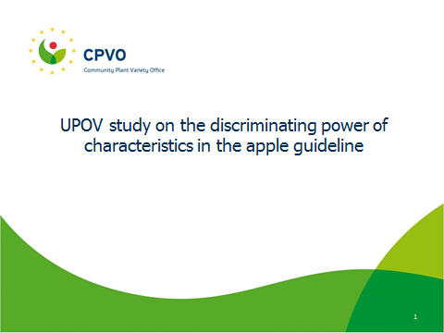

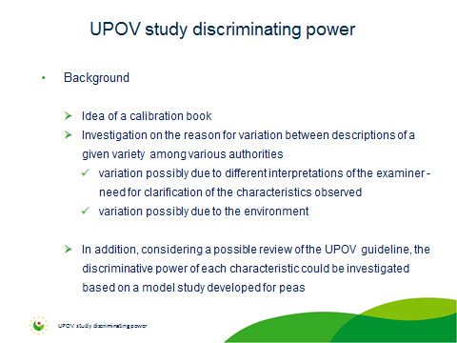

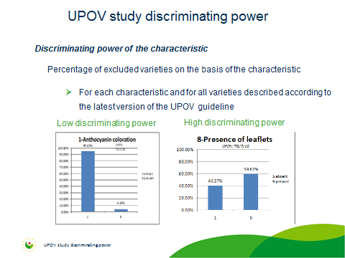

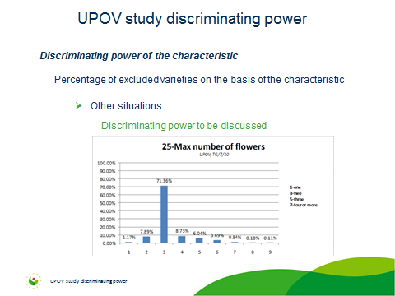

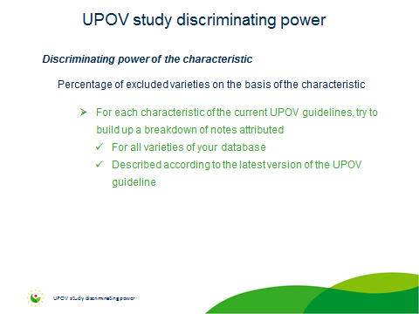

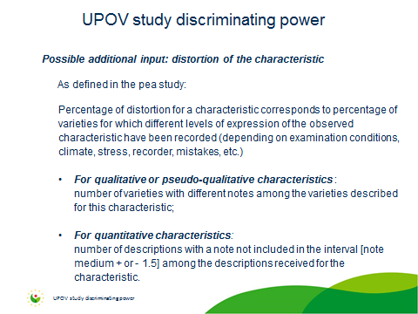

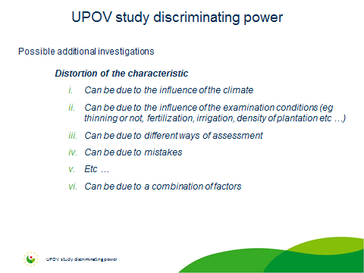

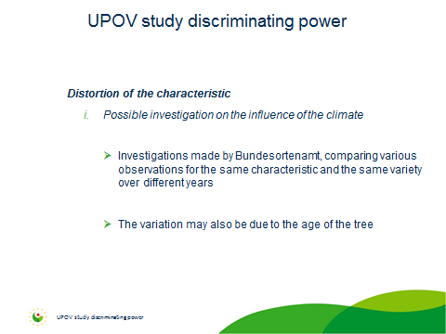

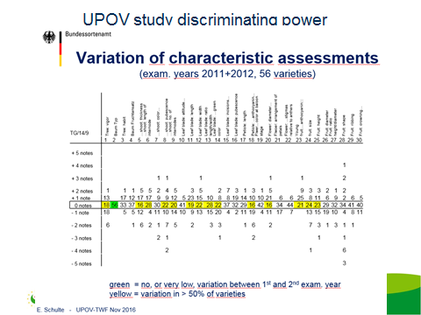

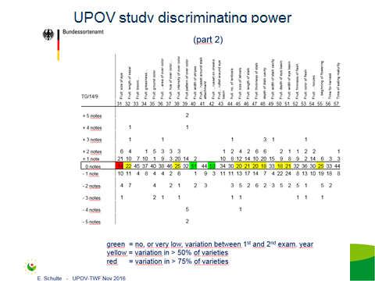

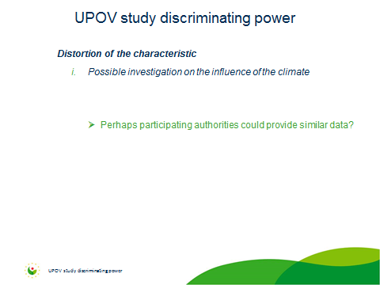

[Annex II follows]

Characteristic UPOV-TG/14/9 |  | Tree: vigour (1) | Tree: type (2) | Only varieties with ramified tree type: Tree: habit (3) | Tree: type of bearing (4) | One-year-old shoot: thickness (5) | One-year-old shoot: length of internode (6) | One-year-old shoot: colour on sunny side (7) | One-year-old-shoot: pubescence (on distal half of shoot) (8) | One-year-old shoot: number of lenticels (9) | Leaf blade: attitude in relation to shoot (10)
frequency of attribution of notes | note 1 | 0.2% | 5.7% | 5.6% | 19.8% |  | 2.4% | 0.8% | 0.6% | 0.4% | 37.5%
 | note 2 | 0.6% | 94.3% | 52.7% | 68.1% | 0.4% | 3.1% | 3.5% | 3.3% | 2.9% | 54.3%
 | note 3 | 4.9% |  | 40.5% | 12.1% | 3.3% | 8.1% | 18.2% | 9.6% | 11.3% | 8.2%
 | note 4 | 16.0% |  | 1.2% |  | 14.1% | 20.9% | 50.0% | 11.7% | 16.4%
 | note 5 | 24.0% |  |  |  | 37.7% | 27.2% | 27.3% | 20.1% | 26.8%
 | note 6 | 29.9% |  |  |  | 27.3% | 27.2% | 0.2% | 23.8% | 22.9%
 | note 7 | 19.1% |  |  |  | 13.9% | 8.9% |  | 16.8% | 17.2%
 | note 8 | 4.7% |  |  |  | 2.3% | 2.0% |  | 11.5% | 2.0%
 | note 9 | 0.6% |  |  |  | 1.0% | 0.4% |  | 2.5% | 0.2%
 |  | n=512 | n=512 | n=484 | n=511 | n=512 | n=508 | n=512 | n=512 | n=512 | n=512

Leaf blade: length (11) | Leaf blade: width (12) | Leaf blade: ratio length/width (13) | Leaf blade: intensity of green colour (14) | Leaf blade: incisions of margin (upper half) (15) | Leaf blade: pubescence on lower side (16) | Petiole: length (17) | Petiole: extent of anthoxyanin coloration from base (18) | Flower: predominant colour at balloon stage (19) | Flower: diameter with petals pressed into horizontal position (20) | Flower: arrangement of petals (21)
0.6% | 0.4% | 0.2% |  | 30.5% | 24.0% |  | 1.4% | 0.2% | 0.2% | 10.0%
3.1% | 1.8% | 1.8% | 0.2% | 28.3% | 44.2% | 1.8% | 11.1% | 2.3% | 3.4% | 34.2%
11.2% | 8.4% | 9.9% | 2.7% | 22.2% | 31.9% | 8.2% | 26.3% | 13.1% | 9.7% | 55.8%
19.0% | 23.7% | 24.5% | 7.8% | 12.1% |  | 18.8% | 20.4% | 30.5% | 23.9%
30.5% | 29.7% | 25.4% | 26.7% | 6.9% |  | 35.2% | 19.8% | 39.3% | 26.8%
22.5% | 18.4% | 20.7% | 30.8% |  |  | 21.1% | 10.3% | 4.3% | 20.9%
8.8% | 11.7% | 11.4% | 23.7% |  |  | 8.4% | 6.7% | 10.2% | 11.0%
3.1% | 4.3% | 4.5% | 7.5% |  |  | 4.5% | 2.8% |  | 3.7%
1.2% | 1.6% | 1.6% | 0.6% |  |  | 2.0% | 1.2% |  | 0.4%
n=511 | n=511 | n=507 | n=510 | n=505 | n=505 | n=511 | n=505 | n=511 | n=507 | n=511

Flower: position of stigmas relative to anthers (22) | Young fruit: extent of anthocyanin overcolour (23) | Fruit: size (24) | Fruit: height (25) | Fruit: diameter (26) | Fruit: ratio height/diameter (27) | Fruit: general shape (28) | Fruit: ribbing (29) | Fruit: crowning at calyx end (30) | Fruit: size of eye (31) | Fruit: length of sepal (32)
31.1% | 0.8% |  | 0.8% | 0.8% |  | 3.3% | 36.5% | 38.1% | 0.2%
42.9% | 6.1% | 1.4% | 3.7% | 3.0% | 1.6% | 47.7% | 56.2% | 56.2% | 0.6% | 0.2%
26.0% | 20.1% | 5.1% | 9.4% | 6.9% | 10.0% | 6.9% | 7.3% | 5.7% | 9.4% | 5.5%
 | 22.6% | 15.1% | 19.3% | 21.3% | 23.2% | 5.9% |  |  | 25.3% | 13.4%
 | 25.8% | 28.7% | 27.4% | 31.5% | 25.0% | 1.2% |  |  | 25.9% | 30.8%
 | 14.4% | 27.3% | 20.9% | 19.7% | 20.5% | 15.1% |  |  | 22.4% | 31.4%
 | 7.1% | 13.0% | 14.0% | 11.2% | 12.6% | 19.8% |  |  | 10.6% | 17.5%
 | 1.2% | 6.5% | 4.3% | 3.9% | 5.5% |  |  |  | 4.1% | 1.2%
 | 2.0% | 2.9% | 0.2% | 1.8% | 1.6% |  |  |  | 1.4%
n=511 | n=508 | n=509 | n=508 | n=508 | n=508 | n=509 | n=509 | n=509 | n=509 | n=509

Fruit: bloom of skin (33) | Fruit: greasiness of skin (34) | Fruit: ground colour (35) | Fruit: relative area of over colour (36) | Fruit: hue of over colour - with bloom removed (37) | Fruit: intensity of over colour (38) | Fruit: pattern of over colour (39) | Fruit: width of stripes (40) | Fruit: area of russet around stalk attachment (41) | Fruit: area of russet on cheeks (42) | Fruit: area of russet around eye basin (43)
63.7% | 55.9% | 2.2% | 1.0% | 14.2% | 0.6% | 22.1% | 0.3% | 38.5% | 96.6% | 89.8%
19.8% | 35.2% | 2.8% | 3.7% | 2.6% | 2.8% | 16.8% | 7.9% | 48.3% | 3.1% | 7.4%
16.5% | 8.9% | 27.6% | 7.9% | 60.9% | 12.8% | 14.2% | 38.5% | 13.2% | 0.3% | 2.8%
 |  | 20.1% | 5.9% | 15.0% | 19.1% | 2.0% | 29.1%
 |  | 42.9% | 10.4% | 7.3% | 21.7% | 0.6% | 12.3%
 |  | 4.5% | 23.2% |  | 21.7% | 12.6% | 5.0%
 |  |  | 28.5% |  | 16.0% | 31.8% | 6.8%
 |  |  | 14.5% |  | 4.5% |  | 0.3%
 |  |  | 4.9% |  | 0.8%
n=509 | n=508 | n=508 | n=509 | n=507 | n=507 | n=507 | n=382 | n=325 | n=325 | n=325

Fruit: number of lenticels (44) | Fruit: size of lenticels (45) | Fruit: length of stalk (46) | Fruit: thickness of stalk (47) | Fruit: depth of stalk cavity (48) | Fruit: width of stalk cavity (49) | Fruit: depth of eye basin (50) | Fruit: width of eye basin (51) | Fruit: firmness of flesh (52) | Fruit: colour of flesh (53)
 | 0.4% | 0.2% | 0.4% |  | 0.4% |  |  |  | 22.4%
0.4% | 5.1% | 2.8% | 1.2% | 2.4% | 2.4% | 2.9% | 1.6% | 0.4% | 56.2%
8.4% | 20.4% | 14.8% | 13.4% | 7.3% | 5.3% | 9.4% | 7.5% | 5.0% | 7.3%
24.2% | 23.6% | 24.0% | 26.5% | 20.0% | 15.9% | 17.5% | 19.6% | 16.8% | 10.6%
34.4% | 32.8% | 27.2% | 27.3% | 31.4% | 34.4% | 29.1% | 34.0% | 31.2% | 1.0%
20.6% | 12.6% | 20.5% | 19.6% | 30.3% | 27.5% | 26.9% | 24.2% | 26.0% | 2.6%
11.6% | 4.1% | 8.7% | 10.2% | 7.3% | 11.0% | 10.2% | 9.6% | 15.1%
0.4% | 1.0% | 1.8% | 1.2% | 1.2% | 2.9% | 3.3% | 2.9% | 5.0%
 |  | 0.2% | 0.2% | 0.2% | 0.2% | 0.6% | 0.6% | 0.4%
n=509 | n=509 | n=508 | n=509 | n=509 | n=509 | n=509 | n=509 | n=458 | n=509

Fruit: aperture of locules (in transverse section) (54) | Time of beginning of flowering (55) | Time for harvest (56) | Time of eating maturity (57)
28.9% |  | 0.2% | 0.2%
43.1% | 1.0% | 2.7% | 1.6%
28.0% | 5.5% | 5.9% | 4.5%
 | 20.1% | 11.8% | 8.6%
 | 31.1% | 24.9% | 20.2%
 | 27.3% | 29.2% | 30.8%
 | 11.1% | 17.1% | 23.8%
 | 2.9% | 6.3% | 7.5%
 | 1.0% | 2.0% | 2.8%
n=508 | n=512 | n=510 | n=509

[End of Annex II and of document]

