E
International Union for the Protection of New Varieties of Plants

Technical Working Party for Fruit Crops  Forty-Eighth Session  Kelowna, British Columbia, Canada, September 18 to 22, 2017 | TWF/48/3  Original: English  Date: November 16, 2018
Reports on Developments in Plant Variety Protection from Members and Observers
Document prepared by the Office of the Union
Disclaimer: this document does not represent UPOV policies or guidance
The Technical Committee (TC), at its forty-seventh session held in Geneva, from April 4 to 6, 2011, agreed to request the Office of the Union to invite experts to submit written reports to the Office of the Union in advance of the Technical Working Party (TWP) sessions in order that a document containing those reports could be prepared by the Office of the Union. The TC noted that TWP experts would be invited to make a brief oral summary of their written report at the session and would also be encouraged to make reports under the agenda item “Experiences with new types and species”, as appropriate. The TC also noted that TWP experts would have an opportunity to raise questions concerning matters of interest (see document TC/47/26 “Report on the Conclusions”, paragraphs 9 and 10).

Written reports were invited by the Office of the Union in Circular E-17/082 of May 16, 2017. The following reports were provided:

- Members of the Union: Annexes I to X: Brazil, Czech Republic, European Union, France, Japan, Netherlands, New Zealand, Poland, Republic of Korea and Turkey

- Organizations: Annex XI: International Community of Breeders of Asexually Reproduced Ornamental and Fruit-Tree Varieties (CIOPORA)

[Annexes follow]

BRAZIL

1. The National Plant Variety Protection Service (SNPC) on the Ministry of Agriculture, Livestock and Food Supply (MAPA), is the national authority for the examination of applications and for granting Plant Breeder’s Rights in Brazil.

2. In 2016, SNPC received 326 applications: agricultural crops (198), ornamentals (51), vegetables (12), fruit crops (44), forest trees (15), forage crops (03) and medicinal and aromatic (03).

3. Those 44 applications of fruit crops were for the following: Prunus persica (14), Vitis (14), Malus domestica (05), Fragaria (03) Malus Mill. (rootstock) (02), Prunus salicina (01), Rubus idaeus (01) and Vaccinium (04).

4. Applications of fruit crops were filed from nationals of: Brazil (17), USA (13), Italy (08), Australia (03), Chile (01), New Zealand (01) and United Kingdom (01).

5. Thirteen (13) titles were granted in 2016 to the following species: Malus domestica (05), Rubus idaeus (03), Actinidia (01), Citrus (01), Paulinia cupana (01), Prunus salicina (01), Rubus subg. Eubatus (01).

6. Those titles were granted to applicants from: Brazil (07), Netherlands (03), New Zealand (01), Italy (01) and Australia (01).

7. Up to July 31th, 2017, SNPC received 171 applications, 9 of them to fruit crops; and granted 169 titles, 10 of them to fruit crops.

A copy of the presentation given by the expert from Brazil on Guarana (Paullinia cupana Kunth) at the forty-eighth session of the Technical Working Party for Fruit crops (TWF/48) follows below:

GUARANA (PAULLINIA CUPANA KUNTH)

Presentation prepared by an expert from Brazil

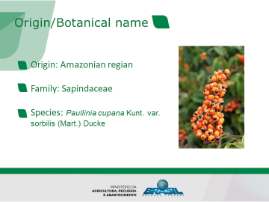

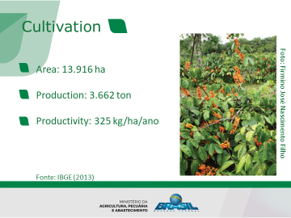

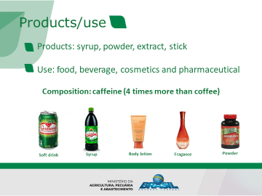

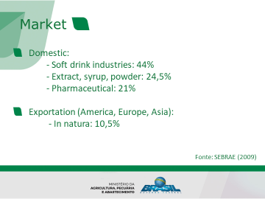

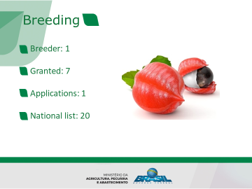

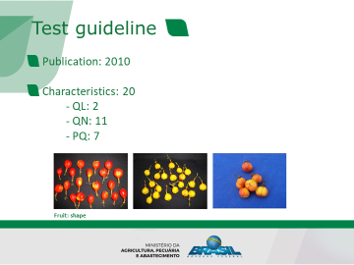

[Annex II follows]

CZECH REPUBLIC

Report of activities of the Central Institute for Supervising and Testing in Agriculture (ÚKZÚZ)

 | 2012 | 2013 | 2014 | 2015 | 2016
National Listing
Number of applications | 491 | 538 | 620 | 573 | 580
Agricultural crops | 468 | 494 | 561 | 517 | 524
Vegetables | 18 | 33 | 49 | 45 | 53
Fruits | 4 | 11 | 10 | 9 | 3
Ornamentals | 1 | 0 | 0 | 2 | 0
Number of listed varieties | 164 | 160 | 175 | 200 | 185
Agricultural crops | 120 | 127 | 140 | 136 | 148
Vegetables | 39 | 33 | 30 | 39 | 35
Fruits | 5 | 0 | 5 | 24 | 2
Ornamentals | 0 | 0 | 0 | 1 | 0
National Listing by the end of December 2016
Total |  |  |  |  | 3246
Agricultural crops |  |  |  |  | 1863
Vegetables |  |  |  |  | 893
Fruits |  |  |  |  | 461
Ornamentals |  |  |  |  | 2
Aromatic crops |  |  |  |  | 27
 | 2012 | 2013 | 2014 | 2015 | 2016
National Plant Variety Rights
Number of applications | 55 | 70 | 99 | 80 | 68
Agricultural crops | 30 | 41 | 72 | 49 | 39
Vegetables | 0 | 1 | 0 | 3 | 3
Fruits | 5 | 17 | 7 | 6 | 8
Ornamentals | 19 | 10 | 19 | 22 | 17
Aromatic crops | 1 | 1 | 1 | 0 | 1
Number of granted varieties | 59 | 58 | 93 | 62 | 73
Agricultural crops | 36 | 40 | 65 | 34 | 45
Vegetables | 2 | 0 | 5 | 2 | 4
Fruits | 7 | 6 | 11 | 9 | 9
Ornamentals | 13 | 12 | 10 | 16 | 15
Aromatic crops | 1 | 0 | 2 | 1 | 0
Czech Plant Variety Rights by the end of December 2016
Total |  |  |  |  | 761
Agricultural crops |  |  |  |  | 512
Vegetables |  |  |  |  | 31
Fruits |  |  |  |  | 126
Ornamentals |  |  |  |  | 84
Aromatic crops |  |  |  |  | 8

Overview of the situation in fruit sector

Implementation of the EU marketing directive
Directive 2008/90 has been already implemented in the Czech Republic seed legislation, Act No. 219/2003 Coll., on the marketing of seed and planting material of cultivated plants and later amendments to the Act .
More than 500 varieties were considered for officially recognised description purposes as follows: apple (180), pear (96), sweet cherry (49), apricot (33), plum (27), sour cherry (19), gooseberry (18), blackberry (14), peach (14), strawberry (11), black currant (10), red currant (10), ribes (10), quince (8), raspberry (7), white currant (6), hazelnut (2), walnut (1).

CPVO
UKZUZ has entrusted for three fruit species: apple, honeysuckle and grapevine. The extension of scope of entrustment has been requested this year. Newly, after fulfilled CPVO requirements during CPVO Quality Audit assessment visit in June 2017, walnut will be included among UKZUZ entrusted species.

Fruit breeding in CZ
There are two most important research institutes:
Research and Breeding Institute of Pomology Holovousy, focused on breeding new varieties of apple, sweet cherry, apricot and plum. The Institute also carries out tests of fruit crop for the presence of viruses.
The second one is Institute of Experimental Botany AS CR, focused on research of resistance against diseases in apples and on breeding of scab resistant and powdery mildew tolerant apple varieties. The varieties are protected by Plant Variety Rights in the Czech Republic, Switzerland, Ukraine and in the European Union, and by United States patent.
Apart from these institutes, there are several private fruit breeders who focus on Czech market.

[Annex III follows]

EUROPEAN UNION

Report on activities of the Community Plant Variety Office (CPVO) of the European Union (EU)

Statistics for 2016: In 2015, the CPVO received 3 299 for Community plant variety rights which represented an increase of 6% compared to the previous year. The number of applications in the fruit sector in 2016 remained at a high level. There were only 5 applications less than in 2015. The top three crops were peach, apple and strawberry. A significant increase compared to the previous year was noted for apple and apricot applications.

In 2015, the Office granted 2 980 titles for Community protection, which represents the highest number ever granted by the CPVO within a calendar year.

Fees: The application fee for online filling has been reduced to 450 EUR since 1.1.2016.

Administrative Council: In 2016, the Administrative Council adopted new CPVO-Technical protocols concerning the following fruit crops: apple rootstocks and mandarins. The Council furthermore agreed to increase the fees for taking over reports to € 320. In addition, a procedure was adopted to assess non EU-based examination offices before initiating technical cooperation and it revised the so-called novelty guidelines.

Cooperation with the European Patent Office (EPO): The CPVO reinforced its cooperation with the EPO and organized a common workshop for patent examiners and CPVO experts in September 2016. Another workshop was organised in spring 2017 at the EPO premises. Both offices are in particular investigating possibilities that EPO has access in a searchable way to a whole range of variety description and technical questionnaire information. This would enable the EPO to have better information on prior art in case of applications for plant related characteristics.

R&D:
The CPVO ad hoc working group for the integration of molecular data into DUS testing IMODDUS had its first meeting in April 2016, followed by another one in January 2017. The working group provided its opinion for 7 project proposals. One of them proposes to set up a toolbox to identify apple mutants with the help of molecular tools. The working group furthermore developed a document on the CPVO Strategy for Imoddus which has been endorsed by the AC in 2017. IMODDUS will meet every year alternately with the UPOV-BMT working group.

In 2016, the CPVO has received the highest number of applications for co-financing R&D projects. Among the projects approved in 2016 there is the “Ring test for strawberries”. The participants to the project (CIOPORA, Bundessortenamt, COBORU, DGAV and OEVV) will investigate on possibilities of harmonisation of the DUS testing, updating example varieties and check suitability of some characteristics proposed to be added to the Technical Protocol. An expected outcome may be a proposal for a revision of the UPOV technical guideline. A kick-off meeting was organised in June 2016. During the meeting the project partners decided about details of the project. After the meeting, submission of plant material to the testing stations took place. In spring and summer 2017 first observations were carried out. The partners met in March in Huelva (Spain) and in May in Lisbon (Portugal) in order to exchange experience and comment on the growing trials. The interim report on the project is scheduled for the end of 2018 and the final report - by the end in 2019.

Fruit experts’ meeting: The annual meeting of 2017 took place in March, in combination with the visit of the trial set up by one partner of the “Strawberry ring test”. The meetings were attended by representatives of the CPVO’s entrusted examination offices and CIOPORA. Experts discussed in particular the status and use of the reserve plants, the reduction of the number of observation periods in the fruit sector, the possible improvement of the strawberry TQ’s by inserting more characteristics and the date of entry into force of the technical protocols.

For up-to-date information on the CPVO’s activities, please visit the CPVO website, read its newsletter and follow and engage with the CPVO on Twitter: @CPVOTweets

[Annex IV follows]

FRANCE

The activity in the framework of national listing and the activity in the framework of DUS bilateral agreements remain globally stable.
The plant breeding effort remains important and even in development for some crops regarding the capacity of genetic improvement to contribute to the challenges in the field of protection of environment and health.

GEVES has a new website which can be consulted here www.geves.fr

In total, GEVES studies each year about 1400 new varieties,
- around 100 new candidate varieties, a year, in the fruit sector.
- around 1000 new candidate varieties, a year, in the agricultural sector.
- around 70 new candidate varieties, a year, in the ornamental sector.
- around 230 new candidate varieties, a year, in the vegetables sector.

However, the number of application for some species decreases in France (for example sunflower and maize), whereas the number of application for some other species increases (for example cereals, sugar beet, ornamental and fruit species)

GEVES activity is entrusted by the CPVO. GEVES, as an examination office on behalf of CPVO, receives around 600 requests of results each year including about 2/3 of take over reports related to field and vegetable crops tested first for national listing. GEVES also sends each year about 400 reports to other examination offices (about 100 examinations and 300 take-overs) and buy about 120 reports from them in the framework of bilateral agreements.
The International System of Cooperation is active and efficient. For more information, the international cooperation service of GEVES can be contacted here : anne-lise.kouditey@geves.fr

GEVES has recently gained experience on DUS tests of new species: Sesamum indicum, Chenopodium quinoa, Musa acuminata, Vanilla planifolia, Allium tuncelianum, Genista stenopetala, Lathyrus sativus, Deutzia spp., Lonicera L. var EmphyllocallyxMaxim., Brassica rapa subsp. Nipposinica.

In addition to that, the French National Office for PBR (INOV) has received 94 applications in 2016, out of which 95% were tested for DUS by GEVES.

GEVES has been involved for the last few years in the following topics:
- cooperation between Examination Offices to share common data bases of phenotypic variety descriptions
- the use of molecular markers in the DUS tests for the management of reference collections, for the identification and characterization of varieties, for checking of hybrid conformity. It is routinely used in maize, barley, sorghum, and fruit species
- continuous improvement of our methods and protocols, in line with CPVO TPs and CPVO requirements and UPOV guidance
- the exchange of data and files via electronic platforms, accessible to other Examination Offices, to the CPVO, to DUS examiners or to applicants, such as “Sharing the online application of the CPVO”, “Exchange electronic documents : B2B platform with the CPVO” and web services from the CPVO Variety Finder.

Considering recent recommandations and discussions at UPOV, GEVES supports:
-the optimization of DUS reference collections and especially
. structuration of DUS reference collections in three areas: theoretical, technical and effective collections (TWV/49/29 Add, 2015).
. development of international DUS data bases managed by Examination Offices collaborating to share data and check the Distinctness together. This approach re inforces the DUS expertise and the quality of the Distinctness criteria.
-the development of the use of molecular markers in the DUS examination, as a complementary element, and in the control of conformity of DUS material and materials from granted varieties.
-the optimization of the duration of the DUS examination: consider the one DUS cycle examination as operational as soon as DUS criteria and reliable description are satisfied. In this area, the use of molecular markers, as a complement, could be evaluated as an help to shorten the examination,
-the revision on how to assess uniformity by off types on basis of more than one growing cycle or on the basis of sub samples
GEVES uses in routine genetic disease resistance characteristics, processed in bio tests, for DUS results. It provides also services, facilities, protocols, identified standards and strains for such activities to Examination Offices and seed companies, in the world. For more information, please contact : GEVES SNES valerie.grimault@geves.fr.
GEVES will host the UPOV BMT in La Rochelle in 2017.

In the fruit sector, in 2017, there are under examination:
- 101 Peaches
- 71 Apples (including 22 Gala mutants and 9 Fuji mutants)
- 61 Apricots
- 29 Cherries
- 21 Japanese Plum
- 11 Pears and interspecific hybrids of Pear
- 4 Prunus rootstocks
- 2 Loniceras
- 2 Bananas
- 1 Vanilla

The most important topics for the fruit team this year were the implementation of new European regulation for fruit trees commercialization, and the improvement of Gala and Fuji mutants DUS tests.

[Annex V follows]

JAPAN

1. Number of application and granted in 2016
(1) Number of applications
Year | Number | (2016/2015) | Fruit | (2016/2015)
1978 to 2016 | 31,884 | - | 1,653 | -
2015  2016 | 912  977 | (107%) | 65  30 | (46%)

Top 5 of application for Fruit in 2016
Apple 8 , Citrus 5 , Peach 4 , Grape 3 , Chestnut 2
(2) Number of granted
Year | Number | (2016/2015) | Fruit | (2016/2015)
1978 to 2016 | 25,571 | - | 1,345 | -
2015  2016 | 847  942 | (111%) | 38  48 | (126%)

Top 5 of granted for Fruit in 2016
Apple 13 , Peach 7 , Citrus 7 , Grape 5 , Blueberry 3 , Japanese Pear 3 , Persimmon 3 , Chestnut 3

2. Japanese national test guidelines had harmonized with UPOV TGs in 2016.
Genera and Species (4)
Adlay, Cosmos, Dianthus, Adzuki bean

3. Japanese national test guidelines had developed for new type of species in 2016.
Genera and Species (11)
Allium ampeloprasum L., Allium karataviense Regel,
Allium victorialis L. subsp. platyphyllum Hulten, Chelone L.,
Hebe Comm. ex Juss., Hemizygia (Benth.) Briq., Iberis L.,
Lophomyrtus Burret, Pittosporum tenuifolium Gaertn., Thuja occidentalis L., Vaccinium vitis-idaea L
Web-site: http://www.hinsyu.maff.go.jp/info/sinsakijun/botanical_taxon_e.html

4. Other.
- We offer UPOV members the examination report at no charge by exchanging the Memorandum of Cooperation (MOC). We have exchanged the MOC documents with 11 members as of now.

- To promote that registered varieties in Japan will be applied for foreign authorities, we are setting up the manual for applying for foreign authorities, the consultation desk, and to assist the cost for them.

- We have established the East Asia Plant Variety Protection (EAPVP) Forum since 2008, which is held to facilitate the improvement of the implementation and the harmonization of the plant variety protection system based on the UPOV system in the Asian region.
The 10th EAPVP Forum meeting will be held at Naypyidaw, Myanmar in September 2017.

- The Center for Seeds and Seedlings, NARO (NCSS) and the Netherlands Inspection Service for Horticulture (Naktuinbouw) concluded the Memorandum of Understanding (MOU) on May 23, 2017 for joint work on DUS test for PVP system.
The MOU signified the start of enhancing international cooperation to promote partnership and ensure PVP system which protects plant breeders' rights that will eventually promote the breeding of new varieties.
The agreement for collaboration is aimed at jointly developing calibration manuals for DUS test for new varieties based on the NCSS manual for DUS test and the Naktuinbouw calibration book. Over the next 5 years, both NCSS and Naktuinbouw have agreed to complete 10 harmonized calibration manuals.
The joint manual will be particularly useful not only for examination of new varieties in Japan and the Netherlands but could also be used in other countries.
http://www.naro.affrc.go.jp/english/topics/075715.html

[Annex VI follows]

NETHERLANDS

Naktuinbouw developments
Organisation

In January 2017 Mrs Agnes van Ardenne was appointed by the Minister of Economic Affairs as Chairman of the Board of Naktuinbouw. In this appointment Mrs van Ardenne (former Minister of Development) succeeded Mr Henk Lange (former CEO Nunhem Seeds).

Within Naktuinbouw a strategic plan is being developed for the next 5 years. In the new plan more attention will be paid to the clients of Naktuinbouw especially in relation to Quality inspection and Laboratory services. Another important aspect will be increased attention on DNA databases and big data, not only for possible use in Variety testing but also for inspection services. In the next few years a new R&D laboratory will be constructed in Roelofarendsveen with an investment of € 6-7 million. In addition the Naktuinbouw location at Horst focusing on the production of virus free plant material of soft fruit species will be renovated with an investment of € 2-3 million.

New Head of Variety Research Naktuinbouw
At the first of November 2016 Mr. Bert Scholte joined Naktuinbouw. After a transfer period of 2 month he has taken over the duties from Mr. Kees van Ettekoven as Head of the Variety Department.

Number of applications received
In 2016, the following number applications were received for testing for the first year for National listing, and for National or European Plant Breeders’ Rights (in brackets the difference with 2015):
Ornamentals 850 (+2%)
Agriculture 135 (-28%)
Vegetables 827 (+10%)
Total 1812 (+3%)
After 2015, this was an increase for Ornamentals and Vegetables, but a remarkable decrease in Agricultural crops. A forecast for 2017 is not yet possible.

UPOV-activities
OAPI meeting in Ivory Coast
From 25 to 28 September 2016 Mr. Kees van Ettekoven and Ms. Cécile Marchenay participated in a seminar about Plant Breeders Rights organized by OAPI, UPOV and CNRA in Ivory Coast. The opening was done by the DG of the Centre National de Recherche Agricole and by Mrs. Ayite, the vice director general of OAPI and the head of the cabinet of the Minister of Scientific Research in Ivory Coast.

International co-operation.
Together with Wageningen University and Research Centre, Naktuinbouw is working on a project in Myanmar to develop a system of Plant Breeders’ Rights and national listing.
In 2016 the Center for Seeds and Seedlings (NCSS), Japan, contacted Naktuinbouw for cooperation on DUS testing. In this framework, two Japanese colleagues visited Naktuinbouw to harmonize Testing manuals/Calibration Books. Recently Naktuinbouw and NCSS have signed a Memorandum of Understanding for continuing the cooperation.
Together with colleagues from Bundessortenamt, NIAB and GEVES, Naktuinbouw was present in the joint CPVO stand on the IPM in Essen Germany 2017.

Education and internships
- The well-known PVP-course was held in Wageningen (in 2016 under coordination of Laura Piñán González and Judith Meijles).
- Like in former years, colleagues from different foreign Examination Offices temporarily joined the Naktuinbouw DUS-examinations in the framework of the internship programme. This programme focuses on exchange of approaches and views between colleagues by working together in practice.
- 7 colleagues followed the UPOV DL-305 course with good results, and 3 colleagues successfully followed the UPOV course DL-205.

National Protocol for True Potato Seed (TPS)
There is an increasing interest in the possibilities for protecting TPS-varieties with Breeders’ Rights. In the Netherlands, a new National Protocol was developed for the DUS-examination of TPS. The Protocol was derived from the CPVO-protocol/UPOV-guideline for (vegetatively propagated) potato, but, according to the UPOV-principles, this new TPS-Protocol is based on the particular features of the TPS-propagation.

(Living) reference collections in Ornamentals
In an increasing number of Ornamental crops, Naktuinbouw keeps a living reference collection according to the CPVO-definitions. In Orchids, much effort was paid to keep the living collection in an optimal condition. For renewing the collection it is very important to have good contacts with the breeders because it takes some time to produce new plant material. Besides living collections, pictures, variety descriptions and experts knowledge, increasing efforts were made to develop ‘DNA-collections’.

Primed seed, also for maintenance control
As mentioned in our newsletter of December 2015, not only for Dutch applications for DUS, but also for samples in the framework of maintenance control of tomato rootstock and eggplant, it is allowed to provide primed seeds to the crop responsible persons. The requirements for these maintenance control samples are as follows:

Tomato rootstock (Solanum lycopersicum L. x Solanum habrochaites S. Knapp & D. M. Spooner of Solanum lycopersicum L. x Solanum pimpinellifolium L.)
If not-primed: 480 seeds (was 500 seeds)
If primed: 12 packages of 40 seeds (sealed laminated aluminium foil bags, label indicating ‘primed’).

Eggplant (Solanum melongena L.)
If not-primed: 480 seeds (was 500 seeds)
If primed: 12 packages of 40 seeds (sealed laminated aluminium foil bags, label indicating ‘primed’).

Submission of Dutch national applications via the online system on the CPVO-website
As from now on it is possible to submit online applications for listing in The Netherlands (Board for plant varieties) or France (GEVES) and/or plant breeders rights on behalf of the CPVO, GEVES or Dutch board for plant varieties. The online system is available on the website of the CPVO (https://www.plantvarieties.eu).

PVP Development Program
A new tool to help countries to develop their Plant Breeders’ Rights system

For the next four years the Dutch Ministry allocates funds to the implementation of this program. Naktuinbouw is responsible for managing the program and cooperates with the Dutch Agricultural Counsellors and their staff. The Counsellors can propose projects aimed at the creation and/or further development of a Plant Breeders’ Right system in the territory in which they work.

Good varieties to feed the world population
The Netherlands is active in sharing knowledge with third countries.
This open attitude is based on the idea that the world will benefit from the availability of good varieties. The aim is to feed the growing world population and to improve food security and food quality. This applies mainly for food crops, but ornamental varieties also contribute to quality of life. Only an active breeding sector (both publicly and privately) can meet this need for good varieties. Plant Breeders’ Rights according to the UPOV model allows companies and institutions to obtain sufficient revenue for their breeding work. The companies can then invest this in breeding new and even better varieties.

A harmonised system is crucial
An harmonised system for the protection of new varieties of plants is important for the world and for companies who are involved in the breeding of plant varieties.
This is the focus of the Netherlands when we share Dutch knowledge on Plant Breeders’ Rights systems with other countries. A good example is the annual Plant Variety Protection Course, which we organize in Wageningen in cooperation with the Wageningen University.

How does it work
In the PVP development program, the Netherlands provides a structured response aimed at sharing knowledge in Plant Breeders’ Rights systems around the world.
Third countries can now directly request specific needs in PVP development to Naktuinbouw. These requests aim at working together with Dutch experts in order to develop and implement Plant Breeders’ Rights systems.
Naktuinbouw is responsible for the coordination, design and a large part of the implementation of the activities. Of course we are supervised by the Ministry in these subjects.
We work together with the Board for Plant Varieties, the Ministry and other experts and/or sector organisations. International cooperation may also be possible by involving CPVO/UPOV or colleagues of other Examination Offices.

Proposals for this program?
The network of Agricultural Counsellors working at the Dutch Embassies in different countries is an important source of information. They are the eyes on the ground that know the needs in their territory. Others may also propose projects through this network. There is a large range of tools in the program available, such as:
- awareness missions in the Netherlands for groups of decision makers
- local experts participating in the PVP course in Wageningen
- training of experts in the work of crop experts
- help in the establishment of an Office for Plant Breeders’ Right in a country
- advise on organisational and administrative matters
- tailor-made trainings in the country
- awareness programs for farmers and traders
Based on the received proposals Naktuinbouw will select projects for the next year and propose these to a steering committee. When agreement is reached this annual plan will be presented to the Ministry for their consent.

Projects running in 2017
In 2017 projects were approved in India, Indonesia, Cuba, Iran (Islamic Republic of), Viet Nam, China, Turkey, Ukraine, Cambodia, United Republic of Tanzania, Ghana and there is a project on the position of small farmers in UPOV PBR.

Please send questions to:
PVPtoolbox@naktuinbouw.nl

CPVO Audit
On 30 and 31 of August 2016 the CPVO held the three-yearly audit at Naktuinbouw. During two days the audit team checked the administrative and technical procedures related to the PBR-work. The audit team was very satisfied however there was one remark for which a corrective action was needed. This issue has been resolved in the meantime.

Naktuinbouw, June 2017

[Annex VII follows]

NEW ZEALAND

The number of applications for fruit varieties in 2016/17 has slightly increased in comparison with the same period in 2015/16. Application numbers have levelled and are in the range of 30 – 40 for the period following a peak at 73 in 2013/14. The most important genera are apple and blueberry.

The meaningful management of time between application date and access to plant material for foreign bred varieties is the greatest challenge to fruit testing in New Zealand. It is not uncommon for there to be four to five years between the application date and suitable plant material is available for a growing trial. This situation is out of the control of the breeder and the PVR authority and is primarily caused by national biosecurity requirements. For some genera, quarantine facilities have a limited capacity which compounds the situation. In order to provide information to fruit breeders, guidance on the availability of plant material has been revised.

https://www.iponz.govt.nz/about-ip/pvr/technical-guidance/current/availability-and-supply-of-plant-material/

A national DUS testing centre for Rubus and higher chill Vaccinium species has been under development for several years in cooperation with a private partner. The Partner provides the location and cultivation expertise and the PVRO provide plant material of varieties under application and testing skills. The Partner is affiliated to an industry organisation but is not involved in any breeding activity. The first evaluations are expected to begin in Spring 2017.

NZ provides test reports under the UPOV Convention for fruit varieties to any other UPOV member state on request. Requests for the supply of reports for apple varieties from South American members have increased in recent years. Test report requests from Australia for Rubus and Vaccinium have also increased in recent years.

An assessment has begun regarding the use of sweetness and acidity characters for determining distinctness, uniformity and stability in apple varieties. The current test guideline does not include these characters, but is often used for other fruit genera. The assessment has arisen due to the inability to distinguish between two home garden type apple varieties using the characters in the current test guideline. The breeder has a strong view that there is a difference between the two varieties due to sweetness and acidity when tree ripened.

[Annex VIII follows]

POLAND

In Poland at the end of July 2017 there were 1177 protected varieties of which 115 for fruit plants (78 from national breeders and 37 from foreign): mainly Apple, Blackberry, Lingonberry, Pear, Raspberry and Strawberry. New varieties of Blackberry, Strawberry, Wild Strawberry and Prunus Rootstock were granted PBR in Poland this year. Currently we have 36 candidate fruit varieties under tests. The Research Centre for Cultivar Testing (COBORU) is CPVO entrusted Examination Office for DUS tests for 11 fruit species. Currently there are 22 varieties under test on behalf of the CPVO (Apple, Blueberry, Raspberry and Strawberry) and some further tests of Blueberry varieties will start this year.

COBORU tests 20 varieties in 7 species of fruit plants for Estonia, Finland, Latvia and Lithuania.

[Annex IX follows]

REPUBLIC OF KOREA

1. Plant Breeder's Right

Total number of application as of September 11, 2017 has been reached 9,321 and among them, 6,834 varieties were registered and 1,360 varieties were rejected or cancelled since implementation of PVP system in 1998.

In the Republic of Korea, according to the Seed and Industrial Act, National Forest Seed Variety Center (called as NFSVC) is responsible for the forest PVP system including ornamental trees, plant flowers and mushrooms, etc.
Since National Forest Seed Variety Center (NFSVC) established in 2008, the number of new varieties for Forest PVP application has reached 322 by the end of 2016. 156 varieties are granted for protection and 7 varieties are rejected. 138 varieties are under DUS test. Among 322 varieties, 111 varieties were ornamental species, 44 varieties were edible species, 78 varieties were fruit species and 62 varieties were mushrooms.
Until now, 246 forest national test guidelines were published for forest plant such as Edible deepblue honeysuckle (Lonicera caerulea var. edulis), Round-leaf spike speedwell (Veronica rotunda), Nut-bearing torreya (Torreya nucifera), etc.

2. Integrated Information System of PVP Examination in KSVS
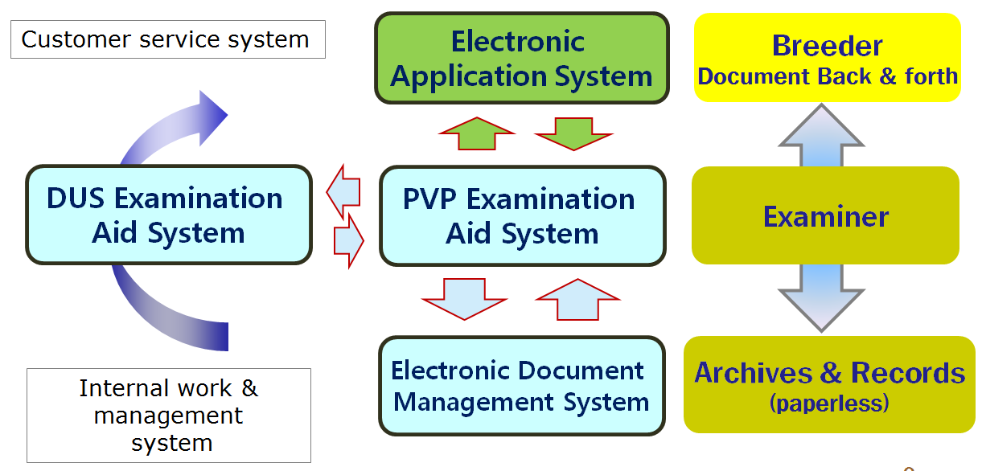

Electronic Application System
- Internet, URL: http://www.seednet.go.kr
- Applicant can fill in and file up application form and pay application fee
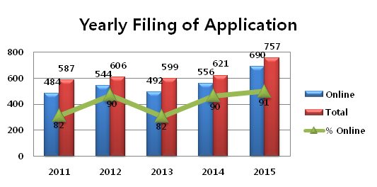

PVP Examination Aid System
- Intranet, URL: http://portal.seed.go.kr
- Operation staff receives electronic application form and manages PVPR
- Examiner inspects PVP application and decides whether he/she grants PVPR or rejects application

DUS Examination Aid System
- Intranet, URL: http://portal.seed.go.kr
- DUS Examiner enters DUS trial data and practices statistical processing and then writes DUS trial report

Electronic Document Management System (EDMS)
- Intranet, URL: http://portal.seed.go.kr
- Application form and all documents related to Examination are converted to PDF file format and transferred to EDMS for storage, search and reference

3. Variety Characteristic Search System

Objective
- PBR judge or examiner for DUS trial is easy to select comparing variety by searching plant variety characteristics

Database
- applied variety, reference variety and so on (since 1998)
- stored variety number : 15,366 (251 crops)

Development course
- To store various image of variety in PV Database
- Number of stored variety image : 14,806(221 crops/6,515 varieties)

4. Plant Variety Protection Law

In the Republic of Korea, Plant variety protection was enforced by Seed Industry Law since 1997. Recently, new Plant Variety Protection Law was amended partially in February of this year for reinforcing its effectiveness. This law shall enter into force on March 1, 2017.
And in respect of amendment of the Law, the patent law also was amended and will be enacted.

5. Molecular Techniques

Recently, our country is actively applying DNA analysis to seed circulation management of several crops. The representative example is analyzed about comparison of DNA profiles between registered seed and marketing seed. In addition, we are utilizing molecular markers in genetic purity assessment of national list of varieties of rice, barley and soybean.

6. International Cooperation

KSVS provides PVP training course for the 11 experts from America, Europe and African countries for 3 weeks in May 2016, supported by KOICA financially.
KSVS hosted the UPOV Technical Working Party of Ornamentals and Forest Trees. This session was held on 12-17 June 2016 in Gimcheon.

[Annex X follows]

TURKEY

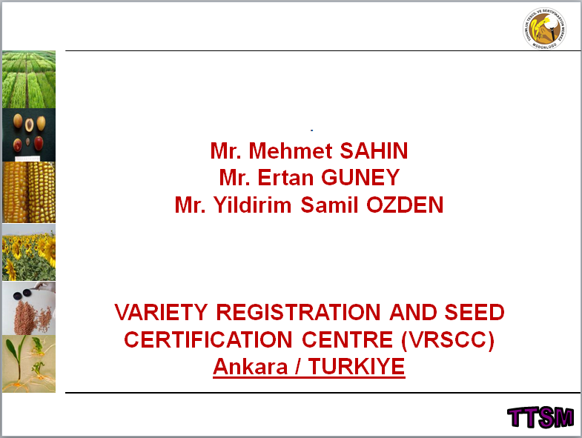

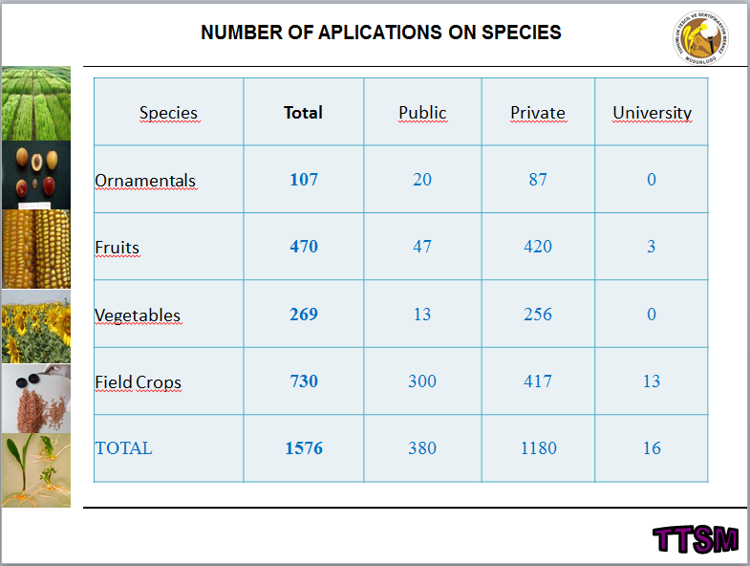

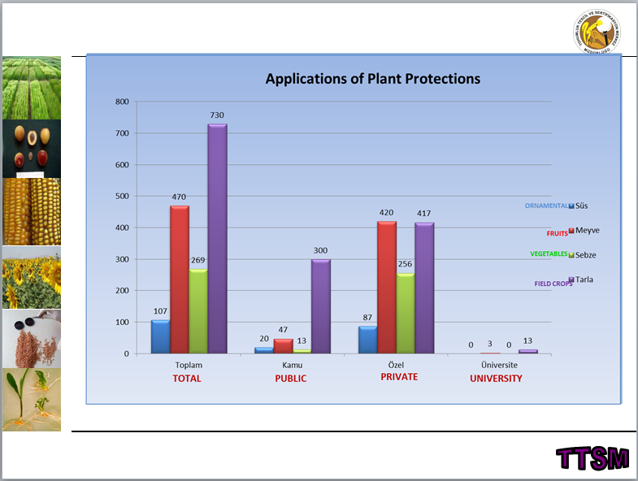

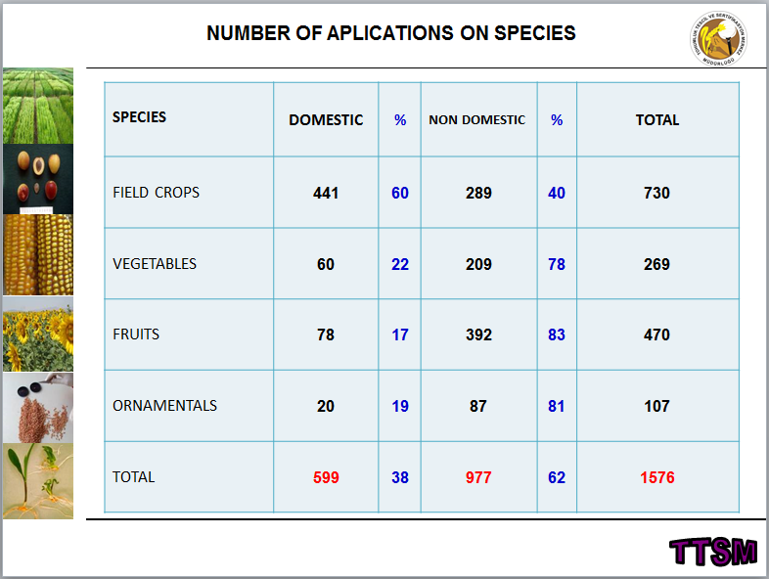

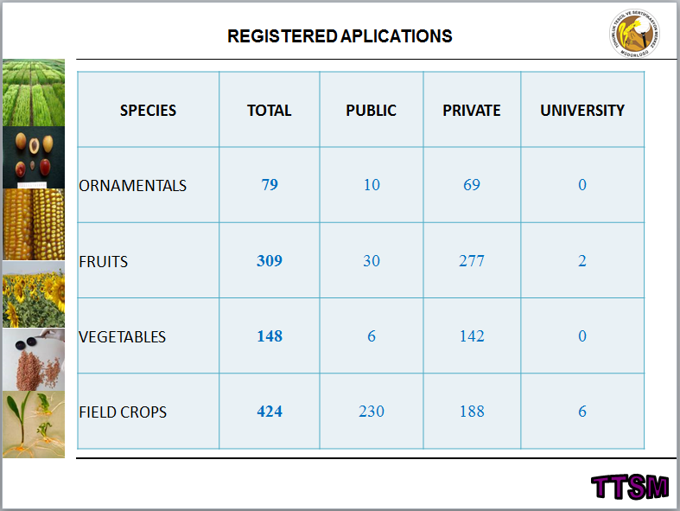

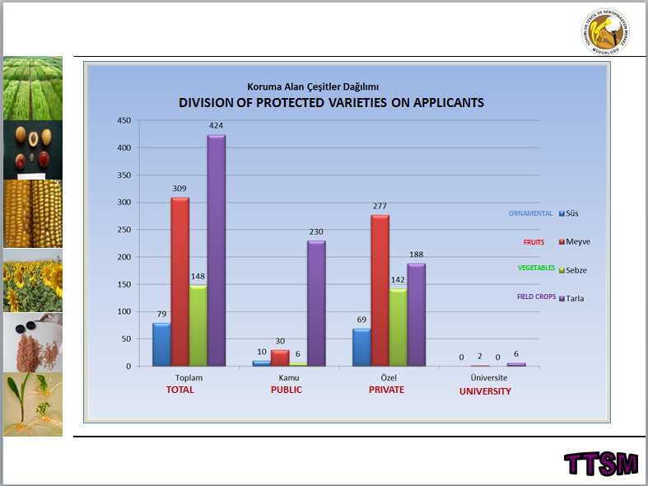

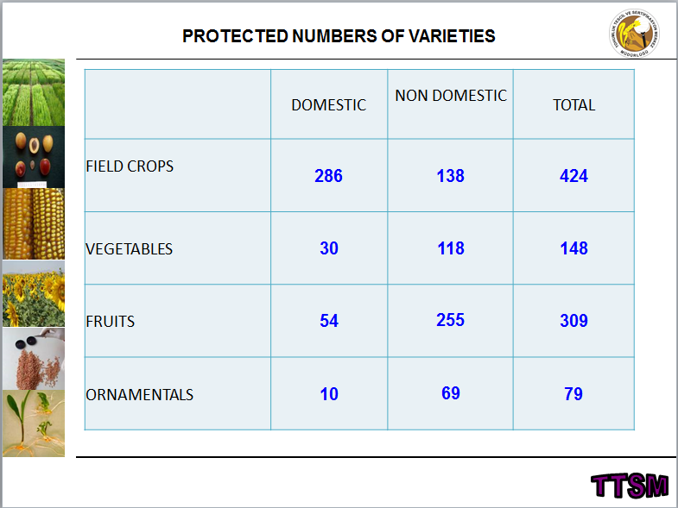

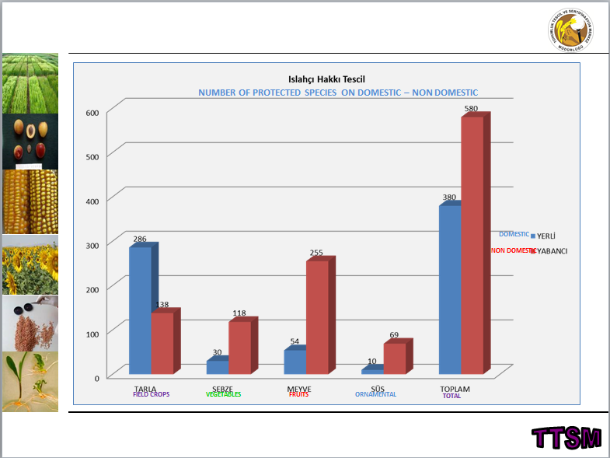

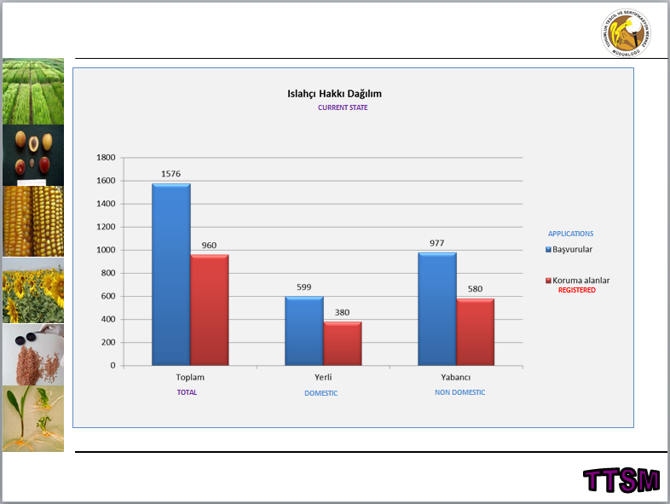

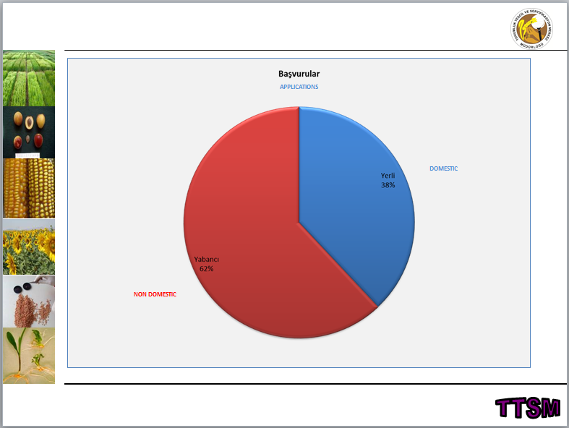

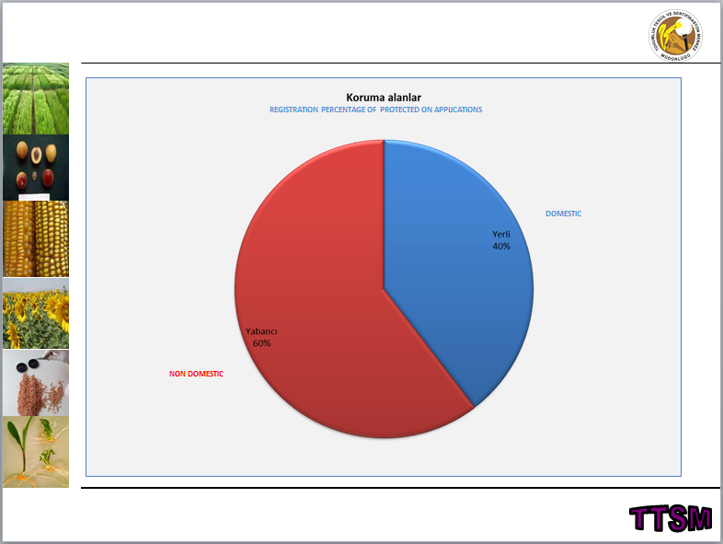

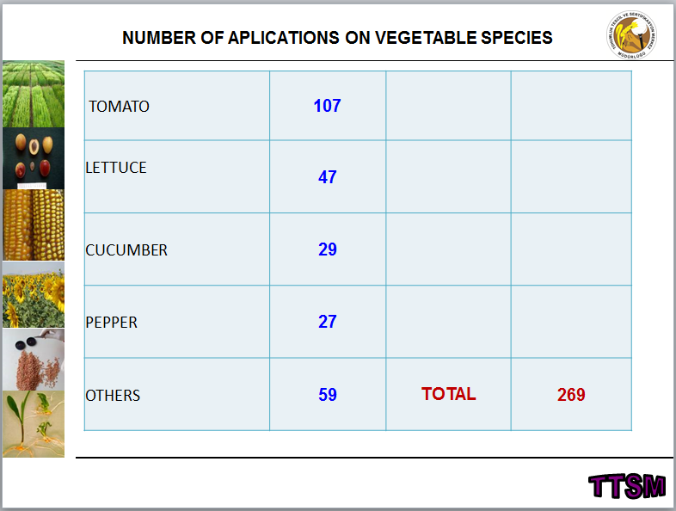

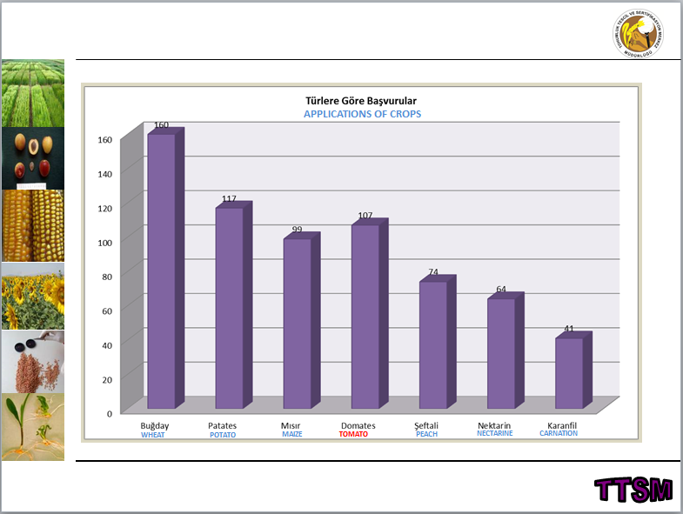

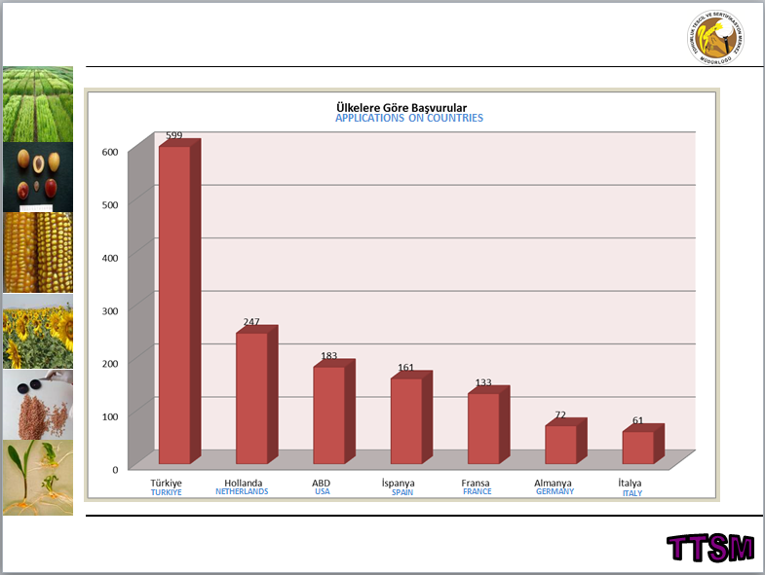

[Annex XI follows]

INTERNATIONAL COMMUNITY OF BREEDERS OF ASEXUALLY REPRODUCED ORNAMENTAL AND FRUIT-TREE VARIETIES (CIOPORA)

CIOPORA Brief on 2016/2017 activities, for consideration in the TWO and TWF

- CIOPORA Position Papers on IP

  - In May and June 2016 the CIOPORA members have approved a new Position Paper on EDV in a written procedure.

Key Statements:

• CIOPORA requests that the EDV concept is clarified through an objective approach and a clear and self-consistent definition, which meets the objective to balance the scope of new breeding techniques and traditional breeding.

• CIOPORA maintains that for vegetatively reproduced ornamental and fruit varieties the EDV concept shall establish dependency for varieties, which are phenotypically distinct and predominantly derived from the Initial Variety.

• The degree of the phenotypic similarity and the number of phenotypic differences between the EDV and the Initial Variety shall not be taken into consideration for the establishment of dependency, but for the assessment of distinctness.

• Predominant derivation is given if material of the Initial Variety has been used for the creation of the EDV and a very high degree of genetic conformity between the Initial Variety and the EDV exists.

• The methods and required degrees of genetic conformity should be established crop-by-crop on the basis of state of the art protocols agreed upon by a panel of experts, including representatives of the breeders of the crop concerned, and has to be proven by the title holder of the Initial Variety in case of dispute and litigation.

• CIOPORA maintains that mutants and GMOs – as far as they are distinct from the Initial Variety – are EDVs, whenever they retain a very high genetic conformity to the Initial Variety as established by the panel of experts, because mutants and GMOs per definition are predominantly derived from the Initial Variety.

• CIOPORA maintains that the outcomes of repeated back-crossing – as far as they are distinct from the Initial Variety – are EDVs in case they retain a very high genetic conformity to the Initial Variety as established by the panel of experts.

• CIOPORA recognizes that there is a realistic possibility that with advancing technologies it might become possible to create independent varieties by new methods, in particular genetic engineering.

1.2 The Board of CIOPORA has finalized a Board Proposal for a CIOPORA Position Paper on Patents for Plant Related Inventions. It has been sent to the CIOPORA members for approval in a written procedure.

- Minimum Distance: Case Study on Minimum Distance

Together with the CPVO and the Examination Offices Naktuinbouw (Roelofarendsveen, The Netherlands), Bundessortenamt (Hanover, Germany), NIAB (Cambridge, United Kingdom), UKZUZ (Brno, Czech Republic) and GEVES (Angers, France) CIOPORA has conducted a case study on Minimum Distance in Apple, Rose and Pelargonium.

The case study is completed now. The results will be presented to the TWO and the TWF.

- People

CIOPORA Elects New Board
CIOPORA held elections for a new Board and President during the association’s 56th Annual General Meeting (AGM) held April 24-28 in Toronto.
Steve Hutton, President and CEO of Star® Roses & Plants/Conard-Pyle of the USA, was elected President of CIOPORA.
The following individuals complete the Board, which will serve CIOPORA from 2017-2020:
- Wendy Cashmore, Plant & Food Research (New Zealand) – Vice President
- Per Klemm, Selecta One (Germany) – Vice President
- Dominique Thévenon, A.I.G.N. (USA) – Treasurer
- Bruno Etavard, Meilland International (France)
- Lars Henriksen, FloriPartner A/S (Denmark)
- Rafi Karniel, Grapa Varieties (Israel)
- Maarten Leune, Royalty Administration International (The Netherlands)
- Jan de Riek, ILVO (Belgium)
- Dean Rule, Conectiflor SA (Ecuador)
- Peter van der Weijden, Florist Holland and HilverdaKooij (The Netherlands)

CIOPORA Board Appoints New Head, Vice Technical Experts for Ornamentals

Ms. Silvia Sartorelli of Cultivar Protection (Brazil) will serve as the new Head Technical Expert (HTE) for Ornamentals and Mr. Herman Scholten of Royalty Administration International (The Netherlands) as the Vice HTE.

The Board appointed Mr. Jan Wouter van Eck, Fresh Forward, The Netherlands, as new Crop leader for Strawberries.

CIOPORA Board appointed Mr. Peter Allderman, TopFruit, South Africa, as new Crop Leader for Apples.

- Participation in UPOV TWP

CIOPORA shall participate in the TWO, the TWF and the BMT meetings in 2017.

- Next CIOPORA AGM

The next CIOPORA Annual General Meeting is scheduled to take place on April 23-27, 2018, in Ghent, Belgium.

The venue of the AGM 2019 will be the Cape Region, South Africa.

[End of Annex XI and of document]

