 |  | E
 | 
  TG/124/4(proj.3)
  ORIGINAL: English
  DATE: 2016-09-30
INTERNATIONAL UNION FOR THE PROTECTION OF NEW VARIETIES OF PLANTS
 | Geneva
  DRAFT
  CHESTNUT
  UPOV Code(s): CASTA_CRE; CASTA_MOL; CASTA_SAT
  Castanea sativa Mill.;
  Castanea crenata Sieold & Zucc.;
  Castanea mollissima Blume
  *
GUIDELINES
FOR THE CONDUCT OF TESTS
FOR DISTINCTNESS, UNIFORMITY AND STABILITY

prepared by experts from Japan
to be considered by the
Technical Working Party for Fruit Crops

at its forty-seventh session, to be held in Angers, France,
from 2016-11-14 to 2016-11-18

Disclaimer: this document does not represent UPOV policies or guidance

Alternative names:*
Botanical name | English | French | German | Spanish
  Castanea crenata Sieold & Zucc.
  Japanese chestnut
  Châtaignier du Japon
  Japanische Kastanie
  Castaño del Japón
  Castanea mollissima Blume
  Chinese Chestnut
  Châtaignier de Chine
  Chinesische Kastanie
  Castaño chino
  Castanea sativa Mill., Castanea vesca Gaertn., Castanea vulgaris, Fagus castanea L.
  Chestnut
  Chataignier
  Kastanie

The purpose of these guidelines (“Test Guidelines”) is to elaborate the principles contained in the General Introduction (document TG/1/3), and its associated TGP documents, into detailed practical guidance for the harmonized examination of distinctness, uniformity and stability (DUS) and, in particular, to identify appropriate characteristics for the examination of DUS and production of harmonized variety descriptions.
ASSOCIATED DOCUMENTS
These Test Guidelines should be read in conjunction with the General Introduction and its associated TGP documents.

TABLE OF CONTENTS | PAGE
1. | SUBJECT OF THESE TEST GUIDELINES.......................................................................................................... | 4
2. | MATERIAL REQUIRED......................................................................................................................................... | 4
3. | METHOD OF EXAMINATION................................................................................................................................ | 5
3.1 | Number of Growing Cycles........................................................................................................................ | 5
3.2 | Testing Place............................................................................................................................................. | 5
3.3 | Conditions for Conducting the Examination............................................................................................... | 5
3.4 | Test Design................................................................................................................................................ | 5
3.5 | Additional Tests......................................................................................................................................... | 5

4. | ASSESSMENT OF DISTINCTNESS, UNIFORMITY AND STABILITY................................................................. | 6
4.1 | Distinctness............................................................................................................................................... | 6
4.2 | Uniformity.................................................................................................................................................. | 7
4.3 | Stability...................................................................................................................................................... | 7

5. | GROUPING OF VARIETIES AND ORGANIZATION OF THE GROWING TRIAL................................................ | 8
6. | INTRODUCTION TO THE TABLE OF CHARACTERISTICS................................................................................ | 9
6.1 | Categories of Characteristics..................................................................................................................... | 9
6.2 | States of Expression and Corresponding Notes........................................................................................ | 9
6.3 | Types of Expression.................................................................................................................................. | 9
6.4 | Example Varieties...................................................................................................................................... | 10
6.5 | Legend....................................................................................................................................................... | 11

7. | TABLE OF CHARACTERISTICS/TABLEAU DES CARACTÈRES/MERKMALSTABELLE/TABLA DE CARACTERES...................................................................................................................................................... | 12
8. | EXPLANATIONS ON THE TABLE OF CHARACTERISTICS............................................................................... | 26
8.1 | Explanations covering several characteristics........................................................................................... | 26
 | Explanations for individual characteristics................................................................................................. | 26
  8.2

9. | LITERATURE......................................................................................................................................................... | 26
10. | TECHNICAL QUESTIONNAIRE............................................................................................................................ | 43

1. | Subject of these Test Guidelines
  These Test Guidelines apply to all varieties of Castanea crenata Sieold & Zucc., Castanea mollissima Blum and Castanea sativa Mill. and hybrids between these species.

2. | Material Required
2.1
  The competent authorities decide on the quantity and quality of the plant material required for testing the variety and when and where it is to be delivered. Applicants submitting material from a State other than that in which the testing takes place must ensure that all customs formalities and phytosanitary requirements are complied with.
2.2
  The material is to be supplied in the form of dormant shoots for grafting or two-year-old trees grafted on a rootstock selected by the testing authority.
2.3
  The minimum quantity of plant material, to be supplied by the applicant, should be:
- 10 dormant shoots or
- 6 two-year-old- trees.

2.4
  The plant material supplied should be visibly healthy, not lacking in vigor, nor affected by any important pest or disease.
2.5
  The plant material should not have undergone any treatment which would affect the expression of the characteristics of the variety, unless the competent authorities allow or request such treatment. If it has been treated, full details of the treatment must be given.

3. | Method of Examination
3.1 | Number of Growing Cycles
 | The minimum duration of tests should normally be two independent growing cycles.
  3.1.1
  3.1.2
  The growing cycle is considered to be the duration of a single growing season, beginning with bud burst, flowering and fruit harvest and concluding when the following dormant period ends with the swelling of new season buds.
3.2 | Testing Place
 | Tests are normally conducted at one place. In the case of tests conducted at more than one place, guidance is provided in TGP/9 “Examining Distinctness”.
3.3 | Conditions for Conducting the Examination
 | The tests should be carried out under conditions ensuring satisfactory growth for the expression of the relevant characteristics of the variety and for the conduct of the examination.
3.4 | Test Design
3.4.1
  Each test should be designed to result in a total of at least 5 trees.
  3.4.2
  The design of the tests should be such that plants or parts of plants may be removed for measurement or counting without prejudice to the observations which must be made up to the end of the growing cycle.
3.5 | Additional Tests
 | Additional tests, for examining relevant characteristics, may be established.

4. | Assessment of Distinctness, Uniformity and Stability
4.1 | Distinctness
4.1.1 | General Recommendations
 | It is of particular importance for users of these Test Guidelines to consult the General Introduction prior to making decisions regarding distinctness. However, the following points are provided for elaboration or emphasis in these Test Guidelines.
4.1.2 | Consistent Differences
 | The differences observed between varieties may be so clear that more than one growing cycle is not necessary. In addition, in some circumstances, the influence of the environment is not such that more than a single growing cycle is required to provide assurance that the differences observed between varieties are sufficiently consistent. One means of ensuring that a difference in a characteristic, observed in a growing trial, is sufficiently consistent is to examine the characteristic in at least two independent growing cycles.
4.1.3 | Clear Differences
 | Determining whether a difference between two varieties is clear depends on many factors, and should consider, in particular, the type of expression of the characteristic being examined, i.e. whether it is expressed in a qualitative, quantitative, or pseudo-qualitative manner. Therefore, it is important that users of these Test Guidelines are familiar with the recommendations contained in the General Introduction prior to making decisions regarding distinctness.
4.1.4
  Number of plants or parts of plants to be Examined
  Unless otherwise indicated, for the purposes of distinctness, all observations on single plants should be made on 5 plants or parts of plants taken from each of 5 plants and any other observations made on all plants in the test, disregarding any off-type plants.
4.1.5 | Method of Observation
 | The recommended method of observing the characteristic for the purposes of distinctness is indicated by the following key in the second column of the Table of Characteristics (see document TGP/9 “Examining Distinctness”, Section 4 “Observation of characteristics”):
MG: single measurement of a group of plants or parts of plants
MS: measurement of a number of individual plants or parts of plants
VG: visual assessment by a single observation of a group of plants or parts of plants
VS: visual assessment by observation of individual plants or parts of plants

 | Type of observation: visual (V) or measurement (M)
 | “Visual” observation (V) is an observation made on the basis of the expert’s judgment. For the purposes of this document, “visual” observation refers to the sensory observations of the experts and, therefore, also includes smell, taste and touch. Visual observation includes observations where the expert uses reference points (e.g. diagrams, example varieties, side-by-side comparison) or non-linear charts (e.g. color charts). Measurement (M) is an objective observation against a calibrated, linear scale e.g. using a ruler, weighing scales, colorimeter, dates, counts, etc.

  Type of record: for a group of plants (G) or for single, individual plants (S)
  For the purposes of distinctness, observations may be recorded as a single record for a group of plants or parts of plants (G), or may be recorded as records for a number of single, individual plants or parts of plants (S). In most cases, “G” provides a single record per variety and it is not possible or necessary to apply statistical methods in a plant-by-plant analysis for the assessment of distinctness.
 | In cases where more than one method of observing the characteristic is indicated in the Table of Characteristics (e.g. VG/MG), guidance on selecting an appropriate method is provided in document TGP/9, Section 4.2.
4.2 | Uniformity
4.2.1 | It is of particular importance for users of these Test Guidelines to consult the General Introduction prior to making decisions regarding uniformity. However, the following points are provided for elaboration or emphasis in these Test Guidelines:
4.2.2 | For the assessment of {indicate type of varieties} uniformity, a population standard of 1% and an acceptance probability of at least 95% should be applied. In the case of a sample size of 5 plants, no off-types are allowed.
4.3 | Stability
4.3.1 | In practice, it is not usual to perform tests of stability that produce results as certain as those of the testing of distinctness and uniformity. However, experience has demonstrated that, for many types of variety, when a variety has been shown to be uniform, it can also be considered to be stable.
4.3.2 | Where appropriate, or in cases of doubt, stability may be further examined by testing a new seed or plant stock to ensure that it exhibits the same characteristics as those shown by the initial material supplied.

5. | Grouping of Varieties and Organization of the Growing Trial
5.1 | The selection of varieties of common knowledge to be grown in the trial with the candidate varieties and the way in which these varieties are divided into groups to facilitate the assessment of distinctness are aided by the use of grouping characteristics.
5.2 | Grouping characteristics are those in which the documented states of expression, even where produced at different locations, can be used, either individually or in combination with other such characteristics: (a) to select varieties of common knowledge that can be excluded from the growing trial used for examination of distinctness; and (b) to organize the growing trial so that similar varieties are grouped together.
5.3 | The following have been agreed as useful grouping characteristics:
  (a)
  Nut: shape (characteristic 31)
  (b)
  Nut: color of skin (characteristic 37)
  (c)
  Nut: size (characteristic 38)
  (d)
  Time of maturity for consumption (characteristic 45)

5.4 | Guidance for the use of grouping characteristics, in the process of examining distinctness, is provided through the General Introduction and document TGP/9 “Examining Distinctness”.

6. | Introduction to the Table of Characteristics
6.1 | Categories of Characteristics
6.1.1 | Standard Test Guidelines Characteristics
 | Standard Test Guidelines characteristics are those which are approved by UPOV for examination of DUS and from which members of the Union can select those suitable for their particular circumstances.
6.1.2 | Asterisked Characteristics
 | Asterisked characteristics (denoted by *) are those included in the Test Guidelines which are important for the international harmonization of variety descriptions and should always be examined for DUS and included in the variety description by all members of the Union, except when the state of expression of a preceding characteristic or regional environmental conditions render this inappropriate.
6.2 | States of Expression and Corresponding Notes
6.2.1 | States of expression are given for each characteristic to define the characteristic and to harmonize descriptions. Each state of expression is allocated a corresponding numerical note for ease of recording of data and for the production and exchange of the description.
6.2.2 | In the case of qualitative and pseudo-qualitative characteristics (see Chapter 6.3), all relevant states of expression are presented in the characteristic. However, in the case of quantitative characteristics with 5 or more states, an abbreviated scale may be used to minimize the size of the Table of Characteristics. For example, in the case of a quantitative characteristic with 9 states, the presentation of states of expression in the Test Guidelines may be abbreviated as follows:
State | Note
small | 3
medium | 5
large | 7

 | However, it should be noted that all of the following 9 states of expression exist to describe varieties and should be used as appropriate:
State | Note
very small | 1
very small to small | 2
small | 3
small to medium | 4
medium | 5
medium to large | 6
large | 7
large to very large | 8
very large | 9

6.2.3 | Further explanation of the presentation of states of expression and notes is provided in document TGP/7 “Development of Test Guidelines”.
6.3 | Types of Expression
 | An explanation of the types of expression of characteristics (qualitative, quantitative and pseudo-qualitative) is provided in the General Introduction.

6.4 | Example Varieties
 | Where appropriate, example varieties are provided to clarify the states of expression of each characteristic.
Example varieties are indicated its species as (A), (B), (C) after variety denomination.
(A): Castanea sativa Mill.
(B): Castanea crenata Siebold & Zucc.
(C): Castanea mollissima Blume

6.5 | Legend
 |  | English |  | français |  | deutsch | español | Example Varieties  Exemples  Beispielssorten  Variedades ejemplo | Note/  Nota
  1
  2
  3
  4
  5
  6
  7
  Name of characteristics in English
  Nom du caractère en français
  Name des Merkmals auf Deutsch
  Nombre del carácter en español
  states of expression
  types d’expression
  Ausprägungsstufen
  tipos de expresión

1 | Characteristic number
2 | (*) | Asterisked characteristic | – see Chapter 6.1.2
3 | Type of expression
 | QL | Qualitative characteristic | – see Chapter 6.3
 | QN | Quantitative characteristic | – see Chapter 6.3
 | PQ | Pseudo-qualitative characteristic | – see Chapter 6.3
4 | Method of observation (and type of plot, if applicable)
 | MG, MS, VG, VS |  | – see Chapter 4.1.5
5
  (+)
  See Explanations on the Table of Characteristics in Chapter 8.2
6
  (a)-(f)
  See Explanations on the Table of Characteristics in Chapter 8.1
7
  Growth stage key See Explanations on the Table of Characteristics in Chapter 8

8 Species of example varieties
(A): Castanea sativa Mill. - see chapter 6.4
(B): Castanea crenata Siebold & Zucc. - see chapter 6.4
(C): Castanea mollissima Blume - see chapter 6.4

7. | Table of Characteristics/Tableau des caractères/Merkmalstabelle/Tabla de caracteres

 |  | English |  | français |  | deutsch | español | Example Varieties  Exemples  Beispielssorten  Variedades ejemplo | Note/  Nota
1. |  | QN | VG | (+) | (a)
  Tree: vigor
 |  | weak |  | faible |  | schwach | débil | Hong Mao Zao(C), Toyotamawase(B) | 3
 |  | medium |  | moyenne |  | mittel | medio | Ibuki(B), Ishizuchi(B), Zhong Chi Li(C) | 5
 |  | strong |  | forte |  | stark | fuerte | Da Hong Pao(C), Ganne(B), Tsukuba(B) | 7
2. | (*) | QN | VG | (+) | (a)
  Tree: growth habit
 |  | upright |  | dressé |  | aufrecht | erguido | Akatyu(B), Arima(B), Bouche rouge(A), Song Jia Zao(C), Tsukuba(B) | 1
 |  | semi-upright |  | demi-dressé |  | halbaufrecht | semierguido | Maraval(A), Otomune(B), Rihei(B), Yan Hong(C) | 2
 |  | spreading |  | divergent |  | breitwüchsig | extendido | Belle Epine(A), Ibuki(B), Zhong Chi Li(C) | 3
3. | (*) | QN | MG/VG |  | (b)
  Current seson's shoot: thickness
 |  | thin |  |  |  |  |  | Arima(B), Ginrei(B), Marsol(A) | 1
 |  | medium |  |  |  |  |  | Ginyose(B), Ishizuchi(B), Marron de Chevanceaux(A), Tanzawa(B) | 3
 |  | thick |  |  |  |  |  | Belle Epine(A), Ibuki(B), Tsukuba(B) | 5
4. | (*) | QN | MS/VG |  | (b)
  Current season's shoot: length of internodes
 |  | short |  |  |  |  |  | Ibuki(B), Marigoule(A), Yanshan Duan Zhi(C) | 3
 |  | medium |  |  |  |  |  | Ganne(B), Kui Li(C), Maraval(A), Shihou(B) | 5
 |  | long |  |  |  |  |  | Jiu Yue Han(C), Marsol(A), Rihei(B) | 7

 |  | English |  | français |  | deutsch | español | Example Varieties  Exemples  Beispielssorten  Variedades ejemplo | Note/  Nota
5. | (*) | QL | VG | (+) | (b)
  Current season's shoot: phyllotaxis
 |  | one half |  |  |  |  |  | Marsol(A) | 1
 |  | two fifths |  |  |  |  |  | Belle Epine(A) | 2
6. | (*) | PQ | VG |  | (b)
  Current season's shoot: color of upper side of stem
 |  | yellow brown |  |  |  |  |  | Ganne(B), Ishizuchi(B), Okkwang(B), Shen Ci Da Ban Li(C) | 1
 |  | brown |  |  |  |  |  | Ginyose(B), Tsukuba(B) | 2
 |  | red brown |  |  |  |  |  | Arima(B), Hong Guang You Li(C), Imakita(B), Tamatsukuri(B) | 3
7. | (*) | QN | VG |  | (b)
  Current seson's shoot: density of lenticels
 |  | sparse |  |  |  |  |  | Marsol(A), Yan Kui(B) | 1
 |  | medium |  |  |  |  |  | Da Ban Hong(C), Ginyose(B), Ibuki(B), Rousse de Nay(A), Tanzawa(B), Tsukuba(B) | 3
 |  | dense |  |  |  |  |  | Boumette(A), Ginrei(B), Tamatsukuri(B), Taziriginyose(B), Yin Feng(C) | 5
8. |  | QN | MS/VG | (+) | (d)
  Shoot: number of female flowers
 |  | few |  |  |  |  |  | Moriwase(B) | 1
 |  | medium |  |  |  |  |  | Tanzawa(B), Tsukuba(B) | 3
 |  | many |  |  |  |  |  | Arima(B), Ishizuchi(B) | 5
9. | (*) | QN | MS/VG |  | (d)
  Male flower: length of filament
 |  | very short |  |  |  |  |  | Bouche rouge(A) | 1
 |  | short |  |  |  |  |  | Marron d' Olargues(A) | 2
 |  | medium |  |  |  |  |  | Marron de Redon(A) | 3
 |  | long |  |  |  |  |  | Belle Epine(A) | 4
 |  | very long |  |  |  |  |  |  | 5

 |  | English |  | français |  | deutsch | español | Example Varieties  Exemples  Beispielssorten  Variedades ejemplo | Note/  Nota
10. | (*) | QN | VG | (+) | (d)
  Unisexual catkin: length
 |  | shot |  |  |  |  |  | Belle Epine(A), Ganne(B), Ishizuchi(B), Jiu Jia Zhong(C), Toyotamawase(B) | 3
 |  | medium |  |  |  |  |  | Akatyu(B), Da Di Qing(C), Ginyose(B), Izumo(B), Marron de Goujo unac(A) | 5
 |  | long |  |  |  |  |  | Arima(B), Chu Shu Hong(C), Ibuki(B), Marron de Chevanceaux(A), Tanzawa(B), Tsukuba(B) | 7
11. | (*) | QL | VG | (+) | (c)
  Young leaf: bronze coloration
 |  | absent |  |  |  |  |  | Bouche rouge(A) | 1
 |  | present |  |  |  |  |  | Belle Epine(A) | 9
12. | (*) | QN | MS/VG | (+) | (c)
  Leaf: size
 |  | small |  |  |  |  |  | Maraval(A), Moriwase(B), Toyotamawase(B), Wu Hua Li(C) | 3
 |  | medium |  |  |  |  |  | Boumette(A), Ginyose(B), Ibuki(B), Kui Li(C), Tanzawa(B) | 5
 |  | large |  |  |  |  |  | Marsol(A), Qian Ci Da Ban Li(C), Riheiguri(B), Tsukuba(B) | 7
13. |  | QN | VG | (+) | (c)
  Leaf: profile in cross section
 |  | straight |  |  |  |  |  | Belle Epine(A) | 1
 |  | slightly concave |  |  |  |  |  |  | 2
 |  | strongly concave |  |  |  |  |  | Comballe(A) | 3
14. |  | QN | VG |  | (c)
  Leaf: symmetry
 |  | symmetric to slightly asymmetric |  |  |  |  |  | Marsol(A) | 1
 |  | moderately asymmetric |  |  |  |  |  |  | 2
 |  | strongly asymmetric |  |  |  |  |  | Boumette(A) | 3

 |  | English |  | français |  | deutsch | español | Example Varieties  Exemples  Beispielssorten  Variedades ejemplo | Note/  Nota
15. |  | QN | MS/VG | (+) | (c)
  Leaf: length/width ratio
 |  | low |  |  |  |  |  | Marsol(A) | 3
 |  | medium |  |  |  |  |  | Marron de Chevanceaux(A) | 5
 |  | high |  |  |  |  |  | Boumette(A) | 7
16. |  | QN | VG | (+) | (c)
  Leaf: attitude in relation to shoot
 |  | upwards |  |  |  |  |  | Bouche rouge(A) | 1
 |  | outwards |  |  |  |  |  | Belle Epine(A) | 2
 |  | downwards |  |  |  |  |  | Marron de Chevanceaux(A) | 3
17. | (*) | QN | VG |  | (c)
  Leaf blade: intensity of green color of upper side
 |  | light |  |  |  |  |  | Belle Epine(A), Da Di Qing(C) | 1
 |  | medium |  |  |  |  |  | Er Xin Zao(C), Ganne(B), Ginyose(B), Rousse de Nay(A), Tsukuba(B) | 3
 |  | dark |  |  |  |  |  | Bouche rouge(A), Dabufen Pinzho ng(C) | 5
18. | (*) | QL | VG |  | (c)
  Leaf: color of lower side
 |  | whitish |  |  |  |  |  | Banseki(B), Marsol(A) | 1
 |  | light green |  |  |  |  |  | Bouche rouge(A), Ginyose(B) | 2
19. | (*) | PQ | VG |  | (c)
  Leaf: shape
 |  | lanceolate |  |  |  |  |  | Jiu Yue Han(C) | 1
 |  | narrow elliptic |  |  |  |  |  | Dae han(B), Ganne(B), Ginyose(B), Mipung(B), Qian Ci Da Ban Li(C), Tsukuba(B) | 2
 |  | broad elliptic |  |  |  |  |  | Zhong Chi Li(C) | 3

 |  | English |  | français |  | deutsch | español | Example Varieties  Exemples  Beispielssorten  Variedades ejemplo | Note/  Nota
20. | (*) | PQ | VG | (+) | (c)
  Leaf: shape of apex
 |  | narrow acuminate |  |  |  |  |  | Ishizuchi(B), Qian Ci Da Ban Li(C), Tanzawa(B), Tsukuba(B) | 1
 |  | broad acuminate |  |  |  |  |  | Ginyose(B), Ibuki(B), Jian Ding You Li(C) | 2
 |  | acute |  |  |  |  |  | Ginrei(B), Imakita(B) | 3
21. | (*) | PQ | VG | (+) | (c)
  Leaf: shape of base
 |  | acute |  |  |  |  |  | Boumette(A), Ginyose(B), Ibuki(B), Jiu Yue Han(C), Tanzawa(B) | 1
 |  | obtuse |  |  |  |  |  | Qian Ci Da Ban Li(C), Verdale(A) | 2
 |  | cordate |  |  |  |  |  | Comballe(A), Hui Huang You Li(C) | 3
22. | (*) | PQ | VG | (+) | (c)
  Leaf: shape of margin
 |  | needle shape |  |  |  |  |  | Ibuki(B), Ishizuchi(B), Tanzawa(B) | 1
 |  | acute |  |  |  |  |  | Akatyu(B), Izumo(B) | 2
 |  | flare shape |  |  |  |  |  | Marsol(A) | 3
23. | (*) | QN | VG |  | (c)
  Leaf: symmetry of base
 |  | symmetric or slightly asymmetric |  |  |  |  |  | Belle Epine(A) | 1
 |  | moderately asymmetric |  |  |  |  |  |  | 2
 |  | strongly asymmetric |  |  |  |  |  | Marsol(A) | 3
24. | (*) | QL | VG |  | (c)
  Leaf: color of petiole
 |  | yellow |  |  |  |  |  | Marsol(A) | 1
 |  | green |  |  |  |  |  | Belle Epine(A) | 2

 |  | English |  | français |  | deutsch | español | Example Varieties  Exemples  Beispielssorten  Variedades ejemplo | Note/  Nota
25. | (*) | QN | MS/VG |  | (c)
  Leaf: ratio length of leaf blade/length of petiole
 |  | low |  |  |  |  |  | Arima(B), Maraval(A), Riheiguri(B), Tsukuba(B) | 3
 |  | medium |  |  |  |  |  | Ginyose(B), Ishizuchi(B), Marsol(A), Tanzawa(B) | 5
 |  | high |  |  |  |  |  | Ganne(B), Ibuki(B), Toyotamawase(B), Verdale(A) | 7
26. | (*) | PQ | VG | (+) | (e)
  Bur: shape
 |  | globose |  |  |  |  |  | Ganne(B), Ibuki(B), Jiao Ci(C) | 1
 |  | obloid |  |  |  |  |  | Arima(B), Ishizuchi(B), Jiu Jia Zhong(C), Tanzawa(B), Tsukuba(B) | 2
 |  | transverse cylindric |  |  |  |  |  | Ginyose(B), Imakita(B) | 3
27. | (*) | QN | VG |  | (e)
  Bur: density of prickles
 |  | sparse |  |  |  |  |  | Duan Ci You Li(C), Tanzawa(B), Tsukuba(B) | 1
 |  | medium |  |  |  |  |  | Cha Wan Li(C), Moriwase(B) | 3
 |  | dense |  |  |  |  |  | Ginyose(B), Ishizuchi(B), Shen Ci Da Ban Li(C) | 5
28. | (*) | QL | VG | (+) | (f)
  Nut: embryony
 |  | mono-embryonic |  |  |  |  |  | Belle Epine(A) | 1
 |  | poly-embryonic |  |  |  |  |  | Laguepie(A) | 2
29. | (*) | QN | VG |  | (f)
  Poly-embryonic varieties only: Nut: coherence of embryos
 |  | weak |  |  |  |  |  | Maraval(A) | 3
 |  | medium |  |  |  |  |  | Precoce Migoule(A) | 5
 |  | strong |  |  |  |  |  | Laguepie(A) | 7

 |  | English |  | français |  | deutsch | español | Example Varieties  Exemples  Beispielssorten  Variedades ejemplo | Note/  Nota
30. | (*) | QN | VG |  | (f)
  Nut: degree of penetration of seed coat into embryo
 |  | absent or very weak |  |  |  |  |  | Marigoule(A) | 1
 |  | weak |  |  |  |  |  | Maraval(A) | 3
 |  | medium |  |  |  |  |  | Boumette(A) | 5
 |  | strong |  |  |  |  |  | Laguepie(A) | 7
31. | (*) | PQ | VG | (+) | (f)
  Nut: shape
 |  | medium ovate |  |  |  |  |  | Jian Ding You Li(C), Marki(A) | 1
 |  | broad ovate |  |  |  |  |  | Marsol(A) | 2
 |  | circular |  |  |  |  |  | Arima(B), Da Hong Pao(C), Ishizuchi(B), Marron de Chevanceaux(A) | 3
 |  | medium oblate |  |  |  |  |  | Laguepie(A) | 4
 |  | broad oblate |  |  |  |  |  | Izumo(B), Marigoule(A), Qian Ci Da Ban Li(C), Riheiguri(B) | 5
32. | (*) | QN | VG | (+) | (f)
  Nut: area of pubescence on upper part
 |  | small |  |  |  |  |  | Ginyose(B), Tamatsukuri(B), Tsukuba(B), You Li(C) | 1
 |  | medium |  |  |  |  |  | Ibuki(B), Ishizuchi(B), Tanzawa(B) | 3
 |  | large |  |  |  |  |  | Ganne(B), Riheiguri(B), Yang Mao Li(C) | 5
33. | (*) | QN | MS/VG | (+) | (f)
  Nut: area of hilum
 |  | small |  |  |  |  |  | Comballe(A), Da Ban Hong(C), Ishizuchi(B), Riheiguri(B), Toyotamawase(B) | 1
 |  | medium |  |  |  |  |  | Ibuki(B), Marron d' Olargues(A), Tanzawa(B), Tsukuba(B), Yanshan Zao Feng(C) | 3
 |  | large |  |  |  |  |  | Arima(B), Da Di Qing(C), Ganne(B), Ginrei(B), Marigoule(A) | 5

 |  | English |  | français |  | deutsch | español | Example Varieties  Exemples  Beispielssorten  Variedades ejemplo | Note/  Nota
34. | (*) | PQ | VG |  | (f)
  Nut: shape of border line of hilum and pericarp
 |  | straight |  |  |  |  |  | Arima(B), Cui Jia Bao Zi 2399(C), Imakita(B) | 1
 |  | curved |  |  |  |  |  | Hong Li(C), Ibuki(B), Tanzawa(B), Tsukuba(B) | 2
 |  | wavy |  |  |  |  |  | Ganne(B), Otomune(B), Riheiguri(B), Xinyang Da Ban Li(C) | 3
35. | (*) | QN | VG |  | (f)
  Nut: conspicuousness of hilum
 |  | inconspicuous |  |  |  |  |  | Rousse de Nay(A) | 1
 |  | moderately conspicuous |  |  |  |  |  | Marigoule(A) | 2
36. | (*) | QN | VG | (+) | (f)
  Nut: glossiness
 |  | absent or weak |  |  |  |  |  | Marigoule(A) | 1
 |  | medium |  |  |  |  |  | Belle Epine(A) | 2
37. | (*) | PQ | VG |  | (f)
  Nut: color of skin
 |  | light brown |  |  |  |  |  | Comballe(A), Hangawii(B), Hong Guang(C), Otomune(B), Tanzawa(B) | 1
 |  | medium brown |  |  |  |  |  | Arima(B), Belle Epine(A), Mipung(B), Okkwang(B), Taziriginyose(B), Zhong Chi Li(C) | 2
 |  | dark brown |  |  |  |  |  | Akatyu(B), Ishizuchi(B), Jiao Zha(C), Tsukuba(B) | 3
 |  | reddish brown |  |  |  |  |  | Daekwang(B), Ganne(B), Ginyose(B), Ibuki(B), Liu Yue Pu(C), Marron de Var(A) | 4
 |  | blackish brown |  |  |  |  |  | Marigoule(A), Riheiguri(B), WuKe Li(C) | 5

 |  | English |  | français |  | deutsch | español | Example Varieties  Exemples  Beispielssorten  Variedades ejemplo | Note/  Nota
38. | (*) | QN | MS/VG |  | (f)
  Nut: size
 |  | small |  |  |  |  |  | Hangan Tie Dan Li(C), Imakita(B), Roussette de Montpazier(A), Toyotamawase(B) | 3
 |  | medium |  |  |  |  |  | Arima(B), Ibuki(B), Laguepie(A), Tanzawa(B), Yan Hong(C) | 5
 |  | large |  |  |  |  |  | Ganne(B), Ginyose(B), Marigoule(A), Tsukuba(B), Xinyang Da Ban Li(C) | 7
39. | (*) | QN | VG | (+) | (f)
  Seed coat: adherence to kernel
 |  | weak |  |  |  |  |  | Marigoule(A), Riheiguri(B) | 3
 |  | medium |  |  |  |  |  | Akatyu(B), Ishizuchi(B), Tanzawa(B) | 5
 |  | strong |  |  |  |  |  | Ginyose(B), Ibuki(B), Laguepie(A), Tsukuba(B) | 7
40. | (*) | PQ | VG |  | (f)
  Kernel: color of flesh
 |  | white |  |  |  |  |  | Akatyu(B), Ginrei(B), Hubei You Li(C), Imakita(B), Marigoule(A) | 1
 |  | whitish yellow |  |  |  |  |  | Arima(B), Belle Epine(A), Ginyose(B), Hangawii(B), Ishizuchi(B), Okkwang(B), Yu Luo Hong(C) | 2
 |  | yellow |  |  |  |  |  | Ibuki(B), Mipung(B), Riheiguri(B), Tanzawa(B), Tsukuba(B), Zhong Chi Ban Li(C) | 3
41. | (*) | QL | VG |  | (f)
  Mono-embryonic varieties only: Kernel: inner cavity
 |  | absent |  |  |  |  |  | Belle Epine(A) | 1
 |  | present |  |  |  |  |  | Bouche rouge(A) | 9

 |  | English |  | français |  | deutsch | español | Example Varieties  Exemples  Beispielssorten  Variedades ejemplo | Note/  Nota
42. | (*) | QN | MG/VG | (+)
  Time of leaf bud burst
 |  | very early |  | très précoce |  | sehr früh | muy temprana | Maraval(A), Shen Ci Da Ban Li(C) | 1
 |  | early |  | précoce |  | früh | temprana | Ginyose(B), Precoce de Vans(A), Toyotamawase(B), Zao Li Zi(C) | 3
 |  | medium |  | moyenne |  | mittel | media | Doree de Lyon(A), Er Hung Zao(C), Ganne(B), Tanzawa(B), Tsukuba(B) | 5
 |  | late |  | tardive |  | spät | tardía | Arima(B), Ishizuchi(B), Marron Dauphine(A), Riheiguri(B), Yan Chang(C) | 7
 |  | very late |  |  |  |  |  | Banseki(B), Marron Comballe(A), Yin Feng(C) | 9
43. | (*) | QN | MG/VG | (+)
  Time of male flowering
 |  | very early |  | très précoce |  | sehr früh | muy temprana | Moriwase(B), Shandong Lai Xi Da You Li(C), Soulage Premiere(A) | 1
 |  | early |  | précoce |  | früh | temprana | Akatyu(B), Marigoule(A), Qing Mao Zao(C), Tamatsukuri(B), Toyotamawase(B) | 3
 |  | medium |  | moyenne |  | mittel | media | Chu Shu Hong(C), Ginyose(B), Ibuki(B), Marron de Chevanceaux(A), Tanzawa(B) | 5
 |  | late |  | tardive |  | spät | tardía | Belle Epine(A), Ganne(B), Ishizuchi(B), Jiu Jia Zhong(C), Tsukuba(B) | 7
 |  | very late |  | très tardive |  | sehr spät | muy tardía | Banseki(B), Jiu Hua 2(C), Marron de Goujo unac(A) | 9

 |  | English |  | français |  | deutsch | español | Example Varieties  Exemples  Beispielssorten  Variedades ejemplo | Note/  Nota
44. | (*) | QN | MG/VG | (+)
  Time of female flowering
 |  | very early |  |  |  |  |  | Chu Shu Hong(C), Moriwase(B), Soulage Premiere(A) | 1
 |  | early |  |  |  |  |  | Akatyu(B), Jiu Jia Zhong(C), Marigoule(A), Tamatsukuri(B) | 3
 |  | medium |  |  |  |  |  | Arima(B), Bouche rouge(A), Hua Guang(C), Ibuki(B) | 5
 |  | late |  |  |  |  |  | Belle Epine(A), Ishizuchi(B), Qing Mao Ruan Ci(C) | 7
 |  | very late |  |  |  |  |  | Banseki(B), Verdale(A) | 9
45. | (*) | QN | MG/VG | (+)
  Time of maturity for consumption
 |  | very early |  | très précoce |  | sehr früh | muy precoz | Bouche de Betizac(A), Eli1(C), Moriwase(B), Toyotamawase(B) | 1
 |  | early |  | précoce |  | früh | precoz | Izumo(B), Precoce Migoule(A), Song Jia Zao(C), Tamatsukuri(B), Tanzawa(B) | 3
 |  | medium |  | moyenne |  | mittel | media | Arima(B), Hua Guang(C), Marigoule(A), Tsukuba(B) | 5
 |  | late |  | tardive |  | spät | tardía | Bouche rouge(A), Ganne(B), Ishizuchi(B), Qing Mao Ruan Ci(C) | 7
 |  | very late |  | très tardive |  | sehr spät | muy tardía | Banseki(B), Verdale(A) | 9

8. | Explanations on the Table of Characteristics
8.1 | Explanations covering several characteristics
 | Characteristics containing the following key in the second column of the Table of Characteristics should be examined as indicated below:
  (a)
  Plant: Observations on the plant should be made in the dormant season.
  (b)
  Current season's shoot: Observations on the current season's shoot should be made on the middle third shoot in the dormant season.
  (c)
  Leaf: Observations on the leaf should be made on fully developed leaves. Leaves should be taken from the middle third of bearing shoots.
  (d)
  Flower: Observations on the flower should be made at full flowering time.
  (e)
  Bur: Observations on the bur should be made just before dehiscence.
  (f)
  Nut: Observations on the nut should be made on nuts mature for consumption. In case of bur containing three nuts, the middle one should be disregarded.

 | Explanations for individual characteristics
  8.2
Ad. 1: Tree: vigor

The vigor of the tree should be considered as the overall abundance of vegetative growth.

Ad. 2: Tree: growth habit

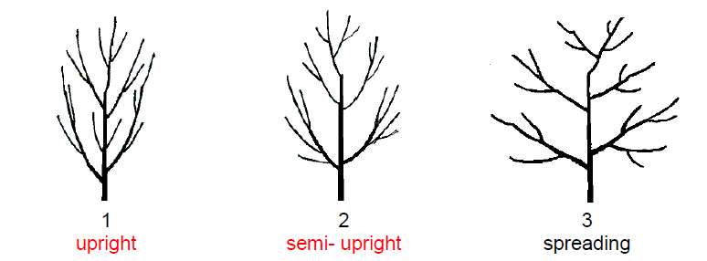

Ad. 5: Current season's shoot: phyllotaxis

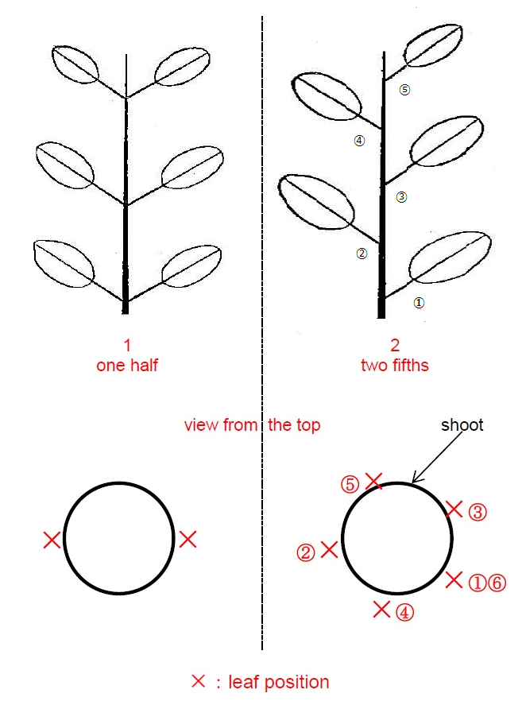

Ad. 8: Shoot: number of female flowers

The number of female flowers should be observed on the bearing shoots at full flowering time.

Ad. 10: Unisexual catkin: length

The length of catkin should be observed on the longest catkin at the full flowering time.

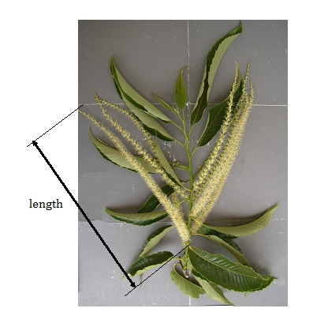

Ad. 11: Young leaf: bronze coloration

Bronze coloration of young leaf should be observed at distal part of current shoot.

Ad. 12: Leaf: size

The size of leaf should be observed on the leaf blade.

Ad. 13: Leaf: profile in cross section

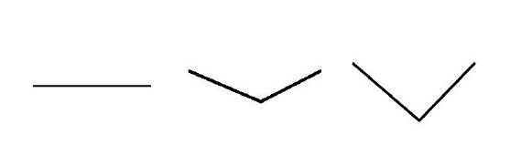
1 2 3
straight slightly concave strongly concave

Ad. 15: Leaf: length/width ratio

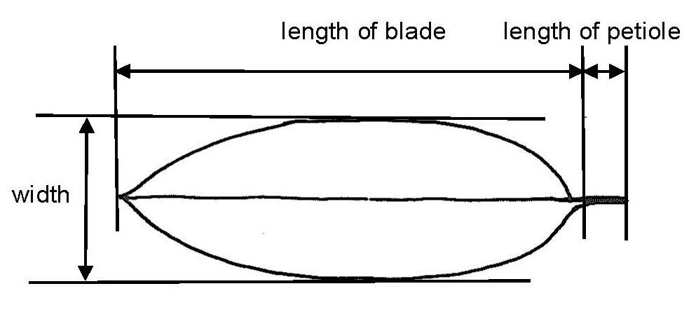
Ad. 16: Leaf: attitude inrelation to shoot

The attitude should be observed on upright shoots vertically.
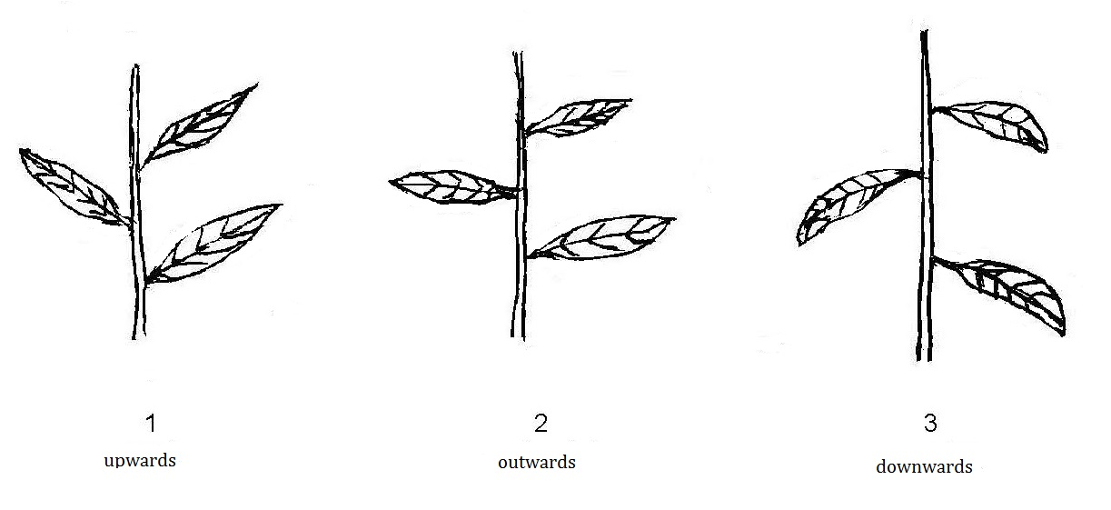

Ad. 19: Leaf: shape

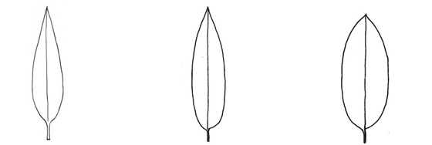
1 | 2 | 3
lanceolate | narrow elliptic | broad elliptic

Ad. 20: Leaf: shape of apex

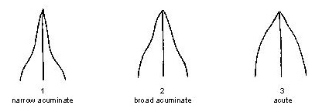
Ad. 21: Leaf: shape of base

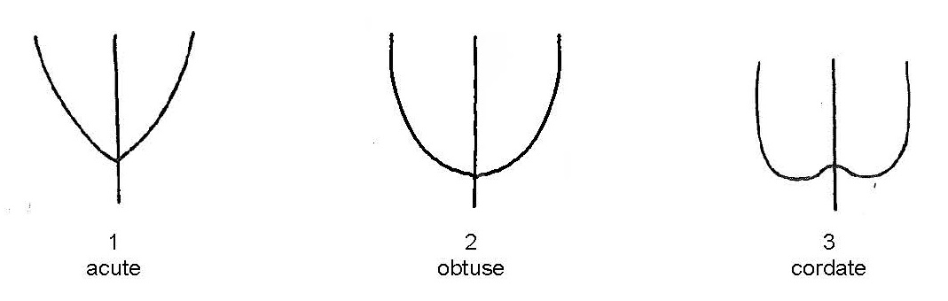

Ad. 22: Leaf: shape of margin

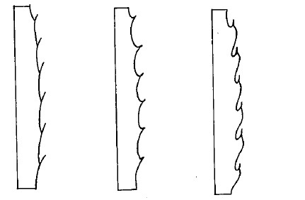
1 2 3
needle shape acute flare shape

Ad. 25: Leaf: ratio length of leaf blade/length of petiole

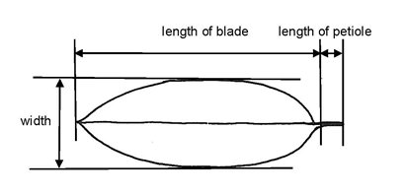
Ad. 26: Bur: shape

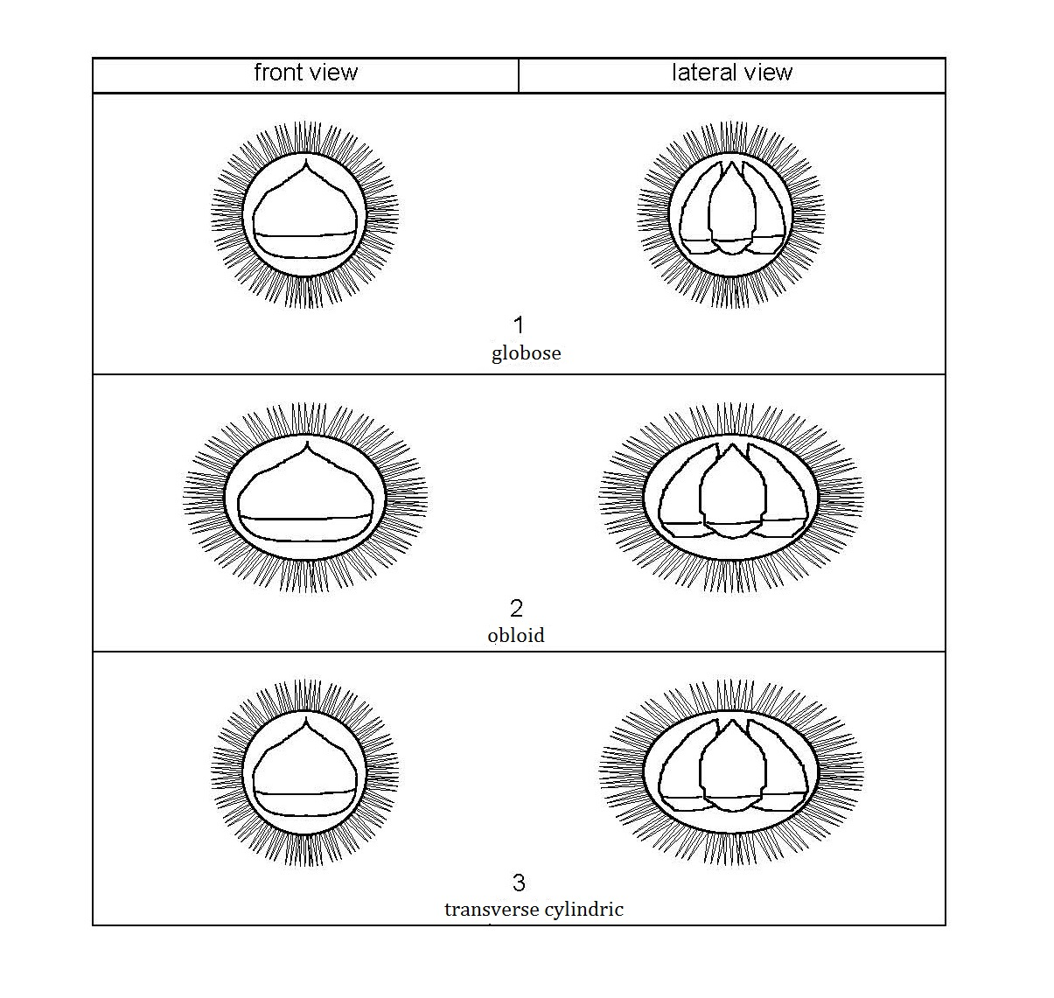

Ad. 28: Nut: embryony

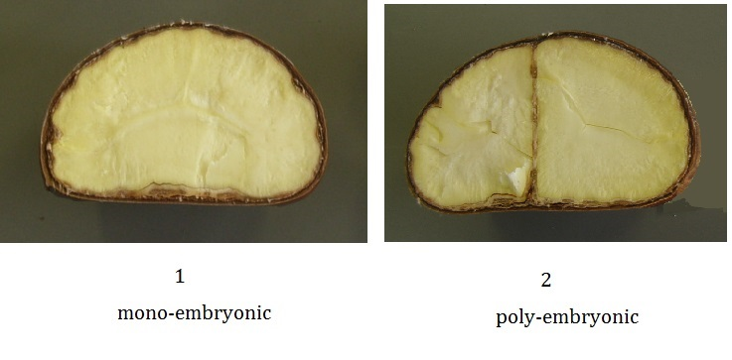

Ad. 31: Nut: shape

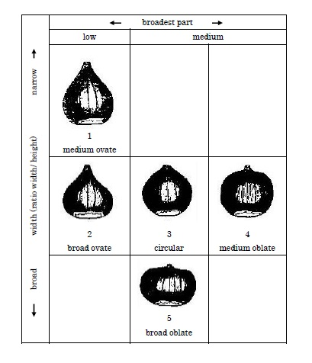
Ad. 32: Nut: area of pubescence on upper part

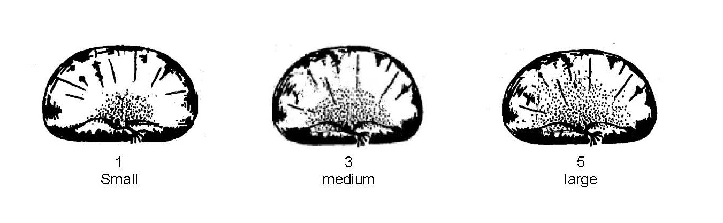
Ad. 33: Nut: area of hilum

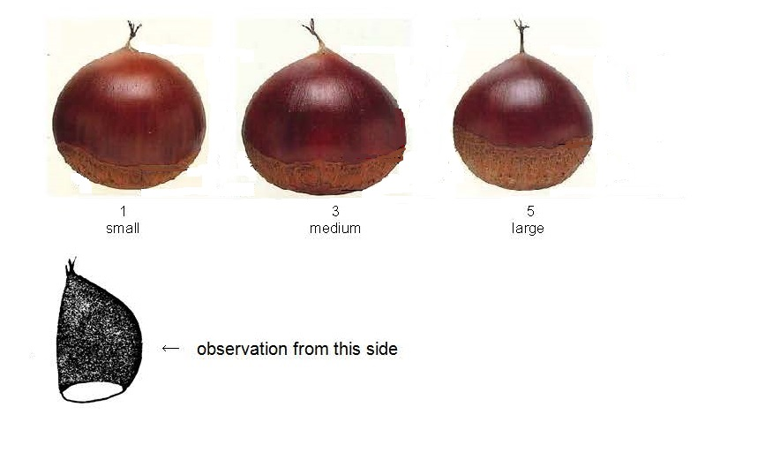
Ad. 34: Nut: shape of border line of hilum and pericarp

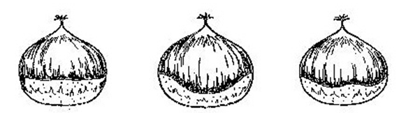
1 | 2 | 3
straight | curved | wavy

Ad. 36: Nut: glossiness

The glossiness of nut should be observed immediately after opening of involucre.

Ad. 39: Seed coat: adherence to kernel

The adherence to kernel should be determined by observation of easiness of peeling seed coat by hand after just harvested nuts are steamed for 50 minutes or roasted for 10 to 15 minutes at 200-250C. Nuts should be cracked with a knife in half of nut skin before steaming or roasting.

Ad. 42: Time of leaf bud burst

The time of leaf bud burst should be considered as the time when 20% of buds show green color at the top of bud.

Ad. 43: Time of male flowering

The time of male and female flowering should be considered as the middle day when 20% of the flower are fully open and the day when 80% of the flower are fully open.

Ad. 44: Time of female flowering

The time of male and female flowering should be considered as the middle day when 20% of the flowers are fully open and the day when 80% of the flower are fully open.

Ad. 45: Time of maturity for consumption

The time of maturity for consumption should be considered as the middle day between the day when 20% nuts are harvested and the day when 100% nuts are harvested.

  8.3
  8.1 (f)
  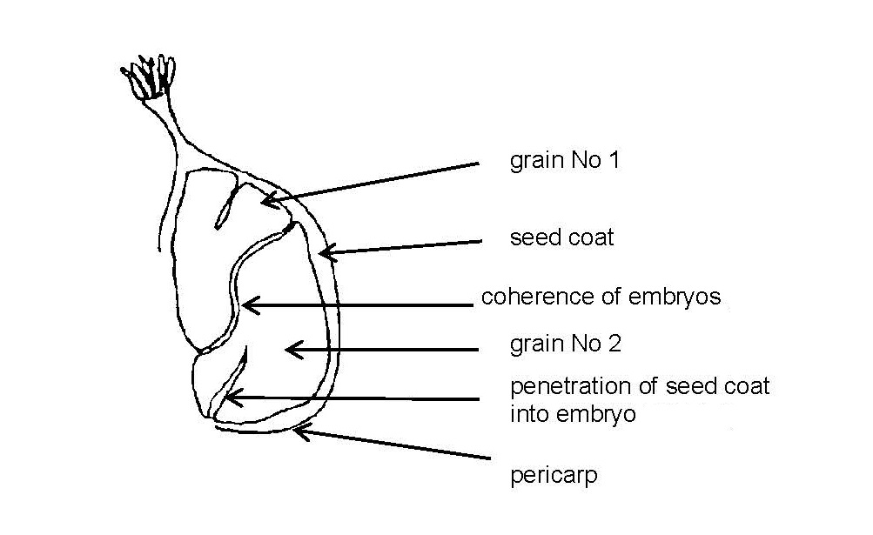

9. | Literature

Pitte, J.R., 1986: Terres de Castanide, Hommes et paysages du chataignier de l’antiquite a nos jours, Editions Fayard, pp. 480

Solignat, G., Chapa, J., 1978: La Biologie florale du chataignier, Invuelec, pp. 35

Bruneton – Governatori A., 1984: Le Pain de bois. Ethnohistoire de la chataigne et du chataignier, Eche Ed., pp. 533

Congreso International Sobre el Castano: Lourizan Pontevedra, Espagna, 1-5 octobre 1984, parution 1986, Xunta de Galicai, pp.429

Chapa, J.- INRA, 1982: Situation de la castaneiculture francaise. Convegno internazionale di Frutticoltura montana, Saint – Vincent d’Aoste, IT

INRA. CTPS., 1986 + 1987: Premier catalogue officiel des varietes de chataignes et marrons, Documents GEVES, pp. 31-33, FR

CHAPA, J. – INRA, 1987: Chataignes et marrons, varietes inscrites au Catalogue officiel. Arboriculture fruitiere, No. 399, pp. 21-30

Kozaki, I. et al., 1996: The fruit in Japan, Yokendo Ltd., JP, pp. 423, pp382- 383

Shimura, I. et al., 1999: Chestnut, The encyclopedia of fruit horticulture, Nosangyoson Bunka Kyokai, v.5, JP

10.
Technical Questionnaire

TECHNICAL QUESTIONNAIRE | Page {x} of {y} | Reference Number:

Application date:
(not to be filled in by the applicant)
TECHNICAL QUESTIONNAIRE
to be completed in connection with an application for plant breeders' rights

1. | Subject of the Technical Questionnaire
 |  | Botanical name
  1.1.1
  Castanea crenata Sieold & Zucc.
  [ ]
 |  | Common name
  1.1.2
  Japanese chestnut
 |  | Botanical name
  1.2.1
  Castanea mollissima Blume
  [ ]
 |  | Common name
  1.2.2
  Chinese Chestnut
 |  | Botanical name
  1.3.1
  Castanea sativa Mill.
  [ ]
 |  | Common name
  1.3.2
  Chestnut
 |  | Botanical name
  1.4.1
  Castanea x Castanea
  [ ]
 |  | Common name
  1.4.2
  Chestnut ( in case of interspecific hybrid )

2. | Applicant
 | Name
 | Address

Telephone No.
Fax No.
E-mail address
Breeder (if different from
applicant)

3. | Proposed denomination and breeder's reference
 | Proposed denomination
 | (if available)
 | Breeder's reference

TECHNICAL QUESTIONNAIRE |  |  | Page {x} of {y} | Reference Number:
#4. | Information on the breeding scheme and propagation of the variety
 | 4.1 | Breeding scheme

Variety resulting from:
4.1.1 Crossing
(a) controlled cross [ ]
(please state parent varieties)

(…………………..……………..…) x (……………..…………………..…)
female parent male parent

(b) partially known cross [ ]
(please state known parent variety(ies))

(…………………..……………..…) x (……………..…………………..…)
female parent male parent

(c) unknown cross [ ]

4.1.2 Mutation [ ]
(please state parent variety)

4.1.3 Discovery and development [ ]
(please state where and when discovered and how developed)

4.1.4 Other [ ]
(please provide details)

TECHNICAL QUESTIONNAIRE  Page {x} of {y} | Reference Number:

 | 4.2 | Method of propagating the variety
 | Other  (Please provide details) | [ ]
  4.2.1

TECHNICAL QUESTIONNAIRE | Page {x} of {y} | Reference Number:

5. | Characteristics of the variety to be indicated (the number in brackets refers to the corresponding characteristic in Test Guidelines; please mark the note which best corresponds).

 | Characteristics | Example Varieties | Note

TECHNICAL QUESTIONNAIRE | Page {x} of {y} | Reference Number:

6. | Similar varieties and differences from these varieties
Please use the following table and box for comments to provide information on how your candidate variety differs from the variety (or varieties) which, to the best of your knowledge, is (or are) most similar. This information may help the examination authority to conduct its examination of distinctness in a more efficient way.

  Denomination(s) of variety(ies) similar to your candidate variety
  Characteristic(s) in which your candidate variety differs from the similar variety(ies)
  Describe the expression of the characteristic(s) for the similar variety(ies)
  Describe the expression of the characteristic(s) for your candidate variety

Example

 | Comments:

TECHNICAL QUESTIONNAIRE | Page {x} of {y} | Reference Number:

#7. | Additional information which may help in the examination of the variety
7.1 | In addition to the information provided in sections 5 and 6, are there any additional characteristics which may help to distinguish the variety?
 | Yes | [ ] | No | [ ]
 | (If yes, please provide details)
7.2 | Are there any special conditions for growing the variety or conducting the examination?
 | Yes | [ ] | No | [ ]
 | (If yes, please provide details)
7.3 | Other information

TECHNICAL QUESTIONNAIRE
Page {x} of {y} | Reference Number:

8. | Authorization for release
 | (a) | Does the variety require prior authorization for release under legislation concerning the protection of the environment, human and animal health?
 |  | Yes | [ ] | No | [ ]
 | (b) | Has such authorization been obtained?
 |  | Yes | [ ] | No | [ ]
 | If the answer to (b) is yes, please attach a copy of the authorization.

9. Information on plant material to be examined or submitted for examination

9.1 The expression of a characteristic or several characteristics of a variety may be affected by factors, such as pests and disease, chemical treatment (e.g. growth retardants or pesticides), effects of tissue culture, different rootstocks, scions taken from different growth phases of a tree, etc.
9.2 The plant material should not have undergone any treatment which would affect the expression of the characteristics of the variety, unless the competent authorities allow or request such treatment. If the plant material has undergone such treatment, full details of the treatment must be given. In this respect, please indicate below, to the best of your knowledge, if the plant material to be examined has been subjected to:

 | (a) | Microorganisms (e.g. virus, bacteria, phytoplasma) | Yes [ ] | No [ ]
 | (b) | Chemical treatment (e.g. growth retardant, pesticide) | Yes [ ] | No [ ]
 | (c) | Tissue culture | Yes [ ] | No [ ]
 | (d) | Other factors | Yes [ ] | No [ ]
 | Please provide details for where you have indicated “yes”.

10. | I hereby declare that, to the best of my knowledge, the information provided in this form is correct:
 | Applicant’s name
 | Signature |  | Date

[End of document]

