|  |  |  |
| --- | --- | --- |
|  |  | E  TWF/46/28  **ORIGINAL:**  English  DATE:  August 10, 2015 |
| INTERNATIONAL UNION FOR THE PROTECTION OF NEW VARIETIES OF PLANTS | | |
| Geneva | | |

Technical working party for fruit cropS

Forty-Sixth Session  
Mpumalanga, South Africa, August 24 to 28, 2015

Definition of “Recurved”

Document prepared by an expert from Israel  
  
Disclaimer: this document does not represent UPOV policies or guidance

The purpose of this document is to present a proposal for a revision of the term “recurved” and accompanying illustration as they appear in TGP/14/2: Section 2: Botanical Terms, Subsection 4: Definitions for Shape, Structure and Color Terms, and TGP/14/2: Section 2: Botanical Terms, Subsection 2: Shapes and Structures: II. Structure, respectively.

BACKGROUND

*2.* In document TGP/14 it is stated:

|  |  |
| --- | --- |
| Curving downwards (abaxially). Compare ‘reflexed’, which is bent downwards more abruptly. | Recurved |

The accompanying illustration:

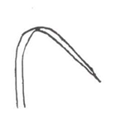

This definition is not correct and it causes a lot of unnecessary ambiguity in the Test Guidelines. The correct meaning of the verb recurve is to curve or bend back or backward.

The origin of the verb is from Latin: *recurvāre*, meaning bent back on itself (the Etymology of the Latin word recurvāre can be found [here](http://www.myetymology.com/latin/recurvare.html)).

*Recurvāre* = *re-* + *curvāre*

*re-*: a prefix, occurring originally in loanwords from Latin, used with the meaning “again” or “again and again” to indicate repetition, or with the meaning “back” or “backward” to indicate withdrawal or backward motion: regenerate; refurbish; retype; retrace; revert (more [here](http://www.learnthat.org/pages/view/roots.html)).

*curvāre*: to curve: a continuously bending line, without angles.

3. Examples from TG's using the term “recurve”:

In TG/262/1 Gypsophila:

|  |  |  |
| --- | --- | --- |
| **11.  (+)** |  | **Leaf: recurvature** |
| **QN** | **(c)** | absent or slightly recurved |
|  |  | moderately recurved |
|  |  | strongly recurved |

Ad. 11:  Leaf: recurvature

|  |  |  |
| --- | --- | --- |
| Description: New Picture (22) | Description: New Picture (22) | Description: New Picture (22) |
| 1 | 2 | 3 |
| absent or  slightly recurved | moderately recurved | strongly recurved |

In TG/59/7 Lily:

|  |  |  |
| --- | --- | --- |
| **16. (*) (+)** |  | **Flower: shape of perianth (excluding pedicel)** |
| **PQ** |  | trumpet |
|  |  | bowl |
|  |  | flat |
|  |  | recurved |

Ad. 16: Flower: shape of perianth (excluding pedicel)

|  |  |  |  |
| --- | --- | --- | --- |
|  |  |  |  |
| 1 | 2 | 3 | 4 |
| trumpet | bowl | flat | recurved |

In these 2 examples the shapes are not “recurved”, they are simply “curved”. There is no backward bending, the line continuously curves in the same direction to form an arc, and there is no change in the direction of the curvature.

PROPOSAL

4. It is proposed to change the wording and illustration for the term “recurved” in document TGP/14. The proposed changes are presented below in highlight and underline (insertion) and strikethrough (~~deletion~~).

*Current wording and illustration:*

|  |  |
| --- | --- |
| ~~Curving downwards (abaxially). Compare ‘reflexed’, which is bent downwards more abruptly.~~ | Recurved |



*Proposed new wording and illustration:*

|  |  |
| --- | --- |
| Curving with a change in direction of curvature at some point | Recurved |



Example photo: Pitahaya fruit bract

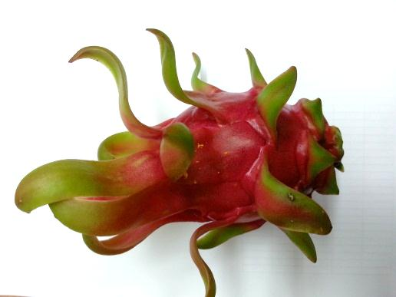

[End of document]