E
TWF/46/24
ORIGINAL: English
DATE: August 4, 2015
INTERNATIONAL UNION FOR THE PROTECTION OF NEW VARIETIES OF PLANTS
Geneva
Technical working party for fruit cropS
Forty-Sixth Session
Mpumalanga, South Africa, August 24 to 28, 2015
Matters to be resolved concerning Test Guidelines adopted by the Technical Committee
Test Guidelines for Pecan Nut (Document TG/PECAN(PROJ.12))
Document prepared by an expert from Mexico
Disclaimer: this document does not represent UPOV policies or guidance
The Technical Working Party for Fruit Crops (TWF), at its forty-fifth session, held in Marrakesh, Morocco, from May 26 to 30, 2014, agreed that the Test Guidelines for Pecan Nut (document TG/PECAN(proj.10)) be submitted to the Technical Committee (TC) for adoption at its fifty-first session, held in Geneva from March 23 to 25, 2015 (see document TWF/45/32, Annex V).

The TC, at its fifty-first session, adopted the Test Guidelines for Pecan Nut (document TG/PECAN(proj.12)).

After the fifty-first session of the TC, the Leading Expert, Mr. Alejandro Barrientos Priego (Mexico), proposed to replace certain illustrations contained in document TG/PECAN(proj.12).

The proposed new illustrations for replacement of current illustrations in the adopted Test Guidelines for Pecan Nut are presented below for consideration by the TWF at its forty-sixth session.

Proposed New Illustrations

Ad. 15: Stigma: splitting

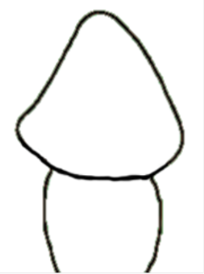 |  | 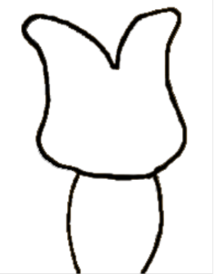
1 | 2 | 3
absent or weak | moderate | strong

Ad. 18: Husk: prominence of ribs

To be observed before husk opening.

 |  |  | 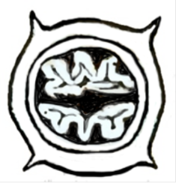
1 | 3 | 5 | 7
absent or very weak | weak | medium | strong

Ad. 30: Kernel: size in relation to size of nut

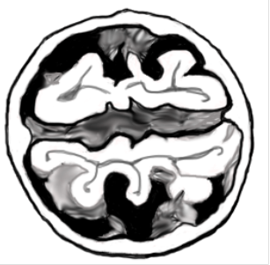 | 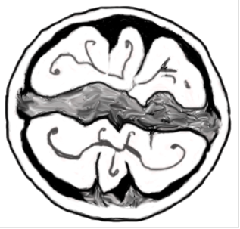 | 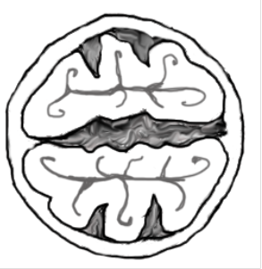
1 | 2 | 3
small | medium | large

[End of document]

