E
TWF/46/14
ORIGINAL: English
DATE: July 22, 2015
INTERNATIONAL UNION FOR THE PROTECTION OF NEW VARIETIES OF PLANTS
Geneva
Technical working party for fruit cropS
Forty-Sixth Session
Mpumalanga, South Africa, August 24 to 28, 2015

REGIONAL SETS OF EXAMPLE VARIETIES
Document prepared by the Office of the Union
Disclaimer: this document does not represent UPOV policies or guidance
EXECUTIVE SUMMARY

The purpose of this document is to consider the term “region” and the basis for selecting example varieties in a region in relation to the establishment of regional sets of example varieties for Test Guidelines.

The TWF is invited to consider whether to include guidance in document TGP/7 that:

(a) a “region” should be comprised of more than one country in order to justify a regional set of example varieties in Test Guidelines; and

(b) the TWP should determine the basis on which the region would establish an agreed regional set of example varieties (e.g. by an exchange of information, or by a ring-test).

The structure of this document is as follows:

BACKGROUND 2
existing guidance in document TGP/7 2
issues to be considered 2
Number of countries 2
Defining regional example varieties 2

ANNEX Extract from document TGP/7, GN28 “Example varieties”

The following abbreviations are used in this document:

CAJ: Administrative and Legal Committee
TC: Technical Committee
TC-EDC: Enlarged Editorial Committee
TWA: Technical Working Party for Agricultural Crops
TWC: Technical Working Party on Automation and Computer Programs
TWF: Technical Working Party for Fruit Crops
TWO: Technical Working Party for Ornamental Plants and Forest Trees
TWV: Technical Working Party for Vegetables
TWPs: Technical Working Parties

BACKGROUND

The TC-EDC, at its meeting in January, 2015, considered the establishment of regional sets of example varieties in relation to the Test Guidelines for Apple Rootstocks. The TC-EDC recommended that clarification be provided on the term “region” and the basis for selecting example varieties in a region.

The TC, at its fifty-first session, held in Geneva, from March 23 to 25, 2015, agreed that guidance should be developed on the term “region” and the basis for selecting example varieties for a region in relation to the establishment of regional sets of example varieties for Test Guidelines.

existing guidance in document TGP/7

Document TGP/7, GN28, Section 2.5, provides guidance on developing regional sets of example varieties as reproduced in the Annex to this document. It explains that “[T]the rationale for identifying regional types will be explained in the Test Guidelines and, where appropriate, correlation between the different regional sets of example varieties may be established (see document TGP/7, Section 2.5.1). […] In cases where the relevant TWP agrees to the development of regional sets of example varieties, the TWP concerned will determine the regions and the contributors of regional lists of varieties” (see document TGP/7, Section 2.5.2.1).

issues to be considered

Number of countries

Currently no guidance is provided on the minimum number of countries to constitute a “region”. It is evident that a country or a part of a country could constitute a “region”. However, in such cases, the “regional” set of example varieties would only be relevant for a single country. In that regard, the purpose of the UPOV Test Guidelines is international harmonization and it might be considered that a regional set of example varieties that would only be relevant for one country would not contribute to international harmonization.

Defining regional example varieties

In the case of a region comprising more than one country, the TWP is required to determine the regions and the contributors of the regional lists. It may be considered useful to add an explanation in document TGP/7 that it would be a matter for the TWP to determine the basis on which the region would establish an agreed regional set of example varieties (e.g. by an exchange of information, or by a ring-test).

The TWF is invited to consider whether to include guidance in document TGP/7 that:

(a) a “region” should be comprised of more than one country in order to justify a regional set of example varieties in Test Guidelines; and

(b) the TWP should determine the basis on which the region would establish an agreed regional set of example varieties (e.g. by an exchange of information, or by a ring-test).

[Annex follows]
EXTRACT FROM DOCUMENT TGP/7 “DEVELOPMENT OF TEST GUIDELINES”

GN 28 (TG Template: Chapter 6.4) – Example varieties
[…]
2. Criteria for Example Varieties

2.1 Availability

Authorities responsible for DUS testing and breeders need to be able to obtain plant material of example varieties and therefore, in general, example varieties should be widely and readily available for the coverage of the Test Guidelines or, in case of regional sets of example varieties, for the region concerned. For this reason, at the point of starting to draft Test Guidelines, drafters are encouraged to seek lists of varieties from interested parties in order to identify example varieties with the widest availability.

[…]

2.5 Regional sets of example varieties

2.5.1 Basis for regional sets of example varieties

UPOV Test Guidelines need to cover all the different countries, regions and environments where the DUS examinations are conducted and, as far as possible, they provide universal sets of example varieties in order to maximize harmonization of variety descriptions. However, the regional adaptation of varieties in some genera and species may mean that it is inappropriate to seek to harmonize variety descriptions on a global basis and, therefore, inappropriate to seek to develop a universal set of example varieties. Nevertheless, in such cases, regional harmonization is important and is facilitated by providing regional sets of example varieties as summarized in Flow Diagram 2 in section 3.4. The rationale for identifying regional types will be explained in the Test Guidelines and, where appropriate, correlation between the different regional sets of example varieties may be established.

2.5.2 Procedure for developing regional sets

2.5.2.1 In cases where the relevant TWP agrees to the development of regional sets of example varieties, the TWP concerned will determine the regions and the contributors of regional lists of varieties.

2.5.2.2 In cases where it is known by the relevant TWP that regional sets of example varieties are to be developed, this will be stated in the Test Guidelines.
[…]

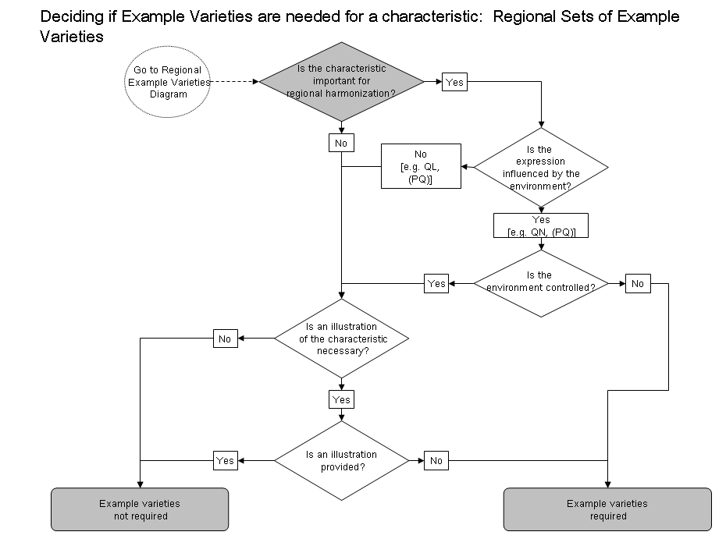
Flow Diagram 2

3. Multiple sets of example varieties

3.1 Presentation of Regional Sets of Example Varieties

3.1.1 The existence of multiple sets of example varieties means that, for some or all characteristics, no example varieties are presented in the Table of Characteristics and the multiple sets of example varieties are presented in an annex available on the UPOV Website which is presented as follows:

 | Region A
Example varieties | Ch. 1 | Ch. 2 | Ch. 3 | Ch. 4 | Ch. 5 | etc.
Variety A | 3 | 1 | 3 |  | 3
Variety B | 5 | 2 | 7 | 1 | 1
Variety C | 7 | 3 | 5 | 9 | 2
Variety D |  | 4 |  |  | 4
etc.

 | Region B
Example varieties | Ch. 1 | Ch. 2 | Ch. 3 | Ch. 4 | Ch. 5 | etc.
Variety I | 3 | 4 | 5 |  | 1
Variety II | 5 | 2 | 3 | 1 | 2
Variety III | 7 | 1 | 7 | 9 | 3
Variety IV |  | 3 |  |  | 4
etc.

3.1.2 Even where the “example variety” column is empty (i.e. there are no universal example varieties for any characteristic), the column is retained in the Table of Characteristics to allow users to complete this with the appropriate example varieties.
[…]
[End of annex and of document]

