E
TG/PYRUS(proj.1)
ORIGINAL: English
DATE: 2015-07-24
INTERNATIONAL UNION FOR THE PROTECTION OF NEW VARIETIES OF PLANTS
Geneva
DRAFT

 | Pear, Japanese Pear  UPOV Code: PYRUS_BRE; PYRUS_COM; PYRUS_LEC; PYRUS_PYR; PYRUS_PYR_CUL; PYRUS_USS  Pyrus communis L.;  Pyrus pyrifolia (Burm. f.) Nakai;  Pyrus pyrifolia (Burm. f.) Nakai var. culta (Mak.) Nakai; Pyrus ussuriensis Maxim.;  Pyrus xbretschneideri Rehder; Pyrus ×lecontei Rehder | *

GUIDELINES
FOR THE CONDUCT OF TESTS
FOR DISTINCTNESS, UNIFORMITY AND STABILITY

prepared by (an) expert(s) from New Zealand

to be considered by the
Technical Working Party for Fruit Crops
at its forty-sixth session
to be held in Mpumalanga, South Africa
from 2015-08-24
to 2015-08-28

Alternative Names:*
Botanical name | English | French | German | Spanish
Pyrus communis L., Pyrus communis L. var sativa DC. | European Pear, Pear | Poirier | Birne | Peral
Pyrus pyrifolia (Burm. f.) Nakai | Asian pear, Chinese pear, Chinese sand pear, Japanese pear, Nashi, Nashi pear, Oriental pear, Sand pear | poirier japonais | China-Birne, Nashi-Birne, Sandbirnbaum | pera
Pyrus pyrifolia (Burm. f.) Nakai var. culta (Mak.) Nakai, Chinese Pear, Japanese Pear, Nashi, Sand Pear | poirier japonais | Chinesische Birne, Nashi, Sandbirne | peral japonés
Pyrus ussuriensis Maxim | Harbin pear, Ussurian pear |  | Ussuri-Birne
Pyrus xbretschneideri Rehder, Pyrus pyrifolia x Pyrus bretschneideri | Chinese white pear, Chinese white pear, white pear |  | weiße Birne
Pyrus ×lecontei Rehder

The purpose of these guidelines (“Test Guidelines”) is to elaborate the principles contained in the General Introduction (document TG/1/3), and its associated TGP documents, into detailed practical guidance for the harmonized examination of distinctness, uniformity and stability (DUS) and, in particular, to identify appropriate characteristics for the examination of DUS and production of harmonized variety descriptions.

ASSOCIATED DOCUMENTS
These Test Guidelines should be read in conjunction with the General Introduction and its associated TGP documents.

Other associated UPOV documents: Pear TG/15/3

Japanese Pear TG/149/2

Pyrus Rootstocks TG/169/1
TABLE OF CONTENTS PAGE

1. Subject of these Test Guidelines 4
2. Material Required 4
3. Method of Examination 4
3.1 Number of Growing Cycles 4
3.2 Testing Place 4
3.3 Conditions for Conducting the Examination 4
3.4 Test Design 5
3.5 Additional Tests 5
4. Assessment of Distinctness, Uniformity and Stability 5
4.1 Distinctness 5
4.2 Uniformity 6
4.3 Stability 6
5. Grouping of Varieties and Organization of the Growing Trial 6
6. Introduction to the Table of Characteristics 7
6.1 Categories of Characteristics 7
6.2 States of Expression and Corresponding Notes 7
6.3 Types of Expression 7
6.4 Example Varieties 8
6.5 Legend 8
7. Table of Characteristics/Tableau des caractères/Merkmalstabelle/Tabla de caracteres 9
8. Explanations on the Table of Characteristics 29
9. Literature 45
10. Technical Questionnaire 46

Subject of these Test Guidelines

These Test Guidelines apply to all varieties of Pyrus xbretschneideri Rehder, Pyrus communis L., Pyrus ×lecontei Rehder, Pyrus pyrifolia (Burm. f.) Nakai, Pyrus pyrifolia (Burm. f.) Nakai var. culta (Mak.) Nakai, Pyrus ussuriensis Maxim..

and hybrids between these species

Material Required

2.1 The competent authorities decide on the quantity and quality of the plant material required for testing the variety and when and where it is to be delivered. Applicants submitting material from a State other than that in which the testing takes place must ensure that all customs formalities and phytosanitary requirements are complied with.

  - The material is to be supplied in the form of grafted or budded trees on a suitable rootstock prescribed by the competent authority.

2.3 The minimum quantity of plant material, to be supplied by the applicant, should be:

five trees.

2.4 The plant material supplied should be visibly healthy, not lacking in vigor, nor affected by any important pest or disease.

2.5 The plant material should not have undergone any treatment which would affect the expression of the characteristics of the variety, unless the competent authorities allow or request such treatment. If it has been treated, full details of the treatment must be given.

Method of Examination

3.1 Number of Growing Cycles

3.1.1 The minimum duration of tests should normally be two independent growing cycles.

3.1.2 In particular, it is essential that the Trees produce a satisfactory crop of fruit in each of the two growing cycles.

3.1.3 The two independent growing cycles may be observed from a single planting, examined in two separate growing cycles.

3.1.4 The growing cycle is considered to be the duration of a single growing season, beginning with bud burst (flowering and/or vegetative), flowering and fruit harvest and concluding when the following dormant period ends with the swelling of new season buds.

3.1.5 The first growing cycle should begin after the trees have produced the first crop of fruit.

3.2 Testing Place

Tests are normally conducted at one place. In the case of tests conducted at more than one place, guidance is provided in TGP/9 “Examining Distinctness”.

3.3 Conditions for Conducting the Examination

3.3.1 The tests should be carried out under conditions ensuring satisfactory growth for the expression of the relevant characteristics of the variety and for the conduct of the examination.

3.3.2 Because daylight varies, color determinations made against a color chart should be made either in a suitable cabinet providing artificial daylight or in the middle of the day in a room without direct sunlight. The spectral distribution of the illuminant for artificial daylight should conform with the CIE Standard of Preferred Daylight D 6500 and should fall within the tolerances set out in the British Standard 950, Part I. These determinations should be made with the plant part placed against a white background. The color chart and version used should be specified in the variety description.

3.4 Test Design

3.4.1 Each test should be designed to result in a total of at least 5 trees.

3.4.2 The design of the tests should be such that plants or parts of plants may be removed for measurement or counting without prejudice to the observations which must be made up to the end of the growing cycle.

3.5 Additional Tests

Additional tests, for examining relevant characteristics, may be established.

Assessment of Distinctness, Uniformity and Stability

4.1 Distinctness

4.1.1 General Recommendations

It is of particular importance for users of these Test Guidelines to consult the General Introduction prior to making decisions regarding distinctness. However, the following points are provided for elaboration or emphasis in these Test Guidelines.

4.1.2 Consistent Differences

The differences observed between varieties may be so clear that more than one growing cycle is not necessary. In addition, in some circumstances, the influence of the environment is not such that more than a single growing cycle is required to provide assurance that the differences observed between varieties are sufficiently consistent. One means of ensuring that a difference in a characteristic, observed in a growing trial, is sufficiently consistent is to examine the characteristic in at least two independent growing cycles.

4.1.3 Clear Differences

Determining whether a difference between two varieties is clear depends on many factors, and should consider, in particular, the type of expression of the characteristic being examined, i.e. whether it is expressed in a qualitative, quantitative, or pseudo-qualitative manner. Therefore, it is important that users of these Test Guidelines are familiar with the recommendations contained in the General Introduction prior to making decisions regarding distinctness.

4.1.4 Number of Plants / Parts of Plants to be Examined

Unless otherwise indicated, for the purposes of distinctness, all observations on single plants should be made on 5 plants or parts taken from each of 5 plants and any other observations made on all plants in the test, disregarding any off-type plants. In the case of observations of parts taken from single plants, the number of parts to be taken from each of the plants should be 2.

4.1.5 Method of Observation

The recommended method of observing the characteristic for the purposes of distinctness is indicated by the following key in the second column of the Table of Characteristics (see document TGP/9 “Examining Distinctness”, Section 4 “Observation of characteristics”):

MG: single measurement of a group of plants or parts of plants
MS: measurement of a number of individual plants or parts of plants
VG: visual assessment by a single observation of a group of plants or parts of plants
VS: visual assessment by observation of individual plants or parts of plants

Type of observation: visual (V) or measurement (M)

“Visual” observation (V) is an observation made on the basis of the expert’s judgment. For the purposes of this document, “visual” observation refers to the sensory observations of the experts and, therefore, also includes smell, taste and touch. Visual observation includes observations where the expert uses reference points (e.g. diagrams, example varieties, side-by-side comparison) or non-linear charts (e.g. color charts). Measurement (M) is an objective observation against a calibrated, linear scale e.g. using a ruler, weighing scales, colorimeter, dates, counts, etc.

Type of record: for a group of plants (G) or for single, individual plants (S)

For the purposes of distinctness, observations may be recorded as a single record for a group of plants or parts of plants (G), or may be recorded as records for a number of single, individual plants or parts of plants (S). In most cases, “G” provides a single record per variety and it is not possible or necessary to apply statistical methods in a plant-by-plant analysis for the assessment of distinctness.

In cases where more than one method of observing the characteristic is indicated in the Table of Characteristics (e.g. VG/MG), guidance on selecting an appropriate method is provided in document TGP/9, Section 4.2.

4.2 Uniformity

    - It is of particular importance for users of these Test Guidelines to consult the General Introduction prior to making decisions regarding uniformity. However, the following points are provided for elaboration or emphasis in these Test Guidelines:

4.2.2 For the assessment of uniformity, a population standard of 1% and an acceptance probability of at least 95 % should be applied. In the case of a sample size of 5 plants, 0 off-types are allowed.

4.3 Stability

4.3.1 In practice, it is not usual to perform tests of stability that produce results as certain as those of the testing of distinctness and uniformity. However, experience has demonstrated that, for many types of variety, when a variety has been shown to be uniform, it can also be considered to be stable.

4.3.2 Where appropriate, or in cases of doubt, stability may be further examined by testing a new plant stock to ensure that it exhibits the same characteristics as those shown by the initial material supplied.

Grouping of Varieties and Organization of the Growing Trial

5.1 The selection of varieties of common knowledge to be grown in the trial with the candidate varieties and the way in which these varieties are divided into groups to facilitate the assessment of distinctness are aided by the use of grouping characteristics.

5.2 Grouping characteristics are those in which the documented states of expression, even where produced at different locations, can be used, either individually or in combination with other such characteristics: (a) to select varieties of common knowledge that can be excluded from the growing trial used for examination of distinctness; and (b) to organize the growing trial so that similar varieties are grouped together.

5.3 The following have been agreed as useful grouping characteristics:

(a) Tree: growth habit (characteristic 3)
(b) Fruit: size (characteristic 45)
(c) Fruit: position of maximum diameter (characteristic 50)
(d) Fruit: profile of sides (characteristic 52)
(e) Fruit: relative area of over color (characteristic 54)
(f) Fruit: hue of over color (characteristic 55)
(g) Fruit: presence of eye in calyx basin (characteristic 69)
(h) Time of harvest maturity (characteristic 83)

5.4 Guidance for the use of grouping characteristics, in the process of examining distinctness, is provided through the General Introduction and document TGP/9 “Examining Distinctness”.

Introduction to the Table of Characteristics

6.1 Categories of Characteristics

6.1.1 Standard Test Guidelines Characteristics

Standard Test Guidelines characteristics are those which are approved by UPOV for examination of DUS and from which members of the Union can select those suitable for their particular circumstances.

6.1.2 Asterisked Characteristics

Asterisked characteristics (denoted by *) are those included in the Test Guidelines which are important for the international harmonization of variety descriptions and should always be examined for DUS and included in the variety description by all members of the Union, except when the state of expression of a preceding characteristic or regional environmental conditions render this inappropriate.

6.2 States of Expression and Corresponding Notes

6.2.1 States of expression are given for each characteristic to define the characteristic and to harmonize descriptions. Each state of expression is allocated a corresponding numerical note for ease of recording of data and for the production and exchange of the description.

6.2.2 In the case of qualitative and pseudo-qualitative characteristics (see Chapter 6.3), all relevant states of expression are presented in the characteristic. However, in the case of quantitative characteristics with 5 or more states, an abbreviated scale may be used to minimize the size of the Table of Characteristics. For example, in the case of a quantitative characteristic with 9 states, the presentation of states of expression in the Test Guidelines may be abbreviated as follows:

State | Note
small | 3
medium | 5
large | 7

However, it should be noted that all of the following 9 states of expression exist to describe varieties and should be used as appropriate:

State | Note
very small | 1
very small to small | 2
small | 3
small to medium | 4
medium | 5
medium to large | 6
large | 7
large to very large | 8
very large | 9

6.2.3 Further explanation of the presentation of states of expression and notes is provided in document TGP/7 “Development of Test Guidelines”.

6.3 Types of Expression

An explanation of the types of expression of characteristics (qualitative, quantitative and pseudo-qualitative) is provided in the General Introduction.

6.4 Example Varieties

Where appropriate, example varieties are provided to clarify the states of expression of each characteristic.

6.5 Legend

(*) Asterisked characteristic – see Chapter 6.1.2

QL Qualitative characteristic – see Chapter 6.3
QN Quantitative characteristic – see Chapter 6.3
PQ Pseudo-qualitative characteristic – see Chapter 6.3

MG, MS, VG, VS – see Chapter 4.1.5

(a)-(a) See Explanations on the Table of Characteristics in Chapter 8.

(+) See Explanations on the Table of Characteristics in Chapter 8.

Table of Characteristics/Tableau des caractères/Merkmalstabelle/Tabla de caracteres

English | français | deutsch | español | Example Varieties Exemples Beispielssorten Variedades ejemplo | Note/ Nota
1. (*) QN VG (+)
Tree: vigor | Arbre : vigueur | Baum: Wuchsstärke | Árbol: vigor
weak | faible | gering | débil |  | 3
medium | moyenne | mittel | mediano |  | 5
strong | forte | stark | fuerte |  | 7
2. (*) QN VG (a)
Tree: branching
absent or very weak |  |  |  |  | 1
weak |  |  |  |  | 3
medium |  |  |  |  | 5
strong |  |  |  |  | 7
3. (*) PQ VG (+) (a)
Tree: growth habit
fastigiate |  |  |  |  | 1
upright |  |  |  |  | 2
semi upright |  |  |  |  | 3
spreading |  |  |  |  | 4
drooping |  |  |  |  | 5
weeping |  |  |  |  | 6
4. QN MS VG (a)
One-year-old shoot: length of internode | Rameau d’un an: longueur des entre‑nœuds | Einjähriger Trieb: Internodienlänge | Rama de un año: longitud de los entrenudos
very short | très courts | sehr kurz | muy cortos |  | 1
short | courts | kurz | cortos |  | 3
medium | moyens | mittel | medios |  | 5
long | longs | lang | largos |  | 7

English | français | deutsch | español | Example Varieties Exemples Beispielssorten Variedades ejemplo | Note/ Nota
5. (*) QN VG (a)
One-year-old shoot: thickness | Rameau d’un an : épaisseur | Einjähriger Trieb: Dicke | Rama de un año: grosor
thin | fin | dünn | delgada |  | 1
medium | moyen | mittel | mediana |  | 2
thick | épais | dick | gruesa |  | 3
6. (*) PQ VG (a)
One year old shoot: color on sunnyside
grey brown |  |  |  |  | 1
grey green |  |  |  |  | 2
greenish brown |  |  |  |  | 3
medium brown |  |  |  |  | 4
dark brown |  |  |  |  | 5
orange brown |  |  |  |  | 6
brown red |  |  |  |  | 7
brown purple |  |  |  |  | 8
dark purple |  |  |  |  | 9
7. (*) QN VG (a)
One-year-old shoot: number of lenticels | Rameau d’un an: nombre de lenticelles | Einjähriger Trieb: Anzahl der Lentizellen | Rama de un año: número de lenticelas
few |  |  |  |  | 1
medium |  |  |  |  | 3
many |  |  |  |  | 5

English | français | deutsch | español | Example Varieties Exemples Beispielssorten Variedades ejemplo | Note/ Nota
8. (*) QN VG (a)
One year old shoot: size of lenticels
small |  |  |  |  | 1
medium |  |  |  |  | 2
large |  |  |  |  | 3
9. (*) PQ VG
One year old shoot: shape of vegetative bud apex
acute |  |  |  |  | 1
obtuse |  |  |  |  | 2
rounded |  |  |  |  | 3
10. QL VG
One year old shoot: presence of axillary flower buds
absent |  |  |  |  | 1
present |  |  |  |  | 9
11. QN VG
One year old shoot: number of axillary flower buds
few |  |  |  |  | 1
medium |  |  |  |  | 2
many |  |  |  |  | 3
12. QN VG
Vegetative bud: position in relation to shoot
adpressed |  |  |  |  | 1
slightly held out |  |  |  |  | 2
strongly held out |  |  |  |  | 3

English | français | deutsch | español | Example Varieties Exemples Beispielssorten Variedades ejemplo | Note/ Nota
13. (*) QN VG
Mature shoot: number of spurs
few |  |  |  |  | 3
medium |  |  |  |  | 5
many |  |  |  |  | 7
14. (*) PQ VG
Young leaf: color of upper side
yellow green |  |  |  |  | 1
greenish brown |  |  |  |  | 2
brown |  |  |  |  | 3
red brown |  |  |  |  | 4
15. (*) QN VG
Young shoot: anthocyanin coloration of growing tip
absent or weak |  |  |  |  | 1
medium |  |  |  |  | 2
strong |  |  |  |  | 3
16. QN VG (+)
Leaf blade: attitude in relation to shoot | Limbe: port par rapport au rameau | Blattspreite: Haltung im Verhältnis zum Trieb | Limbo: porte en relación con la rama
upwards | dressé | aufwärts gerichtet | ascendente |  | 1
outwards | perpendiculaire | abstehend | horizontal |  | 2
downwards | retombant | abwärts gerichtet | descendente |  | 3

English | français | deutsch | español | Example Varieties Exemples Beispielssorten Variedades ejemplo | Note/ Nota
17. (*) QN MS VG
Leaf blade: length | Limbe: longueur | Blattspreite: Länge | Limbo: longitud
short | court | kurz | corta |  | 3
medium | moyen | mittel | media |  | 5
long | long | lang | larga |  | 7
18. (*) QN MS VG
Leaf blade: width | Limbe: largeur | Blattspreite: Breite | Limbo: anchura
narrow | étroit | schmal | estrecha |  | 3
medium | moyen | mittel | media |  | 5
broad | large | breit | ancha |  | 7
19. (*) QN MG VG
Leaf blade: ratio length/width | Limbe: rapport longueur/largeur | Blattspreite: Ver­hältnis Länge/Breite | Limbo: relación entre la longitud y la anchura
small | faible | klein | pequeña |  | 3
medium | moyen | mittel | media |  | 5
large | élevé | groß | grande |  | 7
20. (*) PQ VG (+)
Leaf blade: shape | Limbe: forme | Blattspreite: Form | Limbo: forma
ovate |  |  |  |  | 1
elliptic |  |  |  |  | 2
rounded |  |  |  |  | 3
obovate |  |  |  |  | 4
cordate |  |  |  |  | 5

English | français | deutsch | español | Example Varieties Exemples Beispielssorten Variedades ejemplo | Note/ Nota
21. (*) PQ VG (+)
Leaf blade: shape of apex | Limbe: forme du sommet | Blattspreite: Form der Spitze | Limbo: forma del ápice
acuminate | acuminé | zugespitzt | acuminada |  | 1
acute | pointu | spitz | aguda |  | 2
obtuse |  |  |  |  | 3
rounded |  |  |  |  | 4
22. (*) PQ VG (+)
Leaf blade: shape of base | Limbe : forme de la base | Blattspreite: Form der Basis | Limbo: forma de la base
acute |  |  |  |  | 1
obtuse |  |  |  |  | 2
truncate |  |  |  |  | 3
cordate |  |  |  |  | 4
23. QN VG
Leaf blade: length of tip | Limbe: longueur de la pointe | Blattspreite: Länge der aufgesetzten Spitze | Limbo: longitud de la punta
absent or short |  |  |  |  | 1
medium | moyenne | mittel | media |  | 3
long | longue | lang | larga |  | 5
24. PQ VG (+)
Leaf blade: incisions of margin (upper half) | Limbe: incisions du bord (moitié supérieure) | Blattspreite: Rand­einschnitte (obere Hälfte) | Limbo: incisiones del borde (mitad superior)
entire |  |  |  |  | 1
crenate |  |  |  |  | 2
blunt serrate |  |  |  |  | 3
sharp serrate |  |  |  |  | 4
dentate |  |  |  |  | 5

English | français | deutsch | español | Example Varieties Exemples Beispielssorten Variedades ejemplo | Note/ Nota
25. QN VG
Leaf blade: depth of incisions of margin | Limbe : profondeur des incisions du bord | Blattspreite: Tiefe der Randeinschnitte | Limbo: profundidad de las incisiones del borde
absent or very shallow |  |  |  |  | 1
shallow |  |  |  |  | 2
medium |  |  |  |  | 3
deep |  |  |  |  | 4
26. QN VG
Petiole: length | Pétiole: longueur | Blattstiel: Länge | Peciolo: longitud
short | court | kurz | corta |  | 3
medium | moyen | mittel | media |  | 5
long | long | lang | larga |  | 7
27. QL VG
Petiole: stipules | Pétiole : stipules | Blattstiel: Nebenblätter | Pecíolo: estípulas
absent | absentes | fehlend | ausentes |  | 1
present | présentes | vorhanden | presentes |  | 9
28. QN MG VG (+)
Petiole: distance of stipules from basal attachment
short |  |  |  |  | 1
medium |  |  |  |  | 2
long |  |  |  |  | 3
29. (*) QN MG VG
Ratio length of petiole/ length of blade
small |  |  |  |  | 3
medium |  |  |  |  | 5
large |  |  |  |  | 7

English | français | deutsch | español | Example Varieties Exemples Beispielssorten Variedades ejemplo | Note/ Nota
30. (*) QL VG
Shoot: location of flower buds
mainly on spurs |  |  |  |  | 1
mainly on long shoots |  |  |  |  | 2
31. (*) QN VG
Inflorescence: number of flowers | Inflorescence: nombre de fleurs | Blütenstand: Anzahl Blüten | Inflorescencia: número de flores
few |  |  |  |  | 3
medium |  |  |  |  | 5
many |  |  |  |  | 7
32. (*) QN VG
Flower bud: size
small |  |  |  |  | 3
medium |  |  |  |  | 5
large |  |  |  |  | 7
33. (*) QN MG VG
Flower: number of petals | Fleur: nombre de pétales | Blüte: Anzahl Blütenblätter | Flor: número de pétalos
five or less |  |  |  |  | 1
five and six |  |  |  |  | 2
six and seven |  |  |  |  | 3
more than seven |  |  |  |  | 4
34. (*) QN VG
Flower: arrangement of petals | Fleur: disposition des pétales | Blüte: Anordnung der Blütenblätter | Flor: disposición de los pétalos
free |  |  |  |  | 1
intermediate |  |  |  |  | 2
overlapping |  |  |  |  | 3

English | français | deutsch | español | Example Varieties Exemples Beispielssorten Variedades ejemplo | Note/ Nota
35. (*) QN VG
Flower: number of stamens | Fleur : nombre d’étamines | Blüte: Anzahl der Staubgefäße | Flor: número de estambres
few |  |  |  |  | 1
medium |  |  |  |  | 2
many |  |  |  |  | 3
36. (*) QN VG
Flower: position of stigma in relation to anthers | Fleur : position du stigmate par rapport aux étamines | Blüte: Stellung der Narbe im Vergleich zu den Antheren | Flor: posición del estigma en relación con las anteras
below |  |  |  |  | 1
same level |  |  |  |  | 2
above |  |  |  |  | 3
37. (*) QL VG
Anthers: pollen | Anthères : pollen | Antheren: Pollen | Anteras: polen
absent |  |  |  |  | 1
present |  |  |  |  | 9
38. QL VG
Anthers: intensity of red coloration
light |  |  |  |  | 1
medium |  |  |  |  | 2
dark |  |  |  |  | 3
39. QN MS VG
Petal: length | Pétale : longueur | Blütenblatt: Länge | Pétalo: longitud
short |  |  |  |  | 1
medium |  |  |  |  | 2
long |  |  |  |  | 3

English | français | deutsch | español | Example Varieties Exemples Beispielssorten Variedades ejemplo | Note/ Nota
40. QL MS VG
Petal: width | Pétale : largeur | Blütenblatt: Breite | Pétalo: anchura
narrow |  |  |  |  | 1
medium |  |  |  |  | 2
broad |  |  |  |  | 3
41. PQ VG
Petal: shape | Pétale: forme | Blütenblatt: Form | Pétalo: forma
narrow ovate |  |  |  |  | 1
broad ovate |  |  |  |  | 2
elliptic |  |  |  |  | 3
circular |  |  |  |  | 4
42. PQ VG
Petal: shape of base (excluding claw)
cuneate |  |  |  |  | 1
rounded |  |  |  |  | 2
truncate |  |  |  |  | 3
cordate |  |  |  |  | 4
43. PQ VG
Petal: color of inner side | Pétale : couleur de la face interne | Blütenblatt: Farbe der Innenseite | Pétalo: color de la cara interna
white |  |  |  |  | 1
light pink |  |  |  |  | 2
medium pink |  |  |  |  | 3
dark pink |  |  |  |  | 4

English | français | deutsch | español | Example Varieties Exemples Beispielssorten Variedades ejemplo | Note/ Nota
44. PQ VG
Petal: color of outer side
white |  |  |  |  | 1
light pink |  |  |  |  | 2
medium pink |  |  |  |  | 3
dark pink |  |  |  |  | 4
45. (*) QN VG
Fruit: size | Fruit : taille | Frucht: Größe | Fruto: tamaño
very small | très petit | sehr klein | muy pequeño |  | 1
small | petit | klein | pequeño |  | 3
medium | moyen | mittel | mediano |  | 5
large | grand | groß | grande |  | 7
very large | très grand | sehr groß | muy grande |  | 9
46. (*) QN MS VG
Fruit: height | Fruit: hauteur | Frucht: Höhe | Fruto: altura
short |  |  |  |  | 3
medium |  |  |  |  | 5
tall |  |  |  |  | 7
47. (*) QN MS VG
Fruit: diameter | Fruit: diamètre | Frucht: Durchmesser | Fruto: diámetro
small |  |  |  |  | 3
medium |  |  |  |  | 5
large |  |  |  |  | 7

English | français | deutsch | español | Example Varieties Exemples Beispielssorten Variedades ejemplo | Note/ Nota
48. (*) QN MG VG
Fruit: ratio height/diameter | Fruit: rapport hauteur/diamètre | Frucht: Verhältnis Höhe/Durchmesser | Fruto: relación altura/diámetro
very small |  |  |  |  | 1
small |  |  |  |  | 3
medium |  |  |  |  | 5
large |  |  |  |  | 7
very large |  |  |  |  | 9
49. (*) PQ VG (+)
Fruit: shape (in lateral view) | Fruit : forme (en vue latérale) | Frucht: Form (in Seitenansicht) | Fruto: forma (en vista lateral)
ovate |  |  |  |  | 1
oblate |  |  |  |  | 2
elliptic |  |  |  |  | 3
circular |  |  |  |  | 4
obovate |  |  |  |  | 5
50. (*) QN VG (+)
Fruit: position of maximum diameter | Fruit: localisation du diamètre maximal | Frucht: Position des maximalen Durchmessers | Fruto: posición del diámetro máximo
towards stem end |  |  |  |  | 1
in middle |  |  |  |  | 2
slightly toward calyx end |  |  |  |  | 3
strongly toward calyx end |  |  |  |  | 4
51. QN VG
Fruit: symmetry | Fruit : symétrie | Frucht: Symmetrie | Fruto: simetría
symmetric or slightly asymmetric | symétrique ou légèrement dissymétrique | symmetrisch oder leicht asymmetrisch | simétrico o ligeramente asimétrico |  | 1
moderately asymmetric | modérément dissymétrique | mäßig asymmetrisch | moderadamente asimétrico |  | 2
strongly asymmetric | fortement dissymétrique | stark asymmetrisch | muy asimétrico |  | 3

English | français | deutsch | español | Example Varieties Exemples Beispielssorten Variedades ejemplo | Note/ Nota
52. (*) QN VG (+)
Fruit: profile of sides
concave |  |  |  |  | 1
straight |  |  |  |  | 2
convex |  |  |  |  | 3
53. (*) PQ VG
Fruit: ground color | Fruit: couleur du fond | Frucht: Grundfarbe | Fruto: color de fondo
not visible |  |  |  |  | 1
green |  |  |  |  | 2
yellow green |  |  |  |  | 3
yellow |  |  |  |  | 4
yellow brown |  |  |  |  | 5
red brown |  |  |  |  | 6
54. (*) QN VG
Fruit: relative area of over color | Fruit: proportion de lavis | Frucht: Anteil der Deckfarben | Fruto: zona relativa del color superior
absent or very small |  |  |  |  | 1
small |  |  |  |  | 3
medium |  |  |  |  | 5
large |  |  |  |  | 7
very large |  |  |  |  | 9
55. PQ VG
Fruit: hue of over color | Fruit: teinte du lavis | Frucht: Ton der Deckfarbe | Fruto: tono del color superpuesto
orange |  |  |  |  | 1
orange red |  |  |  |  | 2
pink red |  |  |  |  | 3
light red |  |  |  |  | 4
dark red |  |  |  |  | 5

English | français | deutsch | español | Example Varieties Exemples Beispielssorten Variedades ejemplo | Note/ Nota
56. QN VG
Fruit: area of russet around eye basin | Fruit: surface de liège autour de la cuvette de l’œil | Frucht: Fläche der Berostung im Bereich der Kelchgrube | Fruto: zona de russeting de la cavidad del ojo
absent or small |  |  |  |  | 1
medium |  |  |  |  | 2
large |  |  |  |  | 3
57. QN VG
Fruit: area of russet on cheeks | Fruit: surface de liège sur les joues | Frucht: Fläche der Berostung auf den Wangen | Fruto: zona de russeting de las caras
absent or small |  |  |  |  | 1
medium |  |  |  |  | 2
large |  |  |  |  | 3
58. QL VG
Fruit: area of russet around stalk attachment | Fruit: surface de liège autour du pédoncule | Frucht: Fläche der Berostung im Bereich des Stielansatzes | Fruto: zona de russeting en torno a la base peduncular
absent or small |  |  |  |  | 1
medium |  |  |  |  | 2
large |  |  |  |  | 3
59. (*) QN VG
Fruit: density of lenticels on skin
absent or very sparse |  |  |  |  | 1
sparse |  |  |  |  | 3
medium |  |  |  |  | 5
dense |  |  |  |  | 7

English | français | deutsch | español | Example Varieties Exemples Beispielssorten Variedades ejemplo | Note/ Nota
60. (*) QN MG VG
Fruit: length of stalk | Fruit : longueur du pédoncule | Frucht: Länge des Stiels | Fruto: longitud del pedúnculo
short | court | kurz | corto |  | 3
medium | moyen | mittel | medio |  | 5
long | long | lang | largo |  | 7
61. (*) QL VG
Fruit: thickness of stalk | Fruit: grosseur du pédoncule | Frucht: Dicke des Stiels | Fruto: grosor del pedúnculo
thin | fin | dünn | delgado |  | 1
medium | moyen | mittel | medio |  | 3
thick | gros | dick | grueso |  | 5
62. (*) QN VG
Fruit: attitude of stalk to axis of fruit
straight |  |  |  |  | 1
oblique |  |  |  |  | 2
right angled |  |  |  |  | 3
63. (*) QL VG
Fruit: swelling of stalk
absent |  |  |  |  | 1
present |  |  |  |  | 9
64. QN VG
Fruit: density of lenticels on stalk
absent or sparse |  |  |  |  | 1
medium |  |  |  |  | 3
dense |  |  |  |  | 5

English | français | deutsch | español | Example Varieties Exemples Beispielssorten Variedades ejemplo | Note/ Nota
65. (*) QN VG (+)
Fruit: depth of stalk cavity | Fruit : profondeur de la dépression pédonculaire | Frucht: Tiefe der Stielhöhle | Fruto: profundidad de la cavidad peduncular
absent or very shallow |  |  |  |  | 1
shallow |  |  |  |  | 3
medium |  |  |  |  | 5
deep |  |  |  |  | 7
66. QN VG (+)
Fruit: width of stalk cavity | Fruit : largeur de la dépression pédonculaire | Frucht: Breite der Stielhöhle | Fruto: anchura de la cavidad peduncular
narrow |  |  |  |  | 3
medium |  |  |  |  | 5
broad |  |  |  |  | 7
67. (*) QN VG (+)
Fruit: persistence of calyx
weak |  |  |  |  | 1
mediuum |  |  |  |  | 2
strong |  |  |  |  | 3
68. QN VG (+)
Fruit: attitude of sepals | Fruit : port des sépales | Frucht: Haltung der Kelchblätter | Fruto: porte de los sépalos
converging |  |  |  |  | 1
erect |  |  |  |  | 2
spreading |  |  |  |  | 3

English | français | deutsch | español | Example Varieties Exemples Beispielssorten Variedades ejemplo | Note/ Nota
69. (*) QL VG
Fruit: presence of eye in calyx basin
absent |  |  |  |  | 1
present |  |  |  |  | 9
70. (*) QN VG (+)
Fruit: depth of calyx basin
shallow |  |  |  |  | 3
medium |  |  |  |  | 5
deep |  |  |  |  | 7
71. (*) QN VG (+)
Fruit: width of calyx basin
narrow |  |  |  |  | 3
medium |  |  |  |  | 5
broad |  |  |  |  | 7
72. PQ VG
Fruit: color of flesh | Fruit : couleur de la chair | Frucht: Farbe des Fleisches | Fruto: color de la pulpa
white |  |  |  |  | 1
yellowish white |  |  |  |  | 2
whitish yellow |  |  |  |  | 3
pinkish |  |  |  |  | 4
red |  |  |  |  | 5

English | français | deutsch | español | Example Varieties Exemples Beispielssorten Variedades ejemplo | Note/ Nota
73. QN MG VG
Fruit: firmness of flesh | Fruit: fermeté de la chair | Frucht: Festigkeit des Fruchtfleisches | Fruto: firmeza de la pulpa
very soft | très molle | sehr weich | muy blanda |  | 1
soft | molle | weich | blanda |  | 3
medium | moyenne | mittel | media |  | 5
firm | ferme | fest | firme |  | 7
very firm | très ferme | sehr fest | muy firme |  | 9
74. QN VG
Fruit: texture of flesh | Fruit: texture de la chair | Frucht: Textur des Fleisches | Fruto: textura de la pulpa
fine | fine | fein | fina |  | 1
medium | intermédiaire | mittel | mediana |  | 2
coarse | grossière | grob | grosera |  | 3
75. QN MG VG
Fruit: juiciness of flesh | Fruit: jutosité de la chair | Frucht: Saftigkeit des Fleisches | Fruto: jugosidad de la pulpa
low | faible | gering | baja |  | 3
medium | moyenne | mittel | media |  | 5
high | forte | hoch | alta |  | 7
76. QN MG
Fruit: total soluble solids | Fruit: teneur en matières solubles | Frucht: Gesamt­gehalt an löslicher Trockensubstanz | Fruto: contenido total de sólidos solubles
low | faible | gering | bajo |  | 3
medium | moyenne | mittel | medio |  | 5
high | forte | hoch | alto |  | 7

English | français | deutsch | español | Example Varieties Exemples Beispielssorten Variedades ejemplo | Note/ Nota
77. QN MG
Fruit: acidity | Fruit: acidité | Frucht: Säure | Fruto: acidez
low | faible | gering | baja |  | 3
medium | moyenne | mittel | media |  | 5
high | forte | stark | alta |  | 7
78. QN MG VG (+)
Fruit: ratio diameter of core/diameter of fruit
very small |  |  |  |  | 1
small |  |  |  |  | 3
medium |  |  |  |  | 5
large |  |  |  |  | 7
very large |  |  |  |  | 9
79. QN VG
Fruit: number of locules
very few |  |  |  |  | 1
few |  |  |  |  | 3
medium |  |  |  |  | 5
many |  |  |  |  | 7
80. (*) QL VG
Fruit: cracking
absent |  |  |  |  | 1
present |  |  |  |  | 9

English | français | deutsch | español | Example Varieties Exemples Beispielssorten Variedades ejemplo | Note/ Nota
81. (*) QN VG
Time of beginning of vegetative bud burst | Époque de début de débourrement | Zeitpunkt des Aufbruchs der vegetativen Knospe | Época de brotación de las yemas vegetativas
early |  |  |  |  | 3
medium |  |  |  |  | 5
late |  |  |  |  | 7
82. (*) QN VG
Time of beginning of flowering | Époque de début de floraison | Zeitpunkt des Blüh­beginns | Época de inicio de la floración
very early |  |  |  |  | 1
early |  |  |  |  | 3
medium |  |  |  |  | 5
late |  |  |  |  | 7
very late |  |  |  |  | 9
83. (*) QN MG VG
Time of harvest maturity | Époque de maturité de récolte | Zeitpunkt der Erntereife | Época de madurez para la cosecha
very early |  |  |  |  | 1
early |  |  |  |  | 3
medium |  |  |  |  | 5
late |  |  |  |  | 7
very late |  |  |  |  | 9

Explanations on the Table of Characteristics

8.1 Explanations covering several characteristics

Characteristics containing the following key in the second column of the Table of Characteristics should be examined as indicated below:

(a) Observations should be made in the dormant season.

8.2 Explanations for individual characteristics

Ad. 1: Tree: vigor
Observations should be made during active vegetative growth. The vigor of the tree should be considered as the overall abundance of vegetative growth.

Ad. 3: Tree: growth habit
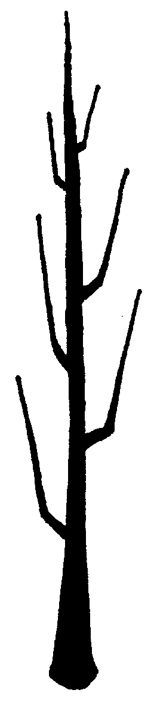
1 - fastigiate
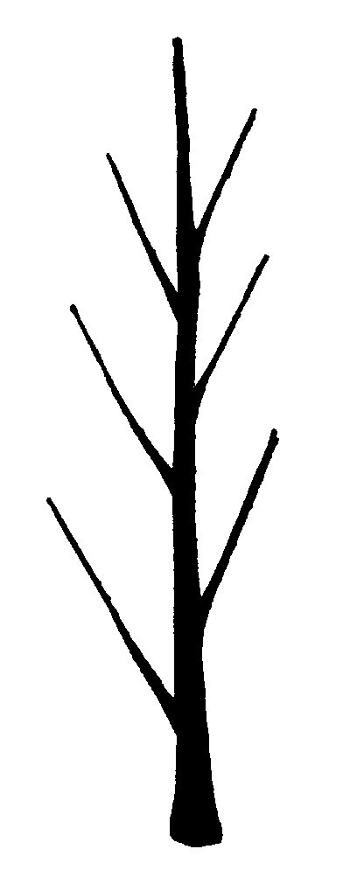
2 - upright
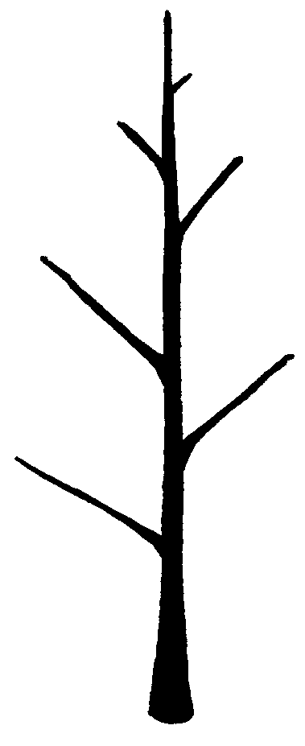
3 - semi upright
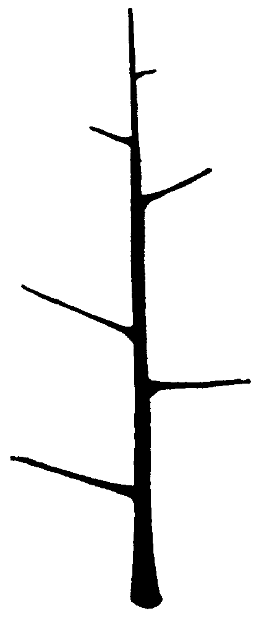
4 - spreading
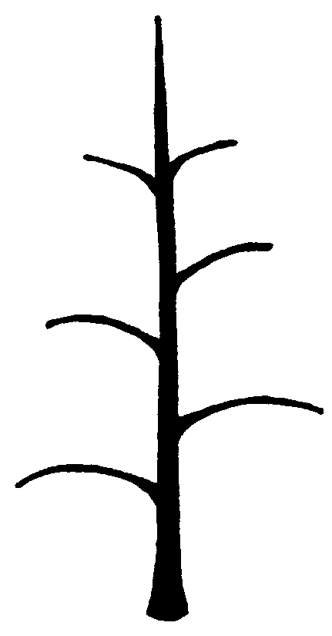
5 - drooping
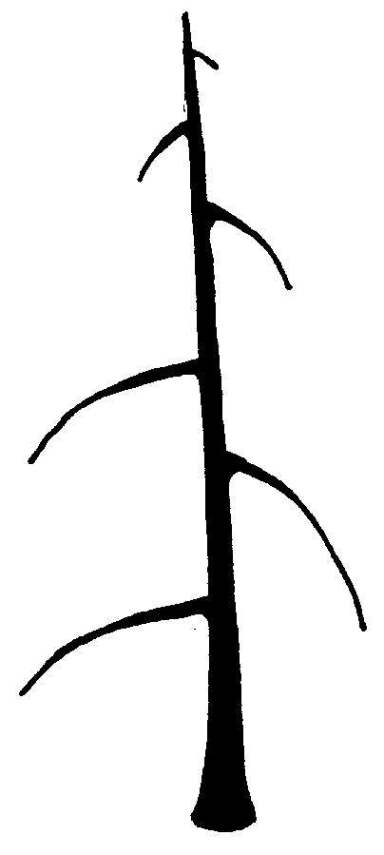
6 - weeping
Ad. 16: Leaf blade: attitude in relation to shoot
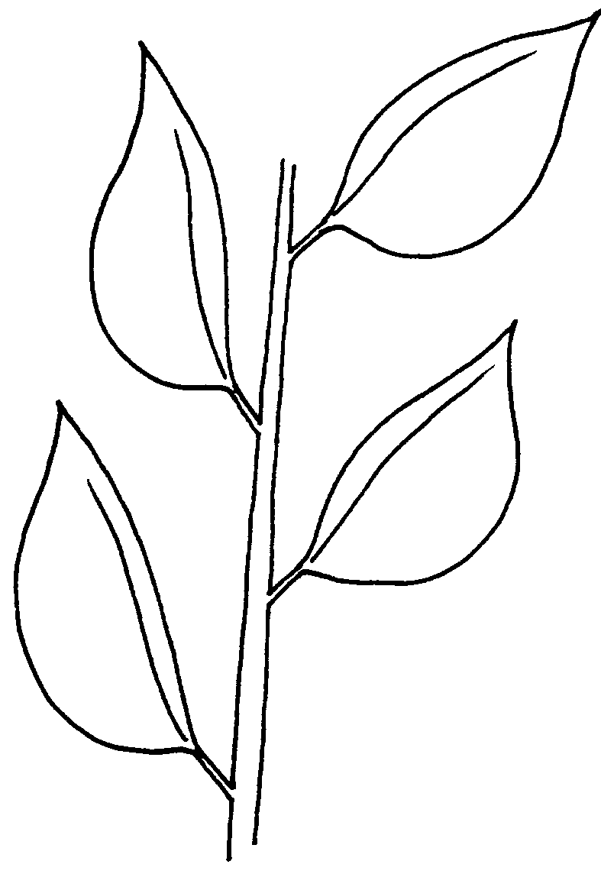
1 - upwards
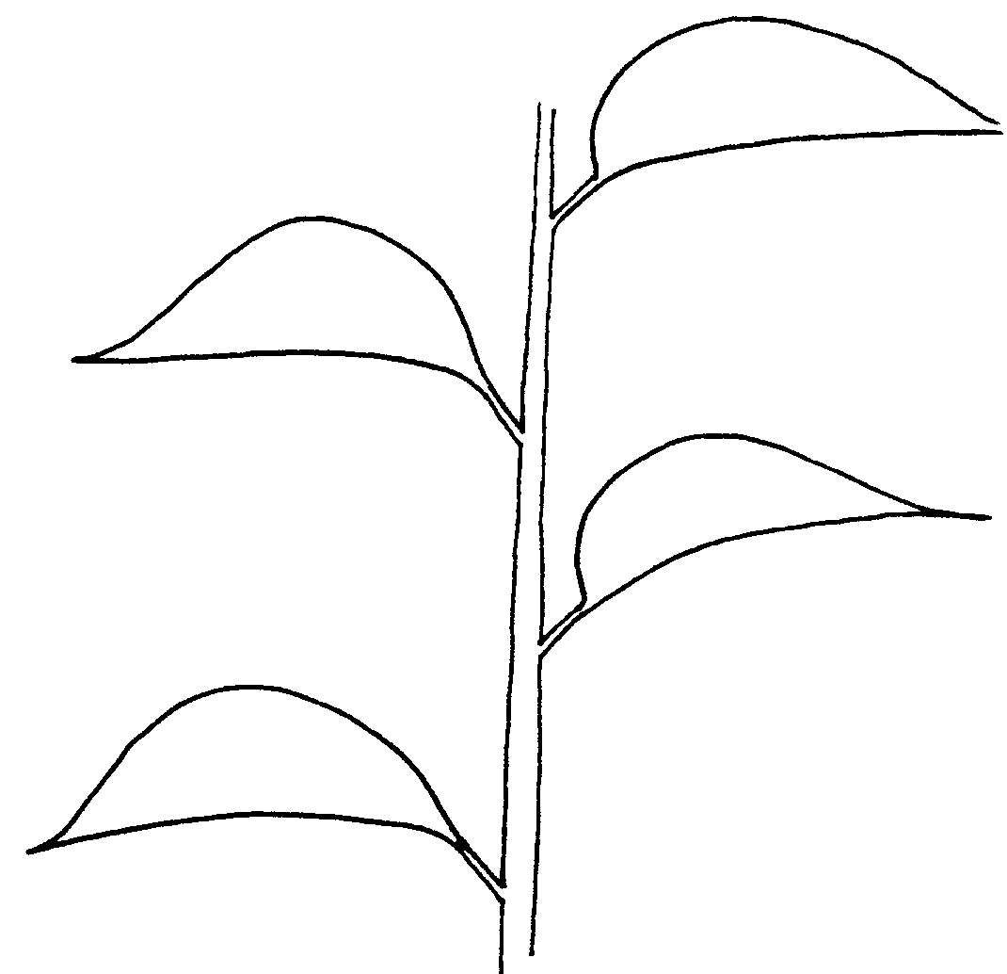
2 - outwards
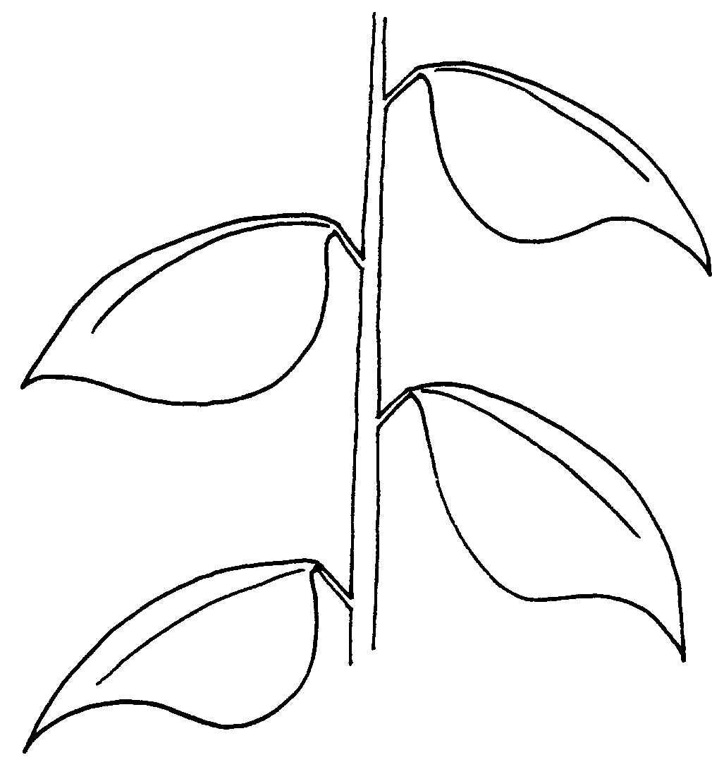
3 - downwards
Ad. 20: Leaf blade: shape
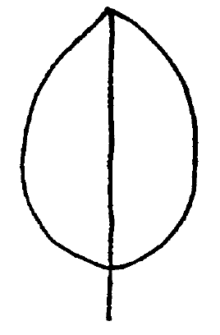
1 - ovate
2 - elliptic
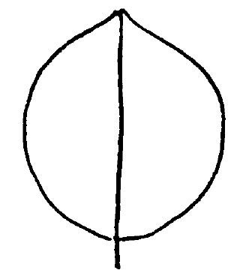
3 - rounded
4 - obovate
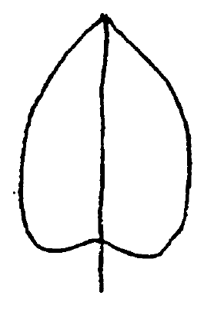
5 - cordate

Ad. 21: Leaf blade: shape of apex
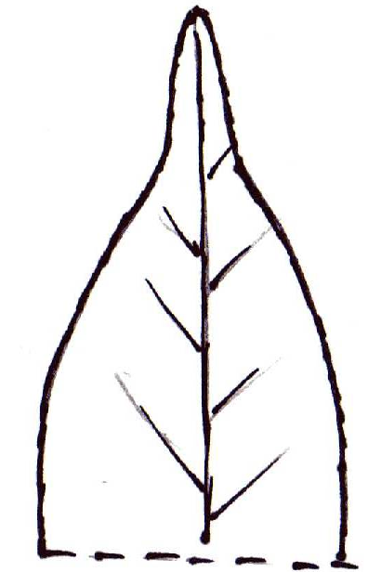
1 - acuminate
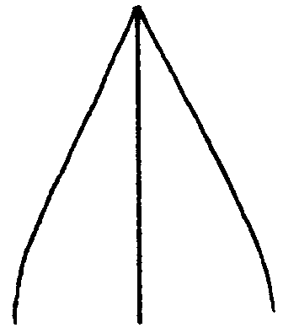
2 - acute
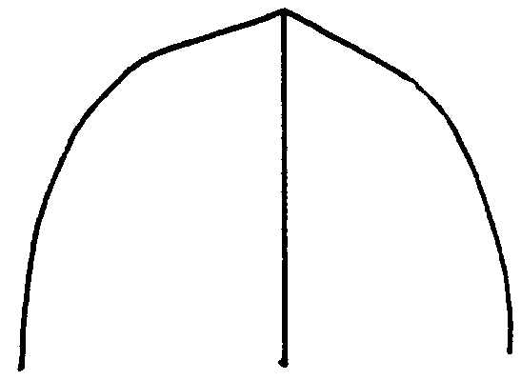
3 - obtuse
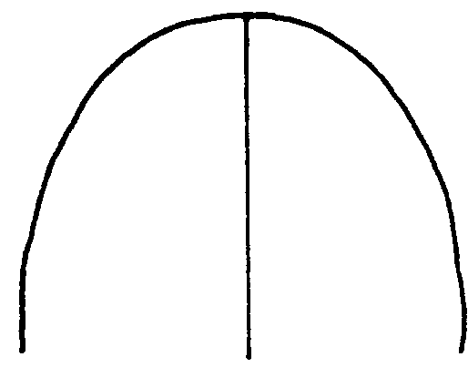
4 - rounded

Ad. 22: Leaf blade: shape of base
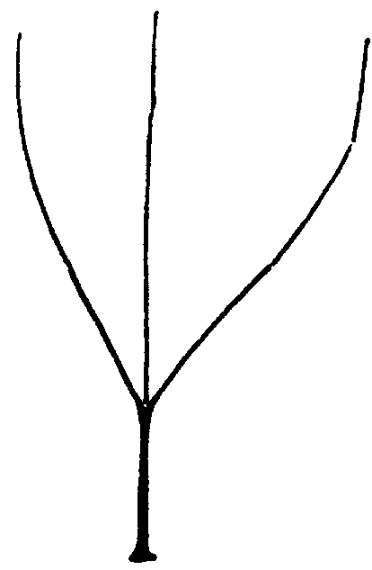
1 - acute
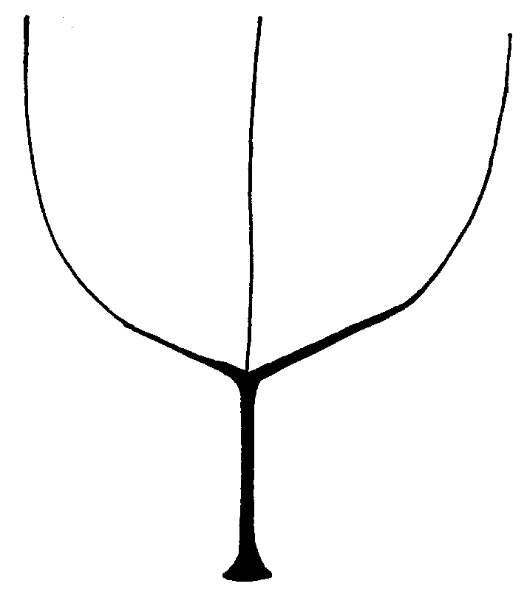
2 - obtuse
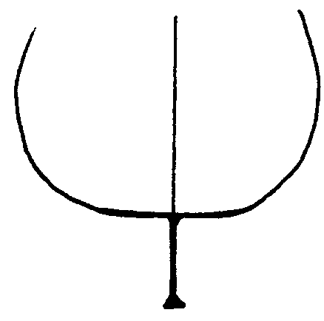
3 - truncate
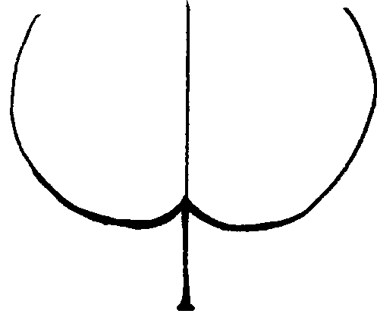
4 - cordate

Ad. 24: Leaf blade: incisions of margin (upper half)
1 - entire
2 - crenate
3 - blunt serrate
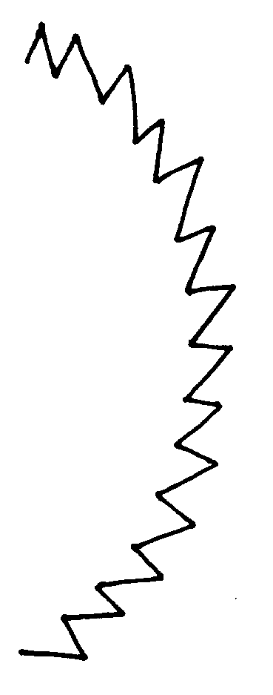
4 - sharp serrate
5 - dentate

Ad. 28: Petiole: distance of stipules from basal attachment
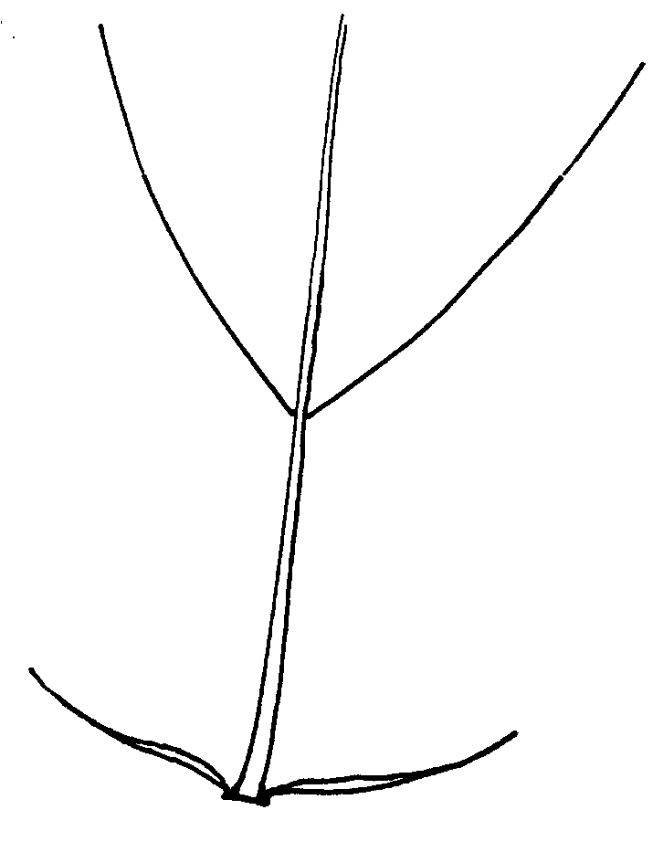
1 - short
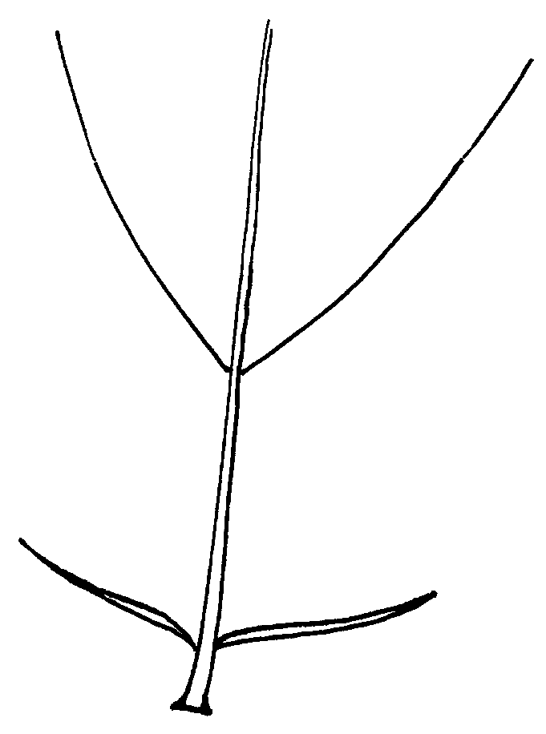
2 - medium
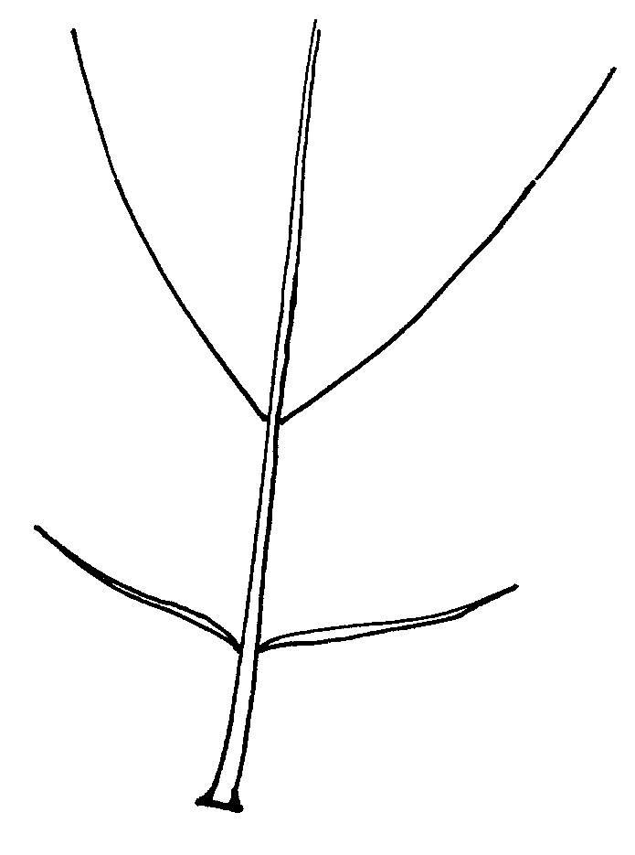
3 - long

Ad. 49: Fruit: shape (in lateral view)
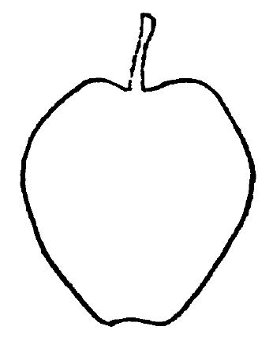
1 - ovate
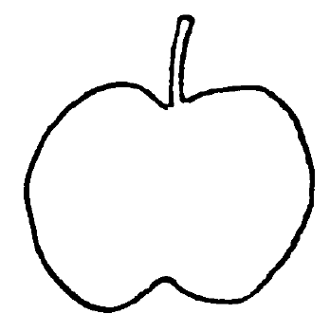
2 - oblate
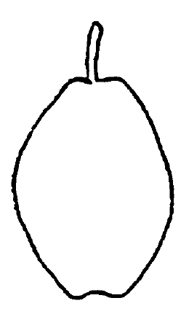
3 - elliptic
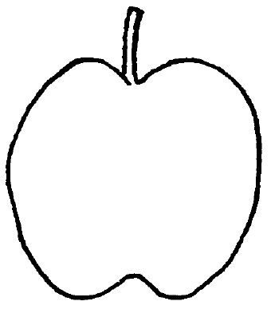
4 - circular
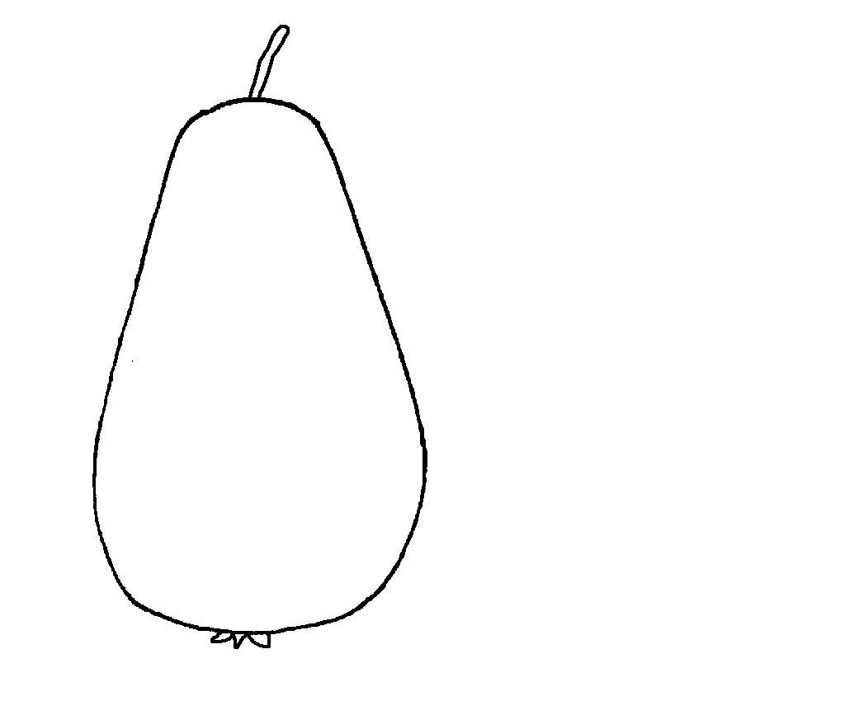
5 - obovate

Ad. 50: Fruit: position of maximum diameter
1 - towards stem end
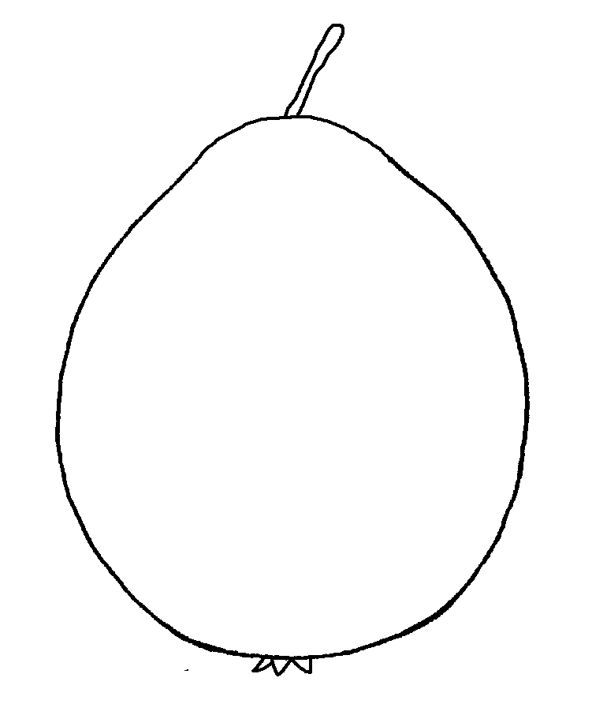
2 - in middle
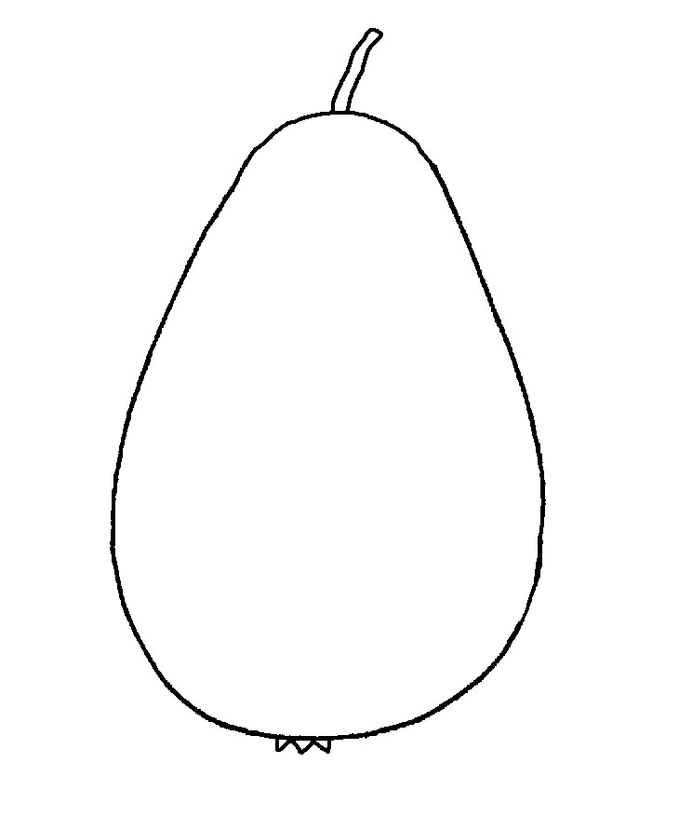
3 - slightly toward calyx end
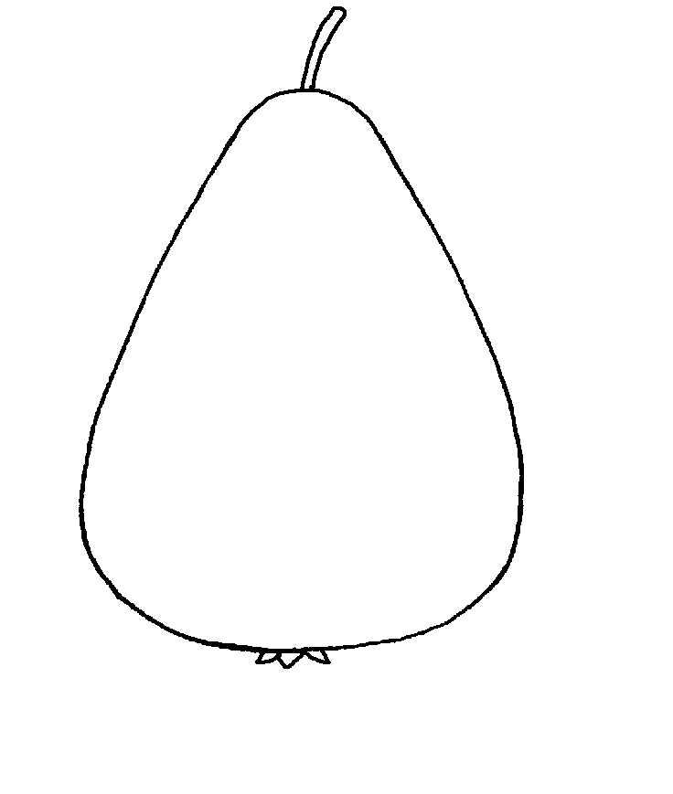
4 - strongly toward calyx end

Ad. 52: Fruit: profile of sides

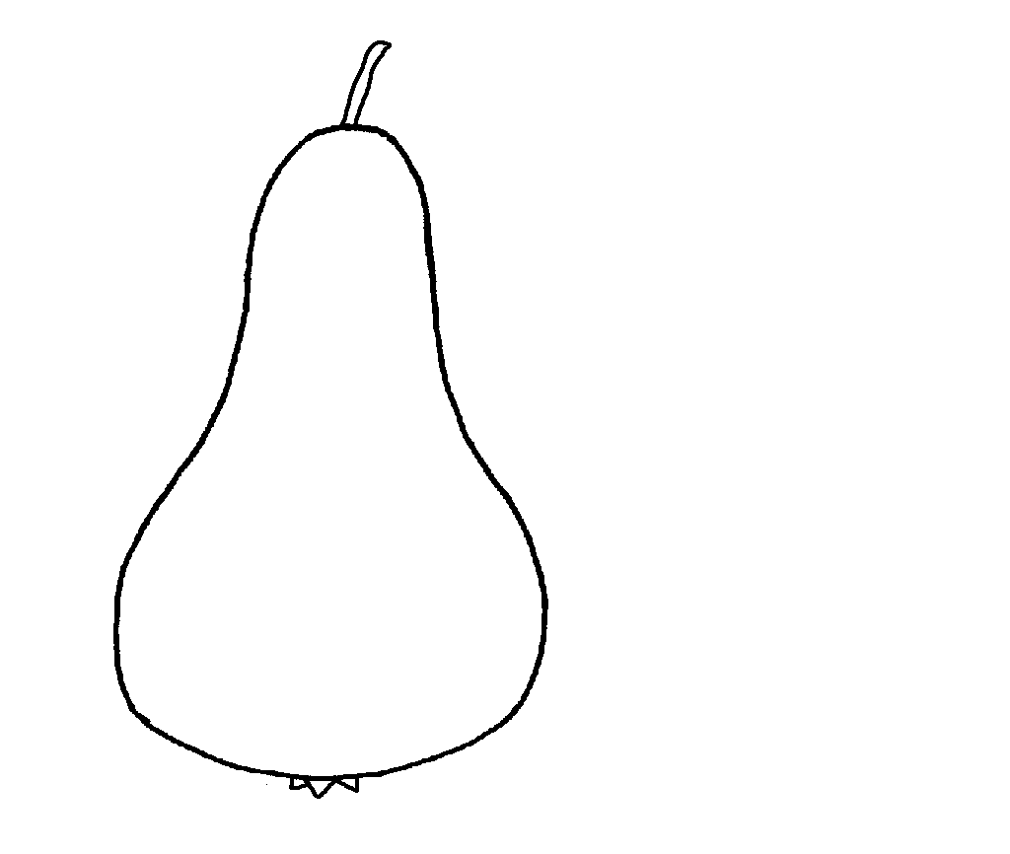
1 - concave
2 - straight
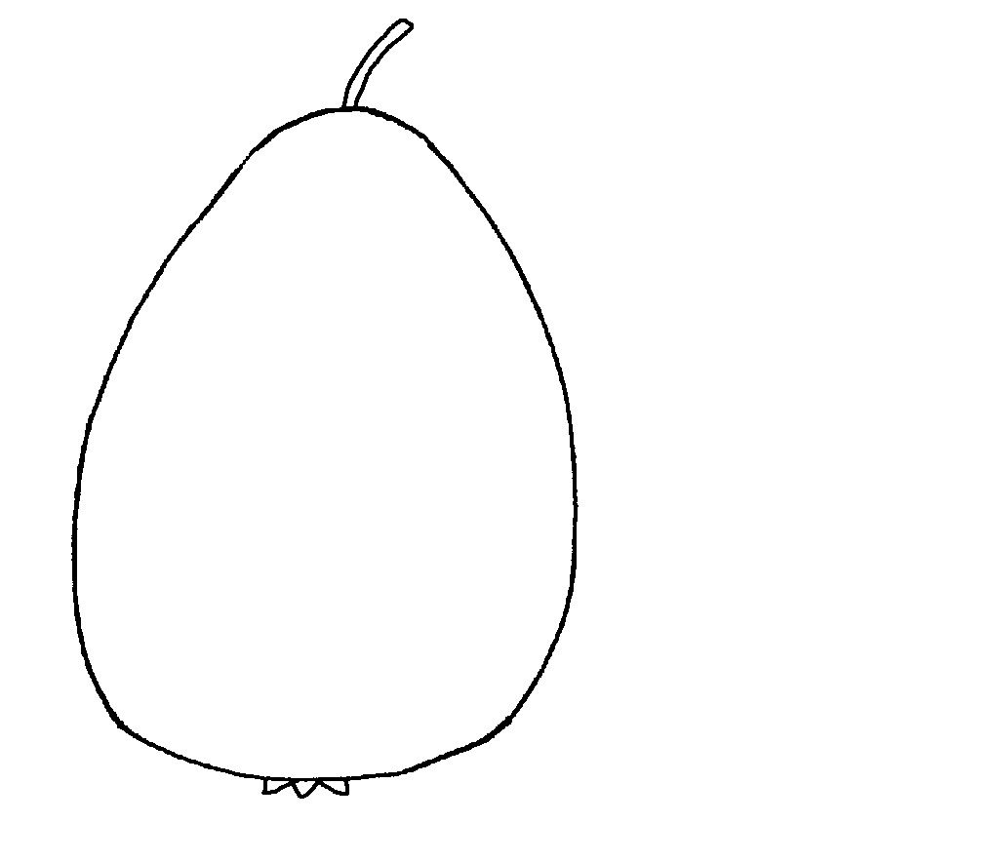
3 - convex

Ad. 65: Fruit: depth of stalk cavity
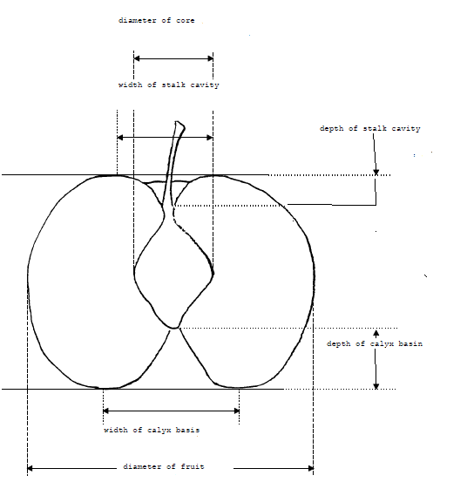
Fruit: depth of stalk cavity

Ad. 66: Fruit: width of stalk cavity
Fruit: width of stalk cavity
Ad. 67: Fruit: persistence of calyx
The sepals on fruit at harvest can be:
absent or very few remaining = weak persistance
approximately half present = medium persistence
all or almost all present = strong persistence

Ad. 68: Fruit: attitude of sepals
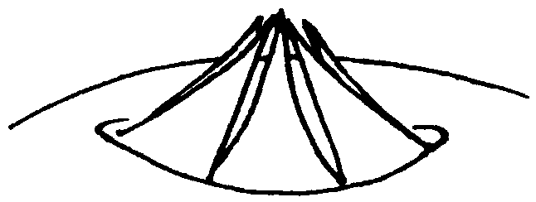
1 - converging
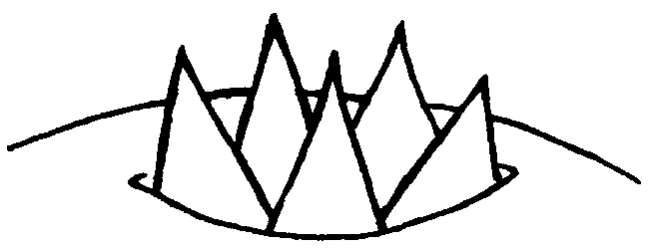
2 - erect
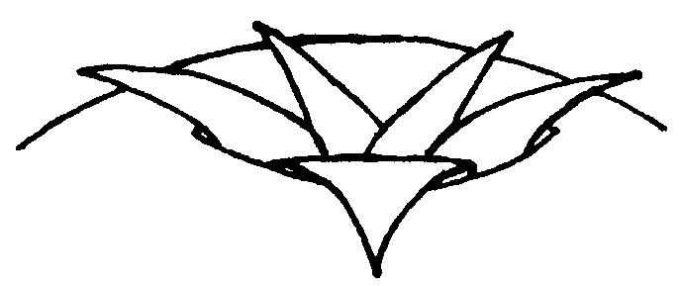
3 - spreading
Ad. 70: Fruit: depth of calyx basin
Fruit: depth of calyx basin

Ad. 71: Fruit: width of calyx basin
Fruit: width of calyx basin

Ad. 78: Fruit: ratio diameter of core/diameter of fruit
Fruit: diameter of core and diameter of fruit

Literature

Brewer LR, Morgan C, Alspach PA, Volz RK, White AG 2008. Interspecific pear breeding for flavour and texture. Xth International Pear Symposium, 22-26 May 2007, Peniche, Portugal. Acta Horticulturae 800: 461-468.

Brewer LR, Morgan CGT, Alspach, P.A, Volz R.K. X1th International Pear Symposium, 23-26 November 2010, Heritability and Parental Breeding Value Estimates of Abrasion-Induced Skin Discolouration on Pear Fruit

Technical Questionnaire

TECHNICAL QUESTIONNAIRE |  | Page {x} of {y} | Reference Number:
 |  |  | Application date:
 |  |  | (not to be filled in by the applicant)
TECHNICAL QUESTIONNAIRE
to be completed in connection with an application for plant breeders’ rights

1. Subject of the Technical Questionnaire
1.1.1 | Botanical Name | Pyrus xbretschneideri Rehder |  | [ ]
1.1.2 | Common Name | Chinese white pear, Chinese white pear, white pear
1.2.1 | Botanical Name | Pyrus communis L. |  | [ ]
1.2.2 | Common Name | European Pear, Pear
1.3.1 | Botanical Name | Pyrus ×lecontei Rehder |  | [ ]
1.3.2 | Common Name
1.4.1 | Botanical Name | Pyrus pyrifolia (Burm. f.) Nakai |  | [ ]
1.4.2 | Common Name | Asian pear, Chinese pear, Chinese sand pear, Japanese pear, Nashi, Nashi pear, Oriental pear, Sand pear
1.5.1 | Botanical Name | Pyrus pyrifolia (Burm. f.) Nakai var. culta (Mak.) Nakai |  | [ ]
1.5.2 | Common Name | poirier japonais
1.6.1 | Botanical Name | Pyrus ussuriensis Maxim. |  | [ ]
1.6.2 | Common Name | Harbin pear, Ussurian pear

2. Applicant
Name
Address
Telephone No.
Fax No.
E-mail address
Breeder (if different from applicant)
3. Proposed denomination and breeder’s reference
Proposed denomination
(if available)

Breeder’s reference

TECHNICAL QUESTIONNAIRE |  | Page {x} of {y} | Reference Number:
4. Information on the breeding scheme and propagation of the variety

4.1 Breeding scheme

Variety resulting from:

4.1.1 Crossing

(a) controlled cross [ ]
(please state parent varieties)

(…………………..……………..…) x (……………..…………………..…)
female parent male parent

(b) partially known cross [ ]
(please state known parent variety(ies))

(…………………..……………..…) x (……………..…………………..…)
female parent male parent

(c) unknown cross [ ]

4.1.2 Mutation [ ]
(please state parent variety)

4.1.3 Discovery and development [ ]
(please state where and when discovered and how developed)

4.1.4 Other [ ]
(please provide details)

4.2 Method of propagating the variety

4.2.1 Vegetative propagation

(a) grafting or budding [ ]
(b) Other (state method) [ ]
..................................................................................................................................................
: :
: :
:................................................................................................................................................:

4.2.2 Other [ ]

(please provide details)
..................................................................................................................................................
: :
: :
:................................................................................................................................................:

5. Characteristics of the variety to be indicated (the number in brackets refers to the corresponding characteristic in Test Guidelines; please mark the note which best corresponds).

 | Characteristics | Example Varieties | Note
5.1 (3) | Tree: growth habit
 | fastigiate |  | 1[ ]
 | upright |  | 2[ ]
 | semi upright |  | 3[ ]
 | spreading |  | 4[ ]
 | drooping |  | 5[ ]
 | weeping |  | 6[ ]
5.2 (45) | Fruit: size
 | very small |  | 1[ ]
 | small |  | 3[ ]
 | medium |  | 5[ ]
 | large |  | 7[ ]
 | very large |  | 9[ ]
5.3 (50) | Fruit: position of maximum diameter
 | towards stem end |  | 1[ ]
 | in middle |  | 2[ ]
 | slightly toward calyx end |  | 3[ ]
 | strongly toward calyx end |  | 4[ ]
5.4 (52) | Fruit: profile of sides
 | concave |  | 1[ ]
 | straight |  | 2[ ]
 | convex |  | 3[ ]
5.5 (54) | Fruit: relative area of over color
 | absent or very small |  | 1[ ]
 | small |  | 3[ ]
 | medium |  | 5[ ]
 | large |  | 7[ ]
 | very large |  | 9[ ]
5.6 (55) | Fruit: hue of over color
 | orange |  | 1[ ]
 | orange red |  | 2[ ]
 | pink red |  | 3[ ]
 | light red |  | 4[ ]
 | dark red |  | 5[ ]
5.7 (69) | Fruit: presence of eye in calyx basin
 | absent |  | 1[ ]
 | present |  | 9[ ]
5.8 (82) | Time of beginning of flowering
 | very early |  | 1[ ]
 | early |  | 3[ ]
 | medium |  | 5[ ]
 | late |  | 7[ ]
 | very late |  | 9[ ]
5.9 (83) | Time of harvest maturity
 | very early |  | 1[ ]
 | early |  | 3[ ]
 | medium |  | 5[ ]
 | late |  | 7[ ]
 | very late |  | 9[ ]

6. Similar varieties and differences from these varieties

Please use the following table and box for comments to provide information on how your candidate variety differs from the variety (or varieties) which, to the best of your knowledge, is (or are) most similar. This information may help the examination authority to conduct its examination of distinctness in a more efficient way.

Denomination(s) of variety(ies) similar to your candidate variety | Characteristic(s) in which your candidate variety differs from the similar variety(ies) | Describe the expression of the characteristic(s) for the similar variety(ies) | Describe the expression of the characteristic(s) for your candidate variety
Example
Comments:

7. Additional information which may help in the examination of the variety

7.1 In addition to the information provided in sections 5 and 6, are there any additional characteristics which may help to distinguish the variety?

Yes [ ] No [ ]

(If yes, please provide details)

7.2 Are there any special conditions for growing the variety or conducting the examination?

Yes [ ] No [ ]

(If yes, please provide details)

7.3 Other information

7.4 A representative color photograph of the variety displaying its main distinguishing feature(s), should accompany the Technical Questionnaire. The photograph will provide a visual illustration of the candidate variety which supplements the information provided in the Technical Questionnaire.

The key points to consider when taking a photograph of the candidate variety are:

- Indication of the date and geographic location
- Correct labeling (breeder’s reference)
- Good quality printed photograph (minimum 10 cm x 15 cm) and/or sufficient resolution electronic format version (minimum 960 x 1280 pixels)

Further guidance on providing photographs with the Technical Questionnaire is available in document TGP/7 “Development of Test Guidelines”, Guidance Note 35 (http://www.upov.int/tgp/en/).

[The link provided may be deleted by members of the Union when developing authorities’ own test guidelines.]

8. Authorization for release

(a) Does the variety require prior authorization for release under legislation concerning the protection of the environment, human and animal health?

Yes [ ] No [ ]

(b) Has such authorization been obtained?

Yes [ ] No [ ]

If the answer to (b) is yes, please attach a copy of the authorization.

TECHNICAL QUESTIONNAIRE | Page {x} of {y} | Reference Number:
9. Information on plant material to be examined or submitted for examination

9.1 The expression of a characteristic or several characteristics of a variety may be affected by factors, such as pests and disease, chemical treatment (e.g. growth retardants or pesticides), effects of tissue culture, different rootstocks, scions taken from different growth phases of a tree, etc.

9.2 The plant material should not have undergone any treatment which would affect the expression of the characteristics of the variety, unless the competent authorities allow or request such treatment. If the plant material has undergone such treatment, full details of the treatment must be given. In this respect, please indicate below, to the best of your knowledge, if the plant material to be examined has been subjected to:

(a) Microorganisms (e.g. virus, bacteria, phytoplasma) Yes [ ] No [ ]

(b) Chemical treatment (e.g. growth retardant, pesticide) Yes [ ] No [ ]

(c) Tissue culture Yes [ ] No [ ]

(d) Other factors Yes [ ] No [ ]

Please provide details for where you have indicated “yes”.

9.3 Has the plant material to be examined been tested for the presence of virus or other pathogens? Yes [ ] (please provide details as specified by the Authority) No [ ]

10. I hereby declare that, to the best of my knowledge, the information provided in this form is correct:

Applicant’s name

Signature Date

[End of document]

* These names were correct at the time of the introduction of these Test Guidelines but may be revised or updated. [Readers are advised to consult the UPOV Code, which can be found on the UPOV Website (www.upov.int), for the latest information.]

