E
TG/125/7(proj.3)
ORIGINAL: English
DATE: 2015-07-24
INTERNATIONAL UNION FOR THE PROTECTION OF NEW VARIETIES OF PLANTS
Geneva
DRAFT

 | Walnut  UPOV Code: JUGLA_REG  Juglans regia L. | *

GUIDELINES
FOR THE CONDUCT OF TESTS
FOR DISTINCTNESS, UNIFORMITY AND STABILITY

prepared by (an) expert(s) from China

to be considered by the
Technical Working Party for Fruit Crops
at its forty-sixth session
to be held in Mpumalanga, South Africa
from 2015-08-24
to 2015-08-28

Alternative Names:*
Botanical name | English | French | German | Spanish
Juglans regia L., | Walnut | Noyer | Walnuß | Nogal

The purpose of these guidelines (“Test Guidelines”) is to elaborate the principles contained in the General Introduction (document TG/1/3), and its associated TGP documents, into detailed practical guidance for the harmonized examination of distinctness, uniformity and stability (DUS) and, in particular, to identify appropriate characteristics for the examination of DUS and production of harmonized variety descriptions.

ASSOCIATED DOCUMENTS
These Test Guidelines should be read in conjunction with the General Introduction and its associated TGP documents.
TABLE OF CONTENTS PAGE

1. Subject of these Test Guidelines 3
2. Material Required 3
3. Method of Examination 3
3.1 Number of Growing Cycles 3
3.2 Testing Place 3
3.3 Conditions for Conducting the Examination 3
3.4 Test Design 3
3.5 Additional Tests 3
4. Assessment of Distinctness, Uniformity and Stability 4
4.1 Distinctness 4
4.2 Uniformity 5
4.3 Stability 5
5. Grouping of Varieties and Organization of the Growing Trial 5
6. Introduction to the Table of Characteristics 6
6.1 Categories of Characteristics 6
6.2 States of Expression and Corresponding Notes 6
6.3 Types of Expression 6
6.4 Example Varieties 6
6.5 Legend 7
7. Table of Characteristics/Tableau des caractères/Merkmalstabelle/Tabla de caracteres 8
8. Explanations on the Table of Characteristics 17
9. Literature 28
10. Technical Questionnaire 29

Subject of these Test Guidelines

These Test Guidelines apply to all varieties of Juglans regia L..

Material Required

2.1 The competent authorities decide on the quantity and quality of the plant material required for testing the variety and when and where it is to be delivered. Applicants submitting material from a State other than that in which the testing takes place must ensure that all customs formalities and phytosanitary requirements are complied with.

  - The material is to be supplied in the form of dormant shoots sufficient for grafting 5 plants or in the form of grafted plants on a rootstock specified by the testing authority.

2.3 The minimum quantity of plant material, to be supplied by the applicant, should be:

10 dormant shoots for grafting or 5 one-year-old grafted plants.

2.4 The plant material supplied should be visibly healthy, not lacking in vigor, nor affected by any important pest or disease.

2.5 The plant material should not have undergone any treatment which would affect the expression of the characteristics of the variety, unless the competent authorities allow or request such treatment. If it has been treated, full details of the treatment must be given.

Method of Examination

3.1 Number of Growing Cycles

3.1.1 The minimum duration of tests should normally be two independent growing cycles.

3.1.2 The growing cycle is considered to be the duration of a single growing season, beginning with bud burst (flowering and/or vegetative), flowering and fruit harvest and concluding when the following dormant period ends with the swelling of new season buds.

3.2 Testing Place

Tests are normally conducted at one place. In the case of tests conducted at more than one place, guidance is provided in TGP/9 “Examining Distinctness”.

3.3 Conditions for Conducting the Examination

3.3.1 The tests should be carried out under conditions ensuring satisfactory growth for the expression of the relevant characteristics of the variety and for the conduct of the examination.

3.4 Test Design

3.4.1 Each test should be designed to result in a total of at least 5 plants.

3.4.2 The design of the tests should be such that plants or parts of plants may be removed for measurement or counting without prejudice to the observations which must be made up to the end of the growing cycle.

3.5 Additional Tests

Additional tests, for examining relevant characteristics, may be established.

Assessment of Distinctness, Uniformity and Stability

4.1 Distinctness

4.1.1 General Recommendations

It is of particular importance for users of these Test Guidelines to consult the General Introduction prior to making decisions regarding distinctness. However, the following points are provided for elaboration or emphasis in these Test Guidelines.

4.1.2 Consistent Differences

The differences observed between varieties may be so clear that more than one growing cycle is not necessary. In addition, in some circumstances, the influence of the environment is not such that more than a single growing cycle is required to provide assurance that the differences observed between varieties are sufficiently consistent. One means of ensuring that a difference in a characteristic, observed in a growing trial, is sufficiently consistent is to examine the characteristic in at least two independent growing cycles.

4.1.3 Clear Differences

Determining whether a difference between two varieties is clear depends on many factors, and should consider, in particular, the type of expression of the characteristic being examined, i.e. whether it is expressed in a qualitative, quantitative, or pseudo-qualitative manner. Therefore, it is important that users of these Test Guidelines are familiar with the recommendations contained in the General Introduction prior to making decisions regarding distinctness.

4.1.4 Number of Plants / Parts of Plants to be Examined

Unless otherwise indicated, for the purposes of distinctness, all observations on single plants should be made on 5 plants or parts taken from each of 5 plants and any other observations made on all plants in the test, disregarding any off-type plants. In the case of observations of parts taken from single plants, the number of parts to be taken from each of the plants should be 2.

4.1.5 Method of Observation

The recommended method of observing the characteristic for the purposes of distinctness is indicated by the following key in the second column of the Table of Characteristics (see document TGP/9 “Examining Distinctness”, Section 4 “Observation of characteristics”):

MG: single measurement of a group of plants or parts of plants
MS: measurement of a number of individual plants or parts of plants
VG: visual assessment by a single observation of a group of plants or parts of plants
VS: visual assessment by observation of individual plants or parts of plants

Type of observation: visual (V) or measurement (M)

“Visual” observation (V) is an observation made on the basis of the expert’s judgment. For the purposes of this document, “visual” observation refers to the sensory observations of the experts and, therefore, also includes smell, taste and touch. Visual observation includes observations where the expert uses reference points (e.g. diagrams, example varieties, side-by-side comparison) or non-linear charts (e.g. color charts). Measurement (M) is an objective observation against a calibrated, linear scale e.g. using a ruler, weighing scales, colorimeter, dates, counts, etc.

Type of record: for a group of plants (G) or for single, individual plants (S)

For the purposes of distinctness, observations may be recorded as a single record for a group of plants or parts of plants (G), or may be recorded as records for a number of single, individual plants or parts of plants (S). In most cases, “G” provides a single record per variety and it is not possible or necessary to apply statistical methods in a plant-by-plant analysis for the assessment of distinctness.

In cases where more than one method of observing the characteristic is indicated in the Table of Characteristics (e.g. VG/MG), guidance on selecting an appropriate method is provided in document TGP/9, Section 4.2.

4.2 Uniformity

    - It is of particular importance for users of these Test Guidelines to consult the General Introduction prior to making decisions regarding uniformity. However, the following points are provided for elaboration or emphasis in these Test Guidelines:

4.2.2 The assessment of uniformity should be according to the recommendations for cross-pollinated varieties in the General Introduction.

4.2.3 For the assessment of uniformity of varieties, a population standard of 1% and an acceptance probability of at least 95 % should be applied. In the case of a sample size of 5 plants, no off-types are allowed.

4.3 Stability

4.3.1 In practice, it is not usual to perform tests of stability that produce results as certain as those of the testing of distinctness and uniformity. However, experience has demonstrated that, for many types of variety, when a variety has been shown to be uniform, it can also be considered to be stable.

4.3.2 Where appropriate, or in cases of doubt, stability may be further examined by testing a new plant stock to ensure that it exhibits the same characteristics as those shown by the initial material supplied.

4.3.3 Where appropriate, or in cases of doubt, the stability of a hybrid variety may, in addition to an examination of the hybrid variety itself, also be assessed by examination of the uniformity and stability of its parent lines.

Grouping of Varieties and Organization of the Growing Trial

5.1 The selection of varieties of common knowledge to be grown in the trial with the candidate varieties and the way in which these varieties are divided into groups to facilitate the assessment of distinctness are aided by the use of grouping characteristics.

5.2 Grouping characteristics are those in which the documented states of expression, even where produced at different locations, can be used, either individually or in combination with other such characteristics: (a) to select varieties of common knowledge that can be excluded from the growing trial used for examination of distinctness; and (b) to organize the growing trial so that similar varieties are grouped together.

5.3 The following have been agreed as useful grouping characteristics:

(a) Flower: number per cluster (characteristic 7)
(b) Female flower: intensity of color of stigma (characteristic 8)
(c) Fruit:setting type (characteristic 9)
(d) Nut: shape in ventral view (characteristic 10)
(e) Nut:thickness of shell (characteristic 28)
(f) Time of male flowering compared to female flowering (characteristic 29)

5.4 Guidance for the use of grouping characteristics, in the process of examining distinctness, is provided through the General Introduction and document TGP/9 “Examining Distinctness”.

Introduction to the Table of Characteristics

6.1 Categories of Characteristics

6.1.1 Standard Test Guidelines Characteristics

Standard Test Guidelines characteristics are those which are approved by UPOV for examination of DUS and from which members of the Union can select those suitable for their particular circumstances.

6.1.2 Asterisked Characteristics

Asterisked characteristics (denoted by *) are those included in the Test Guidelines which are important for the international harmonization of variety descriptions and should always be examined for DUS and included in the variety description by all members of the Union, except when the state of expression of a preceding characteristic or regional environmental conditions render this inappropriate.

6.2 States of Expression and Corresponding Notes

6.2.1 States of expression are given for each characteristic to define the characteristic and to harmonize descriptions. Each state of expression is allocated a corresponding numerical note for ease of recording of data and for the production and exchange of the description.

6.2.2 In the case of qualitative and pseudo-qualitative characteristics (see Chapter 6.3), all relevant states of expression are presented in the characteristic. However, in the case of quantitative characteristics with 5 or more states, an abbreviated scale may be used to minimize the size of the Table of Characteristics. For example, in the case of a quantitative characteristic with 9 states, the presentation of states of expression in the Test Guidelines may be abbreviated as follows:

State | Note
small | 3
medium | 5
large | 7

However, it should be noted that all of the following 9 states of expression exist to describe varieties and should be used as appropriate:

State | Note
very small | 1
very small to small | 2
small | 3
small to medium | 4
medium | 5
medium to large | 6
large | 7
large to very large | 8
very large | 9

6.2.3 Further explanation of the presentation of states of expression and notes is provided in document TGP/7 “Development of Test Guidelines”.

6.3 Types of Expression

An explanation of the types of expression of characteristics (qualitative, quantitative and pseudo-qualitative) is provided in the General Introduction.

6.4 Example Varieties

Where appropriate, example varieties are provided to clarify the states of expression of each characteristic.

6.5 Legend

(*) Asterisked characteristic – see Chapter 6.1.2

QL Qualitative characteristic – see Chapter 6.3
QN Quantitative characteristic – see Chapter 6.3
PQ Pseudo-qualitative characteristic – see Chapter 6.3

MG, MS, VG, VS – see Chapter 4.1.5

(a)-(f) See Explanations on the Table of Characteristics in Chapter 8.

(+) See Explanations on the Table of Characteristics in Chapter 8.

Table of Characteristics/Tableau des caractères/Merkmalstabelle/Tabla de caracteres

English | français | deutsch | español | Example Varieties Exemples Beispielssorten Variedades ejemplo | Note/ Nota
1. (*) QN VG (+) (a)
Tree: growth habit
upright |  |  |  | Corne, Daifeng, Daixiang, Fenghui, Sorrento, Xinzaofeng, Zhonglin 1 | 1
semi-upright |  |  |  | Chuanhe 2, Franquette, Hartley, Liaoning 1, Liaoning 4, Marbot, Shaanhe 1 | 2
spreading |  |  |  | Gustine, Jinfeng, Jinlong 1, Jinlong 2, Luguang, Payne, Shangsong 6, Vina, Xilin 2, Zhonglin 5 | 3
2. QN VG (a) (b)
Tree: branching | Arbre: degré de ramification | Baum: Verzweigung | Árbol: ramificación
weak | faible | gering | débil | Huashan 5, Shangluo 3, Xisiyu 1 | 3
medium | moyen | mittel | media | Chuanhe 2, Hartley, Lübo, Qinyou 1, Shangsong 6, Xinzaofeng | 5
strong | fort | stark | fuerte | Daixiang, Jinfeng, Liaoning 1, Liaoning 4, Luguang, Luguo 2, Shaanhe 1, Xiangling, Xifu 2, Xilin 2, Zhonglin 1, Zhonglin 5 | 7
3. (*) QN VG (+) (b)
Bud: shape
predominantly circular |  |  |  | Daixiang, Jinlong 1, Luguang, Luguo 2, Xiangling, Xilin 2, Xinzaofeng, Zhonglin 1 | 1
predominantly semi-circular |  |  |  | Fenghui | 2
predominantly triangular |  |  |  | Chuanhe 2, Liaoning 4, Zhenzhuhetao | 3
4. (*) PQ VG (+) (c)
Lateral leaflet: shape
lanceolate |  |  |  | Hartley, Payne, Vina | 1
ovate |  |  |  | Corne, Franquette, Marbot, Zhenzhuhetao | 2
elliptic |  |  |  | Chase D 9, Daifeng, Daixiang, Liaoning 1, Shangsong 6 | 3
5. QN VG (+) (c)
Leaflet: glandular hair
absent or few |  |  |  | Xiangling, Xilin 2, Xinzaofeng, Zhonglin 1, Zhonglin 5 | 1
medium |  |  |  |  | 2
many |  |  |  |  | 3

English | français | deutsch | español | Example Varieties Exemples Beispielssorten Variedades ejemplo | Note/ Nota
6. QL VG
Plant: number of flowering times
one |  |  |  | Jinlong 1 | 1
more than one |  |  |  | Liaoning 4 | 2
7. (*) QN VG (d)
Flower: number per cluster
1-2 |  |  |  | Jinlong 1, Luguang, Xiangling, Xilin 2, Xinzaofeng, Zhonglin 1, Zhonglin 5 | 1
3-4 |  |  |  | Shaanhe 1 | 2
5-10 |  |  |  |  | 3
11-20 |  |  |  | Qinyou 1 | 4
more than 21 |  |  |  | Chuanhetao | 5
8. (*) QN VG (d)
Female flower:intensity of yellow color of stigma
light |  |  |  | Daifeng, Daixiang | 1
medium |  |  |  | Jinlong 1, Jinlong 2, Xiangling, Xinzaofeng, Zhonglin 1, Zhonglin 5 | 3
dark |  |  |  | Xifu 2 | 5
9. (*) PQ VG (+)
Fruit: setting type
solitary |  |  |  | Jinlong 1 | 1
binate |  |  |  | Daifeng, Daixiang, Fenghui, Jinlong 1, Liaoning 1, Liaoning 4, Luguang, Luguo 2, Xiangling, Xilin 2, Zhonglin 5 | 2
fascicled |  |  |  | Shaanhe 1 | 3
bunchy |  |  |  | Chuanzihetao | 4

English | français | deutsch | español | Example Varieties Exemples Beispielssorten Variedades ejemplo | Note/ Nota
10. (*) PQ VG (+) (e)
Nut: shape in ventral view
elliptic |  |  |  | Corne, Daifeng, Franquette, Sorrento, Xilin 2 | 1
broad elliptic |  |  |  | Luguang, Parisienne | 2
oblong |  |  |  | Mumahetao | 3
circular |  |  |  | Jinlong 1, Jinlong 2, Liaoning 4, Meylannaise, Xiangling, Zhonglin 1, Zhonglin 5 | 4
ovate |  |  |  | Gustine, Jinfeng | 5
broad ovate |  |  |  | Marbot, Payne, Serr | 6
triangular |  |  |  | Hartley | 7
trapezium |  |  |  | Liaoning 1 | 8
11. (*) PQ VG (+) (e)
Nut: shape in lateral view
circular |  |  |  | Meylannaise | 1
oblate |  |  |  | Yuanbao | 2
ovate |  |  |  | Gustine, Jinfeng | 3
broad ovate |  |  |  | Payne, Serr, Xiangling | 4
broad elliptic |  |  |  | Franquette | 5
triangular |  |  |  | Hartley | 6
12. (*) PQ VG (+) (e)
Nut: shape in cross section
reniform |  |  |  |  | 1
oblate |  |  |  | Chico, Franquette, Liaoning 1 | 2
elliptic |  |  |  | Corne, Hartley, Serr | 3
circular |  |  |  | Marbot, Payne, Xiangling | 4

English | français | deutsch | español | Example Varieties Exemples Beispielssorten Variedades ejemplo | Note/ Nota
13. (*) PQ VG (+) (e)
Nut: shape of base in lateral view
cuneate |  |  |  | Corne | 1
rounded |  |  |  | Chico, Franquette, Payne, Serr, Xiangling | 2
truncate |  |  |  | Parisienne | 3
emarginate |  |  |  | Hartley | 4
14. (*) PQ VG (+) (e)
Nut: shape of apex in lateral view(excluding tip)
obtuse |  |  |  | Vina | 1
rounded |  |  |  | Zhonglin 1 | 2
truncate |  |  |  | Zhonglin 5 | 3
emarginate |  |  |  | Xiangling | 4
15. (*) QN VG (+) (e)
Nut: length of tip
absent or short |  |  |  | Grandjean, Xiangling | 1
medium |  |  |  | Chico, Corne, Hartley, Hexuan | 2
long |  |  |  | Franquette, Marbot, Payne, Serr | 3
16. (*) QN VG (+) (e)
Nut: extent of pad around suture
on upper half |  |  |  | Chico, Hartley, Marbot, Parisienne, Xiangling | 1
on upper 2/3 |  |  |  | Franquette, Gustine, Liaoning 1, Liaoning 4, Payne, Pedro | 3
on whole length |  |  |  | Honghuadian 1 | 3

English | français | deutsch | español | Example Varieties Exemples Beispielssorten Variedades ejemplo | Note/ Nota
17. (*) QN VG (e)
Nut: prominence of pad on suture
weak |  |  |  | Chuanhe 2, Jinlong 2 | 1
medium |  |  |  | Chico, Grandjean | 3
strong |  |  |  | Franquette, Marbot, Payne, Serr | 5
18. QN MG VG (+) (e)
Nut: width of pad on suture in lateral view
narrow |  |  |  | Chico, Grandjean, Parisienne, Xiangling | 1
medium |  |  |  | Gustine, Hartley | 3
broad |  |  |  | Corne, Marbot, Payne, Serr | 5
19. QN VG (e)
Nut: depth of groove along pad on suture
shallow |  |  |  | Chico, Grandjean, Parisienne, Xiangling | 1
medium |  |  |  | Gustine, Hartley | 3
deep |  |  |  | Corne, Marbot, Payne, Serr | 5
20. PQ VG (+) (e)
Nut: structure of surface of shell
slightly grooved |  |  |  | Liaoning 1, Liaoning 4, Luguang | 1
moderately grooved |  |  |  | Chico, Fenghui, Jinlong 1, Jinlong 2, Lübo, Xiangling, Xinzaofeng | 2
strongly grooved |  |  |  | Hartley, Xilin 2 | 3
embossed |  |  |  | Erbazi | 4

English | français | deutsch | español | Example Varieties Exemples Beispielssorten Variedades ejemplo | Note/ Nota
21. PQ VG (e)
Nut: color of shell
yellow |  |  |  | Xiangling | 1
light brown |  |  |  | Zhonglin 1 | 2
brown |  |  |  | Honghetao | 3
22. QN MS VG (e)
Nut: size
small |  |  |  | Chico, Zhenzhuhetao | 3
medium |  |  |  | Franquette, Honghetao, Liaoning 4, Shaanhe 1 | 5
large |  |  |  | Daifeng, Daixiang, Fenghui, Hartley, Jinlong 1, Jinlong 2, Luguang, Luguo 2, Lübo, Xiangling, Xilin 2, Xinzaofeng, Zhonglin 1, Zhonglin 5 | 7
23. QN VG (+) (e)
Nut: thickness of primary and secondary dividing membranes
very thin |  |  |  | Daifeng, Daixiang, Fenghui, Liaoning 1, Liaoning 4, Luguo 2, Lübo, Shaanhe 1, Xiangling, Xilin 2, Zhonglin 1, Zhonglin 5 | 1
thin |  |  |  | Chico, Luguang, Payne, Serr | 2
medium |  |  |  | Franquette, Honghetao, Marbot, Xinzaofeng | 3
thick |  |  |  | Corne | 4
24. PQ VG (+) (e)
Nut: inner pleat wall of shell
papery |  |  |  | Daifeng, Daixiang, Fenghui, Liaoning 1, Liaoning 4, Luguang, Luguo 2, Xiangling, Zhonglin 1, Zhonglin 5 | 1
leathery |  |  |  | Xinzaofeng | 2
bony |  |  |  | Baipihetao | 3

English | français | deutsch | español | Example Varieties Exemples Beispielssorten Variedades ejemplo | Note/ Nota
25. PQ VG (+) (f)
Kernel: color of endopleura
white |  |  |  | Jinmian 2 | 1
yellowish white |  |  |  | Liaoning 1 | 2
yellow |  |  |  | Daifeng | 3
red |  |  |  | Honghetao, Hongranghetao | 4
purple |  |  |  | Chuanhe 2 | 5
yellow brown |  |  |  | Baipihetao | 6
light brown |  |  |  | Shangsong 6 | 7
medium brown |  |  |  | Zhonglin 5 | 8
dark brown |  |  |  |  | 9
26. QN MS (e) (f)
Kernel: percentage of weight relative to total weight of nut
very low |  |  |  | Corne | 1
low |  |  |  | Marbot | 3
medium |  |  |  | Franquette, Hartley, Pedro, Sorrento | 5
high |  |  |  | Chase D 9, Daifeng, Daixiang, Fenghui, Jinlong 2, Liaoning 1, Liaoning 4, Luguang, Luguo 2, Lübo, Payne, Vina, Xinzaofeng, Zhonglin 1, Zhonglin 5 | 7
very high |  |  |  | Jinlong 1, Serr, Shaanhe 1, Xiangling, Xilin 2 | 9
27. QN VG (+) (e) (f)
Kernel: ease of removal
very easy |  |  |  | Payne, Pedro, Serr | 1
easy |  |  |  | Franquette, Hartley, Marbot | 2
medium |  |  |  | Jinlong 2, Meylannaise | 3
difficult |  |  |  | Corne | 4

English | français | deutsch | español | Example Varieties Exemples Beispielssorten Variedades ejemplo | Note/ Nota
28. (*) QN MS VG (+) (e)
Nut: thickness of shell
very thin |  |  |  | Daifeng, Fenghui, Liaoning 1, Liaoning 4, Luguang, Luguo 2, Lübo, Pedro, Serr, Xiangling | 1
thin |  |  |  | Chico, Daixiang, Grandjean, Gustine, Jinlong 1, Jinlong 2, Payne, Serr, Xilin 2, Xinzaofeng, Zhonglin 1, Zhonglin 5 | 2
medium |  |  |  | Chahetao, Franquette, Hartley, Marbot | 3
thick |  |  |  | Corne, Shitou | 4
very thick |  |  |  |  | 5
29. (*) QN VG (d)
Time of male flowering compared to female flowering
before (protandry) |  |  |  | Franquette, Liaoning 1, Liaoning 4, Marbot, Payne, Xiangling | 1
simultaneous (homogamy) |  |  |  | Chico, Meylannaise, Xilin 2 | 2
after (protogyny) |  |  |  | Lübo | 3
30. (*) QN VG (+) (d)
Tree age of initial female flowering
early |  |  |  | Daifeng, Daixiang, Fenghui, Liaoning 1, Liaoning 4, Lübo, Xiangling, Xinzaofeng, Zhonglin 1, Zhonglin 5 | 1
medium |  |  |  | Jinlong 1, Jinlong 2 | 2
late |  |  |  | Liao 30401 | 3
31. QN MG VG (+)
Time of beginning of female flowering
early |  |  |  | Chase D 9, Luguo 2, Lübo, Sorrento, Xilin 2 | 3
medium |  |  |  | Daifeng, Daixiang, Fenghui, Luguang, Marbot, Xiangling, Xinzaofeng, Zhonglin 1, Zhonglin 5 | 5
late |  |  |  | Jinlong 1, Jinlong 2, Liaoning 1, Liaoning 4 | 7

English | français | deutsch | español | Example Varieties Exemples Beispielssorten Variedades ejemplo | Note/ Nota
32. QN MG VG (+)
The time of beginning of male flowering
early |  |  |  | Chase D 9, Fenghui, Gustine, Luguang, Luguo 2, Sorrento, Xiangling, Xilin 2, Xinzaofeng | 3
medium |  |  |  | Lübo, Marbot, Shaanhe 1 | 5
late |  |  |  | Franquette, Jinlong 1, Jinlong 2, Liaoning 1, Liaoning 4, Parisienne, Zhonglin 1, Zhonglin 5 | 7
33. QN MG VG
Time of harvest maturity
early |  |  |  | Fenghui, Luguang, Luguo 2, Lübo, Xiangling, Zhonglin 5 | 3
medium |  |  |  | Chico, Daifeng, Daixiang, Grandjean, Liaoning 1, Payne, Serr, Xinzaofeng, Zhonglin 1 | 5
late |  |  |  | Jinlong 1, Jinlong 2, Liaoning 1, Liaoning 4, Xilin 2 | 7

Explanations on the Table of Characteristics

8.1 Explanations covering several characteristics

Characteristics containing the following key in the second column of the Table of Characteristics should be examined as indicated below:

(a) Observations on tree should be made in dormant season.
(b) Observations on branch should be made on developmental branches from the middle part of the canopy in dormant season.
(c) Observations on leaves should be made on latteral leaves from the middle part of the canopy on the sunny side.
(d) Observations on flowers should be carried out during its full-blossom period.
(e) Observations on nuts should be made on physiological ripe nuts excluding the pericarp immediately after 25% of the pericarp cracked. Take 30 nuts randomly from each tree.
(f) Observations on the kernel should be made when the water content is less than 8%.

8.2 Explanations for individual characteristics

Ad. 1: Tree: growth habit
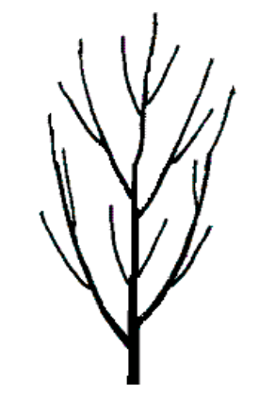
1 - upright
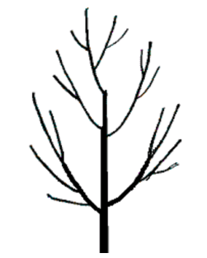
2 - semi-upright
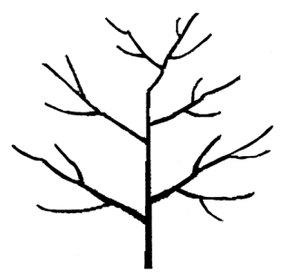
3 - spreading

Ad. 3: Bud: shape
Observations on buds should be made on terminal buds of branches

Ad. 4: Lateral leaflet: shape
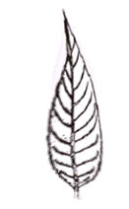
1 - lanceolate
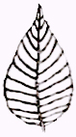
2 - ovate
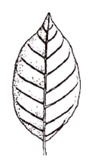
3 - elliptic

Ad. 5: Leaflet: glandular hair
Observation should be taken out using magnifying glasses or something else which can help to observe tiny parts.

Ad. 9: Fruit: setting type
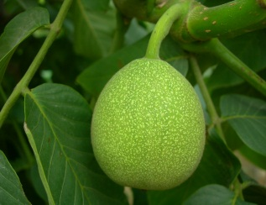
1 - solitary
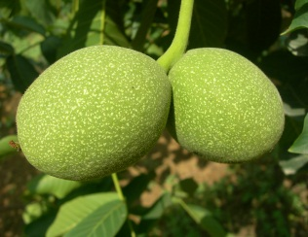
2 - binate
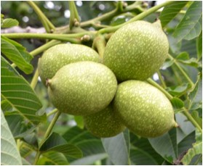
3 - fascicled
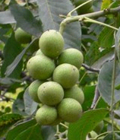
4 - bunchy

Ad. 10: Nut: shape in ventral view
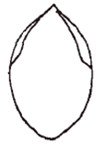
1 - elliptic
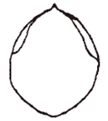
2 - broad elliptic
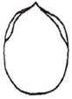
3 - oblong
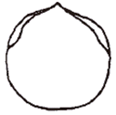
4 - circular
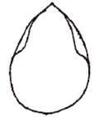
5 - ovate
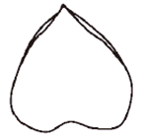
7 - triangular
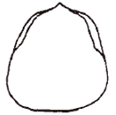
8 - trapezium

Ad. 11: Nut: shape in lateral view
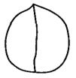
1 - circular
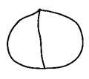
2 - oblate
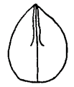
3 - ovate
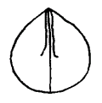
4 - broad ovate
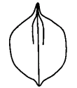
5 - broad elliptic
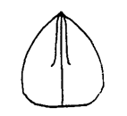
6 - triangular
Ad. 12: Nut: shape in cross section
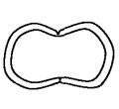
1 - reniform
2 - oblate
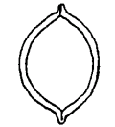
3 - elliptic
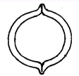
4 - circular

Ad. 13: Nut: shape of base in lateral view
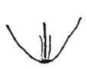
1 - cuneate
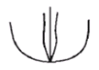
2 - rounded
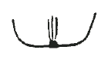
3 - truncate
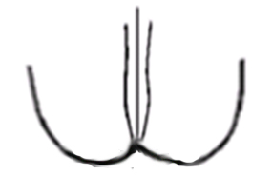
4 - emarginate
Ad. 14: Nut: shape of apex in lateral view(excluding tip)

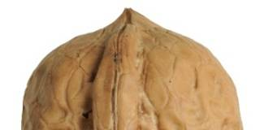
1 - obtuse
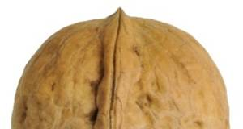
2 - rounded
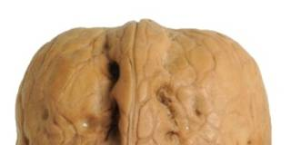
3 - truncate
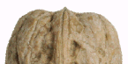
4 - emarginate

Ad. 15: Nut: length of tip

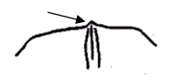
1 - absent or short
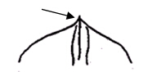
2 - medium
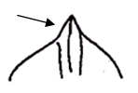
3 - long

Ad. 16: Nut: extent of pad around suture

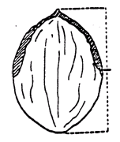
1 - on upper half
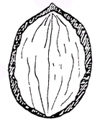
3 - on whole length

Ad. 18: Nut: width of pad on suture in lateral view

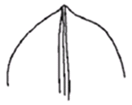
1 - narrow
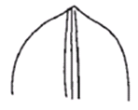
3 - medium
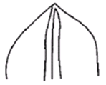
5 - broad

Ad. 20: Nut: structure of surface of shell

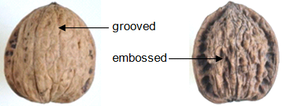

Ad. 23: Nut: thickness of primary and secondary dividing membranes

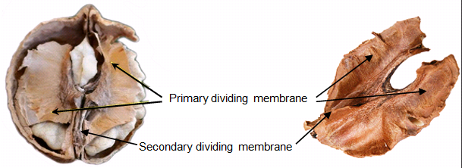

Ad. 24: Nut: inner pleat wall of shell

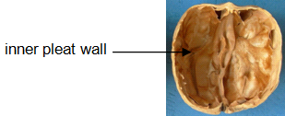

Ad. 25: Kernel: color of endopleura

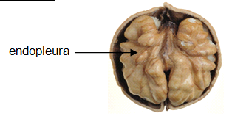

Ad. 27: Kernel: ease of removal
Crack the shell and remove the kernel. Assess the easy of removal according to the situation of the kernel: 1: whole or a half of the kernel, 2: a quarter of the kernel, 3: smashed kernel, 4: unable to take out the kernel normally.

Ad. 28: Nut: thickness of shell
Thickness of the mid part of the shell should be measured and take the average value (accurate to 0.1 mm) as the thickness of shell.

Ad. 30: Tree age of initial female flowering
Observations should be made on plants grafted on two-year-old rootstocks.

Ad. 31: Time of beginning of female flowering
The time of beginning of female flowering should be observed when 5% of the female flowers are in full bloom (at full development of stigmas).

Ad. 32: The time of beginning of male flowering
The time of beginning of male flowering should be observed when 5% of the catkins are in full bloom (at dehiscence of pollen).

Literature

GB/T 20398-2006 Walnut quality grade.

IPGRI, descriptors for walnut (Juglans spp.).International Plant Genetic Resource Institute, Rome, Italy, 1994

Liu Q.Z. and Zhang L.S., 2007: Descriptors and Data Standard for walnut (Juglansregia L.). Beijing: China Agriculture Press. (in Chinese)

Pei D. and Lu X.Z., 2011: Walnut germplasm resources in China. Beijing: China forestry publishing house. (in Chinese)

Technical Questionnaire

TECHNICAL QUESTIONNAIRE |  | Page {x} of {y} | Reference Number:
 |  |  | Application date:
 |  |  | (not to be filled in by the applicant)
TECHNICAL QUESTIONNAIRE
to be completed in connection with an application for plant breeders’ rights

1. Subject of the Technical Questionnaire
1.1.1 | Botanical Name | Juglans regia L.
1.1.2 | Common Name | Walnut

2. Applicant
Name
Address
Telephone No.
Fax No.
E-mail address
Breeder (if different from applicant)
3. Proposed denomination and breeder’s reference
Proposed denomination
(if available)

Breeder’s reference

TECHNICAL QUESTIONNAIRE |  | Page {x} of {y} | Reference Number:
4. Information on the breeding scheme and propagation of the variety

4.1 Breeding scheme

Variety resulting from:

4.1.1 Crossing

(a) controlled cross [ ]
(please state parent varieties)

(…………………..……………..…) x (……………..…………………..…)
female parent male parent

(b) partially known cross [ ]
(please state known parent variety(ies))

(…………………..……………..…) x (……………..…………………..…)
female parent male parent

(c) unknown cross [ ]

4.1.2 Mutation [ ]
(please state parent variety)

4.1.3 Discovery and development [ ]
(please state where and when discovered and how developed)

4.1.4 Other [ ]
(please provide details)

4.2 Method of propagating the variety

4.2.1 Vegetative propagation

(a) cuttings [ ]
(b) in vitro propagation [ ]
(c) grafting(budding) [ ]
(d) Other (state method) [ ]
..................................................................................................................................................
: :
: :
:................................................................................................................................................:

4.2.2 Other [ ]

(please provide details)
..................................................................................................................................................
: :
: :
:................................................................................................................................................:

5. Characteristics of the variety to be indicated (the number in brackets refers to the corresponding characteristic in Test Guidelines; please mark the note which best corresponds).

 | Characteristics | Example Varieties | Note
5.1 (1) | Tree: growth habit
 | upright | Corne, Daifeng, Daixiang, Fenghui, Sorrento, Xinzaofeng, Zhonglin 1 | 1[ ]
 | semi-upright | Chuanhe 2, Franquette, Hartley, Liaoning 1, Liaoning 4, Marbot, Shaanhe 1 | 2[ ]
 | spreading | Gustine, Jinfeng, Jinlong 1, Jinlong 2, Luguang, Payne, Shangsong 6, Vina, Xilin 2, Zhonglin 5 | 3[ ]
5.2 (3) | Bud: shape
 | predominantly circular | Daixiang, Jinlong 1, Luguang, Luguo 2, Xiangling, Xilin 2, Xinzaofeng, Zhonglin 1 | 1[ ]
 | predominantly semi-circular | Fenghui | 2[ ]
 | predominantly triangular | Chuanhe 2, Liaoning 4, Zhenzhuhetao | 3[ ]
5.3 (4) | Lateral leaflet: shape
 | lanceolate | Hartley, Payne, Vina | 1[ ]
 | ovate | Corne, Franquette, Marbot, Zhenzhuhetao | 2[ ]
 | elliptic | Chase D 9, Daifeng, Daixiang, Liaoning 1, Shangsong 6 | 3[ ]
5.4 (7) | Flower: number per cluster
 | 1-2 | Jinlong 1, Luguang, Xiangling, Xilin 2, Xinzaofeng, Zhonglin 1, Zhonglin 5 | 1[ ]
 | 3-4 | Shaanhe 1 | 2[ ]
 | 5-10 |  | 3[ ]
 | 11-20 | Qinyou 1 | 4[ ]
 | more than 21 | Chuanhetao | 5[ ]
5.5 (8) | Female flower:intensity of yellow color of stigma
 | light | Daifeng, Daixiang | 1[ ]
 | medium | Jinlong 1, Jinlong 2, Xiangling, Xinzaofeng, Zhonglin 1, Zhonglin 5 | 3[ ]
 | dark | Xifu 2 | 5[ ]
5.6 (9) | Fruit: setting type
 | solitary | Jinlong 1 | 1[ ]
 | binate | Daifeng, Daixiang, Fenghui, Jinlong 1, Liaoning 1, Liaoning 4, Luguang, Luguo 2, Xiangling, Xilin 2, Zhonglin 5 | 2[ ]
 | fascicled | Shaanhe 1 | 3[ ]
 | bunchy | Chuanzihetao | 4[ ]
5.7 (10) | Nut: shape in ventral view
 | elliptic | Corne, Daifeng, Franquette, Sorrento, Xilin 2 | 1[ ]
 | broad elliptic | Luguang, Parisienne | 2[ ]
 | oblong | Mumahetao | 3[ ]
 | circular | Jinlong 1, Jinlong 2, Liaoning 4, Meylannaise, Xiangling, Zhonglin 1, Zhonglin 5 | 4[ ]
 | ovate | Gustine, Jinfeng | 5[ ]
 | broad ovate | Marbot, Payne, Serr | 6[ ]
 | triangular | Hartley | 7[ ]
 | trapezium | Liaoning 1 | 8[ ]
5.8 (11) | Nut: shape in lateral view
 | circular | Meylannaise | 1[ ]
 | oblate | Yuanbao | 2[ ]
 | ovate | Gustine, Jinfeng | 3[ ]
 | broad ovate | Payne, Serr, Xiangling | 4[ ]
 | broad elliptic | Franquette | 5[ ]
 | triangular | Hartley | 6[ ]
5.9 (12) | Nut: shape in cross section
 | reniform |  | 1[ ]
 | oblate | Chico, Franquette, Liaoning 1 | 2[ ]
 | elliptic | Corne, Hartley, Serr | 3[ ]
 | circular | Marbot, Payne, Xiangling | 4[ ]
5.10 (13) | Nut: shape of base in lateral view
 | cuneate | Corne | 1[ ]
 | rounded | Chico, Franquette, Payne, Serr, Xiangling | 2[ ]
 | truncate | Parisienne | 3[ ]
 | emarginate | Hartley | 4[ ]
5.11 (14) | Nut: shape of apex in lateral view(excluding tip)
 | obtuse | Vina | 1[ ]
 | rounded | Zhonglin 1 | 2[ ]
 | truncate | Zhonglin 5 | 3[ ]
 | emarginate | Xiangling | 4[ ]
5.12 (15) | Nut: length of tip
 | absent or short | Grandjean, Xiangling | 1[ ]
 | medium | Chico, Corne, Hartley, Hexuan | 2[ ]
 | long | Franquette, Marbot, Payne, Serr | 3[ ]
5.13 (16) | Nut: extent of pad around suture
 | on upper half | Chico, Hartley, Marbot, Parisienne, Xiangling | 1[ ]
 | on upper 2/3 | Franquette, Gustine, Liaoning 1, Liaoning 4, Payne, Pedro | 3[ ]
 | on whole length | Honghuadian 1 | 3[ ]
5.14 (17) | Nut: prominence of pad on suture
 | weak | Chuanhe 2, Jinlong 2 | 1[ ]
 | medium | Chico, Grandjean | 3[ ]
 | strong | Franquette, Marbot, Payne, Serr | 5[ ]
5.15 (28) | Nut: thickness of shell
 | very thin | Daifeng, Fenghui, Liaoning 1, Liaoning 4, Luguang, Luguo 2, Lübo, Pedro, Serr, Xiangling | 1[ ]
 | thin | Chico, Daixiang, Grandjean, Gustine, Jinlong 1, Jinlong 2, Payne, Serr, Xilin 2, Xinzaofeng, Zhonglin 1, Zhonglin 5 | 2[ ]
 | medium | Chahetao, Franquette, Hartley, Marbot | 3[ ]
 | thick | Corne, Shitou | 4[ ]
 | very thick |  | 5[ ]
5.16 (29) | Time of male flowering compared to female flowering
 | before (protandry) | Franquette, Liaoning 1, Liaoning 4, Marbot, Payne, Xiangling | 1[ ]
 | simultaneous (homogamy) | Chico, Meylannaise, Xilin 2 | 2[ ]
 | after (protogyny) | Lübo | 3[ ]
5.17 (30) | Tree age of initial female flowering
 | early | Daifeng, Daixiang, Fenghui, Liaoning 1, Liaoning 4, Lübo, Xiangling, Xinzaofeng, Zhonglin 1, Zhonglin 5 | 1[ ]
 | medium | Jinlong 1, Jinlong 2 | 2[ ]
 | late | Liao 30401 | 3[ ]

6. Similar varieties and differences from these varieties

Please use the following table and box for comments to provide information on how your candidate variety differs from the variety (or varieties) which, to the best of your knowledge, is (or are) most similar. This information may help the examination authority to conduct its examination of distinctness in a more efficient way.

Denomination(s) of variety(ies) similar to your candidate variety | Characteristic(s) in which your candidate variety differs from the similar variety(ies) | Describe the expression of the characteristic(s) for the similar variety(ies) | Describe the expression of the characteristic(s) for your candidate variety
Example | Nut: thickness of shell | thick | medium
Comments:

7. Additional information which may help in the examination of the variety

7.1 In addition to the information provided in sections 5 and 6, are there any additional characteristics which may help to distinguish the variety?

Yes [ ] No [ ]

(If yes, please provide details)

7.2 Are there any special conditions for growing the variety or conducting the examination?

Yes [ ] No [ ]

(If yes, please provide details)

7.3 Other information

7.4 A representative color photograph of the variety displaying its main distinguishing feature(s), should accompany the Technical Questionnaire. The photograph will provide a visual illustration of the candidate variety which supplements the information provided in the Technical Questionnaire.

The key points to consider when taking a photograph of the candidate variety are:

- Indication of the date and geographic location
- Correct labeling (breeder’s reference)
- Good quality printed photograph (minimum 10 cm x 15 cm) and/or sufficient resolution electronic format version (minimum 960 x 1280 pixels)

Further guidance on providing photographs with the Technical Questionnaire is available in document TGP/7 “Development of Test Guidelines”, Guidance Note 35 (http://www.upov.int/tgp/en/).

[The link provided may be deleted by members of the Union when developing authorities’ own test guidelines.]

8. Authorization for release

(a) Does the variety require prior authorization for release under legislation concerning the protection of the environment, human and animal health?

Yes [ ] No [ ]

(b) Has such authorization been obtained?

Yes [ ] No [ ]

If the answer to (b) is yes, please attach a copy of the authorization.

TECHNICAL QUESTIONNAIRE | Page {x} of {y} | Reference Number:
9. Information on plant material to be examined or submitted for examination

9.1 The expression of a characteristic or several characteristics of a variety may be affected by factors, such as pests and disease, chemical treatment (e.g. growth retardants or pesticides), effects of tissue culture, different rootstocks, scions taken from different growth phases of a tree, etc.

9.2 The plant material should not have undergone any treatment which would affect the expression of the characteristics of the variety, unless the competent authorities allow or request such treatment. If the plant material has undergone such treatment, full details of the treatment must be given. In this respect, please indicate below, to the best of your knowledge, if the plant material to be examined has been subjected to:

(a) Microorganisms (e.g. virus, bacteria, phytoplasma) Yes [ ] No [ ]

(b) Chemical treatment (e.g. growth retardant, pesticide) Yes [ ] No [ ]

(c) Tissue culture Yes [ ] No [ ]

(d) Other factors Yes [ ] No [ ]

Please provide details for where you have indicated “yes”.

10. I hereby declare that, to the best of my knowledge, the information provided in this form is correct:

Applicant’s name

Signature Date

[End of document]

* These names were correct at the time of the introduction of these Test Guidelines but may be revised or updated. [Readers are advised to consult the UPOV Code, which can be found on the UPOV Website (www.upov.int), for the latest information.]

