E
TWF/45/31 Add.2 Rev.
ORIGINAL: English
DATE: November 7, 2014
INTERNATIONAL UNION FOR THE PROTECTION OF NEW VARIETIES OF PLANTS
Geneva
Technical working party for fruit cropS
Forty-Fifth Session
Marrakesh, Morocco, from May 26 to 30, 2014

Revision to ADDENDUM 2 TO DOCUMENT TWF/45/31

PARTIAL REVISION OF THE test guidelines for
Mandarins (Citrus L.-Group 1) (document TG/201/1)
Document prepared by experts from Morocco

The annex to this document contains the presentation made by experts from Morocco at the forty-fifth session of the Technical Working Party for Fruit Crops (TWF), in relation to the ring test concerning the proposed new characteristic “Fruit: number of seeds (controlled manual cross-pollination)” being considered in relation to the partial revision of the Test Guidelines for Mandarins (Citrus L.-Group 1) (document TG/201/1).

[Annex follows]

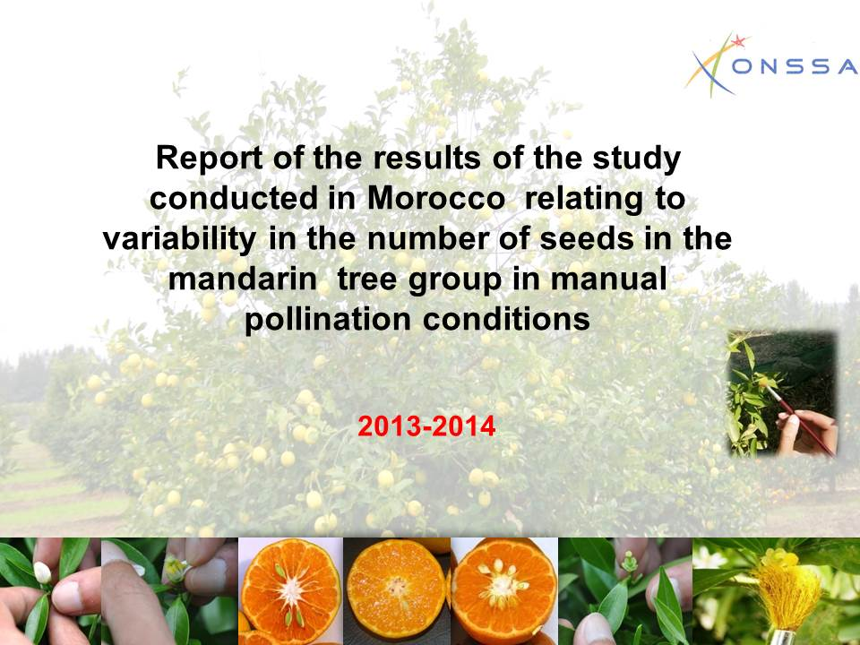

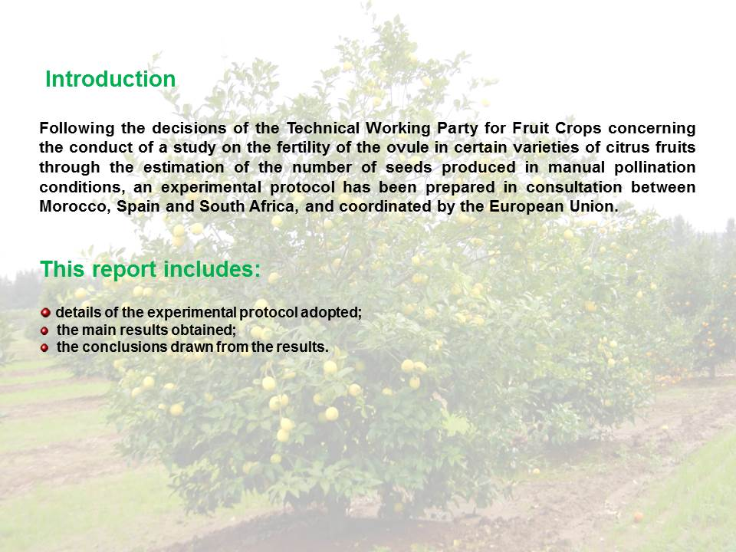

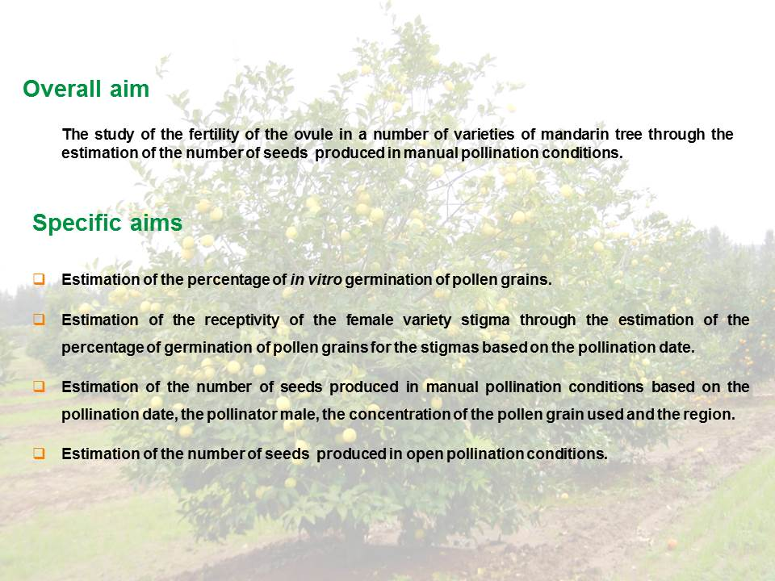

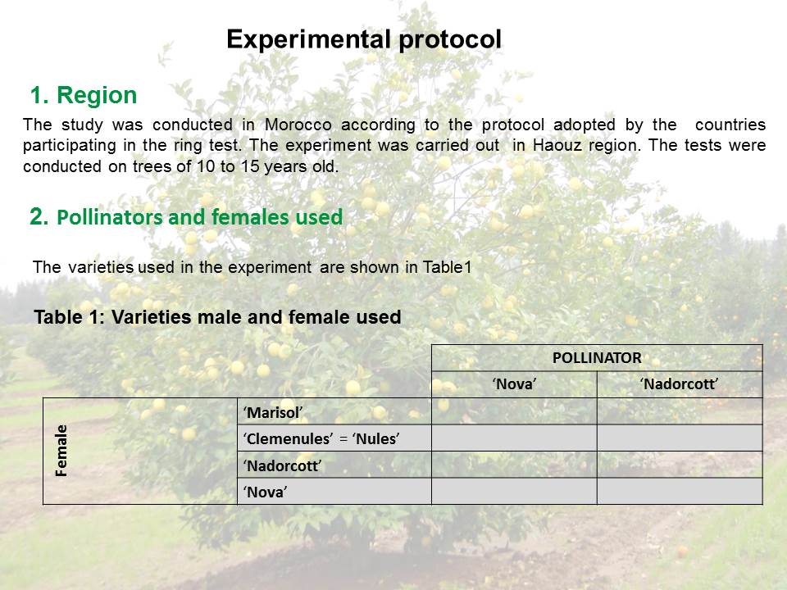

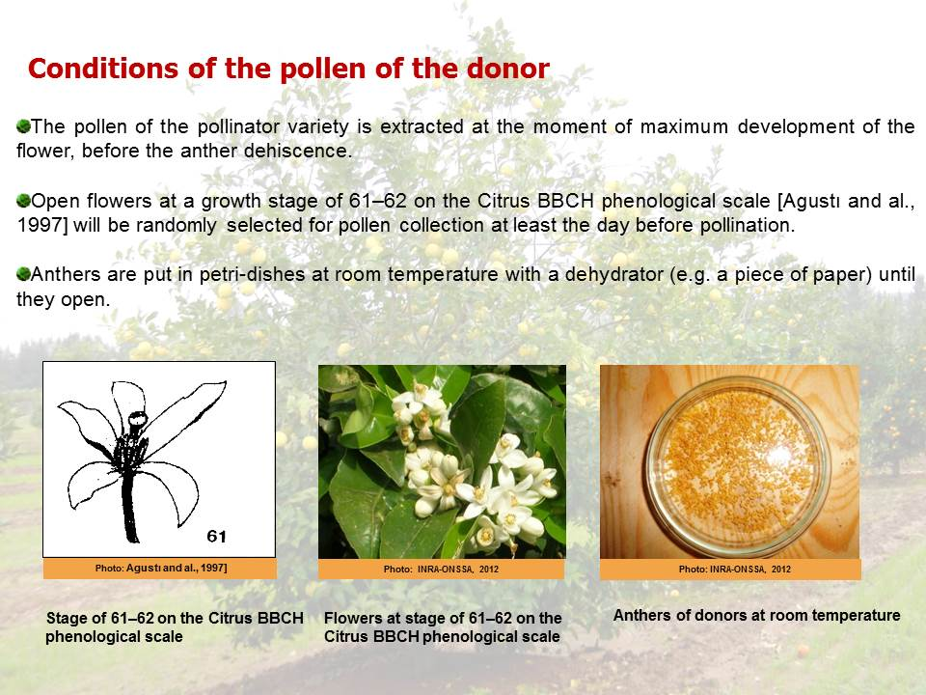

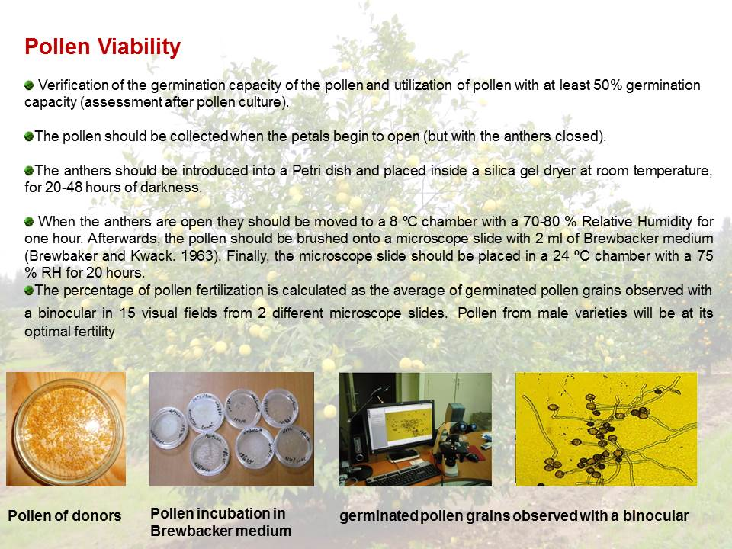

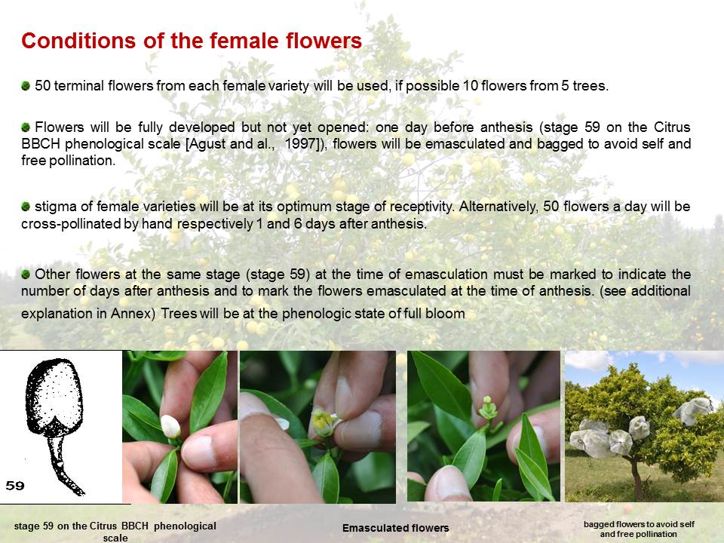

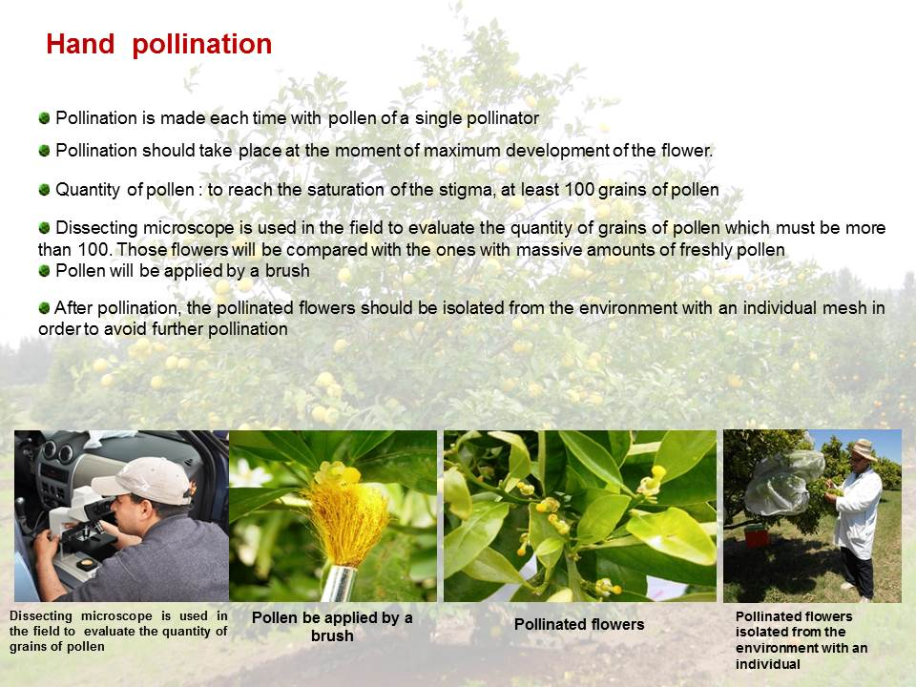

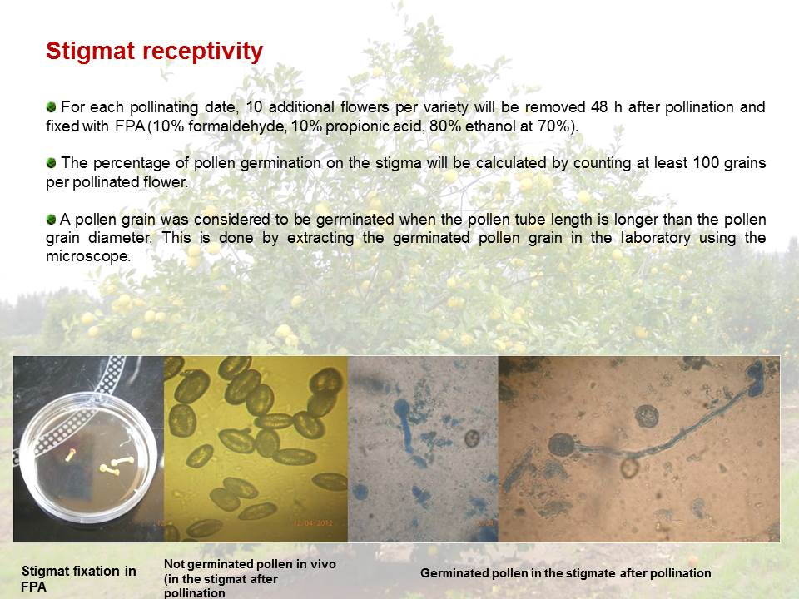

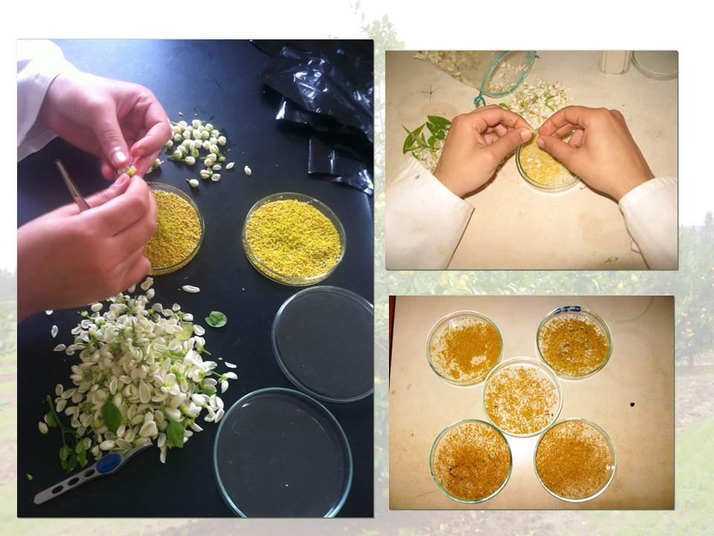

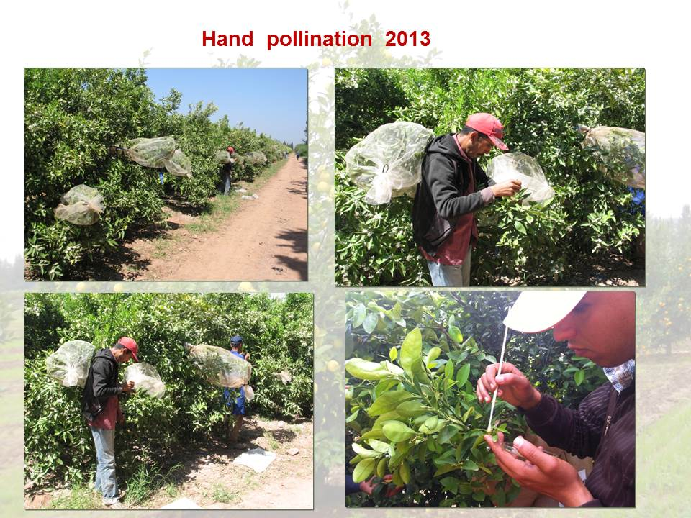

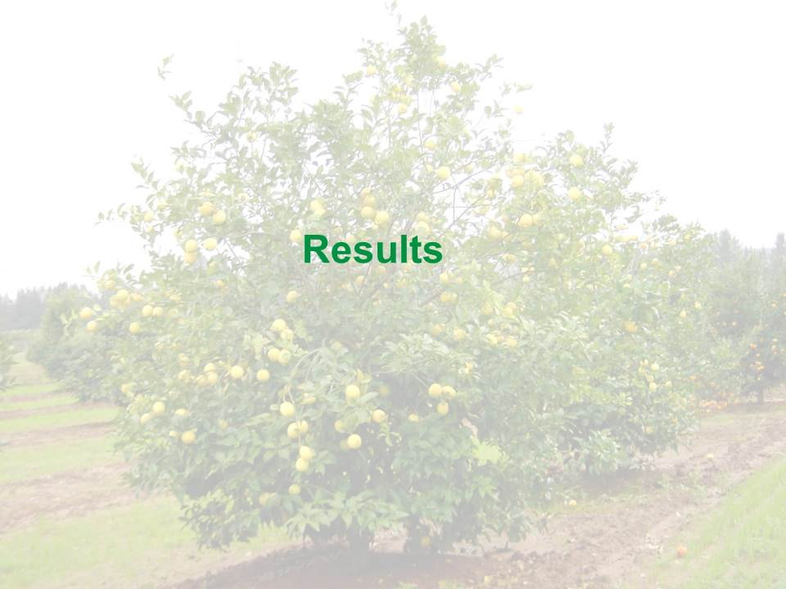

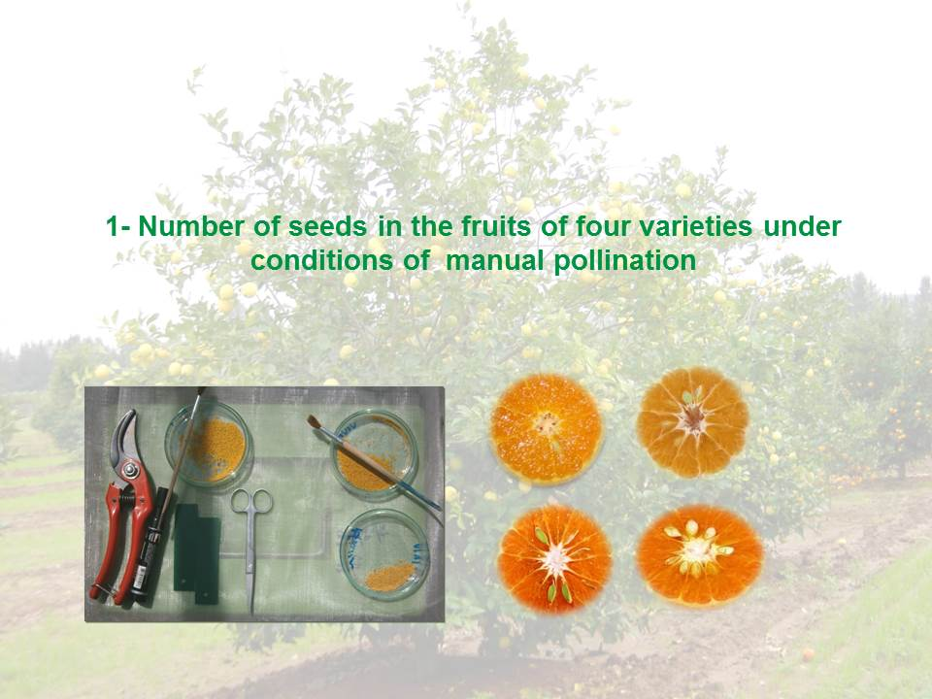

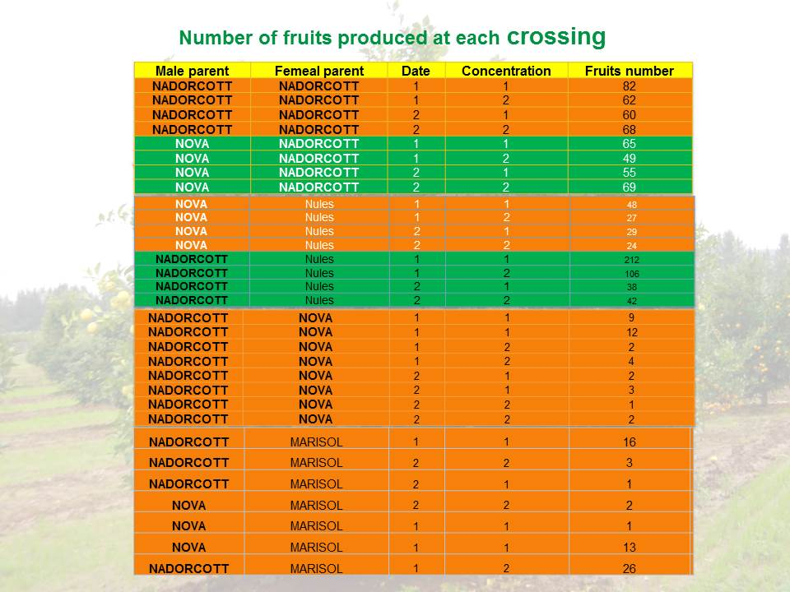

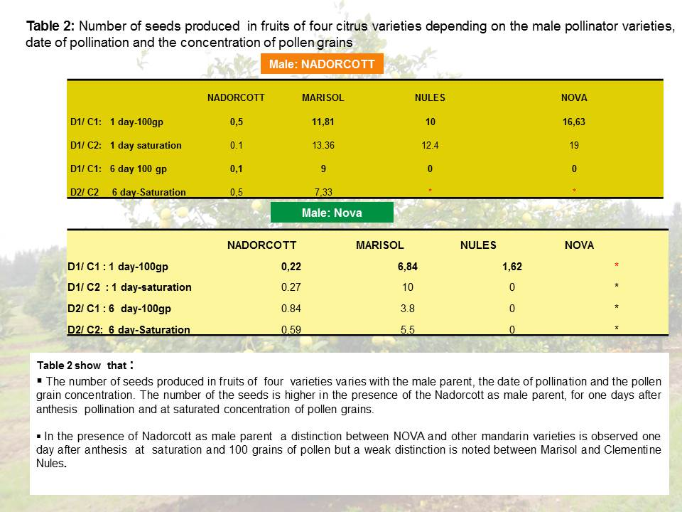

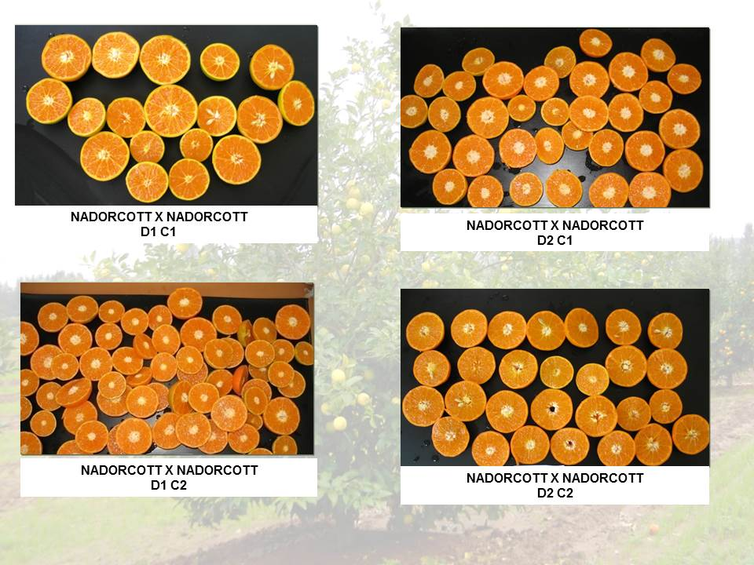

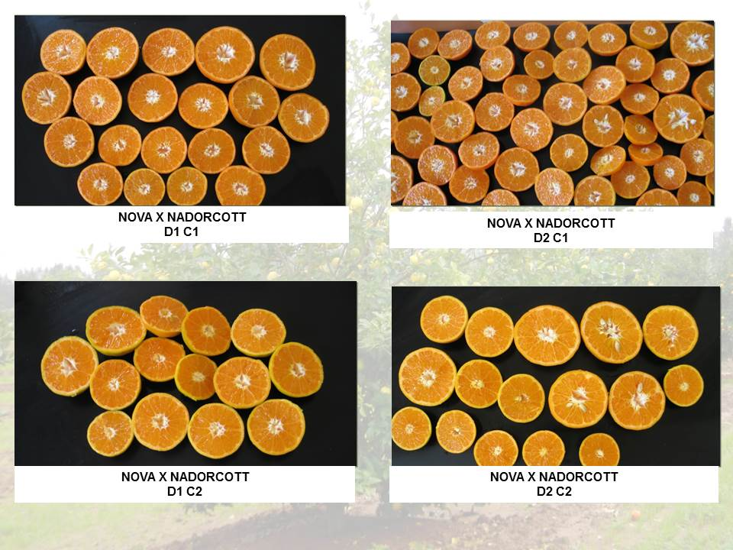

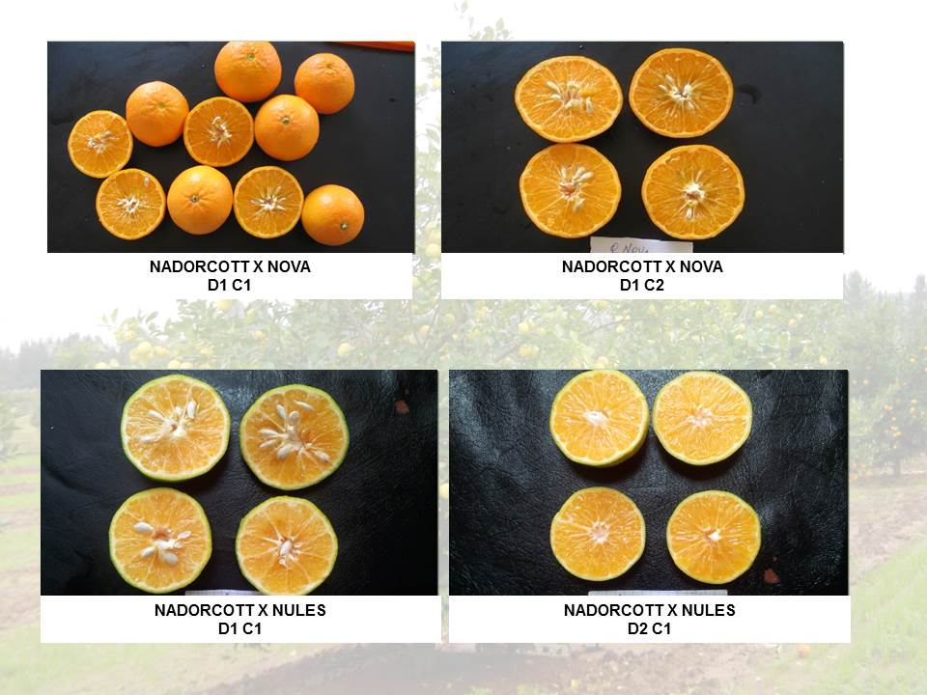

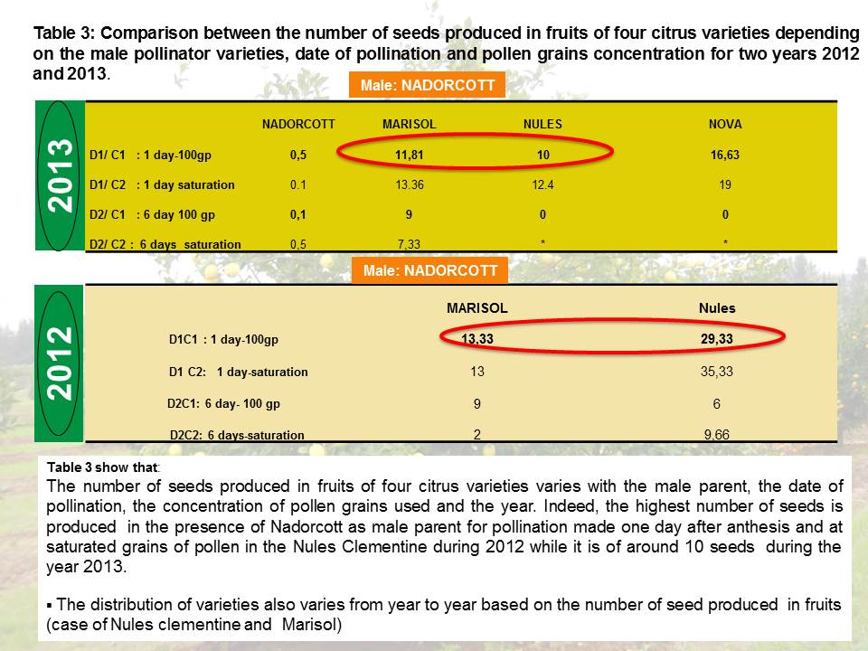

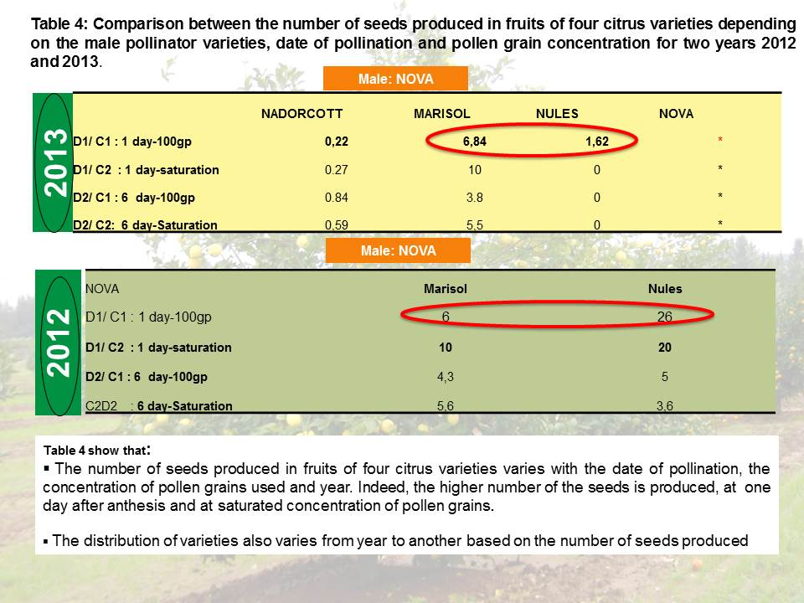

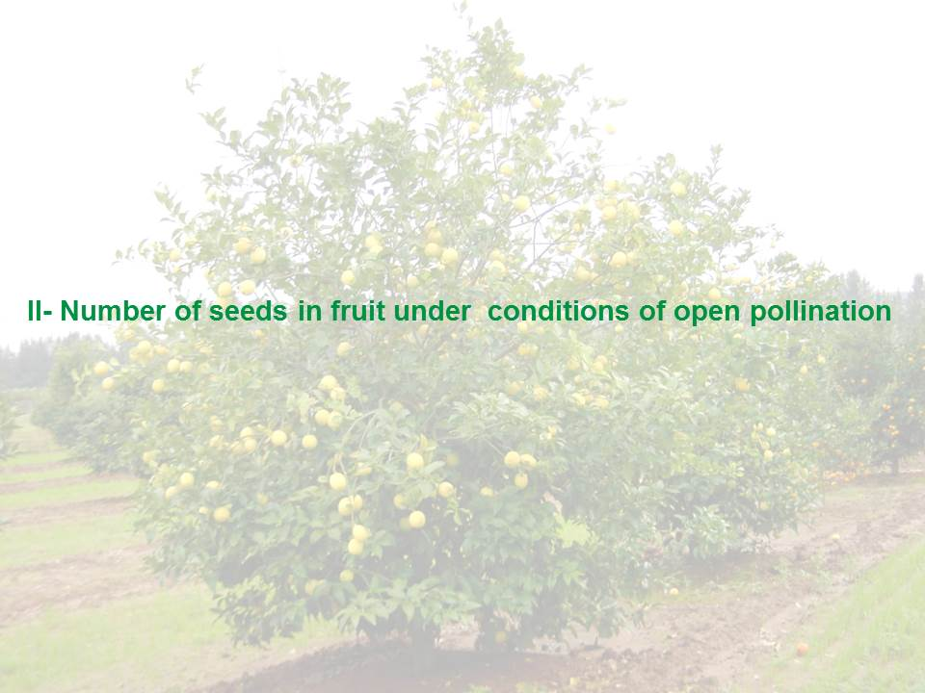

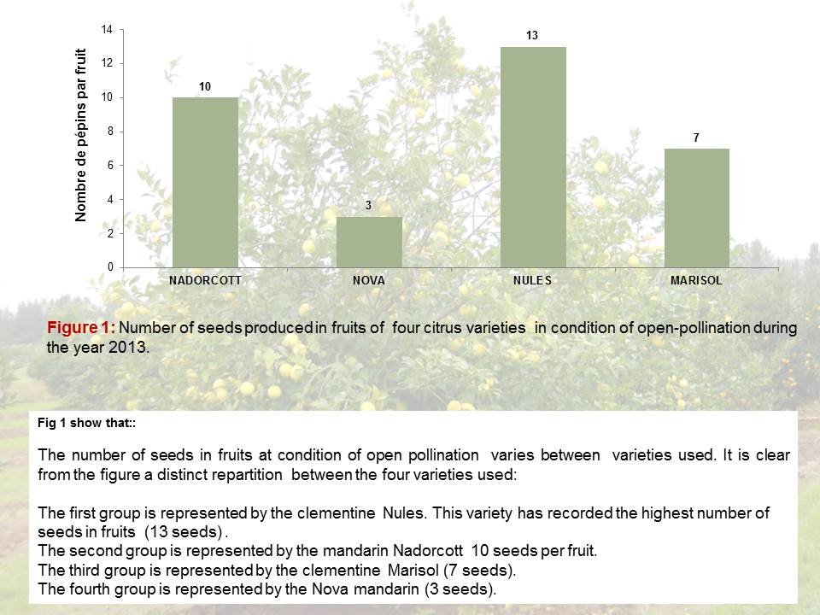

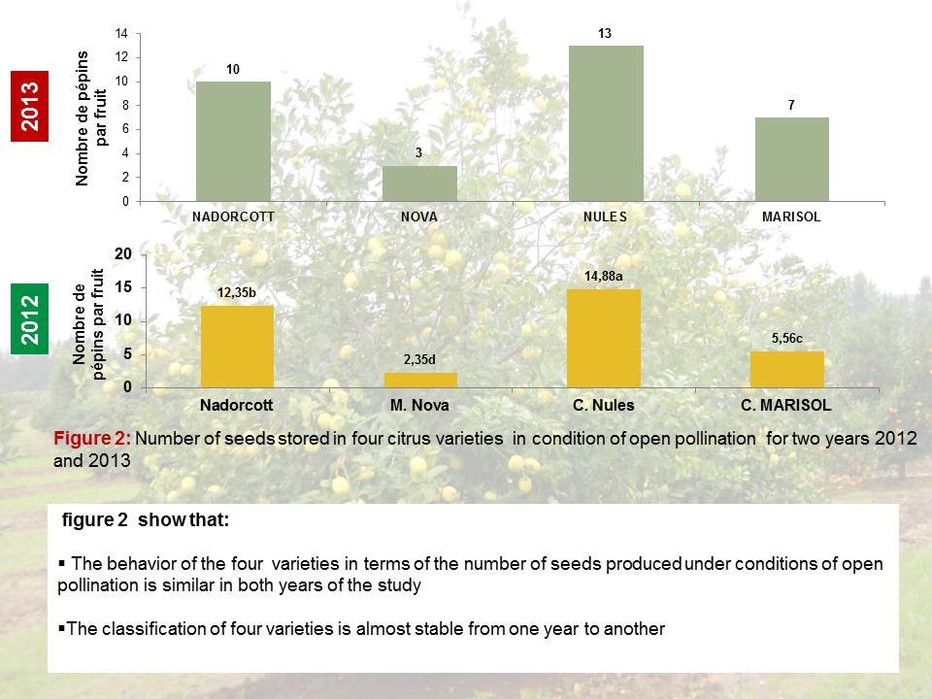

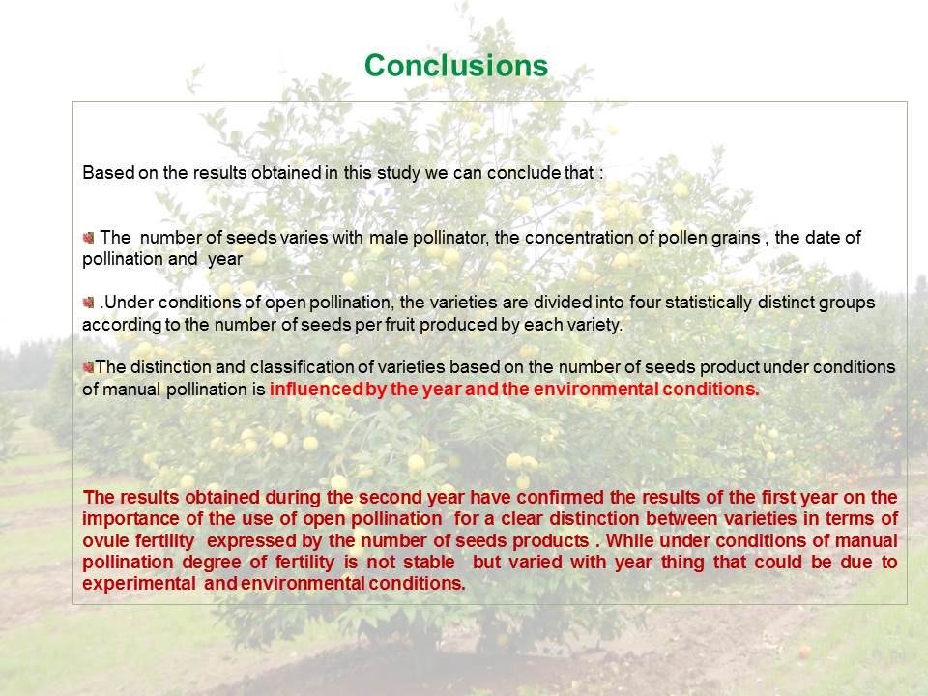

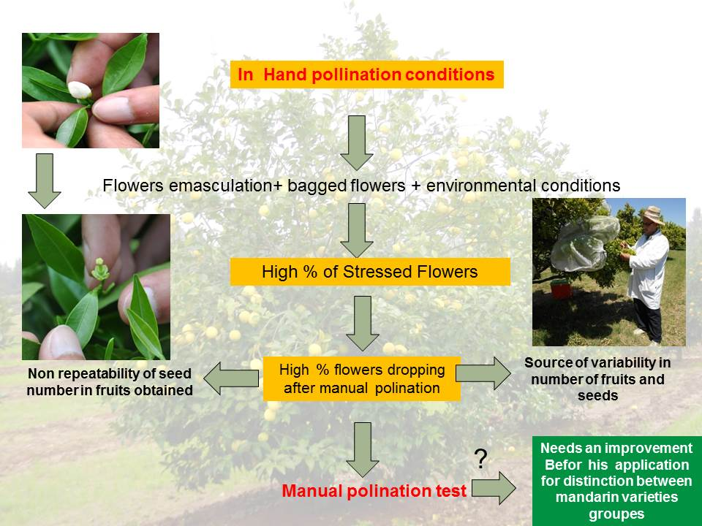

[End of Annex and of document]

