E
TG/JUGLA(proj.1)
ORIGINAL: English
DATE: 2014-04-15
INTERNATIONAL UNION FOR THE PROTECTION OF NEW VARIETIES OF PLANTS
Geneva
DRAFT

 | BLACK WALNUT  UPOV Code: {code}  Juglans nigra L. | *

GUIDELINES
FOR THE CONDUCT OF TESTS
FOR DISTINCTNESS, UNIFORMITY AND STABILITY

prepared by an expert from Spain

to be considered by the
Technical Working Party for Fruit Crops
at its forty-fifth session, to be held in Marrakesh, Morocco, from May 26 to 30, 2014

Alternative Names:*

Botanical name | English | French | German | Spanish
Juglans nigra L. | Black Walnut | Noyer |  | Nogal negro

The purpose of these guidelines (“Test Guidelines”) is to elaborate the principles contained in the General Introduction (document TG/1/3), and its associated TGP documents, into detailed practical guidance for the harmonized examination of distinctness, uniformity and stability (DUS) and, in particular, to identify appropriate characteristics for the examination of DUS and production of harmonized variety descriptions.

ASSOCIATED DOCUMENTS
These Test Guidelines should be read in conjunction with the General Introduction and its associated TGP documents.
TABLE OF CONTENTS PAGE

1. Subject of these Test Guidelines 3
2. Material Required 3
3. Method of Examination 3
3.1 Number of Growing Cycles 3
3.2 Testing Place 3
3.3 Conditions for Conducting the Examination 3
3.4 Test Design 3
3.5 Additional Tests 3
4. Assessment of Distinctness, Uniformity and Stability 4
4.1 Distinctness 4
4.2 Uniformity 5
4.3 Stability 5
5. Grouping of Varieties and Organization of the Growing Trial 5
6. Introduction to the Table of Characteristics 5
6.1 Categories of Characteristics 5
6.2 States of Expression and Corresponding Notes 6
6.3 Types of Expression 6
6.4 Example Varieties 6
6.5 Legend 6
7. Table of Characteristics/Tableau des caractères/Merkmalstabelle/Tabla de caracteres 7
8. Explanations on the Table of Characteristics 11
8.1 Explanations covering several characteristics 11
8.2 Explanations for individual characteristics 11
9. Literature 15
10. Technical Questionnaire 16

ANNEX CHANGES AND COMMENTS

Subject of these Test Guidelines

These Test Guidelines apply to all varieties of the following species of Juglans L. and its hybrids:

  - Juglans nigra (Black walnut)
  - Juglans major
  - Juglans indisii (Northern Black walnut)

Material Required

2.1 The competent authorities decide on the quantity and quality of the plant material required for testing the variety and when and where it is to be delivered. Applicants submitting material from a State other than that in which the testing takes place must ensure that all customs formalities and phytosanitary requirements are complied with.

2.2 The material is to be supplied in the form of one-year-old grafts.

2.3 The minimum quantity of plant material, to be supplied by the applicant, should be:

5 trees (one-year-old grafts).

The rootstock to be used is specified by the competent authority.

2.4 The plant material supplied should be visibly healthy, not lacking in vigor, nor affected by any important pest or disease.

2.5 The plant material should not have undergone any treatment which would affect the expression of the characteristics of the variety, unless the competent authorities allow or request such treatment. If it has been treated, full details of the treatment must be given.

Method of Examination

3.1 Number of Growing Cycles

The minimum duration of tests should normally be two independent growing cycles. The growing cycle is considered to be the duration of a single growing season, beginning with bud burst, and concluding when the following dormant period ends with the swelling of new season buds.

3.2 Testing Place

Tests are normally conducted at one place. In the case of tests conducted at more than one place, guidance is provided in TGP/9 “Examining Distinctness”.

3.3 Conditions for Conducting the Examination

The tests should be carried out under conditions ensuring satisfactory growth for the expression of the relevant characteristics of the variety and for the conduct of the examination. In particular, it is essential that the trees produce a satisfactory crop of fruit in each of the two growing cycles.

3.4 Test Design

3.4.1 Each test should be designed to result in a total of at least 5 trees.

3.4.2 The design of the tests should be such that plants or parts of plants may be removed for measurement or counting without prejudice to the observations which must be made up to the end of the growing cycle.

3.5 Additional Tests

Additional tests, for examining relevant characteristics, may be established.

Assessment of Distinctness, Uniformity and Stability

4.1 Distinctness

4.1.1 General Recommendations

It is of particular importance for users of these Test Guidelines to consult the General Introduction prior to making decisions regarding distinctness. However, the following points are provided for elaboration or emphasis in these Test Guidelines.

4.1.2 Consistent Differences

The differences observed between varieties may be so clear that more than one growing cycle is not necessary. In addition, in some circumstances, the influence of the environment is not such that more than a single growing cycle is required to provide assurance that the differences observed between varieties are sufficiently consistent. One means of ensuring that a difference in a characteristic, observed in a growing trial, is sufficiently consistent is to examine the characteristic in at least two independent growing cycles.

4.1.3 Clear Differences

Determining whether a difference between two varieties is clear depends on many factors, and should consider, in particular, the type of expression of the characteristic being examined, i.e. whether it is expressed in a qualitative, quantitative, or pseudo-qualitative manner. Therefore, it is important that users of these Test Guidelines are familiar with the recommendations contained in the General Introduction prior to making decisions regarding distinctness.

4.1.4 Number of Plants / Parts of Plants to be Examined

Unless otherwise indicated, for the purposes of distinctness, all observations on single plants should be made on 5 plants or parts taken from each of 5 plants and any other observations made on all plants in the test, disregarding any off-type plants. In the case of observations of parts taken from single plants, the number of parts to be taken from each of the plants should be 2.

4.1.5 Method of Observation

The recommended method of observing the characteristic for the purposes of distinctness is indicated by the following key in the second column of the Table of Characteristics (see document TGP/9 “Examining Distinctness”, Section 4 “Observation of characteristics”):

MG: single measurement of a group of plants or parts of plants
MS: measurement of a number of individual plants or parts of plants
VG: visual assessment by a single observation of a group of plants or parts of plants
VS: visual assessment by observation of individual plants or parts of plants

Type of observation: visual (V) or measurement (M)

“Visual” observation (V) is an observation made on the basis of the expert’s judgment. For the purposes of this document, “visual” observation refers to the sensory observations of the experts and, therefore, also includes smell, taste and touch. Visual observation includes observations where the expert uses reference points (e.g. diagrams, example varieties, side-by-side comparison) or non-linear charts (e.g. color charts). Measurement (M) is an objective observation against a calibrated, linear scale e.g. using a ruler, weighing scales, colorimeter, dates, counts, etc.

Type of record: for a group of plants (G) or for single, individual plants (S)

For the purposes of distinctness, observations may be recorded as a single record for a group of plants or parts of plants (G), or may be recorded as records for a number of single, individual plants or parts of plants (S). In most cases, “G” provides a single record per variety and it is not possible or necessary to apply statistical methods in a plant-by-plant analysis for the assessment of distinctness.

In cases where more than one method of observing the characteristic is indicated in the Table of Characteristics (e.g. VG/MG), guidance on selecting an appropriate method is provided in document TGP/9, Section 4.2.

4.2 Uniformity

4.2.1 It is of particular importance for users of these Test Guidelines to consult the General Introduction prior to making decisions regarding uniformity. However, the following points are provided for elaboration or emphasis in these Test Guidelines:

4.2.2 For the assessment of uniformity, a population standard of 1% and an acceptance probability of at least 95% should be applied. In the case of a sample size of 5 plants, no off-types are allowed.

4.3 Stability

4.3.1 In practice, it is not usual to perform tests of stability that produce results as certain as those of the testing of distinctness and uniformity. However, experience has demonstrated that, for many types of variety, when a variety has been shown to be uniform, it can also be considered to be stable.

4.3.2 Where appropriate, or in cases of doubt, stability may be further examined by testing a new plant stock to ensure that it exhibits the same characteristics as those shown by the initial material supplied.

Grouping of Varieties and Organization of the Growing Trial

5.1 The selection of varieties of common knowledge to be grown in the trial with the candidate varieties and the way in which these varieties are divided into groups to facilitate the assessment of distinctness are aided by the use of grouping characteristics.

5.2 Grouping characteristics are those in which the documented states of expression, even where produced at different locations, can be used, either individually or in combination with other such characteristics: (a) to select varieties of common knowledge that can be excluded from the growing trial used for examination of distinctness; and (b) to organize the growing trial so that similar varieties are grouped together.

5.3 The following have been agreed as useful grouping characteristics:

(a) Nut: shape (profile position) (characteristic 12)
(b) Nut: shape of the base (profile position) (characteristic 13)
(c) Nut: shape of apex (profile position) (characteristic 14)
(d) Time of bud burst (characteristic 15)
(e) Time of male peak flowering (characteristic 16)
(f) Time of leaf drop (characteristic 19)

5.4 Guidance for the use of grouping characteristics, in the process of examining distinctness, is provided through the General Introduction and document TGP/9 “Examining Distinctness”.

Introduction to the Table of Characteristics

6.1 Categories of Characteristics

6.1.1 Standard Test Guidelines Characteristics

Standard Test Guidelines characteristics are those which are approved by UPOV for examination of DUS and from which members of the Union can select those suitable for their particular circumstances.

6.1.2 Asterisked Characteristics

Asterisked characteristics (denoted by *) are those included in the Test Guidelines which are important for the international harmonization of variety descriptions and should always be examined for DUS and included in the variety description by all members of the Union, except when the state of expression of a preceding characteristic or regional environmental conditions render this inappropriate.

6.2 States of Expression and Corresponding Notes

6.2.1 States of expression are given for each characteristic to define the characteristic and to harmonize descriptions. Each state of expression is allocated a corresponding numerical note for ease of recording of data and for the production and exchange of the description.

6.2.2 In the case of qualitative and pseudo-qualitative characteristics (see Chapter 6.3), all relevant states of expression are presented in the characteristic. However, in the case of quantitative characteristics with 5 or more states, an abbreviated scale may be used to minimize the size of the Table of Characteristics. For example, in the case of a quantitative characteristic with 9 states, the presentation of states of expression in the Test Guidelines may be abbreviated as follows:

State | Note
small | 3
medium | 5
large | 7

However, it should be noted that all of the following 9 states of expression exist to describe varieties and should be used as appropriate:

State | Note
very small | 1
very small to small | 2
small | 3
small to medium | 4
medium | 5
medium to large | 6
large | 7
large to very large | 8
very large | 9

6.2.3 Further explanation of the presentation of states of expression and notes is provided in document TGP/7 “Development of Test Guidelines”.

6.3 Types of Expression

An explanation of the types of expression of characteristics (qualitative, quantitative and pseudo-qualitative) is provided in the General Introduction.

6.4 Example Varieties

Where appropriate, example varieties are provided to clarify the states of expression of each characteristic.

6.5 Legend

(*) Asterisked characteristic – see Chapter 6.1.2

QL Qualitative characteristic – see Chapter 6.3
QN Quantitative characteristic – see Chapter 6.3
PQ Pseudo-qualitative characteristic – see Chapter 6.3

MG, MS, VG, VS – see Chapter 4.1.5

(1) to (3), (a) See Explanations on the Table of Characteristics in Chapter 8.1

(+) See Explanations on the Table of Characteristics in Chapter 8.2.

Table of Characteristics/Tableau des caractères/Merkmalstabelle/Tabla de caracteres

 |  | English | français | deutsch | español | Example Varieties  Exemples  Beispielssorten  Variedades ejemplo | Note/  Nota
(*)  (+) | VG | Tree: growth habit
QN | (2) | upright |  |  |  |  | 1
 |  | semi-upright |  |  |  | MB Ng-10 | 2
 |  | spreading |  |  |  | Mj209 | 3
 |  | drooping |  |  |  | Ng Pablo | 4
(*)  (+) | MS | Leaf: number of leaflets
QN | (1) | very few |  |  |  | IRTA X-80 | 1
 |  | few |  |  |  |  | 3
 |  | medium |  |  |  | Mj2-2 | 5
 |  | many |  |  |  | Ti Tippecanoe-1 | 7
 |  | very many |  |  |  |  | 9
 | MS | Leaf: terminal leaflet
QL | (1) | absent or rachitic |  |  |  | Emilie, MB Ng-13 | 1
 |  | lower than sidewards |  |  |  | Mj2-2, 722 | 2
 |  | equal or higher than laterals |  |  |  | IRTA X-80 | 3
 | VG | Trunk: bark color in the juvenile phase
PQ | (2) | whitish |  |  |  | J. regia cv Chandler, Mj209 | 1
 |  | reddish |  |  |  |  | 2
 |  | blackish |  |  |  | Ng23 | 3
(+) | VG | Femal flowering: conspicuousness before the Df stage
QL | (3) | no conspicuous |  |  |  | MB Ng-2, MB Ng-10 | 1
 |  | conspicuous |  |  |  | Ng-23 | 2
(*) | VS | Female flowering: number of flowers per inflorescence at Ff2
QN | (3) | isolated |  |  |  | J. regia cv Franquette | 1
 |  | mostly in groups of two |  |  |  | IRTA X-80, Tippecanoe-1 | 3
 |  | mostly in groups of three |  |  |  | MB Hd-37, MB Ng-10 | 5
 |  | mostly in groups of four |  |  |  |  | 7
 |  | mostly in groups of five or more |  |  |  | Ng Pablo | 9
(*) | VS | Female flowering: anthocyanin coloration intensity of stigma at Ff2
QN | (3) | zero |  |  |  | MB Hd-37, MB Ng-10 | 1
 |  | low |  |  |  | Tippecanoe-1 | 3
 |  | medium |  |  |  | 23-14 | 5
 |  | high |  |  |  | Mj209 | 7
 |  | very high |  |  |  | Eurowalnut A-11 | 9
 | VS | Female flowering: length of stigma at Ff2
QN | (3) | short |  |  |  | IRTA X-80 | 3
 |  | medium |  |  |  |  | 5
 |  | long |  |  |  | MB Hd-37, MB Ng-10 | 7
 |  | very long |  |  |  | Hd | 9
(*)  (+) | VS | Female flowering: stigma shape at Ff2
PQ | (3) | V shape |  |  |  | Mj209, Tippecanoe-1 | 1
 |  | T shape |  |  |  |  | 2
 |  | curves to in side |  |  |  | Ng23 | 3
 |  | drooping |  |  |  |  | 4
 | VG | Male flowering: presence of well-developed catkins
QL | (3) | presence |  |  |  | MB Ng-10, Mj209 | 1
 | (a) | absence |  |  |  | IRTA X-95 | 2
(+) | VS | Male flowering: catkin shape at Bm-Cm
QL | (3) | round |  |  |  | MB Ng-2, MB Ng-7 | 1
 |  | cylindric |  |  |  | MB Hd-37, Mj209 | 2
 |  | conic |  |  |  | MB Ng-10, Ng23 | 3
(*)  (+) | VG | Nut: shape (profile position)
PQ | (G) | oblate |  |  |  | EccoVenner | 1
 |  | circular |  |  |  | MB Ng-2 | 2
 |  | conic |  |  |  | Ng Pablo | 3
 |  | trapezium |  |  |  | Mj209 | 4
 |  | elliptic |  |  |  |  | 5
 |  | oblong |  |  |  | IRTA X-80 | 6
 |  | compressed oblong |  |  |  | Beinecke-8 | 7
(+) | VG | Nut: shape of the base (profile position)
QL | (G) | pointed |  |  |  | 24-2 | 1
 |  | cuneate |  |  |  | Beinecke-4 | 2
 |  | rounded |  |  |  | MB Ng-2 | 3
 |  | truncate |  |  |  | Beinecke-8 | 4
 |  | emarginate |  |  |  |  | 5
 |  |  |  |  | recurrente | MB Hd-37 | 6
(+) | VG | Nut: shape of apex (profile position)
QL | (G) | pointed |  |  |  | Purdue-1, 24-2 | 1
 |  | obtuse |  |  |  | Mj209, Ng23 | 2
 |  | rounded |  |  |  |  | 3
 |  | truncate |  |  |  |  | 4
 |  | emarginate |  |  |  |  | 5
 |  | trapezium |  |  |  | MB Hd-37 | 6
(*)  (+) | MS | Time of bud burst
QN | (G) | very early |  |  |  | IRTA X-80, MBHd-37 | 1
 |  | early |  |  |  | MB Ng-13, Mj209 | 3
 |  | medium |  |  |  | MB Ng-2 | 5
 |  | late |  |  |  | MB Ng-7, MB Ng-10 | 7
 |  | very late |  |  |  | Eurowalnut 8, 722 | 9
(*)  (+) | MS | Time of male peak flowering
QN | (G) | very early |  |  |  | MB Ng-13 | 1
 |  | early |  |  |  | Mj209 | 3
 |  | medium |  |  |  | Ng Pablo, 24-2 | 5
 |  | late |  |  |  | Purdue-1, 23-14 | 7
 |  | very late |  |  |  |  | 9
(*)  (+) | MS | Time of female peak flowering
QN | (3) | very early |  |  |  | IRTA X-80, Mj209 | 1
 | (G) | early |  |  |  | Ng23 | 3
 |  | medium |  |  |  | MB Ng-2, MB Ng-13 | 5
 |  | late |  |  |  | MB Ng-10 | 7
 |  | very late |  |  |  | 48-11 | 9
(*)  (+) | MS | Dichogamy
QL |  | protogyny |  |  |  | Mj209, Ng23 | 1
 |  | homogamy |  |  |  |  | 2
 |  | protandry |  |  |  | MB Ng-2, MB Ng-10 | 3
(*)  (+) | MS | Time of leaf drop
QN | (G) | very early |  |  |  |  | 1
 |  | early |  |  |  |  | 3
 |  | medium |  |  |  |  | 5
 |  | late |  |  |  | Mj209 | 7
 |  | very late |  |  |  | Eurowalnut C-09 | 9

Explanations on the Table of Characteristics

8.1 Explanations covering several characteristics

The characters that include the following key in the second column of the table of characters must be examined as it is indicated next:

(1) 2º year of plantation in ahead
(2) 3-4 years
(3) From the second masculine or feminine flowering
(a) The observations in the masculine inflorescence, to establish if the development of the catkin takes place normally, will be made between the stages Bm and Dm

8.2 Explanations for individual characteristics

Ad. 1: Tree: habit

Straighten of the most vigorous branches of the year (> 1 m) of the grafted trees (according to definition of the IPGRI).

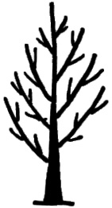 | 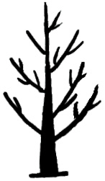 | 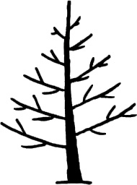 | 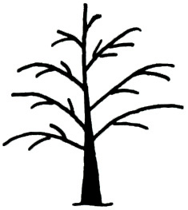
1 | 2 | 3 | 4
upright | semi-upright | spreading | drooping

Ad. 2: Leaf: number of leaflets

The following classification settles down considering nº of leaflets more observed:
Very few: number of leaflets ≤ 9
Few: 9< number of leaflets ≤ 13
Medium: 13< number of leaflets ≤ 17
Many: 17< number of leaflets < 21
Very many: number of leaflets ≥ 21

Ad. 5: Feminine flowering: conspicuousness before the DF stage

Visible flowering is considered when the branches of the year present/display visible flowers before stage DF, on the contrary nonvisible will be when the flowers of stage DF are observed later, these will follow he himself growth that the stages described for walnut (Germain ET to, 1999)

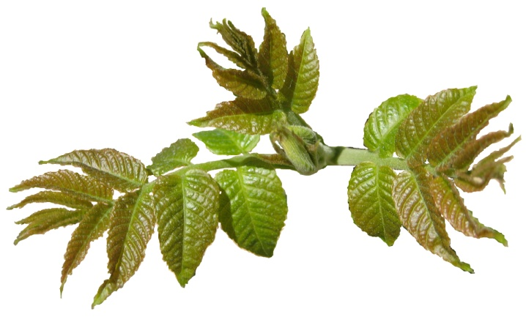 | 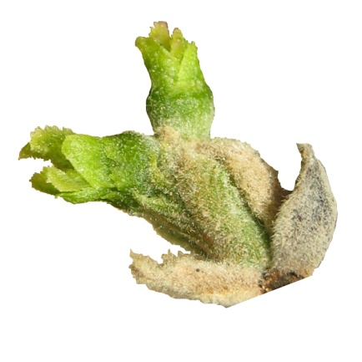
1 | 2
no conspicuous | conspicuous

Ad. 9: Feminine flowering: stigma shape at Ff₂

The form of stigmas is observed, these must present/display stigmas completely unfolded, in Ff stage₂

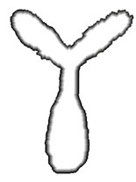 | 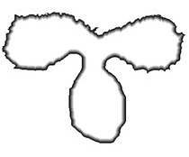 | 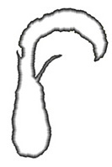 | 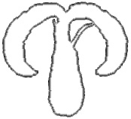
1 | 2 | 3 | 4
V shape | T shape | curves to inside | drooping

Ad. 11: Male flowering: catkin shape at Bm-Cm

1 | 2 | 3
round | cylindric | conic

Ad. 12: Nut: shape (profile position)

The form of the nuts observing them of profile position.

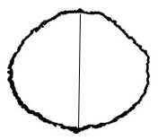 | 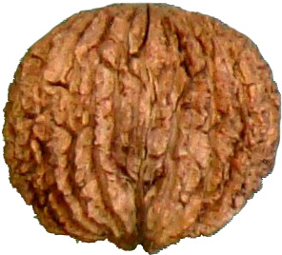 | 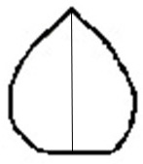 | 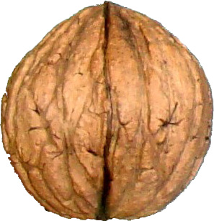
1 | 2 | 3 | 4
oblate | circular | conic | trapezium

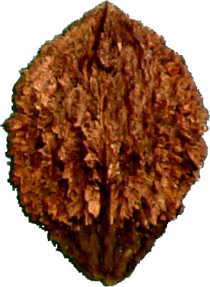 | 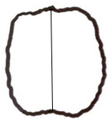 | 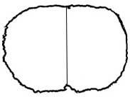
5 | 6 | 7
elliptic | oblong | compressed oblong

Ad. 13: Nut: shape of the base (profile position)

The form of the base of the nut in the profile position settles down

 | 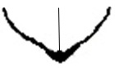
1 | 2 | 3
pointed | cuneate | rounded

 |  | 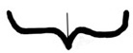
4 | 5 | 6
truncate | emarginate

Ad. 14: Nut: shape of apex (profile position)

The majority form of the apex is obtained observing them in the profile position.

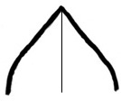 | 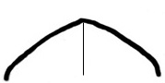 | 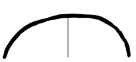
1 | 2 | 3
pointed | obtuse | rounded

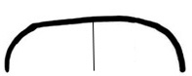 | 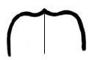 | 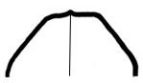
4 | 5 | 6
truncate | emarginate | trapezium

Ad. 15: Time of bud burst

Bud burst is considered when more of 50% of the terminal yolks they are in the Cf state

Ad. 16: Time of male peak flowering

The total masculine flowering takes place when the dehiscencia of anthers is total. It is the period of total emission of pollen (Fm₂)

Ad. 17: Time of female peak flowering

Period of receptivity of the feminine flower. It agrees with the Ff stages₁ and Ff₂.

Ad. 18: Dichogamy

Is the separation in the time of the masculine and feminine flowering in a same tree (asynchronous maturation of stamens and pistils). On the basis of the phenological states defined by Germain ET to. (1999) the following classification is obtained:

Protogynic varieties: feminine flowering previous to masculine (the Ff₁ previous to Fm)
Homogamic varieties: coincidence of the flowerings masculine and feminine (coincidence of Ff₁ with Fm)
Protandric varieties: masculine flowering previous to feminine (the Ff₁ subsequent to Fm)

Ad. 19: Time of leaf drop

The time of leaf drop settles down like the moment at which the tree has lost between the 50 and 75% of its leaves. In atypical years, like those with a frost previous to the 10 of November or much drought, this character is not taken.

Literature

IPGRI. 1994. Descriptors for Walnut. Ed. International Plant Genetic Resources Intitute. Roma. 51pp.

Becquey, J. 1997. Les noyers à bois. Ed. Institut pour le Développement Forestier. Paris. 144 pp.

Germain, E.; Prunet, J.P.; Garcin, A. 1999. Le noyer. Ed. CTIFL. 279 pp.

UPOV. 1999. Descriptor de J. regia. Documento TG/125/6. 31 pp.

UPOV. 2002. Introducción general al examen DHE y a la elaboración de descripciones armonizadas de las obtenciones vegetales. Documento TG/1/3. 28 pp.

Aletà, N; Vilanova, A. 2011. Criterios orientadores para la admisión de materiales de base del género Juglans. Ed MAGRAMA. 39 pp.

F. Luna Lorente . 1990 . El nogal, producción de fruto y de madera. Ministerio de Agricultura, Pesca y Alimentación. Servicio de Extensión Agraria. 154 pp

Technical Questionnaire

TECHNICAL QUESTIONNAIRE |  |  |  | Page {x} of {y} |  | Reference Number:
 |  |  |  |  |  | Application date:
 |  |  |  |  |  | (not to be filled in by the applicant)
TECHNICAL QUESTIONNAIRE
to be completed in connection with an application for plant breeders’ rights

1. Subject of the Technical Questionnaire
1.1 Botanical name |  |  | Juglans L.
1.2 Common name |  |  | Walnut
2. Applicant
Name
Address
Telephone No.
Fax No.
E-mail address
Breeder (if different from
applicant)
3. Proposed denomination and breeder’s reference
Proposed denomination
(if available)
Breeder’s reference
#4. Information on the breeding scheme and propagation of the variety

4.1 Breeding scheme

Variety resulting from:

4.1.1 Crossing

(a) controlled cross [ ]
(please state parent varieties)
(b) partially known cross [ ]
(please state known parent variety(ies))
(c) unknown cross [ ]

4.1.2 Mutation [ ]
(please state parent variety)

4.1.3 Discovery and development [ ]
(please state where and when discovered
and how developed)

4.1.4 Other [ ]
(please provide details)

4.2 Method of propagating the variety

4.2.1 Vegetative propagation

(a) budding or grafting [ ]

(b) other (state method) [ ]

4.2.2 Other [ ]
(please provide details)

5. Characteristics of the variety to be indicated (the number in brackets refers to the corresponding characteristic in Test Guidelines; please mark the note which best corresponds).

 | Characteristics |  |  |  |  |  | Example Varieties |  |  |  | Note
5.1  (12) | Nut: shape (profile position)
 | oblate |  |  |  |  |  | EccoVenner |  |  |  | 1[ ]
 | circular |  |  |  |  |  | MB Ng-2 |  |  |  | 2[ ]
 | conic |  |  |  |  |  | Ng Pablo |  |  |  | 3[ ]
 | trapezium |  |  |  |  |  | Mj209 |  |  |  | 4[ ]
 | elliptic |  |  |  |  |  |  |  |  |  | 5[ ]
 | oblong |  |  |  |  |  | IRTA X-80 |  |  |  | 6[ ]
 | compressed oblong |  |  |  |  |  | Beinecke-8 |  |  |  | 7[ ]
5.2  (13) | Nut: shape of the base (profile position)
 | pointed |  |  |  |  |  | 24-2 |  |  |  | 1[ ]
 | cuneate |  |  |  |  |  |  |  |  |  | 2[ ]
 | rounded |  |  |  |  |  | MB Ng-2 |  |  |  | 3[ ]
 | truncate |  |  |  |  |  |  |  |  |  | 4[ ]
 | emarginated |  |  |  |  |  |  |  |  |  | 5[ ]
 | emarginate |  |  |  |  |  | MB Hd-37 |  |  |  | 6[ ]
5.3  (14) | Nut: shape of apex (profile position)
 | pointed |  |  |  |  |  | Purdue-1, 24-2 |  |  |  | 1[ ]
 | obtuse |  |  |  |  |  | Mj209, Ng23 |  |  |  | 2[ ]
 | rounded |  |  |  |  |  |  |  |  |  | 3[ ]
 | truncate |  |  |  |  |  |  |  |  |  | 4[ ]
 | emarginate |  |  |  |  |  |  |  |  |  | 5[ ]
 | trapezium |  |  |  |  |  | MB Hd-37 |  |  |  | 6[ ]
 | Characteristics |  |  |  |  |  | Example Varieties |  |  |  | Note
5.4  (15) | Time of bud burst
 | very early |  |  |  |  |  | IRTA X-80, MBHd-37 |  |  |  | 1[ ]
 | very early to early |  |  |  |  |  |  |  |  |  | 2[ ]
 | early |  |  |  |  |  | MB Ng-13, Mj209 |  |  |  | 3[ ]
 | early to medium |  |  |  |  |  |  |  |  |  | 4[ ]
 | medium |  |  |  |  |  | MB Ng-2 |  |  |  | 5[ ]
 | medium to late |  |  |  |  |  |  |  |  |  | 6[ ]
 | late |  |  |  |  |  | MB Ng-7, MB Ng-10 |  |  |  | 7[ ]
 | late to very late |  |  |  |  |  |  |  |  |  | 8[ ]
 | very late |  |  |  |  |  | Eurowalnut 8, 722 |  |  |  | 9[ ]
5.5  (16) | Time of male peak flowering
 | very early |  |  |  |  |  | MB Ng-13 |  |  |  | 1[ ]
 | very early to early |  |  |  |  |  |  |  |  |  | 2[ ]
 | early |  |  |  |  |  | Mj209 |  |  |  | 3[ ]
 | early to medium |  |  |  |  |  |  |  |  |  | 4[ ]
 | medium |  |  |  |  |  | Ng Pablo, 24-2 |  |  |  | 5[ ]
 | medium to late |  |  |  |  |  |  |  |  |  | 6[ ]
 | late |  |  |  |  |  | Purdue-1, 23-14 |  |  |  | 7[ ]
 | late to very late |  |  |  |  |  |  |  |  |  | 8[ ]
 | very late |  |  |  |  |  |  |  |  |  | 9[ ]
5.6  (19) | Time of leaf drop
 | very early |  |  |  |  |  |  |  |  |  | 1[ ]
 | very early to early |  |  |  |  |  |  |  |  |  | 2[ ]
 | early |  |  |  |  |  |  |  |  |  | 3[ ]
 | early to medium |  |  |  |  |  |  |  |  |  | 4[ ]
 | medium |  |  |  |  |  |  |  |  |  | 5[ ]
 | medium to late |  |  |  |  |  |  |  |  |  | 6[ ]
 | late |  |  |  |  |  | Mj209 |  |  |  | 7[ ]
 | late to very late |  |  |  |  |  |  |  |  |  | 8[ ]
 | very late |  |  |  |  |  | Eurowalnut C-09 |  |  |  | 9[ ]
6. Similar varieties and differences from these varieties

Please use the following table and box for comments to provide information on how your candidate variety differs from the variety (or varieties) which, to the best of your knowledge, is (or are) most similar. This information may help the examination authority to conduct its examination of distinctness in a more efficient way.

Denomination(s) of variety(ies) similar to your candidate variety |  | Characteristic(s) in which your candidate variety differs from the similar variety(ies) |  |  | Describe the expression of the characteristic(s) for the similar variety(ies) |  |  | Describe the expression of the characteristic(s) for your candidate variety
Example |  | Fruit: size |  |  | small |  |  | medium
Comments:

#7. Additional information which may help in the examination of the variety

7.1 In addition to the information provided in sections 5 and 6, are there any additional characteristics which may help to distinguish the variety?

Yes [ ] No [ ]

(If yes, please provide details)

7.2 Are there any special conditions for growing the variety or conducting the examination?

Yes [ ] No [ ]

(If yes, please provide details)

7.3 Other information

A representative color image of the variety should accompany the Technical Questionnaire.

8. Authorization for release

(a) Does the variety require prior authorization for release under legislation concerning the protection of the environment, human and animal health?

Yes [ ] No [ ]

(b) Has such authorization been obtained?

Yes [ ] No [ ]

If the answer to (b) is yes, please attach a copy of the authorization.

9. Information on plant material to be examined or submitted for examination

9.1 The expression of a characteristic or several characteristics of a variety may be affected by factors, such as pests and disease, chemical treatment (e.g. growth retardants or pesticides), effects of tissue culture, different rootstocks, scions taken from different growth phases of a tree, etc.

9.2 The plant material should not have undergone any treatment which would affect the expression of the characteristics of the variety, unless the competent authorities allow or request such treatment. If the plant material has undergone such treatment, full details of the treatment must be given. In this respect, please indicate below, to the best of your knowledge, if the plant material to be examined has been subjected to:

(a) Microorganisms (e.g. virus, bacteria, phytoplasma) Yes [ ] No [ ]

(b) Chemical treatment (e.g. growth retardant, pesticide) Yes [ ] No [ ]

(c) Tissue culture Yes [ ] No [ ]

(d) Other factors Yes [ ] No [ ]

Please provide details for where you have indicated “yes”.

10. I hereby declare that, to the best of my knowledge, the information provided in this form is correct:

Applicant’s name

Signature Date

[Annex follows]
ANNEX OF CHANGES AND COMMENTS

TG/BLACK WALNUT (proj.1)
(All comments came from experts of CPVO: UB (Urszulla Braum),
JM (Jean Maison), LDE (Laetitia Danechau), and Spain (ES))

1.

UB: Think it might need to be specified that the TG is only for rootstocks and woody uses

LDE: Indeed this protocol will apply for Juglans nigra varieties or not ¿

ES : specified the species involved in the TG

3.1.1.

LDE: To be consistent with the 3.3, the satisfactory fructification period should be mentioned, unless this is deleted from 3.3

3.3.

ES: all varieties of Black Walnut, not only rootstocks

UB6: It does not seem to be essential in case of rootstock varieties unless all the rootstock within the crop produce fruit. To be confirmed.

4.1.3.

LDE: Para 4.1.4. Number of Plants to be observed and for 4.1.5 Method of observations are missing. Is it normal ¿

7.Table of Characteristics

JM: I think that this is a rootstock guideline and it should focus if possible on vegetative characteristics in order to shorten the duration of the trial and to identify varieties at an early stage of development in certification schemes. Flowering and fruit characteristics should be avoided if possible, see for example avocado rootstock guidelines.

ES . is not a rootstock TG

3.

UB: It seems that this characteristic includes in fact two characteristics: 1 – Leaf: terminal leaflet: presence, 2 - Leaf: terminal leaflet: position.

ES: Is an often case, similar than in caracter 7

5.

LD: Should be 9

7.

UB: I propose the following states of expression:
Absent or very weak – 1, weak -3, madium-5, strong – 7, very strong - 9

10.

UB: The order of the states should be changed, at first absent and as the second state – present

ES: agree absence 1, presence 2

LDE: Should be 9

17.

ES: See explanation 3

Ad.5

ES: to add a copy of the stages described by Germain.

[End of document]

* These names were correct at the time of the introduction of these Test Guidelines but may be revised or updated. [Readers are advised to consult the UPOV Code, which can be found on the UPOV Website (www.upov.int), for the latest information.]
# Authorities may allow certain of this information to be provided in a confidential section of the Technical Questionnaire.
# Authorities may allow certain of this information to be provided in a confidential section of the Technical Questionnaire.

