E
TWF/44/18
ORIGINAL: English
DATE: April 18, 2013
INTERNATIONAL UNION FOR THE PROTECTION OF NEW VARIETIES OF PLANTS
Geneva
Technical working party for fruit cropS
Forty-Fourth Session
Napier, New Zealand, April 29 to May 3, 2013
Revision of document TGP/8: Part II:
New Section: Data Processing for the Assessment of Distinctness and for Producing Variety Descriptions
Document prepared by the Office of the Union
The purpose of this document is to present the developments concerning a possible new section for document TGP/8: “Data Processing for the Assessment of Distinctness and for Producing Variety Descriptions”.

The following abbreviations are used in this document:

CAJ: Administrative and Legal Committee
TC: Technical Committee
TC-EDC: Enlarged Editorial Committee
TWA: Technical Working Party for Agricultural Crops
TWC: Technical Working Party on Automation and Computer Programs
TWF: Technical Working Party for Fruit Crops
TWO: Technical Working Party for Ornamental Plants and Forest Trees
TWV: Technical Working Party for Vegetables
TWPs: Technical Working Parties

The structure of this document is as follows:

background 2

DevelopmentS in 2012 2
Technical Working Parties 2

DevelopmentS in 2013 3
Technical Committee 3
Practical exercise with a common data set 3

ANNEX: TRANSFORMATION OF MEASUREMENT INTO NOTES FOR VARIETY DESCRIPTIONS- SUMMARY OF DIFFERENT APPROACHES PRESENTED AT THE TECHNICAL WORKING PARTIES IN 2012

background

The Technical Committee (TC), at its forty-eighth session, held in Geneva from March 26 to 28, 2012, considered Annex III: “TGP/8 PART I: DUS Trial Design and data analysis, New Section 6 – Data processing for the assessment of distinctness and for producing variety Descriptions” in conjunction with Annex VIII: “TGP/8 PART II: Techniques used in DUS Examination, New Section 13 - Methods for data processing for the assessment of distinctness and for producing variety descriptions” of
document TC/48/19 Rev. It agreed that the information provided in Annex VIII of document TC/48/19 Rev. and at the UPOV DUS Seminar, held in Geneva in March 2010, together with the method provided by Japan and the method used in France for producing variety descriptions for herbage crops, as presented at the TWC at its twenty-sixth session (see document TWC/26/15, TWC/26/15 Add. and TWC/26/24), provided a very important first step in developing common guidance on data processing for the assessment of distinctness and for producing variety descriptions, but concluded that the information as presented in
Annex VIII of document TC/48/19 Rev. would not be appropriate for inclusion in document TGP/8. It agreed that the Office of the Union should summarize the different approaches set out in
Annex VIII of document TC/48/19 Rev. with regard to aspects in common and aspects where there was divergence. As a next step, on the basis of that summary, consideration could be given to developing general guidance. The TC agreed that the section should include examples to cover the range of variation of characteristics. It further agreed that the detailed information on the methods should be made available via the UPOV website, with references in document TGP/8 (see document TC/48/22 “Report on the Conclusions” paragraph 52).

DevelopmentS in 2012

Technical Working Parties

At their sessions in 2012, the TWA, TWV, TWC, TWF and TWO, considered documents TWA/41/30, TWV/46/30, TWC/30/30, TWF/43/30 and TWO/45/30 respectively, which contained a presentation on “Summary of different approaches of transformation of measurements into notes for Variety Description”, as reproduced in the Annex to this document.

The TWPs, at their sessions in 2012, made the following comments:

General | The TWA noted the information that a summary of different approaches used for data processing for the assessment of distinctness and for producing variety descriptions would be developed by the Office of the Union (see document TWA/41/34 “Report”, paragraph 44). | TWA
 | The TWV considered document TWV/46/30 and received a presentation made by the Office containing a summary of different approaches for transforming means into notes for variety descriptions. The TWV was informed that the summary would be presented to the TWC at its thirtieth session and that it would be further developed (see document TWV/46/41 “Report”, paragraphs 43 and 44). | TWV
 | The TWC noted information provided in documents TWC/30/30 and TWC/30/30 Add. and agreed that the experts from Finland, Italy and the United Kingdom would support the Office of the Union to summarize the different approaches for further developing common guidance on data processing for the assessment of distinctness and for producing variety descriptions (see document TWC/30/41 “Report”, paragraph 42).  The TWC agreed that experts from the United Kingdom in cooperation with experts from France and Germany should conduct a practical exercise. The exercise would be to process a common data set to produce variety descriptions in order to determine the aspects in common and where there was divergence among the methods (see document TWC/30/41 “Report”, paragraph 43). | TWC
 | The TWF considered documents TWF/43/30 and TWF/43/30 Add. and received a presentation made by the Office containing a summary of different approaches for transforming means into notes for variety descriptions.  The TWF expressed concern that a specific country may have difficulty in describing the full range of states of expression of a characteristic because some varieties might not be available. A universal set of example varieties, the use of historical data and experience of the experts could be a way to address this issue.  The TWF recommended that consideration be given to the construction of a meaningful range of expression in the case of a limited range of available varieties.  (see document TWF/43/38 “Report”, paragraphs 29 to 31) | TWF
 | The TWO agreed with the recommendations of the TWF that consideration be given to the construction of a meaningful scale of expression in the case of a limited range of available example varieties (see document TWO/45/37 “Report”, paragraph 32). | TWO

In accordance with the proposal of the TWC, the Office of the Union invited experts from the United Kingdom, France and Germany to make a proposal for a practical exercise.

DevelopmentS in 2013

Technical Committee

The Technical Committee (TC), at its forty-ninth session held in Geneva from March 18 to 20, 2013, considered document TC/49/29 “Revision of document TGP/8: Part II: Techniques Used in DUS Examination, New Section: Data Processing for the Assessment of Distinctness and for Producing Variety Descriptions ”.

The TC requested the Office of the Union to request experts from the United Kingdom, France and Germany, or other members of the Union, to provide a common data set of self-pollinated and/or vegetatively propagated varieties, because the COY method was already well established for cross-pollinated varieties, for performing a practical exercise. (see document TC/49/41 “Report on the Conclusions”, paragraph 66).

Practical exercise with a common data set

Following the request from the TC at its forty-ninth session, experts from the United Kingdom, France and Germany have been asked to provide a common data set of self-pollinated and/or vegetatively propagated varieties for performing a practical exercise. In response to some of the experts expressing difficulties in providing the data requested by the TC, the other members of the Union that have contributed to the information provided in the Annex of this document (Netherlands, Finland, Republic of Korea and Japan), have been invited to contribute to the practical exercise by providing a common data set of self-pollinated and/or vegetatively propagated varieties.

A report on developments with regard to the practical exercise will be made to the TWF at its
forty-fourth session.

13. The TWF is invited to consider developments on a practical exercise with a common data set to produce variety descriptions of self-pollinated and/or vegetatively propagated varieties, in order to determine the aspects in common and divergence between methods, with a view to developing general guidance.

[Annex follows]
TWF/44/18

ANNEX

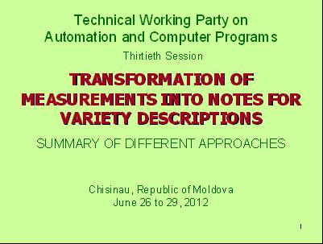

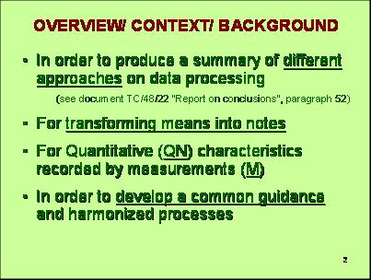

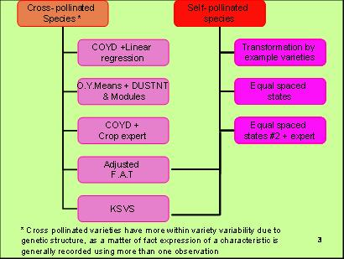

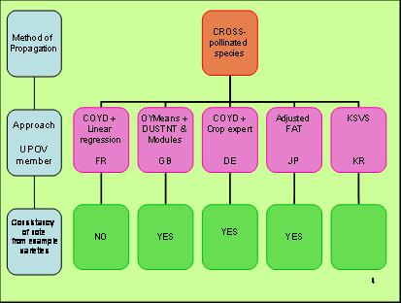

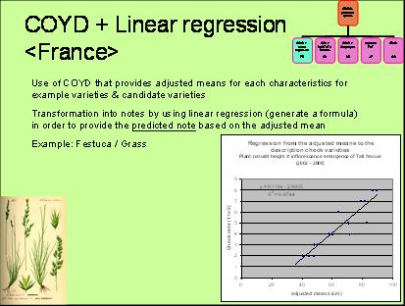

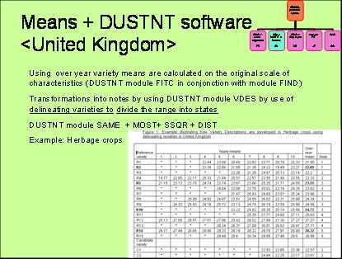

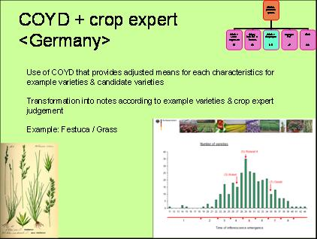

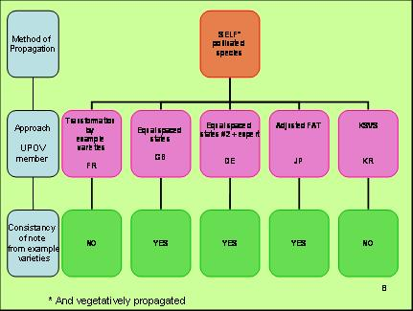

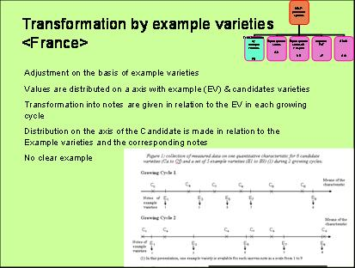

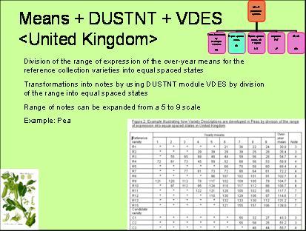

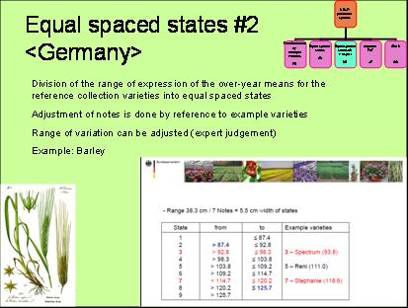

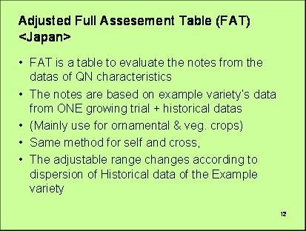

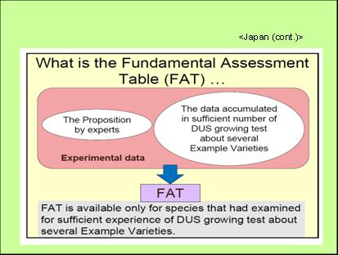

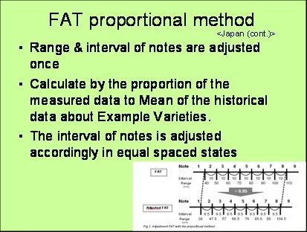

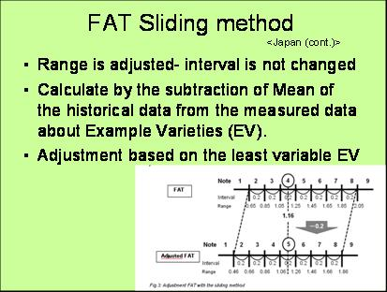

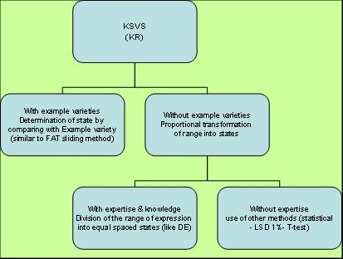

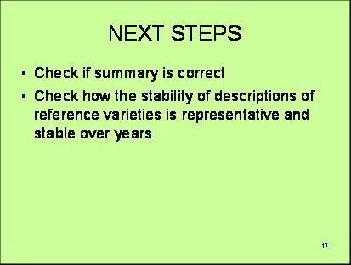

[End of Annex and of document]

