 |  |  | E  TG/LITCHI(proj.3)  ORIGINAL: English  DATE: 2013-03-22
INTERNATIONAL UNION FOR THE PROTECTION OF NEW VARIETIES OF PLANTS
Geneva
 | DRAFT

 | LITCHI  UPOV Code: LITCH_CHI  Litchi chinensis Sonn. | *

GUIDELINES
FOR THE CONDUCT OF TESTS
FOR DISTINCTNESS, UNIFORMITY AND STABILITY

prepared by experts from China

to be considered by the
Technical Working Party for Fruit Crops
at its forty-fourth session, to be held in Napier, New Zealand, from April 29 to May 3, 2013

Alternative Names:*

Botanical name | English | French | German | Spanish
Litchi chinensis Sonn. | Litchi, Lychee | Litchi | Litschi | Lichi

The purpose of these guidelines (“Test Guidelines”) is to elaborate the principles contained in the General Introduction (document TG/1/3), and its associated TGP documents, into detailed practical guidance for the harmonized examination of distinctness, uniformity and stability (DUS) and, in particular, to identify appropriate characteristics for the examination of DUS and production of harmonized variety descriptions.

ASSOCIATED DOCUMENTS
These Test Guidelines should be read in conjunction with the General Introduction and its associated TGP documents.
TABLE OF CONTENTS PAGE

1. Subject of these Test Guidelines 3
2. Material Required 3
3. Method of Examination 3
3.1 Number of Growing Cycles 3
3.2 Testing Place 3
3.3 Conditions for Conducting the Examination 3
3.4 Test Design 3
3.5 Additional Tests 3
4. Assessment of Distinctness, Uniformity and Stability 4
4.1 Distinctness 4
4.2 Uniformity 5
4.3 Stability 5
5. Grouping of Varieties and Organization of the Growing Trial 5
6. Introduction to the Table of Characteristics 5
6.1 Categories of Characteristics 5
6.2 States of Expression and Corresponding Notes 6
6.3 Types of Expression 6
6.4 Example Varieties 6
6.5 Legend 6
7. Table of Characteristics/Tableau des caractères/Merkmalstabelle/Tabla de caracteres 7
8. Explanations on the Table of Characteristics 16
8.1 Explanations covering several characteristics 16
8.2 Explanations for individual characteristics 16
9. Literature 29
10. Technical Questionnaire 30

Subject of these Test Guidelines

These Test Guidelines apply to all varieties of Litchi chinensis Sonn..

Material Required

2.1 The competent authorities decide on the quantity and quality of the plant material required for testing the variety and when and where it is to be delivered. Applicants submitting material from a State other than that in which the testing takes place must ensure that all customs formalities and phytosanitary requirements are complied with.

2.2 The material is to be supplied in the form of air-layerings or grafts. If the material is supplied in the form of grafts, the rootstocks of the grafts should also be supplied at the same time.

2.3 The minimum quantity of plant material, to be supplied by the applicant, should be:

5 plants.

2.4 The plant material supplied should be visibly healthy, not lacking in vigor, nor affected by any important pest or disease.

2.5 The plant material should not have undergone any treatment which would affect the expression of the characteristics of the variety, unless the competent authorities allow or request such treatment. If it has been treated, full details of the treatment must be given.

Method of Examination

3.1 Number of Growing Cycles

3.1.1 The minimum duration of tests should normally be two independent growing cycles.

3.1.2 The growing cycle is considered to be the duration of a single growing season, beginning with bud burst, flowering and fruit harvest and concluding when the following dormant period ends with the swelling of new season buds.

3.1.3 In particular, it is essential that the plants produce a satisfactory crop of fruit in each of the two growing cycles.

3.2 Testing Place

Tests are normally conducted at one place. In the case of tests conducted at more than one place, guidance is provided in TGP/9 “Examining Distinctness”.

3.3 Conditions for Conducting the Examination

The tests should be carried out under conditions ensuring satisfactory growth for the expression of the relevant characteristics of the variety and for the conduct of the examination.

3.4 Test Design

Each test should be designed to result in a total of at least 5 plants.

3.5 Additional Tests

Additional tests, for examining relevant characteristics, may be established.

Assessment of Distinctness, Uniformity and Stability

4.1 Distinctness

4.1.1 General Recommendations

It is of particular importance for users of these Test Guidelines to consult the General Introduction prior to making decisions regarding distinctness. However, the following points are provided for elaboration or emphasis in these Test Guidelines.

4.1.2 Consistent Differences

The differences observed between varieties may be so clear that more than one growing cycle is not necessary. In addition, in some circumstances, the influence of the environment is not such that more than a single growing cycle is required to provide assurance that the differences observed between varieties are sufficiently consistent. One means of ensuring that a difference in a characteristic, observed in a growing trial, is sufficiently consistent is to examine the characteristic in at least two independent growing cycles.

4.1.3 Clear Differences

Determining whether a difference between two varieties is clear depends on many factors, and should consider, in particular, the type of expression of the characteristic being examined, i.e. whether it is expressed in a qualitative, quantitative, or pseudo-qualitative manner. Therefore, it is important that users of these Test Guidelines are familiar with the recommendations contained in the General Introduction prior to making decisions regarding distinctness.

4.1.4 Number of Plants / Parts of Plants to be Examined

Unless otherwise indicated, for the purposes of distinctness, all observations on single plants should be made on 5 plants or parts taken from each of 2 plants and any other observations made on all plants in the test, disregarding any off-type plants.

4.1.5 Method of Observation

The recommended method of observing the characteristic for the purposes of distinctness is indicated by the following key in the second column of the Table of Characteristics (see document TGP/9 “Examining Distinctness”, Section 4 “Observation of characteristics”):

MG: single measurement of a group of plants or parts of plants
MS: measurement of a number of individual plants or parts of plants
VG: visual assessment by a single observation of a group of plants or parts of plants
VS: visual assessment by observation of individual plants or parts of plants

Type of observation: visual (V) or measurement (M)

“Visual” observation (V) is an observation made on the basis of the expert’s judgment. For the purposes of this document, “visual” observation refers to the sensory observations of the experts and, therefore, also includes smell, taste and touch. Visual observation includes observations where the expert uses reference points (e.g. diagrams, example varieties, side-by-side comparison) or non-linear charts (e.g. color charts). Measurement (M) is an objective observation against a calibrated, linear scale e.g. using a ruler, weighing scales, colorimeter, dates, counts, etc.

Type of record: for a group of plants (G) or for single, individual plants (S)

For the purposes of distinctness, observations may be recorded as a single record for a group of plants or parts of plants (G), or may be recorded as records for a number of single, individual plants or parts of plants (S). In most cases, “G” provides a single record per variety and it is not possible or necessary to apply statistical methods in a plant-by-plant analysis for the assessment of distinctness.

In cases where more than one method of observing the characteristic is indicated in the Table of Characteristics (e.g. VG/MG), guidance on selecting an appropriate method is provided in document TGP/9, Section 4.2.

4.2 Uniformity

4.2.1 It is of particular importance for users of these Test Guidelines to consult the General Introduction prior to making decisions regarding uniformity. However, the following points are provided for elaboration or emphasis in these Test Guidelines:

4.2.2 For the assessment of uniformity, a population standard of 1% and an acceptance probability of at least 95% should be applied. In the case of a sample size of 5 plants, no off-types are allowed.

4.3 Stability

4.3.1 In practice, it is not usual to perform tests of stability that produce results as certain as those of the testing of distinctness and uniformity. However, experience has demonstrated that, for many types of variety, when a variety has been shown to be uniform, it can also be considered to be stable.

4.3.2 Where appropriate, or in cases of doubt, stability may be further examined by testing a new plant stock to ensure that it exhibits the same characteristics as those shown by the initial material supplied.

Grouping of Varieties and Organization of the Growing Trial

5.1 The selection of varieties of common knowledge to be grown in the trial with the candidate varieties and the way in which these varieties are divided into groups to facilitate the assessment of distinctness are aided by the use of grouping characteristics.

5.2 Grouping characteristics are those in which the documented states of expression, even where produced at different locations, can be used, either individually or in combination with other such characteristics: (a) to select varieties of common knowledge that can be excluded from the growing trial used for examination of distinctness; and (b) to organize the growing trial so that similar varieties are grouped together.

5.3 The following have been agreed as useful grouping characteristics:

(a) Fruit: size (characteristic 35)
(b) Fruit: color of skin (characteristic 40)
(c) Fruit: appearance of skin protuberances (characteristic 41)
(d) Time of beginning of flowering (characteristic 52)

5.4 Guidance for the use of grouping characteristics, in the process of examining distinctness, is provided through the General Introduction and document TGP/9 “Examining Distinctness”.

Introduction to the Table of Characteristics

6.1 Categories of Characteristics

6.1.1 Standard Test Guidelines Characteristics

Standard Test Guidelines characteristics are those which are approved by UPOV for examination of DUS and from which members of the Union can select those suitable for their particular circumstances.

6.1.2 Asterisked Characteristics

Asterisked characteristics (denoted by *) are those included in the Test Guidelines which are important for the international harmonization of variety descriptions and should always be examined for DUS and included in the variety description by all members of the Union, except when the state of expression of a preceding characteristic or regional environmental conditions render this inappropriate.

6.2 States of Expression and Corresponding Notes

6.2.1 States of expression are given for each characteristic to define the characteristic and to harmonize descriptions. Each state of expression is allocated a corresponding numerical note for ease of recording of data and for the production and exchange of the description.

6.2.2 In the case of qualitative and pseudo-qualitative characteristics (see Chapter 6.3), all relevant states of expression are presented in the characteristic. However, in the case of quantitative characteristics with 5 or more states, an abbreviated scale may be used to minimize the size of the Table of Characteristics. For example, in the case of a quantitative characteristic with 9 states, the presentation of states of expression in the Test Guidelines may be abbreviated as follows:

State | Note
small | 3
medium | 5
large | 7

However, it should be noted that all of the following 9 states of expression exist to describe varieties and should be used as appropriate:

State | Note
very small | 1
very small to small | 2
small | 3
small to medium | 4
medium | 5
medium to large | 6
large | 7
large to very large | 8
very large | 9

6.2.3 Further explanation of the presentation of states of expression and notes is provided in document TGP/7 “Development of Test Guidelines”.

6.3 Types of Expression

An explanation of the types of expression of characteristics (qualitative, quantitative and pseudo-qualitative) is provided in the General Introduction.

6.4 Example Varieties

Where appropriate, example varieties are provided to clarify the states of expression of each characteristic.

6.5 Legend

(*) Asterisked characteristic – see Chapter 6.1.2

QL Qualitative characteristic – see Chapter 6.3
QN Quantitative characteristic – see Chapter 6.3
PQ Pseudo-qualitative characteristic – see Chapter 6.3

MG, MS, VG, VS – see Chapter 4.1.5

(a)-(e) See Explanations on the Table of Characteristics in Chapter 8.1

(+) See Explanations on the Table of Characteristics in Chapter 8.2.

Table of Characteristics/Tableau des caractères/Merkmalstabelle/Tabla de caracteres

 |  | English | français | deutsch | español | Example Varieties  Exemples  Beispielssorten  Variedades ejemplo | Note/  Nota
1.  (*)  (+) | VG | Plant: growth habit
PQ | (a) | upright |  |  |  | Baitangying | 1
 |  | spreading |  |  |  | Guiwei | 2
 |  | drooping |  |  |  | Yuanzhi | 3
2.  (+) | VG | Plant: shape
PQ | (a) | circular |  |  |  | Nuomici | 1
 |  | elliptic |  |  |  | Baitangying | 2
 |  | triangular |  |  |  |  | 3
 |  | irregular |  |  |  |  | 4
3.  (*)  (+) | VG | Plant: vigor
QN | (a) | weak |  |  |  | Baitangying | 1
 |  | medium |  |  |  | Huaizhi | 2
 |  | strong |  |  |  | Zhuangyuanhong | 3
4. | VG/MS | One-year-old shoot: thickness
QN | (b) | thin |  |  |  | Shangshuhuai | 3
 |  | medium |  |  |  | Guiwei | 5
 |  | thick |  |  |  | Sanyuehong | 7
5. | VG | One-year-old shoot: attitude
QN | (b) | upwards |  |  |  | Baitangying | 1
 |  | outwards |  |  |  | Nuomici | 2
 |  | downwards |  |  |  | Yuanzhi | 3
6.  (+) | VG/MS | One-year-old shoot: length of internode
QN | (b) | short |  |  |  | Dianbaibaila | 3
 |  | medium |  |  |  | Sanyuehong | 5
 |  | long |  |  |  | Yuanzhi | 7
7. | VG | One-year-old shoot: size of lenticels
QN | (b) | small |  |  |  | Xiapuli | 1
 |  | medium |  |  |  | Yuanzhi | 2
 |  | large |  |  |  | Luhebao | 3
8. | VG | One-year-old shoot: density of lenticels
QN | (b) | sparse |  |  |  | Baitangying | 3
 |  | medium |  |  |  | Guiwei | 5
 |  | dense |  |  |  | Nuomici | 7
9. | VG | Young shoot: color
PQ | (b) | yellow green |  |  |  | Nuomici | 1
new |  | green |  |  |  |  | 2
 |  | reddish green |  |  |  | Guiwei | 3
 |  | brown |  |  |  | Sanyuehong | 4
10.  (+) | VG | Leaf: predominant arrangement of leaves
QN | (c) | opposite |  |  |  | Nuomici | 1
 |  | both opposite and alternate |  |  |  | Chenzi | 2
 |  | alternate |  |  |  | Heiye | 3
11.  (*)  (+) | MS/VG | Leaf: length
QN | (c) | very short |  |  |  | Ziniangxi | 1
 |  | short |  |  |  | Huaizhi | 3
 |  | medium |  |  |  | Xuehuaizi | 5
 |  | long |  |  |  | Yuanzhi | 7
 |  | very long |  |  |  | Tianjiazi | 9
12.  (*) | VG | Leaf: color of petiole on upper side
PQ | (c) | green |  |  |  | Tianjiazi | 1
 |  | green brown |  |  |  | Feizixiao | 2
 |  | brown |  |  |  | Yuanzhi | 3
 |  | brown red |  |  |  | Guiwei | 4
13.  (*)  (+) | VG | Leaflet: shape
PQ | (c) | lanceolate |  |  |  | Yuanzhi | 1
 |  | elliptic |  |  |  | Baitangying | 2
 |  | oblong |  |  |  | Lanzhu | 3
 |  | ovate |  |  |  | Heiye | 4
 |  | obovate |  |  |  | Qingpitian | 5
14.  (*) | VG | Leaflet: shape in cross section
QN | (c) | strongly concave |  |  |  | Baitangying | 1
 |  | moderately concave |  |  |  | Nuomici | 2
 |  | flat |  |  |  | Sanyuehong | 3
 |  | convex |  |  |  | Shangshuhuai | 4
15. | VG | Leaflet: surface of upper side
QN | (c) | smooth |  |  |  | Guiwei | 1
 |  | moderately rough |  |  |  |  | 2
 |  | very rough |  |  |  | Xuehuaizi | 3
16.  (+) | MS/VG | Leaflet: length of petiolule
QN | (c) | short |  |  |  | Yuanzhi | 1
 |  | medium |  |  |  | Huaizhi | 2
 |  | long |  |  |  | Dianbaibaila | 3
17.  (+) | VG/MS | Leaflet blade: length
QN | (c) | very short |  |  |  | Ziniangxi | 1
 |  | short |  |  |  | Nuomici | 3
 |  | medium |  |  |  | Zhongshanzhuangyuanhong | 5
 |  | long |  |  |  | Heiye | 7
 |  | very long |  |  |  | Yuanzhi | 9
18.  (+) | VG/MS | Leaflet blade: width
QN | (c) | very narrow |  |  |  | Ziniangxi | 1
 |  | narrow |  |  |  | Shuijingqiu | 3
 |  | medium |  |  |  | Nuomici | 5
 |  | broad |  |  |  | Baitangying | 7
 |  | very broad |  |  |  | Tianjiazi | 9
19.  (*) | VG/MS | Leaflet blade: ratio length/width
QN | (c) | strongly elongated |  |  |  | Yuanzhi | 1
 |  | moderately elongated |  |  |  | Guiwei | 3
 |  | weakly elongated |  |  |  | Huaizhi | 5
20.  (+) | VG | Leaflet blade: length of tip
QN | (c) | very short |  |  |  |  | 1
 |  | short |  |  |  | Baitangying, Huaizhi | 2
 |  | medium |  |  |  | Guiwei, Nuomici | 3
 |  | long |  |  |  | Yuanzhi (Shuidong) | 4
21.  (+) | VG | Leaflet: tip: shape of apex
PQ | (c) | caudate |  |  |  | Yuanzhi | 1
 |  | acute |  |  |  | Ziniangxi | 2
 |  | acuminate |  |  |  | Qingpitian | 3
 |  | obtuse |  |  |  | Huaizhi | 4
22.  (+) | VG | Leaflet blade: symmetry of base
QN | (c) | symmetric or weakly asymmetric |  |  |  | Nuomici | 1
 |  | moderately asymmetric |  |  |  |  | 2
 |  | strongly asymmetric |  |  |  | Guiwei | 3
23.  New | VG | Leaflet: shape of base
PQ | (c) | wedge-shaped |  |  |  | Heiye | 1
 |  | broad wedge-shaped |  |  |  | Feizixiao | 2
 |  | nearly rounded |  |  |  | Huaizhi | 3
24.  (*)  (+) | VG | Leaflet blade: undulation of margin
QN | (c) | absent or weak |  |  |  | Lanzhu | 1
 |  | medium |  |  |  | Nuomici | 2
 |  | strong |  |  |  | Baitangying | 3
25.  (*) | VG | Leaflet: intensity of green color
QN | (c) | light |  |  |  | Qingpitian | 1
 |  | medium |  |  |  | Nuomici | 2
 |  | dark |  |  |  | Heiye | 3
26. | VG | Leaflet: glossiness of upper side
QN | (c) | weak |  |  |  | Heiye | 1
 |  | medium |  |  |  | Huaizhi | 2
 |  | strong |  |  |  | Dianbaibaila | 3
27. | VG | Leaflet: conspicuousness of lateral veins
QN | (c) | weak |  |  |  | Guiwei | 1
 |  | medium |  |  |  | Nuomici | 2
 |  | strong |  |  |  | Sanyuehong | 3
28.  (*)  (+) | VG/MS | Inflorescence: length
QN | (d) | short |  |  |  | Ziniangxi | 3
 |  | medium |  |  |  | Huaizhi | 5
 |  | long |  |  |  | Chenzi | 7
29.  (*)  (+) | VG/MS | Inflorescence: width
QN | (d) | narrow |  |  |  | Xuehuaizi | 1
 |  | medium |  |  |  | Guiwei | 2
 |  | broad |  |  |  | Chenzi | 3
30.  (*) | VG/MS | Inflorescence: ratio length/width
QN | (d) | strongly elongated |  |  |  | Feizixiao | 1
 |  | moderately elongated |  |  |  | Guiwei | 3
 |  | weakly elongated |  |  |  | Huaizhi | 5
31.  (+) | VG | Inflorescence: density of branching
QN | (d) | sparse |  |  |  | Yuanzhi | 3
 |  | medium |  |  |  | Guiwei | 5
 |  | dense |  |  |  | Sanyuehong | 7
32.  (+) | VG | Inflorescence: density of flowers
QN | (d) | sparse |  |  |  | Chenzi | 3
 |  | medium |  |  |  | Nuomici | 5
 |  | dense |  |  |  | Shuijingqiu | 7
33. | VG | Inflorescence: intensity of green color on main axis
QN | (d) | light |  |  |  | Nuomici | 1
 |  | medium |  |  |  | Huaizhi | 2
 |  | dark |  |  |  | Sanyuehong | 3
34.  (*)  (+) | VG | Flower: depth of stigma splitting
QN | (d) | shallow |  |  |  | Chenzi | 1
 |  | medium |  |  |  | Huaizhi | 2
 |  | deep |  |  |  | Xuehuaizi | 3
35.  (*) | VG | Fruit: size
QN | (e) | very small |  |  |  | Xinxingxiangli | 1
 |  | small |  |  |  | Chenzi | 3
 |  | medium |  |  |  | Guiwei | 5
 |  | large |  |  |  | Sanyuehong | 7
 |  | very large |  |  |  | Ziniangxi | 9
36.  (*)  (+) | VG | Fruit: shape
PQ | (e) | elliptic |  |  |  |  | 1
 |  | circular |  |  |  |  | 2
 |  | ovate |  |  |  |  | 3
 |  | cordate |  |  |  |  | 4
37.  (*)  (+) | VG | Fruit: shape of shoulder at stalk end
PQ | (e) | sloping |  |  |  |  | 1
 |  | truncate |  |  |  |  | 2
 |  | symmetrically depressed |  |  |  |  | 3
 |  | asymmetrically depressed |  |  |  |  | 4
38.  (+) | VG | Fruit: depth of suture
QN | (e) | shallow |  |  |  | Yuanzhi | 1
 |  | medium |  |  |  | Heiye | 2
 |  | deep |  |  |  | Xuehuaizi | 3
39.  (+) | VG | Fruit: conspicuousness of suture
QN | (e) | weak |  |  |  | Yuanzhi | 1
 |  | medium |  |  |  | Heiye | 2
 |  | strong |  |  |  | Xuehuaizi | 3
40.  (*) | VG | Fruit: color of skin
PQ | (e) | only green |  |  |  |  | 1
 |  | green and red |  |  |  | Feizixiao | 2
 |  | yellow and red |  |  |  | Guangming | 3
 |  | pink red |  |  |  | Kwai May Pink | 4
 |  | only bright red |  |  |  | Nuomici | 5
 |  | only dark red |  |  |  | Jizuili | 6
 |  | purplish red |  |  |  | Ziniangxi | 7
41.  (*)  (+) | VG | Fruit: appearance of skin protuberances
QN | (e) | smooth or slightly raised |  |  |  | Huaizhi | 1
(new) |  | moderately raised |  |  |  | Nuomici | 2
 |  | strongly raised |  |  |  | Guiwei | 3
42.  (*) | VG | Fruit: size
QN | (e) | very small |  |  |  | Xinxingxiangli | 1
 |  | small |  |  |  | Chenzi | 3
 |  | medium |  |  |  | Guiwei | 5
 |  | large |  |  |  | Sanyuehong | 7
 |  | very large |  |  |  | Ziniangxi | 9
43.  (+) | VG | Fruit: thickness of skin
QN | (e) | thin |  |  |  | Nuomici | 1
 |  | medium |  |  |  | Baitangying | 2
 |  | thick |  |  |  | Ziniangxi | 3
44. | VG | Fruit: color of flesh
PQ | (e) | whitish |  |  |  | Huaizhi | 1
 |  | yellowish |  |  |  |  | 2
 |  | yellow |  |  |  | Wuheli | 3
45.  (+) | MG | Fruit: weight of flesh compared to fruit
QN | (e) | low |  |  |  | Dazao | 3
 |  | medium |  |  |  | Huaizhi | 5
 |  | high |  |  |  | Nuomici | 7
46.  (+) | VG | Fruit: shape of seed
PQ |  | elliptic |  |  |  |  | 1
 |  | circular |  |  |  |  | 2
 |  | conical |  |  |  |  | 3
 |  | irregular |  |  |  |  | 4
47. | VG | Fruit: color of seed coat
PQ |  | red brown |  |  |  | Dazao | 1
 |  | medium brown |  |  |  | Huaizhi | 2
 |  | dark brown |  |  |  | Nuomici | 3
48.  (*)  (+) | VG | Fruit: intensity of brown color on the inner side of aril
QN | (e) | absent or weak |  |  |  | Huaizhi | 1
 |  | medium |  |  |  | Feizixiao | 2
 |  | strong |  |  |  | Yuanzhi | 3
49.  (+) | VG/MG | Fruit: content of total soluble solids | Fruit: sweetness of flesh
QN | (e) | low |  |  |  | Ziniangxi | 1
 |  | medium |  |  |  | Feizixiao | 3
 |  | high |  |  |  | Nuomici | 5
50.  (+) | VG | Fruit: juiciness
QN | (e) | low |  |  |  | Baitangying | 1
 |  | medium |  |  |  | Heiye | 2
 |  | high |  |  |  | Feizixiao | 3
51.  (+) | VG | Fruit: ratio of abortive embryos
QN | (e) | low |  |  |  | Heiye | 3
 |  | medium |  |  |  | Guiwei | 5
 |  | high |  |  |  | Nuomici | 7
52.  (*)  (+) | VG | Time of beginning of flowering
QN |  | early |  |  |  | Sanyuehong | 3
 |  | medium |  |  |  | Heiye | 5
 |  | late |  |  |  | Nuomici | 7
53.  (*) | MG | Time of harvest maturity
QN | (e) | early |  |  |  | Baitangying | 3
 |  | medium |  |  |  | Feizixiao | 5
 |  | late |  |  |  | Nuomici | 7

Explanations on the Table of Characteristics

8.1 Explanations covering several characteristics

Characteristics containing the following key in the second column of the Table of Characteristics should be examined as indicated below:

(a) All observations on the whole plant should be made during the dormant season before pruning.

(b) All observations on the shoot should be made on the mature autumnal shoots from the outside of the upper canopy, when all leaves are turning green and the terminal autumnal shoots just stop developing.

(c) All observations on the leaf should be made on the well developed leaf at the central third of the mature autumnal shoots from the outside of the upper canopy.

(d) All observations on the flower should be made on the well developed flowers from the outside of the upper canopy, when 25%-75% of the flowers are in blossom.

(e) All observations on the fruit should be made at the time of physiological ripeness from outside of the upper canopy.

8.2 Explanations for individual characteristics

Ad. 1: Plant: growth habit

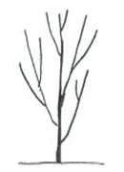 | 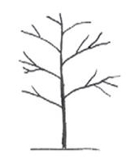 | 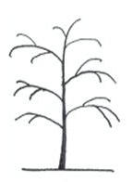
1 | 2 | 3
upright | spreading | drooping

Ad. 2: Plant: shape

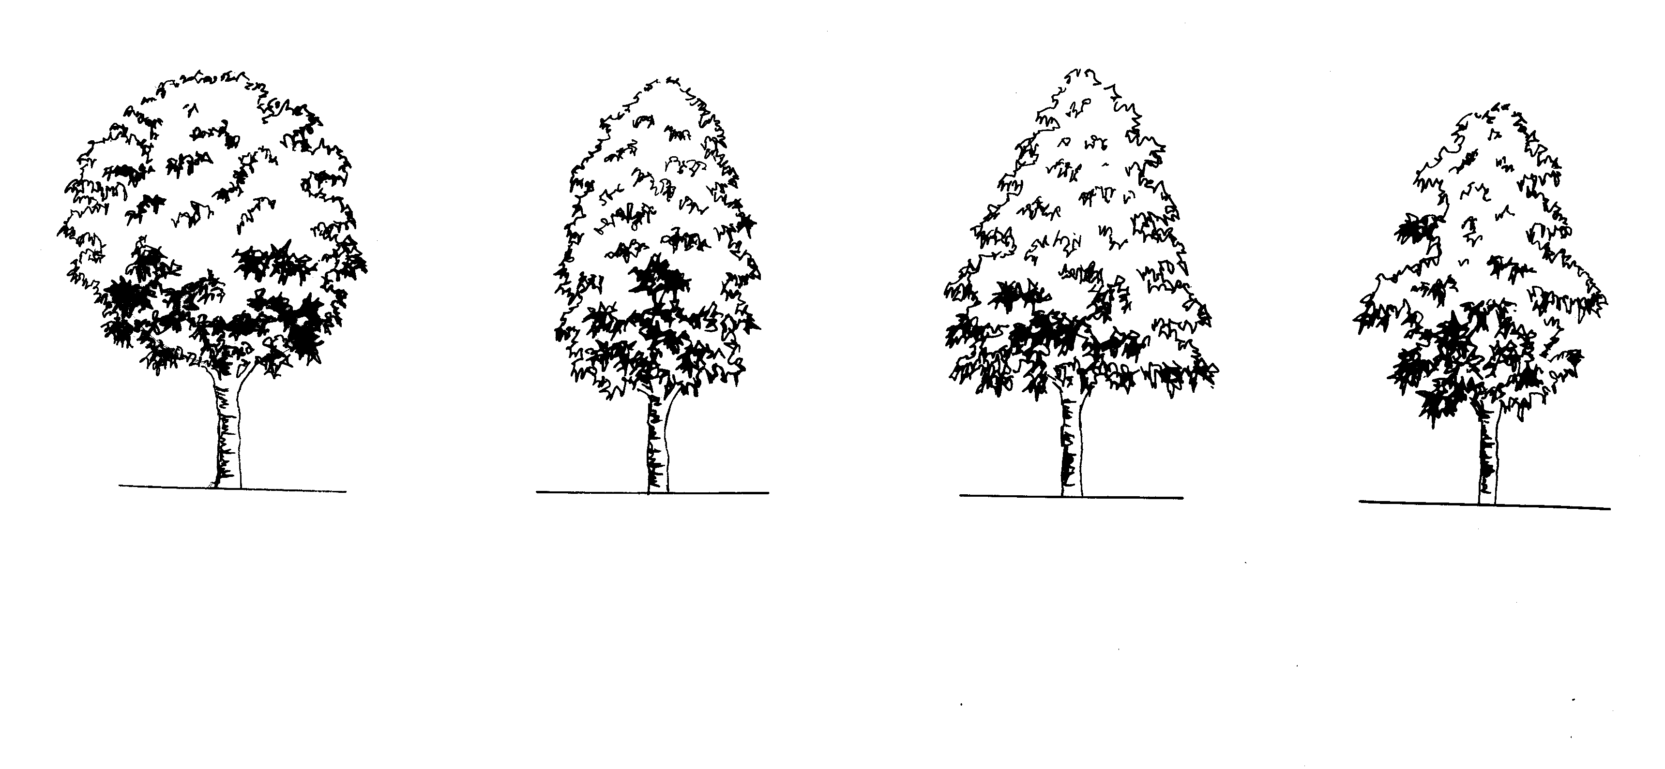  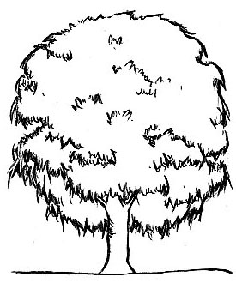 | 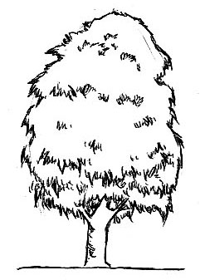 | 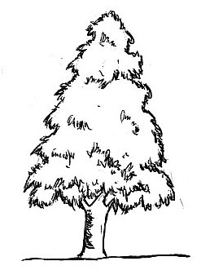 | 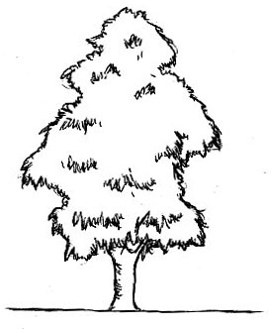
1 | 2 | 3 | 4
circular | elliptic | triangular | irregular

Ad. 3: Plant: vigor

Plant vigor is determined by the evaluation of the overall abundance of vegetative growth.

Ad. 6: One-year-old shoot: length of internode

Observing the stems of growing terminal autumnal shoots, especially the nodal portion. Internodes to be observed on the middle third of the shoot.

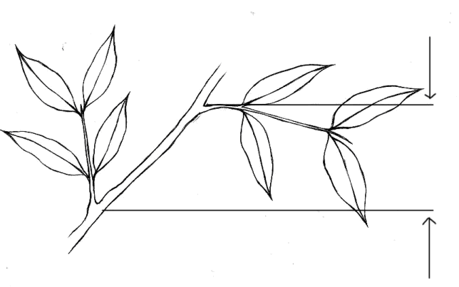
internode

Ad. 10: Leaf: predominant arrangement of leaves

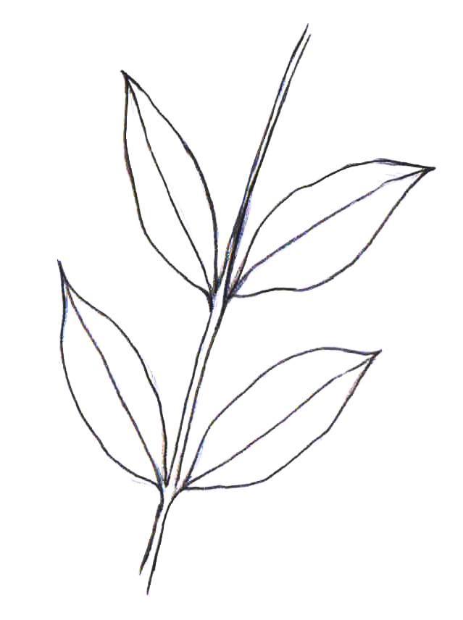 | 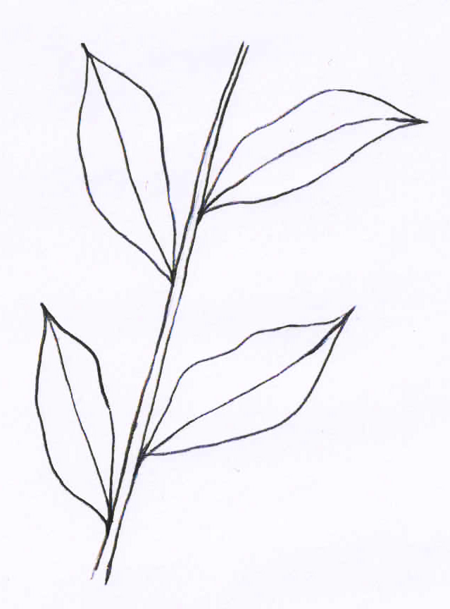 | 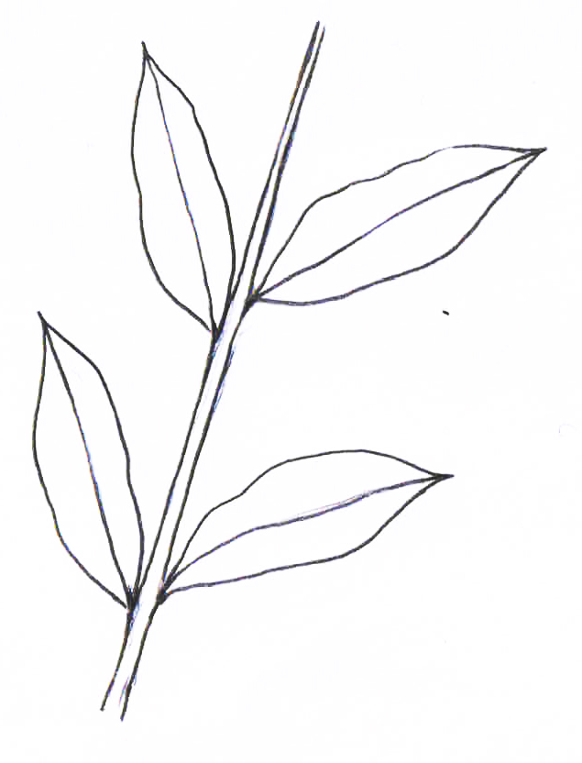
1 | 2 | 3
opposite | both opposite and alternate | alternate

Ad. 11: Leaf: length

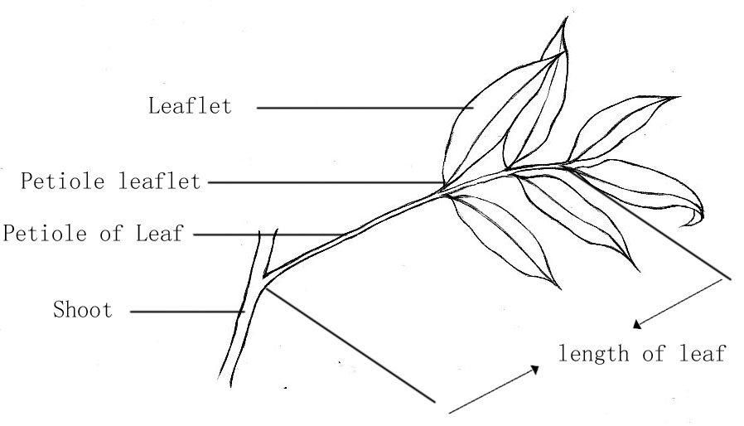

Ad. 13: Leaflet: shape

 | ← Broadest part →
 | Below middle | At middle | Above middle
broad ← width → narrow | 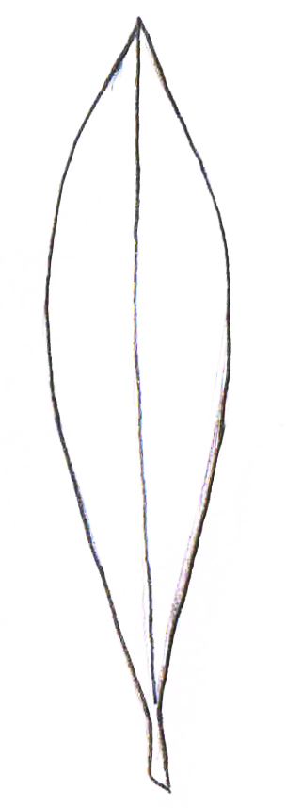
broad ← width → narrow | 1  lanceolate
broad ← width → narrow |  | 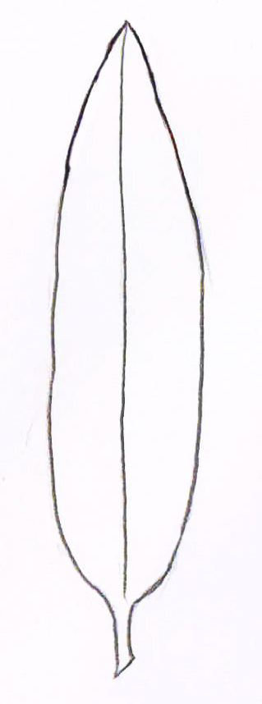
broad ← width → narrow |  | 3  oblong
broad ← width → narrow | 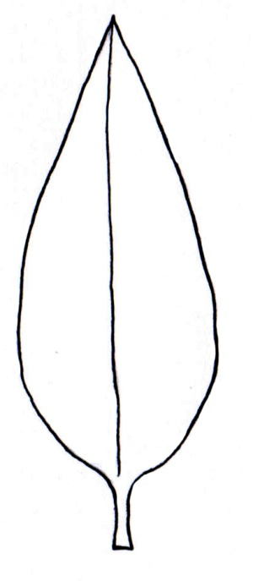 | 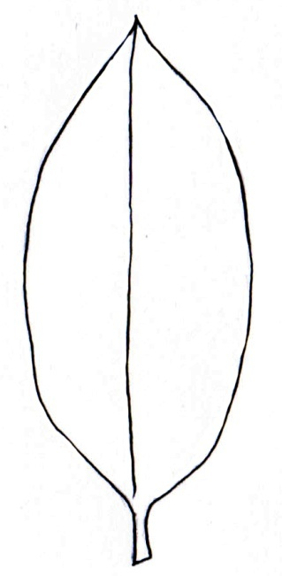 | 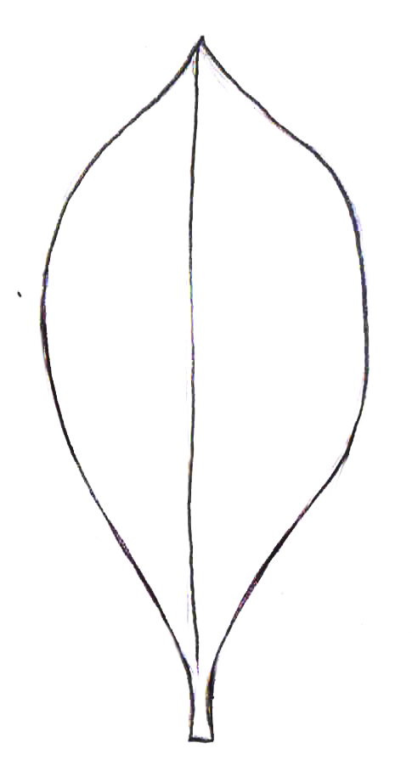
broad ← width → narrow | 4  ovate | 2  elliptic | 5  obovate

Ad. 16: Leaflet: length of petiolule
Ad. 17: Leaflet blade: length
Ad. 18: Leaflet blade: width

All observations on the leaflet should be made on the largest leaflet of the lowest pair.

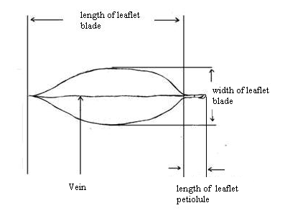

Ad. 20: Leaflet blade: length of tip

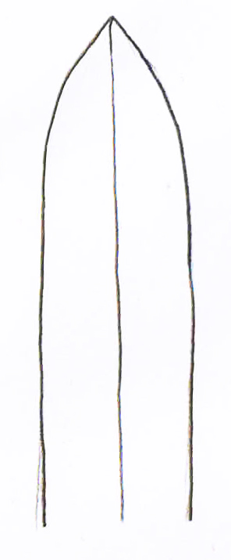 | 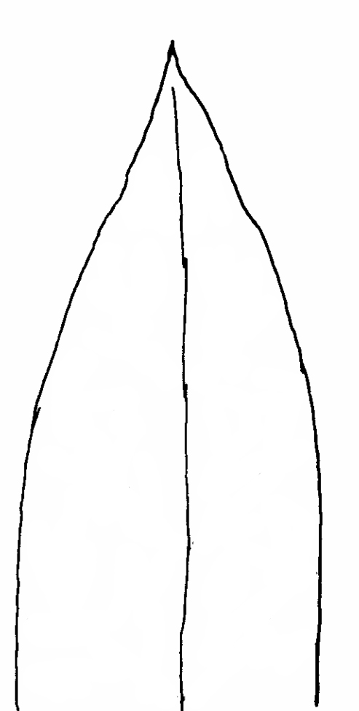 | 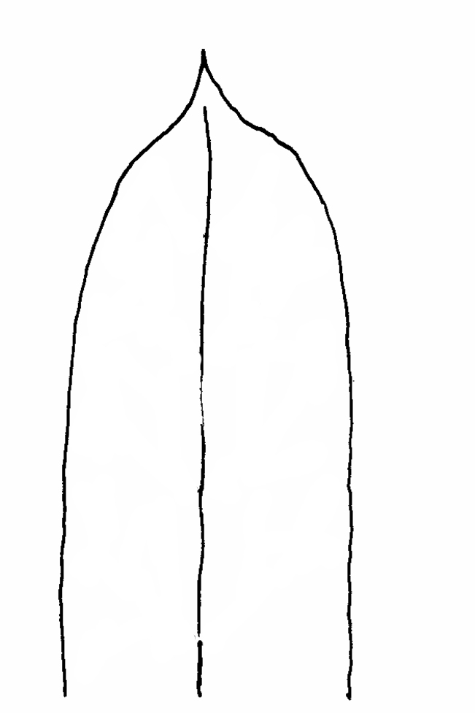 | 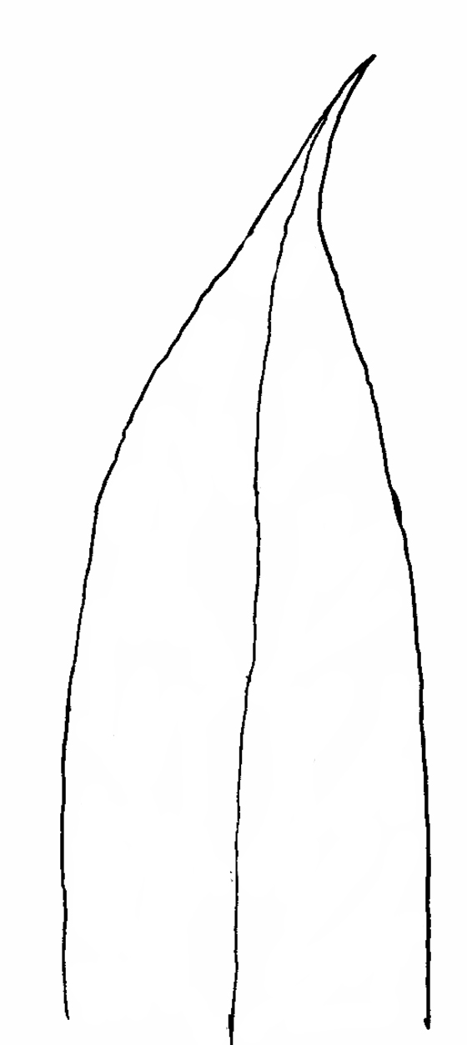
1 | 2 | 3 | 4
very short | short | medium | long

Ad. 21: Leaf blade: shape of apex

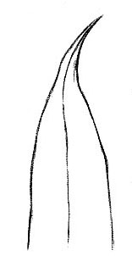 | 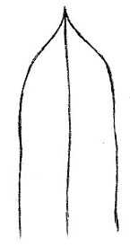 | 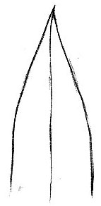 | 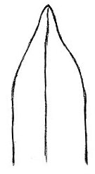
1 | 2 | 3 | 4
caudate | acuminate | acute | obtuse

Ad. 22: Leaf blade: symmetry of base

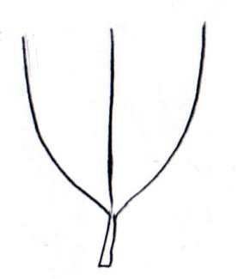 | 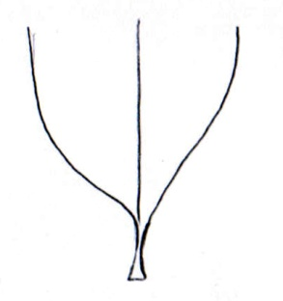 | 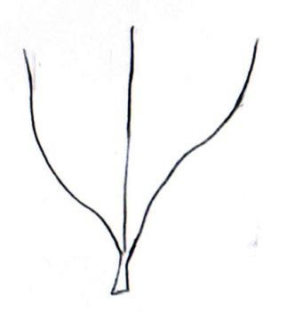
1 | 2 | 3
symmetric or weakly asymmetric | moderately asymmetric | strongly asymmetric

Ad. 23:Leaflet: shape of base

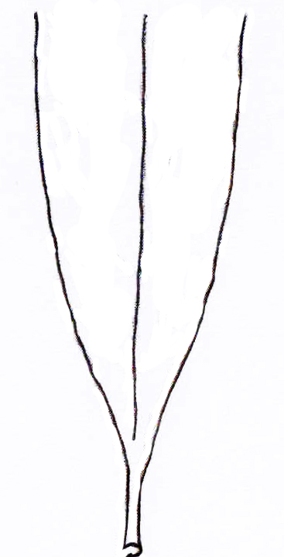 |  | 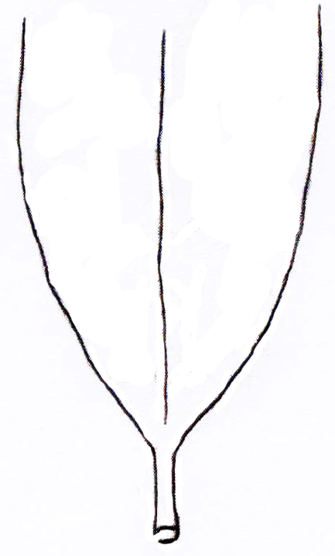 |  | 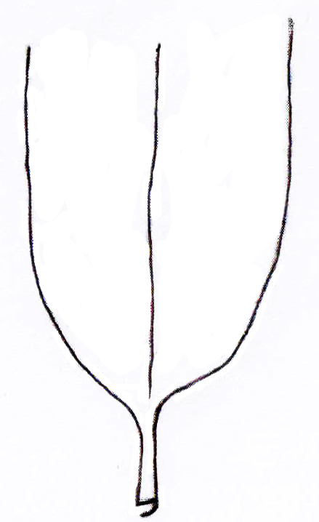
1 | 2 |  | 3
wedge-shaped | broad wedge-shaped |  | nearly rounded

Ad. 24: Leaf blade: undulation of margin

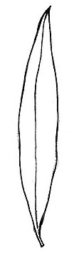 | 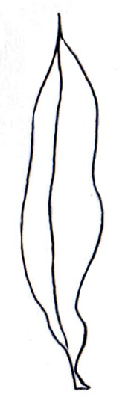 | 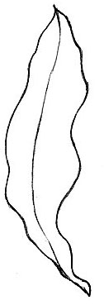
1 | 2 | 3
absent or weak | medium | strong

Ad. 28: Inflorescence: length
Ad. 29: Inflorescence: width

Length of inflorescence
Width of inflorescence

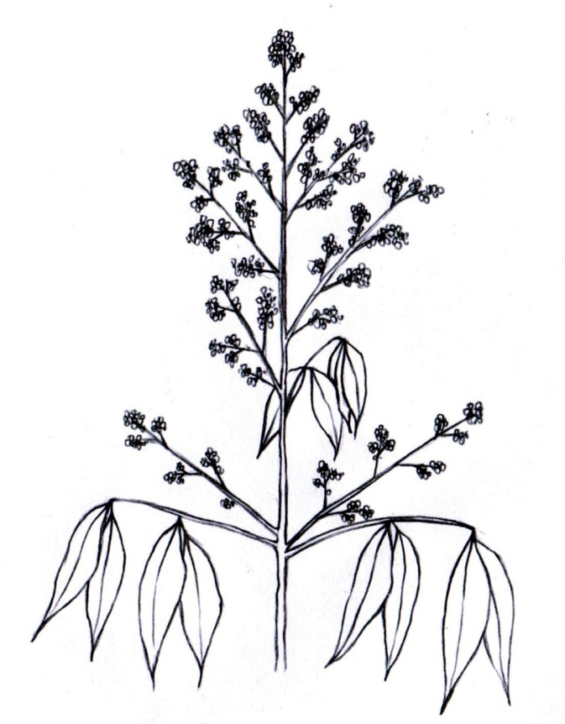
Ad. 31: Inflorescence: density of branching

The density of the secondary branches is observed on the first nodes of the inflorescences.

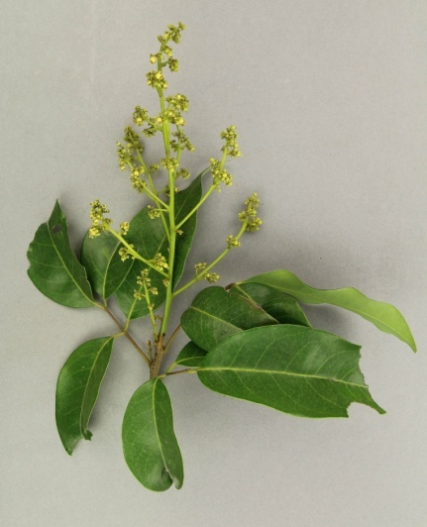 | 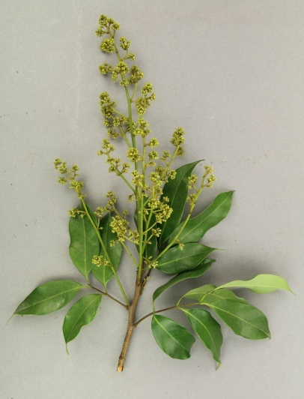 | 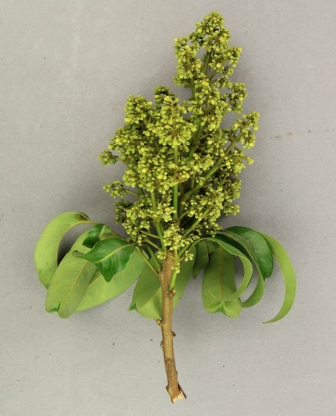
3 | 5 | 7
sparse | medium | dense

Ad. 34: Flower: depth of stigma splitting

This applies to female flowers only.

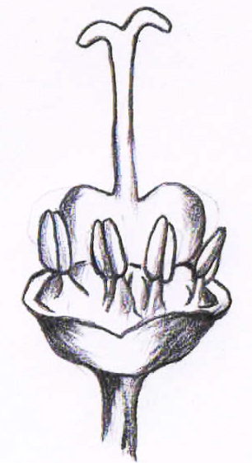 | 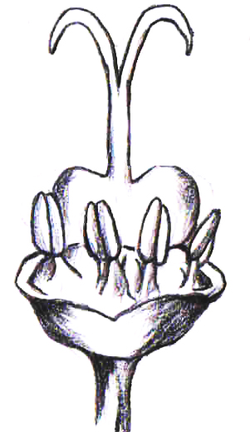 | 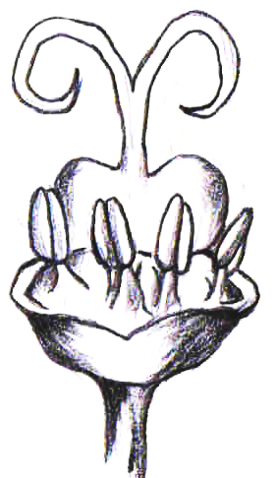
1 | 2 | 3
shallow | medium | deep

Ad. 36: Fruit: shape

 | ← Broadest part →
 | Below middle | At middle | Above middle
Compressed← ratio length/width →elongated | 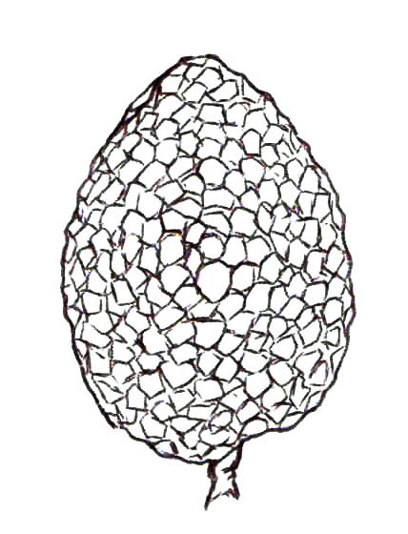 | 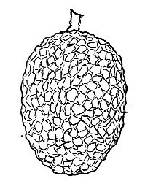
Compressed← ratio length/width →elongated | 3  ovate | 1  elliptic
Compressed← ratio length/width →elongated |  | 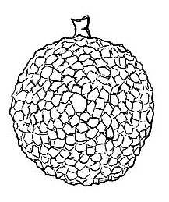
Compressed← ratio length/width →elongated |  | 2  circular
Compressed← ratio length/width →elongated | 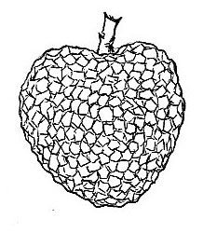
Compressed← ratio length/width →elongated | 4  cordate

Ad. 37: Fruit: shape of shoulder at stalk end

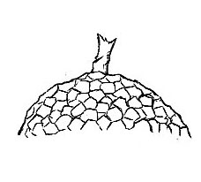 | 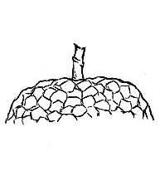 | 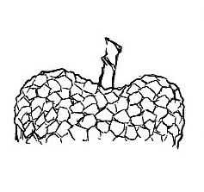 | 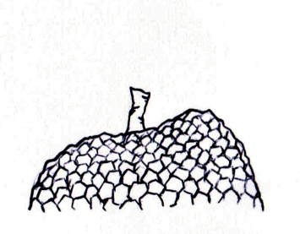
1 | 2 | 3 | 4
sloping | truncate | symmetrically depressed | asymmetrically depressed

Ad. 38: Fruit: depth of suture

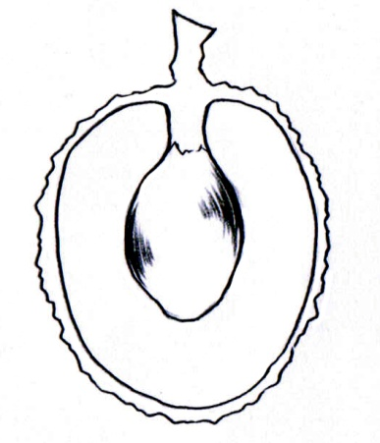 | 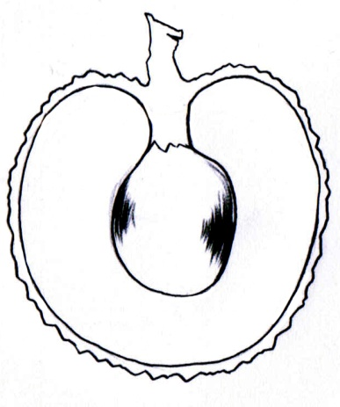 | 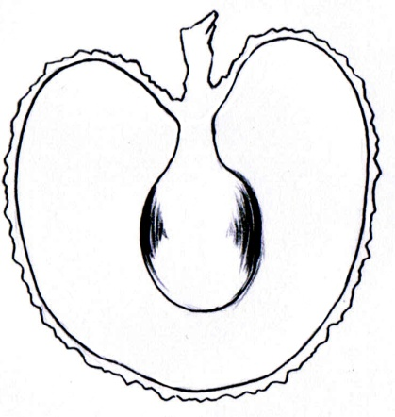
1 | 2 | 3
shallow | medium | deep

Ad. 39: Fruit: conspicuousness of suture

The conspicuousness of suture should be observed based on color, width and depth.

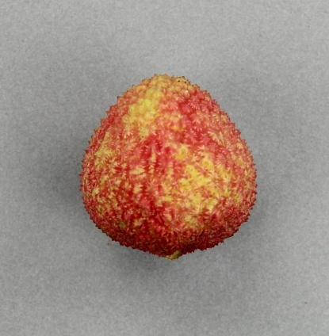 | 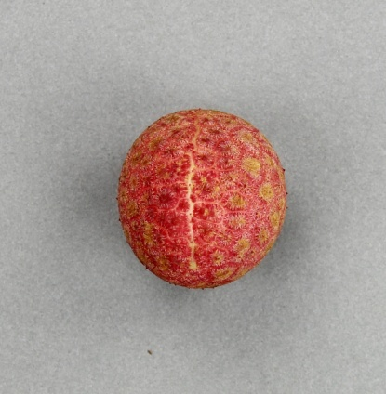 | 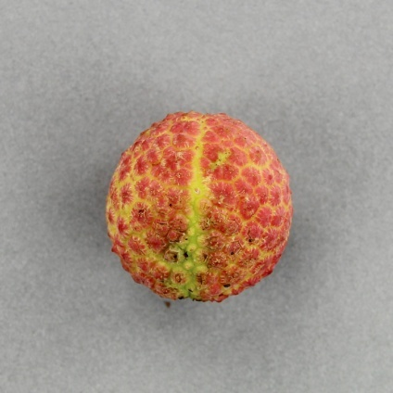
1 | 2 | 3
weak | medium | strong

Ad. 41: Fruit: appearance of skin protuberances

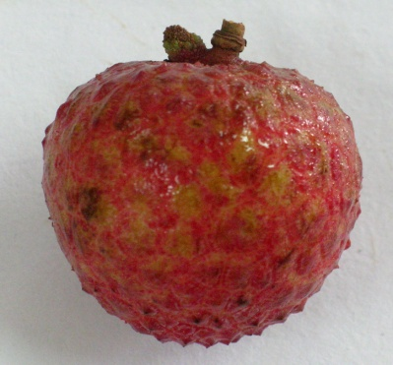 | 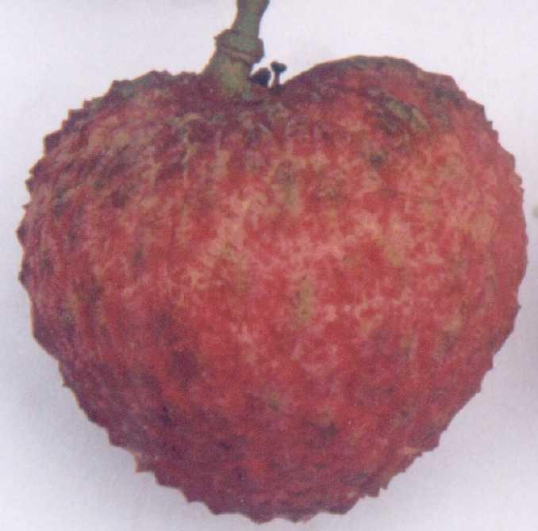 | 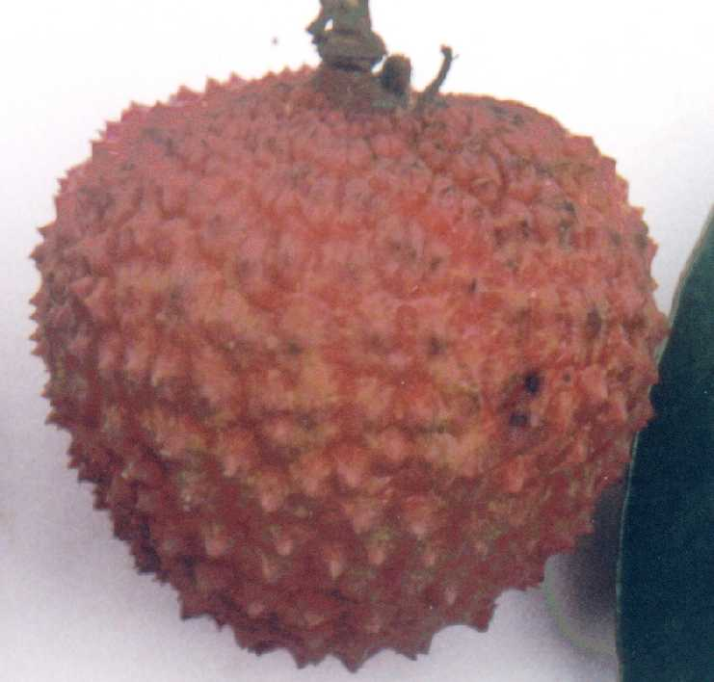
1 | 2 | 3
smooth or slightly raised | moderately raised | strongly raised
(illustration need to be updated)

Ad. 43: Fruit: thickness of skin

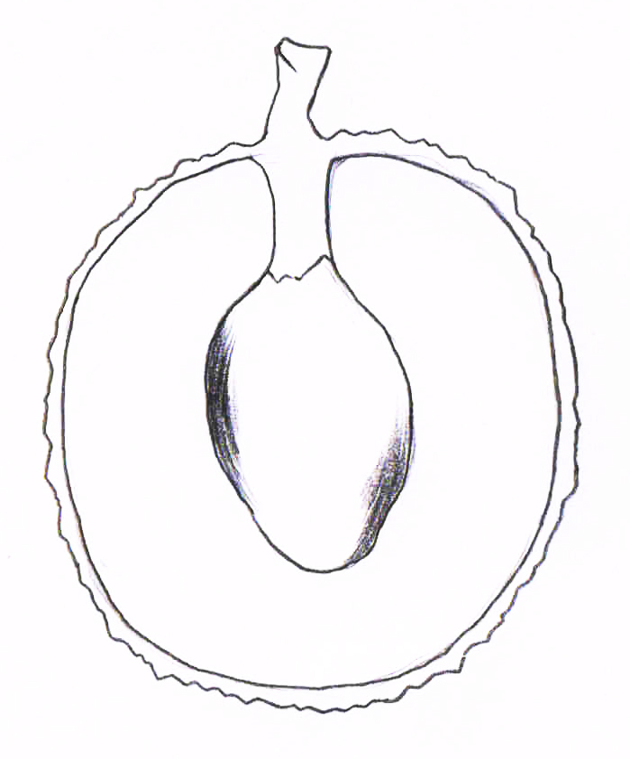
Thickness of skin

Ad. 45: Fruit: weight of flesh compared to fruit

Flesh should be assessed at time of harvest maturity and to be determined on 20 fruits.

Ad. 46: Fruit: shape of seed

 | ← Broadest part →
 | Below middle | At middle | Above middle
broad ← width → narrow
broad ← width → narrow |  | 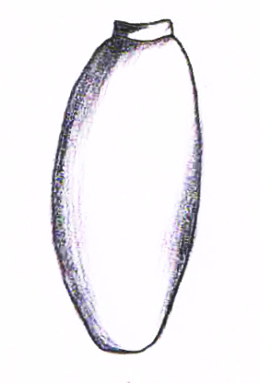 | 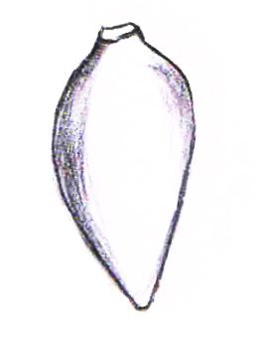
broad ← width → narrow |  | 1  elliptic | 3  conical
broad ← width → narrow |  | 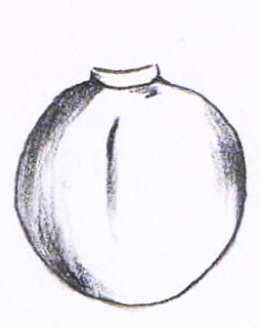
broad ← width → narrow |  | 2  circular
Other | 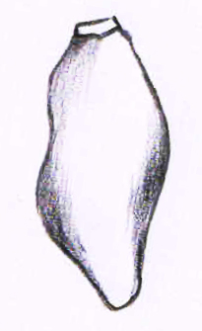
Other | 4  irregular

Ad. 48: Fruit: intensity of brown color on the inner side of aril

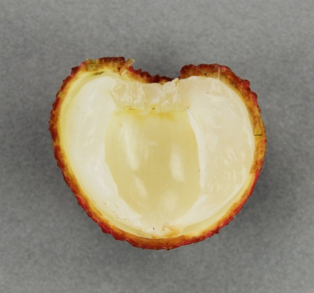 | 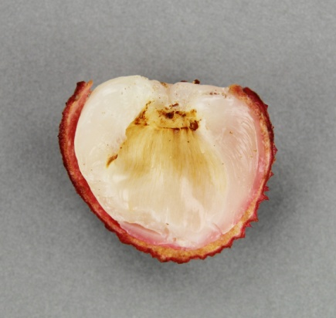 | 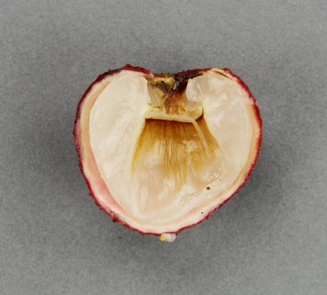
1 | 2 | 3
absent or weak | medium | strong

Ad. 49: Fruit: content of total soluble solids

The content of total soluble solids should be measured by using a refractometer.

Ad. 50: Fruit: juiciness

The fruit is cut into two pieces along the suture with a knife, and then the skin and the core are removed. Afterward, the flesh is wrapped with four layers of absorbent paper for 5 seconds to observe the following:

Low: the absorbent paper is not completely wet
Medium: the absorbent paper is completely wet
High: juice is dripping naturally after the flesh is cut into pieces.

Ad. 51: Fruit: ratio of abortive embryos

Select 20 fruits randomly, then cut the fruit into pieces along the suture to take off the seed and then vertically cut the seed skin open to check the number of the aborted embryos.

Low: less than 20% seeds aborted
Medium: 20-80% seeds aborted
High: more than 80% seeds aborted

Ad. 52: Time of beginning of flowering

The beginning of flowering is considered as when 10% of the inflorescences have started to flower.

Literature

Fu, L.J., 1985: An Album of Guangdong Litchi Varieties in Full Colour. Science Popularization Press Guangzhou Branch. Guangzhou, CN, 78 pp.

Menzel, C.M. and Waite, G.K., 2005: Litchi and Longan, Botany, Production and Uses. CABI Publishing. Nambour, Queensland, AU, pp. 59-86

Wu, S.X., 1998: Encylopaedia of China Fruits: Litchi. Forestry Press, Beijing, CN, pp. 94-206

Technical Questionnaire

TECHNICAL QUESTIONNAIRE |  |  |  | Page {x} of {y} |  | Reference Number:
 |  |  |  |  |  | Application date:
 |  |  |  |  |  | (not to be filled in by the applicant)
TECHNICAL QUESTIONNAIRE
to be completed in connection with an application for plant breeders’ rights

1. Subject of the Technical Questionnaire
1.1 Botanical name |  |  | Litchi chinensis Sonn.
1.2 Common name |  |  | Litchi
2. Applicant
Name
Address
Telephone No.
Fax No.
E-mail address
Breeder (if different from
applicant)
3. Proposed denomination and breeder’s reference
Proposed denomination
(if available)
Breeder’s reference
#4. Information on the breeding scheme and propagation of the variety

4.1 Breeding scheme

Variety resulting from:

4.1.1 Crossing

(a) controlled cross [ ]
(please state parent varieties)

(…………………..…………………………) x (……………..…………..………………..…)
female parent male parent

(b) partially known cross [ ]
(please state known parent variety(ies))

(…………………..……………………....…) x (……………..………………..…………..…)
female parent male parent

(c) unknown cross [ ]
4.1.2 Mutation [ ]
(please state parent variety)

4.1.3 Discovery and development [ ]
(please state where and when discovered and how developed)

4.1.4 Other [ ]
(please provide details)

4.2 Method of propagating the variety

4.2.1 Vegetative propagation

(a) cuttings [ ]

(b) air layering [ ]

(c) grafting (budding) [ ]

(d) in vitro propagation [ ]

(e) other (state method) [ ]

5. Characteristics of the variety to be indicated (the number in brackets refers to the corresponding characteristic in Test Guidelines; please mark the note which best corresponds).

 | Characteristics |  |  |  |  |  | Example Varieties |  |  |  | Note
5.1  (35) | Fruit: size
 | very small |  |  |  |  |  | Xinxingxiangli |  |  |  | 1[ ]
 | very small to small |  |  |  |  |  |  |  |  |  | 2[ ]
 | small |  |  |  |  |  | Chenzi |  |  |  | 3[ ]
 | small to medium |  |  |  |  |  |  |  |  |  | 4[ ]
 | medium |  |  |  |  |  | Guiwei |  |  |  | 5[ ]
 | medium to large |  |  |  |  |  |  |  |  |  | 6[ ]
 | large |  |  |  |  |  | Sanyuehong |  |  |  | 7[ ]
 | large to very large |  |  |  |  |  |  |  |  |  | 8[ ]
 | very large |  |  |  |  |  | Ziniangxi |  |  |  | 9[ ]
5.2  (40) | Fruit: color of skin
 | only green |  |  |  |  |  |  |  |  |  | 1[ ]
 | green and red |  |  |  |  |  | Feizixiao |  |  |  | 2[ ]
 | yellow and red |  |  |  |  |  | Guangming |  |  |  | 3[ ]
 | pink red |  |  |  |  |  | Kwai may pink |  |  |  | 4[ ]
 | only bright red |  |  |  |  |  | Nuomici |  |  |  | 5[ ]
 | only dark red |  |  |  |  |  | Jizuili |  |  |  | 6[ ]
 | purplish red |  |  |  |  |  | Ziniangxi |  |  |  | 7[ ]
5.3  (41) | Fruit: appearance of skin protuberances
 | smooth or slightly raised |  |  |  |  |  | Huaizhi |  |  |  | 1[ ]
 | moderately raised |  |  |  |  |  | Nuomici |  |  |  | 2[ ]
 | strongly raised |  |  |  |  |  | Guiwei |  |  |  | 3[ ]
 | Characteristics |  |  |  |  |  | Example Varieties |  |  |  | Note
5.4  (52) | Time of beginning of flowering
 | very early |  |  |  |  |  |  |  |  |  | 1[ ]
 | very early to early |  |  |  |  |  |  |  |  |  | 2[ ]
 | early |  |  |  |  |  | Sanyuehong |  |  |  | 3[ ]
 | early to medium |  |  |  |  |  |  |  |  |  | 4[ ]
 | medium |  |  |  |  |  | Heiye |  |  |  | 5[ ]
 | medium to late |  |  |  |  |  |  |  |  |  | 6[ ]
 | late |  |  |  |  |  | Nuomici |  |  |  | 7[ ]
 | late to very late |  |  |  |  |  |  |  |  |  | 8[ ]
 | very late |  |  |  |  |  |  |  |  |  | 9[ ]
6. Similar varieties and differences from these varieties

Please use the following table and box for comments to provide information on how your candidate variety differs from the variety (or varieties) which, to the best of your knowledge, is (or are) most similar. This information may help the examination authority to conduct its examination of distinctness in a more efficient way.

Denomination(s) of variety(ies) similar to your candidate variety |  | Characteristic(s) in which your candidate variety differs from the similar variety(ies) |  |  | Describe the expression of the characteristic(s) for the similar variety(ies) |  |  | Describe the expression of the characteristic(s) for your candidate variety
Example |  | e.g. Fruit size |  |  | e.g. small |  |  | e.g. medium
Comments:

#7. Additional information which may help in the examination of the variety

7.1 In addition to the information provided in sections 5 and 6, are there any additional characteristics which may help to distinguish the variety?

Yes [ ] No [ ]

(If yes, please provide details)

7.2 Are there any special conditions for growing the variety or conducting the examination?

Yes [ ] No [ ]

(If yes, please provide details)

7.3 Other information

A representative color image of the variety should accompany the Technical Questionnaire.

8. Authorization for release

(a) Does the variety require prior authorization for release under legislation concerning the protection of the environment, human and animal health?

Yes [ ] No [ ]

(b) Has such authorization been obtained?

Yes [ ] No [ ]

If the answer to (b) is yes, please attach a copy of the authorization.

9. Information on plant material to be examined or submitted for examination

9.1 The expression of a characteristic or several characteristics of a variety may be affected by factors, such as pests and disease, chemical treatment (e.g. growth retardants or pesticides), effects of tissue culture, different rootstocks, scions taken from different growth phases of a tree, etc.

9.2 The plant material should not have undergone any treatment which would affect the expression of the characteristics of the variety, unless the competent authorities allow or request such treatment. If the plant material has undergone such treatment, full details of the treatment must be given. In this respect, please indicate below, to the best of your knowledge, if the plant material to be examined has been subjected to:

(a) Microorganisms (e.g. virus, bacteria, phytoplasma) Yes [ ] No [ ]

(b) Chemical treatment (e.g. growth retardant, pesticide) Yes [ ] No [ ]

(c) Tissue culture Yes [ ] No [ ]

(d) Other factors Yes [ ] No [ ]

Please provide details for where you have indicated “yes”.

10. I hereby declare that, to the best of my knowledge, the information provided in this form is correct:

Applicant’s name

Signature Date

[End of document]

* These names were correct at the time of the introduction of these Test Guidelines but may be revised or updated. [Readers are advised to consult the UPOV Code, which can be found on the UPOV Website (www.upov.int), for the latest information.]
# Authorities may allow certain of this information to be provided in a confidential section of the Technical Questionnaire.
# Authorities may allow certain of this information to be provided in a confidential section of the Technical Questionnaire.

