 |  |  |  |  |  |  | E  TG/COCOS(proj.2)  ORIGINAL: English  DATE: 2013-03-19
INTERNATIONAL UNION FOR THE PROTECTION OF NEW VARIETIES OF PLANTS
Geneva
 |  |  | DRAFT
 |  | COCONUT  UPOV Code: COCOS_NUC  Cocos nucifera L. |  |  | *

GUIDELINES

FOR THE CONDUCT OF TESTS

FOR DISTINCTNESS, UNIFORMITY AND STABILITY

prepared by experts from Brazil

to be considered by the
Technical Working Party for Fruit Crops
at its forty-fourth session, to be held in Napier, New Zealand, from April 29 to May 3, 2013

Alternative Names:*

Botanical name | English | French | German | Spanish
Cocos nucifera L. | Coconut | Cocotier | Kokosnuß | Cocotero

The purpose of these guidelines (“Test Guidelines”) is to elaborate the principles contained in the General Introduction (document TG/1/3), and its associated TGP documents, into detailed practical guidance for the harmonized examination of distinctness, uniformity and stability (DUS) and, in particular, to identify appropriate characteristics for the examination of DUS and production of harmonized variety descriptions.

ASSOCIATED DOCUMENTS
These Test Guidelines should be read in conjunction with the General Introduction and its associated TGP documents.
TABLE OF CONTENTS PAGE

1. Subject of these Test Guidelines 3
2. Material Required 3
3. Method of Examination 3
3.1 Number of Growing Cycles 3
3.2 Testing Place 3
3.3 Conditions for Conducting the Examination 3
3.4 Test Design 3
3.5 Additional Tests 3
4. Assessment of Distinctness, Uniformity and Stability 4
4.1 Distinctness 4
4.2 Uniformity 5
4.3 Stability 5
5. Grouping of Varieties and Organization of the Growing Trial 5
6. Introduction to the Table of Characteristics 5
6.1 Categories of Characteristics 5
6.2 States of Expression and Corresponding Notes 6
6.3 Types of Expression 6
6.4 Example Varieties 6
6.5 Legend 7
7. Table of Characteristics/Tableau des caractères/Merkmalstabelle/Tabla de caracteres 8
8. Explanations on the Table of Characteristics 14
8.1 Explanations covering several characteristics 14
8.2 Explanations for individual characteristics 14
9. Literature 24
10. Technical Questionnaire 25

Subject of these Test Guidelines

These Test Guidelines apply to all varieties of Cocos nucifera L., including tall type, dwarf type and hybrid tall x dwarf, under controlled pollination.

Material Required

2.1 The competent authorities decide on the quantity and quality of the plant material required for testing the variety and when and where it is to be delivered. Applicants submitting material from a State other than that in which the testing takes place must ensure that all customs formalities and phytosanitary requirements are complied with.

2.2 The material is to be supplied in the form of seeds (fruits).

2.3 The minimum quantity of plant material, to be supplied by the applicant, should be:

20 seeds.

2.4 The plant material supplied should be visibly healthy, not lacking in vigor, nor affected by any important pest or disease.

2.5 The plant material should not have undergone any treatment which would affect the expression of the characteristics of the variety, unless the competent authorities allow or request such treatment. If it has been treated, full details of the treatment must be given.

Method of Examination

Number of Growing Cycles

3.1.1 The minimum duration of tests should normally be two independent growing cycles. In particular, it is essential that the palms produce a satisfactory crop of fruit in each of the two growing cycles.

3.1.2 The growing cycle is considered to be the period ranging from the beginning of active vegetative growth or flowering, continuing through active vegetative growth or flowering and fruit development and concluding with the harvesting of fruit.

3.2 Testing Place

Tests are normally conducted at one place. In the case of tests conducted at more than one place, guidance is provided in TGP/9 “Examining Distinctness”.

3.3 Conditions for Conducting the Examination

The tests should be carried out under conditions ensuring satisfactory growth for the expression of the relevant characteristics of the variety and for the conduct of the examination. In particular, it is essential that the trees produce a satisfactory crop of fruit in each of the two growing cycles.

3.4 Test Design

3.4.1 Each test should be designed to result in a total of at least 12 palms.

3.4.2 The design of the tests should be such that plants or parts of plants may be removed for measurement or counting without prejudice to the observations which must be made up to the end of the growing cycle.

3.5 Additional Tests

Additional tests, for examining relevant characteristics, may be established.

Assessment of Distinctness, Uniformity and Stability

4.1 Distinctness

4.1.1 General Recommendations

It is of particular importance for users of these Test Guidelines to consult the General Introduction prior to making decisions regarding distinctness. However, the following points are provided for elaboration or emphasis in these Test Guidelines.

Further guidance is provided in documents TGP/9 “Examining Distinctness” and TGP/8 “Trial Design and Techniques Used in the Examination of Distinctness, Uniformity and Stability”.

4.1.2 Consistent Differences

The differences observed between varieties may be so clear that more than one growing cycle is not necessary. In addition, in some circumstances, the influence of the environment is not such that more than a single growing cycle is required to provide assurance that the differences observed between varieties are sufficiently consistent. One means of ensuring that a difference in a characteristic, observed in a growing trial, is sufficiently consistent is to examine the characteristic in at least two independent growing cycles.

4.1.3 Clear Differences

Determining whether a difference between two varieties is clear depends on many factors, and should consider, in particular, the type of expression of the characteristic being examined, i.e. whether it is expressed in a qualitative, quantitative, or pseudo-qualitative manner. Therefore, it is important that users of these Test Guidelines are familiar with the recommendations contained in the General Introduction prior to making decisions regarding distinctness.

4.1.4 Number of Plants / Parts of Plants to be Examined

Unless otherwise indicated, for the purposes of distinctness, all observations on single plants should be made on 12 plants or parts taken from each of 12 plants and any other observations made on all plants in the test, disregarding any off-type plants. In the case of observations of parts taken from single plants, the number of parts to be taken from each of the plants should be 2.

4.1.5 Method of Observation

The recommended method of observing the characteristic for the purposes of distinctness is indicated by the following key in the second column of the Table of Characteristics (see document TGP/9 “Examining Distinctness”, Section 4 “Observation of characteristics”):

MG: single measurement of a group of plants or parts of plants
MS: measurement of a number of individual plants or parts of plants
VG: visual assessment by a single observation of a group of plants or parts of plants
VS: visual assessment by observation of individual plants or parts of plants

Type of observation: visual (V) or measurement (M)

“Visual” observation (V) is an observation made on the basis of the expert’s judgment. For the purposes of this document, “visual” observation refers to the sensory observations of the experts and, therefore, also includes smell, taste and touch. Visual observation includes observations where the expert uses reference points (e.g. diagrams, example varieties, side-by-side comparison) or non-linear charts (e.g. color charts). Measurement (M) is an objective observation against a calibrated, linear scale e.g. using a ruler, weighing scales, colorimeter, dates, counts, etc.

Type of record: for a group of plants (G) or for single, individual plants (S)

For the purposes of distinctness, observations may be recorded as a single record for a group of plants or parts of plants (G), or may be recorded as records for a number of single, individual plants or parts of plants (S). In most cases, “G” provides a single record per variety and it is not possible or necessary to apply statistical methods in a plant-by-plant analysis for the assessment of distinctness.

In cases where more than one method of observing the characteristic is indicated in the Table of Characteristics (e.g. VG/MG), guidance on selecting an appropriate method is provided in document TGP/9, Section 4.2.

4.2 Uniformity

4.2.1 It is of particular importance for users of these Test Guidelines to consult the General Introduction prior to making decisions regarding uniformity. However, the following points are provided for elaboration or emphasis in these Test Guidelines:

4.2.2. For the assessment of uniformity of controlled pollinated varieties, a population standard of 1% and an acceptance probability of at least 95% should be applied. In the case of a sample size of 12 plants, 1 off-type is allowed.

4.3 Stability

4.3.1 In practice, it is not usual to perform tests of stability that produce results as certain as those of the testing of distinctness and uniformity. However, experience has demonstrated that, for many types of variety, when a variety has been shown to be uniform, it can also be considered to be stable.

4.3.2 Where appropriate, or in cases of doubt, stability may be further examined by testing a new seed or plant stock to ensure that it exhibits the same characteristics as those shown by the initial material supplied.”

Grouping of Varieties and Organization of the Growing Trial

5.1 The selection of varieties of common knowledge to be grown in the trial with the candidate varieties and the way in which these varieties are divided into groups to facilitate the assessment of distinctness are aided by the use of grouping characteristics.

5.2 Grouping characteristics are those in which the documented states of expression, even where produced at different locations, can be used, either individually or in combination with other such characteristics: (a) to select varieties of common knowledge that can be excluded from the growing trial used for examination of distinctness; and (b) to organize the growing trial so that similar varieties are grouped together.

5.3 The following have been agreed as useful grouping characteristics:

- Stem: diameter (characteristic 9)
- Fruit: color (characteristic 27)
- Fruit: weight (characteristic 28)
- Fruit: shape (characteristic 29)
- Nut: shape (characteristic 31)

5.4 Guidance for the use of grouping characteristics, in the process of examining distinctness, is provided through the General Introduction and document TGP/9 “Examining Distinctness”.

Introduction to the Table of Characteristics

6.1 Categories of Characteristics

6.1.1 Standard Test Guidelines Characteristics

Standard Test Guidelines characteristics are those which are approved by UPOV for examination of DUS and from which members of the Union can select those suitable for their particular circumstances.

6.1.2 Asterisked Characteristics

Asterisked characteristics (denoted by *) are those included in the Test Guidelines which are important for the international harmonization of variety descriptions and should always be examined for DUS and included in the variety description by all members of the Union, except when the state of expression of a preceding characteristic or regional environmental conditions render this inappropriate.

6.2 States of Expression and Corresponding Notes

6.2.1 States of expression are given for each characteristic to define the characteristic and to harmonize descriptions. Each state of expression is allocated a corresponding numerical note for ease of recording of data and for the production and exchange of the description.

6.2.2 In the case of qualitative and pseudo-qualitative characteristics (see Chapter 6.3), all relevant states of expression are presented in the characteristic. However, in the case of quantitative characteristics with 5 or more states, an abbreviated scale may be used to minimize the size of the Table of Characteristics. For example, in the case of a quantitative characteristic with 9 states, the presentation of states of expression in the Test Guidelines may be abbreviated as follows:

State | Note
small | 3
medium | 5
large | 7

However, it should be noted that all of the following 9 states of expression exist to describe varieties and should be used as appropriate:

State | Note
very small | 1
very small to small | 2
small | 3
small to medium | 4
medium | 5
medium to large | 6
large | 7
large to very large | 8
very large | 9

6.2.3 Further explanation of the presentation of states of expression and notes is provided in document TGP/7 “Development of Test Guidelines”.

6.3 Types of Expression

An explanation of the types of expression of characteristics (qualitative, quantitative and pseudo-qualitative) is provided in the General Introduction.

6.4 Example Varieties

Where appropriate, example varieties are provided to clarify the states of expression of each characteristic.

6.5 Legend

(*) Asterisked characteristic – see Chapter 6.1.2

QL Qualitative characteristic – see Chapter 6.3
QN Quantitative characteristic – see Chapter 6.3
PQ Pseudo-qualitative characteristic – see Chapter 6.3

MG, MS, VG, VS – see Chapter 4.1.5

(a)-(d) See Explanations on the Table of Characteristics in Chapter 8.1

(+) See Explanations on the Table of Characteristics in Chapter 8.2.

Table of Characteristics/Tableau des caractères/Merkmalstabelle/Tabla de caracteres

 |  | English | français | deutsch | español | Example Varieties  Exemples  Beispielssorten  Variedades ejemplo | Note/  Nota
1.  (*)  (+) | VG | Young plant: color of shoot: |  |  |  | Indonesia to check their examples
PQ |  | yellow |  |  |  | Genjah Kuning Nias | 1
 |  | green |  |  |  | Genjah Salak | 2
 |  | red |  |  |  | Dalam Mapanget | 3
 |  | brown |  |  |  | Genjah Raja Brown | 4
2.  (+) | VG/MS | Young plant: number of leaves
QN |  | few |  |  |  | Genjah Kuning Nias | 3
 |  | medium |  |  |  | Genjah Raja Brown | 5
 |  | many |  |  |  | Dalam Mapanget | 7
3.  (*)  (+) | VG | Young plant: time of leaflets splitting
QN |  | early |  |  |  | GR ???? | 3
 |  | medium |  |  |  | Genjah Kuning Bali | 5
 |  | late |  |  |  |  | 7
4.  (*)  (+) | MG | Time of appearance of first inflorescence
QN |  | early |  |  |  | Genjah Tebing Tinggi | 3
 |  | medium |  |  |  | Dalam Mapanget | 5
 |  | late |  |  |  | DJP ???? | 7
5.  (*)  (+) | VG | Leaves attitude of lower leaves
QN | (a) | upwards |  |  |  |  | 1
 |  | outwards |  |  |  |  | 2
 |  | downwards |  |  |  |  | 3
6.  (*)  (+) | VG | Stem: bole
QL | (a) | absent |  |  |  | Genjah Kuning Nias | 1
 |  | present |  |  |  |  | 9
7.  (*)  (+) | VG/MS | Stem: diameter of the bole
QN | (a) | small |  |  |  | Kelapa Hibrida Indonesia-1 | 1
 |  | medium |  |  |  |  | 3
 |  | large |  |  |  | Dalam Mapanget | 5
8.  (*)  (+) | VG/MS | Stem: height
QN | (a) | short |  |  |  |  | 3
 |  | medium |  |  |  |  | 5
 |  | long |  |  |  |  | 7
9.  (*)  (+) | VG/MS | Stem: diameter
QN | (a) | small |  |  |  |  | 3
 |  | medium |  |  |  |  | 5
 |  | large |  |  |  |  | 7
10.  (+) | VG/MS | Petiole: length
QN | (a) | short |  |  |  | Genjah Kuning Nias | 3
 |  | medium |  |  |  | Kelapa Hibrida Indonesia-1 | 5
 |  | long |  |  |  | Dalam Tenga | 7
11.  (+) | VG/MS | Petiole: thickness
QN | (a) | thin |  |  |  | Genjah Kuning Nias | 3
 |  | medium |  |  |  | Kelapa Hibrida Indonesia-2 | 5
 |  | thick |  |  |  | Dalam Bali | 7
12.  (+) | VG/MS | Petiole: width
QN | (a) | narrow |  |  |  | Dalam Mapanget | 3
 |  | medium |  |  |  | Genjah Raja Brown | 5
 |  | broad |  |  |  | Dalam Kima Atas | 7
13. | VG | Petiole: color
PQ | (a) | yellow |  |  |  | Genjah Kuning Nias | 1
 |  | yellowish green |  |  |  |  | 2
 |  | yellowish red |  |  |  |  | 3
 |  | green |  |  |  | Genjah Salak | 4
 |  | greenish yellow |  |  |  |  | 5
 |  | greenish red |  |  |  |  | 6
 |  | red |  |  |  | Dalam Mapanget | 7
 |  | reddish yellow |  |  |  |  | 8
 |  | reddish green |  |  |  |  | 9
 |  | brown |  |  |  | Genjah Raja Brown | 10
14.  (*)  (+) | VG/MS | Leaf: length of rachis
QN | (a) | short |  |  |  | Genjah Kuning Nias | 3
 |  | medium |  |  |  | Kelapa Hibrida Indonesia-3 | 5
 |  | long |  |  |  | Dalam Palu | 7
15. | VG/MS | Leaf: number of leaflets
QN | (a) | few |  |  |  | DTT ???? | 3
 |  | medium |  |  |  | DJP ???? | 5
 |  | many |  |  |  | Dalam Takome | 7
16.  (+) | VG/MS | Leaf: leaflet length
QN | (a) | short |  |  |  | Genjah Kuning Nias | 3
 |  | medium |  |  |  | DTT ???? | 5
 |  | long |  |  |  | Dalam Kima Atas | 7
17.  (+) | VG/MS | Leaf: leaflet width
QN | (a) | narrow |  |  |  | Genjah Kuning Bali | 3
 |  | medium |  |  |  | DMA ???? | 5
 |  | broad |  |  |  | DAG ??????? | 7
18. | VG | Leafleaflet: intensity of green color:
QN | (a) | light |  |  |  |  | 1
 |  | medium |  |  |  |  | 2
 |  | dark |  |  |  |  | 3
19.  (+) | VG/MS | Inflorescence: peduncle length
QN | (b) | short |  |  |  | Genjah Raja Brown | 3
 |  | medium |  |  |  | Kelapa Hibrida Indonesia-4 | 5
 |  | long |  |  |  | Dalam Mapanget | 7
20.  (+) | VG/MS | Inflorescence: peduncle diameter
QN | (b) | small |  |  |  | Genjah Raja Brown | 3
 |  | medium |  |  |  | Kelapa Hibrida Indonesia-4 | 5
 |  | large |  |  |  | Dalam Mapanget | 7
21.  (+) | VG/MS | Inflorescence: central axis length
QN | (b) | short |  |  |  | Genjah Raja Brown | 3
 |  | medium |  |  |  | Kelapa Hibrida Indonesia-4 | 5
 |  | long |  |  |  | Dalam Mapanget | 7
22.  (+) | VG/MS | Inflorescence: number of spikelets
QN | (b) | few |  |  |  | Dalam Tenga | 3
 |  | medium |  |  |  | Dalam Banyuwangi | 5
 |  | many |  |  |  | Dalam Kima Atas | 7
23.  (*)  (+) | VG/MS | Inflorescence: number of spikelets with female flowers
QN | (b) | few |  |  |  |  | 3
 |  | medium |  |  |  |  | 5
 |  | many |  |  |  |  | 7
24.  (+) | VG/MS | Inflorescence: length of first spikelet bearing female flower
QN | (b) | short |  |  |  | Genjah Raja Brown | 3
 |  | medium |  |  |  | Kelapa Hibrida Indonesia-4 | 5
 |  | long |  |  |  | Dalam Mapanget | 7
25. | VG/MS | Bunch: number of fruits
QN | (c) | few |  |  |  | Dalam Sawarna | 3
 |  | medium |  |  |  | Dalam Mapanget | 5
 |  | many |  |  |  | Dalam Takome | 7
26.  (+) | VG/MS | Bunch: peduncle length | BR: to delete, related char. 19
QN | (c) | short |  |  |  |  | 3
 |  | medium |  |  |  |  | 5
 |  | long |  |  |  |  | 7
27.  (+)  (*) | VG | Fruit: color
PQ | (c) | yellow |  |  |  | Genjah Kuning Bali | 1
 |  | yellowish green |  |  |  |  | 2
 |  | yellowish red |  |  |  |  | 3
 |  | green |  |  |  | Genjah Hijau Nias | 4
 |  | greenish yellow |  |  |  |  | 5
 |  | greenish red |  |  |  |  | 6
 |  | red |  |  |  | GMW???? | 7
 |  | reddish yellow |  |  |  |  | 8
 |  | reddish green |  |  |  |  | 9
 |  | brown |  |  |  | Genjah Raja Brown | 10
28.  (*)  (+) | MS | Fruit: weight
QN | (d) | low |  |  |  | GOS ????? | 3
 |  | medium |  |  |  | Genjah Tebing Tinggi | 5
 |  | high |  |  |  | Dalam Bali | 7
29.  (*)  (+) | VG/MS | Fruit: shape
PQ | (d) | circular |  |  |  |  | 1
 |  | ovate |  |  |  |  | 2
 |  | elliptic |  |  |  |  | 3
 |  | obovate |  |  |  |  | 4
 |  | pyriform |  |  |  |  | 5
30.  (+) | VG/MS | Fruit:ratio weight fruit/husk
QN | (d) | low |  |  |  |  | 1
 |  | medium |  |  |  |  | 3
 |  | high |  |  |  |  | 5
31.  (*)  (+) | VG/MS | Nut: shape
PQ | (d) | ovate |  |  |  |  | 1
 |  | elliptic |  |  |  |  | 2
 |  | circular |  |  |  |  | 3
 |  | oblate |  |  |  |  | 4
32. | VG/MS | Nut: weight
QN | (d) | low |  |  |  | GOS ????? | 3
 |  | medium |  |  |  | Genjah Raja Brown | 5
 |  | high |  |  |  | Dalam Palu | 7
33.  (+) | VG/MS | Shell: thickness
QN | (d) | thin |  |  |  | Genjah Kuning Nias | 3
 |  | medium |  |  |  | Kelapa Hibrida Indonesia-1 | 5
 |  | thick |  |  |  | Dalam Tenga | 7
34.  (*)  (+) | VG/MS | Meat: weight
QN | (d) | low |  |  |  | GOS ???? | 3
 |  | medium |  |  |  | Dalam Tenga | 5
 |  | high |  |  |  | Dalam Bali | 7
35.  (*) | VG/MS | Meat: thickness
QN | (d) | thin |  |  |  | GKJ???? | 3
 |  | medium |  |  |  | Dalam Sawarna | 5
 |  | thick |  |  |  | Dalam Mapanget | 7
36. |  | Consistancy of meat
QL | (d) | solid | compact??? |  |  |  | 1
 |  | lose | jelly???? |  |  |  | 2

Explanations on the Table of Characteristics

8.1 Explanations covering several characteristics

Characteristics containing the following key in the second column of the Table of Characteristics should be examined as indicated below:

- Palm, stem, petiole and petiole and leaf: Observations should be made when the eleventh leaf scars appears (see photo Ad. 5 to 9: leaf scars). Observations on leaf and petiole should be made at 14ª leaf on maturity leaf.

(b) Inflorescence: Observations on inflorescence should be taken after the appearance of the fifth inflorescence, when female flowers are receptive.

(c) Bunch, peduncle and fruit color: Observations on the bunch, peduncle and fruit color should be made at maturity for consumption as water (at 6-7 months age fruit), after the appearance of the sixth bunch (we need to take off the fifth inflorescence to evaluate).

(d) Fruit, nut, shell and meat. Observations on the fruit, nut, shell and meat should be made at maturity for consumption as copra (at 11-12 months age fruit), after the appearance of the sixth bunch.

(a) Leaf scars (Ad. 5 to 18)
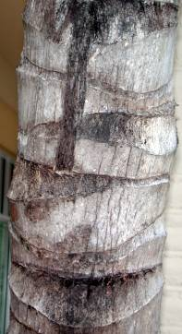 | 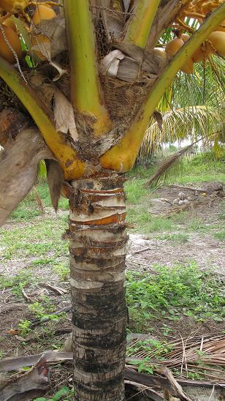

8.2 Explanations for individual characteristics

Ad. 1: Young plant: color of shoot

Should be observed as soon as shoot emergence.

Ad. 2: Young plant: number of leaves

Should be observed at age 6 months after the germination of the seed.

Ad. 3: Young plant: time of leaflets splitting

The leaflets splitting begins around age 6 months of the young plant.

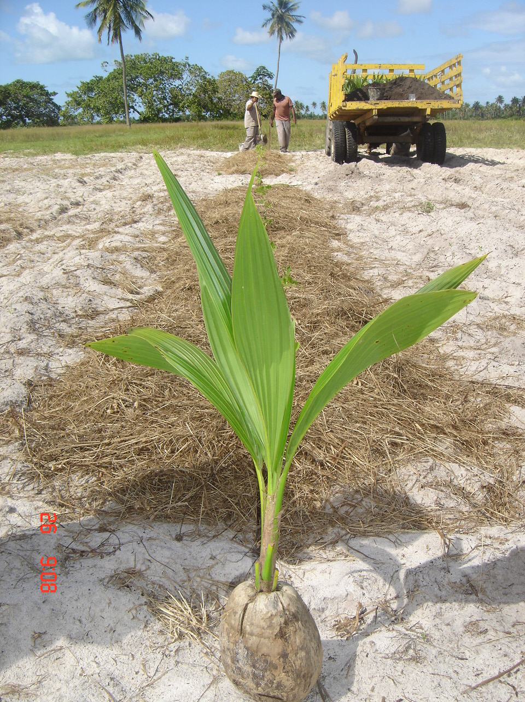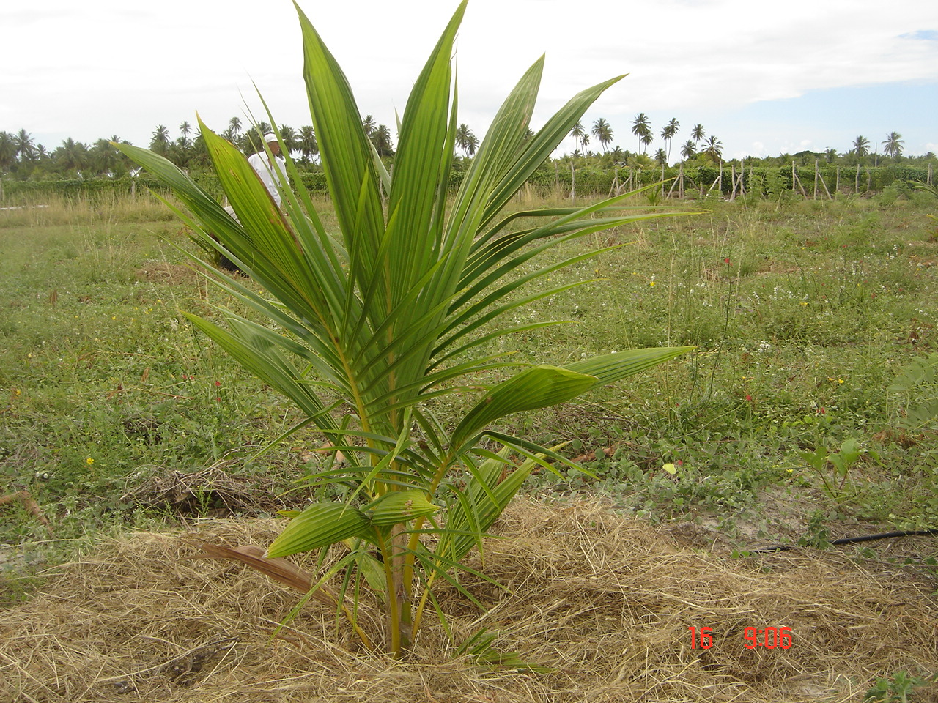
leaflets splitting

Ad. 4: Time of appearance of first inflorescence

The time of appearance of first inflorescence should be observed when 50% of the plants have emitted the first inflorescence.

Ad. 5: Leaves attitude of lower leaves

1 | 2 | 3
upwards | outwards | downwards

Ad. 6: Stem: bole

1 | 9
absent | present

Ad. 7 Stem: diameter of the bole

The diameter of the bole should be measured at 0.2 m at the soil.

Ad. 8: Stem: height

Ad. 9: Stem: diameter

The steam diameter should be measured from ground to 1.5 meters.

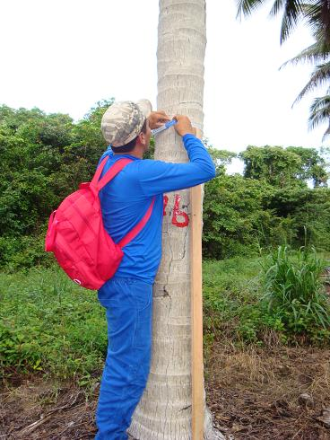

Ad. 10: Petiole: length

The petiole length should be measured from base to the most proximal leaflet of the rachis.

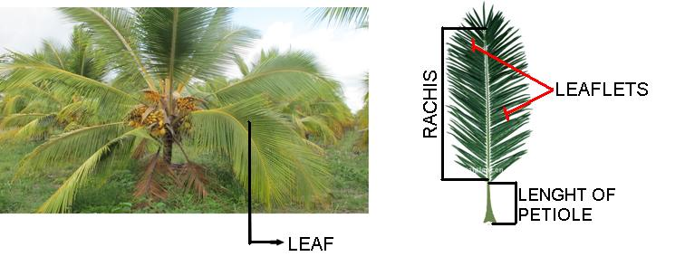

Ad. 11: Petiole: thickness
Ad. 12: Petiole: width

The petiole thickness and the petiole width should be measured at insertion of the first leaflet.

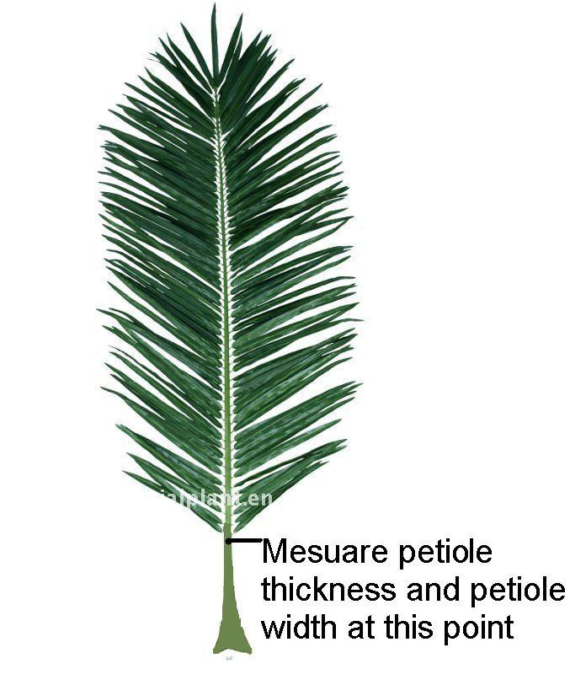
Measure petiole thickness and petiole width at this point

Ad. 14: Leaf: length of rachis

The length of rachis should be measured from to the most proximal leaflet to the tip of the rachis.

Ad. 16: Leaf: leaflet length
Ad. 17: Leaf: leaflet width

The leaflet length and the leaflet width should be measured at halfway of the rachis

Ad. 19: Inflorescence: peduncle length
Ad. 20: Inflorescence: peduncle diameter
Ad. 21: Inflorescence: central axis length

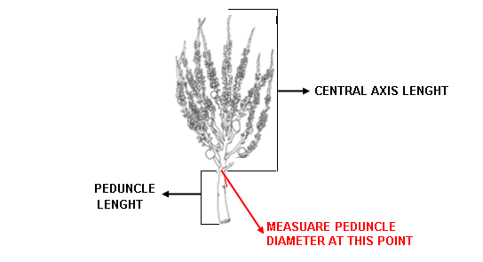
MEASURE PEDUNCLE DIAMETER AT THIS POINT

Ad. 22: Inflorescence: number of spikelets

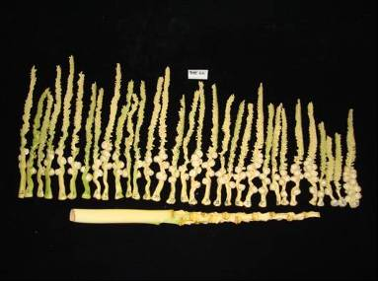 | 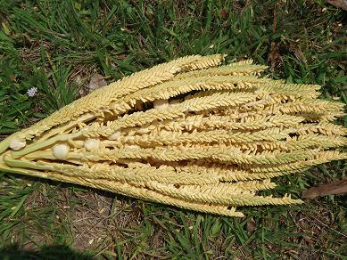

Ad. 23: Inflorescence: number of spikelets with female flowers

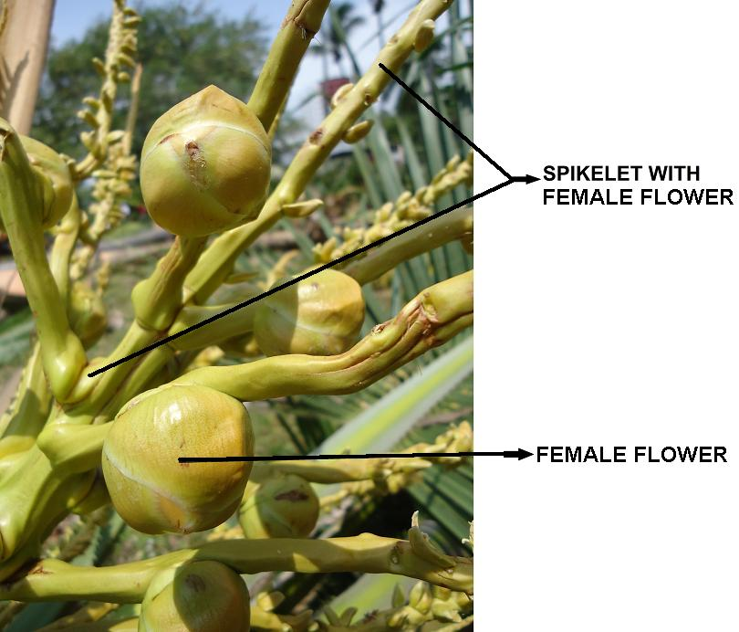 | 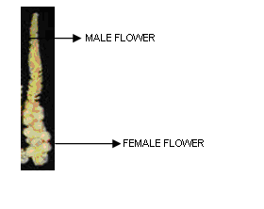

Ad. 24: Inflorescence: length of first spikelet bearing female flower

Should be evaluated after the appearance of the fifth inflorescence, when the first female flower appears.

Ad. 27: Fruit: color

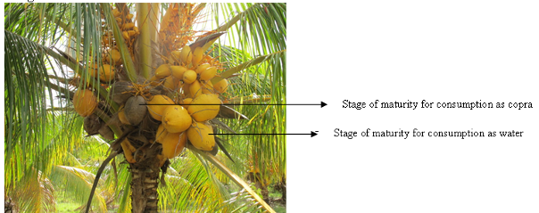

Ad. 29: Fruit: shape

 |  | < broadest part >
 |  | (below middle) | at middle | (above middle)
< lateral outline > | rounded | 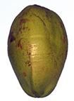  2  ovate | 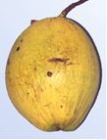  3  elliptic | 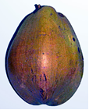  4  obovate
< lateral outline > | rounded |  | 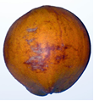  1  circular
< lateral outline > | rounded with neck |  |  | 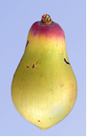  5  pyriform

Ad. 30: Fruit: the ratio weight fruit/husk
Ad. 31: Nut: shape
Ad. 33: Shell: thickness
Ad. 34: Meat: weight

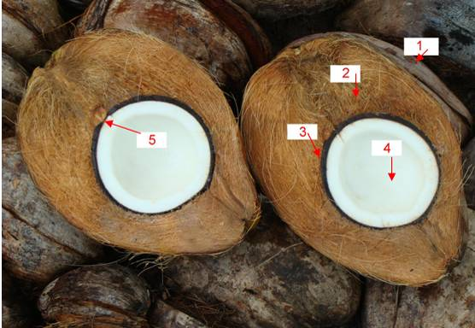

1. | exocarp | husk = exocarp + mesocarp
2. | mesocarp | husk = exocarp + mesocarp
3. | endocarp (shell) | nut = endocarp + endosperm
4. | endosperm (meat) | nut = endocarp + endosperm
5. | embryo

Ad. 31: Nut: shape

 |  | ← | Broadest part | →
 |  | below middle | middle | above middle
→ | elongated | 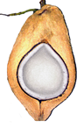  1  ovate | 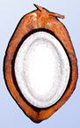  2  elliptic
ratio width/length | medium |  | 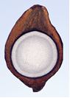  3  circular
← | compressed |  | 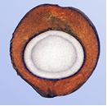  4  oblate

Ad. 36: Consistancy of meat

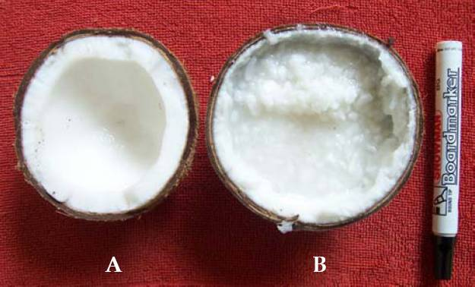
1 | 2
solid ???  compact??? | lose ?????  jelly????

Literature

IPGRI, 1995: Descriptors for Coconut (Cocus nucifera L.). International Plant Genetic Resources Institute. Rome, IT, 61 pp.

The Minimum List of Descriptors for coconut – from CIRAD with same other counties contributions(China, Brasil, France, Mexico, Indonesia, Malaysia, Philippines, Viet Nam), ano....

Ribeiro, F.E., de Siqueira, E.R., Aragão, W.M., Tupinambá, E.A., 1999: O coqueiro anão no Brasil. Aracaju: Embrapa Tabuleiros Costeiros, 23p. (Embrapa-Tabuleiros Costeiros. Documentos, 8).

Ribeiro, F.E., de Siqueira, E.R., Aragão, W.M., Tupinambá, E.A., 2000: Ecótipos de coqueiro gigante no Brasil. Aracaju: Embrapa Tabuleiros Costeiros,. 25p. (Embrapa-Tabuleiros Costeiros. Documentos, 17).

Ribeiro, F.E., de J. Ribeiro, M.M., 2011: Caracterização de populações de coqueiro gigante no Nordeste do Brasil. Aracaju: Embrapa Tabuleiros Costeiros,. 16p. (Embrapa-Tabuleiros Costeiros. Boletim de Pesquisa e Desenvolvimento, 59).

Aragão, W.M., Ribeiro, F.E., Tupinambá, E.A., de Siqueira, E.R., 2003: Variedades e híbridos. In: Fontes, H.R., Ribeiro, F.E., Fernandes, M.F., (Ed.). Coco produção: Aspectos técnicos. Aracaju: Embrapa Tabuleiros Costeiros, p. 21.

de Siqueira, E.R., Ribeiro, F.E., Aragão, W.M., Tupinambá, E.A., 1998: Melhoramento genético do coqueiro. In: Ferreira, J.M.S.; Warwick, D.R.N.; Siqueira, L.A. (Ed.). A cultura do coqueiro no Brasil. 2. Ed. rev. Amp. Brasília: Embrapa-SPI,. 292p.

Aragão, W.M., Ribeiro, F.E., de V. Melo, M.F. 2009: Cultivares de coqueiro para produção de coco seco: coqueiro gigante vs híbridos. In: Cintra, F.L.D., Fontes, H.R., Passos, E.E.M., Ferreira, J.M.S., (Ed.). Fundamentos tecnológicos para a revitalização das áreas cultivadas com coqueiro gigante do Brasil. Aracaju: Embrapa Tabuleiros Costeiros,. 232p.

Wuidart, W., Rognon, F., 1978: L’analysis de composant de la noix de cocotier: Méthode de determination du coprah. Oléagineux, 33(5):225-33.

Technical Questionnaire

TECHNICAL QUESTIONNAIRE |  |  |  | Page {x} of {y} |  | Reference Number:
 |  |  |  |  |  | Application date:
 |  |  |  |  |  | (not to be filled in by the applicant)
TECHNICAL QUESTIONNAIRE
to be completed in connection with an application for plant breeders’ rights

1. Subject of the Technical Questionnaire
1.1 Botanical name |  |  | Cocos nucifera L.
1.2 Common name |  |  | Coconut
2. Applicant
Name
Address
Telephone No.
Fax No.
E-mail address
Breeder (if different from applicant)
3. Proposed denomination and breeder’s reference
Proposed denomination
(if available)

Breeder’s reference
#4. Information on the breeding scheme and propagation of the variety

4.1 Breeding scheme

Variety resulting from:

4.1.1 Crossing

(a) controlled cross [ ]
(please state parent varieties)

(…………………..……………..…) x (……………..…………………..…)
female parent male parent

(b) partially known cross [ ]
(please state known parent variety(ies))

(…………………..……………..…) x (……………..…………………..…)
female parent male parent

(c) unknown cross [ ]

4.1.2 Mutation [ ]
(please state parent variety)

4.1.3 Discovery and development [ ]
(please state where and when discovered and how developed)

4.1.4 Other [ ]

(please provide details)

4.2 Method of propagating the variety

4.2.1 Seed-propagated varieties

(a) Self-pollination [ ]
(b) Cross-pollination
(i) population [ ]
(ii) synthetic variety [ ]
(c) Hybrid [ ]
(d) Other [ ]
(please provide details)

4.2.2 Vegetative propagation

(a) cuttings [ ]

(b) in vitro propagation [ ]

(c) other (state method) [ ]

4.2.3 Other [ ]
(please provide details)

5. Characteristics of the variety to be indicated (the number in brackets refers to the corresponding characteristic in Test Guidelines; please mark the note which best corresponds).

 | Characteristics |  |  |  |  |  | Example Varieties |  |  | Note
5.1  (9) | Stem: diameter
 | very small |  |  |  |  |  |  |  |  | 1[ ]
 | very small to small |  |  |  |  |  |  |  |  | 2[ ]
 | small |  |  |  |  |  |  |  |  | 3[ ]
 | small to medium |  |  |  |  |  |  |  |  | 4[ ]
 | medium |  |  |  |  |  |  |  |  | 5[ ]
 | medium to large |  |  |  |  |  |  |  |  | 6[ ]
 | large |  |  |  |  |  |  |  |  | 7[ ]
 | large to very large |  |  |  |  |  |  |  |  | 8[ ]
 | very large |  |  |  |  |  |  |  |  | 9[ ]
5.2  (27) | Fruit: color
 | yellow |  |  |  |  |  | Genjah Kuning Bali |  |  | 1[ ]
 | yellowish green |  |  |  |  |  |  |  |  | 2[ ]
 | yellowish red |  |  |  |  |  |  |  |  | 3[ ]
 | green |  |  |  |  |  | Genjah Hijau Nias |  |  | 4[ ]
 | greenish yellow |  |  |  |  |  |  |  |  | 5[ ]
 | greenish red |  |  |  |  |  |  |  |  | 6[ ]
 | red |  |  |  |  |  | GMW??? |  |  | 7[ ]
 | reddish yellow |  |  |  |  |  |  |  |  | 8[ ]
 | reddish green |  |  |  |  |  |  |  |  | 9[ ]
 | brown |  |  |  |  |  | Genjah Raja Brown |  |  | 10[ ]
 | Characteristics |  |  |  |  |  | Example Varieties |  |  | Note
5.3  (28) | Fruit: weight
 | very low |  |  |  |  |  |  |  |  | 1[ ]
 | very low to low |  |  |  |  |  |  |  |  | 2[ ]
 | low |  |  |  |  |  | GOS??? |  |  | 3[ ]
 | low to medium |  |  |  |  |  |  |  |  | 4[ ]
 | medium |  |  |  |  |  | Genjah Tebing Tinggi |  |  | 5[ ]
 | medium to high |  |  |  |  |  |  |  |  | 6[ ]
 | high |  |  |  |  |  | Dalam Bali |  |  | 7[ ]
 | high to very high |  |  |  |  |  |  |  |  | 8[ ]
 | very high |  |  |  |  |  |  |  |  | 9[ ]
5.4  (29) | Fruit: shape
 | circular |  |  |  |  |  |  |  |  | 1[ ]
 | ovate |  |  |  |  |  |  |  |  | 2[ ]
 | elliptic |  |  |  |  |  |  |  |  | 3[ ]
 | obovate |  |  |  |  |  |  |  |  | 4[ ]
 | pyriform |  |  |  |  |  |  |  |  | 5[ ]
5.5  (31) | Nut: shape
 | ovate |  |  |  |  |  |  |  |  | 1[ ]
 | elliptic |  |  |  |  |  |  |  |  | 2[ ]
 | circular |  |  |  |  |  |  |  |  | 3[ ]
 | oblate |  |  |  |  |  |  |  |  | 4[ ]
6. Similar varieties and differences from these varieties

Please use the following table and box for comments to provide information on how your candidate variety differs from the variety (or varieties) which, to the best of your knowledge, is (or are) most similar. This information may help the examination authority to conduct its examination of distinctness in a more efficient way.

Denomination(s) of variety(ies) similar to your candidate variety |  | Characteristic(s) in which your candidate variety differs from the similar variety(ies) |  |  | Describe the expression of the characteristic(s) for the similar variety(ies) |  |  | Describe the expression of the characteristic(s) for your candidate variety
Genjah Hijau Nias |  | Fruit: color |  |  | green |  |  | yellow
Comments:

#7. Additional information which may help in the examination of the variety

7.1 In addition to the information provided in sections 5 and 6, are there any additional characteristics which may help to distinguish the variety?

Yes [ ] No [ ]

(If yes, please provide details)

7.2 Are there any special conditions for growing the variety or conducting the examination?

Yes [ ] No [ ]

(If yes, please provide details)

7.3 Other information

Main use of the variety:

(a) pot plant [ ]

(b) garden plant [ ]

(c) other [ ]

A representative color image of the variety should accompany the Technical Questionnaire.

8. Authorization for release

(a) Does the variety require prior authorization for release under legislation concerning the protection of the environment, human and animal health?

Yes [ ] No [ ]

(b) Has such authorization been obtained?

Yes [ ] No [ ]

If the answer to (b) is yes, please attach a copy of the authorization.

9. Information on plant material to be examined or submitted for examination.

9.1 The expression of a characteristic or several characteristics of a variety may be affected by factors, such as pests and disease, chemical treatment (e.g. growth retardants or pesticides), effects of tissue culture, different rootstocks, scions taken from different growth phases of a tree, etc.

9.2 The plant material should not have undergone any treatment which would affect the expression of the characteristics of the variety, unless the competent authorities allow or request such treatment. If the plant material has undergone such treatment, full details of the treatment must be given. In this respect, please indicate below, to the best of your knowledge, if the plant material to be examined has been subjected to:

(a) Microorganisms (e.g. virus, bacteria, phytoplasma) Yes [ ] No [ ]

(b) Chemical treatment (e.g. growth retardant, pesticide) Yes [ ] No [ ]

(c) Tissue culture Yes [ ] No [ ]

(d) Other factors Yes [ ] No [ ]

Please provide details for where you have indicated “yes”.

……………………………………………………………

10. I hereby declare that, to the best of my knowledge, the information provided in this form is correct:

Applicant’s name

Signature Date

[End of document]

* These names were correct at the time of the introduction of these Test Guidelines but may be revised or updated. [Readers are advised to consult the UPOV Code, which can be found on the UPOV Website (www.upov.int), for the latest information.]
# Authorities may allow certain of this information to be provided in a confidential section of the Technical Questionnaire.
# Authorities may allow certain of this information to be provided in a confidential section of the Technical Questionnaire.

