 |  |  |  |  |  |  | E  TG/264/2(proj.6)  ORIGINAL: English  DATE: 2013-03-28
INTERNATIONAL UNION FOR THE PROTECTION OF NEW VARIETIES OF PLANTS
Geneva
 |  |  | DRAFT
 |  | PAPAYA  UPOV Code: CARIC_PAP  Carica papaya L. |  |  | *

GUIDELINES

FOR THE CONDUCT OF TESTS

FOR DISTINCTNESS, UNIFORMITY AND STABILITY

prepared by an expert from Mexico

to be considered by the
Technical Working Party for Fruit Crops
at its forty-fourth session, to be held in Napier, New Zealand, from April 29 to May 3, 2013

Alternative Names:*

Botanical name | English | French | German | Spanish
Carica papaya L. | Papaya, Papaw | Papayer | Melonenbaum, Papaya | Papayo, Lechosa, Fruta bomba

The purpose of these guidelines (“Test Guidelines”) is to elaborate the principles contained in the General Introduction (document TG/1/3), and its associated TGP documents, into detailed practical guidance for the harmonized examination of distinctness, uniformity and stability (DUS) and, in particular, to identify appropriate characteristics for the examination of DUS and production of harmonized variety descriptions.

ASSOCIATED DOCUMENTS
These Test Guidelines should be read in conjunction with the General Introduction and its associated TGP documents.
TABLE OF CONTENTS PAGE

1. Subject of these Test Guidelines 3
2. Material Required 3
3. Method of Examination 3
3.1 Number of Growing Cycles 3
3.2 Testing Place 3
3.3 Conditions for Conducting the Examination 3
3.4 Test Design 3
3.5 Additional Tests 3
4. Assessment of Distinctness, Uniformity and Stability 4
4.1 Distinctness 4
4.2 Uniformity 5
4.3 Stability 5
5. Grouping of Varieties and Organization of the Growing Trial 5
6. Introduction to the Table of Characteristics 5
6.1 Categories of Characteristics 5
6.2 States of Expression and Corresponding Notes 6
6.3 Types of Expression 6
6.4 Example Varieties 6
6.5 Legend 7
7. Table of Characteristics/Tableau des caractères/Merkmalstabelle/Tabla de caracteres 8
8. Explanations on the Table of Characteristics 16
8.1 Explanations covering several characteristics 16
8.2 Explanations for individual characteristics 16
9. Literature 21
10. Technical Questionnaire 22

Subject of these Test Guidelines

These Test Guidelines apply to all varieties of Carica papaya L.

Material Required

2.1 The competent authorities decide on the quantity and quality of the plant material required for testing the variety and when and where it is to be delivered. Applicants submitting material from a State other than that in which the testing takes place must ensure that all customs formalities and phytosanitary requirements are complied with.

2.2 The material is to be supplied in the form of seeds or plants.

2.3 The minimum quantity of plant material, to be supplied by the applicant, should be:

200 seeds in the case of seed-propagated varieties,
or 5 plants in the case of vegetatively propagated varieties.

2.4 The plant material supplied should be visibly healthy, not lacking in vigor, nor affected by any important pest or disease.

2.5 The plant material should not have undergone any treatment which would affect the expression of the characteristics of the variety, unless the competent authorities allow or request such treatment. If it has been treated, full details of the treatment must be given.

Method of Examination

3.1 Number of Growing Cycles

3.1.1 The minimum duration of tests should normally be two independent growing cycles.

3.1.2 The growing cycle is considered to be the period ranging from the beginning of active vegetative growth or flowering, continuing through active vegetative growth or flowering and fruit development and concluding with the harvesting of fruit.

3.2 Testing Place

Tests are normally conducted at one place. In the case of tests conducted at more than one place, guidance is provided in TGP/9 “Examining Distinctness”.

3.3 Conditions for Conducting the Examination

The tests should be carried out under conditions ensuring satisfactory growth for the expression of the relevant characteristics of the variety and for the conduct of the examination. In particular, it is essential that the trees produce a satisfactory crop of fruit in each of the two growing cycles.

3.4 Test Design

3.4.1 Each test should be designed to result in a total of at least 20 plants in the case of seed-propagated plants or, in the case of vegetatively propagated varieties, in a total of at least 5 plants.

3.4.2 The design of the tests should be such that plants or parts of plants may be removed for measurement or counting without prejudice to the observations which must be made up to the end of the growing cycle.

3.5 Additional Tests

Additional tests, for examining relevant characteristics, may be established.

Assessment of Distinctness, Uniformity and Stability

4.1 Distinctness

4.1.1 General Recommendations

It is of particular importance for users of these Test Guidelines to consult the General Introduction prior to making decisions regarding distinctness. However, the following points are provided for elaboration or emphasis in these Test Guidelines.

Further guidance is provided in documents TGP/9 “Examining Distinctness” and TGP/8 “Trial Design and Techniques Used in the Examination of Distinctness, Uniformity and Stability”.

4.1.2 Consistent Differences

The differences observed between varieties may be so clear that more than one growing cycle is not necessary. In addition, in some circumstances, the influence of the environment is not such that more than a single growing cycle is required to provide assurance that the differences observed between varieties are sufficiently consistent. One means of ensuring that a difference in a characteristic, observed in a growing trial, is sufficiently consistent is to examine the characteristic in at least two independent growing cycles.

4.1.3 Clear Differences

Determining whether a difference between two varieties is clear depends on many factors, and should consider, in particular, the type of expression of the characteristic being examined, i.e. whether it is expressed in a qualitative, quantitative, or pseudo-qualitative manner. Therefore, it is important that users of these Test Guidelines are familiar with the recommendations contained in the General Introduction prior to making decisions regarding distinctness.

4.1.4 Number of Plants / Parts of Plants to be Examined

4.1.4.1 In the case of seed-propagated varieties, unless otherwise indicated, for the purpose of distinctness, all observations on single plants should be made on 20 plants or parts taken from each of 20 plants and any other observations made on all plants in the test, disregarding any off-type plants.

4.1.4.2 In the case of vegetatively propagated varieties, unless otherwise indicated, for the purpose of distinctness, all observations on single plants should be made on 5 plants or parts taken from each of 5 plants and any other observations made on all plants in the test, disregarding any off-type plants.

4.1.5 Method of Observation

The recommended method of observing the characteristic for the purposes of distinctness is indicated by the following key in the second column of the Table of Characteristics (see document TGP/9 “Examining Distinctness”, Section 4 “Observation of characteristics”):

MG: single measurement of a group of plants or parts of plants
MS: measurement of a number of individual plants or parts of plants
VG: visual assessment by a single observation of a group of plants or parts of plants
VS: visual assessment by observation of individual plants or parts of plants

Type of observation: visual (V) or measurement (M)

“Visual” observation (V) is an observation made on the basis of the expert’s judgment. For the purposes of this document, “visual” observation refers to the sensory observations of the experts and, therefore, also includes smell, taste and touch. Visual observation includes observations where the expert uses reference points (e.g. diagrams, example varieties, side-by-side comparison) or non-linear charts (e.g. color charts). Measurement (M) is an objective observation against a calibrated, linear scale e.g. using a ruler, weighing scales, colorimeter, dates, counts, etc.

Type of record: for a group of plants (G) or for single, individual plants (S)

For the purposes of distinctness, observations may be recorded as a single record for a group of plants or parts of plants (G), or may be recorded as records for a number of single, individual plants or parts of plants (S). In most cases, “G” provides a single record per variety and it is not possible or necessary to apply statistical methods in a plant-by-plant analysis for the assessment of distinctness.

In cases where more than one method of observing the characteristic is indicated in the Table of Characteristics (e.g. VG/MG), guidance on selecting an appropriate method is provided in document TGP/9, Section 4.2.

4.2 Uniformity

4.2.1 It is of particular importance for users of these Test Guidelines to consult the General Introduction prior to making decisions regarding uniformity. However, the following points are provided for elaboration or emphasis in these Test Guidelines:

4.2.2 Vegetatively propagated varieties: for the assessment of uniformity of vegetatively propagated varieties, a population standard of 1% and an acceptance probability of 95% should be applied. In the case of a sample size of 5 plants, no off-type is allowed.

4.2.3 Seed-propagated varieties: the assessment of uniformity for seed-propagated varieties should be according to the recommendations for cross-pollinated varieties in the General Introduction.

4.3 Stability

4.3.1 In practice, it is not usual to perform tests of stability that produce results as certain as those of the testing of distinctness and uniformity. However, experience has demonstrated that, for many types of variety, when a variety has been shown to be uniform, it can also be considered to be stable.

4.3.2 Where appropriate, or in cases of doubt, stability may be further examined by testing a new seed or plant stock to ensure that it exhibits the same characteristics as those shown by the initial material supplied.

Grouping of Varieties and Organization of the Growing Trial

5.1 The selection of varieties of common knowledge to be grown in the trial with the candidate varieties and the way in which these varieties are divided into groups to facilitate the assessment of distinctness are aided by the use of grouping characteristics.

5.2 Grouping characteristics are those in which the documented states of expression, even where produced at different locations, can be used, either individually or in combination with other such characteristics: (a) to select varieties of common knowledge that can be excluded from the growing trial used for examination of distinctness; and (b) to organize the growing trial so that similar varieties are grouped together.

5.3 The following have been agreed as useful grouping characteristics:

- Plant: height of attachment of first inflorescence or flower (characteristic 2)
- Leaf blade: ratio length/width (characteristic 9)
- Fruit: ratio length/diameter (characteristic 27)
- Fruit: shape (characteristic 28)

5.4 Guidance for the use of grouping characteristics, in the process of examining distinctness, is provided through the General Introduction and document TGP/9 “Examining Distinctness”.

Introduction to the Table of Characteristics

6.1 Categories of Characteristics

6.1.1 Standard Test Guidelines Characteristics

Standard Test Guidelines characteristics are those which are approved by UPOV for examination of DUS and from which members of the Union can select those suitable for their particular circumstances.

6.1.2 Asterisked Characteristics

Asterisked characteristics (denoted by *) are those included in the Test Guidelines which are important for the international harmonization of variety descriptions and should always be examined for DUS and included in the variety description by all members of the Union, except when the state of expression of a preceding characteristic or regional environmental conditions render this inappropriate.

6.2 States of Expression and Corresponding Notes

6.2.1 States of expression are given for each characteristic to define the characteristic and to harmonize descriptions. Each state of expression is allocated a corresponding numerical note for ease of recording of data and for the production and exchange of the description.

6.2.2 In the case of qualitative and pseudo-qualitative characteristics (see Chapter 6.3), all relevant states of expression are presented in the characteristic. However, in the case of quantitative characteristics with 5 or more states, an abbreviated scale may be used to minimize the size of the Table of Characteristics. For example, in the case of a quantitative characteristic with 9 states, the presentation of states of expression in the Test Guidelines may be abbreviated as follows:

State | Note
small | 3
medium | 5
large | 7

However, it should be noted that all of the following 9 states of expression exist to describe varieties and should be used as appropriate:

State | Note
very small | 1
very small to small | 2
small | 3
small to medium | 4
medium | 5
medium to large | 6
large | 7
large to very large | 8
very large | 9

6.2.3 Further explanation of the presentation of states of expression and notes is provided in document TGP/7 “Development of Test Guidelines”.

6.3 Types of Expression

An explanation of the types of expression of characteristics (qualitative, quantitative and pseudo-qualitative) is provided in the General Introduction.

6.4 Example Varieties

Where appropriate, example varieties are provided to clarify the states of expression of each characteristic.

6.5 Legend

(*) Asterisked characteristic – see Chapter 6.1.2

QL Qualitative characteristic – see Chapter 6.3
QN Quantitative characteristic – see Chapter 6.3
PQ Pseudo-qualitative characteristic – see Chapter 6.3

MG, MS, VG, VS – see Chapter 4.1.5

(a)-(d) See Explanations on the Table of Characteristics in Chapter 8.1

(+) See Explanations on the Table of Characteristics in Chapter 8.2.

Table of Characteristics/Tableau des caractères/Merkmalstabelle/Tabla de caracteres

 |  | English |  | français | deutsch | español | Example Varieties  Exemples  Beispielssorten  Variedades ejemplo | Note/  Nota
1  (+) | VG | Young plant: color of stem |  | Jeune plante : couleur de la tige | Junge Pflanze: Farbe des Triebs | Planta joven: color del tallo
PQ |  | only green |  | seulement verte | nur grün | sólo verde | Ishigaki Sango | 1
 |  | yellowish green |  | vert jaunâtre | gelblich grün | verde amarillento | Tainung Nº 1 | 2
 |  | brown |  | brune | braun | marrón | Tangkai hitam | 3
 |  | green and purple |  | verte et pourpre | grün und purpurn | verde y púrpura | Sunrise | 4
 |  | only purple |  | seulement pourpre | nur purpurn | sólo púrpura |  | 5
2  (*)  (+) | VG/MS | Plant: height of first inflorescence |  | Plante: première hauteur inflorescence | Pflanze: ersten Blütenstand Höhe | Planta: altura de la primera inflorescencia
QN | (a) | low |  | basse | niedrig | baja | Ishigaki Sango | 3
 |  | medium |  | moyenne | mittel | media | Sunrise, Tainung Nº 1 | 5
 |  | high |  | haute | hoch | alta | Cera, Dampit, Simangko | 7
3  (*)  (+) | VG | Plant: branching |  | Plante: ramification | Pflanze: Verzweigung | Planta: ramificación
QL |  | absent |  | absente | fehlend | ausente | Ishigaki Sango, Maradol, Sunrise | 1
 |  | present |  | présente | vorhanden | presente |  | 9
4  (+) | VG/MS | Stem: diameter |  | Tige : diamètre | Stängel: Durchmesser | Tallo: diámetro
QN | (a) | small |  | petit | klein | pequeño |  | 3
 |  | medium |  | moyen | mittel | medio | Ishigaki Sango, Sunrise, Tainung Nº 1 | 5
 |  | large |  | large | groß | grande | Klangdong | 7
5  (*)  (+) | VG/MS | Stem: number of nodes |  | Tige : nombre de nœuds | Stängel: Anzahl Knoten | Tallo: número de nudos
QN | (a) | few |  | petit | gering | bajo | Ishigaki Sango | 3
 |  | medium |  | moyen | mittel | medio | Sunrise, Tainung Nº 1 | 5
 |  | many |  | grand | groß | alto | Simangko | 7
6  (*)  (+) | VG/MS | Stem: length of internode |  | Tige : longueur de l’entrenœud | Stängel: Länge der Internodien | Tallo: longitud del entrenudo
QN | (a) | short |  | courte | kurz | corto | Ishigaki Sango | 3
 |  | medium |  | moyenne | mittel | medio | Sunrise, Tainung Nº 1 | 5
 |  | long |  | longue | lang | largo | Simangko | 7
7  (+) | VG/MS | Leaf blade: length |  | Limbe : longueur | Blattspreite: Länge | Limbo: longitud
QN | (b) | short |  | court | kurz | corta | BT-K, Eksotika | 3
 |  | medium |  | moyen | mittel | media | Ishigaki Sango, Sunrise, Tainung Nº 1 | 5
 |  | long |  | long | lang | larga | Dampit | 7
8  (+) | VG/MS | Leaf blade: width |  | Limbe : largeur | Blattspreite: Breite | Limbo: anchura
QN | (b) | narrow |  | étroit | schmal | estrecha | BT-K | 3
 |  | medium |  | moyen | mittel | media | Sunrise, Tainung Nº 1 | 5
 |  | broad |  | large | breit | amplia | Dampit | 7
9  (*)  (+) | VG/MS |  | Leaf blade: ratio length/width | Limbe : rapport longueur/largeur | Blattspreite: Verhältnis Länge/Breite | Limbo: relación longitud/anchura
QN | (b) | low to medium |  | faible à mayenne | niedrig bis mittel | bajo a medio | Golden | 1
 |  | medium |  | moyen | mittel | media | Ishigaki Sango, Sunrise, Tainung Nº 1 | 2
 |  | medium to high |  | moyen à élevé | mittlerem bis hohem | media a alta | Johor | 3
10  (*)  (+) | VG | Leaf blade: presence of tertiary lobes |  | Limbe : présence de lobes tertiaires | Blattspreite: Vorhandensein von Lappen dritter Ordnung | Limbo: presencia de lóbulos terciarios
QL | (b) | absent |  | absents | fehlend | ausencia |  | 1
 |  | present |  | présents | vorhanden | presencia | Ishigaki Sango, Sunrise, Tainung Nº 1 | 9
11  (*) | VG | Leaf: presence of secondary leaf |  | Feuille : présence de feuille secondaire | Blatt: Vorhandensein von sekunären | Hoja: presencia de hoja secundaria
QL |  | absent |  | absente | fehlend | ausentes | Cera, Maradol, Sunrise | 1
 |  | present |  | présente | vorhanden | presentes | Callina, Plugmailai, Sekaki | 9
12  (+) | VG | Leaf blade: pubescence on lower side |  | Limbe : pubescence sur la face inférieure | Blattspreite: Behaarung der Unterseite | Limbo: pubescencia en el envés
QL | (b) | absent |  | absente | fehlend | ausente | Ishigaki Sango, Sunrise, Tainung Nº 1 | 1
 |  | present |  | présente | vorhanden | presente |  | 9
13  (*) | VG/MS | Petiole: length |  | Pétiole : longueur | Blattstiel: Länge | Peciolo: longitud
QN | (b) | short |  | court | kurz | bajo | BT-K | 3
 |  | medium |  | moyen | mittel | medio | Ishigaki Sango, Sunrise, Tainung Nº 1 | 5
 |  | long |  | long | lang | alto | Dampit | 7
14 | VG | Petiole: anthocyanin coloration |  | Pétiole : pigmentation anthocyanique | Blattstiel: Anthocyanfärbung | Peciolo: coloración antociánica
QN | (b) | absent or very weak |  | absente ou très faible | fehlend oder sehr schwach | corta | Ishigaki Sango | 1
 |  | medium |  | moyenne | mittel | media | Sunrise, Tainung Nº 1 | 3
 |  | very strong |  | très forte | sehr stark | larga |  | 5
15  (*)  (+) | MG | Time of flowering |  | Époque de floraison | Blütezeit | Época de floración
QN |  | early |  | précoce | früh | temparana | Arum, Carisya, Sinta | 3
 |  | medium |  | moyenne | mittel | media | Callina, Sunrise | 5
 |  | late |  | tardive | spät | tardía | Cavite Special, Wulung | 7
16  (*)  (+) | VG | Inflorescence: number of flowers on hermaphrodite plants |  | Inflorescence : nombre de fleurs sur plantes hermaphrodites | Blütenstand: Anzahl der Blüten bei zwittrigen Pflanzen | Inflorescencia: número de flores en plantas hermafroditas
QN | (c) | few |  | petit | wenige | escasas | Ishigaki Sango | 3
 |  | medium |  | moyen | mittel | media | Eksotika, Sunrise | 5
 |  | many |  | élevé | viele | abundantes | Tainung Nº 1 | 7
17  (*)  (+) | VG | Inflorescence: number of flowers on female plants |  | Inflorescence : nombre de fleurs sur plantes femelles | Blütenstand: Anzahl der Blüten bei weiblichen Pflanzen | Inflorescencia: número de flores en plantas femeninas
QN | (c) | few |  | petit | wenige | escasass |  | 3
 |  | medium |  | moyen | mittel | media |  | 5
 |  | many |  | élevé | viele | abundantes |  | 7
18  (+) | VG/MS | Inflorescence: length of main axis on hermaphrodite plants |  | Inflorescence : longueur de l’axe central sur plantes hermaphrodites | Blütenstand: Länge der Hauptachse bei zwittrigen Pflanzen | Inflorescencia: longitud del eje central en plantas hermafroditas
QN | (c) | short |  | court | kurz | corta | Ishigaki Sango, Sunrise | 3
 |  | medium |  | moyen | mittel | media | BT-1 | 5
 |  | long |  | long | lang | larga | Dampit | 7
19  (+) | VG/MS | Inflorescence: length of main axis on female plants |  | Inflorescence : longueur de l’axe central sur plantes femelles | Blütenstand: Länge der Hauptachse bei weiblichen Pflanzen | Inflorescencia: longitud del eje central en plantas femeninas
QN | (c) | short |  | court | kurz | corta |  | 3
 |  | medium |  | moyen | mittel | media |  | 5
 |  | long |  | long | lang | larga |  | 7
20  (+) | VG | Inflorescence: anthocyanin coloration of axis on hermaphrodite plants |  | Inflorescence : pigmentation anthocyanique de l’axe sur plantes hermaphrodites | Blütenstand: Anthocyanfärbung der Achse bei zwittrigen Pflanzen | Inflorescencia: pigmentación antociánica del eje en plantas hermafroditas
QN | (c) | absent or weak |  | absente ou faible | fehlend oder schwach | ausente o débil | Ishigaki Sango, Sunrise, Tainung Nº 1 | 1
 |  | medium |  | moyenne | mittel | media |  | 2
 |  | strong |  | forte | stark | fuerte | Tangkai hitam | 3
21  (+) | VG | Inflorescence: anthocyanin coloration of axis on female plants |  | Inflorescence : pigmentation anthocyanique de l’axe sur plantes femelles | Blütenstand: Anthocyanfärbung der Achse bei weiblichen Pflanzen | Inflorescencia: pigmentación antociánica del eje en plantas femeninas
QN | (c) | absent or weak |  | absente ou faible | fehlend oder schwach | ausente o débil |  | 1
 |  | medium |  | moyenne | mittel | media |  | 2
 |  | strong |  | forte | stark | fuerte |  | 3
22  (+) | VG/MS | Flower: length of corolla |  | Fleur : longueur de la corolle | Blüte: Länge der Krone | Flor: longitud de la corola
QN | (c) | short |  | courte | kurz | corta | BT-3 | 3
 |  | medium |  | moyenne | mittel | media | BT-1 | 5
 |  | long |  | longue | lang | larga | Dampit | 7
23  (+) | VG | Flower: color of corolla |  | Fleur : couleur de la corolle | Blüte: Farbe der Krone | Flor: color de la corola
PQ | (c) | white |  | blanche | weiß | blanca | Morib | 1
 |  | cream |  | crème | cremefarben | crema | Eksotika, Sunrise | 2
 |  | yellow |  | jaune | gelb | amarilla |  | 3
 |  | green |  | verte | grün | verde |  | 4
 |  | purple |  | pourpre | purpurn | púrpura | Sabah Yellow | 5
24  (*) | VG/MS | Peduncle: length |  | Pédoncule : longueur | Stiel: Länge | Pedúnculo: longitud
QN | (d) | short |  | court | kurz | corta | Ishigaki Sango, Sunrise | 3
 |  | medium |  | moyen | mittel | media | Sekaki | 5
 |  | long |  | long | lang | larga | Dampit, Semangko | 7
25  (*) | VG/MS | Fruit: length |  | Fruit : longueur | Frucht: Länge | Fruto: longitud
QN | (d) | short |  | petit | kurz | corta | Du Roi Solo, Sunrise | 3
 |  | medium |  | moyen | mittel | media | Ishigaki Sango | 5
 |  | long |  | long | lang | larga | Cera | 7
26  (*) | VG/MS | Fruit: diameter |  | Fruit : diamètre | Frucht: Durchmesser | Fruto: diámetro
QN | (c) | small |  | petit | klein | pequeño | Du Roi Solo, Sunrise | 3
 |  | medium |  | moyen | mittel | medio | Ishigaki Sango | 5
 |  | large |  | large | groß | grande | Cera | 7
27  (*)  (+) | VG/MS | Fruit: ratio length/ diameter |  | Fruit : rapport longueur/diamètre | Frucht: Verhältnis Länge/Durchmesser | Fruto: relación longitud/diámetro
QN | (d) | very low |  | très faible | sehr niedrig | muy bajo | Eksotika, Sunrise | 1
 |  | low |  | faible | niedrig | bajo | Ishigaki Sango, Sekaki | 3
 |  | low to medium |  | faible à mayenne | niedrig bis mittel | bajo a medio | Cera, Dampit | 5
28  (*)  (+) | VG | Fruit: shape |  | Fruit : forme | Frucht: Form | Fruto: forma
PQ | (d) | ovate |  | ovale | eiförmig | oval | Cariflora | 1
 |  | elliptic |  | elliptique | elliptisch | elíptico | Eksitika, Ishigaki Sango | 2
 |  | obovate |  | obovale | verkehrt eiförmig | oboval | Du Roi Solo, Red Lady | 3
 |  | pyriform |  | pyriforme | birnenförmig | piriforme | Kapoho, Rainbow | 4
 |  | oblong |  | oblong | rechteckig | oblongo | Amarela, Sekaki | 5
 |  | obovate waisted |  | obovale étranglée | verkehrt eiförmig tailliert | oboval entallado | BT-1 | 6
29  (+) | VG | Fruit: shape at stalk end |  | Fruit : forme á la extrémité pédonculaire | Frucht: Form am Stielende | Fruto: forma en el extremo peduncular
PQ | (d) | pointed |  | pointue | spitz | en punta | BT-1 | 1
 |  | rounded |  | arrondie | abgerundet | redondeado | Simangko | 2
 |  | truncate |  | tronquée | stumpf | truncado | Sunrise | 3
 |  | depressed |  | déprimée | eingesunken | deprimido | Du Roi Solo, Ishigaki Sango | 4
30 | VG | Fruit: shape at distal end |  | Fruit : forme à l’extrémité distale | Frucht: Form am distalen Ende | Fruto: forma en el extremo distal
QN | (d) | rounded |  | arrondi | abgerundet | redondeado | Tainung Nº 1 | 1
 |  | weakly pointed |  | pointu | leicht spitz | ligeramente puntiagudo | Ishigaki Sango, Sunrise | 2
 |  | strongly pointed |  | fortement pointu | stark spitz | muy puntiagudo | Du Roi Solo | 3
31  (*) (+) | VG | Fruit: main color |  | Fruit : couleur principale | Frucht: Hauptfarbe | Fruto: color principal
PQ | (d) | green |  | verte | grün | verde | Sari Gading | 1
 |  | yellow green |  | vert jaune | gelbgrün | verde amarillento | BT-K, Sabah Yellow | 2
 |  | yellow |  | jaune | gelb | amarillo | Amarela, Kapoho, Tainung Nº 1 | 3
 |  | medium orange |  | orange moyen | mittelorange | anaranjado medio | Ishigaki Sango, Maradol, Mulata | 4
 |  | dark orange |  | orange foncé | dunkelorange | anaranjado oscuro | Dampit, Mamey | 5
32  (+) | VG | Fruit: ridges |  | Fruit : cannelures | Frucht: Rippen | Fruto: aristas
QN | (d) | absent or very weak |  | absentes ou très faibles | fehlend oder sehr schwach | ausentes o muy débiles | Ishigaki Sango, Tainung Nº 1 | 1
 |  | weak |  | faibles | schwach | débiles | BT-4 | 2
 |  | moderate |  | modérées | mittel | moderadas | Simangko | 3
 |  | strong |  | fortes | stark | fuertes | Dampit | 4
33 | VG | Fruit: surface |  | Fruit : surface | Frucht: Oberfläche | Fruto: superficie
QN | (d) | smooth |  | lisse | glatt | lisa | Callina, Paris | 1
 |  | medium |  | moyenne | mittel | media | Carisya | 2
 |  | rough |  | rugueuse | rauh | rugosa | Sukma | 3
34  (*)  (+) | VG | Fruit: thickness of skin |  | Fruit : épaisseur de l’épiderme | Frucht: Dicke der Schale | Fruto: grosor de la piel
QN | (d) | thin |  | mince | dünn | delgada | BT-3 | 1
 |  | medium |  | moyenne | mittel | media | Eksotika, Sunrise | 2
 |  | thick |  | épaisse | dick | gruesa | Dampit, Tainung Nº 1 | 3
35  (*) | VG | Fruit: color of flesh |  | Fruit : couleur de la chair | Frucht: Fleischfarbe | Fruto: color de la pulpa
PQ | (d) | yellow |  | jaune | gelb | amarillo | Amarela, Cera, Kapoho | 1
 |  | orange |  | orange | orange | anaranjado | Sunrise, Tainung N 1 | 2
 |  | red orange |  | rouge orangé | rotorange | anaranjado rojizo | Ishigaki Sango, Maradol | 3
36 | VG | Fruit: firmness of flesh |  | Fruit : fermeté de la chair | Frucht: Festigkeit des Fleisches | Fruto: firmeza de la pulpa
QN | (d) | soft |  | molle | weich | blanda | Cera, Mamey | 3
 |  | medium |  | moyenne | mittel | media | Maradol | 5
 |  | firm |  | ferme | fest | firme | Sekaki, Sunrise | 7
37  (+) | MS | Fruit: sweetness of flesh |  | Fruit : goût sucré de la chair | Frucht: Süße des Fleisches | Fruto: dulzura de la pulpa
QN | (d) | low |  | faible | niedrig | baja | Cera, Sari Gading | 3
 |  | medium |  | moyen | mittel | media | Maradol, Tainung Nº 1 | 5
 |  | high |  | fort | hoch | alta | Ishigaki Sango, Sunrise | 7
38 | VG | Fruit: aroma of flesh |  | Fruit : arôme de la chair | Frucht: Aroma des Fleisches | Fruto: aroma de la pulpa
QN | (d) | weak |  | faible | schwach | débil | Callina, Sekaki | 1
 |  | moderate |  | modéré | mittel | moderado | Ishigaki Sango, Sunrise | 2
 |  | strong |  | fort | stark | fuerte | Eksotika | 3
39 | VG | Fruit: abundance of placental tissue |  | Fruit : abondance de tissu placentaire | Frucht: Menge des plazentalen Gewebes | Fruto: abundancia de tejido placentario
QN | (d) | scarce |  | rare | gering | escaso | BT-1, Mamey | 3
 |  | moderate |  | moyen | mittel | moderado | Eksotika, Sunrise | 5
 |  | abundant |  | abondant | groß | abundante | BT-3, Cera | 7
40  (+) | VG/MS | Fruit: width of central cavity |  | Fruit : largeur de la cavité centrale | Frucht: Breite der zentralen Höhlung | Fruto: anchura de la cavidad central
QN | (d) | narrow |  | étroite | eng | estrecha | Sekaki, Sunrise | 3
 |  | medium |  | moyenne | mittel | media | Ishigaki Sango, Tainung Nº 1 | 5
 |  | broad |  | large | breit | amplia | Dampit, Semangko | 7
41  (*)  (+) | VG | Fruit: shape of central cavity |  | Fruit : forme de la cavité centrale | Frucht: Form der zentralen Höhlung | Fruto: forma de la cavidad central
PQ | (d) | circular |  | circulaire | rund | circular | Niensee | 1
 |  | angular |  | angulaire | winklig | angular | BT-K, Tainung Nº 1 | 2
 |  | stellate type 1 |  | étoilée type 1 | sternförmig Typ 1 | estrellada tipo 1 | Du Roi Solo, Ishigaki Sango, Sunrise | 3
 |  | stellate type 2 |  | étoilée type 2 | sternförmig Typ 2 | estrellada tipo 2 | BT-2 | 4
 |  | irregular |  | irrégulière | unregelmäßig | irregular | Simangko | 5
42  (*) | VG/MS | Fruit: number of seeds |  | Fruit : nombre de graines | Frucht: Anzahl Samen | Fruto: número de semillas
QN |  | absent or very few |  | nul ou très faible | fehlend oder sehr wenige | ninguna o muy pocas | Ishigaki Sango | 1
 |  | few |  | petit | wenige | pocas | Du Roi Solo | 3
 |  | medium |  | moyen | mittel | medio |  | 5
 |  | many |  | grand | viele | numerosas | Sunrise | 7
 |  | very many |  | très grand | sehr viele | muy numerosas | Cera, Tainung Nº 1 | 9
43 | VG | Seed: color |  | Graine : couleur | Samen: Farbe | Semilla: color
PQ |  | grey yellow |  | jaune gris | graugelb | amarillo grisáceo | BT-K | 1
 |  | grey |  | grise | grau | gris | Dampit | 2
 |  | medium brown |  | brun moyen | mittelbraun | marrón medio | Eksotika | 3
 |  | dark brown |  | brun foncé | dunkelbraun | marrón oscuro | BT-1, Sekaki | 4
 |  | black |  | noire | schwarz | negro | Maradol, Morib | 5
44 | VG/MS | Seed: length |  | Graine : longueur | Samen: Länge | Semilla: longitud
QN |  | short |  | courte | kurz | corta | BT-K | 3
 |  | medium |  | moyenne | mittel | media | BT-1 | 5
 |  | long |  | longue | lang | larga | Cera, Dampit | 7
45 | VG/MS | Seed: width |  | Graine : largeur | Samen: Breite | Semilla: anchura
QN |  | narrow |  | étroite | schmal | estrecha | BT-2 | 3
 |  | medium |  | moyenne | mittel | media | Sunrise, Tainung N 1 | 5
 |  | broad |  | large | breit | amplia | Dampit | 7
46  (+) | VG/MS | Seed: ratio length/width |  | Graine : rapport longueur/largeur | Samen: Verhältnis Länge/Breite | Semilla: relación longitud/anchura
QN |  | low to medium |  | faible à mayenne | niedrig bis mittel | bajo a medio | BT-1 | 1
 |  | medium |  | moyen | mittel | media | Sunrise, Tainung Nº 1 | 2
 |  | medium to high |  | moyen à élevé | mittlerem bis hohem | media a alta |  | 3
47  (+) | VG | Seed: position of broadest part |  | Graine : position de la partie la plus large | Samen: Position der breitesten Stelle | Semilla: posición de la parte más ancha
QN |  | at middle |  | au milieu | in der Mitte | en el medio | Sunrise | 1
 |  | slightly towards base |  | légèrement vers la base | leicht zur Basis hin | ligeramente hacia la base | Tainung Nº 1 | 2
 |  | strongly towards base |  | nettement vers la base | stark zur Basis hin | claramente hacia la base |  | 3
48  (+) | VG | Seed: amount of mucilage |  | Graine : quantité de mucilage | Samen: Menge Schleim | Semilla: cantidad de mucílago
QN |  | small |  | petite | gering | pequeña | BT-3 | 1
 |  | moderate |  | modérée | mittel | moderada | Sunrise, Tainung N 1 | 2
 |  | large |  | grande | groß | grande | Cera | 3

Explanations on the Table of Characteristics

8.1 Explanations covering several characteristics

Characteristics containing the following key in the second column of the Table of Characteristics should be examined as indicated below:

- Plant and stem: Observations on the plant and stem should be made when the first inflorescence or single flower has appeared.
- Leaf blade and petiole: Observations on the leaf blade and petiole should be made on mature leaves. Leaves should be taken from the middle third of the current season’s growth when the first inflorescence or single flower has appeared.
- Inflorescence: Observations on inflorescence should be taken after the fourth one has appeared, when it has reached its full length. Single flowers should be excluded from all observations. In seed-propagated varieties observations must be made only on hermaphrodite or female plants, according to the sex of the variety that will be tested.
- Ripe fruit: Observations on the ripe fruit should be made when the color change is complete. In seed-propagated varieties observations must be made only on hermaphrodite or female plants, according to the sex of variety that will be tested.

8.2 Explanations for individual characteristics

Ad. 1: Young plant: color of stem

In the case of seed propagated varieties, the color of the stem should be observed when the first node is formed. In the case of vegetatively propagated varieties, the color of the stem should be observed on the first node of the current season’s shoot.

Ad. 2: Plant: height of first inflorescence

To be considered as the height of attachment of the first inflorescence or single flower.
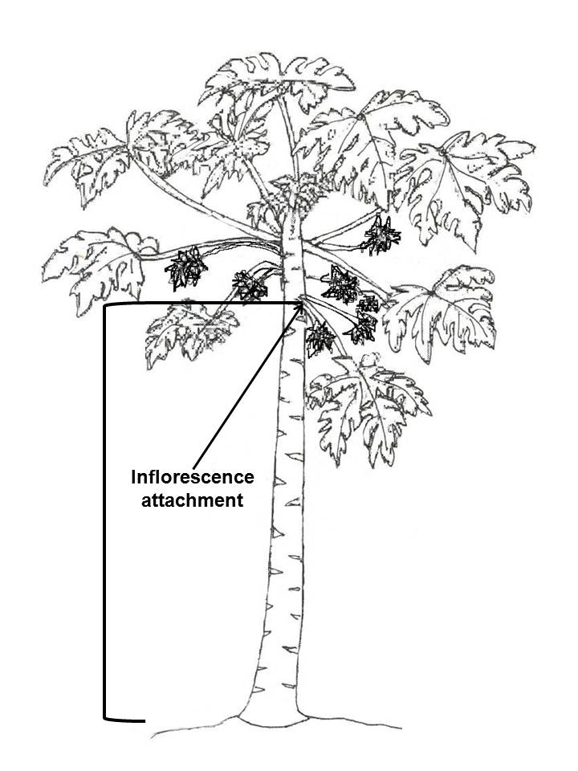

Ad. 3: Plant: branching

The branching should be observed at the beginning of flowering.

Ad. 4: Stem: diameter

The diameter should be observed half-way up the stem, at the beginning of flowering.

Ad. 5: Stem: number of nodes

The number of nodes should be observed from the ground up to the first flower.

Ad. 6: Stem: length of internode

The length of internode should be observed midway between the ground and the first inflorescence.

Ad. 7: Leaf blade: length
Ad. 8: Leaf blade: width

Ad. 9: Leaf: ratio length/width

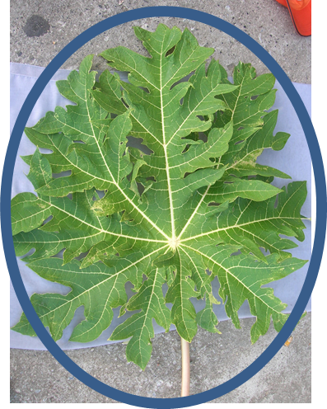 | 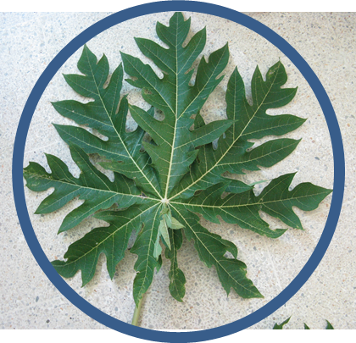 | 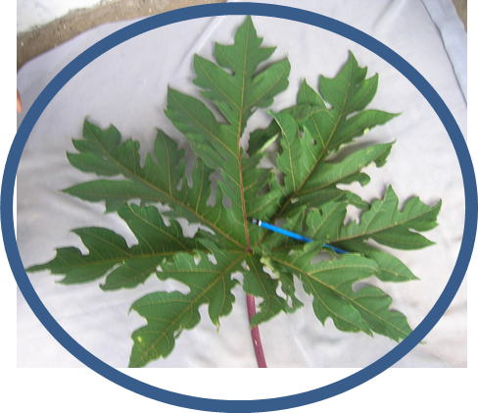
1  low to medium | 2  medium | 3  medium to high

Ad. 10: Leaf blade: presence of tertiary lobes

width
length
primary lobe
tertiary lobe

secondary lobe

Ad. 11: Leaf: presence of secondary leaf

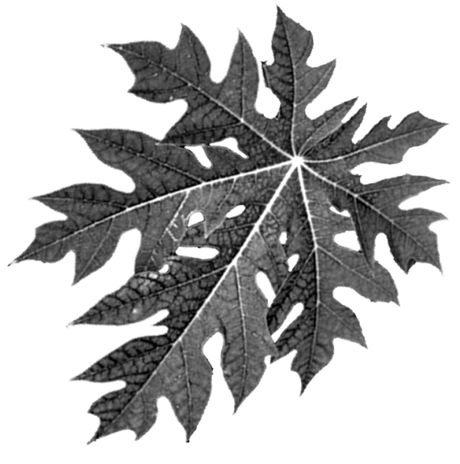 | 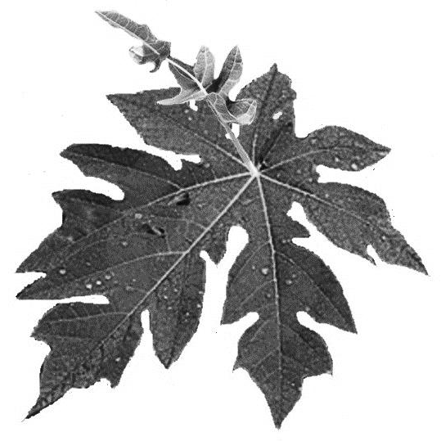
1 | 9
absent | present

Ad. 12: Leaf blade: pubescence on lower side

Observations on pubescence should be made with the aid of a magnifying glass.

Ad. 15: Time of flowering

The time of flowering should be determined when the first inflorescence had opened all their flowers.

Ad. 16: Inflorescence: number of flowers on hermaphrodite plants
Ad. 17: Inflorescence: number of flowers on female plants
Ad. 18: Inflorescence: length of main axis on hermaphrodite plants
Ad. 19: Inflorescence: length of main axis on female plants
Ad. 20: Inflorescence: anthocyanin coloration of axis on hermaphrodite plants
Ad. 21: Inflorescence: anthocyanin coloration of axis on female plants

The characteristics should be taken according to the presence or not of hermaphrodite or female plants in seedling varieties. For the case of vegetative propagated varieties the characteristics should be taken according to the sex of the variety.

Ad. 22: Flower: length of corolla

This characteristic only applies to hermaphrodite or female varieties. Observations on flower length should be made during the first flower opening, at the start of anther dehiscence in hermaphrodite varieties, and in the case of female varieties at midday.

Ad. 23: Flower: color of corolla

This characteristic applies to all types of plants, regardless of the sex. Observations on flower color should be made during the first flower opening.

Ad. 27: Fruit: ratio length/diameter

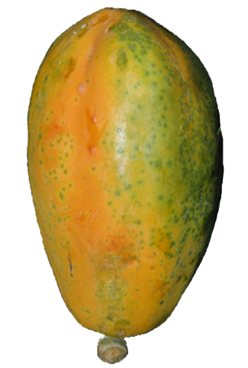 | 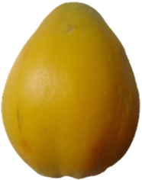
1  very low | 3  low | 5  low to medium

Ad. 28: Fruit: shape

 |  | < broadest part >
 |  | (below middle) | at middle | (above middle)
< lateral outline > | flat parallel sides |  | 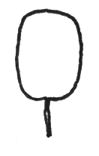  5  oblong
< lateral outline > | rounded | 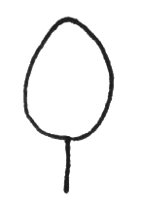  1  ovate | 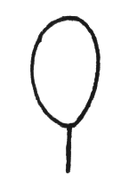  2  elliptic | 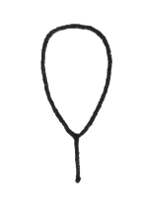  3  obovate
< lateral outline > | rounded with neck |  |  | 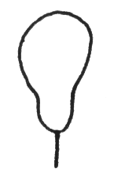  4  pyriform
< lateral outline > | Rounded with central constriction |  |  | 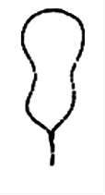  6  obovate waisted
Ad. 29: Fruit: shape of stalk end

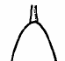 | 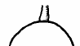 | 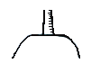 | 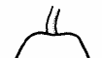
1 | 2 | 3 | 4
pointed | rounded | truncate | depressed

Ad. 31: Fruit: main color

The main color is the color with the largest surface area. In cases where the areas of the main and secondary color are too similar to reliably decide which color has the largest area the darkest color is considered to be the main color.

Ad. 32: Fruit: ridges

To be observed in transverse section.

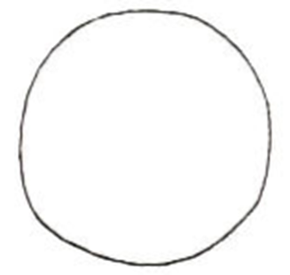 | 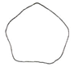 | 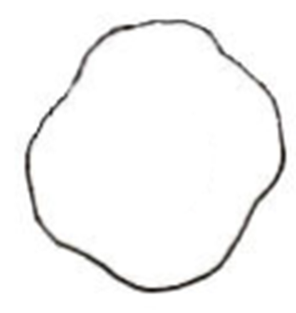 | 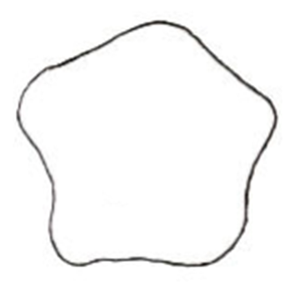
1 | 2 | 3 | 4
absent or very weak | weak | moderate | strong

Ad. 34: Fruit: thickness of skin

The thickness of the skin is observed in transverse section.

Ad. 37: Fruit: sweetness of flesh

To be measured by a refractometer as total soluble solids content.

Ad. 40: Fruit: width of central cavity

The width of the central cavity should be observed at the broadest part.

width | 

Ad. 41: Fruit: shape of central cavity

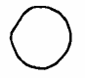 | 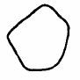 |  |  | 
1 | 2 | 3 | 4 | 5
circular | angular | stellate type 1 | stellate type 2 | irregular

Ad. 46: Seed: ratio length/width

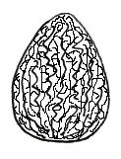
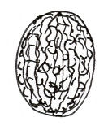

1  low to medium | 2  medium | 3  medium to high

Ad. 47: Seed: position of broadest part

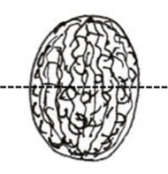 | 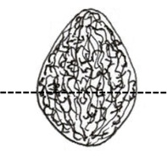 | 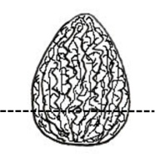
1 | 2 | 3
at middle | slightly towards base | strongly towards base

Ad. 48: Seed: amount of mucilage

The amount the mucilage must be determined visually by separating the mucilage from the seed.

Literature

IBPGR, 1988: Descriptors for Papaya. International Board for Plant Genetic Resources. Rome, IT, 34 pp.

Loyola, J.L.D., Pinto, R.M. de S., Lima, J.F. de, Ferreira, F.R. 2000: Catálogo de germoplasma de mamão (Carica papaya L.). Embrapa Mandioca e Fruticultura, Cruz das Almas, Bahia, BR, 40 pp.

Technical Questionnaire

TECHNICAL QUESTIONNAIRE |  |  |  | Page {x} of {y} |  | Reference Number:
 |  |  |  |  |  | Application date:
 |  |  |  |  |  | (not to be filled in by the applicant)
TECHNICAL QUESTIONNAIRE
to be completed in connection with an application for plant breeders’ rights

1. Subject of the Technical Questionnaire
1.1 Botanical name |  |  | Carica papaya L.
1.2 Common name |  |  | Papaya
2. Applicant
Name
Address
Telephone No.
Fax No.
E-mail address
Breeder (if different from applicant)
3. Proposed denomination and breeder’s reference
Proposed denomination
(if available)

Breeder’s reference
#4. Information on the breeding scheme and propagation of the variety

4.1 Breeding scheme

Variety resulting from:

4.1.1 Crossing

(a) controlled cross [ ]
(please state parent varieties)

(…………………..……………..…) x (……………..…………………..…)
female parent male parent

(b) partially known cross [ ]
(please state known parent variety(ies))

(…………………..……………..…) x (……………..…………………..…)
female parent male parent

(c) unknown cross [ ]

4.1.2 Mutation [ ]
(please state parent variety)

4.1.3 Discovery and development [ ]
(please state where and when discovered and how developed)

4.1.4 Other [ ]
(please provide details)

4.2 Method of propagating the variety

4.2.1 Seed-propagated varieties

(a) Cross-pollination

(b) Hybrid [ ]

(c) Other [ ]
(please provide details)

4.2.1 Vegetative propagation

(a) cuttings [ ]

(b) in vitro propagation [ ]

(c) other (state method) [ ]

4.2.3 Other [ ]
(please provide details)

5. Characteristics of the variety to be indicated (the number in brackets refers to the corresponding characteristic in Test Guidelines; please mark the note which best corresponds).

 | Characteristics |  |  |  |  |  | Example Varieties |  |  | Note
5.1  (2) | Plant: height of first inflorescence
 | very low |  |  |  |  |  |  |  |  | 1[ ]
 | very low to low |  |  |  |  |  |  |  |  | 2[ ]
 | low |  |  |  |  |  | Ishigaki Sango |  |  | 3[ ]
 | low to medium |  |  |  |  |  |  |  |  | 4[ ]
 | medium |  |  |  |  |  | Sunrise, Tainung Nº 1 |  |  | 5[ ]
 | medium to high |  |  |  |  |  |  |  |  | 6[ ]
 | high |  |  |  |  |  | Cera, Dampit, Simangko |  |  | 7[ ]
 | high to very high |  |  |  |  |  |  |  |  | 8[ ]
 | very high |  |  |  |  |  |  |  |  | 9[ ]
5.2  (9) | Leaf blade: ratio length/width
 | low to medium |  |  |  |  |  | Golden |  |  | 1[ ]
 | medium |  |  |  |  |  | Ishigaki Sango, Sunrise, Tainung Nº 1 |  |  | 2[ ]
 | medium to high |  |  |  |  |  | Johor |  |  | 3[ ]
5.3  (27) | Fruit: ratio length/diameter
 | very low |  |  |  |  |  | Eksotika, Sunrise |  |  | 1[ ]
 | very low to low |  |  |  |  |  |  |  |  | 2[ ]
 | low |  |  |  |  |  | Ishigaki Sango, Sekaki |  |  | 3[ ]
 | low to medium |  |  |  |  |  |  |  |  | 4[ ]
 | medium |  |  |  |  |  | Cera, Dampit |  |  | 5[ ]
 | Characteristics |  |  |  |  |  | Example Varieties |  |  | Note
5.4  (28) | Fruit: shape
 | ovate |  |  |  |  |  | Cariflora |  |  | 1[ ]
 | elliptic |  |  |  |  |  | Eksitika, Ishigaki Sango |  |  | 2[ ]
 | obovate |  |  |  |  |  | Du Roi Solo, Red Lady |  |  | 3[ ]
 | pyriform |  |  |  |  |  | Kapoho, Rainbow |  |  | 4[ ]
 | oblong |  |  |  |  |  | Amarela, Sekaki |  |  | 5[ ]
 | obovate waisted |  |  |  |  |  | BT-1 |  |  | 6[ ]
6. Similar varieties and differences from these varieties

Please use the following table and box for comments to provide information on how your candidate variety differs from the variety (or varieties) which, to the best of your knowledge, is (or are) most similar. This information may help the examination authority to conduct its examination of distinctness in a more efficient way.

Denomination(s) of variety(ies) similar to your candidate variety |  | Characteristic(s) in which your candidate variety differs from the similar variety(ies) |  |  | Describe the expression of the characteristic(s) for the similar variety(ies) |  |  | Describe the expression of the characteristic(s) for your candidate variety
Example |  | Fruit: shape |  |  | ovate |  |  | elliptic
Comments:

#7. Additional information which may help in the examination of the variety

7.1 In addition to the information provided in sections 5 and 6, are there any additional characteristics which may help to distinguish the variety?

Yes [ ] No [ ]

(If yes, please provide details)

7.2 Are there any special conditions for growing the variety or conducting the examination?

Yes [ ] No [ ]

(If yes, please provide details)

7.3 Other information

(Please provide the type of sex of the variety: female or hermaphrodite)

A representative color image of the variety should accompany the Technical Questionnaire.

8. Authorization for release

(a) Does the variety require prior authorization for release under legislation concerning the protection of the environment, human and animal health?

Yes [ ] No [ ]

(b) Has such authorization been obtained?

Yes [ ] No [ ]

If the answer to (b) is yes, please attach a copy of the authorization.

9. Information on plant material to be examined or submitted for examination.

9.1 The expression of a characteristic or several characteristics of a variety may be affected by factors, such as pests and disease, chemical treatment (e.g. growth retardants or pesticides), effects of tissue culture, different rootstocks, scions taken from different growth phases of a tree, etc.

9.2 The plant material should not have undergone any treatment which would affect the expression of the characteristics of the variety, unless the competent authorities allow or request such treatment. If the plant material has undergone such treatment, full details of the treatment must be given. In this respect, please indicate below, to the best of your knowledge, if the plant material to be examined has been subjected to:

(a) Microorganisms (e.g. virus, bacteria, phytoplasma) Yes [ ] No [ ]

(b) Chemical treatment (e.g. growth retardant, pesticide) Yes [ ] No [ ]

(c) Tissue culture Yes [ ] No [ ]

(d) Other factors Yes [ ] No [ ]

Please provide details for where you have indicated “yes”.

……………………………………………………………

10. I hereby declare that, to the best of my knowledge, the information provided in this form is correct:

Applicant’s name

Signature Date

[End of document]

* These names were correct at the time of the introduction of these Test Guidelines but may be revised or updated. [Readers are advised to consult the UPOV Code, which can be found on the UPOV Website (www.upov.int), for the latest information.]
# Authorities may allow certain of this information to be provided in a confidential section of the Technical Questionnaire.
# Authorities may allow certain of this information to be provided in a confidential section of the Technical Questionnaire.

