 |  |  |  |  |  |  | E  TG/163/4(proj.3)  ORIGINAL: English  DATE: 2013-03-14
INTERNATIONAL UNION FOR THE PROTECTION OF NEW VARIETIES OF PLANTS
Geneva
 |  |  | DRAFT
 |  | APPLE ROOTSTOCK  UPOV Code: MALUS  Malus Mill. |  |  | *

GUIDELINES

FOR THE CONDUCT OF TESTS

FOR DISTINCTNESS, UNIFORMITY AND STABILITY

prepared by an expert from South Africa

to be considered by the
Technical Working Party for Fruit Crops
at its forty-fourth session, to be held in Napier, New Zealand, from April 29 to May 3, 2013

Alternative Names:*

Botanical name | English | French | German | Spanish
Malus Mill. | Apple Rootstock | Porte-greffes de pommier | Apfel-Unterlagen | Portainjertos de manzano

The purpose of these guidelines (“Test Guidelines”) is to elaborate the principles contained in the General Introduction (document TG/1/3), and its associated TGP documents, into detailed practical guidance for the harmonized examination of distinctness, uniformity and stability (DUS) and, in particular, to identify appropriate characteristics for the examination of DUS and production of harmonized variety descriptions.

ASSOCIATED DOCUMENTS
These Test Guidelines should be read in conjunction with the General Introduction and its associated TGP documents.
TABLE OF CONTENTS PAGE

1. Subject of these Test Guidelines 3
2. Material Required 3
3. Method of Examination 3
3.1 Number of Growing Cycles 3
3.2 Testing Place 3
3.3 Conditions for Conducting the Examination 3
3.4 Test Design 3
3.5 Additional Tests 3
4. Assessment of Distinctness, Uniformity and Stability 4
4.1 Distinctness 4
4.2 Uniformity 5
4.3 Stability 5
5. Grouping of Varieties and Organization of the Growing Trial 5
6. Introduction to the Table of Characteristics 5
6.1 Categories of Characteristics 5
6.2 States of Expression and Corresponding Notes 6
6.3 Types of Expression 6
6.4 Example Varieties 6
6.5 Legend 7
7. Table of Characteristics/Tableau des caractères/Merkmalstabelle/Tabla de caracteres 8
8. Explanations on the Table of Characteristics 18
8.1 Explanations covering several characteristics 18
8.2 Explanations for individual characteristics 18
9. Literature 26
10. Technical Questionnaire 27

ANNEX OBSERVATIONS AND COMMENTS TO DOCUMENT TG/163/4(PROJ.3)

Subject of these Test Guidelines

These Test Guidelines apply to all vegetatively propagated rootstock varieties of Malus Mill..

Material Required

2.1 The competent authorities decide on the quantity and quality of the plant material required for testing the variety and when and where it is to be delivered. Applicants submitting material from a State other than that in which the testing takes place must ensure that all customs formalities and phytosanitary requirements are complied with.

2.2 The material is to be supplied in the form of one-year-old rooted trees, or in the form of one-year-old rooted plants (for stoolbeds).

2.3 The minimum quantity of plant material, to be supplied by the applicant, should be:

5 one-year-old rooted trees and/or
10 one-year-old rooted plants for stoolbeds

2.4 The plant material supplied should be visibly healthy, not lacking in vigor, nor affected by any important pest or disease. It should preferably not be obtained from in vitro propagation.

2.5 The plant material should not have undergone any treatment which would affect the expression of the characteristics of the variety, unless the competent authorities allow or request such treatment. If it has been treated, full details of the treatment must be given.

Method of Examination

3.1 Number of Growing Cycles

The minimum duration of tests should normally be two independent growing cycles.

3.2 Testing Place

Tests are normally conducted at one place. In the case of tests conducted at more than one place, guidance is provided in TGP/9 “Examining Distinctness”.

3.3 Conditions for Conducting the Examination

The tests should be carried out under conditions ensuring satisfactory growth for the expression of the relevant characteristics of the variety and for the conduct of the examination.

3.4 Test Design

3.4.1 Each test should be designed to result in a total of at least 5 plants.

3.4.2 The design of the tests should be such that plants or parts of plants may be removed for measurement or counting without prejudice to the observations which must be made up to the end of the growing cycle.

3.5 Additional Tests

Additional tests, for examining relevant characteristics, may be established.

Assessment of Distinctness, Uniformity and Stability

4.1 Distinctness

4.1.1 General Recommendations

It is of particular importance for users of these Test Guidelines to consult the General Introduction prior to making decisions regarding distinctness. However, the following points are provided for elaboration or emphasis in these Test Guidelines.

4.1.2 Consistent Differences

The differences observed between varieties may be so clear that more than one growing cycle is not necessary. In addition, in some circumstances, the influence of the environment is not such that more than a single growing cycle is required to provide assurance that the differences observed between varieties are sufficiently consistent. One means of ensuring that a difference in a characteristic, observed in a growing trial, is sufficiently consistent is to examine the characteristic in at least two independent growing cycles.

4.1.3 Clear Differences

Determining whether a difference between two varieties is clear depends on many factors, and should consider, in particular, the type of expression of the characteristic being examined, i.e. whether it is expressed in a qualitative, quantitative, or pseudo-qualitative manner. Therefore, it is important that users of these Test Guidelines are familiar with the recommendations contained in the General Introduction prior to making decisions regarding distinctness.

4.1.4 Number of Plants / Parts of Plants to be Examined

Unless otherwise indicated, all observations for the purposes of distinctness should be made on 5 plants or parts taken from each of 5 plants, disregarding any off-type plants. In the case of observations of parts of plants, the number of parts to be taken from each of the plants should be 2.

4.1.5 Method of Observation

The recommended method of observing the characteristic for the purposes of distinctness is indicated by the following key in the second column of the Table of Characteristics (see document TGP/9 “Examining Distinctness”, Section 4 “Observation of characteristics”):

MG: single measurement of a group of plants or parts of plants
MS: measurement of a number of individual plants or parts of plants
VG: visual assessment by a single observation of a group of plants or parts of plants
VS: visual assessment by observation of individual plants or parts of plants

Type of observation: visual (V) or measurement (M)

“Visual” observation (V) is an observation made on the basis of the expert’s judgment. For the purposes of this document, “visual” observation refers to the sensory observations of the experts and, therefore, also includes smell, taste and touch. Visual observation includes observations where the expert uses reference points (e.g. diagrams, example varieties, side-by-side comparison) or non-linear charts (e.g. color charts). Measurement (M) is an objective observation against a calibrated, linear scale e.g. using a ruler, weighing scales, colorimeter, dates, counts, etc.

Type of record: for a group of plants (G) or for single, individual plants (S)

For the purposes of distinctness, observations may be recorded as a single record for a group of plants or parts of plants (G), or may be recorded as records for a number of single, individual plants or parts of plants (S). In most cases, “G” provides a single record per variety and it is not possible or necessary to apply statistical methods in a plant-by plant analysis for the assessment of distinctness.

In cases where more than one method of observing the characteristic is indicated in the Table of Characteristics (e.g. VG/MG), guidance on selecting an appropriate method is provided in document TGP/9, Section 4.2.

4.2 Uniformity

4.2.1 It is of particular importance for users of these Test Guidelines to consult the General Introduction prior to making decisions regarding uniformity. However, the following points are provided for elaboration or emphasis in these Test Guidelines:

4.2.2 For the assessment of uniformity, a population standard of 1% and an acceptance probability of at least 95 % should be applied. In the case of a sample size of 5 plants, no off-type are allowed. In the case of a sample size of 10 plants 1 off type is allowed.

4.3 Stability

4.3.1 In practice, it is not usual to perform tests of stability that produce results as certain as those of the testing of distinctness and uniformity. However, experience has demonstrated that, for many types of variety, when a variety has been shown to be uniform, it can also be considered to be stable.

4.3.2 Where appropriate, or in cases of doubt, stability may be further examined by testing a new plant stock to ensure that it exhibits the same characteristics as those shown by the initial material supplied.

Grouping of Varieties and Organization of the Growing Trial

5.1 The selection of varieties of common knowledge to be grown in the trial with the candidate varieties and the way in which these varieties are divided into groups to facilitate the assessment of distinctness are aided by the use of grouping characteristics.

5.2 Grouping characteristics are those in which the documented states of expression, even where produced at different locations, can be used, either individually or in combination with other such characteristics: (a) to select varieties of common knowledge that can be excluded from the growing trial used for examination of distinctness; and (b) to organize the growing trial so that similar varieties are grouped together.

  - The following have been agreed as useful grouping characteristics:

(a) Plant: vigor (characteristic 1)
(b) Plant: habit (characteristic 4)
(c) Young leaf: extent of anthocyanin coloration (characteristic 19)
(d) Leaf blade: attitude in relation to shoots (characteristic 21)
(e) Leaf blade: incisions of margin (characteristic 27)

5.4 Guidance for the use of grouping characteristics, in the process of examining distinctness, is provided through the General Introduction and document TGP/9 “Examining Distinctness”.

Introduction to the Table of Characteristics

6.1 Categories of Characteristics

6.1.1 Standard Test Guidelines Characteristics

Standard Test Guidelines characteristics are those which are approved by UPOV for examination of DUS and from which members of the Union can select those suitable for their particular circumstances.

6.1.2 Asterisked Characteristics

Asterisked characteristics (denoted by *) are those included in the Test Guidelines which are important for the international harmonization of variety descriptions and should always be examined for DUS and included in the variety description by all members of the Union, except when the state of expression of a preceding characteristic or regional environmental conditions render this inappropriate.

6.2 States of Expression and Corresponding Notes

6.2.1 States of expression are given for each characteristic to define the characteristic and to harmonize descriptions. Each state of expression is allocated a corresponding numerical note for ease of recording of data and for the production and exchange of the description.

6.2.2 In the case of qualitative and pseudo-qualitative characteristics (see Chapter 6.3), all relevant states of expression are presented in the characteristic. However, in the case of quantitative characteristics with 5 or more states, an abbreviated scale may be used to minimize the size of the Table of Characteristics. For example, in the case of a quantitative characteristic with 9 states, the presentation of states of expression in the Test Guidelines may be abbreviated as follows:

State | Note
small | 3
medium | 5
large | 7

However, it should be noted that all of the following 9 states of expression exist to describe varieties and should be used as appropriate:

State | Note
very small | 1
very small to small | 2
small | 3
small to medium | 4
medium | 5
medium to large | 6
large | 7
large to very large | 8
very large | 9

6.2.3 Further explanation of the presentation of states of expression and notes is provided in document TGP/7 “Development of Test Guidelines”.

6.3 Types of Expression

An explanation of the types of expression of characteristics (qualitative, quantitative and pseudo qualitative) is provided in the General Introduction.

6.4 Example Varieties

Where appropriate, example varieties are provided to clarify the states of expression of each characteristic.

Example varieties are marked according to regions: South Africa ¹, China (Asia)², Germany, France (Europe)³ New Zealand⁴
When marked in bold two or more regions have the same example variety for the same state of expression

6.5 Legend

(*) Asterisked characteristic – see Chapter 6.1.2

QL Qualitative characteristic – see Chapter 6.3
QN Quantitative characteristic – see Chapter 6.3
PQ Pseudo-qualitative characteristic – see Chapter 6.3

MG, MS, VG, VS – see Chapter 4.1.5

A - Applies only for stoolbeds

B - Applies only for fully grown trees

(a)-(f) See Explanations on the Table of Characteristics in Chapter 8.1

(+) See Explanations on the Table of Characteristics in Chapter 8.2

Table of Characteristics/Tableau des caractères/Merkmalstabelle/Tabla de caracteres

 |  | English | français | deutsch | español | Example Varieties  Exemples  Beispielssorten  Variedades ejemplo | Note/  Nota
1.  (*)  (+) | VG | Plant: vigor
QN | (a) | very weak |  |  |  | CG 222¹ | 1
 |  | weak |  |  |  | J-TE-F^{3,} M 9⁴, M 26¹⁴, M 27⁴ | 2
 |  | medium |  |  |  | B9³, CG202⁴, J-TE-H³,  JM7⁴, M 7¹ | 3
 |  | strong |  |  |  | M 793¹, MM 106⁴ | 4
 |  | very strong |  |  |  | CG 934¹ | 5
2.  B | VG | Plant: number of branches
QN | (a) | very few |  |  |  | G 222¹, M 27⁴ | 1
 |  | few |  |  |  | M 9¹⁴ | 3
 |  | medium |  |  |  | JM7, M 26¹⁴ | 5
 |  | many |  |  |  | CG202¹⁴, G 707¹,  MM 106⁴ | 7
 |  | very many |  |  |  | M 25¹⁴ | 9
3.  A | VG | Plant: number of shoots
QN | (a) | very few |  |  |  |  | 1
 |  | few |  |  |  | M 9 | 2
 |  | medium |  |  |  | Joha³, Lancep³, M 26, P22(Last Minute)³, Supporter 1³ | 3
 |  | many |  |  |  | MM 111 | 4
 |  | very many |  |  |  | M 25 | 5
4.  (*)  (+) | VG | Plant: habit
PQ | (a) | upright |  |  |  | CG202⁴, M 7¹, M116⁴ | 1
 |  | upright to spreading |  |  |  | CG707¹ | 2
 |  | spreading |  |  |  | Cepiland⁴, CG 222¹, M 9³, M116⁴ | 3
 |  | drooping |  |  |  | Marubakaido¹ | 4
 |  | weeping |  |  |  |  | 5
5.  B | VG | Plant: spines
QN | (b) | absent or few |  |  |  | M 9¹ | 1
 |  | medium |  |  |  | M 25¹ | 2
 |  | many |  |  |  | CG 202¹⁴ | 3
6.  (*)  (+) | VG | One-year-old shoot: growth
QN | (a) | straight |  |  |  | M 9¹³⁴ | 1
 |  | moderately wavy |  |  |  | CG 202¹⁴, Mark³, M 26³, M 793¹, Supporter 1³ | 2
 |  | strongly wavy |  |  |  | M 25¹ | 3
7.  (*)  (+) | VG | One-year-old shoot: pubescence
QN | (b) | absent or very weak |  |  |  |  | 1
 |  | weak |  |  |  | B 9³ | 2
 |  | medium |  |  |  | M 27³, M 793¹ | 3
 |  | strong |  |  |  | Joha³, M 9¹³⁴ | 4
 |  | very strong |  |  |  | Crab C, MM106¹ | 5
8.  (*) | VG | One-year-old shoot: glossiness
QN | (b) | absent or weak |  |  |  | JM7⁴ | 1
 |  | medium |  |  |  | CG202¹⁴, M 26³ | 3
 |  | strong |  |  |  | M 27¹⁴ | 5
9.  (*) | VG/MG | One-year-old shoot: thickness
QN | (b) | thin |  |  |  | M 7¹ | 1
 |  | medium |  |  |  | B 9³, Mark³, MM106⁴ | 2
 |  | thick |  |  |  | Lizzy³ | 3
10.  (*) | VG/MG | One-year-old shoot: length of internodes
QN | (b) | short |  |  |  | J-TE-H³, M 25¹, M27⁴ | 1
 |  | medium |  |  |  | M 26¹, M116⁴,  P22(Last Minute)³ | 2
 |  | long |  |  |  | CG 707¹ | 3
11.  (*) | VG | One-year-old shoot: number of lenticels
QN | (b) | very few |  |  |  |  | 1
 |  | few |  |  |  | M 9¹⁴, J-TE-F³, Lancep³ | 2
 |  | medium |  |  |  | Mark³, M 5³, M 26³, M 793¹, Supporter 1³ | 3
 |  | many |  |  |  | CG 10³, M 2³, MM 111¹ | 4
 |  | very many |  |  |  | MM 104 | 5
12. | VG | One-year-old shoot: size of lenticels
QN | (b) | small |  |  |  | CG 6210¹, J-TE-F³ | 1
 |  | medium |  |  |  | B 9³, CG202⁴, Joha³, Lizzy³, M 9¹ | 2
 |  | large |  |  |  | MM107¹ | 3
13.  (*) | VG | One-year-old shoot: color on sunny side
PQ | (b) | greenish brown |  |  |  | M9¹⁴, M 4³ | 1
 |  | reddish brown |  |  |  | Lizzy³, JM7⁴, Mark³, M 27¹⁴ | 2
 |  | medium brown |  |  |  | J-TE-H³,M 25¹, M 27³ | 3
 |  | dark brown |  |  |  | B 9³, M 2³, M 26¹³, MM106¹³ | 4
14.  (*) | VG | One-year-old shoot: size of vegetative bud
QN | (b) | small |  |  |  | J-TE-H³, M 25¹, MM106⁴, MM 111 | 1
 |  | medium |  |  |  | CG202¹⁴, M 26³, M27⁴ | 2
 |  | large |  |  |  | M 9¹³⁴, M 27 | 3
15.  (+) | VG | One-year-old shoot: shape of apex of vegetative bud
PQ | (b) | acute |  |  |  | CG 10³, JM7⁴, J-TE-H³, M 9¹ | 1
 |  | obtuse |  |  |  | Mark³, M 793¹,  P22(Last Minute)³, Supporter 1³ | 2
 |  | rounded |  |  |  | Bemali, M 7¹³, MM 111, MM116⁴ | 3
16.  A  (+) | VG | One-year-old shoot: position of vegetative bud in relation to shoot
QN | (b) | adpressed |  |  |  | JM7⁴, M 7¹, MM 106⁴ | 1
 |  | slightly held out |  |  |  | M 9¹⁴ | 2
 |  | strongly held out |  |  |  | Cepiland³, M 2³, M 4³ | 3
17.  (+) | VG | One-year-old shoot: size of vegetative bud support
QN | (b) | small |  |  |  | JM7⁴, M 9¹⁴ | 1
 |  | medium |  |  |  | M 7¹³, P22(Last Minute)³ | 2
 |  | large |  |  |  | Mark³, M 2³, MM106¹⁴ | 3
18.  (*)  (+) | VG | Young shoot: color of upper part
PQ | (c) | whitish |  |  |  | M 25, M116⁴ | 1
 |  | greenish |  |  |  | M 2, M 27, MM 106¹⁴ | 2
 |  | reddish |  |  |  | M 9¹⁴ | 3
 |  | blackish |  |  |  | B 9, M 10, M 26¹ | 4
19.  (*) | VG | Young leaf: extent of anthocyanin coloration
QN | (c) | absent or very small |  |  |  | M 27¹, MM116 | 1
 |  | small |  |  |  | CG 222¹ | 2
 |  | medium |  |  |  | CG 202¹ | 3
 |  | large |  |  |  | M7¹ | 4
 |  | very large |  |  |  | B 9, Marubakaido¹ | 5
20.  (*) | VG | Young leaf: hue of anthocyanin coloration
QL | (c) | reddish brown |  |  |  | M 7¹, P 22 | 1
 |  | purple |  |  |  | B 9 | 2
21.  (*)  (+) | VG | Leaf blade: attitude in relation to shoot
QN | (d) | upwards |  |  |  | J-TE-E³, M 27³, M 793¹, M116⁴ | 1
 |  | outwards |  |  |  | CG202⁴, CG 707¹, M 7¹, MM 106⁴ | 2
 |  | downwards |  |  |  | CG 778¹, JM7⁴ | 3
22.  (*) | VG/MS | Leaf blade: length
QN | (d) | short |  |  |  | M 26¹³, M 27³ | 3
 |  | medium |  |  |  | M 793¹ | 5
 |  | long |  |  |  | B 9³, CG 778¹, M 9³ | 7
23.  (*) | VG/MS | Leaf blade: width
QN | (d) | narrow |  |  |  | M 26¹ | 3
 |  | medium |  |  |  | M 9¹, M 27³ | 5
 |  | broad |  |  |  | CG 778¹, P 14 | 7
24.  (*) | VG/MS | Leaf blade: ratio length/width
QN | (d) | very slightly elongated |  |  |  | M 25¹ | 1
 |  | slightly elongated |  |  |  | CG 222¹, M 7¹³, M 27³ | 2
 |  | moderately elongated |  |  |  | MM 111¹,  P22(Last Minute)³, Supporter 1³ | 3
 |  | strongly elongated |  |  |  | CG 778¹ | 4
 |  | very strongly elongated |  |  |  | M 9¹ | 5
25.  (*) | VG | Leaf blade: profile in cross section
QN | (d) | concave |  |  |  | CG778¹, M 27³, M116⁴ | 1
 |  | flat |  |  |  | CG 707¹, M 7¹³, M 9¹³⁴ | 2
 |  | convex |  |  |  | M 25 | 3
26. | VG | Leaf blade: length of tip
QN | (d) | short |  |  |  | M 26¹³, M116⁴ | 1
 |  | medium |  |  |  | CG202¹⁴ , MM 106³ | 2
 |  | long |  |  |  | CG 4214¹, P 16³ , P22(Last Minute)³ | 3
27.  (*)  (+) | VG | Leaf blade: incisions of margin
PQ | (d) | crenate |  |  |  | CG 707¹, J 9³, JM74 | 1
 |  | bicrenate |  |  |  | CG 222¹, J-TE-G³, M 7¹, M 793¹ | 2
 |  | serrate type 1 |  |  |  | J-TE-H³, M 9³, MM 109¹,  M 274 | 3
 |  | serrate type 2 |  |  |  | J-TE-A³ | 4
 |  | biserrate |  |  |  | CG 778¹, MM 106¹, MM 112³, MM 114³ | 5
28. | VG | Leaf blade: depth of incisions of margin
QN | (d) | very shallow |  |  |  | M 26¹ | 1
 |  | shallow |  |  |  | CG 4204¹ | 2
 |  | medium |  |  |  | CG 707¹ | 3
 |  | deep |  |  |  | CG 778¹ | 4
 |  | very deep |  |  |  |  | 5
29.  (*) | VG | Leaf blade: undulation of margin
QN | (d) | absent or very weak |  |  |  | CG 222², CG 778¹², MM 105³, Pi 80³ | 1
 |  | weak |  |  |  | M 9¹², MM 106¹³, MM 110³ | 2
 |  | medium |  |  |  | Cepiland¹³, J-TE-H³, M 7¹², M 26¹² | 3
 |  | strong |  |  |  | CG 24³, CG 6210¹², M 18³ | 5
30. | VG | Leaf blade: pubescence on lower side
QN | (d) | weak |  |  |  | CG202⁴, M 7³, M 9¹ | 1
 |  | medium |  |  |  | M 27¹, Lizzy³, Supporter³ | 2
 |  | strong |  |  |  | MM 106¹ | 3
31.  (*) | VG | Leaf blade: glossiness of upper side
QN | (d) | absent or very weak |  |  |  | CG 707², M 16³, M 26¹², MM 114³, P 60³ | 1
 |  | weak |  |  |  | MM 106¹², MM 111³ | 2
 |  | medium |  |  |  | M 9¹², M 14³, M 17³, MM 106³ | 3
 |  | strong |  |  |  | CG 4202¹², Marubakaido¹², M 9³, MM 102³, MM 110³, MM 112³, Pi-AU 9-24³ | 5
32.  (*) | VG | Leaf blade: intensity of green color
QN | (d) | light |  |  |  | CG 778¹², J-TE-G³, M 7¹² | 1
 |  | medium |  |  |  | CG 24³, CG 707¹², M 9¹²³ | 3
 |  | dark |  |  |  | CG 10³, M 26¹²³, MM 109¹², P 60³ | 5
33.  (*) | VG/MS | Petiole: length
QN | (d) | short |  |  |  | M 26¹, M 27³ | 1
 |  | medium |  |  |  | JM7⁴, M 9¹³ | 3
 |  | long |  |  |  | CG 707¹, MM 106³ | 5
34.  (*)  (+) | VG/MG | Leaf: length of petiole relative to blade
QN | (d) | short |  |  |  | M 7¹ | 1
 |  | medium |  |  |  | B 9, CG 202¹⁴, M 9 | 3
 |  | long |  |  |  | CG 778¹, P 2, P 16 | 5
35.  (+) | VG | Petiole: extent of anthocyanin coloration from base
QN | (d) | small |  |  |  | CG 222¹, J-TE-F³, M 9 | 1
 |  | medium |  |  |  | CG 778¹, M 9³, M 14³ | 2
 |  | large |  |  |  | B-9², CG 10³, Marubakaido¹ | 3
36.  (*) | VG | Stipule: size
QN | (d) | small |  |  |  | M 27¹³ | 1
 |  | medium |  |  |  | M 9¹³ | 2
 |  | large |  |  |  | MM 106¹³ | 3
37.  (+) | VG | Flower presence
QN | (e) | absent or few |  |  |  | Marubakaido¹ | 1
 |  | medium |  |  |  | M 7¹ | 2
 |  | many |  |  |  | CG 707¹ | 3
38.  B  (+) | VG | Flower: color at balloon stage
PQ | (e) | white |  |  |  |  | 1
 |  | whitish yellow |  |  |  |  | 2
 |  | light pink |  |  |  | CG 80³, JM7⁴, M 7¹², M 27² | 3
 |  | medium pink |  |  |  | J-TE-F³, M 9¹² | 4
 |  | medium red |  |  |  | CG 707¹, Supporter 1³ | 5
 |  | dark red |  |  |  | B 9³, CG 228¹ | 6
 |  | purple |  |  |  | B 9², J 9³ | 7
39.  B  (+) | VG | Flower: arrangement of petals
QN | (e) | free |  |  |  | Cepiland¹³, M 9¹² | 1
 |  | intermediate |  |  |  | M 7¹² | 2
 |  | overlapping |  |  |  | CG 222¹, JM7⁴, J-TE-B³, M 27² | 3
40.  B  (+) | VG | Flower: diameter
QN | (e) | very small |  |  |  | CG 228¹ | 1
 |  | small |  |  |  | M 793¹ | 2
 |  | medium |  |  |  | CG 707¹ | 3
 |  | large |  |  |  | M 27¹ | 4
41.  B  (+) | VG | Flower: position of stigmas relative to anthers
QN | (e) | below |  |  |  |  | 1
 |  | same level |  |  |  | M 7¹, P 92³ | 2
 |  | above |  |  |  | CG 228¹, J-TE-B³, M 793¹ | 3
42.  B | VG | Fruit: size
QN | (f) | very small |  |  |  | JM7⁴ | 1
 |  | small |  |  |  | CG202⁴, CG 222¹,  J-TE-F³ | 3
 |  | medium |  |  |  | J-TE-H³, M 7¹, M 793¹ | 5
 |  | large |  |  |  | M 9³, MM 109¹ | 7
 |  | very large |  |  |  | MM106⁴ | 9
43.  B  (+) | VG | Fruit: ratio length/ width
QN | (f) | very low |  |  |  | M 793¹ | 1
 |  | low |  |  |  | M 26¹ | 2
 |  | medium |  |  |  | M 7¹ | 3
 |  | high |  |  |  | CG 222¹ | 4
44.  B  (+) | VG | Fruit: shape
PQ | (f) | cylindrical waisted |  |  |  |  | 1
 |  | conic |  |  |  |  | 2
 |  | ovate |  |  |  | P22(Last Minute)³ | 3
 |  | cylindric |  |  |  |  | 4
 |  | oblate |  |  |  | M 793¹ | 5
 |  | circular |  |  |  | Bemali³, JM7⁴ | 6
 |  | elliptic |  |  |  | M 11³ | 7
45.  B | VG | Fruit: ribbing
QN | (f) | absent or very weak |  |  |  | Bemali³, CG 778¹ | 1
 |  | weak |  |  |  | CG 24³, CG 228¹ | 2
 |  | medium |  |  |  | CG 80³ | 3
 |  | strong |  |  |  | CG 222¹, Lancep³ | 5
46.  B | VG | Fruit: crowning at calyx end
QN | (f) | absent or very weak |  |  |  | CG 707¹, M 3³ | 1
 |  | weak |  |  |  | G 228¹, J-TE-A³ | 2
 |  | medium |  |  |  | Joha³, MM 106¹ | 3
 |  | strong |  |  |  | CG 80³, CG 222¹ | 5
47.  B | VG | Fruit: ground color
PQ | (f) | not visible |  |  |  | B9³ | 1
 |  | whitish yellow |  |  |  | CG 778¹, M 8³ | 2
 |  | yellow |  |  |  | CG202⁴, M 9¹⁴, M26⁴, MM106⁴, P 92³ | 3
 |  | whitish green |  |  |  | CG 24³, CG 228¹ | 4
 |  | yellow green |  |  |  | M 1³, M 793¹ | 5
 |  | green |  |  |  | M 5³ | 6
48.  B  (+) | VG | Fruit: hue of over color
PQ | (f) | orange red |  |  |  | M 26³ | 1
 |  | pink red |  |  |  | CG 228¹, P 47³, P 60³ | 2
 |  | red |  |  |  | CG 222¹, CG 707¹ | 3
 |  | purple red |  |  |  | MM 102³ | 4
 |  | brown red |  |  |  | Mark³ | 5
49.  B  (+) | VG | Fruit: relative area of over color
QN | (f) | absent or very small |  |  |  | JM7⁴, MM 109¹, MM 115³ | 1
 |  | small |  |  |  | CG 228¹, MM 105³, MM116⁴ | 3
 |  | medium |  |  |  | CG 707¹, MM 104³ | 5
 |  | large |  |  |  | M 26³, M 793¹ | 7
 |  | very large |  |  |  | B 6³ | 9
50.  B | VG | Fruit: length of stalk
QN | (f) | very short |  |  |  | M 793¹,  P22(Last Minute)³ | 1
 |  | short |  |  |  | CG 778¹, P 92³ | 3
 |  | medium |  |  |  | MM 109¹, P 1³ | 5
 |  | long |  |  |  | CG 228¹, JM7⁴, SU57233³ | 7
 |  | very long |  |  |  | CG 707¹, Supporter 1³ | 9
51.  B  (+) | VG | Fruit: aperture of locules in transverse section
QN | (f) | closed or slightly open |  |  |  | M 5³, M 7¹ | 1
 |  | moderately open |  |  |  | G 228¹,  P22(Last Minute)³ | 2
 |  | fully open |  |  |  | J-TE-F³,  MM 109¹ | 3
52.  (*)  (+) | VG/MG | Time of beginning of bud burst
QN |  | very early |  |  |  | CG202¹⁴ | 1
 |  | early |  |  |  | M 4³, M 9¹ | 3
 |  | medium |  |  |  | B 9³, Cepiland³, M 25¹ | 5
 |  | late |  |  |  | MM 111¹,  P22(Last Minute)³ | 7
 |  | very late |  |  |  | M 26¹³ | 9
53.  B  (+) | VG/MG | Time of beginning of flowering
QN |  | very early |  |  |  | CG202¹ | 1
 |  | early |  |  |  | G 707¹ | 3
 |  | medium |  |  |  | M25¹ | 5
 |  | late |  |  |  | M 7¹, MM 111¹ | 7
 |  | very late |  |  |  | M 26¹ | 9

Explanations on the Table of Characteristics

8.1 Explanations covering several characteristics

Characteristics containing the following key in the second column of the Table of Characteristics should be examined as indicated below:

(a) Plant: All observations on the plant should be made in the dormant season.

(b) One-year-old shoot: All observations of the shoot should be made on the middle third of the one-year-old shoot in the dormant season.

(c) Young shoot and Young leaf: All observation on the young leave and young shoot should be made on the upper third of the one year old shoot during rapid growth.

(d) Leaf: All observations on the leave should be made on fully developed leaves from the middle third of vigorous current season shoots.

(e) Flower: All observations on the flower should be done on fully grown trees. Observations on the flower should be made on the second or subsequent flowers, at the start of dehiscence.

(f) Fruit: All observations on the fruit should be done on fully grown trees. All observations of the fruit should be made on 10 typical fruits taken from a minimum sample of 20 fruits, at time of visual ripeness.

8.2 Explanations for individual characteristics

Ad. 1: Plant: vigor

The vigor of the plant should be considered as the overall abundance of vegetative growth.

Ad. 4: Plant: habit

Plants in stoolbeds should be assessed on the overall growth habit of the plants.

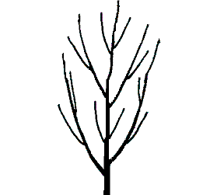 | 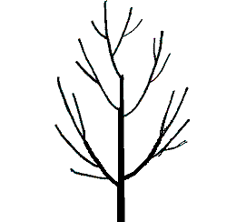 | 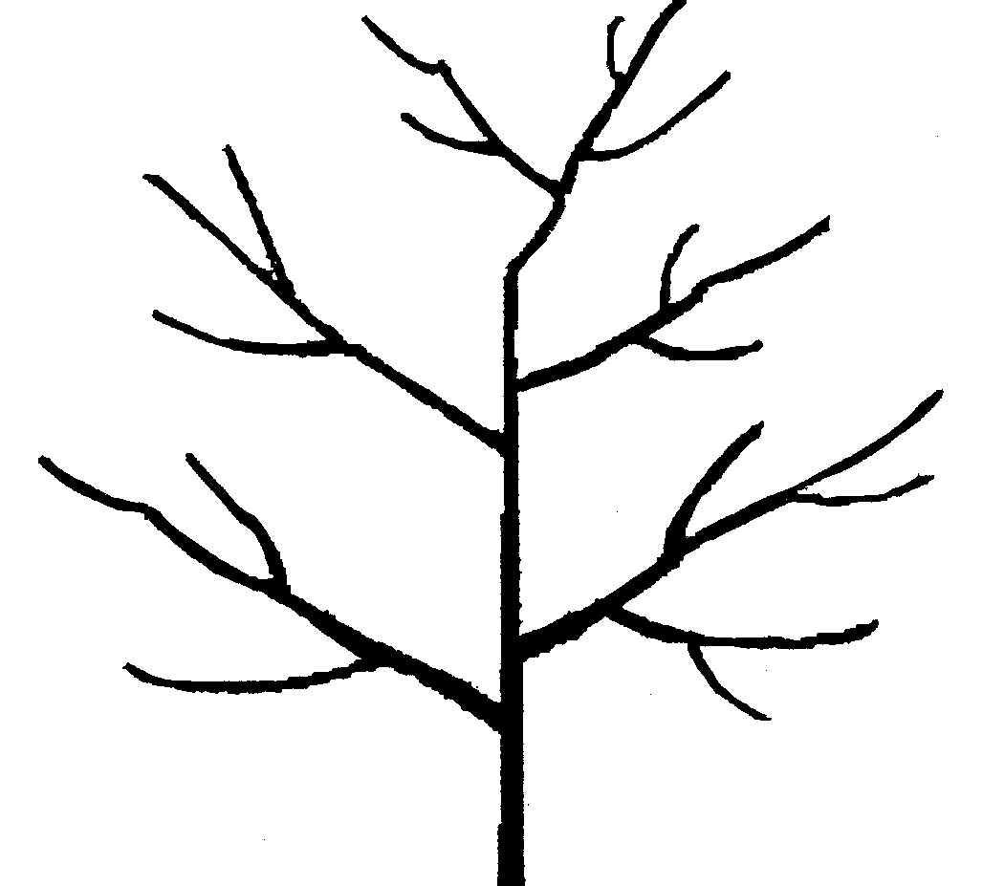
1 | 2 | 3
upright | upright to spreading | spreading

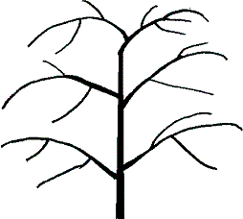 | 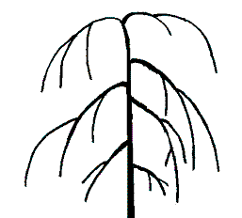
4 | 5
drooping | weeping

Ad. 6: One-year- old shoot: growth

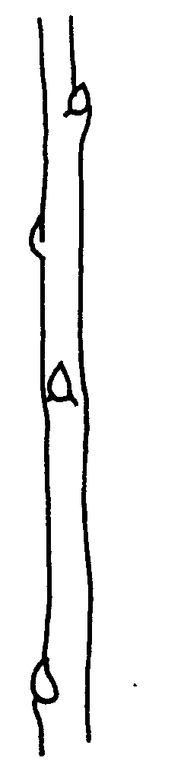 | 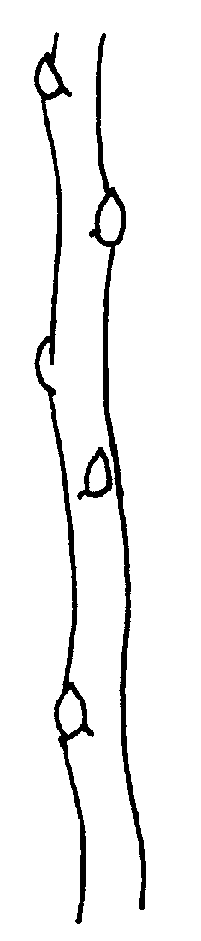 | 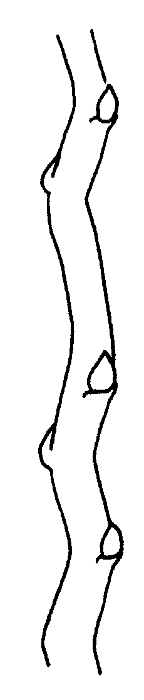
1 | 2 | 3
straight | moderately wavy | strongly wavy

Ad. 7: One-year-old shoot: pubescence

The pubescence should be observed on the distal half of the shoot.

Ad. 15: One-year-old shoot: shape of tip of vegetative bud

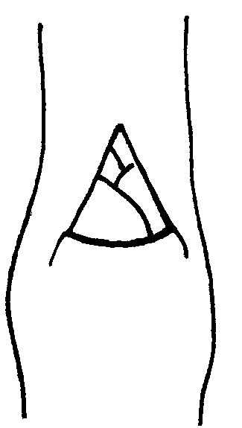 | 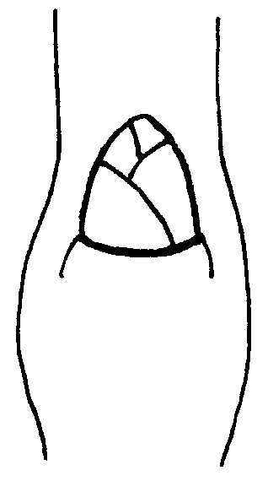 | 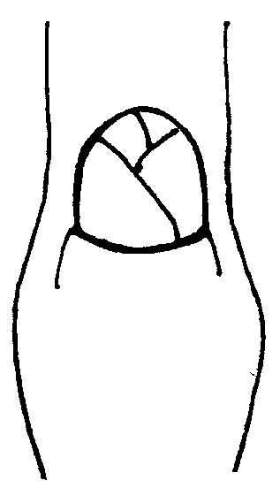
1 | 2 | 3
acute | obtuse | rounded

Ad. 16: One-year-old shoot: position of vegetative bud in relation to shoot

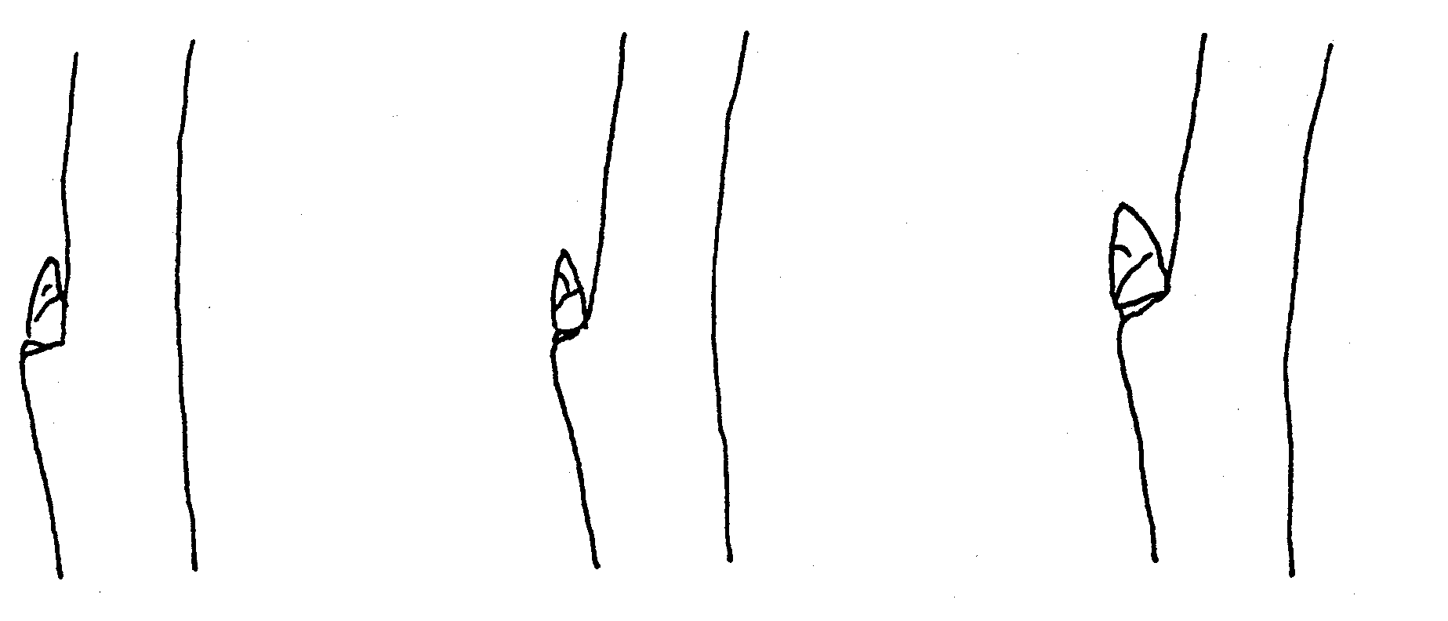
1 | 2 | 3
adpressed | slightly held out | strongly held out

Ad. 17: One-year-old shoot: size of vegetative bud support

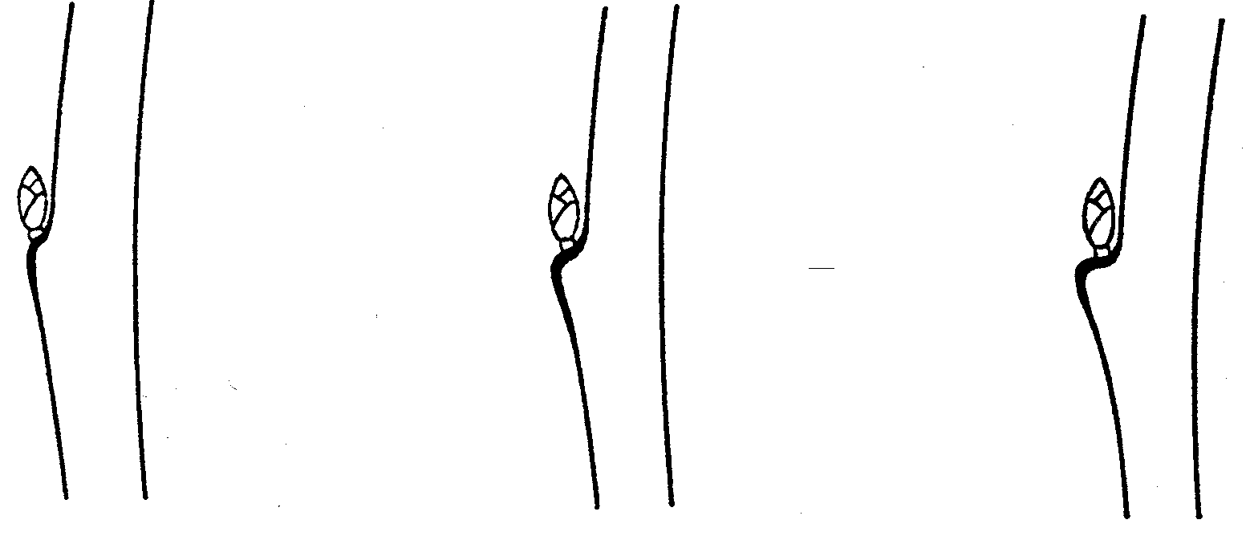
1 | 2 | 3
small | medium | large

Ad. 18: Young shoot: color of upper part

All observations should be made on the upper third of lateral shoots during full growth. The color observed should be of the underlying skin underneath the pubescence.

Ad. 21: Leaf blade: attitude in relation to shoot

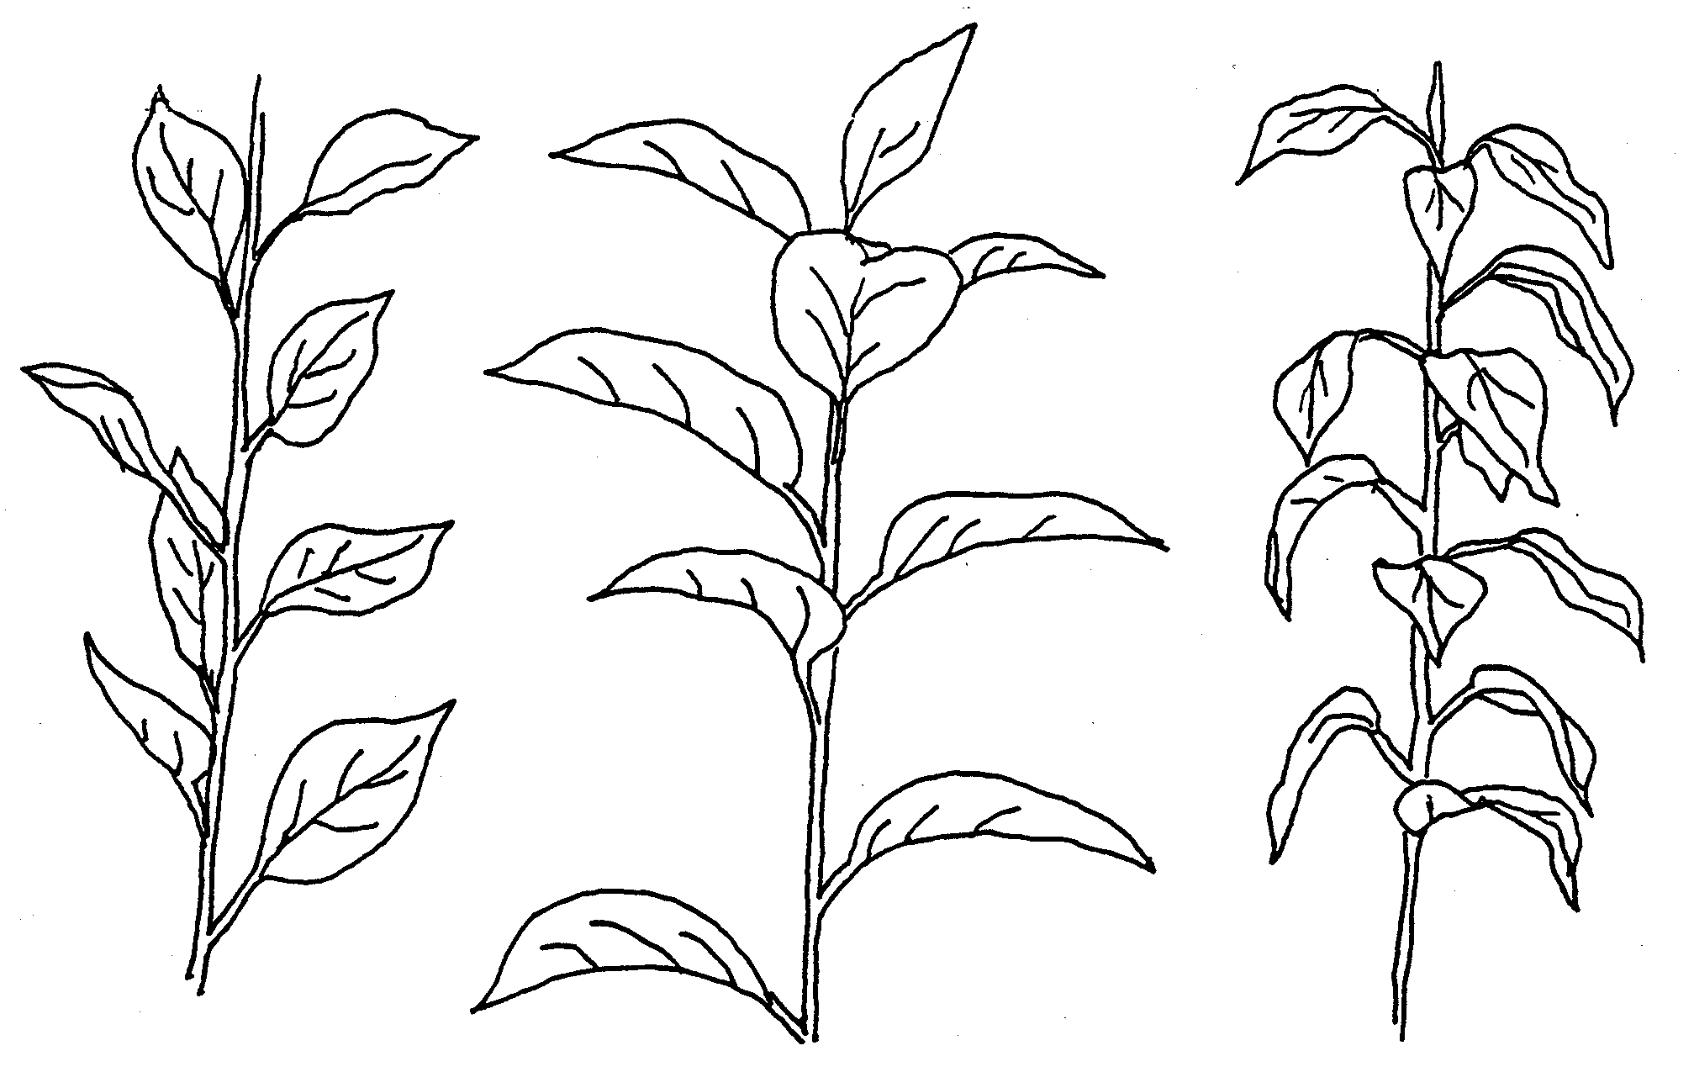
1 | 2 | 3
upwards | outwards | downwards

Ad. 27: Leaf blade: incisions of margin

Observations should be done on the upper half of the leaf blade.

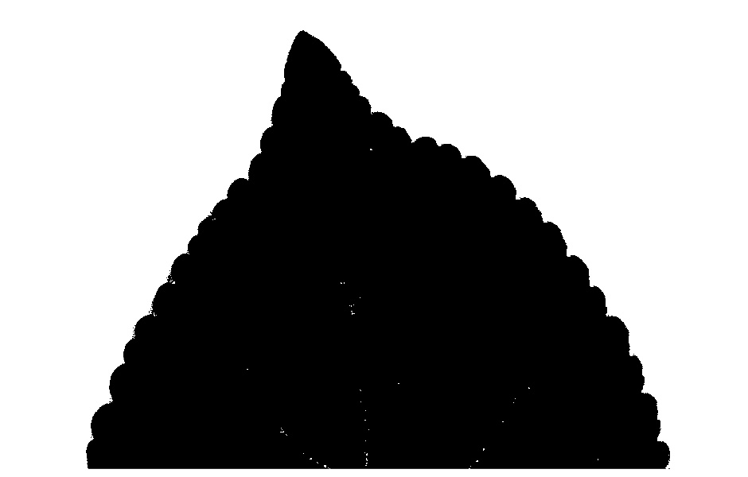 | 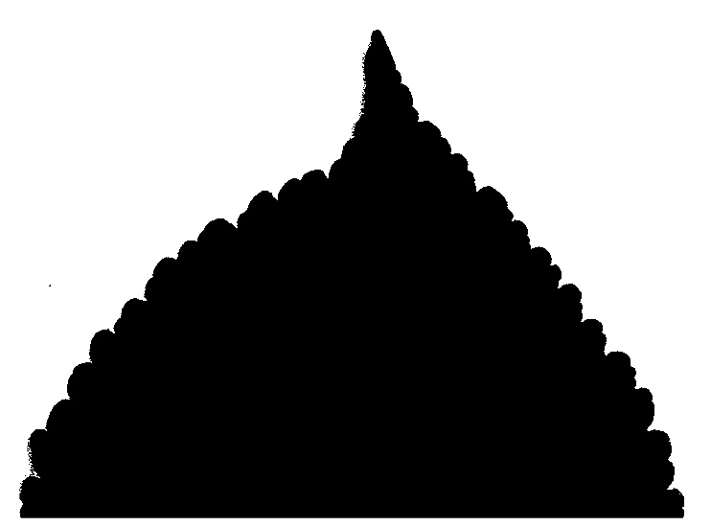
1 | 2
crenate | bicrenate

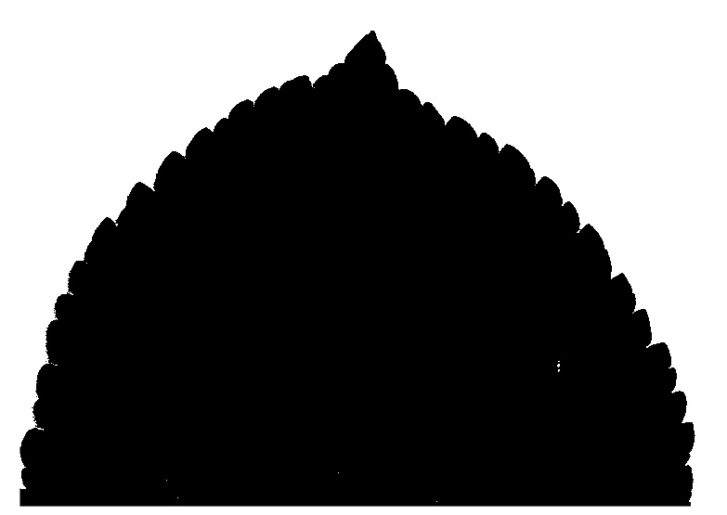 | 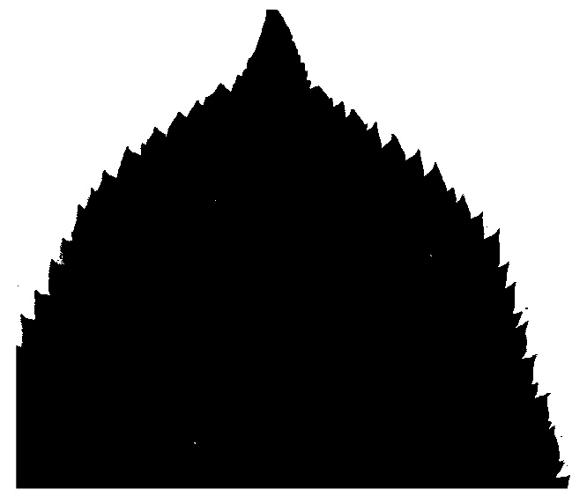
3 | 4
serrate type 1 | serrate type 2

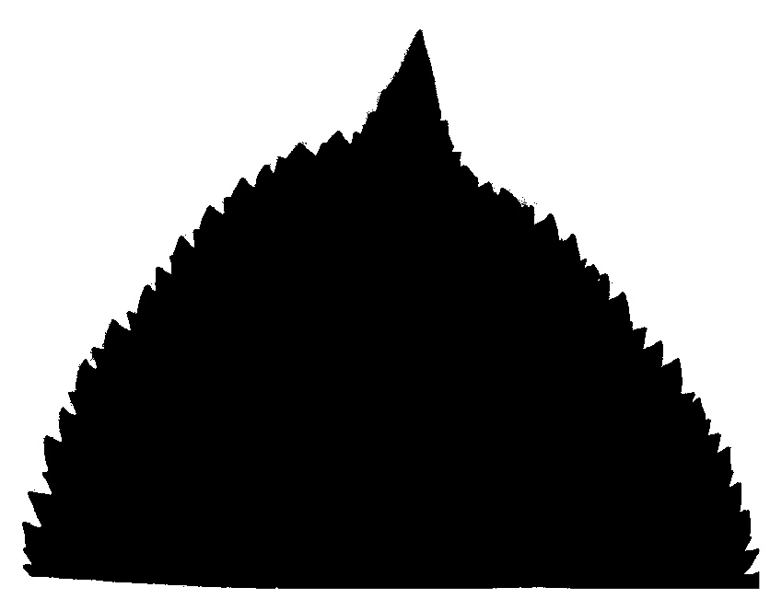
5
biserrate

Ad. 34: Leaf: length of petiole relative to blade

Should be assessed regarding the length of the petiole compared to the length of the middle vein of the leaf.

Ad. 35: Petiole: extent of anthocyanin coloration from base

Should be assessed regarding the degree to which the amount of anthocyanin coloration extend from the petiole base towards the base of the leaf.

Ad. 37: Flower: presence

Should be assessed as the amount of flowers present during the flowering period.

Ad. 38: Flower: color at balloon stage

Balloon stage is the phenological stage in the course of the flower development when the calyx is fully expanded and the petals are recognizable, having partially expanded and inflated but are closed, covering the internal organs. Balloon stage is usually 1-2 days before the petals unfold.

Ad. 39: Flower: arrangement of petals

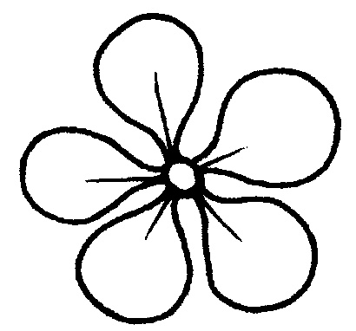 | 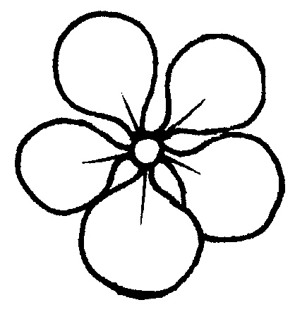 | 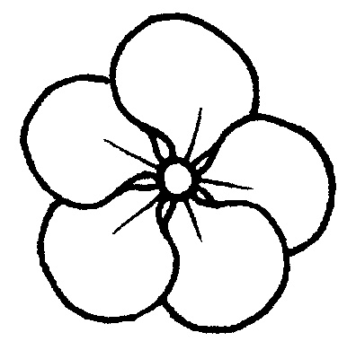
1 | 2 | 3
free | intermediate | overlapping

Ad. 40: Flower: diameter

The observation on the flower should be done with the petals pressed into a horizontal position.

Ad. 41: Flower: position of stigmas relative to anthers

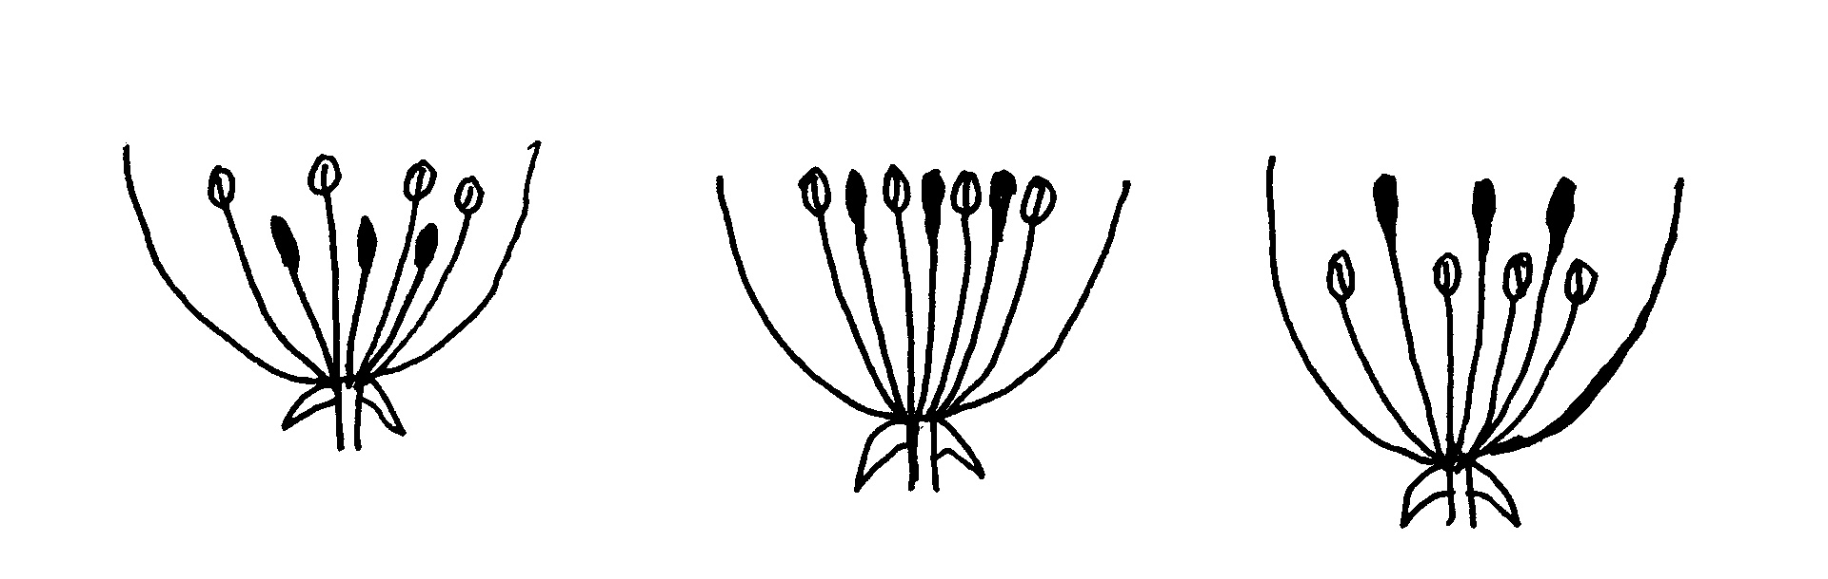
1 | 2 | 3
below | same level | above

Ad. 43: Fruit: ratio length/width
Ad. 44: Fruit: shape

 |  | ← lateral outline in apical half →
 |  | concave | flat tapering | rounded | flat parallel sides
at base ← position of broadest part → at middle |  |  |  | 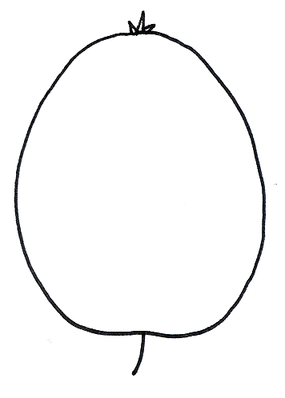  3  ovate
at base ← position of broadest part → at middle |  | 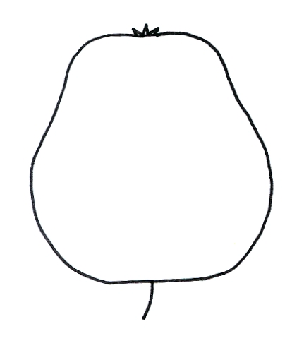 | 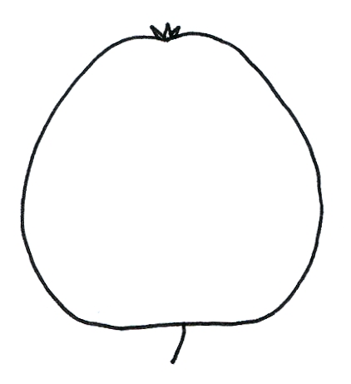 |  | 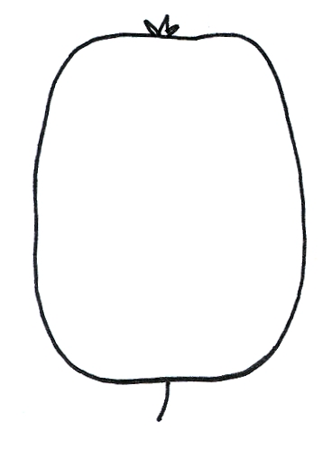
at base ← position of broadest part → at middle |  | 1  cylindrical waisted | 2  conic | 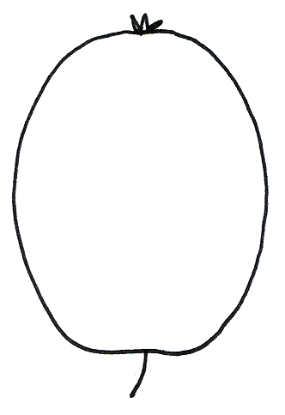  4,5,6  elliptic  (includes circular and oblate) | 7  cylindric

Ad. 48: Fruit: hue of over color

All observation should be done with the bloom removed.

Ad. 49: Fruit: relative area of over color

The extent of over color on the whole fruit.

Ad. 51: Fruit: aperture of locules in transverse section

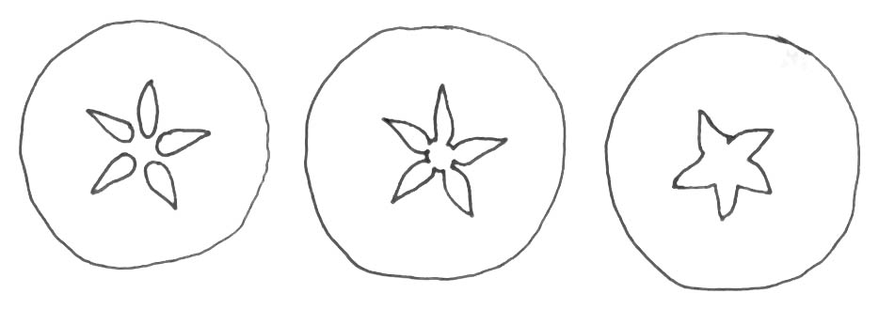
1 | 2 | 3
closed or slightly open | moderately open | fully open

Ad. 52: Time of beginning of bud burst

To be assessed when 10% of the buds show green point.

Ad. 53: Time of beginning of flowering

To be assessed when 10% of the flowers on the tree are fully open.

Literature

Embree, C.G. 1995: “A Photographic Description of the Fruit of Certain Apple Rootstocks,” Fruit Varieties Journal, 49 (1):59-64, USA

Ferree, David C., Carlson, Robert F., 1987: “Apple Rootstocks” in Rootstocks for Fruit Crops, Ed. Rom, Roy C. and Carlson, Robert F., Wiley, 107-143, USA

Krümmel, H., 1956: “Die vegetativ vermehrbaren Unterlagen des Kern- und Steinobstes,” Berlin: Deutscher Bauernverlag, Germany

Maurer, Erich.,1939: “Die Unterlagen der Obstgehölze,” Berlin: Parey Verlag, Germany

Simons, Roy K., 1986: “Leaf Characteristics of Apple Dwarfing Rootstocks,” Fruit Varieties Journal, 40 (3): 71-79, USA

Tydeman, H.M., 1953: “A Description of Classification of the Malling-Merton and Malling XXV Apple Rootstocks,” Report East Malling Research Station for 1952, pp. 53-63, United Kingdom

Tydeman, H.M., 1954: “A Description of Certain MIX Crosses,” Report East Malling Research Station for 1953, United Kingdom

Tydeman, H.M., 1955: “Descriptions of the Malling Apple Rootstocks,” Report East Malling Research Station for 1954, pp. 64-66, United Kingdom

Technical Questionnaire

The TQ will be amended when there is agreement on the table of characteristics.

TECHNICAL QUESTIONNAIRE |  |  |  | Page {x} of {y} |  | Reference Number:
 |  |  |  |  |  | Application date:
 |  |  |  |  |  | (not to be filled in by the applicant)
TECHNICAL QUESTIONNAIRE
to be completed in connection with an application for plant breeders’ rights

1. Subject of the Technical Questionnaire
1.1 Botanical name |  |  | Malus Mill.
1.2 Common name |  |  | Apple Rootstocks
2. Applicant
Name
Address
Telephone No.
Fax No.
E-mail address
Breeder (if different from applicant)
3. Proposed denomination and breeder’s reference
Proposed denomination
(if available)

Breeder’s reference
#4. Information on the breeding scheme and propagation of the variety

4.1 Origin

(a) Seedling of unknown parentage [ ]

(b) Produced by controlled pollination [ ]
(indicate parent varieties)

− Seed bearing parent (indicate parent)

................................................................................................

− Pollen parent (indicate parent)

................................................................................................

(c) Produced by open pollination of [ ]
(indicate seed bearing parent plant)
................................................................................................

(d) Mutation or sport from (indicate original parent variety)

................................................................................................ [ ]

(e) Discovery (indicate where and when)

................................................................................................ [ ]

4.2 In vitro propagation

The plant material of the candidate variety has been obtained
by in vitro propagation yes [ ]
no [ ]

4.3 Virus status

- The variety is free from all known viruses as follows: [ ]
(indicate from which viruses)
...................................................................................................
- The plant material is virus tested [ ]
(indicate against which viruses)
...................................................................................................
- The virus status is unknown [ ]
  - Other information

5. Characteristics of the variety to be indicated (the number in brackets refers to the corresponding characteristic in Test Guidelines; please mark the note which best corresponds).

 | Characteristics |  |  |  |  |  | Example Varieties |  |  | Note
5.1  (1) | Plant: vigor
 | very weak |  |  |  |  |  | CG 222¹ |  |  | 1[ ]
 | weak |  |  |  |  |  | J-TE-F^{3,} M 9⁴, M 26¹⁴, M 27⁴ |  |  | 2[ ]
 | medium |  |  |  |  |  | B9³, CG202⁴, J-TE-H³,  JM7⁴, M 7¹ |  |  | 3[ ]
 | strong |  |  |  |  |  | M 793¹, MM 106⁴ |  |  | 4[ ]
 | very strong |  |  |  |  |  | CG 934¹ |  |  | 5[ ]
5.2  (3) | Plant: number of shoots
 | very few |  |  |  |  |  |  |  |  | 1[ ]
 | few |  |  |  |  |  | M 9 |  |  | 2[ ]
 | medium |  |  |  |  |  | Joha³, Lancep³, M 26, P22(Last Minute)³, Supporter 1³ |  |  | 3[ ]
 | many |  |  |  |  |  | MM 111 |  |  | 4[ ]
 | very many |  |  |  |  |  | M 25 |  |  | 5[ ]
5.3  (4) | Plant: habit
 | upright |  |  |  |  |  | CG202⁴, M 7¹, M116⁴ |  |  | 1[ ]
 | upright-spreading |  |  |  |  |  | CG707¹ |  |  | 2[ ]
 | spreading |  |  |  |  |  | Cepiland⁴, CG 222¹, M 9³, M116⁴ |  |  | 3[ ]
 | drooping |  |  |  |  |  | Marubakaido¹ |  |  | 4[ ]
 | weeping |  |  |  |  |  |  |  |  | 5[ ]
5.4  (6) | One-year-old- shoot: growth
 | straight |  |  |  |  |  | M 9¹³⁴ |  |  | 1[ ]
 | moderately wavy |  |  |  |  |  | CG 202¹⁴, Mark³, M 26³, M 793¹, Supporter 1³ |  |  | 2[ ]
 | strongly wavy |  |  |  |  |  | M 25¹ |  |  | 3[ ]
 | Characteristics |  |  |  |  |  | Example Varieties |  |  | Note
5.5  (19) | Young leaf: extent of anthocyanin coloration
 | absent or very small |  |  |  |  |  | M 27¹, MM116 |  |  | 1[ ]
 | small |  |  |  |  |  | CG 222¹ |  |  | 2[ ]
 | medium |  |  |  |  |  | CG 202¹ |  |  | 3[ ]
 | large |  |  |  |  |  | M7¹ |  |  | 4[ ]
 | very strong |  |  |  |  |  | B 9, Marubakaido¹ |  |  | 5[ ]
5.6  (21) | Leaf blade: attitude in relation to shoot
 | upwards |  |  |  |  |  | J-TE-E³, M 793¹, M116⁴, M 27³ |  |  | 1[ ]
 | outwards |  |  |  |  |  | CG202⁴, CG 707¹, M 7¹, MM 106⁴ |  |  | 2[ ]
 | downwards |  |  |  |  |  | CG 778¹, JM7⁴ |  |  | 3[ ]
5.7  (27) | Leaf blade: incisions of margin
 | crenate |  |  |  |  |  | CG 707¹, J 9³, JM74 |  |  | 1[ ]
 | bicrenate |  |  |  |  |  | CG 222¹, J-TE-G³, M 7¹, M 793¹ |  |  | 2[ ]
 | serrate type 1 |  |  |  |  |  | J-TE-H³, MM 109¹, M 9³,  M 274 |  |  | 3[ ]
 | serrate type 2 |  |  |  |  |  | J-TE-A³ |  |  | 4[ ]
 | biserrate |  |  |  |  |  | CG 778¹, MM 106¹, MM 112³, MM 114³ |  |  | 5[ ]
5.8  (52) | Time of beginning of bud burst
 | very early |  |  |  |  |  | CG202¹⁴ |  |  | 1[ ]
 | very early to early |  |  |  |  |  |  |  |  | 2[ ]
 | early |  |  |  |  |  | M 4³, M 9¹ |  |  | 3[ ]
 | early to medium |  |  |  |  |  |  |  |  | 4[ ]
 | medium |  |  |  |  |  | B 9³, Cepiland³, M 25¹ |  |  | 5[ ]
 | medium to late |  |  |  |  |  |  |  |  | 6[ ]
 | late |  |  |  |  |  | MM 111¹,  P22(Last Minute)³ |  |  | 7[ ]
 | late to very late |  |  |  |  |  |  |  |  | 8[ ]
 | very late |  |  |  |  |  | M 26¹³ |  |  | 9[ ]
6. Similar varieties and differences from these varieties

Please use the following table and box for comments to provide information on how your candidate variety differs from the variety (or varieties) which, to the best of your knowledge, is (or are) most similar. This information may help the examination authority to conduct its examination of distinctness in a more efficient way.

Denomination(s) of variety(ies) similar to your candidate variety |  | Characteristic(s) in which your candidate variety differs from the similar variety(ies) |  |  | Describe the expression of the characteristic(s) for the similar variety(ies) |  |  | Describe the expression of the characteristic(s) for your candidate variety
Example |  | Plant: vigor |  |  | weak |  |  | strong
Comments:
In the case of identical states of expressions of both varieties, please indicate the size of the difference.

#7. Additional information which may help in the examination of the variety

7.1 Resistance to pests and diseases

7.2 Special conditions for the examination of the variety

7.3 Other information

A representative color image of the variety should accompany the Technical Questionnaire.

8. Authorization for release

(a) Does the variety require prior authorization for release under legislation concerning the protection of the environment, human and animal health?

Yes [ ] No [ ]

(b) Has such authorization been obtained?

Yes [ ] No [ ]

If the answer to (b) is yes, please attach a copy of the authorization.

9. Information on plant material to be examined or submitted for examination.

9.1 The expression of a characteristic or several characteristics of a variety may be affected by factors, such as pests and disease, chemical treatment (e.g. growth retardants or pesticides), effects of tissue culture, different rootstocks, scions taken from different growth phases of a tree, etc.

9.2 The plant material should not have undergone any treatment which would affect the expression of the characteristics of the variety, unless the competent authorities allow or request such treatment. If the plant material has undergone such treatment, full details of the treatment must be given. In this respect, please indicate below, to the best of your knowledge, if the plant material to be examined has been subjected to:

(a) Microorganisms (e.g. virus, bacteria, phytoplasma) Yes [ ] No [ ]

(b) Chemical treatment (e.g. growth retardant, pesticide) Yes [ ] No [ ]

(c) Tissue culture Yes [ ] No [ ]

(d) Other factors Yes [ ] No [ ]

Please provide details for where you have indicated “yes”.

……………………………………………………………

{ ASW 17 (Chapter 10: TQ 9.3) – tests for the presence of virus or other pathogens }

“9.3 Has the plant material to be examined been tested for the presence of virus or other pathogens?

Yes [ ]
(please provide details as specified by the Authority)

No [ ]”

10. I hereby declare that, to the best of my knowledge, the information provided in this form is correct:

Applicant’s name

Signature Date

[Annex follows]

Observations and Comments to document TG/163/4(proj.3)

Comments from Australia
General | There are some inconsistencies/corrections in 5.3 and TQ 5. However, it may be better to address these one the table of characteristics is finalised.
Char. 4 Plant: habit  and Ad.4 | Amend “upright-spreading” to “upright to spreading”. Consider adding “spreading to drooping.”  “weeping” is in Ad 4 but not in the table.
Char. 6 One-year-old shoot: growth | Needs rewording and perhaps explanation or Ad. Maybe: “One-year-old shoot: growth habit”?
Char. 8 One-year-old shoot: glossiness of bark | Consider deleting “of bark”
Char. 10 One-year-old shoot: length of internodes | Add brackets around “b”
Chars. 14, 15, 16 and 17 | Add “vegetative” before “bud”
Char. 15 One-year-old shoot: shape of tip of bud | Replace “tip” with “apex”
Char 16. One-year-old shoot: position of bud relative to axis | Consider rewording to “One-year-old shoot: position of vegetative bud in relation to shoot”  Consider replacing “markedly” with “strongly”
Char 19 Young leaf: extent of anthocyanin coloration | Would prefer to use states weak, medium strong etc. But may be ok if referring to distribution of anthocyanin (eg anthocyanin could be strong but not covering a large area). If this is the cae then maybe “area of anthocyanin coloration”?
Char. 20. Young leaf: hue of anthocyanin coloration | Change note “9” to note “2”
Char. 25. Leaf blade: profile in cross section | Consider replacing “straight” with “flat”
Char. 31 Leaf blade: glossiness | Consider “Leaf blade: glossiness of upper side”
Char. 35 Petiole: extent of anthocyanin coloration from base | See comments at char. 19
Char. 51 Fruit: aperture of locules | Amend to “Fruit: aperture of locules in transverse section” to be consistent with Ad.
Comments from New Zealand
 | 3.4.1 Testing is based on 5 plants. How does this relate to 10 plants requested for stoolbeds?
 | Character 2, 3 Place A and B in first column. For all characters.
 | Character 15 Order of states. I support this order and do not propose a change but the EDC recently indicated a preference for rounded to acute. For information.
 | Character 19 We consider this a Young shoot character, not young leaf
 | Character 20 We would question QL. The transition between red brown and purple is never that clear. This is looking at colour of shoot and this information as already been recorded in 18. Do we need?
 | Character 26 Suggest 3 states considering the size of the organ.
 | Character 37 Suggest 3 states In between states would be very difficult to determime
 | Character 38 We have never seen completely white rootstock flowers
 | 8 c We have the view that young leaves are observed collectively as young shoots. Is there a need to mention young leaves. Also in respect to comments for 19
 | Ad 4 These are tree diagrams. Do we need shoot (stoolbed) diagrams?
 | Ad 17 states should mirror character states.
 | Ad 18 revised according to changes in the character
Comments from Germany
Char 1 | M 26 appear double in state 2 and state 3 in DE it is neither nor
Ad 4 | To add explanations/ drawings for plants in stoolbeds
Ad 34 | Should be assessed regarding the length of the petiole compared to the length of the middle vein of the leaf
Ad 35 | Should be assessed regarding the degree to which the amount of anthocyanin coloration extend from the petiole base towards the base of the leaf
Ad 37 | Should be assessed as the amount of flowers present during the flowering period  Does that mean counting?
Ad 44 | Ovate picture looks circular
Ad 44 | Do not understand the explanation in brackets
Ad 53 | To be assessed when 10% of the flowers on the tree are fully open
Comments from CPVO
Page 1
Alternative names :

This wording might be misleading when used for names of the taxa taking into account the particular meaning of “alternative names” according to the International Code of Botanical Nomenclature: “alternative names. Two or more different names based on the same type proposed simultaneously for the same taxon by the same autor”.

Page 3
2.2 The material is to be supplied in the form of one-year-old rooted trees, or in the form of one year old rooted plants (for stoolbeds).

A small editorial remark – the same way of writing should be used for highlighted text.

Page 3
3.1 Number of Growing Cycles
The minimum duration of tests should normally be two independent growing cycles.

1 – the “minimum duration” of the test of 2 (or so growing cycles) it is under the assumption that the outcome of the test will be positive and the variety description will be drafted. In case of a negative outcome (for example clear off-types in leaf colour: 2 plants with red leaf in the sample of a variety with green leaf the test can be finished at an early stage; observations are not carried out only in the two “growing cycles” defined as the in GN for fruit crops) the test can be finished very early even in the first establishment year.

2 - “Independent” – please see the comment of TWC as reported in the document TWO/35/7-TWF/33/15
15. Conclusions: The TWC agreed the following modifications in the text of document TGP/9.6 (additional text underlined and deleted text strikethrough) Paragraph 4 to read as follows: “4. For some crops, such as fruit trees, the same plants are examined over successive years. In this case, the condition of independence of growing cycles is not also satisfied. But, as it would be impossible in practice to plant successive trials, this is accepted”

3 – “growing cycle” – does the definition in the GN for fruit varieties reflects the situation for rootstock varieties?

- 4 - The minimum duration of tests should normally be two independent growing cycles.
This means that in theory, you can grow the variety 2 years for a complete DUS trial, provided you do not foresee to observe flowers or fruit characteristics.
SFS: That depends on whether (some) flower and fruit characteristics are made compulsory. So far I don’t see any flower or fruit characteristics with a (*). Perhaps that is something that should be discussed at the forthcoming TWF.

Page3/page5
/2.3 The minimum quantity of plant material, to be supplied by the applicant, should be:
5 one-year-old rooted trees and/or
10 one-year-old rooted plants for stoolbeds

3.4 Test Design
3.4.1 Each test should be designed to result in a total of at least 5 plants.

4.1.4 Number of Plants / Parts of Plants to be Examined
Unless otherwise indicated, all observations for the purposes of distinctness should be made on 5 plants or parts taken from each of 5 plants, disregarding any off-type plants. In the case of observations of parts of plants, the number of parts to be taken from each of the plants should be 2.

Question: What is the reason to ask for 10 plants for stoolbed taking into account that the minimum in the test is 5 plants? Should there be two different minima depending on the type of material submitted?
The text at 4.1.4 “disregarding any off-type plants” is not applicable in case no off-type is allowed.

Table of characteristics (+ some comments in the attached document)
- Char 37, Flower presence
This depends on the duration of cultivation?

TQ
- The following question can be found in the TQ:
  - In vitro propagation

  - The plant material of the candidate variety has been obtained
  - by in vitro propagation yes [ ]
no [ ]
According to Richard, some characteristics are heavily affected by in vitro cultivation like charact 2, ‘Plant: number of branches ‘. As we accept in vitro propagated material, char 2 is no longer reproducible unless the way of propagation is specified in the variety description.

Comments from France
2.3 | We propose to delete this sentence because observations are conducted on trees for fruiting, so it is no longer necessary to ask plants for stoolbeds
3.1 | We propose to delete this word because the both growing cycles are not independent
General | Comprehensively France does not approve and find not consistent to note characters on a 1-3-5 scale or 1-2-3 knowing that they are also used for apple (TG/14/9) with a 1-3-5-7-9 scale. There is a high risk of scoring error.  There is also a high risk of error if the expression levels as "medium" noted 5 change into a 3 note (which is low) or even 2
21 | the expression levels 3-5-7 would make ratings more accurate
26 | To be consistent with the character 22, the expression levels of 3-5-7 would be more correct
29 | Is it a five-note scale or a seven-note scale
31 | As above; is the note “4” medium to strong”?
37 | Could be “number” instead of “presence”?  We agreed with the CPVO, “number” is more consistent
38 | We propose to add “predominant”  We do not agree with the deletion of the expression levels "white and whitish yellow” because those colors are valid in France
44 | To be more consistent with the UPOV TG14/9 we propose to replace cylindric on the level 4
45 | The expression level should be 4 and not 5
46 | Same as above, the expression level should be 4 and not 5
TQ 5.4 | Why it does not look like the one in the table of characteristics? Which is correct?  In Table of characteristics there are only 3 levels of expression that do not correspond to those where

[End of Annex and of document]

* These names were correct at the time of the introduction of these Test Guidelines but may be revised or updated. [Readers are advised to consult the UPOV Code, which can be found on the UPOV Website (www.upov.int), for the latest information.]
# Authorities may allow certain of this information to be provided in a confidential section of the Technical Questionnaire.
# Authorities may allow certain of this information to be provided in a confidential section of the Technical Questionnaire.

