 |  | E  TWF/43/36  ORIGINAL: English  DATE: July 26, 2012
INTERNATIONAL UNION FOR THE PROTECTION OF NEW VARIETIES OF PLANTS
Geneva
Technical working party for FRUIT CROPS
Forty-Third Session
Beijing, July 30 to August 3, 2012
proposal for a partial revision of the test guidelines for
mandarinS (citrus, Group 1)
Document prepared by an expert from the European Union
1 The Technical Working Party for Fruit Crops (TWF) at its forty-second session held in Hiroshima, Japan, from November 14 to 18, 2011 discussed documents TWF/42/19 “Proposal for Partial Revision of the Test Guidelines for Mandarins (Citrus; Group 1) and TWF/42/19 Add., including the proposal for a new Characteristic “Fruit: number of seeds (controlled manual cross-pollination)”. The TWF agreed that further studies were necessary with regard to the proposed new characteristic in order to test the methodology and also agreed that the wording of the characteristic might need to be reviewed. With these objectives in mind, the TWF agreed to form a subgroup in which Morocco, South Africa and Spain would participate; Australia and Brazil also showed an interest in participating, however they were unable to commit at that time. The TWF requested Mr. Jean Maison (European Union), to coordinate the work of the subgroup. It was agreed to postpone the consideration of the partial revision until the subgroup had presented its results to the TWF (see document TWF/42/26 Rev. ”Revised Report”, paragraph 75).

2 The Annex to this document provides an overview of the proposal for a partial revision of the Test Guidelines for Mandarins (Citrus; Group 1) and the protocol agreed for the ring test concerning the proposed new characteristic “Fruit: number of seeds (controlled manual cross-pollination)”, which started in March 2012.

3 Participants of the subgroup will make an oral report on progress in the ring test at the forty-third session of the TWF.

[Annex follows]

Proposal for a partial revision of the test guidelines for Mandarin

Background

The Tests Guidelines for Mandarins (TG/20/1) were adopted in 2003.

Since then, problems occurred in varieties supposed to be seedless with the presence of seeds derived from unwanted cross pollination with other neighboring plantations. Breeding programs have developed in order to improve the situation with 2 kinds of methodologies:

- triploid varieties (sterile pollen)
- irradiation of varieties to reduce their fertility.

Irradiated varieties have a reduced ovule fertility and produce no seeds independently from pollinators that might be present in the vicinity. The rest of their characteristics remains usually conform to the original variety.

To address those new types, it is proposed that there be a partial revision of the Test Guidelines in order to:

- update characteristic 25 ‘Anther viable pollen’, which has for the moment two states of expression, ‘Absent’ – ‘Present’ where differences observed in the pollen germination percentage cannot be reflected with only two states. It is proposed that the states ‘Absent’ ‘Present’ be substituted by a more detailed classification.

- to introduce a new characteristic to evaluate the ovule fertility by cross pollination with another variety or species: ‘Fruit: number of seeds (controlled manual cross-pollination)’

The update of characteristic 25 has not been contested. This is not the case of the new characteristic which raised some comments.

The proposal for a new characteristic as presented to the TC was:

Ad. NEW Fruit: number of seeds (controlled manual cross-pollination) Method: 10 flowers should be observed on each tree. The 10 flowers should be protected from pollination by use of an individual mesh on each flower. Manual cross-pollination of the 10 flowers should be done with pollen from a variety with a high fertilization capability, such as ‘Fortune’, ‘Ellendale’, ‘Nadorcott’, ‘Nova’ or ‘Common mandarin (Willowleaf, Mediterranean)’.

Range of counts for each of the states when pollinator is “Fortune”:

Example varieties | Note | Range
Okitsu (SAT) | 1 | ≤ 3
 | 2 | > 3≤ 6
Nulessin (CLE) | 3 | > 6≤ 9
 | 4 | > 9 ≤ 11
Esbal (CLE) | 5 | >11 ≤ 15
 | 6 | >15 ≤ 17
Primosole (HMA) | 7 | > 17 < 20
 | 8 | > 20 < 23
Clemenules (HMA) | 9 | ≥ 23

The TC considered that there were technical issues to be resolved concerning the proposed revision of the test guidelines for mandarins and recommended that the issue be referred back to the TWF for further consideration.

The conclusion from the TWF

The TWF reached the following conclusion, as drafted in the report:

The TWF discussed documents TWF/42/19 and TWF/42/19 Add., in particular the proposal for a new Characteristic after existing Characteristic 98 (“Fruit: number of seeds (controlled manual cross-pollination)”). Experts from Morocco requested that the methodology of controlled manual cross-pollination be clarified, and made specific reference to the requirements in document TG/1/3: Section 4.2.1., before any such characteristic could be introduced. The TWF discussed the proposed mandarin partial revision and agreed that further studies were necessary to test the methodology and also agreed that the wording of the Characteristic might need to be reviewed. With these objectives in mind, the TWF agreed to form a subgroup in which Morocco, South Africa and Spain would participate; Australia and Brazil also showed an interest in participating, however they were unable to commit at this time. Furthermore, the TWF requested Mr. Jean Maison (European Union), to coordinate the work of the subgroup. It was agreed to postpone any decision on the proposed mandarin partial revision until the subgroup had presented its results to the TWF. (see: document TWF42/26 “Report”, paragraph 75).

About the presence of seeds in citrus varieties

- Gametophytic compatibility

Incompatibility issues in Citrus are recognized to be gamete related: they are based on the unsuccessful growth of pollen tubes because the S allele carried by the haploid male pollen matches either of the two S alleles existing in the diploid maternal tissue of the pistil. It should be specified that clementines are self incompatible. In order to assess the ovule fertility, the pollinator and receiver should be fully compatible and this is one of the key issues in assessing this characteristic.
For the moment, there seems to be no published molecular technique available in order to identify whether 2 varieties are compatible or not. Also, there does not seem to exist publications about groups of compatibility in Citrus. However, cases of (partial) incompatibility between varieties are not excluded and in order to assess the characteristic reliably, Spanish experts recommended to use a mixture of viable pollen from different donators identified in the industry as being good pollinators.
- In the document TWF/42/19 Add., trial crosses made at IVIA in 2004 are reported as follows.

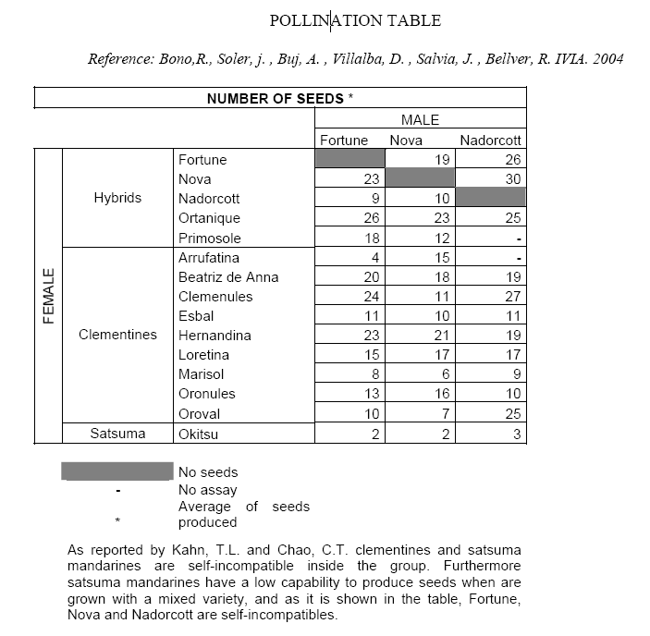
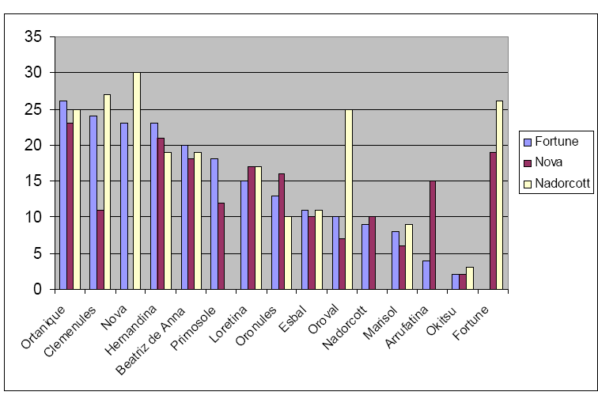
The above mentioned results suggest that the number of seeds produced by a variety with various pollinator – identified as good pollinators - is most of the time relatively independent from the pollinator. However, there might be an interaction between the pollinator and the variety pollinated in some situations and this seems to be the case where ‘Nova’ pollinates ‘Clemenules’, producing apparently less seeds than when ‘Fortune’ or ‘Nova’ are used as a pollinator. The same situation seems to occur for ‘Oroval’ and ‘Arrufatina’, where a pollinator (respectively ‘Nadorcott’ and ‘Nova’) turns out to produce more seeds.

The Ring Test proposal

The characteristic at stake is the female fertility.

It is proposed that this characteristic is observed in counting the maximum number of seeds obtained after pollination with a range of good pollinators, under the agroclimatic and pollen donor conditions as described in the Ring test protocol. It is proposed that the pollination is made each time with pollen of a single pollinator rather than with a pollen mixture, the composition of which could be the subject of variation. In order to avoid incompatibility issues, pollinators should have very different genetic background. This is the reason why along with to the Clementine varieties ‘Nadorcott’, Fortune and Nova, other Citrus species or types could be used as the tangelo ‘Minneola’, or a Citrus medica variety <Oral communication with the French INRA Corsica>

In order to perform the test, all the varieties to be used as pollinators (male) and all those to be used as receptors (female) should ideally be available for all partners (ES, MA, ZA). In order to identify pollinator and receptor varieties for the ring test, the project partners are requested to send to the Community Plant Variety Office of the European Union (CPVO) a list of varieties that would be available for the trial starting in 2012 and a proposal for varieties which could be used as pollinator .

Once this has been achieved, a pollination table as illustrated above could be drawn and the consistency of results compared. At the end of the ring test, it could then be concluded whether the characteristic can be reliably assessed or not.

Ring Test Protocol

The characteristic at stake is the female fertility.

In order to perform the test, all the varieties to be used as pollinators (male) and all those to be used as receptors (female) should ideally be available for all partners (ES, MO, ZA)

Procedure for hand pollination:

- Conditions of the Pollen of the Donor

  - Viability : Verification of the germination capacity of the pollen and utilization of pollen with at least 50% germination capacity (assessment after pollen culture)

Method: The pollen should be collected when the petals begin to open (but with the anthers closed). The anthers should be introduced into a Petri dish and placed inside a silica gel dryer at room temperature, for20-48 hours of darkness. When the anthers are open they should be moved to a 8 ºC chamber with a 70-80 % Relative Humidity for one hour. Afterwards, the pollen should be brushed onto a microscope slide with 2 ml of Brewbacker medium (Brewbaker and Kwack. 1963). Finally, the microscope slide should be placed in a 24 ºC chamber with a 75 % RH for 20 hours.

The percentage of pollen fertilization is calculated as the average of germinated pollen grains observed with a binocular in 15 visual fields from 2 different microscope slides.

(Brewbaker, J.L. and Kwack, B.H. 1963. The essential role of calcium ion in pollen germination and pollen tube growth. Amer. Jour. Botany. 50: 859-865.)

  - Pollen from male varieties will be at its optimal fertility

  - The pollen of the pollinator variety is extracted at the moment of maximum development of the flower, before the anther dehiscence. Open flowers at a growth stage of 61–62 on the Citrus BBCH phenological scale [Agustı and al., 1997] will be randomly selected for pollen collection at least the day before pollination. Anthers are put in petri-dishes at room temperature with a dehydrator (e.g. a piece of paper) until they open.

Conditions of the Female Flowers:

  - 50 terminal flowers from each female variety will be used, if possible 10 flowers from 5 trees. If less than 5 trees, the number of trees, the number of female trees to be pollinated should be specified

  - Flowers will be fully developed but not yet opened: one day before anthesis (stage 59 on the Citrus BBCH phenological scale [Agust and al., 1997]), flowers

  - will be emasculated and bagged to avoid self and free pollination.

  - stigma of female varieties will be at its optimum stage of receptivity. Alternatively, 50 flowers a day will be cross-pollinated by hand respectively 1 and 6 days after anthesis.

Other flowers at the same stage (stage 59) at the time of emasculation must be marked to indicate the number of days after anthesis and to mark the flowers emasculated at the time of anthesis. (see additional explanation in Annex)

  - Trees will be at the phenologic state of full bloom

Agroclimatic Conditions:

  - Wet days are not suitable and the temperature should be above 20°
Methodology of Hand Pollination:

  - Pollination is made each time with pollen of a single pollinator

  - Pollination should take place at the moment of maximum development of the flower.

  - Quantity of pollen : to reach the saturation of the stigma, at least 100 grains of pollen

Dissecting microscope is used in the field to evaluate the quantity of grains of pollen which must be more than 100. Those flowers will be compared with the ones with massive amounts of freshly pollen (see additional explanation in Annex)

  - Pollen will be applied by a brush

  - After pollination, the pollinated flowers should be isolated from the environment with an individual mesh in order to avoid further pollination

If felt necessary, for each pollinating date if this is the case, 10 additional flowers per variety will be removed 48 h after pollination and fixed with FPA (10% formaldehyde, 10% propionic acid, 80% ethanol at 70%). The percentage of pollen germination on the stigma will be calculated by counting at least 100 grains per pollinated flower. A pollen grain was considered to be germinated when the pollen tube length is longer than the pollen grain diameter. This is done by extracting the germinated pollen grain in the laboratory using the microscope. (see additional explanation in Annex)

Observation of Results:

  - Fruits produced from manual pollination should be identified

  - Seeds produced in each individual resulting fruit must be counted and registered when the fruits are at stage of fruit maturity or one month before to get an average of the number of seeds per fruit. The number of fruits observed for each variety should be reported.

  - A pollination table could be drawn to compare the results

Taking into account the proposals, the varieties to be considered for the ring test will be the following

 |  | POLLINATOR
 |  | ‘Nova’ | ‘Nadorcott’
Female | ‘Marisol’
Female | ‘Clemenules’ = ‘Nules’
Female | ‘Nadorcott’
Female | ‘Nova’

[End of Annex and of document]

