 |  | E  TWF/43/31  ORIGINAL: English  DATE: July 23, 2012
INTERNATIONAL UNION FOR THE PROTECTION OF NEW VARIETIES OF PLANTS
Geneva
Technical working party for FRUIT CROPS
Forty-Third Session
Beijing, July 30 to August 3, 2012
PARTIAL REVISION OF THE test guidelines for Peach
(Document TG/53/7)
Document prepared by experts from France
It is proposed that the Test Guidelines for Peach (document TG/53/7) be amended as follows:

Chapter 1 “Subject of these Test Guidelines”

Current wording:

These Test Guidelines apply to all varieties of peach (including nectarine) of the species Prunus persica (L.) Batsch. For the examination of hybrids involving Prunus persica (L.) Batsch, guidance is provided in document TGP/13 “Guidance for New Types and Species”.

Proposed new wording:

These Test Guidelines apply especially to fruit varieties and to all varieties of peach (including nectarine) of the species Prunus persica (L.) Batsch. For the examination of hybrids involving Prunus persica (L.) Batsch, guidance is provided in document TGP/13 “Guidance for New Types and Species”.

Chapter 2.3

Current wording:

The minimum quantity of plant material, to be supplied by the applicant, should be:

5 grafted trees.

Proposed new wording:

The minimum quantity of plant material, to be supplied by the applicant, should be:

3 grafted trees.

Chapter 3.4.1

Current wording:

Each test should be designed to result in a total of at least 5 trees.

Proposed new wording:

Each test should be designed to result in a total of at least 3 trees.

Chapter 3.5 “Number of Plants / Parts of Plants to be Examined”

Current wording:

Unless otherwise indicated, all observations should be made on 5 plants or parts taken from each of 5 plants. In the case of parts of plants, the number to be taken from each of the plants should be 2.

Proposed new wording:

Unless otherwise indicated, all observations should be made on 3 plants or parts taken from each of 3 plants. In the case of parts of plants, the number to be taken from each of the plants should be 5 at least.

Chapter 4.2.2

Current wording:

For the assessment of uniformity, a population standard of 1% and an acceptance probability of at least 95% should be applied. In the case of a sample size of 5 plants, no off-types are allowed.

Proposed new wording:

For the assessment of uniformity, a population standard of 1% and an acceptance probability of at least 95% should be applied. In the case of a sample size of 3 plants, no off-types are allowed.

Chapter 5.3 “Grouping Characteristics”

- Tree: size (characteristic 1)
- Flowering shoot: presence of anthocyanin coloration (characteritic 6)
- Flower: type (characteristic 9)
- Anthers: pollen (characteristic 17)
- Ovary: pubescence (characteristic 18)
- Leaf blade: red mid-vein on the lower side (characteristic 28)
- Petiole: nectaries (characteristic 30)
- Petiole: shape of nectaries (characteristic 31)
- Fruit: shape (in ventral view) (characteristic 33)
- Fruit: pubescence of skin (characteristic 44)
- Fruit: carotenoid coloration of flesh (characteristic 51)
- Fruit: acidity (characteristic 57) with the following groups:
- low
- medium
- high
- Fruit: flesh type (TQ characteristic), with the following groups:
- melting
- non-melting (pavies)
- stony hard
- Stone: adherence to flesh (characteristic 64)
- Time of beginning of flowering (characteristic 67)
(p) Time of maturity for consumption (characteristic 68)

Chapter 7 “Table of Characteristics”

Amendments to characteristics for example varieties only:

Char. 1 | state 1 | to add “Bonfire, Pix Zee, Zaino”
Char. 5 | state 1 | to add “Bonfire, Pix Zee, Zaino”
Char. 21 | state 7 | to delete “Dixinel”, to add “Dixired”
Char. 25 | state 3 | to delete “Merrill Fransiscan”, to add “Merrill Franciscan”
Char. 34 | state 9 | to delete “Jersey Land”, to add “Jerseyland”
Char. 36 | state 2 | to delete “Brittaney Lane”, to add “Brittney Lane”
 | state 3 | to delete “Precoccissima Moretini”, to add “Precocissima Morettini”
Char. 40 | state 2 | to delete “Rubberima”, to add “Ruberrina”
Char. 41 | state 1 | to add “Ghiaccio 1, Zholty”
Char. 43 | state 1 | to delete “Flavorcrest”, to add “Zaitabo”
 | state 2 | to delete “Merill Sundance”, to add “Merrill Sundance”
Char. 47 | state 3 | to delete “Royal gem”, to add “Royal Gem”
Char. 50 | all states | to delete existing example varietes, new example varieties to be provided
Char. 51 | state 6 | to delete “Merill Franciscan”, to add “Merrill Franciscan”
Char. 56 | state 1 | to delete “Merryl Gemfree”, to add “Merrill Gemfree”
Char. 57 | state 1 | to delete “Ambre, Kevine, Nacre, Opale, Zaiboni”, to add “ Monna, Zaibomi, Zaidaso”
 | state 2 | to delete “Felicia, Monprime”, to add “Zaifave, Zaitabo”
 | state 3 | to delete “O’Henry, Ryan Sun, Zaitabo”, to add “Mercil, Monprime, Ryans Sun”
 | state 4 | to delete “Hermione, Primerose”, to add “ Kraprim, Zailice”

Characteristic 3 “Tree: habit”

Current wording:

3.  (*)  (+) |  | Tree: habit | Arbre : port | Baum: Wuchsform | Árbol: porte
QN | (a) | upright | dressé | aufrecht | erecto | Nectarose, Pillar | 1
 |  | upright to spreading | dressé à étalé | aufrecht bis breitwüchsig | erecto hacia extendido | Fairhaven, Redwing | 2
 |  | spreading | étalé | breitwüchsig | extendido | Albertina, Elegant Lady, O’Henry | 3
 |  | drooping | retombant | überhängend | colgante | Charles Roux | 4
 |  | weeping | très retombant | lang überhängend | llorón | Biancopendulo | 5

Proposed new wording:

3.  (*)  (+) |  | Tree: habit | Arbre : port | Baum: Wuchsform | Árbol: porte
QN | (a) | pillar | columnaire | aufrecht | erecto | Nectarose, Pillar | 1
 |  | upright | dressé | aufrecht bis breitwüchsig | erecto hacia extendido | Fairhaven, Redwing | 2
 |  | standard | intermediaire | breitwüchsig | extendido | Albertina, Elegant Lady, Mercil | 3
 |  | open | ouvert | überhängend | colgante | Charles Roux | 4
 |  | weeping | retombant | lang überhängend | llorón | Biancopendulo | 5

Ad. 3: Tree: habit

To be observed the year before the main pruning.

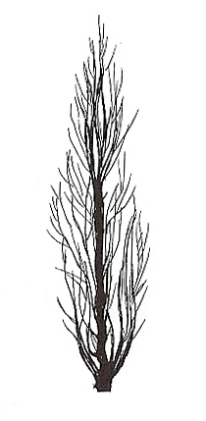 | 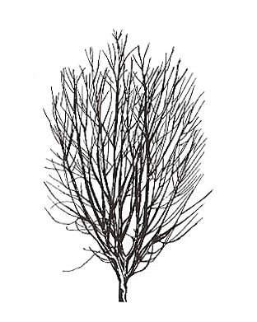 | 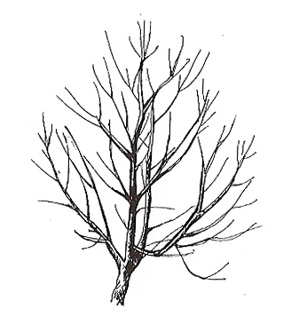 | 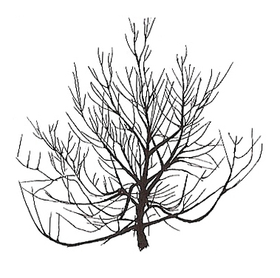 | 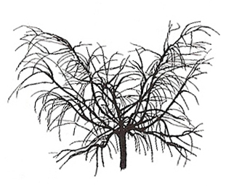
1 | 2 | 3 | 4 | 5
upright | upright to spreading | spreading | drooping | weeping
pillar | upright | standard | open | weeping

Characteristic 7 “Flowering shoot: intensity of anthocyanin coloration”

Current wording:

7.  (+) |  | Flowering shoot: intensity of anthocyanin coloration | Rameau mixte : intensité de la pigmentation anthocyanique | Blütentrieb: Intensität der Anthocyanfärbung | Rama floral: intensidad de la pigmentación antociánica
QN | (d) | weak | faible | gering | débil | Springtime | 3
 |  | medium | moyenne | mittel | media | Fuzalode | 5
 |  | strong | forte | stark | fuerte | Robin, Sanguine Chanas | 7

Proposed new wording:

7.  (+) |  | Flowering shoot: intensity of anthocyanin coloration | Rameau mixte : intensité de la pigmentation anthocyanique | Blütentrieb: Intensität der Anthocyanfärbung | Rama floral: intensidad de la pigmentación antociánica
QN | (d) | very weak | très faible |  |  | Biancopendulo,  De flor doble blanca, | 1
 |  | weak | faible | gering | débil | Springtime | 3
 |  | medium | moyenne | mittel | media | Fuzalode | 5
 |  | strong | forte | stark | fuerte | Robin, Sanguine Chanas | 7

Characteristic 9 “Flower: type”

Current wording:

9.  (*)  (+) |  | Flower: type | Fleur : type | Blüte: Typ | Flor: tipo
QL | (d) | campanulate | campanulée | glockenförmig | acampanada | Dida, Springtime | 1
 | (e) | rosette | rosacée | rosettenförmig | roseta | Robin, Vesuvio | 2

Proposed new wording:
9.  (*)  (+) |  | Flower: type | Fleur : type | Blüte: Typ | Flor: tipo
QL | (d) | campanulate (non showy) | campanulée | glockenförmig | acampanada | Dida, Springtime | 1
 | (e) | rosette (showy) | rosacée | rosettenförmig | roseta | Robin, Vesuvio | 2

Ad. 9: Flower: type

‘Campanulate’ (bell-shaped) is also referred to as ‘non showy’: these types have small petals and stamens often higher than the petals.

‘Rosette’ (rose-shaped) is also referred to as ‘showy’: these types have large petals.

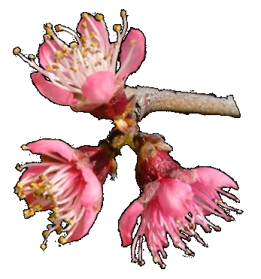 | 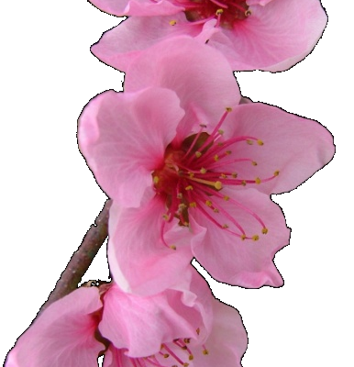
1 | 2
campanulate  (non showy) | rosette  (showy)

Characteristic 15 “Stamen: position compared to petals”

Current wording:

15.  (+) |  | Stamen: position compared to petals | Étamines : position par rapport aux pétales | Staubgefäße: Stellung im Verhältnis zu den Blütenblättern | Estambre: posición relativa a los pétalos
QN | (d) | below | au-dessous | unterhalb | por debajo | Loring | 1
 | (e) | at same level | au même niveau | auf gleicher Höhe | en el mismo nivel | Robin, Springtime | 2
 |  | above | au-dessus | oberhalb | por encima | Redhaven | 3

Proposed new wording:

15.  (+) |  | Stamen: position compared to petals | Étamines : position par rapport aux pétales | Staubgefäße: Stellung im Verhältnis zu den Blütenblättern | Estambre: posición relativa a los pétalos
QN | (d) | below | au-dessous | unterhalb | por debajo | Loring | 1
 | (e) | same level | au même niveau | auf gleicher Höhe | en el mismo nivel | Robin, Springtime | 2
 |  | above | au-dessus | oberhalb | por encima | Redhaven | 3

Ad. 15: Stamen: position compared to petals

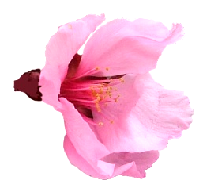 | 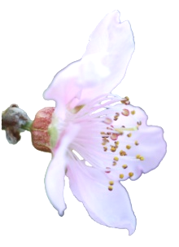 | 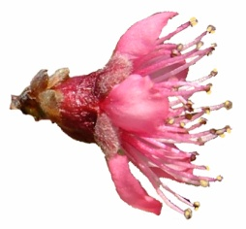
1 | 2 | 3
below | at same level | above
below | same level | above

Characteristic 35 “Fruit: shape of pistil end (excluding mucron tip)”

Current wording:

35.  (+) |  | Fruit: shape of pistil end (excluding mucron tip) | Fruit : forme de l’extrémité pistillaire (mucron non compris) | Frucht: Form des Kelchendes (außer aufgesetzte Spitze) | Fruto: forma del extremo del pistilo (la punta del mucrón excluida)
 |  | prominently pointed | nettement pointue | deutlich zugespitzt | destacadamente puntiagudo | Jersey Land | 1
 |  | weakly pointed | faiblement pointue | schwach zugespitzt | débilmente puntiagudo | Springtime | 2
 |  | flat | plate | flach | plano | Redhaven | 3
 |  | weakly depressed | faiblement déprimée | schwach eingesenkt | débilmente hundido | Robin | 4
 |  | strongly depressed | fortement déprimée | stark eingesenkt | muy hundido | Bailou, UFO3 | 5

Proposed new wording:

35.  (+) |  | Fruit: shape of pistil end (excluding mucron tip) | Fruit : forme de l’extrémité pistillaire (mucron exclu) | Frucht: Form des Kelchendes (außer aufgesetzte Spitze) | Fruto: forma del extremo del pistilo (la punta del mucrón excluida)
 |  | prominently pointed | nettement pointue | deutlich zugespitzt | destacadamente puntiagudo | Jerseyland | 1
 |  | weakly pointed | faiblement pointue | schwach zugespitzt | débilmente puntiagudo | Springtime | 2
 |  | flat | plate | flach | plano | Redhaven | 3
 |  | weakly depressed | faiblement déprimée | schwach eingesenkt | débilmente hundido | Robin | 4
 |  | strongly depressed | fortement déprimée | stark eingesenkt | muy hundido | Bailou, UFO3 | 5

Characteristic 52 “Fruit: anthocyanin coloration of flesh next to skin”

Characteristic 52 to be split into two characteristics.

Current wording:

52.  (*)  (+) |  | Fruit: anthocyanin coloration of flesh next to skin | Fruit : pigmentation anthocyanique sous-épidermique | Frucht: Anthocyanfärbung direkt unter der Haut | Fruto: pigmentación antociánica de la pulpa pegada a la piel
QN | (f) | absent or very weak | absente ou très faible | fehlend oder sehr gering | ausente o muy débil | Redhaven | 1
 |  | weak | faible | gering | débil | Daisy, Dolores, Monco | 2
 |  | strong | forte | stark | fuerte | Monalu, Monof, Rich May, Sanguine Chanas, Sanguine Vineuse, Zairegem | 3

Proposed new wording:

52.  (*)  (+) |  | Fruit: anthocyanin coloration of flesh next to skin | Fruit : pigmentation anthocyanique sous-épidermique | Frucht: Anthocyanfärbung direkt unter der Haut | Fruto: pigmentación antociánica de la pulpa pegada a la piel
QN | (f) | absent |  |  |  | Springfire | 1
 |  | present |  |  |  | Sanguine Vineuse | 9
NEW  (*)  (+) |  | Fruit: anthocyanin coloration of flesh next to skin | Fruit : pigmentation anthocyanique sous-épidermique | Frucht: Anthocyanfärbung direkt unter der Haut | Fruto: pigmentación antociánica de la pulpa pegada a la piel
QN | (f) | weak | faible |  |  | To be provided | 1
 |  | medium | moyenne |  |  | To be provided | 2
 |  | strong | forte |  |  | Monalu, Monof, Rich May, Sanguine Chanas, Sanguine Vineuse, Zairegem | 3

Ad. NEW: Fruit: anthocyanin coloration of flesh next to skin

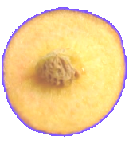 | 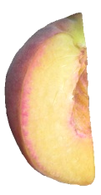 | 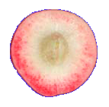
1 | 2 | 3
absent or very weak | weak | strong
weak | medium | strong

Characteristic 53 “Fruit: anthocyanin coloration of flesh in central part of flesh”

Characteristic 53 to be split into two characteristics.

Current wording:

53.  (*)  (+) |  | Fruit: anthocyanin coloration of flesh in central part of flesh | Fruit : pigmentation anthocyanique de la partie centrale de la chair | Frucht: Anthocyanfärbung des Fleisches im mittleren Teil des Fruchtfleisches | Fruto: pigmentación antociánica de la parte central de la pulpa
QN | (f) | absent or very weak | absente ou très faible | fehlend oder sehr gering | ausente o muy débil | Robin | 1
 |  | weak | faible | gering | débil | Dolores, Monco | 2
 |  | strong | forte | stark | fuerte | Monof, Zairegem | 3

Proposed new wording:

53.  (*)  (+) |  | Fruit: anthocyanin coloration of flesh in central part of flesh | Fruit : pigmentation anthocyanique de la partie centrale de la chair | Frucht: Anthocyanfärbung des Fleisches im mittleren Teil des Fruchtfleisches | Fruto: pigmentación antociánica de la parte central de la pulpa
QN | (f) | absent |  |  |  | Springfire | 1
 |  | present |  |  |  | Monof | 9
NEW  (*)  (+) |  | Fruit: anthocyanin coloration of flesh in central part of flesh | Fruit : pigmentation anthocyanique de la partie centrale de la chair | Frucht: Anthocyanfärbung des Fleisches im mittleren Teil des Fruchtfleisches | Fruto: pigmentación antociánica de la parte central de la pulpa
QN | (f) | weak |  |  |  | To be provided | 1
 |  | medium |  |  |  | To be provided | 2
 |  | strong |  |  |  | Monof, Zairegem | 3

Ad. NEW: Fruit: anthocyanin coloration of flesh in central part of flesh

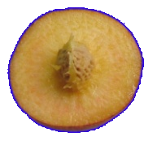 | 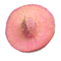 | 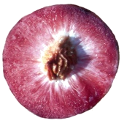
1 | 2 | 3
absent or very weak | weak | strong
weak | medium | strong

Characteristic 54 “Fruit: anthocyanin coloration of flesh around stone”

Characteristic 54 to be split into two characteristics.

Current wording:

54.  (*)  (+) |  | Fruit: anthocyanin coloration of flesh around stone | Fruit : pigmentation anthocyanique de la chair autour du noyau | Frucht: Anthocyanfärbung im Bereich des Steines | Fruto: pigmentación antociánica de la pulpa alrededor del hueso
QN | (f) | absent or weak | absente ou faible | fehlend oder gering | ausente o débil | Springtime | 1
 |  | medium | moyenne | gering | media | Ryan Sun | 2
 |  | strong | forte | stark | fuerte | Summer Lady, Zaipeo | 3

Proposed new wording:
54.  (*)  (+) |  | Fruit: anthocyanin coloration of flesh around stone | Fruit : pigmentation anthocyanique de la chair autour du noyau | Frucht: Anthocyanfärbung im Bereich des Steines | Fruto: pigmentación antociánica de la pulpa alrededor del hueso
QN | (f) | absent |  |  |  | Springfire | 1
 |  | present |  |  |  | Summer Lady | 9
NEW.  (*)  (+) |  | Fruit: anthocyanin coloration of flesh around stone | Fruit : pigmentation anthocyanique de la chair autour du noyau | Frucht: Anthocyanfärbung im Bereich des Steines | Fruto: pigmentación antociánica de la pulpa alrededor del hueso
QN | (f) | weak |  |  |  | To be provided | 1
 |  | medium |  |  |  | To be provided | 2
 |  | strong |  |  |  | Summer Lady, Zaipeo | 3

Ad. NEW: Fruit: anthocyanin coloration of flesh around stone

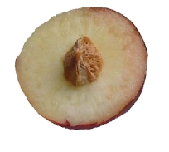 | 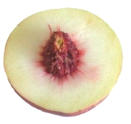 | 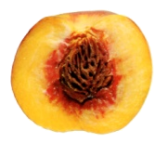
1 | 2 | 3
absent or very weak | medium | strong
weak | medium | strong

Characteristic 55 “Fruit: flesh fiber”

Current wording:

55. |  | Fruit: flesh fiber | Fruit : chair fibreuse | Frucht: Fleischfasern | Fruto: pulpa fibrosa
QN | (f) | absent or weak | absente ou faible | fehlend oder schwach | ausente o débil | Redhaven | 1
 |  | moderate | modérée | mäßig | moderada |  | 2
 |  | strong | forte | stark | fuerte | Sunhigh | 3

Proposed new wording:

55.  (+) |  | Fruit: flesh fiber | Fruit : chair fibreuse | Frucht: Fleischfasern | Fruto: pulpa fibrosa
QN | (f) | not fibrous | non fibreux |  |  | Redhaven | 1
 |  | fibrous | fibreux |  |  | Sunhigh | 9

Ad. 55: Fruit: flesh fiber

The flesh fiber is evaluated by tasting, and the states are illustrated by this photo.

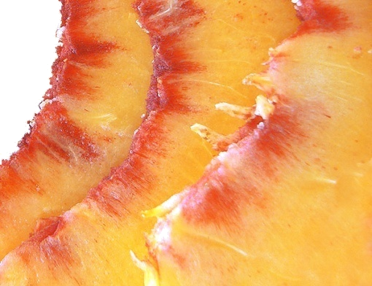
1

9

9

not fibrous

fibrous

fibrous

Characteristic 58 “Stone: size compared to fruit”

Current wording:

58.  (*)  (+) |  | Stone: size compared to fruit | Noyau : taille par rapport à celle du fruit | Stein: Größe im Verhältnis zur Frucht | Hueso: tamaño con respecto al fruto
QN | (g) | small | petit | klein | pequeño | Alex, Robin | 3
 |  | medium | moyen | mittel | mediano | Redhaven | 5
 |  | large | gros | groß | grande | Somervee | 7

Proposed new wording:
58.  (*)  (+) |  | Stone: size in relation to fruit | Noyau : taille par rapport à celle du fruit | Stein: Größe im Verhältnis zur Frucht | Hueso: tamaño con respecto al fruto
QN | (g) | small | petit | klein | pequeño | Alex, Robin | 3
 |  | medium | moyen | mittel | mediano | Redhaven | 5
 |  | large | gros | groß | grande | Somervee | 7

Characteristic 66 “Stone: size compared to fruit”

Current wording:

66.  (+) |  | Time of beginning of leaf bud burst | Époque de début de débourrement foliaire | Zeitpunkt des Aufbrechens der vegetativen Knospe | Época de comienzo de la brotación de la yema folear
QN |  | very early | très précoce | sehr früh | muy temprana | Sunred | 1
 |  | early | précoce | früh | temprana | Springtime | 3
 |  | medium | moyenne | mittel | media | Redhaven | 5
 |  | late | tardive | spät | tardía | Genadix 7 | 7
 |  | very late | très tardive | sehr spät | muy tardía | Philp | 9

Proposed new wording:

66.  (+) |  | Time of beginning of leaf bud burst | Époque de début de débourrement foliaire | Zeitpunkt des Aufbrechens der vegetativen Knospe | Época de comienzo de la brotación de la yema foliar
QN |  | very early | très précoce | sehr früh | muy temprana | Sunred | 1
 |  | early | précoce | früh | temprana | Springtime | 3
 |  | medium | moyenne | mittel | media | Redhaven | 5
 |  | late | tardive | spät | tardía | Genadix 7 | 7
 |  | very late | très tardive | sehr spät | muy tardía | Philp | 9

Characteristic 68 “Time of maturity for consumption”

Current wording:

68.  (*)  (+) |  | Time of maturity for consumption | Époque de maturité pour la consommation | Zeitpunkt der Genußreife | Época de madurez para el consumo
QN |  | very early | très précoce | sehr früh | muy temprana | Rich May,  Springtime, Zaibaro | 1
 |  | very early to early | très précoce à précoce | sehr früh bis früh | de muy temprana a temprana | Zainoar, Zaitani | 2
 |  | early | précoce | früh | temprana | Antonia, Redwing, Rich Lady, Robin | 3
 |  | early to medium | précoce à moyenne | früh bis mittel | de temprana a media | Craucail, Diamond Princess | 4
 |  | medium | moyenne | mittel | media | Fairhaven, Fantasia, Summer Bright, Zee Lady | 5
 |  | medium to late | moyenne à tardive | mittel bis spät | de media a tardía | Maillarbig,  Savana Red, Zaimor | 6
 |  | late | tardive | spät | tardía | Fairlane, Flacara, Veteran, Western red, Zailati, Zairova | 7
 |  | late to very late | tardive à très tardive | spät bis sehr spät | de tardía a muy tardía | Andgold, Tardibelle | 8
 |  | very late | très tardive | sehr spät | muy tardía | Firetime, Rubidoux | 9

Proposed new wording:

68.  (*)  (+) |  | Time of maturity for consumption | Époque de maturité pour la consommation | Zeitpunkt der Genußreife | Época de madurez para el consumo
QN |  | very early | très précoce | sehr früh | muy temprana | Rich May,  Springtime, Zaibaro | 1
 |  | very early to early | très précoce à précoce | sehr früh bis früh | de muy temprana a temprana | Zainoar, Zaitani | 2
 |  | early | précoce | früh | temprana | Antonia, Redwing,  Rich Lady, Robin | 3
 |  | early to medium | précoce à moyenne | früh bis mittel | de temprana a media | Craucail, Diamond Princess | 4
 |  | medium | moyenne | mittel | media | Fairhaven, Fantasia, Summer Bright, Zee Lady | 5
 |  | medium to late | moyenne à tardive | mittel bis spät | de media a tardía | Maillarbig,  Savana Red, Zaimor | 6
 |  | late | tardive | spät | tardía | Fairlane, Flacara,  Western Red, Veteran, Zailati, Zairova | 7
 |  | late to very late | tardive à très tardive | spät bis sehr spät | de tardía a muy tardía | Andgold, Tardibelle | 8
 |  | very late | très tardive | sehr spät | muy tardía | Firetime, Rubidoux | 9
 |  | ultra late | ultra tardive |  | ultra tardia | Calante, Jesca | 10

Ad. 68: Time of maturity for consumption

Current wording:

The time of maturity for consumption is when the overall appearance, firmness and taste indicate that the fruit is ready for consumption.

Proposed new wording:

The time of maturity for consumption is evaluated with a penetrometer. After removing the skin of the fruit, the penetrometer is placed on the flesh in order to test the firmness of the fruit. The measurement is performed on about 15 representative fruits collected from different parts of the three trees. When firmness (pressure) is between 0.5 and 1kg/cm ² the fruit is considered mature for consumption.
Chapter 8.2 “Explanations for individual characteristics”

Ad. 8 “Flowering shoot: density of flower buds”

Current wording:

To be observed along the shoot on one meter.

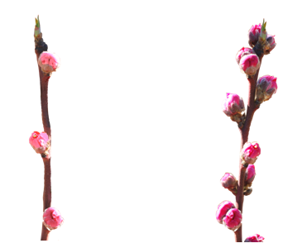
3 | 7
sparse | dense

Proposed new wording:

The density of flower buds is determined by counting the number of flower buds along one meter of shoot.
3 | 7
sparse | dense

New Ad. 28 “Leaf blade: red mid-vein on the lower side”

April, May and September months are the most appropriate to observe this character in the North hemisphere. The red mid vein leaf blade characteristic is linked with the “blood flesh” character (bf gene). This early observation allows a first check, from the first budbreak of the plantation year.

Other types of bloody flesh peaches are known, among which some without red mid-rib. So, this character of the leaf blade (presence/absence of red mid-vein on the lower side) can allow to distinguish them.

Chapter 9 “Literature”

To add following literature references:

Chaparro J.X., Werner D.J., Whetten R.W. and D.M. O'Malley, 1995. Inheritance, genetic interaction and biochemical characterization of anthocyanin phenotypes in peach. J. Hered., 86: 32-38.

Hu D. and R. Scorza, 2009: Analysis of the ‘A72’ peach tree Growth Habit and its inheritance in progeny obtained from crosses of ‘A72’ with columnar peach trees. J. Amer. Sc. Hort. Sci. 134(2):236-243.

Layne D.R. and D. Bassi, 2008. The peach : Botany, production and uses. Ed. By Desmond R. Layne and Daniele Bassi. ISBN 978 1 84593 386 9. CABI, 30 nov. 2008 - 615 pages.

Monet R., Bastard Y. en Gibault B., 1988. Etude génétique du caractère « port pleureur » chez le pêcher. Agronomie, 8(2) : 127-132.

Monet R. Guye A. and N. Dachary, 1996. Peach Mendelian genetics: a short review and new results. Agronomie, 16: 321-329.

Sajer O., Scorza R., Dardick C., Zhenbentyayeva T., 2012. Development of sequence-tagged site markers linked to the pillar growth type in peach (Prunus persica). Abbott A.G. and R. Horn, Plant Breeding, doi:10.1111/j.1439-0523.2011.01912.x

Scorza R., Lightner G.W. and A. Liverani, 1989. The pillar peach tree and growth habit analysis of compact x pillar progeny. J. Am. Soc. Hortic. Sci., 114: 991-995.

Werner R.W. Creller M.A. and J.X. Chaparro, 2005. Inheritance of the blood-flesh trait in peach. Hortscience, 33(7): 1243-1246.

Werner R.W. and Chaparro J.X., 2005. Genetic interactions between pillar and weeping peach genotypes. Hortscience 40(1): 18-20.
Chapter 10 “Technical Questionnaire”

To delete the following characteristics from Chapter 5:

Fruit: flesh type (TQ characteristic), with the following groups:
- melting
- non-melting (pavies)
- stony hard
Stone: adherence to flesh (characteristic 64)

To add the following characteristics to Chapter 5:

Tree: size (characteristic 1)
Flowering shoot: presence of anthocyanin coloration (characteritic 6)
Anthers: pollen (characteristic 17)
Ovary: pubescence (characteristic 18)
Leaf blade: red mid-vein on the lower side (characteristic 28)
Petiole: nectaries (characteristic 30)
Fruit: shape (in ventral view) (characteristic 33)

[End of document]

